Initial Environmental Examination Report

Project Number: 55236-001
August 2024

Project Readiness Financing for Punjab Urban Development Projects

Updated IEE for Replacement of Existing Conductance Main from Rawal Lake Filtration Plant to Water Works Sufaid Tanki and Solarization Component under DREAMS-I

Prepared by Project Management Unit of PRF PUDP, Government of Punjab, Pakistan

This updated version of the Initial Environmental Examination Report is a document of the borrower. The views expressed herein do not necessarily represent those of ADB Board of Directors, Management, or staff, and may be preliminary in nature.

In preparing any country program or strategy, financing any project, or by making any designation of or reference to a particular territory or geographic area in this document, the ADB does not intend to make any judgments as to the legal or other status of any territory or area.

CURRENCY EQUIVALENTS
As of 28th August, 2024
Currency Unit – Pak Rupees (Pak Rs.)
Pak Rs 1.00 = $ 0.0036 US$1.00 = Pak Rs. 277
CONVERSIONS
1 meter = 3.28 feet
1 hectare = 2.47 acre

Acronyms

ADB Asian Development Bank
AIP Access to Information Policy
AMSL Above Mean Sea Level
BC Before Construction
BOQ Bill of Quantities
CDA Capital Development Authority
Cft. Cubic Feet
CoI Corridor of Impact
COVID-19 Corona Virus Infectious Disease-2019
CSC Construction Supervision Consultant
DC During Construction
DO During Operation
EA Executing Agency
ECM Existing Conductance Main (ECM)
EDCM Engineering Design Construction Management
EHS Environmental, Health, and Safety
EIA Environment Impact Assessment
EMP Environmental Management Plan
EPA Environmental Protection Agency
FFC Flood Forecasting Commission
GoP Government of Pakistan
GRC Grievance Redressal Committee
GRM Grievance Redressal Mechanism
GWSS Gravity Water Supply Scheme
HDPE High Density Polyethylene
IA Implementing Agency
IAP Impact Assessment Survey
IBAT Integrated Biodiversity Assessment Tool
IEE Initial Environmental Examination
IFC International Finance Corporation
KPI Key Performance Indicator
LAA Land Acquisition Act (of 1984)
LEA Equivalent sound pressure level
LPCD liters per person (capita) per day
MGD Million Gallons per Day
MSDS Material Safety Data Sheet
NCS National Conservation Strategy
NEP National Environmental Policy
NEQS National Environmental Quality Standards
OHS Occupational Health and Safety
O&M Operation & Maintenance
PAP Project Affected Persons
PC Public consultation
PCC Plain Cement Concrete
PEP Act Pakistan Environment Protection Act 1997
PEPC Pakistan Environmental Protection Council
PEQS Punjab Environmental Quality Standards
PGA Peak Ground Acceleration
PM Particulate Matter
PMU Project Management Unit
PPE Personal Protective Equipment
PV Photovoltaic
RCC Reinforced Cement Concrete
RDA Rawalpindi Development Authority
REA Rapid Environmental Assessment
RP Resettlement Plan
SOPs Standard Operating Procedures
SS Suspended Solids
SPS Safeguard Policy Statement
SSEMP Site Specific Environmental Management Plan
TDS Total Dissolved Solid
TMA Tehsil Municipal Administration
TMP Traffic Management Plan
UCs Union Councils
USEPA United States Environmental Protection Agency
WHO World Health Organization

Table of Contents
1. EXECUTIVE SUMMARY i
1.1 Proposed Project i
1.2 Project Benefits ii
1.3 Policy, Legal and Administrative Framework ii
1.4 Project Description iii
2. INTRODUCTION 1
2.1 Overview of the project 1
2.2 Project Need 3
2.3 Project Benefits 7
2.4 Environmental Safeguards Category of the Project 7
2.5 Scope and Objectives of the IEE 8
2.6 Methodology of IEE Study 8
2.7 Structure of the Report 10
2.8 IEE Team 11
2.9 Further Additions & Updating of IEE Study 11
3. POLICY, LEGAL AND ADMINISTRATIVE FRAMEWORK 13
3.1 General 13
3.2 National Policy and Legal Framework 13
3.3 Regulations for Environmental Assessment, Pakistan EPA 13
3.4 Regulatory Clearances, Punjab EPA and Pak EPA 13
3.5 Guidelines for Environmental Assessment, Pakistan EPA 13
3.6 Pakistan / Punjab Environmental Quality Standards (NEQS) 2000 & 2010 14
3.7 Other Environment Related Legislations 14
3.8 ADB’s Safeguard Policy Statement (SPS), 2009 25
3.9 ADB’s Access to Information Policy (AIP) 2018 25
3.10 ADB’s Accountability Mechanism Policy 2012 25
3.11 ADB’s Policy on Gender and Development 26
3.12 Implications of ADB’s safeguard policies on proposed project 26
3.13 IFC Environmental, Health and Safety Guidelines for Water and Sanitation 27
3.14 Comparison of International and Local Environmental Legislations 28
4. PROJECT DESCRIPTION 32
4.1 Project Introduction 32
4.2 Scope of Work 35
4.3 Salient Parameters of the Existing Line 35
4.4 Existing Condition of Conductance Main 36
4.5 Existing Conductance Main (ECM) Details 37
4.6 Design Criteria/ Parameters 39
4.7 Solar PV System Installation 41
4.8 Construction Activities 44
4.9 Operation phase of Solar installation 46
4.10 Decommissioning 46
4.11 Access Roads 47
4.12 Project Administrative Jurisdiction and Tentative Cost 49
4.13 Land Use and Vegetation Features of the Project Site 49
4.14 Construction Machinery and Material Requirement 49
4.15 Construction Camp (Temporary Facility) 50
4.16 Workforce Requirements 50
4.17 Power Requirement and Source 50
4.18 Water Requirement 50
4.19 Wastewater Generation 51
4.20 Solid Waste Estimation 51
5. PROJECT ALTERNATIVES 52
5.1 Overview 52
5.2 Zero Alternative “No Project Option” 52
5.3 Laying of New Pipeline (Alternative-I) 52
5.4 Insertion of New Pipe in Existing Pipe (Alternative-II) 53
5.5 Minimum (0.6 m) Dismantling of existing pipe at the top (Alternative-III) 53
5.6 Dismantling of Existing Pipe at the Top Up-To Half Dia. (Alternative-IV) 54
5.7 Comparison / Analysis of Alternatives 57
5.8 Conclusion 57
5.9 Solar PV Installation Component 58
6. DESCRIPTION OF THE ENVIRONMENT 60
6.1 General 60
6.2 Field Visits for Baseline Study 60
6.3 Physical Environment 62
6.4 Topography 62
6.5 Land use of the Proposed Project 62
6.6 Hydrology 62
6.7 Groundwater 63
6.8 Surface Water 63
6.9 Geology and Soil 65
6.10 Climate 67
6.11 Rainfall 68
6.12 Relative Humidity 69
6.13 Floods 70
6.14 Ecological Environment 72
6.15 Agriculture and Crop Pattern 74
6.16 Fauna/Wildlife 74
6.17 Protected Areas 77
6.18 Socio-economic Environment 81
6.19 Administrative Setup 83
6.20 Demography & Population 84
6.21 Religion 86
6.22 Archaeological and Cultural Site 86
6.23 Ethnicity in the Project Area 86
6.24 Language and Dialects 86
6.25 Dwellings 86
6.26 Economics of Rawalpindi / Islamabad 86
6.27 Education Facilities in Project area 86
6.28 Social Amenities in the project area 86
6.29 Major Source of Drinking Water 87
6.30 Health Facilities in project area 87
6.31 Environmental Sensitive Receptors 87
6.32 Environmental Monitoring 90
6.33 Water Quality 93
Dhok Kala Khan Road 93
6.34 Ambient Air Quality 96
6.35 Noise Level 97
7. POTENTIAL ENVIRONMENTAL IMPACTS AND MITIGATION MEASURES 100
7.1 General 100
7.2 Methodology for Impact Screening 100
7.3 Potential Positive Impacts 101
7.4 Potential Adverse Impacts 102
7.5 Design/Pre-Construction Phase 102
7.6 Adverse Impacts during Planning and Design Phase 104
7.7 Adverse Impacts during Construction Stage 107
7.8 Anticipated Impacts during Operational Phase 127
7.9 Solar PV Installation 130
7.10 Impacts and mitigation measures during Construction Phase 133
7.11 Operation Phase 146
7.12 Waste Generation 149
7.13 Ecological Impacts 149
7.14 Occupational Health and Safety 150
7.15 Glare from solar panels might blind pilots or air traffic control towers 150
7.16 Interference with navigation and communication systems of aircrafts (electromagnetic interference) 151
7.17 Green energy-based climate friendly form of power generation 151
7.18 Decommissioning 151
7.19 Cumulative Impacts 152
7.20 Indirect and Induced Impacts 152
8. ENVIRONMENTAL MANAGEMENT PLAN & INSTITUTIONAL REQUIREMENTS 153
8.1 Introduction 153
8.2 Environmental Management Plan (EMP) 153
8.3 Objectives of EMP 153
8.4 Institutional Arrangements 154
9. Monitoring Parameters 177
9.1 Environmental Training 177
10. Environmental Management Costs for ECM Component 184
11. Environmental Management Costs for Solar Installation 193
12. Performance Indicators 196
13. PUBLIC CONSULTATION AND INFORMATION DISCLOSURE 197
13.1 Identification of Stakeholders 197
13.2 Consultation Process 198
13.3 Consultation with Project Affected Peoples 198
13.4 Consultation with Official Stakeholders 207
13.5 Summary of Concerns from Affected Persons 210
13.6 Consultation Plan for Construction and Operation Phase 210
13.7 Information Disclosure 210
13.8 Consultations for Solar Installations 211
14. GRIEVANCE REDRESSAL MECHANISM 220
14.1 General 220
14.2 Scope of GRM 220
14.3 Functions of GRC Committee 220
14.4 Stage of GRM 221
15. CONCLUSION AND RECOMMENDATIONS 224
15.1 Conclusion 224
15.2 Recommendations 225
Annexures 227
Annexure I: Filled Checklist for Rapid Environmental Assessment (REA) 228
Annexure II: Map for tentative locations of working Chamber and Land Use 234
Annexure III: IBAT Findings 239
Annexure IV: Environmental Testing & Monitoring Reports 248
Annexure V: Calibration Certificate of Noise and Air Quality Measuring Instruments 259
Annexure VI: Chance Find Procedures 265
Annexure VII: Framework for Traffic Management Plan 267
Annexure VIII: Framework for Resources Conservation Plan 277
Annexure IX: Framework for Occupational Health & Safety Management Plan 280
Annexure X: Framework for Emergency Response Plan 291
Annexure XI: Framework for Dust Management Plan 308
Annexure XII: Framework for Construction Noise and Vibration Management Plan 313
Annexure XIII: Template for Site-Specific EMP 317
Annexure-XIV: Tool for Socioeconomic Survey 326
Annexure XV: Attendance Sheets of FGDs 330
Annexure XVI: Public Consultation Minutes for 340
Solar Installation Development 340
Annexure XVII: Laboratory Monitoring Results for Solar Installation Site at Rawal lake Water Filtration Plant 362

List of Table
Table ES.1: Impact Assessment Matrix for Pre-Construction Phase for ‘Conductance Mains Component’ vii
Table ES.2: Impact Assessment Matrix for Construction Phase for ‘Conductance Mains Component’ vii
Table ES.3: Impact Assessment Matrix for Operation Phase for ‘Conductance Mains Component’ ix
Table ES.4: Screening of possible Impacts during Design/Pre- Construction phase for ‘Solar PV Component’ ix
Table ES.5: Screening of Possible Impacts during Construction Phase for ‘Solar PV Component’ x
Table ES.6: Screening of Potential Impacts during Operation Phase for ‘Solar PV Component’ xi
Table 2.1: Project Original and revised scope 3
Table 2.1: Design Parameters of Horizon 2016-2040 7
Table 2.2: Executing Agency Contact Details 10
Table 2.3: Details of IEE Team 11
Table 3.1: Main Strategies/Policies Related to Environment and Relevance to the Project 14
Table 3.2: Main Legislation/Acts Related to Environment and Their Relevance to the Project 17
Table 3.4: IFC Work Environment Noise limits11.2: 27
Table 3.5: Comparison of International and local Air Quality Standards*1.3 28
Table 3.6: Comparison of International and Local Noise Standards1.4 28
Table 3.7: Comparison of International and Local Water Quality Standards1.5 29
Table 4.1: Detail of the Syphons 36
Table 4.2: Summary of Conductance Main Inventory 37
Table 4.3: Design Life of Water Supply Infrastructure 38
Table 4.4: Theoretical per capita water demand 39
Table 4.5: Climatic Parameters for the project 39
Table 4.6: Estimated Contractor’s Equipment and Machinery 48
Table 4.7: Construction Material and Source of Raw Material 49
Table 5.1: Comparison of Different Options 54
Table 5.2: Analysis of Alternatives 56
Table 6.1: Yearly Mean Temperature (2018-2022) 66
Table 6.2: Mean Yearly Rainfall (2018-2022) 67
Table 6.3: Mean Yearly Humidity (2018-2022) 68
Table 6.4: Vegetative species of the region 72
Table 6.5: List of indigenous Mammals 73
Table 6.6: Amphibians of the Study Area 74
Table 6.7: Reptiles of the Study Area 74
Table 6.8: Birds Found in Study Area 75
Table 6.9: Forests Located near the Project Area 77
Table 6.10: Administrative subdivision of Rawalpindi District 82
Table 6.11: Detail of Environmental Sensitive receptors 88
Table 6.12: Water Quality Sampling Location Description 92
Table 6.13: Results of Water Quality Analysis 92
Table 6.14: Detail of Air Quality Sampling Locations 95
Table 6.15: Ambient Air Quality Results 96
Table 6.16: Detail of location for Noise Levels Monitoring 97
Table 6.17: Noise Level 97
Table 7.1: Screening of possible Impacts during Design/Pre- Construction phase for Conductance Mains Component 102
Table 7.2: Screening of Possible Impacts during Construction Phase for Conductance Mains Component 106
Table 7.3: Estimated Wastewater Generated by Workers in Construction Camps 111
Table 7.4: Noise Produced by Construction Equipment 115
Table 7.5: Potential Impacts from Operation for Conductance Mains Component 126
Table 6.9: Screening of possible Impacts during Design/Pre- Construction phase for ‘Solar PV Component’ 129
Table 7.7: Screening of Possible Impacts during Construction Phase for ‘Solar PV Component’ 132
Table 7.8: Screening of Possible Impacts during Operation Phase for ‘Solar PV Component’ 146
Table 8.1: Environmental Management Plan for Conductance Mains Works 155
Table 7.11: Environmental Management Plan for Solar PV Installation 167
Table 9.1: Pre-Construction’ Environmental Monitoring for Baseline Development 178
Table 9.2: Construction Phase Monitoring Requirements 179
Table 9.3: Operation Phase Environmental Monitoring Plan 181
Table 9.4: Capacity Development and Training Programme 182
Table 10.1: Annual Cost Estimates for ‘Pre-Construction Phase’ 183
Table 10.2: Annual Cost Estimates for ‘Construction Phase’ Environmental Monitoring 184
Table 10.3: Annual Cost Estimates for ‘Operation Phase’ Environmental Monitoring 184
Table 10.4: Estimated Costs for EMP Implementation 185
Table 10.5: Cost of Capacity Development and Training Programme for Project Contractor(s) 186
Table 10.6: Environmental Management Plan for Solar Installation 187
Table 11.1: Cost Estimates for ‘Pre-Construction Phase’ – Solar 192
Table 11.2: Cost Estimates for ‘Construction Phase’ Environmental Monitoring - Solar 193
Table 11.3: Estimated Costs for EMP Implementation - Solar 193
Table 11.4: Cost of Capacity Development and Training Program for Project Contractor(s) - Solar 194
Table 13.1: Consultation with Project Affected Peoples 198
Table 13.2: Data of Focus Group Discussion 201
Table 13.3: Consultation with Government Stakeholders 207
Table 13.4: Details of consultations conducted for solar installations 211

List of Figures
Figure 1.1: Location Map of the Proposed Project iv
Figure 1.2: Proposed solar PV installation at Rawal Lake Water Filtration Plant v
Figure 2.1: Proposed Layout of Conductance Rawal Lake WTP 2
Figure 2.2: Proposed solar PV installation at Rawal Lake Water Filtration Plant 5
Figure 2.3: Boundary Map of Rawalpindi City 6
Figure 4.1: RWTP Conductance Main Corridor of Impact 32
Figure 4.2: Route of Conductance Main 33
Figure 4.3: Site Visit Glimpse 35
Figure 4.4: Conceptual design of Solar PV system installation at Rawal WTP 43
Figure 4.5: Detail of Access Roads 47
Figure 6.1: Location Map of Proposed Project for Conductance Mains Component 60
Figure 6.2: Location of Water sources for RWASA 63
Figure 6.3: Seismic Zone of Pakistan 65
Figure 6.4: Yearly Mean Temperature (2018-2022) 67
Figure 6.5: Mean Yearly Rainfall (mm) 2018-2022 68
Figure 6.6: Mean Yealy Humidity (2018-2022) 68
Figure 6.7: Areas vulnerable to Floods 70
Figure 6.8: Flora Fauna found in Project Area 75
Figure 6.9: Results of IBAT A 77
Figure 6.10: Results of IBAT B 77
Figure 6.11: Location of Forests near project site 79
Figure 6.12: Socioeconomic Conditions of the project area 80
Figure 6.13: Demographic features of Rawalpindi 84
Figure 6.14: Environmental sensitive Receptors 87
Figure 6.15: Locations of Environmental Monitoring Points 91
Figure 6.16: Photos of Environmental Monitoring 98
Figure 13.1: Consultations with Stakeholders 203
Figure 13.2: Consultations with Institutional Stakeholders 208
Figure 14.1: GRM Process 222

EXECUTIVE SUMMARY
- The proposed sub-project is a part of the Developing Resilient Environments and Advancing Municipal Services (DREAMS) project which Asian Development Bank (ADB) is financing in the amount of USD 180 million.
- The DREAMS project will support inclusive, resilient, and sustainable urban infrastructure and services in two rapidly growing cities in Punjab province i.e. Rawalpindi and Bahawalpur by (i) expanding and modernizing urban water supply systems in Rawalpindi and solid waste collection, treatment, and disposal in Bahawalpur and (ii) strengthening institutional capacity in service delivery to improve the quality, coverage, efficiency and reliability of these services, as well as the financial sustainability of the utilities. The project will benefit up to 1.5 million urban dwellers in Punjab, the most populous province of the country.
- Rawalpindi city mainly depends on rainfall for both surface and groundwater resources (as the perched aquifers deplete rapidly due to lesser rainfall, the perched aquifer is usually above the normal ground water table due to presence of rock or other impermeable sediment layer). Water supply, being the foremost utility for citizens, is currently the most affected municipal service in the city.
- In order to fulfil the water requirements of Rawalpindi, the Rawalpindi Water and Sanitation Agency (RWASA) is utilizing both underground as well as surface water resources. The water utilization from Rawal dam is 10 million gallons per day (MGD), from Khanpur dam it is 6 MGD and from tube wells it is 35 MGD. The total water availability from different water sources to Rawalpindi city, excluding cantonment board is 51 MGD while the water demand is 80 MGD and so with this current water deficit of 29 MGD, it will expected to only further increase in the future.
- The water will be taken from Transmission Main of Rawal lake filtration plant and the Rawal filtration plant has an approved capacity of 28 MGD for Rawalpindi city but only 23 MGD is currently supplied to the city, due to nonfunctioning of the Existing Conductance Main (ECM). The new Conductance Main will supply 5 MGD water to Rawalpindi and will help to utilize the full allocated water supply of 28 MGD from the Rawal lake filtration plant.

Proposed Project
- The proposed project comprises of the following components:
- Replacement of 36” (900mm) dia. PRCC pipe from Water Works (Sufaid Tanki) to 6th road, satellite town with a length of 2.52 km.
- Insertion of 36” (900mm) dia. HDPE pipe into existing 54” line (1350 mm) dia. PRCC pipe from 6th road satellite town to Rawal Lake filtration plant with a length of 6.58 km.
The project location plan is shown below as Figure 1.
- Furthermore, in order to cater to the power requirements of the proposed project, a grid connected solar photovoltaic (PV) system of 0.6 MW capacity will be installed over 10 acres of land at the site of the Rawal lake water filtration plant and the power generated will be used for meeting the project needs. The site for installation of the solar PV panels is shown as Figure ES-2 below.
- The old PRCC Conductance main (Existing conductance main ECM) was laid in 1979 under “Rawalpindi Greater Water Supply Project” from Rawal Lake Filtration Plant to Bifurcation Point for MES line near 6th Road, in A-Block Satellite Town during augmentation of Rawal lake Filtration Plant. This Conductance Main remained functional till 2001 and now is abandoned due to heavy leakages from joints. A new Conductance Main (Duplicate conductance main (DCM)) was laid down in 2001 which is supplying water to the city and has a carrying capacity of 23 MGD.
- Approximately 5 MGD of water is not being treated by the treatment plant due to non- functionality of the old PRCC line. The available treatment capacity of the plant dictates the replacement of this line so that Rawalpindi citizens can be benefited with 5 MGD of water, which can fulfil the water requirement of about 125,000 persons. The proposed project will not involve the installation of any pumping machinery as the water will be flowing through gravity from Sector I-10 of Islamabad to Sufaid Tanki, Rawalpindi.

Project Benefits
- The main benefits of this project are management of leakage points, reduction of water supply deficit and enhancement and sustainable water supply to Rawalpindi by reducing pressure on the ground water resource.

Policy, Legal and Administrative Framework
- The project will comply with all the applicable environmental policies, laws, guidelines, acts and legislations of Government of Pakistan and the provincial government as well as international environmental guidelines.

Regulations for Environmental Assessment, Punjab / Federal EPA
- A project falling under any category specified in Schedule I or II of the Initial Environmental Examination (IEE)/Environmental Impact Assessment (EIA) Regulations (SRO 339 (I0/2000) need to obtain environmental approval under section 12 of the Punjab Environmental Protection Act, 1997 (Amendment 2012) (in case of Punjab EPA) / Pakistan Environmental Protection Act 1997 (in case of Federal EPA). As per Schedule-II (F-1) of IEE/EIA Regulations, 2000, and Punjab Environmental Protection (Review of Initial Environmental Examination and Environmental Impact Assessment) Regulations, 2022, the proposed project falls under category of projects requiring EIA for Punjab EPA and Federal EPA.

ADB’s Safeguard Policy Statement (SPS), 2009
- The ADB’s SPS 2009 requires that environmental considerations to be incorporated into ADB funded projects to ensure that the project will have minimal environmental impacts and be environmentally sound. Categorization is to be undertaken using Rapid Environmental Assessment (REA) checklists and the project will be classified into one of the following environmental categories: A, B, C or Financial Intermediary (FI).
- An IEE is required to determine whether or not significant environmental impacts warranting an EIA are likely. If an EIA is not needed, the IEE is regarded as the final environmental assessment report. It was ascertained that certain adverse environmental impacts are not expected of significance that detailed assessment is required. Therefore, the project has been categorized under category B as per ADB’s SPS 2009 and an IEE study has been conducted.
- This is the updated version of the original draft IEE report which was disclosed on the ADB web page in June 2023 (web page link: https://www.adb.org/projects/documents/pak-55236-001-iee-0). This updated version contains details and the assessment on the solarization component of the project and also provides additional information on the original scope of the IEE along with improving the readability of the IEE report.

Project Description
- The proposed project intends to replace the redundant old Conductance Main of 56 inch diameter with a new Conductance Main of 36 inch diameter with the new Conductance Main to be placed within the existing Conductance Main. The existing Right of Way (ROW) will be used for the proposed project and no land acquisition is involved in the proposed project, which will pass from the following areas: Rawal Lake Filtration Plant (Start Point), Street 6, Margalla Road, Swan Road, Islamabad Expressway Crossing, Dhok Kala Khan Road, Malik Mirza Road, Muhammad Iqbal Road, 6th road, Murree Road crossing, Saidpur Road and Sufaid Tanki (End Point).

Project Alternatives
- Four options have been considered for construction of the proposed project. The size of the new line has been calculated on the basis of available discharge from the Rawal Lake Water Treatment Plant (WTP) and working head available at final discharge point. The four alternative options that were considered are as follows:
- Laying of new pipeline (Option 1)
- Insertion of new pipe in existing pipe (Option 2)
- Minimum (0.6m) dismantling of the existing pipe at the top (Option 3)
- Dismantling of existing pipe at the top.
- The option 2 was selected as the final option for the proposed project as it involves minimum disturbance to the environment and it is also cost effective.
- The different potential options relating to the proposed solar PV development were assessed. The ‘No project’ scenario is not a viable option since Pakistan is facing an energy deficit and needs to urgently switch from the cost intensive and environmentally unfriendly diesel-based power generation and move towards developing renewable based cheap and reliable energy on a long-term basis.
- For the purpose of this proposed solar PV installation, bifacial monocrystalline modules will be utilized in the solar plant. For end of life/failure or at decommissioning, provision in tender agreements with suppliers/vendors will ensure proper and safe collection, recycling and/or disposal, as needed.

Figure 1.1: Location Map of the Proposed Project
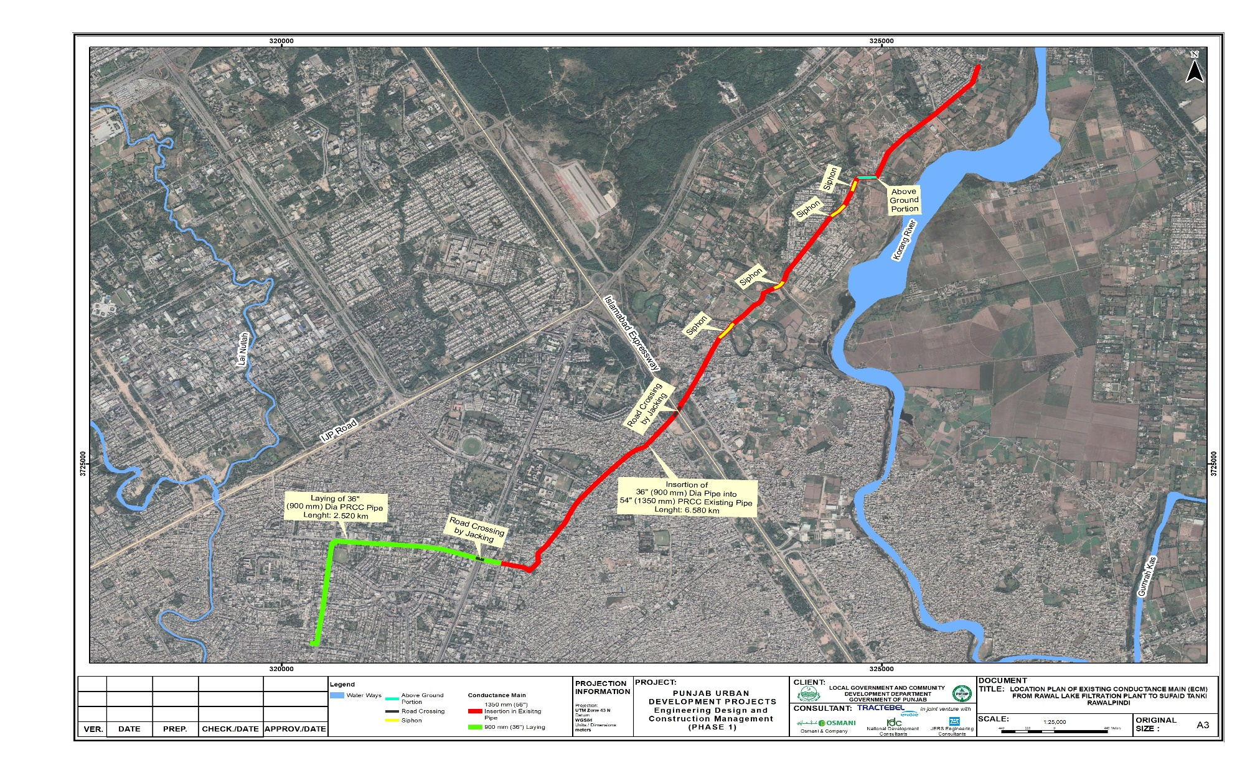

Figure 1.2: Proposed solar PV installation at Rawal Lake Water Filtration Plant
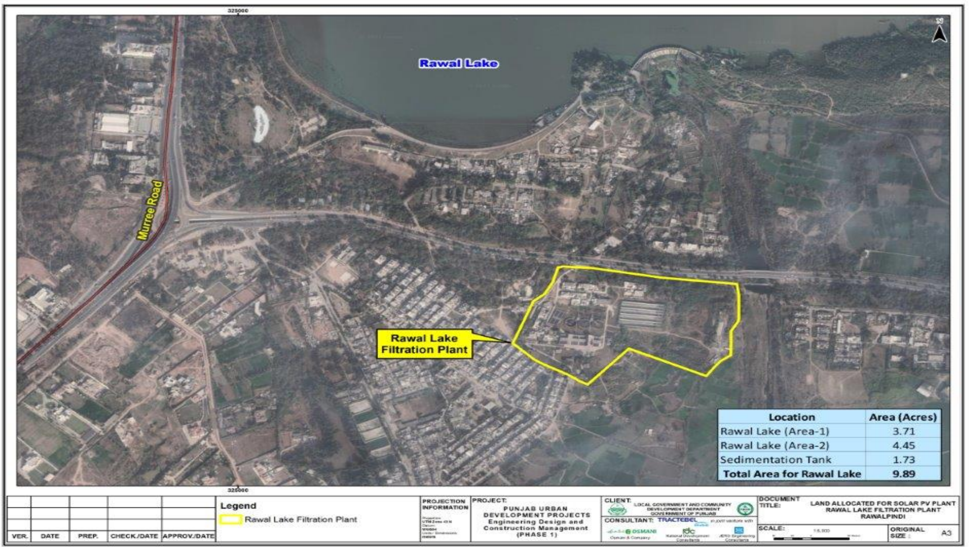

Description of the Environment
- Considering the potential impacts of the proposed project, the existing baseline environmental conditions of the proposed project’s Corridor of Impact (CoI) has to be used as a benchmark for comparison of the physical, ecological and socio-economic conditions before and after construction phases of the project. This baseline will also provide the datum for assessing the impacts and suggesting the mitigation measures, which will be implemented effectively at various phases of the proposed project activities.
- The data has been collected from both primary and secondary sources. For primary data acquisition, the environment and social team conducted the field visit during the month of December, 2022. The secondary data was collected from published sources/reports and relevant departments, which were also verified through visual observations during detailed surveys. Data has been collected for following elements of environment:
  - Physical Environment
  - Biological Environment
  - Socioeconomic environment

Environmental Testing & monitoring
- Environmental parameters such as air quality, noise level and drinking water quality were analysed to assess the baseline conditions of project area and the detailed results of the monitoring are provided in Chapter 5. The test results show that majority of the parameters of water, air and noise levels are in compliance with applicable National/Punjab Environmental Quality Standards (NEQS / PEQS) and other international standards such as World Health Organization (WHO). The monitoring results shows that Particulate Matter (PM₁₀), Carbon monoxide (CO) and Sulphur dioxide (SO₂) were exceeding the limits set by WHO for ambient air, which are more stringent than PEQS/NEQS. Noise levels near the Rawal lake Treatment Plant site were higher than prescribed limiting values of PEQS/NEQS, which are more stringent than WHO.

Potential Environmental Impacts and Mitigation Measures
- Potential impacts have been assessed for the design/pre-construction, construction and operation phases of the proposed project on the physical, ecological and socio-economic impacts of the environment. Impact assessment of all parameters has been carried out and appropriate mitigation measures have been proposed wherever felt necessary.
Project Impact Evaluation Matrix
- The project impact evaluation matrices have been developed to evaluate the potential impacts of the proposed project during the planning, construction and operation phases. Qualitative description of each aspect and the affected environment in both RoW and the project’s corridor of impact (CoI) have been prepared. The risk evaluation matrix for pre-construction/design phase, construction and operation phases are provided below as Tables 1.1, to 1.3 respectively.
Table ES.1: Impact Assessment Matrix for Pre-Construction Phase for ‘Conductance Mains Component’
S/No. | Potential Issue | Likelihood (Certain, Likely, Unlikely, Rare) | Consequence (Catastrophic, Major, Moderate, Minor) | Risk Level (Significant, Medium, Low) | Residual Impact  (Short term, Long term)
1 | Improper designing of  distribution networks including  transmission mains (Replacement and New Distribution Lines) | 3 /  Likely | 2 /  Moderate | 6 /  Medium | Low / Long Term
2 | Lack of integration of  IEE/EMP requirements into Construction bid documents | 3 /  Likely | 2 /  Moderate | 6 /  Medium | Low / Short Term
3 | Relocation of existing utilities | 3 /  Likely | 2 /  Moderate | Medium | Low residual  Impact
4 | Identification of Locations for Labor Camps and ancillary facilities | 3 /  Likely | 2 /  Moderate | 6 /  Medium | Medium / Short Term
5 | Traffic Issues | 3 /  Likely | 2 /  Moderate | 6 /  Medium | Low / Short Term
6 | Land acquisition and resettlement impacts | 2 / Unlikely | 2 /  Moderate | Low | Low residual Impact
7 | Topographic Impact due to Excavation | 2 / Unlikely | 2 /  Moderate | Low | Low residual Impact
8 | Seismic Impacts | 2 / Unlikely | 2 /  Moderate | Low | Low residual  Impact
Table ES.2: Impact Assessment Matrix for Construction Phase for ‘Conductance Mains Component’
S/No. | Potential Issue | Likelihood (Certain, Likely, Unlikely, Rare) | Consequence (Catastrophic, Major, Moderate, Minor) | Risk Level (Significant, Medium, Low) | Residual  Impact (Short term, long term)
1 | Impacts due to Excavation of Chambers for Insertion of New Conductance Main within Existing Conductance Main | 3 / Likely | 2 / Moderate | 6 / Medium | Low/Short term
2 | Site Accessibility Issues | 3 / Likely | 2 / Moderate | 6 / Medium | Low/Short term
3 | Traffic Issues | 3 / Likely | 2 / Moderate | 6 / Medium | Low/Short term
4 | Impacts on Local Resources | 3 / Likely | 2 / Moderate | 6 / Medium | Low/Short term
5 | Community Health & Safety | 3 / Likely | 2 / Moderate | 6 / Medium | Low/Short term
6 | Occupational Health & Safety | 3 / Likely | 2 / Moderate | 6 / Medium | Low/Short term
7 | Impacts due to Construction Camps/ Camp Site | 3 / Likely | 2 / Moderate | 6 / Medium | Low/Short term
6 | Waste water generation | 3 / Likely | 2 / Moderate | 6 / Medium | Low/Short term
7 | Solid Waste Generation | 3 / Likely | 2 / Moderate | 6 / Medium | Low/Short term
8 | GHG Emissions | 3 / Likely | 2 / Moderate | 6 / Medium | Low/Short term
9 | Potential Emergencies during Construction Phase | 3 / Likely | 2 / Moderate | 6 / Medium | Low/Short term
10 | Impacts of Natural and Man Made Disaster | 3 / Likely | 2 / Moderate | 6 / Medium | Low/Short term
11 | Degradation of ambient air quality | 3 / Likely | 2 / Moderate | 6 / Medium | Low/Short term
12 | Noise/ Vibration | 3 / Likely | 2 / Moderate | 6 / Medium | Low/Short term
13 | Flora | 3 / Likely | 2 / Moderate | 6 / Medium | Low/Short term
14 | Fauna | 3 / Likely | 2 / Moderate | 6 / Medium | Low /Short term
15 | Social and Cultural Conflicts | 3 / Likely | 2 / Moderate | 6 / Medium | Low/Short term
16 | Communicable diseases incl. COVID-19 | 3 / Likely | 2 / Moderate | 6 / Medium | Low/Short term
Table ES.3: Impact Assessment Matrix for Operation Phase for ‘Conductance Mains Component’
S/No. | Potential Issues | Likelihood  (Certain, Likely, Unlikely, Rare) | Consequence  (Catastrophic, Major, Moderate, Minor) | Risk Level (Significant, Medium, Low) | Residual Impact (Short term, Long term)
1 | Water system leaks and water discharges during flushing | 2 /  Unlikely | 3 /  Major | 6 /  Medium | Low / Short Term
2 | Improved drinking water availability | Positive impacts expected |  |  | Long term positive
3 | Improvements in  Public Health | Positive impacts expected |  |  | Long term positive
Table ES.4: Screening of possible Impacts during Design/Pre- Construction phase for ‘Solar PV Component’
S/No. | Potential Impacts | Likelihood (Certain, Likely, Unlikely, Rare) | Consequence (Catastrophic, Major, Moderate, Minor) | Risk Level (Significant, Medium, Low) | Residual Impact  (Low, medium, High)
1 | Relocation of existing utilities | 3 /  Likely | 2 /  Moderate | 6 /  Medium | Low
2 | Traffic Issues/ Traffic Management Plan | 3 /  Likely | 2 /  Moderate | 6 /  Medium | Low
3 | Lack of integration of  IEE/EMP requirements into Construction bid documents | 3 /  Likely | 2 /  Moderate | 6 /  Medium | Low
4 | Seismic impacts | 3 /  Likely | 2 /  Moderate | 6 /  Medium | Low
5 | Site and Route selection | 3 /  Likely | 2 /  Moderate | 6 /  Medium | Low
6 | Land requirements | 2 /  Unlikely | 1 /  Minor | 2 /  Low | Low
Table ES.5: Screening of Possible Impacts during Construction Phase for ‘Solar PV Component’
Sr. No. | Potential Impacts | Likelihood (Certain, Likely, Unlikely, Rare) | Consequence (Catastrophic, Major, Moderate, Minor) | Risk Level (Significant, Medium, Low) | Residual Impact (Low, medium, High)
1 | Traffic Issues | 3/ Likely | 2/ Moderate | 6/ Medium | Low
2 | Air Quality | 3/ Likely | 2/ Moderate | 6/ Medium | Low
3 | Noise and Vibration | 3/ Likely | 2/ Moderate | 6/ Medium | Low
4 | Occupational Health & Safety | 3/ Likely | 2/ Moderate | 6/ Medium | Low
5 | Community Health and Safety | 3/ Likely | 2/ Moderate | 6/ Medium | Low
6 | Waste generation | 3/ Likely | 2/ Moderate | 6/ Medium | Low
7 | Vegetation impacts | 3/ Likely | 2/ Moderate | 6/ Medium | Low
8 | Fauna impacts | 3/ Likely | 3/ Moderate | 9/ Medium | Low
9 | Biodiversity | 3/ Likely | 2/ Moderate | 6/ Medium | Low
10 | Interruption to existing facilities | 3/ Likely | 2/ Moderate | 6/ Medium | Low
11 | Physical landscape | 3/ Likely | 2/ Moderate | 6/ Medium | Low
12 | Topography impacts | 3/ Likely | 2/ Moderate | 6/ Medium | Low
13 | Groundwater quality | 3/ Likely | 2/ Moderate | 6/ Medium | Low
14 | Soil quality | 3/ Likely | 2/ Moderate | 6/ Medium | Low
15 | Local Economic development | 3/ Likely | 2/ Moderate | 6/ Medium | Low
16 | Physical Cultural Resources | 3/ Likely | 2/ Moderate | 6/ Medium | Low
17 | Other Risks | 3/ Likely | 2/ Moderate | 6/ Medium | Low
Table ES.6: Screening of Potential Impacts during Operation Phase for ‘Solar PV Component’
S/No. | Potential Issues | Likelihood (Certain, Likely, Unlikely, Rare) | Consequence (Catastrophic, Major, Moderate, Minor) | Risk Level (Significant, Medium, Low) | Residual Impact (Low, medium, High)
1 | Workforce Organization and Orientation | 2/ Unlikely | 3/ Major | 6/ Medium | Low
2 | Water usage for panel cleaning leading to water shortage | 3/ Likely | 2/ Moderate | 6/ Medium | Low
3 | Landscape impact | 2/ Unlikely | 3/ Moderate | 6/ Medium | Low
4 | Air quality, noise and vibration | 2/ Unlikely | 1/ Minor | 2/ Low | Low
5 | Waste generation | 2/ Unlikely | 1/ Minor | 2/ Low | Low
6 | Ecological impacts | 2/ Unlikely | 1/ Minor | 2/ Low | Low
7 | Occupational health and safety | 2/ Unlikely | 1/ Minor | 2/ Low | Low
8 | Green energy-based climate friendly form of power generation | Positive impacts expected |  |  | Positive  residual  impact
Critical Risk Level
Significant Risk Level
Medium Risk Level
Low Risk Level
Positive Impacts

Sensitive Receptors
- Sensitive receptors have been identified which fall within the CoI of 100 meters along the alignment of the proposed project. These receptors include places of worship, educational institutes, health facilities and areas of spiritual value. Mapping of these receptors has been carried out to assess the impacts and proposed mitigation measures accordingly.

Environmental Management Plan & Institutional Requirements
- The IEE has evaluated potential impacts that are likely to arise during the proposed project in detail, both negative and positive impacts at each stage of the project. To minimize the effects of adverse impacts, mitigation measures has been recommended in the Environmental Management Plan (EMP).

Institutional Arrangements
- Roles and responsibilities of different stakeholders including PMU, RWASA, Federal and Punjab EPA, Construction Supervision Consultant (CSC), Contractor and RWASA to implement and supervise the recommended mitigation measures under the EMP and Environmental Monitoring Plan.

Environment Budget
- An estimated cost for implementation of mitigation measures prescribed in the EMP has been calculated and given in Chapter 7 of the IEE report. The estimated environmental budget for proposed project is PKR 19,262,500 (19.26 million PKR) for the ECM component and PKR 935,000 for the solar component. The cost includes the hiring of staff, arrangements for water sprinkling, provision of PPEs to workers, tree plantation, the arrangement of first aid kits at the site and waste management etc.

Public Consultation and Information Disclosure
- Detailed public consultations have been carried out with all relevant stakeholders. The process and outcomes of the consultations carried out with various groups of stakeholders as part of the environmental and social assessment are provided as Chapter 8 of this report. It includes a brief discussion on the concerns expressed by the stakeholders during the consultation meetings and responses provided in order to address the concerns through necessary mitigation measures given in the EMP. The disclosure of relevant information was conducted according to the requirements as per ADB SPS 2009, PMU and Punjab EPA. A total of 94 persons, including 29 females (30.9%) and 65 males (69.1%) were consulted. The overall response of PC was positive and people expressed their consent in the favour of the project with few suggestions which have been incorporated during the impact assessment process. The Executive Summary (ES) of this report will be translated into local language (Urdu) and will be disclosed at easily accessible locations for the general public.
- Additional consultations were conducted during the public hearing, conducted on the 27th of June’24 in Rawalpindi and attended by seventy eight individuals from both the public and private sectors, consisting of local community members, students, academic faculty, owners of local businesses as well as other stakeholders from the project area. They expressed queries and concerns related to the source of the water supply and its geographical coverage of supply as well as other issues such as expected vibration levels during construction works and potential impacts from high dust and noise levels during the works. Responses were provided to all their comments and queries and these are provided along with photographic evidence in Annexure XV of this IEE study.
- In regards to the solar PV installation for the project, a consultation session was conducted with city stakeholders on Environmental Assessment, under the chairmanship of Deputy Director (Development) Rawalpindi, dated 5th August 2023 at 2:00 pm in the Committee Room of Deputy Commissioner, Rawalpindi, for the project “Solarization for Sustainable & Resilient Water Supply System in RAWALPINDI “in which the consultant presented their observations as part of preparing the environmental assessment report.
- The Project Support Officer, City Implementation Unit (CIU) Rawalpindi gave a brief introduction of the Project and priority projects of Rawalpindi for the water sector under DREAMS – I and then the Engineering Design and Construction Management (EDCM) Consultant’s environment expert presented their assessment.
- Also, in view of the densely populated urban setting in which the project works are to be conducted, it shall be ensured that extensive public engagement is conducted throughout the project implementation phase.

Grievance Redressal Mechanism
- The Grievance Redressal Mechanism (GRM) has been developed as required by ADB SPS, 2009 to receive and facilitate resolution of the concerns of displaced/affected persons and grievances regarding the project’s social and environment performance. The measures have been identified to mitigate any potential environmental and social impacts.

Conclusion and Recommendations
- The replacement of the ECM to supply water to the residents of Rawalpindi is of high significance considering the urgent need for developing a sustainable water supply system in the city. Based on the findings of this IEE study, the proposed project is unlikely to cause any significant, irreversible or unprecedented environmental impacts. The potential impacts are localized, temporary in nature and can be addressed through proven mitigation measures.
- Thus, the classification of the project as Category B as per ADB SPS,2009 is confirmed and recommendations have been provided on the basis of identified impacts to make the project development sustainable. The contractor will be bound to follow the requirements of the EMP and the Site Specific Environmental Management Plan (SSEMP) shall be developed and implemented by the contractor under the guidelines of SSEMP, given in this IEE report. The requirements of ADB SPS, PMU and Federal & EPA Punjab shall be communicated to the contractor by the PMU in order to control any potentially negative impact(s) on the environment.

INTRODUCTION

Overview of the project
- The proposed sub-project in Rawalpindi to lay a 9.1 km water conductance main will also contain a solarization component and will be a part of the Developing Resilient Environments and Advancing Municipal Services (DREAMS) project, to be developed with financing from the Asian Development Bank (ADB) in the amount of USD 180 million.
- The DREAMS project will support inclusive, resilient, and sustainable urban infrastructure and services in two rapidly growing cities in Punjab province---Rawalpindi and Bahawalpur by (i) expanding and modernizing urban water supply systems in Rawalpindi and solid waste collection, treatment, and disposal in Bahawalpur and (ii) strengthening institutional capacity in service delivery to improve the quality, coverage, efficiency, and reliability of these services, as well as the financial sustainability of the utilities. The project will benefit up to 1.5 million urban dwellers in Punjab, the most populous province of the country.
- This sub-project comprises of the following two components:
- Replacement of 36” (900mm) dia. PRCC pipe from Water Works (Sufaid Tanki) to 6th road satellite town with a length of 2.52 km.
- Insertion of 36” (900mm) dia. PRCC pipe into existing 54” line (1350 mm) dia. PRCC pipe from 6th road satellite town to Rawal Lake filtration plant with a length of 6.58 km. The project has been designed with the information that at the time of the feasibility study i.e. the year 2022, two conductance mains exist to convey water from treatment plant to the city along with a solar photovoltaic (PV) component aimed at producing renewable energy on a sustainable basis for use at the project site as well as for exporting the surplus energy to the grid. The project location is shown in Figure 2.1.
- Rawalpindi city mainly depends on rainfall for the sustainability of both surface and groundwater resources (as the perched aquifers deplete rapidly due to lesser rainfall). Water supply being the foremost utility for the citizens is currently the most affected municipal service in the city and the city residents are facing a limited supply of water due to depleting water resources and an aging water supply network.
- RWASA is responsible to provide water supply and sewerage services to 1.77 million (2022) people living in 66 Union Councils of Rawalpindi city. RWASA has divided this jurisdictional area into six water supply zones, namely EAST-1, EAST-2, WEST-1, WEST-2, PP-12, PP-13 and the Non-Revenue Water (NRW) constitutes almost 30% of the city’s water supply, mainly because of the outlived and rusty water supply infrastructure and due to the absence of net water metering.
- The old PRCC Conductance main (i.e.Existing conductance main (ECM)) was laid in 1979 under “Rawalpindi Greater Water Supply Project” from Rawal Lake Filtration Plant to Bifurcation Point for MES line near 6th Road, in A-Block Satellite Town during augmentation of the Rawal lake filtration plant. This conductance main remained functional till 2001 and now is abandoned due to heavy leakages from joints. A new conductance main (Duplicate conductance main (DCM)), laid in 2001 is only under use to convey water to the city and has a flow carrying capacity of about 22 MGD and approximately 5MGD of water is not being treated by the treatment plant due to non- functionality of the old PRCC line. The available treatment capacity of the plant dictates the replacement of this line so that Rawalpindi citizens can be benefited with 5MGD of water, which can fulfill the water requirement of about 125,000 persons.
Figure 2.1: Proposed Layout of Conductance Rawal Lake WTP
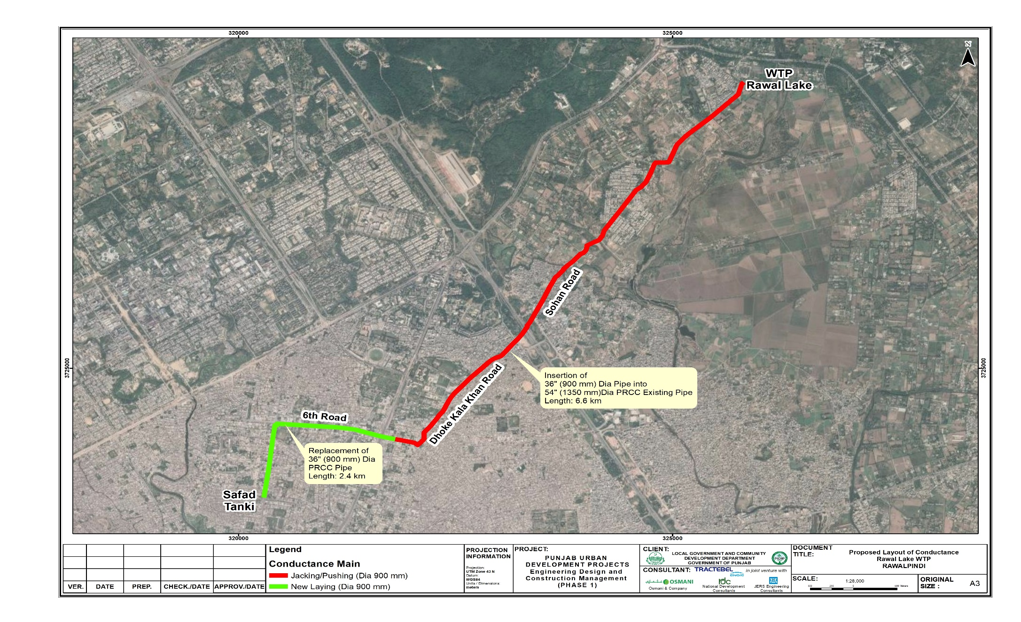

- In order to fulfill the water requirements of Rawalpindi, the RWASA is utilizing both underground as well as surface water sources. The water utilization from Rawal dam is 10 MGD, from Khanpur dam it is 6 MGD and from tube wells it is 35 MGD. Total water availability from different water sources to Rawalpindi city, excluding cantonment board is 51 MGD while the demand of water is 80 MGD. So, the current water deficit is 29 MGD, which will further increase in future. Since, water demand of Rawalpindi city is increasing day by day, there is need to tap more water. Five (5) MGD water may be tapped from Rawal filtration through replacement of existing conductance main which is currently abundant due to heavy leakages. Replacement will enhance the water supply from Rawal Lake Filtration Plant from 23 to 28 MGD. After replacement of existing conductance main, the water deficit will be decreased from 29 MGD to 24 MGD.
- Furthermore, in order to cater to the power requirements of the proposed project, a grid connected solar photovoltaic (PV) system of 0.6 MW capacity will be installed over 10 acres of land at the site of the Rawal lake water filtration plant and the power generated will be used for meeting the project needs. The site for installation of the solar PV panels is shown as Figure 2.2 below.
- This is the updated version of the original draft IEE report which was disclosed on the ADB web page in June 2023 (web page link: https://www.adb.org/projects/documents/pak-55236-001-iee-0). This updated version contains details and the assessment on the solarization component of the project and also provides additional information on the original scope of the IEE along with improving the readability of the IEE report.
- The project original scope along with the additional scope to incorporate the solar PV solarization is provided in the Table 2.1 below.
Table 2.1: Project Original and revised scope
Project Original Scope | Project Additional Scope
- Replacement of 36” (900mm) dia. PRCC pipe from Water Works (Sufaid Tanki) to 6th road satellite town with a length of 2.520 km.  - Insertion of 36” (900mm) dia. PRCC pipe into existing 54” line (1350 mm) dia. PRCC pipe from 6th road satellite town to Rawal Lake filtration plant with a length of 6.580 km. The project is designed with the information that at present (2022) two conductance mains exist to convey water from treatment plant to the city. | A grid connected solar photovoltaic (PV) system of 0.6 MW capacity will be installed over 10 acres of land at the site of the Rawal lake water filtration plant and the power generated will be used for meeting the project needs and any excess power is exported to the grid.

Project Need
- Rawalpindi is the capital city of the Rawalpindi division, and it is the fourth-largest city of Pakistan. The population estimate for 2022 is 2.32 million, and the projected population for 2050 is 5.82 million with growth rate of 2.02%. This population considers both Cantonment and MC area. Increase in population; water demand is also increasing for the city. Currently, the main water sources are groundwater (tubewells) and surface water sources (Rawal lake and Khanpur dam) in the city. 20. The city of Rawalpindi consists of the urban and peri-urban areas of Rawal Town and Potohar Town. The, below shows the existing MC boundary and the RDA boundary; covering the urban and the peri-urban areas and the Cantonment boundary.
- Rawalpindi city is currently facing major challenges of municipal administration. One of these issues is the uninterrupted supply of clean water. The situation is getting even worse due to depletion of underground water reservoirs.

Figure 2.2: Proposed solar PV installation at Rawal Lake Water Filtration Plant

Figure 2.3: Boundary Map of Rawalpindi City
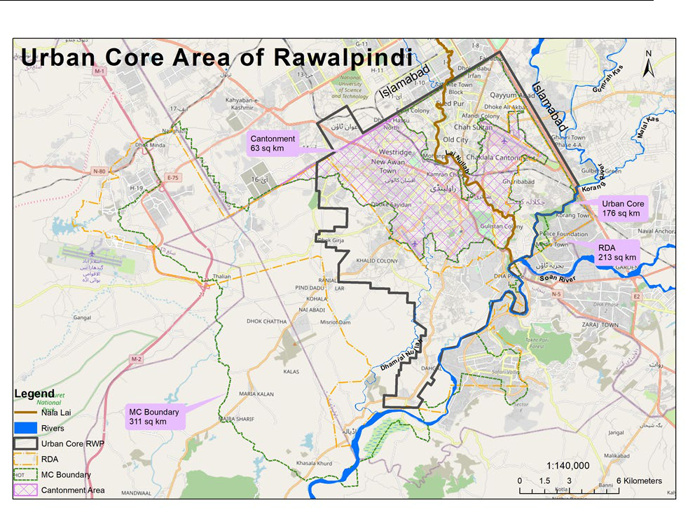

- The increase in population is also increasing the water demand and the supply and demand gap is increasing continuously. The water deficit was calculated for the year 2021 and project design life i.e. year 2040, keeping in view the per capita water demand of around 182 lpcd (40 gpcd). These design parameters of the Master Plan are shown in
Table 2.1: Design Parameters of Horizon 2016-2040
Parameters | Urban Areas | Peri-urban  Areas | Rural Areas
Target population 2040 | 1,778,796 | 580,959 | 243,994
Water demand 2040 (m³/d (MGD)) | 324,000 (71) | 106,000 (23) | 45,000 (10)
Production (2016, (m³/d (MGD)) | 272,000  (59.9) | 15,000 (3.3) | 0
NRW (2016) | 0.3 | - | -
Total water supply deficit (2040, (m³/d  (MGD) | 134,000 (29) | 91,000 (20) | 45,000 (10)
Total production (2016, (m³/d (MGD) | 287,000 (63)
Total deficit (2040, (m³/d (MGD) | 270,000 (59)
*Source: PDUP-EDCM Consultants
- Since the groundwater is depleting continuously, therefore, boring of new tube wells to meet the additional water requirements cannot be considered. However, augmentation of the surface water source to meet future water requirements can be considered a sustainable source of water.

Project Benefits
- The main benefits of this project include the following:
  - Replacement of old distribution lines to control leakages and mixing of water.
  - Efficient use of already available OHRs and GSTs in city.
  - Enhancement in supply of water supply to residents of Rawalpindi.
  - Shifting on surface water use to secure ground water resource. Surface water reservoir has sufficient water to cater this need.
  - Power generation from renewable energy using solar PV panels installed at the Rawal Lake Water Filtration plant site to meet the project’s energy needs and any excess power may be exported to the grid.

Environmental Safeguards Category of the Project
- According to ADB’s SPS 2009, a Rapid Environmental Assessment (REA) Checklist was prepared for the proposed project.
- A project is classified as "Category B" if its potential adverse environmental impacts on human populations or environmentally important areas, (e.g., wetlands, forests, grasslands, and other natural habitats) are less adverse than those of Category A projects. It was ascertained that certain adverse environmental impacts are not expected of significance that detailed assessment is required. Therefore, the project has been categorized under category B of ADB’s SPS 2009 and IEE has been conducted. The REA checklist has been attached as Annexure-I.
- Furthermore, as per legal requirement under Section 12 of Punjab Environmental Protection Act, 1997 (Amendment 2012), this project requires Environmental Approval from the Punjab EPA. As a part of the Conductance Main is passing through the federal territory of Islamabad, this project also requires Environmental Approval from Pak EPA under Section 12 of Pakistan Environmental Protection Act, 1997. As per clause F, Schedule-II of Pakistan Environmental Protection Agency (Review of IEE and EIA) Regulations 2000 of the Acts ibid, the proposed project falls in the category of projects requiring Environmental Impact Assessment (EIA) on the basis of project cost.

Scope and Objectives of the IEE
- The scope of the IEE study will include environmental assessment of project activities including design, construction and operation of the proposed project activities i.e. replacement of Existing Conductance Main from Rawal Lake to Water Works (approximately 9.1 km) and installation of grid connected solar PV panels for generation of 0.6 MW of energy at the Rawal lake water filtration plant site. The objectives of the IEE study are as follows:
  - Assess the existing environmental conditions of project area, including the identification of environmental sensitive receptors and develop a baseline of its prevalent environmental and socioeconomic conditions;
  - Identify and investigate all impacts of the proposed project during pre-construction/design, construction, operation phases, on the physical, biological and socioeconomic environment of the project area;
  - To proposed mitigation measures that would help the execution agency RWASA in conducting the proposed project activities in an environmentally sustainable manner;
  - To uncover the planning and operational phase impacts up to microenvironment levels in which project is proposed to be sited; and
  - To develop an Environmental Management Plan (EMP) that would assist execution agency, RWASA in the effective implementation of the recommendations of the IEE.

Methodology of IEE Study
- The various steps undertaken in the preparation of the IEE are summarized below:

Understanding of the Proposed Operation
- This involves collecting of information from the ADB, PMU PICIIP, CIU and RWASA, design of Osmani & Company Limited (OCL) and Engineering Design and Construction Management (EDCM) technical team on the proposed project activities and understanding the activities to identify potential impacts of implementing these designs.

Review of Legislation and Guidelines
- National legislation, international agreements, environmental guidelines both of Punjab Environment Protection Authority (Punjab EPA), and ADB, and best industry practices has been reviewed to set environmental standards that RWASA, being project implementation agency will adhere during implementation of the project.

Secondary Data Collection
- Available published and unpublished information pertaining to the background environment has been obtained and reviewed. All data sources have been carefully reviewed to collect the following information.
  - Physical Environment: Topography, Geology, Seismology, Geomorphology, Soils, Surface and Groundwater Resources and Climate;
  - Biological Environment: Habitat types, Flora and Fauna (particularly rare or endangered species), Critical Habitats, Vegetation and Communities within the area;
  - Physical Cultural Resources: Sites, Structures, Groups of Structures, and Natural Features and Landscapes that have Archaeological, Paleontological, Historical, Architectural, Religious, Aesthetic, or other Cultural Significance; and,
  - Socio-economic Environment: Settlements, Socio-economic conditions, Infrastructure and Land use.

Field Data Collection (Baseline Survey)
- Field visits were undertaken consisting of preliminary scoping through survey and assessment activities to establish the potential impacts and categorization of activities and the Rapid Environmental Assessment (REA) was completed. The key environmental sensitive receptors and stakeholders within the project area were identified.
- Baseline surveys were conducted to by the multidisciplinary team of environmentalists, social expert and data enumerators to identify and establish environmental and social impacts of the project.

Public Consultation
- Public consultations (PC) were carried out with all key stakeholders, particularly local communities residing in the project area, local businesses and government and local government bodies in line with ADB’s “Safeguard Policy Statement (SPS) – June 2009”/ Environmental Assessment Guidelines.
- In regards to the solar PV installation for the project, a consultation session was conducted with city stakeholders on Environmental Assessment, under the chairmanship of Deputy Director (Development) Rawalpindi, dated 5th August 2023 at 2:00 pm in the Committee Room of Deputy Commissioner, Rawalpindi, for the project “Solarization for Sustainable & Resilient Water Supply System in RAWALPINDI “in which the consultant presented their observation as part of preparing the environmental assessment report.
- The Project Support Officer, City Implementation Unit (CIU) Rawalpindi gave a brief introduction of the Project and priority projects of Rawalpindi for the water sector under DREAMS – I then Engineering Design and Construction Management (EDCM) Consultant’s Environment expert presented the Environmental Assessment on the project.
- Also, in view of the densely populated urban setting in which the project works are to be conducted, it shall be ensured that extensive public engagement is conducted throughout the project implementation phase.

Impact Identification and Assessment
- Potential impacts arising from each phase of the proposed project has been identified and assessed on the basis of field data, secondary data, expert opinion and examining previous similar projects in Pakistan. These include effects on physical, biological and socio-economic environment.

Recommendations for Mitigation Measures
- Mitigation measures to minimize, eliminate or compensate the potential environmental impacts has been recommended. The mitigation measures have been recommended on the basis of past experiences, best industry practices, legislative requirements and professional judgment.

Development of Environmental Management Plan (EMP)
- An Environmental Management Plan (EMP) has been developed for effective implementation of the recommended mitigation measures. The EMP has included controls to minimize the identified impacts and monitoring program to monitor effect of mitigation measures implemented and residual impacts, if any, during implementation. The EMP has identified roles and responsibilities of all concerned parties during the implementation of the project.

Proponent of Project
- The Local Government & Community Development Department (LGCDD) is the proponent of proposed project and the project will be executed through Program Management Unit (PMU), RWASA. Detail of project proponent is given in Table 2.2.
Table 2.2: Executing Agency Contact Details
Executing Agency Details | Information
Name of EA | PMU, Punjab Intermediate Cities Improvement Investment Program (PICIIP), LGCDD, Government of Punjab
Address | Plot 41, Block B1, Gulberg III, MM Alam Road Lahore, Pakistan
Telephone | 042-99210013-4 / 042-99268484

Structure of the Report
- The IEE report contains the following chapters:
- Introduction - “Introduction” describes introduction, location of project, objective and purpose of the IEE report
- Policy, Legal Framework and Administrative Framework - “Environment Legislative Requirements and Framework” elucidates the current legal framework including national and funding agency’s guidelines which is applicable to the proposed project in the context of environment and sustainable development;
- Description of the Project - Project Description” furnishes an overall description of the project, including its background, features and key components, timeframe and cost, Alternatives;
- Analysis of Project Alternatives – discussed the available option and selection of best option based on specific criteria.
- Description of Environment - comprises a detailed narrative of the existing (baseline) conditions of the project area, with respect to its physical, biological and socio-economic environment;
- Potential Environmental Impacts and Mitigation Measures - elaborates the likely impacts of the project on the physical, biological and socio-economic environment during the construction and operation stages and lays down the proposed measures to mitigate the adverse impacts of the project;
- Environmental Management Plan and Institutional Requirements - provides the mechanism to be adopted for the implementation of measures and monitoring the environment during all stages
- Public Consultation, and Information Disclosure - provides summary of consultative sessions with the local community as well as with other stakeholders including local government officials for their opinions and suggestions on the project;
- Grievance Redressal Mechanism – Mechanism for complaint management has been described under this chapter.
- Conclusion and Recommendations - gives the conclusion of the impact assessment study and recommendations for the construction and operational stages

IEE Team
- The IEE team comprised of the members as provided in Table 2.3 below.
Table 2.3: Details of IEE Team
Members | Status in Project
ADB/PMU Team
Mr. Saad Malik | ADB’s Environmental Consultant
Mr. Aziz Karim | Individual Consultant (Environmental Consultant)
Mr. Waqas Afzal | Deputy Director (Social & Environmental Safeguards)
Syed Osama Faheem Rizvi | Assistant Director M&E, PMU
Ms. Shahnaz Kousar Khan | Assistant Director (Monitoring & Evaluation), PRF
EDCM Team
Mr. Kevin Holroyd | Team Leader –EDCM
Mr. Farooq Khatak | Deputy Team Leader –EDCM
Asad Yaqoob | GIS Mapping Expert
Mr. Muhammad Mujahid | Project In charge -Environment Component
Dr. Nadeem | Ecological Expert
Ms. Rabia Rafiq | Environmentalist (IEE / EIA specialist)
Mr. Babar Ali | Environmentalist (IEE / EIA specialist)
Mr. Sami Ullah | Social Expert (Env. Team)
Mis. Komal Aroosh | Jr. Social Expert (Female Enumerator)
Ms. Shagufta Tahir | Female Enumerator

Further Additions & Updating of IEE Study
- This version of the report will be further updated if required on the basis of changes in the detailed design and alignment of Conductance Main. These revisions shall be incorporated into any subsequent updated versions of this IEE report. The updated IEE will be submitted for ADB review and approval and posted on the ADB and PMU / Project websites for information disclosure. IEE/EMP will be disclosed locally at the PMU PICIIP website at least two weeks prior to the next consultation to allow the public time to read, look for information or consult experts, and form opinions.

POLICY, LEGAL AND ADMINISTRATIVE FRAMEWORK

General
- This chapter provides an overview of the policy framework and legislation that applies to control the environmental consequences as a result of implementation and operation of project "Replacement of Existing Conductance Main (ECM) from Rawal Lake Filtration Plant to Water Works (Sufaid Tanki) Rawalpindi". The project needs to comply with all the applicable environmental policies, laws, guidelines, acts and legislations of Government of Pakistan and the provincial government as well as International Environmental Guidelines.

National Policy and Legal Framework
- The Pakistan National Conservation Strategy (NCS) that was approved by the federal cabinet in March 1992 is the principal policy document on environmental issues in the country (EUAD/IUCN, 1992). The NCS outlines the country's primary approach towards encouraging sustainable development, conserving natural resources, and improving efficiency in the use and management of resources. The NCS has 68 specific programs in 14 core areas in which policy intervention is considered crucial for the preservation of Pakistan's natural and physical environment. The core areas that are relevant in the context of the proposed project development are ground water depletion, provision of sustainable potable water to citizens while conserving biodiversity.
- Prior to the adoption of the 18th Constitutional Amendment, the Pakistan Environmental Protection Act (PEPA) 1997 was the governing law for environmental conservation in the country. Under PEPA 1997, the Pakistan Environmental Protection Council (PEPC) and Pak EPA were primarily responsible for administering PEPA 1997. Post the adoption of the 18th Constitutional Amendment in 2011, the subject of environment was devolved, and the provinces have been empowered for environmental protection and conservation.

Regulations for Environmental Assessment, Pakistan EPA
- Under Section 12 (and subsequent amendment) of the PEPA (1997), a project falling under any category specified in Schedule I of the IEE/EIA Regulations (SRO 339 (I0/2000), requires the proponent of the project to file an IEE with the concerned provincial EPA. Projects falling under any category specified in Schedule II require the proponent to file an EIA with the provincial agency, which is responsible for its review and accordance of approval or request any additional information deemed necessary.

Regulatory Clearances, Punjab EPA and Pak EPA
- In accordance with provincial regulatory requirements, an IEE/EIA report satisfying the requirements of the Punjab Environmental Protection Act, 1997 (Amendment 2012) and Pakistan Environmental Protection Act, 1997 are to be submitted to Punjab Environmental Protection Agency (Punjab EPA) and Pakistan Environmental Protection Agency, Islamabad (Pak-EPA) for review and approval, and subsequent issuance of Environmental Approval (EA) before the commencement of construction.

Guidelines for Environmental Assessment, Pakistan EPA
- The Pak-EPA has published a set of environmental guidelines for conducting environmental assessments and the environmental management of different types of development projects. The guidelines that are relevant to the proposed project are listed below:
  - Guidelines for the Preparation and Review of Environmental Reports, Pakistan, EPA1997;
  - Guidelines for Public Consultations; Pakistan EPA May 1997;

Pakistan / Punjab Environmental Quality Standards (NEQS) 2000 & 2010
- The Punjab Environmental Quality Standards (PEQS), 2000 & 2010, specify the following standards:
  - Maximum allowable concentration of pollutants (32 parameters) in municipal and liquid industrial effluents discharged to inland waters, sewage treatment facilities, and the sea (three separate sets of numbers);
  - Maximum allowable concentration of pollutants (16 parameters) in gaseous emissions from industrial sources;
  - Maximum allowable concentration of pollutants (two parameters) in gaseous emissions from vehicle exhaust and noise emission from vehicles;
  - Maximum allowable noise levels from vehicles;
  - Maximum allowable concentration of parameters in drinking water.

Other Environment Related Legislations
- The national and international laws and regulations are provided in Table 3.1 and Table 3.2 below.
Table 3.1: Main Strategies/Policies Related to Environment and Relevance to the Project
Policy/Strategy | Brief Coverage | Relevance to Project
National Conservation Strategy, 1992 | Pakistan National Conservation Strategy (NCS), which was approved by the federal cabinet in March 1992, is the principal policy document on environmental issues in the Country. The NCS outlines the Country’s primary approach towards encouraging sustainable development, conserving natural resources and improving efficiency in the use and management of resources. The NCS has 68 specific programs in 14 core areas in which policy intervention is considered crucial for the preservation of Pakistan’s natural and physical environment. | The core areas that are relevant in the context of the proposed project are pollution prevention during construction and conserving biodiversity and forestry.
National Environmental Policy, 2005 | In March 2005, Government of Pakistan (GoP) launched its National Environmental Policy, which provides a framework for addressing the environmental issues. Section 5 of the policy commits for integration of environment into development planning as instrument for achieving the objectives of National Environmental Policy. It also provides broad guidelines to the Federal Government, Provincial Governments, Federally Administered Territories and Local Governments to address their environmental concerns and to ensure effective management of their environmental resources. | Clause (b) of sub-section 5.1 states that Environmental Protection Act, 1997, will be diligently enforced for all developmental projects.
National Forest Policy, 2001 | The goal of this policy is to foster the sustainable development of Renewable Natural Resources (RNR) in Pakistan, through maintenance and rehabilitation of these essential resources and enhancement of sustainable livelihoods of rural masses, particularly women, children and other deserving groups.  The various components of the policy include:  - Reducing poverty, powerlessness and unemployment;  - Population planning in critical ecosystems;  - Reducing the impact of socio-economic factors;  - Providing substitutes to firewood in the mountain-woods;  - Reducing political interferences in Forestry and Wildlife Departments;  - Renovating and invigorating the institutions of RNR;  - Supporting Local Governments in the sustainable development of their RNR;  - Policies for fragile ecosystems;  - Riverside forests;  - Irrigated plantations;  - Preservation of sensitive and unique forests;  - Wildlife conservation;  - Rangelands and desert ecosystems; and  - Planting trees and fodder on farmlands. | The proposed project does not pass through a Reserve Forest or other notified areas. However, other relevant components like wildlife conservation, planting trees will be applicable.
Pakistan Labour Policy, 2010 | The main objective of the Labour Policy, 2010 is the social and economic well-being of the labour of Pakistan. The Labour Policy, 2010 has following 4 parts:  - Legal Framework;  - Advocacy: rights of workers and employers;  - Skill development and employment; and  - Manpower export. | The labour will be employed for construction and operation of the proposed project. The provision of policy will apply to all the labour employed.
National Climate Change Policy, 2012 | The National Climate Change Policy provides a framework for addressing the issues that Pakistan faces or will face in future due to the changing climate. In view of Pakistan’s high vulnerability to the adverse impacts of climate change, in particular extreme events, adaptation effort is the focus of this policy document. The vulnerabilities of various sectors to climate change have been highlighted and appropriate adaptation measures spelled out.  The policy cover measures to address issues in various sectors such as water, agriculture, forestry, coastal areas, biodiversity and other vulnerable ecosystems.  Notwithstanding the fact that Pakistan’s contribution to global Greenhouse Gas (GHG) emissions is very small, its role as a responsible member of the global community in combating climate change has been highlighted by giving due importance to mitigation efforts in sectors such as energy, forestry, agriculture and livestock.  Furthermore, appropriate measures relating to disaster preparedness, capacity building, institutional strengthening; technology transfer; introduction of the climate change issue in higher education curricula; ensuring environmental compliance through Initial Environmental Examinations (IEE) and Environmental Impact Assessments (EIA) in the development process; addressing the issue of deforestation and illegal trade in timber; promoting Clean Development Mechanisms (CDM); and raising Pakistan’s stance regarding climate change at various international forums, have also been incorporated as important components of the policy.  The policy thus provides a comprehensive framework for the development of Action Plans for national efforts on adaptation and mitigation. | This policy document is a ‘living’ document and will be reviewed and updated regularly to address emerging concepts and issues in the ever-evolving science of climate change.  This policy will accelerate due to the emissions from the construction machinery.
National Water Policy 2018 | This first ever water policy was unanimously approved in April 2018 by Council of Common Interest (CCI). The Policy aims at efficient management and conservation of existing water resources, optimal development of potential water resources, steps to minimize time and cost overruns in completion of water sector projects, equitable water distribution in various areas and canal commands, measures to reverse rapidly declining groundwater levels in low-recharge areas, increased groundwater exploitation in high-recharge areas, effective drainage interventions to maximize crop production, improved flood control and protective measures, steps to ensure acceptable and safe quality of water, minimization of salt build-up and other environmental hazards in irrigated areas, institutional reforms to make the managing organizations more dynamic and responsive.  The policy covered all water related issues, including water uses, allocation of priorities, integrated planning for development, use of water resources, environmental integrity of the basin, impact of climate change, trans boundary water sharing, irrigated and rain fed agriculture, drinking water and sanitation, hydropower and industry, groundwater, water rights & sustainable water infrastructure, water related hazards, quality management, awareness, conservation, legal and capacity building of infrastructure. | The proposed project will comply with these standards.
National Drinking Water Policy, 2009 | The National Drinking Water Policy provides a framework for addressing the key issues and challenges facing Pakistan in the provision of safe drinking water to the people. Drinking water is the constitutional responsibility of the provincial governments and the specific provision function has been devolved to specially created agencies in cities and Town and Tehsil Municipal Administrations under the Local Government Ordinance 2001. | This policy will be applicable as the proposed Project is about the provision of drinking water residents of the Rawalpindi.

Table 3.2: Main Legislation/Acts Related to Environment and Their Relevance to the Project
Act | Brief Coverage | Relevance to Project
Punjab Environmental Protection 1997 (Amended) Act, 2012 | The Punjab Environmental Protection Act, 1997 (Amended, 2017) is comprehensive legislation and provides the legislative framework for protection, conservation, rehabilitation and improvement of the environment. The ‘environment’ has been defined in the Act as: (a) air, water and land; (b) all layers of the atmosphere; (c) all organic and inorganic matter and living organisms; (d) the ecosystem and ecological relationships; (e) buildings, structures, roads, facilities and works; (f) all social and economic conditions affecting community life; and (g) the interrelationships between any of the factors specified in sub-clauses ‘a’ to ‘f’.  The notable points of the law are:  - No proponent of a project shall commence construction or operation unless he has filed an EIA / IEE with the Provincial Agency designated by the Provincial EPAs an EIA / IEE, and has obtained an approval;  - Establishment and formation of the Punjab Environmental Protection Council (PEPC);  - Prohibition of certain discharges or emissions;  - Punjab Environmental Quality Standards (PEQS) for wastewater, air emissions and noise; and  - Provincial Government can issue notices and enforce them to protect the environment.  In the amendment of 2012, legislatives powers related to environment and ecology are given to provincial governments from the Federal government. The provinces are required to enact their own legislation for environmental protection. Other amendments include increasing the penalties for violations.  For the proposed Project, Environmental Protection Department (EPD)/Environmental Protection Agency (EPA), Government of Punjab (GoPb) is the concerned authority. The capability of regulatory institutions for environmental management is ultimately responsible for the success of environmental assessments and that development projects are environmentally sound and sustainable. | The provision of the act is applicable to proposed Project for conducting an IEE/EIA according to section 12 and to obtain environmental approval from the Punjab EPA.  The section 11 of the act is applicable in term of compliance with Punjab Environmental Quality Standards (PEQS). Similarly, section 13 of the act prohibits the import of hazardous waste.  The provisions of section 16 are also applicable to comply with the discharge or emission of any effluent, waste, air pollutant or noise or disposal of waste or handling of hazardous substance. Under section 17, penalties will apply if anyone fails to comply with the provisions of section 11, 12, 13 and 16.
Pakistan Environmental Protection Agency, (Review of IEE and EIA) Regulations, 2000 | These regulations set out:  - Key policy and procedural requirements for filing an EIA / IEE;  - The purpose of environmental assessment;  - The goals of sustainable development;  - The requirement that environmental assessment be integrated with feasibility studies;  - The jurisdiction of the Federal and Provincial EPA’s and Planning &Development (P&D) Departments;  - The responsibilities of proponents;  - Duties of responsible authorities;  - Provides schedules of proposals that the project requires either IEE or an EIA;  - The environmental screening process of the projects under schedule I, II and III; and  - The procedure for the environmental approval for filing the case with the concerned EPA for the granting of the NOC. | The proposed project falls under the Category ‘G’ of “Water Supply and Treatment” of the Schedule I. This category requires an IEE study to be conducted to initiate the process of environmental approval by the Punjab EPA.
Punjab Environmental Quality Standards (PEQS), 2016 | PEQS promulgated recently in 2016. Specified standards under PEQS are for:  - Drinking Water;  - Ambient Air;  - Noise;  - Industrial Gaseous Emissions;  - Municipal and Liquid Industrial Effluents;  - Motor vehicle exhaust and noise; and  - Treatment of Liquid and Bio-Medical Waste. | All projects to be implemented in Punjab must conform to PEQS during all the phases i.e. construction and operation.
Guidelines for the Preparation and Review of Environmental Reports, 1997 | These guidelines describe the format and content of IEE/EIA reports to be submitted to PEPA for obtaining NOC/approval.  The guidelines present:  - The environmental assessment report format;  - Assessing impacts;  - Mitigation and impact management and preparing an environmental management plan;  - Reporting;  - Review and decision making;  - Monitoring and auditing; and  - Project Management. | The guidelines are applicable for the preparation of the IEE Report.
Guidelines for Environmental Assessment | Pak-EPA has published a set of environmental guidelines for conducting environmental assessments and the environmental management of different types of development Projects. The guidelines that are relevant to the proposed Project are listed below.  - Guidelines for the Preparation and Review of Environmental Reports, Pakistan Environmental Protection Agency, 1997;  - Guidelines for Public Consultation, Pakistan Environmental Protection Agency, May, 1997; and  - Sectoral Guidelines: Pakistan Environmental Assessment Procedures, Pakistan Environmental Protection Agency, October 1997. | The guidelines are applicable for the preparation of the IEE Report.
Punjab Plantation and Maintenance of Trees Act, 1974 | The Punjab Plantation and Maintenance of Trees Act, (1974) regulates tree plantations and enforces measures for their protection. | The requirements of this act are applicable in terms of planting new trees and their maintenance by the occupier of the existing land who would have the physical possession.
Pakistan Antiquities Act 1975 & Punjab Antiquities Amendment Act 2012 | The Punjab Antiquities Amendment Act, 2012 is adopted from the Pakistan Antiquities Act of 1975 with a few minor changes. The Antiquities Act, 1975 (amended in 1990) states the following:  - “Ancient” is any object that is at least 75 years old;  - All accidental discoveries of artefacts must be reported to the Federal Department of Archaeology;  - The Government is the owner of all buried antiquities discovered on any site, whether protected or otherwise;  - All new construction within a distance of 200 feet from protected antiquities is forbidden;  - No changes or repairs can be made to a protected monument, even if it is owned privately, without approval of the responsible authorities; and  - The cultural heritage laws of Pakistan are uniformly applicable to all categories of sites regardless of their state of preservation and classification as monuments of national or world heritage. | The law will be applicable to the project mainly due to its two provisions:  - According to the law, any construction activity within 61 m or 200 ft. of protected antiquities, are prohibited.  The provisions of this act would also be applicable, if any accidental archaeological discoveries may occur during the excavation works for the construction of proposed Project.
Pakistan Penal Code, 1860 | The Code deals with the offences where public or private property or human lives are affected due to intentional or accidental misconduct of an individual or organization. The Code also addresses control of noise, noxious emissions and disposal of effluents. | The provisions of the Penal Code, 1860 are applicable to the project in terms of penalties for effecting human lives and public property. It also addresses the control of noise, air emissions and effluent disposal.
The Protection against Harassment of Women at the Workplace Act, 2010 | The Protection Against Harassment of Women at the Workplace Act (2010) refers to sexual harassment at the workplace. | This Act will be applicable to the project if women are employed for the construction of the proposed Project.
Labour Laws as part of Constitution of Pakistan 1973, | The Constitution of Pakistan contains a range of provisions with regards to labour rights, in particular:  - Article 11 of the Constitution prohibits all forms of slavery, forced labour and child labour;  - Article 17 provides a fundamental right to exercise the freedom of association and the right to form unions;  - Article 25 lays down the right to equality before the law and prohibition of discrimination on the grounds of sex alone; and  - Article 37(e) makes provision for securing just and human conditions of work, ensuring that children and women are not employed in vocations unsuited to their age or sex, and for maternity benefits for women in employment.  Labour law is controlled at both provincial and national levels with compulsory employment agreements containing the terms set out by the labour laws. The labour laws are a comprehensive set of laws in Pakistan dealing with the following aspects:  - Contract of Employment;  - Termination of Contract;  - Working Time and Rest Time;  - Working hours;  - Paid Leave;  - Maternity Leave and Maternity Protection;  - Other Leave Entitlements;  - Minimum Age and Protection of Young Workers;  - Equality  - Pay Issues;  - Workers' Representation in the Enterprise;  - Trade Union and Employers Association Regulation; and  - Other Laws. | The labour laws will be relevant as it would deal with employment of labour for the construction of propose project.  Following are the major labour laws which are applicable to the project:  - Bonded Labour System (Abolition) Act, 1992  - Employment of Child Act, 1991  - Minimum Wages Ordinance, 1961  - Industrial Relations Act, 2010  - West Pakistan Minimum Wages for Unskilled Workers’ Ordinance, 1969
Employment of Children Act, 1991 | Article 11(3) of the Constitution of Pakistan prohibits employment of children below the age of 14 years in any construction, or any other hazardous employment.  In accordance with this Article, the Employment of Child Act 1991 prohibits child labour (a child is under 14 years old). | The relevance of this act to the project will be to prohibit child employment for construction of the proposed project.
Pakistan Climate Change Act, 2017 | This Act aims to meet obligations under international conventions relating to climate change and to provide for adoption of comprehensive adaptation and mitigation policies, plans, programmes, projects and other measures required to address the effects of climate change and for matters connected herewith and ancillary thereto. | This Act will accelerate due to the emissions from the construction machinery.
National Clean Air Act, 2000 | The Act aims to control vehicular emissions, pollution from industry, and indoor air pollution in rural and urban areas. | This Act will trigger if vehicles and machinery used for construction activities emanate air pollutants above the permissible limit.
Seismic Building Code of Pakistan 2007 | This code stipulates the minimum requirements for seismic safety of building and structures and the provisions of the Building Code of Pakistan (Seismic Provisions-2007) shall apply for engineering design of buildings, like structures and related components.  Construction of buildings shall be considered as violation of professional engineering work specified under clause (XXV) of section 2 of the Act. | This Code is applicable to the proposed project as it includes the formation of structures.
The Parks and Horticulture Authority Act, 2012 | This act entails regulation, development, and maintenance of public parks, green belts and green areas in the Punjab; regulation of billboards, sky signs and outdoor advertisements; to promote open and unrestricted views of the Punjab. | This act will be applicable if any green belt will be involved.
Punjab Municipal Water Act, 2014 | The basic aim of the Act is to recognize, regulate and manage present and future municipal water supply and sanitation services and to establish rights of access to basic water supply and basic sanitation, and to ensure conservation of water resources in the province. This Act is in draft stage. | This Act will elicit if there is misappropriation of water supply during construction activities.
Punjab Environmental Protection (Motor Vehicles) Rules, 2013 | Subject to the provisions of this act, and the rules and regulations, no person shall operate a motor vehicle from which air pollutants and noise are being emitted in an amount, concentration or level which is in excess of the Punjab Environmental Quality Standards, or where applicable the standards established under clause (g) of subsection (1) of section 6 of the act. | This act will be elicited during construction and operational phase due to use of motor vehicles that produces air pollutants and noise.
The Punjab Occupational Safety and Health Act, 2019 | This Act entails provision of occupational safety and health of the workers at workplace and to protect them against risks arising out of the occupational hazards; to promote safe and healthy working environment catering to the physiological and psychological needs of the employees at workplace. | The Act will trigger during construction and operational phase to ensure health and safety of workers at workplace associated with the project activities.
Electricity Act, 1910 | The Act provides a legal basis for distribution of Power. It enables a licensee to conduct operations for supply of electricity and binds the license to payment of compensation in respect of any damages caused during the construction, Operation and Maintenance (O&M) of Power distribution facilities. | This act will be applicable if any damages occur during construction of the power facilities.
Cutting of Trees (Prohibition) Act, 1975 | The Act was enforced in 1975 to place restrictions on cutting of trees in order to restrain unchecked trend of tree felling without replacement plantations. | This act will be applicable to the subject project where the cutting of tree will be involved.
National Disaster Management Act, 2010 | National Disaster Management Act, 2010 was passed by Parliament of Pakistan in 2010. The Act applies to whole Pakistan. The Act was passed in backdrop of 2010 Floods in Pakistan and strengthens Disaster Management system. | This act is applicable to the proposed project. The proposed project will require special consideration to disasters and risk management strategies as per the Act.
Hazardous Substance Rule, 2003 | The rule describes the procedure of handling, transportation and disposal of hazardous substances and hazardous waste. Inter alia, general safety precautions for handling hazardous substances as well as safety precautions for workers, and notification requirements in the event of an accident are described in these rules. Requirements for project waste management plans are also defined. These include a requirement for updating the plan every three years, the need to provide for management of hazardous waste in a manner that will prevent adverse environmental impacts and to ensure that hazardous and non-hazardous waste are not mixed. | This rule is applicable to the proposed project due to involvement of hazardous waste handling, use and disposal during the construction and operational stages.

ADB’s Safeguard Policy Statement (SPS), 2009
- The ADB’s SPS 2009 requires that environmental considerations be incorporated into ADB funded projects to ensure that the project will have minimal environmental impacts and be environmentally sound. As stated in the SPS, the project must protect the health and safety of both the local residents and the project workers. A Grievance Redress Mechanism (GRM) to receive applications and facilitate resolution of affected peoples’ concerns, complaints, and grievances about the project’s environmental performance is also established.
- All loans and investments are subject to categorization to determine environmental assessment requirements. Categorization is to be undertaken using Rapid Environmental Assessment (REA) checklists, consisting of questions relating to (i) the sensitivity and vulnerability of environmental resources in project area, and (ii) the potential for the project to cause significant adverse environmental impacts. Projects are classified into one of the following environmental categories:
- Category A: A proposed project is classified as category A if it is likely to have significant adverse environmental impacts that are irreversible, diverse or unprecedented. These impacts may affect an area larger than the sites or facilities subject to physical works. An environmental impact assessment (EIA) is required.
- Category B: A proposed project is classified as category B if its potential adverse environmental impacts are less adverse than those of category A projects. These impacts are site-specific, few if any of them are irreversible, and in most cases mitigation measures can be designed more readily than for category A projects. An initial environmental examination (IEE) is required. The project “Replacement of Existing Conductance Main project” falls in Category B. ADB requirements as stated in ADB SPS (2009) are that the IEE should at least include:
- ADB SPS 2009 also guide that the borrower/client will assess the significance of project impacts and risks on biodiversity and natural resources as an integral part of the environmental assessment process
- Category C: A proposed project is classified as category C if it is likely to have minimal or no adverse environmental impacts. No environmental assessment is required although environmental implications need to be reviewed.
- Category FI: A proposed project is classified as category FI if it involves investment of ADB funds to or through a financial intermediary (FI).

ADB’s Access to Information Policy (AIP) 2018
- ADB’s Access to Information Policy (AIP), reflects the ADB’s ongoing commitment to transparency, accountability, and participation by stakeholders. The policy contains principles and exceptions to information sharing with external stakeholders, led by a new overarching principle of “clear, timely, and appropriate disclosure.

ADB’s Accountability Mechanism Policy 2012
- The objectives of the Accountability Mechanism are providing an independent and effective forum for people adversely affected by ADB-assisted projects to voice their concerns and seek solutions to their problems, and to request compliance review of the alleged noncompliance by ADB with its operational policies and procedures that may have caused, or is likely to cause, them direct and material harm. The Accountability Mechanism is a “last resort” mechanism.

ADB’s Policy on Gender and Development
- ADB’s Policy on Gender and Development will adopt mainstreaming as a key strategy for promoting gender equity. Gender considerations will be mainstreamed into all ADB activities, including macroeconomic and sector work, and lending and technical assistance (TA) operations. The key elements of ADB’s policy will include gender sensitivity, gender analysis, gender planning, mainstreaming, and agenda setting.

Implications of ADB’s safeguard policies on proposed project
- The objectives of ADB’s safeguards are to:
  - Avoid adverse impacts of projects on the environment and affected people, where possible;
  - minimize, mitigate, and/or compensate for adverse project impacts on the environment and affected people when avoidance is not possible; and
  - Help borrowers/clients to strengthen their safeguard systems.
  - ADB’s SPS sets out the policy objectives, scope and triggers, and principles for three key safeguard areas:
  - environmental safeguards,
  - involuntary resettlement safeguards, and
  - Indigenous Peoples safeguards.
- The objective of the environmental safeguards is to ensure the environmental soundness and sustainability of projects and to support the integration of environmental considerations into the project decision-making process. ADB’s policy principles are summarized in below.
Table 3.3: ADB Policy Principles
No. | Policy principle | Summary
1 | Screening and categorization | Screening process initiated early to determine the appropriate extent and type of environmental assessment.
2 | Environmental assessment | Conduct an environmental assessment to identify potential impacts and risks in the context of the project’s area of influence.
3 | Alternatives | Examine alternatives to the project’s location, design, technology, and components and their potential environmental and social impacts, including no project alternative.
4 | Impact mitigation | Avoid, and where avoidance is not possible, minimize, mitigate, and/or offset adverse impacts and enhance positive impacts. Prepare an environmental management plan (EMP).
5 | Public consultations | Carry out meaningful consultation with affected people and facilitate their informed participation. Involve stakeholders early in the project preparation process and ensure that their views and concerns are made known to and understood by decision makers and taken into account. Continue consultations with stakeholders throughout project implementation. Establish a grievance redress mechanism.
6 | Disclosure of environmental assessment | Disclose a draft environmental assessment in a timely manner, in an accessible place and in a form and language(s) understandable to stakeholders. Disclose the final environmental assessment to stakeholders.
7 | Environmental management plan | Implement the EMP and monitor its effectiveness. Document monitoring results and disclose monitoring reports.
8 | Biodiversity | Do not implement project activities in areas of critical habitats.
9 | Pollution prevention | Apply pollution prevention and control technologies and practices consistent with international good practices. Adopt cleaner production processes and good energy efficiency practices. Avoid pollution, or, when avoidance is not possible, minimize or control the intensity or load of pollutant emissions and discharges. Avoid the use of hazardous materials subject to international bans or phase outs.
10 | Occupational health and safety/Community safety. | Provide workers with safe and healthy working conditions and prevent accidents, injuries, and disease. Establish preventive and emergency preparedness and response measures to avoid, and where avoidance is not possible, to minimize, adverse impacts and risks to the health and safety of local communities.
11 | Physical cultural resources | Conserve physical cultural resources and avoid destroying or damaging them. Provide for the use of “chance find” procedures.

IFC Environmental, Health and Safety Guidelines for Water and Sanitation
- The IFC EHS Guidelines for Water and Sanitation include information relevant to the operation and maintenance of (i) potable water treatment and distribution systems, and (ii) collection of sewage in centralized systems (such as piped sewer collection networks) or decentralized systems (such as septic tanks subsequently serviced by pump trucks) and treatment of collected sewage at centralized facilities.
- Environmental issues associated with water and sanitation projects may principally occur during the construction and operational phases, depending on project-specific characteristics and components.
- Guidelines are related to following impacts associated with Drinking water supply and treatment are as follows:
- Water Withdrawal
- Water Treatment
- Solid waste
- Wastewater
- Hazardous chemicals
- Air emissions
- Ecological impact
- Water Distribution
- Water system leaks and loss of pressure
- Water discharges

Comparison of International and Local Environmental Legislations
- The ADB SPS, 2009 requires application of pollution prevention and control technologies and practices consistent with international good practice, as reflected in internationally recognized standards. The SPS states that when host country regulations differ from these standards, the EA will achieve whichever is more stringent.
- In order to select the most stringent standards applicable, a mix of local (NEQS) and international (IFC) regulations have been selected. The IFC Environmental, Health, and Safety (EHS) Guidelines, General EHS Guidelines and Environmental standards are also applicable. It shall be ensured that all necessary noise mitigation measures are implemented to minimize the noise levels in the project area.
- The presents IFC workplace noise standards that are applicable to the construction workers. It should also be noted that IFC EHS guidelines advise that where existing ambient noise levels already exceed thresholds, the project should not result in an increase of more than 3 dB over existing ambient noise levels at the nearest receptor location off-site.
- A comparison of applicable local and international guidelines for ambient air quality has been provided in table below. In the case of most pollutants, the Pak NEQS standards for ambient air quality are more stringent in comparison to USEPA and WHO/IFC standards. The applicable and most stringent parameters for each respective pollutant are highlighted in green.
- Similar to the standards for air quality, the comparison of noise standards provided in below Table clearly shows that the Pakistan NEQS standards for noise are more stringent in comparison to the IFC standards. The only exception is the daytime noise level standard for Industrial areas where the IFC standard is more stringent (70 dB (A)) in comparison to NEQS (75 dB (A)) and so for this particular parameter, the IFC standard will be used. Apart from this one exception, the NEQS standards have been used for water quality of development project.
- Comparison of International and Local Water Quality Standards has been provided in below Table Standard for Bacterial contamination are same for both NEQS and IFC/WHO standard while physical parameters are different. NEQS for odor, turbidity, hardness and pH are more stringent while IFC/WHO standards are stringent in metallic contaminations i.e., Arsenic, Barium, Boron, Cadmium and Zinc.
- As far as regulations regarding other environmental parameters are concerned such as acceptable effluent disposal parameters, the local regulations i.e., NEQS take precedence over any other international regulations such as IFC.
Table 3.4: IFC Work Environment Noise limits11.2:
Type of Work, Workplace | IFC General EHS Guidelines
Heavy Industry (no demand for oral communication) | 85 Equivalent level Leq,8hrs
Light industry (decreasing demand for oral communication) | 50-65 Equivalent level Leq,8hrs

Table 3.5: Comparison of International and local Air Quality Standards*1.3
Pollutants | WHO/IFC |  | Pak. NEQS / PEQS
 | Avg. Time | Standard | Avg. Time | Standard
SO2 | 24 hr. | 40 µg/m3 | 24 hrs. | 120 up/m3
CO | 24 hrs. | 4 mg/m³ | 8 hrs. | 5 mg/m3
NO2 | 1 yr.  24 hrs. | 10 µg/m³  25 µg/m³ | Annual Mean  24 hrs. | 40 up/m3  80 up/m3
O3 | 8 hrs. | 100 µg/m³ | 1 hr. | 130 µg/m3
TSP | - | - | Annual Mean  24 hrs. | 360 up/m3  500 up/m3
PM10 | 1 yr.  24 hr. | 15 µg/m3  45 µg/m3 | Annual Mean  24 hrs. | 120 up/m3  150 up/m3
PM2.5 | 1 yr.  24 hr. | 5 µg/m3  15 up/m3 | Annual Average  24 hrs.  1 hr. | 15 up/m3  35 up/m3  15 up/m3
*: The standards highlighted in green for each respective pollutant are the most stringent based on a comparison between local and international regulations and thus shall be applicable for the proposed project.
* In instances where the air shed is significantly degraded and the pollutant levels are already exceeding the ambient pollutant concentrations provided in the table above, it shall be ensured that the project activities cause as small an increase in pollution levels as feasible, and amounts to a fraction of the applicable short term and annual average air quality guidelines or standards as established in the project specific environmental assessment.
Table 3.6: Comparison of International and Local Noise Standards1.4
Category of Area/Zone | Limit in dB(A) Leq.
 | NEQS/PEQS |  | WHO
 | Day Time  06:00 – 22:00 | Night Time  22:00-06:00 | Day Time  07:00 – 22:00 | Night Time  22:00-07:00
Residential area (A) | 55 | 45 | 55 | 45
Commercial area (B) | 65 | 55 | 70 | 70
Industrial area (C) | 75 | 65 | 70 | 70
Silence zone (D) | 50 | 45 | 55 | 45
*: The standards highlighted in green for each respective Area/Zone are the most stringent based on a comparison between local and international regulations and thus shall be applicable for the proposed project.
* In instances where baseline noise levels are already exceeding the standards above, it will need to be ensured that the project activities do not cause an increment of more than 3 dB (A) from the baseline noise levels.
Table 3.7: Comparison of International and Local Water Quality Standards1.5
 | Parameter |  | Unit |  | NEQS/PEQS |  | WHO/IFC
Bacterial
E-Coli |  | numbers/ml |  | Must not be detectable in any 100 ml sample |  | Must not be detectable in any 100 ml sample
Total Coliform |  | numbers/ml |  | Must not be detectable in any 100 ml sample |  | Must not be detectable in any 100 ml sample
Physical
Color |  | TCU |  | ≤ 15 TCU |  | ≤ 15 TCU
Taste |  | No objectionable/Acceptable |  | No objectionable/Acceptable |  | No objectionable/Acceptable
Odor |  | No objectionable/Acceptable |  | No objectionable/Acceptable |  | No objectionable/Acceptable
Turbidity |  | NTU |  | < 5 NTU |  | < 5 NTU
Total Hardness |  | mg/l |  | < 500 mg/l |  | --
TDS |  | mg/l |  | < 1000 |  | < 1000
pH |  |  |  | 6.5-8.5 |  | 6.5-8.5
Chemical
Aluminum |  | mg/l |  | ≤0.02 |  | 0.2
Antimony |  | mg/l |  | ≤0.005 (P) |  | <0.02
Arsenic |  | mg/l |  | ≤0.05 (P) |  | 0.01
Barium |  | mg/l |  | 0.7 |  | 0.7
Boron |  | mg/l |  | 0.3 |  | 0.3
Cadmium |  | mg/l |  | 0.01 |  | 0.003
Chloride |  | mg/l |  | <250 |  | 250
Chromium |  | mg/l |  | ≤0.05 |  | 0.05
Copper |  | mg/l |  | 2 |  | 2
Cyanide |  | mg/l |  | ≤0.05 |  | 0.07
Fluoride |  | mg/l |  | <1.5 |  | 1.5
Lead |  | mg/l |  | ≤0.05 |  | 0.01
Manganese |  | mg/l |  | ≤0.5 |  | 0.5
Mercury |  | mg/l |  | ≤0.001 |  | 0.001
Nickel |  | mg/l |  | ≤0.02 |  | 0.02
Nitrate |  | mg/l |  | ≤50 |  | 50
Nitrite |  | mg/l |  | ≤3 |  | 3
Selenium |  | mg/l |  | 0.01 )P) |  | 0.01
Residual Chlorine |  | mg/l |  | 0.2-0.5 at consumer end |  | -
Zinc |  | mg/l |  | 5.0 |  | 3
*: The standards highlighted in green for each respective Area/Zone are the most stringent based on a comparison between local and international regulations and thus shall be applicable for the proposed project.

PROJECT DESCRIPTION

Project Introduction
- The RWASA is responsible for providing water supply and sewerage services to about 2 million people living in the 66 Union Councils/Urban Core of Rawalpindi. The WASA has divided its jurisdictional area into six water supply zones, EAST-1, EAST-2, WEST-1, WEST-2, PP-12 and PP-13.
- The project is designed with the information that was present at the time of preparation of the feasibility study in 2023, two conductance mains exist to convey water from the treatment plant to the city. The old PRCC Conductance main (existing conductance main, ECM) was laid in 1979 from Rawal Lake Filtration Plant to Bifurcation Point for the MES line near 6th Road, in A-Block Satellite Town. This conductance main remained functional until 2001 and is now abandoned due to heavy leakages from joints. A new conductance main (duplicate conductance main, DCM) laid in 2001 is only being used to convey water to the city. Approximately 5 MGD of water is not being treated by the treatment plant due to the non-functionality of the old PRCC line. As the Rawal Lake Water Treatment Plant (WTP) has installed capacity for 28 MGD water treatment, this project has been conceived under DREAM-1 to replace the ECM for obtaining an additional 5 MGD. This project will fulfil the water requirements of about 125,000 people. Water from the Rawal Lake treatment plant will be supplied to Sufaid Tanki under gravity. No pumping is involved, which makes this project self-sustainable.
- The proposed Conductance Main will pass through the residential and commercial areas of Islamabad and Rawalpindi. Figure 4.1 shows the route of Conductance Main.
- A diameter of 36” (900) mm is currently proposed for the replacement of the conductance main. HDPE pipe is recommended to use for replacement of the conductance main. The HDPE is an environmentally friendly option due to its long life and less prone to leakage. Unlike MS pipelines, it will not be rusted, and it is cheaper and hydraulically more efficient than MS pipes.

Figure 4.1: RWTP Conductance Main Corridor of Impact
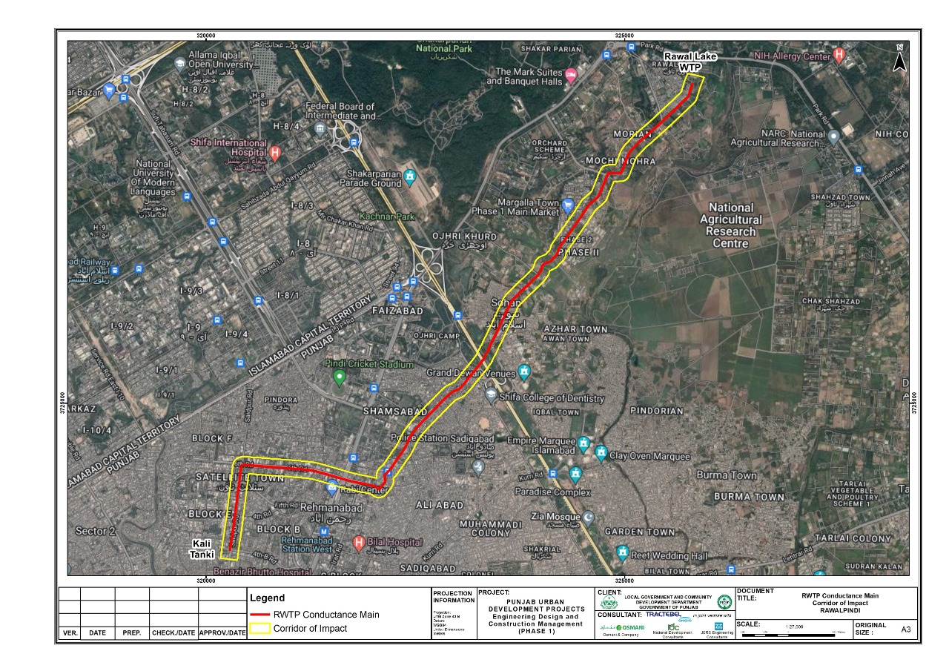
Figure 4.2: Route of Conductance Main
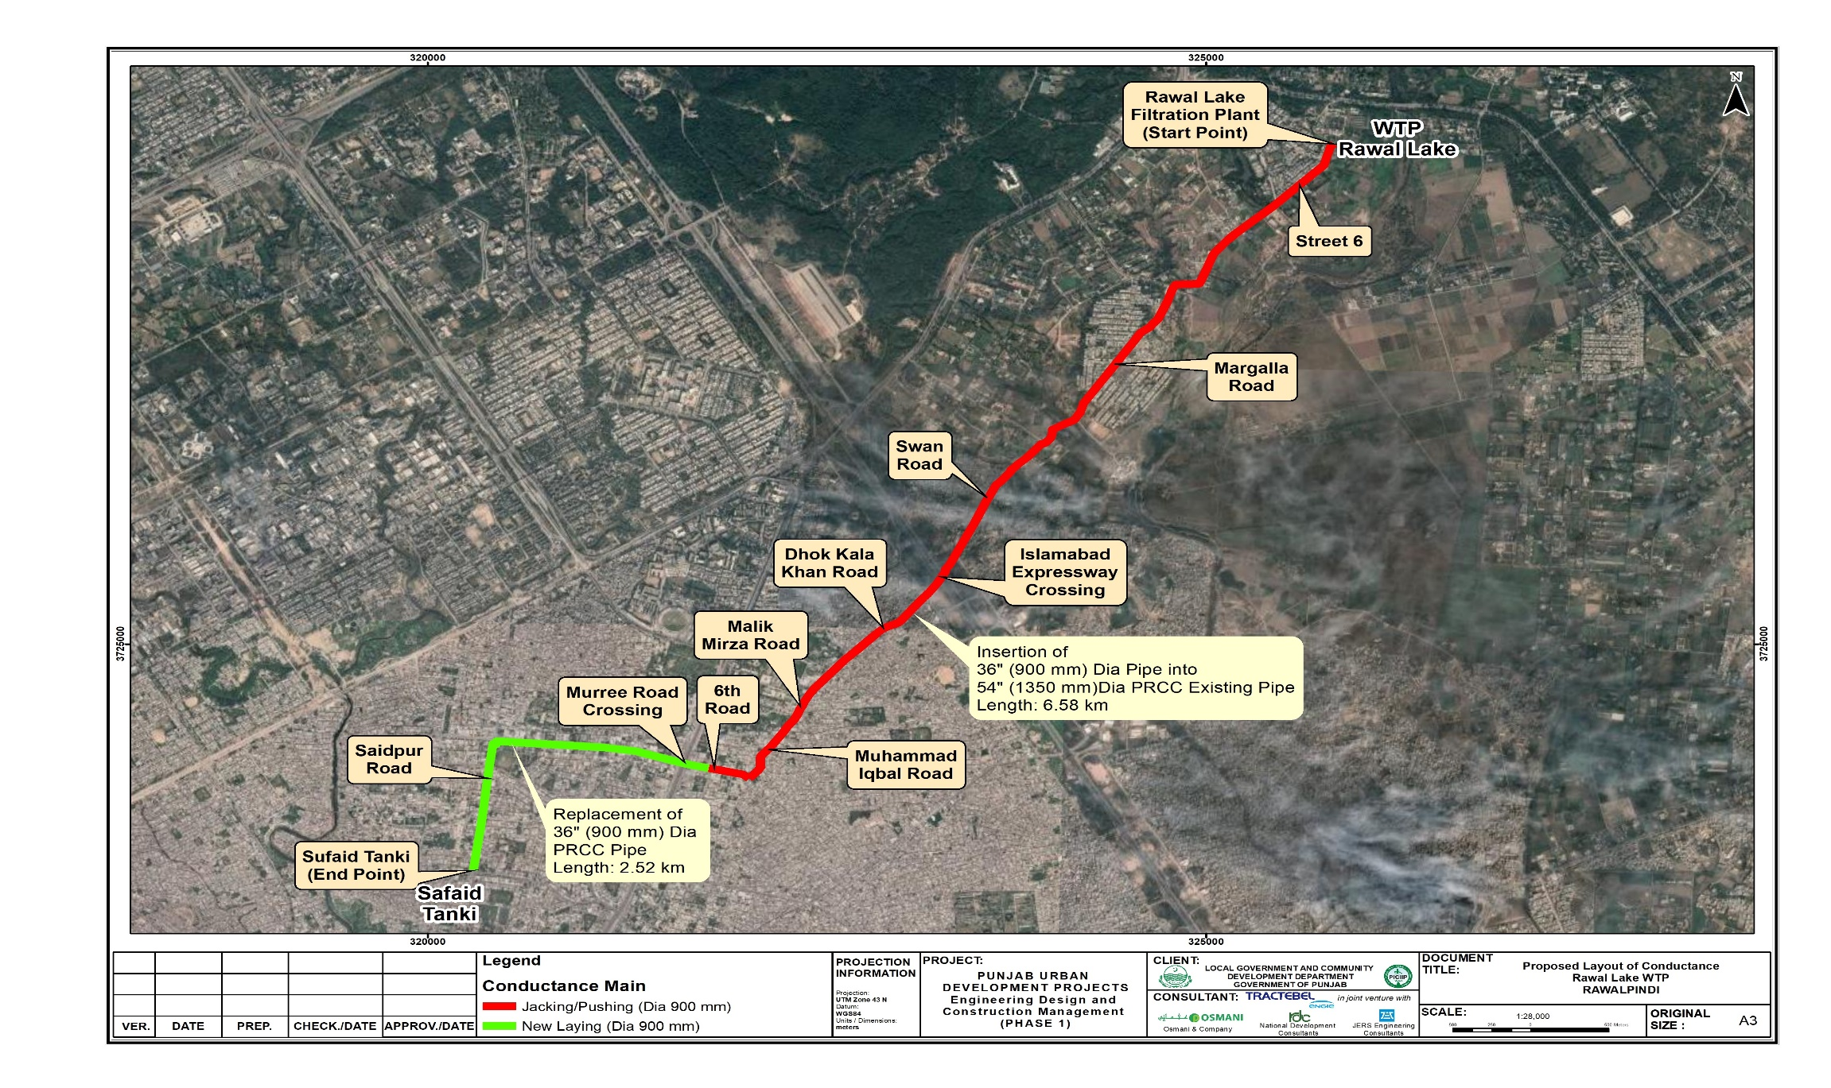

Scope of Work
- The scope of work for laying of the ECM works will comprise of the following civil works:
  - Excavation of working chambers/trenches;
  - Dismantling of existing non-functional conductance main at working chamber’s locations;
  - Insertion of HDPE 900mm dia. PN-10 in existing 1350mmdia.PRCC pipe;
  - Laying of new conductance main;
  - Installation of measuring devices, valves etc;
  - Nullah crossings with MS pipe;
  - Connections with existing lines;
  - Shifting /restoration of underground services;
  - Restoration works, temporary works, site management and general management etc.
- The scope of works for installation of the solar PV system will be as follows:
  - Site establishment, setting up of construction site offices, storage areas etc;
  - Importing of materials and equipment;
  - Clearing of any trees and vegetation;
  - Establishment of any access ways and drainage system across the site;
  - Earthworks to create level construction platform;
  - Installation of foundations using pre-cast concrete blocks, earth screw anchors or piles (whichever is most suitable);
  - Installation of solar PV modules;
  - Excavation of cable trenches;
  - Installation of electrical equipment/connection of internal electrical connections;
  - External connection for power evacuation (BPC);
  - Testing and commissioning;
  - Landscaping works and demobilization of construction site, waste disposal etc.

Salient Parameters of the Existing Line
- The existing pipeline consists of two sizes (54 and 36 inches). The salient parameters of this line are as follows:
  - The line's internal diameter is 54 inches (1370 mm), and the wall thickness is 3 inches (76.2 mm). The line's outer diameter measures 60 inches (1520 mm);
  - Pipe material is Pressurized reinforced concrete pipe (PRCC);
  - The total length of 1370 mm diameter pipe is 6800 meters;
  - The 36-inch-diameter line is 2300 m long, and it is working at many reaches by connecting with the existing system. This segment cannot be disturbed, and a new line will be laid parallel to existing one;
  - During the structural condition survey, it was observed that the existing line is not totally choked, but some deposition of 1.0-1.5 ft was found in some of the reaches, similarly, some dewatering will also be required due to leakages from valves where it is connected with duplicate conductance main (DCM) or other lines of WASA.

Existing Condition of Conductance Main
- A site visit was carried out from 10th to 13th April 2022, in order to check the existing condition of the conductance main. A pictorial view of the site visit is presented in Figure 4.3.
Figure 4.3: Site Visit Glimpse
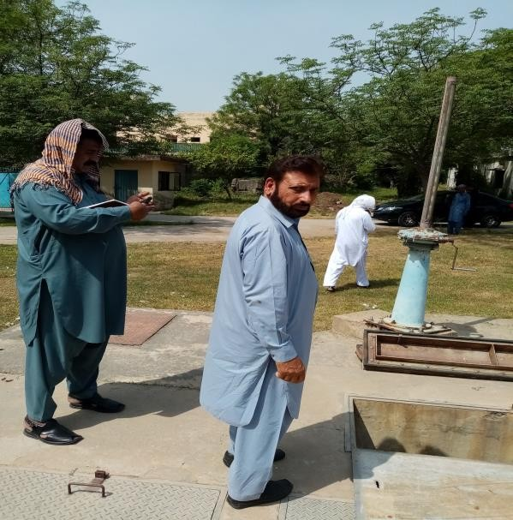 | 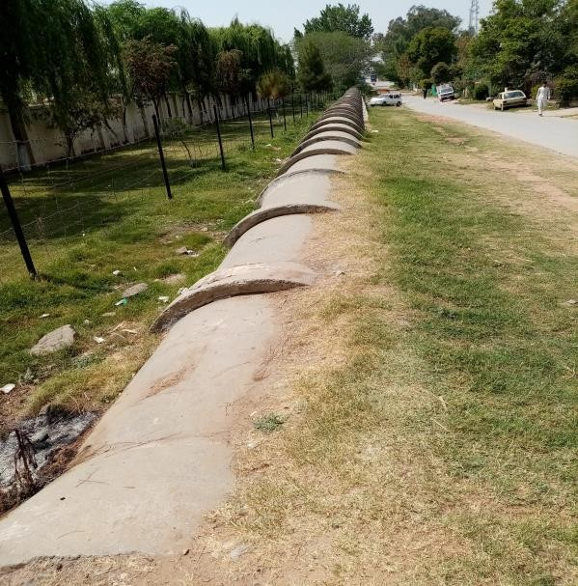
Start point of Conductance Main | Above ground part of existing conductance main
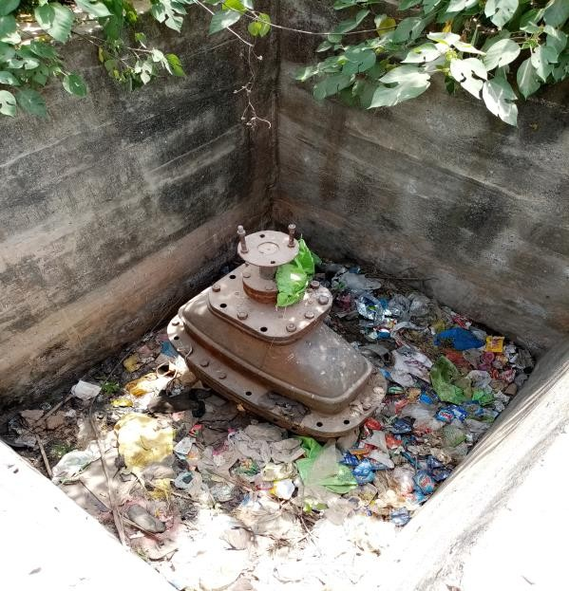 | 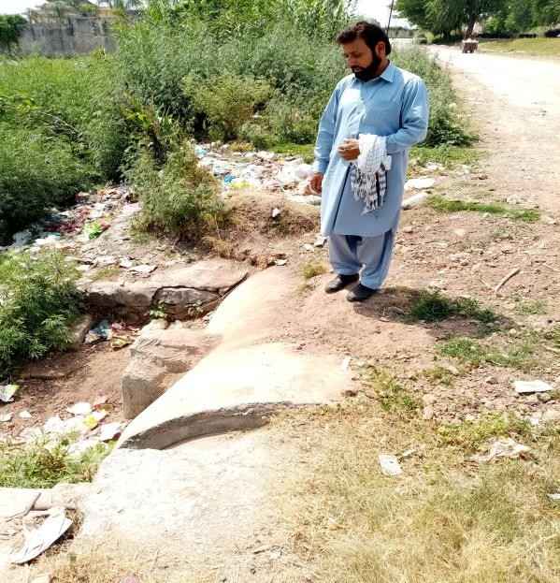
Valve chamber at conductance main | Another above ground part of conductance main
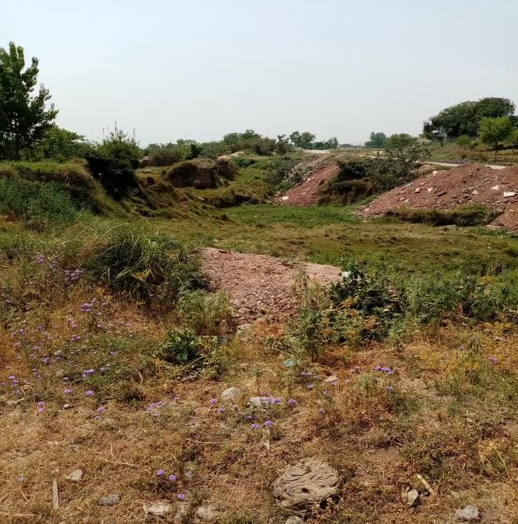 | 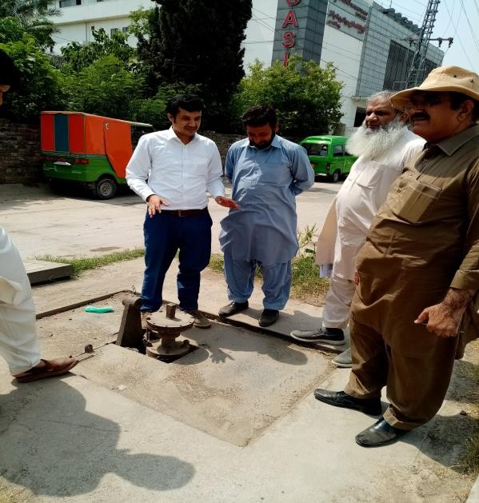
A view of syphon at conductance main | Discussing about valve near Murree Road
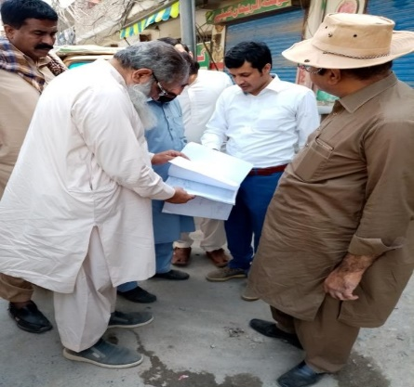 | 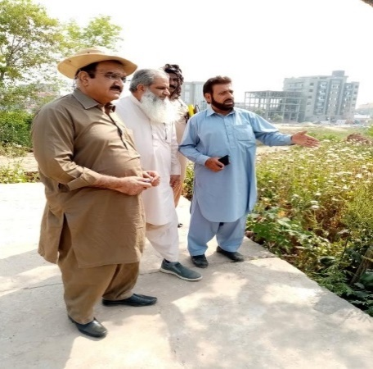
Discussion about conductance main at site | Discussion at site about crossing near Islamabad Highway

Existing Conductance Main (ECM) Details
- ECM begins with a sluice valve at the exit point of water filtration plant. It passes through local roads with encroachments of almost 50 feet on each side. There are 4 syphons along the route of conductance main. The details of the syphons are discussed in Table 4.1.
Table 4.1: Detail of the Syphons
Syphon No | Details
Syphon No. 1 | Syphon no. 1 starts at RD 1+700 and terminates at RD 1+800 with a length of 100 meters.
Syphon No. 2 | Syphon no. 2 starts at RD 1+950 and terminates at RD 2+100 with a length of 150 meters.
Syphon No. 3 | Syphon no. 3 starts at RD 2+850 and terminates at RD 2+950 with a length of 100 meters.
Syphon No. 4 | Syphon no. 4 starts at RD 3+450 and terminates at RD 3+630 with a length of 170 meters. After running along the community roads, it crosses Islamabad Expressway at RD 4+360 and cross Murree Road at RD 6+700.
- The existing conductance main is above ground in 2 places. The total length of the above-ground portion is 200 m. After crossing the Islamabad expressway, a more populated area and narrow streets (Rawalpindi city area) start, through which the conductance main is passing.
- The functional portion of the conductance main starts near Murree Road at RD 6+500 and ends at RD 8+750. After RD 8+750 the conductance main becomes again dysfunctional. RD-wise route of conductance main is attached as Annexure II. A summary of the conductance main inventory is shown in Table 4.2.
Table 4.2: Summary of Conductance Main Inventory
Sr. No. | Item | No’s
1 | Flow meter chamber | 1
2 | 30-degree horizontal bend | 2
3 | Access Chamber | 4
4 | Syphons (Nullah crossing under bed) | 4
5 | Washout | 12
6 | Double air Valve and access chamber | 15
7 | 19-degree Horizontal Bend | 1
8 | Branch to standpipe and access chamber | 1
9 | 68-degree horizontal bend | 2
10 | crossover connection chamber | 4
11 | Rolled bend, 21-degree horizontal bend, 7 degree vertical bend | 1
12 | 42-degree horizontal bend | 2
13 | 26-degree horizontal bend | 1
14 | 6-degree verical bend | 1
15 | 38-degree horizontal bend | 1
16 | 28-degree horizontal bend | 1
17 | 58-degree horizontal bend | 1
18 | 56-degree horizontal bend | 5
19 | 60-degree horizontal bend | 2
20 | 40-degree horizontal bend | 3
21 | Tee for crossover branch | 4
22 | single air valve and access chamber | 1
23 | drainage ditch | 1
24 | 66-degree horizontal bend | 1
25 | 45-degree horizontal bend | 8
26 | 17-degree horizontal bend | 1
27 | 20-degree horizontal bend | 1
28 | 50-degree horizontal bend | 1
29 | access Chamber (Type I-B) | 4
30 | 90-degree horizontal bend | 3
31 | 7-degree vertical bend | 1
32 | 23-degree horizontal bend | 3
33 | 33-degree horizontal bend | 3

Design Criteria/ Parameters

Designing Concept & Objective
- The objective of the feasibility study is to provide guidance for the selection of projects for development of the water sector to resolve the escalating problems resulting from the lack of a holistic approach in the water sector management (water source monitoring and management, asset and consumer database management, O&M plans for infrastructure and machinery, tariff structure and revenue collection system etc.) which in turn leads to unsustainable/uncontrolled use of water sources, the deteriorating condition of the existing infrastructure and the distrust of consumers in the public water supply.

Design Horizon and Planning Phases
- The overall design horizon is the year 2050, divided in the following distinct implementation phases:
  - Immediate measures (years 2021 - 2025)
  - Short-term measures (years 2026 - 2030)
  - Medium-term measures (years 2031 - 2040)
  - Long-term measures (years 2041 - 2050)

Design Life of Infrastructure
- To determine required re-investment for outlived infrastructure and respective M&E installations, the following design life of civil works tube-wells, pumping machinery, distribution network, transmission main etc. are considered for spatial planning. The details of the design life is discussed in Table 4.3 below.
Table 4.3: Design Life of Water Supply Infrastructure
Component | Design life [years]
Civil works for buildings | 50
Civil works for process units, reservoirs | 50
Tube wells | 15
Transmission mains, primary & secondary network | 30
Tertiary distribution network | 30
Valves, actuators, bulk instrumentation | 15
Consumer water meters | 10
Filter media (water treatment) | 15
M&E plant and equipment | 15
Pumps | 15
SCADA & PLC Systems | 15
Computers, Server | 5
Vehicles, trucks | 10

Summary of Theoretical per Capita Water Demand
- Taking into consideration the different water consumptions as described in the preceding sub-chapters, the calculated theoretical per capita water demand is summarized in the Table 4.4 below. It is calculated in the following way:
  - Water consumption (net) = domestic (net) + 35% x domestic (net)
  - Water demand (gross) = Total water consumption (net) / (100% - NRW %).
Table 4.4: Theoretical per capita water demand
Details |  | 2021 | until 2030 | 2031 - 2040 | 2041 - 2050
Domestic consumption (net) | lpcd | 80 | 80 | 94 | 108
 | gpcd | 18 | 18 | 21 | 24
Non-domestic |  | 35% | 35% | 35% | 35%
Total water consumption (net) | lpcd | 108 | 108 | 127.44 | 145.8
 | gpcd | 24 | 24 | 28 | 32
NRW |  | 40% | 40% | 30% | 20%
Water Demand (gross) | lpcd | 180.00 | 180.00 | 182.06 | 182.25
 | gpcd | 40 | 40 | 40 | 40

Design Flows
- The design flow has been calculated to be 5-mgd or 9.27 cusec or 0.263 m³/sec.

Flow Velocity
- For the feasibility stage, the flow velocities shall range between 0.5-1.5 m/sec for the Transmission mains.

Water Metering
- To establish a sustainably managed water supply system in the cities, water metering is essential as it allows not only for continuous monitoring of the network and reduction of non-revenue water, but it is also important for cost recovery by the water utility. As such, the Consultant has proposed to adopt metering at conductance main by installing bulk water meters at feeding and disposal points.

Pipe materials
- Water supply pipes available nowadays are manufactured in different materials and some of the major types discussed below along with their advantages and disadvantages which are considered in selection of the pipe:
  - Mild Steel (MS)
  - Ductile Iron (DI)
  - Galvanized Iron (GI)
  - High Density Polyethylene (HDPE)
  - Un-plasticized Polyvinyl Chloride (uPVC)
  - Glass Reinforced Pipe (GRP)

Climatic Consideration
- Local climatic conditions, i.e. the temperature, wind velocity, thunderstorm levels, relative humidity, etc., control the selection of materials to be used.
- The Table 4.5 shows the climatic parameters, considered in designing of the project.
Table 4.5: Climatic Parameters for the project
Maximum Temperature | 48.3ºC
Minimum Temperature | -3.9ºC
Annual Mean temperature (2022) | 43ºC (maximum) to 30ºC (minimum)
Maximum Rainfall | 340 mm/month
Annual Relative Humidity | 39.6%

Solar PV System Installation
- The work under this section will consist of supply, installation, testing & commissioning of the grid connected 0.6 MW solar PV power system over 10 acres of land. The Contractor shall furnish all labor, materials, services and all skilled supervision necessary for the construction, erection, installation and connection of all equipment.
- The solar PV power system equipment shall comply with following international standards wherever applicable.
  - IEC 60364‐7‐712: Electrical Installations of Buildings: Requirements for Solar PV power supply systems.
  - IEC 61727 or similar: Utility Interface Standard for PV power plants >10kW.
  - IEC 62103, 62109 and 62040 (UL 1741): Safety of Static Inverters‐ Mechanical and Electrical safety aspects.
  - IEC 62116: Testing procedure of Islanding Prevention Methods for Utility‐Interactive PV Inverters.
  - PV Modules: IEC 61730‐Safety qualification testing, IEC 61701‐Operation in corrosive atmosphere.
  - IEC 61215: Crystalline Silicon PV Modules qualification.
  - String/array junction boxes/: IP65, Protection Class II, IEC 60439‐1, 3.
  - The Inverter shall be rated for IP54.
  - The AC distribution boards shall be rated IP54.
- The different components to be installed will be as follows:

Solar Modules
- Power output: 90% power output at end of 10th year and 80% power output at the end of 25th year.
- Solar photovoltaic panels will be used by the solar power plant for generating electrical power by converting solar radiation into direct current. This phenomenon takes place due to the photovoltaic effect exhibited by the semiconductors.
  - The solar PV modules shall be fixed firmly on top of the pole / structure using mounting structure, with suitable tilt and inclination to receive maximum sunlight.
  - The PV module shall be of half-cut mono‐crystalline technology.
  - The PV module vendor and its model shall be same for whole project.
  - Efficiency of individual PV modules shall be at least 19% or higher, under Standard Testing Conditions (STC).
  - A suitable number of solar PV modules shall be connected in a series string. A suitable number of series strings shall be connected in parallel to formulate a series‐parallel array.
  - The PV strings and array shall be designed to match the inverter input specifications.
  - Maximum DC output voltage of the array shall not exceed than as specified for inverter.
  - The module shall be provided with junction box with provision of by‐pass diodes.
  - Plug‐in connectors shall be external MC4 type or equivalent.
  - The front surface of the module shall consist of impact resistant and toughened glass.
  - The module frame shall be made of corrosion resistant material.
  - DC negative conductor shall be bonded to the ground.

Inverter
  - Output: 97% or higher.
  - Product service: 20 years.
  - The KW ratings of inverters shall be chosen as per the PV system wattage, however vendor of all the inverters shall be same for whole project.
  - The sine wave output of the inverter shall be suitable for connecting to 400V, 3 phase AC LT voltage grid.
  - The peak inverter output efficiency shall exceed 97% and higher.
  - The nominal AC frequency tracking range shall be ‐ 6Hz to +5Hz.
  - Power factor:
    - Lagging 0.8 or higher
    - Leading 0.8 or higher
  - The inverter shall use transformer/transformer less topology.
  - The inverter shall have string fuse/ failure detection, ground fault detection, grid islanding protection, suitable DC/AC fuses/circuit breakers and voltage surge protection.
  - The inverter shall have internal protection against any sustained faults in DC inputs by providing DC reverse-polarity protection / reverse current protection and in mains AC grid circuits/lightning etc.
  - Inverter shall provide display of PV array DC voltage, current and power, AC output voltage and current (All 3 phases), AC power, Power Factor and AC energy (All 3 phases and cumulative) and output frequency etc.
  - The Inverter should have provisioning for remote monitoring.
  - Operating temperature range between 0 - 60°C.
  - Protection rating:
    - Electronics- IP66
    - Connection points/area - IP54

Charge Controller
- Product service: up to 20 years.

Mounting structure for Solar PV array/tree
- Structural & foundation: 20 years.
  - The proposed Solar PV system shall be designed to maintain the overall aesthetics.
  - The mounting structure for module array shall allow ventilation for cooling and also ease of cleaning and maintenance of panels.
  - Proper location and spacing of the PV modules arrays should be selected for minimum shadow effect.
  - Material for solar and module array support structure shall be fabricated using corrosion resistant material.
  - All the support structure welded joints shall be adequately treated to resist corrosion.
  - The support structure shall be free from corrosion when installed.
  - The structure of solar module array shall be designed so that PV modules can be placed and fixed with ease.
  - Screw fasteners shall use existing mounting holes provided by module manufacturer. No additional holes shall be drilled on module frames. Module fasteners/clamps shall be adequately treated to resist corrosion.
  - The support structure shall withstand the weight of solar PV modules installed on each solar modules on each PV array at buildings and other installed equipment.
  - The structure shall be designed to withstand operating environmental conditions for a period of minimum 20 years.
  - The structure should have provision for connecting the earthing cables.

Balance of System (BoS)
- Product service: 20 years.

Equipment for solar PV system cleaning
- The following equipment for cleaning of the solar PV panels will be installed:
  - 1HP electric water motor pump.
  - Flexible water pipe with stand (it shall have access to every solar panel)
  - Mid & low-pressure nozzles to splash water.
  - 2 nos. of each min. 6 feet long retractable brushes & viper.
  - Brush fiber shall be made of polystyrene, soft enough to protect the photovoltaic cells, yet enough to remove debris.
  - High pressure cleaning equipment should not be used to clean solar panels as this may cause water to get under the glass.

Power Evacuation
- The power generated will be connected to the national grid through the nearest substation to evacuate any excess power that is being generated and is not required to be exported onto the grid.

Site Drainage
- In order to prevent any damage to the solar equipment from flash flooding and soil erosion, an effective watershed management and drainage system inside and outside of the site boundary will be implemented during the construction and operation phases. Run-off from precipitation will be collected and drained through a specified points or outlets at the project site.

Security Measures (Fencing and Lighting)
- The solar equipment will be secured with chain link fencing up to 2.5 m high to prevent access; to ensure the safety of the adjacent local communities and to provide security for the solar photovoltaic panels. In addition to this, two security personnel will be deputed on rotation basis (all day and night hours, alternately) to prevent the entry of unauthorized persons to the site.
Figure 4.4: Conceptual design of Solar PV system installation at Rawal WTP
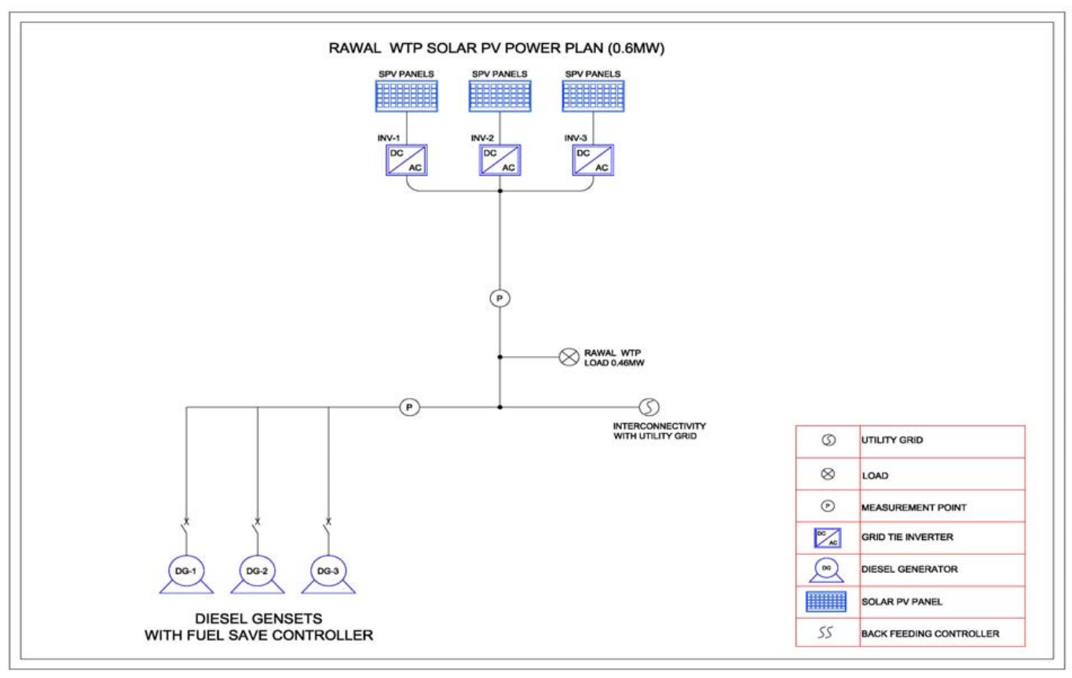

Construction Activities

Solar Power Plant Design, Installation and Supply Contractor
- A Contractor will be selected to develop the solar power equipment on a Design, Installation and Supply basis through a competitive bidding process. The Design, Installation and Supply contractor will undertake the detailed design, carry out civil works, supply and install the solar power equipment, construct the power evacuation facilities to evacuate power at the grid connection point and set up the operation and control systems required for solar power operation. The Design, Installation and Supply contractor will also continue to be engaged during operation through warranties to rectify any issues arising from equipment defects or workmanship issues.

Temporary Facilities
- Construction site offices, stores for fuel, oil and chemicals, storage/laydown areas for materials, plant and equipment, sanitation and welfare facilities including washrooms, cooking, and eating areas and worker camps will need to be temporarily set up within the allocated land, on completion of construction these will be removed from site.

Construction Methods
- Construction of the solar power facility will be semi-mechanized. This means a combination of both machine and labor will be utilized. The use of machines will mainly be for earthworks and excavation and the installation of foundations. There is the possibility that soil compaction and/or piling will be required due to ground condition at the site, although it is to be avoided if possible.

Construction Materials
- Construction materials will be required for the solar power equipment, including gravel for any access ways that might be required, concrete for foundations, hot dip galvanized steel or aluminium for solar PV module tables and concrete, reinforcement bars and bricks etc. No borrow areas or quarries will be opened to provide construction materials. Solar PV modules and electrical equipment meeting the technical specification will be procured from licensed manufacturers. No CFCs, PCBs or asbestos containing materials will be used in construction.

Manpower requirement
- At most, 30 construction workers are expected to reside at the solar power facility during the construction period. Skilled workers will need to come from outside the local community due to the need for them to have suitable qualifications and experience to work on construction site, but unskilled manual labor may be sourced from the local communities.

Power Requirement
- The project site has grid connection available from the Rawal lake water filtration plant which will be available for use, although the Contractor may choose to use temporary diesel generator set during construction as backup power.

Water Requirement
- There will be water required during construction for drinking and dust suppression. During the construction, it is estimated about 30 laborers will be stationed at the project site requiring about 5 cubic of water. For human consumption (drinking, bathing, cooking, toilet etc.) alone, the estimated water requirement is about 5 m³ per day.

Waste Generation
- There will be excess soil (waste spoil) generated from earthwork and excavation during the construction phase. Excess soil will ideally be disposed of in backfilling or landscaping of the solar plant site or disposed off at an acceptable location in accordance with EPA guidelines.
- During construction, there will be wastewater, solid waste and some hazardous waste generated. This includes solid waste generated from construction workers and temporary worker camps in the form of domestic garbage and wastewater sludge. Wastewater will need to be treated with septic tanks. Solid and hazardous wastes will need to be taken by licensed waste contractors who should reuse/recycle or dispose of the waste according to type to suitably licensed and engineered waste management facilities.

Operation phase of Solar installation

Solar Power Plant Owner and Operator
- SCADA system will be installed for remotely controlling and monitoring the solar power equipment. The RWASA staff will be trained by the Design, Installation and Supply contractors to operate, maintain, and carry out repairs of the solar power facility. However, some of the operational activities, such as, cleaning of solar photovoltaic panels and maintenance and service of key components such as connector boxes, switchgear, and transformers may be assigned to third party contractors.

Manpower Requirement
- Once the construction activities are completed, only a few people will be required for operation and maintenance of the plant. Only 3 employees for this facility are expected to be engaged.

Power Requirement
- The project site has grid connection available from the Rawal lake water filtration plant which will be available for use in case of any emergencies.

Water Requirement
- The main consumption of water is for cleaning of the solar PV modules with minimal requirement for domestic usage. Cleaning of all modules will be done only once per month. It will be possible to clean all the panels by using requiring 4 m³ of water per day.

Waste Generation
- There will be small volumes of wastewater, solid waste and some hazardous waste generated. This includes domestic garbage and wastewater sludge from the site offices. Wastewater will need to be treated with septic tanks.

Vegetation Management
- Management will be required, particularly to avoid the site becoming overgrown and to assist with the eventual restoration of the site back to its original state on decommissioning. There are various techniques for managing the vegetation, which include mowing and trimming.

Decommissioning
- The lifespan of the solar plant is 25 years (solar photovoltaic panels typically last 25-30 years) after which decommissioning will be initiated by RWASA. Decommissioning will involve removal of the solar plant infrastructure, including all equipment, structures, foundations, access paths and fences; disposing of or recycling its components; and restoring the land to its original state. RWASA is anticipated to appoint a third-party contractor to undertake decommissioning work.
- Decommissioning activities will be similar to those involved during construction, the main difference being that there will be many solar PV panels and transformers containing oil to dispose of in an environmentally safe and sound manner. The RWASA focal staff will seek guidance from the concerned EPA staff on the disposal of hazardous waste. Recyclable waste can be sold to licensed waste collectors who should reuse/recycle or dispose of the waste according to type to suitably licensed and engineered waste management facilities. If at the time, RWASA is to pursue an alternative scenario such as repowering using new solar PV panels, this will be subject to national environment laws and regulations in force at the time.

Access Roads
- The proposed project can be accessed through various routes along the 9.1km length of proposed replaceable Conductance Main. The Conductance Main is starting from Rawal Lake Filtration Plant and passing through Street 6, Margalla Road, Swan Road, Islamabad Expressway Crossing, Dhok Kala Khan Road, Malik Mirza Road, Muhammad Iqbal Road, 6th road, Murree Road crossing, Saidpur Road. Details of the access routes to project site are provided as Figure 4.5.

Figure 4.5: Detail of Access Roads
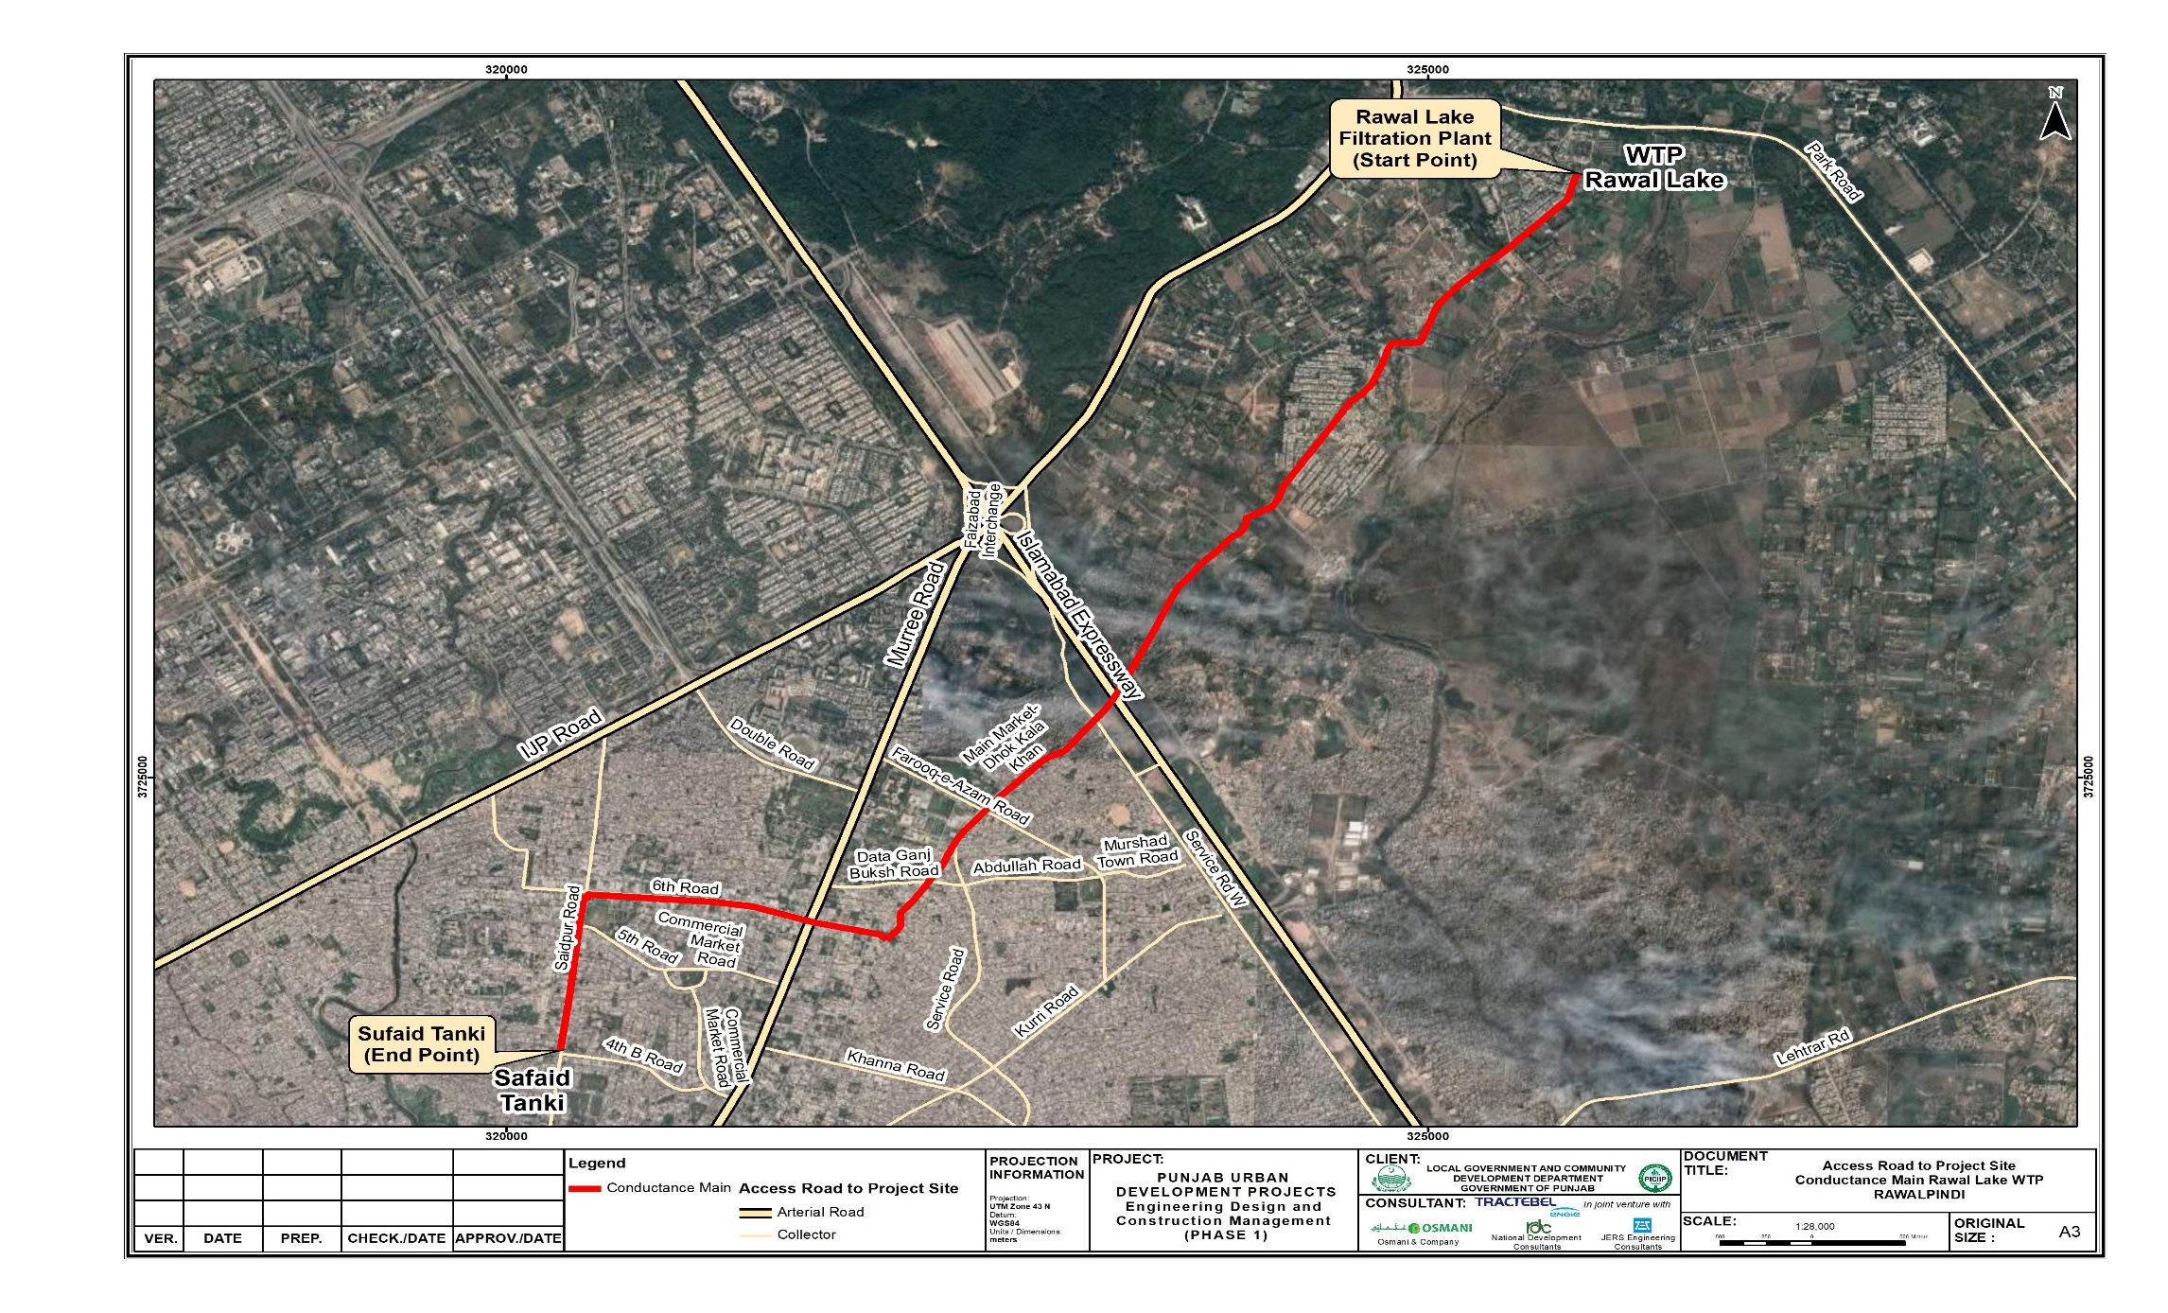

Project Administrative Jurisdiction and Tentative Cost
- The proposed project lies in the Rawalpindi district of Punjab region of Pakistan. The proposed project will be completed with an estimated construction period of 24 months with total cost of approx. 4.72 million USD @ 277.9/USD (1,320.03 million PKR).

Land Use and Vegetation Features of the Project Site
- The land use of the project area is mainly residential and commercial with some educational facilities, medical facilities, religious sites and recreational facilities. The details of the land-use of the project area are discussed in detail in Chapter 5. The study area has a variety of trees shrubs, herbs and grasses along the roadsides and in the lawns of administrative buildings, educational institutions and parks.

Construction Machinery and Material Requirement
- For storing materials, stocking equipment and parking machinery and vehicles, the Contractor(s) shall require open and accessible sites close to the labor camps. The Contractor(s) shall make the arrangements at his own expense, keeping in mind the contractual obligations to honor the applicable national and international guidelines regarding level of pollution.
- The Table 4.6 below outlines the approximate number of major machinery and vehicles that are envisaged to be required for the project construction works.
Table 4.6: Estimated Contractor’s Equipment and Machinery
Sr. No. | Machinery / Equipment | Quantity required*
1 | Excavators | 2
2 | Batching Plants | 2-4
4 | Loaders | 1
5 | Power Generators | 2
6 | Tractor Trolley | 2
7 | Compactor / Roller | 1
8 | Crane | 1
10 | Concrete Pump | 1
11 | Vibro Hammer | 1
13 | Watering Tanks (moveable) | 1
14 | Cars/Pickups | 4
* Number of machineries is indicative and can be changed subject to working schedule.
- During the construction phase, construction materials in considerable volumes will be required. The typical materials required for the replacement of the ECM and associated supply network is available locally and the same will be utilized.
- The Table 4.7 summarizes the approximate quantities of raw material needed for construction of the proposed project.
Table 4.7: Construction Material and Source of Raw Material
Sr.# | Raw Material | Estimated Quantity | Source
1 | Earth Material | 50,126 Cft. | Available locally, borrowed from the lands acquired for the project.
2 | Aggregate | 265,038 Cft | Available at many sources within the vicinity of the site. No aggregates shall be sourced from river or stream beds.
3 | Riprap material | 12,100 | Will be taken from local suppliers
4 | Sand | 193,898 Cft | Sand is available in local market.
5 | Water | 5000 lit/day | Water will be taken from existing network of water supply.
6 | Cement | 59,293 Cft. | Ordinary Portland Cement is suitable, which is available at various factories in Pakistan mainly from Kalar Kahar and local market.
7 | Reinforcement steel |  | Steel re-rolling mills in Peshawar meeting the standards from the billet produced either by Pakistan steel or imported. These will serve the purpose of steel availability.
8 | Energy | Given in relevant section | Electricity supplies are available at the site through IESCO.

Construction Camp (Temporary Facility)
- The camp site will be selected keeping in view the availability of adequate area including parking areas for machinery, stores, and workshops, access to communication, and local markets. It should be at an appropriate distance away from sensitive areas of the vicinity. The site location will be selected and finalized after approval from RWASA.

Workforce Requirements
- The estimated number of workers (including skilled and semi-skilled labour) required for the entire construction period is approximately 150.

Power Requirement and Source
- The main source of electricity/electric power during construction phase will be diesel generators due to lack of power grid. However, the necessary power infrastructure will be developed and for the operational phase, the electric power shall be supplied by the Islamabad Electric Supply Company (IESCO).

Water Requirement
- Based on an estimated average daily per capita water consumption of 50 gallons/day, the water consumption is estimated to be 7,500 gallons per day for 150 construction workers and it is anticipated that about 2 tankers (approx. 1200 liters) per day shall be required during construction phase of the project for water sprinkling .

Wastewater Generation
- The wastewater generation is estimated to be 6,000 gallons per day for 150 construction workers during construction phase of the proposed project. (*Source: Design Criteria of Public Health Engineering for Water Supply, Sewerage and Storm Water Drain).

Solid Waste Estimation
- Two types of solid waste will be produced during the construction activity of proposed project. The municipal solid waste from construction camps and the construction waste including excavation material. The municipal solid waste generation is estimated to be 90 kilograms per day, (0.6 kg/person) for 150 construction workers during construction phase of the proposed project. The estimated quantity of excavation material including spoil and left over waste will be 1,064,306 Cft.

PROJECT ALTERNATIVES

Overview
- The discussion and analysis of alternatives considers other practicable strategies that will promote the elimination of the identified negative environmental impacts. This section is critical in consideration of the ideal development with minimal environmental disturbance.
- The report identifies the potential environmental impacts of each alternative and develops a comparative analysis matrix with respect to replacement of the ECM and environmental impacts to suggest the most feasible alternative that can be taken up for development.
- The following alternatives have been assessed:
  - Zero Alternative: No Project Option
  - Alternative I: Laying of New Pipeline
  - Alternative – II: Insertion of New Pipeline in Existing Conductance Main
  - Alternative – III: Minimum (0.6m) dismantling of Existing pipe at the top
  - Alternative – IV: Dismantling of Existing Pipe at the top up-to Half Dia

Zero Alternative “No Project Option”
- The “no action” alternative is required to ensure the consideration of the original environment without any development. This is necessary for the decision-makers to consider all possibilities. The development will have a minimal effect on the physical environment. In terms of the social environment, the “no-action” alternative would result in a water shortage in the area, eliminate job opportunities, require residents to pay a higher cost for water containers from private dealers, have environmental impacts due to the transportation of private containers and further deplete the groundwater of Rawalpindi due to extraction of ground water by the local population with electrical pumps.
- The ‘no project’ option will result in further depletion of resources and water scarcity in Rawalpindi due to increasing demand of water from increasing community / population.

Recommendation
- The “No project option” reveals the shortage of water in the area, further depletion of ground water resource, higher cost of buying water containers from private contractors, therefore it is not recommended.

Laying of New Pipeline (Alternative-I)
- The existing conductance main (ECM) line has a diameter of 1350 mm and is constructed of PRCC. This pipeline can serve as a base for new line laying/construction. The size of the new line is calculated on the basis of the available discharge from the WTP and the working head available at final discharge point, which will mainly govern the working efficiency of line.
- This will simply include laying of new line on new location parallel to the existing line and may include:
  - Dismantling of existing road and structure
  - Excavation of trench
  - Laying of pipe
  - Back filling
  - Restoration of pavement
  - Construction of chambers
  - Relocation of underground services
- This option is only feasible where reasonable bank space along the road is available.

Insertion of New Pipe in Existing Pipe (Alternative-II)
- This option is feasible if the joints are leakproof for the required head before jacking and pushing. This is further supported by PCC filling, which will work as an additional measure to protect leakages. Furthermore, special care is to be taken for PCC filling, excluding the joints in the first stage, which can be filled after testing. Pipe joints can be identified over the length of the selected /inserted reach and cut /hole for filling of the PCC around the pipe can be made which can also be used for inspection during testing and shall be filled after testing. In this way, this option becomes the most favourable option for execution of the project.
  - Dismantling of existing road and structure at working chamber locations
    - Excavation of chambers
    - Jacking /pushing of pipe
  - PCC filling in gap between old pipe and new pipe
    - Back filling at chambers
    - Construction of chambers
- This option is only feasible when joints are leakproof for the required head before jacking and pushing because any leakage of joints during testing will require excavation over whole the selected reach. Furthermore, special care is to be taken for PCC filling excluding the joints in first stage, which can be filled after testing. Pipes joints can be identified over the length of selected /inserted reach and cut /hole for filling of PCC around pipe can be made which can also be used for inspection during testing and filled after testing. In this way this option becomes the mast favourable option for execution of project

Minimum (0.6 m) Dismantling of existing pipe at the top (Alternative-III)
- This option includes excavation of over cover of the existing line, breaking of existing pipe on top (min. 0.6m). Insertion of new pipe in existing pipe by jacking /pushing method. The main activities included are:
  - Dismantling of existing road and structure over the pipeline
    - Excavation of trench 1.0-0.6 m
    - Jacking /pushing of pipe
  - PCC filling in gap between old pipe and new pipe in above ground situations
  - Sand filling in gap between old pipe and new pipe in underground situations where 0.75 m earth cover is available
    - Back filling at chambers
    - Construction of chambers
- This option requires jacking and pushing method and encasing of PCC/sand. Access to joints will facilitate any repair required during testing. No new corridor or bank space along the road is required for new line. This option will require continuous excavation throughout the existing pipe alignment.

Dismantling of Existing Pipe at the Top Up-To Half Dia. (Alternative-IV)
- This option includes excavation of over cover of the existing line, breaking of existing pipe from top to half of its’ dia. placing of new pipe in the half cut existing pipe and so on. The main activities included are:
  - Dismantling of existing road and structure over the pipeline
    - Excavation of trench min. 2-1.5 m wide
    - Placing of new pipe in existing pipe
  - PCC filling in gap between old pipe and new pipe and around/above the new pipe in above ground situations
  - Sand filling in gap between old pipe and new pipe and around /above new pipe in underground situations where 0.75 m earth cover is available
    - Back filling at chambers
    - Construction of chambers
- The comparison of different options is presented in Table 5.1 below.

Table 5.1: Comparison of Different Options
Description | Approximate Cross Section | Advantages | Disadvantages
Option-1  Laying of new pipeline |  | - New pipe at new location  - Away from Building line  - Repair after testing easy | - Require space along road  - Demolition and excavation  - Relocation of UG services  - Restoration of surfaces required
Option-2  Insertion of new pipe in existing pipe (Option 2) | 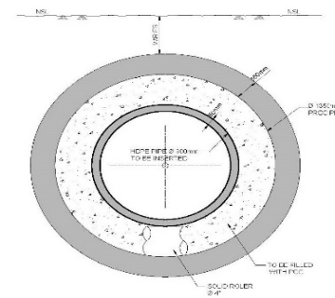 | - No demolition /excavation for maximum length of line  - No disturbance of underground services  - No bank space required  - No restoration of surface | - Location of joints marking will be required to facilitate any repair of leakage during testing  - Cleanliness of existing line required.  - Pouring of concrete will require pump.  - jacking and pushing skill required
Option-3  Minimum (0.6m) Dismantling of existing pipe at the top (Option 3) | 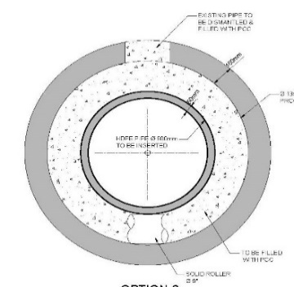 | - No disturbance of underground services  - No bank space required  - Pouring of concrete easy  - Repair of leakages after testing easy | - Some demolition /excavation for whole length of line required  - Cleanliness of existing line required.  - jacking and pushing skill required  - Restoration of surfaces required
Option-4  Dismantling of existing pipe at the top | 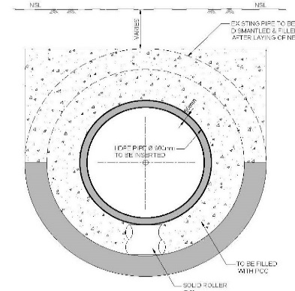 | - No disturbance of underground services  - No bank space required  - Pouring of concrete easy  - Repair of leakages after testing easy | - More Demolition /excavation for whole length of line required  - Cleanliness of existing line required.  - Restoration of surfaces required  - Costly due to concrete encasement

Comparison / Analysis of Alternatives
- The comparison between all four alternatives based on environmental, social and economic impacts is described in the table below. The alternative to be selected must qualify the basic criteria of cost effectiveness, environmentally sustainable and socially acceptable.
Table 5.2: Analysis of Alternatives
Parameters | Laying of New Pipeline | Insertion of New Pipeline in Existing Conductance Main | Minimum (0.6m) dismantling of Existing pipe at the top | Dismantling of Existing Pipe at the top up-to Half Dia
Cost | It would be the most expensive option because it would require excavation and the removal of an old pipeline in order to build a new line. | This would be comparatively cheaper because less excavation would be required. | This would be costly option as it will involve excavation and cutting of upper edge of existing pipeline | This would be costly option as in involve excavation and cutting of top half of the existing pipeline
Environmental Aspects | The new laying of the pipeline will involve excavation of the entire route of the existing conductance main, and it will generate huge amounts of construction waste, noise, air emissions, and disturbance to other buried services. | This option will produce less construction waste. Chambers will be built for pulling and pushing of new pipeline. | This will also involve generation of more construction waste, noise and air pollution due to excavation of whole route of ECM and cutting of ECM | This will also involve generation of more construction waste, noise and air emissions due to excavation of whole route of ECM and cutting of ECM
Social Aspects | It will involve more space for storage of mucking material and new pipelines and excavation of whole area will cause hindrance in free movement of community for short time. Disturbance will be more serious while working in congested area of Dhoke Kala Khan and Sohan Market. Safety and health issues will also arise due to deep excavations. | Minimum disturbance will occur in movement of people because it will not involve excavation of trenches | It will involve more social impacts due to large excavations. Free Movement of people will be disturbed. Safety and health issues will also arise due to deep excavations. | It will involve more social impacts due to large excavations. Free Movement of people will be disturbed. Safety and health issues will also arise due to deep excavations.

Conclusion
- Based on the discussion of the available options and comparing their economic, environmental and socioeconomic aspects the Alternative-II is recommended for this project. This will have minimum adverse impacts and maximum positive impacts; therefore it is recommended.

Solar PV Installation Component

With’ and ‘Without’ Project Scenario
- The ‘No project’ scenario is not a viable option since Pakistan is facing an energy deficit and needs to urgently switch from the cost intensive and environmentally unfriendly diesel-based power generation and move towards developing renewable based cheap and reliable energy on a long-term basis.
- Also, the benefits from the addition of this solar installation project are primarily in terms of offsetting energy production primarily from fossil fuel-based generation (resulting in fuel savings), but also include significant benefits from more efficient operation of diesel generators, less diesel generator maintenance and depreciation and delayed purchase of new generator capacity in later years.
- The Table 8.1 below presents a comparison of the ‘with project’ and ‘without project’ scenario.
Table 8.1 – ‘With’ and ‘Without’ Project Scenario
No. | Parameter | With Project Scenario | Without Project Scenario
1 | Electricity | Major benefits are as follows:  - Improve the electricity supply and stability of the national grid;  - Diversify power generation mix;  - Increase percentage of clean energy;  - Supply less expensive than current oil-based generation;  - Improve electricity supply and stability of the national grid. | Negative effect, increase in greenhouse gas (GHG) emissions due to continued reliance on inefficient oil-based energy generation.
Environment
2 | Effect on protected, sensitive or forest areas | No effect, avoids national protected areas, environmentally sensitive and forest areas. | No effect.
3 | Effect on endangered species | No endangered species identified in project area. | No effect.
4 | Tree Cutting, vegetation removal. | No major effect anticipated. | No effect.
5 | Air emissions | Minor effect during construction; increase in air emissions because of construction activities / trenching, dust generation.  Major effect during operation: Decrease in GHG emissions. | Negative effect, Increase in GHG emissions due to continued reliance on fossil-fuel based energy generation.
6 | Water Supply | Minor effect during construction and operation; Increase in groundwater withdrawal compared to without project scenario. Shall comply with project EMP as prescribed in clearances, permits and licenses obtained from relevant authorities.  Major effect during operation; improved water accessibility for different purposes due to relevant power available for pumping etc. as required. | No effect.
Social
7 | Disturbances to people/ communities. | Minor effect during construction phase; temporary and localized impact due to power outage, dust and noise due to movement of machinery and construction vehicles; shall comply with project EMP (community health and safety plan, traffic control and road management plan, noise and dust control plan) Influx of migrant workers; shall comply with project EMP (emphasis on local hiring). | No issue.
8 | Effect of business. | Construction activities may employ local populace generating economic and livelihood generation opportunities | No issue.
9 | Status of living. | Major effect, improved access to electricity, reduced domestic load for persons such as women involved in cooking activities or in accessing water supplies. | No change.
Economic
10 | Economic Development | Greater rate of economic development expected. | Slow development.

DESCRIPTION OF THE ENVIRONMENT

General
- This chapter provides the description of the baseline conditions along the proposed Project within the Corridor of Impact (CoI). The CoI, taken for the assessment of direct impact is 100-meter radius from the project site.
- Considering the potential impacts of the proposed project, existing baseline environmental conditions of the project area has to be used as a benchmark for comparison of the physical, ecological and socio-economic conditions before and after construction phases of the project. This baseline will also provide the datum for assessing the impacts and suggesting the mitigation measures, which will be implemented effectively at various phases of the proposed project activities. The location map of the proposed project is presented as Figure 6.1.

Field Visits for Baseline Study
- The data presented in the forthcoming sections has been collected from the primary and secondary sources. For primary data acquisition, the Environment and Social team conducted the field visit during December, 2022.
- The major objective of the field visits was to collect the baseline data on physical, eco-biological and social aspects along with identification, assessment and categorization of the significant environmental and social impacts of the proposed Project. The secondary data was collected from published sources/reports and relevant departments, which were also verified through visual observations during detailed surveys. The required information/ data of a baseline study was classified into two main categories i.e., primary data and secondary data. The primary data was collected directly from the concerned communities and affected households while secondary data was the information gathered through secondary sources such as census report, research publications, topographic sheets, other published data related to the project such as wildlife, livestock, fishery, forestry, agriculture, horticulture, climate etc.
- Corridor of Impact: The proposed areas where the replacement project is proposed is passing through highly populate areas of Rawalpindi. The project CoI is referred to all those areas in the region within 100m from the project corridor and which may be affected directly or indirectly by the project activities. The required right of way (RoW) for project will be approximately 15ft.
- This chapter provides an overview of the environmental and social baseline information of proposed project area, with special reference to impacts on the CoI. The information has been compiled from primary and secondary sources of data and the major environmental components are:
- Physical Environment
- Biological Environment
- Socioeconomic Environment

Figure 6.1: Location Map of Proposed Project for Conductance Mains Component

Physical Environment
- The following section provides an overview of the information on physical environment of the project area collected from primary as well as secondary sources. The major parameters covered include Topography, Geology, Seismicity, Soil, Climate, Water Resources, Ambient Air Quality & Noise, Solid Waste and Land-use along the proposed project.

Topography
- The project is located in Rawalpindi tehsil division which falls in the Salt Range and Potohar Plateau. The terrain mainly consists of plains and mountains (reaching an elevation of over 1,175 m) traversed by ravines and nullahs originating from the mountains. The northern part of the metropolitan area lies in the mountainous terrain of the Margala Hills, a part of the lower and outer Himalayas, which also includes the Hazara and Kala Chitta Ranges. The foot of Margalla range stands at an elevation of about 620 m and the top of the mountain is about 1,200 m. The terrain of Rawalpindi gradually falls off towards Lai Nullah in the west and the Kurang River in the east. Lai Nullah enters the city from the southwest and joins the Soan River in the southern side. Occasionally it overflows during the rainy season, causing considerable damage. Four major tributaries, namely Saidpur Kas, Tenawali Kas, Bedarawali Kas, and Johd Kas, originate from Margalla Hills.

Land use of the Proposed Project
- There are different types of land use i.e., open, built-up, cultivated land, graveyards, green belt, rivers, road/track, stream/ Nullah, residential and commercial details structures, trees/ bushes and water ponds etc. Some scattered houses as well as densely populated houses have also been observed along the entire alignment of the project area.

Hydrology
- In the Rawalpindi city area, the groundwater occurs in the alluvial deposits, comprising silty sandy gravely beds and the thick conglomerate beds. The thickness, extension and the depth of these conglomerates’ beds vary from place to place and are the main aquifer. The groundwater of the Rawalpindi area gets recharged from the rainfall and the foothills of the Margala Hills in the north and the Murree Hills in the northeast, through the extensive drainage system. Although, the groundwater availability was not a problem in the Rawalpindi area in the past, as it was present at the shallow depth. However, with the passage of time, the groundwater extraction by the WASA’s water supply tube-wells has damaged the aquifer by the depletion of the water level to the dangerous limits.
- In the Rawalpindi area, during the construction of the WASA tube-wells; the subsurface strata encountered the alternate beds of the silty clay/clayey silt, sandy beds and the thick conglomerates bed; down to the depth of 122 m to 183 m.
- Since the aquifer layers are confined in the thick clay beds and their depth, thickness and extension vary from place to place. Therefore, in some tube-wells, semi artesian conditions have also been reported during their construction.
- The behavior of the underlain aquifer is not homogenous. The discharges from the WASA water supply tube wells vary from place to place. The present water level in the city area has dropped to 91 m to 107 m deep, whereas in 1980, the average depth was 12 m. The depletion in the water level in the city area has gone so deep due to the over-groundwater abstraction by the water supply tube-wells. This indicates that the aquifer is being mined against its recharge.
- The thickness of the alluvial material containing the previous beds decreases towards the western area of Rawalpindi City and ultimately disappears and the rocks of the Murree.

Groundwater
- The Rawalpindi city is one of the major cities of Pakistan, having a population of 2.00 million. To meet the city's water demand, the WASA has installed a total of 495 water supply tube wells in and around the city.
- The reported depth of the WASA tube-wells ranges from 122 m to 183 m and pumping setting depth ranges from 107 m to 122 m.
- As reported, the RWASA office supplies 231,851 m³/day (51 MGD) of water to the city, out of which 127,290 – 136,383 m³/day (28 - 30 MGD) of the groundwater is being abstracted by operating the tube-wells and remaining from the surface water sources. As a result, the average discharge of each operating tube-well is from 10.91 m³ /hour to 16.4 m³/hour. The poor discharges of the operating water supply tube-wells are due to the poor permeability of the conglomerate's aquifers. The conglomerate's aquifers generally yield low discharge due to cementation and have a higher drawdown.

Surface Water
- The water treatment plant located near Rawal Dam had an initial capacity of 14.0 MGD with the provision to increase that capacity to 28.0 MGD to meet the future water demand. Due to acute water shortage experienced in 1972-73, extension of 7.0 MGD was planned, and its construction was completed in 1979 by public health Engineering Department. With this increase i.e., 07 MGD, the total capacity of the treatment plant became 21 MGD. With further increase in population and the consequent increase in the water demand, the capacity of the Rawal lake filtration plant was further augmented by 7 MGD during implementation of the urban water supply & sanitation project in year 2001-02. Presently, the total capacity of the treatment plant stands at 28 MGD.
- The water from the Rawal dam is distributed among the following consumers
  - City area- 45,461 m³/d (10 MGD)
  - Bulk consumers, MES, NIH & NARC – 59,099 m³/d (13 MGD)
- Similarly, Khanpur dam is another source of surface water for Rawalpindi, located on the Haro River near the Potohar Plateau and the village of Khanpur, Khyber Pakhtunkhwa, almost 40 kilometers (25 miles) from Islamabad. The Khanpur dam supplies water to Rawalpindi and Islamabad for domestic consumption, irrigation water to the agricultural lands and industrial areas surrounding the twin cities. Khanpur Dam has a design capacity of 231,851 m³/d (51 MGD). Depending on the amount of water in the dam, a maximum of 66,373 m³/d (14.6 MGD) of water can be provided through the Sangjani treatment plant. Due to a lack of water in Khanpur reservoir, the designed storage has not been achieved most of the time, and the actual supply of water from this dam is only 27,277 m³/d (6 MGD). The location of the different water sources is shown in Figure 13.
Figure 6.2: Location of Water sources for RWASA
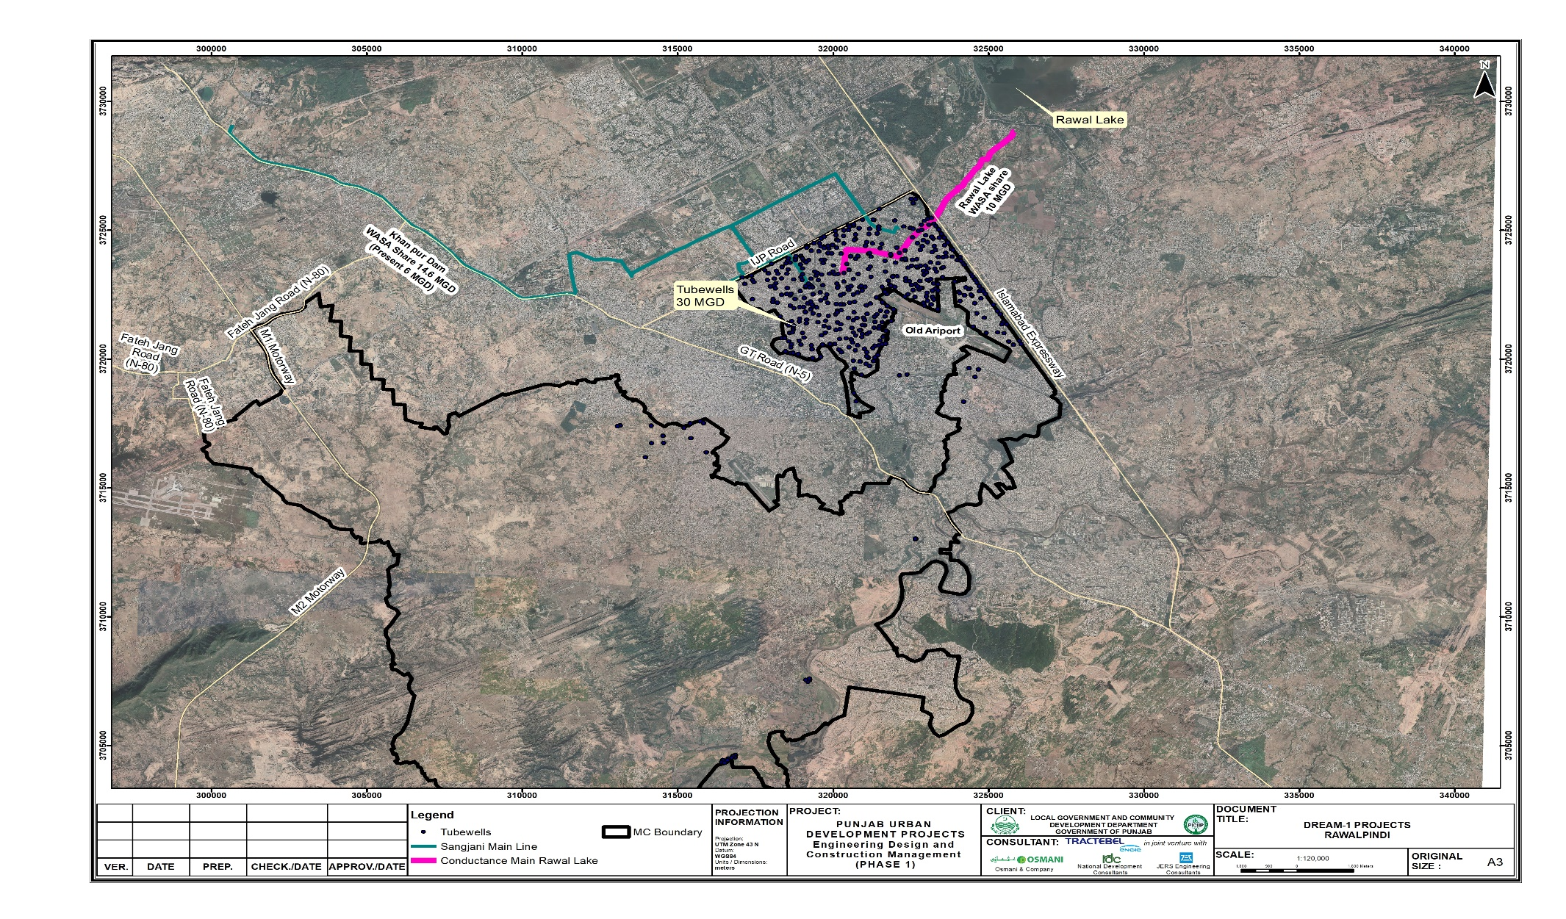

Geology and Soil
- Limestone is the character of the Margalla range, and this is the main source of fertility of those villages laying at its base. It is found also but in limited quantity in Murree hills. The alluvial deposits occur chiefly in the lower portion of Kahuta Tehsil. In Rawalpindi Tehsil and the low hills, limestone is common and, in the plains, Kankar deposits can be found. The pebble ridges described as alluvial deposits in Kahuta hills are also the remarkable structural features of Rawalpindi Tehsil.
- The potohar plains were mainly formed during the quaternary period. They are composed of alluvial (clayorsil) and gravel caps. The clay of the district exhibits five district strata or layers. The lowest layer is of course pebbles with sand or clay. Stratum is that of alluvium deposit by older system of the Soan basin over the pebble bed. During this period the Soan was a mighty river, bigger than the present-day Indus.
- The next upper layer consists of the alluvium deposits of the present river system, the air borne top layer of silt or clay called Loess and at the top is the gravely conglomerate and loose gravel caps deposits. Pebbles beds, pebbles mounds and pebble ridges form a conspicuous feature of the landscape.
- Seismology
- Based on SAARC Seismic Microzonation, Pakistan has been divided into four zones. The project area is falling in moderate hazard zone. The boundaries of these zones are defined on the basis as shown in Figure 6.3.
Figure 6.3: Seismic Zone of Pakistan
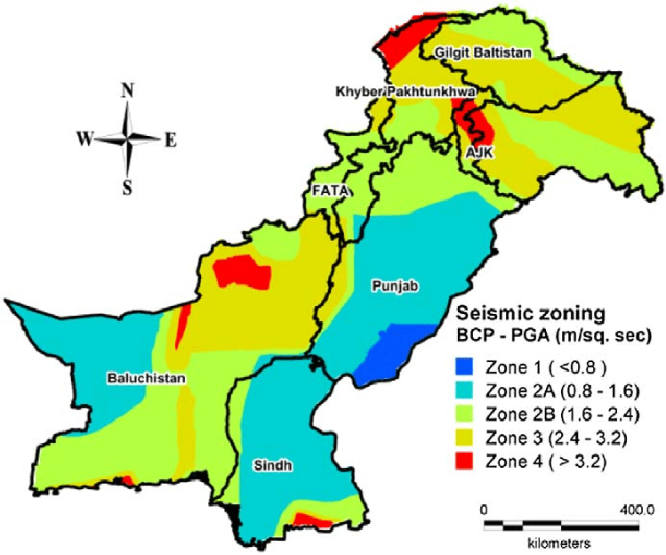

Climate
- The project area is classified as having a humid subtropical climate. The humid subtropical climates are characterized by typically mild, dry, and short winters. The summers in project area are long, with higher temperatures starting in mid-April and reaching peak temperatures in June/July. The temperatures often exceed 40 °C in summer. The summers are typically followed by monsoons, during which heavy rains are experienced. The project area receives rain in all seasons, but monsoon rain is pronounced and constitutes a definite rainy season between the months of July and September. Average high temperatures decrease during the monsoon season, but humidity increases. This results in hot and humid conditions, similar to summers in other humid subtropical climates.
- The following sections present the climate details of the meteorological gauging station situated near the proposed project. Airport, Islamabad meteorological station was identified near to the proposed project.
- The monthly data for Temperature, Rainfall, and Relative Humidity from year (2018-2022) for the above-mentioned Weather Stations for the Project Area are presented in a subsequent section.
6.3.6.1 Temperature
- The proposed project area will be subjected to long periods of high temperature in summers and low temperature in winter. The mean monthly temperature (max & min) of Rawalpindi for the 2018 to 2022 years are 38, 37, 36, 38 and 28C. The mean yearly temperature data is presented in Table 6.1.
- The temperature rises rapidly until June, and the temperature drops with the advent of the monsoon in July. The temperature rises rapidly until June and the temperature drops with advent of monsoon in July. The months of December and January experience a severe drop in temperature and the temperature falls below the freezing point in areas above 1800 masl. Summer is marked by monsoon rains, which usually occur in July/August. Yearly average temperature data is presented in Figure 6.4.
Table 6.1: Yearly Mean Temperature (2018-2022)
Sr. No. | Year | Mean Max. Temperature (0C) | Mean Min. Temperature (0C) | Mean Temperature (0C)
1 | 2022 | 43 | 38 | 28
2 | 2021 | 41 | 31 | 38
3 | 2020 | 41 | 30 | 36
4 | 2019 | 42 | 32 | 37
5 | 2018 | 30 | 30 | 38
*Source: Worldweatheronline.com
Figure 6.4: Yearly Mean Temperature (2018-2022)

Rainfall
- The mean yearly rainfall data for the years 2018- 2022 is 18.3, 31.6, 27.4, 25.9 and 6.92 mm. The maximum rainfall occurs during the months of July and August, which is about 50% of the annual rainfall. Winter rains generally occur during the months of January to March, whereas November is normally the month with the least precipitation. The mean yearly data is given in Table 6.2.
Table 6.2: Mean Yearly Rainfall (2018-2022)
Sr. No. | Months | Mean Yearly Rainfall (mm)
1 | 2022 | 6.92
2 | 2021 | 25.9
3 | 2020 | 27.4
4 | 2019 | 31.6
5 | 2018 | 18.3
*Source: Worldweatheronline.com
- Graphical representations of mean yearly rainfall in district Rawalpindi are provided below in Figure 6.5. The maximum rainfall occurs during the monsoon season in the months of July and August. The maximum rainfall occurs during the monsoon season during the month of July.
Figure 6.5: Mean Yearly Rainfall (mm) 2018-2022

Relative Humidity
- The relative humidity data for Rawalpindi district is given in Table 6.3. The average yearly humidity for the year 2018- 2022 is 34.4, 43.0, 41.0, 38.0, and 41.5. The relative humidity levels are mostly high during the month of August, whereas, these are extremely lower during the highest temperature i.e., May and June.
Table 6.3: Mean Yearly Humidity (2018-2022)
Sr. No. | Yearly | Humidity
1 | 2022 | 41.5
2 | 2021 | 38.0
3 | 2020 | 41.0
4 | 2019 | 43.0
5 | 2018 | 34.5
*Source: Worldweatheronline.com
- Graphical representations of average yearly Humidity of district Rawalpindi are provided below in Figure 6.6.
Figure 6.6: Mean Yealy Humidity (2018-2022)

Floods
- Disaster management in Pakistan basically revolves around flood disasters, with a primary focus on rescue and relief. The existing institutional structures responsible for disaster management are geared to reactive short-term responses. Experience has shown that abnormal heavy rains in catchment areas result in flash floods in Lai Nullah especially in 2001, 2010, 2011, 2012, 2014 and 2015.
- Though the flood water recedes within a period of 3-8 hours, it causes considerable damage in the city area. Local drains from Chah Sultan and Cantonment area also fall in it which further aggravates the situation, especially when these drains cannot find their way into Nullah Lai which is already in flood, causing inundation of surrounding low-lying areas (back water effect). The potential sites/vulnerable areas are as follows:
  - Dhoke Naju
  - Zain-ul-Haq Colony
  - Both sides of Bridge at Ratta.
  - Bhoosa Godown
  - Mohanpura Neae Jinnah Road Bridge.
  - Javaid Colony,
  - Tipu Road,
  - Chamanzer Colony,
  - Nadeem Colony.
  - Dhoke Chiragh Din
  - Mohallah Raja Sultan
  - New phagwari
  - Mohallah Raja Sultan
  - Gawalmandi.
  - Dhoke Ellahi Buksh.
- The area of high flood vulnerability is shown in Figure 6-7 below.

Figure 6.7: Areas vulnerable to Floods
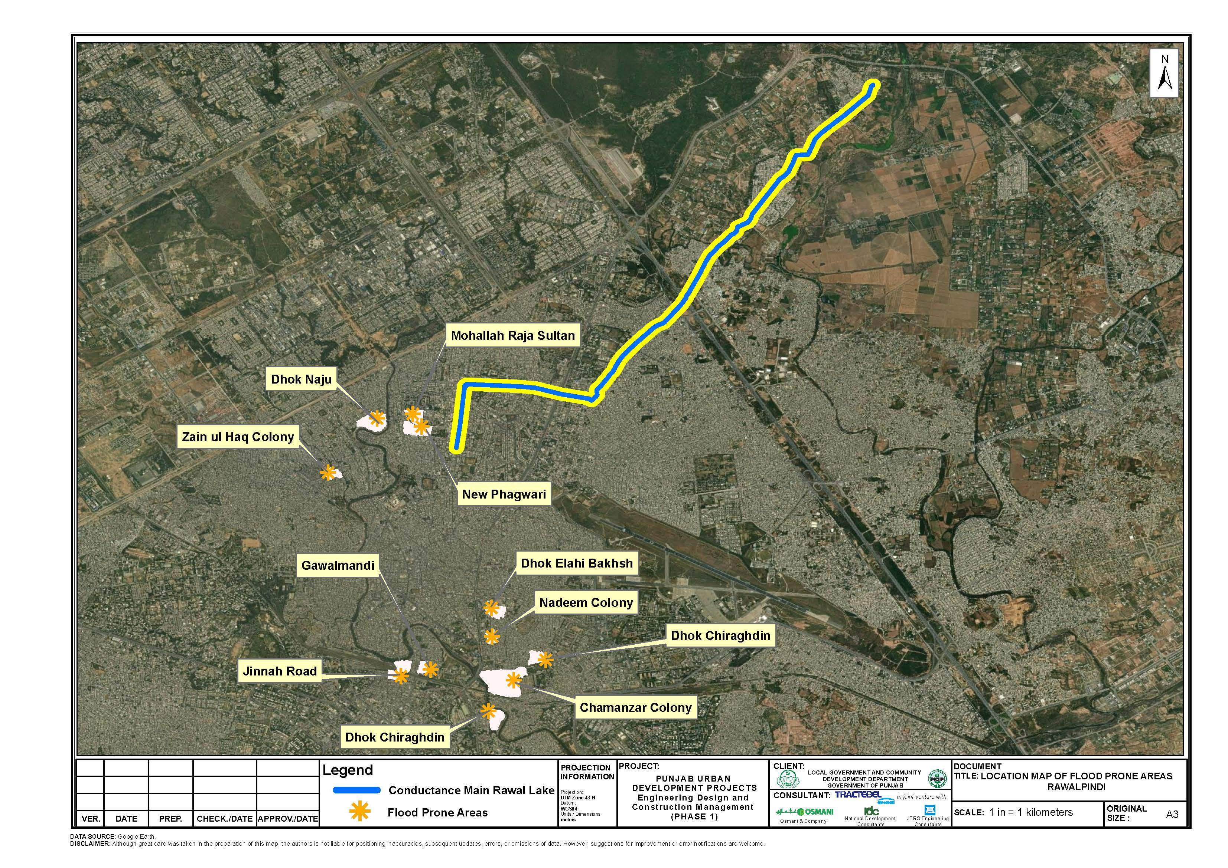
- Heavy rainfall during monsoon season is the main triggering factor for urban flash flooding along with contributing factors of throwing of garbage in the mainstream of Lia Nullah as well as in tributaries of nearby vulnerable areas.
- In the management and/or administration of the Lai Nullah area, there are a number of other agencies that have a role in this area, namely: the Capital Development Authority (CDA), responsible for master planning of Islamabad; the Small Dams Organization (SDO), is responsible for the maintenance of Rawal Dam, one of the main sources for water supply in the twin cities; the Rawalpindi Development Authority (RDA), which deals with surface drainage or flood mitigation projects; and the Tehsil Municipal Administration (TMA), which is responsible for the execution and management of development plans, the enforcement of all municipal laws and rules, and the prevention of encroachments. Finally, after the 2001 flood, it was decided that the joint flood management problem of Islamabad and Rawalpindi should be tackled by the Flood Forecasting Commission (FFC) through medium- and long-term planning and implementation of measures. FFC was assigned the task of acting as a coordinating agency between the Federal Capital and Rawalpindi Administrations.
- Extreme flood years were 1981, 1988, 1997, and 2001, the latter having been the largest among the recorded events (considered a national disaster). The intensity and amount of rainfall caused the water level of Lai Nullah and its tributaries to rise remarkably flooding Rawalpindi (where the damages were several times larger than in Islamabad).
- Housing; Agriculture and Livestock; and Transport and Communications sectors suffered the most significant damage, at USD 5.6 billion, USD 3.7 billion, and USD 3.3 billion, respectively. Sindh is the worst-affected province, with close to 70 percent of total damages and losses, followed by Balochistan, Khyber Pakhtunkhwa, and Punjab.
- The Ministry of Planning, Development, and Special Initiatives led the Post-Disaster Needs Assessment (PDNA), which was conducted jointly with the Asian Development Bank (ADB), the European Union (EU), the United Nations agencies, with technical facilitation by the United Nations Development Programme (UNDP), and the World Bank. The PDNA, in addition to estimating damages, economic losses and recovery and reconstruction needs, also assesses broader macro-economic and human impacts and recommends principles along which to develop a comprehensive recovery and reconstruction framework.

Ecological Environment
- All the available literature was thoroughly reviewed to have a better understanding of the project area and its surroundings including habitat, flora and fauna. The route alignment was thoroughly examined based on the primary and secondary data. The stakeholder Forest, Wildlife, EPA, Fisheries and Agricultural departments were also consulted. This survey broadly covers ecosystem sensitivities (If any), vegetation, other flora and fauna. No tree cutting or damage to vegetation is anticipated in the above said project.
- The climate of the project area has a typical version of humid subtropical and dry climate, with five seasons. The surrounding area majorly lies in sub-tropical scrub zone. The dominant trees species of this natural zone are: Kau (Olea ferruginea), Phulai (Acacia modesta), and sanatha (Dodonaea viscosa).
- In order to improve the landscape and living environment of the Rawalpindi, traits like color or blossom, shade, form or shape, scent, and being free from disease and nuisance are considered during the selection of trees and shrubs for a given location. So, the study area in general is under significant biotic pressure and under retrogression due to various factors such as unsustainable practices, natural hazards causing habitat loss, soil erosion, and a lack of proper functioning of ecosystems. Areas have been accessible to humans for a long time, resulting in low diversity and wildlife abundance.

Flora
- As climate of study area is subtropical, the vegetation of the area falls under subtropical broad leaved evergreen scrub type as per phyto-geographical classification of the area. The tract, in which the project site exists, was once covered with native vegetation consisting of trees and thick cover of bushy vegetation, with the onslaught of civilization, this vegetation was cleared for agricultural purposes.
- Kau (Olea cuspidata) is the climax species. However, in the project and the study area, Phulahi (Acacia modesta) and Kikar (Acacia nilotica) dominate. Shisham (Dalbergia sissoo), Mesquit (Prosopis juliflora) and Paper Mulberry (Broussonetia papyrifera) have also grown as secondary species with Phulahi. With the onslaught of civilization and urbanization of the tract, the original vegetation in and around the tract was removed and replaced by agricultural lands, which is the dominant land use in the tract.
- The project site is the proposed water supply project. The present ecological conditions of the project area fall into two categories: agricultural and degraded land. The project area is designated as agriculture area, so no green developmental activates were considered in the past to improve the ecological balance of the targeted area.
- The detail of vegetative species of the region are given in Table 6.4 below:
Table 6.4: Vegetative species of the region
Sr. No. | Common Name | Scientific Name
1 | Banyan/Bhor | Ficus benghalensis
2 | Phulai | Acacia modesta
3 | Sanatha | Dodonaea viscosa
4 | Dhak | Butea frondosa
5 | Anar | Punica granatum
6 | Pear | Pyrus pasha
7 | Sukh Chain | Pongamia pinnata
8 | Amaltas | Cassia fistula
9 | Bottle Brush | Callistemon spp
10 | Jasmine | Jasminum humile
11 | Holmskioldia | Holmskiodia sanguine
12 | Beri | Zizyphus mauritiana
13 | Royle's Spike Thorn | Gymnosporia royleana
14 | Baikarh | Adhatoda vasica
15 | Zebrawood | Pistacia integerrima
16 | Poplar | Populus sp.
17 | Devil tree | Alstonia scholaris
18 | Bougainvillea | Bougainvillea spectabilis
19 | Sukh chain | Pongamia pinnata
20 | Dharek | Melia azedarach
21 | Eucalyptus | Eucalyptus camaldulensis
Source: TAS for LAI Expressway Project, 2022

Agriculture and Crop Pattern
- Agricultural holdings are small, with the average is about 5 to 10 kanals per family. There are generally two' crops in a year. The Rabi crop is followed by a Kharif crop, and then the land lies fallow for a year until the Rabi sowing. This system is locally known as Do-Fasli Do-Sala. Wheat, bajra and maize are common crops. The principal crop during Rabi is wheat and Jawar, maize and fodder are the main crops of Kharif. There are no fruit orchards in the project area. Apart from the wheat crops, whatever area is available is used for growing fodder crops for stall feeding of livestock.
- The people of this area do not generally take much pains in crop husbandry, because of unfavorable conditions for agriculture. The cultivators generally content themselves with sowing the seeds broadcast after shallow plugging and leave the rest to Nature. The use of improved agricultural implements and fertilizers is not very common except for cash crops like potatoes and orchards.

Fauna/Wildlife
- On account of the nature of vegetation and topography, the project area, the project area, once rich in vegetation and wildlife, has now reduced its potential due to overhunting, loss of proper habitat, and conversion of forest land. The wild mammals were not spotted commonly. However, domestic mammals were found to be common in study area. The fauna of the tract consists of mammals, reptiles, amphibians and birds. The details are given below:
- Mammals
- The study was once considered as good habitat for many wild species but due to expansion of population and commercialization, the habitats of many species are now degraded.
- However, there is no wild mammalian species observed in the project area except some domesticated animals including cats, dogs, etc. However, the following Table 6.5 shows the list of mammalian species present in the region, as the project area is to be considered highly degraded in terms of wild fauna. Jackals are quite common. Foxes are also common, and the piercing bark of the fox is usually heard in the hills. Wild boars are quite common. Hares are to be found on all the low hills and in most of the ravines.
Table 6.5: List of indigenous Mammals
Sr. No. | Mammals | Scientific Name | IUCN Status
1 | Jackal | Canis aureus | LC
2 | Fox | Vulpes vulpes | LC
3 | Jungle Cat | Felis chaus | LC
4 | Palm Squirrel | Funambulus palmarum | LC
5 | Mongoose | Herpestes auropunctatus | LC
6 | Indian mole rat | Rattus rattus | LC
7 | Field mouse | Funambulus pennant | LC
8 | Porcupine | Hystrix indica | LC
9 | Rabbit | Oryctolagus cuniculus | EN
10 | Cape hare | Lepus capensis | LC
11 | Masked palm civet | Paguma larvata | LC
12 | Wild boar | Sus scrofa | LC
Source: TAS for LAI Expressway Project, 2022
*LC = Least Concern
*EN = Endangered
- Amphibians
- The amphibians that are found near or around the project area are given in the Table 6.6 below.
Table 6.6: Amphibians of the Study Area
Sr. No. | Local/ English Name | Scientific Name | IUCN Status
1 | Common frog | Rana tigrine | LC
2 | Common toad | Bufo bufo | LC
3 | Marble frog | Uperodon systoma | LC
Source: TAS for LAI Expressway Project, 2022
*LC = Least Concern
- Reptiles
- The study supports a good variety of reptiles. In the project area, the most common reptile that is worth mentioning and is occasionally witnessed by hikers is Monitor Lizard. These are generally large reptiles, although some can be as small as 12 centimeters in length. They have long necks, powerful tails and claws, and well-developed limbs. The reptiles that are found near or around the study area are given in the Table 6.7 below.
Table 6.7: Reptiles of the Study Area
Sr. No. | Local/ English Name | Scientific Name | IUCN Status
1 | Fringed toed Lizard | Acanthodactylus cantoris | LC
2 | Spiny tailed Lizard | Uromastyx hardwickii | VU
3 | Common Krait | Bungarus caeruleus | LC
4 | King Cobra | Ophiophagus Hannah | VU
5 | Viper | Vipera xanthina | LC
Source: TAS for LAI Expressway Project, 2022
*LC = Least Concern
*VU = Vulnerable
- Birds – Avifauna
- Many bird species have been reported in and around the study area. These include passage migrants, vagrant, resident, breeding and irregular visitors. The migratory birds descend from higher altitudes during the winter months. Avifauna of the tract consists of small and medium sized birds of different colors, flying from one tree to the other or from crop to crop. Most common birds are House Sparrow, House Crow and Mynah. Birds like Cuckoo, Bulbul, Hoopoe, Parrots, Blue Birds, and Little Egrets etc were frequently sighted. The common birds observed and reported in the study area are given in Table 6.8 below:
Table 6.8: Birds Found in Study Area
Sr. No. | Common Name | Scientific Name | IUCN Status
1 | Rock Pigeon | Columba livia | LC
2 | Myna | Acrido therestritis | LC
3 | Grey Partridge | Perdix perdix | LC
4 | House Sparrow | Passer domesticus | LC
5 | Red-billed chough | Pyrrhocorax pyrrhocorax | LC
6 | Magpie | Pica pica | LC
7 | Alpine Chough | Pyrrhocorax graculus | LC
8 | Grey shrikes | Lanius excubitor | LC
9 | Spotted doves | Spilopelia chinensis | LC
Source: TAS for LAI Expressway Project, 2022
Figure 6.8: Flora Fauna found in Project Area
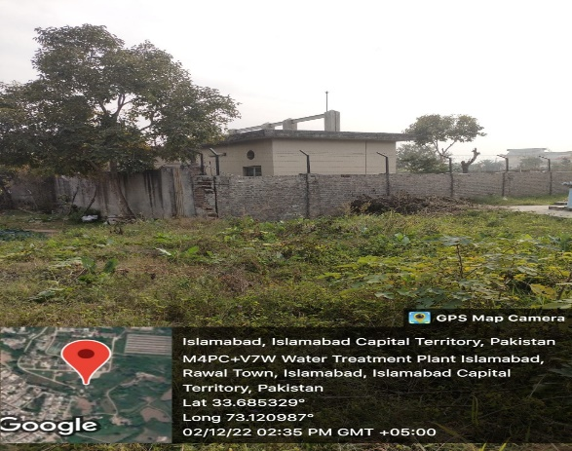 | 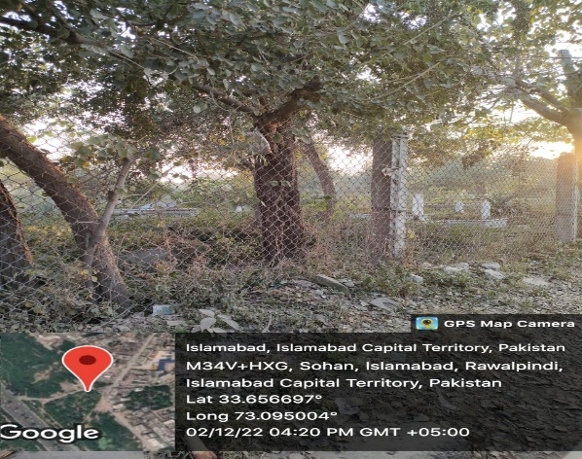
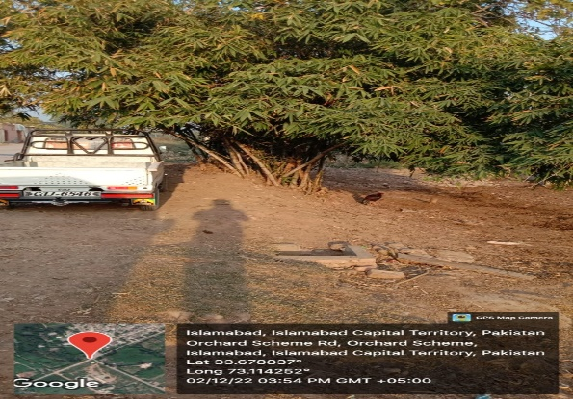 | 
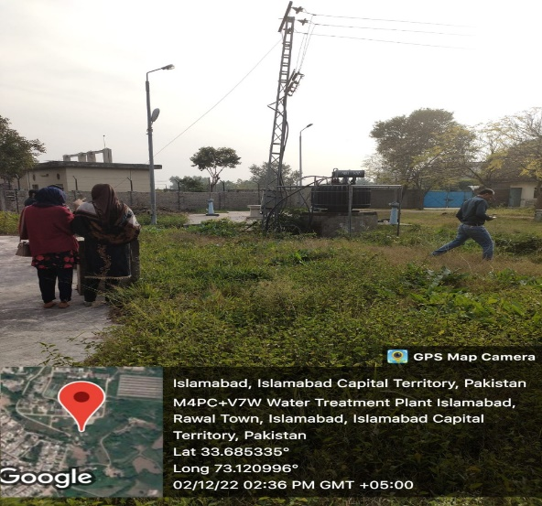 | 
- Wetlands
- There are no designated wetlands in the project area.
- Fish Species
- There are 15 fish species belonging to 11 genera that are present in Rawal Lake. The fish species in Rawal Lake and its tributaries include: Doula (Channa channa), Rahu (Labeorohita), Thaila (Catla catla), Mori (Cirrhinus mrigala), Carp fish (Cyprinus carpio) and Talapia (Tilapia mossambica).
- Terrestrial Fauna
- The reservoir is of considerable importance for wintering waterfowl, especially Anas platyrhynchos.
- Resident mammals include the Red fox, Indian pangolin, Indian crested porcupine, jungle cat, Persian jackal, Central Asian boar and yellow-throated marten.
- Reptiles include Indian Cobra and Russell's viper. It is a good place for birds watching, as the majority of Birds of Islamabad are found here.

Protected Areas
- Margala Hills National Park is the nearest protected area which is located at approximate distance of 10 km from the project site. Screening was carried out for biodiversity features of the area by using Integrated Biodiversity Assessment Tool (IBAT) for proposed project to identify the biodiversity features and species that are located within the following buffers: 1 km, 3 km and 5 km. Results of IBAT screening shows that there were no protected and/or key biodiversity areas found within 5 km buffer from the alignment of proposed Conductance Main.
- The result of IBAT shows that there is no Game Reserve, Reserve Forests and wild sanctuaries reported in the project alignment. The results of IBAT are shown in Figure 6.9 and Figure 6.10. The detailed IBAT report is attached as Annexure-III of this report.
Figure 6.9: Results of IBAT A
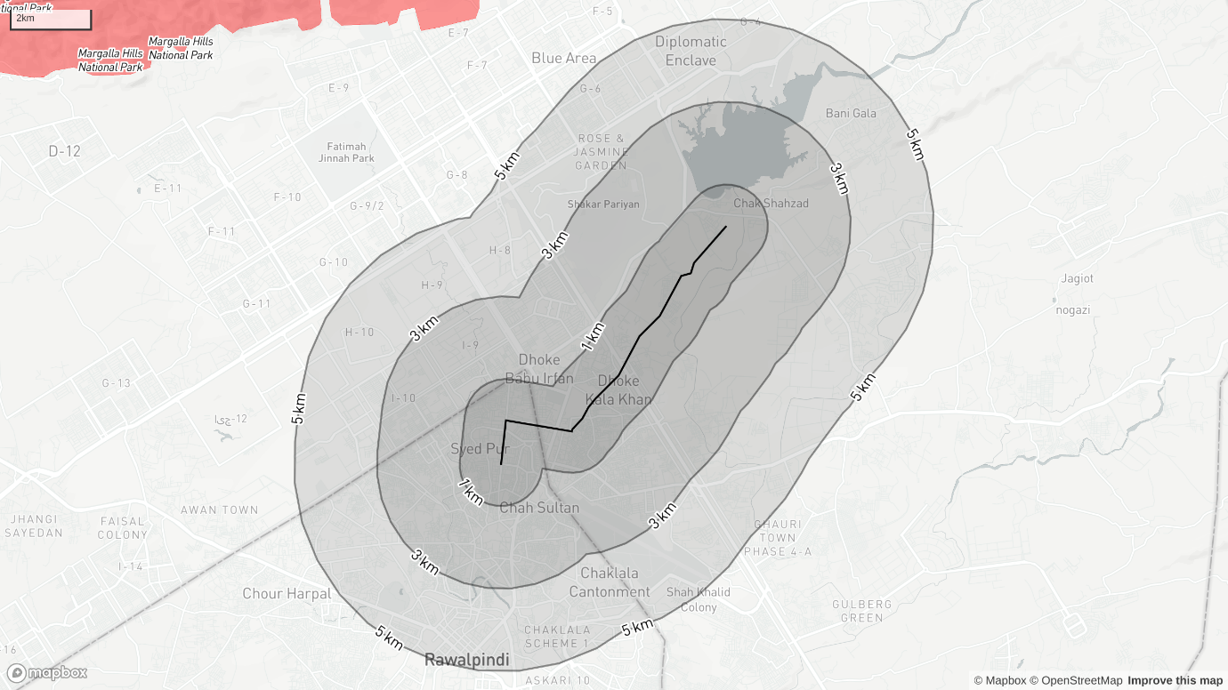
Figure 6.10: Results of IBAT B
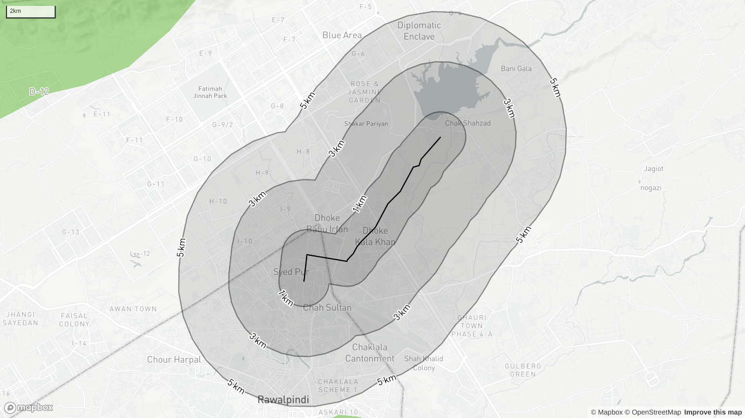
- These two figures show presence/absence of endangered species around the project site with two different angles.
- Furthermore, the forests located near the project area are listed in Table 6.9. However, no impact is anticipated due to the proposed interventions as the project area is far away from the boundary of below listed forests.
Table 6.9: Forests Located near the Project Area
Sr. No. | Name | Area (Acre)
1 | Takhar Pari Forest | 2,210
2 | Margala Hills National Park | 42,962
2 | Khairi Murat Reserved Forest | 12,680
3 | Dhungi Reserved Forest | 4,746
4 | Adiala Reserved Forest | 1,330
Source: TAS for LAI Expressway Project, 2022
- The Figure 22 shows the location and approximate distances of the nearest forests from the project site.
Figure 6.11: Location of Forests near project site
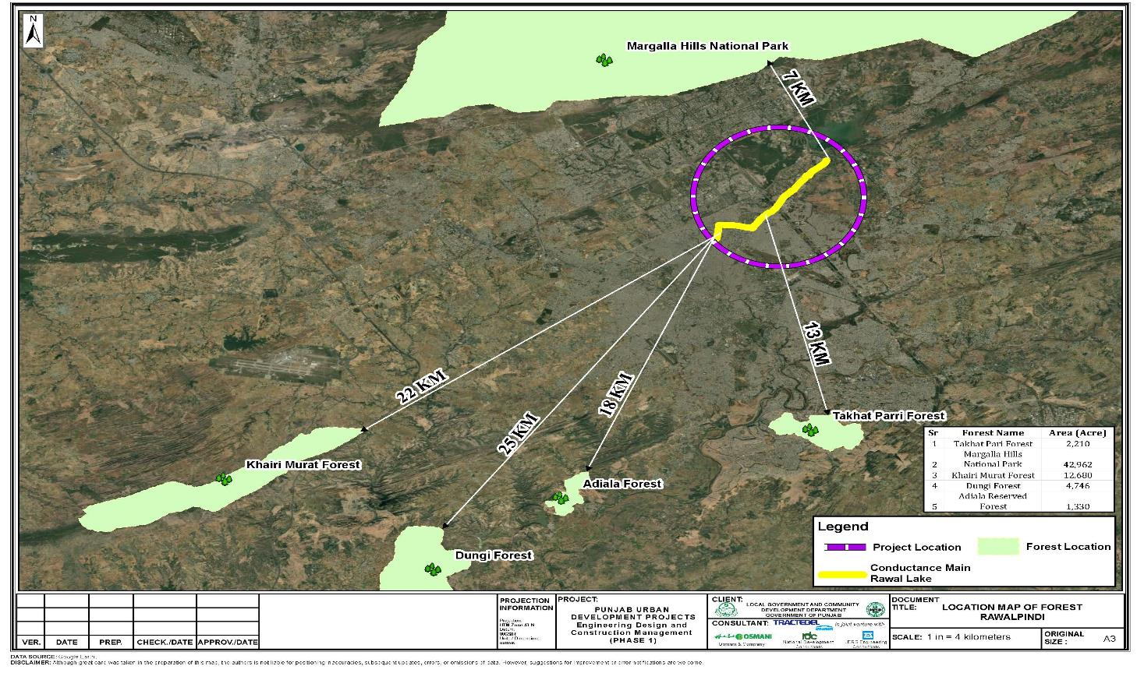

Socio-economic Environment
- This section includes a summary of the prevailing socio-economic conditions in the project area and the population that will be potentially affected by the project. To ascertain the socio-economic condition of the project area, primary and secondary data was collected including social and physical infrastructure in the project area.
- To assess the socioeconomic conditions of the project area, consultations were carried out with participants in the area. Households has been studied during field survey based on individual interviews as well as focus group discussions/ public consultations. Consultation participants include project affected people and community residing along the route of the pipelines to be laid. In addition, the secondary data, including Economic Survey of Pakistan (2018-19), Bureau of Statistics (2017-18) and District Population Census report were used as secondary data sources.
- Detailed surveys were conducted for project scoping during the month of December 2022. For the environmental and social assessment and sensitive receptor data collection, a CoI of 100 meters was taken. Most of the field data collection was carried out within this corridor though where relevant data was also collected from a wider area along the proposed project site. The reason for selecting this corridor is to cover those areas that have the potential to be affected by the project activities.
- The names of the major settlements falling within the close vicinity of project area are Rawal Town, Orchard Scheme, Dhoke Kala Khan, Satellite Town, Asghar Mall Scheme, Shamsabad, etc. Figure 6.12 shows socioeconomic conditions of the area.
Figure 6.12: Socioeconomic Conditions of the project area
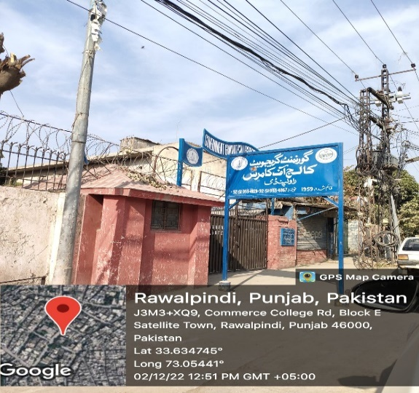 | 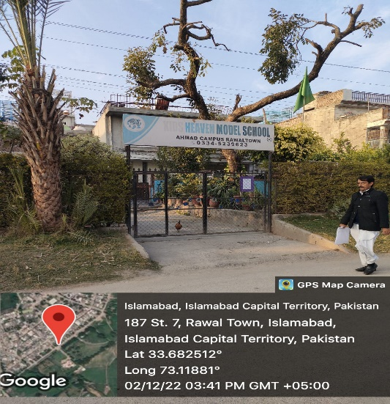
Schools within of CoI of proposed project
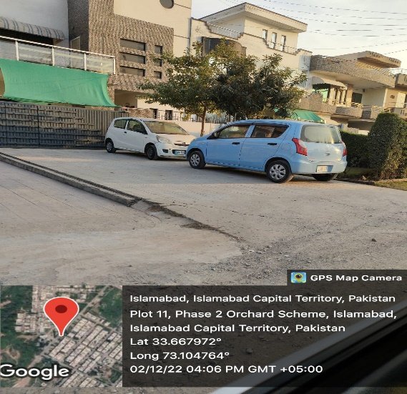 | 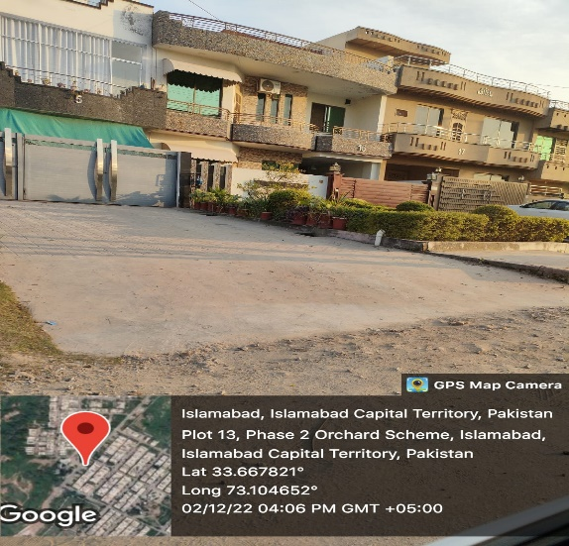
Houses in Islamabad area of project
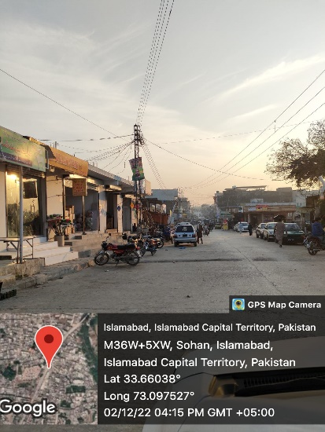 | 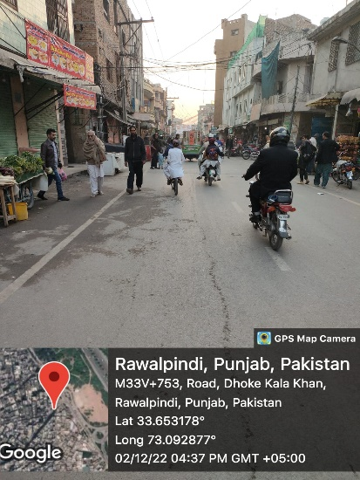
Sohan Market, Islamabad | Dhoke Kala Khan Market area
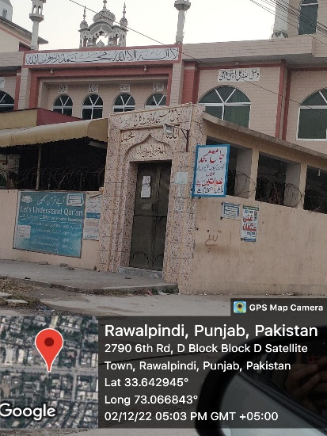 | 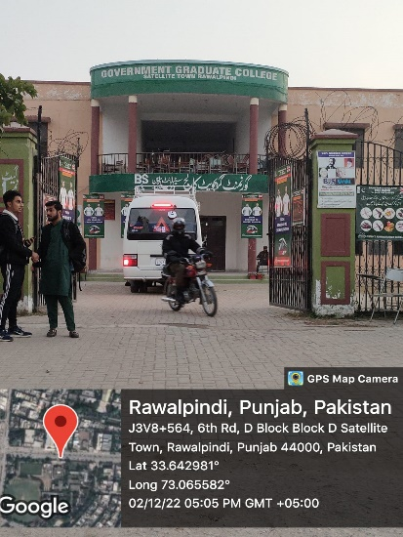
Mosque near Satellite Town | School in Satellite Town
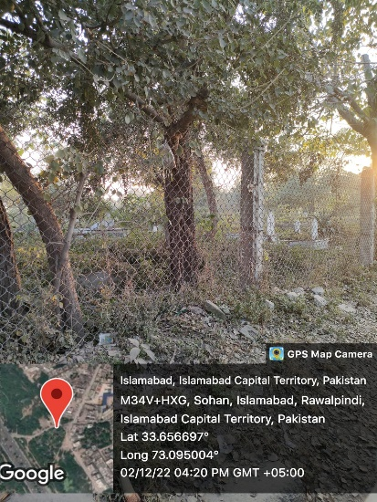 | 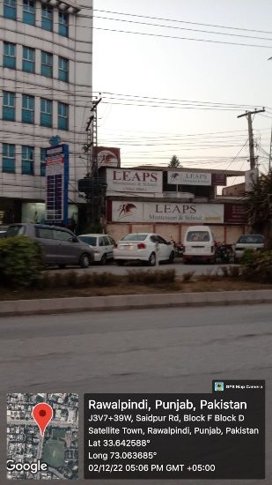
Graveyard near Sohan | Hospital at Saidpur Road

Administrative Setup
- The proposed project components are in two territories, Rawalpindi and Islamabad. Start of New Conductance Main is from Rawal Town of Islamabad, and it will run parallel to Saidpur Road and enters into Rawalpindi with the remaining project component being located in district Rawalpindi.
- Rawalpindi district is governed by the Rawalpindi District Council, while several regions sub-divided into one Municipal Corporation, two Cantonment Boards and Seven Tehsils;
  - Rawalpindi Municipal Corporation
  - Rawalpindi Cantonment Board
  - Chaklala Cantonment Board
- The Table 6.10 below shows the administrative subdivision of Rawalpindi district.
Table 6.10: Administrative subdivision of Rawalpindi District
Sr. No | Tehsil | Headquarters | Area  (km²) | Population  (2017)
1 | Taxila | Taxila | NA | 677,951
2 | Rawalpindi | Rawalpindi | NA | 3,258,547
3 | Gujar Khan https://en.wikipedia.org/wiki/Gujar_Khan_Tehsil | Gujar Khan | 1,466 | 678,503
4 | Kallar Syedan | Kallar Syedan | 421 | 217,273
5 | Kahuta | Kahuta | NA | 220,576
6 | Potohar | Potohar | NA | NA

Demography & Population
- According to Census 2017, the male population of Rawalpindi was 2,736,180 and female population was 2,665,089. The ratio of people living in rural and urban areas was; 2,396,672 (44.36%) lived in rural areas and 3,005,708 (55.64%) lived in urban areas.
- Similarly, the population of Islamabad was 2.01 million and total area is 906.50 Sq. Km. Islamabad city is divided into five major zones: Zone I, Zone II, Zone III, Zone IV, and Zone V. Zone IV is the largest in area while Zone I is the largest developed residential area. Zone 1 is divided into sectors. Each residential sector is identified by a letter of the alphabet and a number, and covers an area of approximately 2 km × 2 km. The Figure 6.13 showing the demographic features of Rawalpindi.
Figure 6.13: Demographic features of Rawalpindi

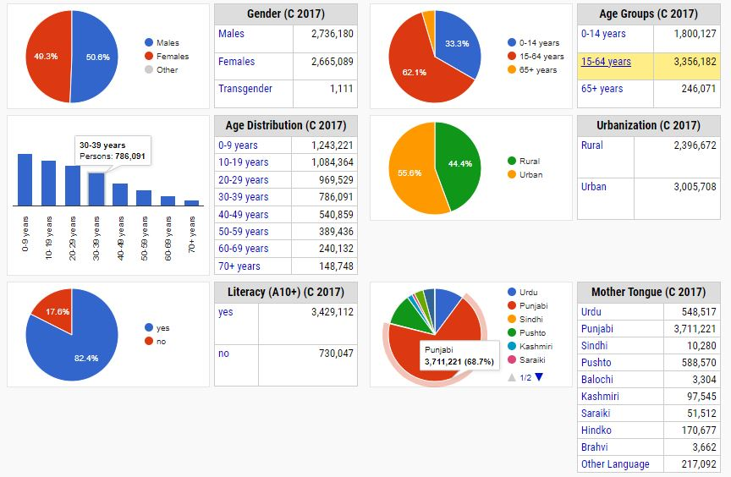

Religion
- Majority of the population of project area are Muslims. Cultural festivals are mostly linked with traditional religious events. According to the 2017 census, Muslims were the overwhelming majority religion with 98.01%, while Christians were 1.90% of the population.

Archaeological and Cultural Site
- No archaeological and cultural site was observed in close proximity of the proposed project. However, if any archaeological antiquity will be discovered, the Archaeological Chance Find procedure shall be adopted and is provided as Annexure-VI.

Ethnicity in the Project Area
- During social survey of the proposed project area, it was found that the entire population is Muslims. Thus, none of these castes may be considered as indigenous people (IP) based on ADB SPS definition.

Language and Dialects
- The major languages of the area are Hindko, Punjab, Urdu and Pashto with certain people also speaking Kashmiri, Saraiki and Brahvi.

Dwellings
- The housing conditions of the respondents have been analyzed according to the type of houses in which they were residing. The house or building constructed with concrete or burnt bricks fall in ‘pacca’ category whereas house or building constructed with burnt bricks with mud comes under ‘semi-pacca’ category, while houses constructed with mud bricks or temporary wooden logs etc. are categorized as ‘kacha’ house. All the respondents in project area are living in category of ‘Pacca’ houses.

Economics of Rawalpindi / Islamabad
- The economy of the majority of the people of study area is based on their private business and government jobs. People living in Rawal Town, Satellite town etc. areas are well settled with high per capita income. Some family members are settled outside the country and send remittances to family members in Pakistan. The majority of the people of Rawalpindi and Islamabad are directly or indirectly depending on Government/private jobs in educational/government institutions for their income.

Education Facilities in Project area
- The cities of Islamabad and Rawalpindi fall under the category of large cities that are among the hub of educational facilities with a considerable number of public and private schools and colleges present in the study area.

Social Amenities in the project area
- During the field survey, the access/ availability of the social amenities/ basic infrastructure was asked from the surveyed households as well as physically observed at site. It was noted that facilities such as Electricity, Sui Gas, Water Supply, Telephone, Sewerage Drainage, school are available in both Rawalpindi and Islamabad.

Major Source of Drinking Water
- Currently, there are two main sources of water supply in people of project area. The major source is water supply from RWASA and CDA. While the other source of water is ground water. Some households have installed their own electrical pumps on bore holes.

Health Facilities in project area
- Health facilities in the form of Government and Private health care institutes is present in and around the project area. It shows the presence of health care facilities. Being the major cities, Rawalpindi and Islamabad has primary, secondary and tertiary health care facilities. PIMS, Shifa International, CMH, Rawal Foundation, Ripha International Hospital, Islamabad International Hospital and Research Centre etc.

Environmental Sensitive Receptors
- Sensitive receptors are people/places more susceptible to the adverse effects of exposure to pollutants and social disturbances, due to the developmental projects. Thus, sensitive receptors are necessary to be identified, to evaluate the potential impacts of the proposed project on public health and the environment and adopt necessary mitigation measures to minimize the impact.
- The sensitive receptors identified for the proposed project within or near the CoI includes educational institutes, health care facilities like hospitals, site of religious and cultural importance etc. They are prone to sensitivity during construction phase, due to emission of air pollutants, noise and vibration, traffic jams/access, temporary edifice of construction camps, and mobilization issues. The map of sensitive receptors of the study area is shown in Figure 6.14 and Table 6.11 shows the detail of Environmental Sensitive Receptors along the COI of proposed project area.

Figure 6.14: Environmental sensitive Receptors
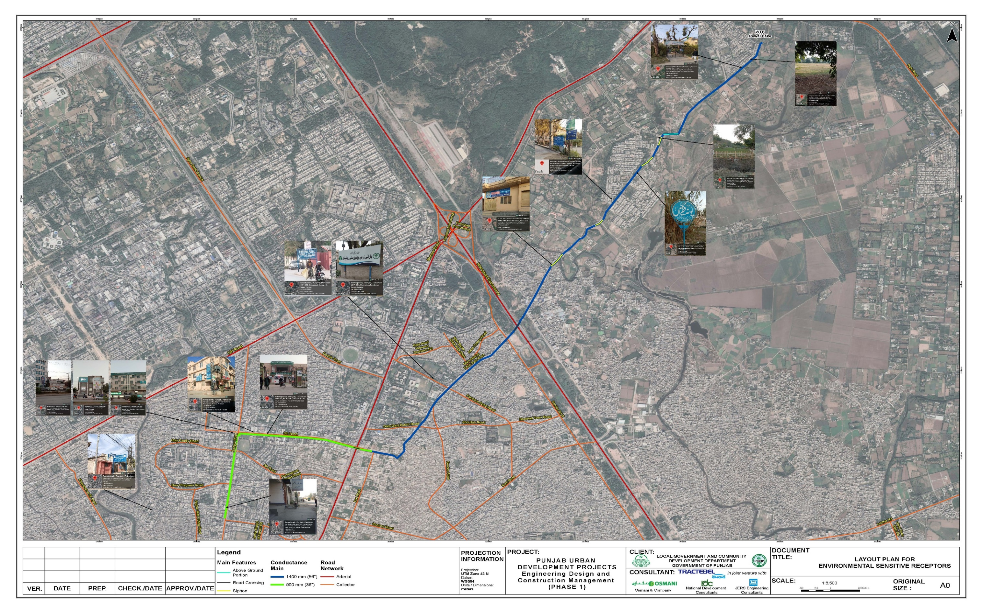

Table 6.11: Detail of Environmental Sensitive receptors
Sr. No. | Pictorial View | Coordinates | Description
 | 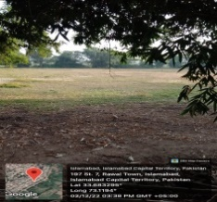 | 33.683295° N  73.1194° E | Park
 | 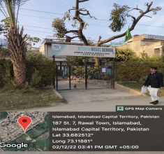 | 33.682512° N  73.11881° E | School
 | 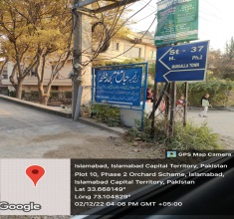 | 33.668149° N  73.104829° E | Mosque
 | 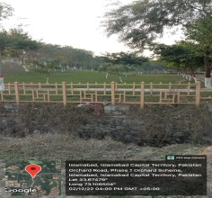 | 33.67479° N  73. 109504° E | Park
 |  | 33.67121° N  73.107386° E | Mosque
 | 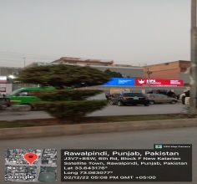 | 33.643176° N  73.063077° E | College
 | 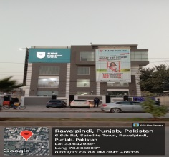 | 33.642989° N  73.065909° E | College
 | 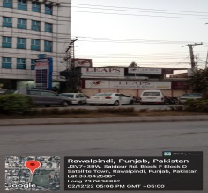 | 33.642588° N  73.063685° E | College
 | 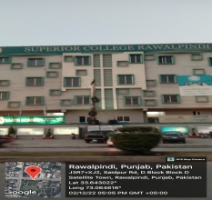 | 33.643022° N  73.064618° E | College
 | 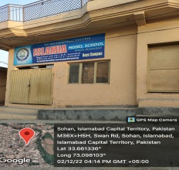 | 33.661336° N  73.098103° E | School
 | 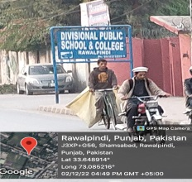 | 33.648914° N  73.085216° E | School and College
 | 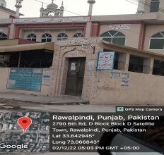 | 33.642945° N  73.066843° E | Mosque
 | 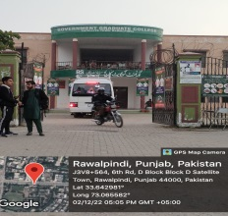 | 33.642981° N  73.065582° E | College
 | 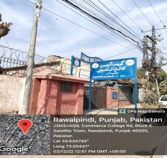 | 33.634745° N  73.05441° E | College
 | 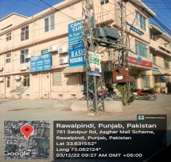 | 33.631552° N  73.062124° E | Medical Clinic
 | 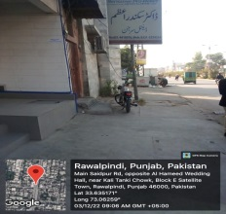 | 33.635171° N  73.06259° E | Medical Clinic

Environmental Monitoring
- Environmental monitoring was carried out for water, air and noise levels at two locations along the proposed project line. Two locations were selected for environmental monitoring based on the environmental receptors and level of construction activity involved. Environmental monitoring was carried out in December 2022 by EPA Certified Laboratory. The location of the sampling points are marked on the layout map. The results of Environmental Monitoring are attached as Annexure-IV. The monitoring is carried out with calibrated equipment. Calibration certificates of the equipment are attached as Annexure-V.
Figure 6.15: Locations of Environmental Monitoring Points
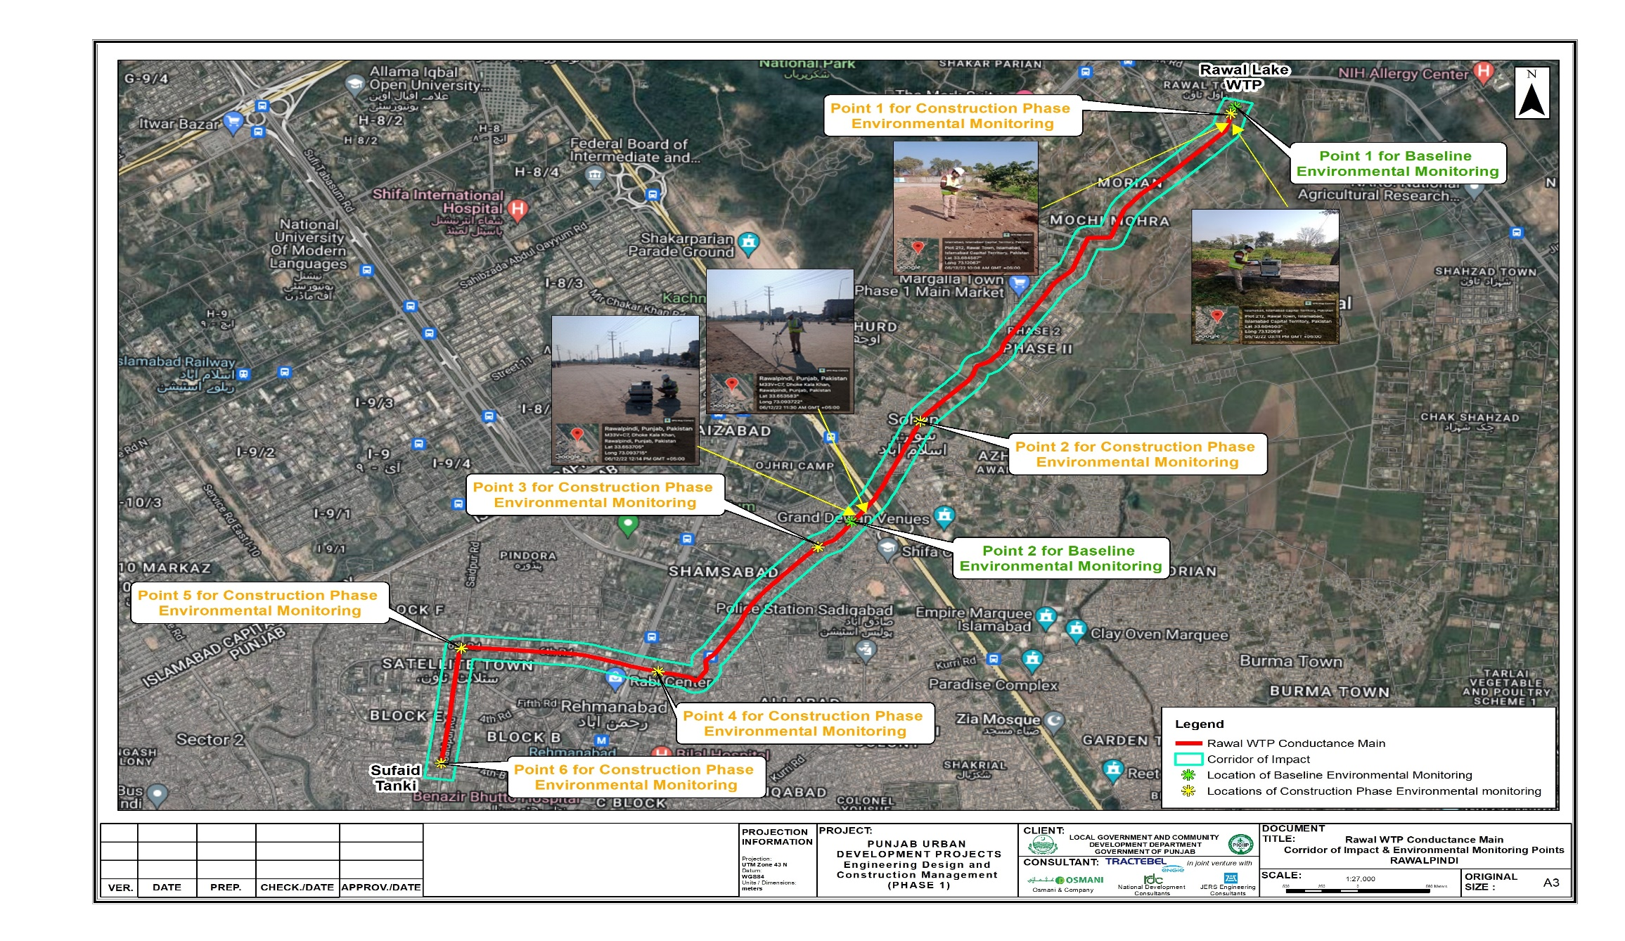

Water Quality
- Water sampling was carried out at two locations (i) Near Rawal Lake Filtration Plant (ii) Dhoke Kala Khan Road on 5-6 December 2022. Ground water samples were taken for analysis. The complete lab results for drinking water quality of the sample collected at two locations are given below. The lab reports are attached as Annexure IV.

Locations and Reason for selection of Monitoring point:
- The location and rationale of the water sampling is given below in Table 6.12.
Table 6.12: Water Quality Sampling Location Description
Sample | Coordinated | Location | Sample Taken | Rationale of Selection
W.1 | Lat. 33.684651  Long. 73.120621 | Near Rawal WTP | Drinking water (Tap Water) | The sampling locations were identified to check the water quality near the treatment plant (source)
W.2 | Lat. 33.653685  Long. 73.093652 | Dhoke Kala Khan | Drinking Water (tap water) | sample was taken from midway to check if contamination is added in water due to leakage of DCM pipe line
- The sampling locations were identified to check the water quality near the treatment plant (source) and the other sample was taken from midway to check if contamination is added in water due to leakage of DCM pipe line. Sampling location and coordinates are marked on the pictures given int

Results and Analysis
- It is evident from the laboratory results that all the analyzed parameters are within compliance with the limiting values set by WHO, PEQS, and NEQS for drinking water. The results show that the water is fit for drinking purposes as no biological contamination is found in the water samples and the physical and chemical parameters are also fit for drinking purposes. The water samples were taken from a nearby house along the alignment of the proposed Conductance Main. Tap water was taken for analysis. Table 6.13 shows the water analysis results for the project area.
Table 6.13: Results of Water Quality Analysis

Dhok Kala Khan Road
Sr. No. | Parameters | N/P EQS | WHO | Unit | Result | Method
01 | pH | 6.5-8.5 | -- | - | 7.29 | APHA 4500-H B
02 | TDS | 1000 | 1000 | Mg/l | 326.0 | APHA 2540 C
03 | Chloride | 250 | 250 | Mg/l | 120.99 | 4500- APHA Cl B
04 | Fluoride | 1.5 | 1.5 | Mg/l | 0.7 | APHA 4500 F D
05 | Taste | Unobjec. | -- | Unobjec. | Unobject. | APHA 2120B
06 | Odour | Un objectionable | -- | Unobjec. | Unobject. | APHA 2120B
07 | Colour | ≤15 | -- | TCU | 1.5 | APHA 2120 B
08 | Nitrate | 50 | 50 | Mg/l | BDL | APHA 4500-NO⁻³ E
09 | Nitrite | 3 | -- | Mg/l | BDL | APHA 4500-NO⁻³ B
10 | Lead | ≤0.05 | 0.01 | Mg/l | 0.01 | APHA-Pb B
11 | Total Hardness | ≤500 | -- | Mg/l | 141.96 | APHA 2340 C
12 | Turbidity | ≤5 | -- | NTU | BDL | APHA 2130 B
13 | Zinc | 5 | 3 | Mg/l | 0.3 | APHA 3500-Zn B
14 | Aluminum | ≤0.2 | 0.2 | Mg/l | 0.05 | APHA 3111 D
15 | Chromium | ≤0.05 | 0.05 | Mg/l | 0.37 | APHA 3500-Cr B
16 | Cadmium | 0.01 | 0.003 | Mg/l | BDL | APHA 3500-Cd D
17 | Copper | 2 | 2 | Mg/l | 0.08 | APHA 3500-Cu C
18 | Boron | 0.3 | 0.3 | Mg/l | 0.045 | APHA 4500-B C
19 | Barium | 0.7 | 0.7 | Mg/l | 0.054 | APHA 3111 B
20 | Antimony | ≤0.005 (P) | ≤0.02 | Mg/l | 0.008 | APHA 3114 C
21 | Arsenic | 0.05 | 0.01 | Mg/l | BDL | APHA 3114 C
22 | Cyanide | 0.05 | 0.07 | Mg/l | 0.001 | APHA 4500-CN D
23 | Mercury | 0.001 | 0.001 | Mg/l | BDL | APHA 3112
24 | Nickel | 0.02 | 0.02 | Mg/l | BDL | APHA 3111 B
25 | Residual Chlorine | 0.2-0.5 at consumer end | -- | Mg/l | 0.31 | APHA 4500-Cl₂
26 | Total Coliform | 0/100ml | 0/100ml | Number/100ml | 0 | APHA 9222 B
27 | Thermo Coliform | 0/100ml | 0/100ml | Number/100ml | 0 | APHA 9222 B
28 | E. Coli | 0/100ml | 0/100ml | Number/100ml | 0 | APHA 9222 C
Near Rawal Lake Filtration Plant
Sr. No. | Parameters | PEQS | WHO | Unit | Result | Method
01 | pH | 6.5-8.5 | -- | - | 7.18 | APHA 4500-H B
02 | TDS | 1000 | 1000 | Mg/l | 267.0 | APHA 2540 C
03 | Chloride | 250 | 250 | Mg/l | 9.99 | 4500- APHA Cl B
04 | Fluoride | 1.5 | 1.5 | Mg/l | 0.7 | APHA 4500 F D
05 | Taste | Unobjectable | -- | Unobjec. | Unobject. | APHA 2120B
06 | Odor | Unobjectable | -- | Unobjec. | Unobject. | APHA 2120B
07 | Color | 15 | -- | TCU | 1.5 | APHA 2120 B
08 | Nitrate | 50 | 50 | Mg/l | BDL | APHA 4500-NO-3 E
09 | Nitrite | 3 | -- | Mg/l | BDL | APHA 4500-NO-3 B
10 | Lead | 0.05 | 0.01 | Mg/l | 0.01 | APHA-Pb B
11 | Total Hardness | 500 | -- | Mg/l | 183.8 | APHA 2340 C
12 | Turbidity | 5 | -- | NTU | BDL | APHA 2130 B
13 | Zinc | 3 | 3 | Mg/l | 0.6 | APHA 3500-Zn B
14 | Aluminum | 0.2 | 0.2 | Mg/l | 0.05 | APHA 3111 D
15 | Chromium | 0.050 | 0.05 | Mg/l | 0.37 | APHA 3500-Cr B
16 | Cadmium | 0.01 | 0.003 | Mg/l | BDL | APHA 3500-Cd D
17 | Copper | 2 | 2 | Mg/l | 0.04 | APHA 3500-Cu C
18 | Boron | 0.300 | 0.3 | Mg/l | BDL | APHA 4500-B C
19 | Barium | 0.700 | 0.7 | Mg/l | BDL | APHA 3111 B
20 | Antimony | 0.020 | ≤0.02 | Mg/l | 0.005 | APHA 3114 C
21 | Arsenic | 0.050 | 0.01 | Mg/l | BDL | APHA 3114 C
22 | Cyanide | 0.05 | 0.07 | Mg/l | 0.001 | APHA 4500-CN D
23 | Mercury | 0.001 | 0.001 | Mg/l | BDL | APHA 3112
24 | Nickel | 0.020 | 0.02 | Mg/l | BDL | APHA 3111 B
25 | Residual Chlorine | 0.2-0.5 | -- | Mg/l | 0.28 | APHA 4500-Cl2
26 | Total Coliform | 0/100ml | 0/100ml | Number/100ml | 0 | APHA 9222 B
27 | Thermo Coliform | 0/100ml | 0/100ml | Number/100ml | 0 | APHA 9222 B
28 | E. Coli | 0/100ml | 0/100ml | Number/100ml | 0 | APHA 9222 C

Ambient Air Quality
There is no major anthropogenic source found near and around the proposed project site area, other than local roads and a few cooking stoves in villages. The agricultural land results in windblown dust in dry conditions. The pollutants selected for evaluation, based on the expected emissions from the project activities and the level of risk to human health posed by these pollutants, are as follows:
  - Respirable particulate matter: PM₁₀
  - Sulfur dioxide (SO₂)
  - Oxides of Nitrogen (NO_{X}): Mainly Nitrogen dioxide (NO₂) and Nitric oxide (NO)
  - Carbon Monoxide (CO)

Reason for selection of Monitoring point
- The sampling locations were identified to check the ambient air quality near the treatment plant and the other sample was taken from Dhoke Kala Khan where commercial activities are at its peak in the area. Further, these are the main points where more environmental receptors are available and potential for exposure is high.
- The sampling location and rationale is given below in Table 6.14.
Table 6.14: Detail of Air Quality Sampling Locations
Sample ID | Coordinates | Location | Rational for selection
A-1 | Lat/ 33.684562  Long. 73.120684 | Near Rawal Lake WTP | The sampling locations were selected based on the presence of Environmental Sensitive Receptors (like health care institutes, educational institutes and places of religious importance) and scale of construction activity.
A-2 | Lay. 33.653705  Long. 73.093715 | Near Dhoke Kala Khan | The sampling locations were selected based on the presence of Environmental Sensitive Receptors (like health care institutes, educational institutes and places of religious importance) and scale of construction activity.
- Sampling location and coordinates are marked on the pictures given in the Figure.

Results and Analysis
Ambient Air Quality sampling was carried out at two locations (i) Near Rawal Lake Filtration Plant (ii) Dhok Kala Khan Road on 5-6 December, 2022. The complete lab results for ambient air quality at all two locations and results are given in Table 36 below. The lab reports are attached as Annexure IV.

Key results:
- All parameters analyzed are within NEQS/PEQS limits for ambient air. However, values of PM10, CO and SO2 exceeded the limiting value set by WHO which is more stringent than PEQS/NEQS limiting values. The major source of particulate matter, Carbon monoxide and Sulphur dioxide are traffic and commercial activities in the area.
Table 6.15: Ambient Air Quality Results
Near Rawal Lake Filtration Plant
Sr. No | Parameters | NEQS/PEQS | WHO | Units | Results | Test Method
1 | PM₁₀ | 150 | 45 | µg/m³ | 124.8 | 40 CFR Part 50, App J (US-EPA)
2 | CO | 10 | 4 | mg/m³ | 4.38 | 40 CFR Part 50, App. C (US-EPA)
3 | NO_{x} (NO, NO₂) | 80 | 25 | µg/m³ | 35.6 | 40 CFR Part 50, App. F (US-EPA)
4 | SO₂ | 120 | 24hrs 40 | µg/m³ | 49.4 | EQSA-0197-114 (US-EPA)
Dhoke Kala Khan Road
Sr. No. | Parameters | NEQS/PEQS | WHO | Units | Results | Test Method
1 | PM₁₀ | 150 | 45 | µg/m³ | 139.8 | 40 CFR Part 50, App J (US-EPA)
2 | CO | 10 | 4 | mg/m³ | 5.6 | 40 CFR Part 50, App. C (US-EPA)
3 | NO_{x} (NO, NO₂) | 80 | 25 | µg/m³ | 38.4 | 40 CFR Part 50, App. F (US-EPA)
4 | SO₂ | 120 | 24hrs 40 | µg/m³ | 62.5 | EQSA-0197-114 (US-EPA)

Noise Level
- This section defines the baseline ambient noise levels in the CoI in a manner that can be used for the assessment of the noise impact of the proposed project. Noise levels were measured at two selected locations on 5-6 December, 2022, considered representative of the nearby receptors of possible noise disturbance from the project. Noise monitoring was carried out for 24 hours. The summary of results is shown in Table 6.16. The detail monitoring report is attached as Annexure IV.

Reason for selection of Monitoring point
- The sampling locations were identified to check the noise levels near the treatment plant (source) and the other sample was taken from Dhoke Kala khan. Dhoke Kala khan is a densely populated area with large number of receptors and people to be affected by project activity. Baseline has been established to check the level of impact during construction phase of the proposed project. Sampling location and coordinates are marked on the pictures given in this section.
The location of noise levels sampling with rational for selection of site is given below in Table 38.
Table 6.16: Detail of location for Noise Levels Monitoring
Sample ID | Coordinates | Location | Rational for selection
N-1 | Lat 33.684594  Long. 73.120671 | Near Rawal Lake WTP | The sampling locations were selected based on the presence of Environmental Sensitive Receptors (like health care institutes, educational institutes and places of religious importance) and scale of construction activity.
N-2 | Lat. 33.653685  Long. 73.093652 | Near Dhoke Kala Khan | The sampling locations were selected based on the presence of Environmental Sensitive Receptors (like health care institutes, educational institutes and places of religious importance) and scale of construction activity.

Key results are:
All parameters analyzed were within PEQS/NEQS limiting values for noise levels in the day time at Dhoke Kala Khan. The noise levels are exceeding the limiting values, set by PEQS/NEQS for residential area at Rawal Lake Filtration Plant site.
Table 6.17: Noise Level
Near Rawal Lake Filtration Plant
Sr. No. | Day Average (24hrs) | Noise  db(A) |  | PEQS/NEQS Limits |  | WHO Limits |  | Remarks
 |  | Day | Night | Day Time | Night Time | Day | Night
1 | 57.31 | 55.9 | 54.7 | 55 | 45 | 70 | 70 | Within limits of WHO
Dhoke Kala Khan
Sr. No | Day Average (24hrs) | Noise Levels (db(A) |  | PEQS/NEQS Limits |  | WHO limits |  | Remarks
 |  | Day | Night | Day Time | Night Time | Day | Night
1 | 59.8 | 57.3 | 51.1 | 65 | 55 | 70 | 70 | Within limits

- The photographic evidence of baseline environmental monitoring of drinking water, ambient air and noise level is shown in Figure 6.16.
Figure 6.16: Photos of Environmental Monitoring
Environmental Monitoring Photo Log
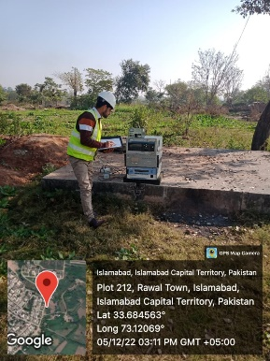 | 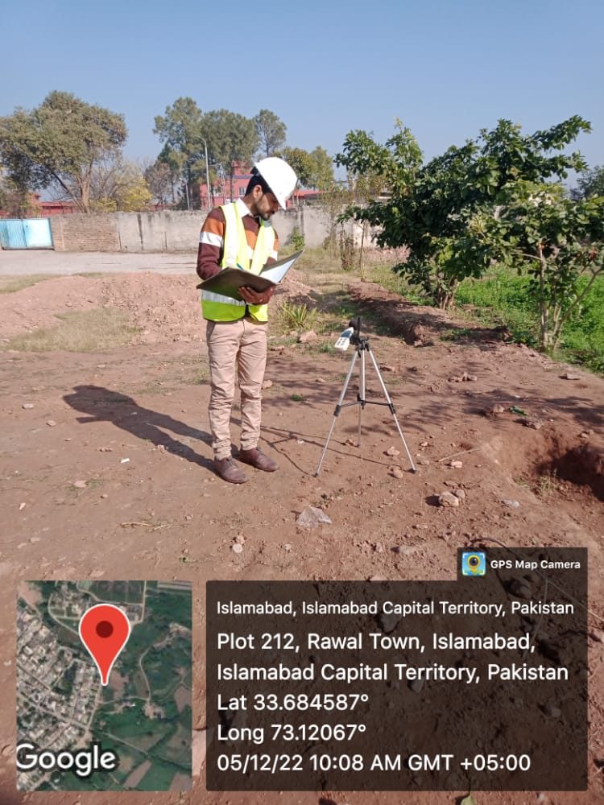
Sampling location near Rawal Lake WTP
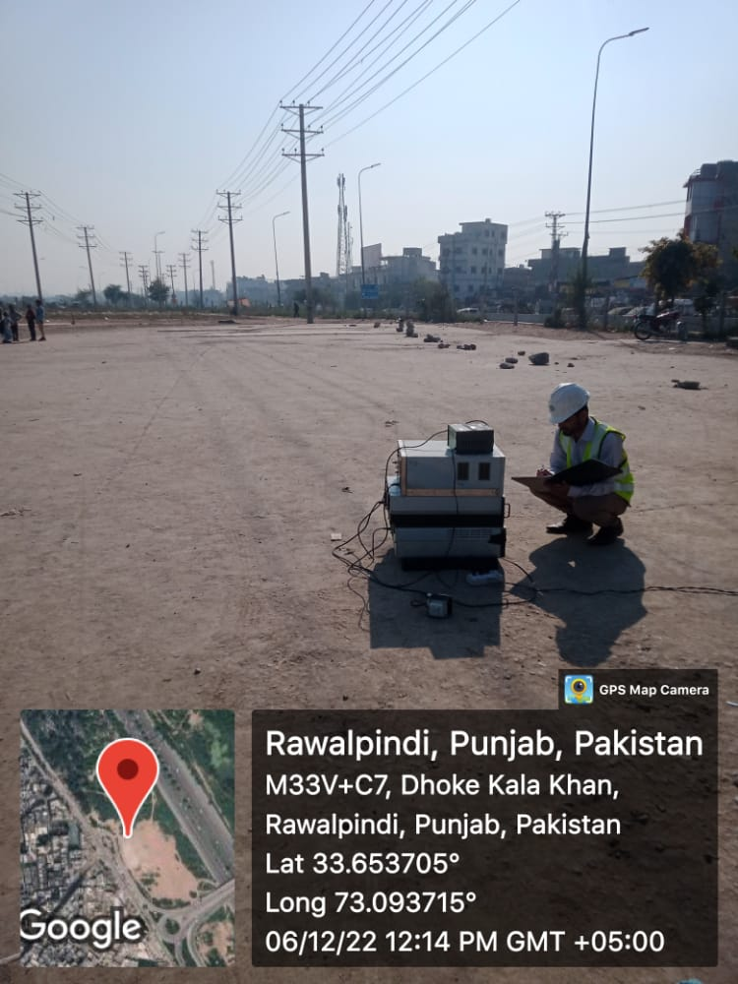 | 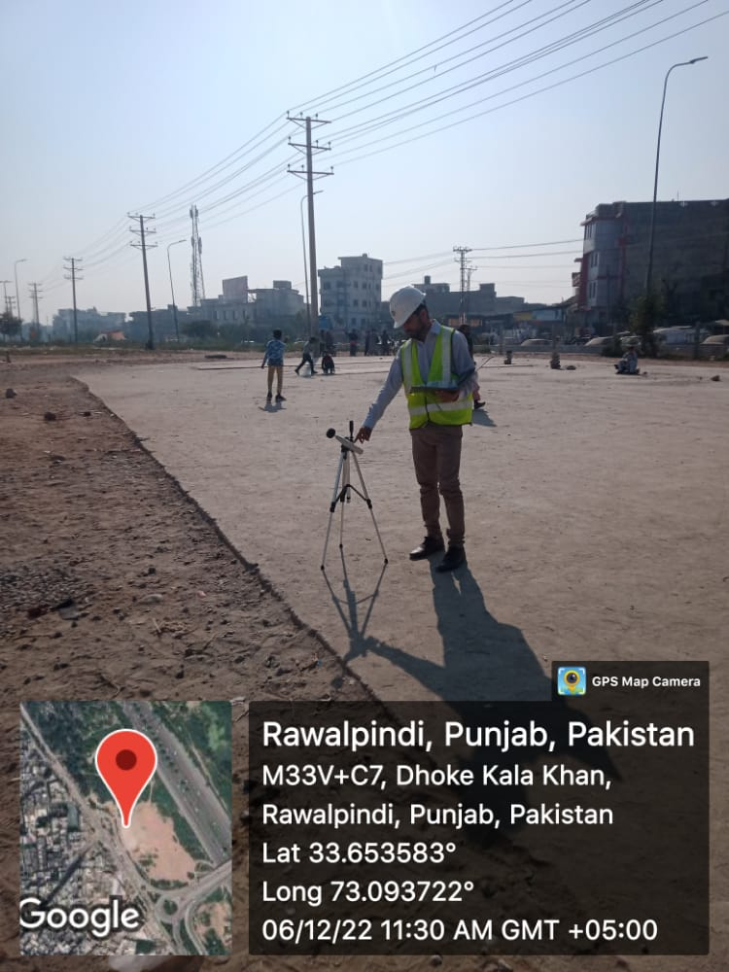
Monitoring location near Dhoke Kala Khan

POTENTIAL ENVIRONMENTAL IMPACTS AND MITIGATION MEASURES

General
- This chapter identifies the beneficial as well as the potentially significant adverse environmental and social impacts during design/pre-construction, construction and operation phases of the proposed project on the physical, ecological and socio-economic domains of the environment. The appropriate mitigation and remedial measures are proposed in this chapter. A project impact evaluation matrix has been developed to evaluate the potential impacts of the proposed Project. A brief qualitative description of each aspect and the affected environment in both RoW and the project’s corridor of impact is presented below.

Methodology for Impact Screening
- The methodology for assessing the risk level associated with each potential impact is presented below.
Risk is assessed as the likelihood that the activity will have an effect on the environment as well as the consequence of the effect occurring. It is often described like this:
Risk = Likelihood × Consequence

Likelihood Scale

Likelihood | Definition | Scale
Certain | Will certainly occur during the activity at a frequency greater than every week if preventative measures are not  applied | 5
Likely | Will occur more than once or twice during the activity but less than weekly if preventive measures are not applied | 3
Unlikely | May occur once or twice during the activity if preventive measures are not applied | 2
Rare | Unlikely to occur during the project | 1

Consequence Scale

Consequence | Definition |  | Score
Catastrophic | The action will cause unprecedented damage or impacts on the environment or surrounding  communities |  | 5
Major | The action will cause major adverse damage on the environment or surrounding communities |  | 3
Moderate | No or minimal adverse environmental or social impacts |  | 2
Minor | No or minimal adverse environmental or social impacts |  | 1

Risk Score Table

Likelihood | Consequence
 |  | Catastrophic | Major | Moderate | Minor
 | Certain | 25 | 15 | 10 | 5
 | Likely | 15 | 9 | 6 | 3
 | Unlikely | 10 | 6 | 4 | 2
 | Rare | 5 | 3 | 2 | 1
Risk: Significant: 15-25 Medium: 6-10 Low 1-5
- Any ‘Medium’ to ‘Significant’ risk requires an environmental management measure to manage the potential environmental risk. Judgment will be required concerning the application of an environmental management measure to mitigate low risk situations.

Potential Positive Impacts
- The positive impacts due to the proposed project are mentioned below:
  - The project will provide sustainable and clean water sources in serving areas.
  - Access to clean water will improve the general health status of the area and reduce exposure to waterborne diseases, ultimately, health budget of the project area will be decreased.
  - The project will result in conservation of groundwater resource of project area by augmenting more surface water from Rawal Lake WTP.
  - People will save money that they need to spend on the purchase of water containers, especially during the summer season.
  - The project will result in improved access to water for nearby communities and other major settlements.
  - The sale of food and other services to immigrant workers during the construction phase of the project will lead to some direct incomes as a form of project impact.
  - The communities may be presented in the form of temporary employment, when engaged to assist surveyors. Also, experts involved in feasibility studies and other pre-project consultations may lead to some level of purchases of items from petty traders and farmers during their presence in the communities. Some form of temporary employment would be generated for community members during the construction phase by the project directly. However, the completion of the project enhances the employment possibilities of the inhabitants.

Potential Adverse Impacts
- Apart from positive impacts, there are some potential adverse environmental and social impacts on the local environment. The proposed project is divided into three (03) stages i.e. Pre-construction / Planning and Design Stage, Construction Stage and Operation and Maintenance (O&M) Stage. The Pre-Construction Stage includes all stages before the construction Stage (i.e. site investigation work i.e. topographical, seismic studies etc.); construction Stage includes all stages from mobilization of Contractor to the completion of the project; and operation Stage starts after the construction Stage which includes the inspection and repair works.
Adverse impacts envisaged at these three (03) stages of the proposed water supply project along with their proposed remedial or mitigation measures are given in the following section.

Design/Pre-Construction Phase

Impact Screening Matrix
- The screening of potential impacts during the design/pre-construction phase is provided in Table 7.1 below.

Table 7.1: Screening of possible Impacts during Design/Pre- Construction phase for Conductance Mains Component
S/No. | Potential Issue | Likelihood (Certain, Likely, Unlikely, Rare) | Consequence (Catastrophic, Major, Moderate, Minor) | Risk Level (Significant, Medium, Low) | Residual Impact  (Short term, long term)
1 | Improper designing of  distribution networks including transmission mains (Replacement and New Distribution Lines) | 3 /  Likely | 2 /  Moderate | 6 /  Medium | Low / Long Term
2 | Lack of integration of  IEE/EMP requirements into Construction bid documents | 3 /  Likely | 2 /  Moderate | 6 /  Medium | Low / Short Term
3 | Relocation of existing utilities | 3 /  Likely | 2 /  Moderate | Medium | Low residual  Impact
4 | Identification of Locations for Labor Camps and ancillary facilities | 3 /  Likely | 2 /  Moderate | 6 /  Medium | Medium / Short Term
5 | Traffic Issues | 3 /  Likely | 2 /  Moderate | 6 /  Medium | Low / Short Term
6 | Land acquisition and resettlement impacts | 2 / Unlikely | 2 /  Moderate | Low | Low residual Impact
7 | Topographic Impact due to Excavation | 2 / Unlikely | 2 /  Moderate | Low | Low residual Impact
8 | Seismic Impacts | 2 / Unlikely | 2 /  Moderate | Low | Low residual  Impact

Critical Risk Level
Significant Risk Level
- Medium Risk Level
Low Risk Level

Adverse Impacts during Planning and Design Phase
- Potential adverse impacts during the planning and design stage of the project are given below.

Improper Designing of Distribution Networks including Transmission Mains (Replacement and New Distribution Lines)

Potential Impacts
- If location of water distribution networks is not carefully selected considering topography, geology and catchment of watershed results in degradation of channel embankments, reduce water flow or increased chances of structure settlement due to weak geological conditions/weak bearing capacity of soil.
- The water shall be conveyed to water works through Conductance Main is also primarily designed on gravity. If not designed properly while maintaining minimum head, the system will require high energy for pumping water to the desired storage tanks.

Mitigation Measures
- The following mitigation measures will be implemented:
  - Factors such as site capacity, accessibility, acceptability, stability, environmental sensitivity, land use, socio-economic receptors and climate hazards will be studied, and site will be selected accordingly.
  - A water supply network will be designed on the gravity flow to facilitate uninterrupted water supply through gravity system.

Residual Impact
- Provided the proposed mitigation measures are implemented, no significant adverse residual environmental effects are likely to occur. However, in case improper designing of conductance main, the residual impact will be low adverse in nature.

Lack of Integration of IEE/EMP Requirements into Construction Bid Documents

Potential Impacts
- The bidding documents must reflect the requirement to select a qualified and experienced Contractor from the perspective of ensuring implementation of required safeguards during project development.

Mitigation Measures
- The Environmental staff of PMU will be assigned the task of checking that design and bid documents are responsive to key environmental, social and safety considerations, and that the proposed method of work reflects the boundaries defined in the EMP. The bid documents must include the EMP, and its implementation cost must be reflected in the BOQ.
- IEE/EMP implementation and monitoring requirements must be part of bidding documents and necessary contractual binding must be agreed by project contractors before award of contract.
- Project contractors shall have qualified and experienced environmental staff to plan, arrange, implement, monitor and report IEE/EMP requirements.

Residual Impact
- Upon integration of EMP requirements into construction contract agreement, and upon implementation of EMP in true letter and spirit, the residual environmental effects are expected to be low in magnitude, and short term

Relocation of Utilities
- Utility services such as sewerage lines and telephone lines lying along the project alignment may need to be relocated temporarily or permanently to prevent damage to them.

Mitigation Measures
  - Detailed filed surveys will be conducted to assess any sub-surface utilities that might be present under the proposed project alignment within the right of way of the project, shall be relocated prior to the commencement of the work.
  - Based on the utilities that are identified during the detailed surveys, a relocation plan of those utilities will be developed by the respective line agencies in close coordination.
  - In case any utilities can be allowed to remain in place and avoidance of their damage is possible, the contractor will need to be aware of the location of these services so that disruptions are not caused. In such a scenario, the responsibility for any repair of damaged services will lie with the contractor.

Residual Impact
- Provided the proposed mitigative measures are implemented, the magnitude and extent of the environmental effects will be low. Therefore, no significant adverse residual environmental effects are likely to occur.

Identification of Locations for Labor Camps and ancillary facilities

Impacts
- The duration of the construction activity for the proposed project is expected to be 24 months and a considerable amount of workforce will be engaged. As a result, worker camps will need to be developed and ancillary facilities will need to be provided such as electricity, washrooms for labor with suitable effluent and sewage disposal facilities as well as water for their everyday use for drinking and bathing etc.

Mitigation Measures
- To prevent a nuisance, specific locations shall be designated for the development of the labor camps. All necessary facilities and amenities shall be provided in these camps such as resting areas, drinking water, electricity, and a supply of water.
- Solid and liquid effluent waste disposal facilities shall also be designed to cater for waste of administration/office building etc.
- The use of proper planning while identifying locations for the labor camps will ensure there is minimal disturbance to all key receptors and the traffic is not disrupted by labor camps being set up roadside next to the construction sites.
- A comprehensive Construction Management Plan will be prepared as part of the Site-Specific Environmental Management Plan (SSEMP) by the contractor and approved by the Executing Agency.

Residual Impact
No residual effects are expected.

Traffic Issues

Impacts
- In particular, the lying of water pipelines could result in heavy congestion due to the movement of construction heavy machinery and equipment with significant delays for traffic apart from posing a significant risk for vehicles.

Mitigation Measures
- A comprehensive traffic management plan shall be developed by the contractor and approved by the Executing Agency or the Project Management Unit that will contain the traffic diversion onto alternate routes and management of traffic flows to minimize the congestion and the possibility of accidents. This plan shall be dependent on the EMP and will be implemented by the contractor.

Residual Impacts
- After implementing the traffic management plan, the residual impacts will be low.

Land Acquisition and Resettlement Impacts

Impacts
- The proposed project involves the distribution of the water supply network. This water distribution network or pipes will be laid within the existing network of water pipes, so no land acquisition is involved in this proposed project.

Mitigation Measures
No mitigation measures are required.

Residual Impacts
No residual impacts so it will remain low.

Topographic Impacts due to Excavation

Potential Impacts
- The project area features a plain topography and no land acquisition is required for the proposed project. However, land excavation will be necessary for the proposed project. A minor physical change in the topography due to excavation of land is expected in the project area during the construction phase. This anticipated adverse impact is minimal.

Mitigation Measures
- Mitigation measures will involve adoption of best engineering design measures keeping in view of the aesthetics of the project area and provision of green areas for the landscape in design. The proposed design has tried to minimize these impacts.

Residual Impact
- No residual effects from this component of the project are anticipated as no significant topographical change is anticipated.

Seismic Impacts

Potential Impact
- In Building Code of Pakistan (Seismic Provisions, 2007), the whole region of Pakistan is classified into five main Seismic Hazard zones i.e., i) Zone-1, ii) Zone-2A, iii) Zone-2B, iv) Zone-3, v) Zone-4 based on the peak horizontal ground acceleration and its ultimate tendency to damages during seismic events. The proposed Project Area falls in the seismic zone classified as “Zone-2B” with g-value 0.16 to 0.24 and is considered as Moderate Hazard seismicity zone.
- The project is located in an active seismic region with a g-value ranging from 0.16 to 0.24. Therefore, care shall be taken in the design of all structures under this project, especially the construction of overhead reservoirs at all water works. The proposed project will not affect the earthquake activity of the area, as none of the activities involved have the potential to cause seismic disturbances. This adverse impact is medium in nature.

Mitigation Measures
- The proposed structure should be designed and constructed keeping in mind high-intensity earthquakes. For seismic hazard analysis, updated structural and seismic evaluations should be conducted by the design engineer/consultant. Moreover, geo-technical investigations must be conducted prior to the construction phase.

Residual Impacts
- Upon implementation of mitigation measures suggested above, no significant residual impact is anticipated

Adverse Impacts during Construction Stage

Impact Screening Matrix
The screening of potential impacts during the construction phase is provided in table below.
Table 7.2: Screening of Possible Impacts during Construction Phase for Conductance Mains Component
S/No. | Potential Issue | Likelihood (Certain, Likely, Unlikely, Rare) | Consequence (Catastrophic, Major, Moderate, Minor) | Risk Level (Significant, Medium, Low) | Residual  Impact (Short term, Long term)
1 | Impacts due to Excavation of Chambers for Insertion of New Conductance Main within Existing Conductance Main | 3 / Likely | 2 / Moderate | 6 / Medium | Low / Short term
2 | Site Accessibility Issues | 3 / Likely | 2 / Moderate | 6 / Medium | Low / Short term
3 | Traffic Issues | 3 / Likely | 2 / Moderate | 6 / Medium | Low / Short term
4 | Impacts on Local Resources | 3 / Likely | 2 / Moderate | 6 / Medium | Low / Short term
5 | Community Health & Safety | 3 / Likely | 2 / Moderate | 6 / Medium | Low / Short term
6 | Occupational Health & Safety | 3 / Likely | 2 / Moderate | 6 / Medium | Low / Short term
7 | Impacts due to Construction Camps/ Camp Site | 3 / Likely | 2 / Moderate | 6 / Medium | Low / Short term
6 | Waste water generation | 3 / Likely | 2 / Moderate | 6 / Medium | Low / Short term
7 | Solid Waste Generation | 3 / Likely | 2 / Moderate | 6 / Medium | Low / Short term
8 | GHG Emissions | 3 / Likely | 2 / Moderate | 6 / Medium | Low / Short term
9 | Potential Emergencies during Construction Phase | 3 / Likely | 2 / Moderate | 6 / Medium | Low / Short term
10 | Impacts of Natural and Human-Caused Disaster | 3 / Likely | 2 / Moderate | 6 / Medium | Low / Short term
11 | Degradation of ambient air quality | 3 / Likely | 2 / Moderate | 6 / Medium | Low / Short term
12 | Noise/ Vibration | 3 / Likely | 2 / Moderate | 6 / Medium | Low / Short term
13 | Flora | 3 / Likely | 2 / Moderate | 6 / Medium | Low / Short term
14 | Fauna | 3 / Likely | 2 / Moderate | 6 / Medium | Low / Short term
15 | Social and Cultural Conflicts | 3 / Likely | 2 / Moderate | 6 / Medium | Low / Short term
16 | Communicable diseases incl. COVID-19 | 3 / Likely | 2 / Moderate | 6 / Medium | Low / Short term
Critical Risk Level
Significant Risk Level
Medium Risk Level
Low Risk Level

Impacts due to Excavation of Working Chambers for Insertion of Conductance Main within ECM

Impacts
- Construction activity for Conductance Main will be conducted along the roads within the existing Right of Way of the water lines.
- Working Chambers of 8/2.5 meters will be excavated for the pulling and pushing of PCM within the ECM. These working chambers will be used to insert the new conductance main of 36 inches in diameter into the existing Conductance Main of 54-inch dia. Trench will be excavated for 36-inch line in Satellite Town using an excavator and where it is not feasible will be done manually. Excavated soil will be placed along the trench. A bed of sand of 150 mm thick will be prepared at the bottom and pipes will be placed and laying of local sand around the water supply line shall be done. Excavated soil will be backfilled and compacted. Where the pipes are laid, handheld pneumatic drills will be used to break the road surface.
- The pipeline is to be laid along the existing road. The excavated soil, placed along the trench may get disturbed due to wind, rainwater and the movement of workers, vehicles and pedestrians, and spill onto road way – disturbing road users, creating dust, road safety issues, etc., and also into nearby open drains.
- Construction of the pipelines involves quite simple techniques of civil works, the invasive nature of excavation will result to impacts to the sensitive receptors of project locations such as residents, business and community in general.
- These anticipated impacts are temporary and for short duration. Physical impacts will be reduced by the method of working and scheduling of work, whereby the project components will be (i) constructed by small teams working at a time; (ii) any excavation done near sensitive area like school, religious places and house will be protected as per standard construction practices.

Mitigation Measures
- Mitigation measures adopted for construction of Conductance Main are provided below:
- Prior to starting work, the contractor shall prepare a method statement for water supply pipeline works. This shall be simple and explain the contractor’s work process that is actually conducted on site, with safety and safeguard concerns.
  - The Method Statement is very important, particularly for water supply pipeline works along the roads.
  - The Method Statement can be prepared for each stretch (say 1 km) /specific site based on the project area.
  - The Method Statement shall be in a Table format with appended site layout map and cover the following:
Work description:
  - No. of workers (skilled & unskilled)
  - Details of Plant, equipment & machinery, vehicles
  - Work duration (total, and activity-wise, for example for pipe laying, from excavation to road resurfacing/testing)
  - PPE (helmet, gloves, boots, etc.) details for each type of work
  - Details of materials at each site (type & quantity)
  - Risks/hazards associated with the work (for example, Trench excavation will have risks such as trench collapse, persons/vehicles falling into trench, structural risk to nearby buildings, damage to buildings, infrastructure etc.)
  - Construction waste/debris generated (details and quantity)
  - Detail the sequence of the work process (step-by-step), including specific details of each work
  - Contractor’s supervision and management arrangements for the work
  - Emergency: Designate (i) responsible person on site, and (ii) first aider
  - Typical site layout plan includes pipe trenching, placement of material, excavated earth, barricading etc.
  - The following shall be included in the site layout plan:
  - Provide barricading/security personnel at the site to prevent entry/trespassing of pedestrian/vehicles into the work zone.
  - Location of temporary stockpiles and provision of bunds
  - Separation of stockpiles areas with workers/vehicle movement paths to avoid disturbing the stockpiled soil
  - Wetting of soil to arrest dust generation by sprinkling water
  - Waste/surplus soil utilization and disposal plan – indicate expected duration of temporary stockpiling along the trench at each site and identify final surplus soil utilization/disposal site in consultation with CSC/PMU.
- PMU LG&CD will ensure the identification of disposal sites for unsuitable excavated material.
- Stock piling of excavated material at places that are congested will be avoided as these piles can create traffic issues and public nuisance.
- The new Conductance Main will be pulled/pushed within the ECM by constructing chambers of 8x2.5 meters. The location of chambers will be readjusted to avoid dislocation, if required. The tentative location of chambers is marked on layout attached as Annexure-II.
Residual Impact
- After implementation of the proposed mitigation measures, the residual impacts would be low and short term in nature.

Site Accessibility during Construction

Potential Impact
- The proposed project can be approached through various roads. The construction material, equipment, and machinery will arrive at the proposed workshop area and construction camps sites. From the camp, the material, equipment, and machinery will be transferred to the work site.

Mitigation Measures
- Selection of access roads/tracks should be based upon certain criteria to ensure high stability, no or minimum tree cutting and crop damage, minimum disturbance to nearby settlements and other social amenities;
- The approach roads should be selected to avoid any soil degradation and erosion impacts;
- Special care should be taken for known sensitive areas to ensure that all interested parties are aware of the type and location of working. Measures should be taken where necessary to protect such areas physically; and
- Mitigations for the loss of trees and crops, soil erosion, soil contamination, air and noise pollution, waste generation, and loss of agricultural land provided in the sections below will be adopted.

Residual Impacts
- Provided the proposed mitigative measures are implemented, the environmental effects will have low magnitude and will be reversible. Therefore, no significant adverse residual effects are expected.

Traffic Issues

Potential Impact
- The construction phase of the proposed project, the laying of the water supply pipelines, could result in heavy congestion due to the movement of construction heavy machinery and equipment’s with significant delays for the traffic apart from posing a significant accident risk for vehicles.
- The efficient management of traffic once the construction activity commences will be critical in order to minimize the risk of possible road accidents and construction related hazards.

Mitigation Measures
- To minimize traffic problems in the proposed project area, following measures will be considered:
  - Movement of vehicles carrying construction materials and equipment/machinery will be restricted during the daytime to reduce traffic load and inconvenience to the local population;
  - Construction vehicles, machinery and equipment will be parked at designated areas (at construction camps site) to avoid un-necessary congestions on roads;
  - The speed of the vehicles will be controlled (at 20 to 25 km/hr) to reduce the probability of severe accidents, soil erosion, debris flows due to vibrations and dust emission;
  - Damages of roads due to construction vehicles will be instantly repaired and/or compensated after the completion of work;
  - Proper sign boards will be provided for smooth flow of traffic;
  - Period of construction and area / location of construction site shall be informed to public in general and specifically to local residents; and
  - Any closure of the roads (especially main roads) and deviations / diversions proposed should be informed to the riders through standard signs and displays.
  - A Traffic Management Plan will be implemented to avoid traffic accidents, jams/public inconvenience. Guidelines for Traffic Management Plan has been prepared and given as Annexure-VII.

Residual Impacts
- Upon implementation of the proposed mitigation measures, no significant adverse residual effects are anticipated. Further, the traffic management plan has been developed and after implementation of Traffic Management Plan the residual impact will be low.

Wastewater Generation

Potential Impact
- One (01) construction camp will be proposed to be established during the construction period for the subject project.
- Wastewater will be generated at the construction camp and from construction activities. If the generated wastewater is not properly treated or disposed of, this may contaminate the surface water sources such as nullahs, drains, water channels etc. apart from soil contamination. Water from dewatering activities (during rainy season) has the potential to contain suspended solids and oil and grease and if disposed of untreated may affect the soil quality. The Table 7.3 below shows anticipated composition and estimate of the wastewater to be generated by construction workers during the construction phase of the project assuming that on average the water demand per person is 50 liters per day and that 80% of the water demand will become wastewater.
Table 7.3: Estimated Wastewater Generated by Workers in Construction Camps
Sr. No. | No. of Workers* | Estimated Total Water Demand**  (liters/day) | Estimated Wastewater Generated (liters/day)***
1 | 150 | 7,500 | 6,000
* “Tentative Work Force Requirements Including Client and Contractor Staff”
** = (150) x (40) = 7,500 liters/day
*** = (7,500) x (80%) =6,000 liters/day
- This 6,000 liters/day of wastewater is from the construction camp. This impact can be categorized as medium adverse in nature.

Mitigation Measures
- To dispose the liquid waste generated from the construction activities, the following steps will be taken by the contractor:
  - Domestic and chemical effluents from the construction camp will be disposed of by the development of on-site sanitation systems i.e. septic tanks.
  - Proper monitoring to check the compliance of PEQS will be carried out; and
  - Sewage from construction camps will be disposed of after proper pre-treatment and processes such as soakage pit.
  - The contractor(s) will be responsible for submitting details of site-specific wastewater management plan along with details of wastewater collection, transportation and its disposal.

Residual Impacts
- Provided the proposed mitigative measures are implemented, no significant adverse residual environmental impacts are likely to occur, and the residual impact is low.

Solid Waste Generation

Potential Impact
- Considering the laborers (about 150 in numbers) residing in the construction camp and the locally available labor, an average solid waste generation rate of 0.6 kg/capita/day is adopted for the estimation of solid waste generation. Based on this assumption, a total of about 90 kg of solid waste will be generated from construction camp on daily basis. The major components of the labor camp waste will be garbage, putrescible waste, rubbish and small portion of ashes and residues. Other types of wastes may include inorganic construction wastes including hazardous waste.
- The estimated quantity of excavation material is 1,064,306 cubic feet. A small quantity of other construction waste, such as rags, packing, dirt, and so on, will be produced in addition to excavation waste.. These wastes will be generated due to the construction activities and the materials used for construction. This waste would require proper disposal to minimize land and water contamination. This impact can be categorized as medium adverse in nature.

Mitigation Measures
  - All the solid waste from the camps will be properly collected at source by placing containers and disposed of through proper solid waste management system. The contractor will coordinate with local representatives and administration of the concerned solid waste management department for the disposal of solid waste;
  - The contractor must develop a plan of action with the help of concerned solid waste management department for transporting the waste to the disposal site;
  - Toxic waste will be handled, stored, transported and disposed separately;
  - The waste will be properly sealed in containers with proper labels indicating the nature of the waste; and
  - Solid waste will be segregated at source so that it can be re-used or recycled.
  - Waste Management Plan will be developed to implement an efficient and responsive solid waste management system during construction phase. Recyclable wastes e.g. steel bars will be sold to waste vendors;
  - Reusable material will be used as a filling material during ground levelling;
  - Almost 80% of the excavated material will be reused in backfilling of excavations. However, the left over will be disposed of by developincontractsct with private housing societies to backfill low laying areas.
  - Solid waste generated during construction will be safely disposed in demarcated waste disposal sites and the contractor will provide a proper waste management plan; and
  - The site will be restored back to its original condition after construction completion.

Residual Impact
- Upon implementation of the proposed mitigation measures, no significant adverse residual effects are anticipated, and the residual impacts will be low.

Emissions of Green House Gases (GHG)

Potential Impact
- The main sources of greenhouse gases (CO₂, CH₄, NO_{x} etc.) during the construction activities of the proposed project will include both mobile and stationary sources. The mobile source will be the construction and transportation vehicles while the stationary source will be the backup generator for electricity. Emission of greenhouse gases cause global warming and other climatic changes on regional and global scale. This impact can be categorized as high to low adverse in nature.

Mitigation Measures
- Regular motioning of the vehicles for engine efficiency;
- Avoid idling of construction vehicles;
- Alternative energy resources shall be considered where possible; and
- The Contractor shall ensure the compliance with NEQS/PEQS, 2016.

Residual Impacts
- After implementation of suggested mitigation measures the residual impact will be low.

Degradation of Ambient Air Quality

Potential Impact
- Air quality will be affected by fugitive dust emissions from construction machinery, dust from the unpaved surface and construction vehicles. Emissions may be carried over longer distances depending upon the wind speed, direction, temperature of surrounding air and atmospheric stability.
- Potential impacts on the air quality during the construction stage will be due to the fugitive dust and the exhaust gases generated in and around the construction site. Dust is a major component of air pollution, generated mainly from the following construction activities:
- Site clearance and use of heavy vehicles and machinery/equipment etc. at construction site;
- Procurement and transport of construction materials such as sand, cement, etc. to the construction site;
- Other gaseous emissions during construction result from operating of construction vehicles, plant and equipment.
- The sensitive receptors identified within or near the project length are educational institutions and religious and cultural places etc. which may be affected during construction phase, due to emission of air pollutants. The construction activities will also result in increased air pollution in the area. The overall impact on the quality of air during the construction phase will, however, be temporary and limited to the project’s implementation phase only. This impact is highly adverse in nature.

Mitigation Measures
- The major source of air emission is fugitive dust emitted from construction machinery and movement of vehicles. The impacts construction phase of the proposed project could be effectively mitigated by the implementation of simple procedures by the contractor including but not limited to the following:
- All vehicles, machinery, equipment and generators used during construction activities should be kept in good working condition and be properly tuned and maintained in order to minimize the exhaust emissions;
- Open burning of solid waste from the Contractor’s camps and at construction site should be strictly banned;
- Preventive measures against dust should be adopted for on-site mixing and unloading operations;
- Construction and spoil materials will be transported trucks covered with tarpaulins and all vehicles (e.g., trucks, equipment, and other vehicles that support construction works) will comply with the PEQS (as amended) for carbon emissions and noise;
- Contractors shall comply with submitted work schedule, keeping emission operations away from sensitive receptors and residential areas;
- Regular water sprinkling of the site should be carried out to suppress excessive dust emission(s);
- Emissions from power generators and construction machinery are important point sources at the construction sites. Proper maintenance and repair is needed to minimize the hazardous emissions;
- Construction equipment is generally left idling while the operators are on break or waiting for the completion of another task. Emissions from idling equipment tend to be high. Existing idling control technologies, which automatically shut the engine off after a pre-set time can reduce emissions, without intervention of the operators;
- Along the project alignment with water pipelines and trunk sewer being laid, water will be sprinkled at high frequency especially during summer season at all construction sites to suppress dust emissions;
- Vehicles carrying construction material or mucking material will be covered with tarpaulin sheets to avoid dust emission ultimately to avoid degradation of ambient air quality;
- Stockpiles will also be covered with tarpaulin sheet to avoid dust emission;
- Construction workers should be provided with masks for protection against the inhalation of dust;
- Vehicles used for construction should be tuned properly and regularly to control emission of exhaust gases; and
- Regular monitoring of air quality in accordance with PEQS, 2016 and WHO Guidelines; and
- A Dust Management plan has been developed and will be implemented by contractor to manage dust emission. The dust management plan is attached as Annexure-XI of this report.

Residual Impact
- It is anticipated that air emissions will not exceed the ambient air quality standards after implementation of the suggested mitigation measures.

Noise

Potential Impact
- The laying of water pipelines will result in different construction equipment and machinery being used which will generate high noise levels at the project sites and in the project areas.
- The noise will be produced due to the operation of construction machinery and equipment. Sources of noise and vibration during construction are heavy machinery such as bulldozers, excavators, concrete mixing plant, pneumatic drills and other equipment’s. Noise and vibration are perceived as one of the most undesirable consequences of construction activity. The above machinery is expected to generate noise levels that would be severe in the project area.
The cumulative effects from several machines can be significant and may cause significant nuisances. However, these increased noise levels will prevail only for a short duration during the construction stage. The noise produced by construction equipment is presented below as reference.
Table 7.4: Noise Produced by Construction Equipment
Sr. No. | Equipment | Noise dB(A)  at 15ft from Source
1 | Wheeled loading | 90
2 | Grader | 90
3 | Bulldozer | 86
4 | Sprayer | 87
5 | Power generator | 98
6 | Impact drill | 87
7 | Truck | 92
8 | Concrete mixer | 91
9 | Concrete pump | 85
10 | Pneumatic hammer and rock crusher | 98
11 | Breaker | 84
12 | Pneumatic spanner | 95
*Source: Quagliata, A., et al (2018),Transit Noise and Vibration Impact Assessment Manual(No. FTA Report No. 0123).
- The likely impacts due to noise are:
- Psychological effects of distraction of attention, irritation and short temperedness in the exposed persons due to persistently higher noise levels; and
- Noisy settings and higher background levels can cause temporary threshold shift and the consequent habit of speaking loud, which may cause damage to vocal cords in the persons exposed.
- The sensitive receptors identified within or near the RoW are educational institutions and religious and cultural places etc. Which may affect during construction phase, due to noise and vibration.
- Though the construction method has not been determined yet,it is believed that the adopted method of construction will produce less noise and vibration if the suggested mitigation measures are adopted. This impact is high adverse in nature.

Mitigation Measures
- Noise and Vibration management plan has been developed for the guidance of construction contractors. The management plan is attached as Annexure-XII of the report. There are a variety of ways by which construction equipment and worksite noise can be controlled. The following is a list of ways to control noise level at the worksite of the proposed project:
- Quieter Equipment: A cost-effective way to reduce noise at a construction worksite is to buy quiet equipment. In addition, the equipment in use should be the most suitable for the job. Avoid using equipment that is over-powered and, conversely, avoid using underpowered equipment. Whenever possible the quietest equipment alternative should be used. In general, electronic powered equipment is quieter than diesel powered equipment and hydraulically powered equipment is quieter than pneumatic power.
- Modifying Existing Old Equipment: The most common way to reduce the noise levels of common construction equipment is through worksite modifications. Some common worksite modifications consist of retrofitting existing equipment with damping materials and mufflers.
- Barrier Protection: An effective way of reducing noise is to locate noisy equipment behind purpose-built barriers. The barriers can be constructed on the work site from common construction building material (plywood, block, stacks or spoils) or the barriers can be constructed from commercial panels which are lined with sound absorbing material to achieve the maximum shielding effect possible. To be effective, the length of the barrier should be greater than its height. The noise source should not be visible and barrier should be located as close as possible to either the noise source or the receiver.
- Work Activity Scheduling: Work activity scheduling are administrative means to control noise exposure. Planning how noise sources are sited and organized on a work site can reduce noise hazards. Jobs can be rotated so that exposure time is limited. Transferring workers from a high exposure task to a lower exposure task could make the employee’s daily noise exposure acceptable.
- Maintenance: Increased attention to maintenance of tools and equipment will reduce worksite noise levels. Maintaining plants and equipment in good order not only increaselife bute, but makes it safer to use and quieter. Loose and worn parts should be fixed as soon as possible. Ideally, the worksite should have a system in place for checking and servicing the various machines and power tools.
- Use of low noise machinery, or machinery with noise shielding and absorption;
- Contractors shall comply with submitted work schedule, keeping noisy operations away from sensitive receptors, residential areas; implement regular maintenance and repairs; and employ strict implementation of operation procedures;
- The Contractor shall comply with PESQ, 2016.

Residual Impact
- Provided the proposed mitigative measures are implemented as suggested, the environmental effects due to noise will have a low magnitude. Therefore, no significant adverse residual impacts on the acoustic environment are likely to occur. Therefore, the residual impacts due to noise and vibration will be low.

Vibrations

Potential Impact
- Exposure to hand-arm vibration from equipment such as hand and power tools, or whole-body vibrations from surfaces on which the worker stands or sits, should be controlled through choice of equipment, installation of vibration dampening pads or devices, and limiting the duration of exposure. Limits for vibration and action values. Exposure levels should be checked on the basis of daily exposure time and data provided by equipment manufacturers.

Mitigation Measures
- All vibration producing machinery will be identified by the contractor and vibration producing machinery will be operated at low frequency to reduce the vibration impacts.
- Vibration monitoring will be carried out in accordance with German Standard DIN 4150 (heritage structures) and BS 7385: Part 2 – 1993 (other structures).
- vibration monitoring will be undertaken at the nearest buildings to the construction sites during times of vibration intensive works
- Where exceedances of the criteria are recorded, corrective actions would be implemented where soils at risk of vibration induced settlement are identified.
- A regular program of vibration monitoring shall be implemented as a minimum in accordancewith this document.
- The Contractor will submit the proposed method, the frequency and the location of monitoring site to the Planning Authority for agreement prior to commencing works.

Residual Impact
- Provided the proposed mitigative measures are implemented, no significant adverse residual impacts are likely to occur, and the residual impact is envisaged as low in nature.

Impacts on Local Resources

Potential Impact
- During the construction, overburden on local resources (like water, electricity, construction material etc.) is possible if construction facilities such as workers camp and construction camp built near rural areas and can create problems for local communities. There are possibilities that conflicts may arise due to conflicting demands of resources between construction workers and the local community.

Mitigation Measures
- Resource Conservation Plan has been developed for the proposed project and attached as Annexure-VIII.

Residual Impact
- Provided the proposed mitigative measures are implemented as suggested, the environmental impacts will have low magnitude on resource conservation. Therefore, low residual impacts due to the project are anticipated.

Potential Emergency during Construction Phase

Potential Impact
- The construction of the proposed project may encounter emergencies. In addition, disasters such as earthquakes and fires may occur. Lack of Emergency Response Plan (ERP) or an inefficient response plan may lead to an accident or critical injury. This impact is medium adverse in nature.

Mitigation Measures
- Emergency Response Plan has been developed to manage all potential and actual emergency situation during construction phase. The same is attached as Annexure X of the report.

Residual Impact
- Successful implementation of mitigation measures suggested here and in Emergency Response Plan (attached as Annexure) will keep the residual impact to low.

Impacts on Natural and Man-Made Disasters

Potential Impact
- Natural disasters (earthquakes) and accidents such as fire, falls, slips and trips may result in injuries, financial losses and may even lead to deaths. The workers shall be trained and facilitated to cope with such disasters. This impact is medium adverse in nature.

Mitigation Measures
- Mitigation measures include the following:
- An ERP for earthquakes and manmade disasters should be developed by the contractor, in coordination with SC and the proponent (WASA), should be implemented in close consultation with the RESCUE 1122 Services and other concerned departments;
- Training of the contractor and WASA staff and employees regarding the emergency procedures and plans should be regularly conducted;
- Emergency numbers should be clearly posted at all disposal stations; and
- Minor incidents and near misses should be reported, and preventive measures should be formulated accordingly by the WASA Management.

Residual Impact
- The mitigation measures suggested above will keep the risk of natural disasters to low category.

Impacts on Health and Safety of Community

Potential Impact
- Community health and safety issues during the construction of proposed project may include dust, noise, and vibration from construction vehicle transit, and communicable disease associated with the influx of temporary construction labor. Significant community health and safety issues associated with the projects may also include:
- Pedestrian safety;
- Traffic safety; and
- Emergency preparedness.
- Further, the laying of water supply pipelines, will require the digging of trenches for laying these lines will pose a risk of community members falling into these trenches. The construction areas located near the, settlements, may cause accident for the people moving near to these areas. Considering these consequences, this impact can be categorized as direct, moderate, site-specific, medium term, temporary, medium probability and irreversible.

Mitigation Measures
- The World Bank/IFC EHS Guidelines, 2007, defines community health and safety in terms that guarantee as-built infrastructure conforms to acceptable standards (structural safety, flood and fire risk), water supply sources are of suitable potable quality, emergency response planning is in place for built environments, traffic safety provisions are enforced alongside transport hazard assessment and mitigation, and disease prevention measures are taken. The Contractor will prepare the site specific community health and safety plan in compliance with relevant sections of the IFC General Environmental Health and Safety Guidelines (WB/IFC 2007), Pakistan Labor Laws, Punjab Occupational Safety and Health Act (2019);
- The Contractor will clearly barricade work areas to prevent access by the public, while ensuring passage by providing safe pathways for pedestrians around construction zones;
- The Contractor will exclude parking, waiting vehicles and vendors from areas adjacent to the work by means of clearly marked barricades and posted signage;
- The Contractor will remove excavated earth, spoil, rubble, cut vegetation and refuse whether generated by the project or discarded by third parties from areas within the construction zone, where it has potential to interfere with the public or generate dust;
- The Contractor will provide temporary lighting to facilitate construction during night time;
- The Contractor will remove hazardous conditions on construction sites that cannot be controlled effectively with site access restrictions and will barricade any excavations and materials placed near the public place (if applicable);
- The Contractor will promptly reinstate any services and reinstall any physical facilities that are cut, disconnected or damaged during construction, and maintain or provide temporary services that are interrupted by construction. The Supervisory Consultant will inspect and certify the adequacy of all reinstated services and facilities;
- Installation and maintenance of speed control and traffic calming devices at pedestrian crossing areas especially near the settlements;
- An Emergency Preparedness and Response Plan (EPRP) in coordination with the local emergency responders to provide timely first aid response in the event of accidents and hazardous materials response in the event of spills;
- Instruct foremen to strictly enforce the keeping out of non-working persons, particularly children, off work sites;
- Timely public notification on planned construction works;
- Close consultation with local communities to identify optimal solutions for diversions to maintain community integrity and social links;
- Any environmental condition that is disagreeable to the public and causes an avoidable nuisance can be addressed with additional provisions over and above those described above, as determined necessary by the supervisory consultant.
- These requirements will be incorporated into the bidding specification and contract documents, and will be binding on the contractor, at risk of penalty for noncompliance, as charges to be recovered from contractor for unsafe act or condition.

Residual Impacts
- Upon implementation of the proposed mitigation measures suggested above, and also upon implementation of the proposed Health and Safety Plan, no residual impacts are anticipated.

Impacts on Occupational Health and Safety

Potential Impact
- Occupational Health and Safety (H&S) related impacts will arise during construction stage activities including clearing of earth, levelling, compaction, foundations, finishing, testing & commissioning. In nutshell, occupational health and safety issues associated with the construction of proposed project will primarily include physical hazards; chemical hazards; and noise.
- Noise: Construction and maintenance personnel may be potentially exposed to high levels of noise from heavy equipment operation and from working in proximity to vehicular traffic. As most of these noise sources can be prevented, by using noise barriers, new machinery and by using personal hearing protection by exposed personnel and implementation of work rotation programs to reduce cumulative exposure.
- In addition, disasters such as earthquakes and fires may occur. Lack of Emergency Response Plan (ERP) or an inefficient response plan may lead to an accident or critical injury. Considering these consequences, this impact can be categorized as direct, moderate, site-specific, medium term, temporary, medium probability and irreversible.

Mitigation Measures
- Following mitigation measures shall be adopted by the contractor to control accidents due to deep excavations.
- Hard barricading shall be applexcavations excavation deeper than 6 feet.
- Warning taps shall be applied to trenches which are around 3 feet deep.
- Isolation of area must be done during excavation activities to control accidents.
- Damping down of area to control fugitive dust.
- Where necessary, apply green sheets to control fugitive dust, especially during high wind season.
- Material shall be stored at least 3 feet away from the edges of excavations.
- If any confined space encounters (excavation deeper than 10 feet or any main hole etc.), procedure for confined space entry shall be followed.
- For further details, framework for OH&S management plan has been developed to handle any health and safety issues of workers and community. Moving Equipment and Traffic Safety
- Establishment of work zones to separate workers on foot from traffic and equipment by:
- Routing of traffic to alternative roads when possible;
- Where worker exposure to traffic cannot be completely eliminated, use of protective barriers to shield workers from traffic vehicles, or installation of channeling devices (e.g. traffic cones and barrels) to delineate the work zone;
- Regulation of traffic flow by warning lights, avoiding the use of flaggers if possible;
- Reduction of maximum vehicle speeds in work zones; and
- Training of workers in safety issues related to their activities, such as the hazards of working on foot around equipment and vehicles; and safe practices for work at night and in other low-visibility conditions, including use of high-visibility safety apparel and proper illumination for the workspace (while controlling glare so as not to blind workers and passing motorists).
- Provide appropriate PPE in conjunction with training, use, and maintenance of the PPE.
- Furthermore, the noise reduction options that should be considered which include:
- Selecting equipment with lower sound power levels;
- Installing suitable mufflers on engine exhausts and compressor components;
- Installing vibration isolation for mechanical equipment;
- Providing noise protection PPEs (ear plugs/ear muffs) to the construction workers;
- Re-locating noise sources to fewer sensitive areas to take advantage of distance and shielding;
- Developing a mechanism to record and respond to complaints; and
- Regular monitoring of noise levels at active sites or near noise producing equipment/machinery and compare it to the available occupational noise standards.

Residual Impacts
- Upon implementation of the proposed mitigation measures suggested above, , no residual impacts are anticipated.

Monitoring of OHS Activities:
- During the construction phase of the proposed project, occupational health and safety monitoring programs of the contractor (s) should verify the effectiveness of prevention and control strategies. The selected indicators should be representative of the most significant occupational, health, and safety hazards at the construction site and camps, and the implementation of prevention and control strategies. The occupational health and safety monitoring program should include:
- Regular inspection and testing of all safety features and hazard control measures focusing on engineering and personal protective features, work procedures, places of work, installations, equipment, and tools used;
- Surveillance of the working environment: The contractors should document compliance using an appropriate combination of portable and stationary sampling and monitoring instruments. Monitoring and analyses should be conducted according to internationally recognized methods and standards. Monitoring methodology, locations, frequencies, and parameters should be established individually for each project following a review of the hazards;
- Continuous and efficient surveillance of worker’s health during the entire construction phase by the nominated officials of contractors; and
- Training: Training activities for employees (construction contractor & supervision consultant staff) and visitors should be adequately monitored and documented (curriculum, duration, and participants). Emergency exercises, including fire drills, should be documented adequately. Service providers and contractors should be contractually required to submit to the employer adequate training documentation before the start of their assignment.
- Contractor(s) shall prepare a comprehensive OHS Plan as part of Site-Specific Environmental Management Plan (SSEMP) including work method statements for all hot works to avoid incidents during construction stage. A guideline OHS Plan is provided in Annexure X.

Impacts due to Construction Camps/Camp Sites

Potential Impact
- Approximately one (01) construction camp is proposed to be established during construction period for the subject project. Due to the proposed camp site, loss of vegetation and dissatisfaction of rehabilitation measures during and after completion of construction phase may occur. This may include waste, soil pollution, groundwater pollution, dust, etc. However, the impact will be medium adverse in nature. For these impacts, mitigation measures have been developed to minimize the likelihood, extent or duration of their occurrence and any associated adverse effects.

Mitigation Measures
- Environmental
  - Reinstate any temporary facilities to pre-existing conditions in ecologically sensitive areas.
  - Implement landscaping plan for all facilities in areas where high landscape value and visual vulnerability to the proposed activities warrants site-specific landscape restoration measures.
  - Operate equipment in a manner sympathetic to the ambient noise environment. Do not leave equipment idling unnecessary.
  - Provide adequate warnings of impeding works to all potential receptors within a 1 km corridor surrounding the RoW via public notices and local news.
- Social
  - State land will be a first preference for worker camp location, followed by land where there is a willing lessee.
  - Employment policies which aim to maximize job opportunities for local people will help to minimize tensions caused by different socio-cultural values.
  - Training will be provided to all staff on camp management rules and overall discipline and cultural awareness. This will include, in appropriate languages:
  - A briefing on camp rules
  - A community relations orientation to increase awareness about the local area, cultural sensitivities and the project Code of Conduct
  - Awareness-raising on health considerations, including sexually transmitted diseases (STDs).
- The construction contractor is required to develop a Construction Camp Management Plan to address:
- Discipline;
- Community liaison;
- Ethnic tensions and;
- Communicable diseases.
- A Code of Conduct and Camp Rules will be required within the Construction Camp Management Plan, which provides policies and a disciplinary framework with respect to worker behavior.
- Camp Location
- The construction contractor will be required to assess the environmental/social sensitivity of any additional or alternative sites prior to their approval for adoption.
- Some additional mitigation measures should include:
- The contractor(s) should provide plan to the Proponent for removal & rehabilitation of site upon completion;
- Photographical and botanical inventory of vegetation before clearing the site; and
- Compensatory plantation to be scheduled when construction works near end.

Residual Impacts
- The residual impacts are envisaged to be low after implementation of suggested preventive and mitigatory measures.

Flora

Potential Impact
- The project has no impact on destruction of vegetation. No tree cutting is anticipated during the construction phase of the project. The labor camp area will be selected away from the residential by keeping in view that movement of vehicle does not disturb the flora of the area.

Mitigation Measures
- The proponent shall implement the program with the help of Forest Department and with the consultation of concerned consultant ecologist;
- Open fires should be banned in the area to avoid hazards of fire in the area;
- However, if such type of land is not available, it shall be ensured that minimum clearing of the vegetation is carried out and minimum damage is caused to trees and undergrowth;
- Construction vehicles, machinery and equipment will remain confined within their designated areas of movement;
- The Contractor’s staff and labor shall be strictly directed not to damage any vegetation such as trees or bushes; and
- Contractor shall provide gas cylinders at the camps for cooking purposes and cutting of trees/bushes for fuel shall be strictly prohibited.

Residual Impacts
- Given the type of vegetation involved, and the presence of type of land adjacent to the Project Site, the residual effects on vegetation are considered not significant.

Fauna

Potential Impact
- During construction phase the existing population of birds, mammals and reptiles of the construction areas will be affected due to disturbance arising from construction activities involving excavation, movement of machinery and vehicular traffic, movement of labor, camping, etc. The existing fauna will leave the directly affected areas due to construction activities and human intervention. Some animals particularly reptiles may get killed during the earthworks operations. Moreover, the movements of the mammals and reptiles will be restricted during the construction phase.
- Birds as well, will tend to move away from the construction areas and find shelter and food elsewhere due to the activities mentioned above for fear of being hunted / trapped.
- Noise generated from machinery particularly during the night hours will even scare the wildlife residing in habitats located at some distance from the construction areas. Food and refuse at the Contractor’s camps may attract animals that might in turn be hunted by the workers. This impact is indirect, site-specific, temporary, reversible, possible and medium significant.

Mitigation Measures
- Care shall be taken during construction activities for avoiding purposely or chance killing of animals;
- If any wild species and habitat is found during construction, it must be dealt carefully and local wildlife department officials should be informed;
- Hunting, poaching and harassing of wild animals shall be strictly prohibited, and Contractor shall be required to instruct and supervise its labor force accordingly and clear orders should be given in this regard;
- The Contractor must be held responsible for instructing his work force accordingly and for enforcing this restriction. In addition, this shall have to be controlled by the Wildlife Department.
- Special measures shall be adopted to minimize impacts on the wild birds, such as avoiding noise generating activities during the critical periods of breeding;
- Noise generating activities shall not be carried out during the night by the work force;
- Wastes of the camps shall be properly disposed of to prevent it being eaten by animals, as it may be hazardous to them; and
- Noise produced due to construction activities may be kept to acceptable level.

Residual Impacts
- The residual, after implementation of suggested mitigation measures, will be low.

Social and Cultural Conflicts

Potential Impact
- During the construction phase of the proposed project, conflicts may arise between labor force and local community. Use of local resources and products by the construction workers can generate stress on the local resources. Furthermore, difference in cultural values may also cause discomfort to local residents. This impact is negative, local, low, short-term and probable.

Mitigation Measures
- Local labor especially from nearby communities should be given preference for the construction works;
- Careful planning and training of work force to minimize disturbance to the local people;
- Public notification through print or electronic media during the entire construction phase to avoid any inconvenience in accessibility to the locals; and
- Adequate training especially for the transitive workforce of the station (involved both in the construction process and in the commissioning) to regard the customs of the area so that the locals do not feel insecure.

Residual Impacts
- Implementation of mitigation measures will reduce the risk of conflicts in society and will results into short term and low residual impacts.

Communicable Diseases

Potential Impact
- The laborers in the Contractor Camp, truck drivers and like personnel who interact with each other have the potential for the spread of COVID-19 and HIV/AIDS if the incidence exists. The majority of the people living in the surrounding of the Project, and potential Labor are not aware of the source, mode of communication or consequences of COVID-19 & HIV/AIDS. Although their religious and cultural value system largely excludes the outbreak or rapid commAIDS, of HIV/AIDS, yet its occurrence in such a situation cannot be precluded. It is necessary that awareness and preventive campaigns are run from time to time in the Labor camps and the field offices of the Project to prevent communicable diseases like Cholera, Typhoid and Tuberculosis.
- There is a chance of spreading of an epidemic of Coronavirus disease (COVID-19) due to close interaction of the labor force during construction not only among the workers but also in the area. This impact is high adverse in nature.

Mitigation Measures
- The Contractor shall:
- Arrange to run an active campaign, in the labor camp, to make people aware of the cause, mode of transmission and consequences of HIV/AIDS;
- Latest / Updated SOPs by WHO, national and provincial Government related to the construction industry to control spreading of COVID-19, should be implemented by the contractor and should be strictly monitored;
- Strengthen the existing local health & medical services for the benefit of labor as well as the surrounding villages;
- Ensure cleanliness and hygienic conditions at the labor camp by ensuring proper drainage and suitable disposal of solid waste. Inoculation against Cholera will be arranged at intervals recommended by the Health Department;
- Locating a labor camp at least away from the villages (local settlement), and
- Keep all the camps, offices, material depots, machinery yards and work sites open for the inspection of health and safety measures and related documents.

Residual Impacts
- Successful implementation of suggested mitigation measures in above section in implementation of WHO guidelines for prevention of COVID-19 will reduces the chances of spread of communicable diseases among workers and nearby community. Therefore, the impact will be low.

Impacts during Site restorations

Impacts
- After completion of construction activities, the project facilities will be restored as close to its original condition as possible. One of the important tool is the photographic record of project facilities e.g., campsite(s) prior to set-up will be taken and will be compared after site restoration.
- Unattended construction waste and excavated material along the RoW of transmission and water supply mains will be source of bad aesthetics within city. Before closure of typical construction day area need to be cleared from all type of waste and construction material.

Mitigation measures
- Demobilization of all equipment and machinery;
- Disposal of any waste material remaining at the time of completion of the operation;
- Backfilling of all excavation followed by compactions;
- Dismantling and removal of fence or barriers surrounding the campsite area;
- General restoration of the site area including landscaping and restoration of drainage where required.
- PMU through Contractor will ensure that restoration of construction works at water transmission and supply mains will be carried out by contractors.
- PMU will ensure periodic monitoring of such restorations.
- Contractors will develop site restoration protocols and will submit to PMU for review and approval.
- Construction site restoration protocols will be part of bidding documents and constructions contracts.
- Construction contractors will add restorations costs into BOQs.

Residual Impacts
- The proposed site will be restored near to its original conditions and the residual impacts will be low.

Anticipated Impacts during Operational Phase
- The anticipated impacts related to the proposed project have been studied for the operational phase and discussed hereunder. The potential impacts from operation phase are provided as Table 7.5 below.
Table 7.5: Potential Impacts from Operation for Conductance Mains Component
S/No. | Potential Issues | Likelihood  (Certain, Likely, Unlikely, Rare) | Consequence  (Catastrophic, Major, Moderate, Minor) | Risk Level (Significant, Medium, Low) | Residual Impact (Short term, Long term)
1 | Water system leaks and water discharges during flushing | 2 /  Unlikely | 3 /  Major | 6 /  Medium | Low / Short Term
2 | Improved drinking water availability | Positive impacts expected |  |  | Long term positive
3 | Improvements in  Public Health | Positive impacts expected |  |  | Long term positive

Critical Risk Level
Significant Risk Level
Medium Risk Level Low Risk Level Positive Impacts

Water system leaks and water discharges during flushing

Impacts
- Water system leaks can reduce the pressure of the water system compromising its integrity and ability to protect water quality (by allowing contaminated water to leak into the system) and increasing the demands on the source water supply, the quantity of chemicals, and the amount of power used for pumping and treatment. Leaks in the distribution system can result from improper installation or maintenance, inadequate corrosion protection, settlement, stress from traffic and vibrations, frost loads, overloading, and other factors.
- Water supply lines may be periodically flushed to remove accumulated sediments or other impurities that have accumulated in the pipe. Flushing is performed by isolating sections of the distribution system and opening flushing valves or, more commonly, fire hydrants to cause a large volume of flow to pass through the isolated pipeline and suspend the settled sediment. The major environmental aspect of water pipe flushing is the discharge of flushed water, which may be high in suspended solids, residual chlorine, and other contaminants that can harm surface water bodies. Recommended measures to prevent, minimize, and control impacts from flushing of mains include:

Mitigation Measures
- Ensure construction meets applicable standards and industry practices;
- Conduct regular inspection and maintenance;
- Implement a leak detection and repair program (including records of past leaks and unaccounted-for water to identify potential problem areas);
- Consider replacing mains with a history of leaks of with a greater potential for leaks because of their location, pressure stresses, and other risk factors.
- Discharge the flush water into a municipal sewerage system with adequate capacity;
- Discharge the flush water into a separate storm sewer system
- Minimize erosion during flushing, for example by avoiding discharge areas that are susceptible to erosion and spreading the flow to reduce flow velocities

Residual Impact
- The implementation of suggested mitigation measures will reduce impacts on the environment and the residual impacts will be low.

Improved Drinking Water Availability

Impacts
- The continued supply of treated quality water by proposed project will be an indispensable facility in Rawalpindi. The proposed water supply system will facilitate the domestic as well as commercial water requirements of people living in Rawalpindi. Moreover, the proposed project will provide improved and sustainable potable water availability to citizens of for next fifty years. The project will reduce abstraction of ground water from tube wells and water bores omitting chances of ground water depletion and reduce operation cost for RWASA.
- Furthermore, project implementation will also create job opportunities during operation, thereby improving the socioeconomic condition of the local people and help in improving their quality of life. Thus, the ‘no project’ option is not a viable option.

Mitigation measures
No measures required.

Residual Impact
No residual impacts.

Improvements in Public Health

Impacts
- The clean potable water will reduce water borne disease, improve public health and ultimately reduce pressure on health care system.

Mitigation measures
No measures required.

Residual Impacts
No residual impacts.

Cumulative Impacts
- Based on the scoping exercise of the site and based on discussions with the public sector agencies responsible for development in the project area. No other infrastructure works are planned to be conducted in the project area while these project works shall be conducted. Thus, no cumulative impacts are expected.

Solar PV Installation

Impacts and mitigation measures during pre-Construction phase
- The potential adverse environmental impacts associated with the project are avoided or minimized by: (i) careful site selection and route alignment; (ii) integrating key measures that will permanently become part of the infrastructure and will be included in the project detailed engineering design; (iii) implementation of environmental mitigation measures for identified impacts; and (iv) ensuring project environment management readiness. These are provided below. Also, the screening matrix for the pre-construction phase is provided in the Table 6.9 below.
Table 6.9: Screening of possible Impacts during Design/Pre- Construction phase for ‘Solar PV Component’
S/No. | Potential Impacts | Likelihood (Certain, Likely, Unlikely, Rare) | Consequence (Catastrophic, Major, Moderate, Minor) | Risk Level (Significant, Medium, Low) | Residual Impact  (Low, medium, High)
1 | Relocation of existing utilities | 3 /  Likely | 2 /  Moderate | 6 /  Medium | Low
2 | Traffic Issues/ Traffic Management Plan | 3 /  Likely | 2 /  Moderate | 6 /  Medium | Low
3 | Lack of integration of  IEE/EMP requirements into Construction bid documents | 3 /  Likely | 2 /  Moderate | 6 /  Medium | Low
4 | Seismic impacts | 3 /  Likely | 2 /  Moderate | 6 /  Medium | Low
5 | Transmission line interconnection Route selection | 2 /  Unlikely | 1 /  Minor | 2 /  Low | Low
6 | Land requirements | 2 /  Unlikely | 1 /  Minor | 2 /  Low | Low
Critical Risk Level
Significant Risk Level
Medium Risk Level
Low Risk Level
Positive Impacts

Relocation of Utilities
Potential impacts
- Utility services such as sewerage lines and/or telephone, electricity or gas pipelines lying in the project area or across the project site may need to be relocated temporarily or permanently to prevent damage to them.
Mitigation measures
- Detailed filed surveys will be conducted to assess any sub-surface utilities that might be present under or across the project site or in the project area and they shall be relocated prior to the commencement of the work.
- Based on the utilities that are identified during the detailed surveys, a relocation plan of those utilities will be developed by the respective line agencies in close coordination.
- In case any utilities can be allowed to remain in place and avoidance of their damage is possible, the contractor will need to be aware of the location of these services so that disruptions are not caused. In such scenario, the responsibility for any repair of damaged services will lie with the contractor.
Residual Impact
- Provided the proposed mitigative measures are implemented, the magnitude and extent of the environmental effects will be low. Therefore, no significant adverse residual environmental effects are likely to occur.

Traffic Issues
Potential impacts
- In particular, the movement of heavy equipment and machinery for the solar PV installation works could result in heavy congestion due to the movement of construction heavy machinery and equipment with significant delays for traffic apart from posing a significant risk for vehicles.
Mitigation Measures
- A comprehensive traffic management plan shall be developed by the contractor and approved by the Executing Agency or the PMU that will contain the traffic diversion onto alternate routes and management of traffic flows to minimize the congestion and the possibility of accidents. This plan shall be dependent to the EMP and will be implemented by the contractor.
Residual Impacts
- After implementing the traffic management plan, the residual impacts will be low.

Lack of Integration of IEE/EMP Requirements into Construction Bid Documents
Potential Impacts
- The bidding documents must reflect the requirement to select a qualified and experienced Contractor from the perspective of ensuring implementation of required environmental safeguards provisions during project development.
Mitigation Measures
- Appointment of at least one environment focal person and one social focal person within the PMU to be in charge of EMP coordination, implementation and site inspections including project GRM;
- Appointment of at least one environment, health and safety officer within the Contractor staff to be in charge of EMP coordination, implementation, site inspections and information disclosure and consultations;
- Appointment of at least one GRM focal person to be in charge of project GRM coordination, handling complaints, dispute resolution, site visits and information disclosure and consultations.
- The environmental staff of PMU will be assigned the task to check that design and bid documents are responsive to key environmental, social and safety considerations, and that the proposed method of work reflects the boundaries defined in the EMP. The bid documents must include the EMP and its implementation cost must be reflected in the BOQ.
- IEE/EMP implementation and monitoring requirements must be part of bidding documents and necessary contractual binding must be agreed by project contractors before award of contract.
Residual Impacts
- Upon implementation of mitigation measures suggested above, low or no significant residual impact is anticipated.

Seismic Impacts
Potential Impacts
- In Building Code of Pakistan (Seismic Provisions, 2007), the whole region of Pakistan is classified into five main Seismic Hazard zones i.e., i) Zone-1, ii) Zone-2A, iii) Zone-2B, iv) Zone-3, v) Zone-4 based on the peak horizontal ground acceleration and its ultimate tendency to damages during seismic events. The proposed project area falls in the seismic zone classified as “Zone-2B” with g-value 0.16 to 0.24 and is considered as ‘moderate’ hazard seismicity zone.
- No change (+/-) in the impact of seismology risk of the area is expected during the project construction phase as none of the project activities is expected to be of such a powerful extent to influence the tectonic risk. This adverse impact is medium in nature.
Mitigation Measures
- The proposed structures shall be designed and constructed keeping in consideration high intensity earthquakes. For seismic hazard analysis, updated structural and seismic evaluations should be conducted by the design engineer/consultant. Moreover, geo-technical investigations must be conducted prior to construction phase.
Residual Impacts
- Upon implementation of mitigation measures suggested above, low or no significant residual impact is anticipated.

Transmission Line Interconnection Route Selection
Potential impacts
- The power generated from the solar PV installation will need to be evacuated through interconnection to the nearest substation. The route of the transmission line for the interconnection must be selected to ensure the minimal distance and scope of work is conducted while avoiding and/or minimizing any potential impacts on identified receptors, particularly any areas of importance such as protected areas, habitats and species of conservation value, physical cultural resources (PCRs) etc.
- The EPCM consultants have already conducted a feasibility study and identified the most feasible interconnection route which will avoid and/or minimize any potential impacts on identified receptors.
Mitigation measures
No measures required.
Residual Impacts
- Upon implementation of mitigation measures suggested above, low or no significant residual impact is anticipated.

Land requirements
Potential impacts
- The proposed solar installation will be developed on publicly owned land. Thus, no land acquisition and/or resettlement will be applicable for this project development and all civil works will be conducted within the acquired land area.
Mitigation measures
No measures required.
Residual Impacts
- Upon implementation of mitigation measures suggested above, low or no significant residual impact is anticipated.

Landscape Impact
Potential impacts
- The solar plant will create a visual impact and may result in induced access to the area. The site is not surrounded by habitation or permanent structures. Steps to reduce visual impacts e.g. maintenance of hedges and field margins around the fenced perimeter will be incorporated after completion of civil works and during the start of operation. This project will showcase green development of the power sector in Pakistan as well as preserve the local biodiversity. Solar panel glare issues are not anticipated for solar PV plants.
Mitigation measures
No measures required.
Residual Impacts
- Upon implementation of mitigation measures suggested above, low or no significant residual impact is anticipated.

Impacts and mitigation measures during Construction Phase
- The screening matrix for the construction phase is provided in the Table 7.7 below.
Table 7.7: Screening of Possible Impacts during Construction Phase for ‘Solar PV Component’
Sr. No. | Potential Impacts | Likelihood (Certain, Likely, Unlikely, Rare) | Consequence (Catastrophic, Major, Moderate, Minor) | Risk Level (Significant, Medium, Low) | Residual Impact (Low, medium, High)
1 | Traffic Issues | 3/ Likely | 2/ Moderate | 6/ Medium | Low
2 | Air Quality | 3/ Likely | 2/ Moderate | 6/ Medium | Low
3 | Noise and Vibration | 3/ Likely | 2/ Moderate | 6/ Medium | Low
4 | Occupational Health & Safety | 3/ Likely | 2/ Moderate | 6/ Medium | Low
5 | Community Health and Safety | 3/ Likely | 2/ Moderate | 6/ Medium | Low
6 | Waste generation | 3/ Likely | 2/ Moderate | 6/ Medium | Low
7 | Vegetation impacts | 3/ Likely | 2/ Moderate | 6/ Medium | Low
8 | Fauna impacts | 3/ Likely | 2/ Moderate | 6/ Medium | Low
9 | Biodiversity | 3/ Likely | 2/ Moderate | 6/ Medium | Low
10 | Interruption to existing facilities | 3/ Likely | 2/ Moderate | 6/ Medium | Low
11 | Physical landscape | 3/ Likely | 2/ Moderate | 6/ Medium | Low
12 | Topography impacts | 3/ Likely | 2/ Moderate | 6/ Medium | Low
13 | Groundwater quality | 3/ Likely | 2/ Moderate | 6/ Medium | Low
14 | Soil quality | 3/ Likely | 2/ Moderate | 6/ Medium | Low
15 | Local Economic development | 3/ Likely | 2/ Moderate | 6/ Medium | Low
16 | Physical Cultural Resources | 2 /  Unlikely | 1 /  Minor | 2 /  Low | Low
17 | Other Risks | 3/ Likely | 2/ Moderate | 6/ Medium | Low
Critical Risk Level
Significant Risk Level
Medium Risk Level
Low Risk Level
Positive Impacts

Traffic Issues
Potential Impact
- The construction phase of the proposed solar installation, particularly the transportation to site of the solar PV panels and associated electronical equipment and infrastructure could result in congestion due to the movement of construction heavy machinery and equipment with significant delays for the traffic apart from posing a significant accident risk for vehicles.
- The efficient management of traffic once the construction activity commences will be critical in order to minimize the risk of possible road accidents and construction related hazards.
Mitigation Measures
- In order to minimize traffic problems in the proposed project area, following measures will be considered:
- Movement of vehicles carrying construction materials and equipment/machinery will be restricted during the daytime to reduce traffic load and inconvenience to the local population;
- Construction vehicles, machinery and equipment will be parked at designated areas (at construction camps site) to avoid un-necessary congestions on roads;
- The speed of the vehicles will be controlled (at 20 to 25 km/hr) to reduce the probability of severe accidents, soil erosion, debris flows due to vibrations and dust emission;
- Damages of roads due to construction vehicles will be instantly repaired and/or compensated after the completion of work;
- Proper sign boards will be provided for smooth flow of traffic;
- Period of construction and area / location of construction site shall be informed to public in general and specifically to local residents; and
- Any closure of the roads (especially main roads) and deviations / diversions proposed should be informed to the riders through standard signs and displays.
- Traffic Management Plan will be implemented to avoid traffic accidents, jams/public inconvenience. Guideline for Traffic Management Plan has been prepared and given as Annexure-V.
Residual Impacts
- Upon implementation of the proposed mitigation measures, no significant adverse residual effects are anticipated. Further, traffic management plan has been developed and after its implementation, the residual impact will be low.

Air Quality
Potential impacts
- Potential air quality impacts during construction include dust emissions associated with earthworks and gaseous emissions from construction activities and heavy vehicles used to support the construction works. Some concerning activities are wind-borne dust emissions from cleared areas, stockpiles, and unpaved site roads; truck-derived dust emissions from traffic on haulage routes and dumping; and dozer- and excavator-derived dust emissions from clearing operations and earthworks.
- Moderate temporary air quality impacts during peak construction phase of the project are anticipated because of construction activities scheduled in the dry season and due to fugitive dust generation associated with construction works and transport (of materials, equipment and machinery), loading, unloading and haulage of materials and corresponding increase in vehicular emissions. Use of construction machinery and equipment and movement of transport vehicles may also affect levels of nitrogen oxides (NOx) and sulfur oxides (SOx), affecting air quality. Building access roads to and within the project site (asphalt road pavement) will produce fumes containing small quantities of toxic and hazardous chemicals such as volatile organic compounds (VOC) and poly-aromatic hydrocarbons (PAH).
Mitigation measures
- The measures to be implemented will be as follows:
- Particulate dust generation will be minimized by restricting land clearing to the areas flagged for immediate use, progressively rehabilitating exposed soils as soon as practicable, avoiding clearing and earthworks activities during dry, windy conditions and applying water to all cleared, road and stockpile areas whenever weather conditions have the potential to mobilize fugitive dust.
- Open burning (e.g. of vegetation, waste, hydrocarbons) will be avoided.
- A detailed management and monitoring plan for air quality is provided in the EMP for the Project, which will monitor emissions generated during construction.
- General air quality management and mitigation measures are as follows:
  - Conduct awareness trainings on dust emissions for project employees and workforce;
  - Restrict speed limit on unsealed roads to minimize dust generation;
  - Conduct topsoil stripping when soil is moist to the extent practical;
  - Monitor for air quality impacts near any sensitive receptors identified near construction areas and along the access roads;
  - Use low-sulfur fuels where practical;
  - Source low-emission diesel equipment (e.g. Tier 2 or better), where practical.
- The Contractor(s) will conduct air quality monitoring at the solar site, once before start of the civil works to establish the baseline, quarterly during the civil works and once after completion of the civil works to monitor and mitigate exceedances (if any) with respect to the applicable ambient air quality standards.
- Air monitoring will be conducted utilizing handheld air monitoring devices at select locations identified on site map.
- Open and exposed land areas at solar plant will be sprayed with water to suppress dust levels, particularly during the dry season.
- Use of chemical dust suppressants will be prohibited.
- Aside from this, works sites will be temporarily barricaded to control dust levels.
- Storage areas/warehouse for materials required for construction and civil works will be provided onsite (construction camps at the solar plant) to reduce construction vehicle trips of transporting materials and minimize stockpiling.
- Vehicles transporting materials that generate dust will be covered with tarps. Construction vehicles and machinery will be maintained to a high standard to minimize vehicular emissions and noise.
- Log of monitoring/incidences of non-compliance and rectification will be recorded and maintained.
Residual Impacts
- Upon implementation of mitigation measures suggested above, low or no significant residual impact is anticipated.

Noise and vibration
Potential impacts
- Noise impacts will be temporary and localized at all construction sites as construction machinery and vehicles generate noise as they operate. Other noise sources include loading, unloading and haulage of equipment and materials. Significant noise impacts will be experienced by construction site workers/operators; construction machinery may produce noise levels up to 90 A-weighted decibels (dBA).
- For the solar plant, only construction workers will be this close to the machinery for extended periods of time. Measurement of noise levels at the plant site will be conducted once prior to start of the civil works to establish the baseline, quarterly during the civil works and once after completion of the civil works (the latter will be conducted at the solar plant only/upon commissioning of the substation) to monitor and mitigate exceedances (if any), with respect to the ambient noise standards. The potential impacts due to noise and vibration will be mitigated by the following measures as set out in the EMP.
- Potential vibration and noise impacts include those associated with vehicle movements, heavy machinery and construction activities. Since there are no nearby residents around the project, potential noise and vibration impacts are primarily issues for workers onsite. Sources of noise and vibration associated with project construction include:
- Light vehicle movements associated with personnel arrival/departure and onsite activities;
- Earthworks in the project area using heavy machinery (clearing, grubbing and cutting);
- Earthworks associated with upgrade of the project internal roads;
- Concrete foundation works;
- Building and facility construction;
- Heavy vehicle movements associated with delivery of equipment, building materials and infrastructure.
Mitigation measures
- The measures to be implemented will be as follows:
- Noise and vibration associated with vehicles will be minimized by imposing a speed limit on site roads, by scheduling the majority of vehicle movements to daylight hours, minimizing air/exhaust braking where this would cause disturbance, and establishing soil berms or vegetation along roads to reduce the impact of traffic noise.
- Equipment with lower noise levels will be selected where practical and the operation of noisy equipment will be limited to daylight hours where practical.
- Schedule project supply deliveries to daylight hours.
- Maintain road surface to reduce rumble.
- Conduct periodic auditing of noise levels to ensure minimal potential impacts.
- Noise monitoring will be conducted utilizing handheld noise monitors at select locations identified on site map.
- Log of monitoring/incidences of non-compliance and rectification will be recorded and maintained.
- Drivers will be required to observe low speed wherever necessary and no blowing of horns.
- Construction activities utilizing heavy machinery work will be restricted between 8 AM – 6 PM.
- Advance warning to communities will be provided with respect to the timing of noisy activities.
- Construction vehicles and machinery will be maintained to a high standard to minimize emissions and noise.
- All construction workers / operators will use appropriate PPE, including ear defenders, when operating machinery.
- Implement CEMP sub-plans:
- The Noise and Dust Control Plan
- Traffic and Road Management Plan
Residual Impacts
- Upon implementation of mitigation measures suggested above, low or no significant residual impact is anticipated.

Occupational Health and Safety
Potential impacts
- During the construction phase, more workers will be employed to support project construction, to be housed on site in the construction camps. The key factors that will pose risks to worker health and safety are movement of heavy machinery and high volumes of traffic on site as well as any potential injuries resulting from electrical and civil works while developing the project infrastructure.
Mitigation measures
- The measures to be implemented will be as follows:
- The project will demarcate exclusion and safety zones around any high-risk areas.
- The project will strictly require all workers wear personal protective equipment appropriate to their duties with signage at designated sites.
- Clinical assistance will be available to project personnel and medical emergency evacuation procedures will be developed.
- Fatigue will be monitored and managed during travel and during on site operations.
- Standard Operating Procedures (SOPs) for the safe handling, storage and transportation of associated facilities and materials.
- The project will strictly implement the management and monitoring measures as per EMP for water quality, waste management, air, health and safety, noise and vibration and transport measures.
- Implement CEMP sub-plan on Occupational Health and Safety (OHS) Plan.
- Provide sanitary facilities and wash areas, safe drinking water and garbage bins.
- Provide health assessments (health and fitness to workers once every two months).
- Periodic training will be provided to workers in all aspects of the ERP and OHS
- Coordinate with nearest hospital for arrangements in case of accidents.
- Provide first aid treatment for construction sites and camp.
- Assess safety risks and safety protocols (such as for electrical works, working at heights, etc.), and implement.
- Workers will be equipped with PPE, including proper safety clothes and protection gear/equipment to avoid accidents.
- Provide communication devices to designated site officers / engineers.
- Electrical safety risks will be assessed and safety protocols will be developed and implemented such as for electrical works, working at heights, etc.
- All works at height will be prohibited during night time, periods of fog and strong wind.
- All workers climbing towers will have a Safety Certificate.
- All towers, steel structures and equipment will be properly earthed and equipped with lightening protection.
- When testing electrical equipment, all unrelated works in the flagged zone – marked as danger zone- will be stopped and unrelated workers will leave the zone.
- Records of health assessments/incidents/accidents/near-miss/fatalities will be maintained.
Residual Impacts
- Upon implementation of mitigation measures suggested above, low or no significant residual impact is anticipated.

Community Health and Safety
Potential impacts
- Site preparation and civil works, movement of vehicles bringing equipment, materials, supplies and machinery may interfere with road crossings, flow of traffic and may cause an increase in traffic congestion. These activities may pose safety risks to the communities residing in close proximity to the work sites and general public. In addition, construction camps and an influx of workers may cause social conflict or even lead to the spread of any communicable diseases. Contractors will obtain permissions from relevant authorities before commencement of activities. A code of conduct will be developed for all relevant stakeholder and workers to keep the work organized and safe.
- The Project may also generate (fugitive) dust mainly from upgrading any access roads, clearing any vegetation/forestland for infrastructure and transportation of materials and equipment. Noise from these activities may also disturb nearby residents at night as well as impact on daily economic/business activities. Also, during the construction phase, the project may lead to a number of key risks for community health, food security and safety, including:
- Safety impacts will be primarily associated with accidents involving company vehicles along the project access road. During construction, in particular, there will be a significant increase in project traffic.
- Potential psycho-social and health impacts among project personnel associated with air quality, noise, and vibration effects.
Mitigation measures
- Security fencing and patrols to prevent safety impacts from any construction activities undertaken during construction.
- Potential noise impacts will be reduced to acceptable levels through scheduled daytime construction, while dust generation will be managed through regular water spraying on major dust sources associated with the project.
- The project will strictly implement the management and monitoring measures as per EMP for water quality, waste management, air, health and safety, noise and vibration, and transportation; and sub-plans, including Emergency Preparedness and Response Plan, Community Health and Safety Plan, Stakeholder Engagement Plan, Traffic and Transport Management Plan and Waste Management Plan.
- Provide healthcare services for project employees with an appropriately staffed site clinic
- Effectively control the risks associated with accidents involving multiple vehicles, interactions between different types of vehicles with consideration for the volume and speed of traffic, and vehicle and person interactions.
- Obeying speed limits and apply additional caution by considering environmental conditions such as time of day, visibility, precipitation.
- Implement an effective site waste management strategy to prevent the incidence of vector-borne diseases.
- Develop a management strategy for worker accommodation in line with international/national standards to minimize spread of infectious disease and food-related illnesses.
- Adhere to strict schedule for completion of civil works and avoid prolonged construction and disturbance.
- Implement CEMP sub-plans.
- Community Health and Safety Plan.
- Traffic and Road Management Plan.
- Provide perimeter fencing to mitigate trespassing (fencing will be constructed with adequate ground clearance for passing of wild animals/other species at the solar plant site).
- Provide sufficient lights, clear warning signs and danger signals.
- Assign security personnel to prevent accidents, trespassing and pilferage.
- Warning signs and cones will be installed in and around the transmission tower site and along roads, with clearly marked danger zones.
- Safety flags and flag persons will be used, as needed.
- Record of incidents/accidents/near-miss/fatalities associated with the project will be maintained.
- Records of issues raised will be maintained in accordance with GRMs.
- Outreach to local communities to disseminate knowledge about safety and ERPs at or near solar plant will be provided via information disclosure and consultation activities, project information booklet (PIB) / frequently asked questions (FAQ) flyers.
Residual Impacts
- Upon implementation of mitigation measures suggested above, low or no significant residual impact is anticipated.

Waste Generation
Potential impacts
- Impacts due to waste generation during construction stage have been assessed for all infrastructure types under the solar plant and discussed as follows:
- Impacts on resource use and impacts associated with disposal will arise from waste generated during site preparation and civil works. This includes generation of inert wastes e.g. spoil, biodegradable wastes e.g. cleared vegetation, construction debris, packaging waste, metal scrap, domestic waste.
- Impacts of disposal and wind-blown litter will be seen at the construction areas, whereas the impacts of resource use are national and global.
Mitigation measures
- Establish a covered onsite sorting and recycling area away from any drainage sources.
- Transport of recyclables, scrap, discarded equipment to depots, dedicated storage yards for resale or auction to authorized dealers. The broken or damaged solar panels will be sold to a solar panel specializing panel recycling.
- For other type of wastes, licensed companies will be hired to collect, transport and dispose of wastes at licensed dump facilities.
- Biodegradable waste such as cleared vegetation may be provided to local communities for use.
- Provide multiple waste containers at construction camps.
- Waste burning will be prohibited.
- No final waste disposal on site.
Residual Impacts
- Upon implementation of mitigation measures suggested above, low or no significant residual impact is anticipated.

Vegetation impacts

Potential impacts
- The most significant impact to terrestrial habitats and flora associated with the project is expected to occur during the construction phase when habitats within the project footprint will be cleared. Since the project site is located far away from any areas of note, thus habitat clearance will not result in the loss of natural or modified habitats and no critical habitats have been found.
Mitigation measures
- Construction camps to be set up at least 400 m from any water source or drainage channels;
- Access to adjacent properties will be maintained, as necessary;
- Vegetation clearances will be strictly restricted to work sites;
- Use of herbicides/pesticides will be prohibited for vegetation clearing to prevent soil contamination;
- Excess spoil will be backfilled onsite or spread out in a manner that causes no disturbance to local drainage pattern;
- Implement the following CEMP sub-plans:
- Strictly implement the Spoils Disposal plan
- Drainage and Storm-water Management Plan
- Site Rehabilitation and Clean-up Plan after completion of civil works to preconstruction conditions, including vegetation planting to stabilize soil where it does not compromise the intended function.
Residual Impacts
- Upon implementation of mitigation measures suggested above, low or no significant residual impact is anticipated.

Fauna Impacts
Potential impacts
- No major loss to any fauna in the project area is expected. Any potential impact will largely be localized and restricted to the limited vegetation to be removed from the project site. As preparatory works begin, the on-site species will move into other parts of their range. Other priority birds, reptiles and small mammals have a wide habitat tolerance and are likely to move into similar habitat elsewhere.
Mitigation measures
- The project will design the solar plant layout to avoid most sensitive habitats, including maintaining the buffer zone for instance to keep habitats as far as possible.
- The project will avoid direct and indirect impacts to any areas of biodiversity sensitivity.
- Habitat clearance will be undertaken in a progressive and sensitive manner to enable priority fauna to move away from the area of works and to avoid isolating fauna in fragmented areas of habitat.
- Adverse impact to habitats, flora and fauna arising from fugitive dust will be minimized through the regular application of water to reduce dust levels in areas of biodiversity sensitivity (particularly during the dry season), the stabilization of landforms and the implementation of erosion prevention measures.
- Raise awareness with workforce and local villagers about importance of protecting forest resources and conservation important species and their habitats.
Residual Impacts
- Upon implementation of mitigation measures suggested above, low or no significant residual impact is anticipated.

Biodiversity
Potential impacts
- Vegetated areas occurring within the project footprint will also be cleared. Potential impacts will include:
- Release of suspended sediment from construction activities
- Accidental spills of diesel fuel
Mitigation measures
- The potential impacts on ecological resources will be mitigated by the following measures as set out in the EMP:
- Minimize vegetation clearing confined to the footprint of the solar plant area.
- No use of chemicals (pesticides/herbicides).
- Maintain hedges and field margins along solar plant perimeter.
- After completion of civil works, implement Site Rehabilitation and Clean Up Plan, including landscaping along the fenced perimeter of the solar plant, re-seeding most or all of the site with native species of plants.
- Provision for adequate ground clearance under fencing for allowing passage of animals/wild species to prevent habitat fragmentation.
- Restoring temporarily disturbed areas to pre-construction conditions.
- Trees below 3 m will not be cut or felled, minimum lopping and pruning will be undertaken as necessary.
- Any identified bat roosting sites will not be disturbed.
- Restoring temporary land use (used for material storage) to pre-construction conditions.
Residual Impacts
- Upon implementation of mitigation measures suggested above, low or no significant residual impact is anticipated.

Interruption to Existing Utilities
Potential impacts
- In order to reduce impacts on existing utilities (such as power outages), the solar plant construction works will be scheduled in a phased manner. All activities will be supervised by PMU Environment and Social Officer.
- Use of Existing Access Roads. Delivery of equipment, materials and machinery to work sites at the solar plant may lead to increase in traffic and road congestion. It may cause interference with road crossings during stringing of conductors. Movement of transport vehicles will also result in moderate air quality impacts (dust and increase in vehicular emissions) as well as an increase in noise (due to operation of transport vehicles) during peak construction period (these are discussed under Impact on Air Quality, Noise and Vibration).
Mitigation measures
- The potential impacts due to increase in traffic and road congestion will be mitigated through the following measures as set out in the EMP:
- Implement Traffic and Road Management Plan.
- Follow planned transportation routes and delivery schedule.
- Any traffic detours to have danger and clearly visible warning signs as well as flag persons.
- Compliance with local speed limits vehicle load carrying capacity and other road regulations.
- Any damage to roads to be borne by Contractor(s).
- Record of incidents/accidents/near-miss/fatalities/road damage will be maintained.
Residual Impacts
- Upon implementation of mitigation measures suggested above, low or no significant residual impact is anticipated.

Physical Landscape
Potential impacts
- The solar installation may involve some vegetation clearance and soil compaction. Due to the topographical location of the project, the changes to physical landscape in the project development area will not be visible or have an impact beyond the project’s immediate vicinity4.
- The solar project has been designed to minimize adverse physical impacts to the surrounding landscape by minimizing the project footprint and blending major project components with the surroundings to the extent practicable.
Mitigation measures
No measures required.
Residual Impacts
- Upon implementation of mitigation measures suggested above, low or no significant residual impact is anticipated.

Topography
Potential impacts
- Land leveling and grading works may alter drainage patterns at the solar plant site that may result in surface erosion, generation of spoil and localized flooding. Impacts will also result from installation of equipment, installation of cable routes (above ground and/or underground) and commissioning of new equipment. These impacts will be temporary and localized at the construction sites within the solar project boundaries.
Mitigation measures
- Clear demarcation of work sites, no encroachment outside the demarcated zone;
- Access to adjacent properties and agricultural land will be maintained, as necessary;
- Construction camp/ workers accommodation set up at least 400 m from natural streams or any other water source at site.
- Use of herbicides/pesticides will be prohibited for vegetation clearing to prevent soil contamination;
- Implement engineering and biological measures to prevent surface erosion such as provision of silt traps or sowing soil-binding grass, as needed;
- Restore loose soil from foundations through ramming, if required;
- Implement the following CEMP sub-plans;
  - Spoils Disposal plan;
  - Drainage and Storm-water Management Plan
- Also, site rehabilitation and clean-up plan will be implemented after completion of civil works to restore works site to pre-construction conditions, including landscaping along the fenced perimeter, maintain hedges and field margins to reduce visual and dust impact, re-seeding most or all of the site with native plant species (soil binding grass) to stabilize the soil and restore habitat as far as possible.
Residual Impacts
- Upon implementation of mitigation measures suggested above, low or no significant residual impact is anticipated.

Groundwater Quality
Potential impacts
- There are some potential effluences for groundwater contamination, i.e. contamination of soil and groundwater with oil, grease and hydrocarbon pollution associated with vehicles and heavy machinery and with pathogen and nutrient pollution associated with human activity, accommodation, sewage treatment and putrescible waste.
Mitigation measures
- All chemicals and hydrocarbons will be handled and stored appropriately according to the EMP and associated standard operation procedures, with adequate bunding, hardstand preparation including lining, concreting or compaction, as well as inspection, auditing and contingency measures.
- Septic tank will be installed to keep wastewater from toilet and kitchen to prevent pollution to groundwater.
- Groundwater quality is to be monitored using groundwater monitoring bores installed up and down gradient of potential contamination zones. Important quality parameters to be monitored as per applicable guidelines.
Residual Impacts
- Upon implementation of mitigation measures suggested above, low or no significant residual impact is anticipated.

Soil Quality
Potential impacts
- Vegetation will be cleared in preparation for the construction of project components. Measures are therefore required to minimize soil erosion (by rain and wind) and prevent sediment release. Soil compaction within active construction areas is likely due to heavy traffic passage and construction activities. Soil contamination from accidental leaks/spills of hydrocarbons, oil, grease, chemicals and sewage/wastewater effluent is also possible and will require management.
Mitigation measures
- The project has been designed to minimize long-term negative impacts to soil in the project site by recovering topsoil stripped from clearing and construction activities and subsequently for progressive and final rehabilitation.
- Land clearing is to be limited to the immediate project site required for development to the extent practical.
- Activities involving chemicals or hydrocarbons (including storage of broken and redundant solar panels) are to be restricted to designated areas that have been prepared with appropriate bunding, a concrete or compacted earth base, and fully contained by drainage controls.
- An appropriate sanitation system is to be provided to collect all waste and sewage for proper storage and disposal;
- Strict controls on the use of sanitation facilities will be implemented through education and enforcement.
Residual Impacts
- Upon implementation of mitigation measures suggested above, low or no significant residual impact is anticipated.

Local Economic Development
Potential impacts
- Despite the generally positive impacts the Project will have on economic development and employment, there is a risk of inequitable employment, training and procurement opportunities or inadequate communication leading to community dissatisfaction.
Mitigation measures
- The project will implement the preferential local recruitment and procurement policies in place. Implementation of social management and monitoring as per the EMP and sub-plans: Stakeholder Engagement Plan and Grievance Mechanism.
- Provide a grievance mechanism for the Project.
Residual Impacts
- Upon implementation of mitigation measures suggested above, low or no significant residual impact is anticipated.

Physical Cultural Resources (PCRs)
Potential impacts
- There are no known PCRs in the project area of the solar plant. However, site preparation and civil works during the construction stage have the potential to disturb as yet unknown PCRs.
Mitigation measures
- A ‘Chance Find’ Procedure will be implemented as necessary. All activities will be supervised by the PMU Environment and Social Officer.
Residual Impacts
- Upon implementation of mitigation measures suggested above, low or no significant residual impact is anticipated.

Other Risks
Potential impacts
- Forest/vegetation catching fire in the dry season are risks that need to be accounted for in the planning, design and management of the Project.
Mitigation measures
- The project will construct a fire path break around the project boundary to prevent forest/vegetation fires from reaching the solar plant and other facilities.
- The project will maintain equipment ready for fire-fighting (e.g. water trucks with water cannons) and train personnel to respond to forest fires in the project area.
- Implement and provide inductions to all staff on the Emergency Preparedness and Response Procedures and measures described in the EMP.
- Ongoing engagement with government authorities and consultation with local communities will form part of a proactive approach to prevent or reduce risk of natural hazards to project activities and communities.
Residual Impacts
- Upon implementation of mitigation measures suggested above, low or no significant residual impact is anticipated.

Operation Phase
- The screening matrix for the construction phase is provided in the Table 7.8 below.
Table 7.8: Screening of Possible Impacts during Operation Phase for ‘Solar PV Component’
S/No. | Potential Issues | Likelihood (Certain, Likely, Unlikely, Rare) | Consequence (Catastrophic, Major, Moderate, Minor) | Risk Level (Significant, Medium, Low) | Residual Impact (Low, medium, High)
1 | Workforce Organization and Orientation | 2/ Unlikely | 3/ Major | 6/ Medium | Low
2 | Water usage for panel cleaning leading to water shortage | 3/ Likely | 2/ Moderate | 6/ Medium | Low
3 | Landscape impact | 2/ Unlikely | 3/ Moderate | 6/ Medium | Low
4 | Air quality, noise and vibration | 2/ Unlikely | 1/ Minor | 2/ Low | Low
5 | Waste generation | 2/ Unlikely | 1/ Minor | 2/ Low | Low
6 | Ecological impacts | 2/ Unlikely | 1/ Minor | 2/ Low | Low
7 | Occupational health and safety | 2/ Unlikely | 1/ Minor | 2/ Low | Low
8 | Glare from solar panels may blind pilots or air traffic control towers | 2/ Unlikely | 1/ Minor | 2/ Low | Low
9 | Interference with navigation and communication systems of aircrafts (electromagnetic interference) | 2/ Unlikely | 1/ Minor | 2/ Low | Low
10 | Green energy-based climate friendly form of power generation | Positive impacts expected |  |  | Positive  residual  impact
Critical Risk Level
Significant Risk Level
Medium Risk Level
Low Risk Level
Positive Impacts

Workforce Organization and Orientation

Potential impacts
- The plant workforce will possess limited capacities in regard to national and ADB specific safeguard requirements.
Mitigation measures
- The Plant operator will conduct briefing and orientation for all project staff, workers and its turnkey contractor/sub-contractors (facility operators):
- EMP, GRM, Information disclosure and meaningful consultation, environmental monitoring and reporting requirements.
- Responsibilities of the contractors in implementing SOPs and monitoring environmental compliance with environmental performance indicators and EMP.
- Responsibility of the Contractors in engaging with affected persons for project GRM.
- Record and maintain briefing and orientation events log with duration and list of attendees.
Residual Impacts
- Upon implementation of mitigation measures suggested above, low or no significant residual impact is anticipated.

Water usage for panel cleaning
Potential impacts
- There could be a potential shortage of water in the project area and/or lowering of water table due to cleaning of solar panels.
Mitigation measures
- The following measures will be implemented:
- Maintain storm water retention pond for use for PV cleaning.
- Periodic cleaning of storm water retention pond to remove debris.
- No use of chemicals/detergents for cleaning purposes.
Residual Impacts
- Upon implementation of mitigation measures suggested above, low or no significant residual impact is anticipated.

Air Quality, Noise and Vibration
Potential impacts
- Operation of the solar plant will not impact the air quality except for some fugitive dust generation due to movement of project vehicles. Noise-generating equipment (such as inverters/transformers) at the substation will be enclosed and periodic maintenance of equipment will be conducted to minimize disturbance.
Mitigation measures
No measures required.
Residual Impacts
- Upon implementation of mitigation measures suggested above, low or no significant residual impact is anticipated.

Waste Generation
Potential impacts
- While it is not expected that solar PV panels of the solar plant will require replacement since their life span is 25+ years; however, some may fail due to rain, humidity or heat. Inverters at the substation will likely be rebuilt as opposed to replaced. Small amounts of domestic solid waste will also be generated at the solar plant site during operation. Lack of proper handling, storage and disposal of domestic waste and/or broken PV panels may result in adverse impacts.
Mitigation measures
- The potential impacts due to waste generation will be mitigated by following the measures as set out in the EMP:
- Utilize licensed vendors/suppliers for collection, transportation and disposal of broken/unused PV panels.
- Store broken/redundant panels in covered bunded areas.
- Implement SOP for Materials Management and Waste Management.
Residual Impacts
- Upon implementation of mitigation measures suggested above, low or no significant residual impact is anticipated.

Ecological Impacts
Potential impacts
- The large area of PV panels in the solar plant may create a ‘lake effect’ which could attract birds that mistake the solar panels for a water body and the hot panels could kill or seriously injure birds, which attempt to land on them especially the young inexperienced ones.
Mitigation measures
- Visual deterrents and flight diverters will be provided at the solar plant, particularly close to the storm water retention pond.
Residual Impacts
- Upon implementation of mitigation measures suggested above, low or no significant residual impact is anticipated.

Occupational Health and Safety
Potential impacts
- Contractors will comply with the relevant safety measures required by law and as per international best practices.
Mitigation measures
- The potential impacts to workers will be mitigated through the following measures as set out in the EMP:
- Implement SOP for Occupational Health and Safety.
- Compliance to relevant national electrical safety standards.
- Provide and maintain signage as per Institute of Electrical and Electronics Engineers standards at dangerous places for warning of electrical hazards.
- Provide and maintain health assessment by a competent medical practitioner for all workers.
- Provide periodic training to all workers with access to electrical and hazardous conditions and workers will be certified to work on site.
- Provide and maintain workers appropriate PPE.
- Equipment and tools will be inspected before use to ensure proper and safe operation.
- Appropriate grounding and deactivation of live power equipment during maintenance work or if working in close proximity to the equipment; provision of lightning arrestors as appropriate.
- Record of health assessments, incidents, accidents, near-miss, fatalities will be maintained.
- EMF levels expected to be below the limits set by International Commission on Non-Ionizing Radiation Protection which is 4.17 kV/m for electric field and 833 miliGauss for magnetic field;
- Periodic EMF monitoring using handheld devices to be conducted, as required.
Residual Impacts
- Upon implementation of mitigation measures suggested above, low or no significant residual impact is anticipated.

Glare from solar panels might blind pilots or air traffic control towers
Potential impacts
- The proposed solar PV installation site is located 9 km from the nearest airfield i.e PAF Noor Khan Airbase, which is used by the Airforce as well as for movement of VIPs arriving and departing from the country. In view of this considerable distance and since the proposed site is not located in the flight path of any incoming or outgoing air traffic, thus no impacts are expected from potential glare issues from the proposed solar installation.
Mitigation measures
No mitigation measures required.
Residual impacts
No residual impacts are expected to take place.

Interference with navigation and communication systems of aircrafts (electromagnetic interference)
Potential impacts
- The proposed solar PV installation site is located 9 km from the nearest airfield i.e PAF Noor Khan Airbase, which is used by the Airforce as well as for movement of VIPs arriving and departing from the country. In view of this considerable distance and since the proposed site is not located in the flight path of any incoming or outgoing air traffic, no impacts from interference with the navigation and communication systems of aircrafts is expected.
Mitigation measures
No mitigation measures required.
Residual impacts
No residual impacts are expected to take place.

Green energy-based climate friendly form of power generation
Potential impacts
- The proposed solar PV installation will result in green and renewable based energy generation which will be sustainable in the long term.
Mitigation measures
No mitigation measures required.
Residual impacts
Positive residual impacts are expected to take place.

Decommissioning
- The solar plant facility lifespan is expected to be >20 years, at which point it might be decommissioned. Typical activities during the decommissioning and site reclamation phase include facility removal, breaking up of concrete pads and foundations, removal of access roads that are not maintained for other uses, re-contouring the surface (if required), and land re-vegetation and replantation of trees. Associated impacts include erosion, noise, dust and vehicle exhaust and the need to properly manage large amounts of debris, solar panels, wire and cabling, electronics, etc.
- Solar plant and its power production may have a much longer lifespan that the solar PV plants (order of 45 to 60 years), which may be further extended through maintenance and periodic equipment replacement.
- The EMP provides a preliminary assessment of potential mitigation measures/safeguards that may be implemented at a minimum of six months prior to plant closure at that time. This will be followed by a detailed decommissioning and site reclamation plan to be developed at that time. The preliminary assessment will include measures for avoiding and/or minimizing surface erosion, impact to air and water quality, noise and vibration, flow alteration, waste generation, impact to flora and fauna, traffic related issues as well as health and safety of workers and communities.

Cumulative Impacts
- Based on the scoping exercise of the site and based on discussions with the public sector agencies responsible for development in the project area. No other infrastructure works are planned to be carried in the project area while these project works shall be conducted. Thus, no cumulative impacts are expected.

Indirect and Induced Impacts
- The potential impact of development of the works under this sub-project in the project area has been examined, which indicated that the existing and planned infrastructure would be adequate to accommodate any potential population intake as a result of the proposed project development. Impacts on the environment from air emissions, traffic and noise have also been assessed and have found to be acceptable and within the carrying capacities of the environmental media.
Thus, negative indirect and induced impacts from the proposed works are not expected.

ENVIRONMENTAL MANAGEMENT PLAN & INSTITUTIONAL REQUIREMENTS

Introduction
- The IEE has identified potential impacts that are likely to arise during proposed project in detail, both negative and positive impacts at each stage of the project. To minimize the effects of adverse impacts, the IEE study has recommended mitigation measures in the EMP. The proposed mitigation measures have been based on the understanding of the sensitivity and behavior of environmental receptors in the project area, the legislative controls that apply to the project and a review of good industry practices for projects of similar nature. For residual impacts (impacts remaining after applying the recommended mitigation measures) and for impacts in which there can be a level of uncertainty in prediction at the IEE stage, monitoring measures have been recommended to ascertain these impacts during the course of the project activities.
- The Environmental Management Plan (EMP) is developed to eliminate and/or mitigate the impacts envisaged at the design, construction and operation stages.
- The detailed EMP provided has no detrimental effect on the surrounding environment. The plan shall act as a guideline for incorporating environmental measures to be carried out by the contractors engaged for the proposed project. It shall also be used for other parties concerned for mitigating possible impacts associated with each project and will form part of the contract documents to be considered alongside the specifications. This plan shall act as the Environmental Management and Monitoring Plan during the construction and operation phase of the project and will allow for prompt implementation of effective corrective measures.

Environmental Management Plan (EMP)
- The EMP attached with this report ensures the following:
- Delivery of the prescribed environmental outcomes during all phases of this sub- project;
- Formulating a system for compliance with applicable legislative requirements and obligations and commitments for this sub-project.
- Ensure that project design process incorporates best practice environmental design and sustainability principles to minimize potential impacts of construction and operation on the environment and community.
- Ensure that the construction and operation work procedures minimize potential impacts on the environment and community.
- Develop, implement and monitor measures that minimize pollution and optimize resource use.

Objectives of EMP
- The EMP provides a delivery mechanism to address potential impacts of the project activities, to enhance project benefits and to outline standardized good practice to be adopted for all project works. The EMP has been prepared with the objectives of:
- Defining the roles and responsibilities of the project proponent for the implementation of EMP and identifying areas where these roles and responsibilities can be shared with other parties involved in the execution and monitoring of the project;
- Outlining mitigation measures required for avoiding or minimizing potential negative impacts assessed by environmental study;
- Developing a monitoring mechanism and identifying requisite monitoring parameters to confirm effectiveness of the mitigation measures recommended in the study;
- Defining the requirements for communication, documentation, training, monitoring, management and implementation of the mitigation measures.

Institutional Arrangements
- The environmental management plan will require involvement of the following organizations for its implementation during construction and operation phases of the project:

Role of PMU/CIU, PUNJAB LG &CDDD
- The PMU will:
- Provide support to ADB missions;
- Coordinate activities with all stakeholders, review consultants, proposals, and provide overall guidance during various stages of project preparation;
- Manage and ensure safeguard due diligence and disclosure requirements including resettlement and environmental safeguards in accordance with ADB’s Safeguard Policy Statement (2009) and PUNJAB government requirements;
- Manage and ensure effective implementation of the gender action plan;
- Ensure submission of all IEE requirements as per law by responsible entities; and
- Monitoring of activities of the entire project.
- Preparation of Semi Annual Environmental Monitoring Reports (SAEMR’s);

Role of the ADB
- The ADB will:
- Ensure project compliance with ADB SPS 2009;
- Support the coordination and administration of the project;
- Provide guidance to PMU and R-WASA on implementation issues and project design;
- Disclose all safeguards documents, and monitor safeguards implementation;
- Monitor and report project performance; and
- Conduct periodic review of the project.

Role of Construction Supervision Consultant (CSC)
- The CSC will be responsible for the following items:
- Incorporates into the project design the environmental protection and mitigation measures identified in the EMP for the design stage;
- Hire qualified and experienced staff to monitor and ensure implementation of mitigation measures suggested in the EMP.
- Addition of one international consultant to supervise the implementation process.
- Assists PMU to ensure that all environmental requirements and mitigation measures from the IEE and EMP are incorporated in the bidding and contracts documents
- Assist in preparation of SWEMR’s and review and approve the contractor’s Site Specific Environmental Management Plan (SSEMP) with consent of ADB Environmental Team.
- Undertakes environmental management capacity building activities for relevant project focal staff.

Role of Punjab EPA
- The Punjab EPA will have the following responsibilities with regards to this project:
- Provides regulatory compliance works for the project.
- Reviews and approves environmental assessment report, submitted by PMU.
- Issues environmental clearance certification for the project based on their mandate and regulations.
- Undertakes monitoring of the project's environmental performance based on their mandate.

Role of Project Contractor
- The project contractor will be responsible for following items:
- Implementation of, or adherence to, all provisions of the IEE and EMP;
- Preparation of site specific EMPs (SSEMPs) as required. SSEMPs will be prepared by Contractor’s Environment Specialist, site in charge, HSE staff and project technical team before their mobilization and it will be submitted to Engineer of construction supervision consultant/PMU for review and approval. Site specific EMP template for guidance of contractors is provided as Appendix XIV.
- Contractor’s environmental performance will rest with the person holding the highest management position within the contractor’s organization. Reporting to their management, the contractor’s site managers will be responsible for the effective implementation of the EMP.
- Preparation of monthly environmental monitoring reports.
- The Contractor will be required to have qualified and experienced Environmental Specialists in their team to ensure all mitigation measures are implemented during the different development phases of the project.

Role of Rawalpindi WASA
- The RWASA will be responsible for following items:
- Implementation of, or adherence to, all provisions of the IEE and EMP
- Preparation of site specific EMPs for operations phase
- RWASA would be responsible for ensuring that contractors engaged during operation phase of the project are executing activities in compliance to IEE/EMP.
- RWASA will be required to have qualified Environmental Specialist designated to ensure all mitigation measures are implemented in true letter and spirit.
- The EMP Legend is below.
CSC | Construction Supervision Consultant
BC | Before Construction
DC | During Construction
PMU | Project Management Unit
DO | During Operation

Table 8.1: Environmental Management Plan for Conductance Mains Works
Project Phases | Section | Aspect | Impacts | Mitigation Measures Recommended | Responsibility |  | Timing
 |  |  |  |  | Execution | Monitoring
Design/Pre- Construction Phase | 1.1 | Impact due to Improper design of distribution networks and Transmission Mains (Replacement and New Distribution Lines) | - If location of water distribution networks is not carefully selected considering topography, geology and catchment of watershed results in degradation of channel embankments, reduce water flow or increased chances of structure settlement due to weak geological conditions/weak bearing capacity of soil.  - The water shall be conveyed to water works through Conductance Main is also primarily designed on gravity. If not designed properly while maintaining minimum head, the system will require high energy for pumping water to the desired storage tanks. | - Factors such as site capacity, accessibility, acceptability, stability, environmental sensitivity, land use, socio-economic receptors and climate hazards have been studied and site has been selected accordingly.  - Water supply network design shall facilitate uninterrupted water supply through gravity system without technical constraints. | Design Consultant | PMU, LG&CD | BC: during detailed designing of the project
 | 1.2 | Lack of integration of IEE/EMP requirements into Construction bid documents | - The bidding documents must reflect the requirement to select a qualified and experienced Contractor from the perspective of ensuring implementation of required safeguards during project development. | - The Environmental staff of PMU will be assigned the task to check that design and bid documents are responsive to key environmental, social and safety considerations, and that the proposed method of work reflects the boundaries defined in the EMP. The bid documents must include the EMP and its implementation cost must be reflected in the BOQ.  - IEE/EMP implementation and monitoring requirements must be part of bidding documents and necessary contractual binding must be agreed by project contractors before award of contract.  - Project contractors shall have qualified and experienced environmental staff to plan, arrange, implement, monitor and report IEE/EMP requirements. | Design Consultant | PMU, LG&CD | BC: during detailed designing of the project
 | 1.3 | Relocation of Utilities | - Utility services such as sewerage lines and telephone lines lying along the project alignment may need to be relocated temporarily or permanently to prevent damage to them. | - Detailed filed surveys will be conducted to assess any sub-surface utilities that might be present under the proposed project alignment within the right of way of the project, shall be relocated prior to the commencement of the work.  - Based on the utilities that are identified during the detailed surveys, a relocation plan of those utilities will be developed by the respective line agencies in close coordination.  - In case any utilities can be allowed to remain in place and avoidance of their damage is possible, the contractor will need to be aware of the location of these services so that disruptions are not caused. In such scenario, the responsibility for any repair of damaged services will lie with the contractor. | Design Consultant | PMU, LG&CD | BC: during detailed designing of the project
 | 1.4 | Identification of Locations for Labor Camps and ancillary facilities | The duration of the construction activity for the proposed project is expected to be 24 months and a considerable amount of work force will be engaged. As a result, worker camps will need to be developed and ancillary facilities will need to be provided such as electricity, washrooms for labor with suitable effluent and sewage disposal facilities as well as water for their everyday use for drinking and bathing etc. | - In order to prevent a nuisance, specific locations shall be designated for development of the labor camps. All necessary facilities and amenities shall be provided in these camps such as resting area, drinking water, electricity, supply of water.  - Solid and liquid effluent waste disposal facilities shall also be designed to cater waste of administration/office building etc.  - The use of proper planning while identifying locations for the labor camps will ensure there is minimal disturbance to all key receptors and the traffic is not disrupted by labor camps being set up roadside next to the construction sites. | Design Consultant | PMU, LG&CD | BC: during detailed designing of the project
 | 1.5 | Traffic Issues | - In particular, the lying of water pipelines could result in heavy congestion due to the movement of construction heavy machinery and equipment with significant delays for traffic apart from posing a significant risk for vehicles. | - A comprehensive traffic management plan shall be developed by the contractor and approved by the Executing Agency or the Project Management Unit that will contain the traffic diversion onto alternate routes and management of traffic flows to minimize the congestion and the possibility of accidents. This plan shall be dependent to the EMP and will be implemented by the contractor. | Construction Contractor | CSC, PMU | During Construction/ Prior to Operations
 | 1.6 | Topographic Issues due to Excavation | - The project area has plain topography but no land acquisition is involved for the proposed project. However, excavation of land is involved for the proposed Project. A minor physical change in the topography due to excavation of land is expected in the project area. This adverse impact is low in nature. | - Mitigation measures will involve adoption of best engineering design measures keeping in view of the aesthetics of the project area and provision of green areas for the landscape in design. The proposed design has tried to minimize these impacts. | Design Consultant | PMU, LG&CD | BC: during detailed designing of the project
 | 1.7 | Seismic Impacts | - The project area has plain topography but no land acquisition is involved for the proposed project. However, excavation of land is involved for the proposed Project. A minor physical change in the topography due to excavation of land is expected in the project area. This adverse impact is low in nature. | - The proposed structure should be designed and constructed keeping in consideration high intensity earthquakes. For seismic hazard analysis, updated structural and seismic evaluations should be conducted by the design engineer/consultant. Moreover, geo-technical investigations must be conducted prior to construction phase. | Design Consultant | PMU, LG&CD | BC: during detailed designing of the project
Construction  Phase | 2.1 | Excavation of Chambers for Insertion of New Conductance Main within Existing Conductance Main | - Construction activity for Conductance Main will be conducted along the roads within the existing Right of Way of the water lines.  - Working Chambers of 8/2.5 meters will be excavated for pulling and pushing of PCM within the ECM. These working chambers will be used to insert the new conductance main of 36-inch dia into existing Conductance Main of 54-inch dia. Trench will be excavated for 36-inch line in Satellite Town using excavator and where it is not feasible will be done manually. Excavated soil will be placed along the trench. A bed of sand of 150 mm thick will be prepared at the bottom and pipes will be placed and laying of local sand around water supply line shall be done. Excavated soil will be backfilled and compacted. Where the pipes are laid, handheld pneumatic drill will be used to break the road surface.  - The pipeline is to be laid along the existing road. The excavated soil, placed along the trench may get disturbed due to wind, rainwater and the movement of workers, vehicles and pedestrians, and spill onto road way – disturbing road users, creating dust, road safety issues, etc., and also into nearby open drains.  - Construction of the pipelines involves quite simple techniques of civil works, the invasive nature of excavation will result to impacts to the sensitive receptors of project locations such as residents, business and community in general.  - These anticipated impacts are temporary and for a short duration. Physical impacts will be reduced by the method of working and scheduling of work, whereby the project components will be (i) constructed by small teams working at a time; (ii) any excavation done near sensitive area like school, religious places and house will be protected as per standard construction practices. | - Prior to starting of work, the contractor shall prepare a method statement for water supply pipeline works. This shall be simple and explain the contractor’s work process that is actually conducted on site, with safety and safeguard concerns.  - Method Statement is very important, particularly for water supply pipeline works along the roads.  - Method Statement can be prepared for each stretch (say 1 km) /specific site based on the project area.  - Method Statement shall be in a Table format with appended site layout map and cover the following:  Work description:  - No. of workers (skilled & unskilled)  - Details of Plant, equipment & machinery, vehicles  - Work duration (total, and activity-wise, for example for pipe laying, from excavation to road resurfacing/testing)  - PPE (helmet, gloves, boots, etc.) details for each type of work  - Details of materials at each site (type & quantity)  - Risks/hazards associated with the work (for example, Trench excavation will have risks such as trench collapse, persons/vehicles falling into trench, structural risk to nearby buildings, damage to buildings, infrastructure etc.)  - Construction waste/debris generated (details & quantity)  - Detail the sequence of work process (step-by-step) including specific details of each work.  - Contractor’s supervision & management arrangements for the work  - Emergency: Designate (i) responsible person on site, and (ii) first aider  - Typical site layout plan including pipe trenching, placement of material, excavated earth, barricading etc.  - The following shall be included in the site layout plan:  - Provide barricading/security personnel at the site to prevent entry/trespassing of pedestrian/vehicles into the work zone.  - Location of temporary stockpiles and provision of bunds.  - Separation of stockpiles areas with workers/vehicle movement paths to avoid disturbing the stockpiled soil  - Wetting of soil to arrest dust generation by sprinkling water  - Waste/surplus soil utilization and disposal plan – indicate expected duration of temporary stockpiling along the trench at each site and identify final surplus soil utilization/disposal site in consultation with CSC/PMU.  - PMU LG&CD will ensure the identification of disposal sites for unsuitable excavated material.  - Stock piling of excavated material at places that are congested will be avoided as these piles can create traffic issues and public nuisance. | Construction Contractor | CSC, PMU | During Construction at Active Construction Site
 | 2.2 | Site Accessibility during Construction | - The proposed project can be approached through various roads. The construction material, equipment and machinery will be arrived at proposed workshop area and construction camps sites. From the camp, the material, equipment and machinery will be transferred to work site. | - Selection of access roads/tracks should be based upon certain criteria to ensure high stability, no or minimum tree cutting and crop damage, minimum disturbance to nearby settlements and other social amenities;  - The approach roads should be selected to avoid any soil degradation and erosion impacts;  - Special care should be taken for known sensitive area to ensure that all interested parties are aware of the type and location of working. Measures should be taken where necessary to protect such areas physically; and  - Mitigations for the loss of trees and crops, soil erosion, soil contamination, air and noise pollution, waste generation, and loss of agricultural land provided in below sections will be adopted. | Construction Contractor | CSC, PMU | During Construction
 | 2.3 | Traffic Issues | - The construction phase of the proposed project, the laying of the water supply pipelines, could result in heavy congestion due to the movement of construction heavy machinery and equipment’s with significant delays for the traffic apart from posing a significant accident risk for vehicles.  - The efficient management of traffic once the construction activity commences will be critical to minimize the risk of possible road accidents and construction related hazards. | To minimize traffic problems in the proposed project area, following measures will be considered:  - Movement of vehicles carrying construction materials and equipment/machinery will be restricted during the daytime to reduce traffic load and inconvenience to the local population;  - Construction vehicles, machinery and equipment will be parked at designated areas (at construction camps site) to avoid un-necessary congestions on roads;  - The speed of the vehicles will be controlled (at 20 to 25 km/hr) to reduce the probability of severe accidents, soil erosion, debris flows due to vibrations and dust emission;  - Damages of roads due to construction vehicles will be instantly repaired and/or compensated after the completion of work;  - Proper sign boards will be provided for smooth flow of traffic;  - Period of construction and area / location of construction site shall be informed to public in general and specifically to local residents;  - Any closure of the roads (especially main roads) and deviations / diversions proposed should be informed to the riders through standard signs and displays; and  - Traffic Management Plan will be implemented to avoid traffic accidents, jams/public inconvenience. | Construction Contractor | CSC, PMU | During Construction
 | 2.4 | Impacts on Health and Safety of Community | - Community health and safety issues during the construction of proposed project may include dust, noise, and vibration from construction vehicle transit, and communicable disease associated with the influx of temporary construction labor. Significant community health and safety issues associated with the projects may also include:  - Pedestrian safety;  - Traffic safety; and  - Emergency preparedness.  - Further, the laying of water supply pipelines will require the digging of trenches for laying these lines will pose a risk of community members falling into these trenches. The construction areas located near the settlements, may cauaccidents for the people moving near to these areas. Considering these consequences, this impact can be categorized as direct, moderate, site-specific, medium term, temporary, medium probability and irreversible. | - The World Bank/IFC EHS Guidelines, 2007, defines community health and safety in terms that guarantee as-built infrastructure conforms to acceptable standards (structural safety, flood and fire risk), water supply sources are of suitable potable quality, emergency response planning is in place for built environments, traffic safety provisions are enforced alongside transport hazard assessment and mitigation, and disease prevention measures are taken. The Contractor will prepare the site-specific community health and safety plan in compliance with relevant sections of the IFC General Environmental Health and Safety Guidelines (WB/IFC 2007), Pakistan Labor Laws, Punjab Occupational Safety and Health Act (2019);  - The Contractor will clearly barricade work areas to prevent access by the public, while ensuring passage by providing safe pathways for pedestrians around construction zones;  - The Contractor will exclude parking, waiting vehicles and vendors from areas adjacent to the work by means of clearly marked barricades and posted signage;  - The Contractor will remove excavated earth, spoil, rubble, cut vegetation and refuse whether generated by the project or discarded by third parties from areas within the construction zone, where it has potential to interfere with the public or generate dust;  - The Contractor will provide temporary lighting to facilitate construction during nighttime;  - The Contractor will remove hazardous conditions on construction sites that cannot be controlled effectively with site access restrictions and will barricade any excavations and materials placed near the public place (if applicable);  - Hard Barricades will be provided at the excavation deeper than 1.5 meter as per “NZS 3845:1999 Road safety barrier systems”;  - The Contractor will promptly reinstate any services and reinstall any physical facilities that are cut, disconnected or damaged during construction, and maintain or provide temporary services that are interrupted by construction. The Supervisory Consultant will inspect and certify the adequacy of all reinstated services and facilities;  - Installation and maintenance of speed control and traffic calming devices at pedestrian crossing areas especially near the settlements;  - An Emergency Preparedness and Response Plan (EPRP) in coordination with the local emergency responders to provide timely first aid response in the event of accidents and hazardous materials response in the event of spills;  - Instruct foremen to strictly enforce the keeping out of non-working persons, particularly children, off work sites;  - Timely public notification on planned construction works;  - Close consultation with local communities to identify optimal solutions for diversions to maintain community integrity and social links;  - Any environmental condition that is disagreeable to the public and causes an avoidable nuisance can be addressed with additional provisions over and above those described above, as determined necessary by the supervisory consultant.  These requirements will be incorporated into the bidding specification and contract documents, and will be binding on the contractor, at risk of penalty for noncompliance, as charges to be recovered from contractor for unsafe act or condition. | Construction Contractor | CSC, PMU | During Construction
 | 2.5 | Impacts on Occupational Health and Safety | - Occupational Health and Safety (H&S) related impacts will arise during construction stage activities including clearing of earth, levelling, compaction, foundations, finishing, testing & commissioning. In nutshell, occupational health and safety issues associated with the construction of proposed project will primarily include physical hazards; chemical hazards; and noise.  - Noise: Construction and maintenance personnel may be potentially exposed to high levels of noise from heavy equipment operation and from working in proximity to vehicular traffic. As most of these noise sources can be prevented, by using noise barriers, new machinery and by using personal hearing protection by exposed personnel and implementation of work rotation programs to reduce cumulative exposure.  - In addition, disasters such as earthquakes and fires may occur. Lack of Emergency Response Plan (ERP) or an inefficient response plan may lead to an accident or critical injury. Considering these consequences, this impact can be categorized as direct, moderate, site-specific, medium term, temporary, medium probability and irreversible. | - Complying with the safety precautions for the construction workers as per International Labour Organization (ILO) Convention No. 62, as far as applicable to the Project Contract;  - Formulation of layout plan for camp site, indicating safety measures taken by the contractor, e.g. firefighting equipment, safe storage of hazardous material, first aid, security, fencing, and contingency measures in case of accidents;  - Work safety measures and good workmanship practices are to be followed by the contractor to ensure no health risks for laborers;  - Provision of adequate sanitation, washing, cooking and dormitory facilities including light up to satisfaction;  - Proper maintenance of facilities for workers shall be monitored;  - Provision of protective clothing for laborers handling hazardous materials, e.g. helmet, adequate footwear for bituminous pavement works, protective goggles, gloves, etc. Ensure strict use of wearing these protective clothing during work activities;  - Contractor will ensure the provision of medicines, first aid kits, ambulance etc. at the camp site;  - Provision of proper safety and diversion signage, particularly at sensitive/accident-prone spots; and  - Disasters such as earthquakes, flooding, due to heavy rain and other manmade disasters such as fires may occur, and that must be considered for minimizing their impacts. Therefore, an Emergency Response Plan for earthquakes and manmade disasters should be developed by the construction contractor; and  - Contractor(s) shall prepare a comprehensive OHS Plan including work method statements for all hot works to avoid incidents during construction stage. A guideline OHS Plan is provided in Annexure-IX.  - The Contractor will prepare the site specific occupational health and safety plan in compliance with relevant sections of the IFC General EHS Guidelines (WB/IFC 2007), Pakistan Labor Laws and Punjab Occupational Safety and Health Act (2019). | Construction Contractor | CSC, PMU | During Construction at Active Construction Site
 | 2.6 | Wastewater Generation | - One (01) construction camp will be proposed to be established during construction period for the subject project.  - Wastewater will be generated at the construction camp and from construction activities. If the generated wastewater is not properly treated or disposed of, this may contaminate the surface water sources such as nullahs, drains, water channels etc. apart from soil contamination. Water from dewatering activities (during rainy season) has the potential to contain suspended solids and oil and grease and if disposed of untreated may affect the soil quality. Estimate of the wastewater to be generated by construction workers during the course of the construction phase of the project assuming that on average the water demand per person is 50 liters per day and that 80% of the water demand will become wastewater. | - To dispose the liquid waste generated from the construction activities, the following steps will be taken by the contractor:  - Domestic and chemical effluents from the construction camp will be disposed by the development of on-site sanitation systems i.e. septic tanks.  - Proper monitoring to check the compliance of PEQS will be carried out; and  - Sewage from construction camps will be disposed of after proper pre-treatment and processes such as soakage pit.  - The contractor(s) will be responsible to submit details of site-specific wastewater management plan along with details of wastewater collection, transportation and its disposal. | Construction Contractor | CSC, PMU | During Construction
 | 2.7 | Solid Waste Generation | - Considering the laborers (about 150 in numbers) residing in the construction camp and the locally available labor, an average solid waste generation rate of 0.6 kg/capita/day is adopted for the estimation of solid waste generation. Based on this assumption, a total of about 90 kg of solid waste will be generated from construction camp on daily basis. The major components of the labor camp waste will be garbage, putrescible waste, rubbish and small portion of ashes and residues. Other type of wastes may include inorganic construction wastes including hazardous waste.  - The estimated quantity of excavation material for ROW clearance cannot be provided at design stage. The contractor will provide the estimated quantity of excavation material during the construction phase. These wastes will be generated due to the construction activities and the materials used for construction. This waste would require proper disposal to minimize land and water contamination. This impact can be categorized as medium adverse in nature. | - All the solid waste from the camps will be properly collected at source by placing containers and disposed of through proper solid waste management system. The contractor will coordinate with local representatives and administration of the concerned solid waste management department for the disposal of solid waste;  - The contractor must develop a plan of action with the help of concerned solid waste management department for transporting the waste to the disposal site;  - Toxic waste will be handled, stored, transported and disposed separately;  - The waste will be properly sealed in containers with proper labels indicating the nature of the waste;  - Solid waste will be segregated at source so that it can be re-used or recycled;  - Waste Management Plan will be developed to implement an efficient and responsive solid waste management system during construction phase. Recyclable wastes e.g. steel bars will be sold to waste vendors;  - Reusable material will be used as a filling material during ground levelling; and  - Solid waste generated during construction will be safely disposed in demarcated waste disposal sites and the contractor will provide a proper waste management plan. | Construction Contractor | CSC, PMU | During Construction
 | 2.8 | Emissions of Green House Gas (GHG) | The main sources of greenhouse gases (CO₂, CH₄, NO_{x} etc.) during the construction activities of the proposed project will include both mobile and stationary sources. The mobile source will be the construction and transportation vehicles while the stationary source will be the backup generator for electricity. Emission of greenhouse gases cause global warming and other climatic changes on regional and global scale. This impact is can be categorized as high to low adverse in nature. | - Regular motioning of the vehicles for engine efficiency;  - Avoid idling of construction vehicles;  - Alternative energy resources shall be considered where possible; and  - The Contractor shall ensure the compliance with PEQS, 2016. | Construction Contractor | CSC, PMU | During Construction
 | 2.9 | Degradation of Ambient Air Quality | - Air quality will be affected by fugitive dust emissions from construction machinery; dust from the unpaved surface and construction vehicles. Emissions may be carried over longer distances depending upon the wind speed, direction, temperature of surrounding air and atmospheric stability.  - Potential impacts on the air quality during the construction stage will be due to the fugitive dust and the exhaust gases generated in and around the construction site. Dust is a major component of air pollution, generated mainly from the following construction activities:  - Site clearance and use of heavy vehicles and machinery/equipment etc. at construction site;  - Procurement and transport of construction materials such as sand, cement, etc. to the construction site;  - Other Gaseous emissions during construction result from operating of construction vehicles, plant and equipment;  - The sensitive receptors identified within or near the project length are educational institutions and religious and cultural places etc. which may be affected during construction phase, due to emission of air pollutants. The construction activities will also result in increased air pollution in the area. The overall impact on the quality of air during the construction phase will, however, be temporary and limited to the project’s implementation phase only. This impact is high adverse in nature. | - All vehicles, machinery, equipment and generators used during construction activities should be kept in good working condition and be properly tuned and maintained in order to minimize the exhaust emissions;  - Open burning of solid waste from the Contractor’s camps and at construction site should be strictly banned;  - Preventive measures against dust should be adopted for on-site mixing and unloading operations;  - Construction and spoil materials will be transported trucks covered with tarpaulins and all vehicles (e.g., trucks, equipment, and other vehicles that support construction works) will comply with the PEQS (as amended) for carbon emissions and noise;  - Contractors shall comply with submitted work schedule, keeping emission operations away from sensitive receptors and residential areas;  - Regular water sprinkling of the site should be carried out to suppress excessive dust emission(s);  - Emissions from power generators and construction machinery are important point sources at the construction sites. Proper maintenance and repair is needed to minimize the hazardous emissions;  - Construction equipment is generally left idling while the operators are on break or waiting for the completion of another task. Emissions from idling equipment tend to be high. Existing idling control technologies, which automatically shut the engine off after a pre-set time can reduce emissions, without intervention of the operators;  - Along the project alignment with water pipelines and trunk sewer being laid, water will be sprinkled at high frequency especially during summer season at all construction sites to suppress dust emissions;  - Construction workers should be provided with masks for protection against the inhalation of dust;  - Vehicles used for construction should be tuned properly and regularly to control emission of exhaust gases; and  - Regular monitoring of air quality in accordance with PEQS, 2016. | Construction Contractor | CSC, PMU | During Construction
 | 2.10 | Noise | - The likely impacts due to noise are:  - Psychological effects of distraction of attention, irritation and short temperedness in the exposed persons due to persistently higher noise levels; and  - Noisy settings and higher background levels can cause temporary threshold shift and the consequent habit of speaking loud, which may cause damage to vocal cords in the persons exposed.  - The sensitive receptors identified within or near the RoW are educational institutions and religious and cultural places etc. Which may affect during construction phase, due to noise and vibration.  - Though the construction method has not been determined yet, however it is believed that the adopted method of construction shall produce less noise and vibration if the suggested mitigation measures are adopted. This impact is high adverse in nature. | Quieter Equipment: A cost-effective way to reduce noise at a construction worksite is to buy quiet equipment. In addition, equipment in use should be the most suitable for the job. Avoid using equipment that is over-powered and, conversely, avoid using under powered equipment. Whenever possible the quietest equipment alternative should be used. In general, electronic powered equipment is quieter than diesel powered equipment and hydraulically powered equipment is quieter than pneumatic power.  Modifying Existing Old Equipment: The most common way to reduce the noise levels of common construction equipment is through worksite modifications. Some common worksite modifications consist of retro-fitting existing equipment with damping materials and mufflers.  Barrier Protection: An effective way of reducing noise is to locate noisy equipment behind purpose-built barriers. The barriers can be constructed on the work site from common construction building material (plywood, block, stacks or spoils) or the barriers can be constructed from commercial panels which are lined with sound absorbing material to achieve the maximum shielding effect possible. To be effective, the length of the barrier should be greater than its height. The noise source should not be visible and barrier should be located as close as possible to either the noise source or the receiver.  Work Activity Scheduling: Work activity scheduling are administrative means to control noise exposure. Planning how noise sources are sited and organized on a work site can reduce noise hazards. Jobs can be rotated so that exposure time is limited. Transferring workers from a high exposure task to a lower exposure task could make the employee’s daily noise exposure acceptable.  Maintenance  Increased attention to maintenance of tools and equipment will reduce worksite noise levels. Maintaining plant and equipment in good order not only increases its life, but makes it safer to use and quieter. Loose and worn parts should be fixed as soon as possible. Ideally, the worksite should have a system in place for checking and servicing the various machines and power tools.  - Use of low noise machinery, or machinery with noise shielding and absorption;  - Contractors shall comply with submitted work schedule, keeping noisy operations away from sensitive receptors, residential areas; implement regular maintenance and repairs; and employ strict implementation of operation procedures;  - The Contractor shall comply with PESQ, 2016. | Construction Contractor | CSC, PMU | During Construction at Active Construction Site
 | 2.11 | Vibrations | Exposure to hand-arm vibration from equipment such as hand and power tools, or whole-body vibrations from surfaces on which the worker stands or sits, should be controlled through choice of equipment, installation of vibration dampening pads or devices, and limiting the duration of exposure. Limits for vibration and action values. Exposure levels should be checked on the basis of daily exposure time and data provided by equipment manufacturers. | - All vibration producing machinery will be identified by the contractor and vibration producing machinery will be operated at low frequency to reduce the vibration impacts.  - Vibration monitoring will be carried out in accordance with German Standard DIN 4150 (heritage structures) and BS 7385: Part 2 – 1993 (other structures).  - vibration monitoring will be undertaken at the nearest buildings to the construction sites during times of vibration intensive works  - Where exceedances of the criteria are recorded, corrective actions would be implemented where soils at risk of vibration induced settlement are identified.  - A regular program of vibration monitoring shall be implemented as a minimum in accordance with of this document.  - The Contractor will submit the proposed method, the frequency and the location of monitoring site to the Planning Authority for agreement prior to commencing works.
 | 2.12 | Flora | The project has no impact on destruction of vegetation. No tree cutting is anticipated during the construction phase of the project. Labor camp area will be selected away from the residential by keeping in view that movement of vehicle does not disturb the flora of the area. | - Cutting and / or disturbance of trees shall be avoided, as far as possible;  - A tree plantation program shall be implemented with the recommendations and technical support of Punjab, Forest Department for the enhancement ecological condition of the area;  - Final and actual plantation and trees plantation cost will be finalized after assessment by Punjab, Forest Department. All the activities will be executed as per agreement/MOU between proponent and Punjab, Forest department while strictly considering law of land.  - Open fires should be banned in the area to avoid hazards of fire in the area;  - Clearing of vegetation cannot be avoided at the areas specified for project structures, but damage to the natural vegetation may be minimized by establishing camp sites, workshops and concrete mixing plants on waste/barren land rather than on forested or green land. However, if such type of land is not available, it shall be ensured that minimum clearing of the vegetation is carried out and minimum damage is caused to trees and undergrowth;  - Construction vehicles, machinery and equipment will remain confined within their designated areas of movement;  - The Contractor’s staff and labor shall be strictly directed not to damage any vegetation such as trees or bushes; and  - Contractor shall provide gas cylinders at the camps for cooking purposes and cutting of trees/bushes for fuel shall be strictly prohibited. | Construction Contractor | CSC, PMU | During Construction
 | 2.13 | Fauna | - During construction phase the existing population of birds, mammals and reptiles of the construction areas will be affected due to disturbance arising from construction activities involving excavation, movement of machinery and vehicular traffic, movement of labor, camping, etc. The existing fauna will leave the directly affected areas due to construction activities and human intervention. Some animals particularly reptiles may get killed during the earthworks operations. Moreover, the movements of the mammals and reptiles will be restricted during the construction phase.  - Birds as well, will tend to move away from the construction areas and find shelter and food elsewhere due to the activities mentioned above for fear of being hunted / trapped.  - Noise generated from machinery particularly during the night hours will even scare the wildlife residing in habitats located at some distance from the construction areas. Food and refuse at the Contractor’s camps may attract animals that might in turn be hunted by the workers. This impact is indirect, site-specific, temporary, reversible, possible and medium significant. | - Care shall be taken during construction activities for avoiding purposely or chance killing of animals;  - If any wild species and habitat is found during construction, it must be dealt carefully and local wildlife department officials should be informed;  - Hunting, poaching and harassing of wild animals shall be strictly prohibited, and Contractor shall be required to instruct and supervise its labor force accordingly and clear orders should be given in this regard;  - The Contractor must be held responsible for instructing his work force accordingly and for enforcing this restriction. In addition, this shall have to be controlled by the Wildlife Department.  - Special measures shall be adopted to minimize impacts on the wild birds, such as avoiding noise generating activities during the critical periods of breeding;  - Noise generating activities shall not be carried out during the night by the work force;  - Wastes of the camps shall be properly disposed of to prevent it being eaten by animals, as it may be hazardous to them; and  - Noise produced due to construction activities may be kept to acceptable level. | Construction Contractor | CSC, PMU | During Construction
 | 2.14 | Social and Cultural Conflicts | - During the construction phase of the proposed project, conflicts may arise between labor force and local community. Use of local resources and products by the construction workers can generate stress on the local resources. Furthermore, difference in cultural values may also cause discomfort to local residents. This impact is negative, local, low, short-term and probable. | - Local labor especially from nearby communities should be given preference for the construction works;  - Careful planning and training of work force to minimize disturbance to the local people;  - Public notification through print or electronic media during the entire construction phase to avoid any inconvenience in accessibility to the locals; and  - Adequate training especially for the transitive workforce of the station (involved both in the construction process and in the commissioning) to regard the customs of the area so that the locals do not feel insecure. | Construction Contractor | CSC, PMU | During Construction
 | 2.15 | Communicable Diseases | - The laborers in the Contractor Camp, truck drivers and like personnel who interact with each other have the potential for the spread of COVID-19 and HIV/AIDS if the incidence exists. Majority of the people living in the surrounding of the Project, and potential Labor are not aware of the source, mode of communication or consequences of COVID-19 & HIV/AIDS. Although their religious and cultural value system, to a large extent excludes the outbreak or rapid communication of HIV/AIDS, yet its occurrence in such a situation cannot be precluded. It is necessary that awareness and preventive campaigns are run from time to time in the Labor camps and the field offices of the Project to prevent the communicable diseases like Cholera, Typhoid and Tuberculosis.  - There is a chance of spreading of an epidemic of Coronavirus disease (COVID-19) due to close interaction of the labor force during construction not only among the workers but also in the area. This impact is high adverse in nature. | - Arrange to run an active campaign, in the labour camp, to make people aware of the  cause, mode of transmission and consequences of HIV/AIDS;  - Latest / Updated SOPs by WHO, national and provincial Government related to the construction industry to control spreading of COVID-19, should be implemented by the contractor and should be strictly monitored;  - Strengthen the existing local health & medical services for the benefit of labor as well as the surrounding villages;  - Ensure cleanliness and hygienic conditions at the labor camp by ensuring proper drainage and suitable disposal of solid waste. Inoculation against Cholera will be arranged at intervals recommended by the Health Department;  - Locating a labor camp at least away from the villages (local settlement), and  - Keep all the camps, offices, material depots, machinery yards and work sites open for the inspection of health and safety measures and related documents. | Construction Contractor | CSC, PMU | During Construction at Active Construction Site/ Camps
 | 2.16 | Impacts during Site restorations | - After completion of construction activities, the project facilities will be restored as close to its original condition as possible. One of the important tool is the photographic record of project facilities e.g., campsite(s) prior to set-up will be taken and will be compared after site restoration.  - Unattended construction waste and excavated material along the RoW of transmission and water supply mains will be source of bad aesthetics within city. Before closure of typical construction day area need to be cleared from all type of waste and construction material. | - Demobilization of all equipment and machinery;  - Disposal of any waste material remaining at the time of completion of the operation;  - Backfilling of all excavation followed by compactions;  - Dismantling and removal of fence or barriers surrounding the campsite area;  - General restoration of the site area including landscaping and restoration of drainage where required.  - PMU through Contractor will ensure that restoration of construction works at water transmission and supply mains will be carried out by contractors.  - PMU will ensure periodic monitoring of such restorations.  - Contractors will develop site restoration protocols and will submit to PMU for review and approval.  - Construction site restoration protocols will be part of bidding documents and constructions contracts.  - Construction contractor will add restorations costs into BOQs.
Operational Phase | 3.1 | Water system leaks and water discharges during flushing | - Water system leaks can reduce the pressure of the water system compromising its integrity and ability to protect water quality (by allowing contaminated water to leak into the system) and increasing the demands on the source water supply, the quantity of chemicals, and the amount of power used for pumping and treatment. Leaks in the distribution system can result from improper installation or maintenance, inadequate corrosion protection, settlement, stress from traffic and vibrations, frost loads, overloading, and other factors.  - Water supply lines may be periodically flushed to remove accumulated sediments or other impurities that have accumulated in the pipe. Flushing is performed by isolating sections of the distribution system and opening flushing valves or, more commonly, fire hydrants to cause a large volume of flow to pass through the isolated pipeline and suspend the settled sediment. The major environmental aspect of water pipe flushing is the discharge of flushed water, which may be high in suspended solids, residual chlorine, and other contaminants that can harm surface water bodies. | - Ensure construction meets applicable standards and industry practices;  - Conduct regular inspection and maintenance;  - Implement a leak detection and repair program (including records of past leaks and unaccounted-for water to identify potential problem areas);  - Consider replacing mains with a history of leaks of with a greater potential for leaks because of their location, pressure stresses, and other risk factors.  - Discharge the flush water into a municipal sewerage system with adequate capacity;  - Discharge the flush water into a separate storm sewer system  - Minimize erosion during flushing, for example by avoiding discharge areas that are susceptible to erosion and spreading the flow to reduce flow velocities. | RWASA | Env. Expert/ EPAs | During Operations

Table 7.11: Environmental Management Plan for Solar PV Installation
Project Stages | Section | Aspects | Impact | Mitigation Measures Recommended | Responsibility |  |  | Timing
 |  |  |  |  | Execution | Monitoring
Design/Pre- Construction Phase | 1.1 | Impacts due to Lack of integration of IEE/EMP requirements into Construction bid documents. | The bidding documents must reflect the requirement to select a qualified and experienced Contractor from the perspective of ensuring implementation of required environmental safeguards provisions during project development. | - Appointment of at least one environment focal person and one social focal person within the PMU to be in charge of EMP coordination, implementation and site inspections including project GRM;  - Appointment of at least one environment, health and safety officer within the Contractor staff to be in charge of EMP coordination, implementation, site inspections and information disclosure and consultations;  - Appointment of at least one GRM focal person to be in charge of project GRM coordination, handling complaints, dispute resolution, site visits and information disclosure and consultations.  - The environmental staff of PMU will be assigned the task to check that design and bid documents are responsive to key environmental, social and safety considerations, and that the proposed method of work reflects the boundaries defined in the EMP. The bid documents must include the EMP and its implementation cost must be reflected in the BOQ.  - IEE/EMP implementation and monitoring requirements must be part of bidding documents and necessary contractual binding must be agreed by project contractors before award of contract. | Design Consultant | PMU, LG&CD | BC: during detailed designing of the project.
 | 1.2 | Relocation of Utilities | Utility services such as sewerage lines and/or telephone, electricity or gas pipelines lying in the project area or across the project site may need to be relocated temporarily or permanently to prevent damage to them. | - Detailed field surveys will be conducted to assess any sub-surface utilities that might be present under or across the project site or in the project area and they shall be relocated prior to the commencement of the work.  - Based on the utilities that are identified during the detailed surveys, a relocation plan of those utilities will be developed by the respective line agencies in close coordination.  - In case any utilities can be allowed to remain in place and avoidance of their damage is possible, the contractor will need to be aware of the location of these services so that disruptions are not caused. In such scenario, the responsibility for any repair of damaged services will lie with the contractor. | Design Consultant | PMU, LG&CD | BC: during detailed designing of the project.
 | 1.3 | Traffic issues | Heavy congestion due to the movement of construction heavy machinery and equipment with significant delays for traffic apart from posing a significant risk for vehicles. | A comprehensive traffic management plan shall be developed by the contractor and approved by the Executing Agency or the PMU that will contain the traffic diversion onto alternate routes and management of traffic flows to minimize the congestion and the possibility of accidents. This plan shall be dependent to the EMP and will be implemented by the contractor. | Design Consultant | PMU, LG&CD | BC: during detailed designing of the project
 | 1.4 | Seismic Impacts | Damage to project infrastructure could take place. | The proposed structures shall be designed and constructed keeping in consideration high intensity earthquakes. For seismic hazard analysis, updated structural and seismic evaluations shall be conducted by the design engineer/consultant. Moreover, geo-technical investigations will be conducted prior to construction phase. | Design Consultant | PMU, LG&CD | BC: during detailed designing of the project
Construction  Phase | 2.1 | Traffic Issues | The construction phase of the proposed solar installation, particularly the transportation to site of the solar PV panels and associated electronical equipment and infrastructure could result in congestion due to the movement of construction heavy machinery and equipment with significant delays for the traffic apart from posing a significant accident risk for vehicles. | - Movement of vehicles carrying construction materials and equipment/machinery will be restricted during the daytime to reduce traffic load and inconvenience to the local population;  - Construction vehicles, machinery and equipment will be parked at designated areas (at construction camps site) to avoid un-necessary congestions on roads;  - The speed of the vehicles will be controlled (at 20 to 25 km/hr) to reduce the probability of severe accidents, soil erosion, debris flows due to vibrations and dust emission;  - Damages of roads due to construction vehicles will be instantly repaired and/or compensated after the completion of work;  - Proper sign boards will be provided for smooth flow of traffic;  - Period of construction and area / location of construction site shall be informed to public in general and specifically to local residents; and  - Any closure of the roads (especially main roads) and deviations / diversions proposed should be informed to the riders through standard signs and displays.  - Traffic Management Plan will be implemented to avoid traffic accidents, jams/public inconvenience. | Construction Contractor | CSC, PMU | During Construction at Active Construction Site
 | 2.2 | Air Quality | Potential air quality impacts during construction include dust emissions associated with earthworks and gaseous emissions from construction activities and heavy vehicles used to support the construction works. Some concerning activities are wind-borne dust emissions from cleared areas, stockpiles, and unpaved site roads; truck-derived dust emissions from traffic on haulage routes and dumping; and dozer- and excavator-derived dust emissions from clearing operations and earthworks. | - Particulate dust generation will be minimized by restricting land clearing to the areas flagged for immediate use, progressively rehabilitating exposed soils as soon as practicable, avoiding clearing and earthworks activities during dry, windy conditions and applying water to all cleared, road and stockpile areas whenever weather conditions have the potential to mobilize fugitive dust.  - Open burning (e.g. of vegetation, waste, hydrocarbons) will be avoided.  - A detailed management and monitoring plan for air quality is provided in the Environmental and Social Management Plan (EMP) for the Project, which will monitor emissions generated during construction.  - General air quality management and mitigation measures are as follows:  - Conduct awareness trainings on dust emissions for project employees and workforce;  - Restrict speed limit on unsealed roads to minimize dust generation;  - Conduct topsoil stripping when soil is moist to the extent practical;  - Monitor for air quality impacts near any sensitive receptors identified near construction areas and along the access roads;  - Use low-sulphur fuels where practical;  - Source low-emission diesel equipment (e.g. Tier 2 or better), where practical.  - The Contractor(s) will conduct air quality monitoring at the solar site, once before start of the civil works to establish the baseline, quarterly during the civil works and once after completion of the civil works to monitor and mitigate exceedances (if any) with respect to the applicable ambient air quality standards.  - Air monitoring will be conducted utilizing handheld air monitoring devices at select locations identified on site map.  - Open and exposed land areas at solar plant will be sprayed with water to suppress dust levels, particularly during the dry season.  - Use of chemical dust suppressants will be prohibited.  - Aside from this, works sites will be temporarily barricaded to control dust levels.  - Storage areas/warehouse for materials required for construction and civil works will be provided onsite (construction camps at the solar plant) to reduce construction vehicle trips of transporting materials and minimize stockpiling.  - Vehicles transporting materials that generate dust will be covered with tarps. Construction vehicles and machinery will be maintained to a high standard to minimize vehicular emissions and noise.  - Log of monitoring/incidences of non-compliance and rectification will be recorded and maintained. | Construction Contractor | CSC, PMU | During Construction at Active Construction Site
 | 2.3 | Noise and Vibration | Noise impacts will be temporary and localized at all construction sites as construction machinery and vehicles generate noise as they operate. Other noise sources include loading, unloading and haulage of equipment and materials. | - Noise and vibration associated with vehicles will be minimized by imposing a speed limit on site roads, by scheduling the majority of vehicle movements to daylight hours, minimizing air/exhaust braking where this would cause disturbance, and establishing soil berms or vegetation along roads to reduce the impact of traffic noise.  - Equipment with lower noise levels will be selected where practical and the operation of noisy equipment will be limited to daylight hours where practical.  - Schedule project supply deliveries to daylight hours.  - Maintain road surface to reduce rumble.  - Conduct periodic auditing of noise levels to ensure minimal potential impacts.  - Noise monitoring will be conducted utilizing handheld noise monitors at select locations identified on site map.  - Log of monitoring/incidences of non-compliance and rectification will be recorded and maintained.  - Drivers will be required to observe low speed wherever necessary and no blowing of horns.  - Construction activities utilizing heavy machinery work will be restricted between 8 AM – 6 PM.  - Advance warning to communities will be provided with respect to the timing of noisy activities.  - Construction vehicles and machinery will be maintained to a high standard to minimize emissions and noise.  - All construction workers / operators will use appropriate PPE, including ear defenders, when operating machinery.  - Implement CEMP sub-plans:  - The Noise and Dust Control Plan  - Traffic and Road Management Plan | Construction Contractor | CSC, PMU | During Construction at Active Construction Site
 | 2.4 | Occupational Health and Safety | During the construction phase, more workers will be employed to support project construction, to be housed on site in the construction camps. The key factors that will pose risks to worker health and safety are movement of heavy machinery and high volumes of traffic on site as well as any potential injuries resulting from electrical and civil works while developing the project infrastructure. | - The project will demarcate exclusion and safety zones around any high-risk areas.  - The project will strictly require all workers wear personal protective equipment appropriate to their duties with signage at designated sites.  - Clinical assistance will be available to project personnel and medical emergency evacuation procedures will be developed.  - Fatigue will be monitored and managed during travel and during on site operations.  - Standard Operating Procedures (SOPs) for the safe handling, storage and transportation of associated facilities and materials.  - The project will strictly implement the management and monitoring measures as per EMP for water quality, waste management, air, health and safety, noise and vibration and transport measures.  - Implement CEMP sub-plan on Occupational Health and Safety (OHS) Plan.  - Provide sanitary facilities and wash areas, safe drinking water and garbage bins.  - Provide health assessments (health and fitness to workers once every two months).  - Periodic training will be provided to workers in all aspects of the ERP and OHS  - Coordinate with nearest hospital for arrangements in case of accidents.  - Provide first aid treatment for construction sites and camp.  - Assess safety risks and safety protocols (such as for electrical works, working at heights, etc.), and implement.  - Workers will be equipped with PPE, including proper safety clothes and protection gear/equipment to avoid accidents.  - Provide communication devices to designated site officers / engineers.  - Electrical safety risks will be assessed and safety protocols will be developed and implemented such as for electrical works, working at heights, etc.  - All works at height will be prohibited during night time, periods of fog and strong wind.  - All workers climbing towers will have a Safety Certificate.  - All towers, steel structures and equipment will be properly earthed and equipped with lightening protection.  - When testing electrical equipment, all unrelated works in the flagged zone – marked as danger zone- will be stopped and unrelated workers will leave the zone.  - Records of health assessments/incidents/accidents/near-miss/fatalities will be maintained. | Construction Contractor | CSC, PMU | During Construction at Active Construction Site
 | 2.5 | Community Health and Safety | Site preparation and civil works, movement of vehicles bringing equipment, materials, supplies and machinery may interfere with road crossings, flow of traffic and may cause an increase in traffic congestion. These activities may pose safety risks to the communities residing in close proximity to the work sites and general public. | - Security fencing and patrols to prevent safety impacts from any construction activities undertaken during construction.  - Potential noise impacts will be reduced to acceptable levels through scheduled daytime construction, while dust generation will be managed through regular water spraying on major dust sources associated with the project.  - The project will strictly implement the management and monitoring measures as per EMP for water quality, waste management, air, health and safety, noise and vibration, and transportation; and sub-plans, including Emergency Preparedness and Response Plan, Community Health and Safety Plan, Stakeholder Engagement Plan, Traffic and Transport Management Plan and Waste Management Plan.  - Provide healthcare services for project employees with an appropriately staffed site clinic  - Effectively control the risks associated with accidents involving multiple vehicles, interactions between different types of vehicles with consideration for the volume and speed of traffic, and vehicle and person interactions.  - Obeying speed limits and apply additional caution by considering environmental conditions such as time of day, visibility, precipitation.  - Implement an effective site waste management strategy to prevent the incidence of vector-borne diseases.  - Develop a management strategy for worker accommodation in line with international/national standards to minimize spread of infectious disease and food-related illnesses.  - Adhere to strict schedule for completion of civil works and avoid prolonged construction and disturbance.  - Implement CEMP sub-plans.  - Community Health and Safety Plan.  - Traffic and Road Management Plan.  - Provide perimeter fencing to mitigate trespassing (fencing will be constructed with adequate ground clearance for passing of wild animals/other species at the solar plant site).  - Provide sufficient lights, clear warning signs and danger signals.  - Assign security personnel to prevent accidents, trespassing and pilferage.  - Warning signs and cones will be installed in and around the transmission tower site and along roads, with clearly marked danger zones.  - Safety flags and flag persons will be used, as needed.  - Record of incidents/accidents/near-miss/fatalities associated with the project will be maintained.  - Records of issues raised will be maintained in accordance with GRMs.  - Outreach to local communities to disseminate knowledge about safety and ERPs at or near solar plant will be provided via information disclosure and consultation activities, project information booklet (PIB) / frequently asked questions (FAQ) flyers. | Construction Contractor | CSC, PMU | During Construction
 | 2.6 | Waste Generation | Impacts on resource use and impacts associated with disposal will arise from waste generated during site preparation and civil works. This includes generation of inert wastes e.g. spoil, biodegradable wastes e.g. cleared vegetation, construction debris, packaging waste, metal scrap, domestic waste. | - Establish a covered onsite sorting and recycling area away from any drainage sources.  - Transport of recyclables, scrap, discarded equipment to depots, dedicated storage yards for resale or auction to authorized dealers. The broken or damaged solar panels will be sold to a solar panel specializing panel recycling.  - For other type of wastes, licensed companies will be hired to collect, transport and dispose of wastes at licensed dump facilities.  - Biodegradable waste such as cleared vegetation may be provided to local communities for use.  - Provide multiple waste containers at construction camps.  - Waste burning will be prohibited.  - No final waste disposal on site. | Construction Contractor | CSC, PMU | During Construction
 | 2.7 | Vegetation impacts | The most significant impact to terrestrial habitats and flora associated with the project is expected to occur during the construction phase when habitats within the project footprint will be cleared. | - Construction camps to be set up at least 400 m from any water source or drainage channels;  - Access to adjacent properties will be maintained, as necessary;  - Vegetation clearances will be strictly restricted to work sites;  - Use of herbicides/pesticides will be prohibited for vegetation clearing to prevent soil contamination;  - Excess spoil will be backfilled onsite or spread out in a manner that causes no disturbance to local drainage pattern;  - Implement the following CEMP sub-plans:  - Strictly implement the Spoils Disposal plan  - Drainage and Storm-water Management Plan  - Site Rehabilitation and Clean-up Plan after completion of civil works to preconstruction conditions, including vegetation planting to stabilize soil where it does not compromise the intended function. | Construction Contractor | CSC, PMU | During Construction
 | 2.8 | Fauna impacts | No major loss to any fauna in the project area is expected. Any potential impact will largely be localized and restricted to the limited vegetation to be removed from the project site. | - The project will design the solar plant layout to avoid most sensitive habitats, including maintaining the buffer zone for instance to keep habitats as far as possible.  - The project will avoid direct and indirect impacts to any areas of biodiversity sensitivity.  - Habitat clearance will be undertaken in a progressive and sensitive manner to enable priority fauna to move away from the area of works and to avoid isolating fauna in fragmented areas of habitat.  - Adverse impact to habitats, flora and fauna arising from fugitive dust will be minimized through the regular application of water to reduce dust levels in areas of biodiversity sensitivity (particularly during the dry season), the stabilization of landforms and the implementation of erosion prevention measures.  - Raise awareness with workforce and local villagers about importance of protecting forest resources and conservation important species and their habitats. | Construction Contractor | CSC, PMU | During Construction
 | 2.9 | Biodiversity | Vegetated areas occurring within the project footprint will also be cleared. | - Minimize vegetation clearing confined to the footprint of the solar plant area.  - No use of chemicals (pesticides/herbicides).  - Maintain hedges and field margins along solar plant perimeter.  - After completion of civil works, implement Site Rehabilitation and Clean Up Plan, including landscaping along the fenced perimeter of the solar plant, re-seeding most or all of the site with native species of plants.  - Provision for adequate ground clearance under fencing for allowing passage of animals/wild species to prevent habitat fragmentation.  - Restoring temporarily disturbed areas to pre-construction conditions.  - Trees below 3 m will not be cut or felled, minimum lopping and pruning will be undertaken as necessary.  - Any identified bat roosting sites will not be disturbed.  - Restoring temporary land use (used for material storage) to pre-construction conditions. | Construction Contractor | CSC, PMU | During Construction
 | 2.10 | Interruption to existing utilities | In order to reduce impacts on existing utilities (such as power outages), the solar plant construction works will be scheduled in a phased manner. All activities will be supervised by PMU Environment and Social Officer. | - Implement Traffic and Road Management Plan.  - Follow planned transportation routes and delivery schedule.  - Any traffic detours to have danger and clearly visible warning signs as well as flag persons.  - Compliance with local speed limits vehicle load carrying capacity and other road regulations.  - Any damage to roads to be borne by Contractor(s).  - Record of incidents/accidents/near-miss/fatalities/road damage will be maintained. | Construction Contractor | CSC, PMU | During Construction
 | 2.11 | Impacts from land clearing and topographical changes | Land leveling and grading works may alter drainage patterns at the solar plant site that may result in surface erosion, generation of spoil and localized flooding. Impacts will also result from installation of equipment, installation of cable routes (above ground and/or underground) and commissioning of new equipment. | - Clear demarcation of work sites, no encroachment outside the demarcated zone;  - Access to adjacent properties and agricultural land will be maintained, as necessary;  - Construction camp/ workers accommodation set up at least 400 m from natural streams or any other water source at site.  - Use of herbicides/pesticides will be prohibited for vegetation clearing to prevent soil contamination;  - Implement engineering and biological measures to prevent surface erosion such as provision of silt traps or sowing soil-binding grass, as needed;  - Restore loose soil from foundations through ramming, if required;  - Implement the following CEMP sub-plans;  - Spoils Disposal plan;  - Drainage and Storm-water Management Plan  Also, site rehabilitation and clean-up plan will be implemented after completion of civil works to restore works site to pre-construction conditions, including landscaping along the fenced perimeter, maintain hedges and field margins to reduce visual and dust impact, re-seeding most or all of the site with native plant species (soil binding grass) to stabilize the soil and restore habitat as far as possible. | Construction Contractor | CSC, PMU | During Construction
 | 2.12 | Groundwater quality | There are some potential effluences for groundwater contamination, i.e. contamination of soil and groundwater with oil, grease and hydrocarbon pollution associated with vehicles and heavy machinery and with pathogen and nutrient pollution associated with human activity, accommodation, sewage treatment and putrescible waste. | - All chemicals and hydrocarbons will be handled and stored appropriately according to the EMP and associated standard operation procedures, with adequate bunding, hardstand preparation including lining, concreting or compaction, as well as inspection, auditing and contingency measures.  - Septic tank will be installed to keep wastewater from toilet and kitchen to prevent pollution to groundwater.  - Groundwater quality is to be monitored using groundwater monitoring bores installed up and down gradient of potential contamination zones. Important quality parameters to be monitored as per applicable guidelines. | Construction Contractor | CSC, PMU | During Construction
 | 2.13 | Soil quality | Vegetation will be cleared in preparation for the construction of project components. Measures are therefore required to minimize soil erosion (by rain and wind) and prevent sediment release. Soil compaction within active construction areas is likely due to heavy traffic passage and construction activities. | - The project has been designed to minimize long-term negative impacts to soil in the project site by recovering topsoil stripped from clearing and construction activities and subsequently for progressive and final rehabilitation.  - Land clearing is to be limited to the immediate project site required for development to the extent practical.  - Activities involving chemicals or hydrocarbons (including storage of broken and redundant solar panels) are to be restricted to designated areas that have been prepared with appropriate bunding, a concrete or compacted earth base, and fully contained by drainage controls.  - An appropriate sanitation system is to be provided to collect all waste and sewage for proper storage and disposal;  - Strict controls on the use of sanitation facilities will be implemented through education and enforcement. | Construction Contractor | CSC, PMU | During Construction
 | 2.14 | Local Economic Development | Despite the generally positive impacts the Project will have on economic development and employment, there is a risk of inequitable employment, training and procurement opportunities or inadequate communication leading to community dissatisfaction. | - The project will implement the preferential local recruitment and procurement policies in place. Implementation of social management and monitoring as per the EMP and sub-plans: Stakeholder Engagement Plan and Grievance Mechanism.  - Provide a grievance mechanism for the Project. | Construction Contractor | CSC, PMU | During Construction
 | 2.15 | Other Risks | Forest/vegetation catching fire in the dry season are risks that need to be accounted for in the planning, design and management of the Project. | - The project will construct a fire path break around the project boundary to prevent forest/vegetation fires from reaching the solar plant and other facilities.  - The project will maintain equipment ready for fire-fighting (e.g. water trucks with water cannons) and train personnel to respond to forest fires in the project area.  - Implement and provide inductions to all staff on the Emergency Preparedness and Response Procedures and measures described in the EMP.  - Ongoing engagement with government authorities and consultation with local communities will form part of a proactive approach to prevent or reduce risk of natural hazards to project activities and communities. | Construction Contractor | CSC, PMU | During Construction
Operational Phase | 3.1 | Workforce Organization and Orientation | The plant workforce will possess limited capacities in regard to national and ADB specific safeguard requirements. | - The Plant operator will conduct briefing and orientation for all project staff, workers and its turnkey contractor/sub-contractors (facility operators):  - EMP, GRM, Information disclosure and meaningful consultation, environmental monitoring and reporting requirements.  - Responsibilities of the contractors in implementing SOPs and monitoring environmental compliance with environmental performance indicators and EMP.  - Responsibility of the Contractors in engaging with affected persons for project GRM.  - Record and maintain briefing and orientation events log with duration and list of attendees. | RWASA | Env. Expert/ EPAs | During Operations
 | 3.2 | Water usage for panel cleaning | There could be a potential shortage of water in the project area and/or lowering of water table due to cleaning of solar panels. | - Maintain storm water retention pond for use for PV cleaning.  - Periodic cleaning of storm water retention pond to remove debris.  - No use of chemicals/detergents for cleaning purposes. | RWASA | Env. Expert/ EPAs | During Operations
 | 3.3 | Waste generation | Although not expected, yet certain electrical components might need to be retired and replaced along with potential lack of proper handling might result in breakage of panels etc. along with generation of domestic waste. | - Utilize licensed vendors/suppliers for collection, transportation and disposal of broken/unused PV panels.  - Store broken/redundant panels in covered bunded areas.  - Implement SOP for Materials Management and Waste Management. | RWASA | Env. Expert/ EPAs | During Operations
 | 3.4 | Ecological impacts | The large area of PV panels in the solar plant may create a ‘lake effect’ which could attract birds that mistake the solar panels for a water body and the hot panels could kill or seriously injure birds, which attempt to land on them especially the young inexperienced ones. | Visual deterrents and flight diverters will be provided at the solar plant, particularly close to the storm water retention pond. | RWASA | Env. Expert/ EPAs | During Operations
 | 3.5 | Occupational Health and Safety | Contractors will need to comply with the relevant safety measures required by law and as per international good practices. | - Implement SOP for Occupational Health and Safety.  - Compliance to relevant national electrical safety standards.  - Provide and maintain signage as per Institute of Electrical and Electronics Engineers standards at dangerous places for warning of electrical hazards.  - Provide and maintain health assessment by a competent medical practitioner for all workers.  - Provide periodic training to all workers with access to electrical and hazardous conditions and workers will be certified to work on site.  - Provide and maintain workers appropriate PPE.  - Equipment and tools will be inspected before use to ensure proper and safe operation.  - Appropriate grounding and deactivation of live power equipment during maintenance work or if working in close proximity to the equipment; provision of lightning arrestors as appropriate.  - Record of health assessments, incidents, accidents, near-miss, fatalities will be maintained.  - EMF levels expected to be below the limits set by International Commission on Non-Ionizing Radiation Protection which is 4.17 kV/m for electric field and 833 miliGauss for magnetic field;  - Periodic EMF monitoring using handheld devices to be conducted, as required. | RWASA | Env. Expert/ EPAs | During Operations

Monitoring Parameters
- A monitoring plan for the pre-construction/design, construction and operation phases of the project, indicating environmental parameters, mitigation measures of the negative environmental impacts, responsible authority and frequency is provided tables below as , respectively.
- An environmental management and monitoring plan (EMMP) establishes the linkages between the environmental and social impacts, mitigation strategy and the agencies responsible for execution. Thus, the EMMP covers:
- A comprehensive listing of mitigation measures (actions).
- The institution(s)/ person(s) responsible for implementation of specific actions.
- The parameters to be monitored to ensure the effective implementation of the actions.
- A timescale for the implementation of actions has been indicated subject to the project life cycle and indicated as design phase, construction and during the operation phase.
- During the procurement/pre-construction period, the monitoring activities will focus on (i) checking the contractor’s bidding documents, particularly to ensure that all necessary environmental requirements have been included and (ii) checking that the contract documents’ references to environmental mitigation measures requirements have been incorporated as part of contractor’s assignment and making sure that any advance works are carried out in good time.
- During the construction period, the monitoring activities will focus on ensuring that any required environmental mitigation measures are implemented to address any potential impacts.
- In general, the construction impacts will be manageable and no insurmountable impacts are predicted, provided that the EMP is implemented to its full extent as required in the Contract documents. However, experience suggests that some Contractors may not be familiar with this approach or may be reluctant to carry out some measures. For the proposed project, in order that the Contractor is fully aware of the implications of the EMP and to ensure compliance, environmental measures must be costed separately in the tender documentation and listed as BOQ items, and that payment milestones must be linked to environmental performance, vis a vis the implementation of the EMP.
- The effective implementation of the EMP will be audited as part of the loan conditions by ADB, and as part of regulatory/NOC compliance by Federal and Punjab EPA. In this regard, the PMU/CSC will guide the design engineers and Contractors on the environmental aspects and necessary EMP documentation. Monitoring during operation phase of water supply system will be carried out by RWASA with support from PMU.

Environmental Training
- Capacity building and training programs are necessary for the project staff in order to control the negative impacts resulting from the project construction and during its operation phase. They will also require trainings on monitoring and inspecting of such a project for environmental impacts and for implementation of mitigation measures.
- The details of this capacity building and training program are presented in the Table 9.1.

Table 9.1: Pre-Construction’ Environmental Monitoring for Baseline Development
Parameter to be measured | Objective of  Monitoring | Parameters to be  Monitored | Measurements | Location | Frequency | Responsibility
Ambient Air  Quality | To establish baseline air quality levels | CO,NO2 & PM10 (particulate matter smaller than 10 microns) concentration at receptor level, PM 2.5 | 1-hr and 24-hr concentration levels | At least two random receptor locations (especially one in Federal Area and One in Punjab) in the project area , both upwind downwind | Once | PMU / Design Consultant
Ambient Noise | To establish baseline noise levels | Ambient noise level  near receptors in project area | A-weighted noise levels  24 hours, readings taken at 15 s intervals over 15 min. every hour, and then averaged | At two random receptor locations in the project area | Once | PMU / Design Consultant
Water Quality in vicinity of project area | To establish water quality in project area | water quality in project area | Water samples for comparison against NEQS parameters | At two locations within the project area | Once | PMU / Design Consultant

Table 9.2: Construction Phase Monitoring Requirements
Project Activity and Potential Impact | Objective of  Monitoring | Parameters to be  Monitored | Measurements | Location | Frequency | Responsibility
Noise  Disturbance due to noise from construction activity. | To determine the effectiveness of noise abatement measures on sound pressure levels. | Ambient noise level at different  locations in project area. | A-weighted noise levels  24 hours, readings taken at 15 s intervals over 15 min. every hour at 15 m from receptors, and then averaged. | At two random receptor locations in project area. | Monthly basis on a typical working day. | Contractor’s Environmental officer, CSC
Air Quality  Dust emissions from construction vehicles and equipment | To determine the effectiveness of dust control program on dust at receptor level | CO,NO2 & PM10 (particulate matter smaller than 10 microns), PM 2.5 concentration at receptor level. | 1-hr and 24-hr concentration levels. | At two random receptor locations in project area. | Monthly basis on a typical working day | Contractor’s Environmental officer, CSC
 |  | Visible dust | Visual observation of size of dust clouds,  their dispersion and the  direction of dispersion | Construction site | Once daily during peak construction period | Contractor’s Environmental officer, CSC
Water Quality Monitoring for ground water and Wastewater | To determine the effectiveness of mitigation measures | As per WHO/PEQS/NEQS | Water samples for comparison against PEQS parameters | workers camp and active construction site (one sample each location) | Monthly basis on a typical working day | Contractor’s Environmental officer, CSC

Project Activity and Potential Impact | Objective of  Monitoring | Parameters to be  Monitored | Measurements | Location | Frequency | Responsibility
Safety precautions by Safety workers | To prevent accidents for workers and general public | Number of near miss events and accidents taking place | Visual inspections | Construction site | Once Daily | Contractor’s Environmental officer, CSC
Soil  Contamination | To prevent contamination of soil from oil and toxic chemical spills and leakages | Incidents of oil and toxic chemical spills | Visual inspections | At construction site and at vehicle and machinery refueling  & maintenance areas | Once a month | Contractor’s Environmental officer, CSC
Solid Waste & Effluent disposal  Insufficient procedures for waste collection, storage, transportation and disposal | To check the availability of waste management system and implementation | Inspection of solid and liquid effluent generation, collection, segregation, storage, recycling and disposal will be undertaken at all work sites in project area | Visual inspections | At work sites in project area | Once daily | Contractor’s Environmental officer, CSC

Table 9.3: Operation Phase Environmental Monitoring Plan
Parameter to be measured | Objective of  Monitoring | Parameters to be  Monitored | Measurements | Location | Frequency | Responsibility
Wastewater  Quality | To determine the effectiveness of mitigation measures. | As per WHO/NEQS | Water samples for comparison against NEQS parameters. | Sufaid Tanki water works. | Annual basis on a typical working day. | RWASA
Drinking Water Quality | To assess whether provided portable water is within limits of PEQS. | As per PEQS | Water samples for comparison against NEQS parameters. | At storage tanks and few samples will be taken from users taps. | Annual basis on a typical working day. | RWASA

Table 9.4: Capacity Development and Training Programme
Provided by | Organized by | Contents | Target  Audience | Venue | Duration
Pre-construction Phase  PMC offering specialized services in environmental management and monitoring | CSC & PMU | Short seminars and courses on: Environmental Management Plan  and Environmental Monitoring  Plan  Group exercise and participatory workshop to measure effectiveness of program | Contractor staff | RWASA Office | One day long training seminar including group exercise/workshop
Construction Phase  PMC offering specialized services in social management and monitoring | CSC & PMU | Short seminar on Environmental risks associated with construction phase.  Development of Environmental  Performance Indicators  Occupational Health and Safety  (OHS) issues  Group exercise and participatory workshop to measure effectiveness of program | Contractor staff | RWASA Office | One day long training seminar including group exercise/workshop

Environmental Management Costs for ECM Component
- The Table 10.1 below provides cost estimates for ‘Pre-Construction phase’ monitoring while Table 10.2 and Table 10.3 provides cost estimates for ‘Construction phase’ and ‘Operation phase’ monitoring of key environmental parameters.
- The costs associated with implementation of the EMP and the necessary mitigation measures are provided Table 10.4 as below.
- Cost of Capacity Development and Training Programme for Project Contractor(s) is given below in Table 10.5.
Table 10.1: Annual Cost Estimates for ‘Pre-Construction Phase’
Monitoring  Component | Parameters | Quantity | Amount  PKR | Details
Air Quality | CO, NO2, SO2, O3, PM10 | 2 (Once only at locations) | 140,000 | 2 readings @ PKR  70,000 per sample
Noise Levels | dB(A) | 2 (Once only at 2 locations) | 60,000 | 2 readings @ PKR  30,000 per reading
Ground Water Quality | As per NEQS | 2 (Once only at 2 locations) | 60,000 | 2 readings @ PKR  30,000 per sample
Total |  |  | 260,000.0
Contingencies |  |  | 13,000 | 5% of monitoring cost
Total (PKR) |  |  | 373,000

Table 10.2: Annual Cost Estimates for ‘Construction Phase’ Environmental Monitoring
Monitoring Component | Parameters | Quantity | Amount PKR | Details
Wastewater  Quality | PEQS / NEQS / WHO | 24 (Monthly at 2 locations) | 720,000 | 24 readings @ PKR  30,000 per sample
Drinking water quality | PEQS / NEQS / WHO | 24 (Monthly at 2 locations) | 720,000 | 24 readings @ PKR  30,000 per sample
Air Quality | CO, NO2, PM10.PM2.5 | 24 (Monthly basis at 2 Locations) | 720,000 | 24 readings @ PKR  30,000 per sample
Noise Levels | dB(A) | 24 (Monthly basis at 2 locations) | 240,000 | 24 readings @ PKR  10,000 per reading
Total |  |  |  | 2,400,000.0
Contingencies |  |  | 120,000 | 5% of monitoring cost
Total (PKR) |  |  | 2,520,000*
*Subject to monitoring requirements of EPAs as per conditions of Environmental Approval for construction phase

Table 10.3: Annual Cost Estimates for ‘Operation Phase’ Environmental Monitoring
Monitoring  Component | Parameters | Quantity | Amount  PKR | Details
Drinking Water  Quality | PEQS/WHO | 12 | 360,000 | 12 readings @ PKR  30,000 per sample
Wastewater Quality | PEQS/PEQS | 1 | 30,000 | 1 readings @ PKR  30,000 per sample
Contingencies |  |  | 19,500 | 5% of monitoring cost
Total (PKR) |  |  | 409,500
**Subject to monitoring requirements of EPAs as per conditions of Environmental Approval for Operation phase

Table 10.4: Estimated Costs for EMP Implementation
Item | Sub-Item | Estimated Total  Cost (PKR)
Staff, audit and monitoring cost | 1 person for 24 months.  (@ 100,000 per month) | 4,800,000
Monitoring Activities | Provided separately in Tables 7.7 and  7.8. | ---
Mitigation Measures | As prescribed under EMP and IEE. | 4,000,000
(i) Water sprinkling | To suppress dust emissions. | 1,000,000
(ii) Hazardous and non-hazardous collection &  disposal | From construction sites (based on initial estimates). | 1,500,000
(iii) Plantation around project | To plant vegetation all along the boundary of WTP. | 15,00,000
(iv) Hard Barricades, shoring, restoration and noise barriers | Provision of hard barricades in case the trench is 1.5-meter deep. | 4,000,000
Total |  | 16,800,000
Contingencies | 5% of EMP implementation cost. | 840,000
Total Estimated Cost (PKR) |  | 17,640,000

Table 10.5: Cost of Capacity Development and Training Programme for Project Contractor(s)
Provided by | Organized by | Contents | No. of training events | Duration | Cost (PKR)
Pre-construction Phase  Monitoring Consultants/Organizations offering specialized services in environmental management and monitoring | CSC & PMU | Short seminars and courses on: Environmental Management Plan  and Environmental Monitoring Plan | Two seminars for Contractor management staff and project staff | 1 day | 100,000/Training
Construction Phase  Monitoring Consultants/Organizations offering specialized services in environmental management and monitoring | CSC & PMU | Short seminars on Environmental risks associated with construction phase.  Development of Environmental  Performance Indicators  Occupational Health and Safety  (OHS) issues | Two seminars for Contractor management staff and project staff dealing in environment and social issues | 1 day | 100,000/Training
Total |  |  | 200,000 (PKR 0.2 million)

Table 10.6: Environmental Management Plan for Solar Installation
Activities | Environmental & Social Safeguard Aspects | Potential Impacts | Nature |  | Incidence |  |  | Time-Scale | Significance | Residual Impact (After Mitigate ion Measure res)
Construction Phase
Site Development:  - Clearance, filling, leveling and compaction.  - Fencing of site.  - Construction of access road through site.  - Development of drainage channel through site. | Loss of habitat | The project site is not located in any protected area and does not contain any existing habitats of special importance and thus clearing of this land in preparation of the project will not cause any significant loss of habitats. |  | Negative |  | Direct | Short-term |  | Low | Low
 | Loss of Vegetation (Trees, grasses etc.) | The removal of minimal trees, bushes and grasses will be required to clear the site for development of the project infrastructure. |  | Negative |  | Direct | Short-term |  | Low | Low
 | Change in landscape/  aesthetics | The aesthetics of the project area and particularly the project site will change once the solar IPP project along with its infrastructure is developed. However, the project site is located in a remote location and thus any change in aesthetics will not be of any significance. |  | Negative |  | Direct | Short-term |  | Low | Low
Development of Project Infrastructure on site:  - Transportation of construction materials.  - Transportation of solar modules and ancillary facilities.  - Foundation excavation, piling and construction for solar mounts, site office,  - Transformer  Electrical cable laying and installation of PV module  - Transmission tower installation and stringing of wire  - Storage, handling and disposal of waste  - Storage and handling of chemicals (unplanned release)  - Generation of sewage  - Influx of construction workers  - Sourcing of water | Noise | Increase in noise level from construction works. However, no receptors are present in the project area. |  | Negative |  | Direct | Short-term |  | Low | Low
 | Air Quality | Deterioration in air quality (dust). However, no receptors are present in the project area. |  | Negative |  | Direct | Short-term |  | Low | Low
 | Vehicular access and movement of construction vehicles | Traffic hindrance to residents and communities in project area. However, project site is located in a remote and deserted area with minimal traffic volumes on the main road passing next to the site. |  | Negative |  | Direct | Short-term |  | Low | Low
 | Soil and land use | Vegetation loss |  | Negative |  | Direct | Short-term |  | Low | Low
 | Surface Water quality | Deterioration in surface water quality i.e. drainage passing through site from/to Rawal lake. |  | Negative |  | Direct | Short-term |  | Low | Low
 | Ground water quality | Potential contamination of ground water due to leakage of chemicals, lubricants, oils etc. |  | Negative |  | Direct | Short-term |  | Low | Low
 | Change in Drainage pattern | Development of site could potentially negatively impact drainage pattern if proper drainage structures are not developed through the site. However, required design infrastructure are being placed to manage the drainage effectively. |  | Negative |  | Direct | Short-term |  | Low | Low
 | Occupational Health and Safety | If required precautions are not taken during the works by the workforce in accordance with international best practices on occupational health and safety, injuries and accidents could take place. |  | Negative |  | Direct | Short-term |  | Low | Low
 | Community Health and Safety | Potential accidents and injuries could take place to members of the community present in the project area if required precautions are not taken and best practices are not adopted. |  | Negative |  | Direct | Short-term |  | Low | Low
 | Terrestrial Ecology | Potential negative impacts could take place on the terrestrial ecology due to the construction works. However, since there is no notable flora/fauna present on site, thus no significant impact in this regard is expected. |  | Negative |  | Direct | Short-term |  | Low | Low
 | Aquatic Flora/Fauna | Based on the initial site assessments conducted so far, no aquatic flora/fauna of special importance is present on site. |  | Negative |  | Direct | Short-term |  | Low | Low
 | Cultural Resources | Any cultural resources present in project area getting negatively affected/damaged due to planned works.  No cultural/historic/religious sites are present. |  | Negative |  | Direct | Short-term |  | Low | Low
 | Infrastructure and Services | Potential damage to the existing infrastructure and services in the project area is possible due to the works.  There is no infrastructure present at site, apart from the existing main road and the transmission line passing next to site. |  | Negative |  | Direct | Short-term |  | Low | Low
 | Vulnerable Groups | Potential vulnerable groups getting impacted due to planned works.  No vulnerable groups and/or any receptors are present in the project area. |  | Negative |  | Direct | Short-term |  | Low | Low
Construction Activities – Macro Benefits | Socioeconomic | Opportunity for job creation for local community and enhance workers’ skills. |  | Positive |  | Direct | Medium-term |  | Moderate | Moderate
Operational & Maintenance Phase
Washing of solar modules | Rawal Lake | Water will be required for washing of the solar PV panels at a certain frequency. |  | Negative |  | Direct | Long-term |  | Low | Low
Decommissioning
Removal of PV Modules | Improper disposal of metal scrap and waste | Improper disposal of the metal scrap, waste and any chemicals could result in long term damage to the biodiversity of the site and aesthetics of the project area. |  | Negative |  | Direct | Long-term |  | Low | Low
Removal of ground mounted structures, ancillary facilities | Improper disposal of metal scrap and waste | Improper disposal of the metal scrap, waste and any chemicals could result in long term damage to the biodiversity of the site and aesthetics of the project area. |  | Negative |  | Direct | Long-term |  | Low | Low

Environmental Management Costs for Solar Installation
- The Table 11.1 below provides cost estimates for ‘Pre-Construction phase’ monitoring while Table 11.2 provides cost estimates for ‘Construction phase’ monitoring of key environmental parameters.
- The costs associated with implementation of the EMP and the necessary mitigation measures are provided below. Cost of Capacity Development and Training Programme for Project Contractor(s) is provided in Table 11.4 below.
Table 11.1: Cost Estimates for ‘Pre-Construction Phase’ – Solar
Monitoring  Component | Parameters | Quantity | Amount  PKR | Details
Air Quality | CO, NO2, SO2, O3, PM10 | 1 (Once only at 1location) | 30,000 | 1 readings @ PKR  30,000 per sample
Noise Levels | dB(A) | 1 (Once only at 1location) | 30,000 | 1 readings @ PKR  30,000 per sample
Ground Water Quality | As per NEQS | 1 (Once only at 1location) | 30,000 | 1 readings @ PKR  30,000 per sample
Total |  |  | 90,000.0
Contingencies |  |  | 4500 | 5% of monitoring cost
Total (PKR) |  |  | 94,500

Table 11.2: Cost Estimates for ‘Construction Phase’ Environmental Monitoring - Solar
Monitoring Component | Parameters | Quantity | Amount PKR | Details
Wastewater  Quality | PEQS / NEQS / WHO | 3 (Monthly at 1 locations) over 3 month construction period. | 90,000 | 3 readings @ PKR  30,000 per sample
Drinking water quality | PEQS / NEQS / WHO | 3 (Monthly at 1 locations) over 3 month construction period. | 90,000 | 3 readings @ PKR  30,000 per sample
Air Quality | CO, NO2, PM10.PM2.5 | 3 (Monthly at 1 locations) over 3 month construction period. | 90,000 | 3 readings @ PKR  30,000 per sample
Noise Levels | dB(A) | 3 (Monthly at 1 locations) over 3 month construction period. | 90,000 | 3 readings @ PKR  30,000 per sample
Total |  |  |  | 360,000
Contingencies |  |  | 18,000 | 5% of monitoring cost
Total (PKR) |  |  | 378,000
Table 11.3: Estimated Costs for EMP Implementation - Solar
Item | Sub-Item | Estimated Total  Cost (PKR)
Staff, audit and monitoring cost | 1 person for 3 months.  (@ 100,000 per month) | 300,000
Monitoring Activities | Provided separately in Tables 7.12 and  7.13. | ---
Mitigation Measures | As prescribed under EMP and IEE. | 400,000
(i) Water sprinkling | To suppress dust emissions. | 200,000
(ii) Hazardous and non-hazardous collection &  disposal | From construction sites (based on initial estimates). | 200,000
Total |  | 700,000
Contingencies | 5% of EMP implementation cost. | 35,000
Total Estimated Cost (PKR) |  | 735,000

Table 11.4: Cost of Capacity Development and Training Program for Project Contractor(s) - Solar
Provided by | Organized by | Contents | No.of training events | Duration | Cost (PKR)
Pre-construction Phase  Monitoring Consultants/Organizations offering specialized services in environmental management and monitoring. | CSC & PMU | Short seminars and courses on: Environmental Management Plan  and Environmental Monitoring Plan | Two seminars for Contractor management staff and project staff | 1 day | 100,000/Training
Construction Phase  Monitoring Consultants/Organizations offering specialized services in environmental management and monitoring. | CSC & PMU | Short seminars on Environmental risks associated with construction phase.  Development of Environmental  Performance Indicators  Occupational Health and Safety  (OHS) issues | Two seminars for Contractor management staff and project staff dealing in environment and social issues | 1 day | 100,000/Training
Total |  |  | 200,000 (PKR 0.2 million)

Performance Indicators
- For evaluating the performance of the environmental management and monitoring plan, performance indicators are identified for the efficient and timely implementation of measures/actions proposed in EMP. The indicators are defined both for the implementation phase and for the operation phase. QA/QC Consultant will be responsible for compiling the information on these indicators and report to WASA/PMU.
- To measure the overall environmental performance of the project, a list of performance indicators is given below:
- The number of inspections carried out by QA/QC Consultant per month.
- The number of non-compliances observed by QA/QC Consultant.
- Availability of environmental and OHS specialists in QA/QC Consultant.
- Availability of environmental and OHS specialists with Contractors.
- Timely reporting of documents (as defined in EMMP and monitoring plan).
- Number of training imparted to stakeholders/other capacity building initiatives.
- Number of grievances received.
- Number of grievances resolved.
- Number of constructions related accidents.

PUBLIC CONSULTATION AND INFORMATION DISCLOSURE
- This section describes the process and outcomes of the consultations carried out with various groups of stakeholders as part of the IEE study. It includes a brief discussion on the concerns expressed by the stakeholders during the consultation meetings and responses provided in order to address the concerns through necessary mitigation measures. The specific objectives of the consultation were: (i) obtaining local and indigenous knowledge about the environment and people living in the project area; (ii) interaction with the project affected population and other stakeholders for the collection of primary and secondary data on environment and the people; and (iii) engaging stakeholders for maximization of the project benefits.
- Information disclosure through public consultation was carried out and a brief of the project activities was developed and shared with all relevant stakeholders. For disclosure of information, PMU will submit the updated IEE report to ADB for uploading the IEE on its website before final approval from ADB. The Executive Summary (ES) of the IEE report will be translated into Urdu for better understanding of people and the translated ES will be placed at different locations, including the website of PMU, office of PMU & CIU and RWASA. Also, RWASA will prepare brochures related to the project, containing basic information of the project, construction activities, traffic diversion routes, time of construction etc. for awareness of the general public.
- The PMU will provide relevant safeguards information in a timely manner, in an accessible place and in a form and language understandable to affected people and other stakeholders. For illiterate people, other suitable communication methods will be used. The environmental assessment process under the Pakistan Environmental Protection Act only requires the disclosure to the public after the statutory IEE / EIA has been accepted by the relevant EPA (in this case Federal EPA and Punjab EPA) to be in strict adherence to the rules. In this IEE, the consultation process was performed to satisfy the ADB requirements.
- The public consultation process commenced from December, 2022 till 2024. The methodology used for public consultation included Focus Group Discussions (FGDs) and one-to-one (individual) consultations. Mainly key informants were consulted for these meetings which were carried out in an open atmosphere conducive to appreciation of the basic elements of the project and dissemination of information on beneficial and adverse impacts and mitigation for adverse impacts.
- A total of 94 persons were consulted in these FGDs and individual consultations. Out of these 94 participants, 29 (30.9%) were females and 65 (69.1%) were male members. The participants of the consultation were briefed on the proposed project activities and information on positive and negative impacts associated with the construction and operational stages and proper mitigation of adverse impacts were shared during these consultations. The socio-economic tool, based on questionnaires for conducting the field surveys along with the attendance sheets of FGDs are attached as Annexure-XV of this report.
- Also, in view of the densely populated urban setting in which the project works are to be conducted, it shall be ensured that extensive public engagement is conducted throughout the project implementation phase.

Identification of Stakeholders
- The primary stakeholders are primarily the Project Affected Persons (PAPs) and general public including women residing in the project area - for example, people living in the project area particularly those affected by the footprint of proposed project. These are the people who are directly exposed to the project’s impacts though in most cases they may not be receiving any direct benefit from the project.
- The secondary stakeholders are typically general public including women residing in the project area for example, people living in the project area particularly those affected by the footprint of proposed project. These also include institutional stakeholders for instance, related government department/agencies, local government and organizations that may not be directly affected by the project; however, they may influence the project and its design. They include RWASA, other concerned departments that may have a role during various phases of the project, regulatory agencies such as EPA, other relevant departments such as Forest and Wildlife, non-governmental organizations (NGOs), the broader interested communities including academia and journalists and the general public.

Consultation Process
- As part of the present environmental and social assessment, detailed consultations were carried out through meetings and FGDs with the communities, including women in the project area. The consultations were carried out along the route of the New Conductance Main. PAPs were highlighted during preliminary visit of the site and residents from Sohan market, Dhoke Kala Khan Market and Rawal Town were consulted since the population density is high in these areas. As the project will be executed within existing ROW and the number of APs (in terms of displacement and involuntary resettlement) are negligible, therefore random consultations were carried out. With reference to the consultation with the public sector stakeholders, all the relevant departments were invited for consultation meetings at the DC Office and the details of these meetings are provided below.

Consultation with Project Affected Peoples
- The consultations with PAPs was carried out during the site visits during 2022 and in 2024. Details of stakeholder consultations are provided for both individual consultations as well as for FGDs and the pictorial evidences of these consultations are provided as Table 13.1.
Table 13.1: Consultation with Project Affected Peoples
Sr.# | Date | Location/ Venue/ Address | Specifics of Participant | Feedback/ Concerns | Replies
Public Consultation
 | 03-12-2022 | Saidpur Road, Satellite town, Rawalpindi | Mr Asmatullah  [Optical Centre, Owner] | The provision of clean water is the right of every citizen, so I have no issue regarding this project. | -
 | 03-12-2022 | Saidpur Road, Satellite town, Rawalpindi. | Mr. Adnan Khan  [Optical Centre, Worker] | Proper PEQS should be followed to avoid noise and dust pollution during construction. | EDCM & Social Environmental Consultant will make sure that PEQS be followed during and after Construction of the project.
 | 03-12-2022 | Saidpur Road, Satellite town, Rawalpindi. | Mr. Sami Ullah  [Optical Centre, Worker] | I have no issue regarding this project. | -
 | 03-12-2022 | Kali Tanki Stop, Rawalpindi | Mr. M. Aslam  [Carpet Seller] | No objection. It is requested to handle the construction materials properly and work skilfully. | EDCM & Social Environmental Consultant will make sure that the construction materials be handled carefully and avoid them spreading on the road.
 | 03-12-2022 | Kali Tanki Stop, Rawalpindi. | Mr. M. Shan  [Carpet Seller] | No objection and satisfied with this project. | -
 | 03-12-2022 | Kali Tanki Stop, Rawalpindi. | Mr. Adeel Ahmad  [Cloth Shop Seller] | It seems a decent project so I have no issue regarding this project. | -
 | 03-12-2022 | Satellite town, Block-B, Rawalpindi | Mam Mirha  [Housewife] | I have no issue with the development of this project. It is requested to monitor the pipeline maintenance on a daily basis. | EDCM & Social Environmental Consultant will make sure to fulfill the daily maintenances of the pipelines after & during construction of the project.
 | 03-12-2022 | Satellite town, Block-B, Rawalpindi | Mam Rashmile  [Housewife] | Satisfied with the project. Regular monitoring should be carried out to avoid the leakages. | EDCM & Social Environmental Consultant will ensure that the necessary steps are taken to prevent the water leakage.
 | 03-12-2022 | Satellite town, Block-B, Rawalpindi | Mam Noor  [Housewife] | Dust, noise, and traffic issues are three of the most significant barriers to any development, so it is imperative that the construction work be handled properly to avoid these issues. | To overcome these significant barriers EDCM & Social Environmental Consultant will ensure that materials is handled carefully during construction and it is not spread on the road.
 | 03-12-2022 | Satellite town, Block-B, Rawalpindi | Mam Hadia  [Housewife] | I have no objections, as it seems like a good project to handle the water issues. | -
 | 03-12-2022 | Satellite town, Block-B, Rawalpindi | Mam Hooria  [Housewife] | I have no objections to this initiative. | -
 | 03-12-2022 | Satellite town, Rawalpindi | Mr. Ashraf Gulam Abbas  [Police Officer] | No issue regarding the project. The stated project will be helpful to provide and managing the life better with provision of clean water. | -
 | 03-12-2022 | Dhok Kashmirian, Rawalpindi. | Mr. Safdar Zahoor  [Vegetable Seller] | Proper monitoring of materials during construction should be carried out to prevent any risky circumstances. | EDCM & Social Environmental Consultant will ensure to meet the terms of monitoring plan to prevent the risk during construction.
 | 03-12-2022 | Dhok Paracha, Rawalpindi. | Mr. Shaban Abid  [Tyre Service Shop] | No issue regarding this project. | -
 | 03-12-2022 | Gosia Chowk, Dhok Kala Khan, Rawalpindi | Mr. Yasir Mehmood  [Shopkeeper] | I have no issue as stated the said project will be helpful to increase the source of employment. | -
 | 03-12-2022 | Gosia Chowk, Dhok Kala Khan, Rawalpindi. | Mr. Abdul Wahab  [Shopkeeeper] | No issue regarding this project. | -
 | 03-12-2022 | Gosia Chowk, Dhok Kala Khan, Rawalpindi. | Mr. Shams ur Rehman  [Shop Keeper] | This is a good project to solve water crisis issues in the country. I have no objection. | -
 | 03-12-2022 | Dhok Kala Khan Market, Rawalpindi. | Mam Khalida  [Teacher] | This is a good thing that existing project is expanding as this will benefit locals and water related issues will be further resolved. | -
 | 03-12-2022 | Dhok Kala Khan Market, Rawalpindi. | Mr. Shafi Ullah  [Shopkeeper] | I have no objections, regarding this project. | -
 | 03-12-2022 | Dhok Kala Khan Market, Rawalpindi. | Mr. Abdul Rasheed  [Shopkeeper] | It is a positive move toward the community's economic empowerment. This project will augment standard of living. | -
 | 03-12-2022 | Dhok Kala Khan Market, Rawalpindi. | Mr. Abdullah  [Shopkeeper] | I hope the technical staff and programme management are sufficiently skilled to maintain a peaceful and orderly workplace. | EDCM & Social Environmental Consultant will ensure that all the project management requirements are satisfied.
 | 03-12-2022 | Dhok Kala Khan Market, Rawalpindi. | Mr. Umar Farooq [Shopkeeper] | I have no issue regarding this project. I hope this project may be helpful in providing a better lifestyle. | -
 | 03-12-2022 | Dhok Kala Khan Market, Rawalpindi. | Mr. M. Adnan  [Shopkeeper] | No issue regarding this project. It is requested to monitor the construction work properly to avoid inconvenience, especially during our earning hours. | EDCM & Social Environmental Consultant will ensure that the construction activities are carried out in accordance with the standards and that locals are not inconvenienced during working hours.
 | 03-12-2022 | Dhok Kala Khan Market, Rawalpindi. | Mam Wajeeha  [Housewife] | It is requested to handle the construction work properly to avoid any inconvenience. | Construction operations will be carried out in accordance with the norms & the EDCM & Social Environmental Consultant will make sure that locals are not inconvenienced during working hours.
 | 03-12-2022 | Dhok Kala Khan Market, Rawalpindi. | Mr. Abdul Hameed  [Shopkeeper] | No objection and satisfied with this project. | -
 | 03-12-2022 | Dhok Kala Khan Market, Rawalpindi. | Mr. Yousaf Maseeh  [Shopkeeper] | Requested to handle construction work properly. Stated project shall not affect our daily lives and sources of income. | EDCM & Social Environmental Consultant will make sure to handle the materials during construction carefully & it will not affect the daily lives of locals.
 | 03-12-2022 | Dhok Kala Khan Market, Rawalpindi. | Mr. Shahid Hussain  [Shopkeeper] | I have no objection regarding this project. | -
 | 03-12-2022 | Dhok Kala Khan Market, Rawalpindi. | Mr. M. Usman  [Shopkeeper] | No issue. Handle the construction work in such a way that it does not affect our work. | EDCM & Social Environmental Consultant will ensure to handle the materials during construction carefully& it will not affect the earnings of locals.
 | 03-12-2022 | Dhok Kala Khan Market, Rawalpindi. | Mr. Atiq ur Rehman  [Shopkeeper] | I have no issue regarding this project. It is requested to handle the construction work properly. | EDCM & Social Environmental Consultant will ensure to handle the materials during construction carefully.
 | 03-12-2022 | Dhok Kala Khan Market, Rawalpindi. | Mam Ambreen  [Housewife] | Adequate standards should be followed to prevent pollution during construction. I do not have any issue with this project. | EDCM & Social Environmental Consultant will make sure to comply with the PEQS during and after Construction of the projects to prevent pollution during construction.
 | 03-12-2022 | Dhok Kala Khan Market, Rawalpindi. | Mr. Shahryar  [Shopkeeper] | No opposition. It is requested that you work carefully and with correct handling of the construction supplies. | EDCM & Social Environmental Consultant will ensure that materials are handled carefully during construction to avoid disrupting resident’s living standard.
 | 03-12-2022 | Dhok Kala Khan Market, Rawalpindi. | Mam Zaiba  [Housewife] | No issues and pleased with the project. | -
 | 03-12-2022 | Dhok Kala Khan Market, Rawalpindi. | Mr. Tabraiz  [Shopkeeper] | This project appears reasonable, thus I don't see any problems with it.
 | 03-12-2022 | Dhok Kala Khan Market, Rawalpindi. | Mr. Shahbaz  [Shopkeeper] | To avoid any potentially dangerous situations, construction work should be properly monitored. | EDCM & Social Environmental Consultant will ensure compliance with the EMP Plans to avoid potential hazard.
 | 03-12-2022 | Dhok Kala Khan Market, Rawalpindi. | Mam Amina  [Teacher] | Try to solve the traffic issues, while the project is still being built. I have no issue. | The EDCM & Social Environmental Consultant will ensure compliance with the improvement in traffic issues during construction.
 | 03-12-2022 | Dhok Kala Khan Market, Rawalpindi. | Mr. Ibrahim  [Shopkeeper] | It is requested to handle the construction work properly. The project should not implement our source of income. | In order to improve traffic problems while construction is underway, the EDCM & social environmental consultant will verify compliance.
 | 03-12-2022 | Dhok Kala Khan Market, Rawalpindi. | Mr. Mujahid  [Shopkeeper] | The project seems good, hope this initiative will help to tackle the water crisis. | The EDCM & Social Environmental Consultant will ensure to help the water crisis issues.
 | 03-12-2022 | Dhok Kala Khan Market, Rawalpindi. | Mr. Umar Gill  [Shopkeeper] | The expansion of an on-going project is a good thing because it will help the community and further handle water-related problems. | -
 | 03-12-2022 | Dhok Kala Khan Market, Rawalpindi. | Mam Abida  [Housewife] | In regards to this project, I have no issues. | -
 | 03-12-2022 | Dhok Kala Khan Market, Rawalpindi. | Mr. Rehman Ullah  [Shopkeeper] | I have no issue. I'm hoping that this initiative will contribute to a higher quality of life. | -
 | 03-12-2022 | Dhok Kala Khan Market, Rawalpindi. | Mr. Akhtar  [Shopkeeper] | No issue, It is requested to monitor the construction properly to prevent any disruption | By adhering to monitoring during project construction, the EDCM & social environmental consultant guaranteed that disruption is avoided.
 | 03-12-2022 | Dhok Kala Khan Market, Rawalpindi. | Mr. Shoukat Ali  [Shopkeeper] | I have no issue regarding this project. | -
 | 03-12-2022 | Dhok Kala Khan Market, Rawalpindi. | Mam Tayyaba  [Housewife] | Handle the construction work properly plus pipelines should also be monitored on a regular basis. | The EDCM & social environmental consultants will ensure to prevent disruption by adhering to the monitoring requirement throughout the construction of project.
 | 03-12-2022 | Dhok Kala Khan, Rawalpindi. | Mr. Zawyan  [Unemployed] | Proper monitoring of pipelines should be carried out on a weekly basis, at least. | The EDCM & environmental consultants will ensure to carry out monitoring of pipelines on regular basis after construction of the project.
 | 03-12-2022 | Dhok Kala Khan, Rawalpindi. | Mr. Hadi  [Shopkeeper] | No issue. Handle the materials properly, during construction. | The EDCM & environmental consultants will ensure to handle the materials properly.
 | 03-12-2022 | Dhok Kala Khan, Rawalpindi. | Mr. Hidayat Ullah  [Shopkeeper] | Proper monitoring of pipelines should be carried out to avoid any leakages. | The EDCM & environmental experts will ensure to comply the regular monitoring of pipeline after the project execution.
 | 03-12-2022 | Dhok Kala Khan, Rawalpindi. | Mr. Ibrar  [Student] | I do not have any issue regarding this project. It is requested to monitor the pipelines on a regular basis. | The EDCM & environmental consultants will ensure to carry out monitoring of pipelines on regular basis after construction of the project.
 | 03-12-2022 | Dhok Kala Khan, Rawalpindi. | Mr. Khizar Qazmi  [Data Analyst] | Hopefully, this project will aid in the resolution of water woes. I have no issue. | The EDCM & social environmental experts will ensure cooperation to assist with water crisis challenges.
 | 03-12-2022 | Rawal Town, Islamabad | Mr. Hafiz Rameez  [Govt. Employe] | It is requested to work properly and do not disturb the daily lives of locals. | The EDCM & social environmental experts will ensure that no interferences with locals’ living standards occur.
 | 03-12-2022 | WASA Colony, Rawalpindi | Mam. Huma Hidayat Ullah  [Housewife] | I do not have any issue regarding this project. Proper PEQS should be followed to avoid noise and dust pollution during construction. | The EDCM & social environmental advisor will make sure to follow the PEQS both before & after project construction.
 | 03-12-2022 | WASA Colony, Rawalpindi | Mr. Shahbaz Fyaz Khan  [Freelancer] | It is a good project, such projects should promote in the country to help the water shortage. | -

Table 13.2: Data of Focus Group Discussion
Sr. # | Name & Profession | Location | Feedback/Concerns | Replies
FGD at Satellite town, Block-B, Rawalpindi
 | Mr. Rana Imran  [Technician] | Satellite town, Block-B, Rawalpindi | In the overall FGD, no opposition was reported. They appear pleased that this initiative is being carried out as their increasing daily water demand will be satisfied by the implementation of this project. It was requested that the construction materials be handled correctly and with caution. It is important to adhere to appropriate standards when working on a construction site. While the project is still being built, they also demanded that the traffic-related problems be resolved. | The EDCM & Social Environmental Consultant will ensure compliance with the improvement in traffic issues during construction and will make sure to adhere to PEQS both during & after project construction.
Mr. Usman
[CSO]
Mr. Saeed Shah
[Technician]
Mr. M. Naveed
[CSO]
Mr. Zahid Iqbal
[Office Boy]
FGD at Dhok Kala Khan, Rawalpindi.
 | Mr. Abraiz Akhtar  [Scrap dealer] | Dhok Kala Khan, Rawalpindi. | The proposal appears satisfied, according to the following FGD, as this endeavor will help address the water shortage. It is beneficial to expand an ongoing project since it will benefit the neighborhood and better address water-related issues. They also requested that the traffic-related issues be fixed while the project is still being built. Additionally, it was required to handle the task expertly both during and after construction. | EDCM & Social Environmental Consultant will ensure that the construction materials be handled carefully and avoid them spreading on the road and will make sure to handle the traffic issues properly. It will definitely be helpful to resolve the water related issues.
Mr. Saleem Iqbal
[Scrap dealer]
Mr. Malik Zaheer
[Scrap dealer]
Mr. Shaheen Iqbal
[Scrap dealer]
FGD at Dhok Kala Khan, Rawalpindi.
 | Mr. M. Riaz  [Bykea Service Employ] | Dhok Kala Khan, Rawalpindi. | The FGD suggested that the following project be implemented in order to better solve water-related concerns and meet water demand. In order to prevent any disruption in their income, they asked that the construction be finished quickly, and while the project is still being developed, the traffic-related problems should be resolved. | The EDCM & Social Environmental advisor will guarantee adherence to PEQS both before & after project construction as well as compliance with the improvement in traffic concerns during construction. Better income resource will be made available and water will be supplied at a reasonable price.
Mr. Kashif
[Bykea Service Employ]
Mr. Ilyas Maseeh
[Bykea Service Employ]
FGD at Dhok Kala Khan, Rawalpindi.
 | Mam Sumaira Rajpoot  [Teacher] | Dhok Kala Khan, Rawalpindi. | The FGD participants approve the implementation of the project. They think that the project will raise people's living standards. It was requested that the scheduling of transit during construction be controlled to avoid obstructing their normal routine. Try to discover solutions for issues associated with construction, such as dust, traffic, and machine noise. | The EDCM and Social Environmental Advisor will ensure PEQS adherence, as well as compliance with the reduction of traffic-related concerns.
Mam Mehreen Batool
[Teacher]
Mam Rehana Munir
[Teacher]
Mam Hira Shehzadi
[Teacher]
FGD at Dhok Kala Khan, Rawalpindi.
 | Mam Ambreen BiBi  [Housewife] | Dhok Kala Khan, Rawalpindi | The FGD participants appear pleased with the manner in which this project was implemented because it would give them cheap and convenient access to water. They will have access to a reliable source of drinking water. They also believe that carrying out the project will make it easier to fight the local ailments. They hope the project's development will be completed skillfully. In short, they approved of the project's implementation. | The EDCM and Social Environmental Advisor will ensure that water is provided at a fair price and better revenue resources are made available.
Mam Parveen BIBi
[Housewife]
Mam Khadija BiBi
[Housewife]
Mam Urooj Fatima
[Housewife]
Mam Areeba Rani
[Housewife]
FGD at Satellite town, Block-B, Rawalpindi.
 | Mam Umtal Samina  [Housewife] | Satellite town, Block-B, Rawalpindi | They encourage the development and implementation of the project since it will aid in the solution of the water-related issues. The project idea is to increase the water supply level and build the better water supply system, so they were encouraging the idea. It was requested that everyone have easy access to clean water. | The EDCM and Social Environmental Advisor will ensure to resolve the water related issues rising in the area and provision of clean water with ease.
Mam Sunaina Akbar
[Housewife]
Mam Rashida Kanwal
[Housewife]

Figure 13.1: Consultations with Stakeholders
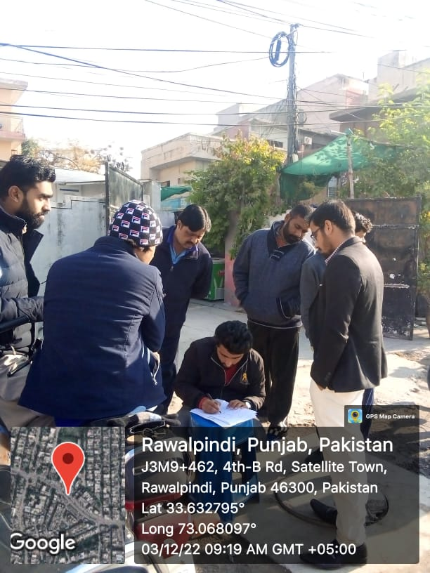 | 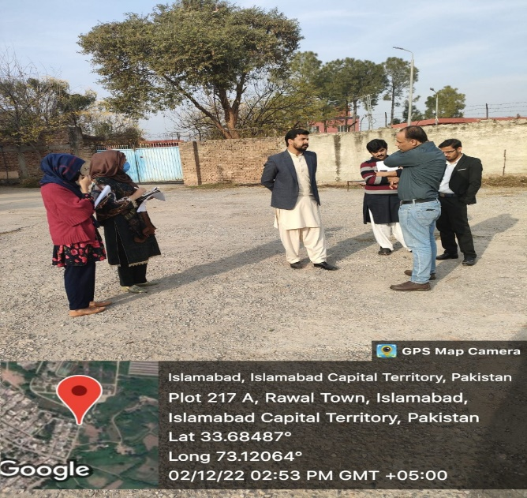
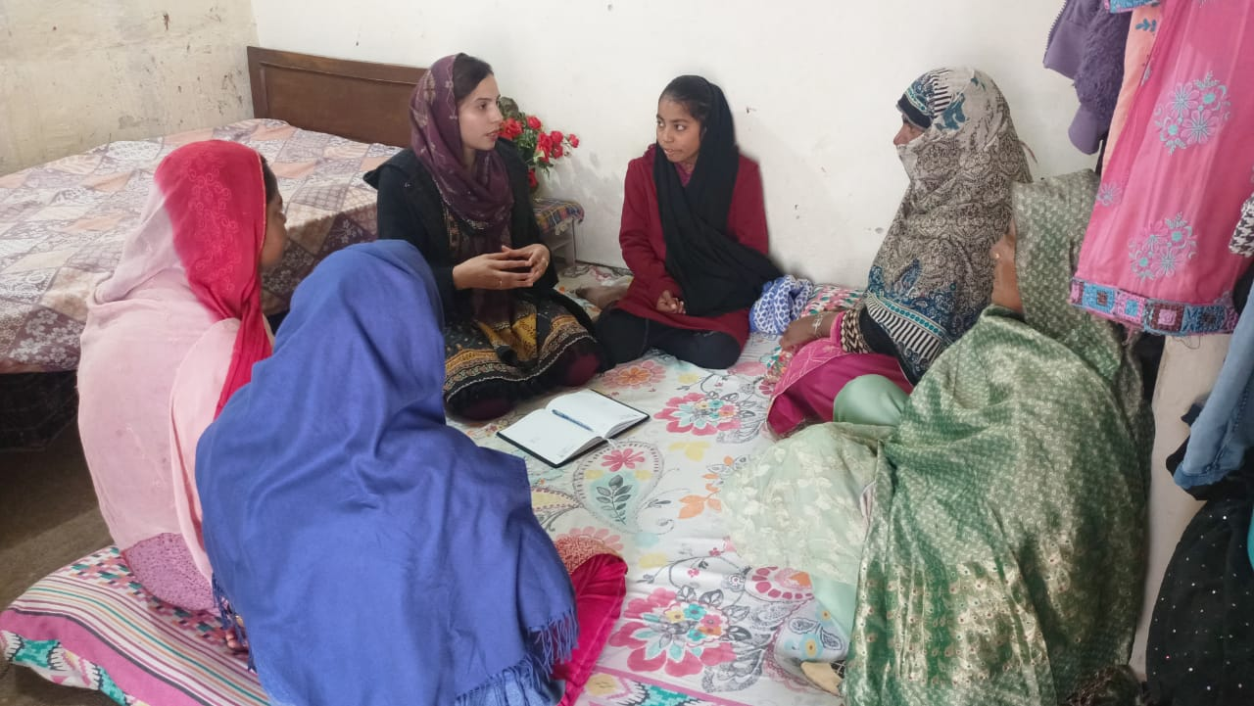 | 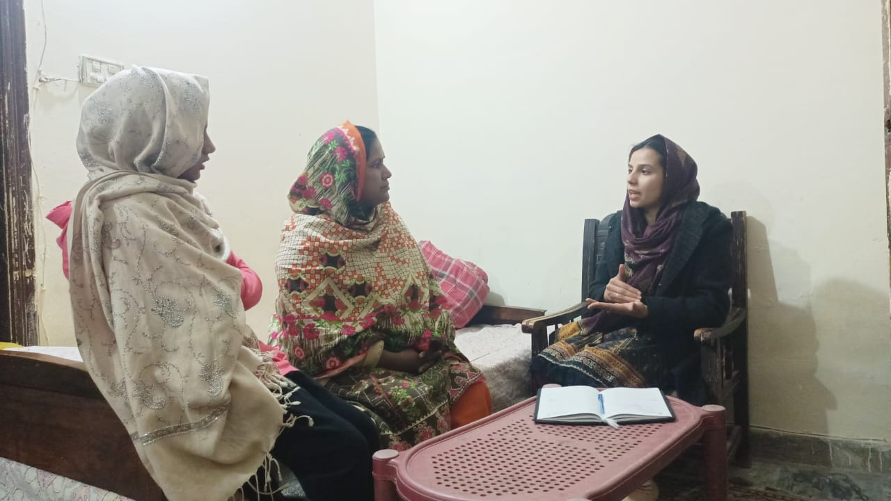
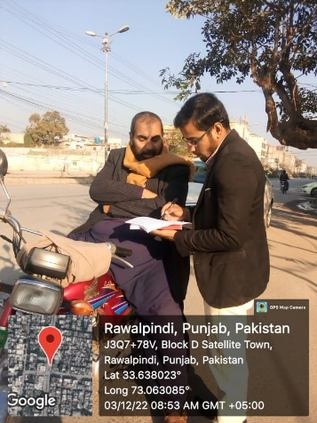 | 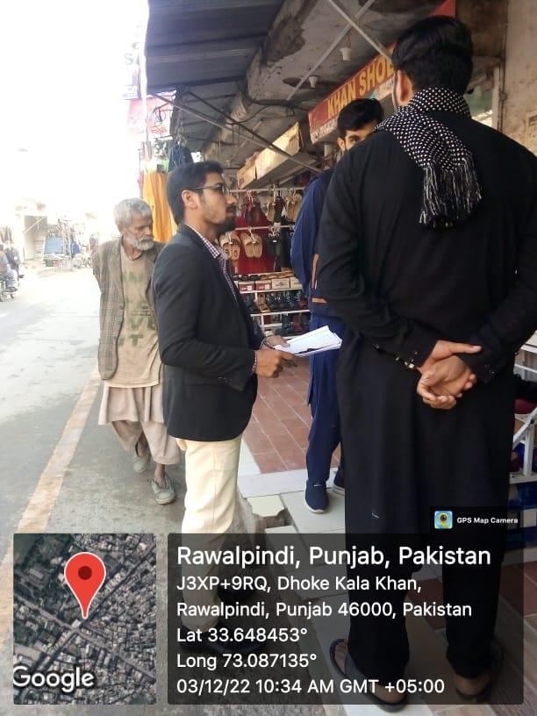
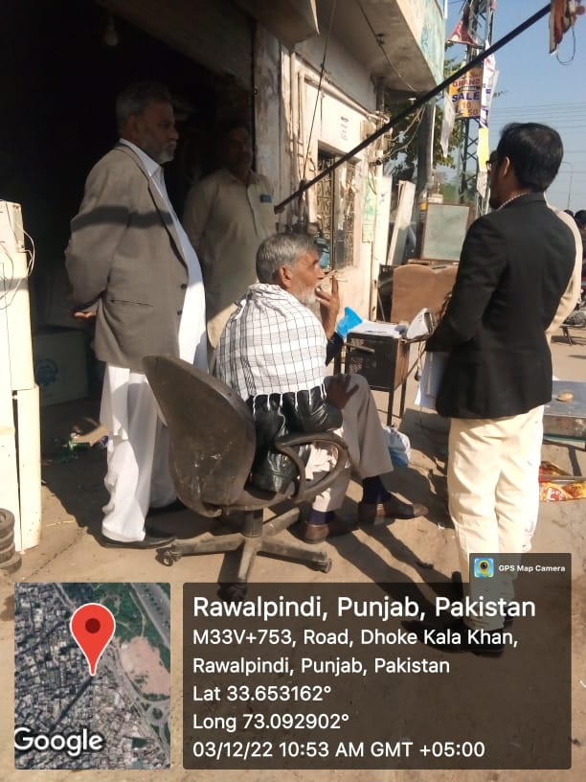 | 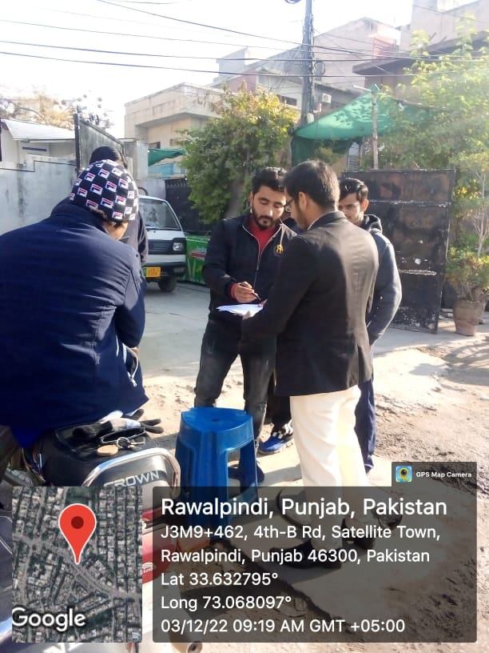
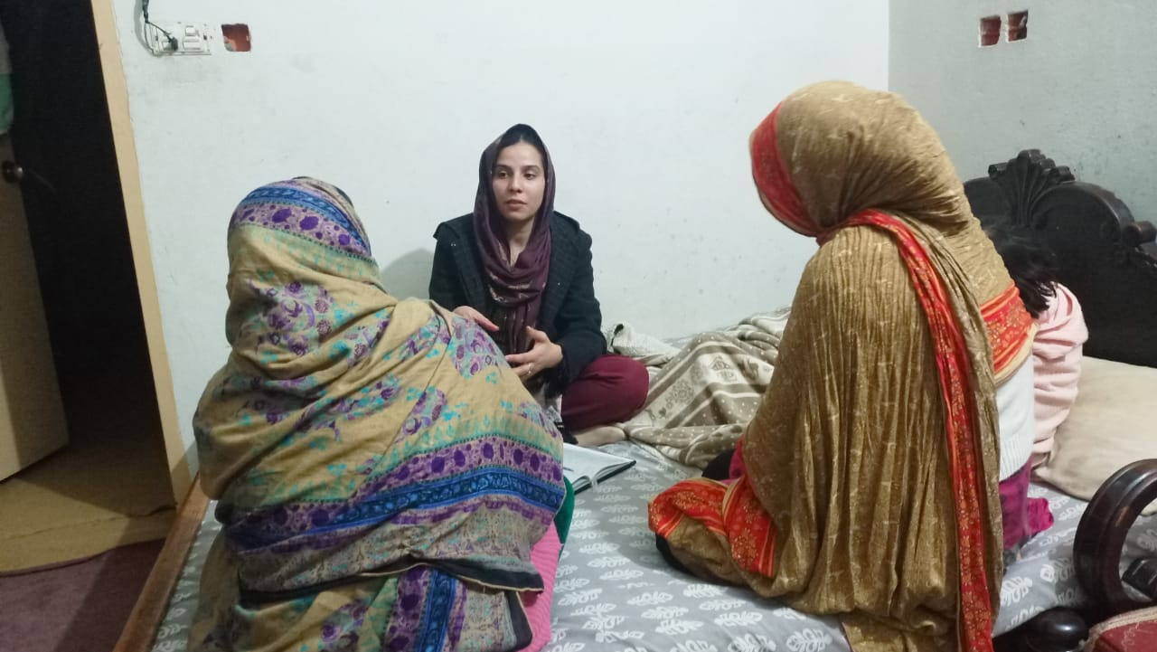 | 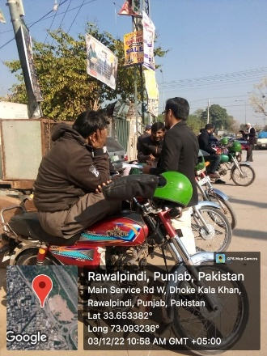
 | 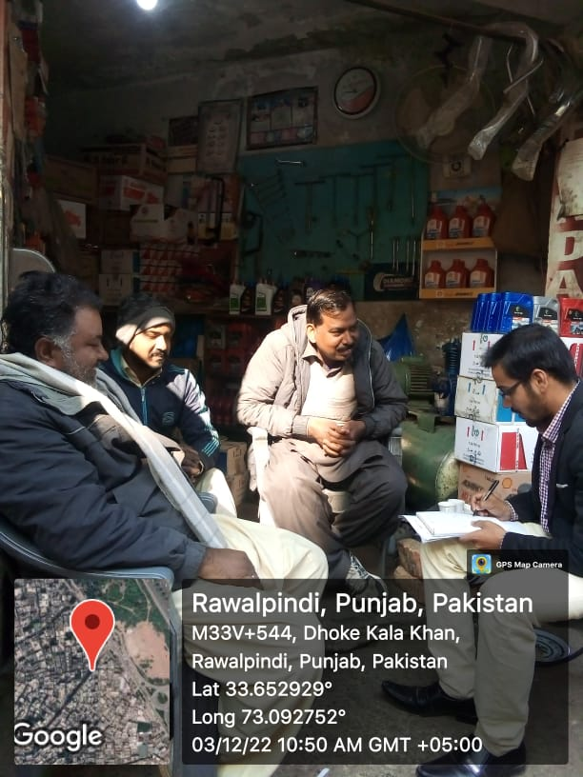
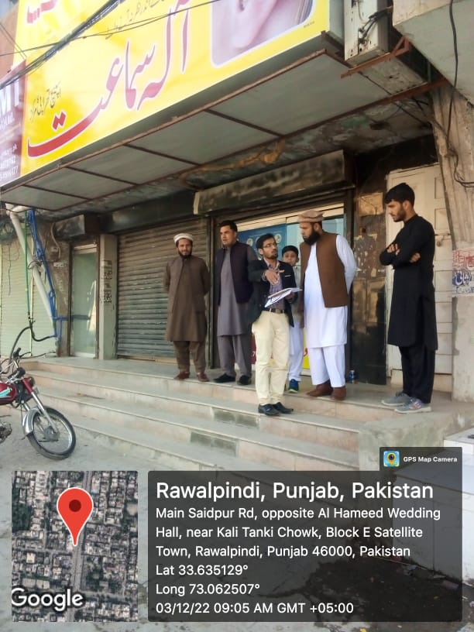 | 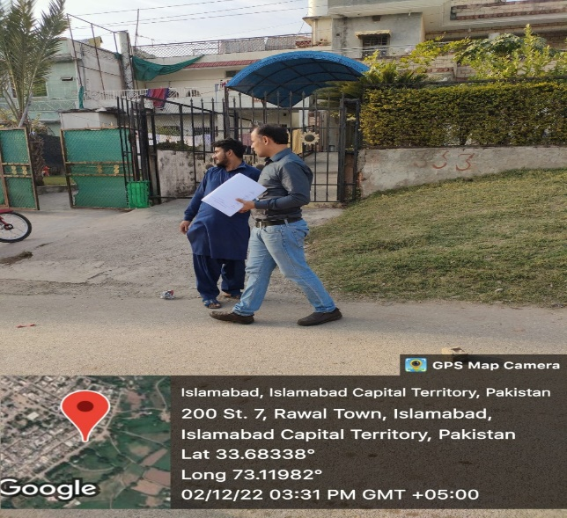
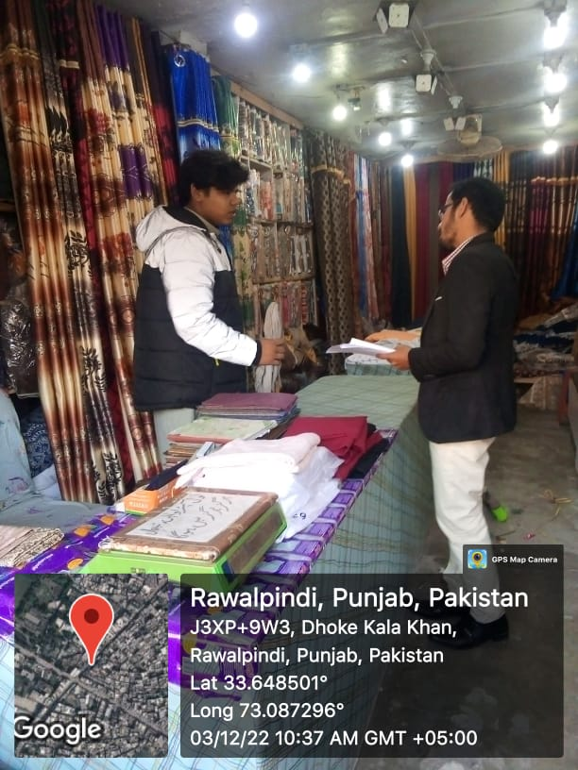 | 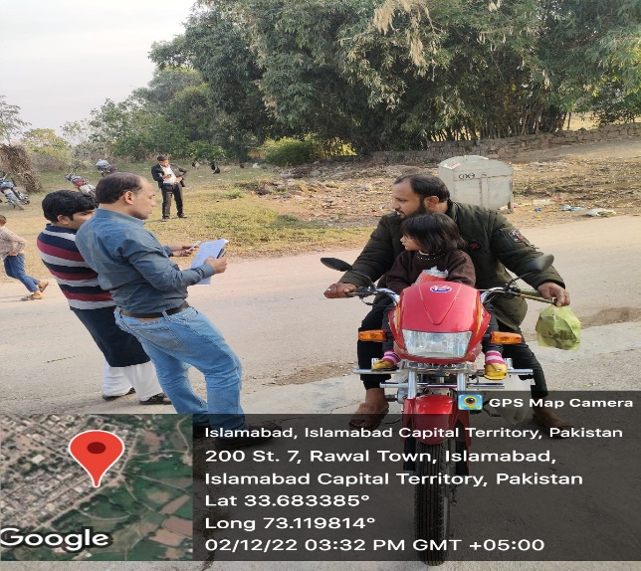
- The comments and feedback obtained from the project area stakeholders and responses provided to them were as follows:
- The people living in the vicinity of the Rawal Filtration Plant expressed some concerns related to the water supply system of the city and stated that the existing water supply is not sufficient to cater to the needs of nearby localities in regards to water demand.
- Broken lids of water tanks allow dust and dirt to settle down in the existing water storage tanks around city and thus making the drinking water impure.
- There are no special arrangements for cleaning the drains. With this, the wastewater often mixes into clean water pipeline and this water is again harmful to health. This is an indication of drinking water being contaminated at some point.
- The improvement in water supply system will help in the water supply 24/7.
- Residents in the site’s vicinity were assured that the proposed project is designed to provide 24/7 water supply to the residents of the city so they can fulfil their water needs just enough.
- The water supply network will improve the current situation of water tanks and pipeline network. All the damaged or repairable pipeline and water tanks will be replaced/rehabilitate with new structures.
- The drain shall be cleaned and arrangements shall be made separately to avoid mixing of wastewater in the clean water source.
- After installation of water supply network, sufficient water will be supplied to every house in the parameter and hence water shortage will no longer exist and thus the burden on water pumps will lower as well.
- Locals will be preferred for jobs provision as this is both socially and economically favored and feasible.
- Water quality will be monitored and any leakages into the water supply network shall also be noticed.

Consultation with Official Stakeholders
- As part of environmental assessment, detailed meetings were held with the institutional stakeholders in the form group meetings i.e. with DG RDA, Rawalpindi, Additional Deputy Commissioner (Revenue), Rawalpindi, Managing Director (RWASA), Chief Engineer, Irrigation Department, Rawalpindi, Chief Officer, District Officer, Rawalpindi, Project Director, Small Dam, Rawalpindi, Chief Officer, Metropolitan Corporation, Rawalpindi, Divisional Forest Officer, Forest Department, Rawalpindi, Program Director, PMU PICIIP, Lahore, Dy Program Director, PMU PRF, Lahore, Technical Advisor, PMU PRF, Lahore, Wildlife, Fisheries and etc. Details of this consultation process are described below.
- Officials of the different public sector departments have been consulted and briefed on the salient features of the project. Mostly suggestions were that proper mitigation plan shall be designed and then implemented in the construction and operation phase of the project. Details of consultation meetings with official stake holders are mentioned in Table 13.3 and photographs are attached as Figure 13.2 below.
- Although the engagement is in its initial stages, at some point prior to and during construction phase, the Punjab EPA as well as other government departments are expected to be increasingly involved in the stakeholder consultation process.

Table 13.3: Consultation with Government Stakeholders
Finding of Consultation with Government Stake Holders
Sr. # | Date | Location | Department | Name (FGD) | Comments
1 | 30-11-22 | PMU Office | PMU/CIU | Mr. Ali Qunanin  [Infrastructure Engineer] | An infrastructure engineer CIU, Rawalpindi gave a description of the project’s objectives. The deputy director development, Rawalpindi also inquired about the project's scope and whether it will have an impact on the supply chains and distribution networking.
 |  |  |  | Mam Sehrish Khurshid [Project Officer]
2 | 01-12-22 | WASA Office | WASA | Mr. Azizullah Khan  [Deputy Director] | According to the WASA deputy director, "A water distribution network already exists; the project will increase the water's storage capacity, allowing for a continuous supply of water."
Mr. M.Imran Haider
[GM OCL]
Mr. Mujahid
[EDCM Environmental Consultant]
3 | 03-12-22 | Committee Room of DC | DC Office | Mr. Umer Razzaq  [P & D] | People from different departments suggested that plan for this project should be shared with their representative so that they can provide effective input. Also asked that this project is doable for the government and for local residents. infect recommended that new societies are emerging that future population along with this project should also be served with the clean water supply.
Mr. Azizullah Khan
[Ex. Deputy Director]
Mr. Amir Mumtaz
[XEN Small Dam Islamabad]
Mr. Abid Hussain Abid
[Forest Conservator Rawalpindi]
Mr. Jawad Arshad
[AD (Engineer)]
Mr. M. Haseeb
[AD(M & E)]
Mr. Muazzam Mukhatar
[Social Safeguard]
Mam Sehrish Khursheed
[Project Officer]
Mam Sana Urooj
[DDF Rawalpindi]
Mam Rizwana Aziz
[ADW Rawalpindi]
Mam Arifa Batool
[DDW Rawalpindi]
Mr. M. Farooq
[DTL EDCM]
Mr. Aziz Karim
[Environmental Specialist]
Mr. Ali Qunain
[IE, CIU Rawalpindi]
Mr. Ahmad Afzal
[AD (Eng) PRF]
Mr. M. Shahzad
[MD Reservoir MCR]
Mr. Mujahid
[EDCM Environmental Consultant]

Figure 13.2: Consultations with Institutional Stakeholders
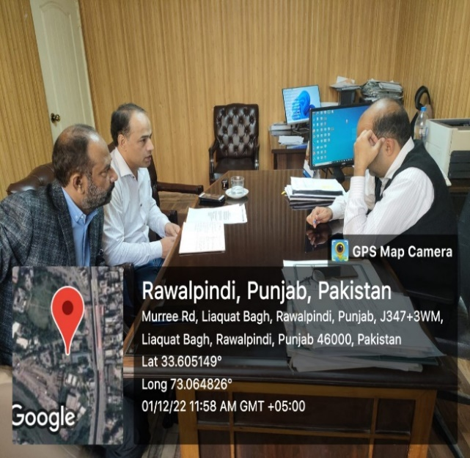 | 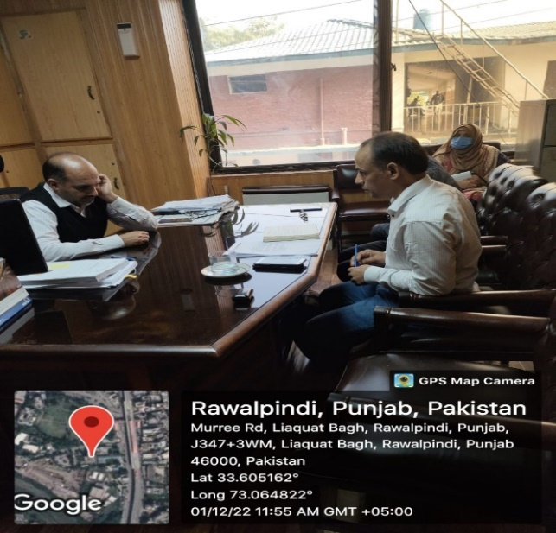
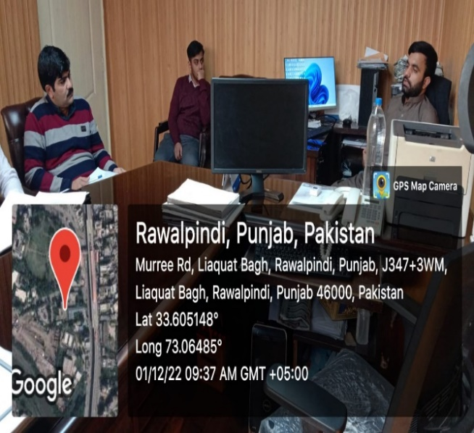 | 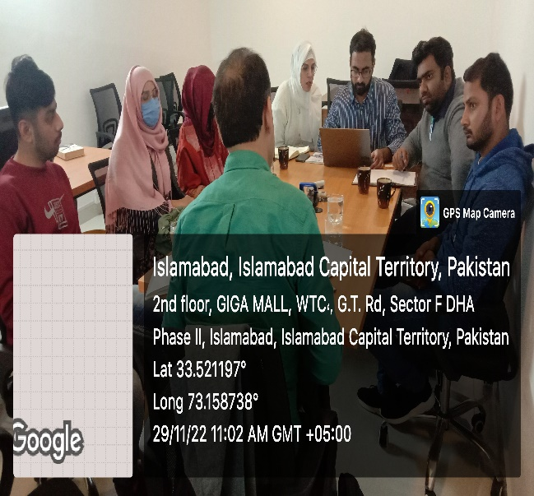
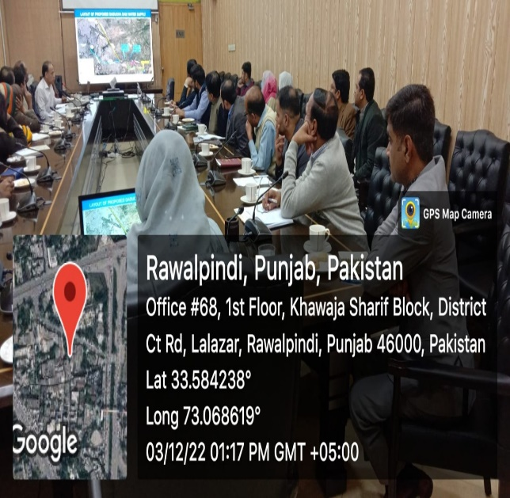 | 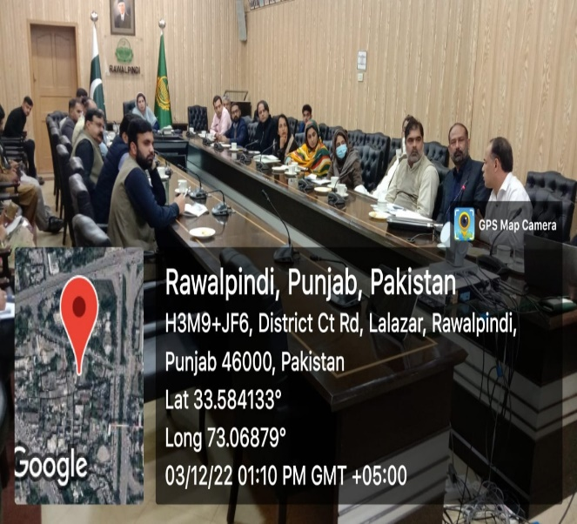

Summary of Concerns from Affected Persons
- The summary of consulted people during the site visit is as follows:
- Dust, noise, and traffic issues are three of the most significant barriers to any development, so it is imperative that the construction work be handled properly to avoid these issues.
- The project will be helpful to provide and managing the life better with provision of clean water.
- The provision of clean water is the right of every citizen.
- Proper NEQS/PEQS will be followed to avoid noise and dust pollution during construction.
- It is requested to handle the construction materials properly and work skillfully.
- Proper monitoring of materials during construction will be carried out to prevent any risky circumstances.
- Very useful project to solve water crisis issues of the area.
- It is a positive move toward the community's economic empowerment. This project will augment standard of living.

Consultation Plan for Construction and Operation Phase
- Consultation plan for construction and operation phase of the proposed project will be prepared in order to involve all relevant public sector departments. Similarly, social safeguard teams will be developed to record the responses of project stakeholders and general public about the project. Periodic consultations and community feedback surveys will be carried out to develop positive perception about the project. Intended stakeholders for such consultations will be all stakeholders that are consulted at the time of IEE preparation and PICIIP-CIU. Record of such consultations will be maintained at PMU/RWASA offices and necessary changes in operational modalities will be introduced in the system in light of the response provided by the consultants.

Information Disclosure
- Consultation is ongoing process that will be carried out with the relevant department and other stakeholders along the alignment of proposed project throughout project implementation period. All future consultations will be documented and record will be maintained properly.
- Efforts will be made to maximize the consultations during the project implementation. The consultations will be carried out with the objectives to develop and maintain communication linkages between the project promoters and stakeholders, provide key project information to the stakeholders and to solicit their views on the project and its potential or perceived impacts and ensure that views and concerns of the stakeholders are incorporated during the implementation with the objectives of reducing or offsetting negative impacts and enhancing benefits of the proposed project.
- After suggesting the possible solutions of the stakeholders’ concerns, the solutions will be disclosed once again, if required, for the stakeholders and general public. The IEE report will be accessible to interested parties on request and the version of final report will be available in the office of PMU, CIU and RWASA and its summary will be available in national language (Urdu).

Consultations for Solar Installations
- A consultation session was conducted with city stakeholders on Environmental Assessment, under the chairmanship of Deputy Director (Development) Rawalpindi, dated 5th August 2023 at 2:00 pm in the Committee Room of Deputy Commissioner, Rawalpindi in which the consultant presented their observation as part of preparing the Environmental Assessment report.
- Project Support Officer, City Implementation Unit (CIU) Rawalpindi gave a brief introduction of the Project and priority projects of Rawalpindi for the water sector under DREAMS – I then Engineering Design and Construction Management (EDCM) Consultant’s Environment expert presented the Environmental Assessment on the project. The discussion and decisions are provided in the Table 13-4 below.
- Additional consultations were conducted during the public hearing, conducted for this sub-project on 27th of June’24 in Rawalpindi and attended by seventy-eight (78) individuals from both the public and private sectors, consisting of local community members, students, academic faculty, owners of local businesses as well as other stakeholders from the project area. They expressed queries and concerns related to the source of the water supply and its geographical coverage of supply as well as other issues such as expected vibration levels during construction works and potential impacts from high dust and noise levels during the works. Responses were provided to all their comments and queries are provided along with the photographic evidence as Annexure XVI of this IEE study.

Table 13.4: Details of consultations conducted for solar installations
Sr. No. | Agenda item | Discussion/ Direction | Action By
1. | Solarization for sustainable & resilient water supply system in Rawalpindi. | - Mr. Shiekh Mujahid, Environment Expert EDCM enlighten the anticipated positive impacts, and installation/construction environmental impacts of this project. Also, suggested the mitigation measures according to the IEE report, mentioned below:  Following are the anticipated POSITIVE impacts from the Projects:  - Provision of clean and renewable sources of Energy to make the project energy efficient and sustainable.  - Cost Saving in the longer run.  - Reduction in Green House Gases  - Positive impact on Climate which is very critical to humans and other forms of life.  - Reduce water usage (used in energy production)  - Help to improve Air Quality Index by reduction in pollutants.  - Economic uplift and creation of job opportunities  Following are the Installation/Construction Specific Environmental impacts:  - Excavation/ digging of soil for base  - Cutting of trees/bushes falling within the placement area of Solar PV Panels (Minimum).  - Land acquisition  - Disturbance created to the public during transportation of solar panels and frames.  - Noise during the installation phase.  - Solid waste generation during construction.  - Surface water body contamination by soil erosion and sediments.  Following are the mitigation measures suggested in the IEE report:  - Land is already available for the said project (even in already operational buildings the plant can be installed at rooftops which will further reduce the energy cost of cooling)  - Negligible civil work, hence negligible fugitive emissions, noise, and vibration.  - A tree-cutting plan will be devised and 1:10 will be adopted for tree plantation  - Implementation of the Traffic diversion plan  - Proper maintenance of vehicle and construction machinery  - Development and implementation of Solid Waste Management Plan (SWMP)  - Secondary containment for oil and other chemical storage  - Provision of septic tanks for construction camps  - Development and Implementation of Health and Safety Plans  - Environmental consultants of EDCM, further explained the field survey experience and observations for the collection of initial data to forecast a few points regarding the environment and social.  - He added that according to the Punjab Environmental Protection (Amendment) Act 2012: Section 12 (1) “No proponent of a project shall commence construction or operation unless he has filed with the Provincial Agency an initial environmental examination or where the project is likely to cause adverse environmental effects an environmental impact assessment and has obtained from the Provincial Agency approval in respect there off”.  - Punjab Environmental Protection Agency (Review of IEE and EIA) Regulations 2022:  - The proposed project falls under Clause B (4) (Energy) of Schedule I, which requires IEE before the commencement of construction.  - Clause B applies to projects related to Energy.  - ADB’s Safeguard Policy Statement (SPS), 2009: “All loans and investments are subject to categorization to determine environmental assessment requirements. Categorization is to be undertaken using Rapid Environmental Assessment (REA) checklists, consisting of questions relating to (i) the sensitivity and vulnerability of environmental resources in the project area, and (ii) the potential for the project to cause significant adverse environmental impacts. Projects are classified into one of the following environmental categories:” Category A, B, C & F1, and this project falls in category B.  - Mr. Zulqarnain Shah, District Officer (I/S), the District Office, Rawalpindi, highlighted that this project has a life of 30 years therefore what technology/procedure/technique is to recycle/dispose of the waste after 30 years. He suggested that the product-generated waste should be sent back to the supplier country for recycling because in Pakistan currently there is no technology available for it. He also asked about the maintenance measures after installation.  - Mrs. Sehrish Khurshid, Project Support Officer, City Implementation Unit, Rawalpindi, said in response that the guidelines for the maintenance services and disposal will be addressed during the feasibility study and detailed engineering design. Mr. Aziz Ullah Khan, DD (PnD), RWASA added that at this time, it will be difficult to address this point because scientific advancement with the passage of time and technology will be changed after 30 years.  - Mr. Maqbool Qureshi, Inspector of Environment Protection Agency, Rawalpindi, highlighted the requirement of the Punjab Environmental Protection Act 1997 (amendment 2012) and the Power of Delegation Rules made under the act. He asked that is this case will be submitted at the Divisional Level or the Head Office of EPA Punjab. The EDCM Environmental Consultant replied that the Delegation of Power Rules were framed almost three years back while the Guidelines has been revised in 2022. Therefore, the report will be submitted to the Head Office of EPA Punjab for environmental approval. Further, Mr. Maqbool Qureshi, Inspector EPA Punjab asked about the requirements of Pak EPA regarding the installation of a Solar Plant.Mr. Sheikh Mujahid Environment Expert EDCM Consultant briefed that IEE/EIA Regulations 2000 of Pak EPA do not give any requirement to obtain Environmental Approval from Pak EPA under Section 12 of Pakistan Environmental Protection Act, 1997.  - Mr. Mazhar Nadeem Deputy Director (Development), Rawalpindi asked for the Costing and use of technology for this project. Mr. Sheikh Mujahid Environment Expert EDCM Consultant acknowledged that the feasibility study and detailed engineering design are in progress, as we have the report, it will be shared.  - Mr. Muhmmad Sajid Hanif, XEN, IESCO, Rawalpindi inquire about the brands and capacities of batteries, inverters, plates, etc. Mr. Aziz Ullah Khan Dy. Director (PnD) WASA responds that it’s a direct supply of a total of 14.3 MW on 4 sites and we are not using the hybrid technology.  - Mr. Muhmmad Sajid Hanif, XEN, IESCO, Rawalpindi asked about the calculation method of the figures mentioned in the table of “Electrical Load & Generation Details”. Mr. Sheikh Mujahid Environment Expert EDCM Consultant acknowledged that in this meeting these factors cannot be defined because the feasibility study and detailed engineering design are in progress, and as we have the report, it will be shared.  - Mr. Mazhar Nadeem Deputy Director (Development), Rawalpindi, and Director (Water Supply), RWASA asked for the cost difference and revenue generation calculations.  - Mr. Abid Aleem SDO (E), C/line Cantt, WAPDA added that a new solar system product is introduced by China which consumes low space with maximum output capacity. Mrs. Sehrish Khurshid, Project Support Officer, City Implementation Unit, Rawalpindi requested the Brand name and product specification for a feasibility study.  - Mr. Maqbool Qureshi, Inspector Environment Protection Agency, highlighted that 2 project sites are within Rawalpindi and 2 are in Islamabad, so what are the EIA/IEE approval criteria? The Environmental Consultant of EDCM replied that separate reports will be submitted to EPA Punjab and Pak EPA if a requirement arises from Pak EPA.

PROCEEDING OF PUBLIC HEARING
Project | Replacement of existing conductance main from Rawal lake filtration plant to water works Sufaid Tanki .
Subject | Proceeding of Public Hearing Regarding Environmental Impact Assessment of Replacement of existing conductance main from Rawal lake filtration plant to water works Sufaid Tanki.
Date | 27-06-2024 (Thursday)
Venue | COMSATS University, Islamabad
Time | 10:30 AM
Proponent | Project Director  Punjab Intermediate Cities Improvement  Investment Program (PICIIP),  58-C-3 near FDR Office, Gulberg-III, Lahore  For Information and contact:  M. Waqas Afzal  Deputy Director (Safeguards), PMU-PICIIP  Ph: 0340-3301477
Participants of the Public Hearing | Mr. Ashiq Nawaz Bangash, Director EIA PAK-EPA preceded the public hearing. There were total 78 participants physically present at the venue (Annex-A).
The proceedings of public hearing were held as under:
Time |  | Task
11:00 to 11:30 |  | Registration of Participants.
11:30 to 11:33 |  | Recitation of Holy Quran.
11:33 to 11:36 |  | Mr. Muhammad Mujahid, Environment Consultant welcomes the participants and briefly described the agenda of public hearing.
11:36 to 11:40 |  | Mr. Ashiq, Director EIA Monitoring PAK-EPA presented the opening note and briefed the participants on the importance of environmental conservation.
11:40 to 12:40 |  | Mr. Muhammad Mujahid as consultant of the project narrated the objective of the meeting and presented the project through power point presentation. He discussed all the aspects of proposed project and briefed the components, environmental impacts and mitigation measures suggested in the EIA report.
12:40 to 12:45 |  | Mr. Muhammad Mujahid asked for public questions and announced that despite of this public hearing, if anyone has any reservation or suggestions, he can submit it in written form in PAK-EPA, Islamabad.
12:45 to 01:00 |  | Question & Answer session
01:03 |  | End
QUESTION / ANSWER SESSION
Comments |  |  | Reply
Mr. Zia Ex. Director EIA from Federal EPA appreciated PMU and Punjab Government to bring water supply project for Rawalpindi. He further appreciated the quality of EIA report. |  |  | Mr. M. Mujahid, Environment Consultant (EDCM) thanked him for the compliments .
Mr. Yaqob Ali Khan, DIG Forests, MOCCEC asked that how much amount is allocated for tree plantation and how this plantation will be carried out? |  |  | Mr. M. Mujahid, Environment Consultant (EC) (EDCM) replied 1% of total project cost is allocated for trees plantation. It will be carried out in collaboration with PMU, CDA and PHA Rawalpindi. Forest Department will also be consulted for their valuable inputs while finalizing the plantation plan. He further added that indigenous species will be planted at different locations (finalized by CDA and PHA.
Ms. Sumbal Siddiq, Lecturer Department of Metrology, CUI asked about the reference which has been used for impact matrix and scaling? |  |  | Mr. M. Mujahid, EC (EDCM) replied that guidelines of ADB namely SPS 2009 have been used as reference for preparing EIA report and scaling checklist. He further added that experienced team of environmentalist has filled this checklist while using their previous experience of similar projects.
Dr. Jabir Hussain Syed, Associate Professor, Department of Metrology, CUI raised concern that monitoring points in the project seem insufficient keeping in view the length of pipeline? |  |  | Mr. M. Mujahid, EC (EDCM) replied that monitoring point have been selected according to nature of construction activity. However, more monitoring points will be added during execution (construction) phase of the project.
Dr. Ali Shah, Associate Professor, Department of Biosciences, CUI asked about the material which has been used for laying of new pipelines? What is its life? |  |  | Mr. M. Mujahid, EC (EDCM) and Mr. Javed Technical Representative replied that HDPE pipe will be used as new pipeline material because of its flexibility. It is easily adjustable in existing pipeline. Its life is 50 years.
Mr. Arooj Ali asked about the road crossing of Murree road and Islamabad Expressway. Are there any road cuttings involved in the project? |  |  | Mr. M. Mujahid, EC (EDCM) replied that there is already an existing tunnel under Islamabad Expressway and Murree Road. The same will be used for pulling and pushing of new pipeline. No Road cutting will be carried out.
Ms. Sumbal Siddiq, Lecturer Department of Metrology, CUI asked that how have ratings been given to environmental impacts the report? |  |  | Mr. M. Mujahid, Environment Consultant (EDCM) replied that ratings have been given by the expert team according to similar projects which are completed before.
Mr. Arsalan, Student of CUI asked that how will the rehabilitation work conducted and by whom? |  |  | Mr. M. Mujahid, EC (EDCM) replied that rehabilitation work will be carried out by Construction Contractor to the minimum same level as it was before project activity. PMU will supervise this work.
Mr. Adnan Khan from CDA asked that is there any permanent structure likely to be disturbed by the project? |  |  | Mr. M. Mujahid, EC (EDCM) replied that there is no any permanent structure likely to be disturbed by the project. The construction methodology will further help us to bypass any temporary or permanent structure by shifting the location of working chamber up to 200 meters.

While concluding the session, the chair appreciated the proponent of the proposed project on their presentation; appreciated faculty and students of CUI. He urged the proponent to take into consideration the suggestions and recommendations that came up during public hearing. It was also stated that the participant/stakeholders could also forward their comments / observations in writing to PAK-EPA so that the same could be duly addressed while processing the case of environmental approval of the project.

GRIEVANCE REDRESSAL MECHANISM

General
- The ADB SPS, 2009 requires the establishment of a local grievance redress mechanism (GRM) to receive and facilitate resolution of the Displaced/Affected Persons concerns and grievances regarding the project’s social and environment performance. The measures have been identified to mitigate any potential environmental and social impacts to be caused due to implementation of the proposed project.
- However, in spite of best efforts, there is a chance that the individuals/households affected by the project or other stakeholders are dissatisfied with measures adopted to address adverse social impacts of the project. To address, such situation, an effective GRM has been established to ensure timely and successful implementation of the project. It will also provide a public forum to the aggrieved to raise their objections and the GRM will address such issues adequately. It will receive, evaluate and facilitate the resolution of displaced persons’ concerns, complaints and grievances about the social and environmental performance at the project level.
- The GRM will aim to investigate charges of irregularities and complaints received from any displaced persons and provide a time-bound early, transparent and fair resolution to voice and resolve social and environmental concerns linked to the project.
- The PMU RWASA shall make the public aware of the GRM through public awareness campaigns. The name of contact person(s) and his/her phone number, will serve as a hotline for complaints and shall be publicized through the media and placed on notice boards outside their offices, construction camps of contractors and at accessible and visible locations in the project area. The project information brochure will include information on the GRM and shall be widely disseminated throughout the project area. Grievances can be filed in writing, via web- based provision or by phone with any member of the PMU.

Scope of GRM
- During different stages of project preparation and implementation, it is likely that Affected Persons (APs) having livelihood impacts and falling in COI in particular and local community residing in the vicinity of the project area and other stakeholders may have some grievances related to project actions and activities. To resolve all such issues, a GRM will be available to allow APs or the local community to appeal any disagreeable decision, practice or activity arising from project implementation. APs and the general public will be informed of their rights and of the procedures for registering complaints and GRM verbally in the consultation held during the Impact Assessment Survey (IAS). Consultations were held with the APs to discuss livelihood impacts, measures for minimizing these impacts and GRM or the Grievance Redressal Committee (GRC) to be in place specifically to redress complaints revolving around compensation related to livelihood disruption.

Functions of GRC Committee
- The GRC or GRM will perform the following functions:
- Ensure effective implementation of the GRM on the issues that fall under their jurisdiction;
- Ensure an easy access to GRM having provision to file grievances verbally or by phone, in writing or via web based provision, including the option of submitting grievances anonymously;
- GRC will look into all referred grievances and effectively address and resolve them within 15 days from the receipt of the grievances, in a timely and impartial manner;
- The GRC will deal promptly with any issues relating to livelihood and utilities disturbance;
- The GRC will take decisions on the basis of consensus or majority of votes;
- When required, the GRC will seek the assistance of other persons and institutions;
- Speaking orders and decisions of the committee on the grievances shall be recorded and replied to aggrieved parties and persons with a copy kept as record;
- In case the aggrieved party is not satisfied by the decision of the GRC, she/he can file an appeal within ten days of receipt of the decision and the GRC could refer the case to the appropriate forum after examining the appeal; and
- In the event that a grievance cannot be resolved by GRC, the affected person(s) can seek alternative redress through the higher administrative authority or court of law or as appropriate.

Stage of GRM
- The PMU is the first tier of GRM which offers the fastest and most accessible mechanism for resolution of grievances. The PMU staff for environment and social safeguards will be designated as the key officers for grievance redressal. Resolution of complaints will be completed within a period of seven (7) working days. Investigation of grievances will involve site visits and consultations with relevant parties (e.g., affected persons, contractors, traffic police, etc.). Grievances will be documented and personal details (name, address, date of complaint, etc.) will be included, unless anonymity is requested. A tracking number will be assigned for each grievance, including the following elements:
- Initial grievance sheet (including the description of the grievance), with an acknowledgement of receipt handed back to the complainant when the complaint is registered;
- Grievance monitoring sheet, mentioning actions taken (investigation, corrective measures);
- Closure sheet, one copy of which will be handed to the complainant after he/she has agreed to the resolution and signed-off.
- The updated register of grievances and complaints will be available to the public at the PMU office, construction sites and other key public offices in the project area. Should the grievance remain unresolved, it will be escalated to the second tier.
- The PMU will activate the second tier of GRM by referring the unresolved issue (with written documentation) to the RWASA, who will pass unresolved complaints upward to the GRC. The GRC will be established by WASA before commencement of site works.
- The GRC will consist of the following persons: (i) Project Director; (ii) representative of District government; (iii) representative of the affected person(s); (iv) representative of the local Deputy Commissioners office and (v) representative of the EPA (for environmental-related grievances).
- A hearing will be called with the GRC, if necessary, where the affected person can present his/her concerns/issues. The process will facilitate resolution through mediation. The local GRC will meet as necessary when there are grievances to be addressed. The local GRC will suggest corrective measures at the field level and assign clear responsibilities for implementing its decision within fifteen (15) working days. The Contractor will have observer status on the Committee. If unsatisfied with the decision, the existence of the GRC will not impede the complainant’s access to the Government’s judicial or administrative remedies.
- The functions of the local GRC are as follows: (i) resolve problems and provide support to affected persons arising from various environmental issues and including dust, noise, utilities, power and water supply, waste disposal, traffic interference and public safety as well as social issues and land acquisition (temporary or permanent); asset acquisition; and eligibility for entitlements, compensation and assistance; (ii) reconfirm grievances of displaced persons, categorize and prioritize them and aim to provide solutions within a month; and (iii) report to the aggrieved parties about developments regarding their grievances and decisions of the GRC.
- The WASA officers will be responsible for processing and placing all papers before the GRC, maintaining a database of complaints, recording decisions, issuing minutes of the meetings and monitoring to see that formal orders are issued and the decisions carried out.
- In the event that a grievance cannot be resolved directly by the PMU (first tier) or GRC (second tier), the affected person can seek alternative redressal through the district committees as appropriate. The PMU or GRC will be kept informed by the district, municipal or national authority. The monitoring reports of the EMP implementation will include the following aspects pertaining to progress on grievances: (i) Number of cases registered with the GRC, level of jurisdiction (first, second and third tiers), number of hearings held, decisions made, and the status of pending cases; and (ii) lists of cases in process and already decided upon may be prepared with details such as Name, ID with unique serial number, date of notice, date of application, date of hearing, decisions, remarks, actions taken to resolve issues, and status of grievance (i.e., open, closed, pending).
- In order to provide greater clarity, the pictorial description of the GRM is provided in Figure 14.1 below.

Figure 14.1: GRM Process
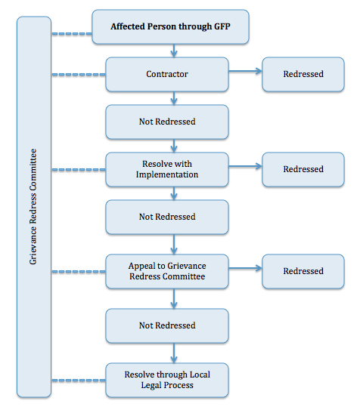

CONCLUSION AND RECOMMENDATIONS

Conclusion
- The proposed project is of high significance considering the urgent need for ensuring a sustainable water supply system to Rawalpindi city while the solar PV component will ensure provision of clean and reliable energy.
- Primary and secondary data has been collected and used to assess the environmental impacts of the project. This IEE report highlights all potential environmental impacts associated with the project and recommends necessary mitigation measures. Any environmental impacts associated with the project need to be properly mitigated through the existing institutional arrangements described in this report.
- The majority of the environmental impacts are associated with the distribution networks, including transmission main and generation of solid waste as well as sludge and waste water during the water treatment plant operation. Major impacts during construction phase will be related to traffic congestion and community health and safety issues during laying of the water supply system in populated areas.
- Also, for the solar PV component, it is an environmentally friendly technology which is benign during its operation phase with only water required in limited quantities for cleaning of panels. Any potential impacts are expected only during the project construction phase, which too will be site specific and limited in nature, consisting of impacts such as land clearing and levelling and only temporary impacts due to dust and noise emissions.
- The implementation of mitigation measures during the construction period will be the responsibility of the Contractor. Therefore, the required environmental mitigation measures will need to be clearly defined in the bidding and contract documents and appropriately qualified environmental staff retained by the consultant to supervise the implementation process. The EMP includes measures to minimize project impacts due to traffic, noise, air pollution, waste generation etc.
- The EMP contained within this IEE document is considered sufficient for issuance as part of the contracts to the successful bidder(s) and for subsequent use during the project works. It should be mentioned that prior to the commencement of works, this EMP will be further updated by the Contractor into site specific EMPs (SSEMPs) for review and clearance by ADB. In these SSEMPs, aspects such as a detailed traffic management plan, identification of locations for disposal of debris and spoil and any other details which shall become available later must be included for efficient implementation of all proposed mitigation measures and the subsequent monitoring of these measures.
- Based on the above, this report concludes that there are no potential adverse environmental impacts from the proposed project. Impacts of less significance can be mitigated to an acceptable level by adequate implementation of the mitigation measures identified and suggested, hence, no significant or unacceptable change in the baseline environmental conditions will occur. Similarly, the project will have a visible positive impact on the socio-economic conditions of the local residents in terms of uninterrupted treated water supply and it will fix any existing bottlenecks of the system along with generation of clean and renewable energy from the solar PV installation on a sustainable basis.
- Following requirements of ADB SPS, the PMU will apply pollution prevention and control technologies and practices consistent with international good practice as reflected in internationally recognized standards such as the IFC EHS guidelines. Wherever the national regulations differ from these levels and measures, the PMU will achieve whichever is more stringent. If less stringent levels or measures are appropriate in view of specific project circumstances, the PMU will provide full and detailed justification for any proposed alternatives that are consistent with the requirements presented in the ADB SPS.
- Mitigation measures to help alleviate potential identified impacts have been recommended and an EMP has been provided for implementation of these mitigation measures. Furthermore, the PMU RWASA will ensure that the selected construction Contractor has contractual obligation with respect to EMP implementation. Also, the Contractor will ensure appropriate staffing and budgeting for effective implementation and monitoring of the project EMP.
- Also, the project is located in an area where there are several socio-economic and environmental problems for which the project will provide appropriate solutions. From a national perspective, the project will provide an alternate resource, not only for the economy of the country but also for the project area.
- Based on the findings of this IEE study, the project is unlikely to cause any significant, irreversible or unprecedented environmental impacts. The potential impacts are expected to be localized and temporary in nature and can be addressed through proven mitigation measures. Hence, the classification of the project as Category B as per ADB SPS, 2009 is confirmed. No further study or assessment is required at this stage.

Recommendations
- The following measures are recommended:
- Prior to contract award, obtain statutory clearances and make sure to incorporate conditions and requirements into the project design and documents.
- The SSEMP shall be developed and implemented by the Contractor during the construction phase and the PMU will supervise the implementation status through the Construction Supervision Consultant (CSC).
- This IEE shall be updated if unanticipated environmental impacts become apparent and will be submitted to ADB for clearance and disclosure on the ADB website.
- The Executive Summary (ES) of the IEE report shall be translated into Urdu for better understanding of the general public. The translated ES shall be placed at different locations, including the website of PMU, office of PMU & CIU and RWASA.
- The templates for different management plans are attached as Annexures. However, detailed plans shall be developed by the Contractor before mobilization of construction teams.
- Upon mobilization of the Contractors, PMU has to provide a safeguards orientation as per IEE and project administration manual.
- Contractor to appoint environmental safeguards person responsible for environmental safeguards compliance, occupational health and safety and core labor standards.
- Prior approval for setting up of construction camps shall be obtained by the Contractor from PMU.
- Employment opportunities shall be provided to the local community members as per plans discussed in the IEE report.
- Regular monitoring for leakage shall be carried out to avoid contamination of the water supply.
- PMU will have the right to suspend works or payments if the Contractor is in violation of any of his obligations under the EMP and SSEMP.

Annexures

Annexure I: Filled Checklist for Rapid Environmental Assessment (REA)

Rapid Environmental Assessment (REA) Checklist
Replacement of 54-inch Existing Conductance Main from Rawal Treatment Plant to Main Waterworks of Sufaid Tanki, Length 9.1km.

Country/Project Title:
Insertion of diameter of 900 mm HDPE Pipe for rehabilitation / replacement of existing conductance main from Rawal Treatment Plant to Sufaid Tanki, Rawalpindi with total length of approx. 10.5 km.
Sector Division:

Screening Questions | Yes | No | Remarks
A. Project Siting
Is the project area…
- Densely populated? |  |  | The existing Conductance Main is passing through different villages and towns with mixture of sparse and densely populated areas of Moria, Soan Garden, Margla Town, Dhoke Kala Khan, 6th Road and Sufaid Tanki. This project extended in two jurisdictions of Federal Territory of Islamabad and Rawalpindi, Punjab. Rawal Town, Margala Town and Sohan are heavily populated areas of Islamabad. While, dhoke Kala Khan, 6th Road, Satellite town and Sufaid Tanki are densely populated areas of Rawalpindi district.
- Heavy with development activities? |  |  | No heavy development activities have been observed and involved in the proposed project area in conflict with natural resource allocation.
- Adjacent to or within any environmentally sensitive areas? |  |  | No, the project area is not adjacent to or within any environmentally sensitive areas.
- Cultural heritage site |  |  | No specific site of cultural value present in and around the project site.
- Protected Area |  |  | No any protected area is present in and around the project site.
- Wetland |  |  | No wetland is present near project site.
- Mangrove |  |  | No mangroves exist in and around the project area.
- Estuarine |  |  | No estuary exist in and around the project area.
- Buffer zone of protected area |  |  | No any protected area is present in and around the project site.
- Special area for protecting biodiversity |  |  | No any special area is being affected by the proposed water supply project.
- Bay |  |  | No bay exist adjacent to or in the project area.
B. Potential Environmental Impacts
Will the Project cause…
- pollution of raw water supply from upstream wastewater discharge from communities, industries, agriculture, and soil erosion runoff? |  |  | As the project involved only the rehabilitation of the existing conductance main from existing water treatment plant, so no any impact of upstream wastewater discharge is envisaged due to the implementation of the project.
- impairment of historical/cultural monuments/areas and loss/damage to these sites? |  |  | No any historical or cultural site/ monument is located in and around the project area, so there will be no impairment of historical/ cultural monuments or any loss/ damage to such sites.
- hazard of land subsidence caused by excessive ground water pumping? |  |  | As the proposed project doesn’t involve the ground water pumping, so no land subsidence is envisaged at all.
- social conflicts arising from displacement of communities? |  |  | No displacement of communities is expected by the project because the project will use the existing ROW, therefore, no social conflicts are envisaged as negative impact of the project.
- conflicts in abstraction of raw water for water supply with other beneficial water uses for surface and ground waters? |  |  | This proposed project is to rehabilitate/replace existing Conductance Main to utilize the full approved capacity of water supply from Rawal Treatment Plant by RWASA. Therefore, conflict in abstraction of raw water for water supply with other beneficial water uses will not be caused because already approved capacity of water will be abstracted.
- unsatisfactory raw water supply (e.g. excessive pathogens or mineral constituents)? |  |  | Treated water from Rawal Lake Water Treatment Plant will be supplied to Rawalpindi through replacement of existing Conductance Main (5MGD); therefore, there are no chances of unsatisfactory supply of water from existing Rawal Lake Water Treatment Plant.
- inadequate protection of intake works or wells, leading to pollution of water supply? |  |  | The project is only rehabilitation / replacement of existing Conductance Main of 56-inch diameter with 36-inch diameter Conductance Main. So, there will be no any impact related to inadequate protection of intake works or well which may lead to pollution of water supply.
- over pumping of ground water, leading to salinization and ground subsidence? |  |  | As the project does not involve ground water pumping at any stage, therefore, salinization or ground subsidence is not envisioned.
- excessive algal growth in storage reservoir? |  |  | The project has nothing to do with the existing water storage reservoir.
- increase in production of sewage beyond capabilities of community facilities? |  |  | The proposed project will cause increase in production of sewage from end users (communities). However, increase in flow of wastewater will be managed by existing sewerage system.
- inadequate disposal of sludge from water treatment plants? |  |  | The project doesn’t involve any activity where sludge will be generated and its inadequate disposal will create any problem.
- inadequate buffer zone around pumping and treatment plants to alleviate noise and other possible nuisances and protect facilities? |  |  | No any noise or other possible nuisance will be caused due to inadequate buffer zone around pumping and treatment plant, as, the project involves only the laying of conductance main with 900mm diameter.
- Impairments associated with transmission lines and access roads? |  |  | Although impairments will be associated with the laying of Conductance Main in the area of replacement of 36' Conductance Main starting from Murree Road to Sufaid Tanki. However, the existing Right of Way (RoW) of already constructed Conductance Main will be utilized for rehabilitation / placement of 36' dia Conductance within 54' line. But impairment of roads and transmission lines will occure due to excavation of pits for pulling of new Line through existing Conductance Main.
- health hazards arising from inadequate design of facilities for receiving, storing, and handling of chlorine and other hazardous chemicals. |  |  | No water treatment in proposed project.
- health and safety hazards to workers from handling and management of chlorine used for disinfection, other contaminants, and biological and physical hazards during project construction and operation? |  |  | Typical hazards associated with construction work like slips, trips and falls, first aid injuries, movement of heavy machinery and equipment, encounter with snakes and dog etc.
- dislocation or involuntary resettlement of people? |  |  | Dislocation and resettlements issues may arise in congested markets of Sohan and Dhoke Kala Khan for short period of time. These are congested markets and hawkers, people with hand carts are present. During excavation of pits for pulling of new conductance main, some people may be Temporarily displaced for short period of time.
- disproportionate impacts on the poor, women and children, Indigenous Peoples or other vulnerable groups? |  |  | The implementation of the project will help women in their household tasks, hence, positive impact is envisaged due to the project.
- noise and dust from construction activities? |  |  | During construction activities, noise and dust from heavy machinery will be generated, especially during excavation of pits / holes for pulling of new Conductance Main.
- increased road traffic due to interference of construction activities? |  |  | During construction activities, Construction machinery and heavy vehicles will be mobilized in the project area hence, road traffic will be increased accordingly. However, this increase in traffic will be temporary and reversible.
- continuing soil erosion/silt runoff from construction operations? |  |  | During construction phase, soil erosion may occur, if not properly managed.
- delivery of unsafe water due to poor O&M treatment processes (especially mud accumulations in filters) and inadequate chlorination due to lack of adequate monitoring of chlorine residuals in distribution systems? |  |  | The proposed project has nothing to do with the O&M of existing Water Treatment Plant, hence, no delivery of unsafe water is envisaged due to poor O&M.
- delivery of water to distribution system, which is corrosive due to inadequate attention to feeding of corrective chemicals? |  |  | The proposed project does not deal with treatment of water. It only involve rehabilitation / replacement of existing Conductance Main for transportation of treated water from Rawal Lake WTP to Sufaid Tanki, Satellite Town, Rawalpindi.
- accidental leakage of chlorine gas? |  |  | The proposed project does not involve treatment of water and use of Chlorine. Already treated water from Rawal Lake Water Treatment Plant will be taken by rehabilitation of existing Conductance Main.
- excessive abstraction of water affecting downstream water users? |  |  | There are very less chances of affecting water users downstream due to excessive abstraction of water because RWASA has already approval for water supply of 28 MGD,out of which 23 MGD is being supplied throug another water suply scheme while only 5 MGD of the approved quantity of water will be supplied though this proposed project.
- competing uses of water? |  |  | As the project involves the water capacity enhancement, therefore, the project will cause competition in uses of water, especially between two territories of Islamabad and Rawalpindi. However, it is important to mention here that this project will only abstract the already approved quantity of water for RWASA.
- increased sewage flow due to increased water supply |  |  | Due to increase in water supply, number of users will increase resultantly sewage flow will also be increased.
- increased volume of sullage (wastewater from cooking and washing) and sludge from wastewater treatment plant |  |  | Increased water supply in community will certainly increase quantity of wastewater generation and production of Sullage (wastewater from cooking and washing) while no sludge will be generated as no wastewater treatment plant is part of the proposed project.
- large population influx during project construction and operation that causes increased burden on social infrastructure and services (such as water supply and sanitation systems)? |  |  | No large population influx is envisaged therefore, no burden will increase on social infrastructure and services. Local community will be utilized mainly as skilled and unskilled labour during the construction phase of the project.
- social conflicts if workers from other regions or countries are hired? |  |  | Social conflicts may arise in case of hiring of workers from other regions therefore, the contractor would be bound to hire at least 50% unskilled labour from local community to create job opportunities for the locals.
- risks to community health and safety due to the transport, storage, and use and/or disposal of materials such as explosives, fuel and other chemicals during operation and construction? |  |  | Risk to community health and safety will occur due to movement of heavy machinery and transport for transport of material and pipes. However, Transport, Disposal and storage of materials, fuel and other chemicals will be done according to the approved guidelines of the project and according to requirement given in Safety Data Sheet of chemicals. No explosives will be used in this project.
- community safety risks due to both accidental and natural hazards, especially where the structural elements or components of the project are accessible to members of the affected community or where their failure could result in injury to the community throughout project construction, operation and decommissioning? |  |  | Community safety will be at risk due to accidental and natural hazard. The pits for pulling of new Conductance Main will cause hazard to local community if they are kept unprotected. Further, during construction phase, the movement of heavy machinery and dumpers will cause additional risk of accidents to community if not managed properly. Safety Risk due to accidents during operational phase of this project will be negligible as there will be negligible movement of project transport.
Project fall in Category: (A)_______________ (B) __ ________ (C) (F1) _______________

Annexure II: Map for tentative locations of working Chamber and Land Use

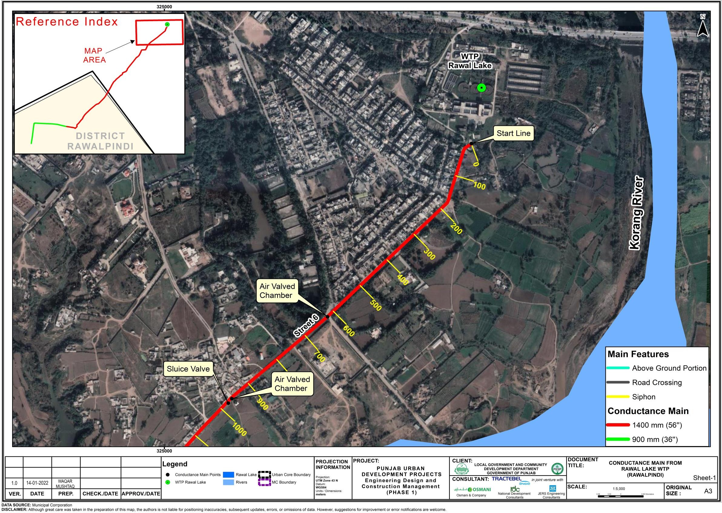

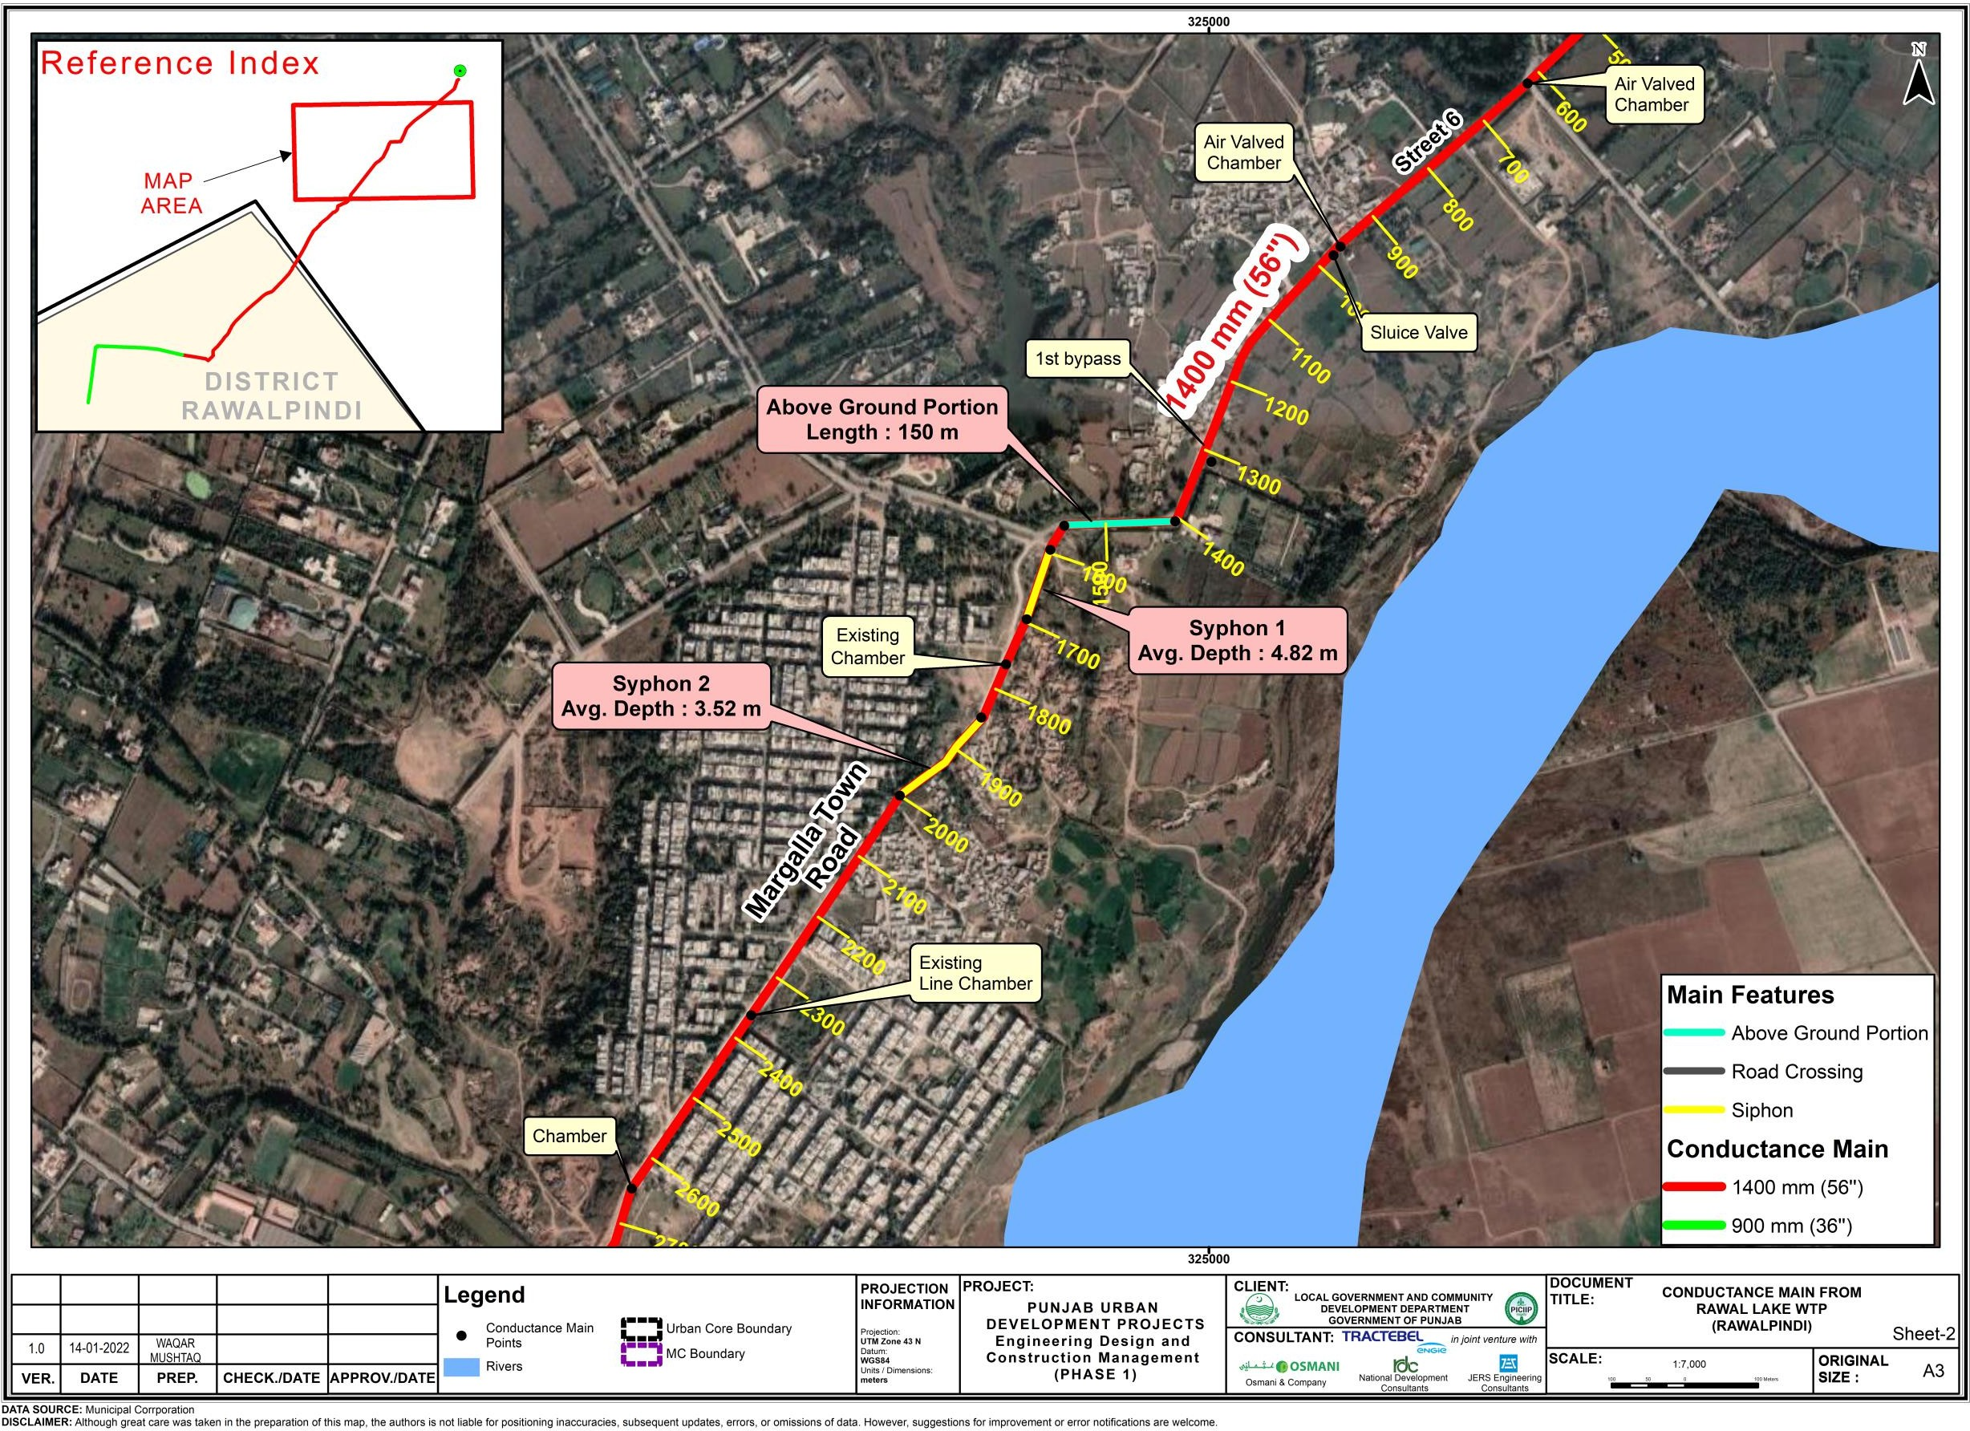

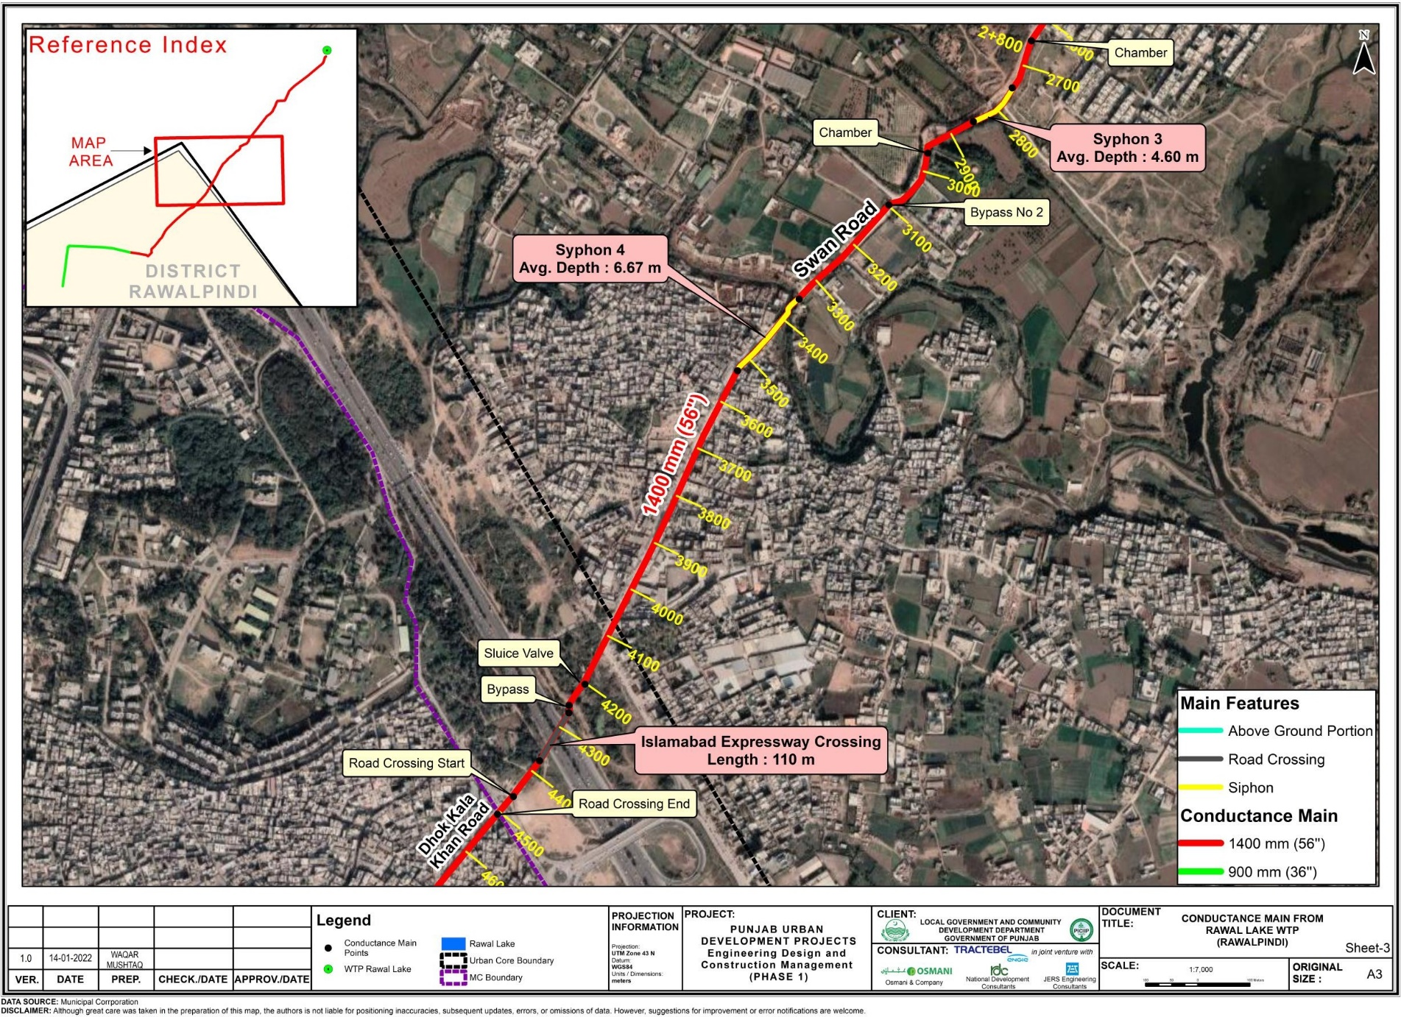

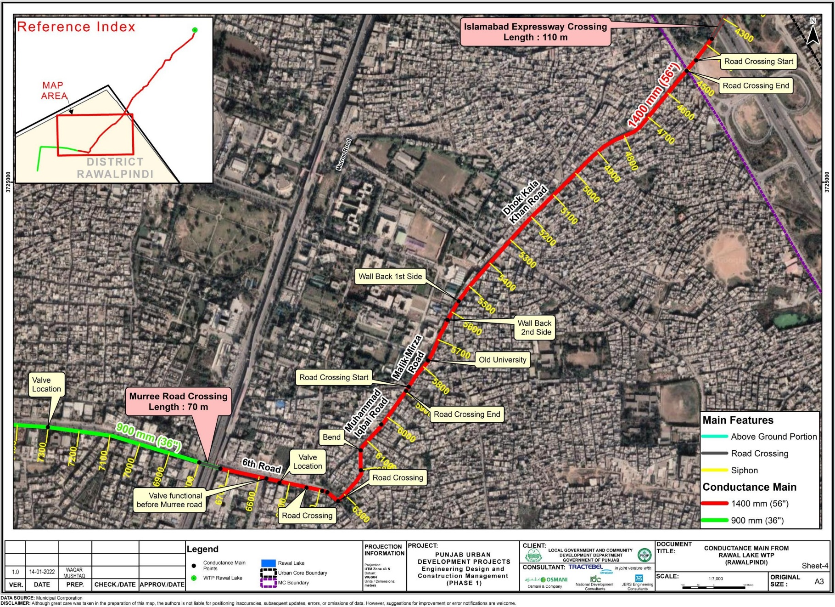

Annexure III: IBAT Findings

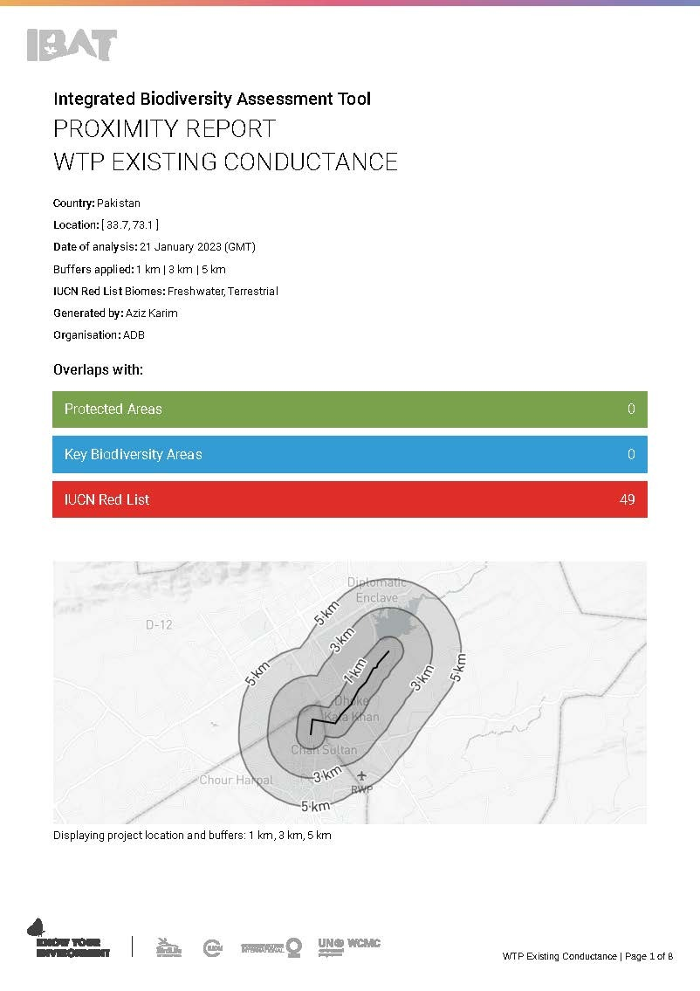
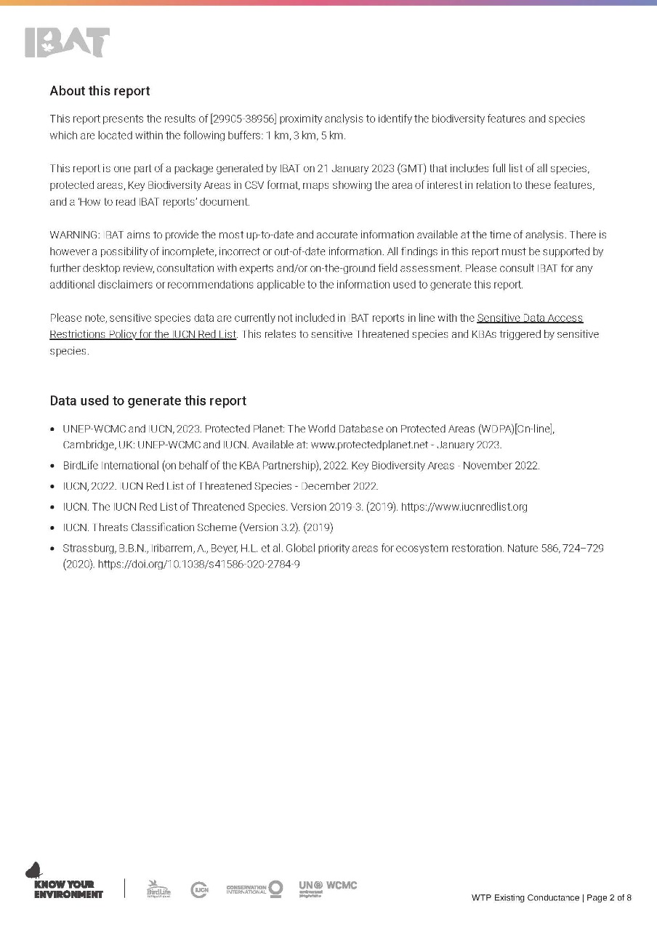
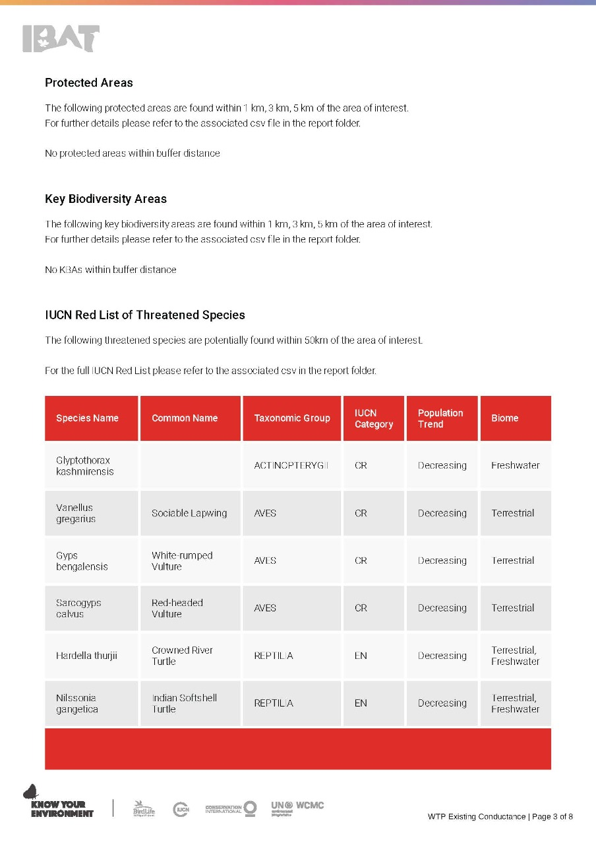

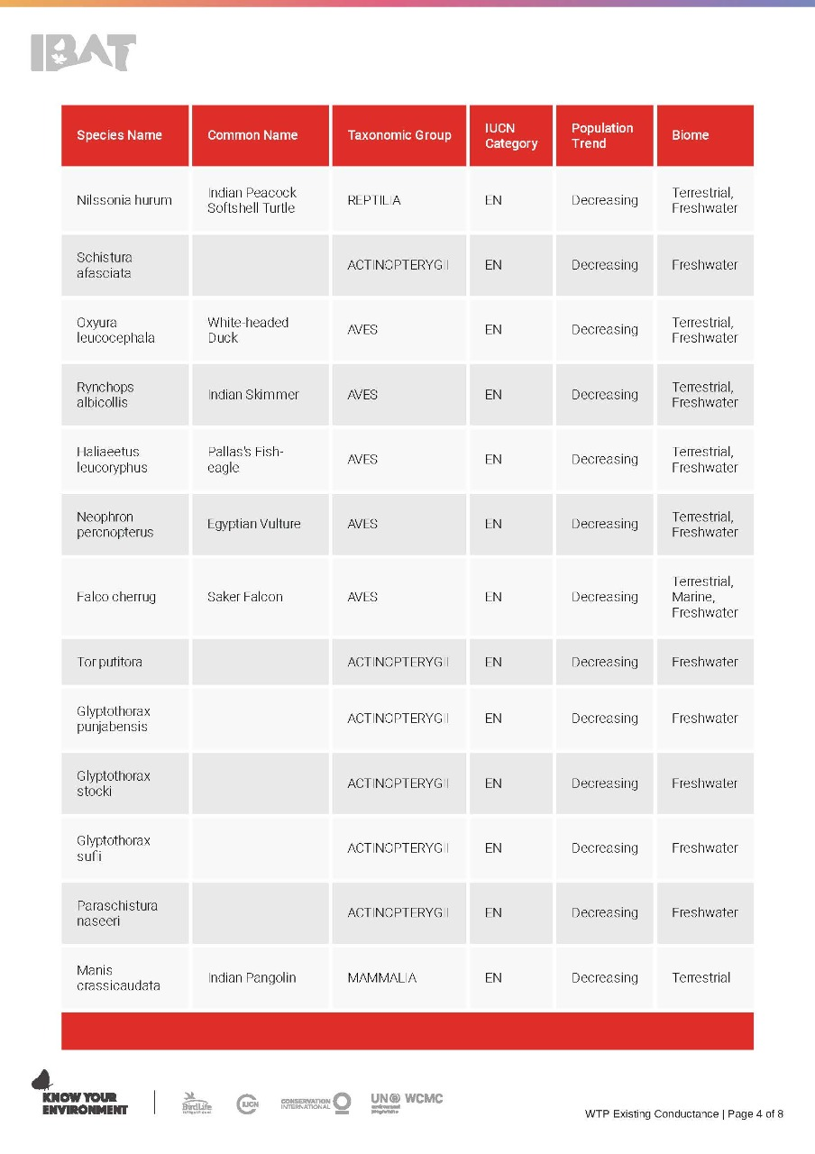

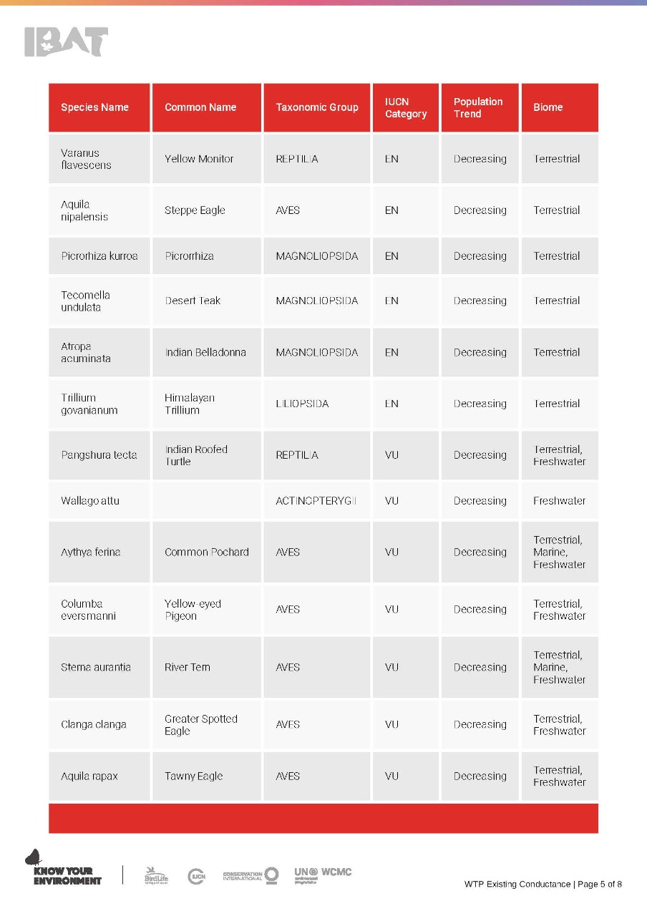

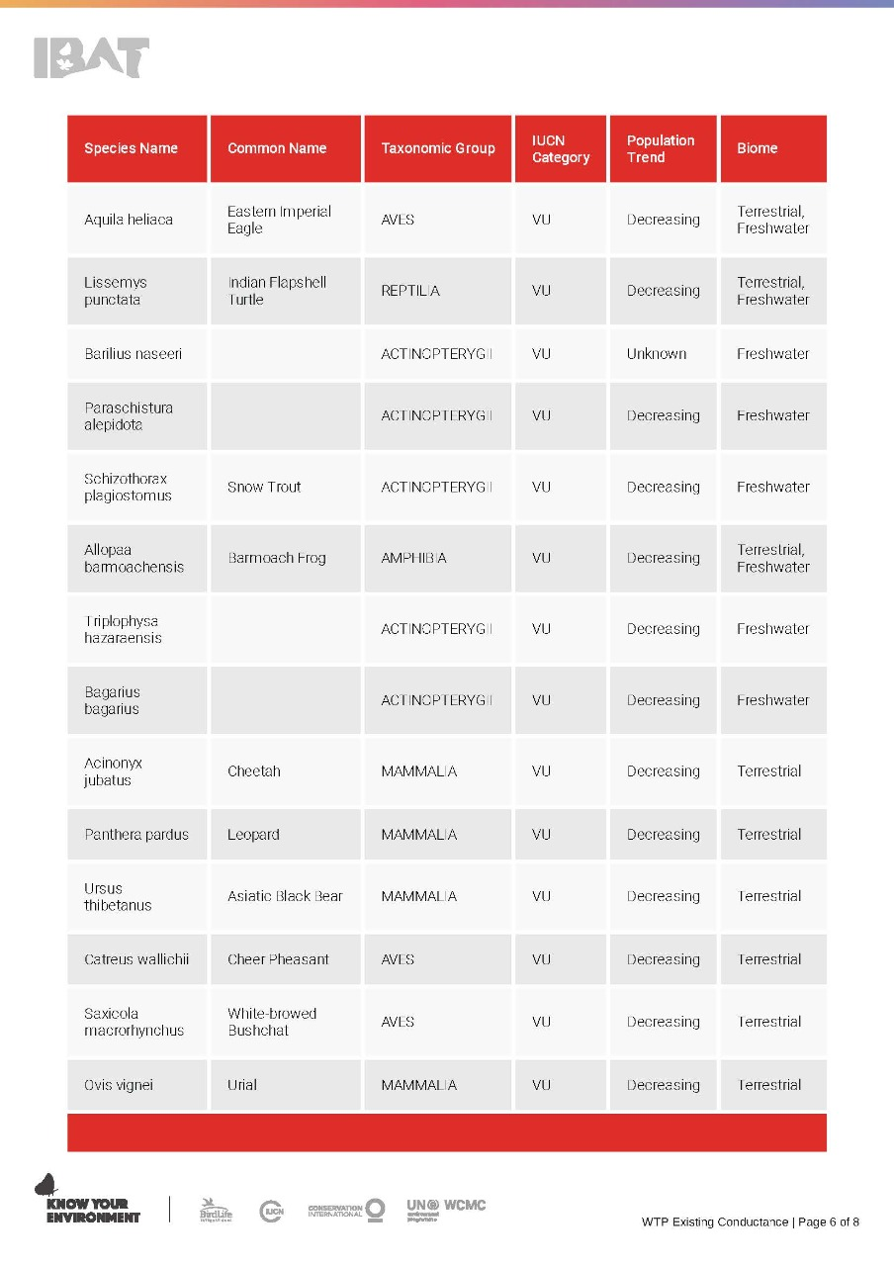

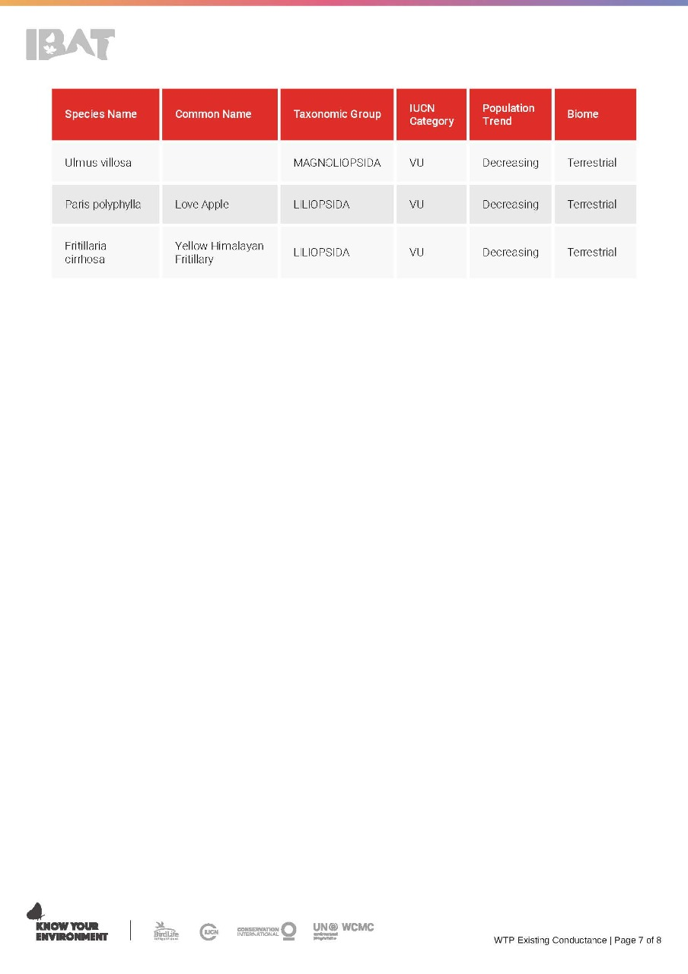
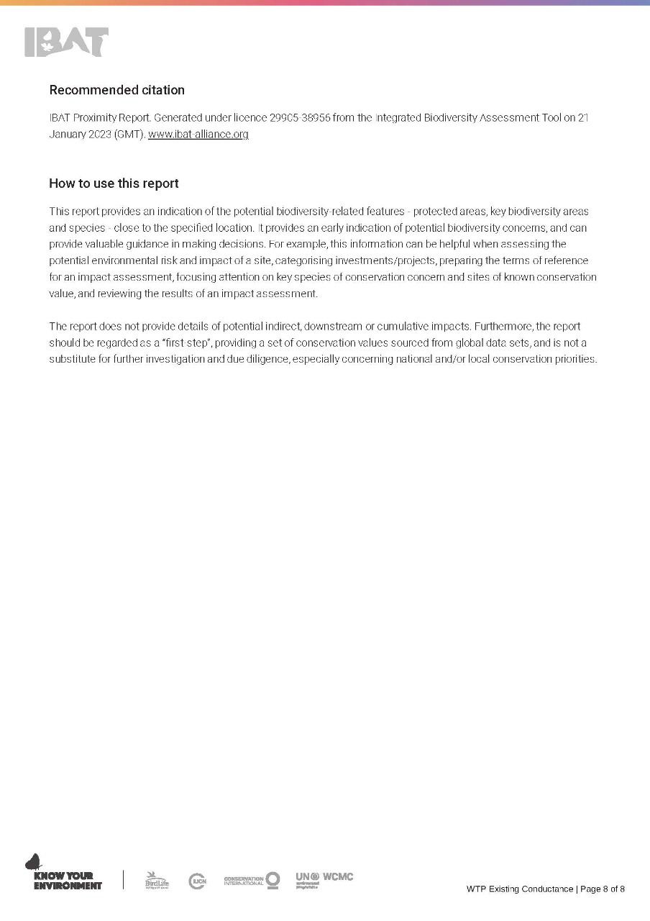

Annexure IV: Environmental Testing & Monitoring Reports

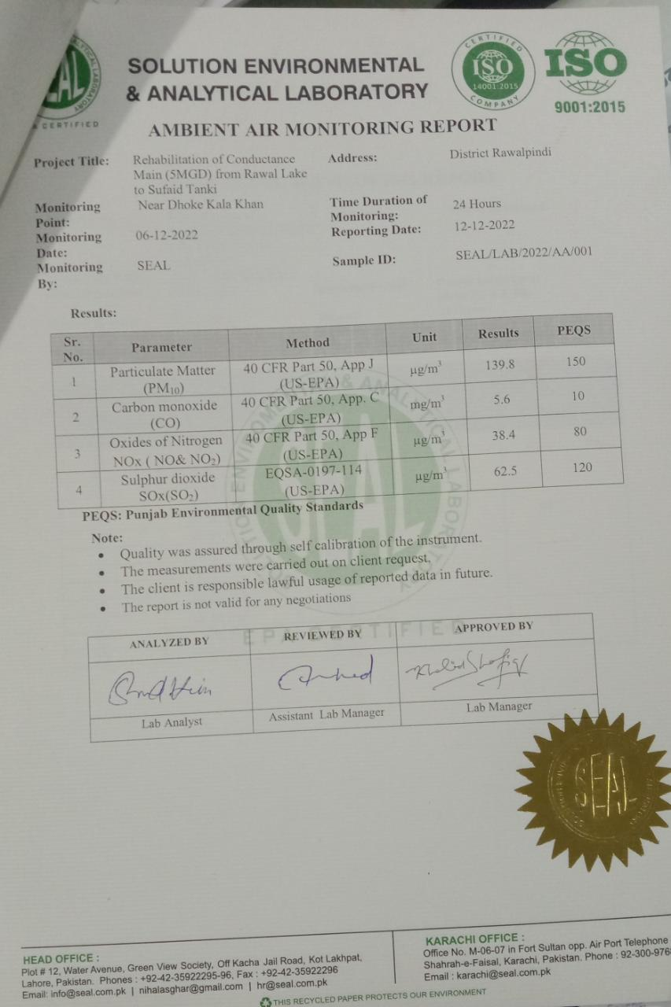

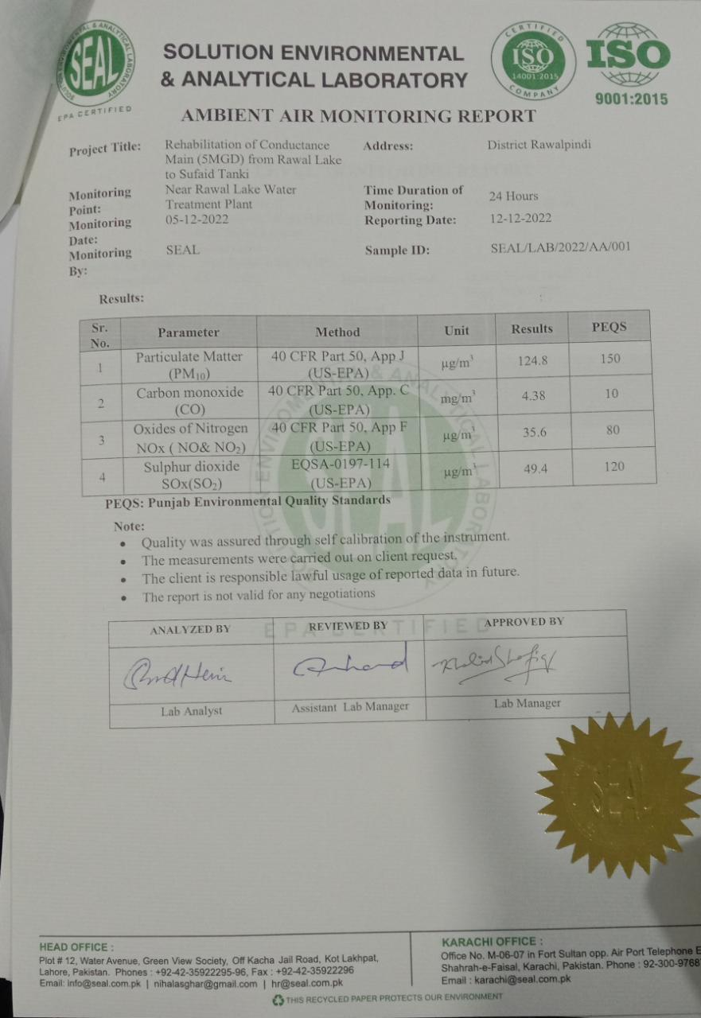

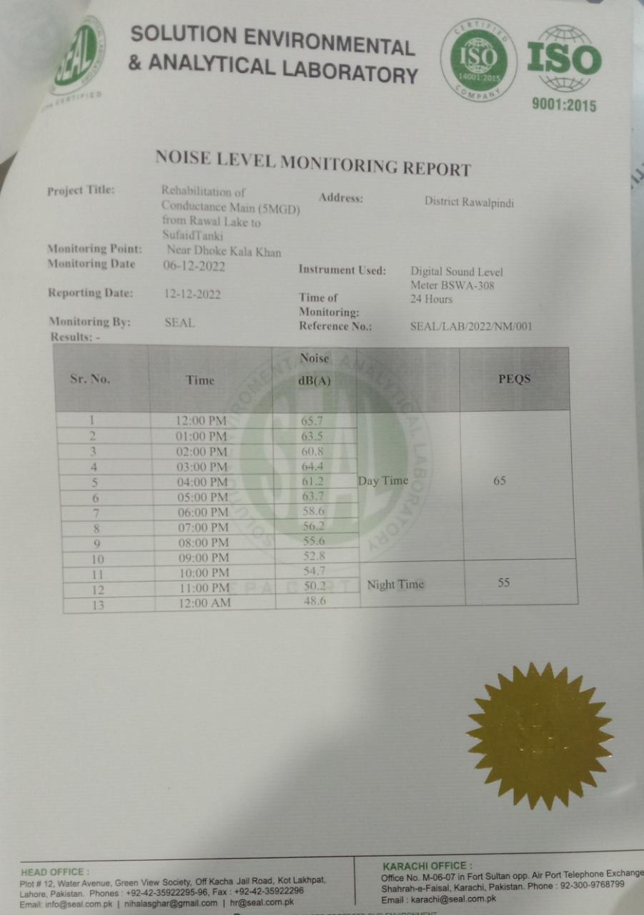
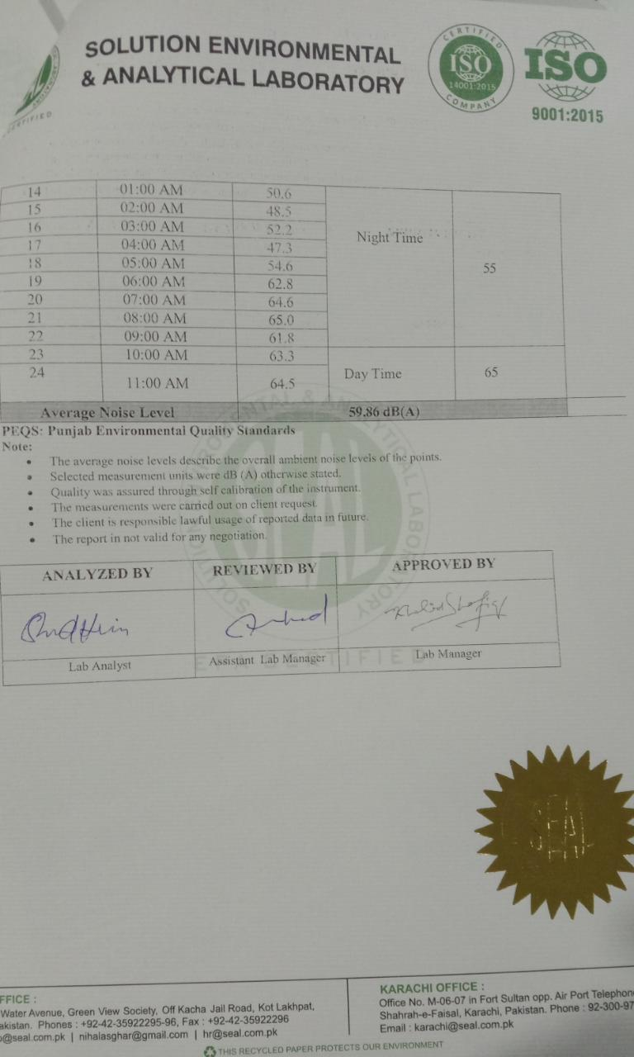

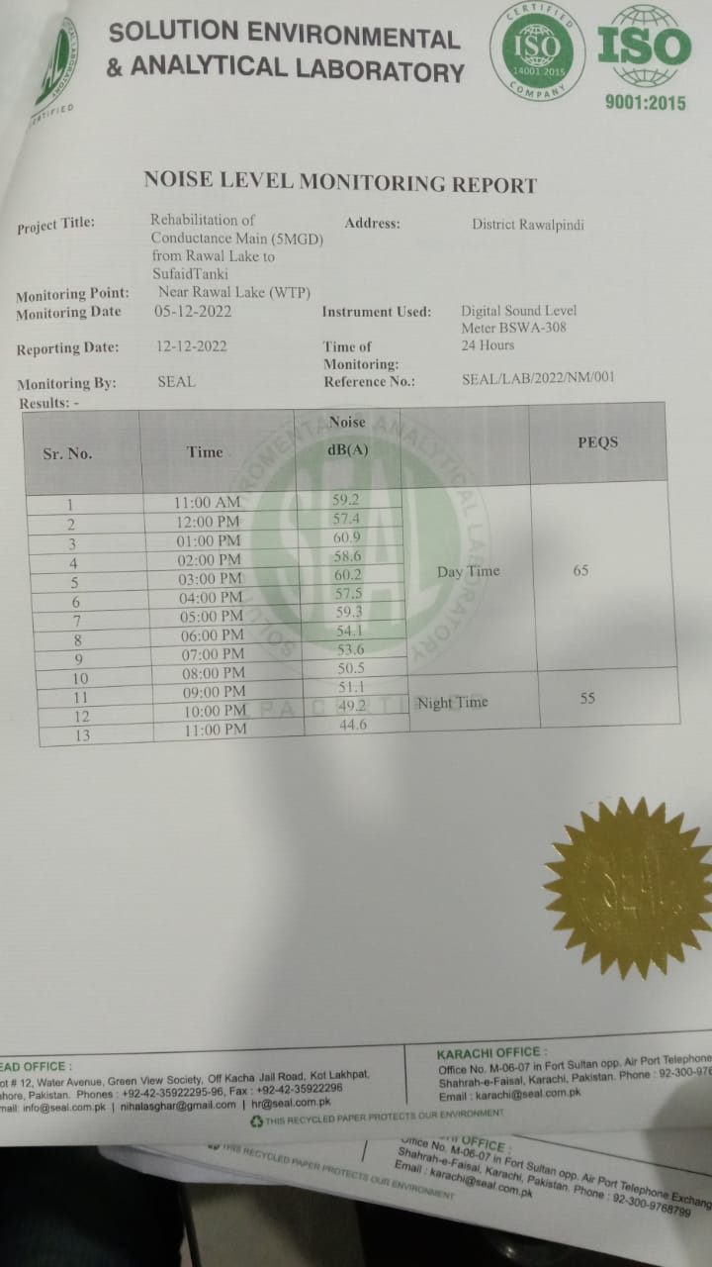

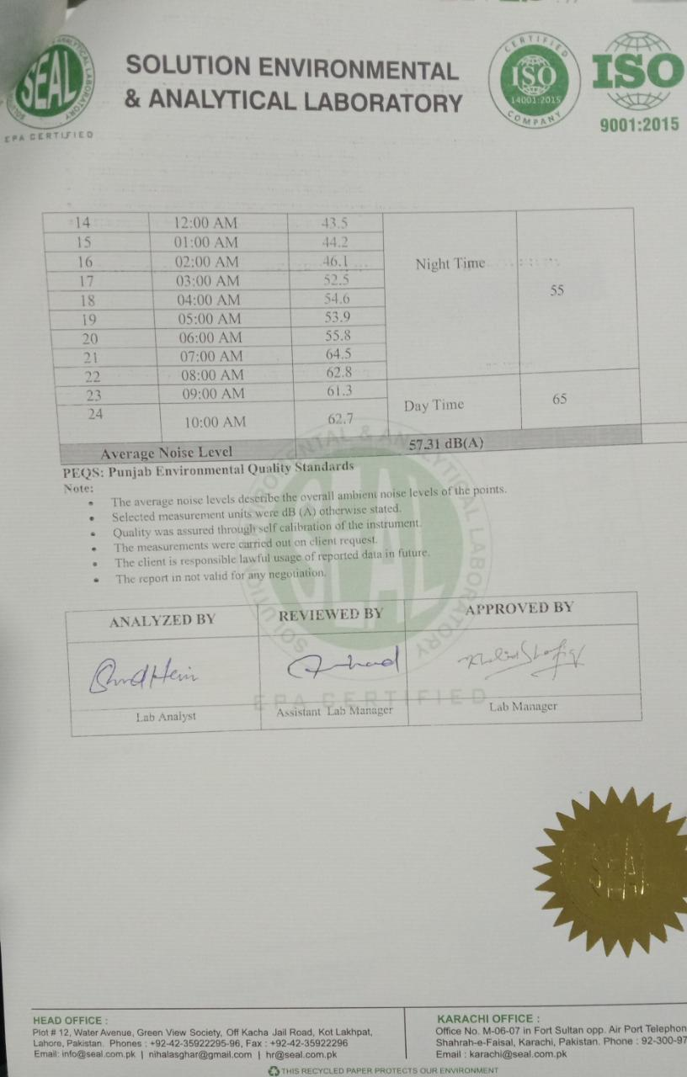

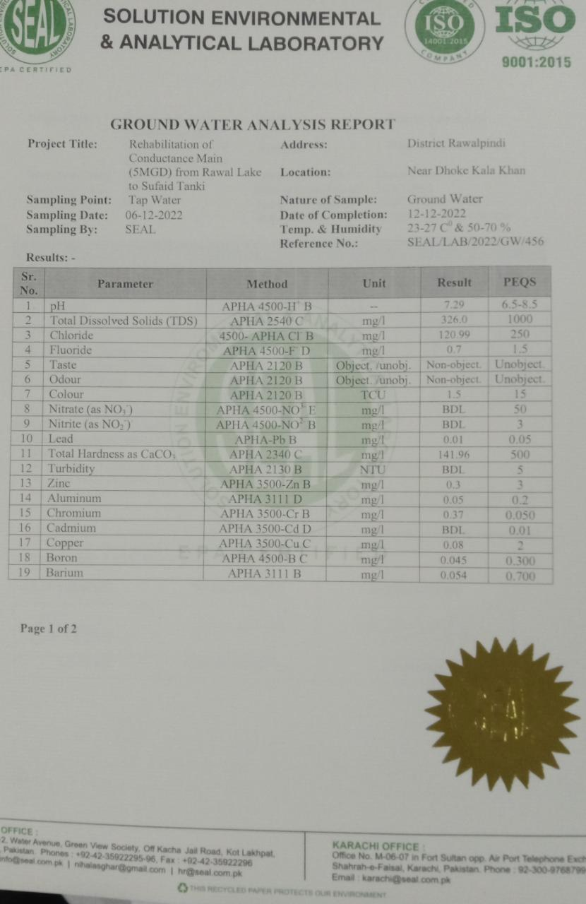

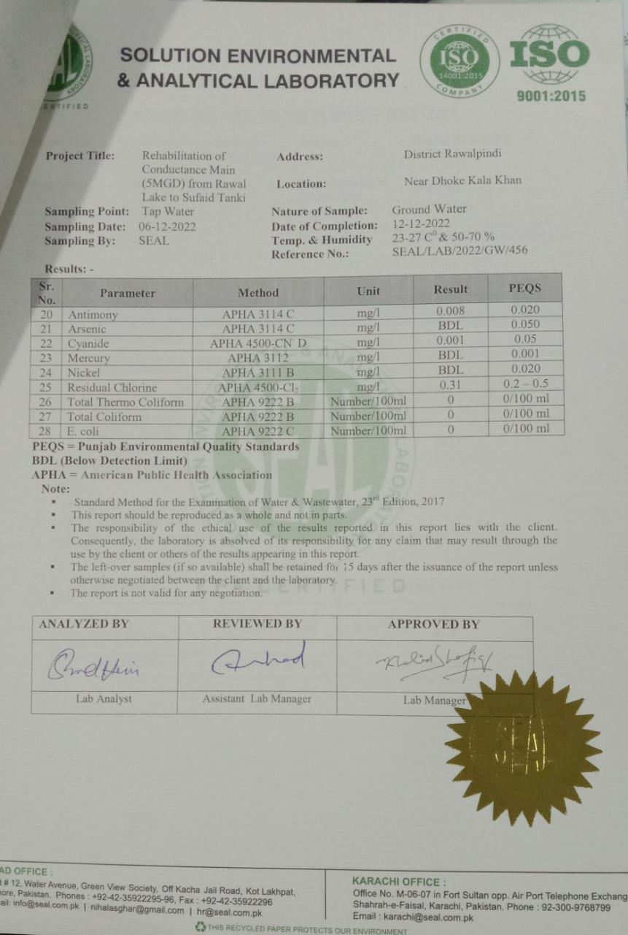

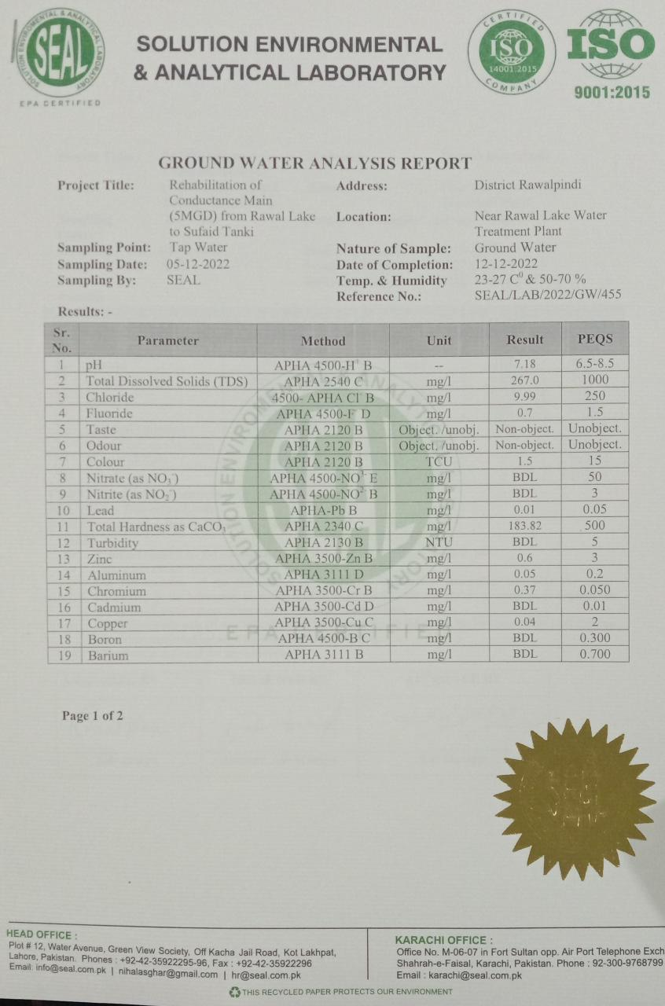

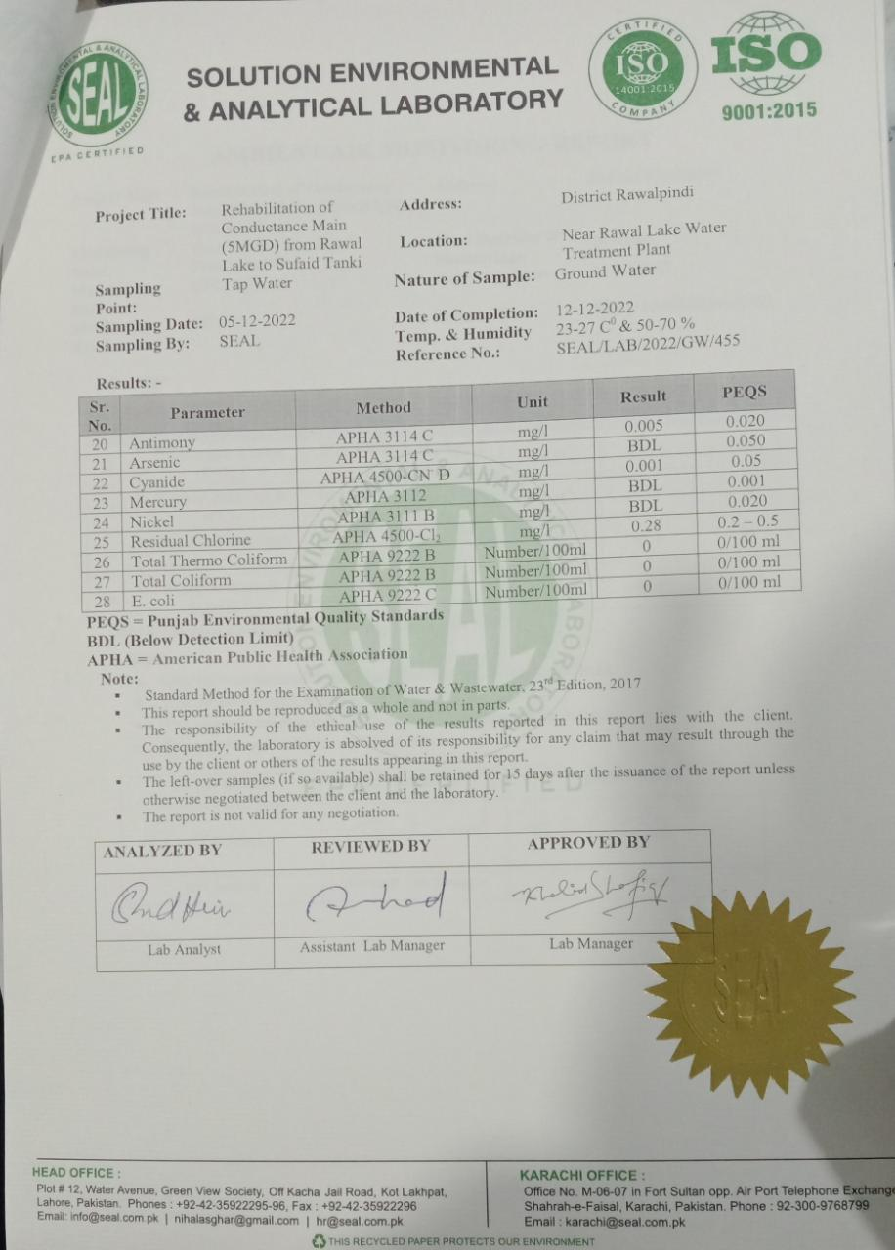

Annexure V: Calibration Certificate of Noise and Air Quality Measuring Instruments

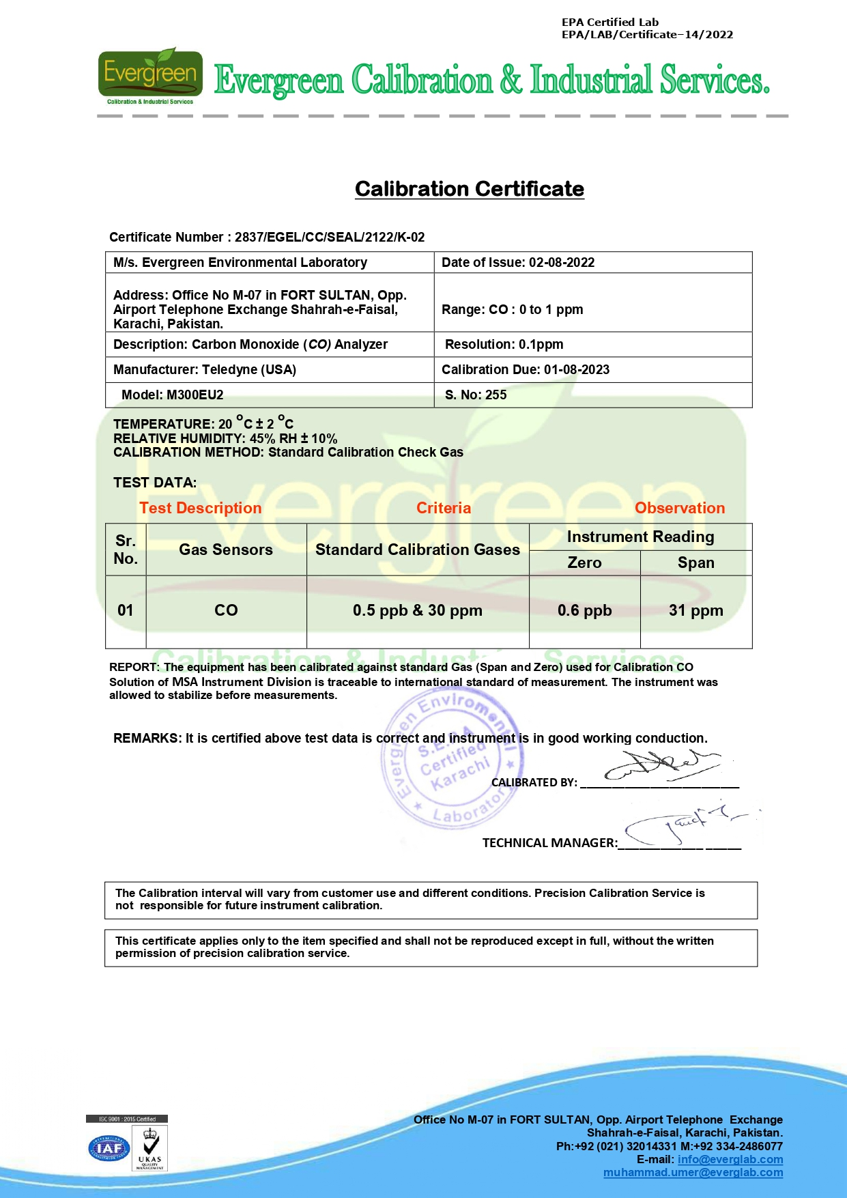
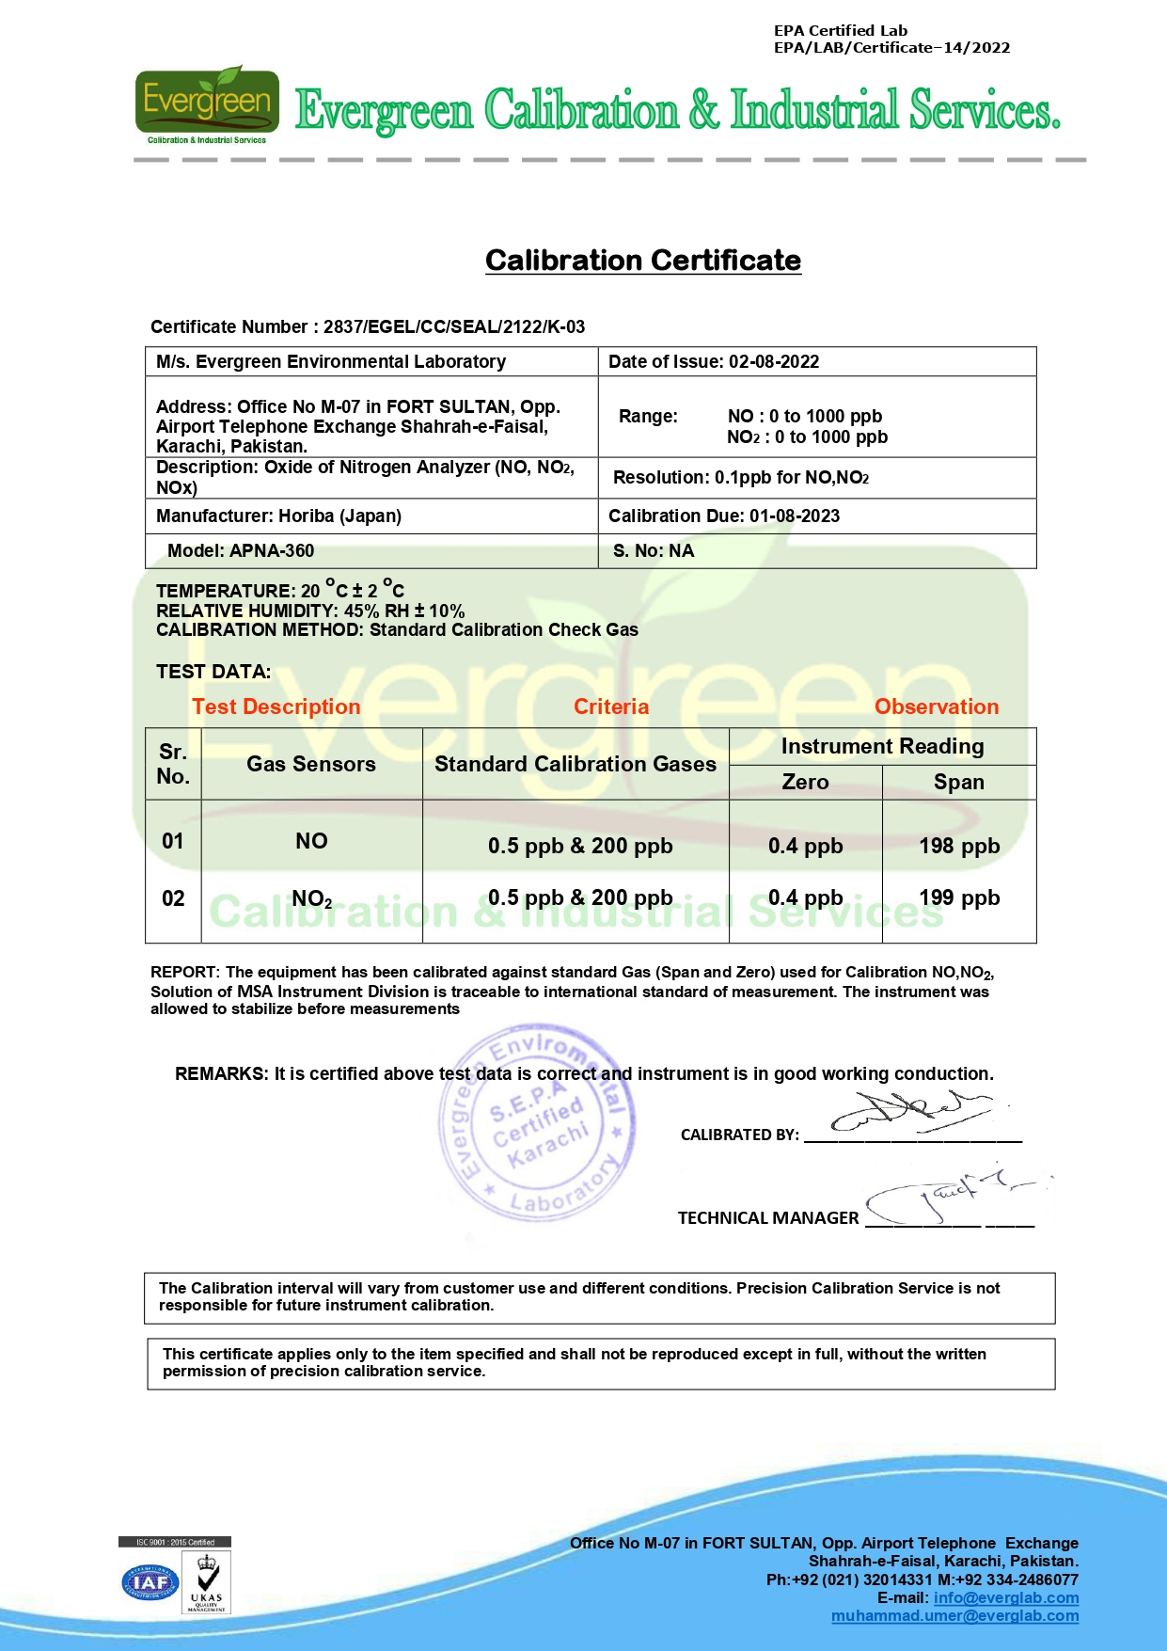
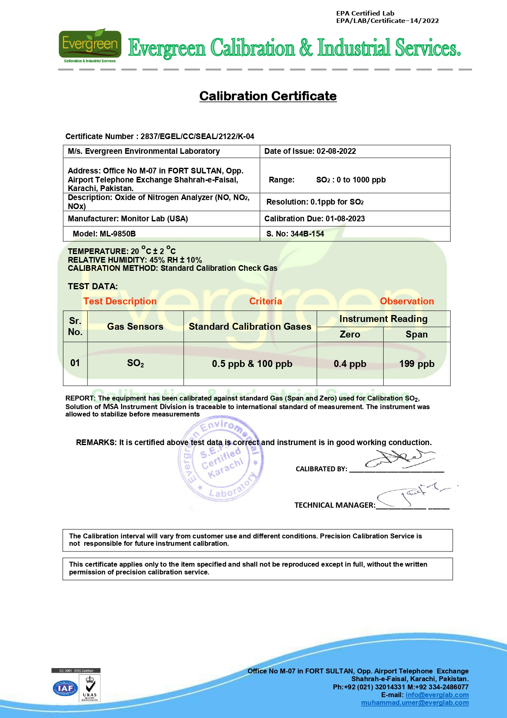
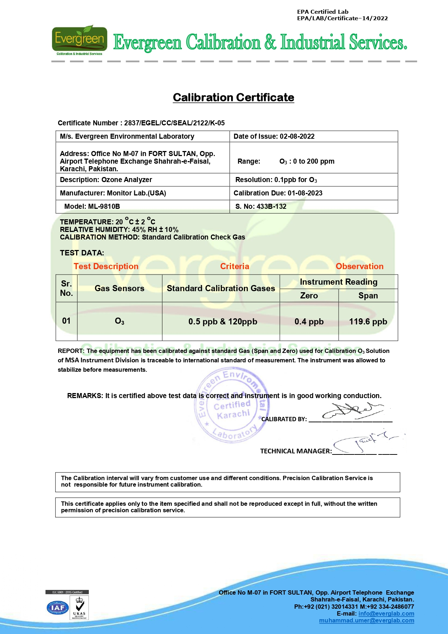
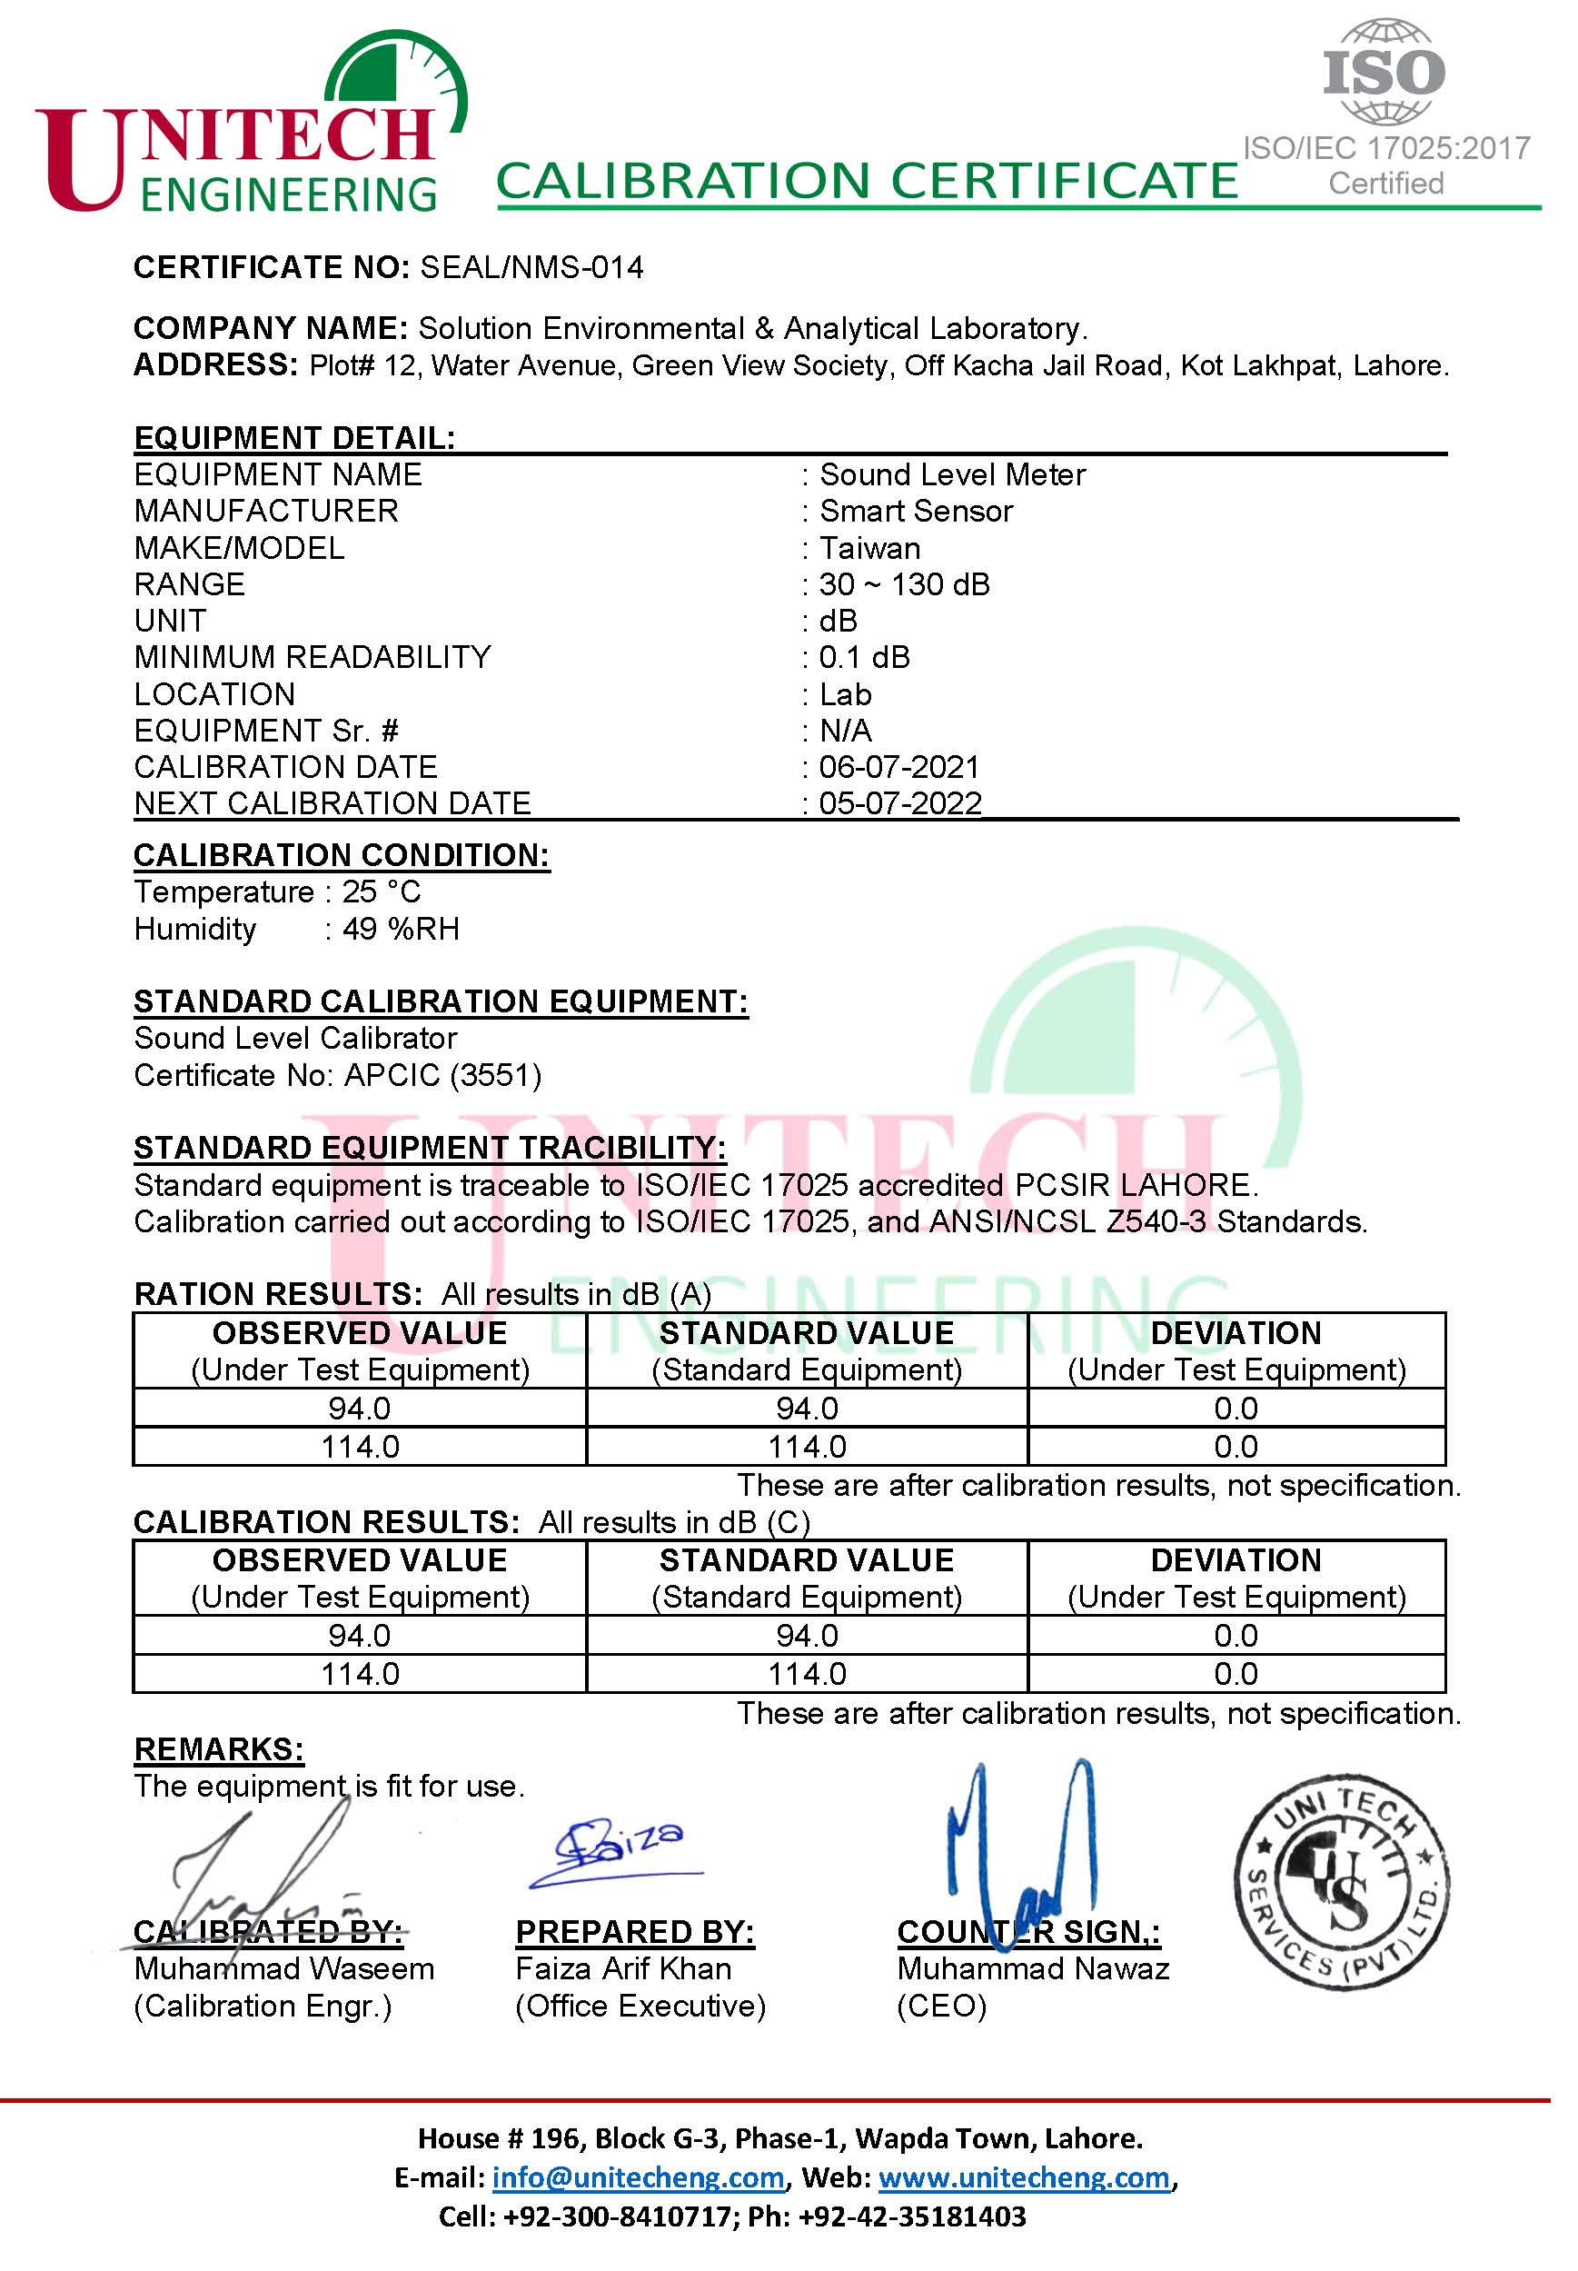

Annexure VI: Chance Find Procedures

Archeological Chance Find Procedure
Project may involve deep excavation. Therefore, the possibility of chance find is not ignorable. In case of any chance find, the contractor will immediately report through Supervision Consultant to Directorate General (DG) of Archeological Department, Government of Pakistan to take further suitable action to preserve those antique or sensitive remains. Representative of the DG will visit the site and observed the significance of the antique, artifact and cultural (religious) properties and significance of the project. The report will be prepared by representative and will be given to the DG. The documentation will be completed and if required suitable action will be taken to preserve those antiques and sensitive remains.
In case any artifact, antiques and sensitive remains are discovered, chance find procedures should be adopted by contractor workers as follows:
- Stop the construction activities in the areas of chance find;
- Delineate the discovered site or area;
- Consult with the local community and provincial Archeological Department
- The suggestion of the local communities and the concerned authorities will be suitably incorporated during taking the preventive measures to conserve the antique, artifact and cultural (religious) properties;
- Secure the site to prevent any damage or loss of removable objects. In case of removable antiquities or sensitive remain, a night guard shall be arranged until the responsible local authorities take over; and
- After stopping work, the contractor must immediately report the discovery to the Supervision Engineer.
The contact Address of Archeology Department is given below:
Archeology Department
19 Ataturk Ave, Shakar Parian,
Islamabad, Islamabad Capital Territory, Pakistan

Annexure VII: Framework for Traffic Management Plan

1. Objectives of TMP
One of the prime objectives of this TMP is to ensure the safety of all the road users along the work sites, and to address the following issues:
- Safety of pedestrians, bicyclists, and motorists travelling through the construction sites;
- Protection of workers from hazards associated with moving traffic;
- Mitigation of the adverse impact on road capacity and delays to the road users;
- Maintenance of access to adjoining properties; and
- Addressing issues and concerns that may delay the implementation of the proposed project.
2. Operating Policies for TMP
The following policies will help promote safe and efficient movement for all road users (motorists, bicyclists, and pedestrians, including persons with disabilities) through and around project sites, while reasonably protecting workers and equipment.
- Make traffic safety and temporary traffic control an integral and high-priority element of project from planning through design, construction, and maintenance;
- Inhibit traffic movement as little as possible;
- Provide clear and positive guidance to drivers, bicyclists, and pedestrians as they approach and travel through the temporary traffic routes;
- Inspect traffic control elements routinely, both day and night, and make modifications when necessary;
- Pay increased attention to roadside safety in the vicinity of temporary traffic routes;
- Train all persons that select, place, and maintain temporary traffic control devices;
- Keep the public well informed; and
- Make appropriate accommodation for abutting property owners, residents, businesses, emergency services, railroads, commercial vehicles, and transit operations.
Policy steps for the TMP are shown in Figure 1. However, operating policy for TMP for the construction of the proposed project along various types of roads is shown in Figures 2 to 7.

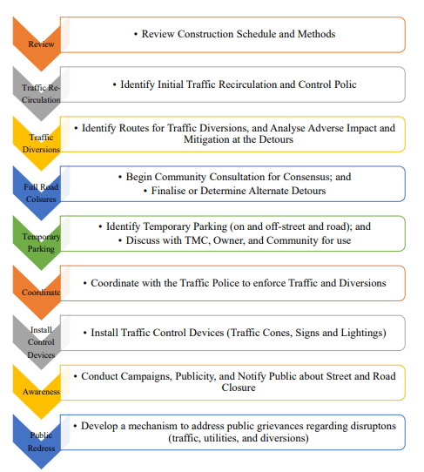
Figure 1: Policy Steps for the TMP

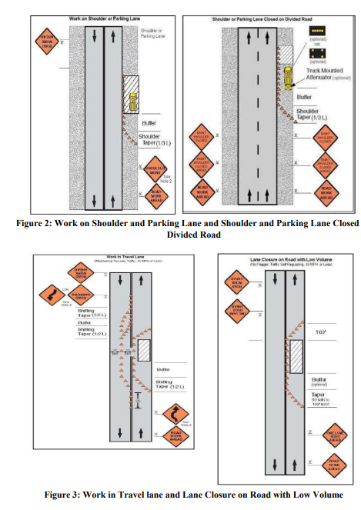

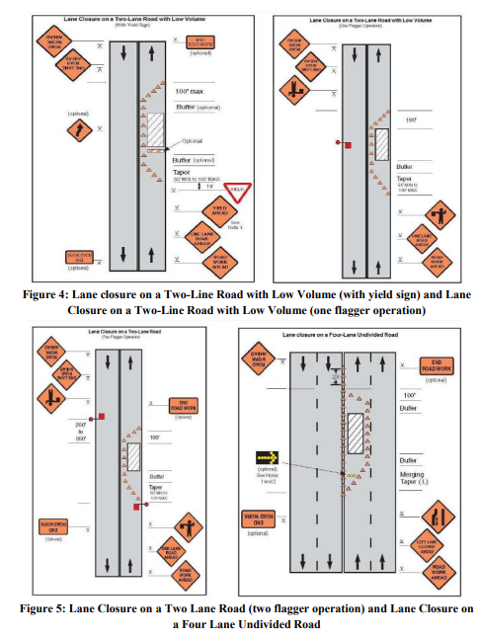

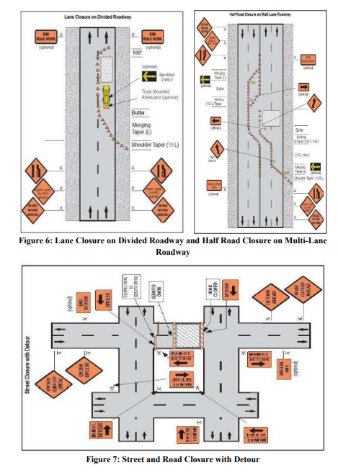
3. Analyze the Impact Due to Street and Road Closure
Apart from the capacity analysis, final decisions to temporary close a particular street and road and divert the traffic should involve the following steps:
- Approval from the Traffic Police to use the local streets and roads as detours;
- Consultation with businesses, community members, residents, road users and traffic police regarding the mitigation measures necessary at the detours where the road is diverted during the construction;
- determining of the maximum number of days allowed for road closure, and incorporation of such provisions into the contract documents;
- determining if additional traffic control or temporary improvements are needed along the detour route;
- considering how access will be provided to the worksite;
- Contacting emergency service, school officials, and transit authorities to determine if there are impacts to their operations; and
- Publish a notice through print and electronic media about road closure to avoid hindrance to public. As part of this notice, the public should be advised of alternate routes that commuters can take or will have to take as result of the traffic diversion.
If full road-closure of certain routes within the proposed project area is not feasible due to inadequate capacity of the Detour Street or public opposition, the full closure can be restricted to weekends with the construction commencing on Saturday night and ending on Monday morning prior to the morning peak period.
4. Public Awareness and Notifications
As per discussions in the previous sections, there will be travel delays during the construction, as is the case with most construction projects, although on a reduced scale if utilities and traffic management are properly coordinated. There are additional grounds for travel delays in the area, as most of the streets and roads in the proposed project sites lack sufficient capacity to accommodate additional traffic from diverted traffic, as a result of street and road closure to accommodate the construction activities.
The awareness campaign and the prior notification for the public will be a continuous activity which the project will carry out to compensate for the above delays and minimize public claims as result of these problems. These activities will take place sufficiently in advance of the time, when the roadblocks or traffic diversions take place at the particular streets and roads. The reason for this is to allow sufficient time for the public and residents to understand the changes to their travel plans. The project will notify the public about the roadblocks and traffic diversion through public notices, ward level meetings, and city level meeting with the elected representatives.
The Project Management Unit (PMU) comprising staff members of WASA, Supervision Consultant and Contractor will also conduct an awareness campaign to educate the public about the following issues:
- Traffic control devices in place at the construction sites (signs, traffic cones, and barriers);
- Defensive driving behavior along the construction sites; and
- Reduced speeds enforced at the construction sites and traffic diversions
It may be necessary to conduct the awareness programs and campaigns on road safety during construction.
The campaign will cater to all types of target groups i.e. children, adults, disabled and drivers.
Therefore, these campaigns will be conducted in schools and community centers. In addition, the project will publish a brochure for public information. These brochures will be widely circulated around the proposed project area and will also be available at the PIU, and the Contractor's site office. The text of the brochure should be concise to be effective, with a lot of graphics. It will serve the following purpose:
- Explain why the brochure was prepared, along with a brief description of the proposed project;
- Advise the public to expect the unexpected delays or roadblocks;
- Educate the public about the various traffic control devices and safety measures adopted at the construction sites;
- Educate the public about the safe road user behavior to emulate at the construction sites;
- Inform the public how to stay informed or where to inquire about road safety issues at the construction sites (name, telephone and mobile number of the contact person); and
- Indicate the office hours of authorized representatives.
5. Install Traffic Control Devices at the Construction Sites and Traffic Diversion Routes
The purpose of installing traffic control devices at the construction sites is to delineate these areas to warn, inform, and direct the road users about a hazard ahead, and to protect them as well as the workers. As proper delineation is a key to achieve the above objective, it is important to install good traffic signs at the construction sites. The following traffic control devices are used in construction sites:
- Signs;
- Pavement Markings;
- Channelizing Devices;
- Arrow Panels; and
- Warning Lights.
Procedures for installing traffic control devices at any construction sites vary, depending on road configuration, location of the work, construction activity, duration, traffic speed and volume, and pedestrian traffic. Work will take place along major roads, and the minor internal roads. As such, the traffic volume and road geometry vary. The main roads carry considerable traffic; internal the roads are narrow but carry traffic. However, regardless of where the construction takes place, all the construction sites should be cordoned off, and traffic shifted away at least with traffic cones, barricades, and temporary signs (temporary “STOP” and “GO”).
Figures 2 to 7 illustrates a typical set-up for installing traffic control devices at the construction sites of the area, depending on the location of work on the road way, and road geometrics:
- Work on shoulder or parking lane;
- Shoulder or parking lane closed on divided road;
- Work in travel lane;
- Lane closure on road with low volume;
- Lane closure on a two-line road with low volume (with yield sign);
- Lane closure on a two-line road with low volume (one flagger operation);
- Lane closure on a two lane road (two flagger operation);
- Lane closure on a four lane undivided road;
- Lane closure on divided roadway;
- Half road closure on multi-lane roadway; and
- Street closure with detour.
The construction sites should take into consideration, for the space required for a buffer zone between the workers and the traffic (lateral and longitudinal), and the transition space required for delineation, as applicable. For the construction works, a 30 centimeter clearance between the traffic and the temporary STOP and GO signs should be provided. In addition, at least 60 centimeter is necessary to install the temporary traffic signs and cones.
Traffic police should regulate traffic away from the construction sites and enforce the traffic diversion outcome from full street closure in certain areas during construction. Flaggers and personnel should be equipped with reflective jackets at all times and have traffic control batons (preferably the LED type) for regulating the traffic during night time.
In addition to the delineation devices, all the construction workers should wear fluorescent safety, vests and helmets in order to be visible to the motorists at all times. There should be provision for lighting beacons and illumination for night constructions.

Annexure VIII: Framework for Resources Conservation Plan

1. INTRODUCTION
The most of the resources in this world are finite and non-renewable in nature. We are completely dependent on these resources to fulfill all our daily requirements. Therefore, sustainable development calls for the need to conserve resources in a way that meet our needs of present generation as well as future generation, especially the non-renewable resources.
2. OBJECTIVE OF THE PLAN
The Resource Conservation Plan is intended to make an effort towards achieving sustainable development. The objective of the resource conservation plan is to:
- Minimize the use of natural resources; and
- Mitigate and prevent pollution contaminating the natural resources.
3. PLANNING
Careful estimations of quantities of material, fuel, water and energy required directly or indirectly shall be done to avoid excessive or unnecessary wastage of these materials. In addition to this, pollution prevention strategies shall also be devised to prevent contamination of resources.
The estimations include the following:
- Estimation of construction material required for the project;
- Estimation of fuel consumption for construction machinery, construction vehicles and generators;
- Estimations of the energy requirements during all the stages of the project; and
- Estimations of water consumption for construction activities and construction camp sites.
- Strategies shall be planned to reduce loads on the identified resources to be consumed;
- Best management practices shall be devised to control or reduce pollution resulting from the activities during different stages of the project; and
- An inspector shall be assigned responsibility to oversee the ongoing activities to check the compliance of the planned strategies.
4. EXECUTION OF THE PLAN
The planned strategies shall be implemented to conserve the natural resources including but not limited to the following:
Material
- Material supplied shall be in conformance with the estimated quantities and excess material shall be returned to the supplier;
- Material wastage shall be avoided by using best management practices;
- Waste produced during the project execution shall be disposed of safely to the designated disposal sites through approved contractors; and
- Reuse of the materials shall be appreciated.

Energy
- Reduce trips and optimize routes to and from the construction site for all kinds of activities;
- Regular maintenance of equipment and vehicles to avoid leaks and sustain efficient fuel consumption;
- Switch off idle equipment and vehicles to avoid wastage of fuel;
- Minimize warm up time, unnecessary acceleration and deceleration of the construction equipment and vehicles;
- Avoid unnecessary burning of fuel for cooking in construction camps;
- Avoid unnecessary use of heating and cooling systems during extreme weathers events;
- Construction shall start in early hours of the day to avoid heat in summers and utilization of day light; and
- Alternate energy sources shall be considered for electricity generations during construction and operation to conserve fossil fuel as it is non-renewable resource.
Water
- Avoid using potable water for sprinkling, curing and washing of equipment and vehicles.
- Surface water or treated effluent can be used instead;
- Wastage of water should be controlled through providing proper valves and through controlling pressure of the water;
- Unnecessary equipment washings should be avoided;
- Awareness amongst workers shall be raised to conserve water and immediately report for any leaks detected; and
- Ensure protection of canal water from contamination resulting from construction activities.
Pollution
- Emissions shall be reduced and controlled as far as possible and direct discharges to air shall be avoided by strictly adhering to the mitigation measures outlined in IEE report;
- Waste water shall not be discharged directly into the canal and must be managed as per the recommendations presented in IEE report; and
- Construction waste, and municipal solid waste shall not be dumped and burnt openly, and shall be handled according to the preventative measure given in IEE report.
5. CHECKING AND CORRECTIVE ACTIONS
The R-WASA shall bind the construction contractor through contract agreement to comply with the strategies outlined in the Resource Conservation Plan. The Environmental Committee shall also appoint an Inspector who shall monitor the daily onsite activities and shall report any issues and concerns raised in relation to Resource Conservation Plan. The inspector shall recommend adequate corrective actions to mitigate the issues raised.

Annexure IX: Framework for Occupational Health & Safety Management Plan

Occupational Health and Safety Management Plan
It is required that all personnel working on the project attend the Health and Safety site induction briefing prior to commencing any work on the site.
The General Site Rules shall act as the main agenda and content of the induction briefing. Additionally, any information specific to the project shall be included in the induction. The induction briefing should be, as far as possible, two way communication with attendees invited to contribute, comment and ask questions regarding health and safety. Other rules are as follows:
- All attendees of the induction briefing will be recorded.
- High visibility jacket/vests, safety helmets and safety footwear (incorporating steel toe- caps and mid-sole) must be worn at all times.
- Safety goggles for protection during all cutting, grinding and drilling operations or where there is risk from impact, dust, chemicals or hot metal.
- Dust masks for protection from dust.
- Ear protection during all operations which produce noise above the level at which you need to raise your voice to be heard. Gloves during concreting work.
- On this site, formal permits must be in place before any of the following operations may be carried out: Permit to Excavate, Hot Work Permit & Confined Spaces Permit. (Where Applicable), thoroughly understand it and get permission from area supervisor (If required).
- Follow the messages and instructions displayed on HSE boards installed on site.
- Be aware of emergency muster (assembly) points and escape routes. In the event of an emergency do not panic, follow the site emergency response procedures.
- Report promptly all accidents to your supervisor and HSE officer at site. Immediately provide first aid for the injured and call for the medic.
- While working alone or in a confined space make sure that your nearby colleague and supervisor are well informed or use a banksman where appropriate.
- Ensure adequate lighting is in place for work on night shifts or for emergency response.
- All Scraps, waste materials and garbage must be disposed of in accordance with the construction waste management Strategy.
- Always clean your work site after completing the job or your shift.
- Maintain appropriate barricades as required.
- Never tamper with electric cables and appliances. Never insert direct cables into sockets, rather use proper plugs.
- Do not enter scaffold that is not tagged safe for access.
- Tools or materials must not be carried while climbing up or down scaffolding or ladders.
- Use pouches or ropes for this purpose.
- Do not smoke or produce naked flame in NO SMOKING area. Use of open fire is prohibited.
- Keep all gangways and aisles clear and clean at work sites.
- Vehicles must be driven at a safe speed, observing speed limits. Drivers must have a valid driving license for the class of vehicle they are operating.
- Vehicles shall only be parked in designated parking areas. Never travel in a vehicle unless in seating equipped with a seatbelt.
- Site HSE Roles and Responsibilities
1.1 Project Manager (PM)
- Develop and disseminate policies for occupational health and safety management systems and environmental management systems
- Provide resources for the management and implementation of occupational health and safety management systems and environmental management systems
- Responsible for ensuring the implementation of occupational health, safety and environmental policies
- Aware of the relevant maters of environment, health and safety.
- Allocate Budget and Provide resources for the implementation of HSE Plan in its true spirit.
- Attend meetings regarding the Health Safety and Environment.
- Report Health Safety and Environment matters to the management of the company as required.
1.2 Construction Manager (CM)
- Responsibilities include, but not limited to:
- Well conversant with international & local, Health, Safety & Environmental rules, regulations and current legislation.
- Ensure that all senior site staff is also conversant with the relevant requirements of current legislations and EPC contractor HSE plan.
- Ensure that site personnel are assigned appropriate duties and responsibilities accordingly to assist in the effective implementation of this HSE Plan.
- Ensure no job is carried on without supervision.
- Approve work methods statements; ensure safety procedures are established and undertaken.
- Funds for essential HSE facilities, equipment and personnel are made available.
- His own personal behavior supports, strengthens and confirms the site’s HSE management program.
1.3 Environmentalist/HSE Officer
- Carry out safety inspection of Work Area, Work Method, Men, Machine & Material and other tools and tackles.
- Facilitate inclusion of safety elements into Work Method Statement.
- Highlight the requirements of safety through Tool-box/other meetings.
- Conduct investigation of all incident/dangerous occurrences & recommend appropriate safety measures.
- Advice & co-ordinate for implementation of HSE plan in its true spirits.
- Convene HSE meeting & minute the proceeding for circulation & follow-up action.
- Plan procurement of PPE & Safety devices and inspect their healthiness.
- Report to Project Manager (PM) and Resident Director EPC contractor on all matters pertaining to status of safety and promotional program at site level.
- Facilitate administration of First Aid
- Facilitate screening of workmen and safety induction.
- Conduct fire and other emergency Drills and facilitate emergency preparedness
- Design campaigns, competitions & other special emphasis programs to promote safety in the workplace.
- Recommend to Site In charge, immediate discontinuance of work until rectification, of such situations warranting immediate action in view of imminent danger to life or property or environment.
- To decline acceptance of such PPE / safety equipment that do not conform to specified requirements.
- Encourage raising Near Miss Report on safety along with, improvement initiatives on safety.
- Ensuring that all injuries, accidents, incidents/near misses and hazards are positively and timely reported.
- Assisting Engineers/Area Supervisors in accident/incident investigations, where required Attending and positively contributing in the HSE Committee Meetings.
1.4 Workers
- Use the proper tools and equipment when operating. According to the requirement of operation and different hazard sources using the PPE and protective clothing provided by company, such as, helmets, safety harness, goggles, safety vest, and other personal protective equipment
- Maintain the tool and keep the tool clean after job completion.
- Report to the site supervisor or on-site project manager for the equipment damage and hidden danger.
- Develop personal safety awareness - including workers themselves and others, especially new employees and young people.
- Avoid unnecessary risk generation.
- For known sources of danger, remind new employees to stay away from these hazards.
- It will strictly be forbidden to play in the construction area or to damage the public utilities.
- Provide advice on how to eliminate hazards.
1.5 Sub-Contractor HSE Management
- Sub-contractor’s employees shall immediately correct all unsafe conditions & acts as directed by Contractor Direct supervision. Unsafe acts by any personnel may be grounds for immediate removal and permanent banning from the project site.
- Only properly trained employees shall be authorized by sub-contractor to operate equipment, machinery, vehicles & tools.
- All Sub-contractors are required to follow safe work practices, and meet the requirements clearly identified in field HSE PLAN.
- The Sub-contractor shall erect & maintain safeguards for the protection of workers, any other sub-contractors & the public and eliminate or mitigate HSE hazards created by or otherwise resulting from performance of the work.
2 Communication and HSE Meetings
2.1 HSE Targets and Goals
Pursuant to the Policy Statement, the following HSE Targets and Goals are identified in order to create a positive approach to health, safety, and protection of the environment during all activities of the project; this will be achieved by employing competent and motivated staff:
- To avoid all personal injuries during the execution of the Project,
- To ensure that all personnel employed on the Project are competent to carry out their designated tasks safely.
- To create positive health, safety and environment attitudes and perceptions at all levels of the Project organization, and to raise health safety and environmental awareness in general.
- To implement a training program that supports the achievement of personnel competency in relation to Health, Safety, and the Environment.
- To complete the Project without incurring any significant property damage to permanent equipment, or temporary facilities.
- To complete the Project with minimum avoidable impact upon the surrounding environment.
- To implement a hierarchy of communication forums that ensure that HSE concerns can be raised and addressed at all levels of the organization. To continually monitor and improve HSE performance.
2.2 HSE Score Board
Environmentalist/HSE Officer will arrange a HSE score board and display at the key location of the project site facilities. Information on the HSE Score Board will be updated on daily basis.
2.3 HSE Awareness Sign Boards
HSE awareness signboards shall be displayed at key locations around the site to create and maintain awareness and ownership of HSE issues.
2.4 Internal Site HSE Committee Meeting
Internal HSE Committee Meetings chaired by the Site Manager/Construction Manager, will be held monthly with all Area Supervisors and nominated Engineers, Supervisors and support staff. HSE committee meetings will allow communication of HSE performance and corrective actions. All-important HSE matters of the site as well as the non-compliance reported in the current month will be discussed in these meetings.
1.3 Performance Monitoring
1.3.1 Performance Review in Site HSE Committee Meetings
Performance reviews shall be held on monthly basis in the Internal Site HSE Committee Meetings. The objective of the review is to gather information from monitoring, inspection and site working activities and to assess the effectiveness of the implementation of HSE procedures on site. The key performance indicators are:
a. Compliance with Health, Safety and Environment standards
b. Identification of areas not addressed in the HSE Plan
c. Achievement of specified HSE objectives
d. HSE statistics, root cause and trend analysis of the statistics
1.3.2 HSE Inspections of Equipment and Tools
a. The Site Manager will ensure that no Civil, Electrical or Mechanical equipment will go to the working area without HSE inspection.
b. Environmentalist/HSE Officer will co-ordinate with Equipment and Plant Department for the inspection of all Civil, Electrical and Mechanical equipment or the inspection of Civil, Electrical and mechanical equipment,
c. If during inspection, any equipment is found sub-standard, Manager Site HSE is authorized to reject this equipment and inform the Site Manager.
1.4 Incident / Accident Reporting and Investigation
1.4.1 Objective
The objective of incident reporting, investigation & analysis is to identify the cause(s) of an incident to allow for preparation of recommendations, to avoid recurrence of such incident(s) in future.
1.4.2 Incident Reporting and Investigation
Any work-related incident, accident, injury, illness, exposure, or property loss must be reported to your supervisor, the SS, and within 1 hour. Motor vehicle accidents must also be reported. A report must be filed for the following circumstances:

a) Accident, injury, illness, or exposure of an employee;
b) Injury of a subcontractor;
c) Damage, loss, or theft of property; and/or
d) Any motor vehicle accident regardless of fault, which involves a company vehicle, rental vehicle, or personal vehicle while the employee is acting in the course of employment.
e) HSE Officer shall brief the Management about the lost time injury/fatal cases and serious incidents/near-misses.
f) Project Manager and Construction Manager will review the incident report and comments on the recommendations of the Site HSE Staff. They will then assign corrective actions accordingly.
g) Occupational accidents resulting in employee injury or illness will be investigated by the SS. This investigation will focus on determining the cause of the accident and modifying future work activities to eliminate the hazard.
h) All employees have the obligation and right to report unsafe work conditions, previously unrecognized safety hazards, or safety violations of others. If you wish to make such a report, it may be made orally to your supervisor or other member or management, or you may submit your concern in writing, either signed or anonymously.
i) The Site HSE Staff shall carry out a follow up of the recommendations/corrective actions from time to time where he identifies ongoing non-compliance he shall inform the Project Manager Construction Manager.
1.5 Orientation, Site HSE Induction and Other Training Activities
1.5.1 Initial HSE Orientation Program
Each and every person will undergo a HSE orientation program. On completion of orientation he will be issued an Organizational Identity card. Contractor Site HSE Staff shall perform the initial orientation based on but not limited to the following:

- Explaining Organizational HSE Policy and Standards.
- General HSE rules and regulations for working in a Construction Site, Batching plant, Excavation Area, Mechanical and Electrical work including use of Personal Protective Equipment, incident reporting, getting first aid, emergency response, (HSE inspection, housekeeping, etc.
- Hazards at construction site, works, offices, or any miscellaneous work.
- Specific hazards like height, open excavations, electrical, fire, Fumes (including spray painting) and vehicle safety etc.
- Environmental hazard.
1.5.2 Daily Tool Box Talk by Supervisors/HSE Officer
HSE tool Box talk shall be conducted by Supervisor/HSE Officer for specific work groups prior to the start of work. The tool box is a forum for two- way communication between management and the employees. Tool box talk is focused on a specific job. The agenda shall consist of the following:
- Details of the jobs being intended for immediate execution.
- The relevant hazards and risks involved in executing the job and their control and mitigating measures.
- Specific site condition to be considered while executing the job like high temperature, humidity, unfavorable weather etc.
- Recent non-compliances observed.
- Appreciation of good work done by any person.
- Feedback from employees
- Any doubt clearing session at the end.
- Record of Tool box talk shall be maintained as per format attached.
- Incidents, which may occur in the site/works, shall also be discussed in “tool box talks”.
- Daily tool box talk record format is attached as Annex. “A”.
1.5.3 HSE Training During Project Execution
HSE training shall be arranged by contractor as per the need of the project execution and recommendation of HSE committee of site.
1.5.3.1 Site-Specific Training
Prior to working at this site, an initial site-specific training session or briefing shall be conducted prior to commencement of work activities. During this initial training session, employees shall be instructed on the following topics:
- Personnel responsibilities;
- Content and implementation of the HASP;
- Description of assigned tasks/scope of work;
- Site hazards and controls;
- Site-specific hazardous procedures (e.g., lining activities, etc.);
- Coordination of Site activities;
- Training requirements;
- PPE requirements;
- Emergency information, including local emergency response team phone numbers,
- route to nearest hospital, accident reporting procedures, evacuation routes and procedures, location of assembly points, and emergency response procedures;
- Instruction in the completion of required inspections and forms; and
- Location of safety equipment (e.g., portable eyewash, first aid kit, fire extinguishers, etc.).
- The various components of the project HASP will be presented followed by an opportunity to ask questions to ensure that each attendee understands the HASP. Personnel will not be permitted to enter or work in potentially contaminated areas of the Site until they have completed the Site-specific training session.
1.5.3.2 Safety Meeting/Health and Safety Plan Review
"Tailgate" safety meetings will take place each day prior to beginning the day's work. All Site personnel will attend these safety meetings, which may be contracted personnel, subcontractor personnel, or personnel from contractors. The safety meetings will cover specific health and safety issues, Site activities, changes in Site conditions, and a review of topics covered in the Site-specific pre-entry briefing.
1.5.3.3 Management Employees Training Program
- The management employees training program will be conducted during the project to ensure that all management employees are trained.
- An HSE specialist from contractor head office shall conduct the meetings, during his visit to site.
- The duration of this course would be half day.

Annexure Sub-A
HSE TOOL BOX TALK RECORD |  |  | Quality Records Forms
 |  |  |  |  | Doc. Version 1
Project Title: Rehabilitation of Conductance Main from Rawal Lake to Sufaid Tanki, Rawalpindi
Project Section:

Topic: Date
SR.  NO. | NAME OF WORKER  / STAFF | CRAFT | AREA | CONTRACTOR |  | REMARKS
Delivered By SITE HSE OFFICER

Annexure X: Framework for Emergency Response Plan

Emergency Response Plan
Contractors are committed and obliged to protecting the community, workers, public and concerned company’s property and the surrounding environment; in the emergency situations. These situations shall be handled through the implementation of an Emergency Preparedness and Response Plan (EPRP). The construction contractors shall meet with the local emergency service institutions and law enforcement agencies i.e. Fire and rescue 1122, Police, to review and discuss the construction process, including unique construction equipment(s), the overall construction process, and schedule/phasing. This plan will be communicated to all the concerned and personnel who will be responsible for managing the emergency situations, and those who will be effected by the emergencies.
1. Purpose
The purpose of the emergency response plan is to identify the actual and potential hazards and their risks, organize responsibilities, identify the resources and plan to utilize them in order to control and minimize impacts of risks in an efficient way. This plan is applicable to all construction processes and sites, machinery/ equipment and materials. It includes preparation to respond in the event of fires, incidents/ accidents involving personnel injuries, property damages etc., hazardous materials emissions, explosions, and natural disasters i.e. flood, earthquake etc. This plan also includes preparation to respond in the event of riots, arsons, terrorist attacks etc.
1.2 Objectives
The objectives of this plan are;
- To develop, maintain, implement, check and improve procedures and practices which will ensure efficient utilization of available resources; in order to protect workers and staff from impacts of hazard’s risks.
- To minimize impacts of emergencies and unplanned happenings.
- The plan includes preparedness and response mechanisms.
1.3 Scope
The emergency management program is applied to all Project elements and intended for use throughout the Project life cycle. The following are some emergencies that may require coordinated response.
- Construction Accident
- Road & Traffic Accident
- Hazardous material spills
- Structure collapse or failure
- Trauma or serious illness
- Sabotage
- Fire
- Environmental Pollution
- Loss of person
- Community Accident
1.4 Types of Emergencies
Following is a list of the hazards and emergency situations, which need planning and proper handling to minimize their risks.
- Fire
- Road Traffic Accidents,
- Materials/ effluents spills i.e. asphalt, POL, etc.
- Natural disasters i.e. torrential rains, floods, earthquakes
- Occupational accidents i.e. fall, electrocutions, cave-ins
- Arsons, vandals
- Terrorist attacks, etc.
1.5 Responsibilities
1.5.1 Alerting
The following procedures will be prescribed for internal reporting of emergencies:
- The Emergency Response Coordinator (ERC) will awaken on-site personnel, including visitors, of the nature of the emergency.
- The ERC will activate and deploy the concerned ERTs, and notify and inform the project person in-charge, emergency medical assistance/ Rescue 1122, fire department, Police etc., whoever and whenever needed.
- Concerned Project Manager (PM) or whosoever is in-charge of the project shall only be authorized to speak on contractors’ behalf to outside agencies (police, fire department, medical services, Media etc.) during an emergency situation.
- The ERC will identify any need for security measures at the Project Area during any emergency and will notify the concerned project or security person in-charge.
- When any person identifies an emergency situation, or the potential for an emergency situation, and reports it to the ERC, the ERC will then activate the Emergency Response Team.
- The supervision consultant shall be notified in writing within 24 hours of any emergency situation.
1.5.1 On Site Person In-charge
The Contractor’s on-site in-charge shall be responsible for handling emergency situations for concerned site. He will act as Emergency Response Coordinator (ERC) and shall be responsible for ensuring that all subcontractors, staff, on-site visitors and others adhere to the appropriate emergency response procedures as stated in this Plan.
1.5.2 Emergency Response Team (ERT)
Emergency Response Team shall be for matted at all camps, each team comprised of 3 or 5 members including and lead by the ER Coordinator or the concerned person in- charge. All the members of the ER Team shall be trained in basic First Aid, search & rescue and firefighting; that will further provide search& rescue, first aid and arrange transportation in case of accidents and emergencies, and extinguish fires, guide workers and staff to assembly points and other safe places. The ERT shall assist the ER Coordinator in accidents investigation. The contact details of the ERTs shall be posted at prominent places so that all workers are aware of them.
Project Manager | Person Incharge (ERT)
Environmentalist/HSE Manager | HSE Coordinator (ERT)
Admin / Labour Team Lead | ERT Team Member

1.5.3 Safety Training
On-site induction, Tool Box Talks (TBT), trainings shall be organized by the Emergency Response Coordinator/ HSE Officer/ Engineer regarding the health & Safety measures from potential and existing hazards, environmental protection, etc. New workers and staff shall be orientated regarding their work and the potential hazards, and safety from them. All trainings shall be recorded and communicated to the Supervision Consultant.
1.5.4 Site Inspections
The concerned HSE Officer/Engineer shall visit and inspect all the worksites, plants, machines, workshops, laboratories, working platforms, safety equipment etc., on regular basis, record and notify findings to the concerned Project Manager/ person in- charge. In- case of any observations i.e. unsafe equipment, un-safe acts, violations, absence of safety equipment, etc. required control and mitigation measures must be communicated to the concerned person Incharge and workers/staff must implement those measures immediately.
1.5.5 First Aid Post / Box
First aid post shall be established at all camps & plants or first aid box provided as per the requirement. The concerned ERTs shall be trained in basic first aid. The first aid post/ or the facilities where first aid box are kept shall be indicated prominently.
1.6 Emergency Response Procedures
1.6.1 Fire
Fire is a major cause of deaths, disabilities and deaths at house hold and work-places. Most of ten fires are caused by in appropriate and unsafe use of materials and equipment. All personnel at camp sand plants shall be trained in fire safety and use of fire Extinguishers. Fire extinguishers, no Smoking sings etc. shall be installed at all camps, offices, plants, stores, fueling stations, workshops etc. In case of fire, areas with potential to be affected shall be evacuated immediately and gathered at the assembly point, or any other safe zone. The ERTs shall be activated. The fire if at initial stages shall be extinguished with keeping in view personnel safety of employees/ workers at priority. The emergency services i.e. fire brigade, rescue 1122 shall be called immediately. All the fire safety equipment and signs shall be regularly inspected and maintained. The reasons for accidents shall be recorded; mitigation or control measures designed and communicated to all employees. The situation must be recorded and reported to the Supervision Consultant within 24 hours of the incident.
1.6.2 Road Traffic Accidents (RTA)
All the drivers at site shall be made aware regarding safe driving practices at the active construction site, borrow areas, camps to avoid accidents. All the drivers shall be trained, motivated and enforced in use of seat belt, obeying speed limit and traffic signs i.e. diversion, speed limits, U-turns, etc. which shall be installed at all required locations. In case of any RTA the concerned ERTs shall be activated; first aid shall be provided to injured person (God Forbid) if any on the spot, transported to the nearest emergency medical facility or the first aid post at the nearest concerned camp. The concerned ER Coordinator or the person in-charge shall be informed immediately. The reasons for accidents shall be investigated, recorded; mitigation or control measures designed and communicated to all employees through a series of trainings, orientations. The situation must be recorded and reported to the Assistant to Employer Representative (AER).
1.6.3 Materials / Effluents Spills
Spillage of liquids hazardous to workers’ health, wild life and property shall be avoided.
Concerned workers shall be trained in proper and safe handling of such materials. PPEs shall be provided and their unseen forced on the concerned workers. In case of liquids and effluents spills the spills must be controlled through spill control kit, collected and properly disposed which does not affect human or wild life. Spillage of significant amount shall be recorded and reported. Concerned workers shall be orientated on the findings of the reasons for spillage and control measures.
1.6.4 Natural Disasters
Since the project area in view of the past weather record is not subject and vulnerable to torrential rains, floods, earthquake; however, the camps shall be established at safe places, and in case of torrential rains, floods workers shall be alerted and mobilized to safe places prior to the impact. In case of earthquake all personnel shall evacuate settlements and gather at the assembly point or any other safe place. The ERTs shall be activated. In case of personnel injuries, first aid shall be provided on the spot and causality(s) transported to the nearest emergency medical facility/ hospital. In case of property damage, its causes shall be recorded and reported to the SC.
1.6.5 Occupational Accidents
All the workers and staff at active construction sites, camps, plants, and workshops shall be trained and orientated on occupational health and safety measures. Tool Box Talks (TBT) shall be organized by the concerned HSE Head/Manager, or site in-charge prior to any new activity or activity potentially hazardous. All such activities shall be recorded and reported accordingly. PPEs shall be provided to all workers and they shall be trained in their proper use and maintenance. All measures needed for the health and safety of workers and staff shall be put in place to a safe and healthy working environment. In case of falls from heights, electrocutions, cave-ins, etc., casualty(s); the ERTs shall be activated; they shall provide first aid and transport causality(s) to the nearest emergency medical facility or the concerned nearest camp/ first aid post. Transportation arrangements must be made immediately and the concerned ER Coordinator or person in-charge must be informed immediately. The happening must be recorded and reported to the Assistant to Employer Representative (AER). The incident must be investigated, findings recorded, control measures devised; and communicated to all concerned, in order to avoid such happenings in future. Daily Tool Box Talk Format and Incident Investigation Format are also formatted for the project.
1.6.6 Arsons / Vandals
All the social disputes among the contractor and workers, subcontractors, and community shall be settled peacefully, with mutual consensus; however, in case of unpleasant situations safety of the workers and staff shall be the priority, and the nearest police station shall be informed to protect employees. Social framework agreements may be signed to sort out the community matters if any.
1.6.7 Terrorist Attacks
Contractor’s own security system will be launched to provide the Security to staff workers and labors and visitors and also security for foreigners, who shall escort them at all construction sites, plants and camps or wherever they move. No foreigners shall be allowed to move outside work areas without Police escort. For security, the contractors have also arranged private security to protect worksites, stores and camps at day and night and prevent, unauthorized trespassing. In case of any terrorist attack (God forbid), safety of the workers and staff shall be the prime priority; however, they shall be trained to protect themselves and seek and move to safe places, moreover the nearest Police/ Elite Force station shall be notified immediately for additional security and further safety.
1.6.8 Emergency Contact Number
Emergency Response personnel/Team will be available during the whole Project and will be utilized to assist during emergency situations or provide first aid as needed.
Project Manager | Person Incharge (ERT)
Environmentalist/ HSE Manager | HSE Coordinator (ERT)
Admin / Labour Team Lead | ERT Team Member
In case of any emergency, Safety Manager or designated person will be authorized to Contact the external public safety agencies/emergency services. Following are the contacts of emergency services.
Fire | 16
Police | 15
Edhi Rescuer | 115
1.7 Fire Prevention and Fire Fighting
1.7.1 Purpose
The purpose of this procedure is to highlight the fire hazards, precautions and suppression facilities required for the Projects. The responsibilities of various staff for this purpose are stated in the table below:

Sr. No. | Staff | Responsibilities
1 | Construction Manager | Ensures that procedure is understood and being applied appropriately.
2 | Site Health, Safety and Environment Staff | Responsible for the improvement of this procedure and monitoring compliance and introducing whatever training is required for fire teams, fire wardens and personnel.
3 | HSE Supervisors | Office and Camp “FIRE ACTION” notices are displayed at strategic locations, and that sufficient “Emergency Assembly Points” are set up, and regular practice evacuation drills are performed.  A number of office/ camp staff are being assigned with the responsibility to act as fire wardens  Office/camp staff (in particular new starts) has been briefed and keeps updated on fire and emergency response procedures.  Awareness to control flammable materials being used on the premises.  Daily checks of the office to ensure that walkways are not blocked, carpet and other fittings are properly secured, fire doors kept closed and that the means of escape are available.  Kitchen areas are being monitored to ensure that electrical fittings have been turned off after use and do not present a fire hazard.  Training for the use of fire extinguishers has been to staff/workers and signs have been displayed on various locations indicating the emergency procedures.  ‘No Smoking’ policy applies in the Meetings/conference rooms.  Common social areas, mess halls and toilets, within the camp, are checked before closure of possible ignition sources following each meal time and at end of evening.
4 | E & M (Electrical and Mechanical) Manager | E & M Manager shall ensure that the following control measures are in place:  - Workshops are maintained in a neat and tidy manner and that waste oil, rags and other flammable materials are removed at the end of each shift or as necessary.  - Maintenance crews are properly trained for the use of fire extinguishers, raising the alarm and fire hazards on the work place.  - Battery recharging will be conducted in well ventilated separate areas, with no smoking signs and fire extinguishers in place  - Areas around pedestal grinders and other hot work type activities are kept free of combustibles.  - Welding and burning shall be screened and controlled to prevent fire risk and exposure to personnel  - That flammable liquid such as gasoline, diesel etc. are not used for cleaning purposes and their container is marked as per the containment.  - Provision of adequate storage areas that are located in places where exits, passage ways and stairways are not adversely affected  - Flammable liquids are stored safely, in a neat and tidy manner with adequate HSE signs provided

1.7.2 Cutting and Welding
Particular care will be taken while carrying out hot work operations on the locations where combustibles are available. This will include precautions such as; inspection of the surrounding area, removal of any combustible materials, protection by fire blankets and provision of fire extinguishers.
Compressed gas cylinders shall be closed when not in use, and shall be stored, properly secured and used in an upright position at all times. Protective end caps will be fitted when being moved or transported (unless by cylinder trolleys).
Compressed gas cylinders shall be kept clear of electrical equipment and cabling where they are part of an electrical circuit
1.8 Hazard Analysis and Risk Management
Hazard Analysis and Risk management techniques shall be adopted so that potential hazards are identified and evaluated prior to execution, thereby enabling either substitution or adoption of control techniques.
1.8.1 Purpose
To ensure that all steps are taken to control hazards identified in a job and provide a safe working environment.
1.8.2 Typical Hazards
Following are examples of typical hazards that can be encountered:
- Falling objects
- Welding
- Gas cutting
- Grinding
- Erection of steel work
- Installation of pipeline etc.
- Transportation / Lifting of heavy equipment
- Excavation Work
1.8.3 Control Hazard
The hierarchy of Risk/Hazard Control is used to determine risk reduction measure in order of their effectiveness, as follows:
- Elimination or substitution of the task / job step or substance.
- Engineering Control Including guarding and mechanical aids such as scaffolding, extraction ventilation and alike.
- Administrative Controls Including permits, training, signage, reduction in time or personnel exposure personal Protective Equipment
1.9 Personal Protective Equipment
1.9.1 Purpose
This procedure has been developed to ensure that all site personnel on the project are provided with, and wear or hold, appropriate Personal Protective Equipment (PPE) to protect them against work related hazards which may endanger their health, safety and environment.
1.9.2 Scope
This procedure applies to all contractor personnel employed including all of Sub- contractor’s deployed at the project.
1.9.3 Definitions
Personal Protective Equipment is defined as equipment designed to be worn or held by personnel to protect themselves against work related hazards which may endanger their health and safety.
1.9.4 Instructions
The risks posed in any particular work activity shall be assessed, and adequate PPE selected in accordance with the following criteria:
- Gives protection against risk(s) without itself leading to any increased risk is suitable for the personnel involved in the work including correct fitting. Is compatible with the work activity.
1.9.5 Basic Personal Protective Equipment (PPE)
Basic and minimum PPE requirements for the safe execution of proposed project are as:
- Safety helmet of plastic construction, manufactured in accordance with standard.
- Safety footwear with steel toe protection manufactured in accordance with standard.
- The construction and sole materials shall be chosen in accordance with the activity and adequate for the place of work.
- In addition to above, EPC contractor shall also supply coveralls to employees working in workshops.
1.9.5.1 Eye and Face Protection
Suitable protective goggles, face shield or screens shall be worn by personnel involved in, assisting with or adjacent to any activity where there may be a danger of projected debris, dust, sparks or other particles; corrosive fluids or mists; excessive heat, light or other harmful radiation.
1.9.5.2 Respiratory Protection
Respiratory Protective Equipment shall be available to all persons who are exposed to any situation in which there is a possibility of the atmosphere being or becoming deficient in oxygen or containing any harmful substance, whether particle, dust mist, vapors or gas.
1.9.5.3 Hearing Protection
Hearing protection shall be made available to all workers exposed to noise levels of 85 dB (A) or above. The selection of type of protection shall be in accordance with the type of noise hazard and the work being performed. In all work environments where the noise level is at or above 85 dB (A), prominent signs in English and in local language shall be displayed indicating the need for ear protection. A visual sign in the form of a line drawing of ear muffs shall also be displayed.
1.9.5.4 Hand and Arm Protection
Adequate hand and arm protection shall be available for all manual labour. The type of protection worn shall be selected according to the hazard to be protected against. These include but not limited to:
- Impacts, cuts, abrasions and infections.
- Extreme temperatures.
- Chemical, toxic, corrosive and other hazardous substances.
WORK ACTIVITIES | SUITABLE PPE
Excavators, breakers, Chippers, drillers. | Protective goggles, hand gloves, Safety helmets and Safety shoes.
Mixing cement, concrete,  Lime mortar, asphalt material, refractory material. | Safety goggles, gloves and protective foot wears.
Electricians | Insulated tools, Rubber hand gloves and electrical resistant shoes, mat.
Grinders | Protective goggles and leather hand gloves
Gas cutters, welder’s helper | Colored goggles, leather hand gloves.
Welders | Welding screen, safety shoes with rubber sole, Leather hand gloves.
Workers engaged in | Dust mask, hand gloves
High noise level area i.e.  D.G operator working, near piling work, compressor operator etc. | Ear plug / ear muff
Working in dusty | Dust mask, Safety goggles.

1.9.5.5 Harnesses
Harnesses shall be provided, worn and properly secured in all work situations, when other safeguards such as nets, planking, or scaffolding cannot be used. Such situations include, but are not limited to:
- Working on scaffolding.
- Work on any high structure, whether in construction or batching plant site.
1.9.5.6 Transportation
Only vehicles necessary to the construction operation shall be permitted on site.
- It shall be ensured that only authorized and competent personnel are allowed to drive vehicles.
- Loads shall be within the safe weight limit for the vehicle and shall not project beyond the vehicle body in such a manner as to present a hazard to other vehicles, pedestrians or adjacent structures.
- Passengers shall not be carried unless a proper seat is provided.
- Personnel shall not get on or off any vehicle whilst it is in motion.
- All vehicles shall be parked on level ground with the hand brake applied.
- Keys shall be left in the ignition unless at an authorized car park.
- Vehicles shall not block access or emergency points.
- All drivers of vehicles shall be in possession of a valid license for the class of vehicle.
- All drivers shall go through an orientation before entering the site.
- Vehicle Inspection is attached as Annex “A”.
1.9.5.7 Speed Limits
During the project laid down speed limits for the vehicles will be strictly observed.
1.9.5.8 Drivers’ Responsibilities
Drivers’ responsibilities include:
- Take responsibility for the vehicle, the load and passengers being carried.
- Checking of the vehicle prior to the start of the journey.
- Ensuring that all personnel in the vehicle are wearing seat belts.
- Shall not pick up unauthorized persons.

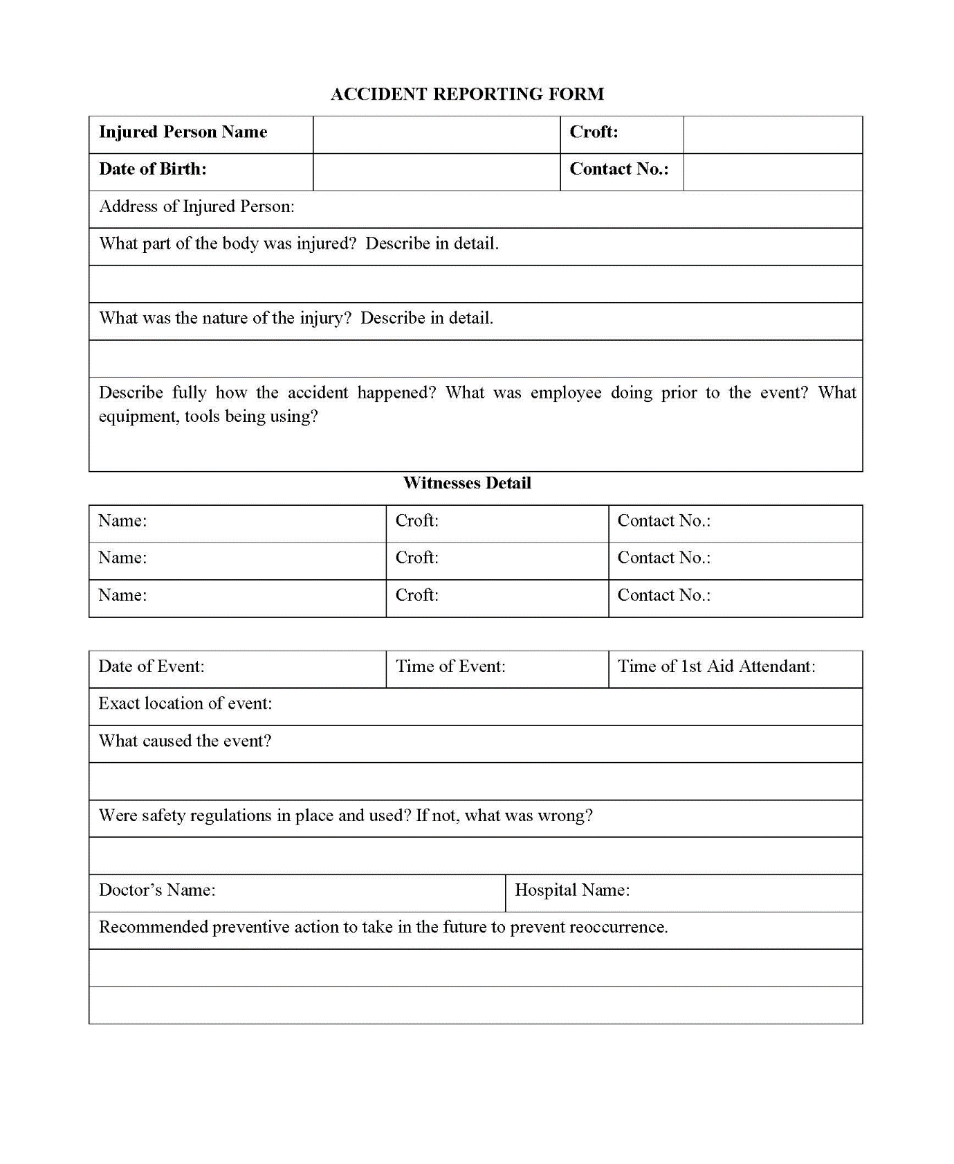
Sub-Annexure-A
Sub-Annexure-B

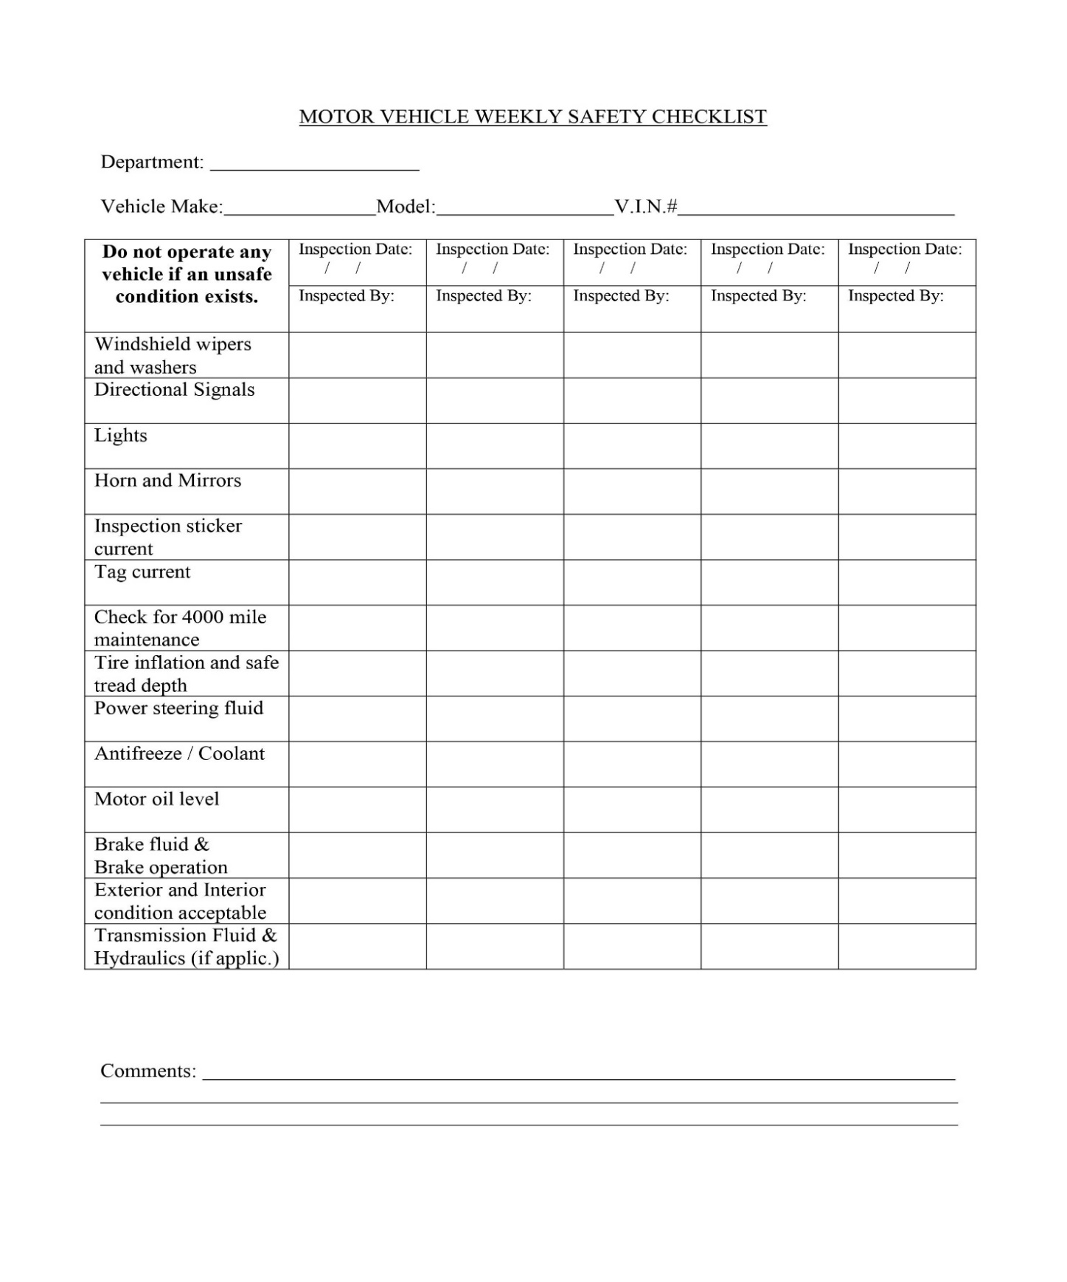

Annexure XI: Framework for Dust Management Plan

Dust Management Plan
General
This plan is prepared for the project "Replacement of Existing Conductance Main from Rawal Lake Filtration Plant to Water Works (Sufaid Tanki). The purpose of this plan is to describe the measures that the project shall take to ensure that the risk of emissions from dust generated by site operations during construction are minimized and that best practice measures are implemented.
Dust emissions from construction can cause ill health effects to Contractor staff along with nuisance and annoyance to members of the local community. Dust will be controlled through:
- Elimination
- Reduction/Minimization
- Control
This dust management plan shall be implemented based on the measures already provided in the Environmental Management Plan (EMP) relating to controlling dust emissions.
Methodology
The following methodology will be undertaken for each project section:
Step 1 – Identify the dust generating activities
Construction activities that are likely to produce dust will be identified. The activities that will be taken into account are:
- Haulage Routes, Vehicles and /Concrete Batching Plant
- Roads, surfaces and public highways
- Excavations for lying of new conductance and replacement of distribution pipelines
- Static and mobile combustion plant emissions
- Materials Handling, Storage, Spillage and Disposal
- Storage of material
- Stockpiles
- Spillages
- Storage of Waste
- Site Preparation and Restoration after Completion
- Earthworks, excavation and digging
- Storage of spoil and topsoil
- Demolition
- Construction and Fabrication Processes
Step 2 – Identify Sensitive Receptors
Sensitive receptors have already been identified. The nature and location of the sensitive receptors will be taken into account when implementing control measures.
Step 3 Implement Best Practice Measures to Control
Based on the nature of the activity producing the dust, the likelihood of dust being produced and the possible consequence of dust based on the sensitive receptors, the most effective control measure will be identified and implemented.
Step 4 – Monitor effectiveness of control
Construction Supervision Staff (CSC) will have the responsibility to ensure that dust control measures are being implemented and are effective.
Step 5 – Record and report result of monitoring
All inspections, audits and results of monitoring will be recorded and kept as part of the site filing system.
Method Statements and Risk Assessments
The Contractor’s Risk Assessments and Method Statements will be required to be approved by the CSC prior to commencing work and will be required to contain environmental aspects of the task, including dust control measures where required.
Where dust has been identified within the risk assessment as a significant issue, the method statement will be required to cover the following:
Methods and materials that will be used to ensure that dust generation is minimized.
The use of pre-fabricated materials where possible.
Optimum site layout:
Dust generating activities to be conducted away from sensitive receptors
Supply of water for damping down.
Good housekeeping and management
All employees will be briefed on the Risk Assessment and Method Statement before starting work.
Training
All Contractor staff will be required to attend training seminars as already mentioned in the EMP document. A site-specific induction will also be required before being allowed to work on site. These will include site-specific sensitive receptors and details regarding dust control measures to be taken.
Toolbox talks on air pollution and minimizing dust emissions will be provided on a regular basis to Contractor staff.
Identification of Dust Generating Sources and Control Methods
Haulage Routes, Vehicles and /Concrete Batching Plant
Dust Source | Dust Control Methods
Major haul roads and traffic routes | Haul roads will be dampened down via a mobile bowser, as required.
Public Roads | Road sweeper will be used to clean public roads as required.
Site traffic management | Site traffic will be restricted to constructed access roads as far as possible.  Site speed limit will be set at 10 mph as this will minimize the production of dust.
Road Cleaning | A mechanical road sweeper will be readily available and used.
Handling, Storage, Stockpiling and Spillage of Dusty materials
Material handling operations | The number of times a material will have to be handled will be kept to a minimum to prevent double handling and ensure dusty materials are not handled unnecessarily.
Transport of fine dusty materials and aggregates. | Closed tankers will be used or sheeted vehicles.
Vehicle loading/unloading materials on to vehicles and conveyors. | Dusty materials will be dampened down  Drop heights will be kept to a minimum and enclosed where possible.
Excavation for Lying new pipelines
Excavation | Excavation will be carried out by applying green sheets on the edges, especially near Environmental Sensitive Receptors, already highlighted in the IEE report.
Handling of Mucking Material | Mucking material will be stored in bonded area to avoid spillage and generation of fugitive dust
Loading of material on dumpers | Mucking material will be damped down before loading on dumpers to reduce fugitive dust emission.
Storage of Materials
Bulk cement, bentonite etc. | Bentonite will be delivered in tankers and stored in dedicated enclosed areas. Bulk cement will be transported through tractor trollies or trailers.
Fine dry materials | These will be protected from the weather and by storing in appropriate containers and indoors, where necessary.
Storage location | Material will be stored in dedicated lay-down areas.
Storage of Stockpiles
Stockpile location | Stockpiles will be placed so as to minimize double handling and facilitate the site restoration.
Building stockpiles | Stockpiles, tips and mounds will not be stored at an angle greater than an angle of repose of the material.
Small and temporary stockpiles | Where possible, stockpiles will be placed under sheeting.  Dusty material will be damped down.  Wind barriers (protective fences) of a similar height to the stockpile will be erected, if required.
Site Preparation and Restoration
Earthworks, excavation and digging | These activity areas will be kept damp where required and if possible, will be avoided during dry and windy periods.
Completed earthworks | Surfaces will be stabilized by re-vegetation as soon as possible, where applicable.
Construction and Fabrication Process
Cutting, grinding, drilling, sawing, trimming, planning, sanding | These activities will be avoided wherever possible.  Equipment and techniques that minimize dust will be implemented.  Water will be used to minimize dust.
Cutting roadways, pavements, blocks | Water sprinkling to be used.
Angle grinders and disk cutters | Best practice measures will be used such as dust extraction.

Monitoring Arrangements
Monitoring will be conducted at sensitive receptor locations in the project area as provided in the EMP. Furthermore, at locations where PM levels are exceeding applicable guidelines, additional stringent measures will be implemented at the respective location(s) in the project area to ensure dust levels are controlled as far as possible.

Annexure XII: Framework for Construction Noise and Vibration Management Plan

Objective
This management plan defines the measures to control and limit noise emissions and vibration levels, at residential properties and other sensitive receptors in the vicinity of the Project.
General Requirements
Best Practicable Means (BPM) of noise control will be applied during construction works to minimize noise (including vibration) at neighboring residential properties and other sensitive receptors arising from construction activities
The general principles of noise management are given below:
Control at source:
Equipment – noise emissions limit for equipment brought to site.
Equipment – method of directly controlling noise e.g. by retrofitting controls to plant and machinery.
Equipment - indirect method of controlling noise e.g. acoustic screens.
Equipment - indirect method of controlling noise e.g. benefits and practicality of using alternative construction methodology to achieve the objective e.g. vibratory piling techniques or hydro- demolition as opposed to more conventional but noisier techniques; selection of quieter tools/machines; application of quieter processes.
Control across site by:
- Administrative and legislative control,
- Control of working hours,
- Control of delivery areas and times,
- Careful choice of compound location,
- Physically screening site,
- Control of noise via Contract specification of limits,
- Noise Monitoring, to check compliance with noise level limits, cessation of works until alternative method is found.
- Many of the activities which generate noise can be mitigated to some degree by careful operation of machinery and use of tools. This may best be addressed by tool box talks and site inductions.
The maintenance of good community relations is vital. Experience shows that construction noise has the potential to cause disturbance but can be tolerated if prior warning and explanation has been given to residents. In particular advice regarding the nature of construction works, the duration of the works and mitigation measures to be implemented can help to reduce people’s reaction to noise.
Contractors will consult local residents/communities regarding works and to give them details of a responsible appointed person on site who will be able to deal with queries.
Construction working hours should be carefully managed. All works should take place between normal working hours 07:30 and 18:30, Monday to Friday with the exception of restricted works.
Noise and Vibration Control Measures
In addition to specific requirements of the Local Authority, the Contractor will be required to adopt the following more specific measures:
Control measures
Without prejudice to the other requirements of this section, the Contractor shall comply with the recommendations set out in BS5228:2009 and in particular with the following requirements:
- Vehicles and mechanical plant will be maintained in a good and effective working order and operated in a manner to minimise noise emissions. The contractor will ensure that all plant complies with the relevant statutory requirements;
- Site vehicles will be equipped with broadband, non-tonal reversing alarms;
- Compressor, generator and engine compartment doors will be kept closed and plant turned off when not in use;
- All pneumatic tools will be fitted with silencers/mufflers;
- Care would be taken when unloading vehicles to avoid un-necessary noise;
- Maintenance operations will be undertaken at distance from noise-sensitive receptors;
- Reduce the speed of vehicle movements;
- Ensure that operations are designed to be undertaken with any directional noise emissions pointing away from noise-sensitive receptors;
- Vehicles should be prohibited from waiting within the site with their engines running or alternatively, located in waiting areas away from sensitive receptors;
Vibration Mitigation
All vibration producing machinery will be identified by the contractor and vibration producing machinery will be operated at low frequency to reduce the vibration impacts.
- Vibration monitoring will be carried out in accordance with German Standard DIN 4150 (heritage structures) and BS 7385: Part 2 – 1993 (other structures).
- vibration monitoring will be undertaken at the nearest buildings to the construction sites during times of vibration intensive works
- Where exceedances of the criteria are recorded, corrective actions would be implemented where soils at risk of vibration induced settlement are identified.
Noise and vibration monitoring
A regular programme of noise and vibration monitoring shall be implemented as a minimum in accordance with of this document.
The Contractor will submit the proposed method, the frequency and the location of monitoring site to the Planning Authority for agreement prior to commencing works. Noise baseline levels will be agreed prior to commencement of construction.
Reference:
https://proaccionaau.blob.core.windows.net/media/4gbpg4vk/ctp-noise-and-vibration-management-plan.pdf.

Annexure XIII: Template for Site-Specific EMP

Guide for Development of SSEMP
- Step 1: Define Boundaries
- Step 2: Identify Sensitive Receptors
- Step 3: Specify construction activities
- Step 4: Conduct Risk Assessment
- Step 5: Assign Environment Management measures
- Step 6: Prepare Site Plans
- Step 7: Prepare Environment Work Plans (if required)
- Step 8: Monitoring
Step 1: The project area needs to be clearly defined.
Step 2: The mapping of sensitive receptors has already been conducted and needs to be presented clearly in a map.
Step 3: The tentative construction activities to be conducted are as follows:
- Site Surveying and Vegetation (Trees and plants) Clearance
- Establishment of Work Camp and access roads
- Dismantling of existing structures including Utilities
- Preparation of ground for Landscaping
Step 4: The Risk Assessment matrix template is provided in the table below.
Risk is assessed as the likelihood that the activity will have an effect on the environment as well as the consequence of the effect occurring. It is often described like this:

Risk = Likelihood × Consequence
Likelihood Scale
Likelihood | Definition | Scale
Certain | Will certainly occur during the activity at a frequency greater than every week if preventative measures are not applied | 5
Likely | Will occur more than once or twice during the activity but less than weekly if preventative measures are not applied | 3
Unlikely | May occur once or twice during the activity if preventative measures are not applied | 2
Rare | Unlikely to occur during the project | 1

Consequence Scale
Consequence | Definition | Score
Catastrophic | The action will cause unprecedented damage or impacts on the environment or surrounding community e.g. extreme loss of soil and water resources and quality from storm water runoff extreme pollution of soil and water resources including major contamination from hazardous materials widespread effects on ecosystems with deaths of fauna/flora widespread community impacts resulting in illness, injury or inconvenience loss or destruction of archaeological or historical sites Occurrence will almost certainly result in the work being halted and a significant fine. | 5
Major | The action will cause major adverse damage on the environment or surrounding communities’ e.g. major loss of soil and water resources and quality from storm water runoff major pollution of soil and water resources including contamination from hazardous materials significant effects on ecosystems with isolated deaths of non-vulnerable flora and fauna significant annoyance or nuisance to communities major damage to or movement required to archaeological or historical sites occurrence may result in work being halted and a fine | 3
Moderate | No or minimal adverse environmental or social impacts e.g. No measurable or noticeable changes in storm water quality. Water quality remains within tolerable limits little noticeable effect on ecosystems no or isolated community complaints no or unlikely damage to archaeological or historical sites no likelihood of being fined | 2
Minor | No or minimal adverse environmental or social impacts e.g.  No measurable or noticeable changes in storm water quality. Water quality remains within tolerable limits  little noticeable effect on ecosystems  no or isolated community complaints  no or unlikely damage to archaeological or historical sites  no likelihood of being fined | 1
Risk Score Table
Likelihood | Consequence
 |  | Catastrophic | Major | Moderate | Minor
 | Certain | 25 | 15 | 10 | 5
 | Likely | 15 | 9 | 6 | 3
 | Unlikely | 10 | 6 | 4 | 2
 | Rare | 5 | 3 | 2 | 1

Risk: Significant: 15-25
Medium: 6-10
Low 1-5
Any Medium to Significant risk requires an environmental management measure to manage the potential environmental risk. Judgment will be required concerning the application of an environmental management measure to mitigate low risk situations.
The higher the risk the more intensive the required mitigation measure will need to be; e.g. where site sedimentation is deemed to be low risk, then silt fences may be needed but as the risk increases, then sediment traps may be required. The selection of the appropriate mitigation measure will require judgment based on the level of risk and the specific site parameters.
Step 5: The Environmental Management measures are to be extracted from the IEE study for the project and should be added in the last column of the table below.

No. | Construction Activity | Hazards to Consider | Likelihood that the site or sensitive receptors will be affected? | Consequence of the site or sensitive receptors being affected? | Risk Score  (consequence x likelihood) | Environmental Management Measures
i | Site Surveying & vegetation clearance | Damage to vegetation beyond project footprint |  |  |  | These can be taken from the EMP provided in the IEE report  (If Risk Score is 6 or more)
 |  | Erosion of exposed areas and sediment
 |  | Loss of topsoil
 |  | Dust generation
 |  | Noise
ii | Establishment of Work Camp, Batching plant etc. | Soil deposited onto roads from tires
 |  | Stockpile erosion
 |  | Noise & Vibration
 |  | Traffic congestion
 |  | Fuel spills
iii | Dismantling of and existing structures including Utilities | Noise and vibration
 |  | Dust generation
 |  | Community safety
 |  | Worker safety
 |  | Traffic Congestion
iv | Preparation of Sub-Base | Noise and vibration
 |  | Dust generation
 |  | Traffic Congestion
v | Camping | Noise and vibration
 |  | Dust generation
 |  | Traffic Congestion
 |  | Community safety
 |  | Labor safety (PPEs)
vi | Landscaping | Dust generation
 |  | Sediment runoff
 |  | Failure of vegetation to take root

Step 6: The Site plans are a critical part of the SSEMP and will need to be prepared, otherwise the UMDS will consider the document as incomplete.
The site plan will need to provide the following:
- Indication of North and scale
- Existing and planned supporting infrastructure (e.g. access roads, water supplies and electricity supplies)
- Location of planned work
- Contours
- Drainage systems
- Locations of sensitive receptors
Step 7 (if required): The completed SSEMP provides details of all the environmental management requirements for all stages of the construction process. For individual work teams who are responsible for only a small part of the overall construction works it can be confusing as to what is required for their particular work component. For example, the work team responsible for stripping soil for the construction areas are not going to be interested in the requirements for pouring concrete for footings and foundations. However, it is essential that the soil stripping team knows exactly what to clear and what to leave and where to put stockpiles of soil for later use.
In situations where different work activities are required at different times or at different locations, environmental work plans can be prepared. These are similar to the work method statements that are often produced for major construction projects.
Step 8: A detailed monitoring plan will be provided along with frequency and responsibilities to ensure all key environmental parameters are monitored to ensure compliance with both national and ADB requirements.
Template for SSEMP
- Introduction
- Project Overview
- Scope of SSEMP
- Objectives of SSEMP
- Map of Sensitive Receptors
- Construction Activities
- Activities
- Risk Assessment
- Risk Assessment Matrix & Mitigation Measures
- Site Plan(s)
- Environmental Monitoring Plan
- Instrumental Monitoring of Environmental Parameters by Contractor as per EMP
- In-house monitoring
- Third Party environmental monitoring
- Visual monitoring of Environmental Parameters by Contractor as per EMP
- Responsibilities
- Organizational Responsibilities and Communication
- Responsibility of EA
- Responsibility of Construction Supervision Consultant (CSC)
- Responsibility of Contractor
- Responsibility of EPA (Punjab and Federal)

Annexure-XIV: Tool for Socioeconomic Survey

SOCIO-ECONOMIC BASELINE SURVEY OF THE PROJECT AREA

Name of Project _ _________________

Name of Interviewer: _____________ Date: _______________

a) Settlement: ___________________ (b) Union Council: _______________________
c) Tehsil: _______________________ (d) District: _____________________________
_____________________________________________________________________________

1. Name of Respondent ________________________

2. What is your father’s name ________________________

3. What is your age

Age years 15 – 25 ________
25 – 35 ________
35 – 45 ________
Above 45 ________
4. Marital Status.

1. Married 2. Unmarried

5. What is your caste /ethnic group _____________________

6. What is your mother tongue? _____________________

7. What is your qualification?

1. Illeterate 2. Primary 3. Middle

4. Metric 5. Intermediate 6. Above Inter

8. What is your profession ____________________________

- Which of the following facilities are available in your house
1. Electricity 2. Water Supply
3. Gas 4. Telephone
5. Sewerage
- What are the sources of water for your domestic use
1. Public Water Supply 2. Hand Pumps
3. Channel 4. Any other
- In your opinion, should this Project be implemented here
1. Yes 2. No
If yes, then reasons If no, then reasons
________________________ ________________________
________________________ ________________________
________________________ ________________________
- In your opinion, what will be possible impacts of the construction of this project area project?
During Construction __________________________________________________
__________________________________________________
__________________________________________________
After Construction __________________________________________________
__________________________________________________
__________________________________________________
- What protective measures do you suggest to safeguard your interests
_________________________________________________
_________________________________________________
________________________________________________
- Is there any health institution in this locality

1. Yes 2. No

If yes, then what is that __________________________
__________________________
- Is there any educational institution in this locality
1. Yes 2. No
If yes, then what is that __________________________
__________________________
- Is there any historical /archeological monument in this locality
1. Yes 2. No
If yes, then what is that __________________________
__________________________
- Is there any shrine /mosque /graveyard in this locality
1. Yes 2. No
If yes, then what is that?
Shrine __________________________
Mosque __________________________
Graveyard __________________________

Annexure XV: Attendance Sheets of FGDs

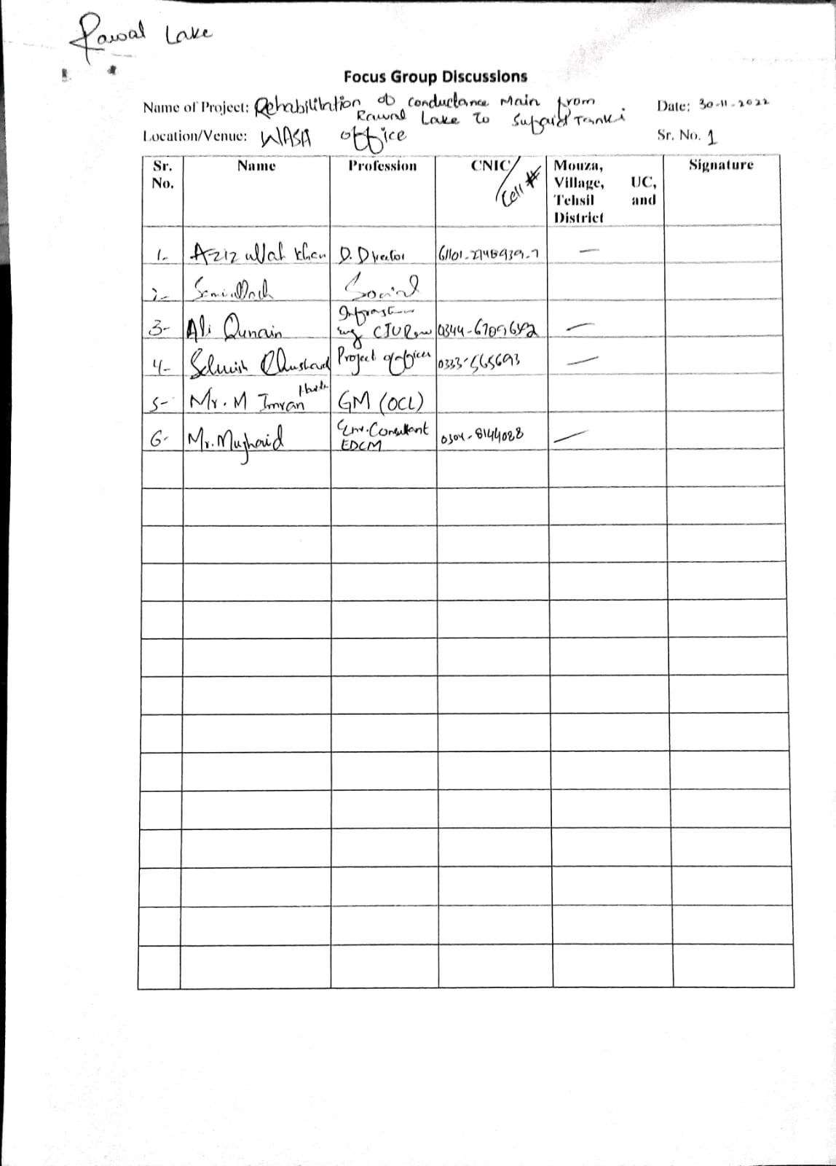

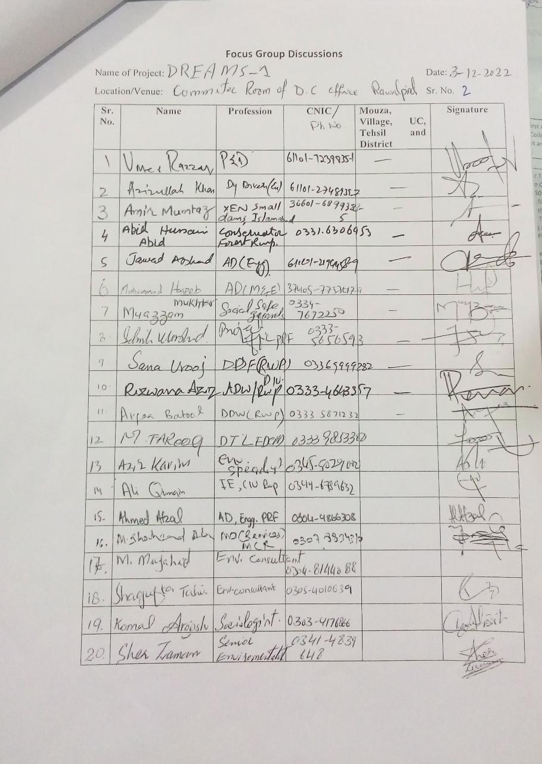
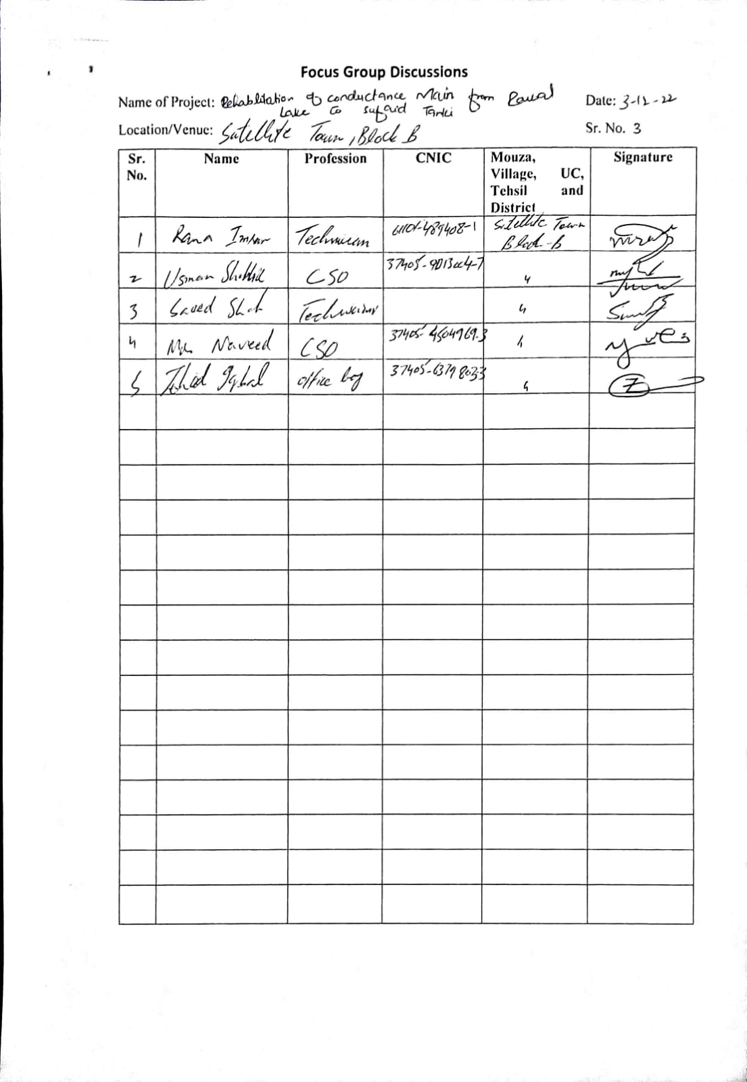

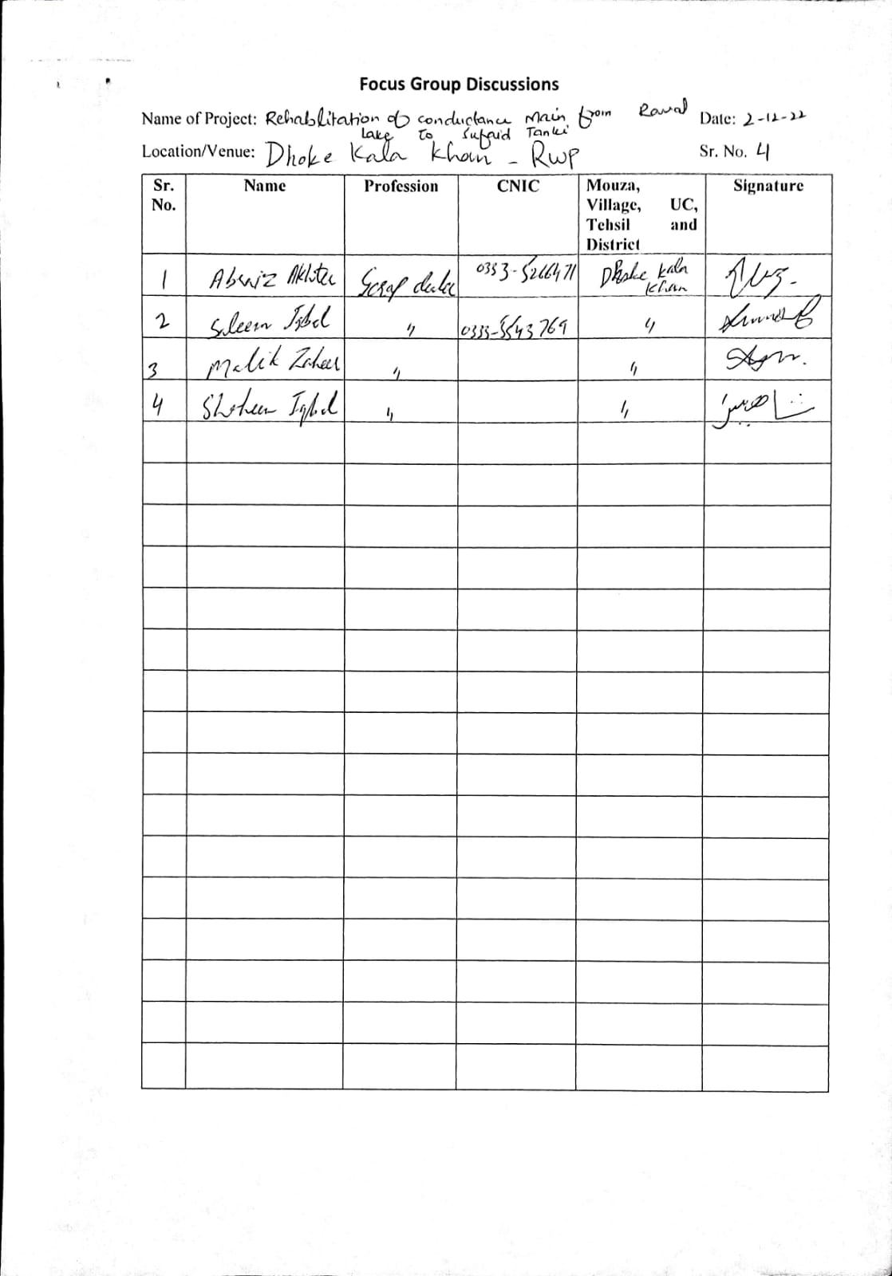
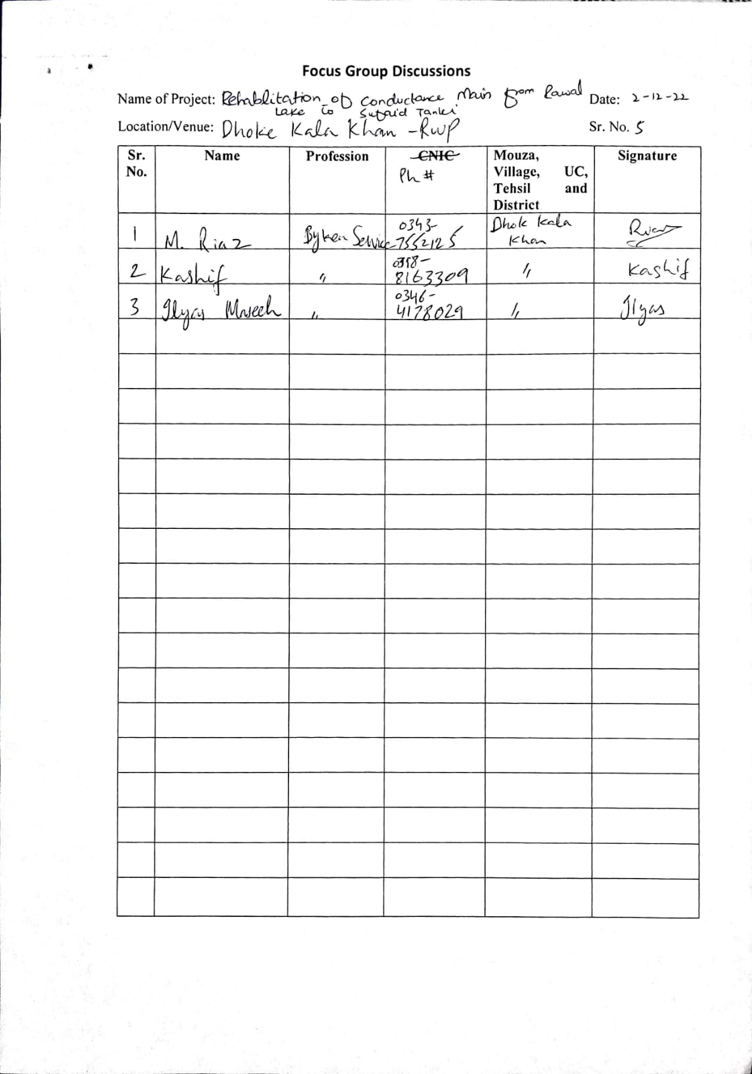

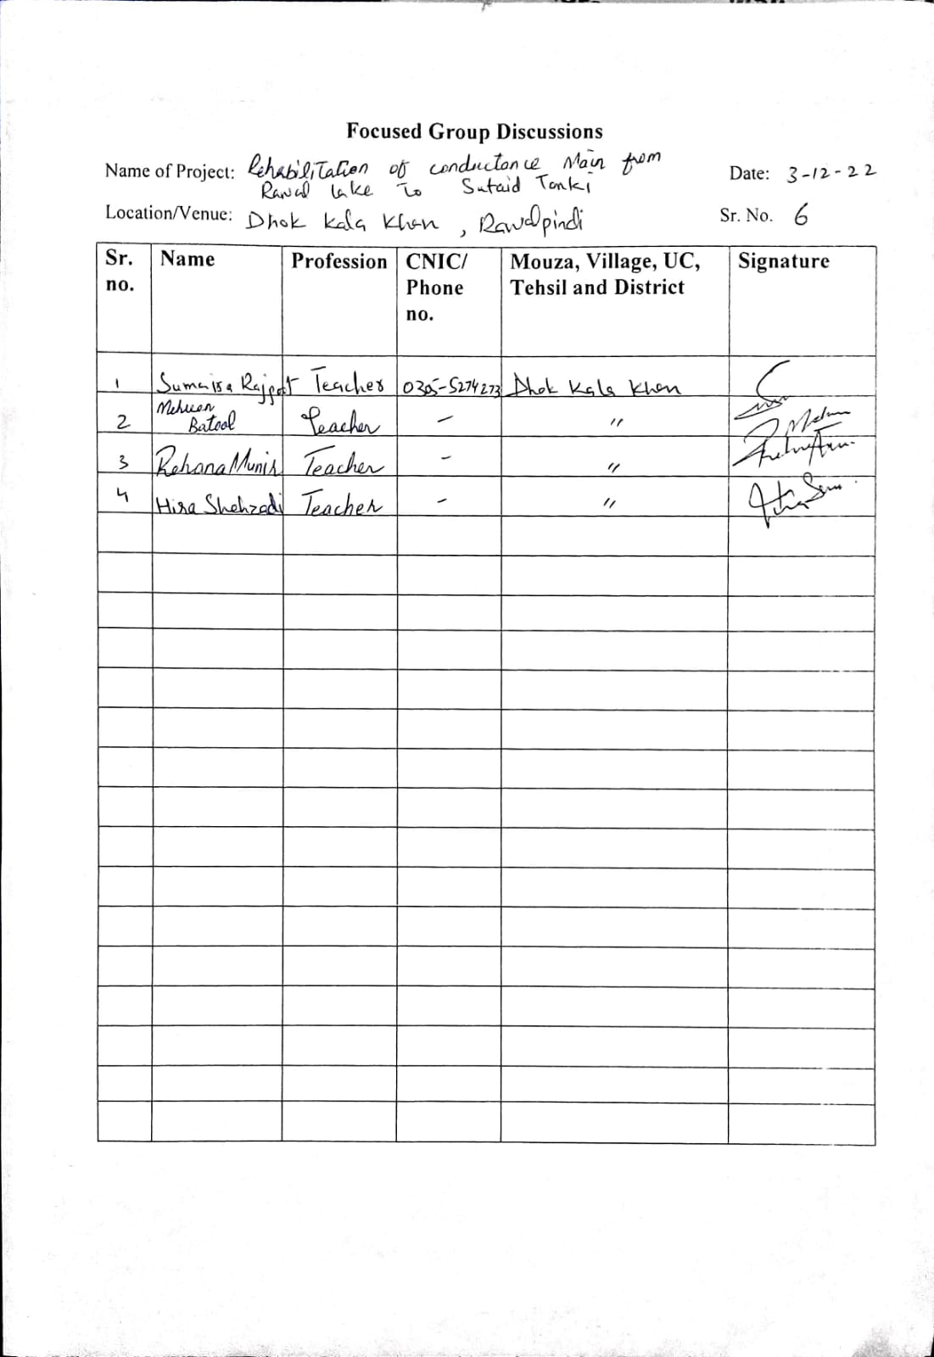
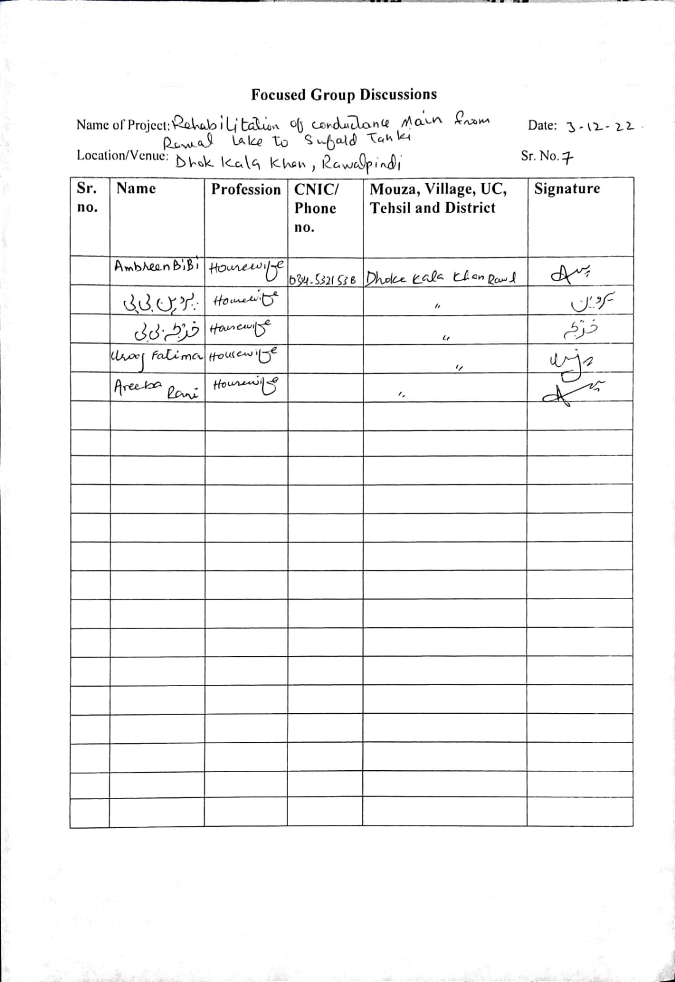
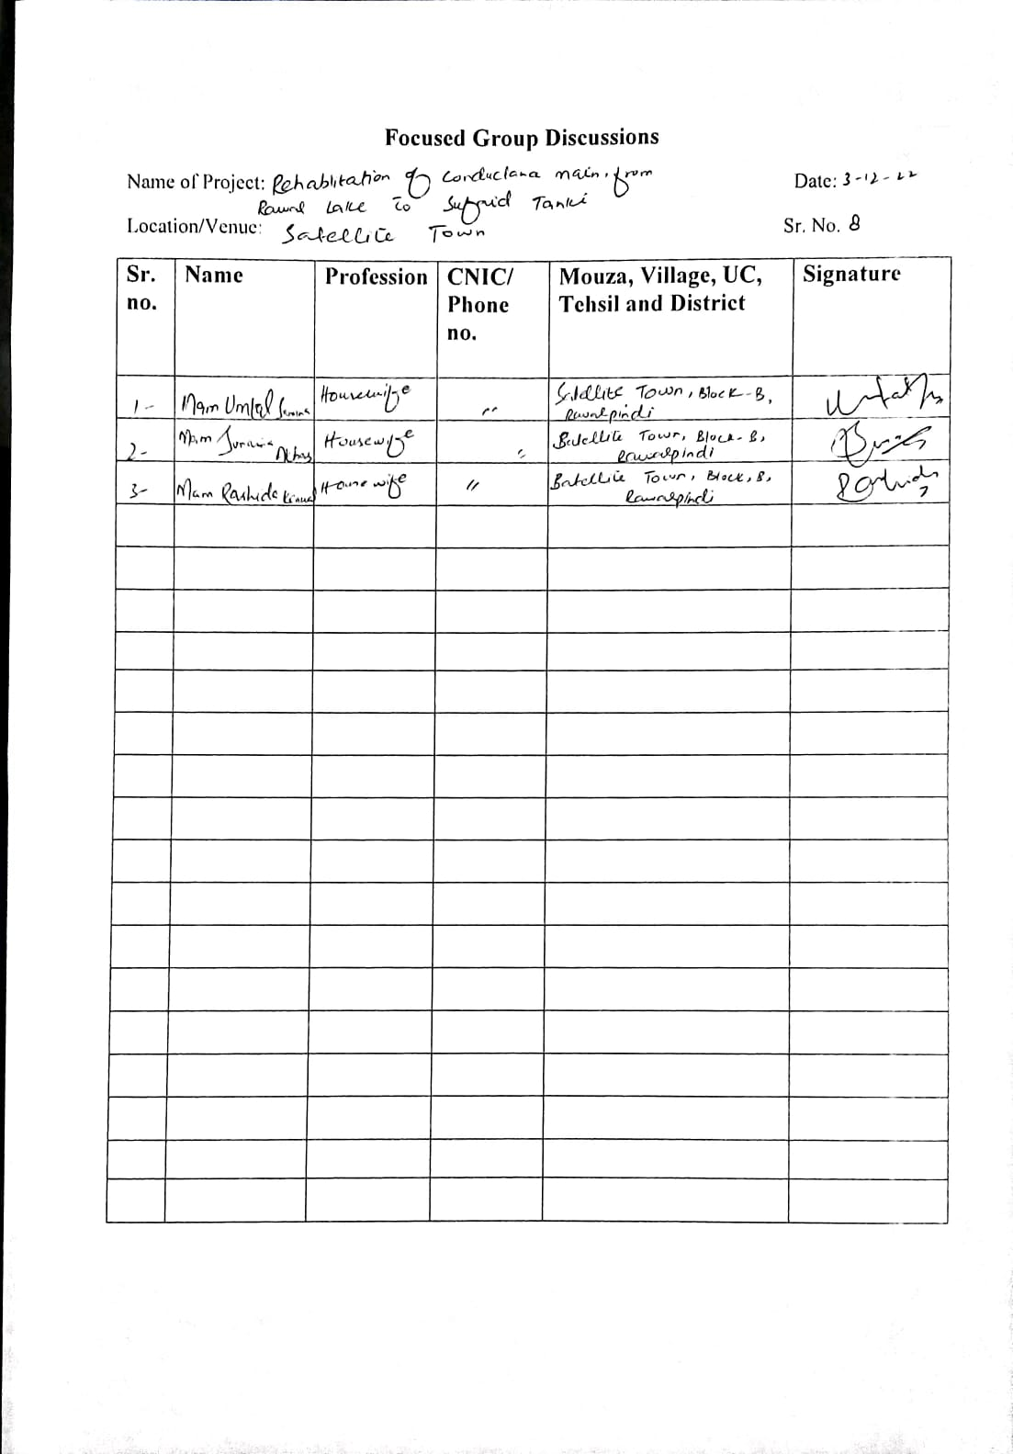

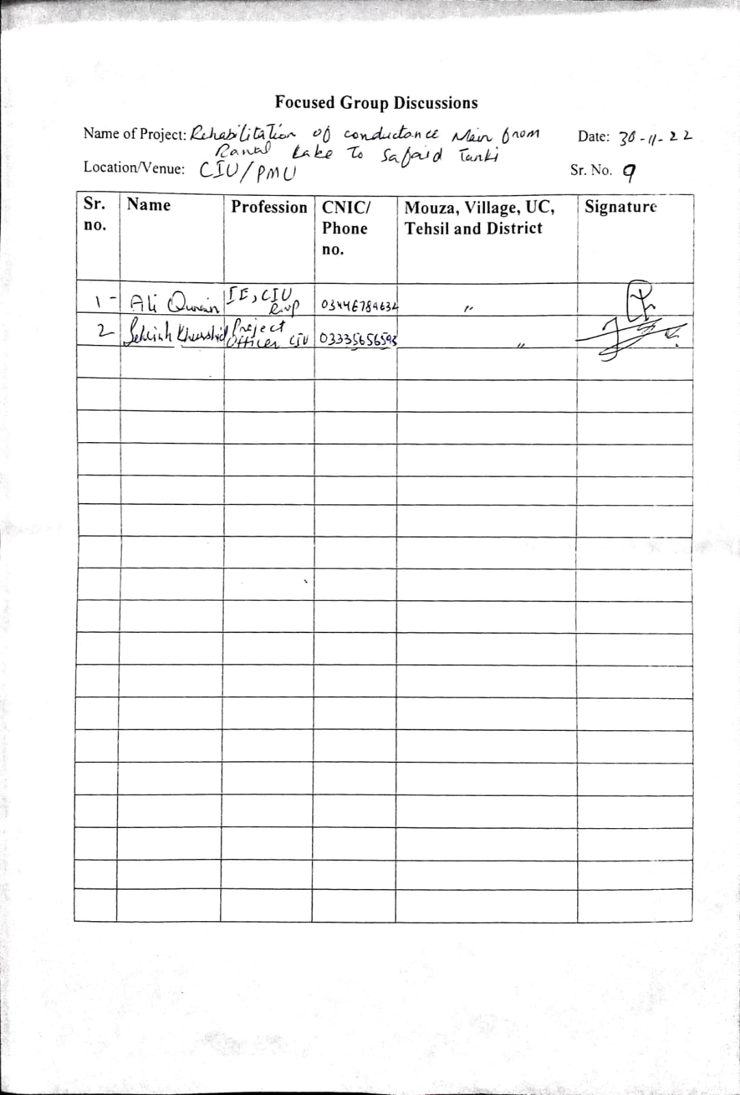

Annexure XVI: Public Consultation Minutes for

Solar Installation Development

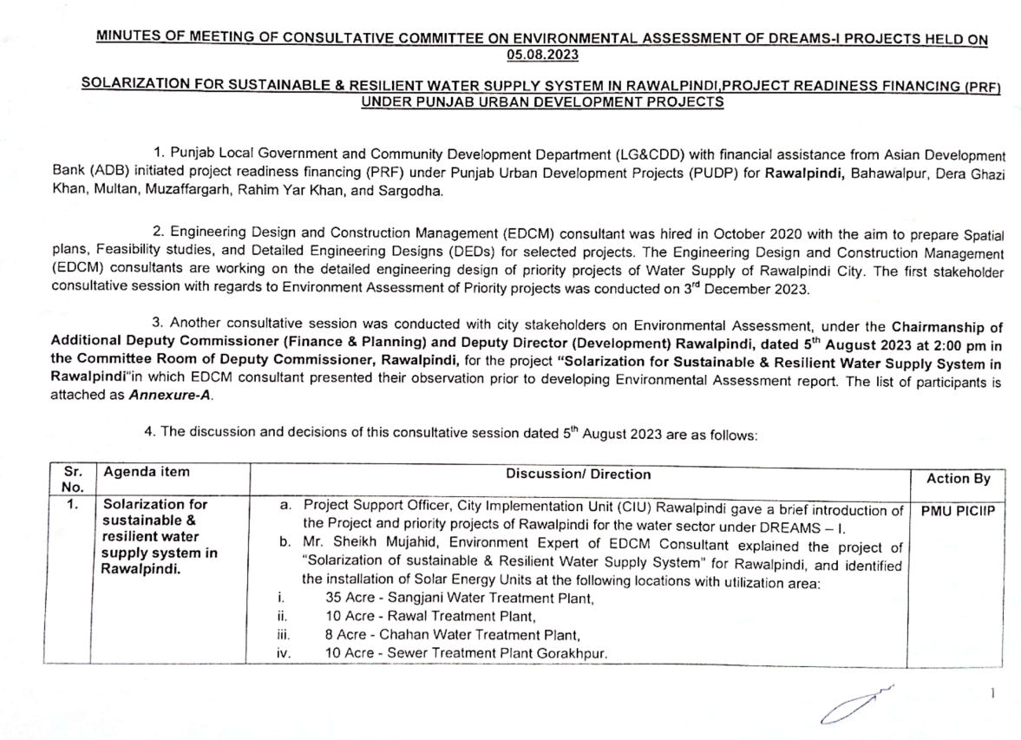
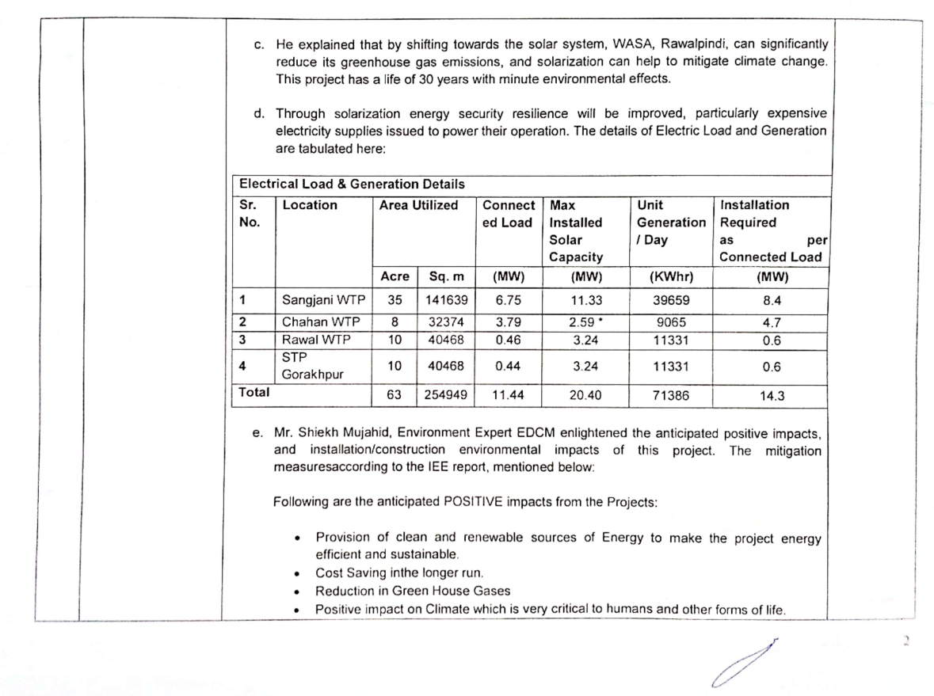
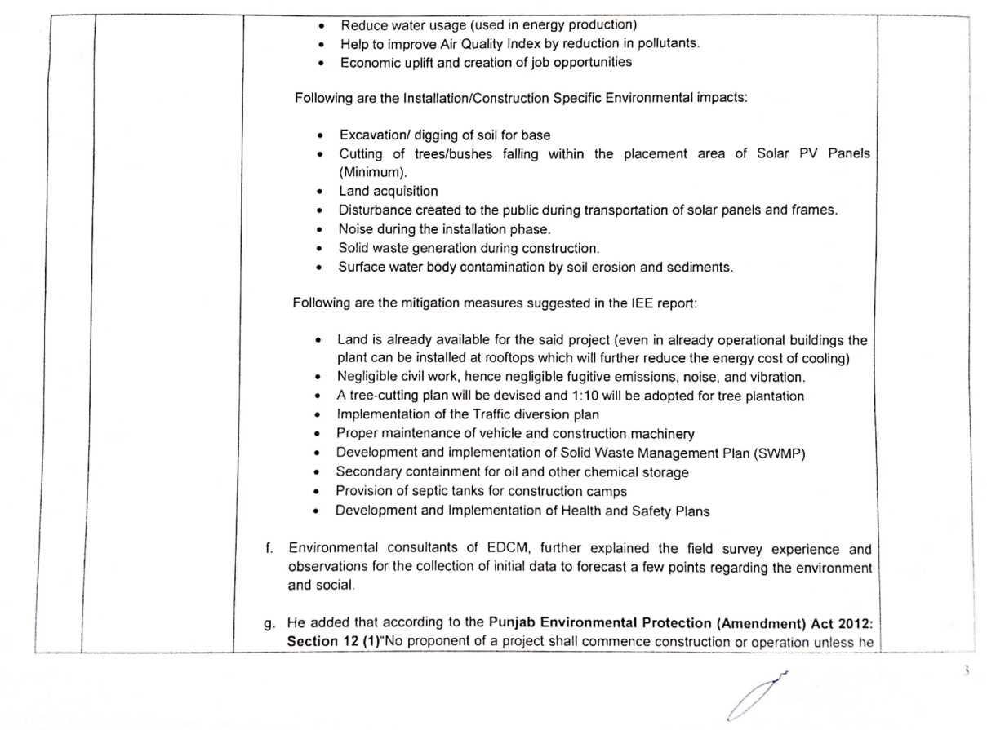
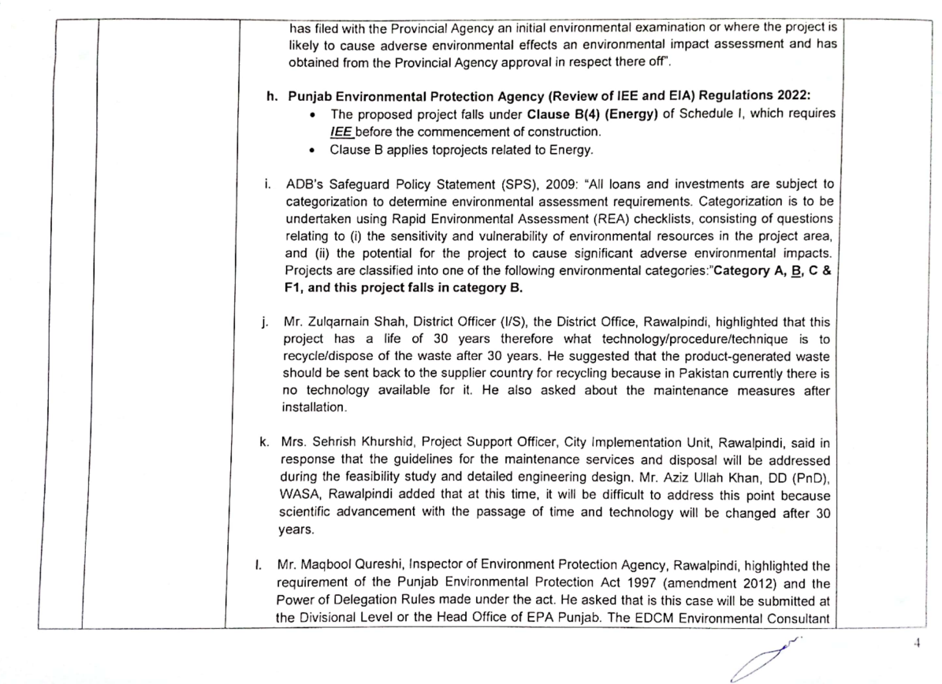
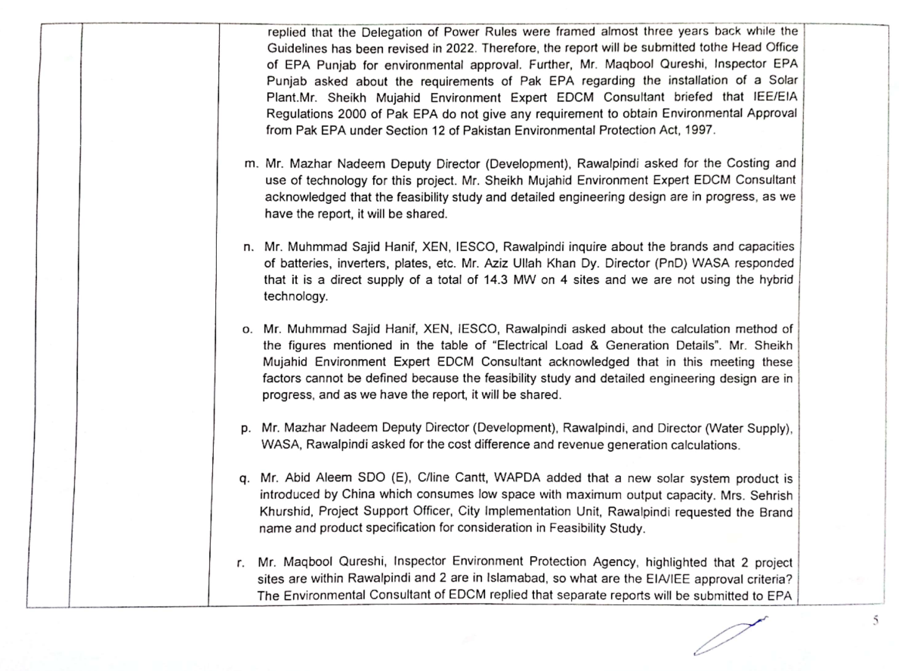
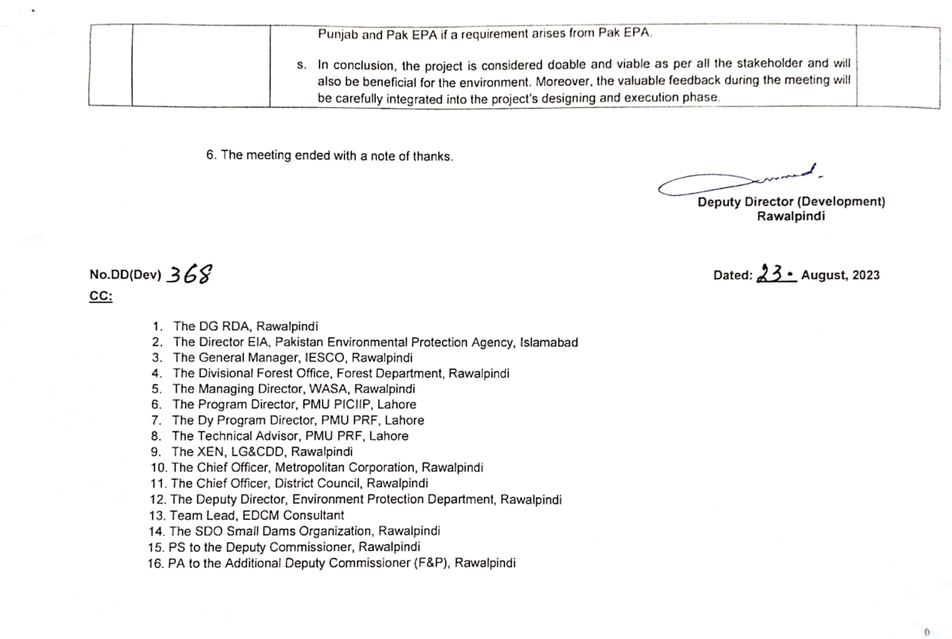

GOVERNMENT OF PAKISTAN
PAKISTAN ENVIRONMENTAL PROTECTION AGENCY
MINISTRY OF CLIMATE CHANGE AND ENVIRONMENTAL COORDINATION
ISLAMABAD

MINUTES OF PUBLIC HEARING

Subject: PROCEEDINGS OF PUBLIC HEARING OF PROJECT “ENVIRONMENTAL IMPACT ASSESSMENT REPORT OF REPLACEMENT OF EXISTING CONDUCTANCE MAIN FROM RAWAL LAKE FILTRATION PLANT TO WATER WORKS SUFAID TANKI”.
The proceeding of Public Hearing was conducted on 27-06-2024 at 10:30 AM at COMSATS University, Islamabad for Environmental Impact Assessment of Replacement of existing conductance main from “Rawal lake filtration plant to water works Sufaid Tanki” under the chairmanship of Director EIA Monitoring PAK-EPA.
PROCEEDING OF PUBLIC HEARING
Project | Replacement of existing conductance main from Rawal lake filtration plant to water works Sufaid Tanki .
Subject | Proceeding of Public Hearing Regarding Environmental Impact Assessment of Replacement of existing conductance main from Rawal lake filtration plant to water works Sufaid Tanki.
Date | 27-06-2024 (Thursday)
Venue | COMSATS University, Islamabad
Time | 10:30 AM
Proponent | Project Director  Punjab Intermediate Cities Improvement  Investment Program (PICIIP),  58-C-3 near FDR Office, Gulberg-III, Lahore  For Information and contact:  M. Waqas Afzal  Deputy Director (Safeguards), PMU-PICIIP  Ph: 0340-3301477
Participants of the Public Hearing | Mr. Ashiq Nawaz Bangash, Director EIA PAK-EPA preceded the public hearing. There were total 78 participants physically present at the venue (Annex-A).
The proceedings of public hearing were held as under:
Time |  | Task
11:00 to 11:30 |  | Registration of Participants.
11:30 to 11:33 |  | Recitation of Holy Quran.
11:33 to 11:36 |  | Mr. Muhammad Mujahid, Environment Consultant welcomes the participants and briefly described the agenda of public hearing.
11:36 to 11:40 |  | Mr. Ashiq, Director EIA Monitoring PAK-EPA presented the opening note and briefed the participants on the importance of environmental conservation.
11:40 to 12:40 |  | Mr. Muhammad Mujahid as consultant of the project narrated the objective of the meeting and presented the project through power point presentation. He discussed all the aspects of proposed project and briefed the components, environmental impacts and mitigation measures suggested in the EIA report.
12:40 to 12:45 |  | Mr. Muhammad Mujahid asked for public questions and announced that despite of this public hearing, if anyone has any reservation or suggestions, he can submit it in written form in PAK-EPA, Islamabad.
12:45 to 01:00 |  | Question & Answer session
01:03 |  | End
QUESTION / ANSWER SESSION
Comments |  |  | Reply
Mr. Zia Ex. Director EIA from Federal EPA appreciated PMU and Punjab Government to bring water supply project for Rawalpindi. He further appreciated the quality of EIA report. |  |  | Mr. M. Mujahid, Environment Consultant (EDCM) thanked him for the compliments .
Mr. Yaqob Ali Khan, DIG Forests, MOCCEC asked that how much amount is allocated for tree plantation and how this plantation will be carried out? |  |  | Mr. M. Mujahid, Environment Consultant (EC) (EDCM) replied 1% of total project cost is allocated for trees plantation. It will be carried out in collaboration with PMU, CDA and PHA Rawalpindi. Forest Department will also be consulted for their valuable inputs while finalizing the plantation plan. He further added that indigenous species will be planted at different locations (finalized by CDA and PHA.
Ms. Sumbal Siddiq, Lecturer Department of Metrology, CUI asked about the reference which has been used for impact matrix and scaling? |  |  | Mr. M. Mujahid, EC (EDCM) replied that guidelines of ADB namely SPS 2009 have been used as reference for preparing EIA report and scaling checklist. He further added that experienced team of environmentalist has filled this checklist while using their previous experience of similar projects.
Dr. Jabir Hussain Syed, Associate Professor, Department of Metrology, CUI raised concern that monitoring points in the project seem insufficient keeping in view the length of pipeline? |  |  | Mr. M. Mujahid, EC (EDCM) replied that monitoring point have been selected according to nature of construction activity. However, more monitoring points will be added during execution (construction) phase of the project.
Dr. Ali Shah, Associate Professor, Department of Biosciences, CUI asked about the material which has been used for laying of new pipelines? What is its life? |  |  | Mr. M. Mujahid, EC (EDCM) and Mr. Javed Technical Representative replied that HDPE pipe will be used as new pipeline material because of its flexibility. It is easily adjustable in existing pipeline. Its life is 50 years.
Mr. Arooj Ali asked about the road crossing of Murree road and Islamabad Expressway. Are there any road cuttings involved in the project? |  |  | Mr. M. Mujahid, EC (EDCM) replied that there is already an existing tunnel under Islamabad Expressway and Murree Road. The same will be used for pulling and pushing of new pipeline. No Road cutting will be carried out.
Ms. Sumbal Siddiq, Lecturer Department of Metrology, CUI asked that how have ratings been given to environmental impacts the report? |  |  | Mr. M. Mujahid, Environment Consultant (EDCM) replied that ratings have been given by the expert team according to similar projects which are completed before.
Mr. Arsalan, Student of CUI asked that how will the rehabilitation work conducted and by whom? |  |  | Mr. M. Mujahid, EC (EDCM) replied that rehabilitation work will be carried out by Construction Contractor to the minimum same level as it was before project activity. PMU will supervise this work.
Mr. Adnan Khan from CDA asked that is there any permanent structure likely to be disturbed by the project? |  |  | Mr. M. Mujahid, EC (EDCM) replied that there is no any permanent structure likely to be disturbed by the project. The construction methodology will further help us to bypass any temporary or permanent structure by shifting the location of working chamber up to 200 meters.

While concluding the session, the chair appreciated the proponent of the proposed project on their presentation; appreciated faculty and students of CUI. He urged the proponent to take into consideration the suggestions and recommendations that came up during public hearing. It was also stated that the participant/stakeholders could also forward their comments / observations in writing to PAK-EPA so that the same could be duly addressed while processing the case of environmental approval of the project.
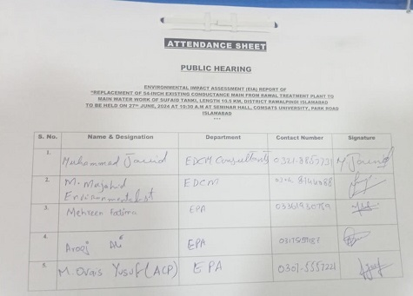
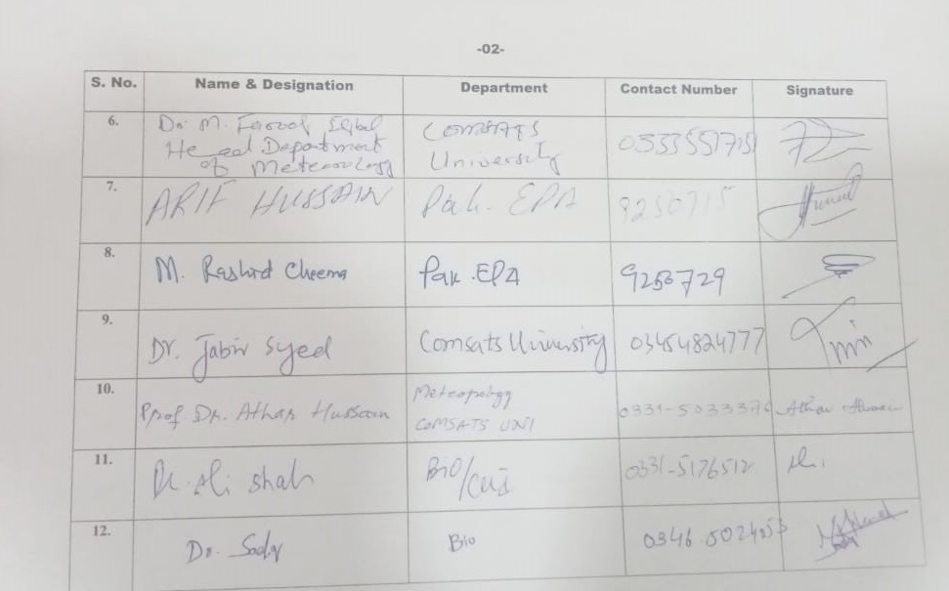

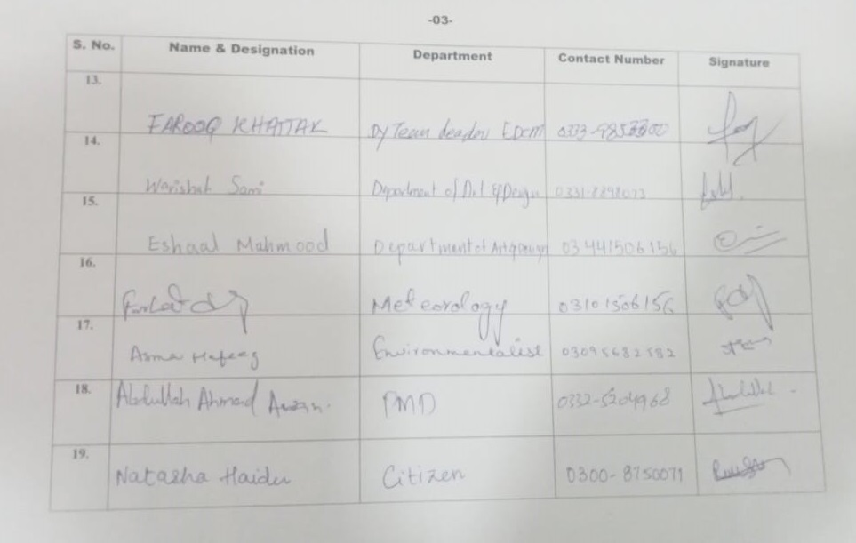

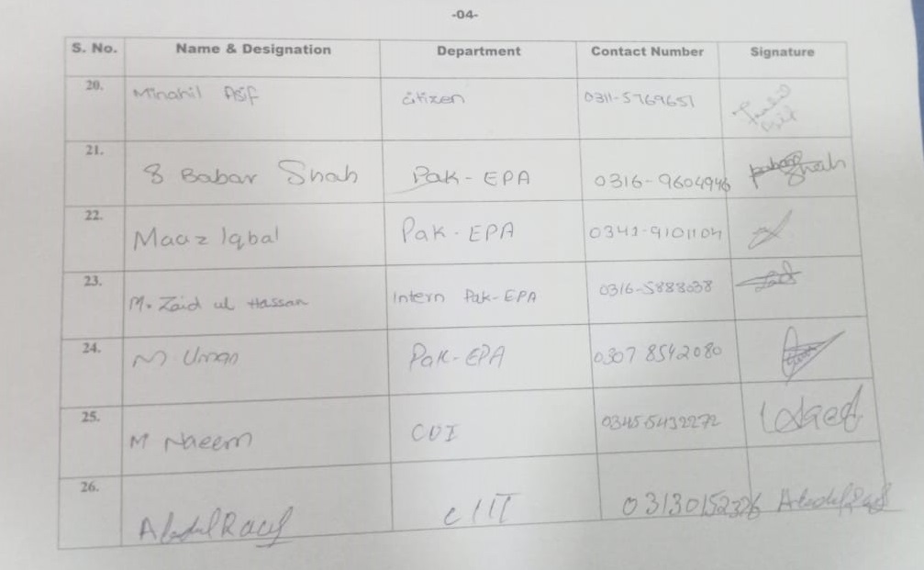

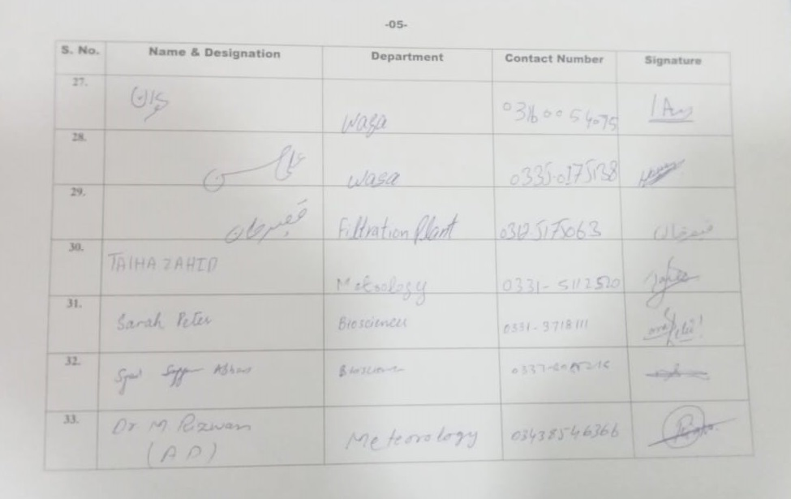
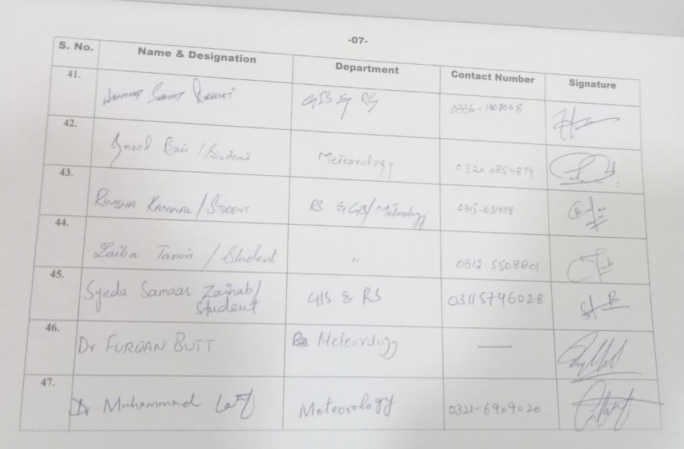

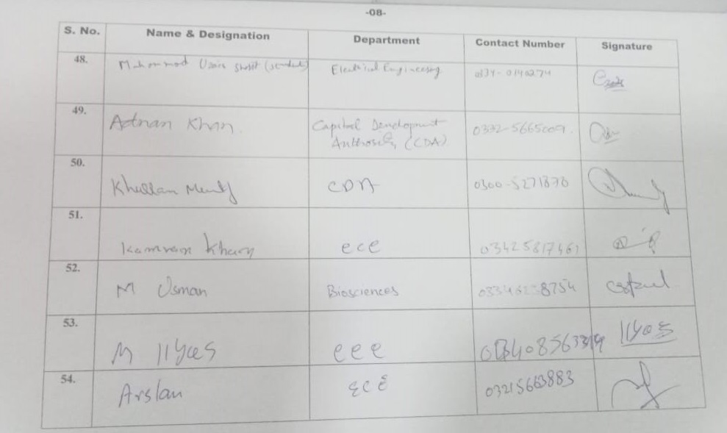
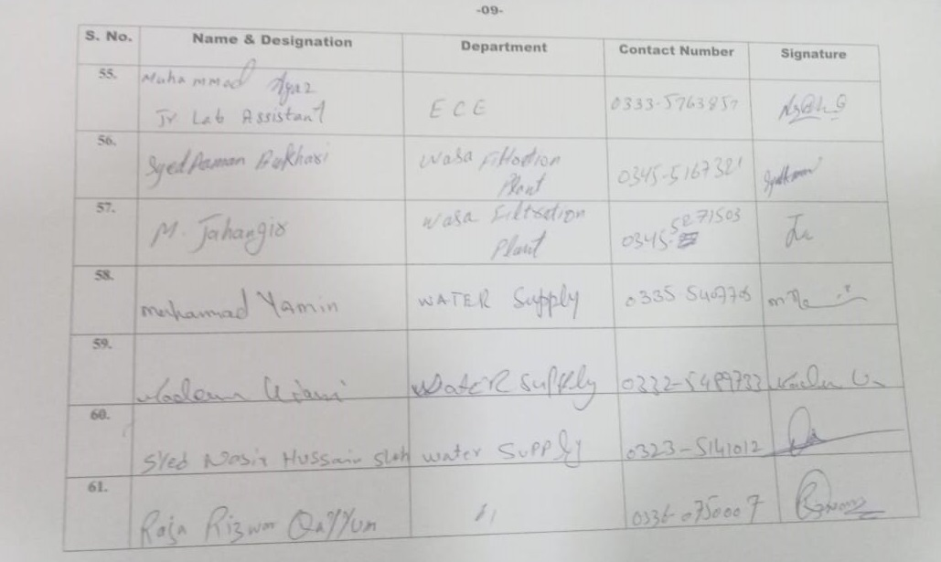

Pictorial Evidence

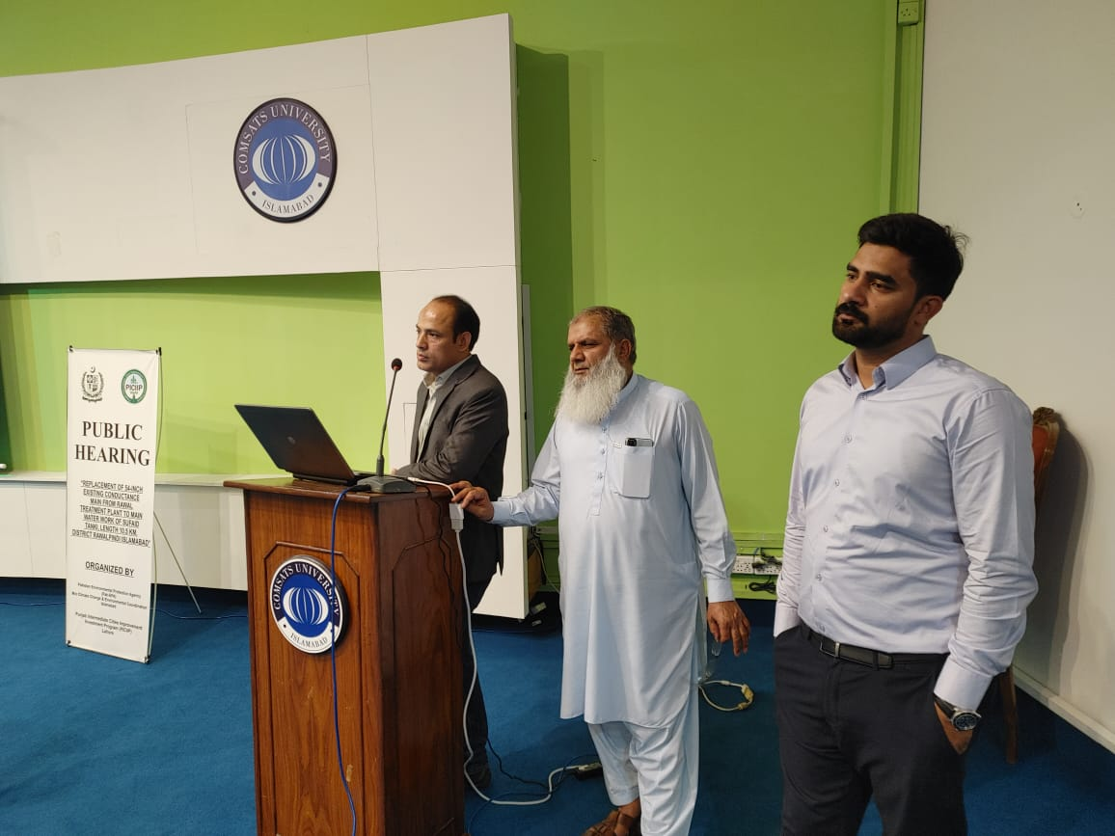
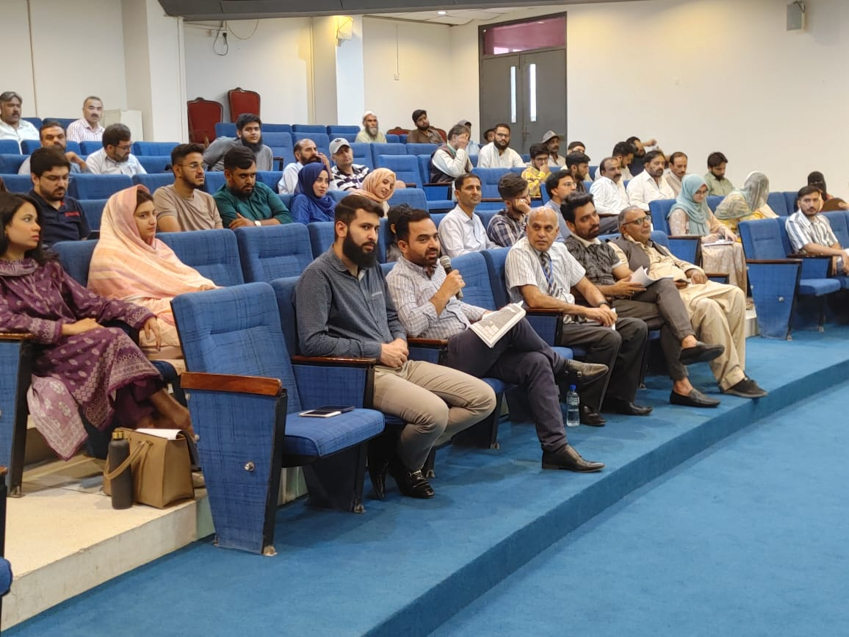
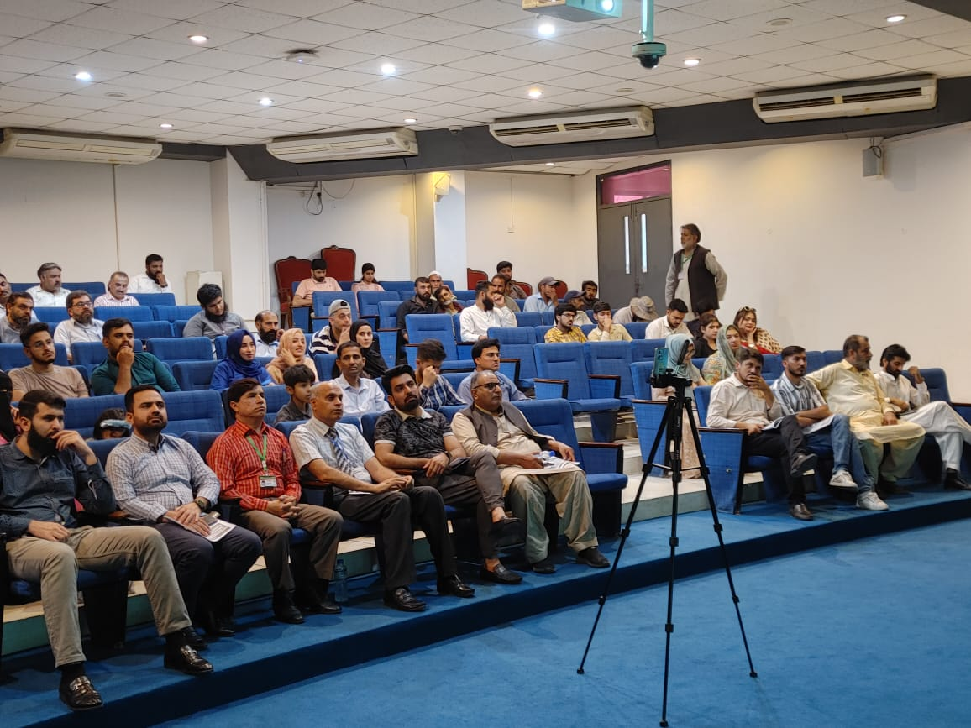

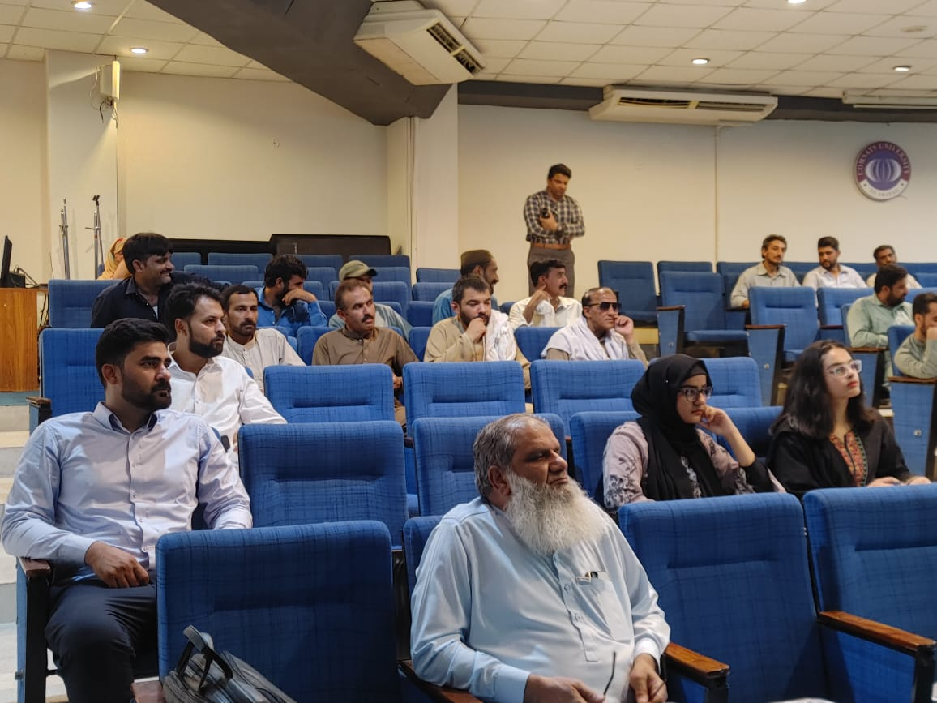
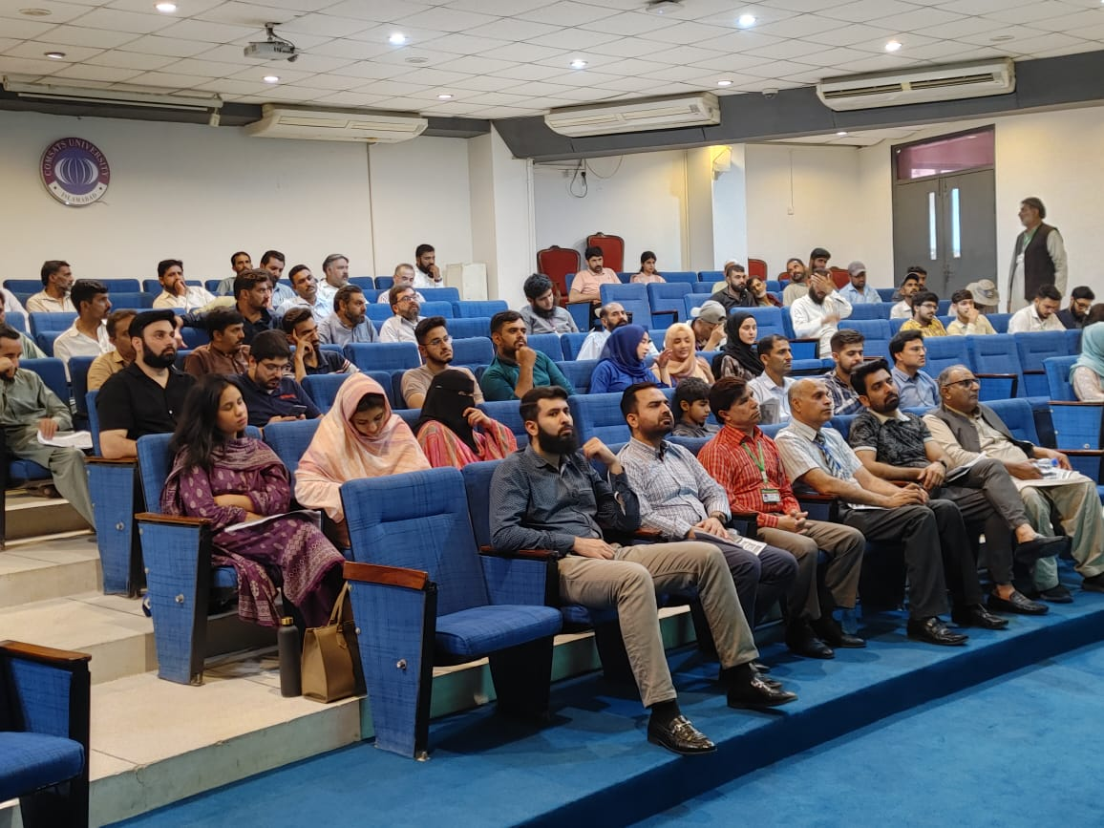

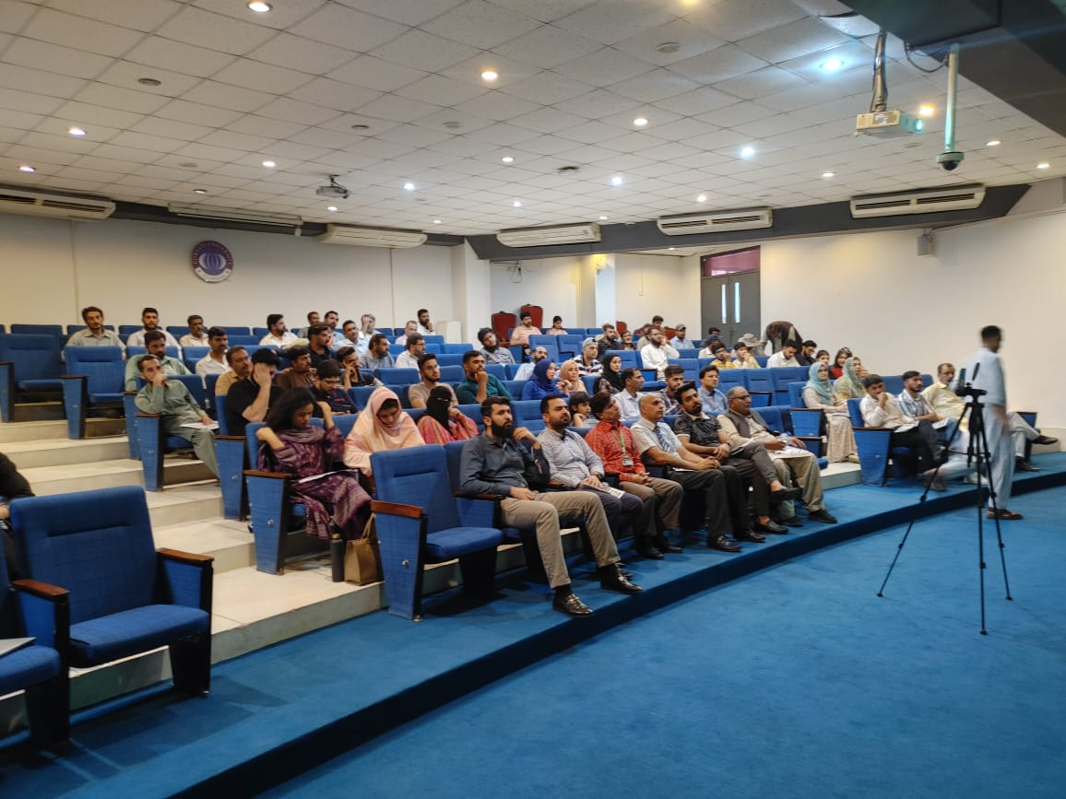

Annexure XVII: Laboratory Monitoring Results for Solar Installation Site at Rawal lake Water Filtration Plant

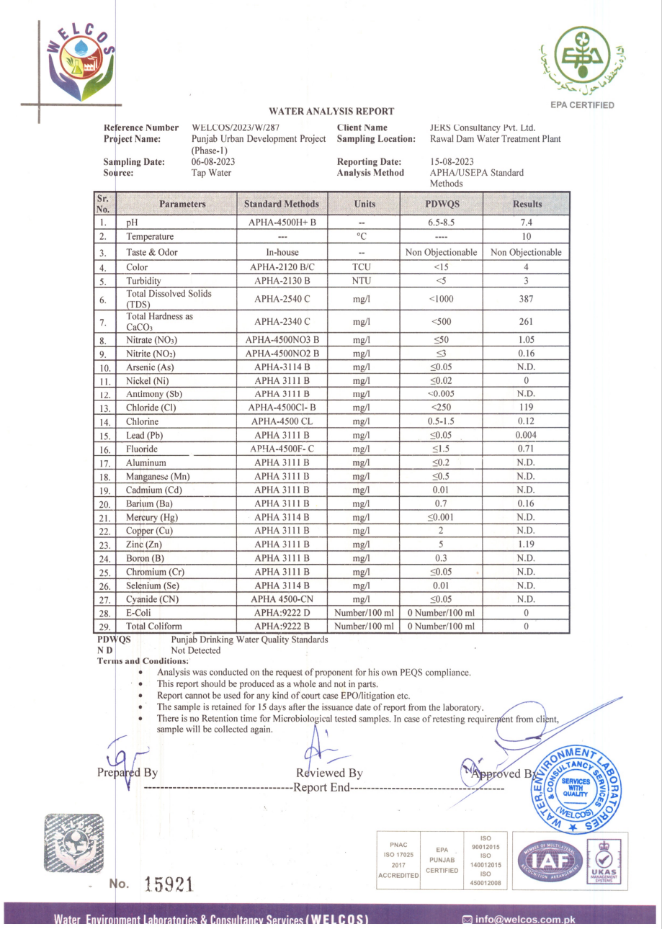

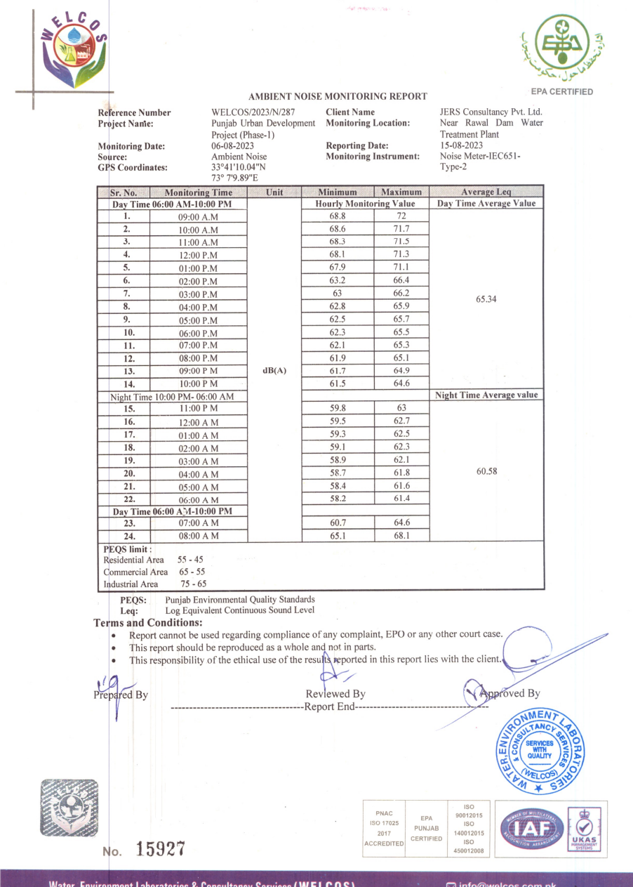

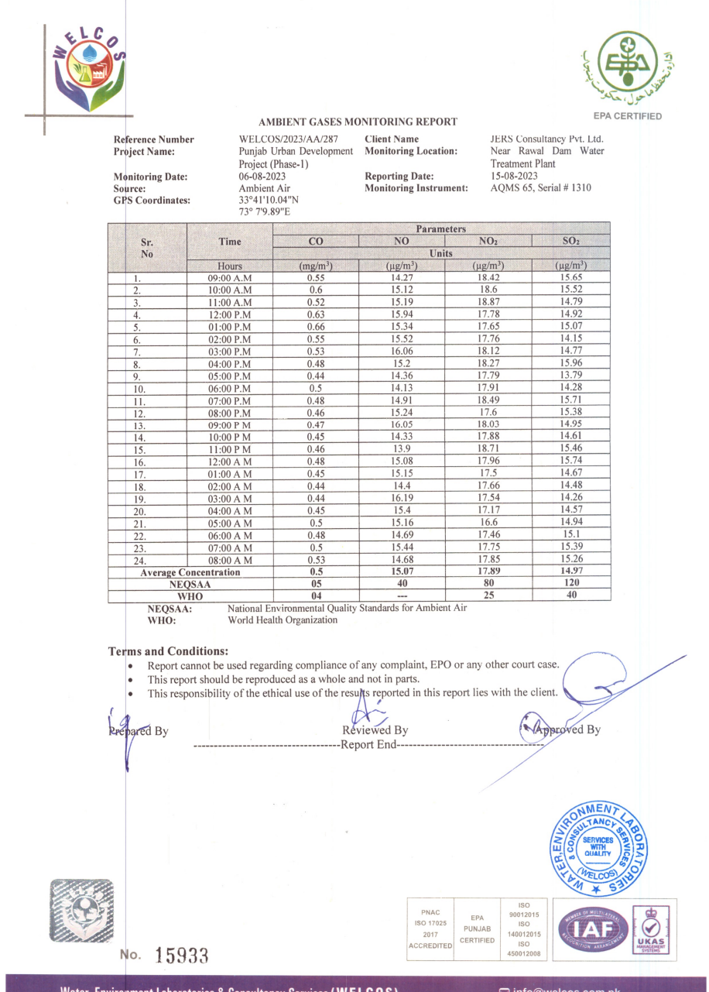

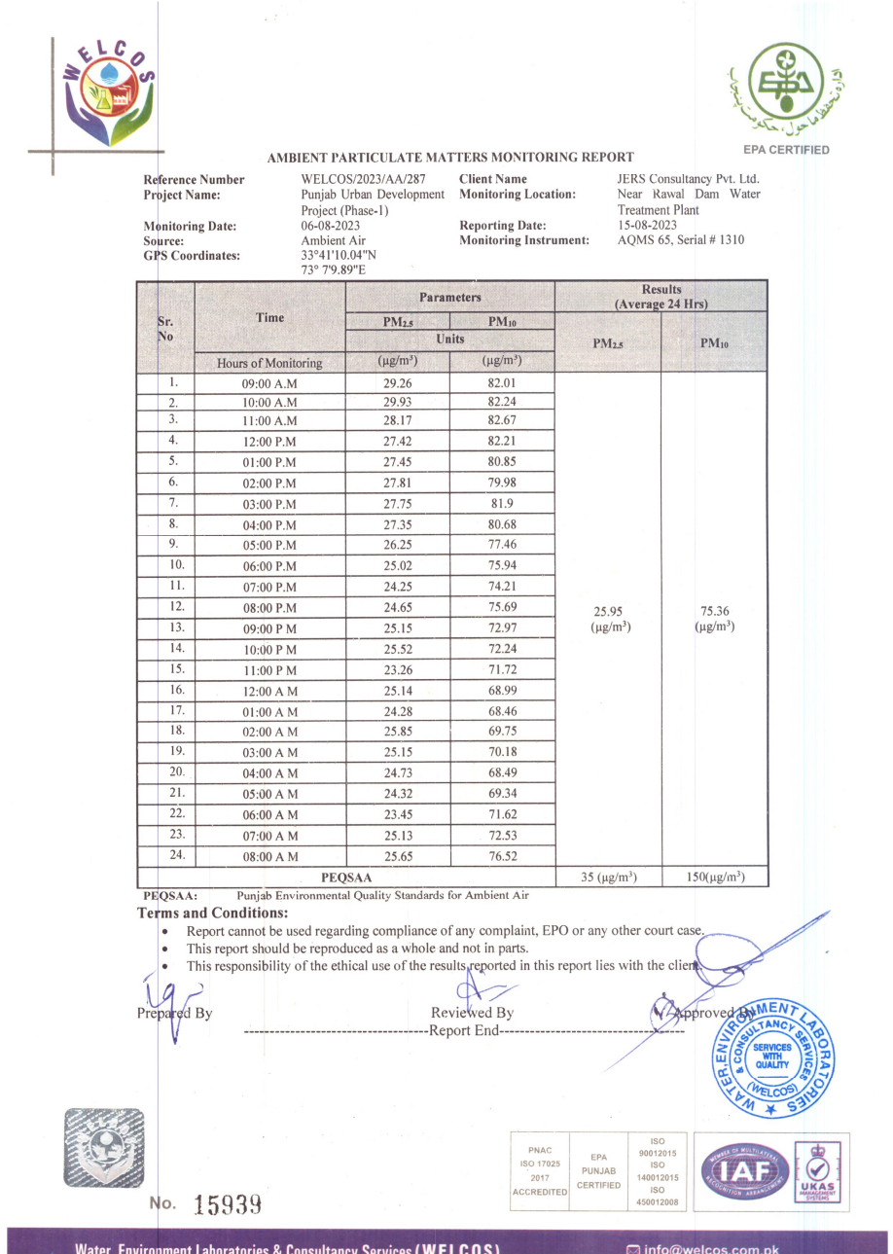

(*Source: Design Criteria of Public Health Engineering for Water Supply, Sewerage and Storm Water Drain)
Source: Iqbal M. Sheikh et al., (Environmental Geology of the Islamabad-Rawalpindi Area, Northern Pakistan) by Geological Survey of Pakistan.
Source: Iqbal M. Sheikh et al., (Environmental Geology of the Islamabad-Rawalpindi Area, Northern Pakistan) by Geological Survey of Pakistan
WMO/GWP Associated Programme on Flood Management Pakistan: Lai Nullah basin flood problem, Islamabad – Rawalpindi cities by Ahmed kamal Federal Flood Commission, Government of Pakistan.
https://www.worldbank.org/en/news/press-release/2022/10/28/pakistan-flood-damages-and-economic-losses-over-usd-30-billion-and-reconstruction-needs-over-usd-16-billion-new-assessme
(Flora of Pakistan-MI-Sheikh, Birds of Pakistan-ZB-Mirza-Mammals of Pakistan-TJ Roberts, Previous EIAs of the proposed area, Manual of silviculture for Pakistan [1965] Champion, Sir H.G.; Pakistan Forest Inst., Peshawar eng; Seth, S.K. Khattak, G.M.)
*Source: Small Dams Organization (Govt. Of the Punjab, Irrigation Department, Development Zone, Lahore, Small Dams Organization, and Islamabad)
https://www.citypopulation.de/en/pakistan/distr/admin/728__rawalpindi/
ADB, Safeguards Unit for Central & West Asia Department, Environmental Management for Construction Handbook.

