Initial Environmental Examination Report

Project Number: 53128-001
October 2024

Project Readiness Financing for Punjab Urban Development Projects

Updated IEE for Augmentation of Water Supply to Rawalpindi City based on Chahan Dam and solarization component under DREAMS-I

Prepared by Project Management Unit of PRF PUDP, Government of Punjab, Pakistan

This updated version of the Initial Environmental Examination Report is a document of the borrower. The views expressed herein do not necessarily represent those of ADB Board of Directors, Management, or staff, and may be preliminary in nature.

In preparing any country program or strategy, financing any project, or by making any designation of or reference to a particular territory or geographic area in this document, the ADB does not intend to make any judgments as to the legal or other status of any territory or area.

CURRENCY EQUIVALENTS
As of 27th October, 2024
Currency Unit – Pak Rupees (Pak Rs.)
Pak Rs 1.00 = $ 0.0036 US$1.00 = Pak Rs. 277
CONVERSIONS
1 meter = 3.28 feet
1 hectare = 2.47 acre

Acronyms
ADB | Asian Development Bank
AIP | Access to Information Policy
AMSL | Above Mean Sea Level
AC | Asbestos Cement
BC | Before Construction
BCP | Building Code of Pakistan
BOQ | Bill of Quantities
COVID-19 | Corona Virus Infection Disease-2019
CSC | Construction Supervision Consultation
DC | During Construction
DDMA | District Disaster Management Authority
DMA | District Metered Area
DO | During Operation
EA | Executing Agency
EDCM | Engineering Design Construction Management
EGL | Existing Ground Level
EHS | Environment Health and Safety
EIA | Environmental Impact Assessment
EMP | Environmental Management Plan
EPA | Environmental Protection Agency
GFR | Gross Enrollment Rate
GI | Galvanized Iron
GST | Ground Storage Tanks
GoP | Government of Pakistan
GRM | Grievance Redress Mechanism
GWSS | Gravity Water Supply Scheme
HDPE | High Density Polyethylene
IA | Implementing Agency
IBAT | Integrated Biodiversity Assessment Tool
IEE | Initial Environmental Examination
IFC | International Finance Corporation
KPI | Key Performance Indicators
LAA | Land Acquisition Act (of 1984)
LARP | Land Acquisition and Resettlement Plan
Lea | Equivalent sound pressure level
MGD | Million Gallons per Day
MSDS | Material safety Data Sheet
NEP | National Environmental Policy
NEQS | National Environmental Quality Standards
PEQS | Punjab Environmental Quality Standards
NER | Net Enrolment Rate
NRW | Non-Revenue Water
OHS | Occupational Safety and Health
O&M | Operation and Maintenance
OHR | Overhead Reservoirs
PAP | Project Affected People
PC | Public Consultation
PPC | Plain Cement Concrete
PDD | Planning and Development Department
PEPA | Pakistan Environmental Protection Act 1997
PEPC | Pakistan environmental protection Council
PEQS | Punjab Environmental Quality Standards
PGA | Peak Ground Acceleration
PMU | Program Management Unit
PPE | Personal protective Equipment
PV | Photovoltaic
Punjab-EPA | Punjab Environmental Protection Agency
RCC | Reinforced Cement Concrete
REA | Rapid Environmental Assessment
RP | Resettlement Plan
RWASA | Rawalpindi Water and Sanitation Agency
SOPs | Standard Operating Procedures
SS | Suspended Solids
SPS | Safeguard Policy Statement
SSEMP | Site Specific Environmental Management Plan
TDS | Total Dissolved Solids
TMA | Tehsil Municipal Administration
TMP | Traffic Management Plan
UCs | Union Councils
USEPA | United States Environmental Protection Agency
WHO | World Health Organization
WTP | Water Treatment Plant

Table of Contents
EXECUTIVE SUMMARY i
1 INTRODUCTION 1
1.1 Overview of the project 1
1.2 Environment Category of the Project 5
1.3 Objective of IEE Report 5
1.4 Project Proponent 5
1.5 Consultant IEE Team 6
1.6 Approach and Methodology 6
1.6.1 Literature Review 7
1.6.2 Review of Environmental Laws and Institutional Requirements 7
1.6.3 Delineation of Corridor of Impact (CoI) 7
1.6.4 Survey of CoI 7
1.6.5 Impact Assessment and Mitigation Measures 7
1.6.6 Environmental Management Plan (EMP) 7
1.6.7 Conclusions and Recommendations 8
1.7 Structure of Report 8
1.8 Further Additions & Updating of IEE Study 8
2 POLICY, LEGAL AND ADMINISTRATIVE FRAMEWORK 9
2.1 General 9
2.2 National Policy and Legal Framework 9
2.3 Regulations for Environmental Assessment, Pakistan EPA 9
2.4 Regulatory Clearances, Punjab EPA 9
2.5 Guidelines for Environmental Assessment, Pakistan EPA 10
2.6 Punjab Environmental Quality Standards (NEQS) 2000 & 2010 10
2.7 Other Environment Related Legislations 10
2.8 Compliance Procedure for Obtaining NOC from PEPA 19
2.9 ADB’s Safeguard Policy Statement (SPS), 2009 20
2.10 ADB’s Access to Information Policy (AIP) 2018 20
2.11 ADB’s Accountability Mechanism Policy 2012 20
2.12 ADB Policy on Gender and Development 20
2.13 Climate Change Risk Management Framework 21
2.14 Comparison of International and Local Environmental Legislations 21
2.15 Administrative Framework 25
2.15.1 Local Government and Community Development (LG&CD) Department 25
2.15.2 Environmental Protection Department, Punjab 25
3 PROJECT DESCRIPTION 26
3.1 Project Introduction 26
3.2 Project Administrative Jurisdiction 26
3.3 Basic Idea of the Project 26
3.3.1 Major components of the Project 26
3.4 Project Location and Components of Project 32
3.4.1 Chahan Dam 32
3.4.2 Location of Water Intake Structure 33
3.4.3 Location of Water Treatment Plant (WTP) 33
3.4.4 Location of Intermediate Pumping Station 33
3.4.5 Intermediate Pumping Station & Water Works 34
3.4.6 Water Main Conductance & Gravity Mains 34
3.4.7 Water Distribution Area 34
3.4.8 Solar PV System Installation 37
3.4.9 Construction Activities 40
3.4.10 Operation phase of Solar installation 41
3.4.11 Decommissioning 42
3.5 Climate change resilience approach 42
3.5.1 Identification of Climate Change Impacts, on the Proposed Project 42
3.6 Construction Aspects 46
3.6.1 Construction Materials 46
3.6.2 Work Force 46
3.6.3 Construction Activities and Required Machinery 46
3.6.4 Construction Camps 47
3.6.5 Water Requirement 47
3.6.6 Wastewater Generation 47
3.6.7 Solid Waste Estimation 48
3.6.8 Project Implementation Schedule 48
3.6.9 Cost of the Project 48
4 ANALYSIS OF ALTERNATIVES 49
4.1 Overview 49
4.2 Alternative for Intake Structure 49
4.2.1 Design Option 1 (Build an Intake Tower Inside the Dam Reservoir) 49
4.2.2 Design Option 2 (Used Existing Intake Tower of Irrigation Dept) 53
4.2.3 Comparison / Analysis of Alternatives 55
4.3 Alternatives for Water Supply Distribution to PP-12 55
4.3.1 Option 1 56
4.3.2 Option 2 57
4.3.3 Option 3 58
4.3.4 Option 4 60
4.3.5 Analysis of Options 61
4.3.6 Comparison / Analysis of Alternatives 64
4.3.7 Recommended Option 65
4.4 Water Treatment Plant 65
4.4.1 Capacity of Treatment Works 65
4.4.2 Raw Water Quality 65
4.4.3 Treatment Process Option 66
4.5 Comparison / Analysis of Alternatives 69
4.5.1 Recommended Process 70
4.6 Solar PV Installation Component 70
5 DESCRIPTION OF ENVIRONMENT 73
5.1 General 73
5.2 Field Visits for Baseline Study 73
5.3 Physical Environment 75
5.3.1 Topography 75
5.3.2 Regional Geology and Soil 77
5.3.3 Seismology 79
5.3.4 Climate 81
5.3.5 Temperature 81
5.3.6 Rainfall 82
5.3.7 Relative Humidity 83
5.3.8 Wind Speed 84
5.3.9 Climate Change Impacts and Vulnerability 85
5.3.10 Floods 85
5.3.11 Water Resources 88
5.3.12 Hydrology and Drainage 88
5.3.13 Solid Waste and Wastewater Situation 88
5.3.14 Environmental Monitoring, Sampling and Testing for Proposed Project 88
5.3.15 Land use of the Proposed Project 98
5.3.16 Environmental Sensitive Receptors of the Proposed Project 99
5.4 Ecological Environment 114
5.4.1 Methodology 114
5.4.2 Ecosystem 115
5.4.3 Flora 115
5.4.4 Agriculture and Crop Pattern 117
5.4.5 Fauna/Wildlife 118
5.4.6 Wetlands 121
5.4.7 Protected Areas (Game Reserves/ Wildlife Sanctuaries/Reserve Forests) 121
5.4.8 IBAT Study 123
5.5 Socio-economic Environment 125
5.5.1 Administrative Setup 125
5.5.2 Demography & Population 126
5.5.3 Religion 128
5.5.4 Archaeological and Cultural Site 128
5.5.5 Ethnicity in the Project Area 128
5.5.6 Language and Dialects 128
5.5.7 Dwellings 128
5.5.8 Economics of Rawalpindi / Islamabad 128
5.5.9 Education Facilities in Project area 128
5.5.10 Social Amenities in the project area 128
5.5.11 Major Source of Drinking Water 129
5.5.12 Health Facilities in project area 129
6 POTENTIAL ENVIRONMENTAL IMPACTS AND MITIGATION MEASURES 130
6.1 General 130
6.2 Methodology for Impact Screening 130
6.3 Potential Positive Impacts 131
6.4 Potential Adverse Impacts 132
6.5 Design/Pre-Construction Phase for Water Supply Component 132
Impact Screening Matrix 132
Adverse Impacts during Planning and Design Phase 134
6.5.1 Improper Selection of intake source and reduce ecological flows Impacts 134
6.5.2 Improper design of water treatment plant and distribution networks including transmission main 134
6.5.3 Lack of Integration of IEE/EMP Requirements into Construction Bid Documents 135
6.5.4 Impacts on Existing Utilities 136
6.5.5 Impacts of Labor Camps and ancillary facilities 136
6.5.6 Traffic Issues 137
6.5.7 Land Acquisition and Resettlement Impacts 137
6.5.8 Topographic Impacts due to Excavation 138
6.5.9 Seismic Impacts 138
6.5.10 Impact on Water Usage for Irrigation 139
6.6 Impacts during Construction Stage for Water Supply Component 139
Impact Screening Matrix 139
6.6.1 Site Accessibility during Construction 140
6.6.2 Degradation of Ambient Air Quality 141
6.6.3 Noise 142
6.6.4 Vibrations 144
6.6.5 Wastewater Generation 144
6.6.6 Solid Waste Generation 145
6.6.7 Traffic Issues 146
6.6.8 Flora 147
6.6.9 Fauna 147
6.6.10 Impacts due to Construction Camps/Camp Sites 148
6.6.11 Impacts on Local Resources 150
6.6.12 Impacts on Health and Safety of Community 150
6.6.13 Impacts on Occupational Health and Safety 152
6.6.14 Impacts of Natural and Man-Made Disasters 154
6.6.15 Social and Cultural Conflicts 155
6.6.16 Communicable Diseases 156
6.6.17 Impacts during Site Restoration 156
6.7 Anticipated Impacts during Operational Phase for Water Supply Component 157
6.7.1 Generation of Sludge and Wash Water 158
6.7.2 Water system leaks and water discharges during flushing 159
6.7.3 Handling of Hazardous Chemicals and Chlorine Release 160
6.7.4 Impacts on Landscape 161
6.7.5 Impacts on Aquatic Life of Chahan Dam due to Uncontrolled Abstraction of Water 161
6.7.6 Impact on Aquatic Life due to change in water quality 162
6.7.7 Impact on the Proposed Project due to Climate Change 162
6.7.8 Improved Drinking Water Availability 163
6.7.9 Improvements in Public Health 163
6.7.10 Cumulative Impacts 163
6.8 Solar PV Installation 163
Impacts and mitigation measures during pre-Construction phase 163
6.8.1 Relocation of Utilities 164
6.8.2 Traffic Issues 165
6.8.3 Lack of Integration of IEE/EMP Requirements into Construction Bid Documents 165
6.8.4 Seismic Impacts 166
6.8.5 Transmission Line Interconnection Route Selection 166
6.8.6 Land requirements 167
6.8.7 Landscape Impact 167
6.8.8 Traffic Issues 168
6.8.9 Air Quality 169
6.8.10 Noise and vibration 171
6.8.11 Occupational Health and Safety 172
6.8.12 Community Health and Safety 173
6.8.13 Waste Generation 175
6.8.14 Vegetation impacts 176
6.8.15 Fauna Impacts 176
6.8.16 Biodiversity 177
6.8.17 Interruption to Existing Utilities 178
6.8.18 Physical Landscape 178
6.8.19 Topography 179
6.8.20 Groundwater Quality 179
6.8.21 Soil Quality 180
6.8.22 Local Economic Development 180
6.8.23 Physical Cultural Resources (PCRs) 181
6.8.24 Other Risks 181
6.8.25 Workforce Organization and Orientation 183
6.8.26 Water usage for panel cleaning 183
6.8.27 Air Quality, Noise and Vibration 183
6.8.28 Waste Generation 184
6.8.29 Ecological Impacts 184
6.8.30 Occupational Health and Safety 184
6.8.31 Glare from solar panels might blind pilots or air traffic control towers 185
Potential impacts 185
6.8.32 Interference with navigation and communication systems of aircrafts (electromagnetic interference) 186
6.8.33 Green energy-based climate friendly form of power generation 186
7 ENVIRONMENTAL MANAGEMENT PLAN 188
7.1 Introduction 188
7.2 Environmental Management Plan 188
7.3 Objectives of EMP 188
7.4 Institutional Arrangements 189
7.4.1 Role of PMU/CIU, Punjab LG &CDDD 189
7.4.2 Role of the ADB 189
7.4.3 Role of Construction Supervision Consultant (CSC) 189
7.4.4 Role of Punjab EPA 190
7.4.5 Role of Project Contractor 190
7.4.6 Role of Rawalpindi WASA 190
7.5 Monitoring Parameters 276
7.6 Environmental Training 281
7.7 Environmental Management Costs 283
a. Environmental Management Costs for Solar Installation 286
7.8 Performance Indicators 288
8 Public Consultation and Information Disclosure 289
8.1 Identification of Stakeholders 289
8.2 Consultation Process 290
8.3 Consultation with Project Affected Peoples 290
8.4 Issues, Concerns and Findings of the Focal Group Discussion 361
8.5 Consultation with Official Stakeholders 361
8.6 Consultation Plan for Construction and Operation Phase 370
8.7 Information Disclosure 370
9 GRIEVANCE REDRESSAL MECHANISM 372
9.1 General 372
9.2 Scope of GRM 372
9.3 Functions of GRC Committee 372
9.4 Stage of GRM 373
10 Conclusion and Recommendations 376
10.1 Conclusion 376
10.2 Recommendations 377
Annexures 378
Annexure-I Filled Checklist of REA 379
Annexure-II Environmental Monitoring Reports 386
Annexure-III Calibration Certificates of Monitoring Equipment 403
Annexure-IV IBAT Report 409
Annexure-V Chance Find Procedure 418
Annexure-VI Framework Dust Management Plan 420
Annexure-VII Framework Noise and Vibration Management Plan 425
Annexure-VIII Framework Traffic Management Plan 429
Annexure-IX Framework Resource Management Plan 438
Annexure-X Framework Occupational Safety and Health Management Plan 441
Annexure-XI Framework Emergency Response Management Plan 451
Annexure-XII Template for Site Specific EMP 467
Annexure-XIII Tool for Socio-economic Survey 476
Annexure-XIV Attendance Sheets of FGDs 480
Annexure XV: Public Consultation Minutes for 493
Solar Installation Development 493
Annexure XVI: Laboratory Monitoring Results for Solar Installation Sites 500

List of Figures
Figure ‎1-1: Project Location Map 4
Figure ‎1-2: Map of solar PV location 4
Figure ‎3-1:Basic Concept of the Project 26
Figure ‎3-2 Location plan of water extraction from Existing Intake to WTP 29
Figure ‎3-3 Location of Conductance Mains, WTP, IPS and Water Works 31
Figure ‎3-4: Aerial View of Water Source (Chahan Dam) 33
Figure ‎3-5 Location Plan of the Water Distribution Area 36
Figure ‎4-1:Location plan of Intake and WTP 51
Figure ‎4-2:Intake Structure and Access Bridge 52
Figure ‎4-3:Location of Water Extraction from existing Intake of Irrigation Department to WTP 54
Figure ‎4-4:Typical treatment performance of conventional SSFs 67
Figure ‎4-5: Process Diagram of Slow Sand Filter 68
Figure ‎4-6: Filtration & Backwash Processes of Rapid Sand Filter 68
Figure ‎4-7: A typical Ultrafiltration Plant 69
Figure ‎5-1: Index Map of COI of Proposed Project 74
Figure ‎5-2: Topography of the Project Area 76
Figure ‎5-3: Regional Geological Map 78
Figure ‎5-4Seismic Zoning Map 80
Figure ‎5-5: Mean Monthly Temperature at Meteorological Gauging Station 82
Figure ‎5-6: Mean Monthly Rainfall of Meteorological Gauging Station 83
Figure ‎5-7: Yearly record of Relative Humidity 84
Figure ‎5-8: Wind Speed of Meteorological Gauging Station 85
Figure ‎5-9: Flood prone Areas of District Rawalpindi 87
Figure ‎5-10: Environmental Monitoring & Sampling Points 96
Figure ‎5-11:Sampling location and coordinates 97
Figure ‎5-12: Land use around the Project Site 99
Figure ‎5-13: Environmental Sensitive Receptors Map 100
Figure ‎5-14: Environmental Sensitive Receptors 101
Figure ‎5-15 Floral profile of project area 116
Figure ‎5-16 Agriculture and Crop Patterns in project area 118
Figure ‎5-17 Mammal Species present around the project site 119
Figure ‎5-18: Distance of Proposed project from nearest Forest 122
Figure ‎5-19:Results of IBAT study 124
Figure ‎5-20:Demographic features of Rawalpindi 127
Figure ‎9-1 GRM Process 375

List of Tables
Table ES.1: Screening of possible Impacts during Design/Pre- Construction phase for ‘Solar PV Component’ vi
Table ES.2: Screening of Possible Impacts during Construction Phase for ‘Solar PV Component’ vii
Table ES.3: Screening of Potential Impacts during Operation Phase for ‘Solar PV Component’ vii
Table ‎1.1.1: Project Original and revised scope 2
Table ‎1-2: Team Involved in Preparation of IEE report 6
Table ‎2-1: Main Strategies/Policies Related to Environment and Relevance to the Project 10
Table ‎2-2: Main Legislation/Acts Related to Environment and Their Relevance to the Project 14
Table ‎2-3: IFC Work Environment Noise limits 22
Table ‎2-4: Comparison of International and local Air Quality Standards* 22
Table ‎2-5: Comparison of International and Local Noise Standards 23
Table ‎2-6: Comparison of International and Local Water Quality Standards 23
Table ‎3-1 Climate Change Impacts on project 43
Table ‎3-2: Machinery and Equipment Requirement 46
Table ‎4-1: proposed options based on environmental, social and economic impacts 55
Table ‎4-2;The feasible area requirement for Chakra WW 56
Table ‎4-3: Area requirements for different WWs location for option 2 57
Table ‎4-4: Area requirements for different WWs location for option 3 59
Table ‎4-5: Area requirements for different WWs location for option 4 60
Table ‎4-6: Area requirement of all options 61
Table ‎4-7: Pump size and power requirement of the options 62
Table ‎4-8: Cost estimation of options 63
Table ‎4-9: O & M cost estimation of options 63
Table ‎4-10: Total cost estimation includes capital and O&M of all options 63
Table ‎4-11: Summary of all options based on different parameters 64
Table ‎4-12: Alternatives based on environmental, social and economic impacts 64
Table ‎4-13:Comparison of Available Option 70
Table ‎5-1: Values of Seismic Zones of Pakistan 79
Table ‎5-2 Monthly Temperature Recorded at Meteorological Gauging Station 81
Table ‎5-3: Mean Monthly Rainfall Record 82
Table ‎5-4: Relative Humidity recorded at Airport Meteorological Gauging Station 83
Table ‎5-5: Wind Speed Record 84
Table ‎5-6:Water Quality Sampling Location Description 89
Table ‎5-7 Results of Water Quality Analysis 90
Table ‎5-8: Detail of Air Quality Sampling Locations 93
Table ‎5-9: Ambient Air Quality Results 93
Table ‎5-10: Detail of location for Noise Levels Monitoring 94
Table ‎5-11: Noise Level Monitoring Results 95
Table ‎5-12: Detail of Environmental Sensitive Receptors 102
Table ‎5-13: Names of Trees/shrubs & Herbs of the Region 117
Table ‎5-14: List of indigenous Mammals 119
Table ‎5-15: Amphibians of the Study Area 120
Table ‎5-16: Reptiles of the Study Area 120
Table ‎5-17: Birds Found in Study Area 121
Table ‎5-18: Forests located near the project area 121
Table ‎5-19: Administrative subdivision of Rawalpindi District 125
Table ‎6-1: Screening of possible Impacts during Design/Pre- Construction phase for Water Supply Component 133
Table ‎6-2: Screening of Possible Impacts during Construction Phase for Water Supply Component 139
Table ‎6-3:Noise Produced by Construction Equipment 142
Table ‎6-4: Estimated Wastewater Generated by Workers in Construction Camps 145
Table ‎6-5: Screening of Possible Impacts during Operation Phase 157
Table ‎6.8.1 Screening of possible Impacts during Design/Pre- Construction phase for ‘Solar PV Component’ 164
Table ‎6.8.2: Screening of Possible Impacts during Construction Phase for ‘Solar PV Component’ 168
Table ‎6.8.3: Screening of Possible Impacts during Operation Phase for ‘Solar PV Component’ 182
Table ‎7-1: Environmental Mitigation and Management Matrix for Water Supply Component 192
Table ‎7.4.2: Environmental Management Plan for Solar PV Installation 252
Table ‎7-3: Pre-Construction’ Environmental Monitoring for Baseline Development 277
Table ‎7-4: Construction Phase Monitoring Requirements 278
Table ‎7-5: Operation Phase Environmental Monitoring Plan 280
Table ‎7-6: Capacity Development and Training Program 282
Table ‎7-7 Cost Estimates for ‘Pre-Construction Phase’ 283
Table ‎7-8: Annual Cost Estimates for ‘Construction Phase’ Environmental Monitoring 284
Table ‎7-9: Annual Cost Estimates for ‘Operation Phase’ Environmental Monitoring 284
Table ‎7-10: Estimated Costs for EMP Implementation 284
Table ‎7-11: Cost of Capacity Development and Training Programme for Project Contractor(s) 285
Table ‎a.1: Cost Estimates for ‘Pre-Construction Phase’ – Solar 286
Table ‎a.2: Cost Estimates for ‘Construction Phase’ Environmental Monitoring - Solar 286
Table ‎a.3: Estimated Costs for EMP Implementation - Solar 287
Table ‎a.4: Cost of Capacity Development and Training Program for Project Contractor(s) - Solar 287
Table ‎8-1:Consultation with Primary Stakeholders – May to August’23 315
Table ‎8-2: Response of Stakeholder during FGDs – August’23 329
Table ‎8-3:Consultation with Project Affected People – November’22 to January’23 335
Table ‎8-4: Response to Stakeholders during FGDs – December’22 347
Table ‎8-5: Public Hearing proceedings – Feb’24 351
Table ‎8-6: Pictorial Evidence of Public Hearing 356
Table ‎8-7: Photographs of Stakeholder Consultations 357
Table ‎8-8 Consultative Session with Government Departments – Aug’23 366
Table ‎8-9: Photographs of Consultations with Institutional Stakeholders – Aug’23 367
Table ‎8-10:Findings of Consultation with Government Stakeholder – Nov to Dec’22 367
Table ‎8-11: Photographs of Consultations with Institutional Stakeholders – Nov’22 370

EXECUTIVE SUMMARY
Project Overview
- The proposed sub-project is a part of the Developing Resilient Environments and Advancing Municipal Services (DREAMS) project which Asian Development Bank (ADB) is financing in the amount of USD 180 million.
- The DREAMS project will support inclusive, resilient, and sustainable urban infrastructure and services in two rapidly growing cities in Punjab province - Rawalpindi and Bahawalpur by (i) expanding and modernizing urban water supply systems in Rawalpindi and solid waste collection, treatment, and disposal in Bahawalpur; and (ii) strengthening institutional capacity in service delivery to improve the quality, coverage, efficiency and reliability of these services, as well as the financial sustainability of the utilities. The project will benefit up to 1.5 million urban dwellers in Punjab, the most populous province of the country.
- The aim of the project is to supply potable/treated water to the areas recently added in Water and Sanitation Agency (WASA) service delivery jurisdiction, which comprise of Dhamial, Quaid-e-Azam Colony, Girja, Dhama Syedan, Lakhan (Lalarukh), Chak Jalal Din, Kalyal, Chakra and adjoining areas.
- The Rawalpindi WASA is responsible for providing water supply and sewerage services to 1.6 million people living in 66 Union councils of the city of Rawalpindi. The domestic water demand is 290,950 m³/d (64 million gallons per day (MGD)), which is almost 13 MGD less than the current water supply. Groundwater is depleting due to extensive abstraction and as a result the number of abandoned tubewells is increasing. There are almost 67 tube wells out of a total of 495 that are either abandoned or non-functional due to decrease in water table. Around 136 tube wells that were installed before the year 2000 are now outlived and need to be rehabilitated or replaced.
Objectives of the Project
- The main objectives of the project are:
- To augment water for present and future needs;
- To address water scarcity and poor condition of water supply;
- To mitigate the problem of contaminated water being supplied to the residents of the city;
- Reduction in the O & M expenditure of WASA;
- To improve the overall environment of the city with the provision of sufficient water to the poor and low-income people;
- To devise effective measures for suitable quality control of water supply system from health consideration and pollution control; and
- To design a system to integrate various sources of water supply for alternate use in case of breakdown.

Policy, Legal and Administrative Framework
- The project needs to comply with all the applicable environmental policies, laws, guidelines, acts and legislation of provincial government as well as international environmental guidelines.
ADB’s Safeguard Policy Statement (SPS), 2009
- According to ADB’s Safeguard Policy Statement (SPS) 2009, a Rapid Environmental Assessment (REA) Checklist was prepared for the proposed project and the project was categorized as ‘B’ under ADB SPS, 2009 and an Initial Environmental Examination (IEE) report has been prepared accordingly.
Project Description
- The project concept is to use the Chahan dam water intake structure as the raw water source. From the intake, 12 MGD raw water will transmit water to the treatment plant by means of raw water pumps. After treatment, the treated water from the WTP will be dispensed to the water distribution areas (PP-12 RWASA Zone) with the help of the intermediate pumping station (IPS), water works (WW), conductance, and gravity mains.
- The basic components of the project are:
- Raw water intake structure
- Water treatment plant
- Intermediate pumping station and Water Works comprise on;
- Under Ground Storage Tanks
- Over Head Reservoirs
- Conductance main and Gravity mains
- Distribution networks system consisting of;
- Distribution Pipe network
- Water metering
- House connections
- Development of a grid connected solar photovoltaic (PV) system of 5.3 MW capacity will be installed over 18 acres of land near the Chahan dam and Gorakhpur Sewerage Treatment Plant (STP) areas and the power generated will be used for meeting the project needs any the excess power will be put onto the grid. The site for installation of the solar PV panels and infrastructure is shown as Figures ES-2 and ES-3 below.
- The project is expected to improve the living conditions and quality of life of 298,468 residents living in areas recently included in Rawalpindi WASA’s jurisdiction.
Project Alternatives
Alternatives for Water Supply Distribution to PP-12
- The treated water from IPS Ranial will further distribute into the distribution area (RWASA PP12) and different options have been assessed for the conveyance system from IPS Ranial to water distribution area.
- The following alternatives have been evaluated for conductance of treated water from IPS Ranial to PP-12:
- Option 1: Distribution of treated water supply in the project area through one Water Works (Chakra).
- Option 2: Distribution of treated water supply in the project area through two IPS (Akbar Chowk & Biscuit Factory) and three water works (Akbar Chowk, Chakra & Adiala).
- Option3: Distribution of the treated water supply in the project area through one IPS (Akbar Chowk) and three water works (Akbar Chowk, Chakra & Adiala).
- Option 4: Distribution of treated water supply in the project area through one IPS (Akbar Chowk) and three water works (Akbar Chowk, Chakra & Adiala) comprising of overhead reservoir (OHR) and ground storage tank.
- After evaluation and keeping in view the land availability, capital and O&M costs, it is recommended to adopt Option 4 for distribution of treated water from Chahan Dam to the water distribution area PP-12.
- Also, various water treatment methods were considered keep in view the advantages and disadvantage of different processes. The most suitable process which is commonly used worldwide and efficient as per required drinking water quality in low land areas and with nominal electricity requirements is the “Rapid Sand Filtration (RSF)” with coagulation, flocculation and settling as pre-treatment and disinfection with chlorination as post treatment. So, the RSF method/ technique is recommended for the water treatment process.
- The different potential options relating to the proposed solar PV development were assessed. The ‘No project’ scenario is not a viable option since Pakistan is facing an energy deficit and needs to urgently switch from the cost intensive and environmentally unfriendly diesel-based power generation and move towards developing renewable based cheap and reliable energy on a long-term basis.
- For the purpose of this proposed solar PV installation, bifacial monocrystalline modules will be utilized in the solar plant while for end of life/failure or at decommissioning, provision in tender agreements with suppliers/vendors will ensure proper and safe collection, recycling and/or disposal, as needed.

Description of the Environment
- Considering the potential impacts of the proposed project, existing baseline environmental conditions of the proposed project’s Corridor of Impact (CoI) will be used as a benchmark for comparison of the physical, ecological and socio-economic conditions before and after construction phases of the project. This baseline will also provide the datum for assessing the impacts and suggesting mitigation measures, which will be implemented effectively at various phases of the proposed project activities.
- The data has been collected from both primary and secondary sources. For primary data acquisition, the Environment and Social team conducted the field visit during the month of November, 2022 while the secondary data was collected from published sources/reports and relevant departments, which were also verified through visual observations during detailed surveys. Data has been collected for the following elements of environment:
- Physical Environment
- Biological Environment
- Socioeconomic environment
- Environmental parameters such as air quality, noise level and drinking water quality were also analyzed to assess the baseline conditions of project area. It is evident from the monitoring results that water quality from the project area is not fit for drinking since it contains contamination of wastewater along with E. coli and Fecal Coliform, which make this water unfit for drinking. The results show that concentrations of PM₁₀ and PM_{2.5} exceed the limiting values set by World Health Organization (WHO) for ambient air. The noise levels at IPS Ranial exceed the limiting values set by Punjab Environmental Quality Standards (PEQS) for day and night times by applying the most stringent applicable standards and the detailed results of the monitoring are provided in Chapter 5 of this IEE study.
Potential Environmental Impacts and Mitigation Measures
- Apart from positive impacts, there are certain potential adverse environmental and social impacts on the local environment. The proposed project is divided into three stages i.e. Pre-construction / Planning and Design, Construction and Operation and Maintenance (O&M) stages. Adverse impacts envisaged at these three stages of the proposed project have been identified and appropriate mitigation and remedial measures have been proposed accordingly. Project impact evaluation matrices have also been developed to evaluate the potential impacts of the proposed project during planning, construction and operation phases of the project.
- The majority of environmental impacts are associated with the distribution networks, which include the transmission main and generation of solid waste, sludge and wastewater treatment during the plant operations. Major impacts during the construction phase will be related to traffic congestion and community health and safety issues during the laying of water supply systems in populated areas.
- Table ES-1,
- Table ES-2, and Table ES- 3 show the impact matrix for pre-construction, construction and operation phases respectively.
Table ES-1 Impact Screening during Pre-Construction Phase for Water Supply to Rawalpindi city from Chahan dam
S/No. | Potential Issue | Likelihood (Certain, Likely, Unlikely, Rare) | Consequence (Catastrophic, Major, Moderate, Minor) | Risk Level (Significant, Medium, Low) | Residual Impact  (Short term, Long term)
1 | Improper selection of intake source and reduce ecological flows Impacts | 2 /  Likely | 5 /  Moderate | 10 /  Medium | Low / Long Term
2 | Improper design of water treatment plant and distribution networks including transmission main | 2 /  Likely | 5 /  Moderate | 10 /  Medium | Low / Long Term
3 | Lack of integration of IEE/EMP requirements into Construction bid documents | 2 /  Likely | 3 /  Moderate | 6 /  Medium | Low / Short Term
4 | Contractor’s Environmental Safeguards Capacity | 3 /  Likely | 3 /  Moderate | 9 /  Medium | Low / Short Term
5 | Relocation of existing utilities | 2 /  Likely | 3 /  Moderate | 6/  Medium | Low residual  Impact
6 | Identification of Locations for Labor Camps and ancillary facilities | 3 /  Likely | 2 /  Moderate | 6 /  Medium | Medium / Short Term
7 | Traffic Issues/ Traffic Management Plan | 3 /  Likely | 2 /  Moderate | 6 /  Medium | Low / Short Term
8 | Land acquisition and resettlement impacts | 5 /  Unlikely | 2 /  Moderate | 10 / Medium | Low residual Impact
9 | Topographic Impact | 2 /  Unlikely | 2 /  Moderate | Low | Low residual Impact
10 | Seismic Impacts | 2 /  Unlikely | 2 /  Moderate | Low | Low residual  Impact

Table ES-2 Screening of Environmental Impacts during Construction Phase for Water Supply to Rawalpindi city from Chahan dam
S/No. | Potential Issue | Likelihood (Certain, Likely, Unlikely, Rare) | Consequence (Catastrophic, Major, Moderate, Minor) | Risk Level (Significant, Medium, Low) | Residual Impact (Short term, long term)
1 | Construction of water treatment plant and other structures not in accordance with finalized design | 2 / Likely | 5 / Moderate | 10 / Medium | Low / Short term
2 | Site Accessibility Issues | 3 / Likely | 2 / Moderate | 6 / Medium | Low / Short term
3 | Traffic Issues | 3 / Likely | 3 / Moderate | 9 / Medium | Low / Short term
4 | Impact on local Resource | 3 / Likely | 2 / Moderate | 6 / Medium | Low / Short term
5 | Community Health & Safety | 3 / Likely | 2 / Moderate | 6 / Medium | Low / Short term
6 | Occupational Health & Safety | 3 / Likely | 2 / Moderate | 6 / Medium | Low / Short term
7 | Impacts due to Construction Camps/ Camp Site | 3 / Likely | 2 / Moderate | 6 / Medium | Low / Short term
8 | Waste water generation | 3 / Likely | 3 / Moderate | 9 / Medium | Low / Short term
9 | Solid Waste Generation | 3 / Likely | 2 / Moderate | 6 / Medium | Low / Short term
10 | GHG Emissions | 3 / Likely | 2 / Moderate | 6 / Medium | Low / Short term
11 | Potential Emergencies during construction phase | 3 / Likely | 2 / Moderate | 6 / Medium | Low / Short term
12 | Impacts of Natural and Man-Made Disaster | 3 / Likely | 2 / Moderate | 6 / Medium | Low / Short term
13 | Degradation of air quality due to construction works | 3 / Likely | 3 / Moderate | 9 / Medium | Low / Short term
14 | Noise/ Vibration | 3 / Likely | 2 / Moderate | 6 / Medium | Low / Short term
15 | Flora | 3 / Likely | 3 / Moderate | 9 / Medium | Low / Short term
16 | Fauna | 3 / Likely | 3 / Moderate | 9 / Medium | Low / Short term
17 | Social and Cultural Conflicts | 3 / Likely | 2 / Moderate | 6 / Medium | Low / Short term
18 | Communicable diseases incl. COVID-19 | 3 / Likely | 2 / Moderate | 6 / Medium | Low / Short term
Table ES- 3 Screening of Possible Impacts during Operation Phase for Water Supply to Rawalpindi city from Chahan dam
Sr./No. | Potential Issues | Likelihood  (Certain, Likely, Unlikely, Rare) | Consequence  (Catastrophic, Major, Moderate, Minor) | Risk Level (Significant, Medium, Low) | Residual Impact (Short term, long term)
1 | Generation of Sludge and Wash Water | 5 /  Certain | 2 /  Moderate | 10 /  Medium | Low / long Term
2 | Water system leaks and water discharges during flushing | 2 /  Unlikely | 3 /  Major | 6 /  Medium | Low / Short Term
3 | Handling of Hazardous Chemicals and Chlorine Release | 2 /  Unlikely | 5 /  Catastrophic | 10 /  Medium | Low / Long Term
4 | Impacts on Landscape | 2 /  Unlikely | 3 /  Major | 6 /  Medium | Low / Long Term
5 | Impacts on Aquatic life of Chahan Dam due to uncontrolled abstraction of water | 2 /  Unlikely | 5 /  Catastrophic | 10 /  Medium | Low / Long Term
6 | Impacts on Aquatic life of Chahan Dam due to change in quality of water | 2 /  Unlikely | 5 /  Catastrophic | 10 /  Medium | Low / Long Term
7 | Impact on the Proposed Project due to Climate Change | 2 /  Unlikely | 3 /  Major | 6 /  Medium | Low / Long Term
8 | Improved drinking water availability | Positive impacts expected |  |  | Long term positive
9 | Impacts on Public Health | Positive impacts expected |  |  | Long term positive
Table ES.1: Screening of possible Impacts during Design/Pre- Construction phase for ‘Solar PV Component’
S/No. | Potential Impacts | Likelihood (Certain, Likely, Unlikely, Rare) | Consequence (Catastrophic, Major, Moderate, Minor) | Risk Level (Significant, Medium, Low) | Residual Impact  (Low, medium, High)
1 | Relocation of existing utilities | 3 /  Likely | 2 /  Moderate | 6 /  Medium | Low
2 | Traffic Issues/ Traffic Management Plan | 3 /  Likely | 2 /  Moderate | 6 /  Medium | Low
3 | Lack of integration of  IEE/EMP requirements into Construction bid documents | 3 /  Likely | 2 /  Moderate | 6 /  Medium | Low
4 | Seismic impacts | 3 /  Likely | 2 /  Moderate | 6 /  Medium | Low
5 | Site and Route selection | 3 /  Likely | 2 /  Moderate | 6 /  Medium | Low
6 | Land requirements | 2 /  Unlikely | 1 /  Minor | 2 /  Low | Low
Table ES.2: Screening of Possible Impacts during Construction Phase for ‘Solar PV Component’
Sr. No. | Potential Impacts | Likelihood (Certain, Likely, Unlikely, Rare) | Consequence (Catastrophic, Major, Moderate, Minor) | Risk Level (Significant, Medium, Low) | Residual Impact (Low, medium, High)
1 | Traffic Issues | 3/ Likely | 2/ Moderate | 6/ Medium | Low
2 | Air Quality | 3/ Likely | 2/ Moderate | 6/ Medium | Low
3 | Noise and Vibration | 3/ Likely | 2/ Moderate | 6/ Medium | Low
4 | Occupational Health & Safety | 3/ Likely | 2/ Moderate | 6/ Medium | Low
5 | Community Health and Safety | 3/ Likely | 2/ Moderate | 6/ Medium | Low
6 | Waste generation | 3/ Likely | 2/ Moderate | 6/ Medium | Low
7 | Vegetation impacts | 3/ Likely | 2/ Moderate | 6/ Medium | Low
8 | Fauna impacts | 3/ Likely | 3/ Moderate | 9/ Medium | Low
9 | Biodiversity | 3/ Likely | 2/ Moderate | 6/ Medium | Low
10 | Interruption to existing facilities | 3/ Likely | 2/ Moderate | 6/ Medium | Low
11 | Physical landscape | 3/ Likely | 2/ Moderate | 6/ Medium | Low
12 | Topography impacts | 3/ Likely | 2/ Moderate | 6/ Medium | Low
13 | Groundwater quality | 3/ Likely | 2/ Moderate | 6/ Medium | Low
14 | Soil quality | 3/ Likely | 2/ Moderate | 6/ Medium | Low
15 | Local Economic development | 3/ Likely | 2/ Moderate | 6/ Medium | Low
16 | Physical Cultural Resources | 3/ Likely | 2/ Moderate | 6/ Medium | Low
17 | Other Risks | 3/ Likely | 2/ Moderate | 6/ Medium | Low

Table ES.3: Screening of Potential Impacts during Operation Phase for ‘Solar PV Component’
S/No. | Potential Issues | Likelihood (Certain, Likely, Unlikely, Rare) | Consequence (Catastrophic, Major, Moderate, Minor) | Risk Level (Significant, Medium, Low) | Residual Impact (Low, medium, High)
1 | Workforce Organization and Orientation | 2/ Unlikely | 3/ Major | 6/ Medium | Low
2 | Water usage for panel cleaning leading to water shortage | 3/ Likely | 2/ Moderate | 6/ Medium | Low
3 | Landscape impact | 2/ Unlikely | 3/ Moderate | 6/ Medium | Low
4 | Air quality, noise and vibration | 2/ Unlikely | 1/ Minor | 2/ Low | Low
5 | Waste generation | 2/ Unlikely | 1/ Minor | 2/ Low | Low
6 | Ecological impacts | 2/ Unlikely | 1/ Minor | 2/ Low | Low
7 | Occupational health and safety | 2/ Unlikely | 1/ Minor | 2/ Low | Low
8 | Green energy-based climate friendly form of power generation | Positive impacts expected |  |  | Positive  residual  impact
Critical Risk Level
Significant Risk Level
Medium Risk Level
Low Risk Level
Positive Impacts
Sensitive Receptors
- Sensitive receptors have been identified which fall within the CoI of 100 meters along the alignment of proposed project. The sensitive receptors, present around within the radius of 2 km of the Water Treatment Plant (WTP), intake structure and water works are also included. These receptors include places of worship, educational institutes, health facilities and areas of spiritual value. Mapping of these receptors has been carried out to assess the impacts and proposed mitigation accordingly.
Environmental Management Plan & Institutional Requirements
- The IEE study has evaluated any positive as well as negative impacts that are likely to arise during the proposed project. To minimize the effects of any potential adverse impacts, appropriate mitigation measures have been provided in the Environmental Management Plan (EMP).
- The implementation of mitigation measures during the construction period will be the responsibility of the contractor. Therefore, the required environmental mitigation measures will be clearly defined in the bidding and contract documents and appropriately qualified environmental staff will be retained by the consultant to supervise the implementation process. The EMP includes measures to minimize potential project impacts due to traffic, noise, air pollution, waste generation etc.
Environmental Budget
- An estimated cost for implementation of mitigation measures prescribed in the EMP has been calculated and is provided in Chapter 7 of the IEE report. The estimated cost for implementation of EMP is PKR 17,892,000 (17.89 million PKR) for the ECM component and PKR 2,386,125 (2.38 million PKR) for the solar component. The cost includes the hiring of staff, arrangements for water sprinkling, provision of PPEs to workers, tree plantation, first aid kits at the site, waste management and capacity building etc.
Public Consultation and Information Disclosure
- Detailed Public Consultations (PC) have been carried out with all relevant stakeholders covering both the water supply as well as the solar PV component. The consultations were carried out with the general public and concerned government departments and the methodology of Focus Group Discussions (FGD) and individual consultations was used for public consultations. A total of 6 FGDs including the consultative sessions with government departments were conducted between 2022 and 2024 covering both the project original scope and the revised scope that included the solarization component. Further, public consultations were carried out with individuals and focus groups with community members from the project area that are directly impacted by the project and fall under project affected people. A total of 154 persons were consulted in these FGDs and individual consultations, including 25 females (16%) and 129 males (84%). The consultations were carried out around the proposed Chahan WTP site, IPS Ranial, Chakra, Akbar Chowk, Adyala Water Works, Sangjani WTP, Rawal Lake WTP and Gorakhpur STP with regards to both the water supply and solar PV component.
- The PC received a positive overall response, with people expressing their consent for the project and incorporating a few suggestions into the mitigation plans. After completion/revision and approval from the ADB, EPA Punjab and Pak EPA, the IEE will be disclosed to all the stakeholders as part of the public consultation process. The stakeholders will have access to the updated IEE on the ADB website and official website of PMU PICIIP Local Government and Community Department (LG & CD), Government of Punjab. The Executive Summary (ES) of the updated IEE report will also be translated into the local language (Urdu) and will be disclosed once again at easily accessible locations for the general public.
- Additional consultations were conducted during the public hearing, conducted on the 20th of February ’24 in Rawalpindi and attended by seventy individuals from both the public and private sectors, consisting of local community members, students, academic faculty, owners of local businesses as well as other stakeholders from the project area in which the water supply as well as solar PV components were discussed. They expressed queries and concerns about the source of the water supply and its geographical coverage of supply in addition to other issues such as expected vibration levels during construction works and potential impacts from high dust and noise levels during the works. Responses were provided to all their comments and queries, and these are provided along with photographic evidence in Annexure XV of this IEE.
- Also, in view of the densely populated urban setting in which the project works are to be conducted, extensive public engagement shall be ensured throughout the project implementation phase.
Grievance Redressed Mechanism
- The Grievance Redressed Mechanism (GRM) has been developed as required by ADB’s SPS (2009) to receive and facilitate resolution of the concerns of displaced/affected persons and grievances regarding the project’s social and environmental performance. The measures have been identified to mitigate any potential environmental and social impacts.

Conclusion and Recommendations
- Based on the above, this report concludes that there are no potential significant adverse environmental impacts from the proposed project. Impacts of less significance can be mitigated to an acceptable level by adequate implementation of the mitigation measures identified and suggested, hence, no significant or unacceptable change in the baseline environmental conditions will occur. Similarly, the project will significantly improve the socio-economic conditions of the residents by providing uninterrupted treated water supply and addressing the issue of portable water availability within the project area while also providing solar PV based green energy on a long term and sustainable basis.
- The Site-Specific Environmental Management Plans (SSEMPs) shall be developed and implemented by the contractor using the SSEMP template provided as an Annexure in this IEE report.
- Mitigation measures to help alleviate potential identified impacts have been recommended and an EMP has been provided for implementation of these mitigation measures. Furthermore, PMU LG&CD, and WASA will ensure that the selected construction contractor is bound contractually to fully implement the EMP. Also, the contractor will ensure appropriate staffing and budgeting for effective implementation and monitoring of the project EMP.
- According to the IEE findings, the project is unlikely to cause any significant, irreversible or unprecedented environmental impacts. The potential impacts are localized and temporary in nature and can be addressed through proven mitigation measures. Hence, the classification of the project as Category B as per ADB SPS, 2009 is confirmed. No further study or assessment is required at this stage.

INTRODUCTION

Overview of the project
- The proposed sub-project is a part of the Developing Resilient Environments and Advancing Municipal Services (DREAMS) project which Asian Development Bank (ADB) is financing in the amount of USD 180 million.
- The DREAMS project will support inclusive, resilient, and sustainable urban infrastructure and services in two rapidly growing cities in Punjab province: Rawalpindi and Bahawalpur by (i) expanding and modernizing urban water supply systems in Rawalpindi and solid waste collection, treatment, and disposal in Bahawalpur; and (ii) strengthening institutional capacity in service delivery to improve the quality, coverage, efficiency, and reliability of these services, as well as the financial sustainability of the utilities. The project will benefit up to 1.5 million urban dwellers in Punjab, the most populous province of the country.
- The aim of the Project is to supply potable/treated water to the areas recently added in WASA service delivery jurisdiction. These areas comprise of Dhamial, Quaid-e-Azam Colony, Girja, Dhama Syedan, Lakhan (Lalarukh), Chak Jalal Din, Kalyal, Chakra and adjoining areas.
- The Water and Sanitation Agency (WASA), Rawalpindi is responsible to provide water supply and sewerage services to 1.6 million people living in 66 Union councils of Rawalpindi city. The existing domestic water demand is 290,950m³/d (64 million gallons per day (MGD)), which is almost 13MGD less than the current water supply. Groundwater is depleting due to extensive abstraction and as a result a number of abandoned tube-wells are increasing. There are almost 67 tube wells out of 495 that are either abandoned or non-functional due to a decrease in the water table. Around 136 tube wells installed before the year 2000 are now outlived and need to be rehabilitated or replaced.
- During the last two decades, Rawalpindi city has undergone considerable expansion and accordingly, the WASA jurisdiction and operational boundaries have also been extended to the newly developed residential areas along the southern and eastern sides of the Rawalpindi Municipal Corporation limits and 15 union councils of Potohar town. These areas lack adequate infrastructure and are experiencing water shortages. Despite the availability of recent water supply sources, WASA is unable to meet the water requirements of the expanded areas.
- According to the previous master plan of Rawalpindi (1996) and the information provided by WASA, the per capita water consumption is estimated to be 182 liters (40 gpcd). The domestic water demand is 290,950m³/d (64MGD), which is almost 13MGD less than the current water supply.
- Groundwater is depleting due to extensive abstraction, and as a result, the number of abandoned tube-wells is increasing. There are almost 67 tube wells out of a total of 495 that are either abandoned or non-functional due to decrease in water table. Around 136 tube wells installed before the year 2000 are now outlived and need to be rehabilitated or replaced.
- As learnt from WASA, Non-Revenue Water (NRW) is almost 30% of the city water supply, which is mainly because of outlived and rusty water supply infrastructure. Overall, the city's current storage capacity is insufficient to fulfill the peak hour demand.
- Keeping in view the rapid growth in population of the city and resulting increased water requirement of the city demands, immediate identification of new surface water sources such as Chahan, Dadhocha and Chirah dams is necessary. Keeping in view this urgent requirement, a project for augmentation of water from Chahan dam has been proposed to meet the current and future water requirements of the project area.
- The project will be financed by the ADB, while Local Government and Community Development (LG&CD) Department, (GoPb) will be the Executing Agency (EA).
- The map showing the location of the proposed project is shown in Figure ‎1-1.
- In order to cater to the power requirements of the proposed project, a grid connected solar photovoltaic (PV) system of 5.3 MW capacity will be installed over a total of 18 acres of land across the Chahan WTP and Gorakhpur STP sites and the power generated will be used for meeting the project needs. The site for installation of the solar PV panels is shown as Error! Reference source not found. below.
- This is the updated version of the original draft IEE report which was disclosed on the ADB web page in June 2023 (web page link: https://www.adb.org/projects/documents/pak-55236-001-iee-0). This updated version contains details and the assessment on the solarization component of the project and provides additional information on the original scope of the IEE along with improving the readability of the IEE report.
- The project original scope along with the additional scope to incorporate the solar PV solarization is provided in Table 2.1 below.
Table ‎1.1.1: Project Original and revised scope
Project Original Scope | Project Additional Scope
From the intake, 12 MGD raw water will transmit water to treatment plant (WTP) by means of raw water pumps. After treatment, the treated water from the WTP will be dispensed to the water distribution areas (PP-12 RWASA Zone) with the help of intermediate pumping station (IPS), water works (WW), conductance and gravity mains. | A grid connected solar photovoltaic (PV) system of 5.3 MW capacity will be installed over 18 acres of land and the power generated will be used for meeting the project needs and any excess power will be exported to the grid.

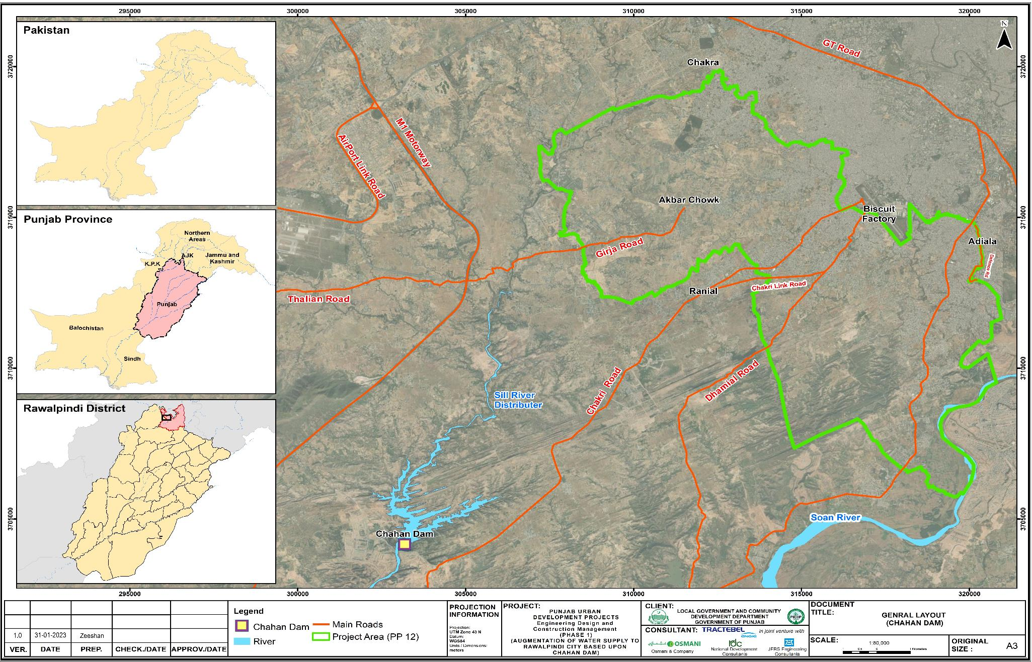
Figure ‎1-1: Project Location Map

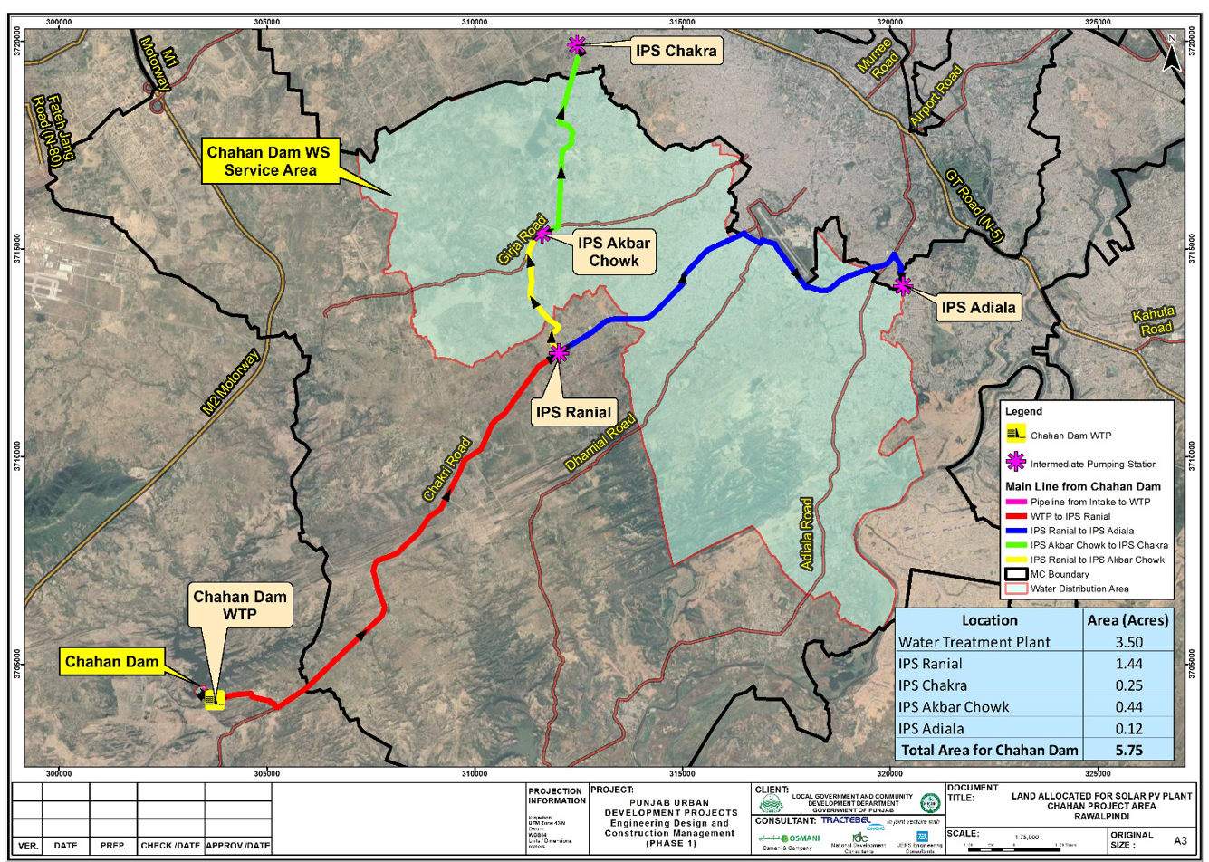

Figure ‎1-2: Map of solar PV location

Environment Category of the Project
- According to ADB’s SPS 2009, an Rapid Environmental Assessment (REA) checklist was prepared, and based on the project scope, scale and expected impacts, it has been categorized as B for Environment and an initial environmental examination (IEE) has been prepared. The REA checklist has been attached as Annexure-I.
- Further as per legal requirement under Section 12 of Punjab Environmental Protection Act, 1997 (Amendment 2012), this project requires the environmental approval from the EPA Punjab. As a part of the Conductance Main is passing through the federal territory of Islamabad, this project also requires Environmental Approval from Pak EPA under Section 12 of Pakistan Environmental Protection Act, 1997. As per clause F, Schedule-II of Pakistan Environmental Protection Agency (Review of IEE and EIA) Regulations 2000 of the acts, the proposed project falls in category of projects requiring Environmental Impact Assessment (EIA) based on project cost.

Objective of IEE Report
- The overall objective of this IEE is to elucidate the anticipated aspects of the proposed intervention and to propose necessary mitigation measures to prevent/minimize adverse impacts on surrounding environment and community. To achieve this objective, an assessment of the existing environmental conditions of the project corridor is a prerequisite and is therefore included after collecting the baseline data of major environmental attributes acquired from secondary sources. This IEE has been prepared to ensure adequate environmental and social management during pre-construction, construction and implementation stages of the proposed project. It provides mechanisms to ensure that potentially significant environmental and social impacts of the proposed project are identified, assessed and mitigated, as required. The more specific objectives of this IEE study are to:
- Facilitate the project proponents in ensuring environmental and social sustainability of the project;
- Establish a baseline of existing social and environmental conditions prior to project initiation by collecting secondary data/information on physical, biological and socio-economic environment of the project area;
- Identify potentially significant environmental and social impacts (both positive and negative) during all stages of the project;
- Avoid, minimize and suggest mitigation measures for significant adverse impacts;
- Conduct, record and report and ensure consultations with major stakeholders; and
- Provide Environmental Management Plan (EMP) for all stages of the project as a tool for the implementation of the suggested measures along with monitoring and evaluation mechanism with adequate resources, including capacity building of the implementing agencies.

Project Proponent
- The LG&CD is the project proponent and the project will be executed through the Program Management Unit (PMU) and Rawalpindi Water & Sanitation Agency (R-WASA). The detail of the project proponent is provided below:
- Program Management Unit, Punjab Intermediate Cities Improvement Investment Program (PICIIP), Local Government and Community Development (LG&CD) Department; Government of the Punjab; Address: 40 B-1, Gulberg III, M.M. Alam Road, Lahore, Pakistan; Ph: 042-99268484/ 042-99210013-4

Consultant IEE Team
- The IEE team comprised of the members as provided in Table ‎1-2 below.
Table ‎1-2: Team Involved in Preparation of IEE report
Members | Status in Project
ADB/PMU Team
Mr. Saad Malik | ADB’s Environmental Consultant (Reviewer)
Mr. Aziz Karim | Individual Consultant (Environmental Consultant)
Mr. Waqas Afzal | Deputy Director (Social & Environmental Safeguards)
Syed Osama Faheem Rizvi | Assistant Director M&E, PMU
Ms. Shahnaz Kousar Khan | Assistant Director (Monitoring & Evaluation), PRF
EDCM Team
Mr. Kevin Holroyd | Team Leader –EDCM
Mr. Farooq Khatak | Deputy Team Leader –EDCM
Asad Yaqoob | GIS Mapping Expert
Mr. Muhammad Mujahid | Project In charge -Environment Component
Dr. Nadeem | Ecological Expert
Ms. Rabia Rafiq | Environmentalist (IEE / EIA specialist)
Mr. Babar Ali | Environmentalist (IEE / EIA specialist)
Mr. Sami Ullah | Social Expert (Env. Team)
Ms. Shagufta Tahir | Female Enumerator
Mis. Komal Aroosh | Jr. Social Expert (Female Enumerator)

Approach and Methodology
- The detailed approach and methodology used for the IEE study is provided below.

Literature Review
- The Consultants conducted a desktop study through collection and review of guidelines, data and reports related to the Project, that included (a) review of National Environmental Legislations; (b) Google Earth Satellite Imagery; (c) Relevant District Census Reports (DCR) and any other relevant documents/drawings; and (d) Reference similar project IEE/ EIA documents.

Review of Environmental Laws and Institutional Requirements
- The project is required to comply with all applicable national as well as international environmental policies, laws, guidelines, acts and legislations.

Delineation of Corridor of Impact (CoI)
- As per the national regulations, impacts and risks have been analyzed within the project Corridor of Impact (CoI) of 100 meter radius along the route of the conductance mains. Environmental impacts and risks will also be analyzed for all relevant stages of the project cycle, including pre-construction, construction and operation phases of the project. The COI is particularly applicable for physical impacts of the proposed project on parameters such as water, air and noise. It is pertinent to mention here that COI for biological and socio-economic environment is not limited to 100 meters.

Survey of CoI
- A team of environmental and social experts, including environmental expert, ecologist and sociologist carried out the baseline surveys of the CoI to establish the potential impacts and categorization of activities and the key environmentally sensitive receptors and stakeholders within the project area were identified. During the surveys, the information regarding the topography, soils, surface water, groundwater, flora and fauna, forested areas, social settings and villages/towns along the CoI were collected while stakeholder consultations were also conducted.

Impact Assessment and Mitigation Measures
- A logical and systematic approach was adopted for impact identification and assessment. The process began during the screening and continued through scoping which identified the key issues and classified them into different categories.
- Identification of potential environmental and social impacts in terms of their nature, magnitude, extent, location, timing and duration were carried out. The impacts were correlated to the project location, design, construction and operation stages. Based on the impacts prediction methods and as a result of public/stakeholder consultations, the study team screened out the adverse environmental and social impacts for inclusion in the mitigation measures and EMP. Matrices and overlays were also used for the evaluation of temporal and spatial impacts respectively.

Environmental Management Plan (EMP)
- An EMP has been developed for effective implementation of the recommended mitigation measures and it has included controls to minimize any identified impacts and a program to monitor the effects of mitigation measures and any residual impacts during implementation along with assigning roles and responsibilities of all parties concerned during the project implementation.

Conclusions and Recommendations
- Based on the baseline conditions, identified impacts and suggested mitigation measures and proposed environmental costs, the conclusions have been developed along with recommendations for the future action plan and outcome of the IEE report.

Structure of Report
- This report contains the following ten chapters:
- Chapter 1– “Introduction” describes introduction, location of project, objective and purpose of the IEE report;
- Chapter 2 – “Policy, Legal and Administrative Framework” elucidates the current legal framework including national and international applicable guidelines;
- Chapter 3 – “Project Description” provides an overall project description, including its background, features and key components, timeframe and costs;
- Chapter 4 – “Analysis of Project Alternatives” discusses the available options and selection of the most suitable options based on specific criteria;
- Chapter 5 – “Description of the Environment” comprises a detailed narrative of the existing (baseline) conditions of the project area, with respect to its physical, biological and socio-economic environment;
- Chapter 6 – “Anticipated Environmental Impacts & Mitigation Measures” elaborates the likely impacts of the project on the physical, biological and socio-economic environment during the construction and operation stages and lays down the proposed measures to mitigate the adverse impacts of the project;
- Chapter 7 – “Environmental Management Plan and Institutional Requirements” provides the mechanism to be adopted for the implementation of measures and monitoring the environment during all stages;
- Chapter 8 – “Public Consultation and Information Disclosure” provides a summary of consultative sessions with the local community as well as with other stakeholders, including local government officials for their opinions and suggestions on the project;
- Chapter 9 – “Grievance Redressal Mechanism” illustrates mechanism for complaint management; and
- Chapter 10 – “Conclusion and Recommendations” gives the conclusion of the IEE study and recommendations for the construction and operational stages.

Further Additions & Updating of IEE Study
- This version of the report will be further updated if required on the basis of changes in detailed design and alignment of the Conductance Main and/or solar PV component. These revisions shall be incorporated into any subsequent updated versions of this IEE report. Any updated version of this IEE will be submitted for ADB review and clearance and posted at ADB and PMU /project website for information disclosure. The IEE/EMP will be disclosed locally at PMU PICIIP website at least two weeks prior to any subsequent consultations.

POLICY, LEGAL AND ADMINISTRATIVE FRAMEWORK

General
- This chapter provides an overview of the policy framework and legislation that applies to control the environmental consequences as a result of project implementation and operation of the project. The project needs to comply with all the applicable environmental policies, laws, guidelines, acts and legislations of Government of Pakistan and the provincial government as well as international environmental guidelines.

National Policy and Legal Framework
- The Pakistan National Conservation Strategy (NCS) that was approved by the federal cabinet in March 1992 is the principal policy document on environmental issues in the country (EUAD/IUCN, 1992). The NCS outlines the country's primary approach towards encouraging sustainable development, conserving natural resources, and improving efficiency in the use and management of resources. The NCS has 68 specific programs in 14 core areas in which policy intervention is considered crucial for the preservation of Pakistan's natural and physical environment. The core areas that are relevant in the context of the proposed project development are ground water depletion, and the provision of sustainable potable water to citizens while conserving biodiversity.
- Prior to the adoption of the 18th Constitutional Amendment, the Pakistan Environmental Protection Act (PEPA) 1997 was the governing law for environmental conservation in the country. Under PEPA 1997, the Pakistan Environmental Protection Council (PEPC) and Pak EPA were primarily responsible for administering PEPA 1997. Post the adoption of the 18th Constitutional Amendment in 2011, the subject of environment was devolved, and the provinces have been empowered for environmental protection and conservation.

Regulations for Environmental Assessment, Pakistan EPA
- Under Section 12 (and subsequent amendment) of the PEPA (1997), a project falling under any category specified in Schedule I of the IEE/EIA Regulations (SRO 339 (I0/2000), requires the proponent of the project to file an IEE with the concerned provincial EPA. Projects falling under any category specified in Schedule II require the proponent to file an EIA with the provincial agency, which is responsible for its review and accordance of approval or request any additional information deemed necessary.

Regulatory Clearances, Punjab EPA
- In accordance with provincial regulatory requirements, an IEE/EIA report satisfying the requirements of the Punjab Environmental Protection Act, 1997 (Amendment 2012) is to be submitted to Punjab Environmental Protection Agency (Punjab EPA) for review and approval and subsequent issuance of Environmental Approval (EA) before the commencement of construction.

Guidelines for Environmental Assessment, Pakistan EPA
- The Pak-EPA has published a set of environmental guidelines for conducting environmental assessments and the environmental management of different types of development projects. The guidelines that are relevant to the proposed project are listed below:
- Guidelines for the Preparation and Review of Environmental Reports, Pakistan, EPA1997;
- Guidelines for Public Consultations; Pakistan EPA May 1997;

Punjab Environmental Quality Standards (NEQS) 2000 & 2010
- The Punjab Environmental Quality Standards (PEQS), 2000 & 2010, specify the following standards:
- Maximum allowable concentration of pollutants (32 parameters) in municipal and liquid industrial effluents discharged to inland waters, sewage treatment facilities, and the sea (three separate sets of numbers);
- Maximum allowable concentration of pollutants (16 parameters) in gaseous emissions from industrial sources;
- Maximum allowable concentration of pollutants (two parameters) in gaseous emissions from vehicle exhaust and noise emission from vehicles;
- Maximum allowable noise levels from vehicles; and
- Maximum allowable concentration of parameters in drinking water.

Other Environment Related Legislations
- The summary of major relevant strategies, policies, acts and legislation from environmental perspective are briefly described in Table ‎2-1 and Table ‎2-1Table ‎2-2 below:
Table ‎2-1: Main Strategies/Policies Related to Environment and Relevance to the Project
Sr. No. | Policy/Strategy | Brief Coverage | Relevance to Project
1. | National Conservation Strategy, 1992 | Pakistan National Conservation Strategy (NCS), which was approved by the federal cabinet in March 1992, is the principal policy document on environmental issues in the Country. The NCS outlines the Country’s primary approach towards encouraging sustainable development, conserving natural resources and improving efficiency in the use and management of resources. The NCS has 68 specific programs in 14 core areas in which policy intervention is considered crucial for the preservation of Pakistan’s natural and physical environment. | The core areas that are relevant in the context of the proposed project are pollution prevention during construction and conserving biodiversity and forestry.
2. | National Environmental Policy, 2005 | In March 2005, Government of Pakistan (GoP) launched its National Environmental Policy, which provides a framework for addressing the environmental issues. Section 5 of the policy commits for integration of environment into development planning as instrument for achieving the objectives of National Environmental Policy. It also provides broad guidelines to the Federal Government, Provincial Governments, Federally Administered Territories and Local Governments to address their environmental concerns and to ensure effective management of their environmental resources. | Clause (b) of sub-section 5.1 states that Environmental Protection Act, 1997, will be diligently enforced for all developmental projects.
3. | National Forest Policy, 2001 | The goal of this policy is to foster the sustainable development of Renewable Natural Resources (RNR) in Pakistan, through maintenance and rehabilitation of these essential resources and enhancement of sustainable livelihoods of rural masses, particularly women, children and other deserving groups.  The various components of the policy include:  - Reducing poverty, powerlessness and unemployment;  - Population planning in critical ecosystems;  - Reducing the impact of socio-economic factors;  - Providing substitutes to firewood in the mountain-woods;  - Reducing political interferences in Forestry and Wildlife Departments;  - Renovating and invigorating the institutions of RNR;  - Supporting Local Governments in the sustainable development of their RNR;  - Policies for fragile ecosystems;  - Riverside forests;  - Irrigated plantations;  - Preservation of sensitive and unique forests;  - Wildlife conservation;  - Rangelands and desert ecosystems; and  - Planting trees and fodder on farmlands. | The proposed project does not pass through a Reserve Forest or other notified areas. However, other relevant components like wildlife conservation, planting trees will be applicable.
4. | National Climate Change Policy, 2012 | The National Climate Change Policy provides a framework for addressing the issues that Pakistan faces or will face in future due to the changing climate. In view of Pakistan’s high vulnerability to the adverse impacts of climate change, in particular extreme events, adaptation effort is the focus of this policy document. The vulnerabilities of various sectors to climate change have been highlighted and appropriate adaptation measures spelled out.  The policy covers measures to address issues in various sectors such as water, agriculture, forestry, coastal areas, biodiversity and other vulnerable ecosystems.  Notwithstanding the fact that Pakistan’s contribution to global Greenhouse Gas (GHG) emissions is very small, its role as a responsible member of the global community in combating climate change has been highlighted by giving due importance to mitigation efforts in sectors such as energy, forestry, agriculture and livestock.  Furthermore, appropriate measures relating to disaster preparedness, capacity building, institutional strengthening; technology transfer; introduction of the climate change issue in higher education curricula; ensuring environmental compliance through Initial Environmental Examinations (IEE) and Environmental Impact Assessments (EIA) in the development process; addressing the issue of deforestation and illegal trade in timber; promoting Clean Development Mechanisms (CDM); and raising Pakistan’s stance regarding climate change at various international forums, have also been incorporated as important components of the policy.  The policy thus provides a comprehensive framework for the development of Action Plans for national efforts on adaptation and mitigation. | This policy document is a ‘living’ document and will be reviewed and updated regularly to address emerging concepts and issues in the ever-evolving science of climate change.  This policy will accelerate due to the emissions from the construction machinery.
5. | National Water Policy 2018 | This first ever water policy was unanimously approved in April 2018 by the Council of Common Interest (CCI). The Policy aims at efficient management and conservation of existing water resources, optimal development of potential water resources, steps to minimize time and cost overruns in completion of water sector projects, equitable water distribution in various areas and canal commands, measures to reverse rapidly declining groundwater levels in low-recharge areas, increased groundwater exploitation in high-recharge areas, effective drainage interventions to maximize crop production, improved flood control and protective measures, steps to ensure acceptable and safe quality of water, minimization of salt build-up and other environmental hazards in irrigated areas, institutional reforms to make the managing organizations more dynamic and responsive.  The policy covered all water related issues, including water uses, allocation of priorities, integrated planning for development, use of water resources, environmental integrity of the basin, impact of climate change, trans boundary water sharing, irrigated and rain fed agriculture, drinking water and sanitation, hydropower and industry, groundwater, water rights & sustainable water infrastructure, water related hazards, quality management, awareness, conservation, legal and capacity building of infrastructure. | This policy will be applicable as the proposed Project utilizes water from Chahan Dam and its distribution to the public.
6. | National Drinking Water Policy, 2009 | The National Drinking Water Policy provides a framework for addressing the key issues and challenges facing Pakistan in the provision of safe drinking water to the people. Drinking water is the constitutional responsibility of the provincial governments and the specific provision function has been devolved to specially created agencies in cities and Town and Tehsil Municipal Administrations under the Local Government Ordinance 2001. | This policy will be applicable as the proposed Project is about the provision of drinking water residents of the project area.
Table ‎2-2: Main Legislation/Acts Related to Environment and Their Relevance to the Project
Sr. No. | Act | Brief Coverage | Relevance to Project
1. | Punjab Environmental Protection 1997 (Amended) Act, 2017 | The Punjab Environmental Protection Act, 1997 (Amended, 2017) is comprehensive legislation and provides the legislative framework for protection, conservation, rehabilitation and improvement of the environment. The ‘environment’ has been defined in the Act as: (a) air, water and land; (b) all layers of the atmosphere; (c) all organic and inorganic matter and living organisms; (d) the ecosystem and ecological relationships; (e) buildings, structures, roads, facilities and works; (f) all social and economic conditions affecting community life; and (g) the interrelationships between any of the factors specified in sub-clauses ‘a’ to ‘f’.  The notable points of the law are:  - No proponent of a project shall commence construction or operation unless he has filed an EIA / IEE with the Provincial Agency designated by the Provincial EPAs an EIA / IEE, and has obtained an approval;  - Establishment and formation of the Punjab Environmental Protection Council (PEPC);  - Prohibition of certain discharges or emissions;  - Punjab Environmental Quality Standards (PEQS) for wastewater, air emissions and noise; and  - Provincial Government can issue notices and enforce them to protect the environment.  In the amendment of 2012, legislatives powers related to environment and ecology are given to provincial governments from the Federal government. The provinces are required to enact their own legislation for environmental protection. Other amendments include increasing the penalties for violations.  For the proposed Project, Environmental Protection Department (EPD)/Environmental Protection Agency (EPA), Government of Punjab (GoPb) is the concerned authority. The capability of regulatory institutions for environmental management is ultimately responsible for the success of environmental assessments and that development projects are environmentally sound and sustainable. | The provision of the act is applicable to proposed Project for conducting an IEE/EIA according to section 12 and to obtain environmental approval from the EPA.  Section 11 of the act is applicable in term of compliance with Punjab Environmental Quality Standards (PEQS). Similarly, section 13 of the act prohibits the import of hazardous waste.  The provisions of section 16 are also applicable to comply with the discharge or emission of any effluent, waste, air pollutant or noise or disposal of waste or handling of hazardous substance. Under section 17, penalties will apply if anyone fails to comply with the provisions of section 11, 12, 13 and 16.
2. | Pakistan Environmental Protection Agency, (Review of IEE and EIA) Regulations, 2000 | These regulations set out:  - Key policy and procedural requirements for filing an EIA / IEE;  - The purpose of environmental assessment;  - The goals of sustainable development;  - The requirement that environmental assessment be integrated with feasibility studies;  - The jurisdiction of the Federal and Provincial EPA’s and Planning &Development (P&D) Departments;  - The responsibilities of proponents;  - Duties of responsible authorities;  - Provides schedules of proposals that the project requires either IEE or an EIA;  - The environmental screening process of the projects under schedule I, II and III; and  - The procedure for the environmental approval for filing the case with the concerned EPA for the granting of the NOC. | The proposed project falls under the Category ‘F’ of “Water Supply and Treatment” of the Schedule II. This category requires an EIA study to be conducted to initiate the process of environmental approval.
3. | Punjab Environmental Quality Standards (PEQS), 2016 | PEQS promulgated recently in 2016. Specified standards under PEQS are for:  - Drinking Water;  - Ambient Air;  - Noise;  - Industrial Gaseous Emissions;  - Municipal and Liquid Industrial Effluents;  - Motor vehicle exhaust and noise; and  - Treatment of Liquid and Bio-Medical Waste. | All projects to be implemented in Punjab must conform to PEQS during all the phases, i.e. construction and operation.
4. | Guidelines for the Preparation and Review of Environmental Reports, 1997 | These guidelines describe the format and content of IEE/EIA reports to be submitted to PEPA for obtaining NOC/approval.  The guidelines present:  - The environmental assessment report format;  - Assessing impacts;  - Mitigation and impact management and preparing an environmental management plan;  - Reporting;  - Review and decision making;  - Monitoring and auditing; and  - Project Management. | The guidelines are applicable for the preparation of the EIA.
5. | Punjab Wildlife Act, 1974 | The Punjab Wildlife Act (1974) is developed for the regulation of activities relating to protection, conservation and management of wildlife in Punjab. | The proposed project involves the cutting of trees which may result in loss of habitat, therefore, the provisions of this law are applicable.
6. | Punjab Plantation and Maintenance of Trees Act, 1974 | The Punjab Plantation and Maintenance of Trees Act, (1974) regulates tree plantations and enforces measures for their protection. | The requirements of this act are applicable in terms of planting new trees and their maintenance by the occupier of the existing land who would have the physical possession.
7. | Pakistan Antiquities Act 1975 & Punjab Antiquities Amendment Act 2012 | The Punjab Antiquities Amendment Act, 2012 is adopted from the Pakistan Antiquities Act of 1975 with a few minor changes. The Antiquities Act, 1975 (amended in 1990) states the following:  - “Ancient” is any object that is at least 75 years old;  - All accidental discoveries of artefacts must be reported to the Federal Department of Archaeology;  - The Government is the owner of all buried antiquities discovered on any site, whether protected or otherwise;  - All new construction within a distance of 200 feet from protected antiquities is forbidden;  - No changes or repairs can be made to a protected monument, even if it is owned privately, without approval of the responsible authorities; and  - The cultural heritage laws of Pakistan are uniformly applicable to all categories of sites regardless of their state of preservation and classification as monuments of national or world heritage. | The law will be applicable to the project mainly due to its two provisions:  According to the law, any construction activity within 61 m or 200 ft. of protected antiquities, are prohibited.  The provisions of this act would also be applicable, if any accidental archaeological discoveries may occur during the excavation works for the construction of proposed Project.
8. | Pakistan Penal Code, 1860 | The Code deals with the offences where public or private property or human lives are affected due to intentional or accidental misconduct of an individual or organization. The Code also addresses control of noise, noxious emissions and disposal of effluents. | The provisions of the Penal Code, 1860 are applicable to the project in terms of penalties for effecting human lives and public property. It also addresses the control of noise, air emissions and effluent disposal.
9. | Punjab Forest Act (Amended), 2010 | The Act empowers the provincial forest departments to declare any forest area as reserved or protected. It empowers the provincial forest departments to prohibit the clearing of forest for cultivation, grazing, hunting, removing forest produce, quarrying and felling, lopping and topping of trees, branches in reserved and protected forests. There is no protected forest situated in and around the Project area. | Therefore, this Act will not be triggered as there is no protected forest situated in the Project area.
10. | Pakistan Climate Change Act, 2017 | This Act aims to meet obligations under international conventions relating to climate change and to provide for adoption of comprehensive adaptation and mitigation policies, plans, programs, projects and other measures required to address the effects of climate change and for matters connected herewith and ancillary thereto. | This Act will accelerate due to the emissions from the construction machinery.
11. | National Clean Air Act, 2000 | The Act aims to control vehicular emissions, pollution from industry, and indoor air pollution in rural and urban areas. | This Act will trigger if vehicles and machinery used for construction activities emanate air pollutants above the permissible limit.
12. | Seismic Building Code of Pakistan 2007 | This code stipulates the minimum requirements for seismic safety of building and structures and the provisions of the Building Code of Pakistan (Seismic Provisions-2007) shall apply for engineering design of buildings, like structures and related components.  Construction of buildings shall be considered as a violation of professional engineering work specified under clause (XXV) of section 2 of the Act. | This Code is applicable to the proposed project as it includes the formation of structures.
13. | Land Acquisition Act (LLA), 1894 Including Later Amendments | The Land Acquisition Act, 1894, is a “law for the acquisition of land needed for public purposes and for companies and for determining the amount of compensation to be paid on account of such acquisition”. The exercise of the power of acquisition has been limited to public purposes. The principles laid down for the determination of compensation, as clarified by judicial pronouncements made from time to time, reflect the anxiety of the law-giver to compensate those who have been deprived of property, adequately. The land needed for the construction of development projects will be acquired under normal conditions based on prevailing market prices or negotiated prices between client and the owners of land. Section 17(4) of the LAA will not be used in the absence of an emergency. Instead, the land will be purchased under willing-seller willing-buyer deal at agreed upon market rates and the seller will have the option not to sell the land, in case an acceptable deal for both the parties is not reached. | This Act will be applicable as proposed Project will involve the permanent acquisition of land in the Project area.
14. | Punjab Municipal Water Act, 2014 | The basic aim of the Act is to recognize, regulate and manage present and future municipal water supply and sanitation services and to establish rights of access to basic water supply and basic sanitation, and to ensure conservation of water resources in the Province. This Act is in the draft stage. | This Act will elicit if there is misappropriation of water supply during construction activities.
15. | Fisheries Act, 1897 | This Act aims at the protection of fish in water bodies by rules of State Government. | This Act will be applicable due to the presence of species of fish in Chahan Dam.
16. | The Punjab Occupational Safety and Health Act, 2019 | This Act entails provision of occupational safety and health of the workers at workplace and to protect them against risks arising out of the occupational hazards; to promote safe and healthy working environment catering to the physiological and psychological needs of the employees at workplace. | The Act will trigger during construction and operational phase to ensure health and safety of workers at workplace associated with the project activities.
17. | Cutting of Trees (Prohibition) Act, 1975 | The Act was enforced in 1975 to place restrictions on cutting of trees in order to restrain unchecked trend of tree felling without replacement plantations. | This act will be applicable to the subject project where the cutting of trees will be involved.

Compliance Procedure for Obtaining NOC from PEPA
- Review of IEE and EIA Regulations, 2000 provide the necessary details on the preparation, submission, and review of the IEE and the EIA reports. Categorization of projects for IEE and EIA is one of the main components of these regulations. Projects have been classified on the basis of expected degree of adverse environmental impacts.
- Based on Pakistan Environmental Protection Agency (Review of IEE and EIA) Regulations, 2000 provides screening categories of projects for which IEE or EIA need to be conducted. The proposed project falls under the Category ‘F’ of “Water Supply and Treatment” of the Schedule II. This category requires an EIA study to be conducted to obtain NOC from respective EPA, Punjab.

ADB’s Safeguard Policy Statement (SPS), 2009
- The ADB’s SPS 2009 requires that environmental considerations be incorporated into ADB funded projects to ensure that the project will have minimal environmental impacts and be environmentally sound. As stated in the SPS, the project must protect the health and safety of both the local residents and the project workers. A Grievance Redress Mechanism (GRM) to receive applications and facilitate resolution of affected peoples’ concerns, complaints, and grievances about the project’s environmental performance is also established. All loans and investments are subject to categorization to determine environmental assessment requirements. Categorization is to be undertaken using REA checklists, consisting of questions relating to (i) the sensitivity and vulnerability of environmental resources in project area, and (ii) the potential for the project to cause significant adverse environmental impacts. Projects are classified into one of the following environmental categories:
- Category A: A proposed project is classified as category A if it is likely to have significant adverse environmental impacts that are irreversible, diverse or unprecedented. These impacts may affect an area larger than the sites or facilities subject to physical works. An environmental impact assessment (EIA) is required.
- Category B: A proposed project is classified as category B if its potential adverse environmental impacts are less adverse than those of category A projects. These impacts are site-specific, few if any of them are irreversible, and in most cases mitigation measures can be designed more readily than for category A projects. An IEE is required.
- Category C: A proposed project is classified as category C if it is likely to have minimal or no adverse environmental impacts. No environmental assessment is required although environmental implications need to be reviewed.
- Category FI: A proposed project is classified as category FI if it involves investment of ADB funds to or through a financial intermediary (FI).

ADB’s Access to Information Policy (AIP) 2018
- ADB’s new Access to Information Policy (AIP), reflects the ADB’s ongoing commitment to transparency, accountability, and participation by stakeholders. The policy contains principles and exceptions to information sharing with external stakeholders, led by a new overarching principle of “clear, timely and appropriate disclosure.”

ADB’s Accountability Mechanism Policy 2012
- The objectives of the Accountability Mechanism is to provide an independent and effective forum for people adversely affected by ADB-assisted projects to voice their concerns and seek solutions to their problems and to request compliance review of the alleged noncompliance by ADB with its operational policies and procedures that may have caused, or is likely to cause, direct and material harm. The Accountability Mechanism is a “last resort” mechanism.

ADB Policy on Gender and Development
- ADB’s Policy on Gender and Development will adopt mainstreaming as a key strategy for promoting gender equity. Gender considerations will be mainstreamed into all ADB activities, including macroeconomic and sector work, and lending and technical assistance (TA) operations. The key elements of ADB’s policy will include gender sensitivity, gender analysis, gender planning, mainstreaming, and agenda setting.

Climate Change Risk Management Framework
- The climate risk management approach of the ADB aims to reduce risks resulting from climate change to investment projects in Asia and the Pacific. ADB’s framework identifies climate change risks to project performance in the early stages of project development and incorporates adaptation measures in the design of projects at risk. ADB climate risk management framework comprises the following steps:
- Context-sensitive climate risk screening at the concept development stage to identify projects that may be at medium or high risk
- Climate change risk and vulnerability assessment during the preparation of projects at risk
- Technical and economic evaluation of adaptation options
- Identification of adaptation options in project design; and
- Monitoring and reporting of the level of risk and climate-proofing measures.

Comparison of International and Local Environmental Legislations
- The ADB SPS, 2009 requires application of pollution prevention and control technologies and practices consistent with international good practice, as reflected in internationally recognized standards. The SPS states that when host country regulations differ from these standards, the EA will achieve whichever is more stringent.
- To select the most stringent standards applicable, a mix of local (NEQS) and international (IFC) regulations have been selected. The IFC Environmental, Health, and Safety (EHS) Guidelines, General EHS Guidelines and Environmental standards are also applicable. It shall be ensured that all necessary noise mitigation measures are implemented to minimize the noise levels in the project area.
- The Table ‎2-3 presents IFC workplace noise standards that are applicable to the construction workers. It should also be noted that IFC EHS guidelines advise that where existing ambient noise levels already exceed thresholds, the project should not result in an increase of more than 3 dB over existing ambient noise levels at the nearest receptor location off-site.
- A comparison of applicable local and international guidelines for ambient air quality has been provided in Table ‎2-4 below. In the case of most pollutants, the Pak NEQS standards for ambient air quality are more stringent in comparison to USEPA and WHO/IFC standards. The applicable and most stringent parameters for each respective pollutant are highlighted in green.
- Similar to the standards for air quality, the comparison of noise standards provided in Table ‎2-5 clearly shows that the Pakistan NEQS standards for noise are more stringent in comparison to the IFC standards. The only exception is the daytime noise level standard for Industrial areas where the IFC standard is more stringent (70 dB (A)) in comparison to NEQS (75 dB (A)) and so for this particular parameter, the IFC standard will be used. Apart from this one exception, the NEQS standards have been used for water quality of development project.
- Comparison of International and Local Water Quality Standards has been provided in Table ‎2-6. Standards for Bacterial contamination are same for both NEQS and IFC/WHO standard while physical parameters are different. NEQS for odor, turbidity, hardness and pH are more stringent while IFC/WHO standards are stringent in metallic contaminations i.e. Arsenic, Barium, Boron, Cadmium and Zinc.
- As far as regulations regarding other environmental parameters are concerned, such as acceptable effluent disposal parameters, as per the requirements of ADB SPS-2009, the most stringent standards will be followed.
Table ‎2-3: IFC Work Environment Noise limits
Type of Work, Workplace | IFC General EHS Guidelines
Heavy Industry (no demand for oral communication) | 85 Equivalent level Leq,8hrs
Light industry (decreasing demand for oral communication) | 50-65 Equivalent level Leq,8hrs

Table ‎2-4: Comparison of International and local Air Quality Standards*
Pollutants | WHO/IFC |  | Pak. NEQS / PEQS
 | Avg. Time | Standard | Avg. Time | Standard
SO2 | 24 hr. | 40 µg/m3 | 24 hrs. | 120 up/m3
CO | 24 hrs. | 4 mg/m³ | 8 hrs. | 5 mg/m3
NO2 | 1 yr.  24 hrs. | 10 µg/m³  25 µg/m³ | Annual Mean  24 hrs. | 40 up/m3  80 up/m3
O3 | 8 hrs. | 100 µg/m³ | 1 hr. | 130 µg/m3
TSP | - | - | Annual Mean  24 hrs. | 360 up/m3  500 up/m3
PM10 | 1 yr.  24 hr. | 15 µg/m3  45 µg/m3 | Annual Mean  24 hrs. | 120 up/m3  150 up/m3
PM2.5 | 1 yr.  24 hr. | 5 µg/m3  15 up/m3 | Annual Average  24 hrs.  1 hr. | 15 up/m3  35 up/m3  15 up/m3
*: The standards highlighted green for each respective pollutant are the most stringent based on a comparison between local and international regulations and thus shall be applicable for the proposed project.
* In instances where the air shed is significantly degraded and the pollutant levels are already exceeding the ambient pollutant concentrations provided in the table above, it shall be ensured that the project activities cause as small an increase in pollution levels as feasible and amounts to a fraction of the applicable short term and annual average air quality guidelines or standards as established in the project specific environmental assessment.
Table ‎2-5: Comparison of International and Local Noise Standards
Category of Area/Zone | Limit in dB(A) Leq
 | PEQS |  | WHO
 | Day Time  06:00 – 22:00 | Night Time  22:00-06:00 | Day Time  07:00 – 22:00 | Night Time  22:00-07:00
Residential area (A) | 55 | 45 | 55 | 45
Commercial area (B) | 65 | 55 | 70 | 70
Industrial area (C) | 75 | 65 | 70 | 70
Silence zone (D) | 50 | 45 | 55 | 45
*: The standards highlighted in green for each respective Area/Zone are the most stringent based on a comparison between local and international regulations and thus shall be applicable for the proposed project.
* In instances where baseline noise levels are already exceeding the standards above, it will need to be ensured that the project activities do not cause an increment of more than 3 dB (A) from the baseline noise levels.

Table ‎2-6: Comparison of International and Local Water Quality Standards
 | Parameter |  | Unit |  | NEQS/PEQS |  | WHO/IFC
Bacterial
E-Coli |  | numbers/ml |  | Must not be detectable in any 100 ml sample |  | Must not be detectable in any 100 ml sample
Total Coliform |  | numbers/ml |  | Must not be detectable in any 100 ml sample |  | Must not be detectable in any 100 ml sample
Physical
Color |  | TCU |  | ≤ 15 TCU |  | ≤ 15 TCU
Taste |  | No objectionable/Acceptable |  | No objectionable/  Acceptable |  | No objectionable/Acceptable
Odor |  | No objectionable/Acceptable |  | No objectionable/  Acceptable |  | No objectionable/Acceptable
Turbidity |  | NTU |  | < 5 NTU |  | < 5 NTU
Total Hardness |  | mg/l |  | < 500 mg/l |  | --
TDS |  | mg/l |  | < 1000 |  | < 1000
pH |  |  |  | 6.5-8.5 |  | 6.5-8.5
Chemical
Aluminum |  | mg/l |  | ≤0.02 |  | 0.2
Antimony |  | mg/l |  | ≤0.005 (P) |  | <0.02
Arsenic |  | mg/l |  | ≤0.05 (P) |  | 0.01
Barium |  | mg/l |  | 0.7 |  | 0.7
Boron |  | mg/l |  | 0.3 |  | 0.3
Cadmium |  | mg/l |  | 0.01 |  | 0.003
Chloride |  | mg/l |  | <250 |  | 250
Chromium |  | mg/l |  | ≤0.05 |  | 0.05
Copper |  | mg/l |  | 2 |  | 2
Cyanide |  | mg/l |  | ≤0.05 |  | 0.07
Fluoride |  | mg/l |  | <1.5 |  | 1.5
Lead |  | mg/l |  | ≤0.05 |  | 0.01
Manganese |  | mg/l |  | ≤0.5 |  | 0.5
Mercury |  | mg/l |  | ≤0.001 |  | 0.001
Nickel |  | mg/l |  | ≤0.02 |  | 0.02
Nitrate |  | mg/l |  | ≤50 |  | 50
Nitrite |  | mg/l |  | ≤3 |  | 3
Selenium |  | mg/l |  | 0.01 )P) |  | 0.01
Residual Chlorine |  | mg/l |  | 0.2-0.5 at consumer end |  | -
Zinc |  | mg/l |  | 5.0 |  | 3
*: The standards highlighted in green for each respective Area/Zone are the most stringent based on a comparison between local and international regulations and thus shall be applicable for the proposed project.

Administrative Framework

Local Government and Community Development (LG&CD) Department
- The Executing Agency of the proposed project is LG&CD, Government of the Punjab. The management of LG&CD will ensure that all the proposed measures are effectively implemented at the design, construction and operational stages

Environmental Protection Department, Punjab
- For the proposed Project, EPD Punjab will be responsible for reviewing the report, issuing NOC and overall/broad based monitoring of the proposed project activities.

PROJECT DESCRIPTION

Project Introduction
- The details of the proposed project, including its project components, design considerations, construction aspects and operation and maintenance activities are discussed below.

Project Administrative Jurisdiction
- The proposed project falls under administrative jurisdiction of district Rawalpindi, Punjab province.

Basic Idea of the Project
- The basic idea of the project is to use the Chahan dam water intake structure as the raw water source. From the intake, 12 MGD raw water will transmit water to treatment plant (WTP) by means of raw water pumps. After treatment, the treated water from the WTP will the dispense to the water distribution areas (PP-12 RWASA Zone) with the help of intermediate pumping station (IPS), water works (WW), conductance and gravity mains as shown in Figure ‎3-1.
Figure ‎3-1:Basic Concept of the Project

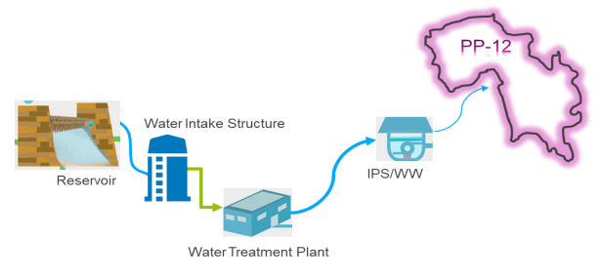

Major components of the Project
- The water supply component of the project consists of:
- Raw water intake structure
- Water treatment plant

- Intermediate pumping station and Water Works comprises on;
- Under Ground Storage Tanks
- Over Head Reservoirs
- Conductance main and Gravity mains
- Distribution networks system consist of;
- Distribution Pipe network
- Water metering
- House connections
- The proposed solar PV component consists of the following:
  - Site establishment, setting up of construction site offices, storage areas etc;
  - Importing of materials and equipment;
  - Clearing of any trees and vegetation;
  - Establishment of any access ways and drainage system across the site;
  - Earthworks to create level construction platform;
  - Installation of foundations using pre-cast concrete blocks, earth screw anchors or piles (whichever is most suitable);
  - Installation of solar PV modules;
  - Excavation of cable trenches;
  - Installation of electrical equipment/connection of internal electrical connections;
  - External connection for power evacuation (BPC);
  - Testing and commissioning;
  - Landscaping works and demobilization of construction site, waste disposal etc.
Water Supply Component
Intake structure:
- An intake structure has been proposed to draw raw water from Chahan dam. In order to transmit 12 MGD of water from the intake structure to the water treatment plant, an appropriate pumping station has been proposed. The pumping station will comprise vertical turbine pumps, valves and other appurtenances while the intake structure of the irrigation department will be used to extract water from Chahan dam.
- It is proposed that 12 MGD of water will be extracted by using the existing intake tower built by the irrigation department for irrigation purposes. The irrigation department has already laid down a pipeline of MS pipe of 36-inch diameter, encased in RCC from the water intake tower through the dam embankment towards the first intermediate tank for water withdrawal purposes. Another pipeline of 48-inch diameter has been laid from the first towards the second intermediate tank for additional water supply.
- The main concept of this proposed design is as follows:
- A tee connection will be installed in the existing pipeline at an approximate distance of 270 m near to the washout from the first towards the second intermediate tank.
- From the Tee connection, a pipeline of 240 m will be laid down towards the booster pump station.
- The booster pump station will be installed at a nearby vacant land of irrigation department and this pump station will be designed on horizontal Centrifugal inline pumps with 3 pumps . The flow of each pump will be 11.6 cusec with a head of 60 m.
- From the booster pump, a pipeline of 762 m with a velocity of 1.26 m will be installed towards the treatment plant, having a diameter of 32 inch of MS pipe.
- The layout of proposed intake structures is shown in Figure ‎3-2.

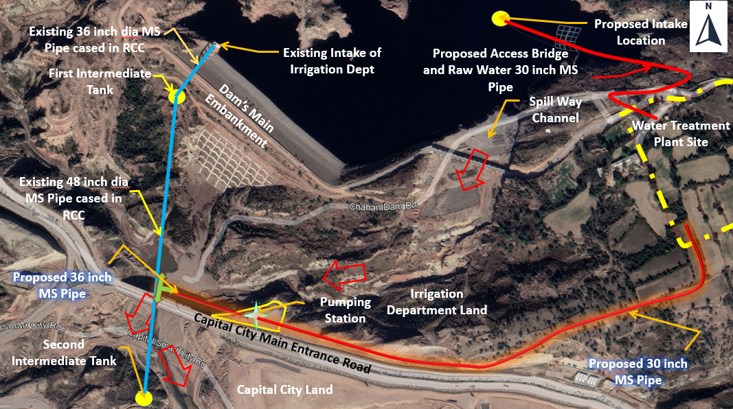
Figure ‎3-2 Location plan of water extraction from Existing Intake to WTP
Water Treatment Plant:
- The source of water supply for the project area will be raw surface water from Chahan dam. Surface water normally contains significant concentrations of various impurities, like suspended solids and bacteriological contamination, rendering it unfit for human consumption. The raw water will hence require proper treatment as per WHO standards and other Guidelines before supply to the consumers. The location of the WTP should ideally be close to the raw water source. Treatment of the raw water near the intake structure site will result in lesser pumping and water transmission effort, reduced pipe diameter, elimination of the possibility of corrosion and pipe choking due to silt load. The water treatment plant will consist of raw water storage tanks, treatment plant units and treated water storage tanks.
Intermediate pumping station:
- The proposed water treatment plant site is far away from the water distribution area. Therefore, to regulate the water supply in the water distribution area and to avoid the high size pumps, a pressure breaker is required at the highest elevated point which should be nearest to the water distribution area. For this purpose, an IPS has been proposed at the Chakri road near to the Ranial village at an elevation level of 522 m. The intermediate pumping station will comprise of ground storage tank, pumping station and overhead tanks.
Water Works:
The water works proposed under this project will be located at Akbar Chowk, Chakra and Adyala. These water works will have underground water storage tanks and overhead reservoirs for distribution of water to nearby community. The locations of these water works are given in Figure 3-3..
Water Conductance Mains:
- The raw water (12 MGD) from intake will be delivered to the WTP through a conductance main (32-inch MS pipe) with an approximate length of 633m.The treated water will be transferred to the IPS at Ranial by another conductance main (32-inch MS pipe) with an approximate length of 13.4 km.
- The schematic of the whole water conductance system (transmission of raw water from intake structure to WTP and then treated water from WTP to IPS and then finally to water works) is shown in Figure 3-3.

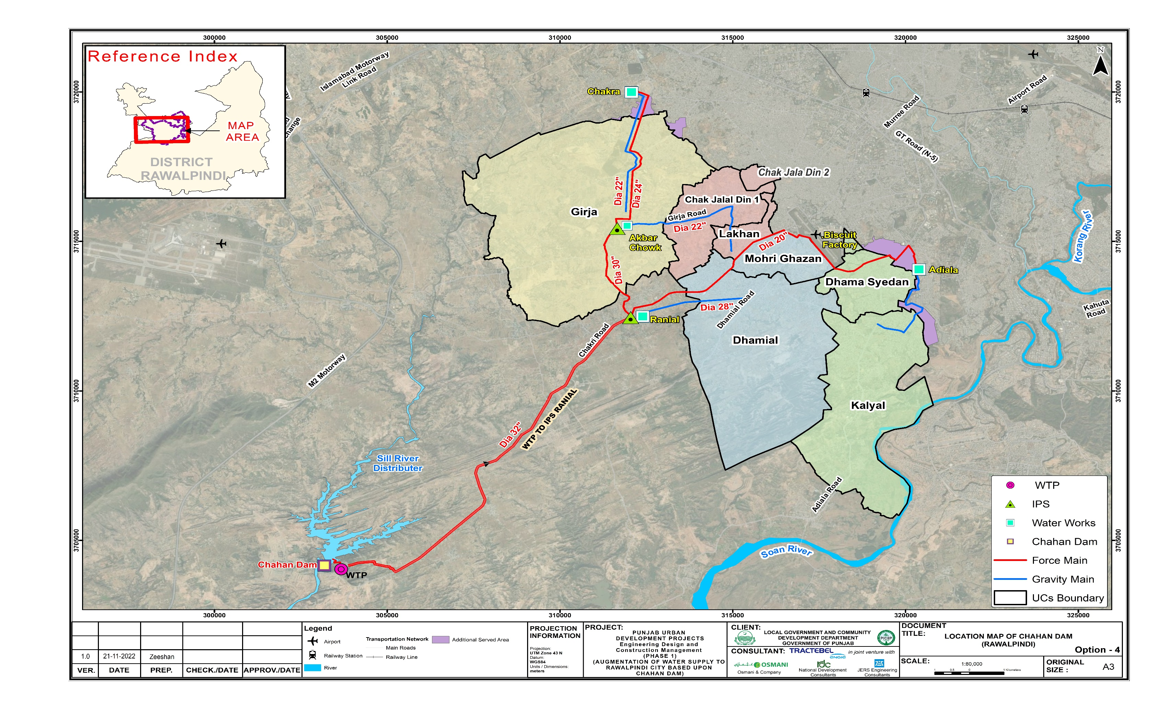
Figure ‎3-3 Location of Conductance Mains, WTP, IPS and Water Works

Project Location and Components of Project

Chahan Dam
- The Chahan dam site is located on Sill Kas, a tributary of Sill river, which ultimately falls into Soan river. The dam site is at a distance of about 5 km from Chahan village, 35 km south west of Rawalpindi City. Small Dams Organization (SDO), Irrigation and Power (I&P) Department has already completed the construction of Chahan dam in 2022 and impoundment is in progress. This dam will feed water to irrigate about 12,000 acres and 6 MGD of raw water have been allocated for RWASA, to serve the recently included areas in WASA jurisdiction (PP-12). Chahan Dam is not an associated facility as the operations of Chahan Dam are not dependent on the proposed project and the dam has been built for irrigation with a total capacity of 35 MGD.
- The proposed project has approval for 6 MGD water extraction from the dam and approval for additional 6MGD is in process. The dam has surplus water available for the proposed project because of conversion of agricultural land into housing colonies. The water from Chahan dam is mainly used for irrigation as the main purpose of this dam was to use its water for irrigation. With development and conversation of land for housing colonies, the demand of irrigation water has reduced. Keeping in view of this point, RWASA has requested the irrigation department to provide further 6MGD water for drinking purposes from Chahan Dam.
- During the consultative meeting held on 3rd December, 2022 at DC Office Rawalpindi under the chairmanship of Additional Deputy Commissioner (Finance & Planning) Rawalpindi Division, the representative of Small Dam Organization, irrigation department has agreed to fulfill the requirement of RWASA for 12 MGD, although the initial approval was for 6 MGD.
- Furthermore, controlled fishing is also taking place at the dam. However, during the primary survey, the representative of Small Dam Organization and Fisheries department stated that the dead level of dam is very high and there will be no noticeable impact on the fish population, even at the dead storage level of dam. Aerial view of Chahan dam is shown in Figure ‎3-4.
- 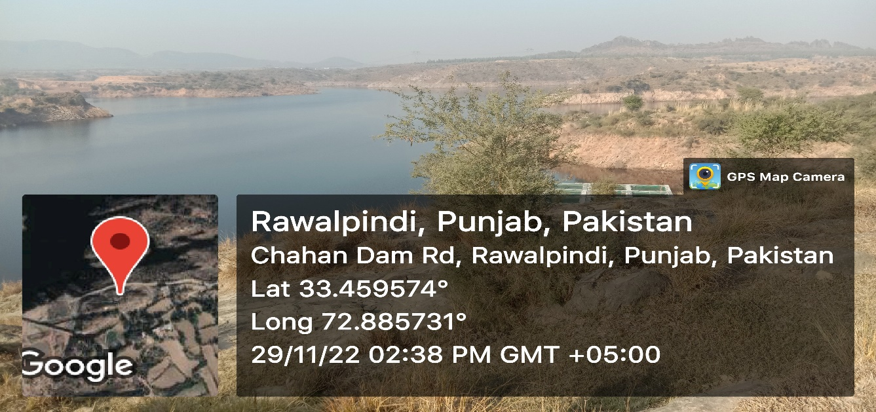
- 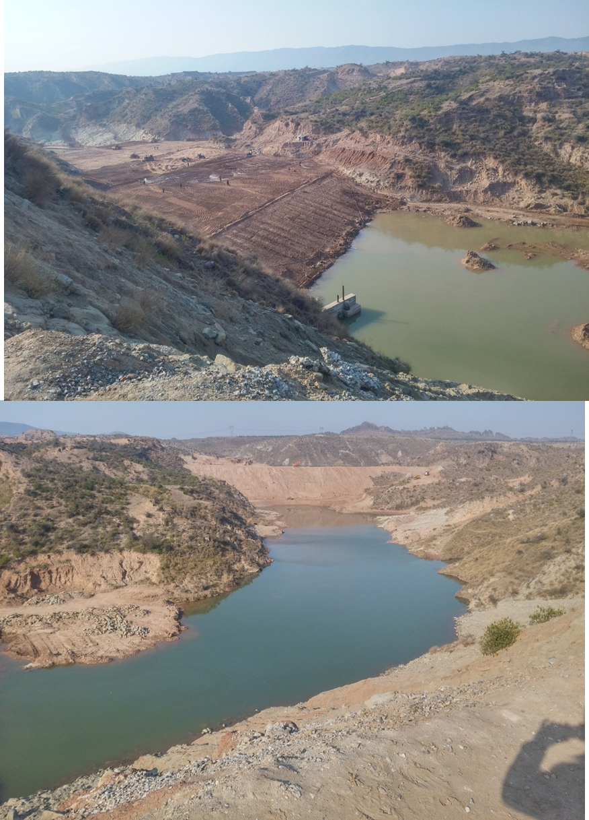
Figure ‎3-4: Aerial View of Water Source (Chahan Dam)

Location of Water Intake Structure
- The location plan of the proposed intake structure is shown in Figure ‎3-2 .In order to cover the seasonal fluctuations in the river discharges, a multistage water withdrawal arrangement is being proposed. The low-level intake will ensure supplies during the lean flows, whereas high level intake will be used during the normal to high flow periods.
- Intake structure has been proposed to draw raw water from Chahan Dam. Topography of the area between Chahan Dam and the proposed treatment plant site does not allow gravitational flow and thus raw water will have to be pumped for its treatment. From the intake, raw water main will transmit water to treatment plant by means of raw water pumps. To pump raw water through the intake, there are two proposed options for the location of intake structure as follows:
- Build an Intake Tower Inside the Dam Reservoir
- Used Existing Intake Tower of Irrigation Department

Location of Water Treatment Plant (WTP)
- The location of WTP is proposed near the dam site. The raw water will be pumped from dam intake structure to WTP through raw water pumping main and after its treatment, the treated water will be pumped through treated water main to IPS at Ranial. It is generally preferable to locate WTP near the raw water source since it has the advantage to pump treated water through the water main with less chances of any silt deposit in the pipeline while wear and tear of high lift pumps will also be less in this case.
- The location plan of intake structure and water treatment plant is shown in Figure ‎3-2.

Location of Intermediate Pumping Station
- The treated water from WTP will be supplied to IPS at Ranial. These pumps deliver water to higher elevation site (Chakara). The storage tank at Chakra shall serve Chakra Union Council and also GSTs at Chakra for remaining areas of Chak Jalal Din, Lakhan, Dhaman Syedan and Kalyal through gravity.

Intermediate Pumping Station & Water Works
- The treated water from the tank shall be pumped to intermediate pumping station, from where one pipeline shall gravitate up to Dhamial ground storage tank and shall serve the Dhamial Union Council. The second force main from intermediate pumping station shall feed the ground storage tank at Chakra. The storage tank at Chakra shall serve Chakra Union Council and also GSTs at Chakra for remaining areas serves the areas of Chak Jalal Din, Lakhan, Dhaman Syedan and Kalyal through gravity. General layout of the proposed project is shown in Figure ‎3-3.

Water Main Conductance & Gravity Mains
- The sizing of raw water main has been based on the water allocated from the dam (126 MGD), considering that it will work for 24 hours to achieve maximum utilization. Since the length of the raw water main is only 900-1000 feet, so the size has been worked out on hydraulic consideration only. Keeping in view the maximum velocity of 6 ft/sec, the size comes out to be 24 inches. The alignment of Conductance Mains is given Figure ‎3-3.
- From WTP to IPS, the length of the treated water main from WTP to IPS is 13.6 km. keeping in view the maximum velocity of 5 ft/sec, the size comes out to be 26 inches, which provides a velocity of 4.46 ft/sec.
- From IPS to Chakra Water Works as Dhamial area will be served from the IPS by gravity and the storage will be provided for Dhamial area at IPS, so the remaining flows reaching at Chkara water works will be the total flow – Dhamial flow (11.13 cusec – 2.13 = 9 cusec). Therefore, the sizing of Treated Water Main from IPS to Chakra water works has been worked out considering that it will work for 24 hours to achieve maximum utilization. Length of treated water main from IPS to Chakra water works is 8.43 KM. keeping in view the maximum velocity of 5 ft/sec, the size comes out to be 24 inches, which provides a velocity of 4.17 ft/sec.
- The sizing of Gravity main from IPS to Dhamial has been based on the water demand of Dhamial area which is 1,196,629 Gallons per day. Size of Pipe comes out to be 16 inches in diameter.
- The sizing of Gravity main from Chakra water works to different remaining areas has been based on the water demand of Chakra, Girja, Chak Jalal din, Dhama syedan, Lakhan and Kalyal which comes out to be 4,702,287 gallons per day. High Density Polyethylene (HDPE) pipe is used for the Gravity Main.
- Since the project area mostly consists of G.I and M.S pipe with diameter of 3 inches and less with the fact that the design life of G.I pipe is also low due to corrosion of the pipes as compared to other pipe materials and pipe diameters, less than 3 inches also creates low terminal pressure to the end consumer with the system failing to meet the water needs of the residents.

Water Distribution Area
- The water distribution area is consisting of 8 UCs of PP-12. Location plan of the project area is shown in Error! Reference source not found.6. The details of each UCs are as follows:
- Dhamial: Dhamial (UC # 86) is situated along both sides of Dhamial Road. It consists of the areas, namely Ashraf Colony, Shadman Town, Green view Colony, Sardar Town and Khalid Colony. Its area is about 5454 acres and population of 54,861 persons according to 2017 census report. Qasim Airbase is situated north east of Dhamial.
- Girja: Girja (UC # 91) is situated at Girja Road and Misrial Road is situated at its top. It consists of Chakra, Razzak Town, Garja, Lakhu, Jatal and Dhok Sama. Its population is about 84,596 persons and area is 8021 acres according to 2017 census report.
- Dhama Syedan: Dhama Syedan (UC #85) is situated at Aadiala Road, adjacent to Askari XIV having Attock Refinery at east. It consists of Khatana, Munawar Colony, Janjua Town and Jarahi. Its population is about 43,107 persons according to 2017 Census report and area is 1065 acres.
- Lakhan: Lakhan (UC # 88) is situated in the north west of Chakri Road and Qasim Airbase in the North East. It consists of Quaid e Azam Colony and LalaRukh Colony. Its population is 23,280 person according to census report of 2017 and area is about 394 acres.
- Chak Jalal din 1: Chak Jalaldin 1 (UC #89) is situated at Girja Road and major areas of Chak Jalaldin are Habib Colony, , Shah Jeevan Colony, Nai Abadi No.1,Nai Abadi No.2, Malik Colony and Qureshia Abad. Its population is 72, 801 persons according to 2017 census report and its area is 1465 acres.
- Chak Jalal din 2: Chak Jalaldin 2 (UC #90) is situated at Girja Road and major areas of Chak Jalaldin 2 are Chaman Abad, Maskeen Abad, Muslim Abad and Christian Colony. Its population is 6679 according to 2017 census report and its area is 148 acres.
- Kalyal: Kalyal (UC#83) is situated on Aadiala Road and it comprises areas of National Town, Gulsahan Abad, Kalyal, Samarazad Housing Society, Madina Town and Radio colony. Its population according to 2017 census report is 20,774 peron and its area is 4080 acres.
- Mohri Ghazan: Mohri Ghazan (UC # 87) is situated in between the Dhamial and Chakri Road. The major areas of Mohri Ghazan are Gulshan Iqbal,Mora Chapar and Maryam Town. Its population is 27,702 persons as per 2017 census and area about 803 acres.
- Figure ‎3-5 shows the water distribution area of the proposed project.

*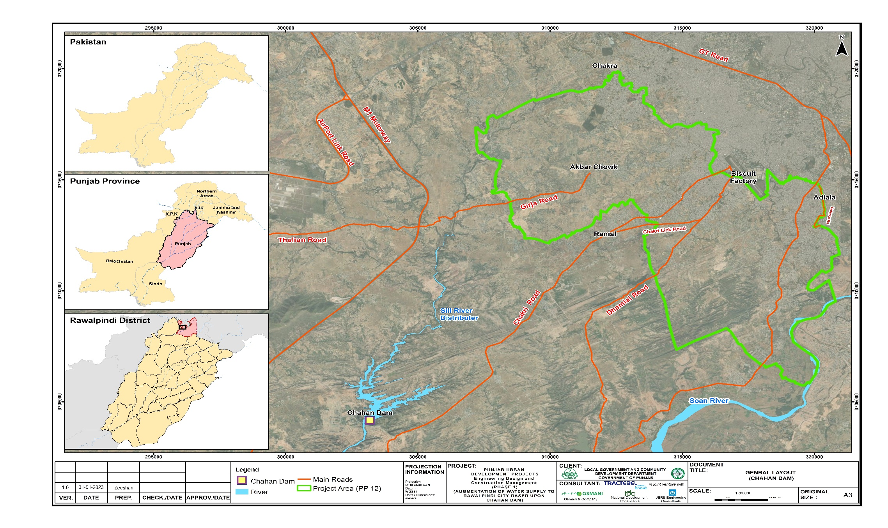
Figure ‎3-5 Location Plan of the Water Distribution Area

    - Solar PV System Installation
- The work under this section will consist of supply, installation, testing & commissioning of the grid connected 5.3 MW capacity, which will be installed over 18 acres of land. The Contractor shall furnish all labor, materials, services, and all skilled supervision necessary for the construction, erection, installation and connection of all equipment.
- The solar PV power system equipment shall comply with following international standards wherever applicable.
- IEC 60364‐7‐712: Electrical Installations of Buildings: Requirements for Solar PV power supply systems.
- IEC 61727 or similar: Utility Interface Standard for PV power plants >10kW.
- IEC 62103, 62109 and 62040 (UL 1741): Safety of Static Inverters‐ Mechanical and Electrical safety aspects.
- IEC 62116: Testing procedure of Islanding Prevention Methods for Utility‐Interactive PV Inverters.
- PV Modules: IEC 61730‐Safety qualification testing, IEC 61701‐Operation in corrosive atmosphere.
- IEC 61215: Crystalline Silicon PV Modules qualification.
- String/array junction boxes/: IP65, Protection Class II, IEC 60439‐1, 3.
- The Inverter shall be rated for IP54.
- The AC distribution boards shall be rated IP54.
The different components to be installed will be as follows:

Solar Modules
- Power output: 90% power output at end of 10th year and 80% power output at the end of 25th year.
- Solar photovoltaic panels will be used by the solar power plant for generating electrical power by converting solar radiation into direct current. This phenomenon takes place due to the photovoltaic effect exhibited by the semiconductors.
- The solar PV modules shall be fixed firmly on top of the pole / structure using mounting structure, with suitable tilt and inclination to receive maximum sunlight.
- The PV module shall be of half-cut mono‐crystalline technology.
- The PV module vendor and its model shall be same for whole project.
- Efficiency of individual PV modules shall be at least 19% or higher, under Standard Testing Conditions (STC).
- A suitable number of solar PV modules shall be connected in a series string. A suitable number of series strings shall be connected in parallel to formulate a series‐parallel array.
- The PV strings and array shall be designed to match the inverter input specifications.
- Maximum DC output voltage of the array shall not exceed than as specified for inverter.

- The module shall be provided with junction box with provision of by‐pass diodes.
- Plug‐in connectors shall be external MC4 type or equivalent.
- The front surface of the module shall consist of impact resistant and toughened glass.
- The module frame shall be made of corrosion resistant material.
- DC negative conductor shall be bonded to the ground.

Inverter
- Output: 97% or higher.
- Product service: 20 years.
- The KW ratings of inverters shall be chosen as per the PV system wattage, however vendor of all the inverters shall be same for whole project.
- The sine wave output of the inverter shall be suitable for connecting to 400V, 3 phase AC LT voltage grid.
- The peak inverter output efficiency shall exceed 97% and higher.
- The nominal AC frequency tracking range shall be ‐ 6Hz to +5Hz.
- Power factor:
    - Lagging 0.8 or higher
    - Leading 0.8 or higher
- The inverter shall use transformer/transformer less topology.
- The inverter shall have string fuse/ failure detection, ground fault detection, grid islanding protection, suitable DC/AC fuses/circuit breakers and voltage surge protection.
- The inverter shall have internal protection against any sustained faults in DC inputs by providing DC reverse-polarity protection / reverse current protection and in mains AC grid circuits/lightning etc.
- Inverter shall provide display of PV array DC voltage, current and power, AC output voltage and current (All 3 phases), AC power, Power Factor and AC energy (All 3 phases and cumulative) and output frequency etc.
- The Inverter should have provisioning for remote monitoring.
- Operating temperature range between 0 - 60°C.
- Protection rating:
- Electronics- IP66
- Connection points/area - IP54

Charge Controller
- Product service: up to 20 years.

Mounting structure for Solar PV array/tree
- Structural & foundation: 20 years.
- The proposed Solar PV system shall be designed to maintain the overall aesthetics.
- The mounting structure for module array shall allow ventilation for cooling and also ease of cleaning and maintenance of panels.
- Proper location and spacing of the PV modules arrays should be selected for minimum shadow effect.
- Material for solar and module array support structure shall be fabricated using corrosion resistant material.
- All the support structure welded joints shall be adequately treated to resist corrosion.
- The support structure shall be free from corrosion when installed.
- The structure of solar module array shall be designed so that PV modules can be placed and fixed with ease.
- Screw fasteners shall use existing mounting holes provided by module manufacturer. No additional holes shall be drilled on module frames. Module fasteners/clamps shall be adequately treated to resist corrosion.
- The support structure shall withstand the weight of solar PV modules installed on each solar modules on each PV array at buildings and other installed equipment.
- The structure shall be designed to withstand operating environmental conditions for a period of minimum 20 years.
- The structure should have provision for connecting the earthing cables.

Balance of System (BoS)
- Product service: 20 years.

Equipment for solar PV system cleaning
- The following equipment for cleaning of the solar PV panels will be installed:
- 1HP electric water motor pump
- Flexible water pipe with stand (it shall have access to every solar panel)
- Mid & low-pressure nozzles to splash water.
- nos. of each min. 6 feet long retractable brushes & viper.
- Brush fiber shall be made of polystyrene, soft enough to protect the photovoltaic cells, yet enough to remove debris.
- High pressure cleaning equipment should not be used to clean solar panels as this may cause water to get under the glass.

Power Evacuation
- The power generated will be connected to the national grid through the nearest substation to evacuate any excess power that is being generated.

Site Drainage
- In order to prevent any damage to the solar equipment from flash flooding and soil erosion, an effective watershed management and drainage system inside and outside of the site boundary will be implemented during the construction and operation phases. Run-off from precipitation will be collected and drained through a specified points or outlets at the project site.

Security Measures (Fencing and Lighting)
- Chain link fencing up to 2.5 m high will secure the solar equipment to preventing access; ensuring the safety of the nearby local communities, and providing security for the solar photovoltaic panels. In addition to this, two security personnel will be deputed on rotation basis (all day and night hours, alternately) to prevent the entry of unauthorized persons to the site.
    - Construction Activities

Solar Power Plant Design, Installation and Supply Contractor
- A Contractor will be selected to develop the solar power equipment on a design, installation, and supply basis through a competitive bidding process. The Design, Installation and Supply contractor will undertake the detailed design, conduct civil works, supply and install the solar power equipment, construct the power evacuation facilities to evacuate power at the grid connection point and set up the operation and control systems required for solar power operation. The Design, Installation and Supply contractor will also continue to be engaged during operation through warranties to rectify any issues arising from equipment defects or workmanship issues.

Temporary Facilities
- Construction site offices, stores for fuel, oil and chemicals, storage/laydown areas for materials, plant and equipment, sanitation and welfare facilities including washrooms, cooking, and eating areas and worker camps will need to be temporarily set up within the allocated land and on completion of construction, these will be removed from site.

Construction Methods
- Construction of the solar power facility will be semi-mechanized. This means a combination of both machine and labor will be utilized. The use of machines will mainly be for earthworks and excavation and the installation of foundations. There is the possibility that soil compaction and/or piling will be required due to ground condition at the site, although it is to be avoided, if possible.

Construction Materials
- Construction materials will be required for solar power equipment, including gravel for any access ways that might be required, concrete for foundations, hot dip galvanized steel or aluminum for solar PV module tables and concrete, reinforcement bars and bricks etc. No borrow areas or quarries will be opened to provide construction materials. Solar PV modules and electrical equipment meeting technical specifications will be procured from licensed manufacturers. No CFCs, PCBs or asbestos containing materials will be used in construction.

Labor requirement
- At most, 30 construction workers are expected to reside at the solar power facility during the construction period. Skilled workers will need to come from outside the local community due to the need for them to have suitable qualifications and experience to work on construction sites, but unskilled manual labor may be sourced from the local communities.

Power Requirement
- The project site has grid connection available, which will be available for use, although the Contractor may choose to use temporary diesel generator sets during construction as backup power.

Water Requirement
- Water will be required during construction for drinking and dust suppression. During the construction, it is estimated about 30 laborers will be stationed at the project site requiring about 5 cubic of water. For human consumption (drinking, bathing, cooking, toilet etc.) alone, the estimated water requirement is about 5 m³ per day.

Waste Generation
- There will be excess soil (waste spoil) generated from earthwork and excavation during the construction phase. Excess soil will ideally be disposed of in backfilling or landscaping of the solar plant site or disposed off at an acceptable location in accordance with EPA guidelines.
- During construction, there will be wastewater, solid waste and some hazardous waste generated. This includes solid waste generated from construction workers and temporary worker camps in the form of domestic garbage and wastewater sludge. Wastewater will need to be treated with septic tanks. Solid and hazardous wastes will need to be taken by licensed waste contractors who should reuse/recycle or dispose of the waste according to type to suitably licensed and engineered waste management facilities.
    - Operation phase of Solar installation

Solar Power Plant Owner and Operator
- SCADA system will be installed for remotely controlling and monitoring the solar power equipment. The Rawalpindi WASA staff will be trained by the design, installation and supply contractors to operate, maintain and carry out repairs of the solar power facility. However, some of the operational activities, such as, cleaning of solar photovoltaic panels and maintenance and service of key components such as connector boxes, switchgear, and transformers may be assigned to third party contractors.

Manpower Requirement
- Once the construction activities are completed, only a few people will be required for operation and maintenance of the plant. Only 10 employees for this facility are expected to be engaged.

Power Requirement
- The project site has grid connection available which will be available for use in case of any emergencies.

Water Requirement
- The main consumption of water is for cleaning of the solar PV modules with minimal requirement for domestic usage. Cleaning of all modules will be done only once per month. It will be possible to clean all the panels by using requiring 4 m³ of water per day.

Waste Generation
- There will be small volumes of wastewater, solid waste and some hazardous waste generated. This includes domestic garbage and wastewater sludge from the site offices. Wastewater will need to be treated with septic tanks.

Vegetation Management
- Management will be required, particularly to avoid the site becoming overgrown and to assist with the eventual restoration of the site back to its original state on decommissioning. There are various techniques for managing the vegetation, which include mowing and trimming.
    - Decommissioning
- The lifespan of the solar plant is 25 years (solar photovoltaic panels typically last 25-30 years) after which decommissioning will be initiated by Rawalpindi WASA. Decommissioning will involve removal of the solar plant infrastructure including all equipment, structures, foundations, access paths and fences; disposing of or recycling its components; and restoring the land to its original state. Rawalpindi WASA is anticipated to appoint a third-party contractor to undertake decommissioning work.
- Decommissioning activities will be like those involved during construction, the main difference being that there will be many solar PV panels and transformers containing oil to dispose of in an environmentally safe and sound manner. The Rawalpindi WASA focal staff will seek guidance from the concerned EPA staff on the disposal of hazardous waste. Recyclable waste can be sold to licensed waste collectors who should reuse/recycle or dispose of the waste according to type to suitably licensed and engineered waste management facilities. If at the time, Rawalpindi WASA is to pursue an alternative scenario such as repowering using new solar PV panels, this will be subject to national environment laws and regulations in force at the time.

Climate change resilience approach
- Essential components for building climate change resilience approach are:
- Identification of climate change impacts on the proposed project
- Development of resilience recommendations.
- Implement recommendation in design phase of the project.

Identification of Climate Change Impacts, on the Proposed Project
- Project area features a humid subtropical climate with long and hot summers, a monsoon and short, mild and wet winters. Its climate is classified as very similar to its twin city Islamabad, but the geographical location and extreme urbanization of Rawalpindi specially in project area (PP-12) has led to weather and climatic conditions that are notably different from its surrounding region. Rawalpindi's weather has historically been known to change rather quickly due to its proximity to Himalayas and the Pir Panjal Range. These mountains not only influence the weather of the city but also provide great recreation during the hot months. Furthermore, its warm comfortable mean annual temperature of 21.3°C (70 °F) attracts people to live here permanently from all over Pakistan.

Major foreseeable Impact on the Proposed Project due to Climate Change

- Potential climate impacts on water supply infrastructure associated with extraction from surface sources, treatment, storage, and piping or distribution structures (treatment facilities, office infrastructures) include:
Changes in the Seasonality of Precipitation Patterns
- Changes in the seasonality of precipitation patterns may affect the reliable yields from surface water such as rivers and reservoirs. Direct changes in precipitation patterns and indirect changes in land use within the catchment can negatively impact surface water and groundwater availability.
- Throughout the year, Rawalpindi experiences an average of about 90 thunderstorms, which is the highest frequency of thunderstorms in Punjab province of any station. In fact, most rainfall in the project area is accompanied by a thunderstorm with peak activity experienced in August.
- The average annual rainfall is abundant at 1,249 millimeters (49.2 in), most of which falls in the monsoon season. However, frontal cloud bands also bring significant rainfall in the winter. The driest month is November, with 16 mm of rain. In July, the precipitation reaches its peak, with an average of 237 mm. Record rainfall was experienced in the year 2013 at a massive 1,952 millimeters (76.9 in) mostly due to an unusually wet monsoon season.
Increased Mean Temperature
- Evaporation losses from surface water reservoirs may be expected to increase as temperatures increase, thereby reducing yields and increasing storage losses.
- On a typical day, Rawalpindi hosts breezy afternoons (30 kilometers per hour (19 mph)+), but usually calm to light breeze (Beaufort scale) wind conditions are observed after midnight. The mean annual wind speed of project area is roughly 10 kilometers per hour (6.2 mph) at 14 m height. In summers, June is the hottest with record maximum temperature at a blistering 48.3 °C (119 °F) recorded on 13 June 1953. On the other hand, January is the coldest month of the year when temperature can drop to a minimum −3.9 °C (25 °F) in the winter recorded on 17 January 1967.
Ground Water Depletion
- Groundwater is the only source to supply water to the R-WASA zone PP-12. Currently, there are 26 tube wells in the Water supply zone PP-12. These tube wells are located on the recharge beds of the Soan river and Sill river distributaries. There are currently 14 functional tube wells which produce about 374.7m3/d (0.082mgd), compared to the entire design capacity of 750m3/d (0.165mgd). There are almost 12 tube wells which are now declared obsoleted/outlived.
- The water table is depleting as a result of excessive groundwater abstraction and with the less or no recharge by surface water. Hence, the number of non-functional/ abandoned tube wells is also increasing with time.
Climate Change Impacts on Various Components of Water Supply project
- Climate change impacts that threaten the structural integrity and service sustainability of water supply infrastructure are summarized in the table below.
Table ‎3-1 Climate Change Impacts on project
Climate Change Event | Infrastructure Impacts and Consequent Risks
Increased Mean Annual and/or Intensity of Precipitation | Water Source  - Increased water turbidity after heavy storms and flood events  - Shifts in river morphology from increased erosive capacity of river during storm events may affect water withdrawal  - Need for dredging to remove sediment, rocks and debris deposited after storm and flood events  Treatment Facility  - Physical damage to structures from flooding Water  - Lower treatment effectiveness due to higher than normal turbidity or disrupted/shorter treatment operation  Storage Tanks  - Contamination due to flooding for cisterns  - Physical damage due to landslides  Pipelines  - Corrosion of metal pipes weaken structures over time  - Physical damage to pipes from flooding and landslides  - Network contamination from pipes damaged by flooding or landslides
Drought and Decreased Mean Annual Precipitation | Water Source  - Decreased availability of surface water resources  - Lower river/reservoir levels affect water intake  - Competing demands for water from industrial, agricultural and urban sectors  Treatment Facility  - Declining raw water quality due to drought-prone algal blooms or diminished runoff and flows that cause concentration of chemical pollutants  - Increased treatment costs as pollutants become more concentrated  Storage Tanks  - Lack of inflow to storage tanks •  - Frequently emptied due to higher demand  Pipelines  - Decreased supply and intermittent or low pressure  - Increased risk of contamination from wastewater intrusion  - Increased demand for increasingly scarce water resources

Development of Resilience Recommendations

- From the above discussion, it is concluded that designing of any new development project mitigation measure must consider:
- Selection of the water source must be considered by keeping in mind the unseen event of drought and high flood;
- Pipe material and protection selection must be designed by considering the unseen event of floods.;
- Metering system for controlling the unauthorized use of water.

Climate Change Resilience Plans Adopted for Proposed Project Design

- As per the feasibility study, the dam is earth-filled with a design life of 50 years and received the maximum discharge of 89,985 cusecs, including both routed and unrouted discharge. The dam has dead, live, and gross storage capacities of 14.4, 19.37, and 33.78 MCM, respectively, with a normal reservoir level, dead storage level, and Nullah bed level of 426.22, 415.24, and 356.4 m, respectively.
- Pond area at normal water levels is 1.781 km². The dam is 304.80 m long, with a top width of 9.14 m and a height of 44.82 m and there is a difference between HFL and the top level of the dam, i.e., 2.2 m.
- Chute type spillway is used with a clear water way of 91.46 meters at normal water level (426.22 m) and will carry a discharge of 38454 cusec. The length of the spillway is 609.4m.
- From Chahan Dam, 45 cusecs of water are allotted for irrigation purposes by using a 1.2-m-diameter PRCC siphon of about 76.2 m in length in an irrigation channel, while an additional 22.3 cusec will be used from Chahan Dam for water supply to PP-12.
- The following plan has been adopted in the design of the proposed project to mitigate the impacts that may take place due to worst climate change events. All the conveyance system network pipe material will be proposed to be buried with the minimum soil cover of 3 ft. to minimize the impact of physical damage of the pipe network.

Construction Aspects

Construction Materials
- Coarse aggregate is obtained either by the naturally occurring weathered and abrasion aggregates or by artificially crushing a larger parent mass. Thus, many properties of aggregate depend on the properties of their parent rocks e.g. chemical and mineral composition, petrographic classification and their physical indices like specific gravity, hardness, strength, structure, color etc. along with their particle shape, size, surface texture and absorption.

Work Force
- Labor demand estimation is an essential component to facilitate deployment of manpower. Total labor required for the proposed project will be estimated by the contractor at construction stage, whereas as per consultant’s previous experience, the workforce for proposed project has been estimated as 100-150 workers comprising skilled and unskilled staff and labor.

Construction Activities and Required Machinery
- Construction activities will involve the following:
- Earth work (clearing of vegetation/ trees and top soil);
- Roadwork;
- Excavation of pits;
- Laying of pipes: and
- Structure works.
- The list of the machinery and the equipment required for the proposed Project is provided in Table ‎3-2.
Table ‎3-2: Machinery and Equipment Requirement
Sr. No. | Machinery / Equipment | Quantity required*
1 | Excavators | 2
2 | Batching Plants | 2-4
3 | Loaders | 1
4 | Power Generators | 2
5 | Tractor Trolley | 2
6 | Compactor / Roller | 1
7 | Crane | 1
8 | Concrete Pump | 1
9 | Vibro Hammer | 1
10 | Watering Tanks (moveable) | 1
11 | Cars/Pickups | 4

Construction Camps
- Camp sites will be selected keeping in view the availability of adequate area for establishing camp sites, including parking areas for machinery, stores and workshops, access to communication and local markets, and an appropriate distance from sensitive areas in the vicinity. Keeping in view the following criteria guidelines, the Contractor has to identify the construction camp sites before the start of the construction activities:
- There should be no resettlement issue for the location of the camps;
- Camp site should be away from the residential areas and sensitive receptors;
- Selection of sites for construction camps shall be near the project area having proper access to the nearby main/link road;
- The camps must be located in a place where the drainage from and through the camps will not threaten any domestic or public water supply;
- Camp site must be adequate in size to prevent overcrowding of necessary structures;
- The camp site should consider avoiding any damage of property, vegetation, irrigation, and drinking water supply systems;
- The camp site must not be subject to periodic flooding; and
- There should not be any ecological sensitive areas e.g. wildlife sanctuaries, game reserves, national parks, forest areas, etc. near to the construction camp site.

Water Requirement
- The source of water during the construction phase will be from water bowser tanks and groundwater (if available) from local sources will be used. The water consumption is estimated to be 10,000 liters /day for 100 construction workers comprising skilled and unskilled staff/ laborers (approx.) for the proposed project.

Wastewater Generation
- The wastewater generation is estimated to be 8,000 liters/day for 100 construction workers comprising skilled and unskilled staff/ laborers (approx.) for the proposed project.

Solid Waste Estimation
- Due to construction activities, waste will be generated at construction site and contractor camp. The contractor will provide the estimated quantity of excavation material during the construction phase. This waste will be generated due to the construction activities and up to the extent possible the excavated materials will be reused, where applicable, for construction purposes. Solid waste generated during construction and camp sites shall be safely disposed of in demarcated waste disposal sites.
- The solid waste generation is estimated to be 45 kg/day (as per 0.45 kg/capita/day waste generation) for 100 construction workers comprising skilled and unskilled staff/ labor for the proposed project.

Project Implementation Schedule
- The proposed project is expected to be completed within two years with an expected commencement date of January 2025 and completion by the first quarter of 2027.

Cost of the Project
- The estimated cost of the construction works of proposed Project is Rs. 19,079 million.

ANALYSIS OF ALTERNATIVES

Overview
- The discussion and analysis of alternatives considers other practicable strategies that will promote the elimination of any negative environmental impacts. This section is critical in consideration of the ideal development with minimal environmental disturbance.
- The report identifies potential environmental impacts of each alternative, develops a comparative analysis matrix with respect to water supply distribution network and water treatment methodology and suggests the most feasible alternative that can be taken up for development.

Alternative for Intake Structure
- There are two options for intake structure as follows:
- Design Option 1 (Build an intake tower inside the dam reservoir)
- Design Option 2 (Use existing intake tower of irrigation department)

Design Option 1 (Build an Intake Tower Inside the Dam Reservoir)
- In design option 1, it is proposed that a new intake tower will be built inside the dam reservoir near to WTP site. The location plan with proposed design of the intake structure is given in Figure ‎4-1 to Figure ‎4-3 respectively. To transmit 12 MGD water from intake structure to water treatment plant, an appropriate pumping station has been proposed. The pumping station will comprise of vertical turbine pumps, valves and other appurtenances.
- In order to secure ensured supplies round the year and to cover the seasonal fluctuations in the river discharges, pumps are proposed at three different levels i.e. normal level, middle level and dead level:
- Dead-level intake pumps at an El. 415 m (sufficiently close to the lowest river bed level)
- Middle -level intake pumps at an El. 422 m (close to the normal pond level in Dam)
- Highest level intake pumps at an El.430 m
- The low-level intake pumps will ensure supplies during the lean flows, whereas high level intake pumps will be used during the normal to high flow periods. Control panel for the operation of pumps will be provided and fixed in a masonry chamber constructed at the bank of the reservoir at least 15 m above the Highest Flood Level (HFL) i.e. 430m.
- An access bridge towards the approach road is also being proposed for carrying logistics to the intake site during and after the completion of works.
Merits
- There will be a separate operating system available for the withdrawal of water.
Demerits
- Construction and O&M costs will be high;
- Construction requires time for the construction of intake tower and access bridge;
- A coffer dam will have to be built for the construction of this option.

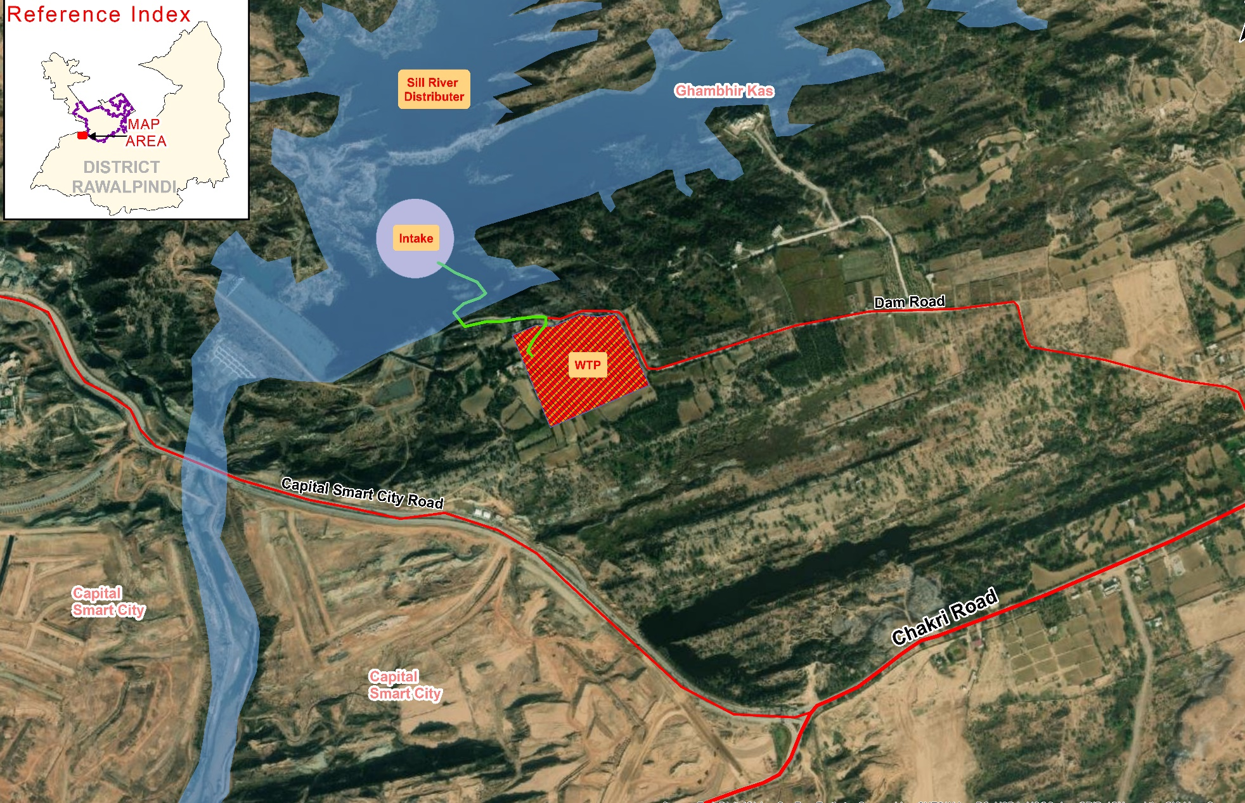
Figure ‎4-1:Location plan of Intake and WTP

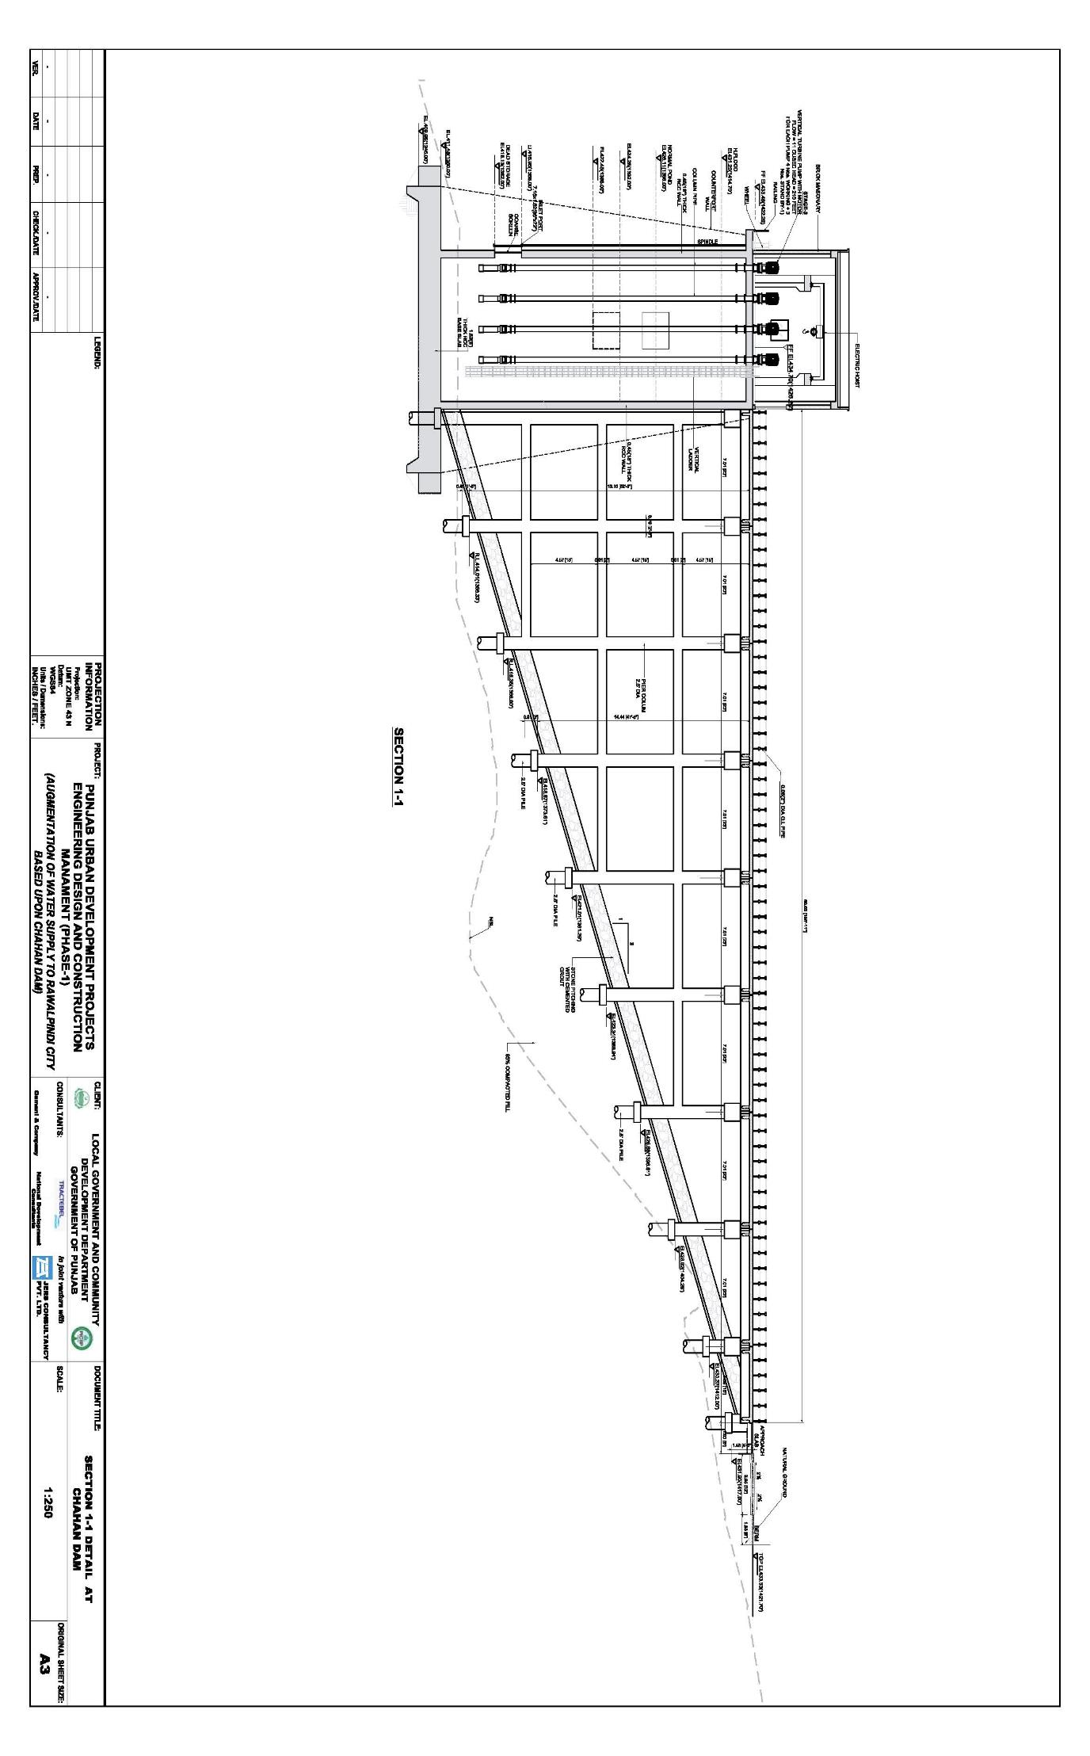
Figure ‎4-2:Intake Structure and Access Bridge

Design Option 2 (Used Existing Intake Tower of Irrigation Dept)
- In option 2, it is proposed that the 12 MGD water will be extracted by using the existing intake tower built by the irrigation department for irrigation purposes. The irrigation department has already laid down a pipeline of MS pipe of 36-inch diameter encased in RCC from the water intake tower through the dam embankment towards the first intermediate tank for water withdrawal purpose. Another pipeline of 48-inch diameter has been laid from the first intermediate tank towards the second intermediate tank for additional water supply.
- The main concept of this proposed design is as follows:
- A tee connection will be installed in the existing pipeline at an approximate distance of 270 m near to the washout from the first intermediate tank towards the second intermediate tank.
- From the Tee connection, a pipeline of 240 m will be laid down towards the booster pump station
- The booster pump station will be installed at a nearby vacant land of irrigation dept. Booster pump station will be designed on horizontal Centrifugal inline pumps with 3 No of Pumps of (2W+1S). The flow of each pump will be 11.6 cusec with a head of 60 m.
- From the booster pump, a pipeline of 762 m with a velocity of 1.26 m will be installed towards the treatment plant, having a diameter of 32 inch of MS pipe.
Merits
- Easy to execute
- Construction and O&M costs will be low as compared to option 1.
Demerits
- Extra land will be required for the booster pump station
Recommendation
- Option 2 will be the most feasible option after obtaining the NOC from the irrigation department due to the low construction and O&M costs and ease of operation.

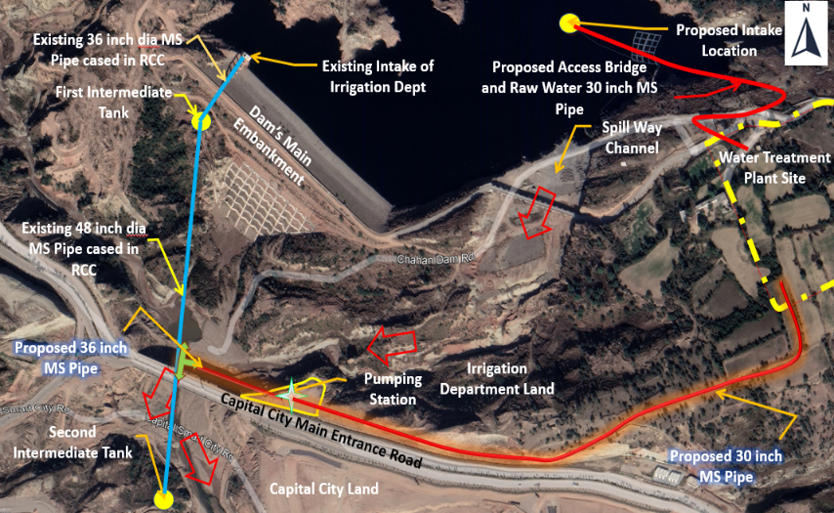
Figure ‎4-3:Location of Water Extraction from existing Intake of Irrigation Department to WTP

Comparison / Analysis of Alternatives
- The comparison between all proposed options based on environmental, social and economic impacts are described in Error! Reference source not found.. The alternative to be selected must qualify the basic criteria of cost effectiveness, environmentally sustainable and social acceptability.
Table ‎4-1: proposed options based on environmental, social and economic impacts
Parameters | Option-1 | Option-2
Cost | Most expensive option as it will involve construction of huge intake structure inside the dam/water reservoir. Operation and maintenance costs will also be high. | Comparatively lesser cost as existing intake structure being utilized for irrigation purposes will be used. O&M cost will be less than option 1.
Environmental Aspects | As a new structure will be constructed inside dam/water reservoir, thus there is a greater possibility for the envisaged impacts on aquatic life along with potential turbidity and siltation. | Existing intake structure would be utilized with few construction activities with minimal chances of impacts on aquatic life, water turbidity and siltation. However, this involves excavation for laying of water pipes to the water treatment plant.
Social Aspects | Minimum disturbance is expected to local community as the intake structure is closer to the WTP. | As extra land will be required and during construction/laying of pipe, excavation will be done which may hinder the social activities in the area.

Recommended Option:
- Option 2 will be most feasible option keeping in view the above comparative analysis.

Alternatives for Water Supply Distribution to PP-12
- The treated water from IPS Ranial will further distribute into the distribution area (RWASA PP12). For this purpose, different options have been studied for the conveyance system from IPS Ranial to water distribution area.
- The following alternatives have been evaluated for conductance of treated water from IPS Ranial to PP-12:
- Option 1: Distribution of treated water supply in the project area through one Water Works (Chakra).
- Option 2: Distribution of treated water supply in the project area through two IPS (Akbar Chowk & Biscuit Factory) and three water works (Akbar Chowk, Chakra & Adiala).
- Option3: Distribution of the treated water supply in the project area through one IPS (Akbar Chowk) and three water works (Akbar Chowk, Chakra & Adiala).
- Option 4: Distribution of treated water supply in the project area through one IPS (Akbar Chowk) and three water works (Akbar Chowk, Chakra & Adiala) comprising of overhead reservoir (OHR) and ground storage tank.

Option 1
- In option 1, the two outlet pipes lines will originate from the IPS Ranial (EL: 520m), including one gravity main to Dhamial and Mohri Ghazzan and one pumping main to Chakra WWs:
- The Pumping main (30-inch MS pipe) with a length of 9.2 km will carry the 7.54 MGD water to Chakra WW located at north side of Bhatta chowk (required EL : 570m) From Chakara WW, further three outlet pipe lines will originate by gravity to serve all UCs (Girja, Chak Jalal Din I&II, Lakhan Mohri Ghazzan Dhama Syedan, and Kalyal) excluded the Dhamial and Mohri Ghazan.
- Gravity main with an approximate length of 10.1 km will carry a discharge of 3.08 MGD to the command area having the UCs Chak Jalal Din I & II and Lahkan by 20-inch HDPE PN 10
- Gravity main with an approximate length of 17.5 km will carry a discharge of 1.92 MGD to the command area having UCs Khayal and Dhama Syedan by 22-inch HDPE PN 10.
- Gravity main from OHR at 15 m height with an approximate length of 5.3 km will carry a discharge of 2.54 MGD to the command area having UCs Girja by 20-inch HDPE PN 10.
- The gravity main carrying water (4.05 MGD) will be laid from IPS Ranial to UC Dhamial and Mohri Ghazan consisting of 28-inch dia HDPE PN10 pipe with a length of 3.4 km.
Area Requirements
- The feasible area requirement for Chakra WW is given in Table ‎4-2:
Table ‎4-2;The feasible area requirement for Chakra WW
Option | Location | Storage Volume | Area Required | Area Required for Allied Facilities | Total Area Required | Required Elevation
 |  | Million Gallons | Acres | Acres | Acres | Meters
1 | WW Chakra (north side of Bhatta Chowk) | 1.88 | 0.54 | 0.50 | 1.1 | 570

Merits
- Minimum land mechanical assets and civil structure will be required.
- Most of the system will employ gravity distribution.
Demerits
- A large pump will be required for pumping a major part of the flow (7.54 MGD) to Chakra water works, resulting in high capital and O&M costs.
- The gravity mains originated from IPS Ranial towards water distribution networks of UCs Dhamial & Mohri Ghazan will face a high elevated obstruction due to uneven terrains of Dhamial to Chakri link road. To overcome this obstacle, overhead tanks will be proposed.
Remarks
- The proposed highly/suitable location for Chakra WW are not available due to disputed land or private land ownership.
- 90% of the water supply will depend on the conductance main from IPS Ranial to Chakra and Chakra water works so, in case of any malfunction, the 90% of the water distribution area will be unserved.

Option 2
- In this option, the three outlet pipes lines will originate from the IPS Ranial (EL: 520m) , including two gravity mains and one pumping main.
- The Pumping main (28-inch MS pipe) with a length of 3.8 km will carry the 5.62 MGD water
- Approximate length of 5.3 km will originate having the water (2.54 MGD) to serve the water distribution system of the UC Girja.
- Gravity main along the Chakri road with a length of 6.9 km will carry a discharge of 1.92 MGD to IPS Biscuit Factory (Required EL; 490 m) (by the pipe (20-inch HDPE PN10)
- The pumping main (18-inch MS pipe) with a length of 4.4 km will carry the 1.92 MGD water to Adiala Water Works (WW) (Required EL; 530 m) at Adiala Road. From the Adiala WW a gravity main (12-inch HDPE PN-10) will originate carrying the water (1.9 MGD) to serve the water distribution system of the UCs Kalyal and Dhama Syedan.
- Another gravity main along the Dhamial to Chakri link road having water (4.05 MGD) will be laid from IPS Ranial to UC Dhamial and Mohri Ghazan consisting of 28-inch dia HDPE PN10 pipe with a length of 3.4 km.
Area Requirement
- The area requirements for the different WW locations for the feasibility of option 2 are provided in Table ‎4-3 below.
Table ‎4-3: Area requirements for different WWs location for option 2
Option | Location | Storage Volume | Area Required | Area Required for Allied Facilities | Total Area Required | Required Elevation
 |  | Million Gallons | Acres | Acres | Acres | Meters
2 | IPS Akbar Chowk (Northeast of Akbar Chowk) | 1.41 | 0.40 | 0.36 | 0.76 | 544
 | WW Chakra (North of Bhatta Chowk) | 0.64 | 0.18 | 0.17 | 0.35 | 570
 | IPS Biscuit Factory | 0.48 | 0.14 | 0.13 | 0.27 | 490
 | Adiala WW (Adiala Road) | 0.48 | 0.14 | 0.13 | 0.27 | 530
Merits
- Each UC of the water distribution area has its independent water supply line, which assures continuous supply of water to one UC without affecting supply to another UC.
- This system is less complex to operate and manage.
Demerits
- The gravity mains originated from IPS Ranial towards IPS Biscuit factory and water distribution networks of UCs Dhamial & Mohri Ghazan will face a high elevated obstruction due to uneven terrains of Chakri road and Dhamial to Chakri link road and in order to overcome this issue, OHR has been proposed.
Remarks
- The proposed land is highly elevated and lies in a suitable direction for IPS Akbar chowk (northeast of Abkar chowk with EL 544m) and Adiala WW (at Adiala road with EL 530m) and Chakra WW (at north side of Bhatta chowk with EL 570m) are not available due to disputed land or private land ownership issues.

Option 3
- In option 3, the two outlet pipes lines will originate from the IPS Ranial (EL: 520), including one gravity main and one pumping main as follows:
- The Pumping main (30-inch MS pipe) with a length of 3.8 km will carry the 7.54 MGD water to IPS Akbar Chowk located at northeast of Abkar chowk with required EL: 544m). From IPS Akbar Chowk, three outlet pipes lines will originate.
- Gravity main with OHR at 15m height along Girja road with an approximate length of 5.3 km will carry a discharge of 3.08 MGD to the command area having the UCs Chak Jalal Din I & II and Lakan by 20-inch HDPE PN 10
- Gravity main along the Girja road with an approximate length of 12.6 km will carry a discharge of 1.92 MGD to the Adiala water works (at Adiala road required EL: 530m) by 28-inch HDPE PN 10. The command area of Adiala water works is Kalyal and Dhama Syedan.
- The pumping main (22-inch MS pipe) with a length of 5.3 km will carry the 2.54 MGD water to Water Works (WW) at Chakra located at north side of Bhatta chowk with required EL 570m. From the Chakra WW a gravity main with OHR at 15 m height (20-inch HDPE PN-10) with an approximate length of 5.3 km will originate having the water (2.54 MGD) to serve the water distribution system of the UCs Girja
- The gravity main having water (4.05 MGD) will be laid from IPS Ranial to UC Dhamial and Mohri Ghazan along Dhamial to Chakri link road, consisting of 28-inch dia HDPE PN10 pipe with a length of 3.4 km.
Area Requirement
- The area requirements for different WWs location for the feasibility of option 3 are provided in Table ‎4-4 below:
Table ‎4-4: Area requirements for different WWs location for option 3
Option | Location | Storage Volume | Area Required | Area Required for Allied Facilities | Total Area Required | Required Elevation
 |  | Million Gallons | Acres | Acres | Acres | Meters
3 | IPS Akbar Chowk (North East of Akbar Chowk) | 1.88 | 0.53 | 0.50 | 1.1 | 544
 | WW Chakra(North of Bhatta Chowk) | 0.64 | 0.18 | 0.17 | 0.35 | 570
 | Adiala WW (Adiala Road) | 0.48 | 0.14 | 0.13 | 0.27 | 530

Merits
- This option involved less pumping and land requirement as compared to Option 1.
- Each UC of the water distribution area has its independent water supply line, which assures continuous supply of water to one UC without affecting supply to another UC.

Demerits
- The gravity mains originated from IPS Ranial towards water distribution networks of UCs Dhamial & Mohri Ghazan will face a high elevated obstruction due to uneven terrains of Dhamial to Chakri link road.
Remarks
- The proposed plots of land are highly elevated and/or suitable direction for IPS Akbar chowk (northeast of Abkar chowk with EL 544m), Adiala WW (at Adiala road with EL 530m) and Chakra WW (at north side of Bhatta chowk with EL 570m) are not available due to disputed land or private land ownership.

Option 4
- In option 4, the three outlet pipes lines will originate from the IPS Ranial (EL: 520m) including one gravity main from overhead reservoir (OHR) and two pumping mains from ground storage tanks.
- The Pumping main (30-inch MS pipe) with a length of 3.8 km will carry discharge of 5.62 MGD water to IPS Akbar Chowk located at southwest of Akbar chowk (EL: 544m). From IPS Akbar chowk following pumping main pledge from the Ground storage tank and Gravity main from the OHR.
- Gravity main with OHR approximate length of 5.3 km will carry a discharge of 3.08 MGD to the command area, having the UCs, Chak Jalal Din I & II and Lakan by using pipe of 22-inch HDPE PN 10.
- Pumping main (24-inch MS pipe) with a length of 5.6 km will carry discharge of 2.54 MGD water to Chakra WW, located at southwest of Bhatta chowk EL 566m. The one gravity main started from the OHR at Chakra will serve the command area of UC Girja, by using a 22- inch HDPE PN 10.
- The pumping main (20-inch MS pipe) from IPS Ranial with a length of 11.1 km will carry discharge of 1.92 MGD water to Adiala WW (EL: 520m), located at Defence road. From Adiala WW, gravity main will be originated to serve the command area, having UCs Khayal and Dhama Syedan.
- The gravity main carrying water (4.05 MGD) will be started from the OHR at IPS Ranial to UC Dhamial and Mohri Ghazan consisting of 28-inch dia HDPE PN10 pipe with a length of 3.4 km
Area Requirement
- The area requirements for different WW locations for the feasibility of option 4 are provided in Table ‎4-5 below.
Table ‎4-5: Area requirements for different WWs location for option 4
Option | Location | Storage Volume | Area Required | Area Required for Allied Facilities | Total Area Required | Required Elevation
 |  | Million Gallons | Acres | Acres | Acres | Meters
4 | IPS Akbar Chowk (Southwest of Akbar Chowk) | 1.41 | 0.40 | 0.36 | 0.76 | 544
 | WW Chakra (South West of Bhatta Chowk) | 0.64 | 0.18 | 0.17 | 0.35 | 566
 | Adiala WW (Defence Road) | 0.48 | 0.14 | 0.13 | 0.27 | 520

Merits
- Each UC of the water distribution area has its independent water supply line, which assures continuous supply of water to one UC without affecting supply to another UC.
De-Merits
- OHR are introduced in this option due to which aesthetics are poor.

Remarks
- Each UC of the water distribution area has its independent water supply line, which assures continuous supply of water to one UC without affecting supply to another UC.
This option is most feasible in terms of available land.

Analysis of Options

Summary of Area Requirement
- The area requirement of the options are summarized in Table ‎4-6 below.
Table ‎4-6: Area requirement of all options
Option | Location | Storage Volume | Total Area Required
 |  | Million Gallons | Acres
1 | WW Chakra | 1.88 | 1.1
2 | IPS Akbar Chowk | 1.41 | 1.65
 | WW Chakra | 0.64
 | IPS Biscuit Factory | 0.48
 | Adiala WW | 0.18
3 | IPS Akbar Chowk | 1.88 | 1.72
 | WW Chakra | 0.64
 | Adiala WW | 0.48
4 | IPS Akbar Chowk | 1.41 | 1.38
 | WW Chakra | 0.64
 | Adiala WW | 0.48

Pump Size and Power Requirement

- The pump size and power requirement of the options are summarized in Table below in
- Table ‎4-7:
Table ‎4-7: Pump size and power requirement of the options
Option | Location of Pump | Pump Head | Total Flow | Flow Each Pump | Total Pump | Power of Each Pump
 |  | ft | Cusec | Cusec | S=stand-by & W=working | HP
1 | IPS Ranial | 249 | 18.68 | 9.34 | 2W+2S | 426
 | IPS Ranial(OHR) | 80 | 17 | 5.64 | 3w+1s | 83
 | Chakra (OHR) | 80 | 11 | 3.54 | 3w+1s | 52
2 | IPS Ranial | 133 | 13.93 | 6.96 | 2W+2S | 169
 | IPS Ranial(OHR) | 80 | 17 | 5.64 | 3w+1s | 83
2 | IPS Akber Chowk | 148 | 6.28 | 3.14 | 2W+2S | 85
 | IPS Akber Chowk (OHR) | 80 | 13 | 4.3 | 3w+1s | 63
 | IPS Biscuit Factory | 207 | 4.75 | 2.37 | 2W+2S | 90
 | Adiala (OHR) | 80 | 8 | 2.67 | 3w+1s | 39
3 | IPS Ranial | 133 | 18.68 | 9.34 | 2W+2S | 227
 | IPS Ranial(OHR) | 80 | 17 | 5.64 | 3w+1s | 83
 | IPS Akbar | 148 | 6.28 | 3.14 | 2W+2S | 85
 | IPS Akber Chowk (OHR) | 80 | 13 | 4.3 | 3w+1s | 63
 | Adiala (OHR) | 80 | 8 | 2.67 | 3w+1s | 39
4 | IPS Ranial (Akbar Chowk) | 133 | 13.93 | 6.96 | 2W+2S | 169
 | IPS Ranial(Adiala) | 128 | 4.75 | 2.38 | 2W+2S | 56
 | IPS Ranial(OHR) | 80 | 17 | 5.64 | 3w+1s | 83
 | IPS Akber Chowk | 148 | 6.28 | 3.14 | 2W+2S | 85
 | IPS Akber Chowk (OHR) | 80 | 13 | 4.3 | 3w+1s | 63
 | Chakra (OHR) | 80 | 11 | 3.54 | 3w+1s | 52
 | Adiala (OHR) | 80 | 8 | 2.67 | 3w+1s | 39

Cost Estimation
Capital Cost

- The cost estimation of the options is summarized in Table ‎4-8 below.
Table ‎4-8: Cost estimation of options
Design Option | Cost (Million PKR) | Cost (Million USD $)
Option 1 | 17,607 | 65.21
Option 2 | 17,863 | 66.16
Option 3 | 17,126 | 63.43
Option 4 | 17,573 | 65.09
O & M Cost
- The O & M cost estimation of the options is summarized in table below in Table ‎4-9.
Table ‎4-9: O & M cost estimation of options
Design Option | Cost (Million PKR) | Cost (Million USD $)
Option 1 | 1,262 | 4.67
Option 2 | 1372 | 5.08
Option 3 | 1,291 | 4.78
Option 4 | 1,305 | 4.84
Total Cost (Capital and O&M)
- The total cost estimation includes capital and O&M of all options are summarized in Table ‎4-10 below:
Table ‎4-10: Total cost estimation includes capital and O&M of all options
Design Option | Cost (Million PKR) | Cost (Million USD $)
Option 1 | 18,869 | 69.90
Option 2 | 19,235 | 71.24
Option 3 | 18,417 | 68.21
Option 4 | 18,879 | 69.92
- Based on the above analysis, the summary of all options based on different parameters is provided below as Table ‎4-11:
Table ‎4-11: Summary of all options based on different parameters
Sr. No. | Parameters | Option -1 | Option-2 | Option-3 | Option-4
1 | Availability of land at required elevation / suitable locations. | Not available | Not available | Not available | Available
2 | Area Requirement | Low | High | Medium | Medium
3 | Power requirement | Medium | Medium | Low | High
4. | Capital Cost | Medium | High | Medium | Medium
5. | O & M Cost | Low | High | Low | Medium
6. | Operational Efficiency | Low | Medium | Above Medium | Medium

Comparison / Analysis of Alternatives
- The comparison between all four alternatives based on environmental, social and economic impacts is provided in Table ‎4-12 below.
Table ‎4-12: Alternatives based on environmental, social and economic impacts
Parameters | Option-1 | Option-2 | Option-3 | Option-4
Cost | 18,869 million PKR including construction and O&M cost | 19,235 million PKR including construction and O&M cost | 18,417 million PKR including  construction and O&M cost | 18,879 million PKR including construction and O&M cost
Environmental Aspects | All options have almost similar nature of environmental impacts.
Social Aspects | The area required for this option is 1.1 acres and thus fewer social issues are expected with respect to land acquisition. | The area required for this option is 1.65 acre, therefore more social issues are expected with respect to land acquisition. | The area required for this option is 1.72 acre, therefore the most social issues are expected in comparison with rest of the options. | The area required for this option is 1.38 acres, therefore fewer social issues are expected in comparison with Option 2 & 3 but more social issues are expected in comparison to Option-1.

Recommended Option
- Based on the discussion above, it is evident that option 3 is the most feasible option as it involves minimum power requirement, which results in the least O&M expenditure in the long term.
- However, in selection of any option, land availability is the limiting factor. The land availability is a major challenge in the project area, which is worsening over time. However, efforts have been made for land acquisition with the help of all relevant government departments, including City Implementation Unit, PMU, RWASA, Land Revenue Department etc. and the availability of land for Option 4 has been ensured.
- After evaluation and keeping in view land availability, capital and O & M costs, it is recommended to adopt Option 4 for distribution of treated water from Chahan dam to the water distribution area PP-12.

Water Treatment Plant
- The raw water will be pumped from dam intake structure to WTP through raw water pumping main and after its treatment, the treated water will be pumped through treated water main to IPS at Ranial. From IPS at Ranial, the following gravity/ pumping mains will serve the different UCs;
- From IPS Ranial to waterworks at Chakkra.
- From IPS/waterworks at Ranial, one gravity main will distribute water to Dhamial UC
- The source of water supply for the proposed areas will be surface water from Chahan dam. Surface water normally contains significant concentrations of various impurities, such as suspended solids and bacteriological contamination, rendering it unfit for human consumption. The raw water will hence require proper treatment as per Punjab Environmental Quality Standards (PEQS) for Drinking Water and other Guidelines before supplying to the consumers.

Capacity of Treatment Works
- The total feeding water into the plant will be 12 MGD. However, 0.7 MDG will be lost in backwash and other purposes. So, the treatment plant capacities will be 11.3 MGD (20.92 cusecs).

Raw Water Quality
- The choice of treatment process is based on the quality of raw water. The raw water from water source was tested by SGS Lahore for various parameters such as sediment and chemicals concentrations. The water quality result indicates the high sediment loads and since the water is abstracted from a dam, seasonal variations are very minor as compared to water sources such as rivers etc. Quantity and quality of water will have minor changes over the course of a year, therefore rapid gravity filters followed by coagulation, flocculation and sedimentation are proposed.

Treatment Process Option
- For raw water, chemical treatment by aluminum sulfate as coagulation will be required to create micro flocs and after that, polyelectrolyte used for tougher flocs for effective settlement. Mostly two types of samples are taken, one for high flow and the other for lean flow but since our source is a dam, water will have sufficient settling time. However, significant sediment load will still be present for which tube settlers are proposed before filters. Filters will remove physical contaminations and then chlorination will ensure the removal of any bacteriological contamination.
- Full physiochemical treatment will, therefore, be applied throughout the whole year. The test results indicate that the natural alkalinity is sufficient to coagulate with alum for producing the effective flocs. However, liming may be required during certain period of the year to maintain the pH of the flocculated water in the appropriate range prior to settlement in the clarifier.

Variant 1: Slow Sand Filters
- Slow sand filtration is a simple and reliable process. They are relatively inexpensive to build but do not require highly skilled operators. The process percolates untreated water slowly through a bed of porous sand with the influent water introduced over the surface of the filter and then drained from the bottom. Properly constructed, the filter consists of a tank, a bed of fine sand, a layer of gravel to support the sand, a system of underdrains to collect the filtered water and a flow regulator to control the filtration rate.
- Slow filters cannot be backwashed and the biomass accumulates in the filter bed. Unfortunately, the unwanted microorganisms and bacteria also multiply in the filter bed and then the filters work as surface filters.
- Slow sand filters (SSFs) require a very low application or filtration rate (0.015 to 0.15 gallons per minute per square foot of bed area, depending on the gradation of the filter medium and the quality of the raw water). The removal action includes a biological process in addition to physical and chemical ones. A sticky mat of biological matter forms on the sand surface, where particles are trapped and organic matter is biologically degraded. SSFs rely on this cake filtration at the surface of the filter for particulate straining. As the surface cake develops during the filtration cycle, the cake assumes the dominant role in filtration rather than the granular media.
- Dosing flocculent cannot be carried out as the hydroxide flakes quickly clog the surface and no colloids are retained either and so gravel or sand passages are excellent slow filters that are used at extremely low filter speeds. So for this project, the use of technical slow filters is not very suitable.
- Typical treatment performance of a conventional SSF and a process diagram is shown in Figure ‎4-4 and Figure ‎4-5 respectively.
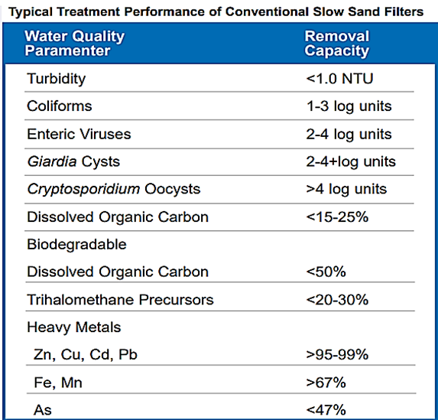
Figure ‎4-4:Typical treatment performance of conventional SSFs

Variant 2: The Rapid Sand Filter (RSF)

Types of Rapid Sand Filter
- The Rapid Sand Filter (RSF) differs from SSFs in a variety of ways, the most important of which are the much greater water treatment filtration rates and the ability to clean automatically using back washing while the mechanism of particle removal also differs. Rapid Sand Water treatment filter does not use biological filtration and depends primarily on mechanical straining, sedimentation, impaction, interception, adhesion and physical adsorption. In RSFs, the complete filtration cycle (filtration and back washing) occurs sequentially.

- There are a number of different types of RSFs depending upon bed depth (e.g., shallow, conventional and deep bed) and the type of filtering medium used (mono-, dual-, and multimedia).
- A further classification can be made based on the driving force as gravity water filters or pressure water filters. Typically, sand is used as the filtering material in single medium filters.
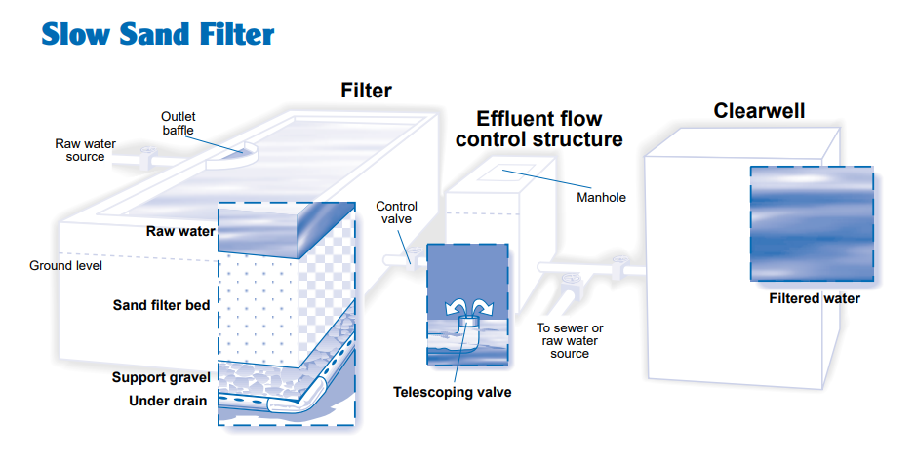
Figure ‎4-5: Process Diagram of Slow Sand Filter

- Dual- medium filters usually consist of a layer of anthracite over a layer of sand. Multimedia filters typically consist of a layer of anthracite over a layer of sand over a layer of garnet. Filtration and backwash process of RSF is shown in Figure ‎4-6 below.
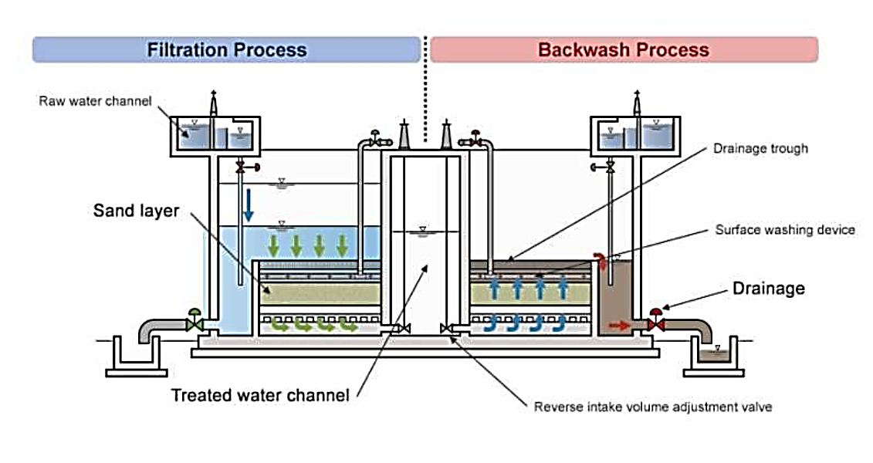
Figure ‎4-6: Filtration & Backwash Processes of Rapid Sand Filter

Efficiency of Rapid Sand Filter
- It is expected that bacteria removal efficiency is about 80 to 90%.
- Turbidity of water can remove the extent of 35 to 40 ppm.
- These filters are highly efficient in color removal i.e. below 3 on the cobalt scale.

Variant 3: Ultrafiltration
- Ultrafiltration plant is a membrane-based technology, which is used for separation of higher molecular weight particles from water and it can separate particles from even 0.01 microns. Different membrane configurations and sizes are available for filtration requirements and hollow fiber and spiral wound configurations are most used in industry. Ultrafiltration system can be used both in pre-treatment and post treatment process. The best feature of Ultra Filtration Plants is their ease of operation and maintenance, automatic operation, compactness, adequate safety interlocks, automatic forward flush and back flush for ground water.
- For surface water such as dam water, the same pre-treatment such as RSF is required which will result in a high project cost that will not be feasible. A typical ultrafiltration plant is shown in Figure ‎4-7.
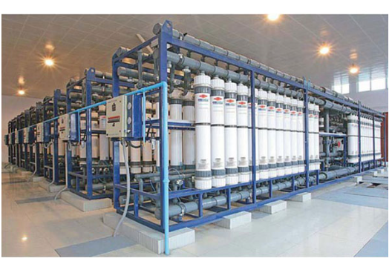
Figure ‎4-7: A typical Ultrafiltration Plant

Advantages
- Size-exclusion filtration as opposed to media depth filtration.
- Good and constant quality of the treated water in terms of particle and microbial removal.
Disadvantages
- High Cost
- Low Membrane life
- High level of technical expertise required for operation
- High Operational cost

Comparison / Analysis of Alternatives
- The comparison between all three alternatives based on environmental, social and economic impacts is described in Table ‎4-13. The alternative to be selected must qualify for the basic criteria of cost effectiveness, environmental sustainability and social acceptability.

Table ‎4-13:Comparison of Available Option

Parameters | Slow Sand Filters | Rapid Sand Filters | Ultrafiltration
Cost | Low construction and operation costs are involved. | Construction and operation costs are high. | Highest costs .
Environmental Aspects | More area is required for production of clean water. | The design of RSF is compact and produce water at faster rate. | Ultrafiltration plant will require change of membranes and will produce more waste.
Social Aspects | Community will receive less water on a daily basis while it will require additional land to be acquired. | Community will receive a higher quantity of water in lesser time due to a higher design efficiency. Also, lesser land will be required compared to SSFs. | It involves production of consistently clean water.

Recommended Process
- In all the three processes above, 20 NTU pre-treatment is necessary which consists of coagulation, flocculation and sedimentation.
- In the light of the above analysis, the most suitable process which is commonly used world-wide and efficient as per required drinking water quality in low land area and with nominal electricity requirement is RSF, with coagulation, flocculation and settling as pre-treatment and disinfection with chlorination as post treatment. Therefore, this option has been recommended as the best option.

With’ and ‘Without’ Project Scenario

Solar PV Installation Component

- The ‘No project’ scenario is not a viable option since Pakistan is facing an energy deficit and needs to urgently switch from the cost intensive and environmentally unfriendly diesel-based power generation and move towards developing renewable based cheap and reliable energy on a long-term basis.
- Also, the benefits from the addition of this solar installation project are primarily in terms of offsetting energy production primarily from fossil fuel-based generation (resulting in fuel savings), but also include significant benefits from more efficient operation of diesel generators, less diesel generator maintenance and depreciation and delayed purchase of new generator capacity in later years.
- The Table 8.1 below presents a comparison of the ‘with project’ and ‘without project’ scenario.

Table 8.1 – ‘With’ and ‘Without’ Project Scenario
No. | Parameter | With Project Scenario | Without Project Scenario
1 | Electricity | Major benefits are as follows:  - Improve the electricity supply and stability of the national grid;  - Diversify power generation mix;  - Increase percentage of clean energy;  - Supply less expensive than current oil-based generation;  - Improve electricity supply and stability of the national grid. | Negative effect, increase in greenhouse gas (GHG) emissions due to continued reliance on inefficient oil-based energy generation.
Environment
2 | Effect on protected, sensitive or forest areas | No effect, avoids national protected areas, environmentally sensitive and forest areas. | No effect.
3 | Effect on endangered species | No endangered species identified in project area. | No effect.
4 | Tree Cutting, vegetation removal. | No major effect anticipated. | No effect.
5 | Air emissions | Minor effect during construction; increase in air emissions because of construction activities / trenching, dust generation.  Major effect during operation: Decrease in GHG emissions. | Negative effect, Increase in GHG emissions due to continued reliance on fossil-fuel based energy generation.
6 | Water Supply | Minor effect during construction and operation; Increase in groundwater withdrawal compared to without project scenario. Shall comply with project EMP as prescribed in clearances, permits and licenses obtained from relevant authorities.  Major effect during operation; improved water accessibility for different purposes due to relevant power available for pumping etc. as required. | No effect.
Social
7 | Disturbances to people/ communities. | Minor effect during construction phase; temporary and localized impact due to power outage, dust and noise due to movement of machinery and construction vehicles; shall comply with project EMP (community health and safety plan, traffic control and road management plan, noise and dust control plan) Influx of migrant workers; shall comply with project EMP (emphasis on local hiring). | No issue.
8 | Effect of business. | Construction activities may employ local populace generating economic and livelihood generation opportunities | No issue.
9 | Status of living. | Major effect, improved access to electricity, reduced domestic load for persons such as women involved in cooking activities or in accessing water supplies. | No change.
Economic
10 | Economic Development | Greater rate of economic development expected. | Slow development.

DESCRIPTION OF ENVIRONMENT

General
- This chapter provides a description of the baseline conditions along the proposed project within the CoI.
- Considering the potential impacts of the proposed project, existing baseline environmental conditions of the proposed project’s CoI has to be used as a benchmark for comparison of the physical, ecological and socio-economic conditions before and after construction phases of the project. This baseline will also provide the datum for assessing the impacts and suggesting mitigation measures, which will be implemented effectively at various phases of the proposed project activities.

Field Visits for Baseline Study
- The data presented in the forthcoming sections has been collected from the primary and secondary sources. For primary data acquisition, the environment and social teams conducted the field visit during November, 2022.
- The major objective of the field visits was to collect the baseline data on physical, eco-biological and social aspects along with identification, assessment and categorization of the significant environmental and social impacts of the proposed project. The secondary data was collected from published sources/reports and relevant departments, which were also verified through visual observations during detailed surveys.
- The primary data was collected directly from the concerned communities and affected households while secondary data was the information gathered through secondary sources such as PMU, EDCM, census report, research publications, topographic sheets, other published data related to the project such as wildlife, livestock, fishery, forestry, agriculture, horticulture, climate etc.
- Corridor of Impact: The proposed areas where the project activities will be carried out are the outskirts of Rawalpindi that consist mostly of scattered population. The COI has been marked for identification of impact on the route of Conductance Main. The project COI is referred to all those areas in the region within 100m from the project line and which may be affected directly or indirectly by the project activities. It is pertinent to mention here that COI for biological and socio-economic environment is not limited to 100 meters. Figure ‎5-1 shows the location of project component marked with COI.
- Right of Way: The required ROW for the proposed project is estimated to be 15 feet for Conductance Mains and distribution network and the ROW for Conductance Mains and distribution network is already available. The proposed project involves land acquisition for WTP, IPS and water works.

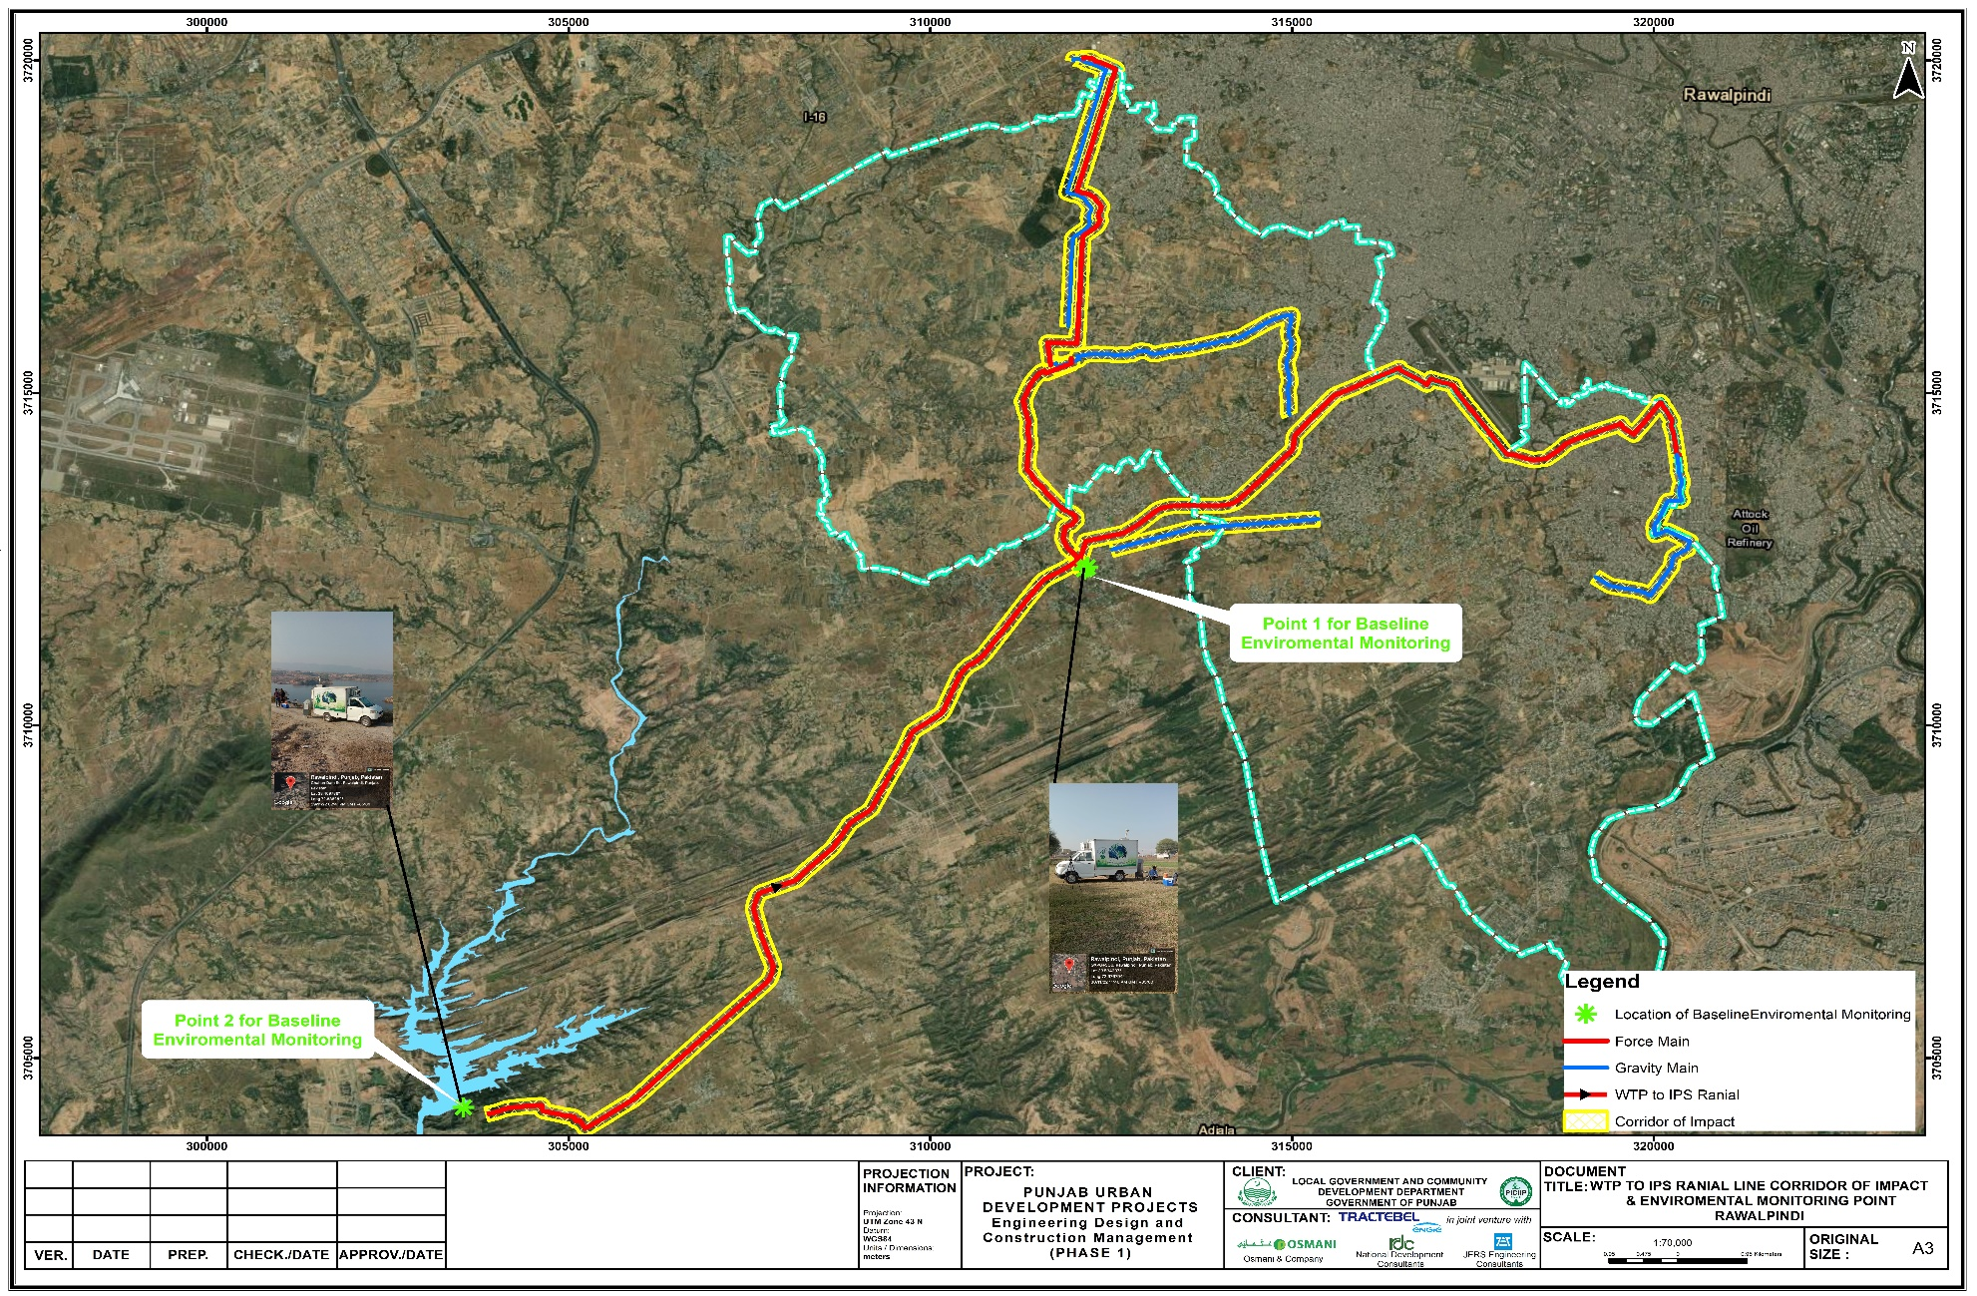
Figure ‎5-1: Index Map of COI of Proposed Project

Physical Environment
- The following section provides an overview of the information on the physical environment of the project area, collected from primary as well as secondary sources. The major parameters covered include topography, geology, seismicity, soil, climate, water resources, ambient air quality & noise, solid waste and land-use along the proposed project.

Topography
- The project is in Rawalpindi tehsil division which falls in the Salt Range and Potohar Plateau. The terrain mainly consists of plains and mountains (reaching an elevation of over 1,175 m) traversed by ravines and nullahs originating from the mountains. The northern part of the metropolitan area lies in the mountainous terrain of the Margala Hills, a part of the lower and outer Himalayas, which also includes the Hazara and Kala Chitta Ranges. The foot of Margalla range stands at an elevation of about 620 m and the top of the mountain is about 1,200 m. The terrain of Rawalpindi gradually falls off towards Lai Nullah in the west and the Kurang River in the east. Lai Nullah enters the city from the southwest and joins the Soan River in the southern side and tends to overflow in the rainy season. Four major tributaries, namely Saidpur Kas, Tenawali Kas, Bedarawali Kas, and Johd Kas, originate from the Margalla Hills. Figure ‎5-2 represents the topography of the area.

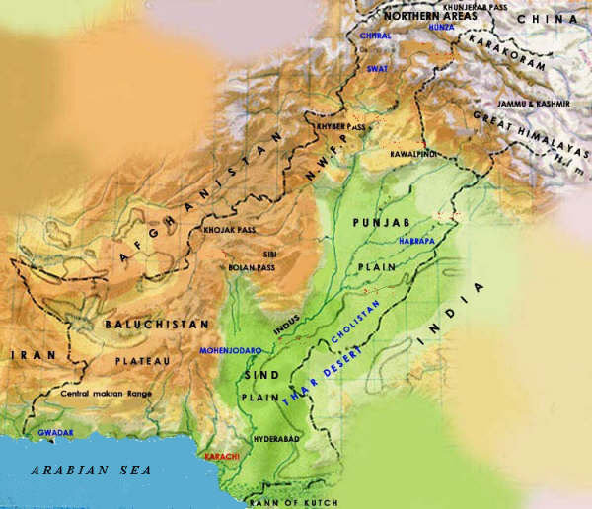
Project Area
Figure ‎5-2: Topography of the Project Area

Regional Geology and Soil
- The area in and around Rawalpindi has a complex geological history of mountain formation, alluvial-loessic deposition and erosion cycles. In the west of the Potohar Uplands, the main depositions of loess are from the Pleistocene period. Streams and ravines cut the loess plain, affected by gully erosion and steep slopes. This type of land is unsuitable for cultivation. The areas are composed of sandstone and limestone. There is an extensive area with exposed bedrock and fragmentary, thin soil formations.
- The gravel and loess are especially important to the environmental geology because they form most of the building foundations and because gravel is the primary ground-water aquifer. West of Rawalpindi, plains of thick, easily eroded loess is extensively dissected into shallow badland valleys. East of Rawalpindi, the folded ridges of Rawalpindi Group rocks rise above the alluvial cover to form prominent hills. Urban development is concentrated in the piedmont bench area, which is little dissected in its northern part, where Islamabad is located, but is more deeply dissected toward the south near the Soan River, where Rawalpindi is located.
- Important minerals like limestone, marble, and fireclay are found in the area. Limestone is found abundantly in Margalla Hills and marble in the western section of Margalla range. Limestone is common in the lower hills in Rawalpindi Tehsil, and deposits can also be found in the Kankar Plains. Clay soils in the district exhibits five strata, from bottom to top: (i) coarse pebbles with sand or clay; (ii) an alluvial stratum deposited by an older river system in the Soan Basin, (iii) alluvial deposits of the present river system (iv) an airborne top layer of silt or clay (loess), and (v) conglomerate and loose gravel deposits.
- Figure ‎5-3 indicates the properties (silty clay, clean clay and sand with silt) of soil in the project area. Out of these three, the silty clay is a predominant one.

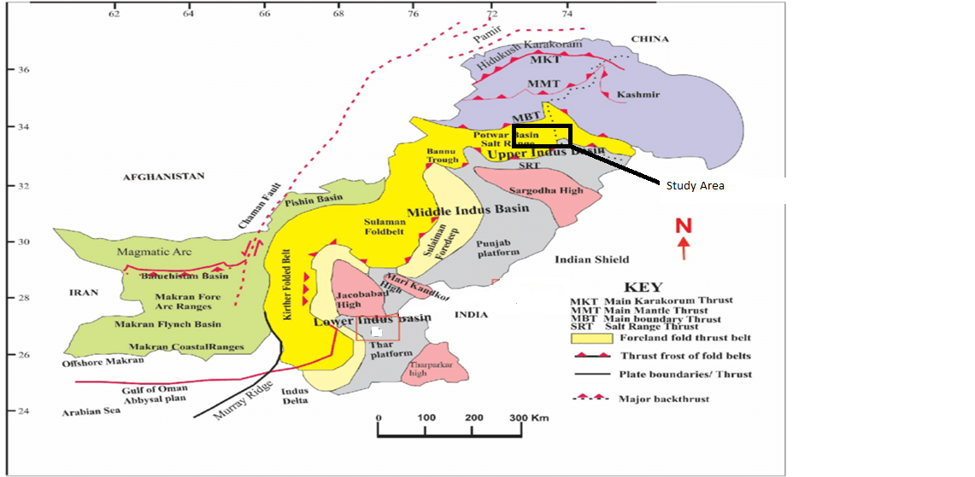
Figure ‎5-3: Regional Geological Map
https://www.google.com/imgres?imgurl=https%3A%2F%2Fwww.researchgate.net%2Fpublication%2F257786007%2Ffigure%2Ffig1%2FAS%3A297487400226816%401447937931075%2FGeological-map-of-Pakistan-showing-field-locations-and-main-geological-features-black.png&imgrefurl=https%3A%2F%2Fwww.researchgate.net%2Ffigure%2FGeological-map-of-Pakistan-showing-field-locations-and-main-geological-features-black_fig1_257786007&tbnid=xJ-0tVxFenhXFM&vet=12ahUKEwjF3pO1qrb9AhW7micCHbB_Ds4QMygJegUIARDJAQ..i&docid=zSmKDw0yP5t0jM&w=850&h=492&q=geological%20map%20of%20pakistan&hl=en&ved=2ahUKEwjF3pO1qrb9AhW7micCHbB_Ds4QMygJegUIARDJAQ#imgrc=xJ-0tVxFenhXFM&imgdii=L3bsuQj6zIwGuM

Seismology
- Based on Peak Ground Acceleration (PGA) values obtained through Probabilistic Seismic Hazard Assessment (PSHA), Pakistan is divided into five seismic zones in line with the Uniform Building Code (UBC), 1997 of Pakistan. The boundaries of these zones are defined on the basis as shown in Table ‎5-1.
Table ‎5-1: Values of Seismic Zones of Pakistan
Sr. No. | Zone | PGA (g)
1 | 1 | 0.05 to 0.08
2 | 2A | 0.08 to 0.16
3 | 2B | 0.16 to 0.24
4 | 3 | 0.24 to 0.32
5 | 4 | > 0.32 g
Source: Uniform Building Code (UBC), 1997 of the Pakistan
- In general, the proposed project, as per Building Code of Pakistan (BCP), 2007 (Seismic Provisions) falls entirely in the zone-2B (Moderate Hazard) category with PGA 0.16 to 0.24g of the seismic zonation map as shown in Figure ‎5-4. Hence all the applicable provisions of BCP will be met during the design and construction for safety against seismic hazards.

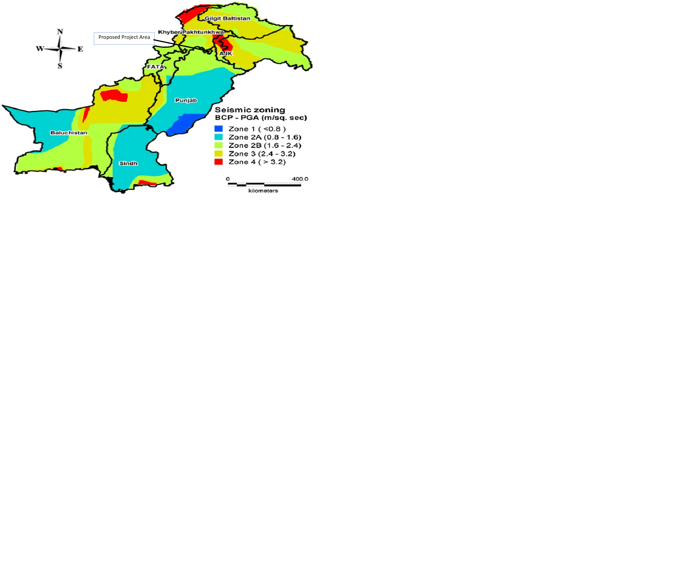
Figure ‎5-4Seismic Zoning Map

Climate
- The project area is classified as humid subtropical climate. The humid subtropical climates are characterized by typically mild, dry and short winters. Summers in project area are long with higher temperatures starting from mid-April and reaching peak temperatures in June/July. The temperatures often exceed 40°C in summers. The summers are typically followed by monsoons where heavy rain is experienced. The project area receives rain in all the seasons but monsoon rain is pronounced and constitutes a definite rainy season between the months of July and September. Average high temperatures decrease during the monsoon season but humidity increases. This results in hot and humid conditions such as summers in other humid subtropical climates.
- The following sections present the climate details of the meteorological gauging station situated near the proposed project. The airport, Islamabad meteorological station was identified near to the proposed project.

Temperature
- The proposed project area will be subjected to long periods of high temperatures in summers and low temperature in winter. The mean monthly temperature (maximum and minimum) of the Islamabad airport climatic station has been acquired from Pakistan Meteorological Department (PMD) for the years 1981 to 2010 and presented in Table ‎5-2.
- Average monthly mean maximum and mean minimum temperatures of above-mentioned station has been discussed in this section which represents the temperature conditions. It may be seen from the Figure ‎5-5 below that the temperature rises rapidly until June and the temperature drops with the advent of monsoon in July. The temperature rises rapidly until June and the temperature drops with the advent of monsoon in July. The months of December and January experience a severe drop in temperature and the temperature falls below the freezing point in areas above 1800 masl. Summer is marked with monsoon rains, which occur usually in July/August.
Table ‎5-2 Monthly Temperature Recorded at Meteorological Gauging Station
Sr. No. | Months | Mean Max. Temperature (⁰C) | Mean Min. Temperature (⁰C) | Mean Temperature (⁰C)
1 | Jan | 17.9 | 3.2 | 10.6
2 | Feb | 19.7 | 6.0 | 12.9
3 | Mar | 24.5 | 10.7 | 17.6
4 | Apr | 30.5 | 15.8 | 23.1
5 | May | 36.0 | 20.7 | 28.3
6 | Jun | 38.4 | 23.7 | 31.0
7 | Jul | 35.3 | 24.4 | 29.8
8 | Aug | 33.7 | 23.8 | 28.8
9 | Sep | 33.7 | 21.1 | 27.4
10 | Oct | 30.9 | 14.5 | 22.7
11 | Nov | 25.9 | 8.3 | 17.1
12 | Dec | 20.2 | 4.3 | 12.2
Source: Pakistan Meteorological Department

Figure ‎5-5: Mean Monthly Temperature at Meteorological Gauging Station
- According to the Metrological Gauging station data, the coldest month is January, in which the mean minimum temperature is 3.2°C and the mean maximum temperature is 17.9°C. June is the hottest month with the mean minimum temperature of 23.7°C and the mean maximum temperature as 38.4°C.

Rainfall
- Mean monthly rainfall data and the number of rainy days recorded of the project area are given in Table ‎5-3. The average annual rainfall of the project area is 1248 mm.
- The maximum rainfall occurs during the months of July and August, which is about 50% of the annual rainfall. Winter rain generally occurs during the months of January to March, whereas November is normally the months with least precipitation.
Table ‎5-3: Mean Monthly Rainfall Record
Sr. No. | Months | Mean Monthly Rainfall (mm)
 |  | Airport
1 | Jan | 56.2
2 | Feb | 84.1
3 | Mar | 92.4
4 | Apr | 63.2
5 | May | 35.8
6 | Jun | 75.3
7 | Jul | 307.8
8 | Aug | 340.3
9 | Sep | 110.7
10 | Oct | 31.7
11 | Nov | 14.4
12 | Dec | 36.3
Annual |  |  | 1248.5
Source: Pakistan Meteorological Department
- Graphical representations of month-wise precipitation of meteorological gauging station are provided below in Figure ‎5-6. The maximum rainfall occurs during the monsoon season in the months of July and August.

Figure ‎5-6: Mean Monthly Rainfall of Meteorological Gauging Station

Relative Humidity
- The relative humidity data is given in Table ‎5-4. The data reveals that at 00:00 hours, the relative humidity levels are generally higher while lower relative humidity levels are recorded at 12:00 hours. Relative humidity levels are mostly high during the month of August, whereas these are extremely lower during the highest temperature i.e., May and June.
Table ‎5-4: Relative Humidity recorded at Airport Meteorological Gauging Station
Sr. No. | Months | Relative Humidity (%)
 |  | 00 UTC | 03 UTC | 12 UTC
1 | January | 87.4 | 86.8 | 46.6
2 | February | 84.1 | 82.5 | 43.4
3 | March | 80.2 | 74.0 | 39.3
4 | April | 72.7 | 60.1 | 32.3
5 | May | 62.0 | 47.6 | 26.5
6 | June | 63.5 | 49.3 | 30.3
7 | July | 81.7 | 73.5 | 52.8
8 | August | 88.8 | 81.6 | 60.9
9 | September | 85.3 | 76.0 | 50.5
10 | October | 83.9 | 76.1 | 41.4
11 | November | 86.2 | 82.7 | 44.0
12 | December | 87.6 | 86.8 | 48.7
Source: Pakistan Meteorological Department
- Graphical representations of month-wise relative humidity of airport meteorological gauging stations are provided below in Figure ‎5-7.

Figure ‎5-7: Yearly record of Relative Humidity

- The maximum humidity recorded at weather station is in the month of December i.e. 87.6 % and the minimum humidity recorded is in the month of May i.e. 62.0 % at 00 UTC.

Wind Speed
- The mean monthly wind speed around proposed project area is given in Table ‎5-5. The data reveals that at 00 UTC, the wind speeds are generally lower while higher wind speeds are recorded at 12 UTC. During summers, wind speeds are generally higher than wind speeds in winters.
Table ‎5-5: Wind Speed Record
Sr. No. | Months | Wind Speed (knots)
 |  | 00 UTC | 03 UTC | 12 UTC
1 | January | 0.7 | 0.6 | 6.4
2 | February | 1.2 | 1.1 | 8.8
3 | March | 1.6 | 1.4 | 9.5
4 | April | 2.4 | 2.2 | 10.0
5 | May | 2.9 | 2.6 | 9.9
6 | June | 2.8 | 3.5 | 9.4
7 | July | 3.6 | 3.5 | 8.3
8 | August | 3.1 | 2.4 | 6.7
9 | September | 1.5 | 1.5 | 5.9
10 | October | 0.8 | 0.7 | 4.9
11 | November | 0.6 | 0.4 | 4.5
12 | December | 0.4 | 0.4 | 5.0
Source: Pakistan Meteorological Department
- Graphical representations of month-wise wind speed is provided below in Figure ‎5-8.

Figure ‎5-8: Wind Speed of Meteorological Gauging Station

- The maximum wind speed recorded at weather station is 10.0 knots in the month of April and the minimum wind speed is 4.5 knots in the month of November at 12 UTC.

Climate Change Impacts and Vulnerability
- The rainfall and temperature pattern of any area plays a significant role in defining the design layout and parameters of project infrastructure. Based on long term regime analysis, any significant variation in the rainfall and/ or temperature may also be explored in terms of any possible climate change scenario. However, data accuracy or redundancy were analyzed before undertaking any such regime analysis. The average monthly rainfall pattern shows that July to September (monsoon period) are the months having maximum rainfall during the year. Whereas the average monthly temperature shows the months of highest temperatures such as May to August (35 to 40ºC) whereas the lowest temperatures (winter season) are December to February as 2 to 5ºC.

Floods
- Disaster management in Pakistan basically revolves around flood disasters, with a primary focus on rescue and relief. The existing institutional structures responsible for disaster management are geared to reactive short-term responses. Experience has shown that abnormal heavy rains in catchment areas result in flash floods in Lai Nullah especially in 2001, 2010, 2011, 2012, 2014 and 2015. Figure ‎5-9 shows the distance of flood prone areas of Rawalpindi from the project site.
- Though the flood water recedes within a period of 3-8 hours, it causes considerable damage in the city area. Local drains from Chah Sultan and Cantonment area also fall in it which further aggravates the situation, especially when these drains cannot find their way into Nullah Lai which is already in flood, causing inundation of surrounding low lying areas (back water effect). Flash Flood urban flood due to Lai Nullah is being planned every year for medium and high risk. The potential sites/vulnerable areas have been pointed out as follows:.
- Dhoke Naju
- Zain-ul-Haq Colony
- Both sides of Bridge at Ratta.
- Bhoosa Godown
- Mohanpura Neae Jinnah Road Bridge.
- Javaid Colony,
- Tipu Road,
- Chamanzer Colony,
- Nadeem Colony.
- Dhoke Chiragh Din
- Mohallah Raja Sultan
- New phagwari Mohallah Raja Sultan
- Gawalmandi.
- Dhoke Ellahi Buksh.
- The flood prone areas of Rawalpindi are marked on the map given in Figure ‎5-9. Extreme flood years were 1981, 1988, 1997 and 2001, the latter having been the largest among the recorded events (considered as a national disaster). The intensity and amount of rainfall caused the water level of Lai Nullah and its tributaries to rise remarkably and flooded Rawalpindi (where the damages were several times larger than in Islamabad).
- Housing; Agriculture and Livestock; and Transport and Communications sectors suffered the most significant damage, at USD 5.6 billion, USD 3.7 billion, and USD 3.3 billion, respectively. Sindh is the worst affected province with close to 70 percent of total damages and losses, followed by Balochistan, Khyber Pakhtunkhwa and Punjab provinces.
- The Ministry of Planning, Development and Special Initiatives led the Post-Disaster Needs Assessment (PDNA), which was conducted jointly with the ADB, the European Union (EU), the United Nations agencies with technical facilitation by the United Nations Development Programme (UNDP) and the World Bank. The PDNA, in addition to estimating damages, economic losses and recovery and reconstruction needs, also assesses broader macro-economic and human impacts and recommends principles along which to develop a comprehensive recovery and reconstruction framework.

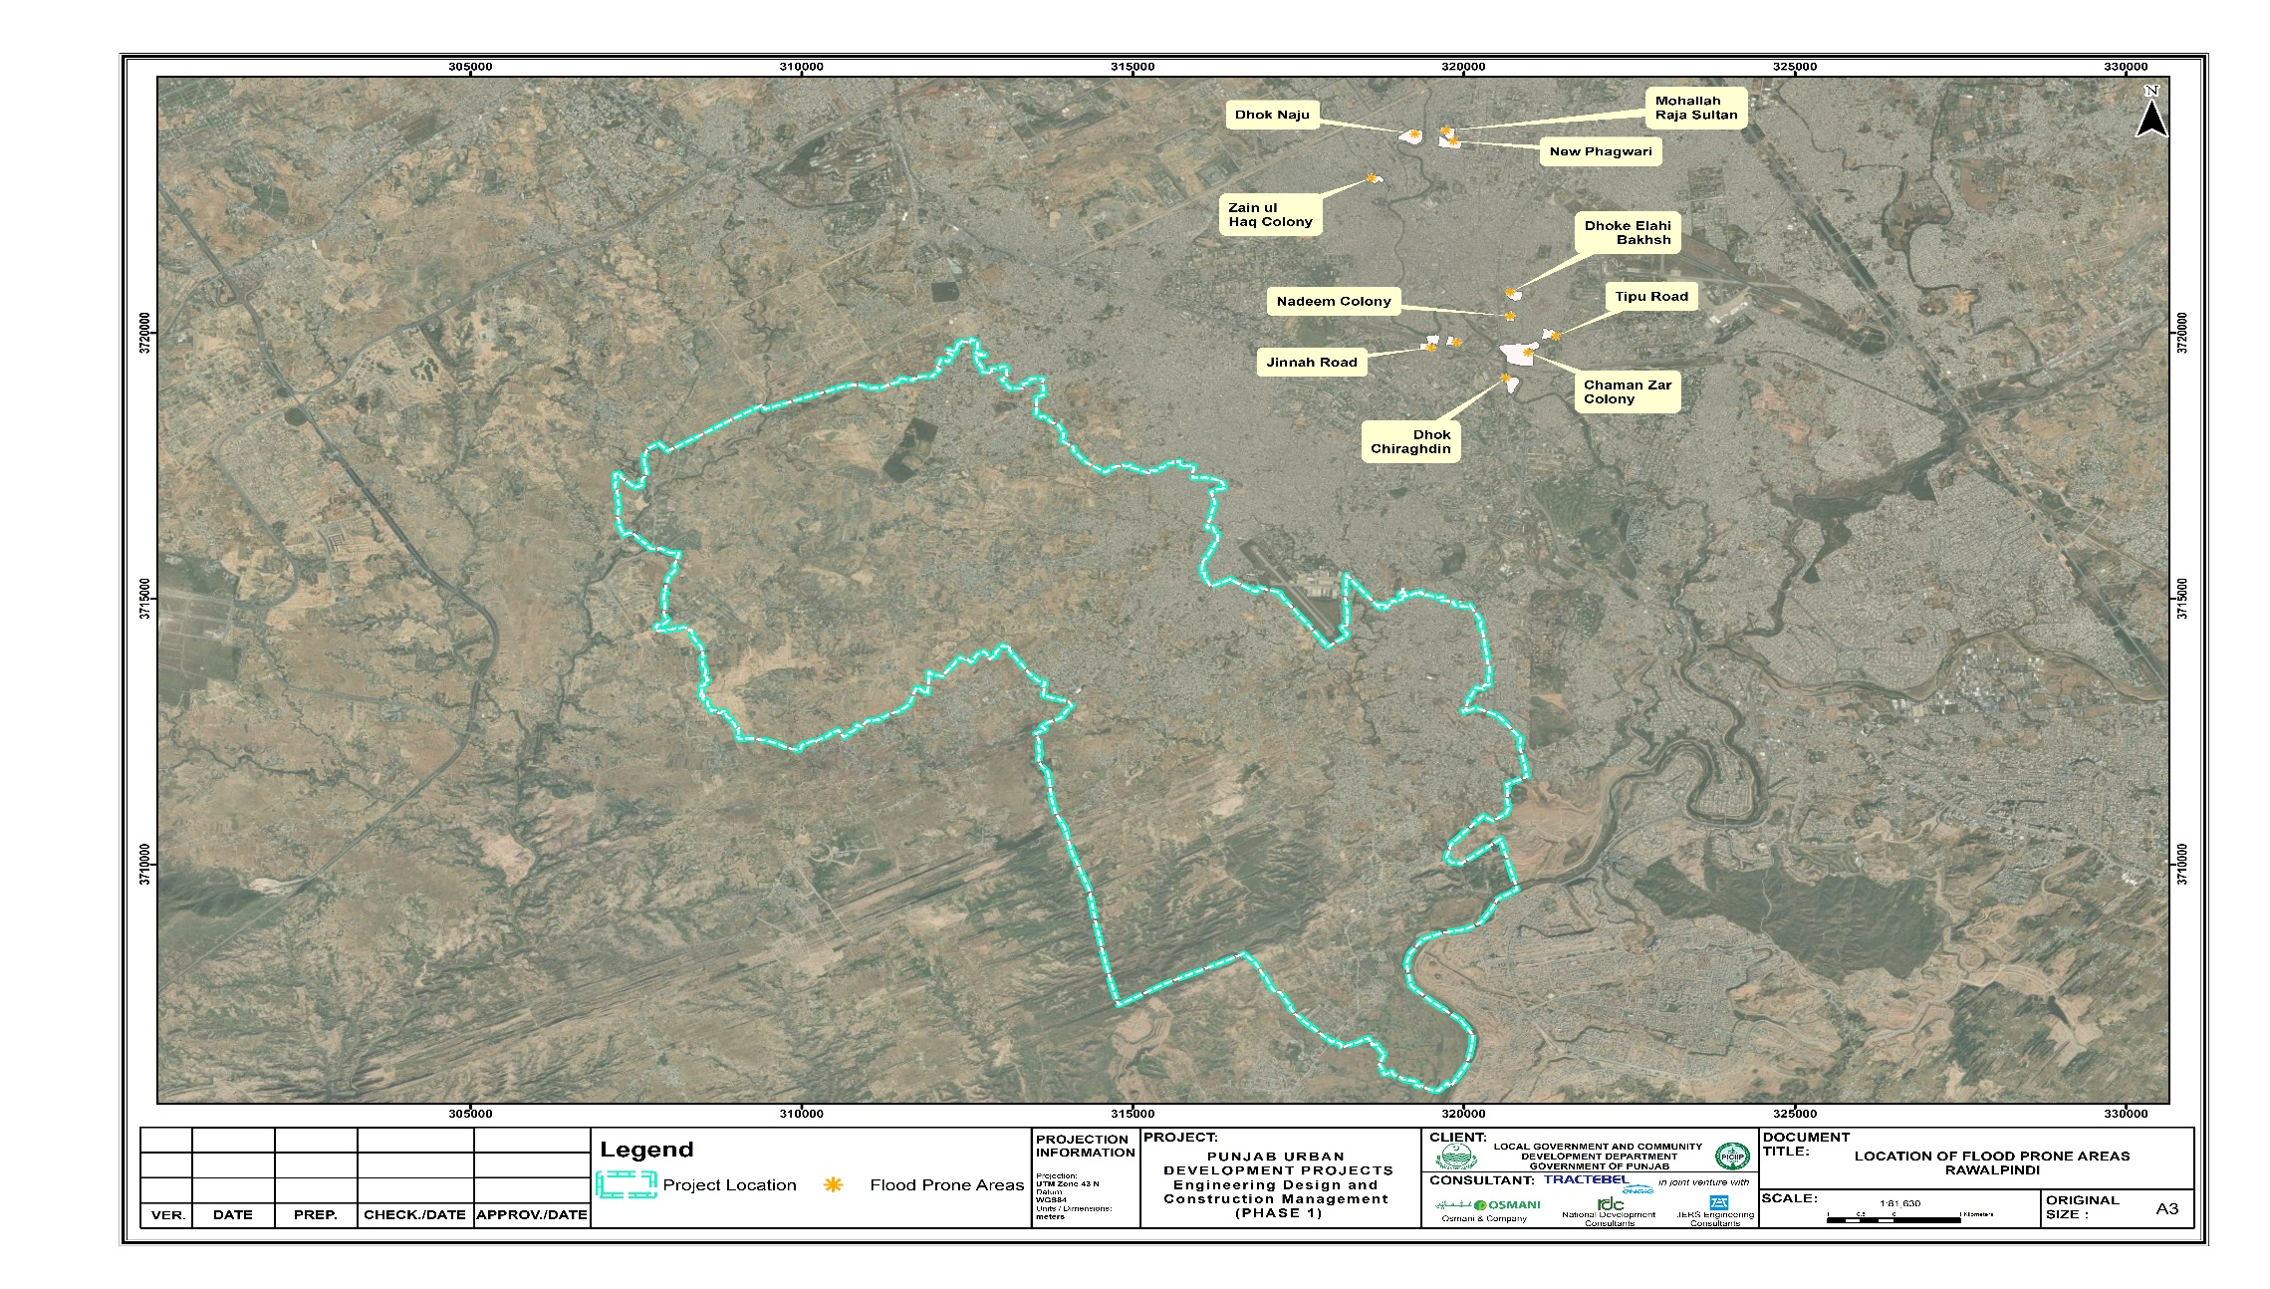
Figure ‎5-9: Flood prone Areas of District Rawalpindi

Water Resources
- In the barani region of Rawalpindi district, small dams have been an important source for drinking water, fish farming and irrigation, built on perennial and non-perennial streams to capture seasonal runoff. Khalasa and Jawa dams are the main dams near the proposed project, while Chahan dam is the source of water for the current proposed project. Moreover, Soan and Sill rivers are also located in the project area.

Hydrology and Drainage
- The study area falls in humid subtropical region and the land use changes from mild slope eroded lands to mix cultural lands under arid conditions.
- Nullah Lai has three major tributaries (Saidpur Kas, Tenawali Kas, and Bedarawali Kas) in the administrative jurisdiction of Islamabad. In the jurisdiction of Rawalpindi below Katarian Bridge, three other major tributaries (Nikki Lai, Pir Wadhai Kas, and Dhoke Ratta Nullah) fall into the Nullah Lai. In addition, there are six other drainage channels joining the Nullah after the Dhoke Ratta and finally the Nullah falls in the Soan River.
- Nullah Lai basin drains a total area of 235 km² south of Margalla Hills, with 70% of the watershed falling within the territory of Islamabad and the remaining 30% within the downstream Rawalpindi municipal and cantonment limits. Stretching from the Margalla hills in the federal capital Islamabad at the north-western edge until the Soan River at south-eastern edge in the district Rawalpindi, the maximum length of the Lai Nullah does not exceed 45 km.
- The hydraulic analysis provided that all the major rivers are functioning as per design discharges with sufficient conveyance capacity. At most of the bridges no significant scour problem was observed and the canals crossings were noticed satisfactorily in operation. The guide banks and allied protective structures should be maintained regularly to avoid any unprecedented event due to high flood conditions.

Solid Waste and Wastewater Situation
- In Rawalpindi city, proper solid waste management systems and sewerage system exist. However, in rural areas, there is no proper sewerage and sanitation system available in the COI. A few villages of the COI were observed to be connected with the proper sewerage system. In most of the cases, village’s wastewater is disposed of into open spaces or nearby ponds. Ultimately, wastewater is drained into a pond/nullah, thus it becomes a source of pollution. Same is the case with solid waste there is no proper arrangement for disposed of solid waste. Most of the solid waste is found to be stored in the form of heaps at various locations near the villages. The remaining organic and livestock waste is collected in the designated area which is used to prepare compost utilized by local farmers in their agriculture fields as a fertilizer. The major constituents of solid waste in the area are paper, plastic, and organic waste (food waste and animal waste) and waste from the existing nearby houses.

Environmental Monitoring, Sampling and Testing for Proposed Project
- In order to determine the ambient air, background noise levels and wastewater quality of the study area, different locations were selected in or near the RoW. The sampling locations for the environmental monitoring of ambient air, noise and water for proposed project is shown in Figure ‎5-10. Detailed environmental motoring, sampling and testing report is attached as Annexure-II. The baseline monitoring was carried out with state-of-the-art equipment with due calibration. Calibration certificates are attached as Annexure-III.
- Two water samples have been collected while two points have been selected for ambient air and background noise monitoring at site. The work for third party monitoring and testing was awarded to an EPA approved environmental laboratory i.e. M/S Environmental Services Pakistan. The details of monitoring points are provided in Figure ‎5-10:

Water Quality
- Water sampling was carried out at two locations: (i) Near Water Intake and water Treatment Plant site and (ii) IPS Ranial on 29-30 November, 2022. Ground water samples were taken for analysis of physical, chemical and biological parameters. The complete lab results for drinking water quality of the sample collected at two locations are given as Annexure-II of the IEE report. Four water samples were taken from different locations at recharge drains of Chahan dam.
- Locations and Reason for selection of Monitoring point
- The location and rationale of the water sampling is given below in Table ‎5-6.
Table ‎5-6:Water Quality Sampling Location Description
Sample | Coordinates | Location | Sample Taken | Rationale of Selection
W.1 | Lat. 33.534561  Long. 72.977173 | Near Water Intake and water Treatment Plant Site | Drinking water (Tap Water) | The sampling locations were identified to check the water quality near the treatment plant (source)
W.2 | Lat. 33.460186  Long. 72.885823 | IPS Ranial | Drinking Water (tap water) | The sampling location was identified based on the presence of Environmental Receptors like schools, mosques etc. and the level of construction activity to be carried out.
- The sampling locations were identified to check the water quality near the treatment plant (source) and the other sample was taken from midway to establish baseline of the area. At IPS Ranial, major construction, after WTP, will be carried out and major structure will be constructed. Therefore, it is important to establish the quality of ground water at IPS to check the impacts during the construction and operation phases of the project.
- The sampling locations for four water samples to design the WTP were taken from the drains which are discharging their water into Chahan dam.
Results and Analysis
- It is evident from the laboratory results that majority of the parameters analyzed are within compliance of limiting values set by WHO and PEQS for drinking water. The biological parameters, total coliform and fecal coliform bacteria are exceeding the prescribed limits of WHO and PEQS. The value of turbidity is also high in the water sample, which shows the presence of high concentration of suspended and dissolved solids. The water samples were taken from a nearby house. The water sample W-1 was taken from a Well and the sample W-2 was taken from the nearby house of IPS Ranial. All the water samples taken from the drains, which discharge their water into Chahan dam, shows the presence of fecal and coliform contamination. This shows that wastewater from nearby communities is entering into the dam. Accordingly, chlorination process will remove biological contaminants and make the water fit for drinking. Table ‎5-7 shows the analysis results of water samples taken from the project site.
Table ‎5-7 Results of Water Quality Analysis
WTP Water Intake Structures Site
Sr. No. | Parameters | PEQS |  | WHO |  | Unit | Result | Method
01 | pH | 6.5-8.5 |  | -- |  | - | 7.6 | SMWW 4500*B
02 | TDS | <1000 |  | 1000 |  | Mg/l | 302 mg/L | SMWW 2540C
03 | Chloride | <250 |  | 250 |  | Mg/l | 25mg/L | SMWW 4500Cl-B
04 | Fluoride | ≤1.5 |  | 1.5 |  | Mg/l | 0.7 mg/L | U.S. EPA 9214
05 | Taste | Nonobjectionable/Acceptable |  | -- |  |  | ND | Organoleptic
06 | Odor | Nonobjectionable/Acceptable |  | -- |  |  | Acceptable | Organoleptic
07 | Colour | ≤15 |  | -- |  | TCU | ND | SMWW 2120C
08 | Nitrate | ≤50 |  | 50 |  | Mg/l | 1.5 mg/L | SMWW 4500NO3-B
09 | Nitrite | ≤3 |  | -- |  | Mg/l | 0.3 mg/L | SMWW 4500NO2-B
10 | Lead | ≤0.05 |  | 0.01 |  | Mg/l | ND | U.S. EPA-200.7
11 | Total Hardness as CaCO3 | <500 |  | -- |  | Mg/l | 136mg/L | SMWW 2340C
12 | Turbidity | <5 |  | -- |  | NTU | 10.6NTU | SMWW 2130B
13 | Zinc | 5 |  | 3 |  | Mg/l | ND | U.S. EPA-200.7
14 | Aluminum | ≤0.2 |  | 0.2 |  | Mg/l | ND | U.S. EPA-200.7
15 | Cadmium | 0.01 |  | 0.003 |  | Mg/l | ND | U.S. EPA-200.7
16 | Selenium | 0.01 |  |  |  | Mg/l | ND | U. S. EPA-200.7
17 | Copper | 2 |  | 2 |  | Mg/l | ND | U.S. EPA-200.7
18 | Boron | 0.3 |  | 0.3 |  | Mg/l | ND | U.S. EPA-200.7
19 | Barium | 0.7 |  | 0.7 |  | Mg/l | 0.1 mg/L | U.S. EPA-200.7
20 | Antimony | ≤0.005 |  | ≤0.02 |  | Mg/l | ND | U.S. EPA-200.7
21 | Arsenic | ≤0.05 |  | 0.01 |  | Mg/l | ND | U.S. EPA-200.7
22 | Cyanide | ≤0.05 |  | 0.07 |  | Mg/l | ND | SMWW 4500 CN-F
23 | Mercury | ≤0.001 |  | 0.001 |  | Mg/l | ND | U.S. EPA-200.7
24 | Nickel | ≤0.02 |  | 0.02 |  | Mg/l | ND | U.S. EPA-200.7
25 | Residual Chlorine | 0.2-0.5 |  | -- |  | Mg/l | ND | SMWW 4500-Cl B
26 | Total Coliform | ----- |  | 0/100ml |  | ------ | 1.1 MPN/100mL | SMWW 9221 B
27 | Fecal Coliform | 0/100ml |  | 0/100ml |  | ml | 1.1 MPN/100mL | SMWW 9221 F
28 | E. Coli | 0/100ml |  | 0/100ml |  | ml | 1.1 MPN/100mL | SMWW 9221 F
29 | Manganese | < 0.5 |  |  |  | Mg/l | ND | U. S. EPA-200.7
30 | Phenolic Compounds as (Phenols) | NGVS |  |  |  | --- | ND | SMWW 5530 C
IPS Ranial Site
Sr. No. | Parameters |  | PEQS |  | WHO | Unit | Result | Method
01 | pH |  | 6.5-8.5 |  | -- | - | 7.3 | SMWW 4500*B
02 | TDS |  | <1000 |  | 1000 | Mg/l | 604 mg/L | SMWW 2540C
03 | Chloride |  | <250 |  | 250 | Mg/l | 32 mg/L | SMWW 4500Cl-B
04 | Fluoride |  | ≤1.5 |  | 1.5 | Mg/l | 0.4 mg/L | U.S. EPA 9214
05 | Taste |  | Nonobjectionable/Acceptable |  | -- | Unobjec. | ND | Organoleptic
06 | Odor |  | Nonobjectionable/Acceptable |  | -- | Unobjec. | Acceptable | Organoleptic
07 | Color |  | ≤15 |  | -- | TCU | ND | SMWW 2120 C
08 | Nitrate |  | ≤50 |  | 50 | Mg/l | 28.4 mg/L | SMWW 4500NO3-B
09 | Nitrite |  | ≤3 |  | -- | Mg/l | ND | SMWW 4500NO2-B
10 | Lead |  | ≤0.05 |  | 0.01 | Mg/l | ND | U.S. EPA-200.7
11 | Total Hardness as CaCO3 |  | <500 |  | -- | Mg/l | 336 mg/L | SMWW 2340C
12 | Turbidity |  | <5 |  | -- | NTU | 10 NTU | SMWW 2130B
13 | Zinc |  | 5 |  | 3 | Mg/l | 0.1 mg/L | U.S. EPA-200.7
14 | Aluminum |  | ≤0.2 |  | 0.2 | Mg/l | 0.1 mg/L | U.S. EPA-200.7
15 | Cadmium |  | 0.01 |  | 0.003 | Mg/l | ND | U.S. EPA-200.7
16 | Selenium |  | 0.01 |  |  | Mg/l | ND | U. S. EPA-200.7
17 | Copper |  | 2 |  | 2 | Mg/l | ND | U.S. EPA-200.7
18 | Boron |  | 0.3 |  | 0.3 | Mg/l | 0.1 mg/L | U.S. EPA-200.7
19 | Barium |  | 0.7 |  | 0.7 | Mg/l | 0.1 mg/L | U.S. EPA-200.7
20 | Antimony |  | ≤0.005 |  | ≤0.02 | Mg/l | ND | U.S. EPA-200.7
21 | Arsenic |  | ≤0.05 |  | 0.01 | Mg/l | ND | U.S. EPA-200.7
22 | Cyanide |  | ≤0.05 |  | 0.07 | Mg/l | ND | SMWW 4500 CN-F
23 | Mercury |  | ≤0.001 |  | 0.001 | Mg/l | ND | U.S. EPA-200.7
24 | Nickel |  | ≤0.02 |  | 0.02 | Mg/l | ND | U.S. EPA-200.7
25 | Residual Chlorine |  | 0.2-0.5 |  | -- | Mg/l | ND | SMWW 4500-Cl B
26 | Total Coliform |  | ---- |  | 0/100ml | Number/100ml | ˃8.0 MPN/100m | SMWW 9221 B
27 | Fecal Coliform |  | 0/100ml |  | 0/100ml | Number/100ml | ˃8.0 MPN/100m | SMWW 9221 F
28 | E. Coli |  | 0/100ml |  | 0/100ml | Number/100ml | ˃8.0 MPN/100m | SMWW 9221 F
29 | Manganese |  | < 0.5 |  |  | Mg/l | 0.1 mg/L | U. S. EPA-200.7
30 | Phenolic Compounds as (Phenols) |  | NGVS |  |  | --- | ND | SMWW 5530 C

Ambient Air Quality
- There is no major anthropogenic source found near and around the proposed project site area, other than local roads and a few cooking stoves in villages. The agricultural land results in windblown dust in dry conditions. The pollutants selected for evaluation, based on the expected emissions from the project activities and the level of risk to human health posed by these pollutants are as follows:
- Respirable particulate matter: (PM2.5, PM10)
- Sulfur dioxide (SO2)
- Oxides of Nitrogen (NOX): Mainly Nitrogen dioxide (NO2) and Nitric oxide (NO)
- Ozone (O3)
- Carbon Monoxide (CO)
- Suspended Particulate Matter (SPM)
- Reason for selection of Monitoring point
- The sampling locations were identified to check the ambient air quality near the treatment plant and the other sample was taken from IPS Ranial, located in a commercial area. Further, these are the main locations where majority of the environmental receptors are available and the potential for exposure is high. Furthermore, these are the locations where most of the activities will be conducted during the construction phase of the project. The monitoring was carried out by engaging an EPA approved laboratory. Detailed results of ambient air quality as presented as Annexure-II of this report.
- The sampling location and rationale is given below in Table ‎5-8.
Table ‎5-8: Detail of Air Quality Sampling Locations
Sample ID | Coordinates | Location | Rational for selection
A-1 | Lat. 33. 459747  Long. 72.886223 | Near proposed Water Intake and water Treatment Plant Site | The sampling locations were selected based on the presence of sensitive receptors (like health care institutes, educational institutes and places of religious importance) and scale of the construction activity.
A-2 | Lay. 33. 53412  Long. 72. 976822 | IPS Ranial | The sampling locations were selected based on the presence of sensitive receptors (like health care institutes, educational institutes and places of religious importance) and scale of construction activity.

Results and Analysis
- The ambient air quality sampling was carried out at two locations (i) near water intake and WTP site and (ii) IPS Ranial on 29-30 November, 2022. The complete lab results for ambient air quality at the two locations and results are given in Table ‎5-9 below. The original lab reports are attached as Annexure-II. It is evident from the monitoring results that the concentration of PM₁₀ and PM_{2.5} exceeds the limiting values set by World Health Organization (WHO) for ambient air.
Key results:
- All parameters analyzed are within the prescribed limits of PEQS and WHO for ambient air except PM₁₀ and PM_{2.5}. Both parameters exceeded the limiting values set by WHO which is more stringent than PEQS. The major sources of particulate matter, Carbon monoxide and Sulphur dioxide are traffic and commercial activities in the area. The monitoring was carried out for a 24 hr period. Table ‎5-9 shows the results of ambient air monitoring.
Table ‎5-9: Ambient Air Quality Results
Near Water Intake and water Treatment Plant Site
Sr. No | Parameters | PEQS | WHO | Units | Results | Test Method
1 | PM10 | 150 | 45 | µg/m3 | 139 | Particulate sensors
2 | PM2.5 | 35 | 15 | µg/m3 | 34 | Particulate sensors
3 | CO | 10 | 4 | mg/m3 | 1.6 | Non Dispersive Infrared Absorption (NDIR)
4 | O3 | 130 | 100 (8 hrs) | µg/m³ | 13 | Non Dispersive U.V Absorption
5 | NO | 40 | 200 (1 hr.) | µg/m3 | 13 | Chemiluminescence Detection
6 | NO2 | 80 | 25 | µg/m3 | 21 | Chemiluminescence Detection
7 | SO2 | 120 | 40 (24Hrs.) | µg/m3 | 20 | U.V Fluorescence (UVF)
8 | SPM | 500 | -- | µg/m3 | 404 | Particulate sensors
Near IPS Ranial
Sr. No. | Parameters | NEQS | WHO | Units | Results | Test Method
1 | PM10 | 150 | 45 | µg/m3 | 146 | Particulate sensors
2 | PM2.5 | 35 | 15 | µg/m3 | 34 | Particulate sensors
3 | CO | 10 | 4 | mg/m3 | 1.8 | Non Dispersive Infrared Absorption (NDIR)
4 | O3 | 130 | 100 (8 hrs) |  | 12 | Non Dispersive U.V Absorption
5 | NO | 40 | 200 (1 hr.) | µg/m3 | 13 | Chemiluminescence Detection
6 | NO2 | 80 | 25 | µg/m3 | 23 | Chemiluminescence Detection
7 | SO2 | 120 | 40 (24Hrs.) | µg/m3 | 22 | U.V Fluorescence (UVF)
8 | SPM | 500 | -- | µg/m3 | 447 | Particulate sensors

Noise Level

- This section defines the baseline ambient noise levels in the CoI in a manner that can be used for the assessment of the noise impact of the proposed project. Noise levels were measured at two selected locations on 29-30 November, 2022. The summary of results is shown in Table ‎5-11. The detail monitoring report is attached as Annexure-II.
Reason for selection of Monitoring point
- The sampling locations were identified to check the noise levels at major construction sites of WTP and IPS Ranial. The samples were taken from two locations; (i) near water Intake and water Treatment Plant Site (ii) IPS Ranial. IPS Ranial is densely populated area with large number of environmental receptors and people to be affected by project activity. Baseline has been established to check the level of impact during construction and operation phase of the proposed project. Sampling location and coordinates are marked on the map are given in Figure ‎5-10.
- The location of noise levels sampling with rationale for selection of site is given below in Table ‎5-10.
Table ‎5-10: Detail of location for Noise Levels Monitoring
Sample ID | Coordinates | Location | Rational for selection
N-1 | Lat. 33. 459747  Long. 72.886223 | Near Water Intake and water Treatment Plant Site | The sampling locations were selected based on the presence of sensitive receptors (like health care institutes, educational institutes and places of religious importance) and scale of construction activity.
N-2 | Lay. 33. 53412  Long. 72. 976822 | IPS Ranial | The sampling locations were selected based on the presence of sensitive receptors (like health care institutes, educational institutes and places of religious importance) and scale of construction activity.

Key results are:
- All parameters analyzed were within NEQS limits values for ambient noise levels in the day time at Water Intake and WTP Site. The noise levels at IPS Ranial are above the prescribed limits of PEQS. The reason of higher noise levels is the commercial activity near the proposed IPS Ranial site. The monitoring was carried out for 24 hrs and the Leq values of noise levels have been calculated and added in the results. Table ‎5-11 shows the results of noise levels monitoring.
Table ‎5-11: Noise Level Monitoring Results
Near Water Intake and water Treatment Plant Site
Sr. No. | Day Average (24hrs) | Noise |  | PEQS Limits |  | WHO Limits |  | Remarks
 |  | db(A)
 |  | Day | Night | Day Time | Night Time | Day | Night
1 | 57.31 | 59 | 54 | 65 | 55 | 70 | 70 | Within limits
Near IPS Ranial
Sr. No | Day Average (24hrs) | Noise Levels (db(A) |  | PEQS Limits |  | WHO limits |  | Remarks
 |  | Day | Night | Day Time | Night Time | Day | Night
1 | 59.8 | 63 | 58 | 55 | 45 | 70 | 70 | Night times results exceed the PEQS limits

Figure ‎5-10: Environmental Monitoring & Sampling Points

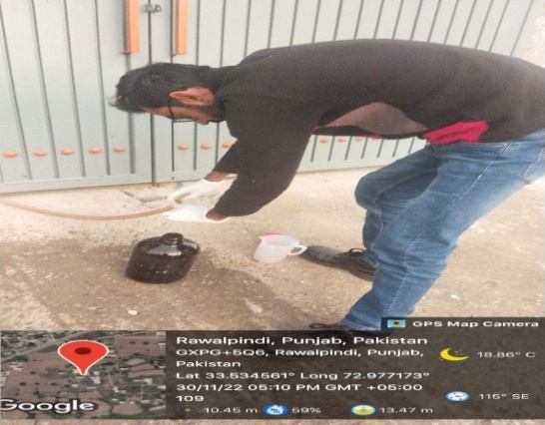
Water Sampling location near water intake and water treatment plant site and IPS Ranial
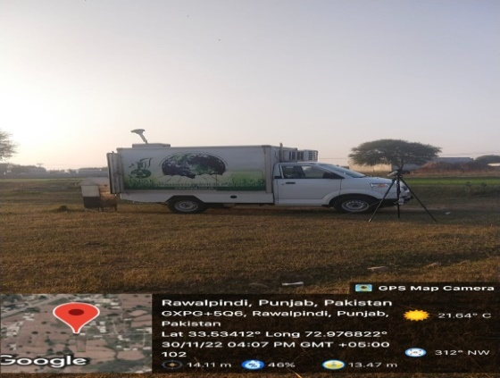 | 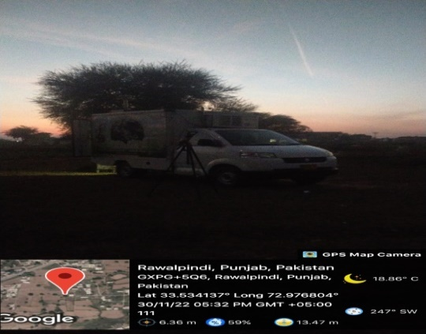
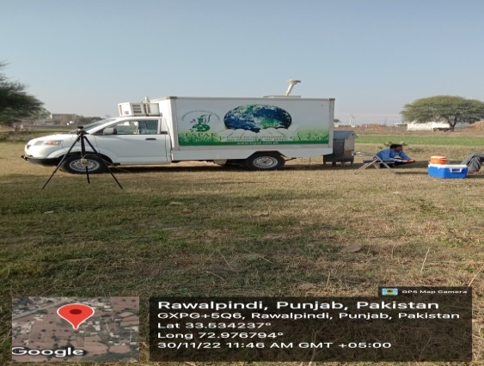 | 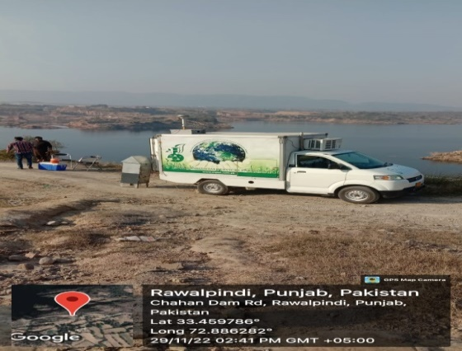
Ambient Air Monitoring location near water intake and water treatment plant site and IPS Ranial
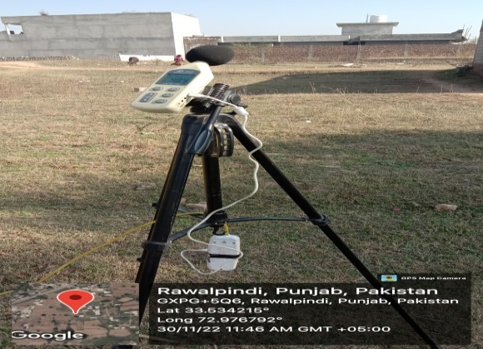 | 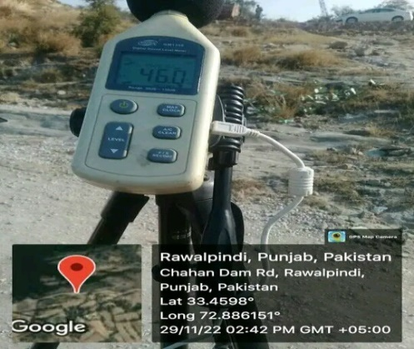
Noise Monitoring location near water intake and water treatment plant site and IPS Ranial
Figure ‎5-11:Sampling location and coordinates

Land use of the Proposed Project
- There are different types of land use i.e. barren / open, built-up, cultivated land, graveyards, green belt, rivers, road/track, stream/ nullah, residential and commercial details structures, trees/ bushes and water ponds etc. Some scattered houses as well as densely populated houses have also been observed along the entire alignment of the project area. Figure ‎5-12 shows the land use around the project site.
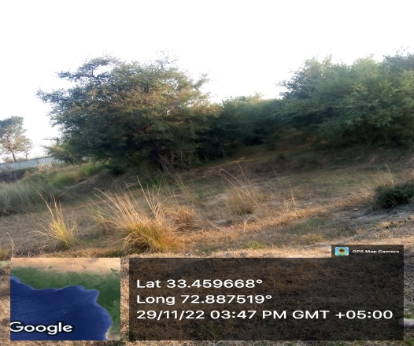 | 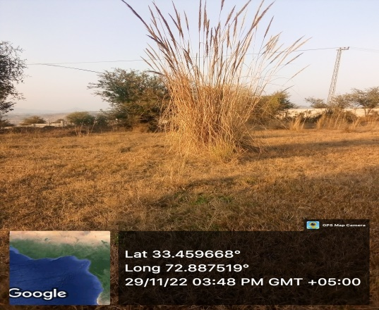
Reserved area for water treatment plant
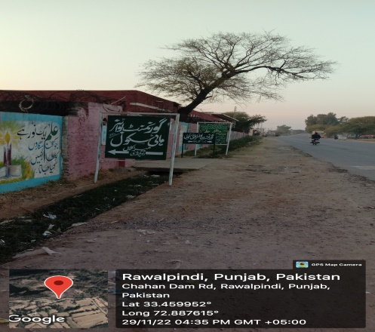 | 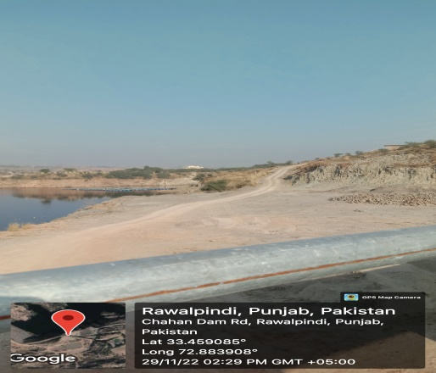
Govt. School at Chahan Dam Road | Chahan Dam Road
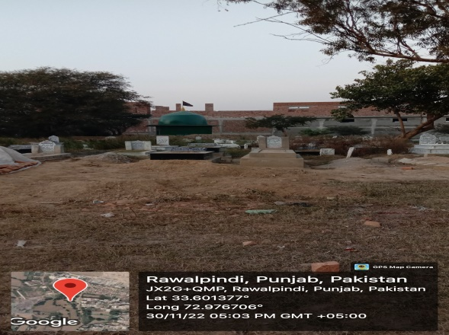 | 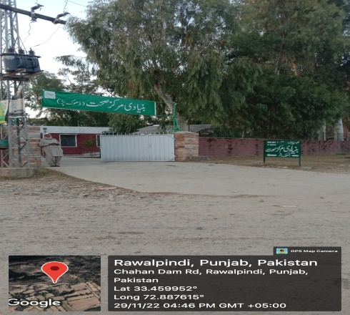
Graveyard near project site | Health center at Chahan Dam Road
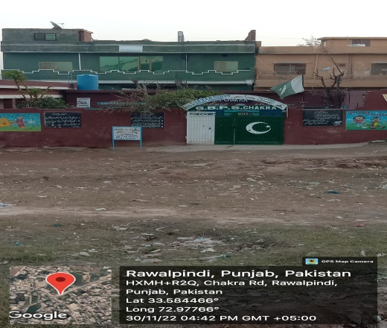 | 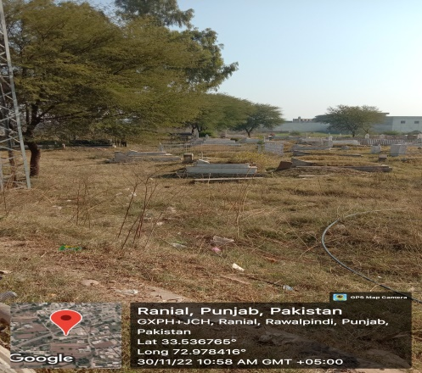
School at Chakra Road | Graveyard in Ranial
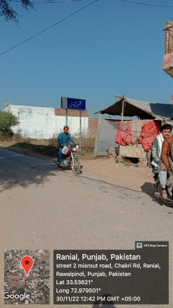 | 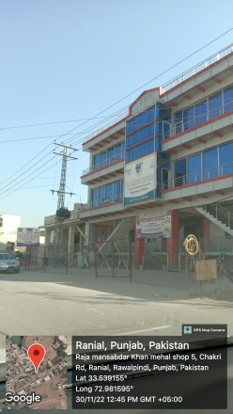
Chakri road
Figure ‎5-12: Land use around the Project Site

Environmental Sensitive Receptors of the Proposed Project
- The sensitive receptors identified for the proposed project within or near the CoI are religious, educational, health care and cultural places etc. They are prone to sensitivity during construction phase, due to emission of air pollutants, noise and vibration, traffic jams/access, temporary edifice of construction camps and mobilization issues. The map of sensitive receptors of the study area is shown in Figure ‎5-13 and Figure ‎5-14. Table ‎5-12 shows the detail of environmental sensitive receptors of the project area.

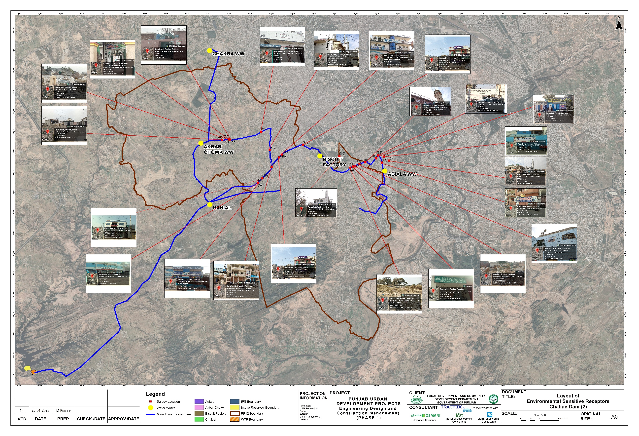
Figure ‎5-13: Environmental Sensitive Receptors Map
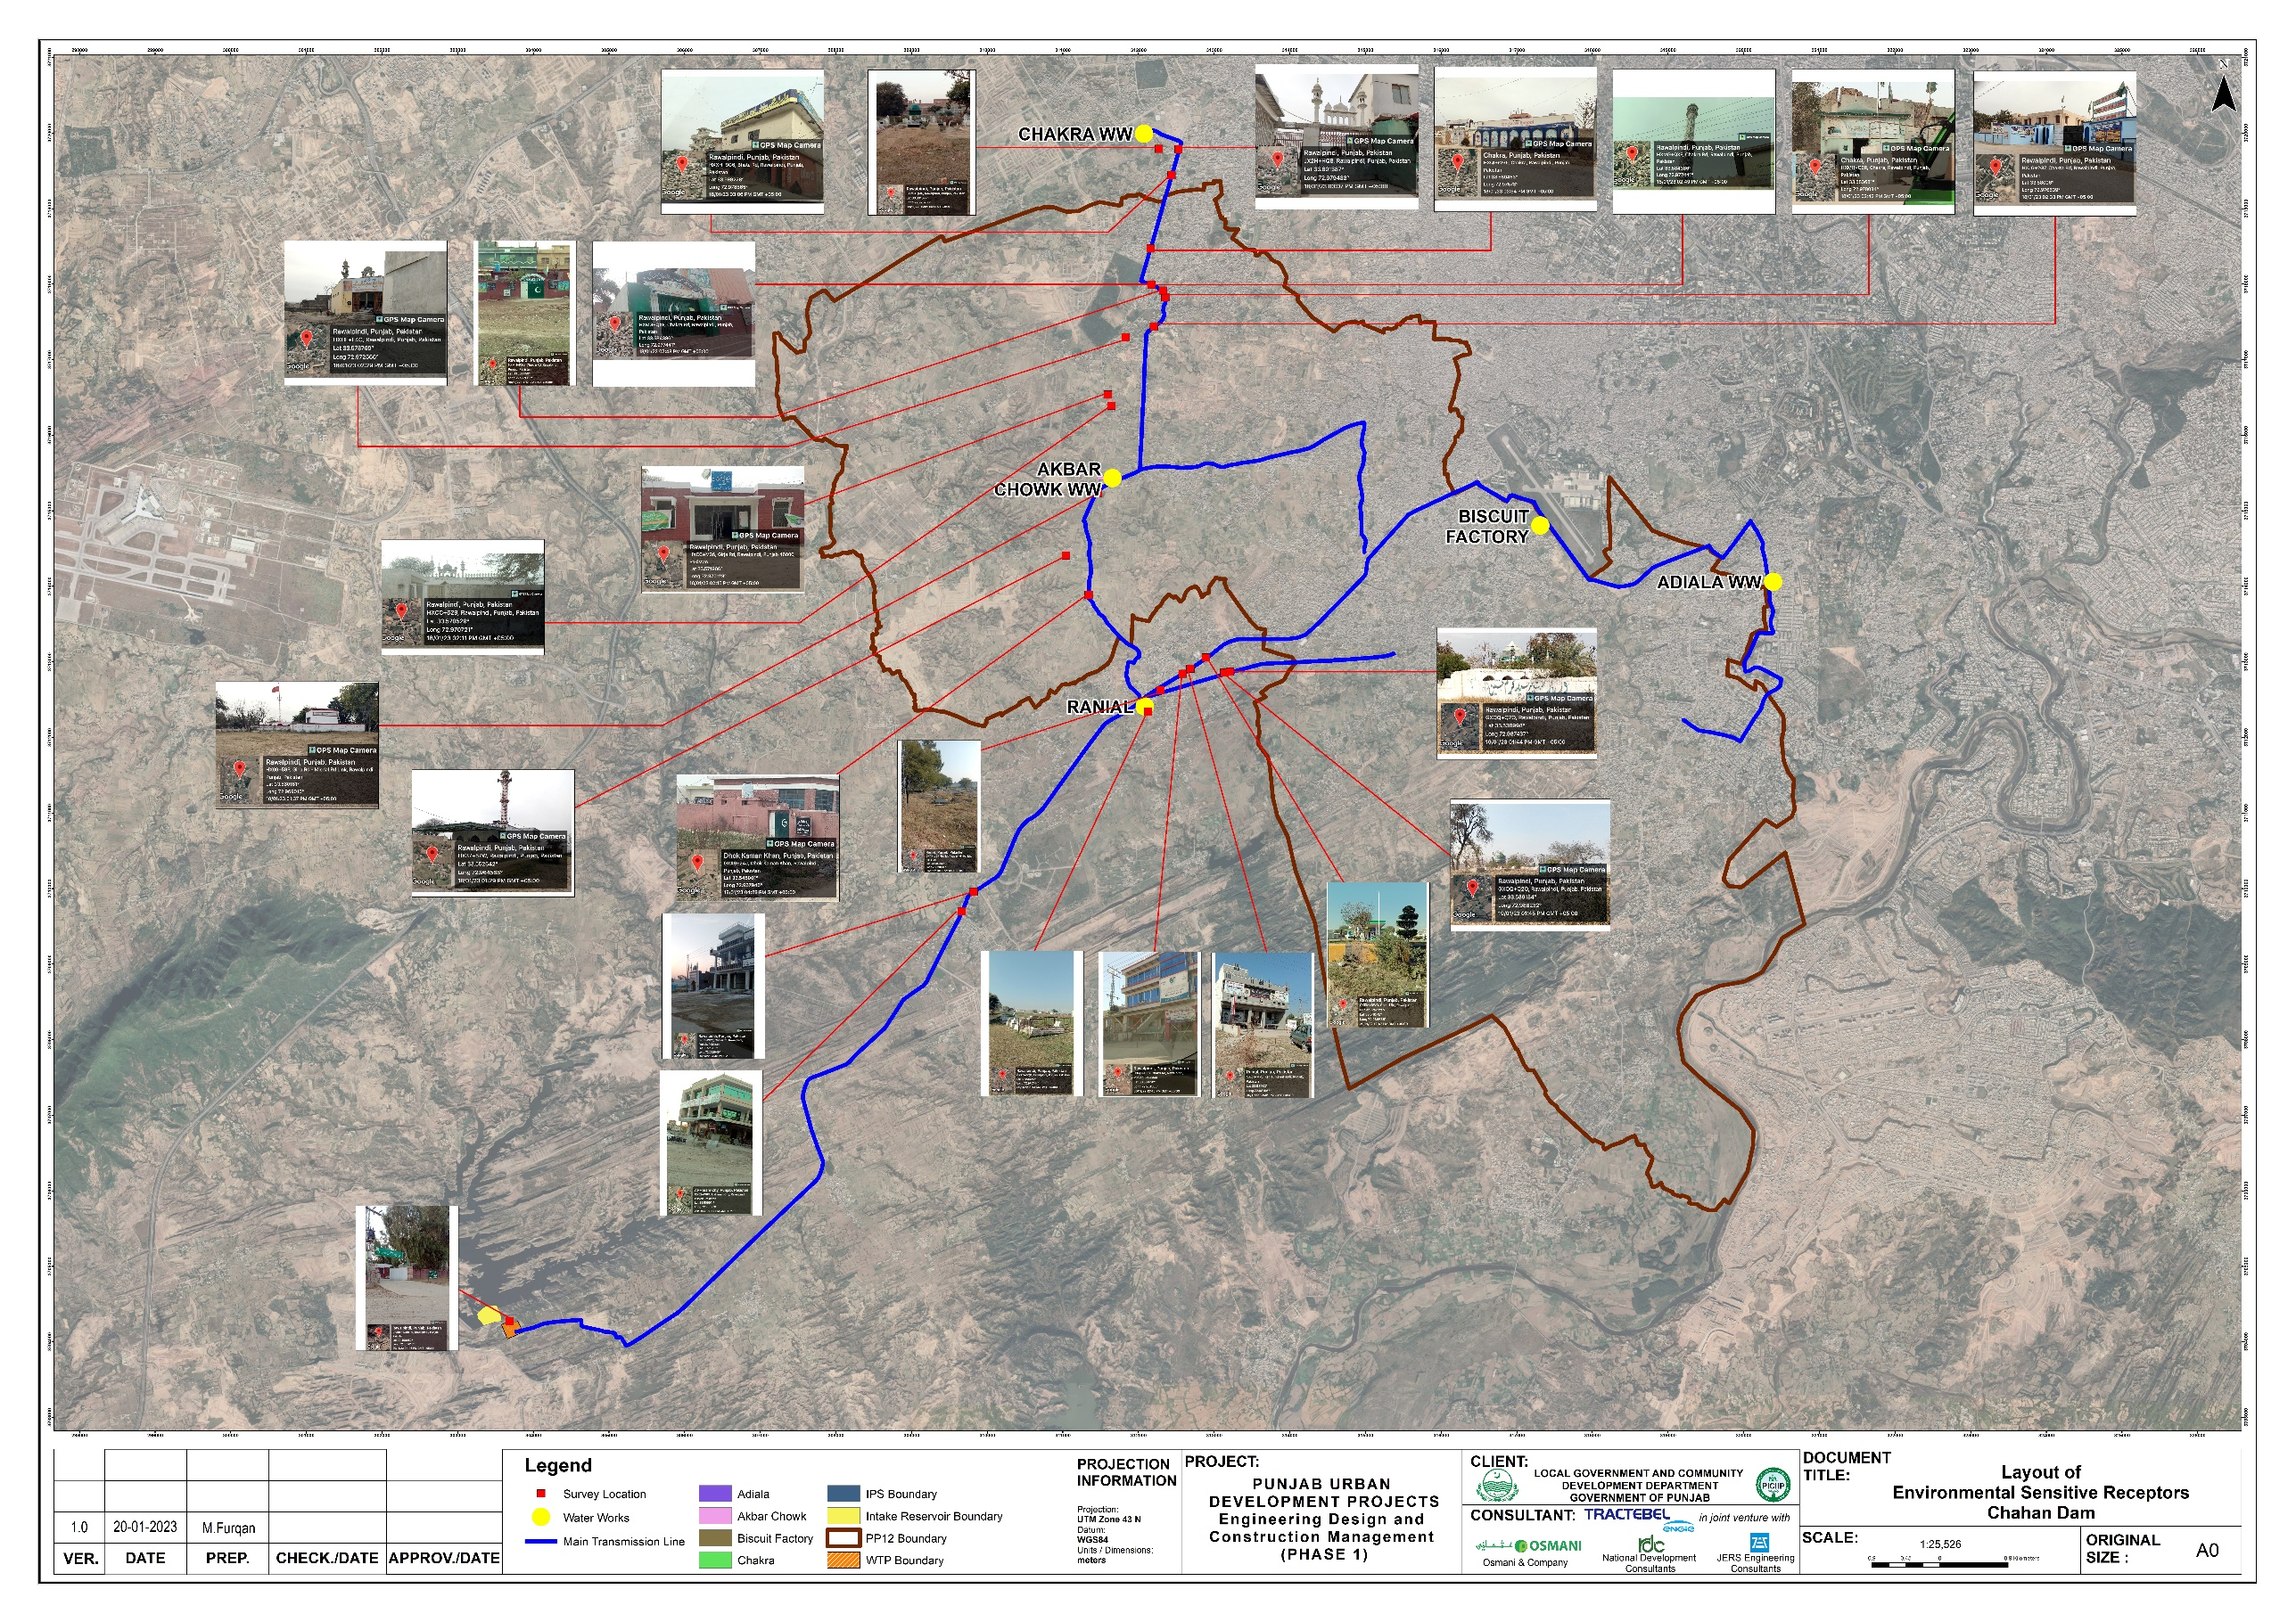
Figure ‎5-14: Environmental Sensitive Receptors

Table ‎5-12: Detail of Environmental Sensitive Receptors
Sr.  No. | Pictorial View | Coordinates | Description | Approx. distance  (meters)
 | 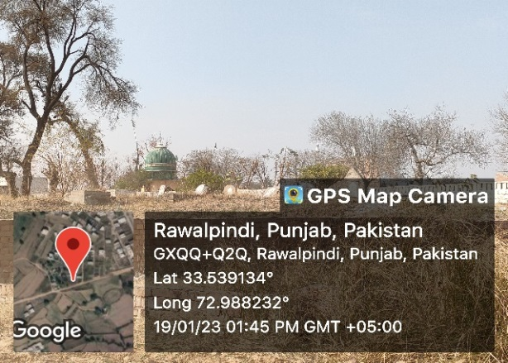 | 33.539134 ° N  72.988232° E | Shrine and  Graveyard | 90
 | 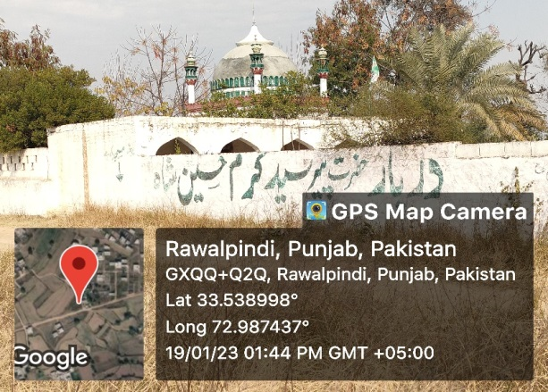 | 33.538998 ° N  72.987437° E | Shrine and  Graveyard | 85
 | 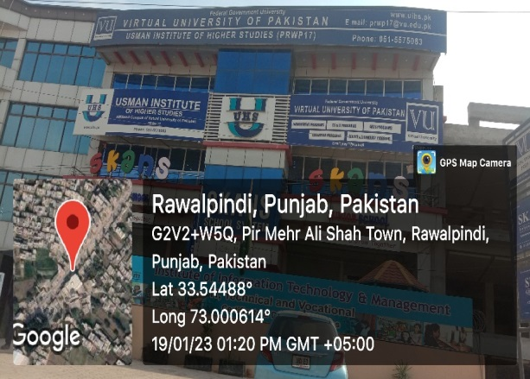 | 33.54488 ° N  73.000614° E | University | 15
 | 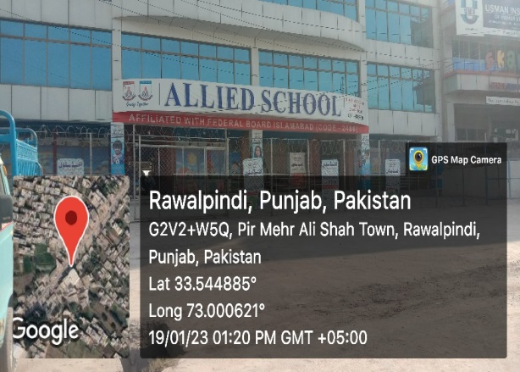 | 33.544885 ° N  73.000621° E | School | 20
 | 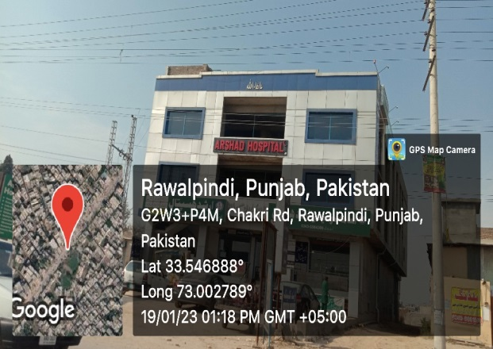 | 33.546888 ° N  73.002789° E | Hospital | 20
 | 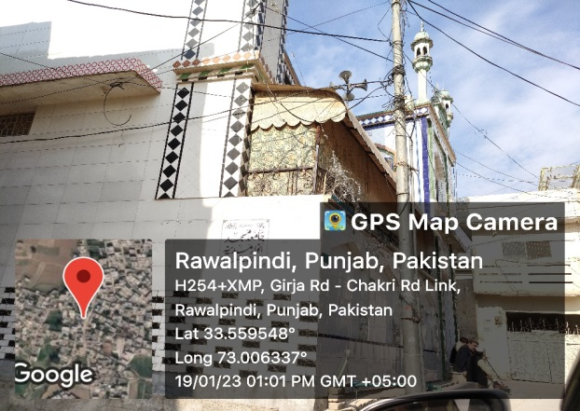 | 33.559548 ° N  73.006337° E | Mosque | 12
 | 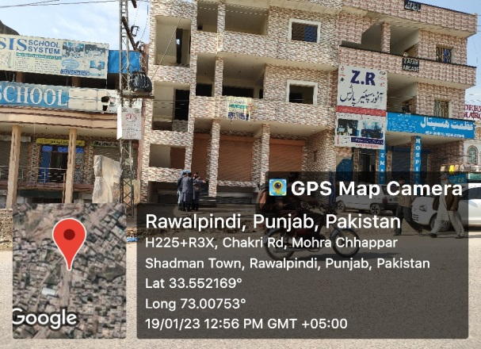 | 33.552169 ° N  73.00753° E | Hospital | 20
 | 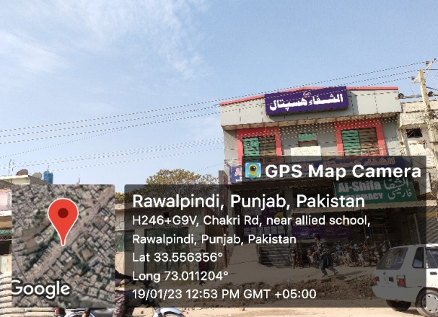 | 33.556356 ° N  73.011204° E | Hospital | 15
 | 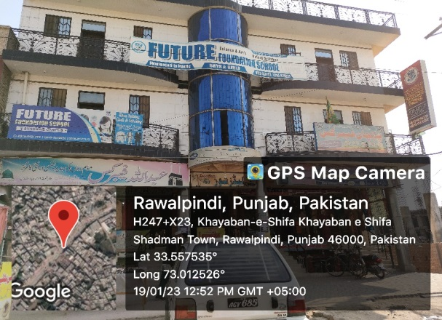 | 33.552169 ° N  73.00753° E | School | 20
 | 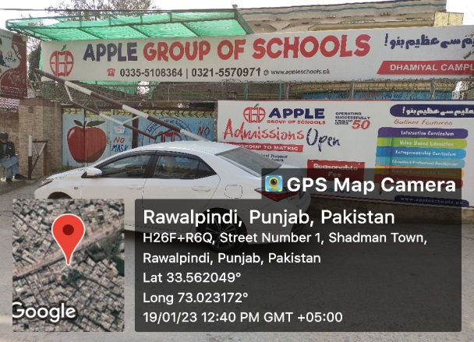 | 33.556356 ° N  73.011204° E | School | 10
 | 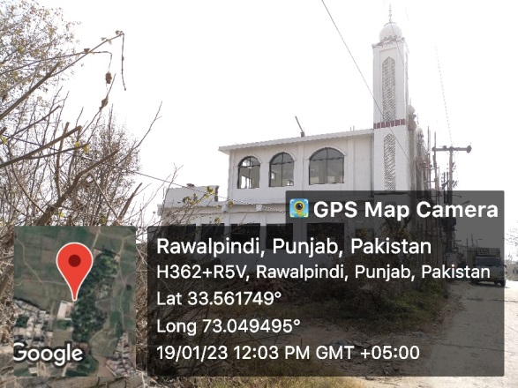 | 33.552169 ° N  73.00753° E | Mosque | 35
 | 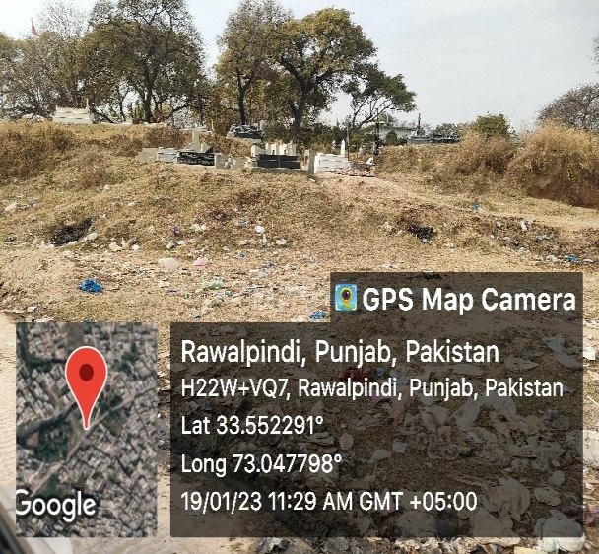 | 33.556356 ° N  73.011204° E | Graveyard | 90
 | 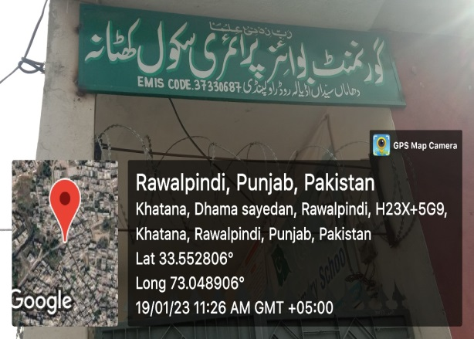 | 33.552169 ° N  73.00753° E | School | 10
 | 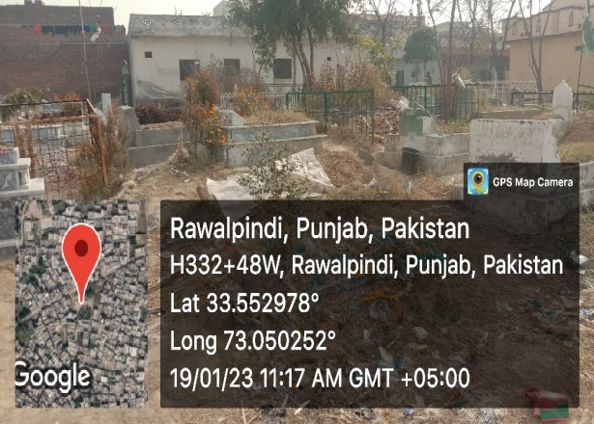 | 33.556356 ° N  73.011204° E | Graveyard | 85
 | 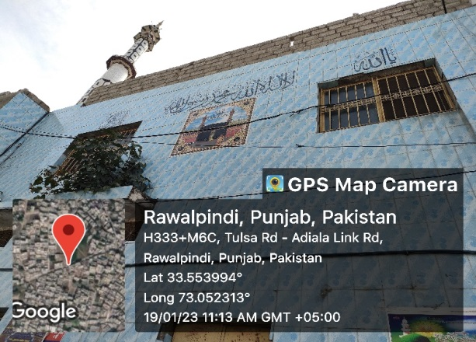 | 33.552169 ° N  73.00753° E | Mosque | 15
 | 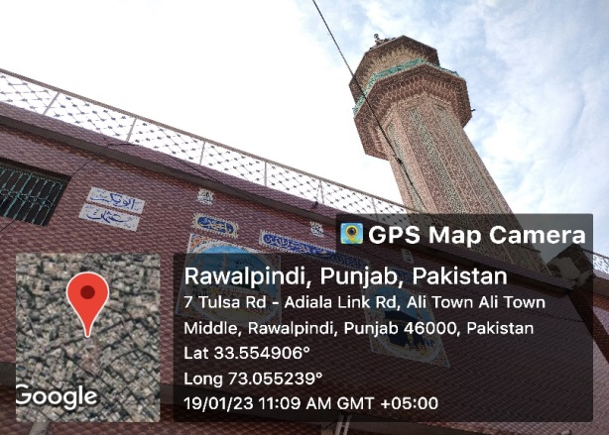 | 33.556356 ° N  73.011204° E | Mosque | 20
 | 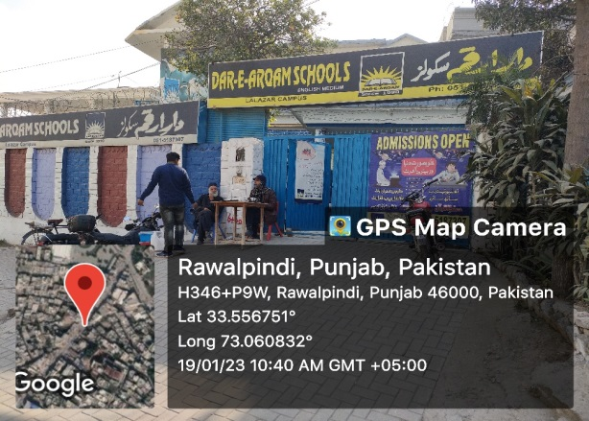 | 33.552169 ° N  73.00753° E | School | 20
 | 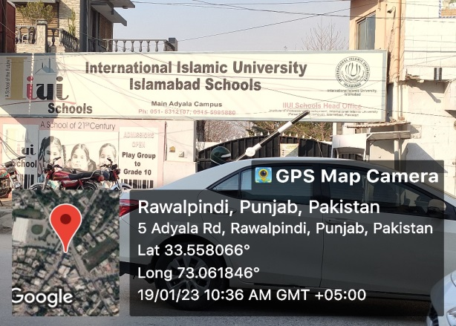 | 33.556356 ° N  73.011204° E | School | 25
 | 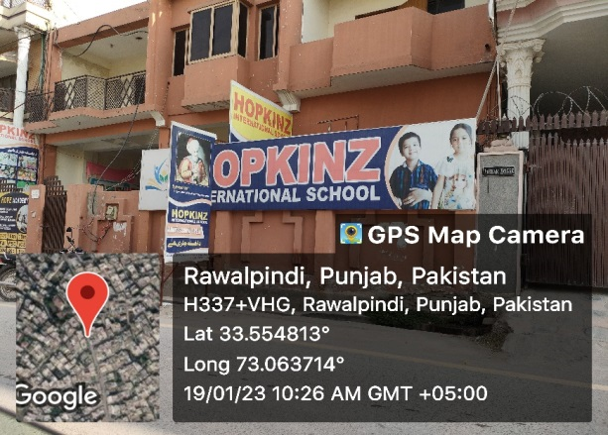 | 33.552169 ° N  73.00753° E | School | 20
 | 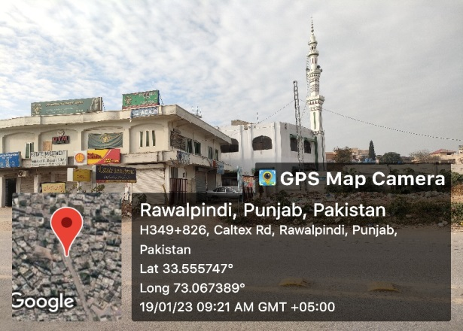 | 33.556356 ° N  73.011204° E | Mosque | 60
 | 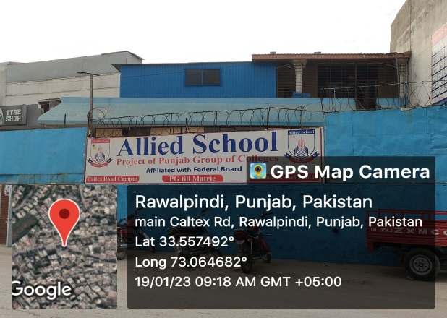 | 33.552169 ° N  73.00753° E | School | 30
 | 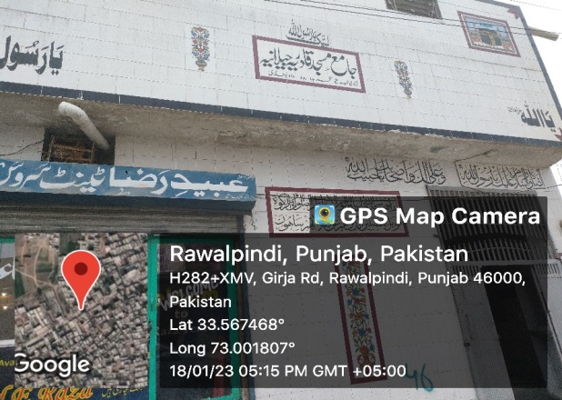 | 33.567468 ° N  73.001807° E | Mosque | 10
 | 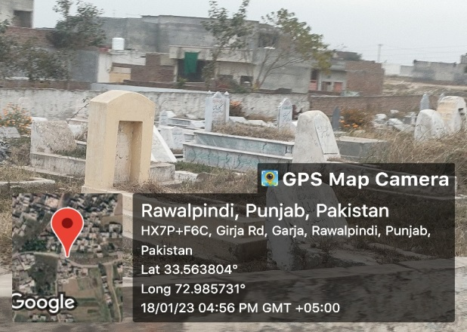 | 33.563804 ° N  72.985731° E | Graveyard
 | 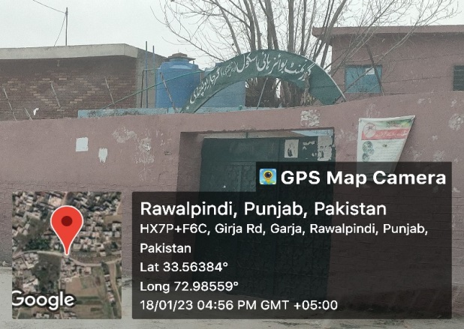 | 33.563884 ° N  72.98559° E | School
 | 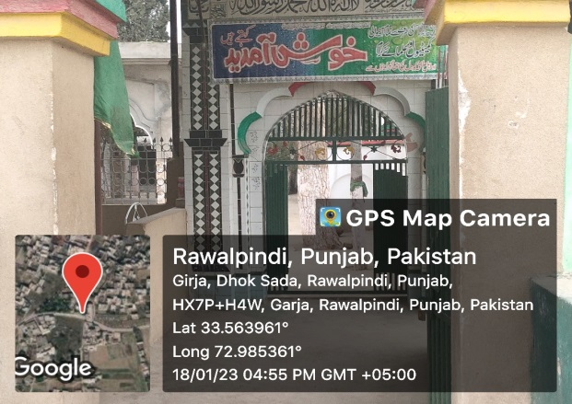 | 33.563961 ° N  72.985361° E | Shrine | 70
 | 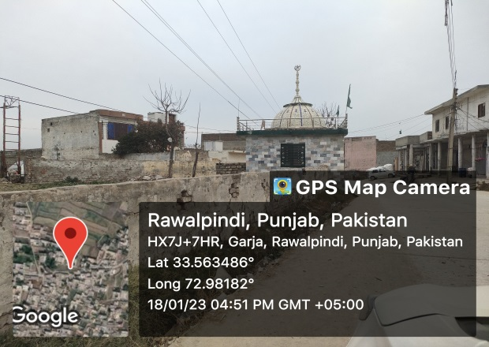 | 33.563486 ° N  72.98182° E | Shrine | 90
 | 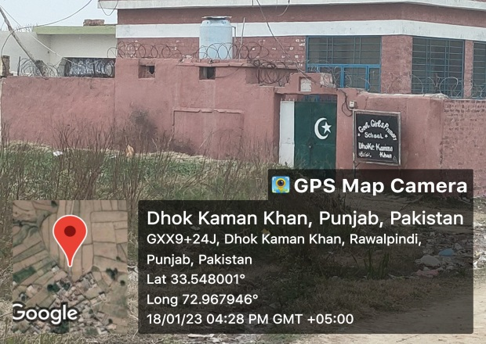 | 33.548001 ° N  72.967946° E | School | 30
 | 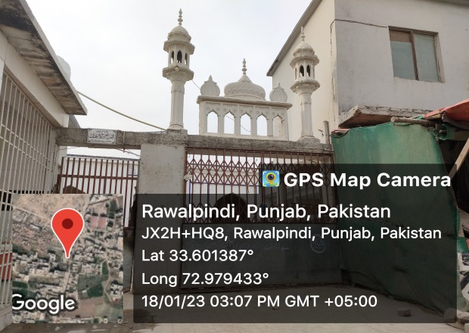 | 33.601387 ° N  72.979433° E | Mosque | 60
 | 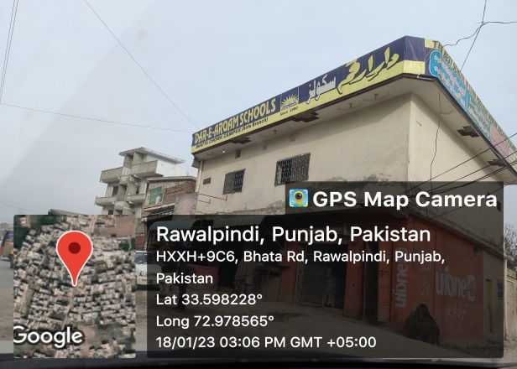 | 33.598228 ° N  72.978565° E | School | 10
 | 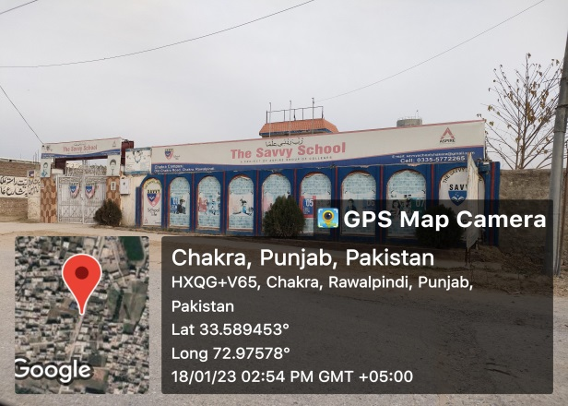 | 33.589453 ° N  72.97578° E | School | 15
 | 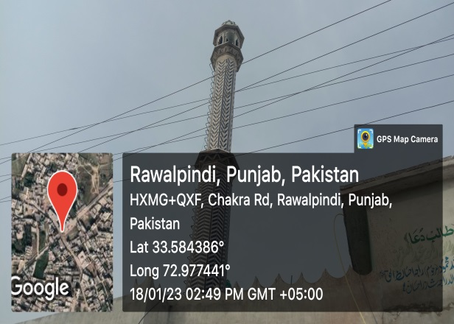 | 33.584386 ° N  72.977441° E | Mosque | 20
 | 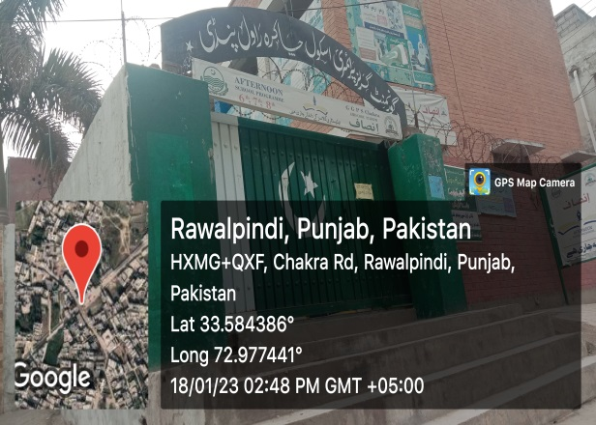 | 33.584386 ° N  72.977441° E | School | 10
 | 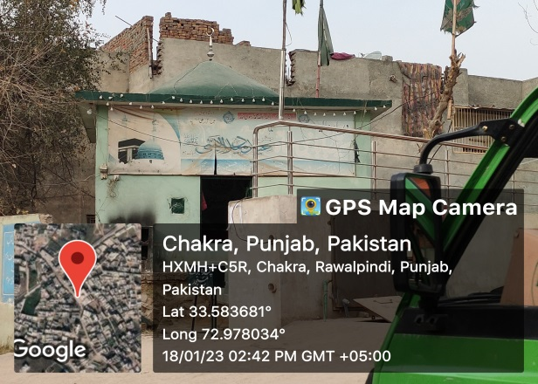 | 33.583681° N  72.978034° E | Shrine | 50
 | 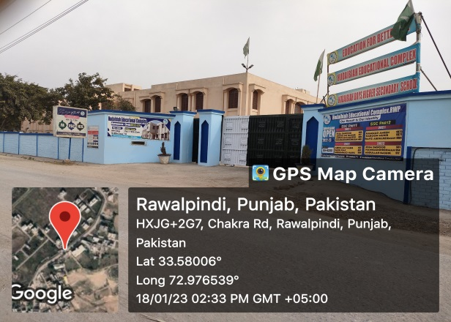 | 33.58006 ° N  72.976539° E | School | 20
 | 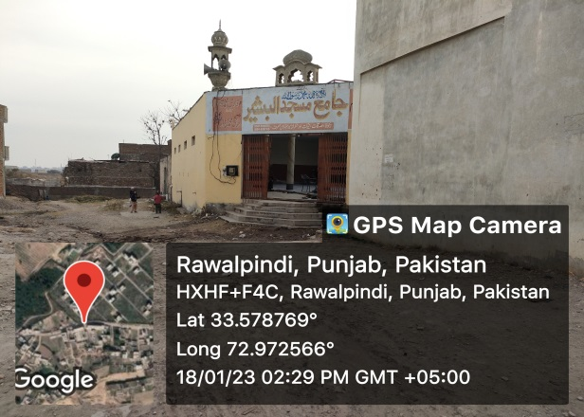 | 33.578769 ° N  72.972566° E | Mosque | 20
 | 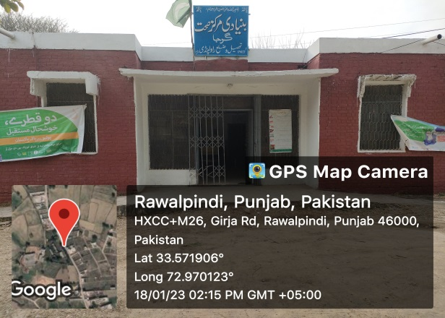 | 33.511906 ° N  72.970123° E | Basic Health Unit | 40
 | 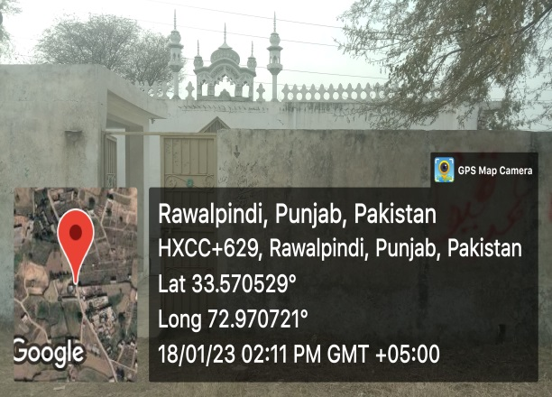 | 33.570529 ° N  72.970721° E | Mosque | 90
 | 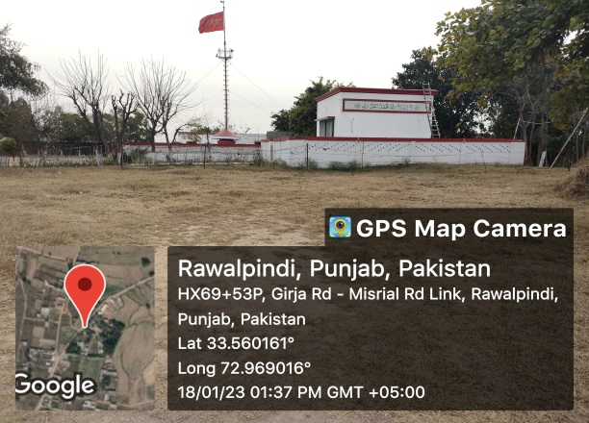 | 33.560161 ° N  72.969016° E | Shrine | 90
 | 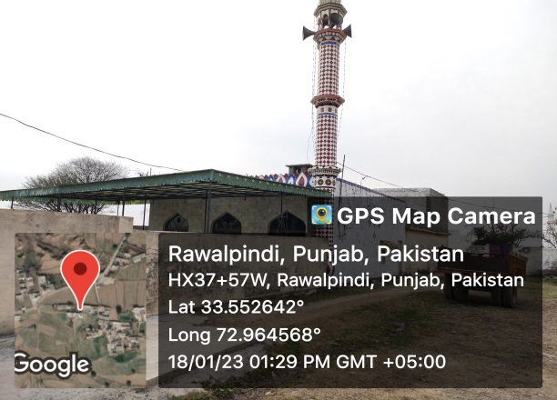 | 33.552642 ° N  72.964568° E | Mosque | 50
 | 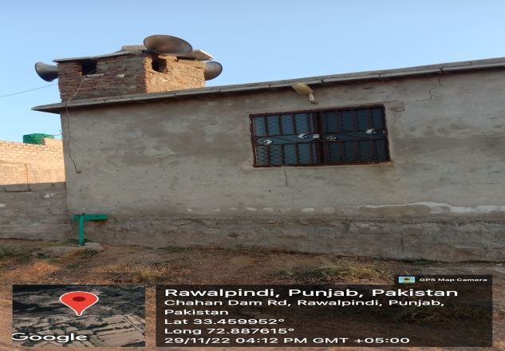 | 33.273583 ° N  72.531540° E | Mosque | 30
 | 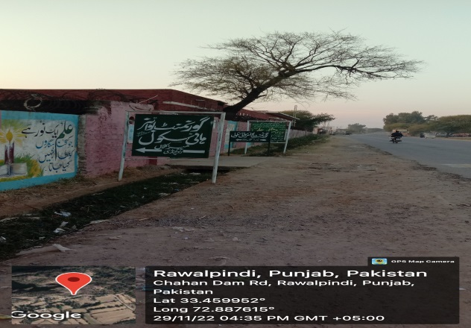 | 33.273583 ° N  72.531540° E | School | 10
 | 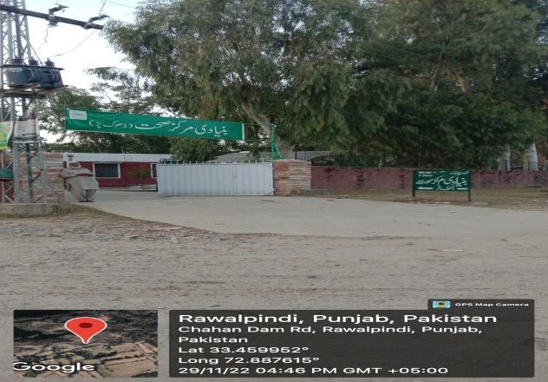 | 33.459952 ° N  72.887615° E | Basic Health Unit | 20
 | 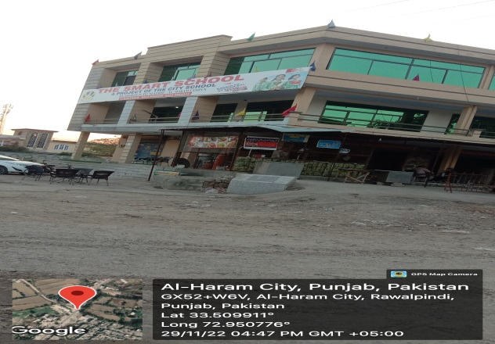 | 33.509911 ° N  72.950776° E | School | 20
 | 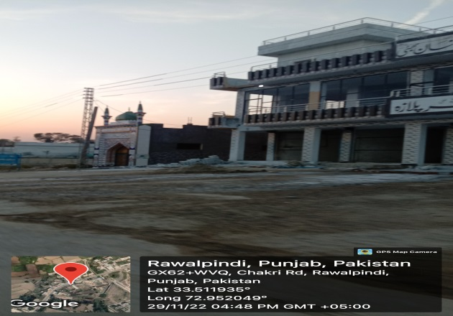 | 33.511935 ° N  72.952049° E | Mosque | 30
 | 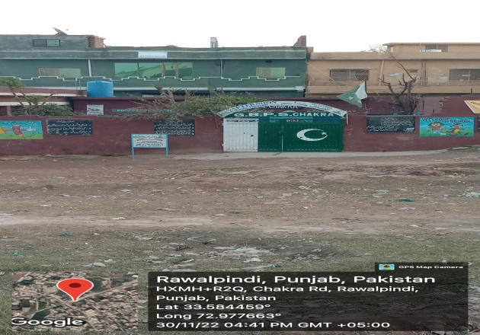 | 33.584459 ° N  72.977663° E | School | 20
 | 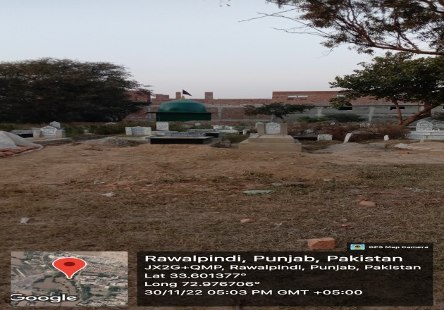 | 33.601377 ° N  72.976706° E | Shrine & Graveyard | 60
 | 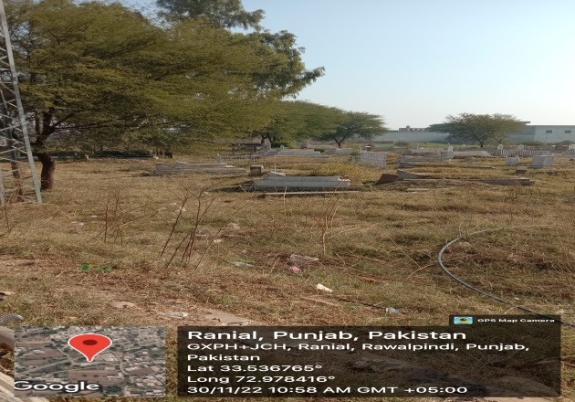 | 33.536765 ° N  72.978416° E | Graveyard | 70
 | 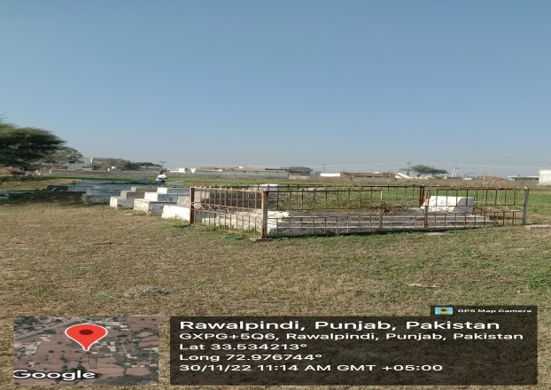 | 33.534213 ° N  72.976744° E | Graveyard | 90
 | 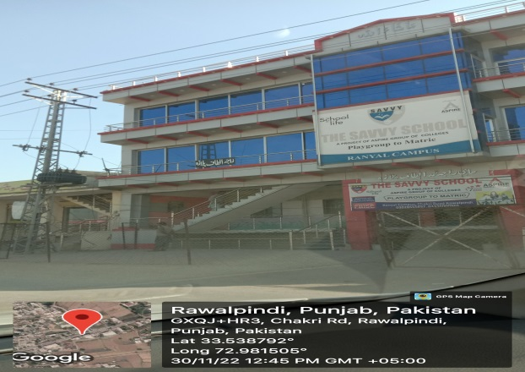 | 33.538792 ° N  72.981506° E | School | 20
 | 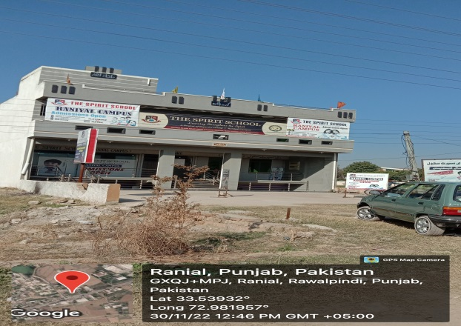 | 33.53932 ° N  72.981957° E | School | 20
 | 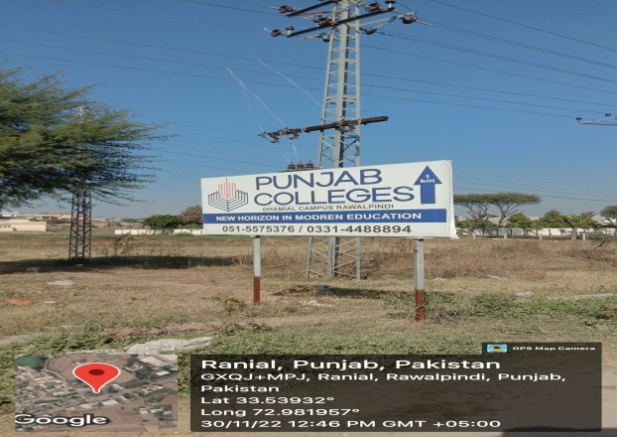 | 33.53932 ° N  72.981957° E | College | 100

Ecological Environment

Methodology
- The ecological data was collected through primary survey, during the field visit of the project site and secondary survey (desktop study). Ecological features of project area were identified and recorded including the faunal and floral species. During primary survey, the available literature was thoroughly reviewed to have a better understanding of the project area and its surroundings including habitat, flora and fauna. The route alignment was thoroughly examined based on the primary and secondary (Flora of Pakistan-MI-Sheikh, Birds of Pakistan-ZB-Mirza-Mammals of Pakistan-TJ Roberts, Previous EIAs of the proposed area, Manual of silviculture for Pakistan [1965] Champion, Sir H.G.; Pakistan Forest Inst., Peshawar eng; Seth, S.K. Khattak, G.M.) data. The stakeholder Forest, Wildlife, EPA, Fisheries and Agricultural departments were also consulted. This survey broadly covers ecosystem sensitivities (If any), vegetation, other flora and fauna. Number of trees along RoW/CoI and in the project vicinity was recorded which includes mostly pole crops.

Ecosystem
- The climate of the project area has a typical version of humid subtropical and dry climate, with five seasons. The study area majorly lies in sub-tropical scrub zone. The dominant trees species of this natural zone are, Kau (Olea ferruginea), Phulai (Acacia modesta) and sanatha (Dodonaea viscosa).
- In order to improve the landscape and living environment of Rawalpindi, traits like color or blossom, shade, form or shape, scent and free from disease and nuisance have been considered during the selection of trees and shrubs for the given locations. So, the study area in general is under significant biotic pressure and under retrogression due to various factors such as unsustainable practices, Natural hazards causing the habitat loss, soil erosion and lack of proper functioning of ecosystems. Areas have been accessible to humans for a long time, resulting in low diversity and wildlife abundance.

Flora
- As climate of study area is subtropical, the vegetation of the area falls under subtropical broad leaved evergreen scrub type as per phyto-geographical classification of the area. The tract in which the project site exists, was once covered with native vegetation consisting, of trees and thick cover of bushy vegetation, with the onslaught of civilization, this vegetation was cleared for agricultural purposes.
- As the project area is part of the Potohar plateau, the vegetation is characteristic of that tract. Kau (Olea cuspidata) is the climax species. However, in the project and the study area, Phulahi (Acacia modesta) and Kikar (Acacia nilotica) dominate. Shisham (Dalbergia sissoo), Mesquit (Prosopis juliflora) and Paper Mulberry (Broussonetia papyrifera) have also grown as secondary species with Phulahi. With the onslaught of civilization and urbanization of the tract, the original vegetation in and around the tract was removed and replaced by agricultural lands, which is the dominant land use in the tract. Figure ‎5-15 shows the dominant tree species present in the project area.

Figure ‎5-15 Floral profile of project area

- 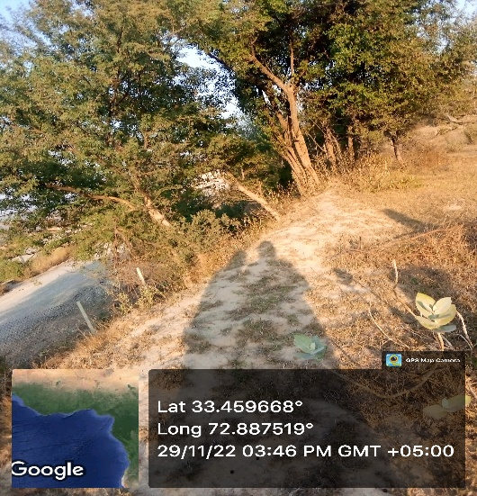 | - 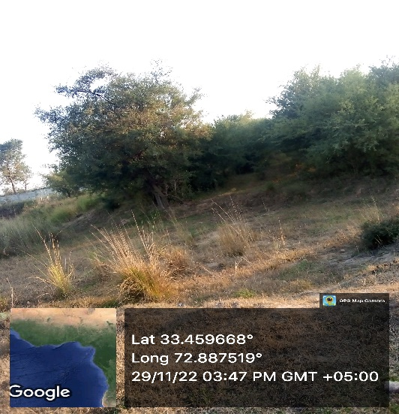
- 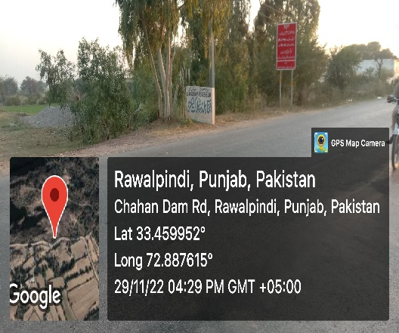 | - 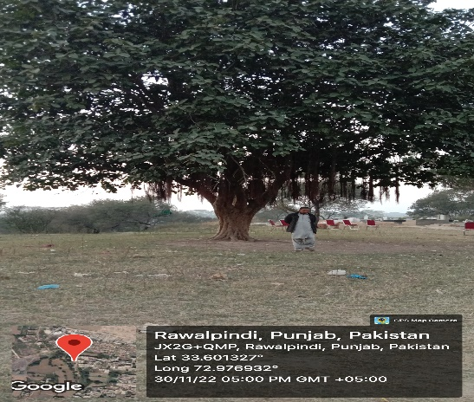
- 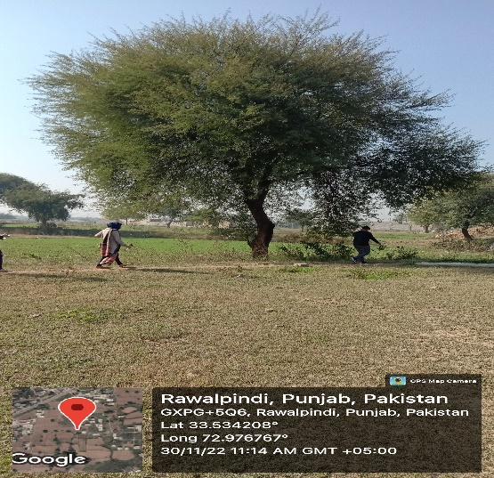 | - 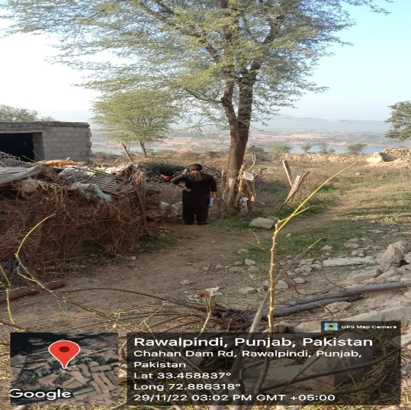
- The present ecological conditions of the project area fall in the category of agricultural and degraded land. The project area is designated as agriculture area, so no green developmental activates were considered in the past to improve its ecological balance in the targeted area.
- The detail of vegetative species of the region are given in Table ‎5-13 below:

Table ‎5-13: Names of Trees/shrubs & Herbs of the Region
Sr. No. | Common Name | Scientific Name
1 | Banyan/Bhor | Ficus benghalensis
2 | Phulai | Acacia modesta
3 | Wild olive | Olea ferruginea
4 | Sanatha | Dodonaea viscosa
5 | Dhak | Butea frondosa
6 | Anar | Punica granatum
7 | Pear | Pyrus pasha
8 | Sukh Chain | Pongamia pinnata
9 | Amaltas | Cassia fistula
10 | Bottle Brush | Callistemon spp
11 | Jasmine | Jasminum humile
12 | Holmskioldia | Holmskiodia sanguine
13 | Beri | Zizyphus mauritiana
14 | Royle's Spike Thorn | Gymnosporia royleana
15 | Baikarh | Adhatoda vasica
16 | Zebrawood | Pistacia integerrima
17 | Poplar | Populus sp.
18 | Devil tree | Alstonia scholaris
19 | Bougainvillea | Bougainvillea spectabilis
20 | Sukh chain | Pongamia pinnata
21 | Dharek | Melia azedarach
22 | Eucalyptus | Eucalyptus camaldulensis
Source: TAS for LAI Expressway Project, 2022

Agriculture and Crop Pattern
- Agricultural holdings are small and on average are about 5 to 10 kanals per family. There are generally two crops in a year. Rabi crop is followed by a Kharif crop and then the land lies fallow for a year until the Rabi sowing and this system is locally known as Do-Fasli Do-Sala. Wheat, bajra and maize are the common crops with the principal crop during Rabi being wheat and Jawar, maize and fodder are the main crops of Kharif. There are no fruit orchards in the project area. Apart from the wheat crops, whatever area is available is used for growing fodder crops for stall feeding of livestock. Figure ‎5-16 depicts the agricultural and crop patterns of the project area.
- The use of improved agricultural implements and fertilizers is not very common except for cash crops like potatoes and orchards.

Figure ‎5-16 Agriculture and Crop Patterns in project area
- 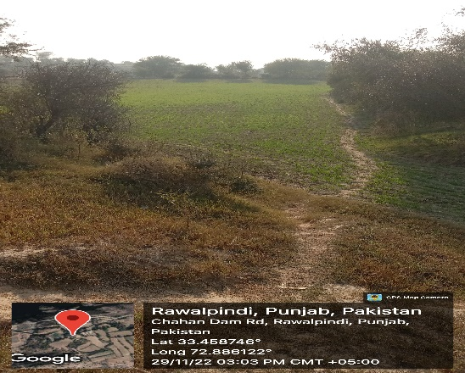 | - 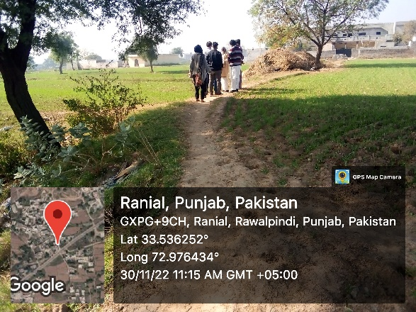
- 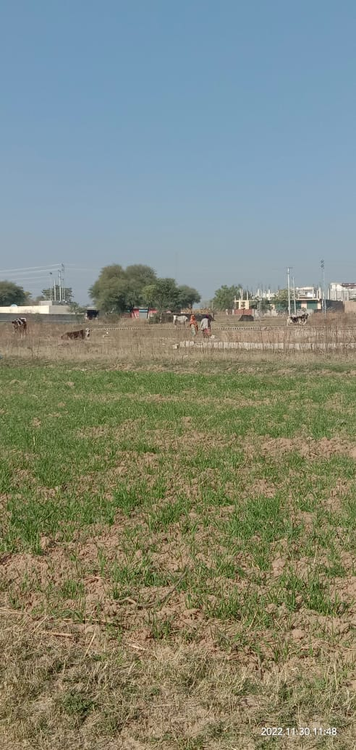 | - 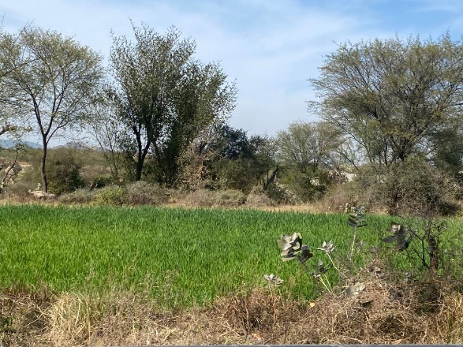

Fauna/Wildlife
- The project area on account of nature of vegetation and topography, once rich in vegetation and wildlife, has now reduced its potential due to over hunting, loss of proper habitat and conversion of forest land. The wild mammals were not spotted commonly, although domestic mammals were found to be common in the study area. Fauna of the tract consists of mammals, reptiles, amphibians and birds and the details are provided below.

Mammals
- The study area was once considered as good habitat to many wild species but due to expansion of population and commercialization, the habitats of many species are declared as degraded. Figure ‎5-17 shows some of the mammal species of project area.
- However, there is no wild mammalian specie observed in the project area except some domesticated animals including cats, dogs, cattle etc.

Figure ‎5-17 Mammal Species present around the project site
- 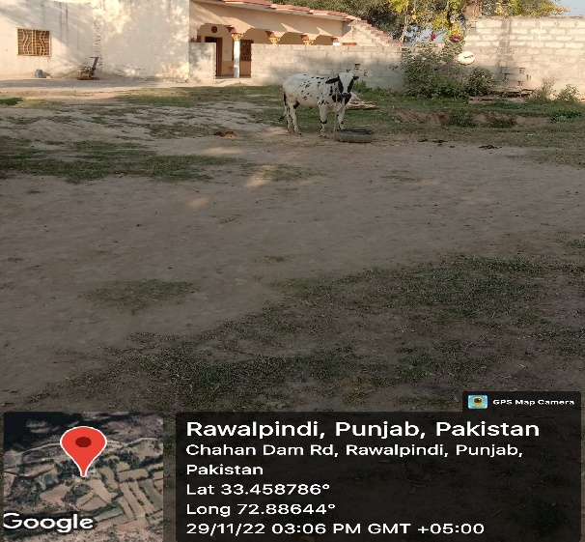 | - 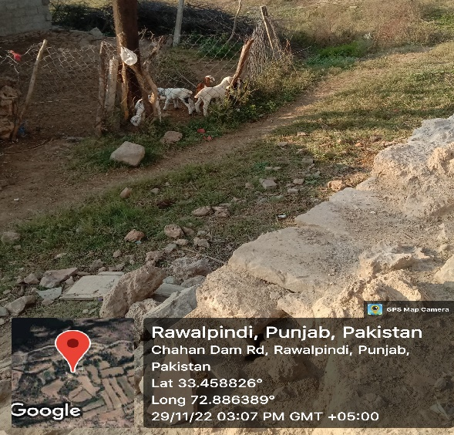
- 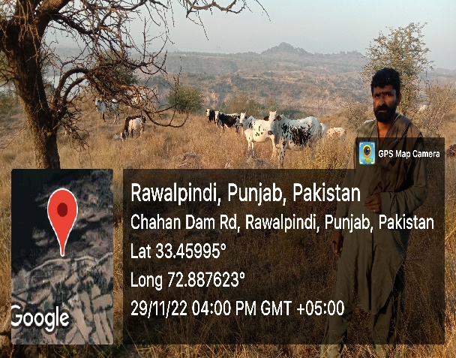 | - 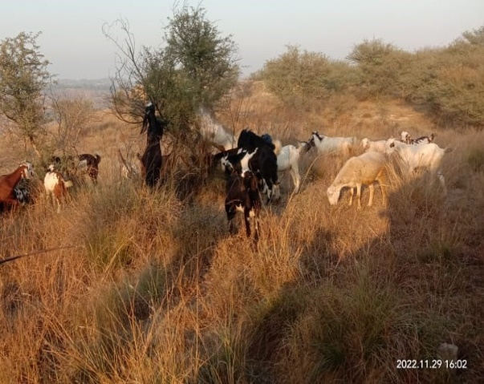
- The Table ‎5-14 shows the list of mammalian species present in the region, as the project area is to be considered highly degraded in terms of wild fauna. Jackals are quite common while foxes are also common and the piercing bark of the fox is usually heard in the hills while wild boars are quite common.
Table ‎5-14: List of indigenous Mammals
Sr. No. | Mammals | Scientific Name | IUCN Status
1 | Jackal | Canis aureus | LC
2 | Fox | Vulpes vulpes | LC
3 | Jungle Cat | Felis chaus | LC
4 | Palm Squirrel | Funambulus palmarum | LC
5 | Mongoose | Herpestes auropunctatus | LC
6 | Indian mole rat | Rattus rattus | LC
7 | Field mouse | Funambulus pennant | LC
8 | Porcupine | Hystrix indica | LC
9 | Rabbit | Oryctolagus cuniculus | EN
10 | Cape hare | Lepus capensis | LC
11 | Masked palm civet | Paguma larvata | LC
12 | Wild boar | Sus scrofa | LC
Source: TAS for LAI Expressway Project, 2022
LC = Least Concern
EN = Endangered

Amphibians

- The amphibians that are found near or around the project area are given in the
- Table ‎5-15 below.
Table ‎5-15: Amphibians of the Study Area
Sr. No. | Local/ English Name | Scientific Name | IUCN Status
1 | Common frog | Rana tigrine | LC
2 | Common toad | Bufo bufo | LC
3 | Marble frog | Uperodon systoma | LC
Source: TAS for LAI Expressway Project, 2022
LC = Least Concern

Fisheries and other Aquatic Life

- The Chahan dam has controlled fish farms. During the primary site survey, the information was gathered related to the species of available fish in the dam and the main fish available includes Rahu, Thaila, Grass Carp and Silver Carp. There are some other species of fish available which were managed in the floating fish farm. The representative of fisheries department stated that no endangered or threatened species of fish or other aquatic life is present in Chahan dam. It is also important to mention here that the construction of Chahan dam has been recently completed and the ecosystem of Chahan dam is still in the development phase.

Reptiles

- The study supports a good variety of reptiles. In the project area, the most common reptile worth mentioning and is occasionally witnessed by the hikers is Monitor Lizard. These are generally large reptiles, although some can be as small as 12 centimeters in length. They have long necks, powerful tails and claws and well-developed limbs.
- The reptiles that are found near or around the study area are given in the Table ‎5-16.
Table ‎5-16: Reptiles of the Study Area
Sr. No. | Local/ English Name | Scientific Name | IUCN Status
1 | Fringed toed Lizard | Acanthodactylus cantoris | LC
2 | Spiny tailed Lizard | Uromastyx hardwickii | VU
3 | Common Krait | Bungarus caeruleus | LC
4 | King Cobra | Ophiophagus Hannah | VU
5 | Viper | Vipera xanthina | LC
Source: TAS for LAI Expressway Project, 2022
LC = Least Concern
VU = Vulnerable

Birds – Avifauna

- Many bird species have been reported in and around the study area. These include passage migrants, vagrant, resident, breeding and irregular visitors. The migratory birds descend from higher altitudes during the winter months. However, no migratory birds were sighted and reported during the site visit. Further, as the construction of Chahan dam has just been recently completed, therefore only local avifauna exist. Avifauna of the tract consists of small and medium sized birds of different colors, flying from one tree to the other or from crop to crop. Most common birds are House Sparrow, House Crow and Mynah. Birds like Cuckoo, Bulbul, Hoopoe, Parrots, Blue Birds, and Little Egrets etc. were frequently sighted. The common birds observed and reported in the study area are given in Table ‎5-17 below:
Table ‎5-17: Birds Found in Study Area
Sr. No. | Common Name | Scientific Name | IUCN Status
1 | Rock Pigeon | Columba livia | LC
2 | Myna | Acrido therestritis | LC
3 | Grey Partridge | Perdix perdix | LC
4 | House Sparrow | Passer domesticus | LC
5 | Red-billed chough | Pyrrhocorax pyrrhocorax | LC
6 | Magpie | Pica pica | LC
7 | Yellow-Billed Chough | Pyrrhocorax graculus | LC
8 | Spotted doves | Spilopelia chinensis | LC
Source: TAS for LAI Expressway Project, 2022
LC = Least Concern

Wetlands
- There are no designated wetlands falling in the project area.

Protected Areas (Game Reserves/ Wildlife Sanctuaries/Reserve Forests)
- There is no Game Reserve, Reserve Forests and/or wild sanctuaries reported in the project alignment. Further, distance of nearest forests from project sites is given in Table ‎5-18. It is important to mention here that none of the forests are located within a 5 kilometer radius of the project location. Therefore, no impact is anticipated due to the proposed interventions as the project area is far away from the boundary of below listed forests. Figure ‎5-18 shows the aerial distance of the nearest forests.
Table ‎5-18: Forests located near the project area
Sr. No. | Name | Area (Acre)
1 | Takhar Pari Forest | 2,210
2 | Khairi Murat Reserved Forest | 12,680
3 | Dhungi Reserved Forest | 4,746
4 | Adiala Reserved Forest | 1,330

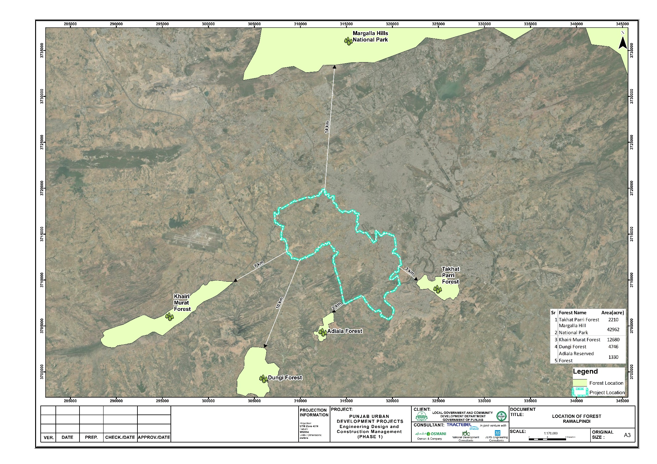
Figure ‎5-18: Distance of Proposed project from nearest Forest

IBAT Study
- The Integrated Biodiversity Assessment Tool (IBAT) has been used to identify the presence of endangered and threatened species of flora and fauna in the study area. Screening was carried out for the species that are located within the buffer zone of 1 km, 3 km and 5 km. From the results of IBAT, it is evident that no endangered or threatened species of flora and fauna are present in the project area. The findings of IBAT study are present in Figure ‎5-19 and the complete IBAT report is attached as Annexure-IV

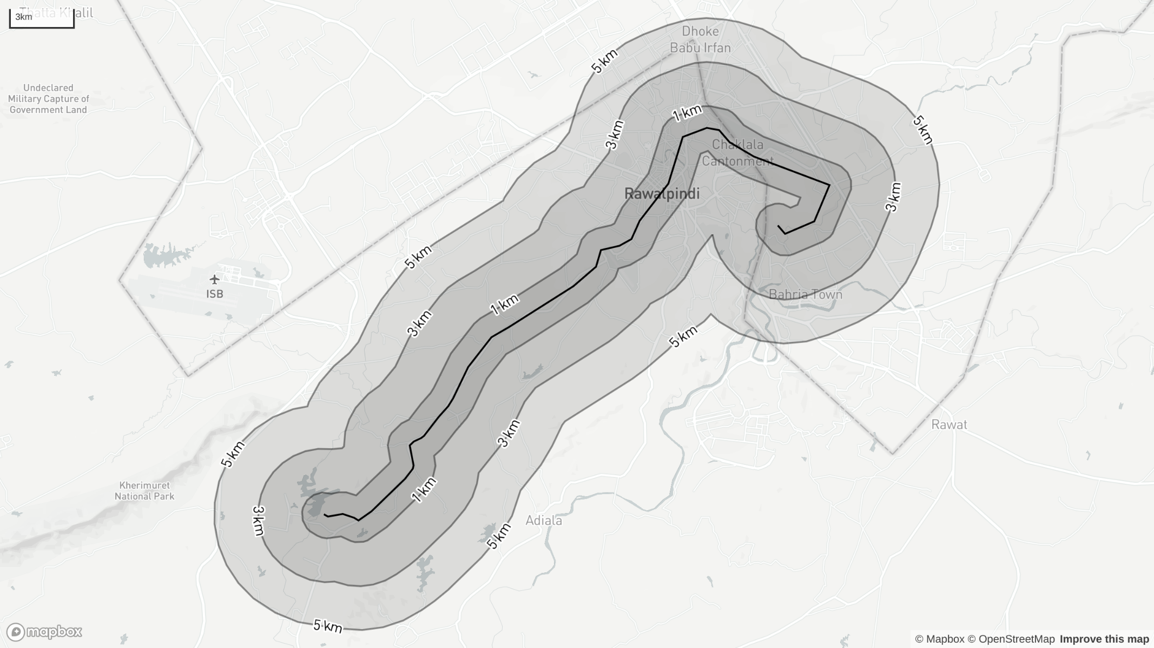
Figure ‎5-19:Results of IBAT study

Socio-economic Environment
- This section includes a summary of the prevailing socio-economic conditions in the project area and the population that will be potentially affected by the project. To ascertain the socio-economic condition of the project area, primary and secondary data was collected, including social and physical infrastructure in the project area.
- To assess the socioeconomic conditions of the project area, consultations are being carried out with participants in the area. Households has been studied during field survey based on individual interviews as well as focus group discussions/ public consultations. Consultation participants include project affected people and community residing along the project route. In addition, the secondary data, including Economic Survey of Pakistan (2018-19), Bureau of Statistics (2017-18) and District Population Census report.
- Detailed surveys were conducted for project scoping during the month of December 2022. For the purpose of the environmental and social assessment and sensitive receptor data collection, a CoI of 100 meters was taken. Most of the field data collection was carried out within this corridor though where relevant data was also collected from a wider area along the proposed project site. The reason for selecting this corridor is to cover those areas that have a potential to be affected by the project activities.
- The names of the major settlements falling within the close vicinity of project area are Rawal Town, Orchard Scheme, Dhoke Kala Khan, Satellite Town, Asghar Mall Scheme, Shamsabad, etc. Figure ‎5-20 shows socioeconomic conditions of the area.

Administrative Setup
- The proposed project components are located in two territories, Rawalpindi and Islamabad. The start of the project alignmnet is from Rawal Town of Islamabad and it will run parallel to Saidpur road and enter into Rawalpindi while the remaining project component will be located in Rawalpindi district.
- Rawalpindi district is governed by the Rawalpindi District Council, while several regions are sub-divided into one Municipal Corporation, two Cantonment Boards and seven tehsils as follows:
- Rawalpindi Municipal Corporation
- Rawalpindi Cantonment Board
- Chaklala Cantonment Board
- The Table ‎5-19 below shows the administrative subdivision of Rawalpindi district.
Table ‎5-19: Administrative subdivision of Rawalpindi District
Sr. No. | Tehsil | Headquarters | Area (km2) | Population  (2017)
1 | Taxila | Taxila | NA | 677,951
2 | Rawalpindi | Rawalpindi | NA | 3,258,547
3 | Gujar Khan | Gujar Khan | 1,466 | 678,503
4 | Kallar Syedan | Kallar Syedan | 421 | 217,273
5 | Kahuta | Kahuta | NA | 220,576
6 | Potohar | Potohar | NA | NA
Source: District wise population Census 2017 by Pakistan Bureau of Statistics Government of Pakistan

Demography & Population
- According to Census 2017, the male population of Rawalpindi was 2,736,180 and female population was 2,665,089. The ratio of people living in rural and urban area was 2,396,672 (44.36%) living in rural areas and 3,005,708 (55.64%) living in urban areas.
- Similarly, the population of Islamabad was 2.01 million and total area is 906.50 sq. km. Islamabad city is divided into five major zones: Zone I, Zone II, Zone III, Zone IV, & Zone V. Zone IV is the largest in area while Zone I is the largest developed residential area. Zone 1 is divided into sectors. Each residential sector is identified by a letter of the alphabet and a number and covers an area of approximately 2 km × 2 km. he Error! Reference source not found. shows the demographic features of Rawalpindi.

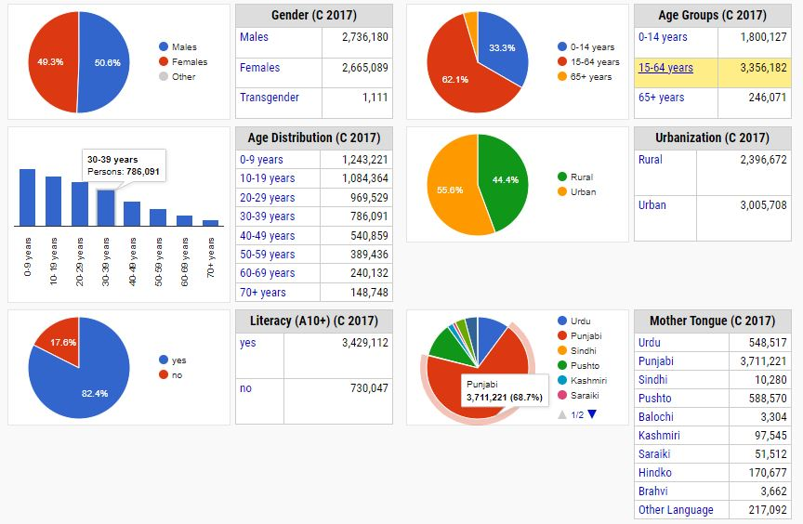
Figure ‎5-20:Demographic features of Rawalpindi

Religion
- Majority of the population of project area are Muslims. Cultural festivals are mostly linked with traditional religious events. According to the 2017 census, Muslims were the overwhelming majority religion with 98.01% while Christians were 1.90% of the population.

Archaeological and Cultural Site
- No archaeological and cultural sites were observed in proximity to the proposed project. However, if any archaeological antiquity is discovered, the Archeological ‘Chance Find’ procedure shall be adopted. The Archeological Chance Find procedure has been attached as Annexure-IV.

Ethnicity in the Project Area
- During social survey of the proposed project site, it was found that the entire population are Muslims and they do not consider themselves to be called any other type of population such as indigenous peoples as the ADB’s SPS 2009.

Language and Dialects
- The major languages of the area are Hindko, Punjab, Urdu and Pashto. People also speak other languages such as Kashmiri, Saraiki and Brahvi.

Dwellings
- Housing conditions of the respondents have been analyzed according to the type of houses in which they were residing. The house or building constructed with concrete or burnt bricks fall in ‘pacca’ (permanent) category whereas house or building constructed with burnt bricks with mud comes under ‘semi-pacca’ (semi-permanent) category while house constructed with mud bricks or temporary wooden logs etc. are categorized as kacha (temporary) house. All the respondents in the project area are living in category of pacca houses.

Economics of Rawalpindi / Islamabad
- The economy of majority of people in the study area is based on their private business and government jobs. People who lived in Rawal town, Satellite town etc. areas are well settled with high per capita income. Some family members are settled outside the country and send remittances to family members in Pakistan. Majority of the people of Rawalpindi and Islamabad are directly or indirectly dependent on Government/private jobs in educational/government institutions for their income.

Education Facilities in Project area
- The cities of Islamabad and fall under category of large cities and they are among the hub of educational facilities. The Government and private schools, colleges etc. are present in the study area.

Social Amenities in the project area
- During the field survey, the access/ availability of the social amenities/ basic infrastructure was obtained from the surveyed households as well as physically observed at site. It was noted that facilities such as electricity, Sui gas, water supply, telephone and sewerage drainage are available in Rawalpindi and Islamabad.

Major Source of Drinking Water
- Currently, there are two main sources of water supply in the project area. The major source is water supply from RWASA while the other source of water is ground water and some households have installed their own electrical pumps on bore holes.

Health Facilities in project area
- Health facilities in the form of Government and private health care institutes are present in and around the project area. Being the major cities, Rawalpindi and Islamabad has primary, secondary and tertiary health care facilities such as PIMS, Shifa International, CMH, Rawal Foundation, Riphah International Hospital and Islamabad International Hospital and Research Centre etc.

POTENTIAL ENVIRONMENTAL IMPACTS AND MITIGATION MEASURES

General
- This chapter identifies the beneficial as well as the potentially significant adverse environmental and social impacts during design/pre-construction, construction and operation phases of the proposed project on the physical, ecological and socio-economic domains of the environment. The appropriate mitigation and remedial measures are proposed in this chapter. A project impact evaluation matrix has been developed to evaluate the potential impacts of the proposed project. A brief qualitative description of each aspect and the affected environment in both RoW and the project’s corridor of impact is presented below.

Methodology for Impact Screening
- The methodology for assessing the risk level associated with each potential impact is presented below. Risk is assessed as the likelihood that the activity will have an effect on the environment as well as the consequence of the effect occurring. It is often described like this:
Risk = Likelihood × Consequence
Likelihood Scale
Likelihood | Definition | Scale
Certain | Will certainly occur during the activity at a frequency greater than every week if preventative measures are not  Applied | 5
Likely | Will occur more than once or twice during the activity but less than weekly if preventive measures are not applied | 3
Unlikely | May occur once or twice during the activity if preventive measures are not applied | 2
Rare | Unlikely to occur during the project | 1

Consequence Scale
Consequence | Definition |  | Score
Catastrophic | The action will cause unprecedented damage or impacts on the environment or surrounding communities |  | 5
Major | The action will cause major adverse damage on the environment or surrounding communities |  | 3
Moderate | No or minimal adverse environmental or social impacts |  | 2
Minor | No or minimal adverse environmental or social impacts |  | 1

Risk Score Table
Likelihood | Consequence
 |  | Catastrophic | Major | Moderate | Minor
 | Certain | 25 | 15 | 10 | 5
 | Likely | 15 | 9 | 6 | 3
 | Unlikely | 10 | 6 | 4 | 2
 | Rare | 5 | 3 | 2 | 1
Total Risk: Significant: 15-25 Medium: 6-10 Low 1-5
- Any ‘Medium’ to ‘Significant’ risk requires an environmental management measure to manage the potential environmental risk. Judgment will be required concerning the application of an environmental management measure to mitigate low risk situations.

Potential Positive Impacts
- The positive impacts due to the proposed project are mentioned below:
- The project will provide a sustainable and clean water source in serving areas. Access to clean water will improve the general health status of the area and reduce exposure to waterborne diseases and ultimately the health budget of the project area will be decreased.
- The project will result in improved access to nearby communities and other major settlements. Accessibility of the corridor will increase the frequency of private entities locating their businesses in the area, hence increasing overall investment in and along the water source and distribution network.
- The sale of food and other services to immigrant workers during the construction phase of the project will lead to some direct incomes as a form of project impact. However, accessibility will lead to better transport services, hence increasing income of operators in that business.
- The communities may be presented in the form of temporary employment, when engaged to assist surveyors. Also, experts involved in feasibility studies and other pre-project consultations may lead to some level of purchases of items from petty traders and farmers during their presence in the communities.
- Some form of temporary employment would be generated for community members during the construction phase by the project directly.
- However, completion of the project and its related structures may lead to an increase in the movement of business concerns to the area surrounding the dam and other intake structures, paved access roads etc, hence enhancing the employment possibilities of inhabitants
- Tourist sites, which may be located in the larger project area could get higher patronage due to easy access which would be created after completion of the project, hence enhancing their economic value e.g. Murat National Forest/Park situated at few kilometers upstream of the dam. Moreover, the dam itself may serve as a tourist spot as many resorts can be built in the vicinity of and dam play a significant role in promoting tourism to those areas. Many types of water sports could be held there, such as parasailing, paragliding and scuba diving, which attract tourists.

Potential Adverse Impacts
- Apart from positive impacts, there are some potential adverse environmental and social impacts on the local environment. The proposed project is divided into three stages i.e. pre-construction/planning and design stage, construction stage and operation and maintenance (O&M) stages. The pre-construction stage includes all stages before the construction stage (site investigation work i.e. topographical, seismic studies etc.). Construction stage includes all stages from mobilization of Contractor to the completion of the project and operation stage starts after the construction stage, which includes the inspection and repair works.
- Adverse impacts envisaged at these three stages of the proposed water supply project along with their proposed remedial or mitigation measures are given in the following section.

Design/Pre-Construction Phase for Water Supply Component

Impact Screening Matrix
- The screening of potential impacts during the design/pre-construction phase is provided in Table ‎6-1 below.

Table ‎6-1: Screening of possible Impacts during Design/Pre- Construction phase for Water Supply Component
S/No. | Potential Issue | Likelihood (Certain, Likely, Unlikely, Rare) | Consequence (Catastrophic, Major, Moderate, Minor) | Risk Level (Significant, Medium, Low) | Residual Impact  (Short term, Long term)
1 | Improper selection of intake source and reduce ecological flows Impacts | 2 /  Likely | 5 /  Moderate | 10 /  Medium | Low / Long Term
2 | Improper design of water treatment plant and distribution networks including transmission main | 2 /  Likely | 5 /  Moderate | 10 /  Medium | Low / Long Term
3 | Lack of integration of IEE/EMP requirements into Construction bid documents | 2 /  Likely | 3 /  Moderate | 6 /  Medium | Low / Short Term
4 | Impacts on existing utilities | 2 /  Likely | 3 /  Moderate | 6/  Medium | Low residual  Impact
5 | Impacts of Labor Camps and Ancillary Facilities | 3 /  Likely | 2 /  Moderate | 6 /  Medium | Medium / Short Term
6 | Traffic Issues/ Traffic Management Plan | 3 /  Likely | 2 /  Moderate | 6 /  Medium | Low / Short Term
7 | Land acquisition and resettlement impacts | 5 /  Unlikely | 2 /  Moderate | 10 / Medium | Low residual Impact
8 | Topographic Impact due to Excavation | 2 /  Unlikely | 2 /  Moderate | Low | Low residual Impact
9 | Seismic Impacts | 2 /  Unlikely | 2 /  Moderate | Low | Low residual  Impact
10 | Impact on Water Usage for Irrigation | 2 /  Unlikely | 2 /  Moderate | Low | Low residual Impact
Critical Risk Level
Significant Risk Level
Medium Risk Level
Low Risk Level

Adverse Impacts during Planning and Design Phase
- Potential adverse impacts during the planning and design stage of the project are discussed below.

Improper Selection of intake source and reduce ecological flows Impacts
- Improper selection of intake sources may lead to impacts which may have long lasting impact on hydraulics and environmental flows of streams. Reduced downstream water availability may deprive the end user or it may disrupt environmental/ecological characteristics of streams. Furthermore, streams are the sources of ground water charging in the vicinity and downstream of catchment area.
- Also, if source water availability is not analyzed during design, it may disrupt uninterrupted raw water supply to the WTP.
Mitigation Measures
- Detailed catchment studies shall be conducted as part of designing intake flow from sources
- Runoff volume calculations shall be carried out on a periodic basis to ensure water supplies from intake structure.
- Periodic flow measurement shall be carried out to ascertain the continuous water availability for the project.
- PMU LG&CD will ensure that design of intake structure is carried out with minimal impact of aquatic life and ecological flows.
Residual Impact
- Once the proposed mitigation measures are implemented; no significant adverse residual environmental effects are likely to occur. However, in case improper selection of intake source, the residual impact will be low.

Improper design of water treatment plant and distribution networks including transmission main
Potential Impacts
- The possibility exists that if the project is not designed in accordance with international standards and guidelines for water and sanitation, it could result in multiple potential impacts that could adversely affect the settlements in the project area.
- If water intake structures are not designed to minimize impacts on aquatic life e.g. higher intake velocity through intake screen may entrap aquatic life and fish if intake structure is not designed adequately and raw water contain high sediment load shall foul the WTP and increase the maintenance cost of WTP.
- If WTP is not designed properly and filtered water will not meet NEQS, it will not fulfill the ultimate purpose of the project to provide safe drinking water to the residents of the area.
- If the distribution mains and supply network are not designed properly, it may increase chances of pipe bursting, leakages and reduce water delivery to particular residents, resulting in social issues.
Mitigation Measures
- The following design-related measures will be implemented to ensure the project activities do not result in unanticipated, long term and potentially irreversible impacts:
- The design criteria are mainly based on the standards and specifications of WASA Lahore. Where required, best international practices were also considered in establishing the design criteria for the proposed water supply system and WTP.
- Limit maximum through-screen design intake velocity to limit entrance of aquatic organisms.
- Avoid construction of water intake structures in sensitive ecosystems.
- Intake structure shall be designed adequately to reduce sediment load and uninterrupted raw water supply to WTP.
- The treatment process will be employed that biological contaminants and suspended solids are brought in the limits set forth in Pakistan Standards and WHO Guideline values for drinking water.
- A SCADA system has been proposed to check compliance and monitoring of WTP components.
- 1.2-meter cover has been proposed from the top of pipe to reduce chances of theft and pipe bursting due to traffic loads.
- Before commissioning, the water supply network shall be tested on 1.5 times the designed pressure to check leakages.
- Water metering system shall be proposed to reduce theft and water wastage.
Residual Impact
- Provided the proposed mitigation measures are implemented, no significant adverse residual environmental effects are likely to occur. However, in case improper designing of WTP and distribution network, the residual impact will be low adverse in nature.

Lack of Integration of IEE/EMP Requirements into Construction Bid Documents
Impacts
- The bidding documents must reflect the requirement to select a qualified and experienced Contractor from the perspective of ensuring implementation of required safeguards during project development.

Mitigation Measures
- The environmental staff of PMU will be assigned the task to check that design and bid documents are responsive to key environmental, social and safety considerations and that the proposed method of work reflects the boundaries defined in the EMP. The bid documents must include the EMP and its implementation cost must be reflected in the BOQ.
- The IEE/EMP implementation and monitoring requirements must be part of bidding documents and necessary contractual binding must be agreed by project contractors before award of contract.
- Project contractors shall have qualified and experienced environmental staff to plan, arrange, implement, monitor and report IEE/EMP requirements.
Residual Impact
- Upon integration of EMP requirements into construction contract agreement, and upon implementation of EMP in true letter and spirit, the residual environmental effects are expected to be low in magnitude and short term.

Impacts on Existing Utilities
- Utility services such as sewerage lines and telephone lines lying along the project alignment may need to be relocated temporarily or permanently to prevent damage to them.
Mitigation Measures
- Detailed filed surveys will be conducted to assess any sub-surface utilities that might be present under the proposed project alignment within the RoW of the project, shall be relocated prior to the commencement of work:
- Based on the utilities that are identified during the detailed surveys, a relocation plan of those utilities will be developed by the respective line agencies in close coordination.
- In case any utilities can be allowed to remain in place and avoidance of their damage is possible, the contractor will need to be aware of the location of these services so that disruptions are not caused. In such a scenario, the responsibility for any repair of damaged services will lie with the contractor.
Residual Impact
- Provided the proposed mitigative measures are implemented, the magnitude and extent of the environmental effects will be low. Therefore, no significant adverse residual environmental effects are likely to occur.

Impacts of Labor Camps and ancillary facilities
Impacts
- The duration of the construction activity for the proposed project is expected to be 36 months and a considerable amount of work force will be engaged. As a result, worker camps will need to be developed and ancillary facilities will need to be provided such as electricity, washrooms for labor with suitable effluent and sewage disposal facilities as well as water for their everyday use for drinking and bathing etc.
Mitigation Measures
- In order to prevent a nuisance, specific locations shall be designated for development of the labor camps. All necessary facilities and amenities shall be provided in these camps such as resting area, drinking water, electricity and supply of water.
- Solid and liquid effluent waste disposal facilities shall also be designed to cater to the waste of administration/office building etc.
- The use of proper planning while identifying locations for the labor camps will ensure there is minimal disturbance to all key receptors and the traffic is not disrupted by labor camps being set up roadside next to the construction sites.
- A comprehensive Construction Camp Management Plan will be prepared as part of the Site-Specific Environmental Management Plan (SSEMP) by the contractor and approved by the Executing Agency.
Residual Impact
No residual impacts are expected.

Traffic Issues
Impacts
- In particular, the laying of water pipelines could result in heavy congestion due to the movement of construction heavy machinery and equipment with significant delays for traffic apart from posing a significant risk for vehicles.
Mitigation Measures
- A comprehensive traffic management plan shall be developed by the contractor and approved by the Executing Agency or the Project Management Unit that will contain the traffic diversion onto alternate routes and management of traffic flows to minimize the congestion and the possibility of accidents. This plan shall be dependent to the EMP and will be implemented by the contractor.
Residual Impacts
- After implementing the traffic management plan, the residual impacts will be low.

Land Acquisition and Resettlement Impacts
Impacts
- The proposed project involves the distribution of the water supply network. This water distribution network or pipes will be laid within the existing network of water pipes, thus no land acquisition is involved in this proposed project.
Mitigation Measures
No mitigation measures are required.

Residual Impacts
No residual impacts.

Topographic Impacts due to Excavation
Potential Impacts
- The project area has plain topography and land acquisition is involved for the proposed project for construction of WTP, IPS at Ranial and Water Works at Akbar Chowk, Chakra and Adyala. This construction will change the topography of the area, specially due to construction of overhead water reservoirs. Further, excavation of land is involved for the proposed project. A minor physical change in the topography due to excavation of land is expected in the project area and the adverse impact is low in nature.
Mitigation Measures
- Mitigation measures will involve adoption of best engineering design measures keeping in view the aesthetics of the project area and provision of green areas for the landscape in design. The proposed design has tried to minimize these impacts.
Residual Impact
- No residual effects from this component of the project are anticipated as no significant topographical change is anticipated.

Seismic Impacts
Potential Impact
- In Building Code of Pakistan (Seismic Provisions, 2007), the whole region of Pakistan is classified into five main seismic hazard zones i.e., i) Zone-1, ii) Zone-2A, iii) Zone-2B, iv) Zone-3, v) Zone-4 based on the peak horizontal ground acceleration and its ultimate tendency to damages during seismic events. The proposed project area falls in the seismic zone classified as “Zone-2B” with g-value 0.16 to 0.24 and is considered as moderate hazard seismicity zone.
- The project is located under the active seismic region with a g-value of 0.16 to 0.24. Therefore, care shall be taken in design of all buildings under this project, especially the construction of overhead reservoirs at all water works. The proposed project will not have any impact on the seismology of the project as none of the project activities will have much magnitude to cause seismic disturbance in the project area and thus the adverse impact is expected to be medium in nature.
Mitigation Measures
- The proposed structure will be designed and constructed keeping in consideration high intensity earthquakes. For seismic hazard analysis, updated structural and seismic evaluations will be conducted by the design engineer/consultant and geo-technical investigations will be conducted prior to the construction phase.

Residual Impacts
- Upon implementation of mitigation measures suggested above, no significant residual impact are anticipated.

Impact on Water Usage for Irrigation
Potential Impact
- As the Chahan dam is not an associated facility, so the operations of Chahan dam are not dependent on this project. The dam has been built for irrigation purposes with a total capacity of 35MGD. Initially, the proposed project has an approval for 6 MGD water extraction from the dam and the approval for an additional 6MGD is in process. The dam has surplus water available for the proposed project because of conversion of agricultural land into housing societies, therefore, insignificant impacts are envisaged on water usage for irrigation purposes.
Mitigation Measures
- As the impact is insignificant, therefore, no mitigation measures are required, however, in case of any anticipated impacts, proper monitoring will be done for other purposes of water usage.
Residual Impacts
- Insignificant residual impacts are anticipated.

Impacts during Construction Stage for Water Supply Component

Impact Screening Matrix
- The screening of potential impacts during the construction phase are provided in Table ‎6-2 below.
Table ‎6-2: Screening of Possible Impacts during Construction Phase for Water Supply Component
S/No. | Potential Issue | Likelihood (Certain, Likely, Unlikely, Rare) | Consequence (Catastrophic, Major, Moderate, Minor) | Risk Level (Significant, Medium, Low) | Residual Impact (Short term, Long term)
1 | Site Accessibility Issues | 3 / Likely | 2 / Moderate | 6 / Medium | Low / Short term
2 | Traffic Issues | 3 / Likely | 3 / Moderate | 9 / Medium | Low / Short term
3 | Impact on local Resource | 3 / Likely | 2 / Moderate | 6 / Medium | Low / Short term
4 | Community Health & Safety | 3 / Likely | 2 / Moderate | 6 / Medium | Low / Short term
5 | Occupational Health & Safety | 3 / Likely | 2 / Moderate | 6 / Medium | Low / Short term
6 | Impacts due to Construction Camps/ Camp Site | 3 / Likely | 2 / Moderate | 6 / Medium | Low / Short term
7 | Waste water generation | 3 / Likely | 3 / Moderate | 9 / Medium | Low / Short term
8 | Solid Waste Generation | 3 / Likely | 2 / Moderate | 6 / Medium | Low / Short term
9 | Impacts of Natural and Man-Made Disaster | 3 / Likely | 2 / Moderate | 6 / Medium | Low / Short term
10 | Degradation of air quality due to construction works | 3 / Likely | 3 / Moderate | 9 / Medium | Low / Short term
11 | Noise/ Vibration | 3 / Likely | 2 / Moderate | 6 / Medium | Low / Short term
12 | Flora | 3 / Likely | 3 / Moderate | 9 / Medium | Low / Short term
13 | Fauna | 3 / Likely | 3 / Moderate | 9 / Medium | Low / Short term
14 | Social and Cultural Conflicts | 3 / Likely | 2 / Moderate | 6 / Medium | Low / Short term
15 | Communicable diseases | 3 / Likely | 2 / Moderate | 6 / Medium | Low / Short term
Critical Risk Level
Significant Risk Level
Medium Risk Level
Low Risk Level
- Potential environmental impacts during the construction phase of the project are provided below.

Site Accessibility during Construction
Potential Impact
- The proposed project can be approached through various roads. The construction material, equipment and machinery will arrive at the proposed workshop area and construction camps sites. From the camp, the material, equipment and machinery will be transferred to the work site.
Mitigation Measures
- Selection of access roads/tracks will be based upon certain criteria to ensure high stability, no or minimum tree cutting and crop damage, minimum disturbance to nearby settlements and other social amenities;
- The approach roads will be selected to avoid any soil degradation and erosion impacts;
- Special care will be taken for known sensitive areas to ensure that all interested parties are aware of the type and location of work activities. Measures will be taken where necessary to protect such areas physically; and
- Mitigation measures for the loss of trees and crops, soil erosion, soil contamination, air and noise pollution, waste generation, and loss of agricultural land provided in below sections will be adopted.

Residual Impacts
- Provided the proposed mitigative measures are implemented, the environmental effects will have low magnitude and will be reversible. Therefore, no significant adverse residual effects are expected.

Degradation of Ambient Air Quality
Potential Impact
- Air quality will be affected by fugitive dust emissions from construction machinery; dust from the unpaved surface and construction vehicles. Emissions may be carried over longer distances depending upon the wind speed, direction, temperature of surrounding air and atmospheric stability.
- Potential impacts on the air quality during the construction stage will be due to the fugitive dust and the exhaust gases generated in and around the construction site. Dust is a major component of air pollution, generated mainly from the following construction activities:
- Site clearance and use of heavy vehicles and machinery/equipment etc. at construction site;
- Procurement and transport of construction materials such as sand, cement, etc. to the construction site;
- Other gaseous emissions during construction result from operating of construction vehicles, plant and equipment;
- The sensitive receptors identified within or near the project length are educational institutions and religious and cultural places etc. which may be affected during the construction phase due to emissions of air pollutants. The construction activities will also result in increased air pollution in the area and the overall impact on the quality of air during the construction phase will, however, be temporary and limited to the project’s implementation phase only. This impact is expected to be highly adverse in nature.
Mitigation Measures
- The major source of air emissions is fugitive dust emitted from construction machinery and movement of vehicles. The impacts during the project construction phase could be effectively mitigated by the implementation of simple procedures by the contractor including but not limited to the following:
- All vehicles, machinery, equipment and generators used during construction activities will be kept in good working condition and be properly tuned and maintained in order to minimize the exhaust emissions;
- Open burning of solid waste from the Contractor’s camps and at construction site will be strictly banned;
- Preventive measures against dust will be adopted for on-site mixing and unloading operations;
- Construction and spoil materials will be transported trucks covered with tarpaulins and all vehicles (e.g., trucks, equipment, and other vehicles that support construction works) will comply with the PEQS (as amended) for carbon emissions and noise;
- Contractors shall comply with the submitted work schedule, keeping emission operations away from sensitive receptors and residential areas;
- Regular water sprinkling of the site will be carried out to suppress excessive dust emission(s);
- Emissions from power generators and construction machinery are important point sources at the construction sites. Proper maintenance and repair will be ensured to minimize the hazardous emissions;
- Construction equipment is generally left idling while the operators are on break or waiting for the completion of another task. Emissions from idling equipment tend to be high. Existing idling control technologies, which automatically shut the engine off after a pre-set time to reduce emissions, without intervention of the operators will be implemented;
- Along with the project alignment with water pipelines and trunk sewer being laid, water will be sprinkled at high frequency, especially during the summer season at all construction sites to suppress dust emissions;
- Vehicles carrying construction material or mucking material will be covered with tarpaulin sheets to avoid dust emissions, ultimately to avoid degradation of ambient air quality;
- Stock piles will also be covered with tarpaulin sheets to avoid dust emission;
- Construction workers will be provided with masks for protection against the inhalation of dust;
- Vehicles used for construction will be tuned properly and regularly to control emission of exhaust gases; and
- Regular monitoring of air quality in accordance with PEQS 2016 and WHO Guidelines will be conducted; and
- The Dust Management plan has been developed and will be implemented by the contractor to manage dust emissions. Dust management plan is attached as Annexure-VI of this report.
Residual Impact
- It is anticipated that air emissions will not exceed the ambient air quality standards after implementation of the suggested mitigation measures.

Noise
Potential Impact
- The laying of water pipelines will result in different construction equipment and machinery being used which will generate high noise levels at the project sites and in the project areas.
- Noise will be produced due to the operation of construction machinery and equipment. Sources of noise and vibration during construction are heavy machinery such as bulldozers, excavators, concrete mixing plant, pneumatic drills and other equipment. Noise and vibration are perceived as one of the most undesirable consequences of construction activity. The above machinery is expected to generate noise levels that may be severe in the project area.
- The cumulative effects from several machines can be significant and may cause significant nuisances. However, these increased noise levels will prevail only for a short duration during the construction stage. The noise produced by construction equipment is presented in
- Table ‎6-3, as reference.
Table ‎6-3:Noise Produced by Construction Equipment
Sr. No. | Equipment | Noise dB(A)  at 15ft from Source
1 | Wheeled loading | 90
2 | Grader | 90
3 | Bulldozer | 86
4 | Sprayer | 87
5 | Power generator | 98
6 | Impact drill | 87
7 | Truck | 92
8 | Concrete mixer | 91
9 | Concrete pump | 85
10 | Pneumatic hammer and rock crusher | 98
11 | Breaker | 84
12 | Pneumatic spanner | 95
*Source: Quagliata, A., et al (2018),Transit Noise and Vibration Impact Assessment Manual (No. FTA Report No. 0123).
- The likely impacts due to noise are:
- Psychological effects of distraction of attention, irritation and short temperedness in the exposed people due to persistently higher noise levels; and
- Noisy settings and higher background levels can cause temporary threshold shifts and the consequent habit of speaking loudly, which may cause damage to vocal cords in the persons exposed.
- The sensitive receptors identified within or near the RoW are educational institutions and religious and cultural places etc that may be affected.
- Though the construction method has not been determined yet, it is believed that the adopted method of construction shall produce less noise and vibration if the suggested mitigation measures are adopted. This impact is highly adverse in nature.
Mitigation Measures
- Noise and Vibration management plan has been developed for the guidance of construction contractor. The management plan is attached as Annexure-VII of the report. There are a variety of ways by which construction equipment and worksite noise can be controlled. The following is a list of ways to control noise level at the worksite of the proposed project:
- Quieter Equipment: To effectively reduce noise at a construction site, quieter equipment will be used and it will be ensured that equipment used is appropriately suited for the task at hand. Also, using equipment that is either overpowered or underpowered will be avoided and whenever possible, the quietest equipment available will be selected.
- Modifying Existing Old Equipment: The most common way to reduce the noise levels of common construction equipment is through worksite modifications by retro-fitting existing equipment with damping materials and mufflers.
- Barrier Protection: Any noisy equipment will be positioned behind purpose-built barriers which can be constructed on-site using common building materials such as plywood, block, stacks or spoils. Alternatively, commercial panels lined with sound absorbing materials will be used if required to maximize noise shielding. For optimal effectiveness, the barrier’s length will exceed its height, the noise source should not be visible, and the barrier should be placed as close as possible to either the noise source or the receiver.
- Work Activity Scheduling: Work activity scheduling are administrative means to control noise exposure. Planning how noise sources are sited and organized on a work site can reduce noise hazards. Jobs can be rotated so that exposure time is limited. Transferring workers from a high exposure task to a lower exposure task could make the employee’s daily noise exposure acceptable.
- Increased attention to maintenance of tools and equipment will reduce worksite noise levels. Maintaining plant and equipment in good order not only increases its life, but makes it safer to use and quieter. Loose and worn parts will be fixed as soon as possible. Ideally, the worksite will have a system in place for checking and servicing the various machines and power tools.
- Use of low noise machinery, or machinery with noise shielding and absorption;
- Contractors shall comply with the submitted work schedule, keeping noisy operations away from sensitive receptors, residential areas; implement regular maintenance and repairs and employ strict implementation of operation procedures;
- The Contractor shall comply with PESQ, 2016.
Residual Impact
- Provided the proposed mitigative measures are implemented as suggested, the environmental effects due to noise will have a low magnitude. Therefore, no significant adverse residual impacts on the acoustic environment are likely to occur. Therefore, the residual impacts due to noise and vibration will be low.

Vibrations
Potential Impact
- Exposure to hand-arm vibration from equipment such as hand and power tools, or whole-body vibrations from surfaces on which the worker stands or sits will be controlled through choice of equipment, installation of vibration dampening pads or devices and limiting the duration of exposure. Exposure levels will be checked on the basis of daily exposure time and data provided by equipment manufacturers.
Mitigation Measures
- All vibration producing machinery will be identified by the contractor and vibration producing machinery will be operated at low frequency to reduce the vibration impacts.
- Vibration monitoring will be carried out in accordance with German Standard DIN 4150 (heritage structures) and BS 7385: Part 2 – 1993 (other structures).
- vibration monitoring will be undertaken at the nearest buildings to the construction sites during times of intensive vibration works.
- Where exceedances of the criteria are recorded, corrective actions will be implemented where soils at risk of vibration induced settlement are identified.
- A regular program of vibration monitoring shall be implemented as a minimum in accordance with this document.
- The Contractor will submit the proposed method, the frequency and the location of monitoring site to the Planning Authority for agreement prior to commencing works.
Residual Impact
- Provided the proposed mitigative measures are implemented, no significant adverse residual impacts are likely to occur and the residual impact is envisaged as low in nature.

Wastewater Generation
Potential Impact
- One construction camp will be proposed to be established during construction period for this project.
- Wastewater will be generated at the construction camp and from construction activities. If the generated wastewater is not properly treated or disposed off, this may contaminate the surface water sources such as nullahs, drains, water channels etc. apart from soil contamination. Water from dewatering activities (during rainy season) has the potential to contain suspended solids and oil and grease and if disposed off untreated may affect the soil quality. The Table ‎6-4 shows anticipated composition and estimate of the wastewater to be generated by construction workers during the construction phase of the project assuming that on average the water demand per person is 100 liters per day and that 80% of the water demand will become wastewater.
Table ‎6-4: Estimated Wastewater Generated by Workers in Construction Camps
Sr. No. | No. of Workers* | Estimated Total Water Demand**  (liters/day) | Estimated Wastewater Generated (liters/day)***
1 | 150 | 15,000 | 12,000
* “Tentative Work Force Requirements including Client and Contractor Staff”
** = (150) x (100) = 15,000 liters/day
*** = (15,000) x (80%) =12,000 liters/day
- 12,000 liters/day of wastewater are from the construction camp and this impact can be categorized as medium adverse in nature.
Mitigation Measures
- To dispose the liquid waste generated from the construction activities, the following steps will be taken by the contractor:
- Domestic and chemical effluents from the construction camp will be disposed off by the development of on-site sanitation systems i.e. septic tanks.
- Proper monitoring to check the compliance of PEQS will be carried out;
- Sewage from construction camps will be disposed off after proper pre-treatment and processes such as soakage pit.
- The contractor(s) will be responsible for submitting details of site-specific wastewater management plan along with details of wastewater collection, transportation and its disposal.
Residual Impacts
- Provided the proposed mitigative measures are implemented, no significant adverse residual environmental impacts are likely to occur and the residual impact is low.

Solid Waste Generation
Potential Impact
- Considering the laborers (about 150) residing in the construction camp and the locally available labor, an average solid waste generation rate of 0.55 kg/capita/day is adopted for the estimation of solid waste generation. Based on this assumption, a total of about 82.5 kg of solid waste will be generated from construction camp on a daily basis. The major components of the labor camp waste will be garbage, putrescible waste, rubbish and small portion of ashes and residues. Other types of wastes may include inorganic construction wastes including hazardous waste.
- The estimated quantity of excavation material for ROW clearance cannot be provided at the design stage. The contractor will provide the estimated quantity of excavation material during the construction phase. This waste will be generated due to the construction activities and the materials used for construction and this waste would require proper disposal to minimize land and water contamination. This impact can be categorized as medium adverse in nature.

Mitigation Measures
- All the solid waste from the camps will be properly collected at source by placing containers and disposed off through proper solid waste management system. The contractor will coordinate with local representatives and administration of the concerned solid waste management department for the disposal of solid waste;
- The construction waste produced due to excavation will be reused. Almost 80% of this waste will be reused in backfilling of excavations/trenches while the leftovers will be landfilled. However, it is important to mention here that this waste shall be reused by making contracts with private housing societies for backfilling of low laying areas.
- The contractor must develop a plan of action with the help of concerned solid waste management department for transporting the waste to the disposal site;
- Toxic waste will be handled, stored, transported and disposed of separately;
- The waste will be properly sealed in containers with proper labels indicating the nature of the waste; and
- Solid waste will be segregated at source so that it can be re-used or recycled.
- The Waste Management Plan will be developed to implement an efficient and responsive solid waste management system during construction phase and recyclable wastes e.g. steel bars will be sold to waste vendors;
- Reusable material will be used as a filling material during ground levelling;
- Solid waste generated during construction will be safely disposed in demarcated waste disposal sites and the contractor will provide a proper waste management plan; and
- The site will be restored back to its original condition after construction completion.
Residual Impact
- Upon implementation of the proposed mitigation measures, no significant adverse residual effects are anticipated and the residual impacts will be low.

Traffic Issues
Potential Impact
- The construction phase of the proposed project, particularly the laying of the water supply pipelines could result in heavy congestion due to the movement of construction heavy machinery and equipment with significant delays for the traffic apart from posing a significant accident risk for vehicles.
- Efficient management of traffic once the construction activity commences will be critical in order to minimize the risk of possible road accidents and construction related hazards.

Mitigation Measures
- To minimize traffic problems in the proposed project area, the following measures will be considered:
- Movement of vehicles carrying construction materials and equipment/machinery will be restricted during the daytime to reduce traffic load and inconvenience to the local population;
- Construction vehicles, machinery and equipment will be parked at designated areas (at construction camps site) to avoid un-necessary congestions on roads;
- The speed of the vehicles will be controlled (at 20 to 25 km/hr) to reduce the probability of severe accidents, soil erosion, debris flows due to vibrations and dust emission;
- Damage of roads due to construction vehicles will be instantly repaired and/or compensated after the completion of work;
- Proper sign boards will be provided for smooth flow of traffic;
- Period of construction and area / location of construction site shall be informed to public in general and specifically to local residents; and
- Any closure of the roads (especially main roads) and deviations / diversions proposed will be informed to the riders through standard signs and displays.
- A Traffic Management Plan will be implemented to avoid traffic accidents, jams/public inconvenience. Guideline for Traffic Management Plan has been prepared and given as Annexure-VIII.
Residual Impacts
- Upon implementation of the proposed mitigation measures, no significant adverse residual effects are anticipated. Further, the traffic management plan has been developed and after implementation of Traffic Management Plan, the residual impact will be low.

Flora
Potential Impact
- The project has no impact on destruction of vegetation and no tree cutting is anticipated during the construction phase of the project. The labor camp area will be selected away from the residential by keeping in view that movement of vehicle does not disturb the flora of the area.
Mitigation Measures
- The proponent shall implement the program with the help of Forest Department and with the consultation of concerned consultant ecologist;
- Open fires will be banned in the area to avoid hazards of fire in the area;
- However, if this type of land is not available, it shall be ensured that minimum clearing of the vegetation is carried out and minimum damage is caused to trees and undergrowth;
- Construction vehicles, machinery and equipment will remain confined within their designated areas of movement;
- The Contractor’s staff and labor shall be strictly directed not to damage any vegetation such as trees or bushes; and
- Contractor shall provide gas cylinders at the camps for cooking purposes and cutting of trees/bushes for fuel shall be strictly prohibited.
Residual Impacts
- Given the type of vegetation involved and the presence of type of land adjacent to the project site, the residual effects on vegetation are considered not significant.

Fauna
Potential Impact
- During the construction phase, the existing populations of birds, mammals and reptiles in the construction areas will be affected by disturbances from activities such as excavation, machinery movement, vehicular traffic, labor movement and camping. The local fauna will likely leave the directly affected areas due to these disturbances and human intervention. Some animals, particularly reptiles, may be killed during earthwork operations. Moreover, the movements of mammals and reptiles will be restricted during the construction phase.
- Birds will also tend to move away from construction areas, seeking shelter and food elsewhere due to disturbances and the fear of being hunted or trapped.
- Noise generated by machinery, particularly during nighttime, will scare wildlife residing in habitats even at some distance from the construction areas. Food and refuse at the contractor’s camps may attract animals, which might then be hunted by the workers. This impact is indirect, site-specific, temporary, reversible, possible and of medium significance.
Mitigation Measures
- Care shall be taken during construction activities for avoiding purposely or chance killing of animals;
- If any wild species and habitat is found during construction, it must be dealt with carefully and local wildlife department officials should be informed;
- Hunting, poaching and harassing of wild animals shall be strictly prohibited, and Contractor shall be required to instruct and supervise its labor force accordingly and clear orders should be given in this regard;
- The Contractor must be held responsible for instructing his work force accordingly and for enforcing this restriction. In addition, this shall have to be controlled by the wildlife department.
- Special measures shall be adopted to minimize impacts on the wild birds, such as avoiding noise generating activities during the critical periods of breeding;
- Noise generating activities shall not be carried out during the night by the work force;
- Camp waste shall be properly disposed off to prevent it being eaten by animals as it may be hazardous to them; and
- Noise produced due to construction activities shall be kept to an acceptable level.
- During site visit, no migratory birds were spotted or reported at Chahan dam. However, bird watchers will be deputed by the contractor to spot migratory birds and if spotted, special actions like isolation of construction area, work duration restriction, restriction and hunting of migratory birds shall be prohibited and wildlife department will be informed accordingly.
- Residual Impacts
- The residual impacts will be low.

Impacts due to Construction Camps/Camp Sites
Potential Impact
- Approximately one construction camp is proposed to be established during the construction period for this project. Due to the proposed camp site, loss of vegetation and dissatisfaction of rehabilitation measures during and after completion of construction phase may occur. This may include waste, soil pollution, groundwater pollution, dust etc. but the impact will be medium adverse in nature. For these impacts, mitigation measures have been developed to minimize the likelihood, extent or duration of their occurrence and any associated adverse effects. Error! Reference source not found.
Mitigation Measures
Environmental
- Reinstate any temporary facilities to pre-existing conditions in ecologically sensitive areas.
- Implement landscaping plan for all facilities in areas where high landscape value and visual vulnerability to the proposed activities warrants site-specific landscape restoration measures.
- Operate equipment in a manner focused to minimize ambient noise environment and no equipment will be left idling unnecessarily.
- Provide adequate warnings of impeding works to all potential receptors within a 1 km corridor surrounding the RoW via public notices and local news.
Social
- State land will be a first preference for the worker camp location, followed by land where there is a willing lessee.
- Employment policies which aim to maximize job opportunities for local people will help to minimize tensions caused by different socio-cultural values.
- Training will be provided to all staff on camp management rules and overall discipline and cultural awareness.
A briefing on camp rules
- A community relations orientation to increase awareness about the local area, cultural sensitivities and the project Code of Conduct will be conducted.
- Awareness-raising on health considerations, including sexually transmitted diseases (STDs) will be conducted.
- The construction Contractor is required to develop a Construction Camp Management Plan to address:
- Discipline;
- Community liaison;
- Ethnic tensions and;
- Communicable diseases.
- A Code of Conduct and Camp Rules will be required within the Construction Camp Management Plan which provides policies and a disciplinary framework with respect to worker behavior.
Camp Location
- The construction Contractor will be required to assess the environmental/social sensitivity of any additional or alternative sites prior to their approval for adoption.
Some additional mitigation measures will include:
- The contractor(s) will provide aplan to the proponent for removal & rehabilitation of site upon completion;
- Photographical and botanical inventory of vegetation before clearing the site; and
- Compensatory plantation to be scheduled when construction works near end.
Residual Impacts
- The residual impacts are envisaged to be low after implementation of suggested preventive and mitigatory measures.

Impacts on Local Resources
Potential Impact
- During the construction, overburden on local resources (energy, water etc.) is possible if construction facilities such as workers camp and construction camp built near rural areas can create problems for local communities. There are possibilities of conflict for resources between workers and local community.
Mitigation:
- Resource Conservation Plan has been developed for the proposed project and attached as Annexure-IX.
Residual Impact
- Provided the proposed mitigative measures are implemented as suggested, the environmental impacts will have low magnitude on resource conservation. Therefore, low residual impacts due to the project are anticipated.

Impacts on Health and Safety of Community
Potential Impact
- Community health and safety issues during the construction of proposed project may include dust, noise and vibration from construction vehicle transit and communicable diseases associated with the influx of temporary construction labor. Significant community health and safety issues associated with the projects may also include:
- Pedestrian safety;
- Traffic safety; and
- Emergency preparedness.
- Further, the laying of water supply pipelines will require the digging of trenches for laying these lines which may pose a risk of community members falling into these trenches. The construction areas located near the settlements may cause accidents for the people moving near these areas. Considering these consequences, this impact can be categorized as direct, moderate, site-specific, medium term, temporary, medium probability and irreversible.

Mitigation Measures
- The World Bank/IFC EHS Guidelines, 2007, defines community health and safety in terms that guarantee as-built infrastructure conforms to acceptable standards (structural safety, flood and fire risk), water supply sources are of suitable potable quality, emergency response planning is in place for built environments, traffic safety provisions are enforced alongside transport hazard assessment and mitigation, and disease prevention measures are taken. The Contractor will prepare the site specific community health and safety plan in compliance with relevant sections of the IFC General Environmental Health and Safety Guidelines (WB/IFC 2007), Pakistan Labor Laws, Punjab Occupational Safety and Health Act (2019);
- The Contractor will clearly barricade work areas to prevent access by the public, while ensuring passage by providing safe pathways for pedestrians around construction zones;
- The Contractor will exclude parking, waiting vehicles and vendors from areas adjacent to the work by means of clearly marked barricades and posted signage;
- The Contractor will remove excavated earth, spoil, rubble, cut vegetation and refuse whether generated by the project or discarded by third parties from areas within the construction zone, where it has potential to interfere with the public or generate dust;
- The Contractor will provide temporary lighting to facilitate construction during night time;
- The Contractor will remove hazardous conditions on construction sites that cannot be controlled effectively with site access restrictions and will barricade any excavations and materials placed near the public place (if applicable);
- The Contractor will promptly reinstate any services and reinstall any physical facilities that are cut, disconnected or damaged during construction and maintain or provide temporary services that are interrupted by construction. The Supervisory Consultant will inspect and certify the adequacy of all reinstated services and facilities;
- Installation and maintenance of speed control and traffic calming devices at pedestrian crossing areas especially near the settlements;
- An Emergency Preparedness and Response Plan (EPRP) in coordination with the local emergency responders to provide timely first aid response in the event of accidents and hazardous materials response in the event of spills;
- Instruct foremen to strictly enforce the keeping out of non-working persons, particularly children, off work sites;
- Timely public notification on planned construction works;
- Close consultation with local communities to identify optimal solutions for diversions to maintain community integrity and social links;
- Any environmental condition that is disagreeable to the public and causes an avoidable nuisance can be addressed with additional provisions over and above those described above, as determined necessary by the supervisory consultant.
- These requirements will be incorporated into the bidding specification and contract documents, and will be binding on the contractor, at risk of penalty for noncompliance, as charges to be recovered from contractor for unsafe act or condition.

Residual Impacts
- Upon implementation of the proposed mitigation measures suggested above and also upon implementation of the proposed Health and Safety Plan, insignificant residual impacts are anticipated.

Impacts on Occupational Health and Safety
Potential Impact
- Occupational Health and Safety (OH&S) related impacts will arise during construction stage activities including clearing of earth, levelling, compaction, foundations, finishing, testing & commissioning. In nutshell, occupational health and safety issues associated with the construction of proposed project will primarily include physical hazards; chemical hazards and noise.
- Noise: Construction and maintenance personnel may be potentially exposed to high levels of noise from heavy equipment operation and from working in proximity to vehicular traffic. As most of these noise sources can be prevented, by using noise barriers, new machinery and by using personal hearing protection by exposed personnel and implementation of work rotation programs to reduce cumulative exposure.
- In addition, disasters such as earthquakes and fires may occur. Lack of Emergency Response Plan (ERP) or an inefficient response plan may lead to an accident or critical injury. Considering these consequences, this impact can be categorized as direct, moderate, site-specific, medium term, temporary, medium probability and irreversible.
Mitigation Measures
- The following mitigation measures shall be adopted by the contractor to control accidents due to deep excavations:
- Hard barricading shall be applied to all excavation deeper than 6 feet.
- Warning taps shall be applied to trenches which are around 3 feet deep.
- Isolation of area must be done during excavation activities to control accidents.
- Damping down of area to control fugitive dust.
- Where necessary, apply green sheet to control fugitive dust, especially during high wind season.
- Material shall be stored at least 3 feet away from the edges of excavations.
- If any confined space encounters (excavation deeper than 10 feet or any main hole etc.), procedure for confined space entry shall be followed.
- The contractor must initiate an HSE Champion program to incentivize the workers to follow the site specific HSE rules and regulations.
- For further details, framework for OH&S management plan has been developed to handle any health and safety issues of workers and community. Mitigation Measures to prevent and control physical hazards include:
Moving Equipment and Traffic Safety
- Establishment of work zones to separate workers on foot from traffic and equipment by:
- Routing of traffic to alternative roads when possible;
- Where worker exposure to traffic cannot be completely eliminated, use of protective barriers to shield workers from traffic vehicles, or installation of channeling devices (e.g. traffic cones and barrels) to delineate the work zone;
- Regulation of traffic flow by warning lights, avoiding the use of flaggers if possible;
- Reduction of maximum vehicle speeds in work zones; and
- Training of workers in safety issues related to their activities, such as the hazards of working on foot around equipment and vehicles; and safe practices for work at night and in other low-visibility conditions, including use of high-visibility safety apparel and proper illumination for the work space (while controlling glare so as not to blind workers and passing motorists).
- Provide appropriate PPEs in conjunction with training, use, and maintenance of the PPEs.
- Furthermore, the noise reduction options that should be considered will include:
- Selecting equipment with lower sound power levels;
- Installing suitable mufflers on engine exhausts and compressor components;
- Installing vibration isolation for mechanical equipment;
- Providing noise protection PPEs (ear plugs/ear muffs) to the construction workers;
- Re-locating noise sources to fewer sensitive areas to take advantage of distance and shielding;
- Developing a mechanism to record and respond to complaints; and
- Regular monitoring of noise levels at active sites or near noise producing equipment/machinery and compare it to the available occupational noise standards.
Monitoring of OHS Activities:
- During the construction phase of proposed project, occupational health and safety monitoring programs of the contractor (s) will verify the effectiveness of prevention and control strategies. The selected indicators will be representative of the most significant occupational, health, and safety hazards at the construction site and camps, and the implementation of prevention and control strategies. The occupational health and safety monitoring program will include:
- Regular inspection and testing of all safety features and hazard control measures focusing on engineering and personal protective features, work procedures, places of work, installations, equipment and tools used;
- Surveillance of the working environment: The contractors will document compliance using an appropriate combination of portable and stationary sampling and monitoring instruments. Monitoring and analyses will be conducted according to internationally recognized methods and standards. Monitoring methodology, locations, frequencies, and parameters will be established individually for each project following a review of the hazards;
- Continuous and efficient surveillance of worker’s health during the entire construction phase by the nominated officials of contractors; and
- Training: Training activities for employees (construction contractor & supervision consultant staff) and visitors will be adequately monitored and documented (curriculum, duration, and participants). Emergency exercises, including fire drills, will be documented adequately. Service providers and contractors will be contractually required to submit to the employer adequate training documentation before start of their assignment.
- Contractor(s) shall prepare a comprehensive OHS Plan as part of Site Specific Environmental Management Plan (SSEMP) including work method statements for all hot works to avoid incidents during construction stage. A guideline OHS Plan is provided in Annexure-IX.
Residual Impacts
- Upon implementation of the proposed mitigation measures suggested above, and also upon implementation of the Occupation Health and Safety Plan (Attached as Annexures), low residual impacts are anticipated.

Impacts of Natural and Man-Made Disasters
Potential Impact
- Natural disasters (earthquakes & floods) and man-made disasters like excavation collapse, structural damage due to deep excavations and fire accidents may result in injuries, financial losses and may even lead to deaths. Release of natural gas, due to damage to gas pipelines may also occur during excavations operations. Incidence of collapse of any nearby structure due to deep excavation can also take place during the construction activities which needs to be avoided. This impact is medium adverse in nature.
Mitigation Measures
- Mitigation measures will be as follows:
- Development of and implementation of Emergency Response Plan (ERP) for earthquakes and manmade disasters will be developed by the contractor, in coordination with CSC and the PMU, will be implemented in close consultation with the PDMA, RDMA, Civil Defence and Punjab Emergency Services Rescue 1122 and other concerned departments;
- Training of the contractor staff and employees regarding the emergency procedures and plans will be regularly conducted;
- In case of excavation near to the existing structure is required, then the appropriate controls measures must be taken before start of excavation;
- Bracing / Wall strengthening/support for deep excavation need to be placed to avoid collapse;
- Emergency numbers will be clearly pasted at all disposal stations; and
- Minor incidents and near miss will be reported and investigated to assess the root causes of these incidents
- Preventive measures will be formulated accordingly by the PMU / WASA Management.
- All potential and actual emergencies must be included in the SSEMP.
- Contractor must conduct risk assessment before start of excavation, especially where the distance between excavation and nearby structure is less than 2 meters.
Residual Impact
- Low risk of residual impacts.

Social and Cultural Conflicts
Potential Impact
- During the construction phase of the proposed project, conflicts may arise between labor force and local community. Use of local resources and products by the construction workers can generate stress on the local resources. Furthermore, differences in cultural values may also cause discomfort to local residents. This impact is negative, local, low, short-term and probable.

Mitigation Measures
- Local labor especially from nearby communities will be given preference for the construction works;
- Careful planning and training of work force to minimize disturbance to the local people;
- Public notification through print or electronic media during the entire construction phase to avoid any inconvenience in accessibility to the locals; and
- Adequate training especially for the transitive workforce of the station (involved both in the construction process and in the commissioning) to regard the customs of the area so that the locals do not feel insecure.
Residual Impacts
- Implementation of mitigation measures will reduce the risk of conflicts in society and will result into short term and low residual impacts.

Communicable Diseases
Potential Impact
- The laborers in the Contractor Camp, truck drivers and like personnel who interact with each other have the potential for the spread of COVID-19 and HIV/AIDS if the incidence exists. Majority of the people living in the surroundings of the Project, and potential Labor are not aware of the source, mode of communication or consequences of COVID-19 & HIV/AIDS. Although their religious and cultural value system, to a large extent excludes the outbreak or rapid communication of HIV/AIDS, yet its occurrence in such a situation cannot be precluded. It is necessary that awareness and preventive campaigns are run from time to time in the Labor camps and the project field offices to prevent communicable diseases like Cholera, Typhoid and Tuberculosis.
- There is a chance of spreading of an epidemic of Coronavirus disease (COVID-19) due to close interaction of the labor force during construction not only among the workers but also in the area. This impact is high adverse in nature.
Mitigation Measures
- The Contractor shall:
- Arrange to run an active campaign, in the labor camp, to make people aware of the cause, mode of transmission and consequences of HIV/AIDS;
- Latest / updated SOPs by WHO, national and provincial Government related to the construction industry to control spreading of COVID-19 will be implemented by the contractor and will be strictly monitored.
- Strengthen the existing local health & medical services for the benefit of labor as well as the surrounding villages;
- Ensure cleanliness and hygienic conditions at the labor camp by ensuring proper drainage and suitable disposal of solid waste. Inoculation against Cholera will be arranged at intervals recommended by the Health Department;
- Locating a labor camp at least away from the villages (local settlement), and
- Keep all the camps, offices, material depots, machinery yards and work sites open for the inspection of health and safety measures and related documents.
Residual Impacts
- Successful implementation of suggested mitigation measures in the above section in implementation of WHO guidelines will reduce the chances of spread of communicable diseases among workers and nearby community. Therefore, the impact will be low.

Impacts during Site Restoration
Potential Impacts
- After completion of construction activities, the project facilities will be restored as close to its original condition as possible. One of the important tools is the photographic record of project facilities e.g., campsite(s) prior to set-up will be taken and will be compared after site restoration.
- Unattended construction waste and excavated material along the RoW of transmission and water supply mains will be source of bad aesthetics within city. Before closure of any typical construction day, the work site will be cleared as far as possible from all types of waste and construction material.
Mitigation Measures
- Following measures/actions will be adopted to restore the site:
- Demobilization of all equipment and machinery;
- Disposal of any waste material remaining at the time of completion of operation;
- Backfilling of all excavation followed by compaction;
- Dismantling and removal of fence or barriers surrounding the campsite area;
- General restoration of the site area, including landscaping and restoration of drainage, where required.
- PMU through Contractor will ensure that restoration of construction works at water transmission and supply mains will be carried out by contractors.
- PMU will ensure periodic monitoring of such restorations.
- Contractors will develop site restoration protocols and will submit to PMU for review and approval.
- Construction site restoration protocols will be part of bidding documents and construction contracts.
- Construction contractor will add restoration costs into BOQs.

Anticipated Impacts during Operational Phase for Water Supply Component
- The potential impacts from operation phase are provided as
Table ‎6-5 below.
Table ‎6-5: Screening of Possible Impacts during Operation Phase
Sr./No. | Potential Issues | Likelihood  (Certain, Likely, Unlikely, Rare) | Consequence  (Catastrophic, Major, Moderate, Minor) | Risk Level (Significant, Medium, Low) | Residual Impact (Short term, Long term)
1 | Generation of Sludge and Wash Water | 5 /  Certain | 2 /  Moderate | 10 /  Medium | Low / long Term
2 | Water system leaks and water discharges during flushing | 2 /  Unlikely | 3 /  Major | 6 /  Medium | Low / Short Term
3 | Handling of Hazardous Chemicals and Chlorine Release | 2 /  Unlikely | 5 /  Catastrophic | 10 /  Medium | Low / Long Term
4 | Impacts on Landscape | 2 /  Unlikely | 3 /  Major | 6 /  Medium | Low / Long Term
5 | Impacts on Aquatic life of Chahan Dam due to uncontrolled abstraction of water | 2 /  Unlikely | 5 /  Catastrophic | 10 /  Medium | Low / Long Term
6 | Impacts on Aquatic life of Chahan Dam due to change in quality of water | 2 /  Unlikely | 5 /  Catastrophic | 10 /  Medium | Low / Long Term
7 | Impact on the Proposed Project due to Climate Change | 2 /  Unlikely | 3 /  Major | 6 /  Medium | Low / Long Term
8 | Improved drinking water availability | Positive impacts expected |  |  | Long term positive
9 | Impacts on Public Health | Positive impacts expected |  |  | Long term positive
Critical Risk Level
Significant Risk Level
Medium Risk Level
Low Risk Level

Generation of Sludge and Wash Water
Impacts
- During the operation phase of the proposed WTP, residual waste will be generated, including sludge drained from plain sedimentation tanks and clarifiers as well as wash water produced from backwashing of rapid sand filters.
- Approximately 90% of suspended particles and turbidity will be removed in the clarifier. Sludge formation occurs due to (i) suspended solid particles coalescing with the addition of coagulants, and (ii) the coagulants themselves contributing to sludge concentration. The solid concentration of clarified sludge ranges from 1 to 2% of the sludge volume, while the total sludge volume is between 2 to 3 % of the product water.
- The solid concentration in the wash water from filter beds generally ranges from 0.05 to 0.5%. These solids constitute only 10% of the total solids generated due to turbidity and coagulants.
Mitigation Measures
- The residual disposal will be carried out as discussed below.
Settled Sludge
- Two circular sludge holding tanks (one for each train) have been proposed with a diameter of 10 m. The sludge of plain sedimentation tanks and clarifiers shall be discharged to the sludge holding tanks. A detailed strategy will be developed on management and disposal of the sludge to be produced as a by-product of the operations of the WWTP. Licensed third party vendors will be contracted on long term arrangements to manage the disposal of the sludge in an environmentally beneficial manner in accordance with international good practices. The sludge from the holding tanks shall be used as a soil conditioning agent for crops.
Wash Water
- The wash water received from filter beds, contains a little number of solids and the wash water shall be discharged into drains.
Residual Impacts
- Implementation of mitigation measures will reduce the risk of generation of sludge and will result in short term and low residual impacts.

Water system leaks and water discharges during flushing
Impacts
- Water system leaks can reduce the pressure of the water system, compromising its integrity and ability to protect water quality (by allowing contaminated water to leak into the system) and increasing the demands on the source water supply, the quantity of chemicals, and the amount of power used for pumping and treatment. Leaks in the distribution system can result from improper installation or maintenance, inadequate corrosion protection, settlement, stress from traffic and vibrations, frost loads, overloading and other factors.
- Water supply lines may be periodically flushed to remove accumulated sediments or other impurities that have accumulated in the pipe. Flushing is performed by isolating sections of the distribution system and opening flushing valves or more commonly, fire hydrants to cause a large volume of flow to pass through the isolated pipeline and suspend the settled sediment. The major environmental aspect of water pipe flushing is the discharge of flushed water, which may be high in suspended solids, residual chlorine, and other contaminants that can harm surface water bodies. Recommended measures to prevent, minimize, and control impacts from flushing of mains are provided below.
Mitigation Measures
- Ensure construction meets applicable standards and industry practices;
- Conduct regular inspection and maintenance;
- Implement a leak detection and repair program (including records of past leaks and unaccounted-for water to identify potential problem areas);
- Consider replacing mains with a history of leaks with a greater potential for leaks because of their location, pressure stresses and other risk factors.
- Discharge the flush water into a municipal sewerage system with adequate capacity;
- Discharge the flush water into a separate storm sewer system
- Minimize erosion during flushing, for example by avoiding discharge areas that are susceptible to erosion and spreading the flow to reduce flow velocities
Residual Impact
- The implementation of suggested mitigation measures will reduce impacts on the environment and the residual impacts will be low.

Handling of Hazardous Chemicals and Chlorine Release
Impacts
- The proposed water treatment involves the use of chemicals for coagulation and disinfection. Chemicals used for coagulation will be Alum (Al2SO4.14H2O), while for chlorination sodium hypochlorite shall be used.
- Alum may cause eye and skin irritation. Prolonged or repeated contact with Alum dust can lead to redness, dryness, and itching of the skin (dermatitis). Over-exposure to aluminum sulfate hydrate dust, if inhaled, may cause irritation of the nose, throat and respiratory tract, depending on its pH.
- Vapors of Sodium Hypochlorite may irritate the respiratory system and cause coughing, asthmatic breathing and breathlessness and it is also corrosive to skin and eyes since the product contains a substance which is very toxic to aquatic organisms.
- Possible air emissions from the WTP can result in an accidental release of chlorine when sodium hypochlorite is accidentally mixed with any acid. However, in the case of the proposed WTP, sodium hypochlorite shall be mixed with water and thus the possibility of such air emission is not envisaged.
Mitigation measures
- Chemical building has been proposed for storage of Alum, Lime and polymer, dose preparation facilities and dosing pumps
- A chemical house will be provided to accommodate the solution tanks, Alum bags and other chemicals (if required). Monorail and overhead crane have been provided for handling of the chemicals.
- For chlorination, Sodium Hypochlorite (NaOCl) will be stored in chlorination building, in which sodium hypochlorite will be mixed with water and the solution of sodium hypochlorite and water will be fed in the chlorine contact tank through dosing pumps.
- Store sodium hypochlorite in cool, dry and dark conditions for no more than one month and use equipment constructed of corrosion-resistant materials.
- Minimize the amount of chlorination chemicals stored on site while maintaining a sufficient inventory to cover intermittent disruptions in supply;
- Mandatory health and medical check-ups for all employees, especially workers at the chemical building as they shall be exposed to Alum and Sodium Hypochlorite.
- Use corrosion-resistant piping, valves, metering equipment and any other equipment coming in contact with gaseous or liquid chlorine and this equipment must be kept free from contaminants, including oil and grease.

Accidental Release Measures (Alum)
- Small spill and leak: Shovel into clean, dry, labelled containers and cover and flush the area with water and prevent water intrusion into containers or on spilled material
- Large spill and leak: Prevent solids from mixing with water or entering sewers or waterways. Shovel into clean, dry, labelled containers and cover. If liquid is present, dike with inert material (sand, earth, etc.). Consider in situ neutralization and disposal. Ensure adequate decontamination of tools and equipment following clean up. Comply with Federal, Provincial/State and local regulations on reporting releases. Deactivating Chemicals: Lime, limestone, soda ash, sodium bicarbonate, dilute sodium hydroxide, dilute aqua ammonia
- Accidental Release Measures (Sodium Hypochlorite)
- Flush away small spillages with plenty of water.
- Large Spillages: Absorb with sand or other inert absorbent. Pick up with vacuum or absorbent solid, store in closed container for disposal.
Residual Impact
- The implementation of suggested mitigation measures will reduce impacts on the environment and the residual impacts will be low.

Impacts on Landscape
Potential Impact
- During the operation stage, new saplings of different plants and trees would be planted to enhance the aesthetics and compensate for the loss of affected trees. This will have a positive impact of permanent nature. The presence of adequate flora at available spaces along the proposed alignment will help in absorbing flue gases, emitting from a large number of vehicles and public transport passing through the project area, which shall help improve the air quality. The impact is medium positive in nature.
Mitigation Measures
- The saplings planted in the project area, against the trees affected should be properly maintained throughout their growth.
Residual Impact
- The implementation of suggested mitigation measures will reduce impacts on the environment and the residual impacts will be low.

Impacts on Aquatic Life of Chahan Dam due to Uncontrolled Abstraction of Water
Potential Impact
- Uncontrolled abstraction of water will lead to depletion of water source of Chahan Dam. This will have negative impact on the aquatic and other faunal and floral species which are relying on the water of Chahan Dam. Controlled fish farming in carried out in Chahan Dam by Irrigation and Fisheries Department. It is also important to mention here that the construction of Chahan Dam is recently completed, and the ecosystem of Chahan Dam is still in the development phase. However, the abstraction of water for irrigation and for water supply can reduce the water level where, aquatic life of Chahan Dam may be disturbed. The impact is medium adverse in nature.
Mitigation Measures
- The level of Chahan Dam after utilization of water for irrigation and water supply purposes will be maintained where aquatic life will not be disturbed. The Irrigation Department has installed measuring gauges on the dam to read the difference from dead level of the dam. Even at the dead storage level, Chahan dam will have surplus water to sustain aquatic life because the dead storage level of Chahan dam is high enough to retain sufficient water for aquatic life including fish population.
- The existing water intake structure of the Irrigation Department will be utilized to extract raw water for the proposed project. The intake of this water pipeline has been provided with screens to avoid the entering of fish species into the pipeline.
- The raw water, through T-junction will be supplied to Raw Water storage ponds of treatment plant where further screens will be provided before the entrance of this water into treatment plant to control the entering of fish species into treatment plant.
Residual Impact
- The implementation of suggested mitigation measures will reduce impacts on the environment and the residual impacts will be very low.

Impact on Aquatic Life due to change in water quality
Potential Impact
- Change in water quality due to addition of pollutants and chemicals from the treatment plant may lead to deterioration of water quality for aquatic life. This will lead to death of fish population and other organisms.
Mitigation Measures
- No direct discharge from the WTP will be allowed in the Chahan Dam. Further, the water intake structure is shifted from dam to already existing discharge point of irrigation department. No chemical addition due to the project will be carried out. Quarterly monitoring will be carried out to keep track of the quality of water in Chahan dam.
Residual Impact
- The implementation of suggested mitigation measures will reduce impacts on the environment and the residual impacts will be very low.

Impact on the Proposed Project due to Climate Change
Potential Impact
- Project area features a humid subtropical climate with long and hot summers, a monsoon and short, mild and wet winters. Its climate is classified as very similar to its twin city Islamabad, but the geographical location and extreme urbanization of Rawalpindi especially in project area (PP-12) has led to weather and climatic conditions that are notably different from its surrounding region. Rawalpindi's weather has historically been known to change rather quickly due to its proximity to Himalayas and the Pir Panjal Range. The following impacts may occur on the proposed project due to climate change:
Water Source
- Increased water turbidity after heavy storm and flood events
- Shifts in river morphology from increased erosive capacity of river during storm events may affect water withdrawal
- Need for dredging to remove sediment, rocks and debris deposited after storm and flood events
Treatment Facility
- Physical damage to structures from flooding Water
- Lower treatment effectiveness due to higher-than-normal turbidity or disrupted/shorter treatment operation
Storage Tanks
- Contamination due to flooding for cisterns
- Physical damage due to landslides
Pipelines
- Corrosion of metal pipes weakens structures over time
- Physical damage to pipes from flooding and landslides
- Network contamination from pipes damaged by flooding or landslides
Mitigation Measures
- Pipe material and protection selection must be design by considering the unseen event of floods.
- Metering system for controlling the unauthorized use of water.
- A climate change resilience plan or climate change adaptation measure will be adopted to avoid any such impacts.
Residual Impact
- The implementation of suggested mitigation measures will reduce impacts on the environment and the residual impacts will be very low.

Improved Drinking Water Availability
Impacts
- The continued supply of treated quality water by proposed project will be an indispensable facility in Rawalpind0 especially in the area of PP-12. The proposed water supply system will facilitate the domestic as well as commercial water requirements of people living in Rawalpindi. Moreover, the proposed project will provide improved and sustainable potable water availability to citizens of for next fifty years. The project will reduce abstraction of ground water from tube wells and water bores omitting chances of ground water depletion and reduce operation cost for RWASA.
- Furthermore, project implementation will also create job opportunities during operation, thereby improving the socioeconomic condition of the local people and help in improving their quality of life. Thus, the ‘no project’ option is not a viable option.
Mitigation measures
- No measures are required.
Residual Impact
- No residual impacts.

Improvements in Public Health
Impacts
- The clean potable water will reduce waterborne disease, improve public health and ultimately reduced pressure on health care system.
Mitigation measures
- No measures are required.
Residual Impacts
- Insignificant residual impact.

Cumulative Impacts
- Based on the scoping exercise of the site and based on discussions with the public sector agencies responsible for development in the project area. No other infrastructure works are planned to be conducted in the project area during the construction period of this project. Thus, no cumulative impacts are expected.

Solar PV Installation

Impacts and mitigation measures during pre-Construction phase
- The potential adverse environmental impacts associated with the project are avoided or minimized by: (i) careful site selection and route alignment; (ii) integrating key measures that will permanently become part of the infrastructure and will be included in the project detailed engineering design; (iii) implementation of environmental mitigation measures for identified impacts; and (iv) ensuring project environment management readiness. These are provided below. Also, the screening matrix for the pre-construction phase is provided in Table 6.8.1 below.

Table ‎6.8.1 Screening of possible Impacts during Design/Pre- Construction phase for ‘Solar PV Component’
- S/No. | - Potential Impacts | - Likelihood (Certain, Likely, Unlikely, Rare) | - Consequence (Catastrophic, Major, Moderate, Minor) | - Risk Level (Significant, Medium, Low) | - Residual Impact  - (Low, medium, High)
1 | Relocation of existing utilities | /Likely | / Moderate | 6 / Medium | Low
2 | Traffic Issues/ Traffic Management Plan | 3 /Likely | 2 / Moderate | 6 / Medium | Low
3 | Lack of integration of  IEE/EMP requirements into Construction bid documents | /  Likely | /  Moderate | 6 /  Medium | Low
4 | Seismic impacts | 3 /  Likely | 2 /  Moderate | 6 /  Medium | Low
5 | Transmission line interconnection Route selection | /  Unlikely | /  Minor | /  Low | Low
6 | Land requirements | 2 /  Unlikely | 1 /  Minor | 2 /  Low | Low
Critical Risk Level
Significant Risk Level
Medium Risk Level
Low Risk Level
Positive Impacts

Relocation of Utilities
Potential impacts
- Utility services such as sewerage lines and/or telephone, electricity or gas pipelines lying in the project area or across the project site may need to be relocated temporarily or permanently to prevent damage to them.
Mitigation measures
- Detailed filed surveys will be conducted to assess any sub-surface utilities that might be present under or across the project site or in the project area and they shall be relocated prior to the commencement of the work.
- Based on the utilities that are identified during the detailed surveys, a relocation plan of those utilities will be developed by the respective line agencies in close coordination.
- In case any utilities can be allowed to remain in place and avoidance of their damage is possible, the contractor will need to be aware of the location of these services so that disruptions are not caused. In such scenario, the responsibility for any repair of damaged services will lie with the contractor.
Residual Impact
- Provided the proposed mitigative measures are implemented, the magnitude and extent of the environmental effects will be low. Therefore, no significant adverse residual environmental effects are likely to occur.

Traffic Issues
Potential impacts
- In particular, the movement of heavy equipment and machinery for the solar PV installation works could result in heavy congestion due to the movement of construction heavy machinery and equipment with significant delays for traffic apart from posing a significant risk for vehicles.
Mitigation Measures
- A comprehensive traffic management plan shall be developed by the contractor and approved by the Executing Agency or the PMU that will contain the traffic diversion onto alternate routes and management of traffic flows to minimize the congestion and the possibility of accidents. This plan shall be dependent to the EMP and will be implemented by the contractor.
Residual Impacts
- After implementing the traffic management plan, the residual impacts will be low.

Lack of Integration of IEE/EMP Requirements into Construction Bid Documents
Potential Impacts
- The bidding documents must reflect the requirement to select a qualified and experienced Contractor from the perspective of ensuring implementation of required environmental safeguards provisions during project development.
Mitigation Measures
- Appointment of at least one environment focal person and one social focal person within the PMU to be in charge of EMP coordination, implementation and site inspections including project GRM;
- Appointment of at least one environment, health and safety officer within the Contractor staff to be in charge of EMP coordination, implementation, site inspections and information disclosure and consultations;
- Appointment of at least one GRM focal person to be in charge of project GRM coordination, handling complaints, dispute resolution, site visits and information disclosure and consultations.
- The environmental staff of PMU will be assigned the task to check that design and bid documents are responsive to key environmental, social and safety considerations, and that the proposed method of work reflects the boundaries defined in the EMP. The bid documents must include the EMP and its implementation cost must be reflected in the BOQ.
- IEE/EMP implementation and monitoring requirements must be part of bidding documents and necessary contractual binding must be agreed by project contractors before award of contract.
Residual Impacts
- Upon implementation of mitigation measures suggested above, low or no significant residual impact is anticipated.

Seismic Impacts
Potential Impacts
- In Building Code of Pakistan (Seismic Provisions, 2007), the whole region of Pakistan is classified into five main Seismic Hazard zones i.e., i) Zone-1, ii) Zone-2A, iii) Zone-2B, iv) Zone-3, v) Zone-4 based on the peak horizontal ground acceleration and its ultimate tendency to damages during seismic events. The proposed project area falls in the seismic zone classified as “Zone-2B” with g-value 0.16 to 0.24 and is considered as ‘moderate’ hazard seismicity zone.
- No change (+/-) in the impact of seismology risk of the area is expected during the project construction phase as none of the project activities is expected to be of such a powerful extent to influence the tectonic risk. This adverse impact is medium in nature.
Mitigation Measures
- The proposed structures shall be designed and constructed keeping in consideration high intensity earthquakes. For seismic hazard analysis, updated structural and seismic evaluations should be conducted by the design engineer/consultant. Moreover, geo-technical investigations must be conducted prior to construction phase.
Residual Impacts
- Upon implementation of mitigation measures suggested above, low or no significant residual impact is anticipated.

Transmission Line Interconnection Route Selection
Potential impacts
- The power generated from the solar PV installation will need to be evacuated through interconnection to the nearest substation. The route of the transmission line for the interconnection must be selected to ensure the minimal distance and scope of work is conducted while avoiding and/or minimizing any potential impacts on identified receptors, particularly any areas of importance such as protected areas, habitats and species of conservation value, physical cultural resources (PCRs) etc.
- The EPCM consultants have already conducted a feasibility study and identified the most feasible interconnection route which will avoid and/or minimize any potential impacts on identified receptors.
Mitigation measures
- No measures required.
Residual Impacts
- Upon implementation of mitigation measures suggested above, low or no significant residual impact is anticipated.

Land requirements
Potential impacts
- The proposed solar installation will be developed on publicly owned land. Thus, no land acquisition and/or resettlement will be applicable for this project development and all civil works will be conducted within the acquired land area.
Mitigation measures
- No measures required.
Residual Impacts
- Upon implementation of mitigation measures suggested above, low or no significant residual impact is anticipated.

Landscape Impact
Potential impacts
- The solar plant will create a visual impact and may result in induced access to the area. The site is not surrounded by habitation or permanent structures. Steps to reduce visual impacts e.g. maintenance of hedges and field margins around the fenced perimeter will be incorporated after completion of civil works and during the start of operation. This project will showcase green development of the power sector in Pakistan as well as preserve the local biodiversity. Solar panel glare issues are not anticipated for solar PV plants.
Mitigation measures
- No measures required.
Residual Impacts
- Upon implementation of mitigation measures suggested above, low or no significant residual impact is anticipated.
Impacts and mitigation measures during Construction Phase
- The screening matrix for the construction phase is provided in Table 7.7 below.

Table ‎6.8.2: Screening of Possible Impacts during Construction Phase for ‘Solar PV Component’
Sr. No. | Potential Impacts | Likelihood (Certain, Likely, Unlikely, Rare) | Consequence (Catastrophic, Major, Moderate, Minor) | Risk Level (Significant, Medium, Low) | Residual Impact (Low, medium, High)
1 | Traffic Issues | 3/ Likely | 2/ Moderate | 6/ Medium | Low
2 | Air Quality | 3/ Likely | 2/ Moderate | 6/ Medium | Low
3 | Noise and Vibration | 3/ Likely | 2/ Moderate | 6/ Medium | Low
4 | Occupational health & Safety | 3/ Likely | 2/ Moderate | 6/ Medium | Low
5 | Community Health and Safety | 3/ Likely | 2/ Moderate | 6/ Medium | Low
6 | Waste generation | 3/ Likely | 2/ Moderate | 6/ Medium | Low
7 | Vegetation impacts | 3/ Likely | 2/ Moderate | 6/ Medium | Low
8 | Fauna impacts | 3/ Likely | 2/ Moderate | 6/ Medium | Low
9 | Biodiversity | 3/ Likely | 2/ Moderate | 6/ Medium | Low
10 | Interruption to existing facilities | 3/ Likely | 2/ Moderate | 6/ Medium | Low
11 | Physical landscape | 3/ Likely | 2/ Moderate | 6/ Medium | Low
12 | Topography impacts | 3/ Likely | 2/ Moderate | 6/ Medium | Low
13 | Groundwater quality | 3/ Likely | 2/ Moderate | 6/ Medium | Low
14 | Soil quality | 3/ Likely | 2/ Moderate | 6/ Medium | Low
15 | Local Economic development | 3/ Likely | 2/ Moderate | 6/ Medium | Low
16 | Physical Cultural Resources | /  Unlikely | 1/ Minor | 3/Low | Low
17 | Other Risks | 3/ Likely | 2/ Moderate | 6/ Medium | Low
Critical Risk Level
Significant Risk Level
Medium Risk Level
Low Risk Level
Positive Impacts

Traffic Issues
Potential Impact
- The construction phase of the proposed solar installation, particularly the transportation to site of the solar PV panels and associated electronical equipment and infrastructure could result in congestion due to the movement of construction heavy machinery and equipment with significant delays for the traffic apart from posing a significant accident risk for vehicles.
- Efficient management of traffic once the construction activity commences will be critical in order to minimize the risk of possible road accidents and construction related hazards.
Mitigation Measures
- In order to minimize traffic problems in the proposed project area, the following measures will be considered:
- Movement of vehicles carrying construction materials and equipment/machinery will be restricted during the daytime to reduce traffic load and inconvenience to the local population;
- Construction vehicles, machinery and equipment will be parked at designated areas (at construction camps site) to avoid un-necessary congestions on roads;
- The speed of the vehicles will be controlled (at 20 to 25 km/hr) to reduce the probability of severe accidents, soil erosion, debris flows due to vibrations and dust emission;
- Damages of roads due to construction vehicles will be instantly repaired and/or compensated after the completion of work;
- Proper sign boards will be provided for smooth flow of traffic;
- Period of construction and area / location of construction site shall be informed to public in general and specifically to local residents; and
- Any closure of the roads (especially main roads) and deviations / diversions proposed should be informed to the riders through standard signs and displays.
- Traffic Management Plan will be implemented to avoid traffic accidents, jams/public inconvenience. Guideline for Traffic Management Plan has been prepared and given as Annexure-V.
Residual Impacts
- Upon implementation of the proposed mitigation measures, no significant adverse residual effects are anticipated. Further, traffic management plan has been developed and after its implementation, the residual impact will be low.

Air Quality
Potential impacts
- Potential air quality impacts during construction include dust emissions associated with earthworks and gaseous emissions from construction activities and heavy vehicles used to support the construction works. Some concerning activities are wind-borne dust emissions from cleared areas, stockpiles, and unpaved site roads; truck-derived dust emissions from traffic on haulage routes and dumping; and dozer- and excavator-derived dust emissions from clearing operations and earthworks.
- Moderate temporary air quality impacts during peak construction phase of the project are anticipated because of construction activities scheduled in the dry season and due to fugitive dust generation associated with construction works and transport (of materials, equipment and machinery), loading, unloading and haulage of materials and corresponding increase in vehicular emissions. Use of construction machinery and equipment and movement of transport vehicles may also affect levels of nitrogen oxides (NOx) and sulfur oxides (SOx), affecting air quality. Building access roads to and within the project site (asphalt road pavement) will produce fumes containing small quantities of toxic and hazardous chemicals such as volatile organic compounds (VOC) and poly-aromatic hydrocarbons (PAH).
Mitigation measures
- The measures to be implemented will be as follows:
- Particulate dust generation will be minimized by restricting land clearing to the areas flagged for immediate use, progressively rehabilitating exposed soils as soon as practicable, avoiding clearing and earthworks activities during dry, windy conditions and applying water to all cleared, road and stockpile areas whenever weather conditions have the potential to mobilize fugitive dust.
- Open burning (e.g. of vegetation, waste, hydrocarbons) will be avoided.
- A detailed management and monitoring plan for air quality is provided in the EMP for the Project, which will monitor emissions generated during construction.
- General air quality management and mitigation measures are as follows:
  - Conduct awareness trainings on dust emissions for project employees and workforce;
  - Restrict speed limit on unsealed roads to minimize dust generation;
  - Conduct topsoil stripping when soil is moist to the extent practical;
  - Monitor for air quality impacts near any sensitive receptors identified near construction areas and along the access roads;
  - Use low-sulfur fuels where practical;
  - Source low-emission diesel equipment (e.g. Tier 2 or better), where practical.
- The Contractor(s) will conduct air quality monitoring at the solar site, once before the start of the civil works to establish the baseline, quarterly during the civil works and once after completion of the civil works to monitor and mitigate exceedances (if any) with respect to the applicable ambient air quality standards.
- Air monitoring will be conducted utilizing handheld air monitoring devices at select locations identified on site map.
- Open and exposed land areas at solar plant will be sprayed with water to suppress dust levels, particularly during the dry season.
- Use of chemical dust suppressants will be prohibited.
- Aside from this, works sites will be temporarily barricaded to control dust levels.
- Storage areas/warehouse for materials required for construction and civil works will be provided onsite (construction camps at the solar plant) to reduce construction vehicle trips of transporting materials and minimize stockpiling.
- Vehicles transporting materials that generate dust will be covered with tarps. Construction vehicles and machinery will be maintained to a high standard to minimize vehicular emissions and noise.
- Log of monitoring/incidences of non-compliance and rectification will be recorded and maintained.
- Residual Impacts
- Upon implementation of mitigation measures suggested above, low or no significant residual impact is anticipated.

Noise and vibration
Potential impacts
- Noise impacts will be temporary and localized at all construction sites as construction machinery and vehicles generate noise as they operate. Other noise sources include loading, unloading and haulage of equipment and materials. Significant noise impacts will be experienced by construction site workers/operators; construction machinery may produce noise levels up to 90 A-weighted decibels (dBA).
- For the solar plant, only construction workers will be this close to the machinery for extended periods of time. Measurement of noise levels at the plant site will be conducted once prior to start of the civil works to establish the baseline, quarterly during the civil works and once after completion of the civil works (the latter will be conducted at the solar plant only/upon commissioning of the substation) to monitor and mitigate exceedances (if any), with respect to the ambient noise standards. The potential impacts due to noise and vibration will be mitigated by the following measures as set out in the EMP.
- Potential vibration and noise impacts include those associated with vehicle movements, heavy machinery and construction activities. Since there are no nearby residents around the project, potential noise and vibration impacts are primarily issues for workers onsite. Sources of noise and vibration associated with project construction include:
- Light vehicle movements associated with personnel arrival/departure and onsite activities;
- Earthworks in the project area using heavy machinery (clearing, grubbing and cutting);
- Earthworks associated with upgrade of the project internal roads;
- Concrete foundation works;
- Building and facility construction;
- Heavy vehicle movements associated with delivery of equipment, building materials and infrastructure.
Mitigation measures
- The measures to be implemented will be as follows:
- Noise and vibration associated with vehicles will be minimized by imposing a speed limit on site roads, by scheduling the majority of vehicle movements to daylight hours, minimizing air/exhaust braking where this would cause disturbance, and establishing soil berms or vegetation along roads to reduce the impact of traffic noise.
- Equipment with lower noise levels will be selected where practical and the operation of noisy equipment will be limited to daylight hours where practical.
- Schedule project supply deliveries to daylight hours.
- Maintain road surface to reduce rumble.
- Conduct periodic auditing of noise levels to ensure minimal potential impacts.
- Noise monitoring will be conducted utilizing handheld noise monitors at select locations identified on site map.
- Log of monitoring/incidences of non-compliance and rectification will be recorded and maintained.
- Drivers will be required to observe low speed wherever necessary and no blowing of horns.
- Construction activities utilizing heavy machinery work will be restricted between 8 AM – 6 PM.
- Advance warning to communities will be provided with respect to the timing of noisy activities.
- Construction vehicles and machinery will be maintained to a high standard to minimize emissions and noise.
- All construction workers / operators will use appropriate PPE, including ear defenders, when operating machinery.
- Implement CEMP sub-plans:
- The Noise and Dust Control Plan
- Traffic and Road Management Plan
Residual Impacts
- Upon implementation of mitigation measures suggested above, low or no significant residual impact is anticipated.

Occupational Health and Safety
Potential impacts
- During the construction phase, more workers will be employed to support project construction, to be housed on site in the construction camps. The key factors that will pose risks to worker health and safety are movement of heavy machinery and high volumes of traffic on site as well as any potential injuries resulting from electrical and civil works while developing the project infrastructure.
Mitigation measures
- The measures to be implemented will be as follows:
- The project will demarcate exclusion and safety zones around any high-risk areas.
- The project will strictly require all workers wear personal protective equipment appropriate to their duties with signage at designated sites.
- Clinical assistance will be available to project personnel and medical emergency evacuation procedures will be developed.
- Fatigue will be monitored and managed during travel and during on site operations.
- Standard Operating Procedures (SOPs) for the safe handling, storage and transportation of associated facilities and materials.
- The project will strictly implement the management and monitoring measures as per EMP for water quality, waste management, air, health and safety, noise and vibration and transport measures.
- Implement CEMP sub-plan on Occupational Health and Safety (OHS) Plan.
- Provide sanitary facilities and wash areas, safe drinking water and garbage bins.
- Provide health assessments (health and fitness to workers once every two months).
- Periodic training will be provided to workers in all aspects of the ERP and OHS
- Coordinate with the nearest hospital for arrangements in case of accidents.
- Provide first aid treatment for construction sites and camp.
- Assess safety risks and safety protocols (such as for electrical works, working at heights, etc.), and implement.
- Workers will be equipped with PPE, including proper safety clothes and protection gear/equipment to avoid accidents.
- Provide communication devices to designated site officers / engineers.
- Electrical safety risks will be assessed, and safety protocols will be developed and implemented such as for electrical works, working at heights, etc.
- All works at height will be prohibited during nighttime, periods of fog and strong wind.
- All workers climbing towers will have a Safety Certificate.
- All towers, steel structures and equipment will be properly earthed and equipped with lightening protection.
- When testing electrical equipment, all unrelated works in the flagged zone – marked as danger zone- will be stopped and unrelated workers will leave the zone.
- Records of health assessments/incidents/accidents/near-miss/fatalities will be maintained.
Residual Impacts
- Upon implementation of mitigation measures suggested above, low or no significant residual impact is anticipated.

Community Health and Safety
Potential impacts
- Site preparation and civil works, movement of vehicles bringing equipment, materials, supplies and machinery may interfere with road crossings, flow of traffic and may cause an increase in traffic congestion. These activities may pose safety risks to the communities residing in close proximity to the work sites and general public. In addition, construction camps and an influx of workers may cause social conflict or even lead to the spread of any communicable diseases. Contractors will obtain permissions from relevant authorities before commencement of activities. A code of conduct will be developed for all relevant stakeholder and workers to keep the work organized and safe.
- The Project may also generate (fugitive) dust mainly from upgrading any access roads, clearing any vegetation/forestland for infrastructure and transportation of materials and equipment. Noise from these activities may also disturb nearby residents at night as well as impact on daily economic/business activities. Also, during the construction phase, the project may lead to a number of key risks for community health, food security and safety, including:
- Safety impacts will be primarily associated with accidents involving company vehicles along the project access road. During construction, in particular, there will be a significant increase in project traffic.
- Potential psycho-social and health impacts among project personnel associated with air quality, noise, and vibration effects.
Mitigation measures
- Security fencing and patrols to prevent safety impacts from any construction activities undertaken during construction.
- Potential noise impacts will be reduced to acceptable levels through scheduled daytime construction, while dust generation will be managed through regular water spraying on major dust sources associated with the project.
- The project will strictly implement the management and monitoring measures as per EMP for water quality, waste management, air, health and safety, noise and vibration, and transportation; and sub-plans, including Emergency Preparedness and Response Plan, Community Health and Safety Plan, Stakeholder Engagement Plan, Traffic and Transport Management Plan and Waste Management Plan.
- Provide healthcare services for project employees with an appropriately staffed site clinic
- Effectively control the risks associated with accidents involving multiple vehicles, interactions between different types of vehicles with consideration for the volume and speed of traffic, and vehicle and person interactions.
- Obeying speed limits and apply additional caution by considering environmental conditions such as time of day, visibility, precipitation.
- Implement an effective site waste management strategy to prevent the incidence of vector-borne diseases.
- Develop a management strategy for worker accommodation in line with international/national standards to minimize spread of infectious disease and food-related illnesses.
- Adhere to strict schedule for completion of civil works and avoid prolonged construction and disturbance.
- Implement CEMP sub-plans.
- Community Health and Safety Plan.
- Traffic and Road Management Plan.
- Provide perimeter fencing to mitigate trespassing (fencing will be constructed with adequate ground clearance for passing of wild animals/other species at the solar plant site).
- Provide sufficient lights, clear warning signs and danger signals.
- Assign security personnel to prevent accidents, trespassing and pilferage.
- Warning signs and cones will be installed in and around the transmission tower site and along roads, with clearly marked danger zones.
- Safety flags and flag persons will be used, as needed.
- Record of incidents/accidents/near-miss/fatalities associated with the project will be maintained.
- Records of issues raised will be maintained in accordance with GRMs.
- Outreach to local communities to disseminate knowledge about safety and ERPs at or near solar plant will be provided via information disclosure and consultation activities, project information booklet (PIB) / frequently asked questions (FAQ) flyers.
Residual Impacts
- Upon implementation of mitigation measures suggested above, low or no significant residual impact is anticipated.

Waste Generation
Potential impacts
- Impacts due to waste generation during construction stage have been assessed for all infrastructure types under the solar plant and discussed as follows:
- Impacts on resource use and impacts associated with disposal will arise from waste generated during site preparation and civil works. This includes generation of inert wastes e.g. spoil, biodegradable wastes e.g. cleared vegetation, construction debris, packaging waste, metal scrap, domestic waste.
- Impacts of disposal and wind-blown litter will be seen at the construction areas, whereas the impacts of resource use are national and global.
Mitigation measures
- Establish a covered onsite sorting and recycling area away from any drainage sources.
- Transport of recyclables, scrap, discarded equipment to depots, dedicated storage yards for resale or auction to authorized dealers. The broken or damaged solar panels will be sold to a solar panel specializing panel recycling.
- For other type of wastes, licensed companies will be hired to collect, transport, and dispose of wastes at licensed dump facilities.
- Biodegradable waste such as cleared vegetation may be provided to local communities for use.
- Provide multiple waste containers at construction camps.
- Waste burning will be prohibited.
- No final waste disposal on site.
Residual Impacts
- Upon implementation of mitigation measures suggested above, low or no significant residual impact is anticipated.

Vegetation impacts
Potential impacts
- The most significant impact to terrestrial habitats and flora associated with the project is expected to occur during the construction phase when habitats within the project footprint will be cleared. Since the project site is located far away from any areas of note, thus habitat clearance will not result in the loss of natural or modified habitats and no critical habitats have been found.
Mitigation measures
- Construction camps to be set up at least 400 m from any water source or drainage channels;
- Access to adjacent properties will be maintained, as necessary;
- Vegetation clearances will be strictly restricted to work sites;
- Use of herbicides/pesticides will be prohibited for vegetation clearing to prevent soil contamination;
- Excess spoil will be backfilled onsite or spread out in a manner that causes no disturbance to local drainage pattern;
- Implement the following CEMP sub-plans:
- Strictly implement the Spoils Disposal plan
- Drainage and Storm-water Management Plan
- Site Rehabilitation and Clean-up Plan after completion of civil works to preconstruction conditions, including vegetation planting to stabilize soil where it does not compromise the intended function.
Residual Impacts
- Upon implementation of mitigation measures suggested above, low or no significant residual impact is anticipated.

Fauna Impacts
Potential impacts
- No major loss to any fauna in the project area is expected. Any potential impact will largely be localized and restricted to the limited vegetation to be removed from the project site. As preparatory works begin, the on-site species will move into other parts of their range. Other priority birds, reptiles and small mammals have a wide habitat tolerance and are likely to move into similar habitat elsewhere.
Mitigation measures
- The project will design the solar plant layout to avoid most sensitive habitats, including maintaining the buffer zone for instance to keep habitats as far as possible.
- The project will avoid direct and indirect impacts to any areas of biodiversity sensitivity.
- Habitat clearance will be undertaken in a progressive and sensitive manner to enable priority fauna to move away from the area of works and to avoid isolating fauna in fragmented areas of habitat.
- Adverse impact to habitats, flora and fauna arising from fugitive dust will be minimized through the regular application of water to reduce dust levels in areas of biodiversity sensitivity (particularly during the dry season), the stabilization of landforms and the implementation of erosion prevention measures.
- Raise awareness with workforce and local villagers about importance of protecting forest resources and conservation important species and their habitats.
Residual Impacts
- Upon implementation of mitigation measures suggested above, low or no significant residual impact is anticipated.

Biodiversity
Potential impacts
- Vegetated areas occurring within the project footprint will also be cleared. Potential impacts will include:
- Release of suspended sediment from construction activities
- Accidental spills of diesel fuel
Mitigation measures
- The potential impacts on ecological resources will be mitigated by the following measures as set out in the EMP:
- Minimize vegetation clearing confined to the footprint of the solar plant area.
- No use of chemicals (pesticides/herbicides).
- Maintain hedges and field margins along solar plant perimeter.
- After completion of civil works, implement Site Rehabilitation and Clean Up Plan, including landscaping along the fenced perimeter of the solar plant, re-seeding most or all of the site with native species of plants.
- Provision for adequate ground clearance under fencing for allowing passage of animals/wild species to prevent habitat fragmentation.
- Restoring temporarily disturbed areas to pre-construction conditions.
- Trees below 3 m will not be cut or felled, minimum lopping and pruning will be undertaken, as necessary.
- Any identified bat roosting sites will not be disturbed.
- Restoring temporary land use (used for material storage) to pre-construction conditions.
Residual Impacts
- Upon implementation of mitigation measures suggested above, low or no significant residual impact is anticipated.

Interruption to Existing Utilities
Potential impacts
- In order to reduce impacts on existing utilities (such as power outages), the solar plant construction works will be scheduled in a phased manner. All activities will be supervised by PMU Environment and Social Officer.
- Use of Existing Access Roads. Delivery of equipment, materials and machinery to work sites at the solar plant may lead to increase in traffic and road congestion. It may cause interference with road crossings during stringing of conductors. Movement of transport vehicles will also result in moderate air quality impacts (dust and increase in vehicular emissions) as well as an increase in noise (due to operation of transport vehicles) during peak construction period (these are discussed under Impact on Air Quality, Noise and Vibration).
Mitigation measures
- The potential impacts due to increase in traffic and road congestion will be mitigated through the following measures as set out in the EMP:
- Implement Traffic and Road Management Plan.
- Follow planned transportation routes and delivery schedule.
- Any traffic detours to have danger and clearly visible warning signs as well as flag persons.
- Compliance with local speed limits vehicle load carrying capacity and other road regulations.
- Any damage to roads to be borne by Contractor(s).
- Record of incidents/accidents/near-miss/fatalities/road damage will be maintained.
- Residual Impacts
- Upon implementation of mitigation measures suggested above, low or no significant residual impact is anticipated.

Physical Landscape
Potential impacts
- The solar installation may involve some vegetation clearance and soil compaction. Due to the topographical location of the project, the changes to physical landscape in the project development area will not be visible or have an impact beyond the project’s immediate vicinity.
- The solar project has been designed to minimize adverse physical impacts to the surrounding landscape by minimizing the project footprint and blending major project components with the surroundings to the extent practicable.
Mitigation measures
- No measures are required.
Residual Impacts
- Upon implementation of mitigation measures suggested above, low or no significant residual impact is anticipated.

Topography
Potential impacts
- Land leveling and grading works may alter drainage patterns at the solar plant site that may result in surface erosion, generation of spoil and localized flooding. Impacts will also result from installation of equipment, installation of cable routes (above ground and/or underground) and commissioning of new equipment. These impacts will be temporary and localized at the construction sites within the solar project boundaries.
Mitigation measures
- Clear demarcation of work sites, no encroachment outside the demarcated zone;
- Access to adjacent properties and agricultural land will be maintained, as necessary;
- Construction camp/ workers accommodation set up at least 400 m from natural streams or any other water source at site.
- Use of herbicides/pesticides will be prohibited for vegetation clearing to prevent soil contamination;
- Implement engineering and biological measures to prevent surface erosion such as provision of silt traps or sowing soil-binding grass, as needed;
- Restore loose soil from foundations through ramming, if required;
- Implement the following CEMP sub-plans;
  - Spoils Disposal plan;
  - Drainage and Storm-water Management Plan
- Also, site rehabilitation and clean-up plan will be implemented after completion of civil works to restore works site to pre-construction conditions, including landscaping along the fenced perimeter, maintain hedges and field margins to reduce visual and dust impact, re-seeding most or all of the site with native plant species (soil binding grass) to stabilize the soil and restore habitat as far as possible.
Residual Impacts
- Upon implementation of mitigation measures suggested above, low or no significant residual impact is anticipated.

Groundwater Quality
Potential impacts
- There are some potential effluences for groundwater contamination, i.e. contamination of soil and groundwater with oil, grease and hydrocarbon pollution associated with vehicles and heavy machinery and with pathogen and nutrient pollution associated with human activity, accommodation, sewage treatment and putrescible waste.
Mitigation measures
- All chemicals and hydrocarbons will be handled and stored appropriately according to the EMP and associated standard operation procedures, with adequate bunding, hardstand preparation including lining, concreting or compaction, as well as inspection, auditing and contingency measures.
- Septic tank will be installed to keep wastewater from toilet and kitchen to prevent pollution to groundwater.
- Groundwater quality is to be monitored using groundwater monitoring bores installed up and down gradient of potential contamination zones. Important quality parameters to be monitored as per applicable guidelines.
- Residual Impacts
- Upon implementation of mitigation measures suggested above, low or no significant residual impact is anticipated.

Soil Quality
Potential impacts
- Vegetation will be cleared in preparation for the construction of project components. Measures are therefore required to minimize soil erosion (by rain and wind) and prevent sediment release. Soil compaction within active construction areas is likely due to heavy traffic passage and construction activities. Soil contamination from accidental leaks/spills of hydrocarbons, oil, grease, chemicals and sewage/wastewater effluent is also possible and will require management.
Mitigation measures
- The project has been designed to minimize long-term negative impacts to soil in the project site by recovering topsoil stripped from clearing and construction activities and subsequently for progressive and final rehabilitation.
- Land clearing is to be limited to the immediate project site required for development to the extent practical.
- Activities involving chemicals or hydrocarbons (including storage of broken and redundant solar panels) are to be restricted to designated areas that have been prepared with appropriate bunding, a concrete or compacted earth base, and fully contained by drainage controls.
- An appropriate sanitation system is to be provided to collect all waste and sewage for proper storage and disposal;
- Strict controls on the use of sanitation facilities will be implemented through education and enforcement.
Residual Impacts
- Upon implementation of mitigation measures suggested above, low or no significant residual impact is anticipated.

Local Economic Development
Potential impacts
- Despite the generally positive impacts the Project will have on economic development and employment, there is a risk of inequitable employment, training and procurement opportunities or inadequate communication leading to community dissatisfaction.

Mitigation measures
- The project will implement the preferential local recruitment and procurement policies in place. Implementation of social management and monitoring as per the EMP and sub-plans: Stakeholder Engagement Plan and Grievance Mechanism.
- Provide a grievance mechanism for the Project.
- Residual Impacts
- Upon implementation of mitigation measures suggested above, low or no significant residual impact is anticipated.

Physical Cultural Resources (PCRs)
Potential impacts
- There are no known PCRs in the project area of the solar plant. However, site preparation and civil works during the construction stage have the potential to disturb as yet unknown PCRs.
Mitigation measures
- A ‘Chance Find’ Procedure will be implemented as necessary. All activities will be supervised by the PMU Environment and Social Officer.
- Residual Impacts
- Upon implementation of mitigation measures suggested above, low or no significant residual impact is anticipated.

Other Risks
Potential impacts
- Forest/vegetation catching fire in the dry season are risks that need to be accounted for in the planning, design and management of the Project.
Mitigation measures
- The project will construct a fire path break around the project boundary to prevent forest/vegetation fires from reaching the solar plant and other facilities.
- The project will maintain equipment ready for fire-fighting (e.g. water trucks with water cannons) and train personnel to respond to forest fires in the project area.
- Implement and provide inductions to all staff on the Emergency Preparedness and Response Procedures and measures described in the EMP.
- Ongoing engagement with government authorities and consultation with local communities will form part of a proactive approach to prevent or reduce risk of natural hazards to project activities and communities.
Residual Impacts
- Upon implementation of mitigation measures suggested above, low or no significant residual impact is anticipated.
- Potential impacts during Operation Phase of solar PV plant
- The screening matrix for the construction phase is provided in the Table 7.8 below.
Table ‎6.8.3: Screening of Possible Impacts during Operation Phase for ‘Solar PV Component’
S/No. | Potential Issues | Likelihood (Certain, Likely, Unlikely, Rare) | Consequence (Catastrophic, Major, Moderate, Minor) | Risk Level (Significant, Medium, Low) | Residual Impact (Low, medium, High)
1 | Workforce Organization and Orientation | 2/ Unlikely | 3/ Major | 6/ Medium | Low
2 | Water usage for panel cleaning leading to water shortage | 3/ Likely | 2/ Moderate | 6/ Medium | Low
3 | Landscape impact | 2/ Unlikely | 3/ Moderate | 6/ Medium | Low
4 | Air quality, noise, and vibration | 2/ Unlikely | 1/ Minor | 2/ Low | Low
5 | Waste generation | 2/ Unlikely | 1/ Minor | 2/ Low | Low
6 | Ecological impacts | 2/ Unlikely | 1/ Minor | 2/ Low | Low
7 | Occupational health and safety | 2/ Unlikely | 1/ Minor | 2/ Low | Low
8 | Glare from solar panels may blind pilots or air traffic control towers | 2/ Unlikely | 1/ Minor | 2/ Low | Low
9 | Interference with navigation and communication systems of aircrafts (electromagnetic interference) | 2/ Unlikely | 1/ Minor | 2/ Low | Low
10 | Green energy-based climate friendly form of power generation | Positive impacts expected |  |  | Positive  residual  impact
Critical Risk Level
Significant Risk Level
Medium Risk Level
Low Risk Level
Positive Impacts

Workforce Organization and Orientation
Potential impacts
- The plant workforce will possess limited capacities in regard to national and ADB specific safeguard requirements.
Mitigation measures
- The Plant operator will conduct briefing and orientation for all project staff, workers and its turnkey contractor/sub-contractors (facility operators):
- EMP, GRM, Information disclosure and meaningful consultation, environmental monitoring, and reporting requirements.
- Responsibilities of the contractors in implementing SOPs and monitoring environmental compliance with environmental performance indicators and EMP.
- Responsibility of the Contractors in engaging with affected persons for project GRM.
- Record and maintain briefing and orientation events log with duration and list of attendees.
Residual Impacts
- Upon implementation of mitigation measures suggested above, low or no significant residual impact is anticipated.

Water usage for panel cleaning
Potential impacts
- There could be a potential shortage of water in the project area and/or lowering of water table due to cleaning of solar panels.
Mitigation measures
- The following measures will be implemented:
- Maintain storm water retention pond for use for PV cleaning.
- Periodic cleaning of storm water retention pond to remove debris.
- No use of chemicals/detergents for cleaning purposes.
Residual Impacts
- Upon implementation of mitigation measures suggested above, low or no significant residual impact is anticipated.

Air Quality, Noise and Vibration
Potential impacts
- Operation of the solar plant will not impact the air quality except for some fugitive dust generation due to movement of project vehicles. Noise-generating equipment (such as inverters/transformers) at the substation will be enclosed and periodic maintenance of equipment will be conducted to minimize disturbance.
Mitigation measures
- No measures required.
Residual Impacts
- Upon implementation of mitigation measures suggested above, low, or no significant residual impact is anticipated.

Waste Generation
Potential impacts
- While it is not expected that solar PV panels of the solar plant will require replacement since their life span is 25+ years; however, some may fail due to rain, humidity or heat. Inverters at the substation will likely be rebuilt as opposed to replaced. Small amounts of domestic solid waste will also be generated at the solar plant site during operation. Lack of proper handling, storage and disposal of domestic waste and/or broken PV panels may result in adverse impacts.
Mitigation measures
- The potential impacts due to waste generation will be mitigated by following the measures as set out in the EMP:
- Utilize licensed vendors/suppliers for collection, transportation, and disposal of broken/unused PV panels.
- Store broken/redundant panels in covered bunded areas.
- Implement SOP for Materials Management and Waste Management.
Residual Impacts
- Upon implementation of mitigation measures suggested above, low or no significant residual impact is anticipated.

Ecological Impacts
Potential impacts
- The large area of PV panels in the solar plant may create a ‘lake effect’ which could attract birds that mistake the solar panels for a water body and the hot panels could kill or seriously injure birds, which attempt to land on them especially the young inexperienced ones.
Mitigation measures
- Visual deterrents and flight diverters will be provided at the solar plant, particularly close to the storm water retention pond.
Residual Impacts
- Upon implementation of mitigation measures suggested above, low or no significant residual impact is anticipated.

Occupational Health and Safety
Potential impacts
- Contractors will comply with the relevant safety measures required by law and as per international best practices.

Mitigation measures
- The potential impacts to workers will be mitigated through the following measures as set out in the EMP:
- Implement SOP for Occupational Health and Safety.
- Compliance to relevant national electrical safety standards.
- Provide and maintain signage as per Institute of Electrical and Electronics Engineers standards at dangerous places for warning of electrical hazards.
- Provide and maintain health assessment by a competent medical practitioner for all workers.
- Provide periodic training to all workers with access to electrical and hazardous conditions and workers will be certified to work on site.
- Provide and maintain workers appropriate PPE.
- Equipment and tools will be inspected before use to ensure proper and safe operation.
- Appropriate grounding and deactivation of live power equipment during maintenance work or if working in close proximity to the equipment; provision of lightning arrestors as appropriate.
- Record of health assessments, incidents, accidents, near-miss, fatalities will be maintained.
- EMF levels expected to be below the limits set by International Commission on Non-Ionizing Radiation Protection which is 4.17 kV/m for electric field and 833 miliGauss for magnetic field;
- Periodic EMF monitoring using handheld devices to be conducted, as required.
Residual Impacts
- Upon implementation of mitigation measures suggested above, low or no significant residual impact is anticipated.

Glare from solar panels might blind pilots or air traffic control towers

Potential impacts
- The proposed solar PV installation site is located 9 km from the nearest airfield i.e PAF Noor Khan Airbase, which is used by the Airforce as well as for movement of VIPs arriving and departing from the country. In view of this considerable distance and since the proposed site is not located in the flight path of any incoming or outgoing air traffic, thus no impacts are expected from potential glare issues from the proposed solar installation.
Mitigation measures
- No mitigation measures required.
Residual impacts
- No residual impacts are expected to take place.

Interference with navigation and communication systems of aircrafts (electromagnetic interference)
Potential impacts
- The proposed solar PV installation site is located 9 km from the nearest airfield i.e PAF Noor Khan Airbase, which is used by the Airforce as well as for movement of VIPs arriving and departing from the country. In view of this considerable distance and since the proposed site is not located in the flight path of any incoming or outgoing air traffic, no impacts from interference with the navigation and communication systems of aircrafts is expected.
Mitigation measures
- No mitigation measures required.
Residual impacts
- No residual impacts are expected to take place.

Green energy-based climate friendly form of power generation
Potential impacts
- The proposed solar PV installation will result in green and renewable based energy generation which will be sustainable in the long term.
Mitigation measures
- No mitigation measures required.
Residual impacts
Positive residual impacts are expected to take place.
- Decommissioning
- The solar plant facility lifespan is expected to be >20 years, at which point it might be decommissioned. Typical activities during the decommissioning and site reclamation phase include facility removal, breaking up of concrete pads and foundations, removal of access roads that are not maintained for other uses, re-contouring the surface (if required), and land re-vegetation and replantation of trees. Associated impacts include erosion, noise, dust and vehicle exhaust and the need to properly manage large amounts of debris, solar panels, wire and cabling, electronics, etc.
- Solar plant and its power production may have a much longer lifespan that the solar PV plants (order of 45 to 60 years), which may be further extended through maintenance and periodic equipment replacement.
- The EMP provides a preliminary assessment of potential mitigation measures/safeguards that may be implemented at a minimum of six months prior to plant closure at that time. This will be followed by a detailed decommissioning and site reclamation plan to be developed at that time. The preliminary assessment will include measures for avoiding and/or minimizing surface erosion, impact to air and water quality, noise and vibration, flow alteration, waste generation, impact to flora and fauna, traffic related issues as well as health and safety of workers and communities.

Cumulative Impacts
- Based on the scoping exercise of the site and based on discussions with the public sector agencies responsible for development in the project area. No other infrastructure works are planned to be carried in the project area while these project works shall be conducted. Thus, no cumulative impacts are expected.
Indirect and Induced Impacts
- The potential impact of development of the works under this sub-project in the project area has been examined, which indicated that the existing and planned infrastructure would be adequate to accommodate any potential population intake as a result of the proposed project development. Impacts on the environment from air emissions, traffic and noise have also been assessed and have found to be acceptable and within the carrying capacities of the environmental media.
- Thus, negative indirect and induced impacts from the proposed works are not expected.

ENVIRONMENTAL MANAGEMENT PLAN

Introduction
- The IEE has identified potential impacts that are likely to arise during proposed project in detail, both negative and positive impacts at each stage of the project. To minimize the effects of adverse impacts, the IEE has recommended mitigation measures in the Environmental Management Plan (EMP). The proposed mitigation measures have been based on the understanding of the sensitivity and behavior of environmental receptors in the project area, the legislative controls that apply to the project and a review of good industry practices for projects of similar nature. For residual impacts (impacts remaining after applying the recommended mitigation measures) and for impacts in which there can be a level of uncertainty in prediction at the IEE stage, monitoring measures have been recommended to ascertain these impacts during the course of the project activities.
- The EMP is developed to eliminate and/or mitigate the impacts envisaged at the design, construction and operation stages.
- The detailed EMP provided in this document as Table ‎7-1 ensures that the proposed water supply project has no detrimental effect on the surrounding environment. The plan shall act as a guideline for incorporating environmental measures to be carried out by the contractors engaged for the proposed project. It shall also be used for other parties concerned for mitigating possible impacts associated with each project and will form part of the contract documents to be considered alongside the specifications. This plan shall act as the Environmental Management and Monitoring Plan during the construction and operation phase of the project and will allow for prompt implementation of effective corrective measures.

Environmental Management Plan
- The EMP attached with this report ensures the following:
- Delivery of the prescribed environmental outcomes during all phases of this sub- project;
- Formulating a system for compliance with applicable legislative requirements and obligations and commitments for this sub-project.
- Ensure that project design process incorporates best practice environmental design and sustainability principles to minimize potential impacts of construction and operation on the environment and community.
- Ensure that the construction and operation work procedures minimize potential impacts on the environment and community.
- Develop, implement and monitor measures that minimize pollution and optimize resource use.

Objectives of EMP
- The EMP provides a delivery mechanism to address potential impacts of the project activities, to enhance project benefits and to outline standardized good practice to be adopted for all project works. The EMP has been prepared with the objectives of:
- Defining the roles and responsibilities of the project proponent for the implementation of EMP and identifying areas where these roles and responsibilities can be shared with other parties involved in the execution and monitoring of the project;
- Outlining mitigation measures required for avoiding or minimizing potential negative impacts assessed by environmental study;
- Developing a monitoring mechanism and identifying requisite monitoring parameters to confirm effectiveness of the mitigation measures recommended in the study;
- Defining the requirements for communication, documentation, training, monitoring, management and implementation of the mitigation measures.

Institutional Arrangements
- The environmental management plan will require involvement of the following organizations for its implementation during construction and operation phases of the project:

Role of PMU/CIU, Punjab LG &CDDD
- The PMU will:
- Provide support to ADB missions;
- Coordinate activities with all stakeholders, review consultants, proposals, and provide overall guidance during various stages of project preparation;
- Manage and ensure safeguard due diligence and disclosure requirements including resettlement and environmental safeguards in accordance with ADB’s Safeguard Policy Statement (2009) and PUNJAB government requirements;
- Manage and ensure effective implementation of the gender action plan;
- Preparation of Semi Annual Environmental Monitoring Reports (SAEMR’s);
- Ensure submission of all IEE requirements as per law by responsible entities; and Monitoring of activities of the entire project.

Role of the ADB
- The ADB will:
- Ensure project compliance with ADB SPS 2009;
- Support the coordination and administration of the project;
- Provide guidance to PMU and R-WASA on implementation issues and project design;
- Disclose all safeguards documents in accordance with the SPS requirements, and monitor the implementation of these safeguards;
- Monitor and report project environmental performance;
- Conduct periodic review of the project.

Role of Construction Supervision Consultant (CSC)
- The CSC will be responsible for the following items:
- Incorporates into the project design the environmental protection and mitigation measures identified in the EMP for the design stage;
- Hire qualified and experienced staff to monitor and ensure implementation of mitigation measures suggested in the EMP.
- Addition of one international consultant to supervise the implementation process.
- Assists PMU to ensure that all environmental requirements and mitigation measures from the IEE and EMP are incorporated in the bidding and contracts documents.
- Assist in preparation of SWEMR’s and review and approve the contractor’s Site-Specific Environmental Management Plan (SSEMP) with consent of ADB Environmental Team.
- Undertakes environmental management capacity building activities for relevant project focal staff.

Role of Punjab EPA
- The Punjab EPA will have the following responsibilities with regards to this landfill project:
- Provides regulatory compliance works for the project.
- Reviews and approves environmental assessment report of landfill, submitted by PMU.
- Issues environmental clearance certification for the project based on their mandate and regulations.
- Undertakes monitoring of the project's environmental performance based on their mandate.

Role of Project Contractor
- The project contractor will be responsible for following items:
- Implementation of or adherence to all provisions of the IEE and EMP;
- Preparation of site specific EMPs (SSEMPs) as required. SSEMPs will be prepared by Contractor’s Environment Specialist, site incharge, HSE staff and project technical team before their mobilization and it will be submitted to Engineer of construction supervision consultant/PMU for review and approval. Site Specific EMP (SSEMP) template for guidance of contractors is provided as Annexure-XII.
- Contractor’s environmental performance will rest with the person holding the highest management position within the contractor’s organization. Reporting to their management, the contractor’s site managers will be responsible for the effective implementation of the EMP.
- Preparation of monthly environmental monitoring reports.
- The Contractor will be required to have qualified and experienced Environmental Specialists in their team to ensure all mitigation measures are implemented during the different development phases of the project.

Role of Rawalpindi WASA
- The RWASA will be responsible for the following items:
- Implementation of, or adherence to, all provisions of the IEE and EMP
- Preparation of site specific EMPs for operations phase
- RWASA would be responsible to ensure that contractors engaged during operation phase of the project are executing activities in compliance to IEE/EMP.
- RWASA will be required to have qualified Environmental Specialist designated to ensure all mitigation measures are implemented in true letter and spirit.
EMP Legend
CSC | Construction Supervision Consultant
BC | Before Construction
DC | During Construction
PMU | Project Management Unit
DO | During Operation

Table ‎7-1: Environmental Mitigation and Management Matrix for Water Supply Component
Project Phases | Section | Aspects | Impacts | Mitigation Measures Recommended | Responsibility |  | Timing
 |  |  |  |  | Execution | Monitoring
Design/Pre- Construction Phase | 1.1 | Impacts due to Improper selection of intake source and reduce ecological flows Impacts | - Improper selection of intake sources may lead to impacts which may have long lasting impact on hydraulics and environmental flows of streams. Reduced downstream water availability shall have deprived end user or it may disrupt environmental/ecological characteristics of streams. Further streams are the sources of ground water charging in the vicinity and downstream of catchment area.  - Furthermore, if source water availability is not analyzed during design it may disrupt uninterrupted raw water supply to WTP. | - Detailed Catchment studies shall be conducted as part of designing intake flow from sources.  - Runoff volume calculations shall be carried on periodic basis to ensure water supplies from intake structure.  - Periodic flow measurement shall be carried out to ascertain the continuous water availability for the project.  - PMU LG&CD will ensure that design of intake structure is carried out with minimal impact of aquatic life and ecological flows. | Design Consultant | PMU, LG&CD | BC: during detailed designing of the project
 | 1.2 | Improper design of water treatment plant and distribution networks including transmission main (replacement and New Distribution Lines) | - The possibility exists that in case the project is not designed in accordance with international standards and guidelines for water and sanitation it could result in multiple potential impacts that could adversely affect the settlements of project area.  - If water intake structures are not designed to minimize impacts on aquatic life e.g. higher intake velocity through intake screen may entrap aquatic life and fish if intake structure is not designed adequately and raw water contain high sediment load shall foul the WTP and increase maintenance cost of WTP.  - If WTP is not designed properly and filtered water will not meet NEQS it will not fulfill the ultimate purpose of project to provide safe drinking water to the residents of the area.  - If Distribution mains and supply network is not designed properly it will increase chances of pipe bursting, leakages, reduce water delivery to particular residents resulting in social issues. | - The design criteria are mainly based on the standards and specifications of WASA Lahore. Where required, international best practices were also considered in establishing the design criteria for the proposed water supply system and water treatment plant.  - Limit maximum through-screen design intake velocity to limit entrance of aquatic organisms  - Avoid construction of water intake structures in sensitive ecosystems.  - Intake structure shall be designed adequately to reduce sediment load and uninterrupted raw water supply to WTP.  - The treatment process will be employed that biological contaminants and suspended solids are brought in the limits set forth in Pakistan Standards and WHO Guideline values for Drinking Water.  - A SCADA system has been proposed to check compliance and monitoring of WTP components.  - 1.2-meter cover has been proposed from the top of pipe to reduce chances theft and pipe bursting due to traffic loads.  - Before commissioning water supply network shall be tested on 1.5 times the designed pressure to check leakages.  - Water metering system shall be proposed to reduce theft and water wastage | Design Consultant | PMU, LG&CD | BC: during detailed designing of the project
 | 1.3 | Lack of integration of IEE/EMP requirements into Construction bid documents | The bidding documents must reflect the requirement to select a qualified and experienced Contractor from the perspective of ensuring implementation of required safeguards during project development. | - The Environmental staff of PMU will be assigned the task to check that design and bid documents are responsive to key environmental, social and safety considerations, and that the proposed method of work reflects the boundaries defined in the EMP. The bid documents must include the EMP and its implementation cost must be reflected in the BOQ.  - IEE/EMP implementation and monitoring requirements must be part of bidding documents and necessary contractual binding must be agreed by project contractors before award of contract.  - Project contractors shall have qualified and experienced environmental staff to plan, arrange, implement, monitor and report IEE/EMP requirements. | Design Consultant | PMU, LG&CD | BC: during detailed designing of the project
 | 1.4 | Impacts on Existing Utilities | - Utility services such as sewerage lines and telephone lines lying along the project alignment may need to be relocated temporarily or permanently to prevent damage to them. | - Detailed filed surveys will be conducted to assess any sub-surface utilities that might be present under the proposed project alignment within the right of way of the project, shall be relocated prior to the commencement of the work.  - Based on the utilities that are identified during the detailed surveys, a relocation plan of those utilities will be developed by the respective line agencies in close coordination.  - In case any utilities can be allowed to remain in place and avoidance of their damage is possible, the contractor will need to be aware of the location of these services so that disruptions are not caused. In such scenario, the responsibility for any repair of damaged services will lie with the contractor. | Design Consultant | PMU, LG&CD | BC: during detailed designing of the project
 | 1.5 | Impacts of Labor Camps and ancillary facilities | - The duration of the construction activity for the proposed project is expected to be 36 months and a considerable amount of work force will be engaged. As a result, worker camps will need to be developed and ancillary facilities will need to be provided such as electricity, washrooms for labor with suitable effluent and sewage disposal facilities as well as water for their everyday use for drinking and bathing etc. | - In order to prevent a nuisance, specific locations shall be designated for development of the labor camps. All necessary facilities and amenities shall be provided in these camps such as resting area, drinking water, electricity, supply of water.  - Solid and liquid effluent waste disposal facilities shall also be designed to cater waste of administration/office building etc.  - The use of proper planning while identiing locations for the labor camps will ensure there is minimal disturbance to all key receptors and the traffic is not disrupted by labor camps being set up roadside next to the construction sites. | Design Consultant | PMU, LG&CD | BC: during detailed designing of the project
 | 1.6 | Traffic Issues | - In particular, the lying of water pipelines could result in heavy congestion due to the movement of construction heavy machinery and equipment with significant delays for traffic apart from posing a significant risk for vehicles. | - A comprehensive traffic management plan shall be developed by the contractor and approved by the Executing Agency or the Project Management Unit that will contain the traffic diversion onto alternate routes and management of traffic flows to minimize the congestion and the possibility of accidents. This plan shall be dependent to the EMP and will be implemented by the contractor. | Construction Contractor | CSC, PMU | During Construction/ Prior to Operations
 | 1.7 | Topographic Impacts due to Excavation | - The project area has plain topography and land acquisition is involved for the proposed project for construction of Water Treatment Plant, Intermediate Pumping Station at Ranial and Water Works at Akbar Chowk, Chakra and Adyala. These constructions will change the topography of the area, specially due to construction of overhead water reservoirs. Further, excavation of land is involved for the proposed Project. A minor physical change in the topography due to excavation of land is expected in the project area. This adverse impact is low in nature. | - Mitigation measures will involve adoption of best engineering design measures keeping in view of the aesthetics of the project area and provision of green areas for the landscape in design. The proposed design has tried to minimize these impacts. | Design Consultant | PMU, LG&CD | BC: during detailed designing of the project
 | 1.8 | Seismic Impacts | - In Building Code of Pakistan (Seismic Provisions, 2007), the whole region of Pakistan is classified into five main Seismic Hazard zones i.e., i) Zone-1, ii) Zone-2A, iii) Zone-2B, iv) Zone-3, v) Zone-4 based on the peak horizontal ground acceleration and its ultimate tendency to damages during seismic events. The proposed Project Area falls in the seismic zone classified as “Zone-2B” with g-value 0.16 to 0.24, and is considered as Moderate Hazard seismicity zone.  - As the project is located under the active seismic region with g-value 0.16 to 0.24. Therefore, care shall be taken in design of all buildings under this project, specially the construction of overhead reservoirs at all water works. The proposed project will not have any impact on the seismology of project are as none of the project activity will have that much magnitude to cause seismic disturbance in the project area. This adverse impact is medium in nature. | - The proposed structure should be designed and constructed keeping in consideration high intensity earthquakes. For seismic hazard analysis, updated structural and seismic evaluations should be conducted by the design engineer/consultant. Moreover, geo-technical investigations must be conducted prior to construction phase. | Design Consultant | PMU, LG&CD | BC: during detailed designing of the project
 | 1.9 | Impact on Water Usage for Irrigation | - As the Chahan Dam is not an associated facility so the operations of Chahan Dam are not dependent on our project. The Dam is built for Irrigation Purpose with total capacity of 35MGD. Initially, the proposed project has approval for 6 MGD water extraction from the Dam and approval for additional 6MGD is in process. The dam has surplus water available for the proposed project because of conversion of agricultural land into housing societies, therefore insignificant impact is envisaged on water usage for irrigation purposes. | - As the impact is insignificant, therefore, no mitigation measures are required, however, in case of any anticipated impact, proper monitoring will be done for other purposes of water usage. | Design Consultant | PMU, LG&CD | BC: during detailed designing of the project
Construction  Phase | 2.1 | Construction of water treatment plant and other structures not in accordance with finalized design | - If the proposed WTP, intake structures and water supply networks is not constructed in accordance with the finalized design and its corresponding design parameters, it could lead to a number of unanticipated impacts such as inadequate water supply, degraded water quality and choking of water distribution networks or ground water contamination due to mishandling wastage (sludge/solid waste) from WTP etc. | - Method statements must be prepared by the Contractor and approved by the Construction Supervision Consultant (CSC) prior to commencement of construction works.  - The CSC must closely monitor the construction works being conducted by the Contractor to ensure the finalized design is implemented in full and the WTP design is developed completely in compliance of the approved finalized designs.  - Any deviation by the Contractor from following the finalized design must be immediately highlighted and corrective measures must be implemented to ensure full compliance with the finalized design of the WTP.  - PMU LG&CD shall ensure that construction activities are being carried out in compliance to project design following best international practices. It will closely review and monitor the activities of CSC and contractors involved in construction activities. | Construction Contractor | CSC, PMU | During Construction
 | 2.2 | Site Accessibility Issues during Construction | - The proposed project can be approached through various roads. The construction material, equipment and machinery will be arrived at proposed workshop area and construction camps sites. From the camp, the material. | - Selection of access roads/tracks should be based upon certain criteria to ensure high stability, no or minimum tree cutting and crop damage, minimum disturbance to nearby settlements and other social amenities;  - The approach roads should be selected to avoid any soil degradation and erosion impacts;  - Special care should be taken for known sensitive area to ensure that all interested parties are aware of the type and location of working. Measures should be taken where necessary to protect such areas physically; and  - Mitigations for the loss of trees and crops, soil erosion, soil contamination, air and noise pollution, waste generation, and loss of agricultural land provided in below sections will be adopted. | Construction Contractor | CSC, PMU | During Construction
 | 2.3 | Traffic Issues | - The construction phase of the proposed project, the laying of the water supply pipelines, could result in heavy congestion due to the movement of construction heavy machinery and equipment’s with significant delays for the traffic apart from posing a significant accident risk for vehicles.  - The efficient management of traffic once the construction activity commences will be critical in order to minimize the risk of possible road accidents and construction related hazards. | - To minimize traffic problems in the proposed project area, following measures will be considered:  - Movement of vehicles carrying construction materials and equipment/machinery will be restricted during the daytime to reduce traffic load and inconvenience to the local population;  - Construction vehicles, machinery and equipment will be parked at designated areas (at construction camps site) to avoid un-necessary congestions on roads;  - The speed of the vehicles will be controlled (at 20 to 25 km/hr) to reduce the probability of severe accidents, soil erosion, debris flows due to vibrations and dust emission;  - Damages of roads due to construction vehicles will be instantly repaired and/or compensated after the completion of work;  - Proper sign boards will be provided for smooth flow of traffic;  - Period of construction and area / location of construction site shall be informed to public in general and specifically to local residents;  - Any closure of the roads (especially main roads) and deviations / diversions proposed should be informed to the riders through standard signs and displays; and  - Traffic Management Plan will be implemented to avoid traffic accidents, jams/public inconvenience. | Construction Contractor | CSC, PMU | During Construction
 | 2.4 | Impacts on Local Resource | - During the construction, overburden on local resources (energy, water etc.) is possible if construction facilities such as workers camp and construction camp built near rural areas and can create problems for local communities. There are possibilities of conflict for resources between workers and local community. | - Resource Conservation Plan has been developed for the proposed project and attached as Annexure-IX | Construction Contractor | CSC, PMU | During Construction
 | 2.5 | Impacts on Health and Safety of Community | - Community health and safety issues during the construction of proposed project may include dust, noise, and vibration from construction vehicle transit, and communicable disease associated with the influx of temporary construction labor. Significant community health and safety issues associated with the projects may also include:  - Pedestrian safety;  - Traffic safety; and  - Emergency preparedness.  - Further, the laying of water supply pipelines, will require the digging of trenches for laying these lines will pose a risk of community members falling into these trenches. The construction areas located near the, settlements, may cause accident for the people moving near to these areas. Considering these consequences, this impact can be categorized as direct, moderate, site-specific, medium term, temporary, medium probability and irreversible. | - The World Bank/IFC EHS Guidelines, 2007, defines community health and safety in terms that guarantee as-built infrastructure conforms to acceptable standards (structural safety, flood and fire risk), water supply sources are of suitable potable quality, emergency response planning is in place for built environments, traffic safety provisions are enforced alongside transport hazard assessment and mitigation, and disease prevention measures are taken. The Contractor will prepare the site specific community health and safety plan in compliance with relevant sections of the IFC General Environmental Health and Safety Guidelines (WB/IFC 2007), Pakistan Labor Laws, Punjab Occupational Safety and Health Act (2019);  - The Contractor will clearly barricade work areas to prevent access by the public, while ensuring passage by providing safe pathways for pedestrians around construction zones;  - The Contractor will exclude parking, waiting vehicles and vendors from areas adjacent to the work by means of clearly marked barricades and posted signage;  - The Contractor will remove excavated earth, spoil, rubble, cut vegetation and refuse whether generated by the project or discarded by third parties from areas within the construction zone, where it has potential to interfere with the public or generate dust;  - The Contractor will provide temporary lighting to facilitate construction during night time;  - The Contractor will remove hazardous conditions on construction sites that cannot be controlled effectively with site access restrictions and will barricade any excavations and materials placed near the public place (if applicable);  - Hard Barricades will be provided at the excavation deeper than 1.5 meter as per “NZS 3845:1999 Road safety barrier systems”;  - The Contractor will promptly reinstate any services and reinstall any physical facilities that are cut, disconnected or damaged during construction, and maintain or provide temporary services that are interrupted by construction. The Supervisory Consultant will inspect and certify the adequacy of all reinstated services and facilities;  - Installation and maintenance of speed control and traffic calming devices at pedestrian crossing areas especially near the settlements;  - An Emergency Preparedness and Response Plan (EPRP) in coordination with the local emergency responders to provide timely first aid response in the event of accidents and hazardous materials response in the event of spills;  - Instruct foremen to strictly enforce the keeping out of non-working persons, particularly children, off work sites;  - Timely public notification on planned construction works;  - Close consultation with local communities to identify optimal solutions for diversions to maintain community integrity and social links;  - Any environmental condition that is disagreeable to the public and causes an avoidable nuisance can be addressed with additional provisions over and above those described above, as determined necessary by the supervisory consultant.  - These requirements will be incorporated into the bidding specification and contract documents, and will be binding on the contractor, at risk of penalty for noncompliance, as charges to be recovered from contractor for unsafe act or condition. | Construction Contractor | CSC, PMU | During Construction
 | 2.6 | Impacts on Occupational Health and Safety | - Occupational Health and Safety (OH&S) related impacts will arise during construction stage activities including clearing of earth, levelling, compaction, foundations, finishing, testing & commissioning. In nutshell, occupational health and safety issues associated with the construction of proposed project will primarily include physical hazards; chemical hazards; and noise.  - Noise: Construction and maintenance personnel may be potentially exposed to high levels of noise from heavy equipment operation and from working in proximity to vehicular traffic. As most of these noise sources can be prevented, by using noise barriers, new machinery and by using personal hearing protection by exposed personnel and implementation of work rotation programs to reduce cumulative exposure.  - In addition, disasters such as earthquakes and fires may occur. Lack of Emergency Response Plan (ERP) or an inefficient response plan may lead to an accident or critical injury. Considering these consequences, this impact can be categorized as direct, moderate, site-specific, medium term, temporary, medium probability and irreversible. | - Complying with the safety precautions for the construction workers as per International Labour Organization (ILO) Convention No. 62, as far as applicable to the Project Contract;  - Formulation of layout plan for camp site, indicating safety measures taken by the contractor, e.g. firefighting equipment, safe storage of hazardous material, first aid, security, fencing, and contingency measures in case of accidents;  - Work safety measures and good workmanship practices are to be followed by the contractor to ensure no health risks for labourers;  - Provision of adequate sanitation, washing, cooking and dormitory facilities including light up to satisfaction;  - Proper maintenance of facilities for workers shall be monitored;  - Provision of protective clothing for laborers handling hazardous materials, e.g. helmet, adequate footwear for bituminous pavement works, protective goggles, gloves, etc. Ensure strict use of wearing these protective clothing during work activities;  - Contractor will ensure the provision of medicines, first aid kits, ambulance etc. at the camp site;  - Provision of proper safety and diversion signage, particularly at sensitive/accident-prone spots; and  - Disasters such as earthquakes, flooding, due to heavy rain and other manmade disasters such as fires may occur, and that must be considered for minimizing their impacts. Therefore, an Emergency Response Plan for earthquakes and manmade disasters should be developed by the construction contractor; and  - Contractor(s) shall prepare a comprehensive OHS Plan including work method statements for all hot works to avoid incidents during construction stage. A guideline OHS Plan is provided in Annexure-IX.  - The Contractor will prepare the site specific occupational health and safety plan in compliance with relevant sections of the IFC General EHS Guidelines (WB/IFC 2007), Pakistan Labor Laws and Punjab Occupational Safety and Health Act (2019).  - The contractor must initiate an HSE Champion program to incentivize the workers to follow the site specific HSE rules and regulations. | Construction Contractor | CSC, PMU | During Construction at Active Construction Site
 | 2.7 | Impacts due to Construction Camps/Camp Sites | Approximately one (01) construction camp is proposed to be established during construction period for the subject project. Due to the proposed camp site, loss of vegetation and dissatisfaction of rehabilitation measures during and after completion of construction phase may occur. This may include waste, soil pollution, groundwater pollution, dust, etc. However, the impact will be medium adverse in nature. For these impacts, mitigation measures have been developed to minimize the likelihood, extent or duration of their occurrence and any associated adverse effects. Error! Reference source not found. Summarizes potential impacts and proposed mitigation measures associated with construction camps. | Environmental  - Reinstate any temporary facilities to pre-existing conditions in ecologically sensitive areas.  - Implement landscaping plan for all facilities in areas where high landscape value and visual vulnerability to the proposed activities warrants site-specific landscape restoration measures.  - Operate equipment in a manner sympathetic to the ambient noise environment. Do not leave equipment idling unnecessary.  - Provide adequate warnings of impeding works to all potential receptors within a 1 km corridor surrounding the RoW via public notices and local news.  Social  - State land will be a first preference for worker camp location, followed by land where there is a willing lessee.  - Employment policies which aim to maximize job opportunities for local people will help to minimize tensions caused by different socio-cultural values.  - Training will be provided to all staff on camp management rules and overall discipline and cultural awareness. This will include, in appropriate languages:  A briefing on camp rules  - A community relations orientation to increase awareness about the local area, cultural sensitivities and the project Code of Conduct  - Awareness-raising on health considerations, including sexually transmitted diseases (STDs).  - The construction contractor is required to develop a Construction Camp Management Plan to address:  - Discipline;  - Community liaison;  - Ethnic tensions and;  - Communicable diseases.  - A Code of Conduct and Camp Rules will be required within the Construction Camp Management Plan, which provides policies and a disciplinary framework with respect to worker behavior.  Camp Location  - The construction contractor will be required to assess the environmental/social sensitivity of any additional or alternative sites prior to their approval for adoption.  - Some additional mitigation measures should include:  - The contractor(s) should provide plan to the Proponent for removal & rehabilitation of site upon completion;  Photographical and botanical inventory of vegetation before clearing the site; and  - Compensatory plantation to be scheduled when construction works near end.
 | 2.8 | Wastewater Generation | Potential Impact  - One (01) construction camp will be proposed to be established during construction period for the subject project.  - Wastewater will be generated at the construction camp and from construction activities. If the generated wastewater is not properly treated or disposed of, this may contaminate the surface water sources such as nullahs, drains, water channels etc. apart from soil contamination. Water from dewatering activities (during rainy season) has the potential to contain suspended solids and oil and grease and if disposed of untreated may affect the soil quality. Estimate of the wastewater to be generated by construction workers during the course of the construction phase of the project assuming that on average the water demand per person is 100 liters per day and that 80% of the water demand will become wastewater.  - This 12,000 liters/day of wastewater is from the construction camp. This impact can be categorized as medium adverse in nature. | - To dispose the liquid waste generated from the construction activities, the following steps will be taken by the contractor:  - Domestic and chemical effluents from the construction camp will be disposed by the development of on-site sanitation systems i.e. septic tanks.  - Proper monitoring to check the compliance of PEQS will be carried out; and  - Sewage from construction camps will be disposed of after proper pre-treatment and processes such as soakage pit.  - The contractor(s) will be responsible to submit details of site-specific wastewater management plan along with details of wastewater collection, transportation and its disposal. | Construction Contractor | CSC, PMU | During Construction
 | 2.9 | Solid Waste Generation | - Considering the laborers (about 150 in numbers) residing in the construction camp and the locally available labor, an average solid waste generation rate of 0.55 kg/capita/day is adopted for the estimation of solid waste generation. Based on this assumption, a total of about 82.5 kg of solid waste will be generated from construction camp on daily basis. The major components of the labour camp waste will be garbage, putrescible waste, rubbish and small portion of ashes and residues. Other type of wastes may include inorganic construction wastes including hazardous waste.  - The estimated quantity of excavation material for ROW clearance cannot be provided at design stage. The contractor will provide the estimated quantity of excavation material during the construction phase. These wastes will be generated due to the construction activities and the materials used for construction. This waste would require proper disposal to minimize land and water contamination. This impact can be categorized as medium adverse in nature. | - All the solid waste from the camps will be properly collected at source by placing containers and disposed of through proper solid waste management system. The contractor will coordinate with local representatives and administration of the concerned solid waste management department for the disposal of solid waste;  - The contractor must develop a plan of action with the help of concerned solid waste management department for transporting the waste to the disposal site;  - Toxic waste will be handled, stored, transported and disposed separately;  - The waste will be properly sealed in containers with proper labels indicating the nature of the waste;  - Solid waste will be segregated at source so that it can be re-used or recycled;  - Waste Management Plan will be developed to implement an efficient and responsive solid waste management system during construction phase. Recyclable wastes e.g. steel bars will be sold to waste vendors;  - Reusable material will be used as a filling material during ground levelling; and  - Solid waste generated during construction will be safely disposed in demarcated waste disposal sites and the contractor will provide a proper waste management plan. | Construction Contractor | CSC, PMU | During Construction
 | 2.10 | Degradation of Ambient Air Quality | - Air quality will be affected by fugitive dust emissions from construction machinery; dust from the unpaved surface and construction vehicles. Emissions may be carried over longer distances depending upon the wind speed, direction, temperature of surrounding air and atmospheric stability.  - Potential impacts on the air quality during the construction stage will be due to the fugitive dust and the exhaust gases generated in and around the construction site. Dust is a major component of air pollution, generated mainly from the following construction activities:  - Site clearance and use of heavy vehicles and machinery/equipment etc. at construction site;  - Procurement and transport of construction materials such as sand, cement, etc. to the construction site;  - Other Gaseous emissions during construction result from operating of construction vehicles, plant and equipment;  - The sensitive receptors identified within or near the project length are educational institutions and religious and cultural places etc. which may be affected during construction phase, due to emission of air pollutants. The construction activities will also result in increased air pollution in the area. The overall impact on the quality of air during the construction phase will, however, be temporary and limited to the project’s implementation phase only. This impact is high adverse in nature. | - All vehicles, machinery, equipment and generators used during construction activities should be kept in good working condition and be properly tuned and maintained in order to minimize the exhaust emissions;  - Open burning of solid waste from the Contractor’s camps and at construction site should be strictly banned;  - Preventive measures against dust should be adopted for on-site mixing and unloading operations;  - Construction and spoil materials will be transported trucks covered with tarpaulins and all vehicles (e.g., trucks, equipment, and other vehicles that support construction works) will comply with the PEQS (as amended) for carbon emissions and noise;  - Contractors shall comply with submitted work schedule, keeping emission operations away from sensitive receptors and residential areas;  - Regular water sprinkling of the site should be carried out to suppress excessive dust emission(s);  - Emissions from power generators and construction machinery are important point sources at the construction sites. Proper maintenance and repair is needed to minimize the hazardous emissions;  - Construction equipment is generally left idling while the operators are on break or waiting for the completion of another task. Emissions from idling equipment tend to be high. Existing idling control technologies, which automatically shut the engine off after a pre-set time can reduce emissions, without intervention of the operators;  - Along the project alignment with water pipelines and trunk sewer being laid, water will be sprinkled at high frequency especially during summer season at all construction sites to suppress dust emissions;  - Construction workers should be provided with masks for protection against the inhalation of dust;  - Vehicles used for construction should be tuned properly and regularly to control emission of exhaust gases; and  - Regular monitoring of air quality in accordance with PEQS, 2016. | Construction Contractor | CSC, PMU | During Construction
 | 2.11 | Noise | - The likely impacts due to noise are:  - Psychological effects of distraction of attention, irritation and short temperedness in the exposed persons due to persistently higher noise levels; and  - Noisy settings and higher background levels can cause temporary threshold shift and the consequent habit of speaking loud, which may cause damage to vocal cords in the persons exposed.  - The sensitive receptors identified within or near the RoW are educational institutions and religious and cultural places etc. Which may affect during construction phase, due to noise and vibration.  - Though the construction method has not been determined yet, however it is believed that the adopted method of construction shall produce less noise and vibration if the suggested mitigation measures are adopted. This impact is high adverse in nature. | - Quieter Equipment: A cost-effective way to reduce noise at a construction worksite is to buy quiet equipment. In addition, equipment in use should be the most suitable for the job. Avoid using equipment that is over-powered and, conversely, avoid using under powered equipment. Whenever possible the quietest equipment alternative should be used. In general, electronic powered equipment is quieter than diesel powered equipment and hydraulically powered equipment is quieter than pneumatic power.  - Modifying Existing Old Equipment: The most common way to reduce the noise levels of common construction equipment is through worksite modifications. Some common worksite modifications consist of retro-fitting existing equipment with damping materials and mufflers.  - Barrier Protection: An effective way of reducing noise is to locate noisy equipment behind purpose-built barriers. The barriers can be constructed on the work site from common construction building material (plywood, block, stacks or spoils) or the barriers can be constructed from commercial panels which are lined with sound absorbing material to achieve the maximum shielding effect possible. To be effective, the length of the barrier should be greater than its height. The noise source should not be visible and barrier should be located as close as possible to either the noise source or the receiver.  - Work Activity Scheduling: Work activity scheduling are administrative means to control noise exposure. Planning how noise sources are sited and organized on a work site can reduce noise hazards. Jobs can be rotated so that exposure time is limited. Transferring workers from a high exposure task to a lower exposure task could make the employee’s daily noise exposure acceptable.  Maintenance  - Increased attention to maintenance of tools and equipment will reduce worksite noise levels. Maintaining plant and equipment in good order not only increases its life, but makes it safer to use and quieter. Loose and worn parts should be fixed as soon as possible. Ideally, the worksite should have a system in place for checking and servicing the various machines and power tools.  - Use of low noise machinery, or machinery with noise shielding and absorption;  - Contractors shall comply with submitted work schedule, keeping noisy operations away from sensitive receptors, residential areas; implement regular maintenance and repairs; and employ strict implementation of operation procedures;  - The Contractor shall comply with PESQ, 2016. | Construction Contractor | CSC, PMU | During Construction at Active Construction Site
 | 2.12 | Vibrations | - Exposure to hand-arm vibration from equipment such as hand and power tools, or whole-body vibrations from surfaces on which the worker stands or sits, should be controlled through choice of equipment, installation of vibration dampening pads or devices, and limiting the duration of exposure. Limits for vibration and action values. Exposure levels should be checked on the basis of daily exposure time and data provided by equipment manufacturers. | All vibration producing machinery will be identified by the contractor and vibration producing machinery will be operated at low frequency to reduce the vibration impacts.  - Vibration monitoring will be carried out in accordance with German Standard DIN 4150 (heritage structures) and BS 7385: Part 2 – 1993 (other structures).  - vibration monitoring will be undertaken at the nearest buildings to the construction sites during times of vibration intensive works  - Where exceedances of the criteria are recorded, corrective actions would be implemented where soils at risk of vibration induced settlement are identified.  - A regular program of vibration monitoring shall be implemented as a minimum in accordance with of this document.  - The Contractor will submit the proposed method, the frequency and the location of monitoring site to the Planning Authority for agreement prior to commencing works.
 | 2.13 | Flora | - The project has no impact on destruction of vegetation. No tree cutting is anticipated during the construction phase of the project. Labor camp area will be selected away from the residential by keeping in view that movement of vehicle does not disturb the flora of the area. | - Cutting and / or disturbance of trees shall be avoided, as far as possible;  - A tree plantation program shall be implemented with the recommendations and technical support of Punjab, Forest Department for the enhancement ecological condition of the area;  - Final and actual plantation and trees plantation cost will be finalized after assessment by Punjab, Forest Department. All the activities will be executed as per agreement/MOU between proponent and Punjab, Forest department while strictly considering law of land.  - Open fires should be banned in the area to avoid hazards of fire in the area;  - Clearing of vegetation cannot be avoided at the areas specified for project structures, but damage to the natural vegetation may be minimized by establishing camp sites, workshops and concrete mixing plants on waste/barren land rather than on forested or green land. However, if such type of land is not available, it shall be ensured that minimum clearing of the vegetation is carried out and minimum damage is caused to trees and undergrowth;  - Construction vehicles, machinery and equipment will remain confined within their designated areas of movement;  - The Contractor’s staff and labor shall be strictly directed not to damage any vegetation such as trees or bushes; and  - Contractor shall provide gas cylinders at the camps for cooking purposes and cutting of trees/bushes for fuel shall be strictly prohibited. | Construction Contractor | CSC, PMU | During Construction
 | 2.14 | Fauna | - During construction phase the existing population of birds, mammals and reptiles of the construction areas will be affected due to disturbance arising from construction activities involving excavation, movement of machinery and vehicular traffic, movement of labor, camping, etc. The existing fauna will leave the directly affected areas due to construction activities and human intervention. Some animals particularly reptiles may get killed during the earthworks operations. Moreover, the movements of the mammals and reptiles will be restricted during the construction phase. | - Care shall be taken during construction activities for avoiding purposely or chance killing of animals;  - If any wild species and habitat is found during construction, it must be dealt carefully and local wildlife department officials should be informed;  - Hunting, poaching and harassing of wild animals shall be strictly prohibited, and Contractor shall be required to instruct and supervise its labor force accordingly and clear orders should be given in this regard;  - The Contractor must be held responsible for instructing his work force accordingly and for enforcing this restriction. In addition, this shall have to be controlled by the Wildlife Department.  - Special measures shall be adopted to minimize impacts on the wild birds, such as avoiding noise generating activities during the critical periods of breeding;  - Noise generating activities shall not be carried out during the night by the work force;  - Wastes of the camps shall be properly disposed of to prevent it being eaten by animals, as it may be hazardous to them; and  - Noise produced due to construction activities may be kept to acceptable level.  - During site visit, no migratory birds were spotted or reported at Chahan Dam. However, bird watchers will be deputed by the contractor to spot migratory birds and if spotted, special actions like isolation of construction area, work duration restriction, restriction and hunting of migratory birds shall be prohibited and wildlife department would be informed accordingly. | Construction Contractor | CSC, PMU | During Construction
 | 2.15 | Impacts of Natural and Man Made Disasters | - Natural disasters (earthquakes) and accidents such as fire, falls, slips and trips may result in injuries, financial losses and may even lead to deaths. The workers shall be trained and facilitated to cope with such disasters. This impact is medium adverse in nature. | - An ERP for earthquakes and manmade disasters should be developed by the contractor, in coordination with SC and the proponent (WASA), should be implemented in close consultation with the RESCUE 1122 Services and other concerned departments;  - Training of the contractor and WASA staff and employees regarding the emergency procedures and plans should be regularly conducted;  - Emergency numbers should be clearly posted at all disposal stations; and  - Minor incidents and near misses should be reported, and preventive measures should be formulated accordingly by the WASA Management. | Construction Contractor | CSC, PMU | During Construction
 | 2.16 | Social and Cultural Conflicts | - During the construction phase of the proposed project, conflicts may arise between labor force and local community. Use of local resources and products by the construction workers can generate stress on the local resources. Furthermore, difference in cultural values may also cause discomfort to local residents. This impact is negative, local, low, short-term and probable. | - Local labor especially from nearby communities should be given preference for the construction works;  - Careful planning and training of work force to minimize disturbance to the local people;  - Public notification through print or electronic media during the entire construction phase to avoid any inconvenience in accessibility to the locals; and  - Adequate training especially for the transitive workforce of the station (involved both in the construction process and in the commissioning) to regard the customs of the area so that the locals do not feel insecure. | Construction Contractor | CSC, PMU | During Construction
 | 2.17 | Communicable Diseases | - The laborers in the Contractor Camp, truck drivers and like personnel who interact with each other have the potential for the spread of COVID-19 and HIV/AIDS if the incidence exists. Majority of the people living in the surrounding of the Project, and potential Labor are not aware of the source, mode of communication or consequences of COVID-19 & HIV/AIDS. Although their religious and cultural value system, to a large extent excludes the outbreak or rapid communication of HIV/AIDS, yet its occurrence in such a situation cannot be precluded. It is necessary that awareness and preventive campaigns are run from time to time in the Labor camps and the field offices of the Project to prevent the communicable diseases like Cholera, Typhoid and Tuberculosis.  - This impact is highly adverse in nature. | - Arrange to run an active campaign, in the labor camp, to make people aware of the  cause, mode of transmission and consequences of HIV/AIDS;  - Latest / Updated SOPs by WHO, national and provincial Government related to the construction industry to control spreading of COVID-19, should be implemented by the contractor and should be strictly monitored;  - Strengthen the existing local health & medical services for the benefit of labor as well as the surrounding villages;  - Ensure cleanliness and hygienic conditions at the labor camp by ensuring proper drainage and suitable disposal of solid waste. Inoculation against Cholera will be arranged at intervals recommended by the Health Department;  - Locating a labor camp at least away from the villages (local settlement), and  - Keep all the camps, offices, material depots, machinery yards and work sites open for the inspection of health and safety measures and related documents. | Construction Contractor | CSC, PMU | During Construction at Active Construction Site/ Camps
 | 2.18 | Impacts during Site Restoration | - After completion of construction activities, the project facilities will be restored as close to its original condition as possible. One of the important tool is the photographic record of project facilities e.g., campsite(s) prior to set-up will be taken and will be compared after site restoration.  - Unattended construction waste and excavated material along the RoW of transmission and water supply mains will be source of bad aesthetics within city. Before closure of typical construction day area need to be cleared from all type of waste and construction material. | - Demobilization of all equipment and machinery;  - Disposal of any waste material remaining at the time of completion of the operation;  - Backfilling of all excavation followed by compactions;  - Dismantling and removal of fence or barriers surrounding the campsite area;  - General restoration of the site area including landscaping and restoration of drainage where required.  - PMU through Contractor will ensure that restoration of construction works at water transmission and supply mains will be carried out by contractors.  - PMU will ensure periodic monitoring of such restorations.  - Contractors will develop site restoration protocols and will submit to PMU for review and approval.  - Construction site restoration protocols will be part of bidding documents and constructions contracts.  - Construction contractor will add restorations costs into BOQs.
Operational Phase | 3.1 | Generation of Sludge and Wash Water | - During the operation phase of proposed WTP the residual waste includes sludge which will be drained out from the plain sedimentation tanks and clarifiers; and wash water produced from backwashing of rapid sand filters.  - About 90% suspended particles and turbidity will be removed in the clarifiers. The sludge is formed due to (i) suspended solid particles which coalesce together on the mixing of coagulants and (ii) the coagulant themselves add to the sludge concentration in terms of solids. The solid concentration of clarified sludge ranges from 1 to 2% of the sludge volume while the total sludge volume is in the range of 2 to 3 % of the product water; and  - The solid concentration in the wash water of filter beds generally ranges from 0.05 to 0.5% and these solids are only 10% of the total solids generated due to turbidity and coagulants. | Settled Sludge  - Two circular sludge holding tanks (one for each train) have been proposed with a diameter of 10 m. The sludge of plain sedimentation tanks and clarifiers shall be discharge to the sludge holding tanks. A detailed strategy will be developed on management and disposal of the sludge to be produced as a by-product of the operations of the WWTP. Licensed third party vendors will be contracted on long term arrangements to manage the disposal of the sludge in an environmentally beneficial manner in accordance with international good practices. The sludge from the holding tanks shall be used as soil conditioning or transported into nearby landfill/ waste disposal site.  Wash Water  - The wash water received from filter beds, contains a little number of solids. The wash water shall be discharged into drain. | WASA, Rawalpindi | Env. Expert/ EPAs | During Operations
 | 3.2 | Water system leaks and water discharges during flushing | - Water system leaks can reduce the pressure of the water system compromising its integrity and ability to protect water quality (by allowing contaminated water to leak into the system) and increasing the demands on the source water supply, the quantity of chemicals, and the amount of power used for pumping and treatment. Leaks in the distribution system can result from improper installation or maintenance, inadequate corrosion protection, settlement, stress from traffic and vibrations, frost loads, overloading, and other factors.  - Water supply lines may be periodically flushed to remove accumulated sediments or other impurities that have accumulated in the pipe. Flushing is performed by isolating sections of the distribution system and opening flushing valves or, more commonly, fire hydrants to cause a large volume of flow to pass through the isolated pipeline and suspend the settled sediment. The major environmental aspect of water pipe flushing is the discharge of flushed water, which may be high in suspended solids, residual chlorine, and other contaminants that can harm surface water bodies. | - Ensure construction meets applicable standards and industry practices;  - Conduct regular inspection and maintenance;  - Implement a leak detection and repair program (including records of past leaks and unaccounted-for water to identify potential problem areas);  - Consider replacing mains with a history of leaks of with a greater potential for leaks because of their location, pressure stresses, and other risk factors.  - Discharge the flush water into a municipal sewerage system with adequate capacity;  - Discharge the flush water into a separate storm sewer system  - Minimize erosion during flushing, for example by avoiding discharge areas that are susceptible to erosion and spreading the flow to reduce flow velocities. | WASA, Rawalpindi | Env. Expert/ EPAs | During Operations
 | 3.3 | Handling of Hazardous Chemicals and Chlorine Release | - The proposed water treatment involves the use of chemicals for coagulation and disinfection. Chemical used for coagulation will be Alum (Al2SO4.14H2O) while for chlorination sodium hypochlorite shall be used.  - Alum may cause eye/skin irritation and Prolonged or repeated contact with Alum dust may cause redness, dryness Over-exposure and itching of the skin (dermatitis) while dusts of aluminum sulfate hydrate if inhaled may probably cause irritation of the nose, throat and respiratory tract based on pH.  - Vapors of Sodium Hypochlorite may irritate the respiratory system and cause coughing, asthmatic breathing and breathlessness. It is also corrosive to skin and eyes. The product contains a substance which is very toxic to aquatic organisms.  - Possible air emissions from water treatment plant can be accidental chlorine release when sodium hypochlorite accidentally mixed with any acid but in proposed WTP sodium hypochlorite shall be mixed with water therefore chances of air emission is not envisaged. | - Chemical building has been proposed to house the facilities like storage of Alum, Lime and polymer, dose preparation facilities and dosing pumps  - A chemical house will be provided to accommodate the solution tanks, Alum Bags and other chemicals (if required). Monorail and overhead crane have been provided for handling of the chemicals.  - For chlorination Sodium Hypochlorite (NaOCl) will be stored in chlorination building, in which sodium hypochlorite will be mixed with water, and the solution of sodium hypochlorite and water will be fed in the chlorine contact tank through dosing pumps.  - Store sodium hypochlorite in cool, dry, and dark conditions for no more than one month, and use equipment constructed of corrosion-resistant materials  - Minimize the amount of chlorination chemicals stored on site while maintaining a sufficient inventory to cover intermittent disruptions in supply;  - Mandatory health and medical check-ups for all employees especially workers working at chemical building as they shall be exposed to Alum and Sodium hypochlorite  - Provision of PPEs to the workers working in chemical building.  - Use corrosion-resistant piping, valves, metering equipment, and any other equipment coming in contact with gaseous or liquid chlorine, and keep this equipment free from contaminants, including oil and grease.  - Accidental Release Measures (Alum)  - Small spill and leak: Shovel into clean, dry, labelled containers and cover. Flush area with water. Do not get water inside containers or on spilled material  - Large spill and leak Prevent solids from mixing with water or entering sewers or waterways. Shovel into clean, dry, labelled containers and cover. If liquid is present, dike with inert material (sand, earth, etc.). Consider in situ neutralization and disposal. Ensure adequate decontamination of tools and equipment following clean up. Comply with Federal, Provincial/State and local regulations on reporting releases. Deactivating Chemicals: Lime, limestone, soda ash, sodium bicarbonate, dilute sodium hydroxide, dilute aqua ammonia  - Accidental Release Measures (Sodium Hypochlorite)  - Flush away small spillages with plenty of water.  - Large Spillages: Absorb with sand or other inert absorbent. Pick up with vacuum or absorbent solid, store in closed container for disposal. | WASA, Rawalpindi | Env. Expert/ EPAs | During Operations
 | 3.4 | Landscape | - During the operation stage, new saplings of different plants and trees would be planted to enhance the aesthetics and compensate the loss of affected trees. This will have a positive impact of permanent nature. The presence of adequate flora at available spaces along the proposed alignment will help in absorbing flue gases, emitting from a large number of vehicles and public transport passing through the project area, which shall help improve the air quality. The impact is medium positive in nature. | - The saplings planted in the Project area against the trees affected should be properly maintained throughout their growth. | WASA, Rawalpindi | Env. Expert/ EPAs | During Operations
 | 3.5 | Impacts on Aquatic Life of Chahan Dam | - Uncontrolled abstraction of water will lead to depletion of water source of Chahan Dam. This will have negative impact on the aquatic and other faunal and floral species which are relying on the water of Chahan Dam. Controlled fish farming in carried out in Chahan Dam by Irrigation and Fisheries Department. It is also important to mention here that the construction of Chahan Dam is recently completed and the ecosystem of Chahan Dam is still in development phase. However, the abstraction of water for irrigation and for water supply can reduce the water level where, aquatic life of Chahan Dam may be disturbed. The impact is medium adverse in nature. | - The level of Chahan Dam after utilization of water for irrigation and water supply purposes will be maintained at level where aquatic life will not be disturbed.  - The existing water intake structure of Irrigation Department will be utilized for the proposed project which has been provided with screens to avoid entering of fish species into the channel. | WASA, Rawalpindi | Env. Expert/ EPAs | During Operations
 | 3.6 | Impacts on the Proposed Project due to Climate Change | - Project area features a humid subtropical climate with long and hot summers, a monsoon and short, mild and wet winters. Its climate is classified as very similar to its twin city Islamabad, but the geographical location and extreme urbanization of Rawalpindi especially in project area (PP-12) has led to weather and climatic conditions that are notably different from its surrounding region. Rawalpindi's weather has historically been known to change rather quickly due to its proximity to Himalayas and the Pir Panjal Range. Following impacts may occur on the proposed project due to climate change:  Water Source  - Increased water turbidity after heavy storm and flood events  - Shifts in river morphology from increased erosive capacity of river during storm events may affect water withdrawal  - Need for dredging to remove sediment, rocks and debris deposited after storm and flood events  Treatment Facility  - Physical damage to structures from flooding Water  - Lower treatment effectiveness due to higher than normal turbidity or disrupted/shorter treatment operation  Storage Tanks  - Contamination due to flooding for cisterns  - Physical damage due to landslides  Pipelines  - Corrosion of metal pipes weaken structures over time  - Physical damage to pipes from flooding and landslides  - Network contamination from pipes damaged by flooding or landslides. | - Pipe material and protection selection must be design by considering the unseen event of floods.  - Metering system for controlling the unauthorized use of water.  - A climate change resilience plan or climate change adaptation measure will be adopted to avoid any such impacts. | WASA, Rawalpindi | Env. Expert/ EPAs | During Operations

Table ‎7.4.2: Environmental Management Plan for Solar PV Installation
Project Stages | Section | Aspects | Impact | Mitigation Measures Recommended | Responsibility |  | Timing
 |  |  |  |  | Execution | Monitoring
Design/Pre- Construction Phase | 1.1 | Impacts due to Lack of integration of IEE/EMP requirements into Construction bid documents. | The bidding documents must reflect the requirement to select a qualified and experienced Contractor from the perspective of ensuring implementation of required environmental safeguards provisions during project development. | - Appointment of at least one environment focal person and one social focal person within the PMU to be in charge of EMP coordination, implementation and site inspections including project GRM;  - Appointment of at least one environment, health and safety officer within the Contractor staff to be in charge of EMP coordination, implementation, site inspections and information disclosure and consultations;  - Appointment of at least one GRM focal person to be in charge of project GRM coordination, handling complaints, dispute resolution, site visits and information disclosure and consultations.  - The environmental staff of PMU will be assigned the task to check that design and bid documents are responsive to key environmental, social and safety considerations, and that the proposed method of work reflects the boundaries defined in the EMP. The bid documents must include the EMP and its implementation cost must be reflected in the BOQ.  - IEE/EMP implementation and monitoring requirements must be part of bidding documents and necessary contractual binding must be agreed by project contractors before award of contract. | Design Consultant | PMU, LG&CD | BC: during detailed designing of the project.
 | 1.2 | Relocation of Utilities | Utility services such as sewerage lines and/or telephone, electricity or gas pipelines lying in the project area or across the project site may need to be relocated temporarily or permanently to prevent damage to them. | - Detailed field surveys will be conducted to assess any sub-surface utilities that might be present under or across the project site or in the project area and they shall be relocated prior to the commencement of the work.  - Based on the utilities that are identified during the detailed surveys, a relocation plan of those utilities will be developed by the respective line agencies in close coordination.  - In case any utilities can be allowed to remain in place and avoidance of their damage is possible, the contractor will need to be aware of the location of these services so that disruptions are not caused. In such scenario, the responsibility for any repair of damaged services will lie with the contractor. | Design Consultant | PMU, LG&CD | BC: during detailed designing of the project.
 | 1.3 | Traffic issues | Heavy congestion due to the movement of construction heavy machinery and equipment with significant delays for traffic apart from posing a significant risk for vehicles. | - A comprehensive traffic management plan shall be developed by the contractor and approved by the Executing Agency or the PMU that will contain the traffic diversion onto alternate routes and management of traffic flows to minimize the congestion and the possibility of accidents. This plan shall be dependent to the EMP and will be implemented by the contractor. | Design Consultant | PMU, LG&CD | BC: during detailed designing of the project
 | 1.4 | Seismic Impacts | Damage to project infrastructure could take place. | - The proposed structures shall be designed and constructed keeping in consideration high intensity earthquakes. For seismic hazard analysis, updated structural and seismic evaluations shall be conducted by the design engineer/consultant. Moreover, geo-technical investigations will be conducted prior to construction phase. | Design Consultant | PMU, LG&CD | BC: during detailed designing of the project
Construction  Phase | 2.1 | Traffic Issues | The construction phase of the proposed solar installation, particularly the transportation to site of the solar PV panels and associated electronical equipment and infrastructure could result in congestion due to the movement of construction heavy machinery and equipment with significant delays for the traffic apart from posing a significant accident risk for vehicles. | - Movement of vehicles carrying construction materials and equipment/machinery will be restricted during the daytime to reduce traffic load and inconvenience to the local population;  - Construction vehicles, machinery and equipment will be parked at designated areas (at construction camps site) to avoid un-necessary congestions on roads;  - The speed of the vehicles will be controlled (at 20 to 25 km/hr) to reduce the probability of severe accidents, soil erosion, debris flows due to vibrations and dust emission;  - Damages of roads due to construction vehicles will be instantly repaired and/or compensated after the completion of work;  - Proper sign boards will be provided for smooth flow of traffic;  - Period of construction and area / location of construction site shall be informed to public in general and specifically to local residents; and  - Any closure of the roads (especially main roads) and deviations / diversions proposed should be informed to the riders through standard signs and displays.  - Traffic Management Plan will be implemented to avoid traffic accidents, jams/public inconvenience. | Construction Contractor | CSC, PMU | During Construction at Active Construction Site
 | 2.2 | Air Quality | Potential air quality impacts during construction include dust emissions associated with earthworks and gaseous emissions from construction activities and heavy vehicles used to support the construction works. Some concerning activities are wind-borne dust emissions from cleared areas, stockpiles, and unpaved site roads; truck-derived dust emissions from traffic on haulage routes and dumping; and dozer- and excavator-derived dust emissions from clearing operations and earthworks. | - Particulate dust generation will be minimized by restricting land clearing to the areas flagged for immediate use, progressively rehabilitating exposed soils as soon as practicable, avoiding clearing and earthworks activities during dry, windy conditions and applying water to all cleared, road and stockpile areas whenever weather conditions have the potential to mobilize fugitive dust.  - Open burning (e.g. of vegetation, waste, hydrocarbons) will be avoided.  - A detailed management and monitoring plan for air quality is provided in the Environmental and Social Management Plan (EMP) for the Project, which will monitor emissions generated during construction.  - General air quality management and mitigation measures are as follows:  - Conduct awareness trainings on dust emissions for project employees and workforce;  - Restrict speed limit on unsealed roads to minimize dust generation;  - Conduct topsoil stripping when soil is moist to the extent practical;  - Monitor for air quality impacts near any sensitive receptors identified near construction areas and along the access roads;  - Use low-sulfur fuels where practical;  - Source low-emission diesel equipment (e.g. Tier 2 or better), where practical.  - The Contractor(s) will conduct air quality monitoring at the solar site, once before start of the civil works to establish the baseline, quarterly during the civil works and once after completion of the civil works to monitor and mitigate exceedances (if any) with respect to the applicable ambient air quality standards.  - Air monitoring will be conducted utilizing handheld air monitoring devices at select locations identified on site map.  - Open and exposed land areas at solar plant will be sprayed with water to suppress dust levels, particularly during the dry season.  - Use of chemical dust suppressants will be prohibited.  - Aside from this, works sites will be temporarily barricaded to control dust levels.  - Storage areas/warehouse for materials required for construction and civil works will be provided onsite (construction camps at the solar plant) to reduce construction vehicle trips of transporting materials and minimize stockpiling.  - Vehicles transporting materials that generate dust will be covered with tarps. Construction vehicles and machinery will be maintained to a high standard to minimize vehicular emissions and noise.  - Log of monitoring/incidences of non-compliance and rectification will be recorded and maintained. | Construction Contractor | CSC, PMU | During Construction at Active Construction Site
 | 2.3 | Noise and Vibration | Noise impacts will be temporary and localized at all construction sites as construction machinery and vehicles generate noise as they operate. Other noise sources include loading, unloading and haulage of equipment and materials. | - Noise and vibration associated with vehicles will be minimized by imposing a speed limit on site roads, by scheduling the majority of vehicle movements to daylight hours, minimizing air/exhaust braking where this would cause disturbance, and establishing soil berms or vegetation along roads to reduce the impact of traffic noise.  - Equipment with lower noise levels will be selected where practical and the operation of noisy equipment will be limited to daylight hours where practical.  - Schedule project supply deliveries to daylight hours.  - Maintain road surface to reduce rumble.  - Conduct periodic auditing of noise levels to ensure minimal potential impacts.  - Noise monitoring will be conducted utilizing handheld noise monitors at select locations identified on site map.  - Log of monitoring/incidences of non-compliance and rectification will be recorded and maintained.  - Drivers will be required to observe low speed wherever necessary and no blowing of horns.  - Construction activities utilizing heavy machinery work will be restricted between 8 AM – 6 PM.  - Advance warning to communities will be provided with respect to the timing of noisy activities.  - Construction vehicles and machinery will be maintained to a high standard to minimize emissions and noise.  - All construction workers / operators will use appropriate PPE, including ear defenders, when operating machinery.  - Implement CEMP sub-plans:  - The Noise and Dust Control Plan  - Traffic and Road Management Plan | Construction Contractor | CSC, PMU | During Construction at Active Construction Site
 | 2.4 | Occupational Health and Safety | During the construction phase, more workers will be employed to support project construction, to be housed on site in the construction camps. The key factors that will pose risks to worker health and safety are movement of heavy machinery and high volumes of traffic on site as well as any potential injuries resulting from electrical and civil works while developing the project infrastructure. | - The project will demarcate exclusion and safety zones around any high-risk areas.  - The project will strictly require all workers wear personal protective equipment appropriate to their duties with signage at designated sites.  - Clinical assistance will be available to project personnel and medical emergency evacuation procedures will be developed.  - Fatigue will be monitored and managed during travel and during on site operations.  - Standard Operating Procedures (SOPs) for the safe handling, storage and transportation of associated facilities and materials.  - The project will strictly implement the management and monitoring measures as per EMP for water quality, waste management, air, health and safety, noise and vibration and transport measures.  - Implement CEMP sub-plan on Occupational Health and Safety (OHS) Plan.  - Provide sanitary facilities and wash areas, safe drinking water and garbage bins.  - Provide health assessments (health and fitness to workers once every two months).  - Periodic training will be provided to workers in all aspects of the ERP and OHS  - Coordinate with nearest hospital for arrangements in case of accidents.  - Provide first aid treatment for construction sites and camp.  - Assess safety risks and safety protocols (such as for electrical works, working at heights, etc.), and implement.  - Workers will be equipped with PPE, including proper safety clothes and protection gear/equipment to avoid accidents.  - Provide communication devices to designated site officers / engineers.  - Electrical safety risks will be assessed and safety protocols will be developed and implemented such as for electrical works, working at heights, etc.  - All works at height will be prohibited during night time, periods of fog and strong wind.  - All workers climbing towers will have a Safety Certificate.  - All towers, steel structures and equipment will be properly earthed and equipped with lightening protection.  - When testing electrical equipment, all unrelated works in the flagged zone – marked as danger zone- will be stopped and unrelated workers will leave the zone.  - Records of health assessments/incidents/accidents/near-miss/fatalities will be maintained. | Construction Contractor | CSC, PMU | During Construction at Active Construction Site
 | 2.5 | Community Health and Safety | Site preparation and civil works, movement of vehicles bringing equipment, materials, supplies and machinery may interfere with road crossings, flow of traffic and may cause an increase in traffic congestion. These activities may pose safety risks to the communities residing in close proximity to the work sites and general public. | - Security fencing and patrols to prevent safety impacts from any construction activities undertaken during construction.  - Potential noise impacts will be reduced to acceptable levels through scheduled daytime construction, while dust generation will be managed through regular water spraying on major dust sources associated with the project.  - The project will strictly implement the management and monitoring measures as per EMP for water quality, waste management, air, health and safety, noise and vibration, and transportation; and sub-plans, including Emergency Preparedness and Response Plan, Community Health and Safety Plan, Stakeholder Engagement Plan, Traffic and Transport Management Plan and Waste Management Plan.  - Provide healthcare services for project employees with an appropriately staffed site clinic  - Effectively control the risks associated with accidents involving multiple vehicles, interactions between different types of vehicles with consideration for the volume and speed of traffic, and vehicle and person interactions.  - Obeying speed limits and apply additional caution by considering environmental conditions such as time of day, visibility, precipitation.  - Implement an effective site waste management strategy to prevent the incidence of vector-borne diseases.  - Develop a management strategy for worker accommodation in line with international/national standards to minimize spread of infectious disease and food-related illnesses.  - Adhere to strict schedule for completion of civil works and avoid prolonged construction and disturbance.  - Implement CEMP sub-plans.  - Community Health and Safety Plan.  - Traffic and Road Management Plan.  - Provide perimeter fencing to mitigate trespassing (fencing will be constructed with adequate ground clearance for passing of wild animals/other species at the solar plant site).  - Provide sufficient lights, clear warning signs and danger signals.  - Assign security personnel to prevent accidents, trespassing and pilferage.  - Warning signs and cones will be installed in and around the transmission tower site and along roads, with clearly marked danger zones.  - Safety flags and flag persons will be used, as needed.  - Record of incidents/accidents/near-miss/fatalities associated with the project will be maintained.  - Records of issues raised will be maintained in accordance with GRMs.  - Outreach to local communities to disseminate knowledge about safety and ERPs at or near solar plant will be provided via information disclosure and consultation activities, project information booklet (PIB) / frequently asked questions (FAQ) flyers. | Construction Contractor | CSC, PMU | During Construction
 | 2.6 | Waste Generation | Impacts on resource use and impacts associated with disposal will arise from waste generated during site preparation and civil works. This includes generation of inert wastes e.g. spoil, biodegradable wastes e.g. cleared vegetation, construction debris, packaging waste, metal scrap, domestic waste. | - Establish a covered onsite sorting and recycling area away from any drainage sources.  - Transport of recyclables, scrap, discarded equipment to depots, dedicated storage yards for resale or auction to authorized dealers. The broken or damaged solar panels will be sold to a solar panel specializing panel recycling.  - For other type of wastes, licensed companies will be hired to collect, transport and dispose of wastes at licensed dump facilities.  - Biodegradable waste such as cleared vegetation may be provided to local communities for use.  - Provide multiple waste containers at construction camps.  - Waste burning will be prohibited.  - No final waste disposal on site. | Construction Contractor | CSC, PMU | During Construction
 | 2.7 | Vegetation impacts | The most significant impact to terrestrial habitats and flora associated with the project is expected to occur during the construction phase when habitats within the project footprint will be cleared. | - Construction camps to be set up at least 400 m from any water source or drainage channels;  - Access to adjacent properties will be maintained, as necessary;  - Vegetation clearances will be strictly restricted to work sites;  - Use of herbicides/pesticides will be prohibited for vegetation clearing to prevent soil contamination;  - Excess spoil will be backfilled onsite or spread out in a manner that causes no disturbance to local drainage pattern;  - Implement the following CEMP sub-plans:  - Strictly implement the Spoils Disposal plan  - Drainage and Storm-water Management Plan  - Site Rehabilitation and Clean-up Plan after completion of civil works to preconstruction conditions, including vegetation planting to stabilize soil where it does not compromise the intended function. | Construction Contractor | CSC, PMU | During Construction
 | 2.8 | Fauna impacts | No major loss to any fauna in the project area is expected. Any potential impact will largely be localized and restricted to the limited vegetation to be removed from the project site. | - The project will design the solar plant layout to avoid most sensitive habitats, including maintaining the buffer zone for instance to keep habitats as far as possible.  - The project will avoid direct and indirect impacts to any areas of biodiversity sensitivity.  - Habitat clearance will be undertaken in a progressive and sensitive manner to enable priority fauna to move away from the area of works and to avoid isolating fauna in fragmented areas of habitat.  - Adverse impact to habitats, flora and fauna arising from fugitive dust will be minimized through the regular application of water to reduce dust levels in areas of biodiversity sensitivity (particularly during the dry season), the stabilization of landforms and the implementation of erosion prevention measures.  - Raise awareness with workforce and local villagers about importance of protecting forest resources and conservation important species and their habitats. | Construction Contractor | CSC, PMU | During Construction
 | 2.9 | Biodiversity | Vegetated areas occurring within the project footprint will also be cleared. | - Minimize vegetation clearing confined to the footprint of the solar plant area.  - No use of chemicals (pesticides/herbicides).  - Maintain hedges and field margins along solar plant perimeter.  - After completion of civil works, implement Site Rehabilitation and Clean Up Plan, including landscaping along the fenced perimeter of the solar plant, re-seeding most or all of the site with native species of plants.  - Provision for adequate ground clearance under fencing for allowing passage of animals/wild species to prevent habitat fragmentation.  - Restoring temporarily disturbed areas to pre-construction conditions.  - Trees below 3 m will not be cut or felled, minimum lopping and pruning will be undertaken as necessary.  - Any identified bat roosting sites will not be disturbed.  - Restoring temporary land use (used for material storage) to pre-construction conditions. | Construction Contractor | CSC, PMU | During Construction
 | 2.10 | Interruption to existing utilities | In order to reduce impacts on existing utilities (such as power outages), the solar plant construction works will be scheduled in a phased manner. All activities will be supervised by PMU Environment and Social Officer. | - Implement Traffic and Road Management Plan.  - Follow planned transportation routes and delivery schedule.  - Any traffic detours to have danger and clearly visible warning signs as well as flag persons.  - Compliance with local speed limits vehicle load carrying capacity and other road regulations.  - Any damage to roads to be borne by Contractor(s).  - Record of incidents/accidents/near-miss/fatalities/road damage will be maintained. | Construction Contractor | CSC, PMU | During Construction
 | 2.11 | Impacts from land clearing and topographical changes | Land leveling and grading works may alter drainage patterns at the solar plant site that may result in surface erosion, generation of spoil and localized flooding. Impacts will also result from installation of equipment, installation of cable routes (above ground and/or underground) and commissioning of new equipment. | - Clear demarcation of work sites, no encroachment outside the demarcated zone;  - Access to adjacent properties and agricultural land will be maintained, as necessary;  - Construction camp/ workers accommodation set up at least 400 m from natural streams or any other water source at site.  - Use of herbicides/pesticides will be prohibited for vegetation clearing to prevent soil contamination;  - Implement engineering and biological measures to prevent surface erosion such as provision of silt traps or sowing soil-binding grass, as needed;  - Restore loose soil from foundations through ramming, if required;  - Implement the following CEMP sub-plans;  - Spoils Disposal plan;  - Drainage and Storm-water Management Plan  - Also, site rehabilitation and clean-up plan will be implemented after completion of civil works to restore works site to pre-construction conditions, including landscaping along the fenced perimeter, maintain hedges and field margins to reduce visual and dust impact, re-seeding most or all of the site with native plant species (soil binding grass) to stabilize the soil and restore habitat as far as possible. | Construction Contractor | CSC, PMU | During Construction
 | 2.12 | Groundwater quality | There are some potential effluences for groundwater contamination, i.e. contamination of soil and groundwater with oil, grease and hydrocarbon pollution associated with vehicles and heavy machinery and with pathogen and nutrient pollution associated with human activity, accommodation, sewage treatment and putrescible waste. | - All chemicals and hydrocarbons will be handled and stored appropriately according to the EMP and associated standard operation procedures, with adequate bunding, hardstand preparation including lining, concreting or compaction, as well as inspection, auditing and contingency measures.  - Septic tank will be installed to keep wastewater from toilet and kitchen to prevent pollution to groundwater.  - Groundwater quality is to be monitored using groundwater monitoring bores installed up and down gradient of potential contamination zones. Important quality parameters to be monitored as per applicable guidelines. | Construction Contractor | CSC, PMU | During Construction
 | 2.13 | Soil quality | Vegetation will be cleared in preparation for the construction of project components. Measures are therefore required to minimize soil erosion (by rain and wind) and prevent sediment release. Soil compaction within active construction areas is likely due to heavy traffic passage and construction activities. | - The project has been designed to minimize long-term negative impacts to soil in the project site by recovering topsoil stripped from clearing and construction activities and subsequently for progressive and final rehabilitation.  - Land clearing is to be limited to the immediate project site required for development to the extent practical.  - Activities involving chemicals or hydrocarbons (including storage of broken and redundant solar panels) are to be restricted to designated areas that have been prepared with appropriate bunding, a concrete or compacted earth base, and fully contained by drainage controls.  - An appropriate sanitation system is to be provided to collect all waste and sewage for proper storage and disposal;  - Strict controls on the use of sanitation facilities will be implemented through education and enforcement. | Construction Contractor | CSC, PMU | During Construction
 | 2.14 | Local Economic Development | Despite the generally positive impacts the Project will have on economic development and employment, there is a risk of inequitable employment, training and procurement opportunities or inadequate communication leading to community dissatisfaction. | - The project will implement the preferential local recruitment and procurement policies in place. Implementation of social management and monitoring as per the EMP and sub-plans: Stakeholder Engagement Plan and Grievance Mechanism.  - Provide a grievance mechanism for the Project. | Construction Contractor | CSC, PMU | During Construction
 | 2.15 | Other Risks | Forest/vegetation catching fire in the dry season are risks that need to be accounted for in the planning, design and management of the Project. | - The project will construct a fire path break around the project boundary to prevent forest/vegetation fires from reaching the solar plant and other facilities.  - The project will maintain equipment ready for fire-fighting (e.g. water trucks with water cannons) and train personnel to respond to forest fires in the project area.  - Implement and provide inductions to all staff on the Emergency Preparedness and Response Procedures and measures described in the EMP.  - Ongoing engagement with government authorities and consultation with local communities will form part of a proactive approach to prevent or reduce risk of natural hazards to project activities and communities. | Construction Contractor | CSC, PMU | During Construction
Operational Phase | 3.1 | Workforce Organization and Orientation | The plant workforce will possess limited capacities in regard to national and ADB specific safeguard requirements. | - The Plant operator will conduct briefing and orientation for all project staff, workers and its turnkey contractor/sub-contractors (facility operators):  - EMP, GRM, Information disclosure and meaningful consultation, environmental monitoring and reporting requirements.  - Responsibilities of the contractors in implementing SOPs and monitoring environmental compliance with environmental performance indicators and EMP.  - Responsibility of the Contractors in engaging with affected persons for project GRM.  - Record and maintain briefing and orientation events log with duration and list of attendees. | WASA, Rawalpindi | Env. Expert/ EPAs | During Operations
 | 3.2 | Water usage for panel cleaning | There could be a potential shortage of water in the project area and/or lowering of water table due to cleaning of solar panels. | - Maintain storm water retention pond for use for PV cleaning.  - Periodic cleaning of storm water retention pond to remove debris.  - No use of chemicals/detergents for cleaning purposes. | WASA, Rawalpindi | Env. Expert/ EPAs | During Operations
 | 3.3 | Waste generation | Although not expected, yet certain electrical components might need to be retired and replaced along with potential lack of proper handling might result in breakage of panels etc. along with generation of domestic waste. | - Utilize licensed vendors/suppliers for collection, transportation and disposal of broken/unused PV panels.  - Store broken/redundant panels in covered bunded areas.  - Implement SOP for Materials Management and Waste Management. | WASA, Rawalpindi | Env. Expert/ EPAs | During Operations
 | 3.4 | Ecological impacts | The large area of PV panels in the solar plant may create a ‘lake effect’ which could attract birds that mistake the solar panels for a water body and the hot panels could kill or seriously injure birds, which attempt to land on them especially the young inexperienced ones. | - Visual deterrents and flight diverters will be provided at the solar plant, particularly close to the storm water retention pond. | WASA, Rawalpindi | Env. Expert/ EPAs | During Operations
 | 3.5 | Occupational Health and Safety | Contractors will need to comply with the relevant safety measures required by law and as per international good practices. | - Implement SOP for Occupational Health and Safety.  - Compliance to relevant national electrical safety standards.  - Provide and maintain signage as per Institute of Electrical and Electronics Engineers standards at dangerous places for warning of electrical hazards.  - Provide and maintain health assessment by a competent medical practitioner for all workers.  - Provide periodic training to all workers with access to electrical and hazardous conditions and workers will be certified to work on site.  - Provide and maintain workers appropriate PPE.  - Equipment and tools will be inspected before use to ensure proper and safe operation.  - Appropriate grounding and deactivation of live power equipment during maintenance work or if working in close proximity to the equipment; provision of lightning arrestors as appropriate.  - Record of health assessments, incidents, accidents, near-miss, fatalities will be maintained.  - EMF levels expected to be below the limits set by International Commission on Non-Ionizing Radiation Protection which is 4.17 kV/m for electric field and 833 miliGauss for magnetic field;  - Periodic EMF monitoring using handheld devices to be conducted, as required. | WASA, Rawalpindi | Env. Expert/ EPAs | During Operations

Monitoring Parameters
- A monitoring plan for the pre-construction/design, construction and operation phases of the project, indicating environmental parameters, mitigation measures of the negative environmental impacts, responsible authority and frequency is provided below as Table ‎7-3, Table ‎7-4 and Table ‎7-5, respectively.
- An EMP establishes the linkages between the environmental and social impacts, mitigation strategy, and the agencies responsible for execution. Thus, the EMP covers:
- A comprehensive listing of mitigation measures (actions).
- The institution(s)/ person(s) responsible for implementation of specific actions.
- The parameters to be monitored to ensure the effective implementation of the actions.
- A timescale for the implementation of actions has been indicated subject to the project life cycle and indicated as Design Phase, Construction and During Operations.
- During the procurement/pre-construction period, the monitoring activities will focus on (i) checking the contractor’s bidding documents, particularly to ensure that all necessary environmental requirements have been included; and (ii) checking that the contract documents’ references to environmental mitigation measures requirements have been incorporated as part of contractor’s assignment and making sure that any advance works are carried out in good time.
- During the construction period, the monitoring activities will focus on ensuring that any required environmental mitigation measures are implemented to address possible impacts.
- In general, the construction impacts will be manageable, and no insurmountable impacts are predicted, provided that the EMP is implemented to its full extent as required in the Contract documents. However, experience suggests that some Contractors may not be familiar with this approach or may be reluctant to carry out some measures. For the proposed project, in order that the Contractor is fully aware of the implications of the EMP and to ensure compliance, environmental measures must be costed separately in the tender documentation and listed as BOQ items, and that payment milestones must be linked to environmental performance, Vis a Vis the carrying out of the EMP.
- The effective implementation of the EMP will be audited as part of the loan conditions by ADB, and as part of regulatory/NOC compliance by Federal and Punjab EPA. In this regard, the PMU/CSC will guide the design engineers and Contractors on the environmental aspects and necessary EMP documentation. Monitoring during operation phase of water supply system will be carried out by WASA Rawalpindi with support from PMU.

Table ‎7-3: Pre-Construction’ Environmental Monitoring for Baseline Development
Parameter to be measured | Objective of  Monitoring | Parameters to be  Monitored | Measurements | Location | Frequency | Responsibility
Ambient Air  Quality | To establish baseline air quality levels | CO,NO2 & PM10 (particulate matter smaller than 10 microns) concentration at receptor level, PM 2.5 | 1-hr and 24-hr concentration levels | At least two random receptor locations | Once | PMU / Design Consultant
Ambient Noise | To establish baseline noise levels | Ambient noise level  near receptors in project area | A-weighted noise levels  24 hours, readings taken at 15 s intervals over 15 min. every hour, and then averaged | At two random receptor locations in the project area | Once | PMU / Design Consultant
Water Quality in vicinity of project area and water of Chahan Dam | To establish water quality in project area | water quality in project area | Water samples for comparison against NEQS parameters | At two locations within the project area | Once | PMU / Design Consultant

Table ‎7-4: Construction Phase Monitoring Requirements
Project Activity and Potential Impact | Objective of Monitoring | Parameters to be Monitored | Measurements | Location | Frequency | Responsibility
Noise  Disturbance due to noise from construction activity | To determine the effectiveness of noise abatement measures on sound pressure levels | Ambient noise level at different  locations in project area | A-weighted noise levels  24 hours, readings taken at 15 s intervals over 15 min. every hour at 15 m from receptors, and then averaged | At Two random receptor locations in project area | Quarterly basis on a typical working day | Contractor’s Environmental officer, CSC
Air Quality  Dust emissions from construction vehicles and equipment | To determine the effectiveness of dust control program on dust at receptor level | CO,NO2 & PM10 (particulate matter smaller than 10 microns), PM 2.5 concentration at receptor level | 1-hr and 24-hr concentration levels | At two random receptor locations in project area | Quarterly basis on a typical working day | Contractor’s Environmental officer, CSC
 |  | Visible dust | Visual observation of size of dust clouds,  their dispersion and the  direction of dispersion | Construction site | Once daily during peak construction period | Contractor’s Environmental officer, CSC
Water Quality Monitoring for Surface water, ground water and Wastewater | To determine the effectiveness of mitigation measures | As per WHO/NEQS | Water samples for comparison against PEQS parameters | Workers camp and active construction site | Quarterly basis on a typical working day | Contractor’s Environmental officer, CSC
Safety precautions by Safety workers | To prevent accidents for workers and general public | Number of near miss events and accidents taking place | Visual inspections | Construction site | Once Daily | Contractor’s Environmental officer, CSC
Soil Contamination | To prevent contamination of soil from oil and toxic chemical spills and leakages | Incidents of oil and toxic chemical spills | Visual inspections | At construction site and at vehicle and machinery refuelling  & maintenance areas | Once a month | Contractor’s Environmental officer, CSC
Solid Waste & Effluent disposal  Insufficient procedures for waste collection, storage, transportation and disposal | To check the availability of waste management system and implementation | Inspection of solid and liquid effluent generation, collection, segregation, storage, recycling and disposal will be undertaken at all work sites in project area | Visual inspections | At work sites in project area | Once daily | Contractor’s Environmental officer, CSC

Table ‎7-5: Operation Phase Environmental Monitoring Plan
Parameter to be measured | Objective of monitoring | Parameters to be Monitored | Measurements | Location | Frequency | Responsibility
Wastewater  Quality | To determine the effectiveness of mitigation measures | As per WHO/PEQS | Water samples for comparison against NEQS parameters | upstream and downstream locations of Intake Structure of Chahan Dam | Annual basis on a typical working day | WASA Rawalpindi
Drinking Water Quality | To assess whether provided portable water is within limits of PEQS. | As per PEQS | Water samples for comparison against NEQS parameters | At storage tanks and few samples will be taken from users taps | Monthly | WASA Rawalpindi

Environmental Training
- Capacity building and training programs are necessary for the project staff in order to control the negative impacts resulting from the project construction and during its operation phase. They will also require trainings on monitoring and inspecting for environmental impacts and for implementation of mitigation measures.
- The details of this capacity building and training program are presented in the Table ‎7-6.

Table ‎7-6: Capacity Development and Training Program
Provided by | Organized by | Contents | Target  Audience | Venue | Duration
Pre-construction Phase  PMC offering specialized services in environmental management and monitoring | CSC & PMU | Short seminars and courses on: Environmental Management Plan  and Environmental Monitoring  Plan  Group exercise and participatory workshop to measure effectiveness of program | Contractor staff | WASA Rawalpindi Office | One day long training seminar including group exercise/workshop
Construction Phase  PMC offering specialized services in social management and monitoring | CSC & PMU | Short seminar on Environmental risks associated with construction phase.  Development of Environmental  Performance Indicators  Occupational Health and Safety  (OHS) issues  Group exercise and participatory workshop to measure effectiveness of program | Contractor staff | WASA Rawalpindi Office | One day long training seminar including group exercise/workshop
Operation Phase  3rd party trainer | WASA & PMU | Short seminars on Environmental risks associated with operation phase.  Development of Environmental  Performance Indicators/  Occupational Health and Safety  (OHS) issues | O&M contractor | WASA Rawalpindi Office | One day long training seminar including group exercise/workshop

Environmental Management Costs
- The Error! Reference source not found. below provides cost estimates for the ‘Pre-Construction phase’ monitoring while Table ‎7-8 and Table ‎7-9 provides cost estimates for the ‘Construction phase’ and ‘Operation phase’ monitoring of key environmental parameters.
- The costs associated with implementation of the EMP and the necessary mitigation measures are provided as Table ‎7-10 below.
- Cost of Capacity Development and Training Program for Project Contractor(s) is given below in Table ‎7-11.
Table ‎7-7 Cost Estimates for ‘Pre-Construction Phase’
Monitoring Component | Parameters | Quantity | Amount PKR | Details
Air Quality | CO, NO2, SO2, O3  PM10 | 2 (Once only at 2 locations) | 140,000 | 2 readings @ PKR  70,000 per sample
Noise Levels | dB(A) | 2 (Once only at 2 locations) | 60,000 | 2 readings @ PKR 30,000 per reading
Groundwater Quality | PEQS /NEQS | 2 (Once only at 2 locations) | 60,000 | 2 readings @ PKR 30,000 per sample
Contingencies |  |  | 13,000 | 5% of monitoring cost
Total (PKR) |  |  | 273,000

Table ‎7-8: Annual Cost Estimates for ‘Construction Phase’ Environmental Monitoring
Monitoring Component | Parameters | Quantity | Amount PKR | Details
Wastewater Quality | PEQS / WHO | 24 (Monthly at 2 locations) | 720,000 | 24 readings @ PKR  30,000 per sample
Air Quality | CO, NO2, PM10 | 24 (Monthly basis at 2 Locations) | 1,680,000 | 24 readings @ PKR  70,000 per sample
Noise Levels | dB(A) | 24 (Monthly basis at 2 locations) | 240,000 | 24 readings @ PKR  10,000 per reading
Contingencies |  |  | 132,000 | 5% of monitoring cost
Total (PKR) |  |  | 2,772,000*
*: Subject to monitoring requirements of EPA’s as per Conditions of Environmental Approval for construction phase
Table ‎7-9: Annual Cost Estimates for ‘Operation Phase’ Environmental Monitoring
Monitoring  Component | Parameters | Quantity | Amount  PKR | Details
Drinking Water Quality | PEQS/WHO | 12 | 360,000 | 12 readings @ PKR  30,000 per sample
Ground Water Quality | PEQS/WHO | 4 (Quarterly) | 120,000.0 | 4 reading @ 30,000 per sample
Surface Water Quality of Chahan Dam | PEQS/WHO | 4 (Quarterly) | 120,000.0 | 4 reading @ 30,000 per sample
Contingencies |  |  | 30,000 | 5% of monitoring cost
Total (PKR) |  |  | 630,000*
*: Subject to monitoring requirements of EPA’s as per Conditions of Environmental Approval for operational phase
Table ‎7-10: Estimated Costs for EMP Implementation
Item | Sub-Item | Estimated Total  Cost (PKR)
Staff, audit and monitoring cost | 1 person for 24 months  (@ 200,000 per month) | 4,800,000
Monitoring Activities | Provided separately in Tables 7.7 and 7.8. | -
Mitigation Measures | As prescribed under EMP and IEE. | 4,000,000
(i) Water sprinkling | To suppress dust emissions | 1,000,000
(ii) Solid waste collection & disposal (including hazardous waste) | From construction sites (based on initial estimates) | 1,500,000
(iii) Plantation around project | To plant vegetation all along the route of Conductance Main and at Water works | 1,500,000
(iv) Hard Barricades, shoring, restoration and noise barriers | Provision of hard barricades in case the trench is 1.5 meter deep | 4,000,000
Contingencies | 5% of EMP implementation cost | 690,000
Total Estimated Cost (PKR) |  | 17,490,000

Table ‎7-11: Cost of Capacity Development and Training Programme for Project Contractor(s)
Provided by | Organized by | Contents | No. of training events | Duration | Cost (PKR)
Pre-construction Phase  Monitoring Consultants / Organizations offering specialized services in environmental management and monitoring | CSC & PMU | Short seminars and courses on: Environmental Management Plan and Environmental Monitoring Plan | Two seminars for Contractor management staff and project staff | 1 day | 100,000/Training
Construction Phase  Monitoring Consultants / Organizations offering specialized services in environmental management and monitoring | CSC & PMU | Short seminars on Environmental risks associated with construction phase.  Development of Environmental Performance Indicators  Occupational Health and Safety (OHS) issues | Two seminars for Contractor management staff and project staff dealing in environment and social issues | 1 day | 100,000/Training
Operation Phase*  3rd party trainer | WASA Rawalpindi | Short seminars on Environmental risks associated with operation phase.  Development of Environmental Performance Indicators  Occupational Health and Safety (OHS) issues | Bi-annual seminars | 1-2 Day | 600,000/Year
Total |  |  | 800,000 (PKR 0.8 million)
* = The cost for operational phase is proposed for 3 years

Environmental Management Costs for Solar Installation
- The Table 11.1 provides cost estimates for ‘Pre-Construction phase’ monitoring while Table 11.2 provides cost estimates for ‘Construction phase’ monitoring of key environmental parameters.
- The costs associated with implementation of the EMP and the necessary mitigation measures are provided as below. Cost of Capacity Development and Training Program for Project Contractor(s) is given below in Table 11.4.
Table ‎a.1: Cost Estimates for ‘Pre-Construction Phase’ – Solar
Monitoring  Component | Parameters | Quantity | Amount  PKR | Details
Air Quality | CO, NO2, SO2, O3, PM10 | 1 (Once only at 1location) | 30,000 | 1 reading @ PKR  30,000 per sample
Noise Levels | dB(A) | 1 (Once only at 1location) | 30,000 | 1 reading @ PKR  30,000 per sample
Ground Water Quality | As per NEQS | 1 (Once only at 1location) | 30,000 | 1 reading @ PKR  30,000 per sample
Total |  |  | 90,000.0
Contingencies |  |  | 4500 | 5% of monitoring cost
Total (PKR) |  |  | 94,500

Table ‎a.2: Cost Estimates for ‘Construction Phase’ Environmental Monitoring - Solar
Monitoring Component | Parameters | Quantity | Amount PKR | Details
Wastewater  Quality | PEQS / NEQS / WHO | 3 (Monthly at 1 locations) over 3 month construction period. | 90,000 | 3 readings @ PKR  30,000 per sample
Drinking water quality | PEQS / NEQS / WHO | 3 (Monthly at 1 locations) over 3 month construction period. | 90,000 | 3 readings @ PKR  30,000 per sample
Air Quality | CO, NO2, PM10.PM2.5 | 3 (Monthly at 1 locations) over 3 month construction period. | 90,000 | 3 readings @ PKR  30,000 per sample
Noise Levels | dB(A) | 3 (Monthly at 1 locations) over 3 month construction period. | 90,000 | 3 readings @ PKR  30,000 per sample
Total |  |  |  | 360,000
Contingencies |  |  | 18,000 | 5% of monitoring cost
Total (PKR) |  |  | 378,000

Table ‎a.3: Estimated Costs for EMP Implementation - Solar
Item | Sub-Item | Estimated Total  Cost (PKR)
Staff, audit and monitoring cost | 1 person for 3 months.  (@ 200,000 per month) | 600,000
Capacity development trainings | 2 trainings @ 100,000 PKR per training | 200,000
Monitoring Activities | Provided separately in Tables 7.12 and  7.13. | 472,500
Mitigation Measures | As prescribed under EMP and IEE. | 10,00,000
(i) Water sprinkling | To suppress dust emissions. | 500,000
(ii) Hazardous and non-hazardous collection &  disposal | From construction sites (based on initial estimates). | 500,000
Total |  | 2,272,500
Contingencies | 5% of EMP implementation cost. | 113,625
Total Estimated Cost (PKR) |  | 2,386,125

Table ‎a.4: Cost of Capacity Development and Training Program for Project Contractor(s) - Solar
Provided by | Organized by | Contents | No.of training events | Duration | Cost (PKR)
Pre-construction Phase  Monitoring Consultants/Organizations offering specialized services in environmental management and monitoring. | CSC & PMU | Short seminars and courses on: Environmental Management Plan  and Environmental Monitoring Plan | Two seminars for Contractor management staff and project staff | 1 day | 100,000/Training
Construction Phase  Monitoring Consultants/Organizations offering specialized services in environmental management and monitoring. | CSC & PMU | Short seminars on Environmental risks associated with construction phase.  Development of Environmental  Performance Indicators  Occupational Health and Safety  (OHS) issues | Two seminars for Contractor management staff and project staff dealing in environment and social issues | 1 day | 100,000/Training
Total |  |  | 200,000 (PKR 0.2 million)

Performance Indicators
- For evaluating the performance of the environmental management and monitoring plan, performance indicators are identified for the efficient and timely implementation of measures/actions proposed in EMP. The indicators are defined both for the implementation phase and for the operation phase. QA/QC Consultant will be responsible for compiling the information on these indicators and report to WASA/PMU.
- To measure the overall environmental performance of the project, a list of performance indicators is given below:
- The number of inspections carried out by QA/QC Consultant per month.
- The number of non-compliances observed by QA/QC Consultant.
- Availability of environmental and OHS specialists in QA/QC Consultant.
- Availability of environmental and OHS specialists with Contractors.
- Timely reporting of documents (as defined in EMMP and monitoring plan).
- Number of training imparted to stakeholders/other capacity building initiatives.
- Number of grievances received and resolved.
- Number of constructions related accidents.

Public Consultation and Information Disclosure
- This section describes the process and outcomes of the consultations carried out with various groups of stakeholders as part of the IEE. It includes a brief discussion on the concerns expressed by the stakeholders during the consultation meetings and responses provided in order to address the concerns through necessary mitigation measures. The specific objectives of the consultation were: (i) obtaining local and indigenous knowledge about the environment and people living in the project area; (ii) interaction with the project affected population and other stakeholders for the collection of primary and secondary data on environment and the people; and (iii) engaging stakeholders for maximization of the project benefits.
- Information disclosure through public consultation was carried out and a brief of the project activities was developed and shared with all relevant stakeholders. For disclosure of information, PMU will submit the updated IEE report to ADB for uploading the IEE on its website. The Executive Summary (ES) of the IEE report will be translated into Urdu for better understanding of people and the translated ES will be placed at different locations, including the website of PMU, office of PMU & CIU and RWASA. Also, RWASA will prepare brochures related to the project, containing basic information about the project, construction activities, traffic diversion routes, time of construction etc. for awareness of the general public.
- The PMU will provide relevant safeguards information in a timely manner, in an accessible place and in a form and language understandable to affected people and other stakeholders. For illiterate people, other suitable communication methods will be used. The environmental assessment process under the Pakistan Environmental Protection Act only requires the disclosure to the public after the statutory IEE / EIA has been accepted by the Punjab EPA to be in strict adherence to the rules. In this IEE the consultation process was performed to satisfy the ADB requirements
- The public consultations were conducted from December 2022 to 2024. The methodology included Focus Group Discussions (FGDs) and individual consultations. Key informants were primarily consulted in these meetings, which were carried out in an open and frank atmosphere. This setting facilitated a thorough understanding of the project’s fundamental elements and the dissemination of information regarding its beneficial and adverse impacts, as well as strategies for mitigation any adverse impacts.
- Information on positive and negative impacts associated with the construction and operational phase of the proposed project were discussed with the participants along with mitigations measures based on Best Available Techniques (BAT). Questionnaires for conducting FGDs and Surveys are attached as Annexure-XIII and the attendance sheet of FGDs are given as Annexure-XIV

Identification of Stakeholders
- Stakeholders are individuals or organizations with an interest in the proposed project or knowledge that will provide insight into issues or influence decision-making related to the project. Based on their interest and role, stakeholders can be categorized into two types, as described below.
- The primary stakeholders are the general public, including women residing in the project area. This includes individuals living in the project area particularly those affected by the footprint of proposed project "Solarization for Sustainable & Resilient Water Supply System in Rawalpindi". Since the project activities will be conducted within already existing land, there are no affected people. These stakeholders are directly exposed to the project’s impacts, although in most cases they may not receive any direct benefits from the project, such as those living near Rawal Lake WTP and Sangjani WTP.
- The secondary stakeholders are typically general public including women residing in the project area - for example, people living in the project area particularly those affected by the footprint of proposed project of solarization. They also include institutional stakeholders, for instance, related government department / agencies, local government, and organizations that may not be directly affected by the project; however, they may influence the project and its design. They include project proponent, execution agency that is Rawalpindi WASA, other concerned departments that may have a role during various phases of the project, regulatory agencies such as EPA, other relevant departments such as Forest and Wildlife department, non-governmental organizations (NGOs), the broader interested communities including academia and journalists, and general public.

Consultation Process
- As part of the present environmental and social assessment, detailed consultations were carried out through meetings and FGDs with the communities, including women in the project area. As the project will be executed within existing ROW and the number of APs (in terms of displacement and involuntary resettlement) are negligible therefore random consultation was carried out. Separate meetings were held with the institutional stakeholders in the form of combine consultative meetings at DC Rawalpindi Office. One to one meeting with WASA Rawalpindi and CIU was carried out. Details of this consultation process are described below.

Consultation with Project Affected Peoples
- The consultation with project affected peoples was carried out during the various site visits. All data of group discussions, individual discussions and FGDs was recorded. A total 6 FGDs were conducted for the proposed project, including consultative sessions with the government department. Further, public consultations were carried out with individuals and focus groups of community from project area who have direct impacts of the project and falls under project affected people. Total 154 persons were consulted in these FGDs and individual consultations including 25 females (16%) and 129 males (84%). The consultation was carried out around the proposed Chahan WTP site, IPS Ranial, Chakra, Akbar Chowk, Adyala Water Works, Sangjani WTP, Rawal Lake WTP and Gorakhpur STP. Project Affected Persons (PAP) were highlighted during preliminary visit of the site. People from Chahan WTP Sites, IPS Ranial, Water Works of Akbar Chowk, Chakra, Adyala, Sangjani WTP, Rawal Lake WTP and STP Gorakhpur were consulted where population density is little high and the impact due to construction activity is envisaged. As the project activities will be executed within existing land and the number of APs (in terms of displacement and involuntary resettlement) are negligible, therefore, random consultation was carried out. With reference to the consultation of government stakeholders, all the relevant departments were invited for consultation meetings at DC Office.
- Details of stakeholder consultations are given in Table ‎8-1:Consultation with Primary Stakeholders – May to August’23
Sr.# | Date | Location/ Venue/ Address | Specifics of Participant | Feedback/ Concerns | Replies
 | 02-05-2023 | Sheikhpur | Mr. Ch Jehangi  [Land Owner]r | - Proper monitoring of solar equipment should be carried out regularly. | - The EDCM & environmental consultants will ensure to carry out monitoring regularly.
 | 02-05-2023 | Sheikhpur | Mr. Ch Yasir  [Land Owner] | - Unexpected damages can be avoided by using solar power system so I am pleased with this project initiative.
 | 02-05-2023 | Sheikhpur | Mr. M Kazim  [Land Owner] | - An excellent idea for providing drinking water as solar powered pumps lessens reliance on traditional power sources.
 | 02-05-2023 | Sheikhpur | Mam Noor ul Aain  Private Job Holder] | - It’s a good project for the provision of clean drinking water. No issue.
 | 02-05-2023 | Sheikhpur | Mr. Khurram Shahzad  [Land Owner] | - It's an extremely beneficial project to maintain a consistent supply of drinking water with ease.
 | 02-05-2023 | Sheikhpur | Mr. Adeel Amad  [Land Owner] | - Hopefully, this project will aid in the resolution of water woes. I have no issue. | - The EDCM & social environmental experts will ensure cooperation to assist with water crisis challenges.
 | 02-05-2023 | Sheikhpur | Mr. Raja Altaf  [Land Owner] | - It is requested to work properly and do not disturb the daily lives of locals. | - The EDCM & social environmental experts will ensure that no interferences with locals’ living standards occur.
 | 02-05-2023 | Sheikhpur | Mr. Waqas Afzal  [DD Social Safeguard] | - Given that a viable solar water solution provides communities with the consistent water supply they need, this endeavour seems to be necessary.
 | 02-05-2023 | Sheikhpur | Mr. M. Junaid  [Sociologist] | - It’s a good project, such projects should promote in the country to help the water shortage.
 | 02-05-2023 | Sheikhpur | Mam Ifra  [Teacher] | - I hope the labours are sufficiently skilled to complete the construction work properly. | - EDCM & Social Environmental Consultant will ensure that all the labor requirements are satisfied.
 | 02-05-2023 | Sheikhpur | Mr.Mohsin Raza  [Cons. IVS] | - Good initiative, solar systems usually have long product life, low maintenance cost and manageable service requirements.
 | 02-05-2023 | Sheikhpur | Mr. Zohaib  [Cons IVS] | - No objection, such projects are demand of the time.
 | 02-05-2023 | Chahan | Mr. Syed Tanveer Shah  [Land Owner] | - This is a good thing that the stated project is being implemented, as it’s a global way to develop sustainable water solution.
 | 02-05-2023 | Chahan | Mr. Iftikhar  [Land Owner] | - The initiative appears to be advantageous for the locals. In Pakistan, solar energy is a fantastic replacement for expensive, electric water supply systems.
 | 02-05-2023 | Chahan | Mr. Mazar Haq  [Land Owner] | - It was requested to keep the prices low and secure payment for water services provided to consumers | - The EDCM & social environmental experts will ensure to provide water facilities with low prices.
 | 02-05-2023 | Chahan | Mr. Bashrat Husain  [Land Owner] | - Effective water delivery systems for the community can be made possible by solar water solutions.
 | 02-05-2023 | Chahan | Mr. Umer Shahzad  [Land Owner] | - No issue regarding this project. Hopefully, reasonable cost will be charged for the provision of water services. | - The EDCM & social environmental experts will ensure to provide water facilities with low prices.
 | 02-05-2023 | Chahan | Mr. Major Sajjid  [Land Owner] | - I have no objection to the implementation of this project. Solar water solutions can ensure an effective water supply system for communities.
 | 02-05-2023 | Chahan | Mr. Abdur Sattor  [Land Owner] | - Solar power for water supply system is a great alternative to high priced and unpredictable electrical water pumps.
 | 02-05-2023 | Chahan | Mam Fozia  [Teacher] | - No issue, as solar water system can make effective water delivery systems to our area. .
- `` | 02-05-2023 | Chahan | Mr. Mamraiz  [Farmer] | - Solar systems are a good initiative to avoid noise and air pollution caused by electrical power supply systems.
 | 02-05-2023 | Chahan | Mr. Zafiyat  [Farmer] | - I am satisfied with the implementation of this project as Pakistan is already facing with water and energy crisis problems.
 | 02-05-2023 | Chahan | Mr. Waqas Afzal  [DD Social Sociologist] | - Solar water pump installations will be helpful to manage drinking water supply issues so I am satisfied with the implementation of this project.
 | 02-05-2023 | Chahan | Mam Khizra  [Teacher] | - The idea seems good. It was requested to provide jobs to locals. | - EDCM & Social Environmental Consultant will make sure to provide job facilities to local, if any.
 | 02-05-2023 | Chahan | Mr. M Junaid  [Cons Sociologist] | - As explained, solar-powered water pump systems are reliable, so I have no issue with this project's implementation.
 | 02-05-2023 | Chahan | Mr. Zohaib  [IVS Cons] | - There is no problem with this initiative; in fact, it will help to lessen problems caused by conventional power plant systems, such as climate change and global warming.
 | 02-05-2023 | Chahan | Mam Farhat  [LadyHealth Worker] | - The initiative appears to be advantageous for the locals
 | 03-05-2023 | Raniyal | Mr.Zahid Hussain  [Land Owner] | - No issues and pleased with the project.
 | 03-05-2023 | Raniyal | Mr. Raja Aurangzaib Khan  [Land Representative] | - This project appears reasonable, thus I don't see any problems with it.
 | 03-05-2023 | Raniyal | Mr. Ch Tariq Mahmood  [Land Representative] | - This is a good idea because solar-powered water pumping systems offer an economical and sustainable source of energy.
 | 03-05-2023 | Raniyal | Mr. Baber Hussain  [Land Owner] | - Try to solve the traffic issues, while the project is still being built. I have no issue. | - The EDCM & Social Environmental Consultant will ensure compliance with the improvement in traffic issues during construction.
 | 03-05-2023 | Raniyal | Mr. Raja Mahmood  [Land Owner] | - Solar water pumping systems are a good concept because they provide a financially sustainable source of water supply system.
 | 03-05-2023 | Raniyal | Mr. Arshad Mahmood  [Land Owner] | - There is no issue regarding this project, such projects will help to reduce issues like global warming and climate change triggered by conventional power plant systems.
 | 03-05-2023 | Raniyal | Mr. Shahana Iqbal  [Houswife] | - This is a good idea because solar-powered water pumping systems offer an economical and sustainable source of energy.
 | 03-05-2023 | Raniyal | Mr. Fahad Sultan  [Land Owner] | - Solar power systems are reliable, clean, and cost-free so such initiatives ought to be supported.
 | 03-05-2023 | Raniyal | Mr. Bilwal Zaib  [Land Owner] | - In regards to this project, I have no issues.
 | 03-05-2023 | Raniyal | Mr. M Fawad  [Land Owner] | - I have no issue. I'm hoping that this initiative will contribute to a higher quality of life. | - The EDCM & Social Environmental Consultant will ensure better quality standard.
 | 03-05-2023 | Raniyal | Mr. Waheed Mahmood  [Land Owner] | - The pump can be operated and monitored remotely thanks to the remote monitoring feature, which also lowers the cost of hiring staff. The government may utilize the money saved to provide some welfare. | - .
 | 03-05-2023 | Raniyal | Mr. Waqas afzal  [Land Owner] | - I have no issue regarding this project.
 | 03-05-2023 | Raniyal | Mam Arifa Batool  [Teacher] | - In regards to this project, I have no issues.
 | 03-05-2023 | Raniyal | Mr. M Junaid  [Land Owner] | - Pakistan is facing energy crisis so it's a good initiative to utilize sunlight to run turbines.
 | 04-05-2023 | Morga Adaila | Mam Rizwana Aziz  [Housewife] | - Try to solve the traffic issues during construction. I have no issue. | - The EDCM & Social Environmental Consultant will ensure compliance with the improvement in traffic issues during construction.
 | 04-05-2023 | Morga Adaila | Mam Fatima  [Lady Health worker] | - Solar water pumping system is an excellent ides so satisfied with this project.
 | 04-05-2023 | Morga Adaila | Mr. Waqas Afzal  [DD Social Safeguard] | - It is a positive move toward the community's economic empowerment. This project will augment standard of living.
 | 04-05-2023 | Morga Adaila | Mr.Haji M. Mumraiz  [Owner[ | - I hope the technical staff and programme management are sufficiently skilled to maintain a peaceful and orderly workplace. | - EDCM & Social Environmental Consultant will ensure that all the project management requirements are satisfied.
 | 04-05-2023 | Morga Adaila | Mr.Malik Tahir  [Owner] | - I have no issue regarding this project. I hope this project may be helpful in providing a better lifestyle.
 | 04-05-2023 | Morga Adaila | Mr.Malik Omer  [Owner] | - As a solar water system delivers community water supply from source to tap with zero energy costs and extremely cheap operating expenses, so such projects should be encouraged further.
 | 04-05-2023 | Morga Adaila | Mr.Akthar Ali  [Owner] | - Such initiatives ought to be supported further because solar water systems provide community water supplies from the source to the tap with no energy costs and extremely low running expenses.
 | 04-05-2023 | Morga Adaila | Mr.Yasir Sadiq  [Owner] | - No objection and satisfied with this project.
 | 04-05-2023 | Morga Adaila | Mr.Baber Azeem  [Owner] | - Stated project shall not affect our daily lives and sources of income.
 | 04-05-2023 | Morga Adaila | Mr.Amir Akram  [Owner] | - I have no objection regarding this project.
 | 04-05-2023 | Morga Adaila | Mr. Tanveer Akram  [Land Owner] | - This is a worthwhile idea as water pumping systems powered by solar energy provide a financially and environmentally sound source of power.
 | 04-05-2023 | Morga Adaila | Mr. M Junaid  [Cons. Sociologist] | - No opposition. It is requested that you work carefully.
 | 04-05-2023 | Morga Adaila | Mr. Zohaib  [Irs Cons.] | - I do not have any issue with this project.
 | 04-05-2023 | Morga Adaila | Mr. M Shoaib | - No opposition. It is requested that you work carefully. | - EDCM & Social Environmental Consultant will ensure to work carefully.
 | 04-05-2023 | Morga Adaila | Mam Sana Urooj  [Teacher] | - I am happy with the project's idea because adopting a solar power system can prevent unforeseen harm.
 | 05-05-2023 | Akbar Chowk Girja | Mr. Waqas Afzal  [DD Social Sociologist] | - The pump can be operated and monitored remotely thanks to the remote monitoring feature, which also lowers the cost of hiring staff.
 | 05-05-2023 | Akbar Chowk Girja | Mr. Junaid  [Sociologist] | - This is a good idea because solar-powered water pumping systems offer an economical and sustainable source of energy.
 | 05-05-2023 | Akbar Chowk Girja | Mr. M Ashfaq  [Joined Land Owner] | - It sounds like a good endeavour, since there are no fuel expenditures so low Operation costs is required.
 | 05-05-2023 | Akbar Chowk Girja | Mr. M Waris  [Joined Land Owner] | - I have no issue regarding this project as this technology is dependable and requires no upkeep because solar powered water pump systems are simple.
 | 05-05-2023 | Akbar Chowk Girja | Mam Kanwal  [Teacher] | - No objection. It is requested to handle the construction wor k and materials properly. | - EDCM & Social Environmental Consultant will make sure that the construction work and materials be handled carefully.
 | 05-05-2023 | Akbar Chowk Girja | Mr. Abdul Rashid  [Joined Land owner] | - The initiative appears to be advantageous for the locals. In Pakistan, solar energy is a fantastic replacement for expensive, electric water supply systems.
 | 05-05-2023 | Akbar Chowk Girja | Mam Noreen  [Teacher] | - I hope this project will be helpful in providing improved lifestyle.
 | 05-05-2023 | Akbar Chowk Girja | Mr. Mujeeb  [Joined Land owner] | - Effective water delivery systems for the community can be made possible by solar water solutions.
 | 05-05-2023 | Akbar Chowk Girja | Mr. Qasim  [Joined Land owner] | - Solar power for water supply system is a great alternative to high priced and unpredictable electrical water pumps.
 | 05-05-2023 | Akbar Chowk Girja | Mr. M Haneef  [Joined Land owner] | - Solar systems are a good initiative to avoid noise and air pollution caused by electrical power supply systems.
 | 05-05-2023 | Akbar Chowk Girja | Mr. Malik Nasir  [Joined Land owner] | - I am satisfied with the implementation of this project as Pakistan is already facing with water and energy crisis problems.
 | 05-05-2023 | Akbar Chowk Girja | Mam Hira  [Housewife] | - Solar water pumping systems may provide a financially sustainable source of water supply system.
 | 05-05-2023 | Akbar Chowk Girja | Mr. Zohaib  [Cons. IVS] | - The idea seems interesting, as it is an excellent replacement for Pakistan's expensive electric pump supplies. It was requested to provide jobs to locals. | - EDCM & Social Environmental Consultant will make sure to provide job facilities to local, if any.
 | 05-05-2023 | Akbar Chowk Girja | Mam Kinza Ali  [Housewife] | - The adoption of solar power systems is a smart move to reduce pollution that is spread by electrical power supply systems.
 | 04-08-2023 | Rawal Town | Mr. Imran Ullah  [O-Level Teacher] | - It appears to be an interesting project because it requires no maintenance and runs on sunlight rather than fuel.
 | 04-08-2023 | Rawal Town/House # 205, Street # 7 | Mr. Ameer  [Optical Centre, Worker] | - Proper PEQS should be followed to avoid noise pollution during construction. | - EDCM & Social Environmental Consultant will make sure that PEQS be followed during and after Construction of the project.
 | 04-08-2023 | Rawal Town | Mr. Malik Faizan  [Student] | - I have no issue regarding this project.
 | 04-08-2023 | Rawal Town | Mr. Malik Awais  [Student] | - No objection. It is requested to handle the construction materials properly and work skilfully. | - EDCM & Social Environmental Consultant will make sure that the construction materials be handled carefully and avoid them spreading on the road.
 | 04-08-2023 | Rawal Town | Mam Mirha  [Housewife] | - I have no objections, as it seems like a good project to handle the water issues.
 | 04-08-2023 | Rawal Town | Mam Hadia  [Housewife] | - No objection and satisfied with this project.
 | 04-08-2023 | Rawal Town | Mam Hooria  [Housewife] | - Stated project shall not affect our daily lives and sources of income. | - EDCM & Social Environmental Consultant will make sure to do not disturb the locals in any way.
 | 04-08-2023 | Near Sheikhpur, Batta Chowk | Mr. Zafran  [Salesman] | - No objection and satisfied with this project.
 | 04-08-2023 | Near Sheikhpur, Batta Chowk | Mr. Binyamin  [Worker] | - It seems a decent project so I have no issue regarding this project.
 | 04-08-2023 | Near Sheikhpur, Batta Chowk | Mr. Nadeem Abbas  [Worker] | - I have no issue with the development of this project.
 | 04-08-2023 | Near Sheikhpur, Batta Chowk | Mam Khalida  [Teacher] | - I have no objections to this initiative.
 | 04-08-2023 | Near Sheikhpur, Batta Chowk | Mam Wajeeha  [Housewife] | - I have no issue as stated; the said project will be helpful to increase the source of employment.
 | 04-08-2023 | Near Sheikhpur, Batta Chowk | Mam Ambreen  [Housewife] | - This is a good idea because solar-powered water pumping systems offer an economical and sustainable source of energy.
 | 05-08-2023 | Akbar Chowk, Girja Chowk | Mr. Waqar [Farmer] | - Satisfied with the project. Regular monitoring of solar equipment should be carried out to avoid any failure. | - EDCM & Social Environmental Consultant will ensure that the necessary steps are taken to prevent any damage.
 | 05-08-2023 | Akbar Chowk, Girja Chowk | Mr.Khalid Khan  [Shopkeeper] | - I have no issue regarding this project as this technology is dependable and requires no upkeep because solar powered water pump systems are simple.
 | 05-08-2023 | Akbar Chowk, Girja Chowk | Mr. Zafar Ali Zahoor  [Data Analyst] | - I have no objections, as it seems like a good project to handle the water issues.
 | 05-08-2023 | Akbar Chowk, Girja Chowk | Mr. Hafeez  [School Teacher] | - I have no objections to this initiative.
 | 05-08-2023 | Akbar Chowk, | Mr. Mateeh Ullah  [Police Officer] | - No issue regarding the project. The stated project will be helpful to provide and managing the life better with provision of clean water.
 | 05-08-2023 | Akbar Chowk, | Mam Zaiba  [Housewife] | - Satisfied as the project encourages conservation by using solar energy to pump water.
 | 05-08-2023 | Akbar Chowk, | Mam Amina  [Teacher] | - No issue, solar energy offers a dependable supply of power that is also cost-effective.
 | 05-08-2023 | Akbar Chowk, | Mam Abida  [Housewife] | - It is a positive move toward the community's-economic empowerment.
 | 05-08-2023 | Dhok Bahir Gorakhpur | Mr. Noor Asif  [Vegetable Seller] | - To avoid any potentially dangerous circumstances, proper monitoring during construction should be done. | - EDCM & Social Environmental Consultant will ensure to meet the terms of monitoring plan to prevent the risk during construction.
 | 05-08-2023 | Dhok Bahir Gorakhpur | Mr. Hafiz Imran  [Tyre Service Shop] | - No issue regarding this project.
 | 05-08-2023 | Gorakhpur | Mr. Hashmat Mushtaq  [Shopkeeper] | - I have no issue as stated the said project will be helpful to increase the source of employment.
 | 05-08-2023 | Gorakhpur | Mr. Qazi Waqar Ahmad  [Shopkeeeper] | - No issue regarding this project.
 | 05-08-2023 | Gorakhpur | Mr. Qazi M. Haseeb  [Shop Keeper] | - It sounds like a good endeavour, since there are no fuel expenditures so low Operation costs is required.
 | 05-08-2023 | Gorakhpur | Mam Tayyaba  [Housewife] | - I hope the technical staff and programme management are sufficiently skilled to maintain a peaceful and orderly workplace. | - EDCM & Social Environmental Consultant will ensure that all the project management requirements are satisfied.
 | 05-08-2023 | Gorakhpur | Mam Huma Hidayat Ullah  [Housewife] | - I have no issue as stated the said project will be helpful to increase the source of employment.
 | 05-08-2023 | Jaipur Main | Mr. Qazi Saeed  [Teacher] | - It's an excellent project since it promotes conservation and the environment by using solar energy to pump water.
 | 05-08-2023 | Near Rawal Dam | Mr. Shafique Hussain  [Shopkeeper] | - I have no objections, regarding this project.

Table ‎8-2: Response of Stakeholder during FGDs – August’23
Sr. # | Name (FGD) & Profession | Location | Feedback/Concerns | Replies
FGD at Chaakra Sheikhpur
Date: 05-08-2023
1 | Mr. Zaekhan  [Excavator Runner] | Chaakra Sheikhpur | The following FGD anticipates that this initiative will be beneficial since they will be able to obtain water of improved quality. In Pakistan, problems with the electricity and water crises are getting worse. They think that this project will contribute to lessening these issues. Additionally, they anticipate that water services will be provided at a fair price. Utilizing tactics to lessen construction-related problems, including noise pollution, was requested. | The EDCM & Social Environmental Consultant will ensure compliance with the improvement in noise related issues during construction and will make sure to adhere to PEQS both during & after project construction. Water will be provided at affordable cost.
2 | Mr. Shoaib  [Trauli Runner]
3 | Mr. Ameer Gukdan  [Technician]
4 | Mr. Saif ur Rehman  [CSO]
5 | Mr. Malik  [Office Boy]
6 | Mr. Imran Khan  [ Land Owner]
7 | Mr. Alam Khan  [ Farmer]
FGD at Akbar Chowk.
Date: 05-08-2023
1 | Mr. Mushtaq  [Hotel Owner] | Akbar Chowk | The FGD participants appeared satisfied with the plan because it will aid in addressing the problems associated with water depletion. Using solar electricity instead of expensive and unreliable electrical water pumps is a brilliant idea. It was suggested that locals be given employment possibilities. It was advised that the construction activities be closely regulated to minimize damage. | EDCM & Social Environmental Consultant will make sure to resolve the water related issues and regularly monitor the construction activities to minimize the damage.
2 | Mr. Fawad  [Scrap dealer]
3 | Mr. M Naeem  [Scrap dealer]
4 | Mr. Naveed Akthar  [Scrap dealer]
5 | Mr. Asad  [Hotel Owner]
FGD at Gorakhpur Jabbar
Date: 05-08-2023
1 | Mr. Taimor  [Student] | Gorakhpur Jabbar. | The project's initiative is supported in this focus group discussion since it will aid in resolving the water issues. They think solar water solutions can enable the community to have efficient water distribution systems. An enhanced, higher-quality water supply system will result from the aforementioned project. It was asked to perform routine maintenance on the solar system equipment. | The EDCM & Social Environmental advisor will guarantee adherence to compliance with the improvement in water related issues and solar system equipment will be regularly monitor to avoid any damage.
2 | Mr. Qasim  [Shopkeeper]
3 | Mr. Shoaib  [Shopkeeper]
4 | Mr. Changiz  [Labour]
5 | Mr. zohaib  [Driver]
6 | Mr. Shams Tabriz  [Shopkeeper]
7 | Mr. Hamza  [Hotel Owner]
8 | Mr. Umair  [Shopkeeper]
9 | Mr. Mumraiz  [Property Dealer]
FGD at Sangjani
Date: 04-08-2023
1 | Mr. Naveed Khatak  [Salesman] | Sangjani | The FGD participants seemed pleased with the manner in which this project was implemented because it would give them easy access to water at a low cost. They will have access to a reliable source of drinking water. In addition, they think that solar water pump systems are more dependable at supplying water than electrical water pumps, which can still function in the event of an electricity outage. They are expecting for a skilled development of the project. They essentially accepted the conditions of the proposal. | The EDCM and Social Environmental Advisor will ensure PEQS adherence, as well as compliance with the reduction of billing.
2 | Mr. Ashfaq Qazi  [Land Owner]
3 | Mr. Saleem Khan  [ Farmer]
4 | Mr. Raza Khan  [Hotel owner]
5 | Mr. Shoaib Khan  [Farmer]
6 | Mr.Usman  [Mechanic]
7 | Mr. Adnan  [Mechanic]
8 | Mr. Ahsan  [Mechanic]
9 | Mr. Najeeb Khan  [Mechanic]
10 | Mr. Behroz Khan  [Mechanic]
11 | Mr. Sajid Khan  [Mechanic]
12 | Mr. Mateeh Ullah  [Mechanic]
13 | Mr. Sadeeq Khan  [Mechanic]
14 | Mr. Saeed Umar  [Mechanic]
FGD at Rawal
Date: 04-08-2023
1 | Mr. Mubeen Awan  [Govt Employe] | Rawal | Since this initiative would help distribute clean water, no one in the FGD objected to it. They think it is an outstanding concept because solar-powered bore well pumps reduce dependency on conventional power sources, which is important for providing drinking water. This project will help solve the local drinking water problems without contributing to energy-related difficulties. It was requested that transit schedules be restricted while construction is underway. They were happy that clean water would be made available by the initiative. They hope the project will be finished as soon as possible so that their worries regarding the water supply will be allayed. | The EDCM and social environmental advisor will make sure to manage the transit schedules. They will also make sure to complete the project as soon as possible for the provision of clean water.

Table ‎8-3:Consultation with Project Affected People – November’22 to January’23
- Table ‎8-4, and Table ‎8-6: Pictorial Evidence of Public Hearing
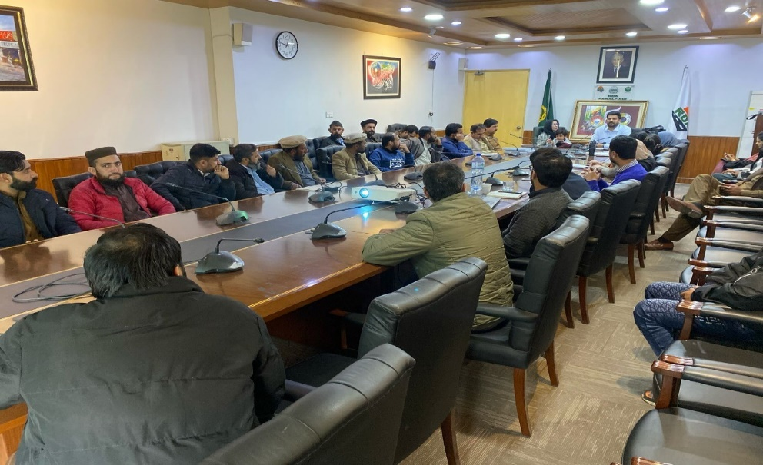

Table ‎8-7 shows Pictorial evidence of the consultation.
- After completion/revision and clearance from the ADB, EPA Punjab and Pak EPA the IEE will be disclosed to all the stakeholders as part of public consultation process. The summary of the IEE report will be made available to the stakeholders at the ADB website and official website of PMU PICIIP Local Government and Community Department (LG & CD), Government of Punjab. The Executive Summary (ES) of the IEE report will be translated into local language (Urdu) and will be disclosed at various places.

Table ‎8-1:Consultation with Primary Stakeholders – May to August’23
Sr.# | Date | Location/ Venue/ Address | Specifics of Participant | Feedback/ Concerns | Replies
 | 02-05-2023 | Sheikhpur | Mr. Ch Jehangi  [Land Owner]r | - Proper monitoring of solar equipment should be carried out regularly. | - The EDCM & environmental consultants will ensure to carry out monitoring regularly.
 | 02-05-2023 | Sheikhpur | Mr. Ch Yasir  [Land Owner] | - Unexpected damages can be avoided by using solar power system so I am pleased with this project initiative.
 | 02-05-2023 | Sheikhpur | Mr. M Kazim  [Land Owner] | - An excellent idea for providing drinking water as solar powered pumps lessens reliance on traditional power sources.
 | 02-05-2023 | Sheikhpur | Mam Noor ul Aain  Private Job Holder] | - It’s a good project for the provision of clean drinking water. No issue.
 | 02-05-2023 | Sheikhpur | Mr. Khurram Shahzad  [Land Owner] | - It's an extremely beneficial project to maintain a consistent supply of drinking water with ease.
 | 02-05-2023 | Sheikhpur | Mr. Adeel Amad  [Land Owner] | - Hopefully, this project will aid in the resolution of water woes. I have no issue. | - The EDCM & social environmental experts will ensure cooperation to assist with water crisis challenges.
 | 02-05-2023 | Sheikhpur | Mr. Raja Altaf  [Land Owner] | - It is requested to work properly and do not disturb the daily lives of locals. | - The EDCM & social environmental experts will ensure that no interferences with locals’ living standards occur.
 | 02-05-2023 | Sheikhpur | Mr. Waqas Afzal  [DD Social Safeguard] | - Given that a viable solar water solution provides communities with the consistent water supply they need, this endeavour seems to be necessary.
 | 02-05-2023 | Sheikhpur | Mr. M. Junaid  [Sociologist] | - It’s a good project, such projects should promote in the country to help the water shortage.
 | 02-05-2023 | Sheikhpur | Mam Ifra  [Teacher] | - I hope the labours are sufficiently skilled to complete the construction work properly. | - EDCM & Social Environmental Consultant will ensure that all the labor requirements are satisfied.
 | 02-05-2023 | Sheikhpur | Mr.Mohsin Raza  [Cons. IVS] | - Good initiative, solar systems usually have long product life, low maintenance cost and manageable service requirements.
 | 02-05-2023 | Sheikhpur | Mr. Zohaib  [Cons IVS] | - No objection, such projects are demand of the time.
 | 02-05-2023 | Chahan | Mr. Syed Tanveer Shah  [Land Owner] | - This is a good thing that the stated project is being implemented, as it’s a global way to develop sustainable water solution.
 | 02-05-2023 | Chahan | Mr. Iftikhar  [Land Owner] | - The initiative appears to be advantageous for the locals. In Pakistan, solar energy is a fantastic replacement for expensive, electric water supply systems.
 | 02-05-2023 | Chahan | Mr. Mazar Haq  [Land Owner] | - It was requested to keep the prices low and secure payment for water services provided to consumers | - The EDCM & social environmental experts will ensure to provide water facilities with low prices.
 | 02-05-2023 | Chahan | Mr. Bashrat Husain  [Land Owner] | - Effective water delivery systems for the community can be made possible by solar water solutions.
 | 02-05-2023 | Chahan | Mr. Umer Shahzad  [Land Owner] | - No issue regarding this project. Hopefully, reasonable cost will be charged for the provision of water services. | - The EDCM & social environmental experts will ensure to provide water facilities with low prices.
 | 02-05-2023 | Chahan | Mr. Major Sajjid  [Land Owner] | - I have no objection to the implementation of this project. Solar water solutions can ensure an effective water supply system for communities.
 | 02-05-2023 | Chahan | Mr. Abdur Sattor  [Land Owner] | - Solar power for water supply system is a great alternative to high priced and unpredictable electrical water pumps.
 | 02-05-2023 | Chahan | Mam Fozia  [Teacher] | - No issue, as solar water system can make effective water delivery systems to our area. .
- `` | 02-05-2023 | Chahan | Mr. Mamraiz  [Farmer] | - Solar systems are a good initiative to avoid noise and air pollution caused by electrical power supply systems.
 | 02-05-2023 | Chahan | Mr. Zafiyat  [Farmer] | - I am satisfied with the implementation of this project as Pakistan is already facing with water and energy crisis problems.
 | 02-05-2023 | Chahan | Mr. Waqas Afzal  [DD Social Sociologist] | - Solar water pump installations will be helpful to manage drinking water supply issues so I am satisfied with the implementation of this project.
 | 02-05-2023 | Chahan | Mam Khizra  [Teacher] | - The idea seems good. It was requested to provide jobs to locals. | - EDCM & Social Environmental Consultant will make sure to provide job facilities to local, if any.
 | 02-05-2023 | Chahan | Mr. M Junaid  [Cons Sociologist] | - As explained, solar-powered water pump systems are reliable, so I have no issue with this project's implementation.
 | 02-05-2023 | Chahan | Mr. Zohaib  [IVS Cons] | - There is no problem with this initiative; in fact, it will help to lessen problems caused by conventional power plant systems, such as climate change and global warming.
 | 02-05-2023 | Chahan | Mam Farhat  [LadyHealth Worker] | - The initiative appears to be advantageous for the locals
 | 03-05-2023 | Raniyal | Mr.Zahid Hussain  [Land Owner] | - No issues and pleased with the project.
 | 03-05-2023 | Raniyal | Mr. Raja Aurangzaib Khan  [Land Representative] | - This project appears reasonable, thus I don't see any problems with it.
 | 03-05-2023 | Raniyal | Mr. Ch Tariq Mahmood  [Land Representative] | - This is a good idea because solar-powered water pumping systems offer an economical and sustainable source of energy.
 | 03-05-2023 | Raniyal | Mr. Baber Hussain  [Land Owner] | - Try to solve the traffic issues, while the project is still being built. I have no issue. | - The EDCM & Social Environmental Consultant will ensure compliance with the improvement in traffic issues during construction.
 | 03-05-2023 | Raniyal | Mr. Raja Mahmood  [Land Owner] | - Solar water pumping systems are a good concept because they provide a financially sustainable source of water supply system.
 | 03-05-2023 | Raniyal | Mr. Arshad Mahmood  [Land Owner] | - There is no issue regarding this project, such projects will help to reduce issues like global warming and climate change triggered by conventional power plant systems.
 | 03-05-2023 | Raniyal | Mr. Shahana Iqbal  [Houswife] | - This is a good idea because solar-powered water pumping systems offer an economical and sustainable source of energy.
 | 03-05-2023 | Raniyal | Mr. Fahad Sultan  [Land Owner] | - Solar power systems are reliable, clean, and cost-free so such initiatives ought to be supported.
 | 03-05-2023 | Raniyal | Mr. Bilwal Zaib  [Land Owner] | - In regards to this project, I have no issues.
 | 03-05-2023 | Raniyal | Mr. M Fawad  [Land Owner] | - I have no issue. I'm hoping that this initiative will contribute to a higher quality of life. | - The EDCM & Social Environmental Consultant will ensure better quality standard.
 | 03-05-2023 | Raniyal | Mr. Waheed Mahmood  [Land Owner] | - The pump can be operated and monitored remotely thanks to the remote monitoring feature, which also lowers the cost of hiring staff. The government may utilize the money saved to provide some welfare. | - .
 | 03-05-2023 | Raniyal | Mr. Waqas afzal  [Land Owner] | - I have no issue regarding this project.
 | 03-05-2023 | Raniyal | Mam Arifa Batool  [Teacher] | - In regards to this project, I have no issues.
 | 03-05-2023 | Raniyal | Mr. M Junaid  [Land Owner] | - Pakistan is facing energy crisis so it's a good initiative to utilize sunlight to run turbines.
 | 04-05-2023 | Morga Adaila | Mam Rizwana Aziz  [Housewife] | - Try to solve the traffic issues during construction. I have no issue. | - The EDCM & Social Environmental Consultant will ensure compliance with the improvement in traffic issues during construction.
 | 04-05-2023 | Morga Adaila | Mam Fatima  [Lady Health worker] | - Solar water pumping system is an excellent ides so satisfied with this project.
 | 04-05-2023 | Morga Adaila | Mr. Waqas Afzal  [DD Social Safeguard] | - It is a positive move toward the community's economic empowerment. This project will augment standard of living.
 | 04-05-2023 | Morga Adaila | Mr.Haji M. Mumraiz  [Owner[ | - I hope the technical staff and programme management are sufficiently skilled to maintain a peaceful and orderly workplace. | - EDCM & Social Environmental Consultant will ensure that all the project management requirements are satisfied.
 | 04-05-2023 | Morga Adaila | Mr.Malik Tahir  [Owner] | - I have no issue regarding this project. I hope this project may be helpful in providing a better lifestyle.
 | 04-05-2023 | Morga Adaila | Mr.Malik Omer  [Owner] | - As a solar water system delivers community water supply from source to tap with zero energy costs and extremely cheap operating expenses, so such projects should be encouraged further.
 | 04-05-2023 | Morga Adaila | Mr.Akthar Ali  [Owner] | - Such initiatives ought to be supported further because solar water systems provide community water supplies from the source to the tap with no energy costs and extremely low running expenses.
 | 04-05-2023 | Morga Adaila | Mr.Yasir Sadiq  [Owner] | - No objection and satisfied with this project.
 | 04-05-2023 | Morga Adaila | Mr.Baber Azeem  [Owner] | - Stated project shall not affect our daily lives and sources of income.
 | 04-05-2023 | Morga Adaila | Mr.Amir Akram  [Owner] | - I have no objection regarding this project.
 | 04-05-2023 | Morga Adaila | Mr. Tanveer Akram  [Land Owner] | - This is a worthwhile idea as water pumping systems powered by solar energy provide a financially and environmentally sound source of power.
 | 04-05-2023 | Morga Adaila | Mr. M Junaid  [Cons. Sociologist] | - No opposition. It is requested that you work carefully.
 | 04-05-2023 | Morga Adaila | Mr. Zohaib  [Irs Cons.] | - I do not have any issue with this project.
 | 04-05-2023 | Morga Adaila | Mr. M Shoaib | - No opposition. It is requested that you work carefully. | - EDCM & Social Environmental Consultant will ensure to work carefully.
 | 04-05-2023 | Morga Adaila | Mam Sana Urooj  [Teacher] | - I am happy with the project's idea because adopting a solar power system can prevent unforeseen harm.
 | 05-05-2023 | Akbar Chowk Girja | Mr. Waqas Afzal  [DD Social Sociologist] | - The pump can be operated and monitored remotely thanks to the remote monitoring feature, which also lowers the cost of hiring staff.
 | 05-05-2023 | Akbar Chowk Girja | Mr. Junaid  [Sociologist] | - This is a good idea because solar-powered water pumping systems offer an economical and sustainable source of energy.
 | 05-05-2023 | Akbar Chowk Girja | Mr. M Ashfaq  [Joined Land Owner] | - It sounds like a good endeavour, since there are no fuel expenditures so low Operation costs is required.
 | 05-05-2023 | Akbar Chowk Girja | Mr. M Waris  [Joined Land Owner] | - I have no issue regarding this project as this technology is dependable and requires no upkeep because solar powered water pump systems are simple.
 | 05-05-2023 | Akbar Chowk Girja | Mam Kanwal  [Teacher] | - No objection. It is requested to handle the construction wor k and materials properly. | - EDCM & Social Environmental Consultant will make sure that the construction work and materials be handled carefully.
 | 05-05-2023 | Akbar Chowk Girja | Mr. Abdul Rashid  [Joined Land owner] | - The initiative appears to be advantageous for the locals. In Pakistan, solar energy is a fantastic replacement for expensive, electric water supply systems.
 | 05-05-2023 | Akbar Chowk Girja | Mam Noreen  [Teacher] | - I hope this project will be helpful in providing improved lifestyle.
 | 05-05-2023 | Akbar Chowk Girja | Mr. Mujeeb  [Joined Land owner] | - Effective water delivery systems for the community can be made possible by solar water solutions.
 | 05-05-2023 | Akbar Chowk Girja | Mr. Qasim  [Joined Land owner] | - Solar power for water supply system is a great alternative to high priced and unpredictable electrical water pumps.
 | 05-05-2023 | Akbar Chowk Girja | Mr. M Haneef  [Joined Land owner] | - Solar systems are a good initiative to avoid noise and air pollution caused by electrical power supply systems.
 | 05-05-2023 | Akbar Chowk Girja | Mr. Malik Nasir  [Joined Land owner] | - I am satisfied with the implementation of this project as Pakistan is already facing with water and energy crisis problems.
 | 05-05-2023 | Akbar Chowk Girja | Mam Hira  [Housewife] | - Solar water pumping systems may provide a financially sustainable source of water supply system.
 | 05-05-2023 | Akbar Chowk Girja | Mr. Zohaib  [Cons. IVS] | - The idea seems interesting, as it is an excellent replacement for Pakistan's expensive electric pump supplies. It was requested to provide jobs to locals. | - EDCM & Social Environmental Consultant will make sure to provide job facilities to local, if any.
 | 05-05-2023 | Akbar Chowk Girja | Mam Kinza Ali  [Housewife] | - The adoption of solar power systems is a smart move to reduce pollution that is spread by electrical power supply systems.
 | 04-08-2023 | Rawal Town | Mr. Imran Ullah  [O-Level Teacher] | - It appears to be an interesting project because it requires no maintenance and runs on sunlight rather than fuel.
 | 04-08-2023 | Rawal Town/House # 205, Street # 7 | Mr. Ameer  [Optical Centre, Worker] | - Proper PEQS should be followed to avoid noise pollution during construction. | - EDCM & Social Environmental Consultant will make sure that PEQS be followed during and after Construction of the project.
 | 04-08-2023 | Rawal Town | Mr. Malik Faizan  [Student] | - I have no issue regarding this project.
 | 04-08-2023 | Rawal Town | Mr. Malik Awais  [Student] | - No objection. It is requested to handle the construction materials properly and work skilfully. | - EDCM & Social Environmental Consultant will make sure that the construction materials be handled carefully and avoid them spreading on the road.
 | 04-08-2023 | Rawal Town | Mam Mirha  [Housewife] | - I have no objections, as it seems like a good project to handle the water issues.
 | 04-08-2023 | Rawal Town | Mam Hadia  [Housewife] | - No objection and satisfied with this project.
 | 04-08-2023 | Rawal Town | Mam Hooria  [Housewife] | - Stated project shall not affect our daily lives and sources of income. | - EDCM & Social Environmental Consultant will make sure to do not disturb the locals in any way.
 | 04-08-2023 | Near Sheikhpur, Batta Chowk | Mr. Zafran  [Salesman] | - No objection and satisfied with this project.
 | 04-08-2023 | Near Sheikhpur, Batta Chowk | Mr. Binyamin  [Worker] | - It seems a decent project so I have no issue regarding this project.
 | 04-08-2023 | Near Sheikhpur, Batta Chowk | Mr. Nadeem Abbas  [Worker] | - I have no issue with the development of this project.
 | 04-08-2023 | Near Sheikhpur, Batta Chowk | Mam Khalida  [Teacher] | - I have no objections to this initiative.
 | 04-08-2023 | Near Sheikhpur, Batta Chowk | Mam Wajeeha  [Housewife] | - I have no issue as stated; the said project will be helpful to increase the source of employment.
 | 04-08-2023 | Near Sheikhpur, Batta Chowk | Mam Ambreen  [Housewife] | - This is a good idea because solar-powered water pumping systems offer an economical and sustainable source of energy.
 | 05-08-2023 | Akbar Chowk, Girja Chowk | Mr. Waqar [Farmer] | - Satisfied with the project. Regular monitoring of solar equipment should be carried out to avoid any failure. | - EDCM & Social Environmental Consultant will ensure that the necessary steps are taken to prevent any damage.
 | 05-08-2023 | Akbar Chowk, Girja Chowk | Mr.Khalid Khan  [Shopkeeper] | - I have no issue regarding this project as this technology is dependable and requires no upkeep because solar powered water pump systems are simple.
 | 05-08-2023 | Akbar Chowk, Girja Chowk | Mr. Zafar Ali Zahoor  [Data Analyst] | - I have no objections, as it seems like a good project to handle the water issues.
 | 05-08-2023 | Akbar Chowk, Girja Chowk | Mr. Hafeez  [School Teacher] | - I have no objections to this initiative.
 | 05-08-2023 | Akbar Chowk, | Mr. Mateeh Ullah  [Police Officer] | - No issue regarding the project. The stated project will be helpful to provide and managing the life better with provision of clean water.
 | 05-08-2023 | Akbar Chowk, | Mam Zaiba  [Housewife] | - Satisfied as the project encourages conservation by using solar energy to pump water.
 | 05-08-2023 | Akbar Chowk, | Mam Amina  [Teacher] | - No issue, solar energy offers a dependable supply of power that is also cost-effective.
 | 05-08-2023 | Akbar Chowk, | Mam Abida  [Housewife] | - It is a positive move toward the community's-economic empowerment.
 | 05-08-2023 | Dhok Bahir Gorakhpur | Mr. Noor Asif  [Vegetable Seller] | - To avoid any potentially dangerous circumstances, proper monitoring during construction should be done. | - EDCM & Social Environmental Consultant will ensure to meet the terms of monitoring plan to prevent the risk during construction.
 | 05-08-2023 | Dhok Bahir Gorakhpur | Mr. Hafiz Imran  [Tyre Service Shop] | - No issue regarding this project.
 | 05-08-2023 | Gorakhpur | Mr. Hashmat Mushtaq  [Shopkeeper] | - I have no issue as stated the said project will be helpful to increase the source of employment.
 | 05-08-2023 | Gorakhpur | Mr. Qazi Waqar Ahmad  [Shopkeeeper] | - No issue regarding this project.
 | 05-08-2023 | Gorakhpur | Mr. Qazi M. Haseeb  [Shop Keeper] | - It sounds like a good endeavour, since there are no fuel expenditures so low Operation costs is required.
 | 05-08-2023 | Gorakhpur | Mam Tayyaba  [Housewife] | - I hope the technical staff and programme management are sufficiently skilled to maintain a peaceful and orderly workplace. | - EDCM & Social Environmental Consultant will ensure that all the project management requirements are satisfied.
 | 05-08-2023 | Gorakhpur | Mam Huma Hidayat Ullah  [Housewife] | - I have no issue as stated the said project will be helpful to increase the source of employment.
 | 05-08-2023 | Jaipur Main | Mr. Qazi Saeed  [Teacher] | - It's an excellent project since it promotes conservation and the environment by using solar energy to pump water.
 | 05-08-2023 | Near Rawal Dam | Mr. Shafique Hussain  [Shopkeeper] | - I have no objections, regarding this project.

Table ‎8-2: Response of Stakeholder during FGDs – August’23
Sr. # | Name (FGD) & Profession | Location | Feedback/Concerns | Replies
FGD at Chaakra Sheikhpur
Date: 05-08-2023
1 | Mr. Zaekhan  [Excavator Runner] | Chaakra Sheikhpur | The following FGD anticipates that this initiative will be beneficial since they will be able to obtain water of improved quality. In Pakistan, problems with the electricity and water crises are getting worse. They think that this project will contribute to lessening these issues. Additionally, they anticipate that water services will be provided at a fair price. Utilizing tactics to lessen construction-related problems, including noise pollution, was requested. | The EDCM & Social Environmental Consultant will ensure compliance with the improvement in noise related issues during construction and will make sure to adhere to PEQS both during & after project construction. Water will be provided at affordable cost.
2 | Mr. Shoaib  [Trauli Runner]
3 | Mr. Ameer Gukdan  [Technician]
4 | Mr. Saif ur Rehman  [CSO]
5 | Mr. Malik  [Office Boy]
6 | Mr. Imran Khan  [ Land Owner]
7 | Mr. Alam Khan  [ Farmer]
FGD at Akbar Chowk.
Date: 05-08-2023
1 | Mr. Mushtaq  [Hotel Owner] | Akbar Chowk | The FGD participants appeared satisfied with the plan because it will aid in addressing the problems associated with water depletion. Using solar electricity instead of expensive and unreliable electrical water pumps is a brilliant idea. It was suggested that locals be given employment possibilities. It was advised that the construction activities be closely regulated to minimize damage. | EDCM & Social Environmental Consultant will make sure to resolve the water related issues and regularly monitor the construction activities to minimize the damage.
2 | Mr. Fawad  [Scrap dealer]
3 | Mr. M Naeem  [Scrap dealer]
4 | Mr. Naveed Akthar  [Scrap dealer]
5 | Mr. Asad  [Hotel Owner]
FGD at Gorakhpur Jabbar
Date: 05-08-2023
1 | Mr. Taimor  [Student] | Gorakhpur Jabbar. | The project's initiative is supported in this focus group discussion since it will aid in resolving the water issues. They think solar water solutions can enable the community to have efficient water distribution systems. An enhanced, higher-quality water supply system will result from the aforementioned project. It was asked to perform routine maintenance on the solar system equipment. | The EDCM & Social Environmental advisor will guarantee adherence to compliance with the improvement in water related issues and solar system equipment will be regularly monitor to avoid any damage.
2 | Mr. Qasim  [Shopkeeper]
3 | Mr. Shoaib  [Shopkeeper]
4 | Mr. Changiz  [Labour]
5 | Mr. zohaib  [Driver]
6 | Mr. Shams Tabriz  [Shopkeeper]
7 | Mr. Hamza  [Hotel Owner]
8 | Mr. Umair  [Shopkeeper]
9 | Mr. Mumraiz  [Property Dealer]
FGD at Sangjani
Date: 04-08-2023
1 | Mr. Naveed Khatak  [Salesman] | Sangjani | The FGD participants seemed pleased with the manner in which this project was implemented because it would give them easy access to water at a low cost. They will have access to a reliable source of drinking water. In addition, they think that solar water pump systems are more dependable at supplying water than electrical water pumps, which can still function in the event of an electricity outage. They are expecting for a skilled development of the project. They essentially accepted the conditions of the proposal. | The EDCM and Social Environmental Advisor will ensure PEQS adherence, as well as compliance with the reduction of billing.
2 | Mr. Ashfaq Qazi  [Land Owner]
3 | Mr. Saleem Khan  [ Farmer]
4 | Mr. Raza Khan  [Hotel owner]
5 | Mr. Shoaib Khan  [Farmer]
6 | Mr.Usman  [Mechanic]
7 | Mr. Adnan  [Mechanic]
8 | Mr. Ahsan  [Mechanic]
9 | Mr. Najeeb Khan  [Mechanic]
10 | Mr. Behroz Khan  [Mechanic]
11 | Mr. Sajid Khan  [Mechanic]
12 | Mr. Mateeh Ullah  [Mechanic]
13 | Mr. Sadeeq Khan  [Mechanic]
14 | Mr. Saeed Umar  [Mechanic]
FGD at Rawal
Date: 04-08-2023
1 | Mr. Mubeen Awan  [Govt Employe] | Rawal | Since this initiative would help distribute clean water, no one in the FGD objected to it. They think it is an outstanding concept because solar-powered bore well pumps reduce dependency on conventional power sources, which is important for providing drinking water. This project will help solve the local drinking water problems without contributing to energy-related difficulties. It was requested that transit schedules be restricted while construction is underway. They were happy that clean water would be made available by the initiative. They hope the project will be finished as soon as possible so that their worries regarding the water supply will be allayed. | The EDCM and social environmental advisor will make sure to manage the transit schedules. They will also make sure to complete the project as soon as possible for the provision of clean water.

Table ‎8-3:Consultation with Project Affected People – November’22 to January’23
Sr.# |  | Date | Location/ Address | Specifics of Participant | Feedback/ Concerns | EDCM/ Social Environmental Advisor Reply
Public Consultation
1 | 30-11-2022 |  | Bank Colony, Ranial, Rawalpindi | Mr. M. Tajjamal Sadiq  [Bykea Delivery Servant] | Since it's a first step towards livelihood, I have no objections to this endeavor. It’s also a good initiative to provide clean water at an affordable price.
2 | 30-11-2022 |  | Bank Colony, Ranial, Rawalpindi | Mr. M. Omer  [Taxi Driver] | Each month, we must set aside Rs. 10–15 K solely for the purchase of drinking water. As stated, this project will give us access to clean water at an affordable price, so I am very satisfied with the implementation of this project.
3 | 30-11-2022 |  | Bank Colony, Ranial, Rawalpindi | Mr. Pervez Khan  [Farmer] | Clean water will be provided so it will be a good initiative towards the livelihood. Requested to use the non-residential sites for distributing the pipelines. | EDCM and Social Environmental Advisor will ensure to avoid offending the villagers by leveraging their property to spread the pipes.
4 | 30-11-2022 |  | Bank Colony, Ranial, Rawalpindi | Mam Raisham Yaqoob  [Housewife] | I am happy regarding this project. Probably, the project will be helpful in providing water with ease. | EDCM and Social Environmental Consultants will make sure to provide water with ease at your homes.
5 | 30-11-2022 |  | Bank Colony, Ranial, Rawalpindi | Mam Hamida  [Housewife] | I am satisfied with this initiative; the project will be helpful in providing clean water at an affordable price.
6 | 30-11-2022 |  | Bank Colony, Ranial, Rawalpindi | Mam Aziza Begum  [Housewife] | Water is the basic necessity; it should be accessible in every home. Hopefully, this project will be helpful to provide safe drinking water in our homes. | EDCM and Social Environmental Advisor will make sure to provide clean water with ease at your homes.
7 | 30-11-2022 |  | Bank Colony, Ranial, Rawalpindi | Mam Laiba Azhar  [Housewife] | It’s a good initiative to solve the water issues in the community. Although during construction we have to face dust and noise related issues, it’s still worth it if we’ll have clean water for drinking, after construction. | EDCM and Social Environmental Advisor will ensure to provide clean water.
8 | 30-11-2022 |  | Bank Colony, Ranial, Rawalpindi | Mr. Mir Afzal  [Islamic educationist] | I have no issue regarding this project. We’ll be able to get water with ease.
9 | 30-11-2022 |  | Bank Colony, Ranial, Rawalpindi | Mam Naseem Akhtar  [Housewife] | There is no proper channel to access water in our area. The project seems beneficial for us in provision of water and job facilities.
10 | 30-11-2022 |  | Bank Colony, Ranial, Rawalpindi | Mr. Ikhlaq Hanif  [Soldier] | This project will augment the standard of living in the area and provide us the direct access to water at an affordable price. Satisfied with the stated project.
11 | 30-11-2022 |  | Bank Colony, Ranial, Rawalpindi | Miss. Rahat Gul  [Student] | This is a worthwhile idea to provide clean water in our area. Requested to overcome dust and noise pollution during construction. | EDCM and Social Environmental Advisor will make sure to adhere to the correct processes for resolving dust and noise-related construction problems.
12 | 30-11-2022 |  | Bank Colony, Ranial, Rawalpindi | Mam Shakeela Begum  [Housewife] | This initiative appears to be worthwhile. This will deliver better-quality water to our houses.
13 | 30-11-2022 |  | Bank Colony, Ranial, Rawalpindi | Mr. Rafiq  [Cycle Puncture Shop] | Bore and clean water is reducing day by day, it seems a good initiative to solve this problem.
14 | 30-11-2022 |  | Bank Colony, Ranial, Rawalpindi | Mr. Zain  [Unemployed] | No objection, the following project will be helpful to provide clean water.
15 | 30-11-2022 |  | Bank Colony, Ranial, Rawalpindi | Mr. M. Javed  [Karyana Store] | We have no access to clean water due to which water borne disease are increasing. It seems like a good project to reduce this issue.
16 | 30-11-2022 |  | Bank Colony, Ranial, Rawalpindi | Mr. Abdul Basit  [Student] | Content with the project's provision of clean water. Hope the construction work will be handled carefully. | EDCM and Social Environmental Advisor will make sure that construction work is handled according to suitable PEQs.
17 | 30-11-2022 |  | Bank Colony, Rawalpindi | Mr. Abdullah  [Student] | This is a good thing that the stated project is being implemented, as this will benefit locals by solving water related issues.
18 | 30-11-2022 |  | Bank Colony, Rawalpindi | Mr. Bilal Ahmad  [Scrap Dealer] | Proper monitoring of water treatment plant and service pipelines shall be carried out on a regular basis. | EDCM and Social Environmental consultant will make sure to fulfill the regular maintenance of the treatment plant and pipelines.
19 | 30-11-2022 |  | Bank Colony, Rawalpindi | Mr. Azan Nasir  [Shopkeeper] | Requested to hire the skilful labours to complete the work without any obstacle. | EDCM and Social Environmental Advisor will ensure that labour is employed in accordance with appropriates guidelines and laws.
20 | 30-11-2022 |  | Bank Colony, Rawalpindi | Mr. Rehan  [Shopkeeper] | I have no objection in the implementation of this project. Locals should be preferred in provision of job opportunities. | EDCM and Social Environmental Advisor will ensure to prefer locals for jobs facilities available, if any.
21 | 30-11-2022 |  | SS Model Town, Rawalpindi | Mam Shaila Shaheen  [Housewife] | The project seems beneficial for the local residents of this town. It is requested to give access to clean water to everyone. | EDCM and Social Environmental Advisor will make sure that every home in the area has access to clean water.
22 | 30-11-2022 |  | SS Model Town, Rawalpindi | Mr. M. Shafiq  [Shopkeeper] | No issue regarding this project. Bores get dried in summer. I hope the project will be helpful in the summer. There will be more opportunities for business as well. | EDCM and Social Environmental Advisor will ensure the provision of water in summer as well.
23 | 30-11-2022 |  | SS Model Town, Rawalpindi | Mam Hajran Gul  [Housewife] | It seems a good project. Hopefully, we’ll also have access to clean water for drinking. Requested to provide water in the homes through proper channels. | EDCM and Social Environmental Advisor will ensure to provide clean water access to every home in the area.
24 | 30-11-2022 |  | SS Model Town,, Rawalpindi | Mam Rabia Ameen  [Housewife] | I am satisfied with the implementation of this project as there is no water in summer using water-bores and tankers are unaffordable.
25 | 30-11-2022 |  | SS Model Town, Rawalpindi | Mr. Afhan Abdul Majeed  [Driver] | I have no issue with the development of this project, as water tankers are too much expensive. Daily wagers like us can’t afford it.
26 | 30-11-2022 |  | SS Model Town, Rawalpindi | Mr. Wajid Ali  [Ward Boy] | No issue regarding this project. It is requested to provide clean water and job facilities to locals. | EDCM and Social Environmental Advisors will ensure that locals have access to clean water and job facilities.
27 | 30-11-2022 |  | SS Model Town, Rawalpindi | Mr. Nazir  [Fruit Stall] | The low quality of our neighbourhoods’ drinking water is a major contributor to the rise in diarrhoea. It is requested that clean water be provided. | EDCM and Social Environmental Advisor will make sure to provide clean water access to locals.
28 | 30-11-2022 |  | SS Model Town, Rawalpindi | Mr. Ayan Zafar  [Unemployed] | I have no issue as it seems to be a useful project. Try to fix the pollution problems while the project is in its construction phase. | EDCM and Social Environmental Advisor will make sure to adhere the correct processes for resolving pollution related issues.
29 | 30-11-2022 |  | SS Model Town, Rawalpindi | Mr. Liaqat Hussain  [Scrap Dealer] | Satisfied with the project in provision of clean water.
30 | 30-11-2022 |  | SS Model Town, Rawalpindi | Mr. Raza  [Shopkeeper] | Water quality issues are leading us to various diseases. The stated project will be helpful to provide and manage the life better with the provision of clean water.
31 | 30-11-2022 |  | SS Model Town, Rawalpindi | Mr. Ibrar Abdullah  [Unemployed] | People in our area have many water borne diseases. As stated, this project will be helpful to enhance the water quality, so I am satisfied.
32 | 30-11-2022 |  | Bata Colony, Chakra, Rawalpindi | Mam Riaz BiBi  [Housewife] | The good initiative, especially for the people who cannot afford tankers. There will be more job prospects for residents.
33 | 30-11-2022 |  | Bata Colony, Chakra, Rawalpindi | Mam Shabnum  [Housewife] | We are using water tankers, which are very expensive. We will be able to get an easy access to water at an affordable price.
34 | 30-11-2022 |  | Bata Colony, Chakra, Rawalpindi | Mam Wahida  [Housewife] | The project seems beneficial. This initiative will be helpful to provide water in our homes. Locals should be preferred for job opportunities. | EDCM and Social Environmental Advisor will make sure to give preference to locals for any employment or job facilities.
35 | 30-11-2022 |  | Bata Colony, Chakra, Rawalpindi | Mr. Tahir Iqbal  [Driver] | This seems good initiative for the local residents of colony. Locals will have more job opportunities and easier access to water.
36 | 30-11-2022 |  | Bata Colony, Chakra, Rawalpindi | Mr. Ahmad Ullah  [Driver] | It appears to be a worthwhile effort for providing clean water. I support this initiative because there is a need for more clean water in our colony.
37 | 30-11-2022 |  | Bata Colony, Chakra, Rawalpindi | Mr. Waqas  [Mechanic] | It is requested to provide clean water through proper channels. No issue with the implementation of the project. | EDCM and Social Environmental Advisor will ensure the provision of clean water through proper channels.
38 | 30-11-2022 |  | Bata Colony, Chakra, Rawalpindi | Mr. Zain  [Labour] | No issue, requested to provide safe and clean water for drinking purposes.
39 | 30-11-2022 |  | Bata Colony, Chakra, Rawalpindi | Mr. Sher Ali  [Scrap Dealer] | The project seems to provide safe drinking water. The job opportunities will also increase, so I do not have any issue regarding this project.
40 | 30-11-2022 |  | Bata Colony, Chakra, Rawalpindi | Mr. Mujahid  [Labour] | No issue regarding the project. It is requested to provide good quality water. | EDCM and Social Environmental Advisor will ensure to provide good quality water.
41 | 30-11-2022 |  | Bata Colony, Chakra, Rawalpindi | Mr. Taimoo r Ahmed  [Labour] | It seems a good project and hope it will bring more job opportunities for locals. | EDCM and Social Environmental Advisor will make an effort to give locals preference for any available positions or job resources.
42 | 30-11-2022 |  | Bata Colony, Chakra, Rawalpindi | Mr. Haider Ali  [Labour] | Satisfied with the project. Locals should be given job opportunities. | EDCM and Social Environmental Advisor will make sure to give preference to locals if there are employment or job facilities available.
43 | 30-11-2022 |  | Bata Colony, Chakra, Rawalpindi | Mr. Amir  [Shopkeeper] | The project seems beneficial to improve water quality. Job opportunities should be provided to locals. | EDCM and Social Environmental Advisor will ensure that locals are given priority if there are any work opportunities available.
44 | 30-11-2022 |  | Kashmiri Abadai, Raniyal Village, Rawalpindi | Mr. Rehan  [Own Business] | I have no issue with the development of this project. It is requested to monitor the maintenance of filtration plant and pipeline on regular basis. | EDCM and Social Environmental Advisor will make sure to prevent disturbing the residents due to the utilization of land for spreading the pipelines.
45 | 30-11-2022 |  | Kashmiri Abadai, Raniyal Village, Rawalpindi | Mam Rahat Ali  [Housewife] | No issue, it’s a good initiative for local residents by increasing their employment opportunities and providing the quality water. Requested to handle the construction work properly. | EDCM and Social Environmental Advisor will make sure to manage the construction work in accordance with appropriate PEQs.
46 | 30-11-2022 |  | Kashmiri Abadai, Raniyal Village, Rawalpindi | Mam Nadia Jameel  [Housewife] | It seems a decent project for the provision of quality water, so I have no issue regarding this project.
47 | 30-11-2022 |  | Kashmiri Abadai, Raniyal Village, Rawalpindi | Mam Mehwish Mumtaz  [Housewife] | I have no objections to this initiative as the quality of water will increase.
48 | 30-11-2022 |  | Kashmiri Abadai, Raniyal Village, Rawalpindi | Mr. Ishtiaq  [Farmer] | No objection and satisfied with this project as the project seems beneficial to improve water quality.
49 | 30-11-2022 |  | Kashmiri Abadai, Raniyal Village, Rawalpindi | Mr. Akbar  [Farmer] | No issue regarding this project. It seems a good initiative to fulfil the amount of water required.
50 | 30-11-2022 |  | Kashmiri Abadai, Raniyal Village, Rawalpindi | Mr. Ahmad  [Unemployed] | We are facing water deficiency in our homes. Hopefully, this initiative will assist in resolving this problem. | EDCM and Social Environmental Advisor will ensure that water is provided to each household in the area, reducing water deficiency-related issues..
51 | 30-11-2022 |  | Kashmiri Abadai, Raniyal Village, Rawalpindi | Mr. Wajahat  [Farmer] | I have no objection. Requested to use the barren land to expand the water supply pipelines. | EDCM and Social Environmental Advisor will ensure to avoid offending the locals by using their property to disseminate the pipes.
52 | 30-11-2022 |  | Kashmiri Abadai, Raniyal Village, Rawalpindi | Mam. Shubnam  [Housewife] | It seems a decent project for the provision of quality water, as well as job facilities for locals.
53 | 30-11-2022 |  | Kashmiri Abadai, Raniyal Village, Rawalpindi | Mam Sakeena  [Housewife] | I have no objections to this project's execution because it looks like an excellent concept to address the local water problems.
54 | 30-11-2022 |  | Kashmiri Abadai, Raniyal Village, Rawalpindi | Mr. Abid  [Farmer] | I have no issue about the initiative of this project, as we’ll be able to receive quality water.
55 | 18-01-2023 |  | Akbar Chowk, Rawalpindi | Mr. Naseer Ahmad  [Shopkeeper] | I am happy with how this project was carried out. Reduce the problems caused by construction as much as possible. | EDCM and Social Environmental Advisor will make sure to follow suitable PEQs for construction to reduce the problems caused by construction.
56 | 18-01-2023 |  | Akbar Chowk, Rawalpindi | Mr. M. Billa  [Plumber] | I have no issue with the implementation of this project. It is demanded that the construction be carefully observed to avoid any hiccups. | EDCM and Social Environmental Advisor will make sure to regulate the construction activities with appropriate procedures to avoid any mishaps.
57 | 18-01-2023 |  | Akbar Chowk, Rawalpindi | Mr. Akram Rafeeq  [Vegetable Seller] | Satisfied with the implementation of this project. Hope it will be helpful to solve water related issues. | EDCM and Social Environmental Advisor will make sure to provide clean water so that water-related concerns are resolved.
58 | 18-01-2023 |  | Akbar Chowk, Rawalpindi | Mr. Farman Khan  [Data Analyst] | It was requested to hire sufficiently skills workers to maintain an orderly workplace both during and after construction. | EDCM and Social Environmental Advisor will ensure that skilled workers are hired in order to keep the workplace organized.
59 | 18-01-2023 |  | Akbar Chowk, Rawalpindi | Mr. Zahir Shah  [School Teacher] | There is no proper water supply and sewerage system in the area; the following project will be helpful to solve this issue, so I am satisfied.
60 | 18-01-2023 |  | Chakra, Rawalpindi | Mr. Chaudhary Khurram  [Shopkeeper] | No issue and I am satisfied with how this project is coming along. Locals should be given preference when offering employability. | EDCM and Social Environmental Advisor will make sure to prefer locals in case of any job facility available.
61 | 18-01-2023 |  | Chakra, Rawalpindi | Mr. M. Yaseen Shah  [Dry Clean Shop] | I have no objections to this project; only make sure the construction activity is appropriately managed. | EDCM and Social Environmental Advisor will make sure to supervise the construction activities in conformity with the appropriate procedures.
62 | 18-01-2023 |  | Chakra, Rawalpindi | Mr. M. Akram  [Vegetable Seller] | No issue regarding this project. It was demanded that local water-related problems be resolved. | EDCM and Social Environmental Advisor will make sure to fulfil the water demands of the locals.
63 | 18-01-2023 |  | Malikabad Chakra Road, Rawalpindi | Mr. Shoaib  [Student] | As stated, this project will result to solve water scarcity issue rising in the area. It was recommended to keep the water quality high. | EDCM and Social Environmental Advisor will ensure that the provided water quality is high.
64 | 18-01-2023 |  | Malikabad Chakra Road, Rawalpindi | Mr. Iftikhar Ahmad  [Fruit Seller] | I don't object because it sounds like a good effort to address the water situation.
65 | 18-01-2023 |  | Malikabad Chakra Road, Rawalpindi | Mr. Naseer Ahmed  [Butcher Shop] | No objections because addressing the issues with the water deficit seem like a good idea. To prevent any inconvenience, it is urged that the construction work be managed correctly. | EDCM and Social Environmental Advisor will make sure to oversee the construction operations according to the necessary protocols.
66 | 19-01-2023 |  | Girja Village, Rawalpindi | Mr. Ismaeel Jahangir  [Service Shop] | There are a lot of water-borne infections rising in the area. I hope, this initiative will assist to improve the quality of the water. | EDCM and Social Environmental Advisor will ensure to provide high quality water.
67 | 19-01-2023 |  | Girja Road, Rawalpindi | Mam Zareen Khan  [Housewife] | Content with the project in provision of high quality water.
68 | 19-01-2023 |  | Girja Road, Rawalpindi | Mam Aziza  [Housewife] | With the delivery of clean water, the aforementioned project will assist to provide and manage life more effectively.
69 | 19-01-2023 |  | Girja Road, Rawalpindi | Mam Haneefa  [Housewife] | No difficulties with the project's execution since the project will be helpful solve our water related concerns.
70 | 19-01-2023 |  | Girja Road, Rawalpindi | Mr. Rashid Tanveer  [Shopkeeper] | I am pleased with the execution of this project as project will help us to address the local water scarcity problem.
71 | 19-01-2023 |  | Girja Road, Rawalpindi | Mr. Shahrukh Tanveer  [Shopkeeper] | I'm hoping that the initiative will help to improve the water quality and that it will expand locals' employment prospects.
72 | 19-01-2023 |  | Kashmir Colony, Girja Road, Rawalpindi | Mr. Mirza Rehmat Ullah  [Data Entry Freelancer] | It was suggested that the project development be kept under check and balance even after construction to avoid any mishaps. | EDCM and Social Environmental Advisor will make sure that the project development be kept under check and balance even after construction.
73 | 19-01-2023 |  | Kashmir Colony, Girja Road, Rawalpindi | Mr. Zaheer Abbas  [Shopkeeper] | I support this initiative as it initially seemed like a project or initiative to address water-related difficulties.
74 | 19-01-2023 |  | Kashmir Colony, Girja Road, Rawalpindi | Mr. Hasan Ali  [Pvt. Job] | Water depletion, particularly during the summer, is one of the major issues we face in our area. The proposed approach seems to be helpful for overcoming this problem. | EDCM and Social Environmental Advisor will make sure to resolve water related concerns arising in the summer.
75 | 19-01-2023 |  | Purani Police Cowki, Rawalpindi | Mr. Abdul Razaq  [Pvt. Employee] | In the summer, we experience a water deficit in our homes. Hopefully, this initiative will assist in resolving this problem. | EDCM and Social Environmental Advisor will ensure the availability of water in order to address summertime water-related issues.
76 | 19-01-2023 |  | New Lalazad Caltex Road, Rawalpindi | Mr. M. Sarwar  [Driver] | I have no objection regarding this initiative. It is requested that construction activities not interfere with their daily lives. | EDCM and Social Environmental Advisor will make sure to follow appropriate rules for construction activities so that they do not affect the daily lives of locals.
77 | 19-01-2023 |  | New Lalazad Caltex Road, Rawalpindi | Mr. Arsha Iqbal  [Hotel Employee] | Due to the use of bore water in our area, we frequently experience water shortages, particularly during the summer. I'm hoping that the suggested endeavour would be effective in resolving this problem | EDCM and Social Environmental Advisor will ensure the accessibility of water in order to overcome obstacles relevant to water throughout the summer.
78 | 19-01-2023 |  | Hassan Street Defence Road, New Lalazae | Mr. Nabeel Rashid  [Driver] | There was no confrontation. It was asked to work cautiously and to handle the construction materials properly. | EDCM and Social Environmental Advisor will ensure that all construction regulations are followed.
79 | 19-01-2023 |  | Hassan Street Defence Road, New Lalazae | Mam Rehana Khan  [Housewife] | We are suffering a severe water deficit. This project will perhaps help find a solution to this issue. | EDCM and Social Environmental Advisor will make sure to resolve water deficit concerns that arise.
80 | 19-01-2023 |  | Hassan Street Defence Road, New Lalazae | Mr. Sheharyar  [Student] | No opposition. It was requested that the construction materials be handled carefully so as not to interfere with our daily lives. | EDCM and Social Environmental Advisor will make sure that construction material be handled according to proper protocols.
81 | 19-01-2023 |  | Hassan Street Defence Road, New Lalazae | Mr. M. Nabeel  [Mechanic] | I don't have any issues with this proposal; Hope, it will help to conveniently deliver clean water. | EDCM and Social Environmental Advisor will make sure that clean water is provided through the appropriate channels.
82 | 19-01-2023 |  | Defence Road, Rawalpoindi | Mr. Fateh Muhammad  [Saloon Worker] | I don't have any issues with the execution of this project because it seems like a good idea to improve water availability and quality in the area.
83 | 19-01-2023 |  | Khwaja Corporation Chowk, Adiala Road | Mr. Naseeb Khan  [Saloon Owner] | It seems a decent project to enhance the water supply and its quality in the area so I have no issue regarding this project.
84 | 19-01-2023 |  | Dhama Mor, Adiala Road, Rawalpindi | Mr. Faizan Lodhi  [Driver] | It's a terrific idea that will benefit the locals by offering them more work opportunities and raising the water standard they receive.
85 | 19-01-2023 |  | Dhama Mor, Adiala Road, Rawalpindi | Mr. M. Idrees  [Wedding Hall Employee] | I am satisfied with the implementation of this project.
86 | 19-01-2023 |  | Sadiq Town, Dhama Syeddan, Rawalpindi | Mr. Tanveer  [Rickshaw Driver] | Hopefully, this program will help us find solutions to our water-related issues. | EDCM and Social Environmental Advisor will make sure to deal with issues relating to water.
87 | 19-01-2023 |  | Sadiq Town, Dhama Syeddan, Rawalpindi | Mr. Zohaib  [Freelancer] | I have no objection with the execution of this project. The project seems good to resolve our water related concerns.
88 | 19-01-2023 |  | Biscuit Factory Area, Kotha Mor | Mr. Mudassir  [Mechanic Shop] | It sounds like a smart idea to address the water crisis concerns that are emerging in the area.
89 | 19-01-2023 |  | Biscuit Factory Area, Kotha Mor | Mr. Jameel  [Car Service Shop] | Considering that the project would improve water quality, I have no issues with its execution.
90 | 19-01-2023 |  | Biscuit Factory Area, Kotha Mor | Mr. Haji Abdul Rasheed  [Pvt. Employee] | We have problems with both the amount and quality of the water in our region, which is causing us to contract a number of ailments; therefore I am happy with the implementation of this project.
91 | 19-01-2023 |  | Biscuit Factory Area, Kotha Mor | Mr. M. Shafique  [Flower Seller] | This initiative appears to be a worthwhile attempt to solve the problems with water's quality and depletion.
92 | 19-01-2023 |  | Biscuit Factory Area, Kotha Mor | Mr. Rawaiz Khan  [Shopkeeper] | It was requested to maintain an orderly workplace after construction to avoid any mishaps. | EDCM and Social Environmental Advisor will make sure to follow appropriate procedures to maintain an orderly workplace even after construction.
93 | 19-01-2023 |  | Chakri Road, Near Ranial WW, Rawalpindi | Mr. Kala  [Waiter] | One of the biggest problems we deal with in our area is the depletion of water, especially during the summer. The suggested strategy appears to be effective in resolving this issue.
94 | 19-01-2023 |  | Chakri Road, Near Ranial WW, Rawalpindi | Mr. Nawaz  [Fruit Seller] | I don't have any issues with the implementation of this project because it seems like a good idea to improve the water issues arising in the area.
95 | 19-01-2023 |  | Chakri Road, Near Ranial WW, Rawalpindi | Mam Shamasa  [Student] | No issues with the project implementation because the water supply and quality problems in our neighbourhood are causing us to contract a variety of illnesses. The project mentioned will help to provide and manage life more effectively with the supply of clean water.
96 | 19-01-2023 |  | Dhamiyal Road, Rawalpindi | Mr. Sarhad  [Rickshaw Driver] | I am pleased with the way this project is going to implement. As much as feasible, lessen the issues brought on by construction. | EDCM and Social Environmental Advisor will make sure to adhere to the correct PEQs for reducing the problems caused by construction.
97 | 19-01-2023 |  | Dhamiyal Road, Rawalpindi | Mr. M. Zulafqar  [Dry Clean Shop] | These initiatives ought to be carried out because water is a basic requirement. The initiative will be useful in resolving summertime water concerns.
98 | 19-01-2023 |  | Dhamiyal Road, Rawalpindi | Miss Salma Nasir  [Student] | The loss of water, particularly during the summer, is one of the main issues we face in our region. The proposed approach seems to be successful in fixing this problem.
99 | 19-01-2023 |  | Muhalla Jaal Giran Raniyal, Rawalpindi | Mr. Sikandar  [Pvt. School Teacher] | With the supply of clean water, the mentioned project would assist to provide and manage life better.
100 | 19-01-2023 |  | Muhalla Jaal Giran Raniyal, Rawalpindi | Mr. Faisal  [Pvt. Employee] | Bore water is widely used in our area, yet we frequently experience water shortages, especially in the summer. I believe the suggested project will be successful in resolving this issue. | EDCM and Social Environmental Advisor will ensure to resolve water deficit issues in the area.
101 | 19-01-2023 |  | Muhalla Jaal Giran Raniyal, Rawalpindi | Mr. Irfan  [Book Seller] | I support this plan since it will help to improve the quality of the water.
102 | 19-01-2023 |  | Raniyal Stop, Mashrot Road, Dong Chakri, Rawalpindi | Mam Tariqa Mehmood  [Pvt. Employee] | It sounds like a decent idea to supply the area with the sufficient amount of water.
103 | 19-01-2023 |  | Raniyal Stop, Mashrot Road, Dong Chakri, Rawalpindi | Mam Shahida  [Housewife] | No issue, as explained about the project, this initiative will help to address the local water shortage problem so I am satisfied. Maintaining excellent water quality was advised. | EDCM and Social Environmental Advisor will ensure to maintain high quality of water.
104 | 19-01-2023 |  | Raniyal Stop, Mashrot Road, Dong Chakri, Rawalpindi | Mam Salma  [Housewife] | We are facing both water deficit and water quality related issues. This project seems like a good initiative to solve these problems. | EDCM and Social Environmental Advisor will ensure that all water related concerns are resolved, such as the maintenance of high quality water and the availability of water in the area.

Table ‎8-4: Response to Stakeholders during FGDs – December’22
Sr. # | Name (FGD) & Profession | Location | Feedback/Concerns | Reply
Bank Colony, Rawalpindi
Date: 01-12-2022
1 | Mr. M. Tajammal  [Shopkeeper] | Bank Colony, Rawalpindi | According to the following FGD, this initiative seems worthwhile as they will receive water of higher quality as a result. Waterborne illnesses are on the rise as a result of the shortage of clean water. They believe that this project will help lessen this problem. Additionally, they hope that the construction will be done carefully. It was requested to use strategies to reduce construction-related issues such as noise and dust pollution. | EDCM and Social Environmental Advisor will make sure to adhere to the correct processes for resolving dust and noise-related construction problems and will also ensure the provision of clean water through proper channels.
2 | Mr. Mir Afzal  [Shopkeeper]
3 | Mr. Gulam Rubani  [Shopkeeper]
Kashmiri Abadai, Raniyal Village, Rawalpindi
Date: 01-12-2022
1 | Mr. Abbasi  [Unemployed] | Raniyal Village, Rawalpindi | A supportive attitude towards the implementation of this project was observed as the majority of the population in the area lacks access to a reliable water source. Water bores are their sole supply of water; they used to share them, but during the summer, the bores dried up. FGD claims to be satisfied as the project will help them increase their water capacity. This project will also result in raising the area's standard of living and giving residents direct access to water at a reasonable cost. They anticipate locals will be given preference if there are any employment opportunities. | EDCM and Social Environmental Advisor will make sure to give preference to locals for any employment or job facilities.
2 | Mr. Malik Shabir Awan  [Farmer]
3 | Mr. Shaukat  [Farmer]
4 | Mr. Asif Bhatti  [Farmer]
5 | Mr. Jawad Akhtar  [Farmer]
FGD at Bata Colony, Chakra, Rawalpindi
Date: 01-12-2022
1 | Mr. Anwar  [Shopkeeper] | Bata Colony, Chakra, Rawalpindi | The FGD participants appear to be happy with the project, given the necessity of such projects in the present. It was suggested that the construction activities be carefully monitored to avoid disruption. Additionally, they believe that the initiative will be helpful during the summer, when water levels drop. It was suggested that compliance criteria be followed to finish the construction work on schedule. It was also suggested to offer locals employment options. | EDCM and Social Environmental Advisor will ensure that labour is employed in accordance with appropriate guidelines and laws. They will make sure to regulate the construction activities with appropriate procedures to avoid any mishaps. EDCM and Social Environmental Advisor will also make sure to give preference to locals for any employment or job facilities.
2 | Mr. Rehman Khan  [Shopkeeper]
3 | Mr. M. Arshid  [Worker]
4 | Mr. Basit Ali  [Worker]
SS. Model Town, Rawalpindi
Date: 01-12-2022
1 | Mr. Abdul Rafay  [Labour] | SS. Model Town, Rawalpindi | No one in the FGD objected to this project because it would aid in the delivery of clean water. They suggested taking adequate measures to manage the construction activity. This initiative will be beneficial in addressing the area's drinking water issues. It was requested that the scheduling of transit during construction be controlled to avoid obstructing their work hours. It was suggested to discover solutions to problems associated with construction, such as dust, traffic, and machine noise. They were pleased that the project would be able to provide clean water. Additionally, it was advised to hire skilled workers to complete the task without any issues. They anticipate that the project will be completed as soon as possible so that their concerns about the availability of water can be addressed. | EDCM and Social Environmental Advisor will ensure that construction labors are employed in compliance with the necessary standards and regulations. To prevent any accidents, they will make sure to control the construction activities using the appropriate protocols. They will guarantee that the required procedures are followed to address construction-related issues with dust and noise, and they will also make sure that clean water is provided through the appropriate channels.
2 | Mr. Hamad  [Shopkeeper]
3 | Mr. Zulfiqar Khan  [Vegetable seller]
4 | Mr. Asad  [Vegetable seller]
5 | Mr. Bilal  [Shopkeeper]
6 | Mr. Shahan  [Shopkeeper]
7 | Mr. Hassan  [Shopkeeper]
8 | Mr. Asif  [Shopkeeper]
FGD at Chak Jalal Din, New Abadi # 2, Chakri Road, Rawalpindi
Date: 18-12-2022
1 | Mr. Zaheer Akhtar  [Food Stall] | Chak Jalal Din, Rawalpindi | The FGD participants seemed content with the proposal, as the said project will be helpful in dealing with the water depletion issues. It was recommended that the construction operations be tightly controlled to minimize damage. Additionally, it was also recommended to provide work opportunities for locals. | The EDCM and Social Environmental Advisor will ensure that construction operations are governed by appropriate procedures in order to minimize damage. EDCM and Social Environmental Advisor will also make sure to give precedence to locals for any job opportunities.
2 | Mr. Noveed Khan  [General Store]
3 | Mr. Noor  [Worker]
4 | Mr. Tayyab  [Worker]
5 | Mr. Israr  [Shopkeeper]
FGD at Awan Town, Girja Road, Rawalpindi
Date: 18-12-2022
1 | Mr. Amjad Mehmood  [Shopkeeper] | Awan Town, Girja Road, Rawalpindi | This focus group discussion is in favor of the project's initiative because the project will help resolve the water concerns arising in the area. Despite having a water supply system, they are having problems with water depletion and contamination. The aforementioned initiative will contribute to an improved, higher-quality water supply system. It was requested to regularly conduct the necessary monitoring of water treatment facilities and service pipes after the execution of the project. | EDCM and Social Environmental Consultant will ensure routine maintenance of the treatment plant and pipelines after the execution of the project.
2 | Mr. Malik Khwaja  [Wedding Shop]
3 | Mr. M. Riaz  [Hardware Shop]
4 | Mr. Yasir Mehmood  [Shopkeeper]
5 | Mr. Haji Muhammad Younas  [Shopkeeper]
FGD at Imtiaz Market, Chakra Road (Akbar Chowk), Rawalpindi
Date: 18-12-2022
1 | Mr. Shahid Abbasi  [Hotel Owner] | Imtiaz Market, Chakra Road, Rawalpindi | The FGD participants appeared pleased with the manner in which this project was implemented because it would give them cheap and convenient access to water. They will have access to a reliable source of drinking water. They also believe that carrying out the project will make it easier to fight the local ailments. It was requested that transit schedules be restricted while construction is underway to prevent interfering with their working hours. They also requested to find solutions for construction-related problems like dust, traffic, and machine noise. They are hoping that the project will be skillfully developed. In essence, they agreed with the project's terms. | EDCM and Social Environmental Advisors will ensure completion of the requests raised by FGD participants. There will be proper schedule to control the traffic issues. Proper construction related protocols will also be followed.
2 | Mr. M. Ramzan  [Shopkeeper]
3 | Mr. Zafar  [Tea Stall]
4 | Mr. M. Shahid  [Hotel Worker]
5 | Mr. Basheer Abbasi  [Shopkeeper]
6 | Mr. Javed Abbasi  [Hotel Worker]
7 | Mr. Farhan  [Shopkeeper]
FGD at Girja Village- Basic Health Unit, Chakra, Rawalpindi
Date: 18-12-2022
1 | Mr. Farhad Ali  [Govt. Employee] | Girja Village, Rawalpindi | They encourage the development and implementation of the project since it will aid in the solution of the water-related issues. Usually, they experience a water deficit in the summer as they are using bore water. Despite the fact that tankers are too expensive, some of the participants need to purchase tankers. This project would increase the water supply. The project is about maintaining the purity of the water and building the water supply system, so they were encouraging the idea. It was requested that everyone have easy access to water. | EDCM and Social Environmental Advisors will ensure the provision of clean water to everyone.
2 | Mr. Hashim  [Govt. Employee]
3 | Mr. Nouman  [Govt. Employee]
4 | Mr. Muneeb  [Govt. Employee]
5 | Mr. Abdul Rehman  [Govt. Employee]
FGD at New Lalazar Caltex Road (Adiala WW), Rawalpindi
Date: 19-12-2022
1 | Mr. Abbass Ali  [Truck Driver] | Caltex Road | The FGDs support the execution of this project since it will assist in resolving the water difficulties that are now plaguing the area. The majority of them use bore water. In the summer, it dries out. With the delivery of clean water, the aforementioned project will help provide and manage life more effectively.  It was asked to minimize construction-related problems as much as possible. It was also requested to carry out the proper monitoring of water treatment plant and service pipelines on a regular basis. | EDCM and Social Environmental Consultant will ensure routine maintenance of the treatment plant and pipelines after the execution of the project. Proper construction related protocols will also be followed.
2 | Mr. Muhammad  [Driver]
3 | Mr. Saif Ur Rehman  [Driver]
4 | Mr. Shahzaib  [Helper]
5 | Mr. SamiUllah  [Assistant]
6 | Mr. Ali Abbas  [Worker]
7 | Mr. Bilal Khan  [Stall]
8 | Mr. Sarwar Khan  [Hotel Waiter]

Table ‎8-5: Public Hearing proceedings – Feb’24
PROCEEDING OF PUBLIC HEARING
Projects | 1. Augmentation of Water Supply to Rawalpindi City Based on Chahan Dam.  2. Replacement of Existing Conductance Main from Rawal Lake Filtration Plant to Water Works Sufaid Tanki.  3. Augmentation of Surface Water Supply for Khayaban-E-Sir-Syed from Khanpur Dam and Creation of DMAs.
Subject | Proceeding of Public Hearing Regarding Environmental Impact Assessment of  1. Augmentation of Water Supply to Rawalpindi City Based on Chahan Dam.  2. Replacement of Existing Conductance Main from Rawal Lake Filtration Plant to Water Works Sufaid Tanki.  3. Augmentation of Surface Water Supply for Khayaban-E-Sir-Syed from Khanpur Dam and Creation of DMAs
Date | 20.02.2024 (Tuesday)
Venue | WASA Headquarters, Liaqaut Bagh, Murree Road, Rawalpindi.
Time | 11:00 AM
Proponent | Project Director  Punjab Intermediate Cities Improvement  Investment Program (PICIIP),  58-C-3 near FDR Office, Gulberg-III, Lahore  For Information and contact:  M. Waqas Afzal  Deputy Director (Safeguards), PMU-PICIIP  Ph: 0340-3301477
Advertisement | - To fulfill the regulatory requirement of the PEPA, Section-12 (3) and Regulation-10 of Pakistan Environmental Protection Agency Review of Initial Environmental Examination and Environmental Impact Assessment Regulations-2022, two advertisements were published, one National (Roznama Pakistan) and one local (Roznama Pakistan Point) newspapers, public notice mentioning therein the type of project, its exact location, the name and address of the proponent and the places at which the EIA of the project can be accessed.
Participants of the Public Hearing | - Ms. Maria Safeer, Deputy Director, EPA-Rawalpindi, preceded the public hearing along with the followings officials;  - Ms. Maria Safeer, Deputy Director, EPA-Rawalpindi  - Ms. Romaisa Babar, Senior Inspector, EPA-Rawalpindi  - Mr. Maqbool Qureshi, Inspector, EPA-Rawalpindi  - Syed Mohsin Abbas, Inspector, EPA-Rawalpindi  - Mr. Inam ul Haq, Inspector EPA-Rawalpindi  - Mr. M. Waqas Afzal, DD LG & CD Dept.  - Usama Faheem, AD PMU, PRF  - Tayyaba Akhtar, AD PMU, PRF  - Shahnaz Kausar Khan, (M & E) AD PMU, PRF  - Sehrish Khursheed, Project Support Officer, PRF, CIU, Rawalpindi.  - Ali Qumain, CIU, Rawalpindi.  - Yasir, EDCM Environment Consultants  - Mr. M. Mujahid, Environment Consultant  - There were total 53 participants physically present at the venue (Annex-A).
- The proceedings of public hearing were held as under:
Time |  | Task
11:00 to 11:30 |  | Registration of Participants.
11:30 to 11:33 |  | Recitation of Holy Quran.
11:33 to 11:36 |  | Mr. Muhammad Mujahid, Environment Consultant welcomes the participants and briefly described the agenda of public hearing.
11:36 to 11:40 |  | Ms. Maria Safeer, Deputy Director, EPA-Rawalpindi presented the opening note and briefed the participants on the importance of environmental conservation.
11:40 to 12:40 |  | Mr. Muhammad Mujahid as consultant of the project narrated the objective of the meeting and presented the projects through power point presentation. He discussed all the aspects of proposed projects and briefed the components, environmental impacts and mitigation measures suggested in the EIA reports of following projects, one by one.  1. Augmentation of Water Supply to Rawalpindi City Based on Chahan Dam.  2. Replacement of Existing Conductance Main from Rawal Lake Filtration Plant to Water Works Sufaid Tanki.  3. Augmentation of Surface Water Supply for Khayaban-E-Sir-Syed from Khanpur Dam and Creation of DMAs
12:40 to 12:45 |  | Mr. Muhammad Mujahid asked for public questions and announced that despite of this public hearing, if anyone has any reservation or suggestions, he/she can submit it in written form in EPA-Rawalpindi office and Office of the Director General EPA-Punjab, National Hockey Stadium, Gate no. 08, main Farozpur Lahore within 07 days.
12:45 to 01:00 |  | Question & Answer session
01:03 |  | End
Question / Answer session
Question from Participants |  |  | Reply
Ms. Maria Safeer, Deputy Director, EPA-Rawalpindi enquired that did you consult area residents about construction of these projects and visit the project sites yourself? |  |  | Mr. M. Mujahid, Environment Consultant, replied that residents nearby the projects’ locations were consulted for the construction of these projects. Consultant’s Environment and Social Team had visited all the project sites and their nearby settlements. He further added that all the respondents of consultation were in favor of project, because of ground water scarcity in most of the areas.
Ms. Maria Safeer asked that what is the distance between the nearby settlements and the water filtration/treatment plants that are going to be installed? |  |  | Mr. M. Mujahid, Environment Consultant replied that water treatment plant will be constructed for one project only which will be near to the Chahan Dam and there is a suitable distance between the nearby settlements and the water treatment plant. Further, the locations of Water Works for each project are selected based on the altitude and distribution network areas. Their location has been planned such that people have easy access to them. Mr. Waqas Afzal, deputy Director LG&CD Dept. added that locations of all the water works and distribution points are selected in a way to minimize energy utilization for distribution. Gravitational force will be utilized.
Ms. Maria Safeer asked that what is the existing condition of the area regarding water-works? |  |  | Mr. M. Mujahid, Environment Consultant replied that existing water works have either become completely dysfunctional, or they are operating with very poor quality. Part of the existing water supply lines of Khyaban-e-Sir Syed need replacement, and it is covered under the scope of this project.  Further, he added that the existing water works for Rawal lake Project and Khyaban-e-Sir Syed projects have sufficient capacities to receive and manage additional water.
Ms. Maria Safeer asked that are the local representatives or people from areas to affected by the construction of projects present here? |  |  | Mr. M. Mujahid, Environment Consultant replied that social mobilization teams were formed to inform the public about the public hearing. Advertisements were also published in the newspapers, as per EPA requirement, but due lack of awareness and importance of the public hearing, residents didn’t show maximum presence. However, he said that large number of people of project areas were consulted (174 for Chahan Dam project, 94 for Rawal Lake water supply project and 109 for Khyaban-e-Sir Syed project). All the consulted people were pro-project and they demand to complete these projects on priority basis to fulfill the vital requirement of water.
Ms. Maria Safeer asked that what were the views of the people during consultation regarding the construction of projects? |  |  | Mr. M. Mujahid, Environment Consultant replied that people are very interested in the construction of these water supply projects as existing water supply systems are either insufficient or have become corroded and dysfunctional.
Ms. Maria Safeer asked that wouldn’t there be any extra burden on funding of project by introducing solar power as a power supply? |  |  | Mr. M. Mujahid, Environment Consultant replied that Asian Development Bank is bearing the funding cost of projects. It is not very burdensome to add solar power into the project scope. Mr. Waqas, DD also added that to make these projects sustainable, Solar power has been recommended. This will help to reduce the carbon footprints of project and also help to minimize Burdon on national grid.
Ms. Maria Safeer asked that is water filtration technology efficient enough to eliminate biological contaminants like bacteria, E. Coli etc. |  |  | Mr. M. Mujahid, Environment Consultant replied that the technology used Water Treatment Plant is based on Rapid Sand Filters, coupled with Chlorine dosing system to eliminate the bacteria and other biological agents in the water. This technology has been tested and is operational in many countries.
Ms. Maria Safeer asked that is the study of aquatic life included in environmental assessment? |  |  | Mr. M. Mujahid, Environment Consultant replied that complete aquatic life study is done. Specific focus was made on any IUCN listed endangered species present within or around project boundaries. IBAT studies has been carried out for all the projects which shows that there is no endangered or threatened species of flora and fauna present in the project areas.
Mr. M. Amin Baig, Research Officer, EPA-Rawalpindi enquired that did you take federal EPA on board for part of projects that fall in capital territory? |  |  | Mr. M. Mujahid, Environment Consultant replied that Federal EPA is taken on board for project area that falls within its territory. Separate EIA reports have been submitted to Federal EPA for Rawal Lake water supply and Khyaban-e-Sir Syed projects. Separate Public Hearing for these projects will be carried out in Islamabad.
Ms. Maria Safeer asked that which other departments are involved in construction of these projects? |  |  | Mr. M. Mujahid, Environment Consultant and Mr. Waqas DD LG & CD Dept. replied that other departments like PTCL, IESCO, SNGPL etc. are involved in the projects where required. Written views from these departments has been received. Further, these departments will submit the layouts of their buried installations/services. All the rehabilitation of work for these Services in covered under the scope of Construction Contractor.
Ms. Maria Safeer asked that will net water metering and water tariff be part of this project. Which department is responsible for this job? |  |  | Mr. M. Mujahid, Environment Consultant replied that net metering and tariff are part of Khyaban-e-Sir Syed water supply project only and WASA Rawalpindi will be responsible for billing.
Mr. M. Amin Baig enquired that who owns the Sangjani water treatment plant? Who is bearing its cost? |  |  | Mr. Ali Qumain, AD City Improvement Unit (CIU) replied that Rawalpindi WASA, CDA and Cantonment Board has equal share in Sangjani Water Treatment Plant. WASA Rawalpindi will only repair the machinery and water pumps which are used to supply water to Rawalpindi City.
Mr. Irshaad Ahmed from Dhok Kala Khan asked that will Dhok Kala Khan benefit from water filtration Rawal lake water supply project? |  |  | Mr. M. Mujahid, Environment Consultant replied that Dhok Kala Khan is not amongst the beneficiaries. However, pipeline will pass nearby the area.
Mr. Syed Mohsin Abbas, Inspector, EPA-Rawalpindi asked that are primary stakeholders (Residents) present in this meeting? |  |  | Mr. M. Mujahid, Environment Consultant replied that social mobilization teams were formed to inform the public about the public hearing. Advertisements were also published in the newspapers, as per EPA requirement, but due lack of awareness and importance of the public hearing, residents didn’t show maximum presence. However, he said that large number of people of project areas were consulted (174 for Chahan Dam project, 94 for Rawal Lake water supply project and 109 for Khyaban-e-Sir Syed project). All the consulted people were pro-project and they demand to complete these projects on priority basis to fulfill the vital requirement of water.
Mr. Maqbool, Inspector, EPA-Rawalpindi asked about the details of tree cutting at Chahan Dam Water Treatment Plant? |  |  | Mr. M. Mujahid, Environment Consultant replied that detailed report for tree cutting is prepared with the help of Forest Department and 6 to 8 full grown trees are present at WTP site along with some bushes and Shrubs. Tree plantation plan, in the ration of 1:10 has been recommended in the EIA report.

Table ‎8-6: Pictorial Evidence of Public Hearing
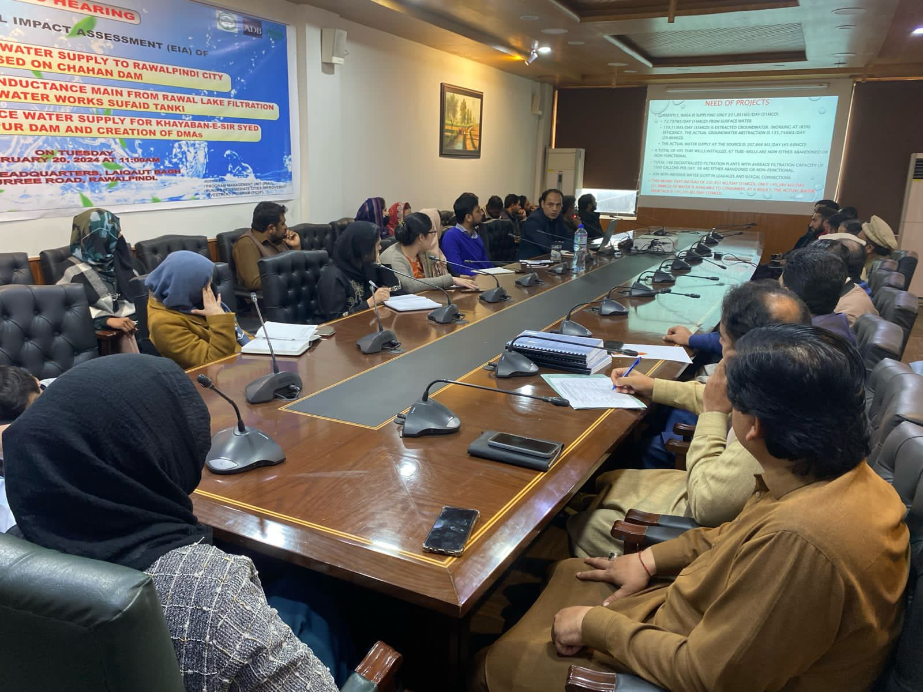

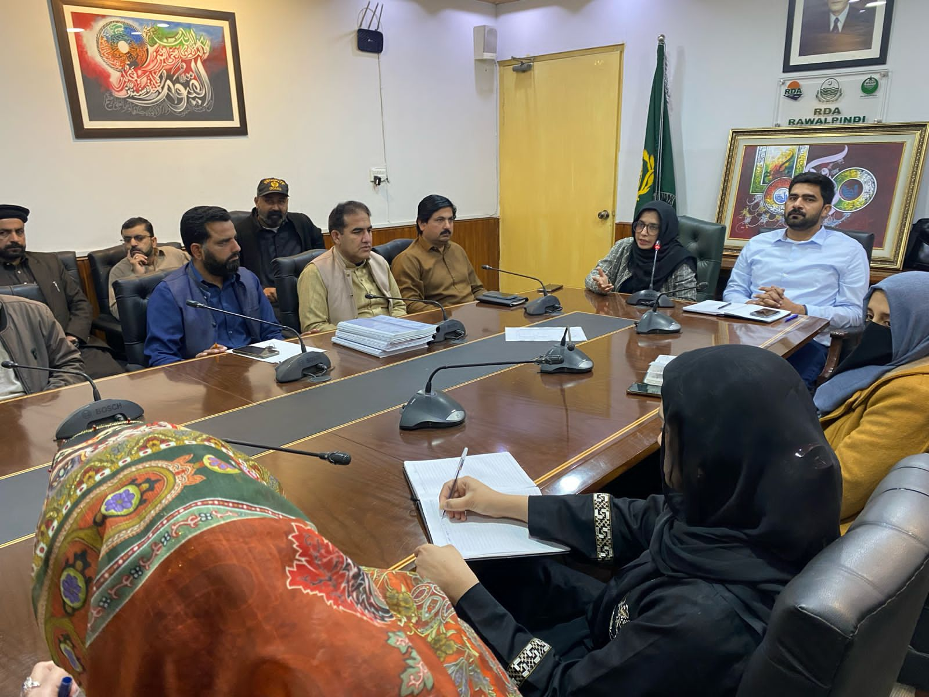

Table ‎8-7: Photographs of Stakeholder Consultations
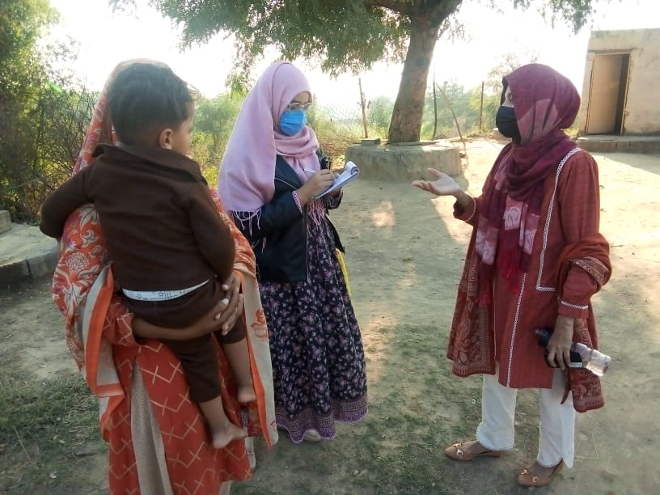 | 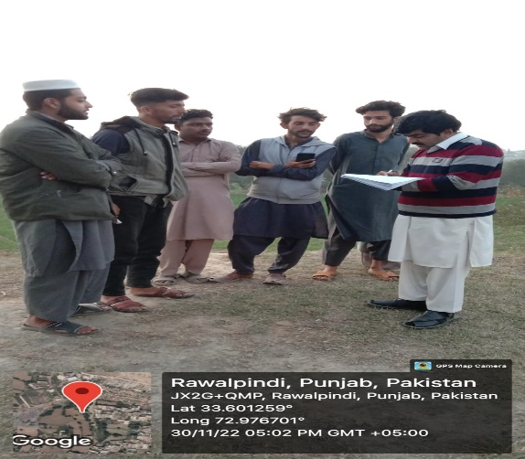
EDCM E&S Safeguard team in consultation with stakeholders near Location of Water Intake Structure | EDCM E&S Safeguard team in consultation with stakeholders at proposed WW site of Chakra
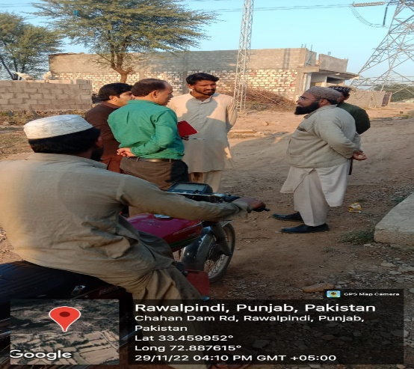 | 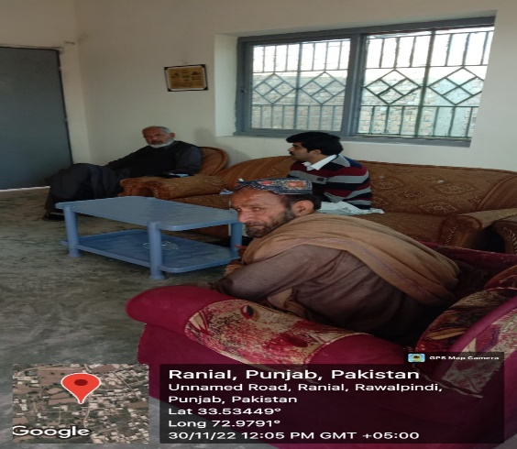
EDCM E&S Safeguard team in consultation with stakeholders Near propose Water Treatment Plant | EDCM E&S Safeguard team in consultation with stakeholders at Kashmir Colony near IPS Ranial
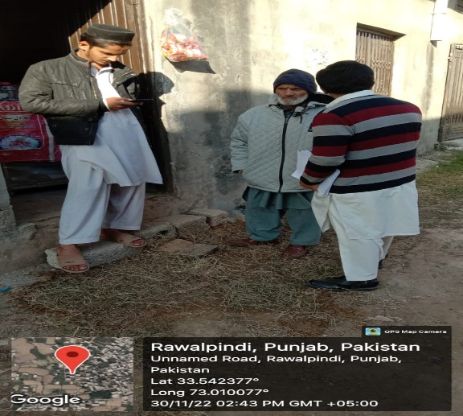 | 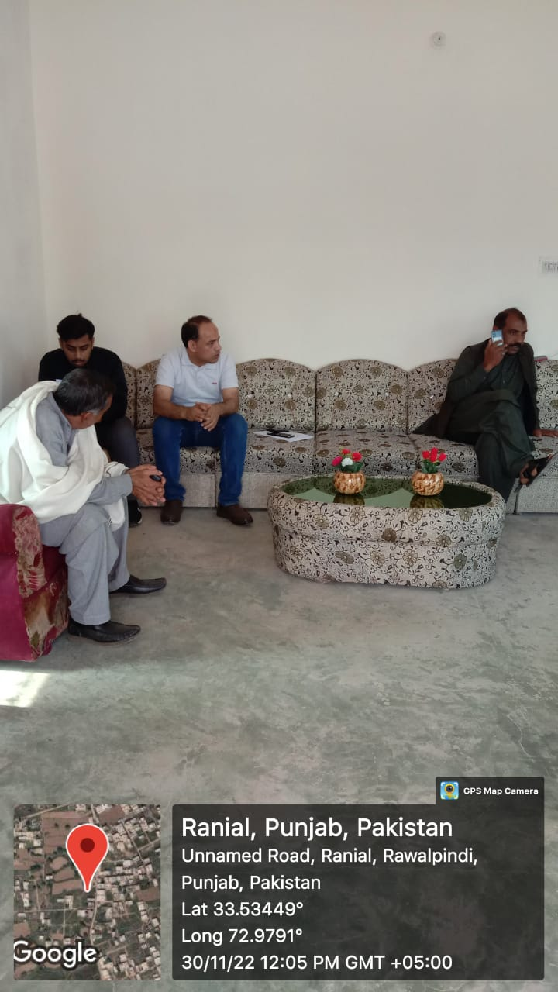
EDCM E&S Safeguard team in consultation with stakeholders | EDCM E&S Safeguard team in consultation with stakeholders at Kashmir Colony near IPS Ranial
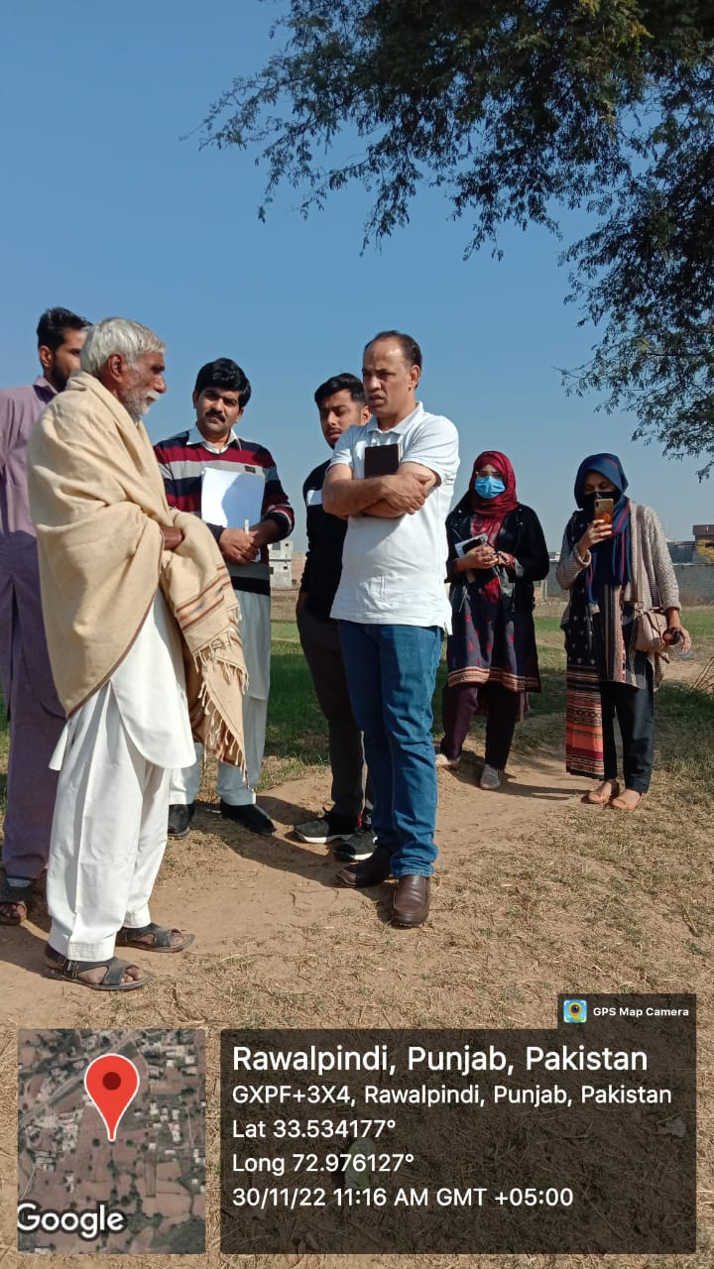 | 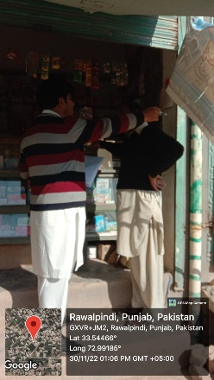
EDCM E&S Safeguard team in consultation with stakeholders at IPS Ranial | EDCM Social Safeguard team in consultation with stakeholders near WW
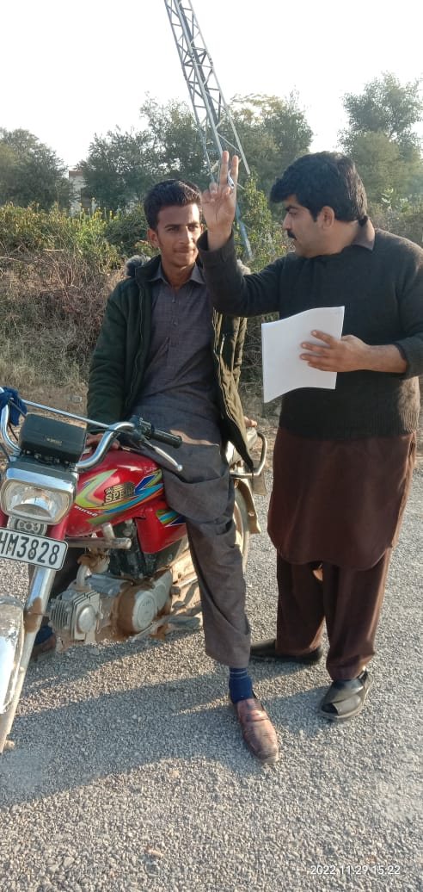 | 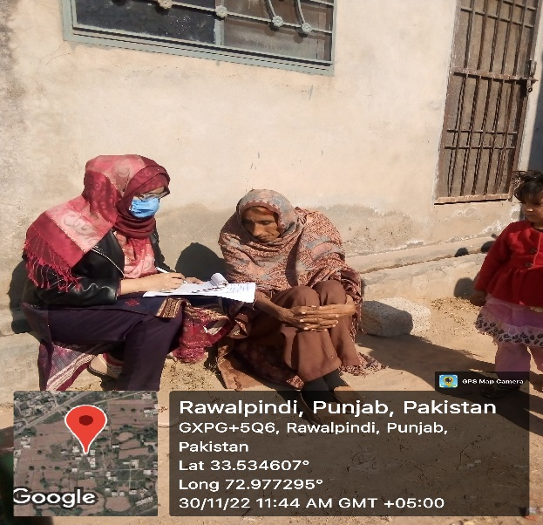
EDCM Social Safeguard team in consultation with stakeholders at WTP site | EDCM E&S Safeguard team in consultation with stakeholders at IPS Ranial site
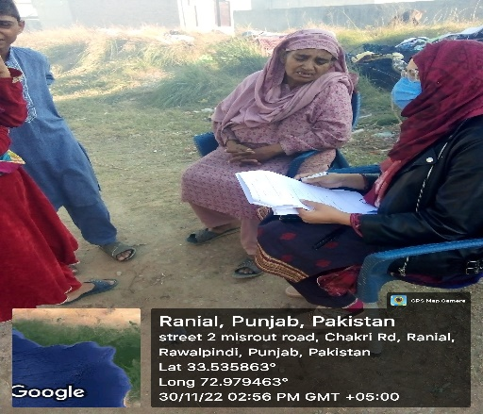 | 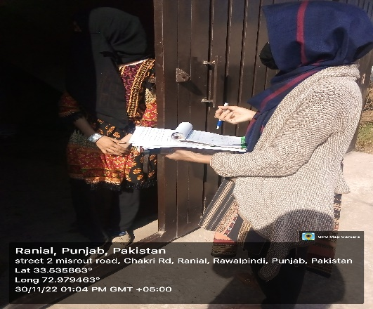
EDCM Social Safeguard team in consultation with stakeholders at Ranial | EDCM Social Safeguard team in consultation with stakeholders at Ranial
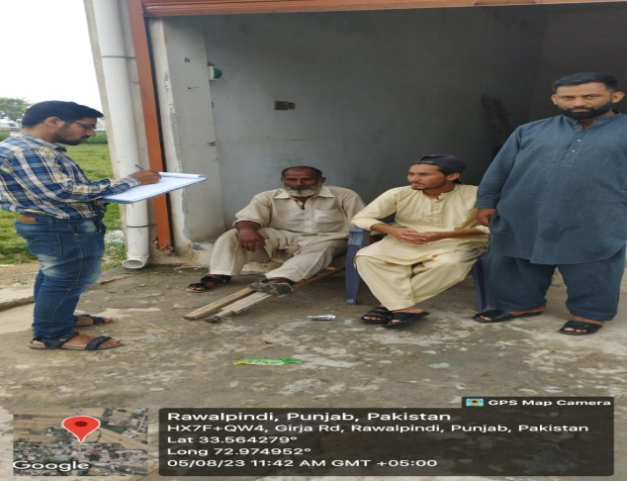 | 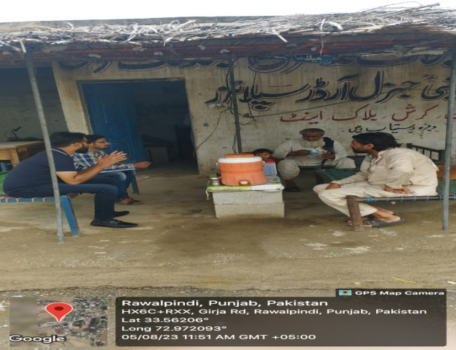
EDCM E&S Safeguard team in consultation with stakeholders near Girja Road Rawalpindi
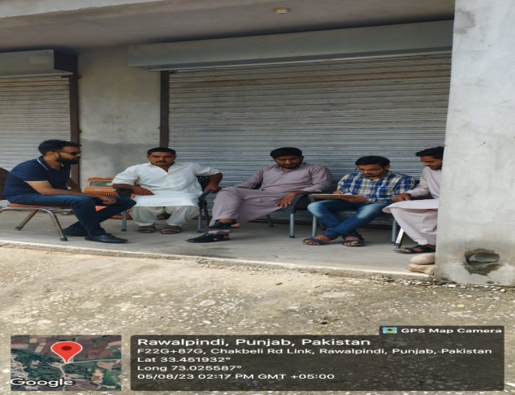 | 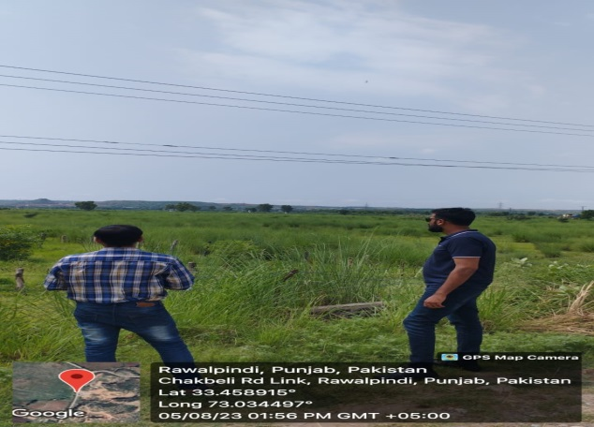
EDCM E&S Safeguard team in consultation with stakeholders at Chakbeli Link Road Rawalpindi
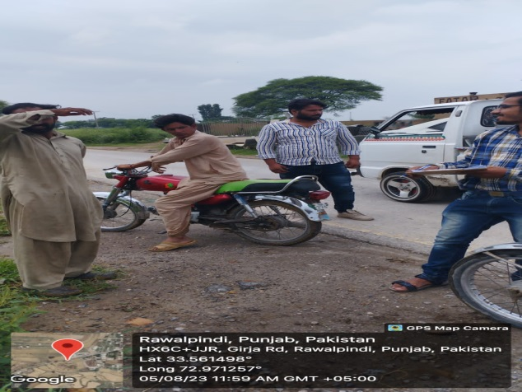 | 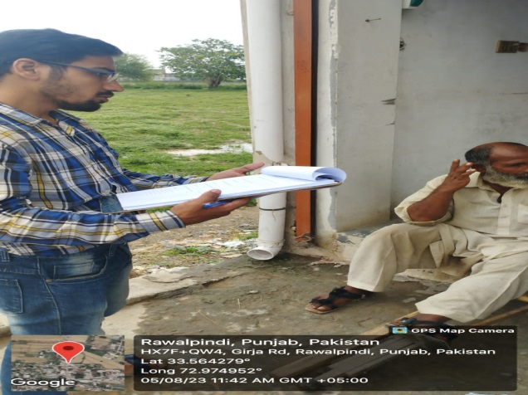
EDCM E&S Safeguard team in consultation with stakeholders at Girja Road Rawalpindi
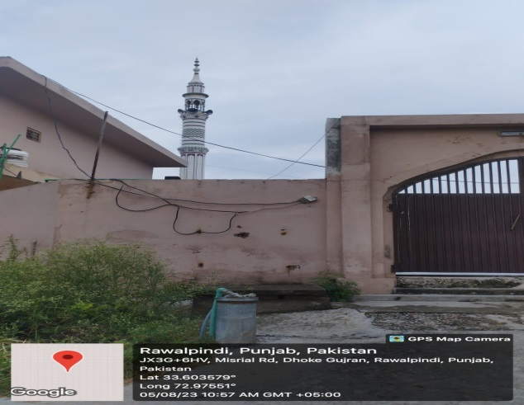 | 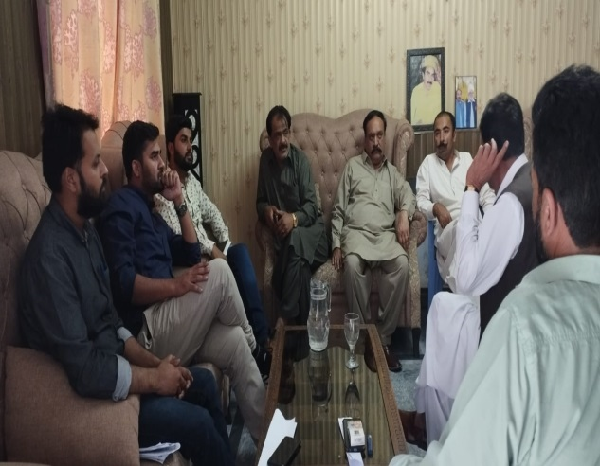
Mosque near Misrial Road, Dhoke Gujran Rawalpindi
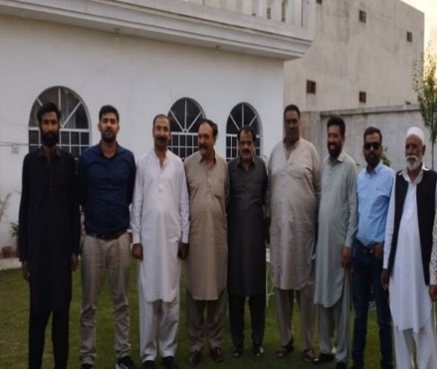 | 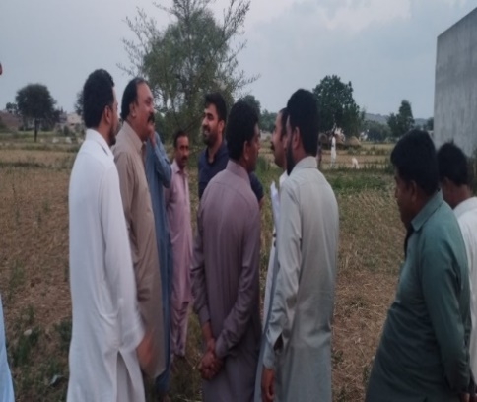
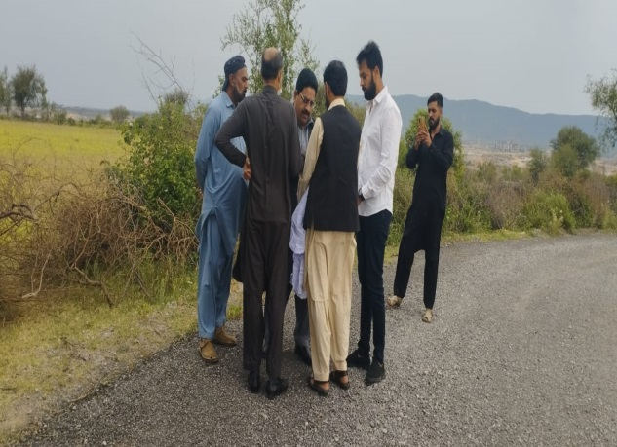 | 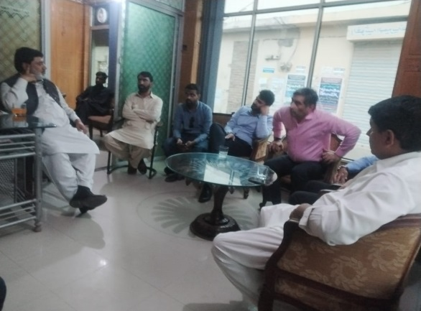
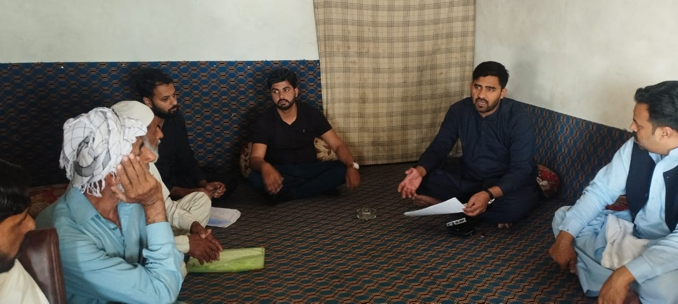 | 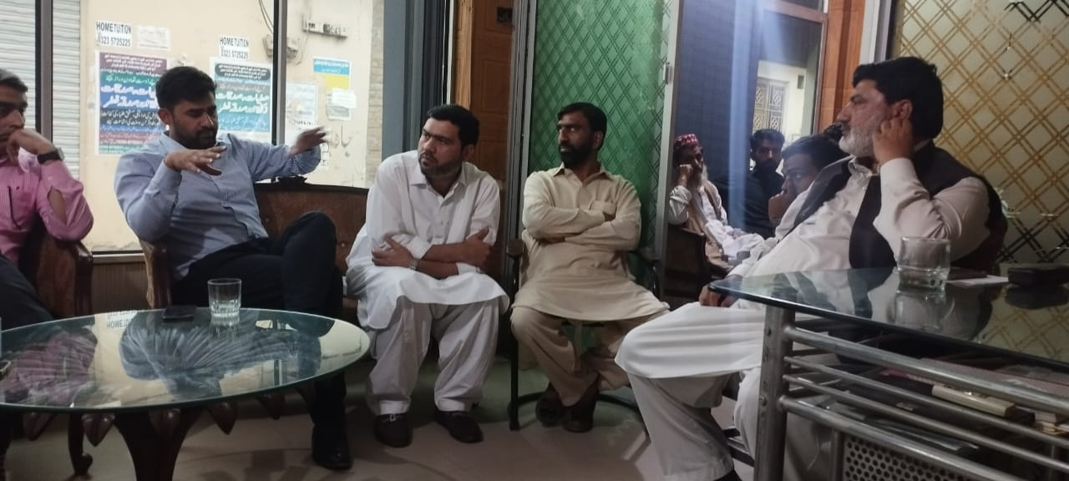
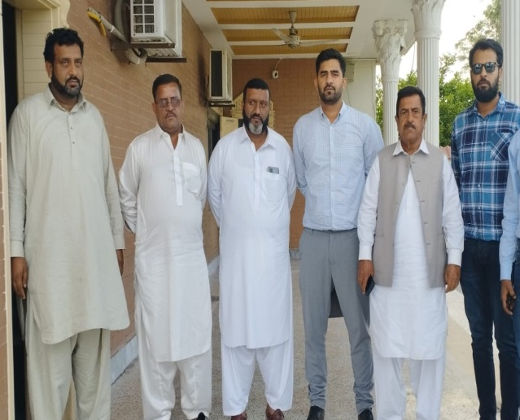 | 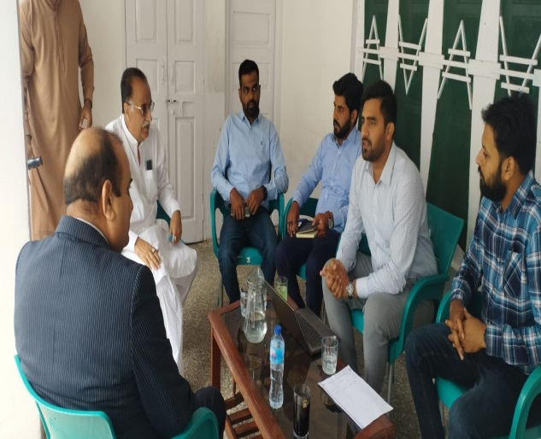
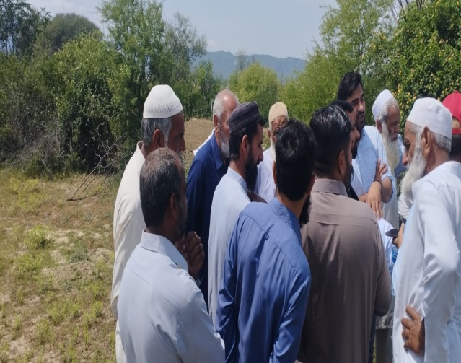 | 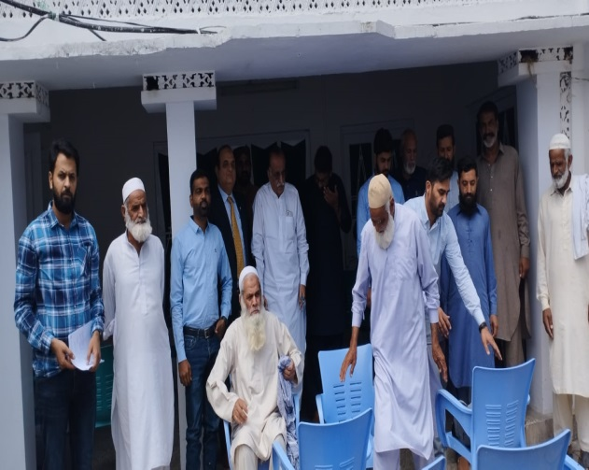

Issues, Concerns and Findings of the Focal Group Discussion
- The people living in the study area shows their concern on existing water supply conditions in their areas
- People of the project area informed that underground water table is very low and they do not have resources to install deep bore holes for water extraction.
- Some of the respondent's claims that even the water from bore holes decreases during summer season.
- People have to buy water from water tankers which is very costly and the quality of water is not satisfactory as well.
- All the respondents showed their consent in favor of proposed project due to water scarcity in the area.
- Some people connect the proposed project with new job opportunities
- It is important to mention here that comments and reservations of respondents have been duly taken care while designing mitigation measures of the project.

Consultation with Official Stakeholders
- As part of environmental assessment, detailed meetings were held with the institutional stakeholders in the form of one-to-one meetings with Rawalpindi WASA and CIU Rawalpindi and collective consultative session under the chairmanship of Additional Deputy Commissioner (Finance & Planning) Rawalpindi District. Different Government departments were invited at DC Office Rawalpindi and the detail of the project was shared with stakeholders for their understanding of the project activities and geographical location.
- The first round of consultation meetings with official stakeholders were held in December’22 while the second round was held in August’23. In the first round, officials from office of RDA Rawalpindi, RWASA, Irrigation Department, District officer Rawalpindi, Small Dam project Rawalpindi, MC Rawalpindi, Forest Department, Fisheries Department, Program Director PMU, Deputy Program Director PMU and Team Lead of EDCM participated in this meeting held on 3rd December, 2022 at DC Office Rawalpindi.
- Details of consultation meetings with official stake holders and photographs are mentioned in mentioned in Table ‎8-8 Consultative Session with Government Departments – Aug’23
Sr. # | Location | Department | Name (FGD) | Meeting Overview
 | Committee room Deputy Commissioner Office Rawalpindi | LG&CD | Mr. Imran Haider  [Sub Engineer] | In the discussion, it was addressed how WASA, Rawalpindi, might drastically lower its greenhouse gas emissions by moving toward the solar system and how solarization could lessen the effects of climate change. This project has a 30-year lifespan and very little environmental impact. Solarization will increase energy security and resilience. A total of 14.3 MW is directly supplied to solar system batteries across four distinct sites. The feasibility study and detailed engineering design are in progress and will be presented to the appropriate department eventually. The maintenance measures after installation will undergo frequent inspection.
 |  | DC Office | Mr. M. Mazhar Nadeem [Deputy Director]
 |  | Forest Department | Mr. M Ramzan  [Officer]
Mr. Asad Abbas
[Mi III Brg]
 |  | PMU | Mrs. Sehrish Khurshid [Project Officer]
Mr. Mujahid
[Environmental Consultant (EDCM)]
 |  | WASA | Mr. Azizullah Khan  [Ex. Deputy Director]
Mr. M Touseef
[Director WASA]
 |  | IESCO | Mr. M Sajid Hanif [XEN City Rawalpindi]
 |  |  | Mr. Syed Fahad Abbas [SDO Small Dam]
 |  | MCR | Mr. Abeer Riaz  [MD Services]
Mr. Zulqarnain Shah
[DO (I/S)]
Mr. Maqbool Qureshi
[Inspector Environmental Consultant]
Mr. M. Abid Aleem
[SDO (E) C/line]

Table ‎8-9: Photographs of Consultations with Institutional Stakeholders – Aug’23
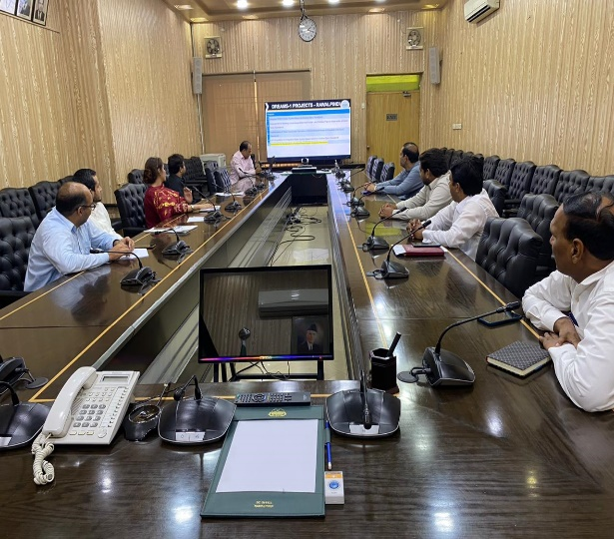 | 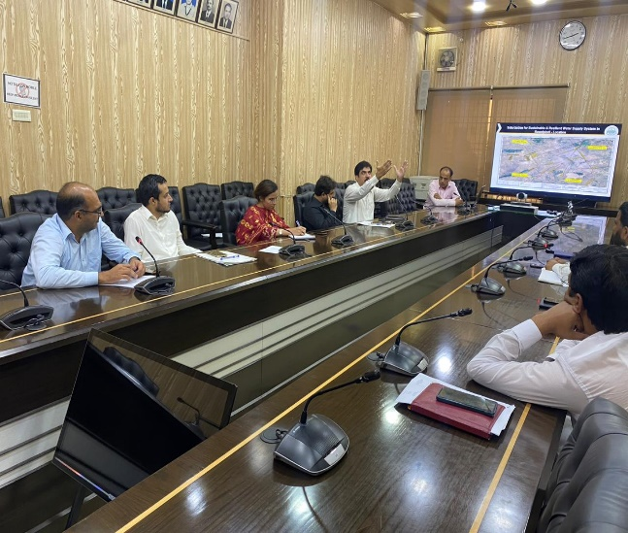
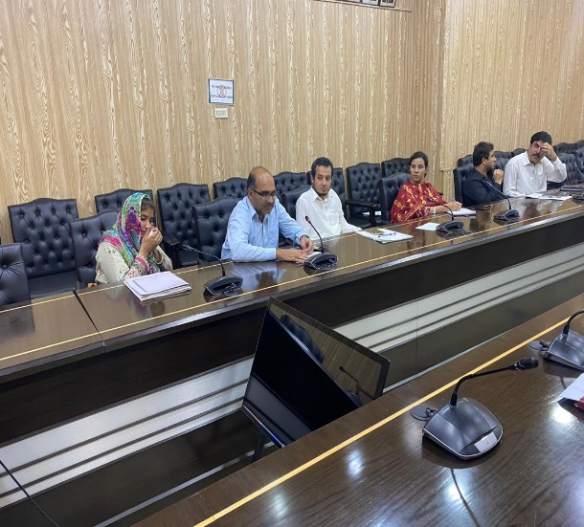 | 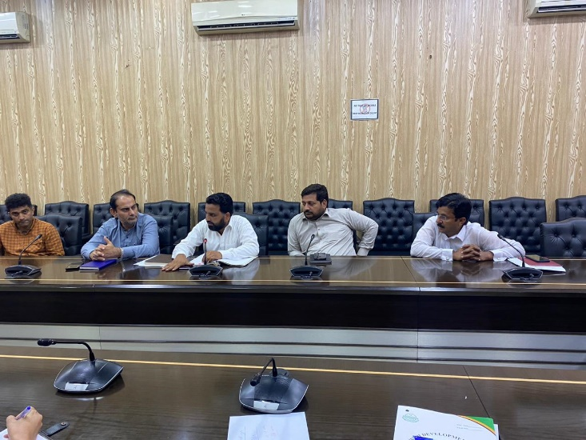

Table ‎8-10 and Table ‎8-11.
DC Office | Mr. M. Mazhar Nadeem [Deputy Director]
Forest Department | Mr. M Ramzan  [Officer]
Mr. Asad Abbas
[Mi III Brg]
PMU | Mrs. Sehrish Khurshid [Project Officer]
Mr. Mujahid
[Environmental Consultant (EDCM)]
WASA | Mr. Azizullah Khan  [Ex. Deputy Director]
Mr. M Touseef
[Director WASA]
IESCO | Mr. M Sajid Hanif [XEN City Rawalpindi]
 | Mr. Syed Fahad Abbas [SDO Small Dam]
MCR | Mr. Abeer Riaz  [MD Services]
Mr. Zulqarnain Shah
[DO (I/S)]
Mr. Maqbool Qureshi
[Inspector Environmental Consultant]
Mr. M. Abid Aleem
[SDO (E) C/line]

- In the second round of consultations, officials from the office of Environment department Rawalpindi WASA, Irrigation department, IESCO, Small Dam project Rawalpindi, MC Rawalpindi, Forest department, Fisheries department and E&S consultant from EDCM participated in this meeting, held on 5th August’2023 at the Committee Room of DC office, Rawalpindi. The details of consultation meetings with official stakeholders and photographs are provided in Tables 8-5 and 8-6.
- Although the project is at its feasibility stage, at some point before or during the construction phase EPA Punjab, as well as other government departments will be deeply involved regarding their suggestions and requirements of NOCs from the respective departments.
Table ‎8-8 Consultative Session with Government Departments – Aug’23
Sr. # | Location | Department | Name (FGD) | Meeting Overview
 | Committee room Deputy Commissioner Office Rawalpindi | LG&CD | Mr. Imran Haider  [Sub Engineer] | In the discussion, it was addressed how WASA, Rawalpindi, might drastically lower its greenhouse gas emissions by moving toward the solar system and how solarization could lessen the effects of climate change. This project has a 30-year lifespan and very little environmental impact. Solarization will increase energy security and resilience. A total of 14.3 MW is directly supplied to solar system batteries across four distinct sites. The feasibility study and detailed engineering design are in progress and will be presented to the appropriate department eventually. The maintenance measures after installation will undergo frequent inspection.
 |  | DC Office | Mr. M. Mazhar Nadeem [Deputy Director]
 |  | Forest Department | Mr. M Ramzan  [Officer]
Mr. Asad Abbas
[Mi III Brg]
 |  | PMU | Mrs. Sehrish Khurshid [Project Officer]
Mr. Mujahid
[Environmental Consultant (EDCM)]
 |  | WASA | Mr. Azizullah Khan  [Ex. Deputy Director]
Mr. M Touseef
[Director WASA]
 |  | IESCO | Mr. M Sajid Hanif [XEN City Rawalpindi]
 |  |  | Mr. Syed Fahad Abbas [SDO Small Dam]
 |  | MCR | Mr. Abeer Riaz  [MD Services]
Mr. Zulqarnain Shah
[DO (I/S)]
Mr. Maqbool Qureshi
[Inspector Environmental Consultant]
Mr. M. Abid Aleem
[SDO (E) C/line]

Table ‎8-9: Photographs of Consultations with Institutional Stakeholders – Aug’23

Table ‎8-10:Findings of Consultation with Government Stakeholder – Nov to Dec’22
Sr. # | Department |  | Name (FGD) | Comments | Reply
Venue: Location; PMU Office
Date;- 30-11-2022
1 | PMU/CIU |  | Mr. Ali Qunanin  [Infrastructure Engineer] | “According to the target timeframe, feasibility studies and comprehensive engineer designs will be finished in December 2022, and by the third quarter of 2023, all tender documents and approvals will be complete,” explained by infrastructure engineer CIU, Rawalpindi.
2 |  |  | Mam Sehrish Khurshid  [Project Officer]
Venue: Location; WASA Office
Date;- 30-11-2022
1 | WASA | Mr. Azizullah Khan  [Deputy Director] |  | The meeting concluded that the project will serve the residents of Quaid-e-Azam colony, Chak Jalal DIN, and Kalyal using the 30 MGD water available at Chauhan dam. WASA will currently receive 6 MGD of water, and the irrigation department sought an extra 6 MGD.
2 |  | Mr. Sami Ullah  [Social]
3 |  | Mr. Ali Qunaian  [Infrastructure Engineer]
4 |  | Mam. Sehrish Khurshid
5 |  | Mr. Sher Zaman  [Environmentalist]
6 |  | Mr. Sairas Ali  [Environmentalist]
Venue: Location; Committee Room DC Office
Date;- 03-12-2022
1 | DC Office | Mr. Umer Razzaq  [P & D] |  | People from different departments suggested that plan for this project should be shared with their stakeholders so that they can provide effective input. Also asked that this project is doable for the government and for local residents. In fact recommended that new societies are emerging that future population along with this project should also be served with the clean water supply.  The Chahan dam was finished in June 2022, and ponding is present in the reservoir, so this project needs to be started right away, according to XEN Small Dams. Fish will not be affected after ingesting water from the reservoir since the dead storage level is sufficient for the species.  As the new societies are forming at the Chakri road, and the forest department conservator advised that these populations, along with those already living in the areas closest to the Chahan dam, should also be served because they have the priority to be served. The PRF team clarified that it has already been thought about.
2 |  | Mr. Azizullah Khan  [Ex. Deputy Director]
3 |  | Mr. Amir Mumtaz  [XEN Small Dam Islamabad]
4 |  | Mr. Abid Hussain Abid  [Forest Conservator Rawalpindi]
5 |  | Mr. Jawad Arshad  [AD (Engineer)]
6 |  | Mr. M. Haseeb  [AD(M & E)]
7 |  | Mr. Muazzam Mukhatar  [Social Safeguard]
8 |  | Mam Sehrish Khurshid  [Project Officer]
9 |  | Mam Sana Urooj  [DDF Rawalpindi]
10 |  | Mam Rizwana Aziz  [ADW Rawalpindi]
11 |  | Mam Arifa Batool  [DDW Rawalpindi]
12 |  | Mr. M. Farooq  [DTL EDCM]
13 |  | Mr. Aziz Karim  [Environmental Specialist]
14 |  | Mr. Ali Qunain  [IE, CIU Rawalpindi]
15 |  | Mr. Ahmad Afzal  [AD (Eng) PRF]
16 |  | Mr. M. Shahzad  [MD reservoir MCR]
17 |  | Mr. Mujahid  [Environmental Consultant]

Table ‎8-11: Photographs of Consultations with Institutional Stakeholders – Nov’22
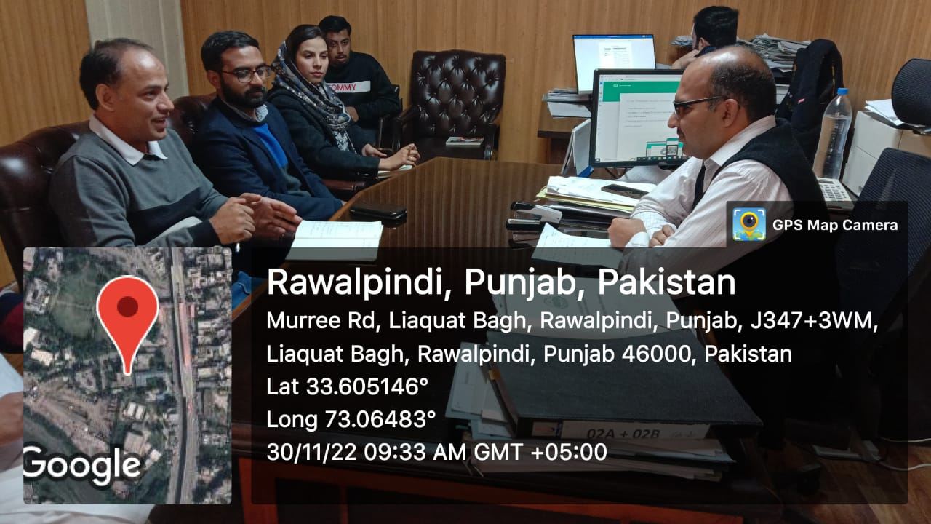 | 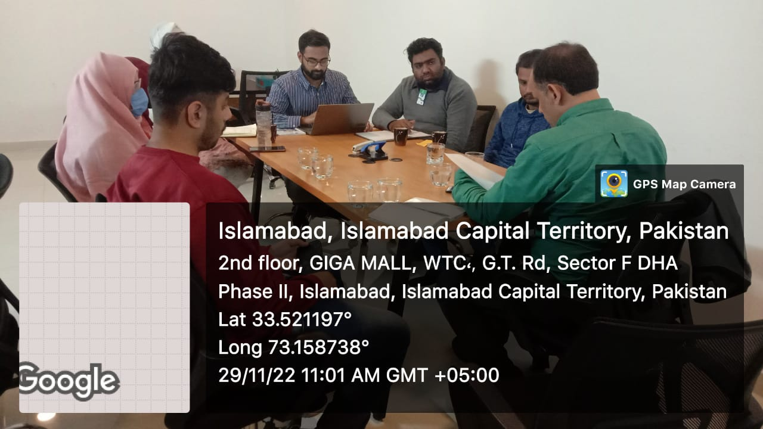
Consultation Meeting with Deputy Director, Rawalpindi WASA | Consultation Meeting with CIU – Rawalpindi
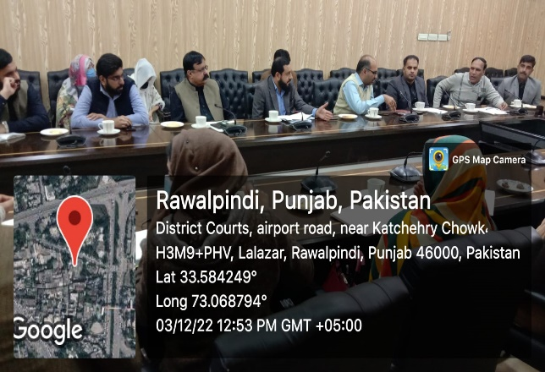 | 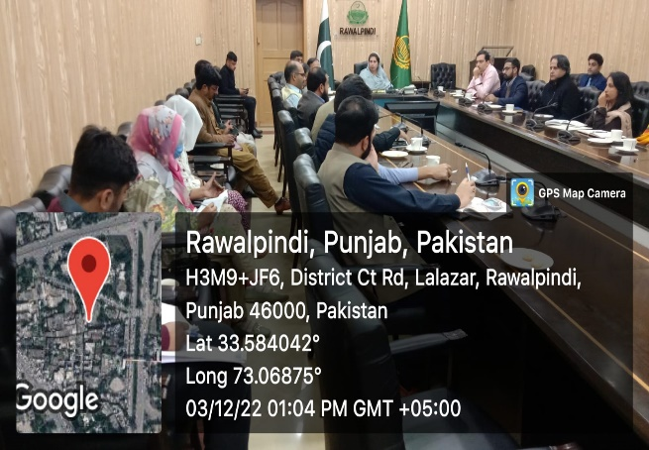
Consultative Meeting with Government Departments at DC Office Rawalpindi

Consultation Plan for Construction and Operation Phase
- Consultation plan for construction and operation phase for proposed project of Augmentation of Augmentation of Water Supply to Rawalpindi City Based upon Chahan Dam will be prepared in order to involve all relevant government departments. Similarly, Social Safeguard teams will be developed to take response of project stakeholders and general public about the project. Periodic consultations and community feedback surveys will be carried out to develop positive perception about the project. Intended stakeholders for such consultations will be all stakeholders that are consulted at the time of IEE preparation. Record of such consultations will be maintained at PMU/RWASA offices and necessary changes in operational modalities will be introduced in the system, in light of the response provided by the consultants.

Information Disclosure
- Consultation is ongoing process that will be carried out with the relevant department and other stakeholders along the alignment of proposed project throughout project implementation period. All future consultations will be documented, and record will be maintained properly.
- Efforts will be made to maximize the consultations during the project implementation. The consultations will be carried out with the objectives to develop and maintain communication linkages between the project promoters and stakeholders, provide key project information to the stakeholders, and to solicit their views on the project and its potential or perceived impacts, and ensure that views and concerns of the stakeholders are incorporated during the implementation with the objectives of reducing or offsetting negative impacts and enhancing benefits of the proposed project.
- After suggesting the possible solutions of the stakeholders’ concerns, the solutions (final IEE report) will be disclosed once again before the stakeholders and general public. IEE report will be accessible to interested parties on request and the version of final report will be available in the office of PMU, CIU and RWASA and its summary will be available in national language (Urdu).

GRIEVANCE REDRESSAL MECHANISM

General
- The ADB Policy (SPS 2009) requires establishment of a local grievance redress mechanism to receive and facilitate resolution of the Displaced/Affected Persons concerns and grievances regarding the project’s social and environment performance. The measures have been identified to mitigate any potential environmental and social impacts to be caused due to implementation of proposed project.
- However, in spite of best efforts, there is a chance that the individuals / households affected by the project or other stakeholders are dissatisfied with measures adopted to address adverse social impacts of the project. To address such situation an effective Grievance Redress Mechanism (GRM) has been established to ensure timely and successful implementation of the project. It will also provide a public forum to the aggrieved to raise their objections and the GRM will address such issues adequately. It will receive, evaluate and facilitate the resolution of displaced persons’ concerns, complaints and grievances about the social and environmental performance at the level of the project.
- The GRM will aim to investigate charges of irregularities and complaints receive from any displaced persons and provide a time-bound early, transparent and fair resolution to voice and resolve social and environmental concerns link to the project.
- The PMU WASA shall make the public aware of the GRM through public awareness campaigns. The name of contact person(s) and his/her phone number, 1134 contact numbers will serve as a hotline for complaints and shall be publicized through the media and placed on noticeboards outside their offices, construction camps of contractors, and at accessible and visible locations in the project area. The project information brochure will include information on the GRM and shall be widely disseminated throughout the project area. Grievances can be filed in writing, via web- based provision or by phone with any member of the PMU.

Scope of GRM
- During different stages of project preparation and implementation, it is likely that Affected Persons (APs) having livelihood impacts and falling in COI in particular and local community residing in the vicinity of the project area and other stakeholders may have some grievances related to project actions and activities. To resolve all such issues, a Grievance Redress Mechanism (GRM) will be available to allow APs or the local community to appeal any disagreeable decision, practice, or activity arising from project implementation. APs and the general public will be informed of their rights and of the procedures for registering complaints and GRM verbally in the consultation held during Impact Assessment Survey (IAS). Consultations were held with the APs to discuss livelihood impacts, measures for minimizing these impacts and Grievance Redress Mechanism (GRM) or Grievance Redressal Committee (GRC) to be in place specifically to redress complaints revolving around compensation related to livelihood disruption.

Functions of GRC Committee
- The GRC or GRM will perform following functions:
- Ensure effective implementation of the Grievance Redressal Mechanism on the issues that fall under their jurisdiction;
- Ensure an easy access to GRM having provision to file grievances verbally or by phone, in writing or via web based provision including the option of submitting grievances anonymously;
- GRC will look into all referred grievances and effectively address and resolve them within 15 days from the receipt of the grievances, in a timely and impartial manner;
- The GRC will deal promptly with any issues relating to livelihood, utilities disturbance;
- The GRC will take decisions on the basis of consensus or majority of votes;
- When required, the GRC would seek the assistance of other persons and institutions;
- Speaking orders and decisions of the committee on the grievances shall be recorded and replied to aggrieved parties and persons with a copy kept as record;
- In case, aggrieved is not satisfied by the decision of the GRC, she/he can prefer an appeal within ten days of the receipt of decision, the GRC could refer the case to the appropriate forum after examining the appeal; and
- In the event that a grievance cannot be resolved by GRC, the affected person can seek alternative redress through the higher administrative authority or court of law or as appropriate.

Stage of GRM
- The PMU is the first tier of GRM which offers the fastest and most accessible mechanism for resolution of grievances. The PMU staff for environment and social safeguards will be designated as the key officers for grievance Redressal. Resolution of complaints will be completed within seven (7) working days. Investigation of grievances will involve site visits and consultations with relevant parties (e.g., affected persons, contractors, traffic police, etc.). Grievances will be documented and personal details (name, address, date of complaint, etc.) will be included, unless anonymity is requested. A tracking number will be assigned for each grievance, including the following elements:
- Initial grievance sheet (including the description of the grievance), with an acknowledgement of receipt handed back to the complainant when the complaint is registered;
- Grievance monitoring sheet, mentioning actions taken (investigation, corrective measures);
- Closure sheet, one copy of which will be handed to the complainant after he/she has agreed to the resolution and signed-off.
- The updated register of grievances and complaints will be available to the public at the PMU office, construction sites and other key public offices in the project area. Should the grievance remain unresolved, it will be escalated to the second tier.
- The PMU will activate the second tier of GRM by referring the unresolved issue (with written documentation) to the Water Sanitation and Agency (WASA), Rawalpindi who will pass unresolved complaints upward to the Grievance Redress Committee (GRC). The GRC will be established by WASA before start of site works.
- The GRC will consist of the following persons: (i) Project Director; (ii) representative of District government; (iii) representative of the affected person(s); (iv) representative of the local Deputy Commissioners office; and (v) representative of the EPA (for environmental-related grievances).
- A hearing will be called with the GRC, if necessary, where the affected person can present his/her concerns/issues. The process will facilitate resolution through mediation. The local GRC will meet as necessary when there are grievances to be addressed. The local GRC will suggest corrective measures at the field level and assign clear responsibilities for implementing its decision within fifteen (15) working days. The contractor will have observer status on the committee. If unsatisfied with the decision, the existence of the GRC will not impede the complainant’s access to the Government’s judicial or administrative remedies.
- The functions of the local GRC are as follows: (i) resolve problems and provide support to affected persons arising from various environmental issues and including dust, noise, utilities, power and water supply, waste disposal, traffic interference and public safety as well as social issues and land acquisition (temporary or permanent); asset acquisition; and eligibility for entitlements, compensation and assistance; (ii) reconfirm grievances of displaced persons, categorize and prioritize them and aim to provide solutions within a month; and (iii) report to the aggrieved parties about developments regarding their grievances and decisions of the GRC.
- The WASA officers will be responsible for processing and placing all papers before the GRC, maintaining a database of complaints, recording decisions, issuing minutes of the meetings and monitoring to see that formal orders are issued and the decisions carried out.
- In the event that a grievance cannot be resolved directly by the PMU (first tier) or GRC (second tier), the affected person can seek alternative redressal through the district committees as appropriate. The PMU or GRC will be kept informed by the district, municipal or national authority. The monitoring reports of the EMP implementation will include the following aspects pertaining to progress on grievances: (i) Number of cases registered with the GRC, level of jurisdiction (first, second and third tiers), number of hearings held, decisions made, and the status of pending cases; and (ii) lists of cases in process and already decided upon may be prepared with details such as Name, ID with unique serial number, date of notice, date of application, date of hearing, decisions, remarks, actions taken to resolve issues, and status of grievance (i.e., open, closed, pending).
- In order to provide greater clarity, the pictorial description of the GRM is provided in Figure ‎9-1 below.
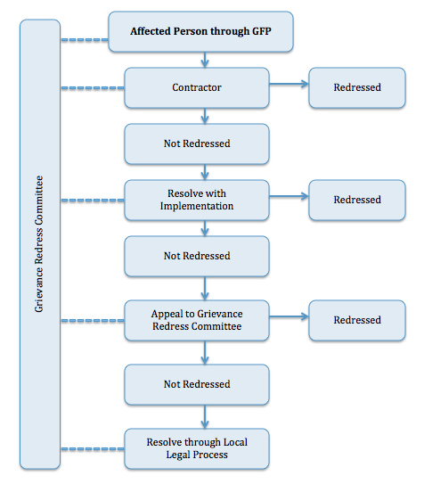

Figure ‎9-1 GRM Process

Conclusion and Recommendations

Conclusion
- The provision of the water treatment plant and water supply system for the residents of Ranial, Akbar Chowk, Chakra, and other areas within PP-12 is of high significance considering the urgent need for improving sustainable water supply system of Rawalpindi city.
- Primary and secondary data have been collected to assess the environmental impacts of the Project. This IEE report highlights all potential environmental impacts associated with the project and recommends mitigation measures. Any environmental impacts associated with the project need to be properly mitigated through the existing institutional arrangements described in this report.
- The majority of the environmental impacts are associated with the distribution networks including the transmission main, and the generation of solid waste, sludge and wastewater during water treatment plant operation. Major impacts during the construction phase will relate to traffic congestion and community health and safety issues during the laying of water supply system in populated areas.
- Also, for the solar PV component, it is an environmentally friendly technology which is benign during its operation phase with only water required in limited quantities for cleaning of panels. Any potential impacts are expected only during the project construction phase, which too will be site specific and limited in nature, consisting of impacts such as land clearing and levelling and any temporary impacts due to dust and noise emissions.
- The implementation of mitigation measures during the construction period will be the responsibility of the contractor. Therefore, the required environmental mitigation measures will have to be clearly defined in the bidding and contract documents, and appropriately qualified environmental staff retained by the consultant to supervise the implementation process. The EMP includes measures to minimize project impacts due to traffic, noise, air pollution, waste generation etc.
- The Environmental Management Plan contained within this Initial Environmental Examination document is considered sufficient for issuance as part of the contracts to the successful bidder(s) and for subsequent use during the project works. It should be noted that prior to the commencement of works, this EMP must be further updated by the contractor into site specific EMPs (SSEMPs) for review and clearance of ADB. These SSEMPs should include aspects such as a detailed traffic management plan, identification of locations for disposal of debris and spoil, and any other details that become available later to ensure the efficient implementation and monitoring of all proposed mitigation measures.
- Based on the above, this report concludes that there are no potentially significant adverse environmental impacts from the proposed project. Less significant impacts can be mitigated to an acceptable level through the adequate implementation of the recommended mitigation measures. Consequently, no significant or unacceptable changes in the baseline environmental conditions will occur. Additionally, the project will have a visible positive impact on the socio-economic conditions of the residents by providing an uninterrupted supply of treated water, thereby addressing the issue of portable water availability in the project area along with generation of clean and renewable energy from the solar PV installation on a sustainable basis.
- Mitigation measures to alleviating potential identified adverse impacts have been recommended, and an EMP has been provided for their implementation. The Project Management Unit of LGCD department and WASA will ensure that the selected construction contractor has contractual obligation to implement the EMP. The contractor will also ensure appropriate staffing and budgeting for the effective implementation and monitoring of the project EMP.
- Based on the findings of the IEE, the project is unlikely to cause any significant, irreversible or unprecedented environmental impacts. The potential impacts are localized, temporary in nature and can be addressed through proven mitigation measures. Hence, the classification of the project as Category B as per ADB SPS, 2009, is confirmed. No further study or assessment is required at this stage.

Recommendations
- Obtain statutory clearances prior to awarding the contract and ensure that conditions and requirements are incorporated in the project design and documents.
- Upon mobilization of the contractors, the PMU will provide a safeguards orientation on the IEE and project administration manual.
- The contractor will appoint an environmental safeguards person responsible for compliance with environmental safeguards, occupational health and safety and core labor standards.
- The project will generate employment opportunities during both the construction and operation phases. Employment opportunities will be provided to the local community as per plans discussed in the IEE report.
- The project is in an area with several socio-economic and health problems, for which the project will provide appropriate solutions.
- The PMU will have the right to suspend works or payments if the contractor violates any of their obligations under the EMP and SSEMP.
- Templates for different management plans are attached as annexures. However, detailed plans must be developed by the contractor before mobilization of construction teams.
- The contractor shall develop and implement a Site-Specific Environmental Management Plan during the construction phase. The PMU will supervise the implementation status through Construction Supervision Consultant (CSC).
- The contractor must obtain prior approval from the PMU for setting up of construction camps.

Annexures

Annexure-I Filled Checklist of REA

Rapid Environmental Assessment (REA) Checklist

Augmentation of Water Supply to Rawalpindi City Based upon Chahan Dam
Country/Project Title:
Water Works at Chahan Dam 12 MGD – RWP
6 sites (intake structure, Treatment plant, conductance main, IPS, OHRs on 4 sites for water distribution)
Sector Division:

Screening Questions | Yes | No | Remarks
A. Project Siting
Is the project area…
Densely populated? |  |  | The area of Intake Structure and Water Treatment Plant (WTP) is not populated. Around 17 houses near Intake and WTP. However, scattered population exist along main conductance to Intermediate Pumping Station at Ranial (IPS-R). Ranial has thickly populated area and the population is increasing due to conversion of agricultural land into housing colonies. Furthermore, the area of overhead reservoirs contains dense population.
Heavy with development activities? |  |  | No heavy development activities have been observed and involved in the proposed project area in conflict with natural resource allocation.
Adjacent to or within any environmentally sensitive areas? |  |  | Khairi Murat National Forest/Park is located at a distance of almost 4.0 km, upstream of Chahan Dam reservoir. However, there is no negative impact envisaged due to the implementation of the proposed project
Cultural heritage site |  |  | No specific site of cultural heritage is present within Corridor of Impact of 100 meters of the proposed project sites
Protected Area |  |  | Khairi Murat National Forest/Park is located at a distance of approx. 4 km from the intake structure. It is not within the Corridor of Impact of this project.
Wetland |  |  | No wetland is present near project site.
Mangrove |  |  | No mangroves exist in and around the project area.
Estuarine |  |  | No estuary exists in and around the project area.
Buffer zone of protected area |  |  | None of the component of proposed project fall in buffer zone of protected area.
Special area for protecting biodiversity |  |  | No any special area is being affected by the proposed water supply project.
Bay |  |  | No bay exists adjacent to or in the project area.
B. Potential Environmental Impacts
Will the Project cause…

- pollution of raw water supply from upstream wastewater discharge from communities, industries, agriculture, and soil erosion runoff? |  |  | The catchment area of Chahan dam has sources of wastewater and the water sample was tested to verify the presence of biological contamination in it (i.e. Total Coliform, fecal Coliform, E.Coli). Treatment will include chlorination process of water for disinfection.
- impairment of historical/cultural monuments/areas and loss/damage to these sites? |  |  | No historical or cultural site/ monument is located in and around the project area, so there will be no impairment of historical/ cultural monuments or any loss/ damage to such sites.
- hazard of land subsidence caused by excessive ground water pumping? |  |  | As the proposed project doesn’t involve the ground water pumping, so no land subsidence is envisaged at all.
- social conflicts arising from displacement of communities? |  |  | No displacement of communities is expected by the project, therefore, no social conflicts are envisaged as negative impact of the project.
- conflicts in abstraction of raw water for water supply with other beneficial water uses for surface and ground waters? |  |  | Conflict may arise as the Chahan Dam is currently being used for irrigation purposes. However, during stakeholder consultation meeting, representative from Irrigation Department mentioned that housing societies are being developed in the surrounding agricultural land areas of Chahan Dam site, as a result irrigation water usage is being lowered down and household water usage demand has been increased accordingly. Therefore, this conflict in abstraction of raw water with other water usages is minor in nature.
- unsatisfactory raw water supply (e.g. excessive pathogens or mineral constituents)? |  |  | The raw water source is reservoir of Chahan Dam which has sources of contamination at its upstream. The samples taken from Chahan Dam reservoir confirms presence of pathogens. However, treatment through Rapid Sand Filters and chlorination will make the water fit for domestic use.
- inadequate protection of intake works or wells, leading to pollution of water supply? |  |  | There is no protective boundary marked on Chahan Dam Reservoir. Run off from nearby villages and agricultural lands / crop lands can go directly into reservoir. This may occur, during rainy season, which ultimately will lead to pollution of water reservoir. Further, there is mushroom growth of housing societies around the reservoir of Chahan Dam which may lead to pollution of water reservoir in future. However, the Intake structure will have screens to filter larger particles / objects.
- over pumping of ground water, leading to salinization and ground subsidence? |  |  | As the project does not involve ground water pumping at any stage, therefore, salinization or ground subsidence is not envisioned.
- excessive algal growth in storage reservoir? |  |  | During field visit, patches of algal growth were observed, especially at controlled Fish Farm area near proposed intake structure. But this algal growth is not covering the whole reservoir and cannot be said excessive. However, considering the summer season with high temperature and more algal growth in reservoir, the intake structure has built-in design with filters / screens to filter out excessive algae. In case of excessive algae in reservoir, the cleaning frequency of filter/screens will be adjusted accordingly. Further, Chlorine dosing will be at both inlet and in final storage tank and chlorine oxidizes and kills algae.
- increase in production of sewage beyond capabilities of community facilities? |  |  | As soon as sewage production will increase, community facilities will also increase accordingly.
- inadequate disposal of sludge from water treatment plants? |  |  | The sludge will be subjected to sludge conditioning and sludge dewatering using chamber filter presses. Water obtained from chamber filter presses will be pumped to the buffer basin from filter wash treatment plant and after dewatering, the solid sludge will be disposed off at a designated site by MC for land filling of low lying areas.
- inadequate buffer zone around pumping and treatment plants to alleviate noise and other possible nuisances and protect facilities? |  |  | The maximum Noise producing equipment is back wash air blowers. During blower operation which has maximum operation time is 10-20 minutes in a day. And maximum Noise level is 50-60 dB after using cabin and silencer. These blowers will be installed in a close building. Further, the area is at sufficient distance from communities, so noise impact will be negligible.
- impairments associated with transmission lines and access roads? |  |  | Although impairments will be associated with the laying of Conductance Main however, the existing Right of Way (RoW) of road will be utilized for said purposes.
- health hazards arising from inadequate design of facilities for receiving, storing, and handling of chlorine and other hazardous chemicals. |  |  | The immediate health hazards from exposure of chlorine is irritation of eyes and skin, coughing and chest congestions, nausea and vomiting. Long exposure or exposure to high concentration of chlorine can cause Pulmonary Edema, burning of eyes, lungs if chlorine is in gaseous form. If exposure of chlorine occurs in liquid form, high concentration or extended exposure for long time can cause burning pain and blisters on skin. Exposure to high concentration of liquid Chlorine can case injuries similar to frostbite.  Besides Chlorine, alum and other electrolyte polymers will be involved in water treatment whose handling and storage will be according to the guidelines provided in Material Safety Data Sheet (MSDS) of the particular chemical.
- health and safety hazards to workers from handling and management of chlorine used for disinfection, other contaminants, and biological and physical hazards during project construction and operation? |  |  | The immediate health hazards from exposure of chlorine is irritation of eyes and skin, coughing and chest congestions, nausea and vomiting. Long exposure or exposure to high concentration of chlorine can cause Pulmonary Edema, burning of eyes, lungs if chlorine is in gaseous form. If exposure of chlorine occurs in liquid form, high concentration or extended exposure for long time can cause burning pain and blisters on skin. Exposure to high concentration of liquid Chlorine can case injuries similar to frostbite.  Besides Chlorine, alum and other electrolyte polymers will be involved in water treatment whose handling and storage will be according to the guidelines provided in Material Safety Data Sheet (MSDS) of the particular chemical.
- dislocation or involuntary resettlement of people? |  |  | The project does not involve dislocation or involuntary resettlement of people. The land for WTP and IPS is confirmed and is under Section 4. Land for land possession. It is pertinent to mention here that land for WTP and IPS is vacant and no dislocation or involuntary resettlement of people is involved. Further, land acquisition process for water works is in progress and the land selected for water works is also not involve dislocation or involuntary resettlement. Further, existing ROW will be used for lying of Conductance Main and water distribution lines.
- disproportionate impacts on the poor, women and children, Indigenous Peoples or other vulnerable groups? |  |  | The implementation of the project will help women in their household tasks, and ultimately will improve the health conditions of the residents of the area hence, positive impact is envisaged due to the project
- noise and dust from construction activities? |  |  | During construction activities, noise and dust from heavy machinery will be generated, especially during excavation of trenches for Conductance Main.
- increased road traffic due to interference of construction activities? |  |  | During construction activities, more machinery or heavy vehicles will mobilize in the project area hence, road traffic will be increased accordingly.
- continuing soil erosion/silt runoff from construction operations? |  |  | During construction phase, soil erosion may occur, if not properly managed.
- delivery of unsafe water due to poor O&M treatment processes (especially mud accumulations in filters) and inadequate chlorination due to lack of adequate monitoring of chlorine residuals in distribution systems? |  |  | In case of negligence in maintenance of water treatment plant and its operations, unsafe drinking water may enter in water distribution network. However, the proposed water treatment plant has mechanism of back washing of filters to remove accumulated mud from filters. While one filter is being backwashed, the other filter will be in working condition for the smooth operation of treatment plant.  The dose of chlorine in drinking water will be monitored regularly to ensure safe delivery of water.
- delivery of water to distribution system, which is corrosive due to inadequate attention to feeding of corrective chemicals? |  |  | Strong monitoring system is built-in part of treatment plant operation, therefor, this is negligible impact.
- accidental leakage of chlorine gas? |  |  | Chlorine gas will be stored in a contained room having leakage detection system installed in it. In case if Chlorine gas is leaked, Sodium Hydroxide (NaOH) will be automatically sprinkled to produce NaCl (salt) solution as a result of reaction of chlorine and NaOH.
- excessive abstraction of water affecting downstream water users? |  |  | There are very less chances of affecting water users downstream due to excessive use of water. The storage capacity of Chahan dam is much higher than proposed abstraction of water for this project. It was confirmed during stakeholder consultative meeting at DC Office. Further, RWASA has approval for intake of 6 MGD of water and has applied for 12 MGD water abstraction from Chahan Dam Reservoir. Representatives of Irrigation department has shown their consent in consultative meeting held at DC Rawalpindi Office on 03-12-2022 for abstraction of 12MGD water from reservoir of Chahan Dam.
- competing uses of water? |  |  | Currently, Water from Chahan Dam is being used for irrigation purposes. However, during stakeholder consultation meeting, representative from Irrigation Department mentioned that housing societies are being developed in the surrounding agricultural land areas of Chahan Dam site, as a result irrigation water usage is being lowered down and household water usage demand has been increased accordingly.
- increased sewage flow due to increased water supply |  |  | Due to increase in water supply, number of users will increase resultantly sewage flow will also be increased.
- increased volume of sullage (wastewater from cooking and washing) and sludge from water treatment plant |  |  | Quantity of Sullage will be increased during construction phase due to worker camps and site office at WTP. Quantity of Sludge and Sullage will also increase during regular operations of WTP and kitchen of site offices respectively. Soakage pits or septic tanks will be provided for the sullage (cooking and washing) while the sludge will be subjected to sludge conditioning and sludge dewatering using chamber filter presses.
- large population influx during project construction and operation that causes increased burden on social infrastructure and services (such as water supply and sanitation systems)? |  |  | No large population influx is envisaged therefore, no burden will increase on social infrastructure and services. Local community will be utilized mainly as skilled and un-skilled labour during the construction phase of the project.
- social conflicts if workers from other regions or countries are hired? |  |  | Social conflicts may arise in case of hiring of workers from other regions therefore, the contractor would be bound to hire at least 60 % skilled and unskilled labour from local area and to create job opportunities for the locals.
- risks to community health and safety due to the transport, storage, and use and/or disposal of materials such as explosives, fuel and other chemicals during operation and construction? |  |  | Transport, Disposal and storage of materials, fuel and other chemicals will be done according to the guidelines in Material safety data sheet. No explosives will be used in this project.
- community safety risks due to both accidental and natural hazards, especially where the structural elements or components of the project are accessible to members of the affected community or where their failure could result in injury to the community throughout project construction, operation and decommissioning? |  |  | Community safety will be at risk due to accidental and natural hazard, especially near overhead reservoirs. The trenches for lying of Conductance Main will act as death traps if not protected with fixed barrication. Further, during construction phase, the movement of heavy machinery and dumpers will cause additional risk of accidents to community if not managed properly. Safety Risk due to accidents during operational phase of this project will be negligible as there will be negligible movement of project transport.

Annexure-II Environmental Monitoring Reports

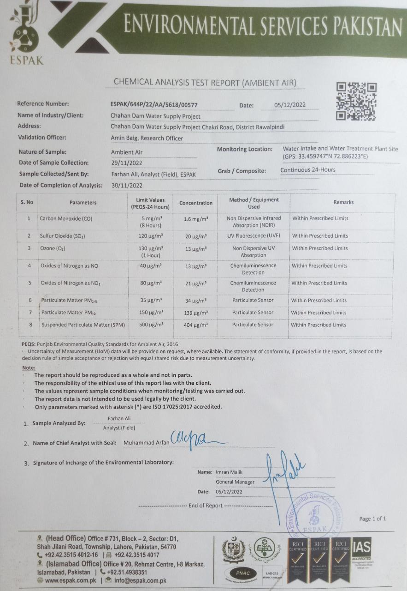

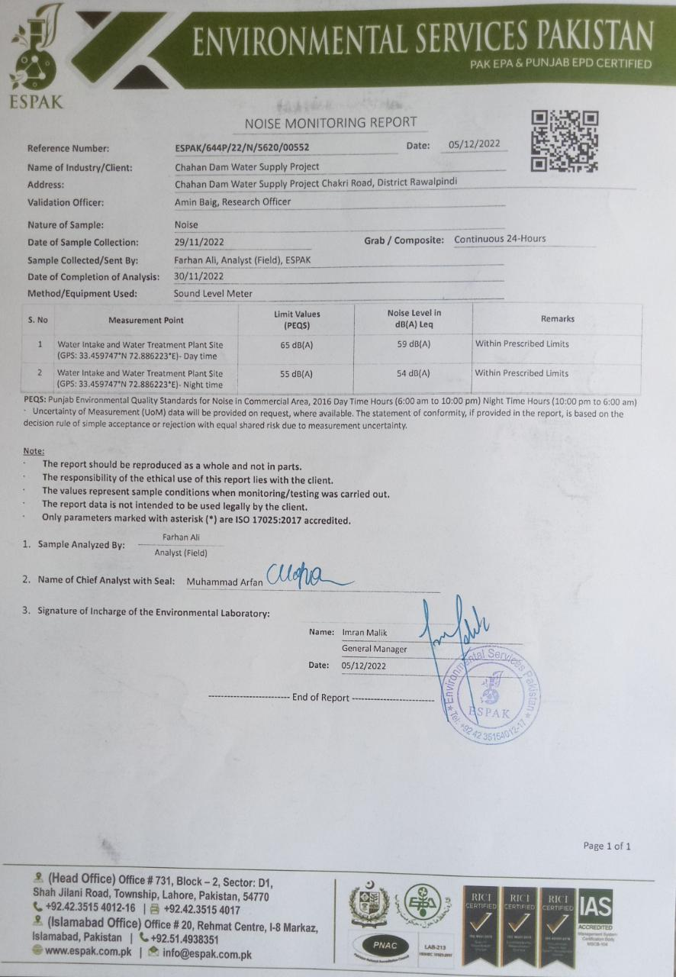

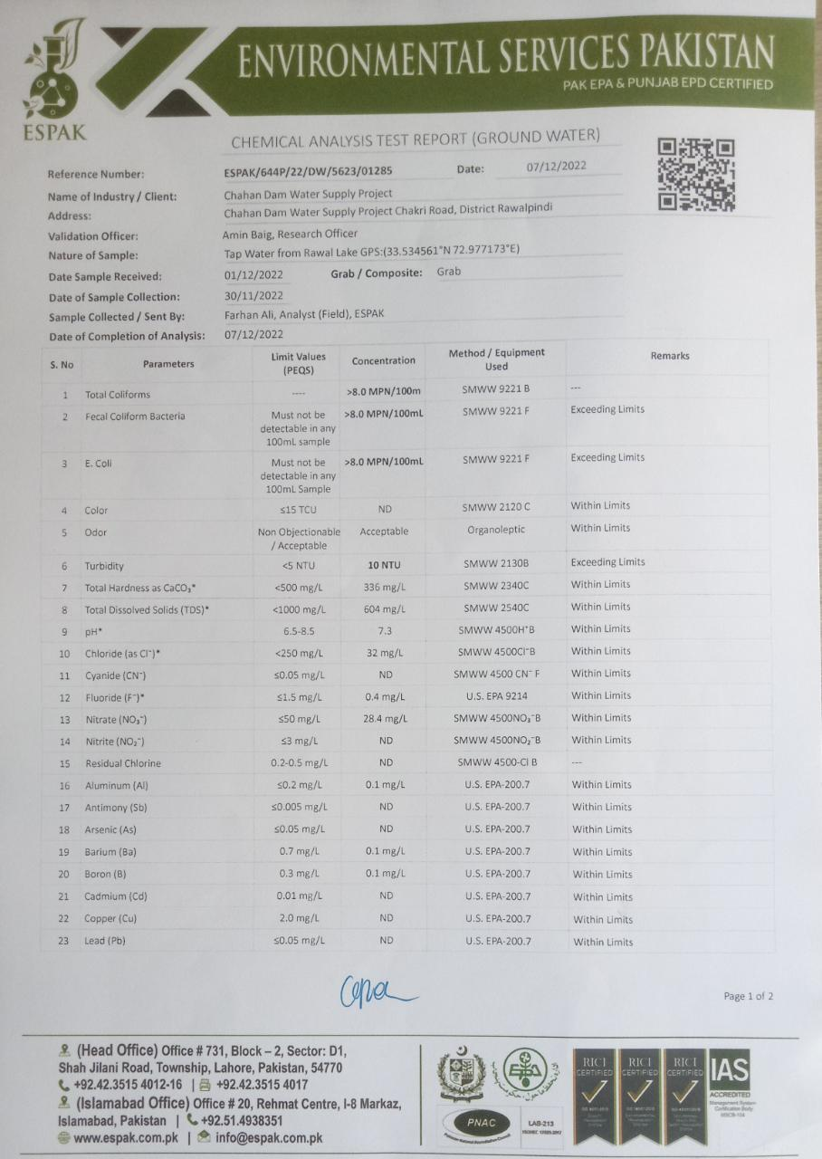

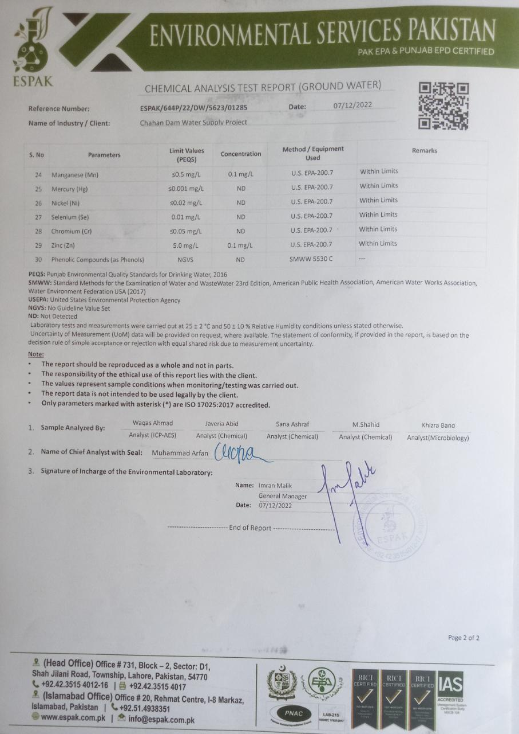

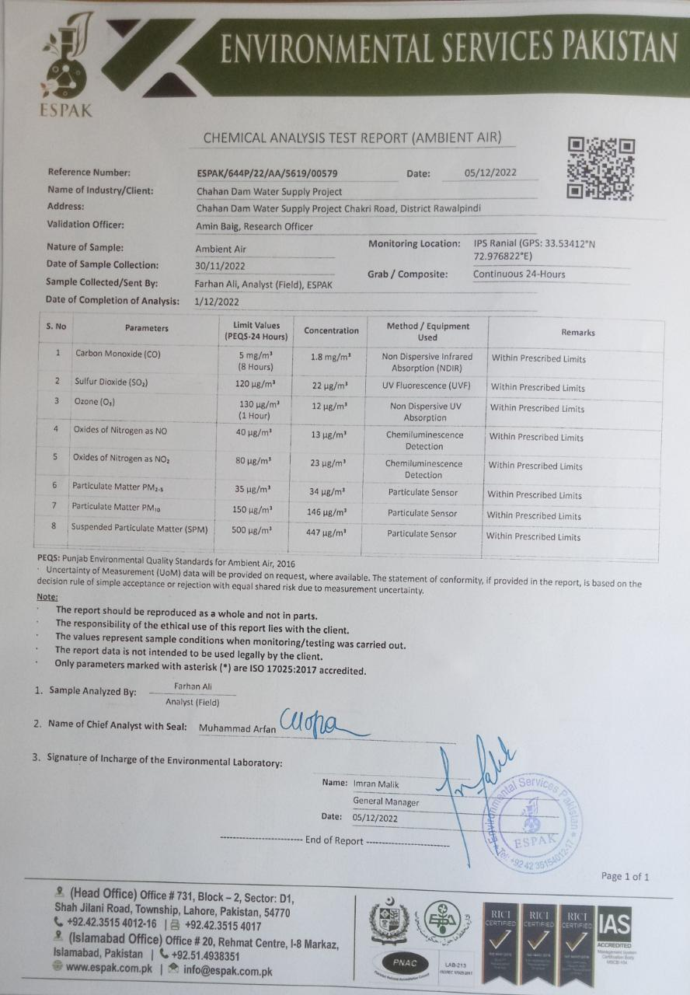

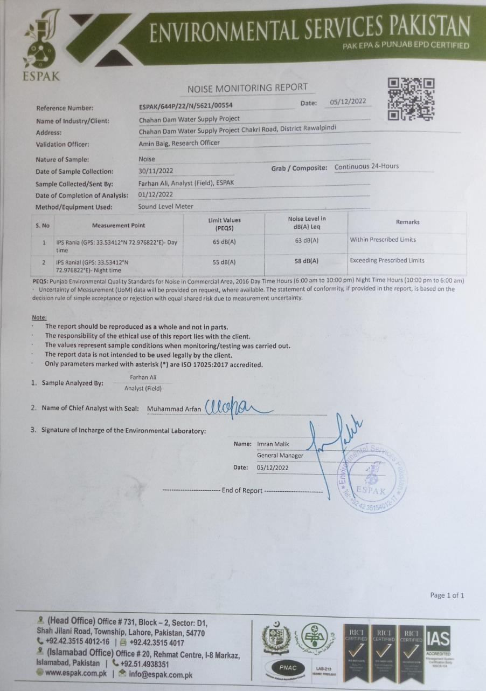

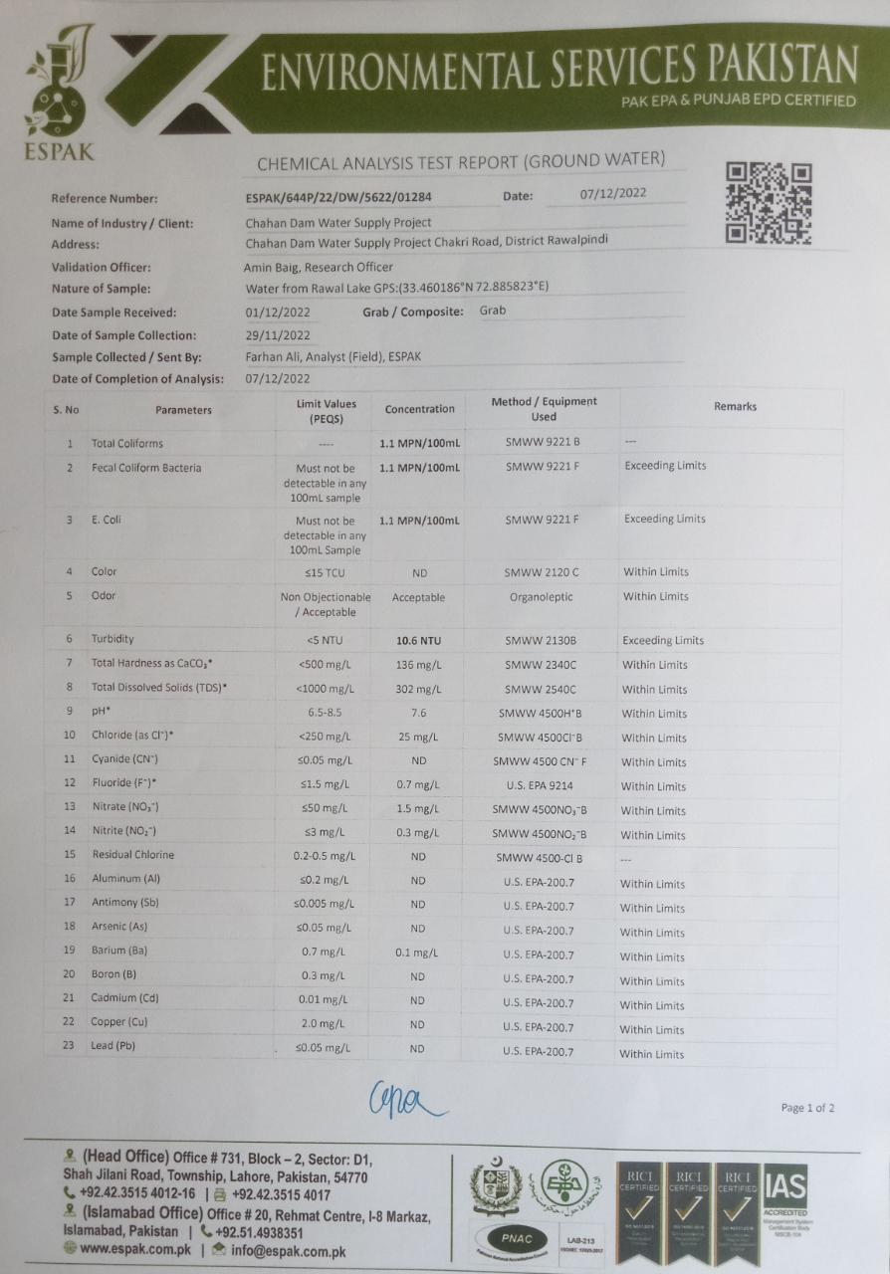

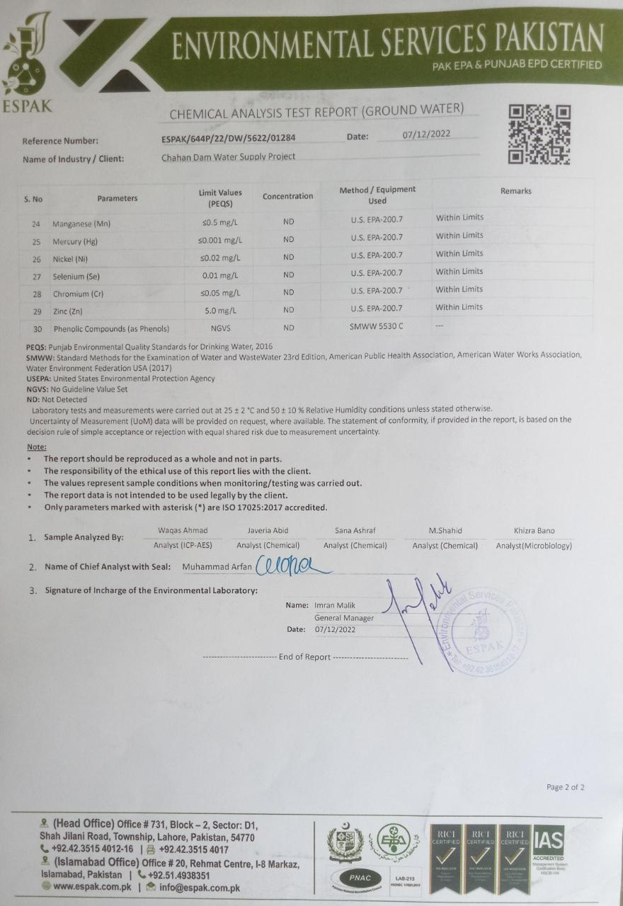

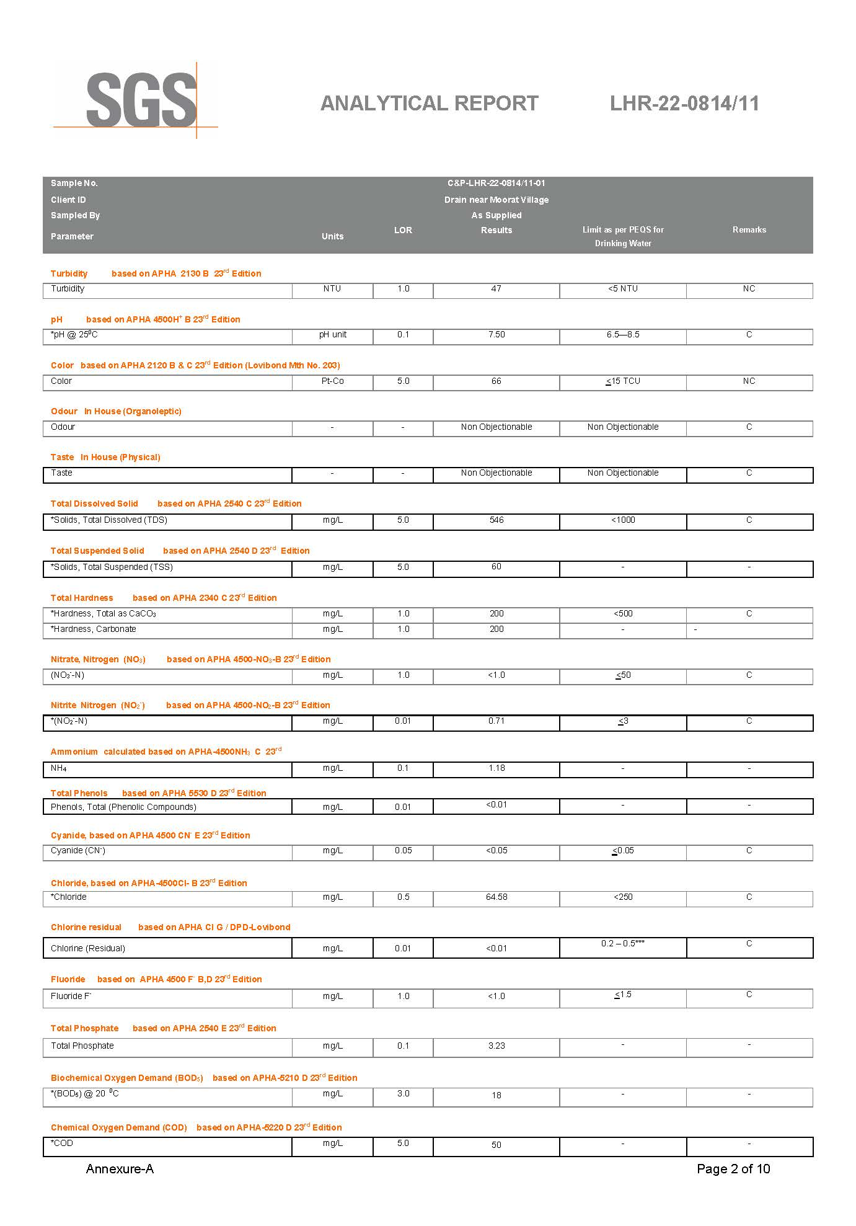
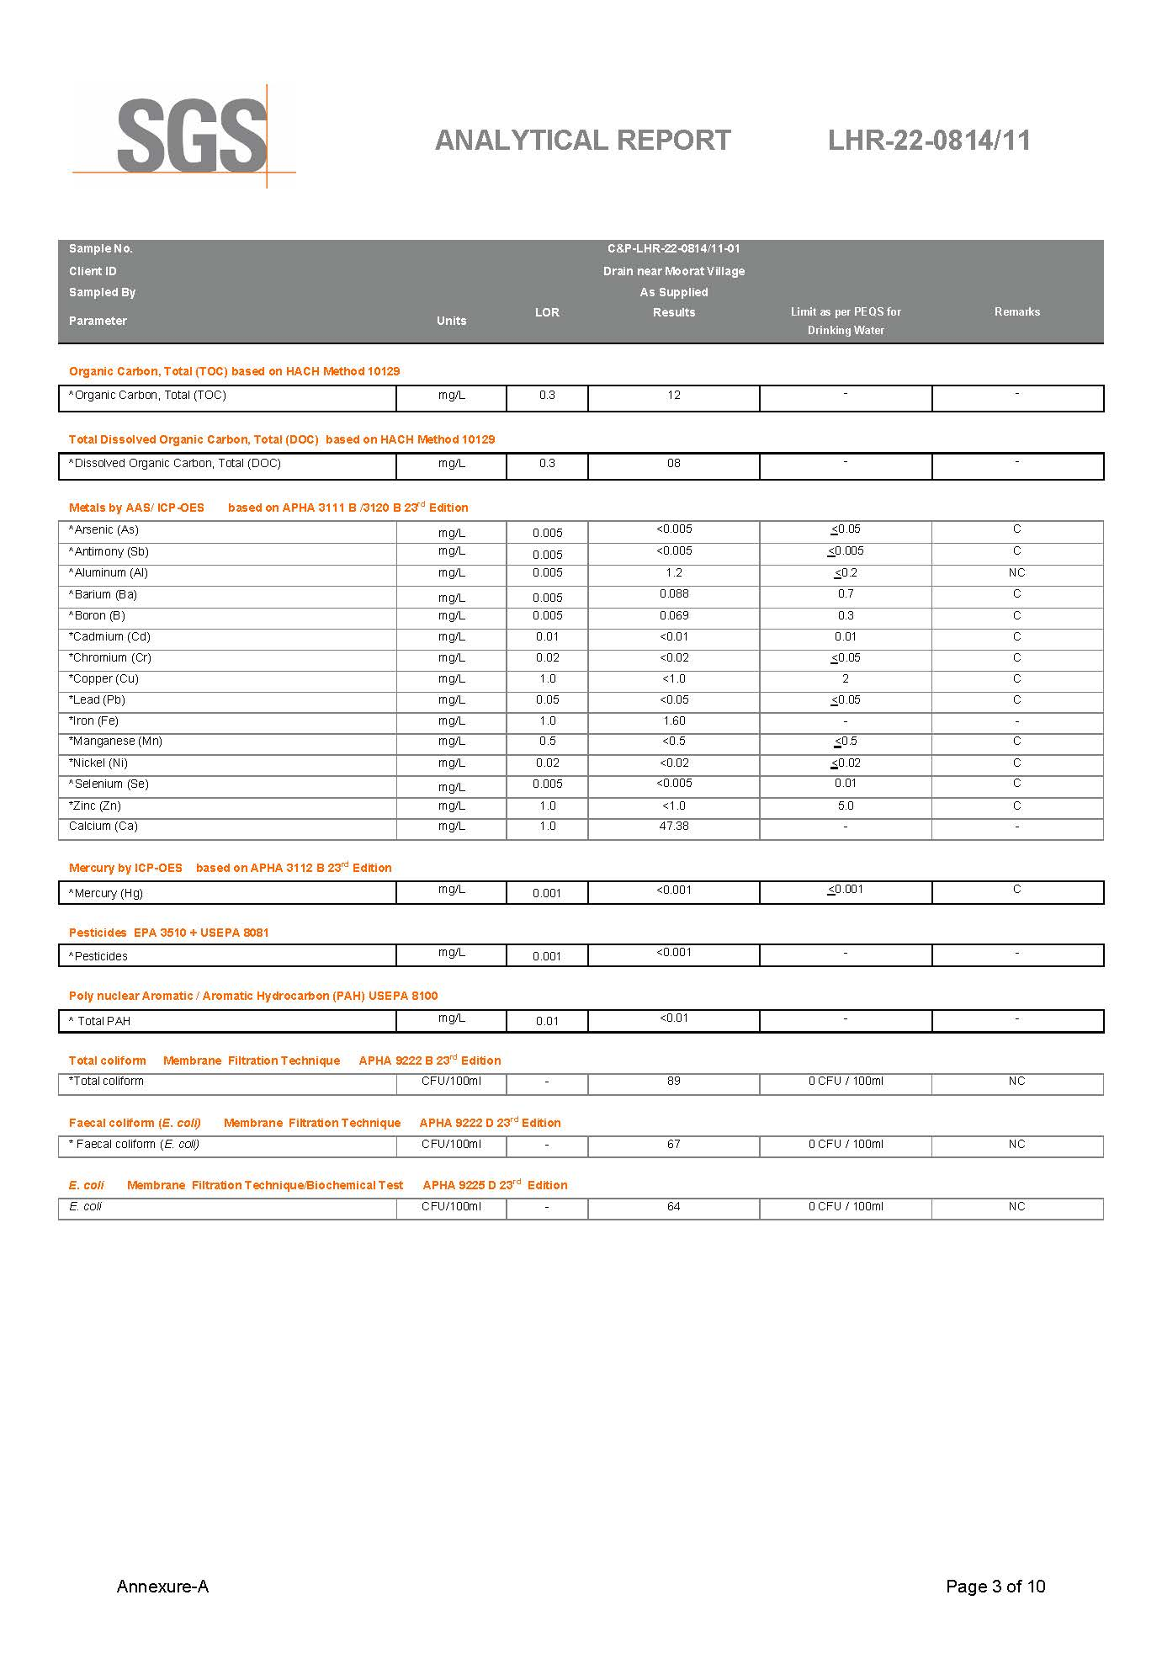

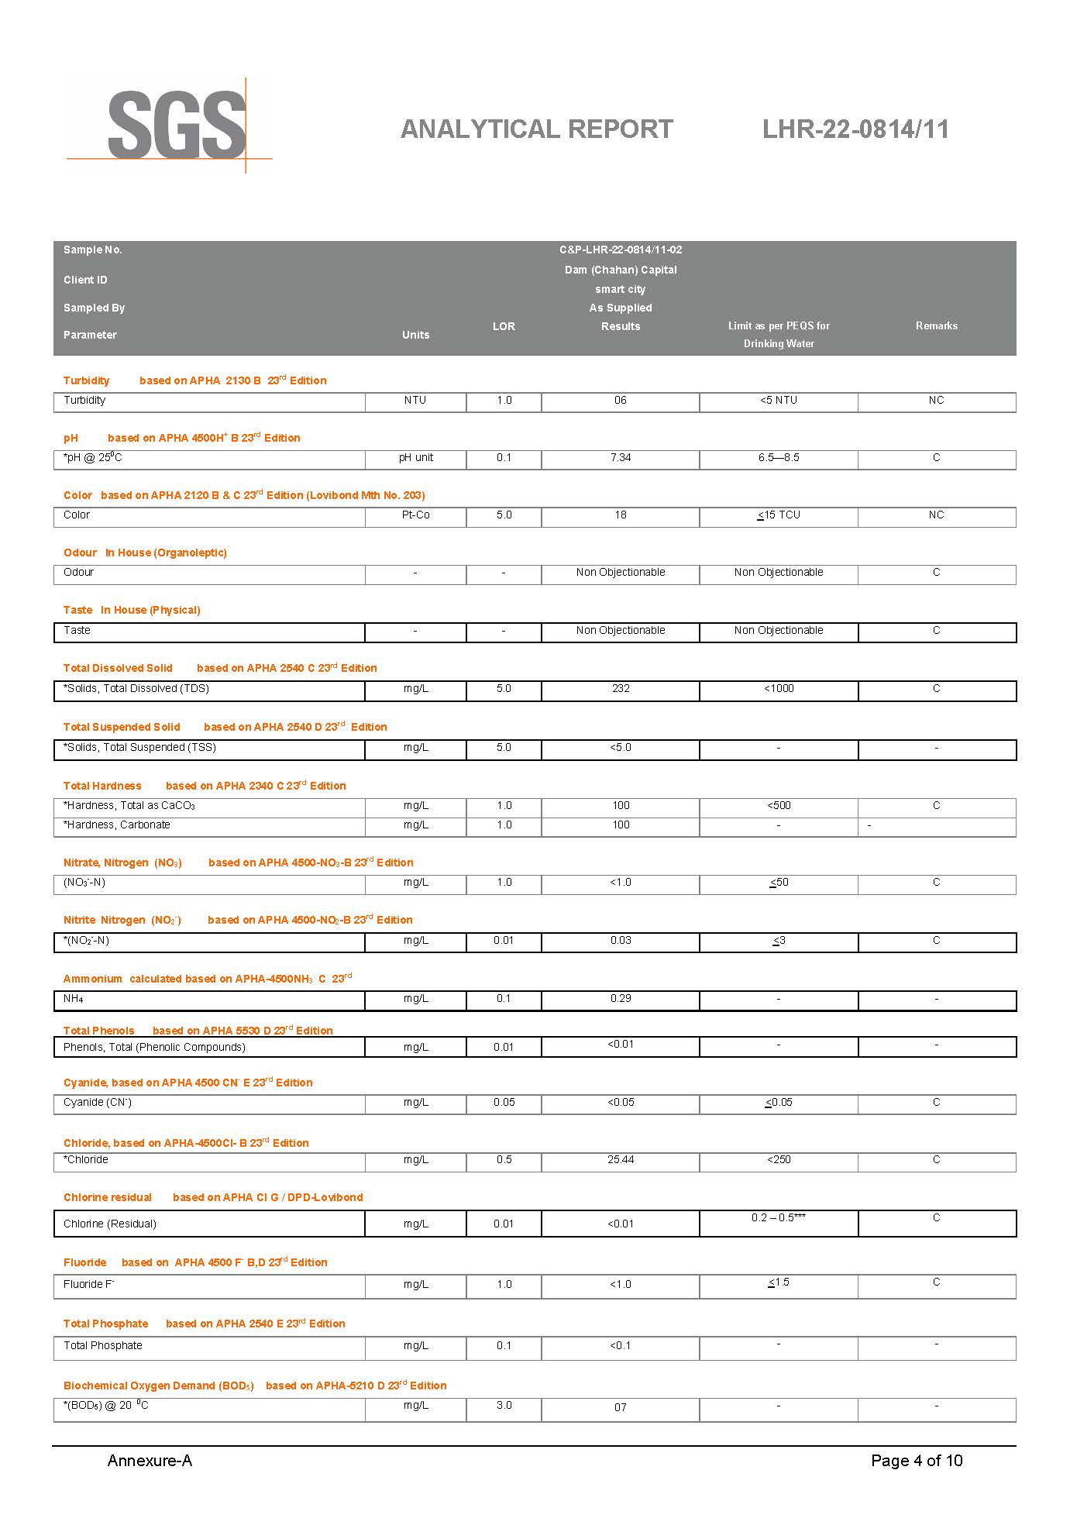
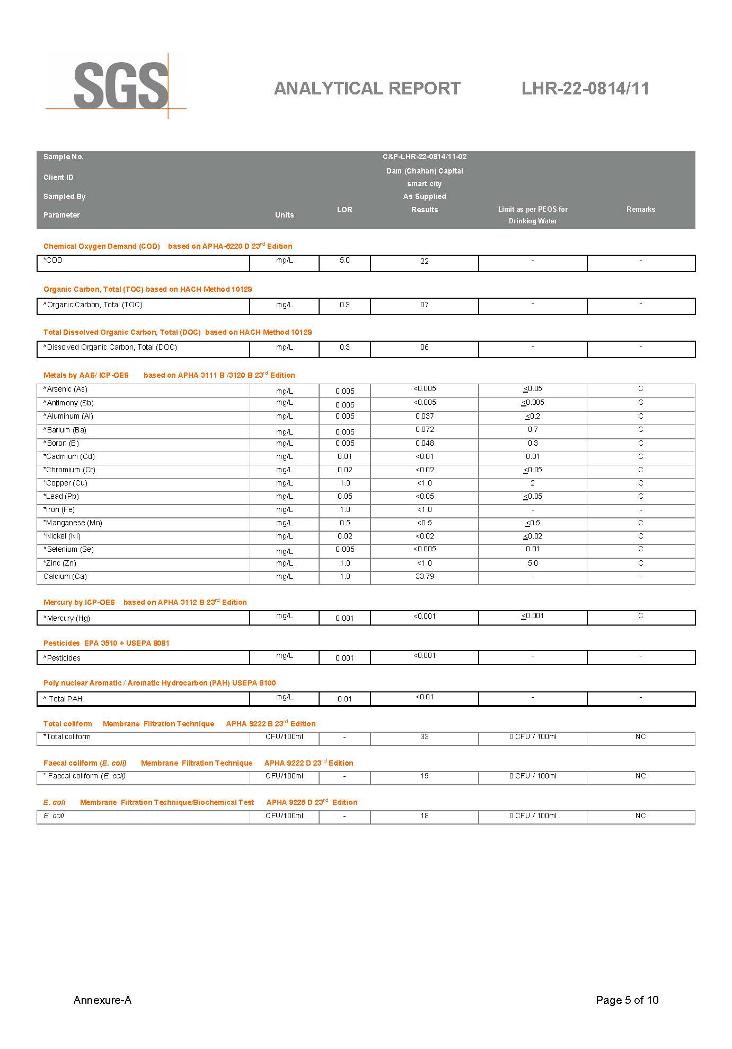

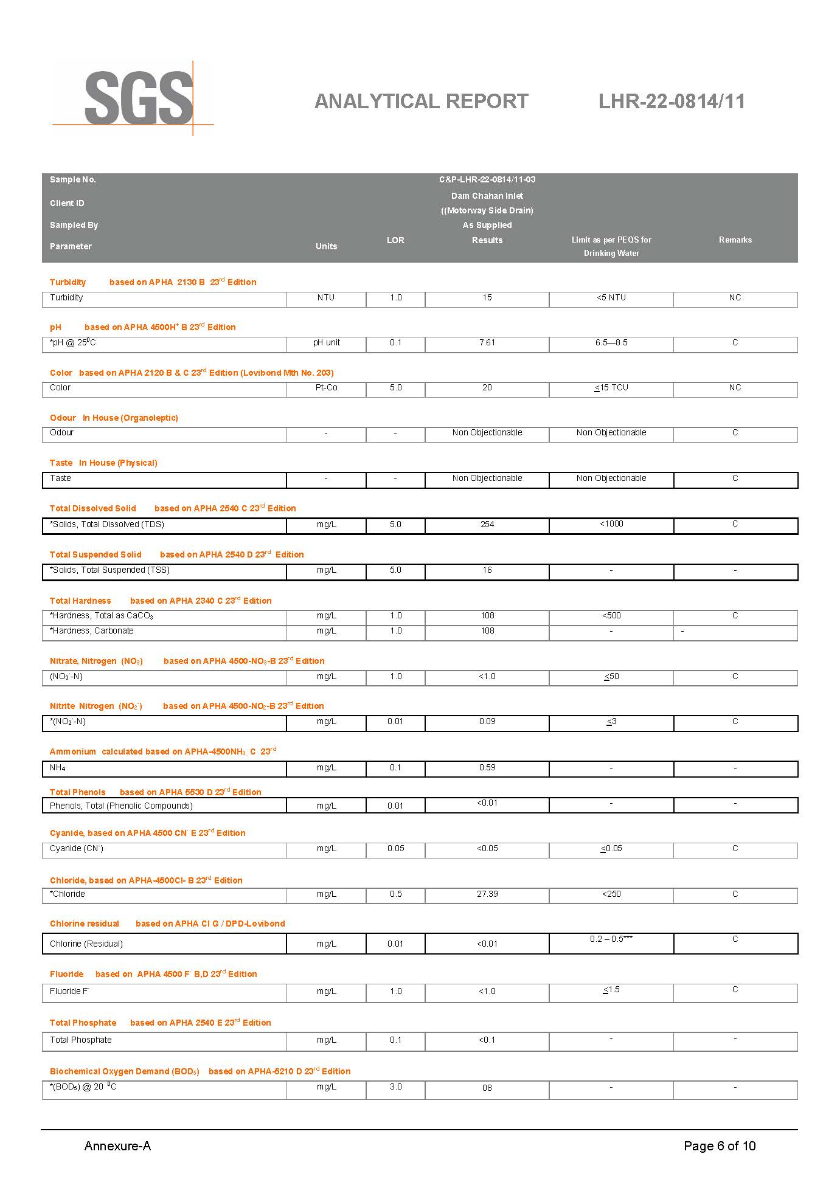

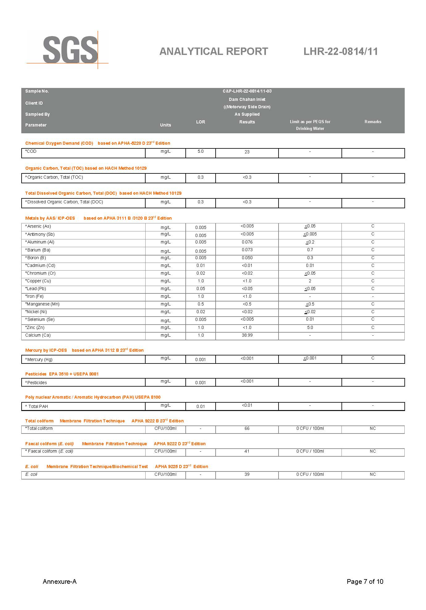

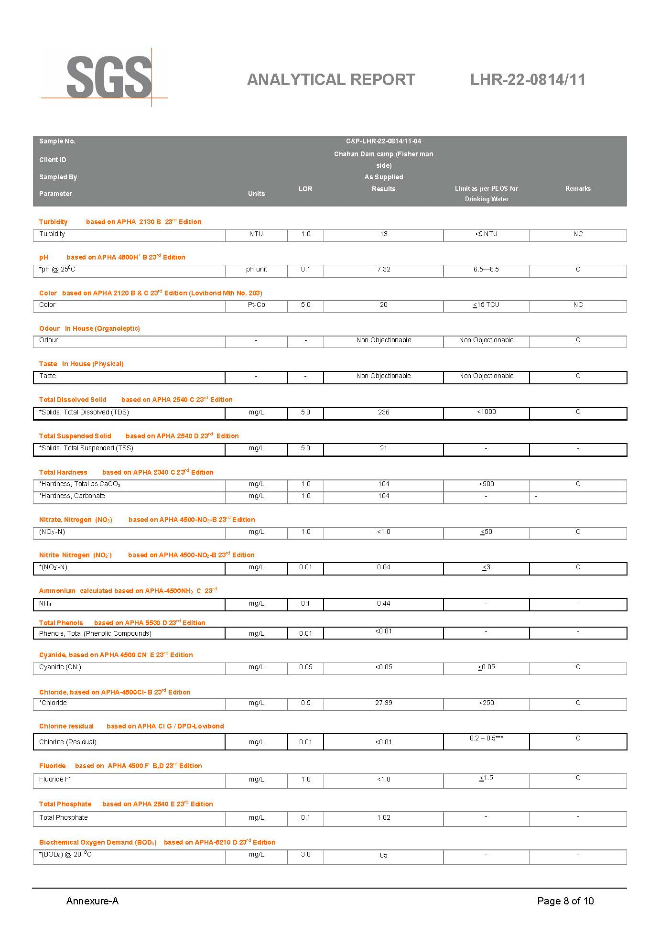

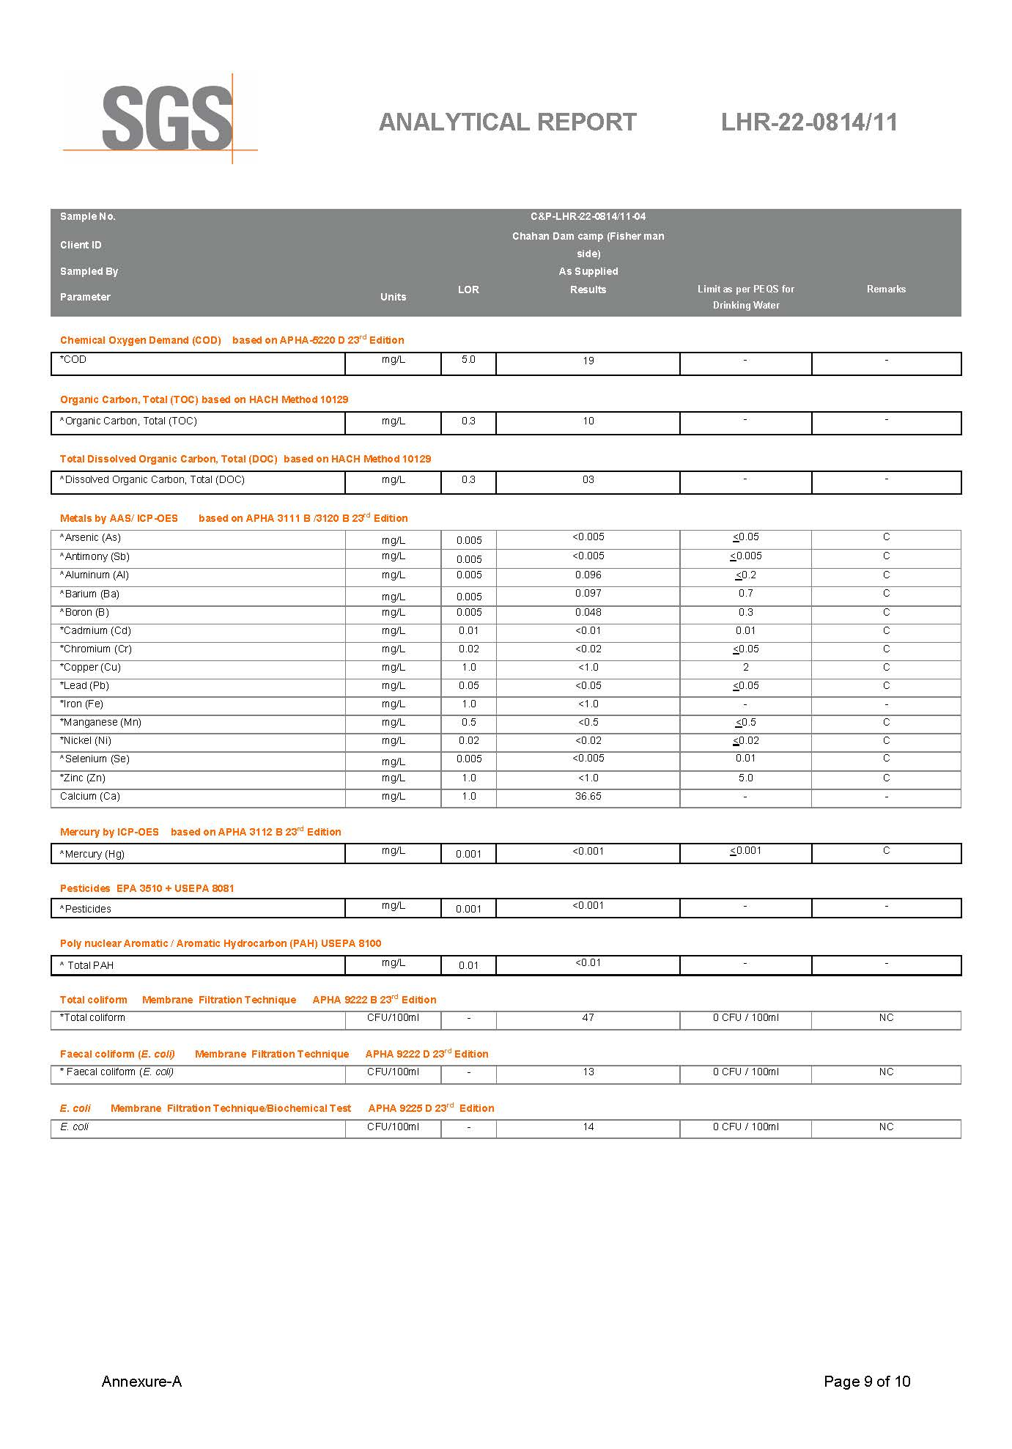

Annexure-III Calibration Certificates of Monitoring Equipment

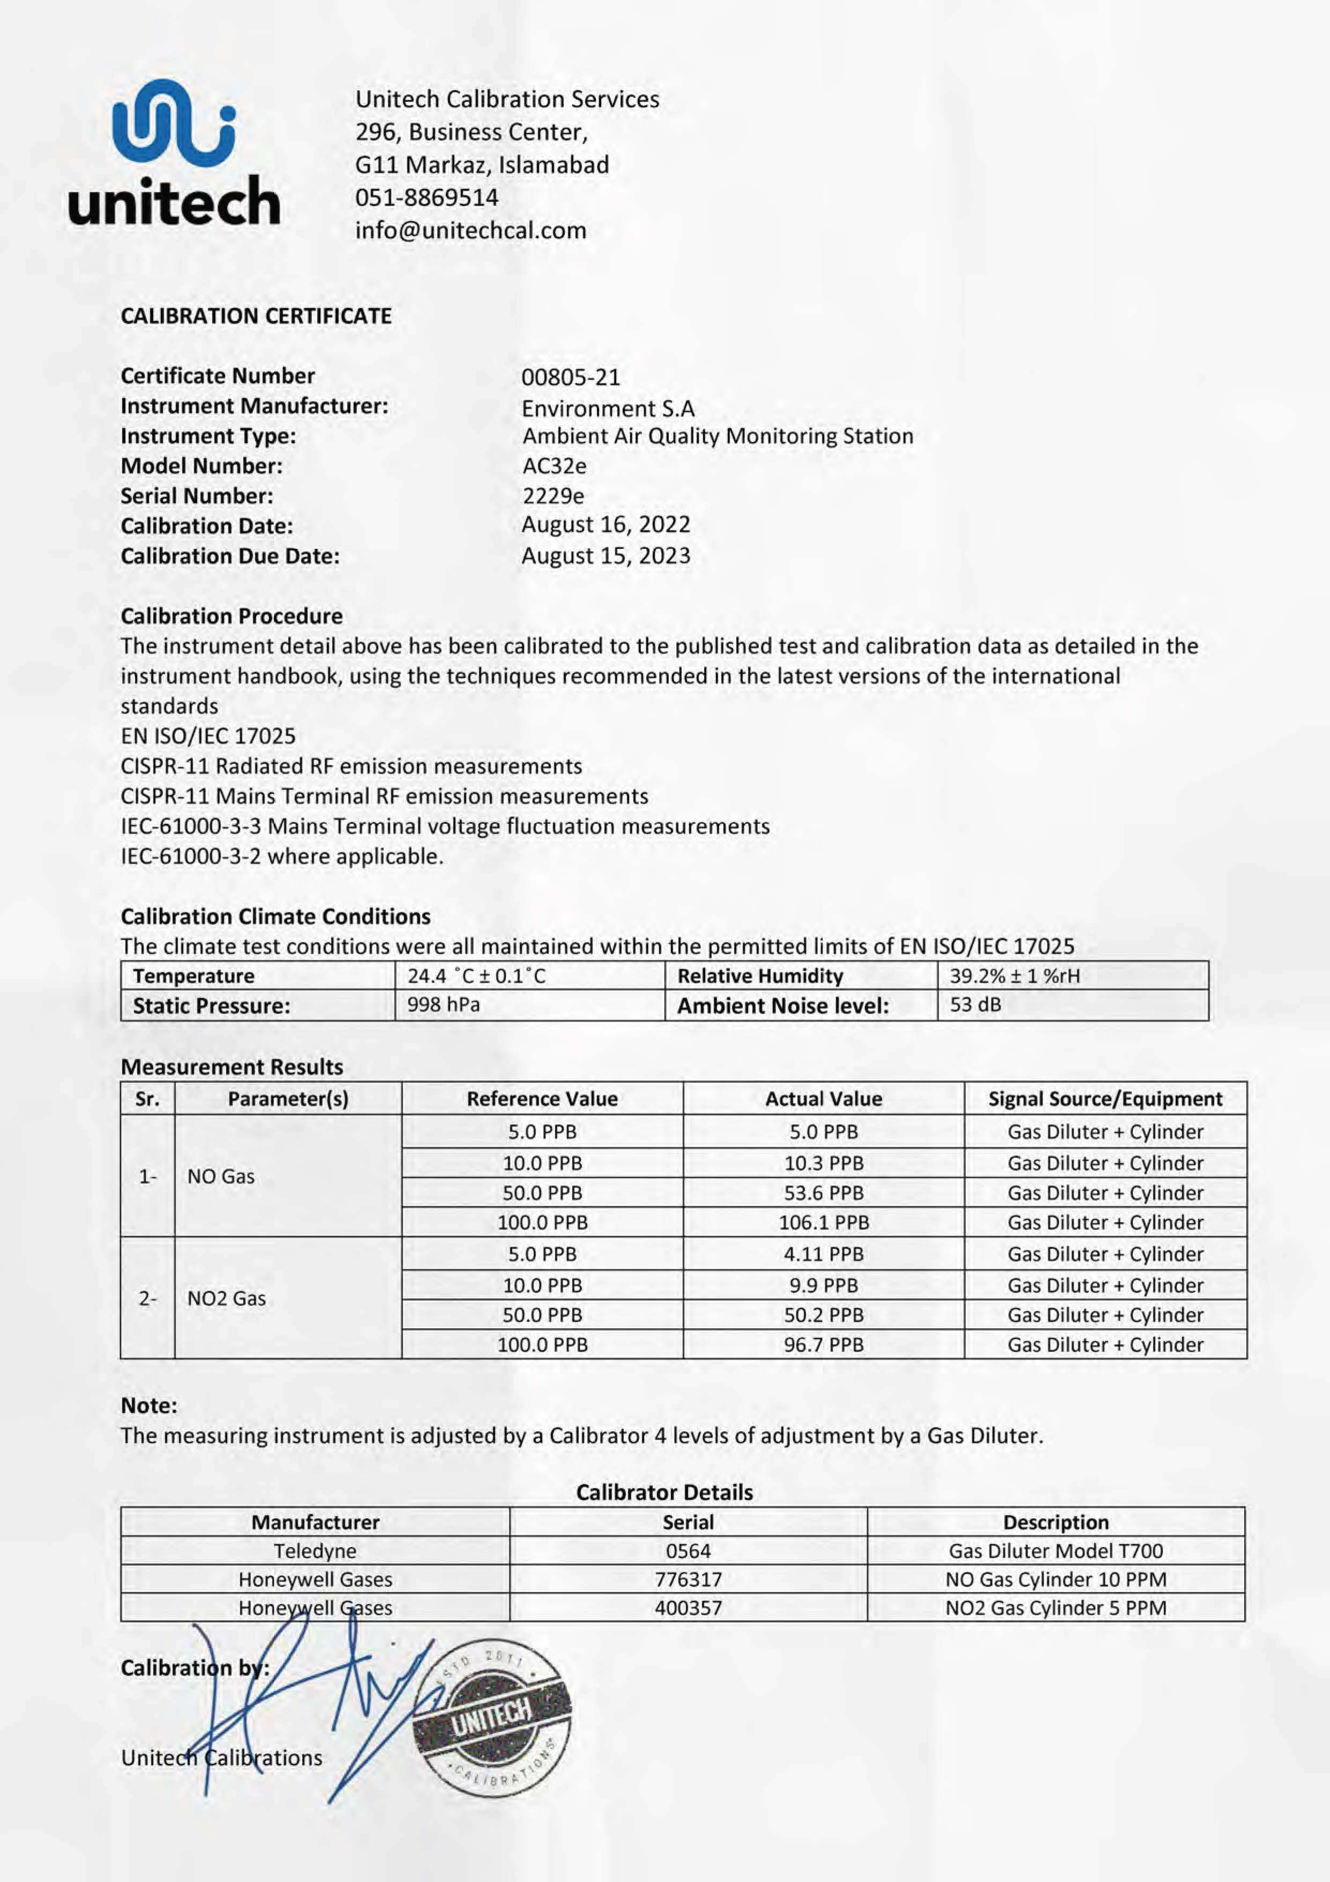

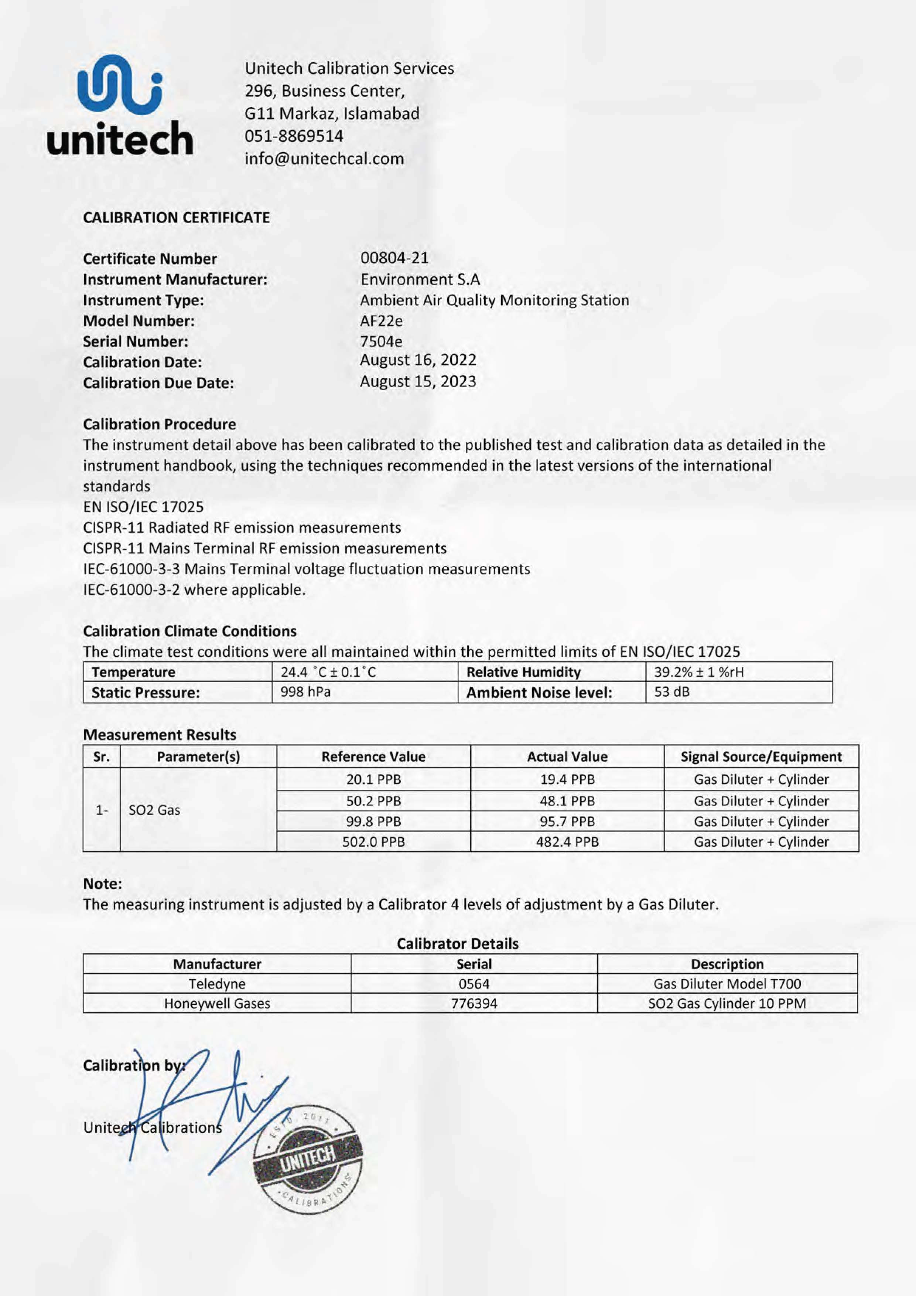

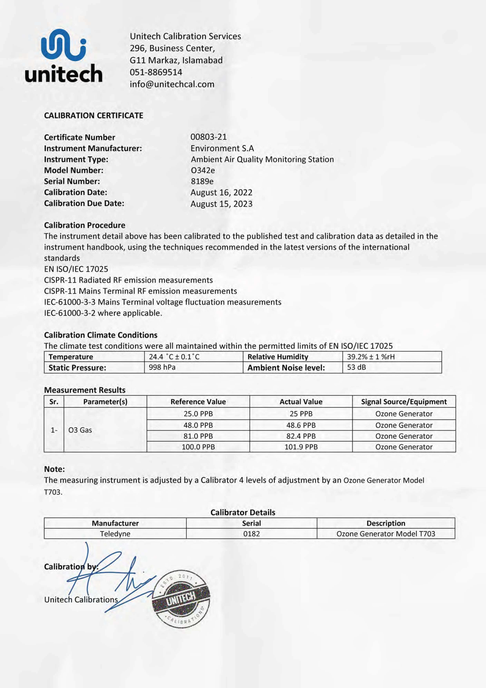

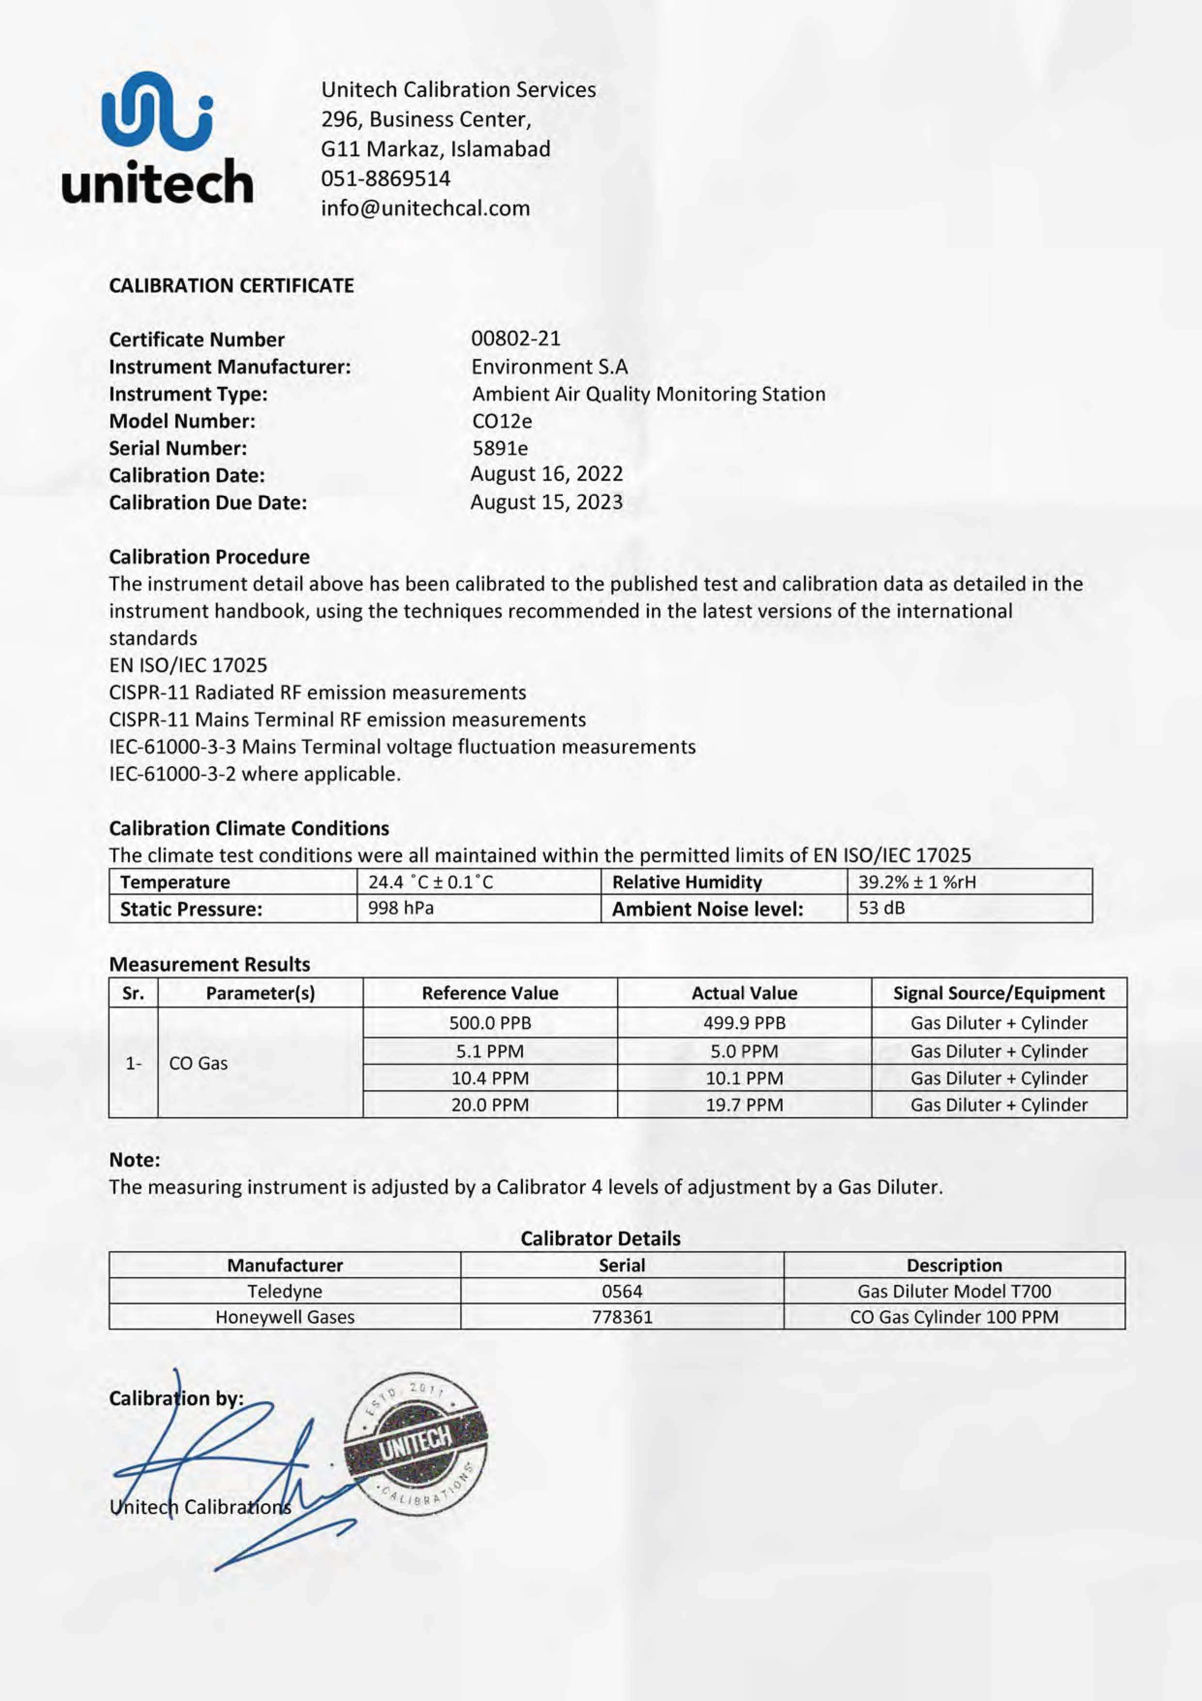

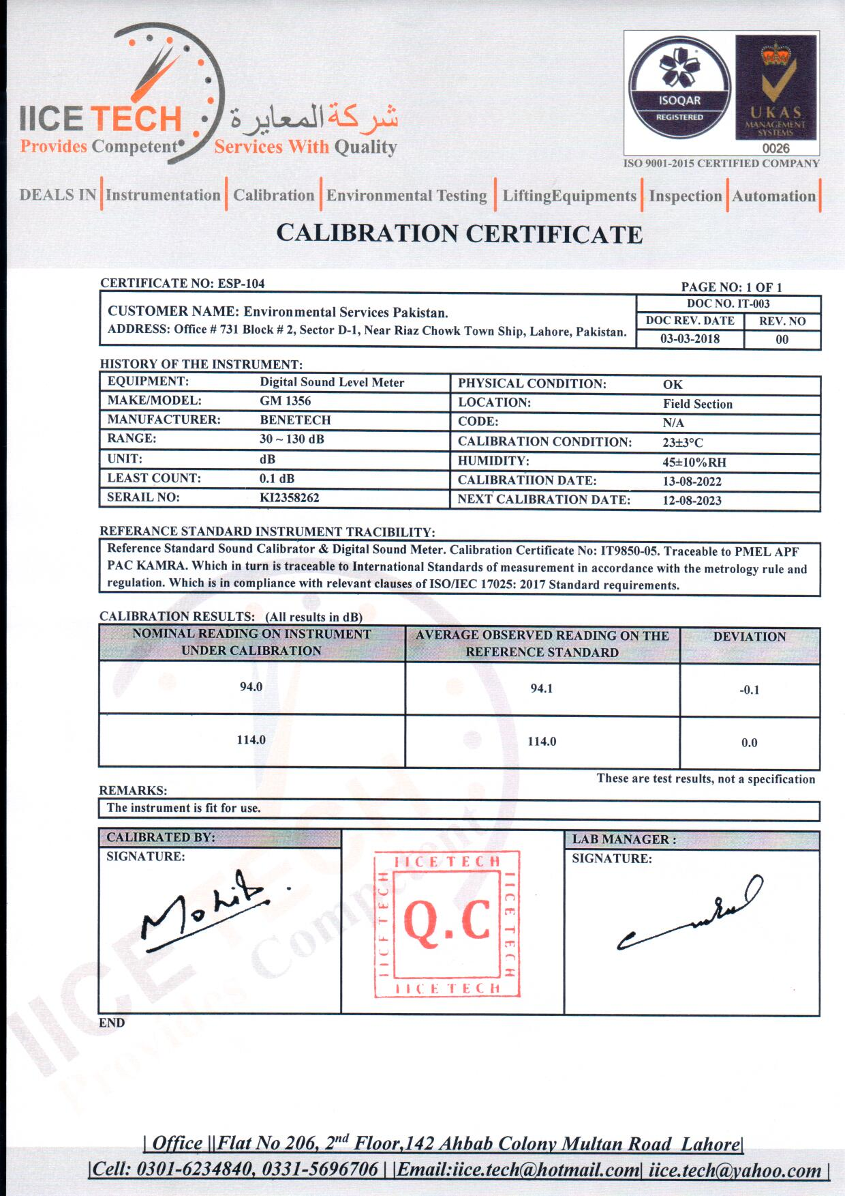

Annexure-IV IBAT Report

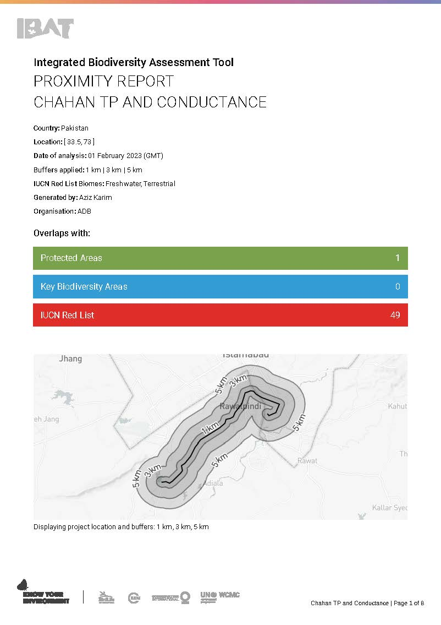

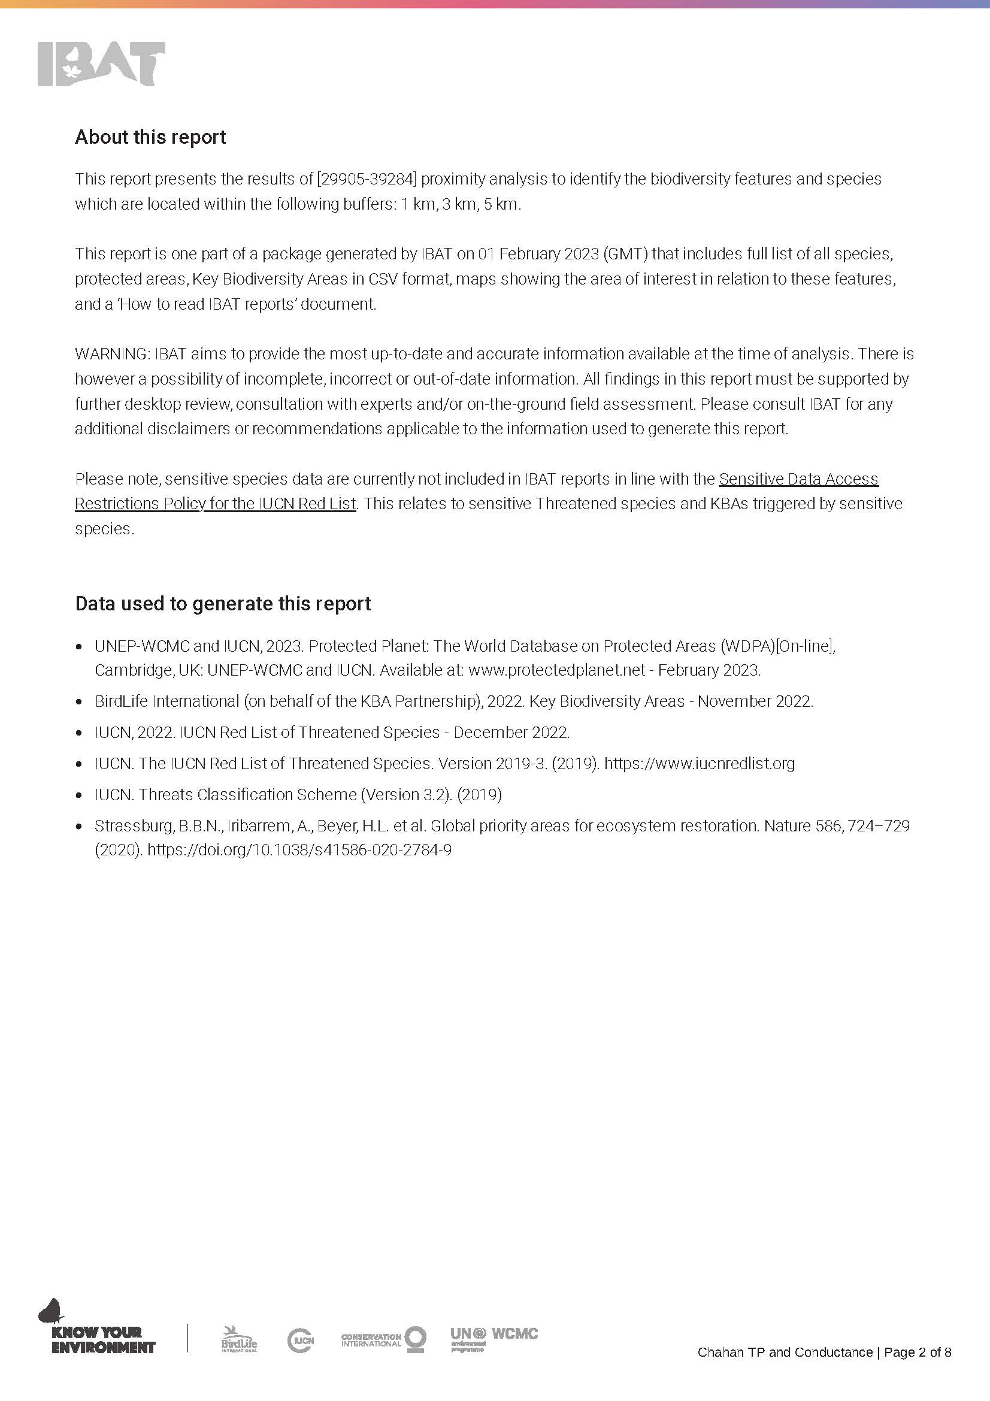
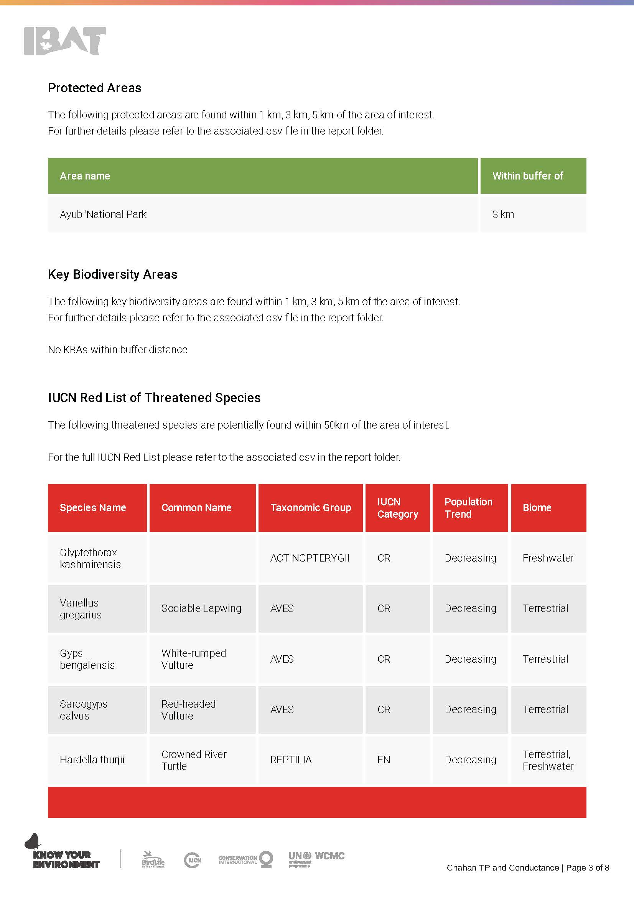
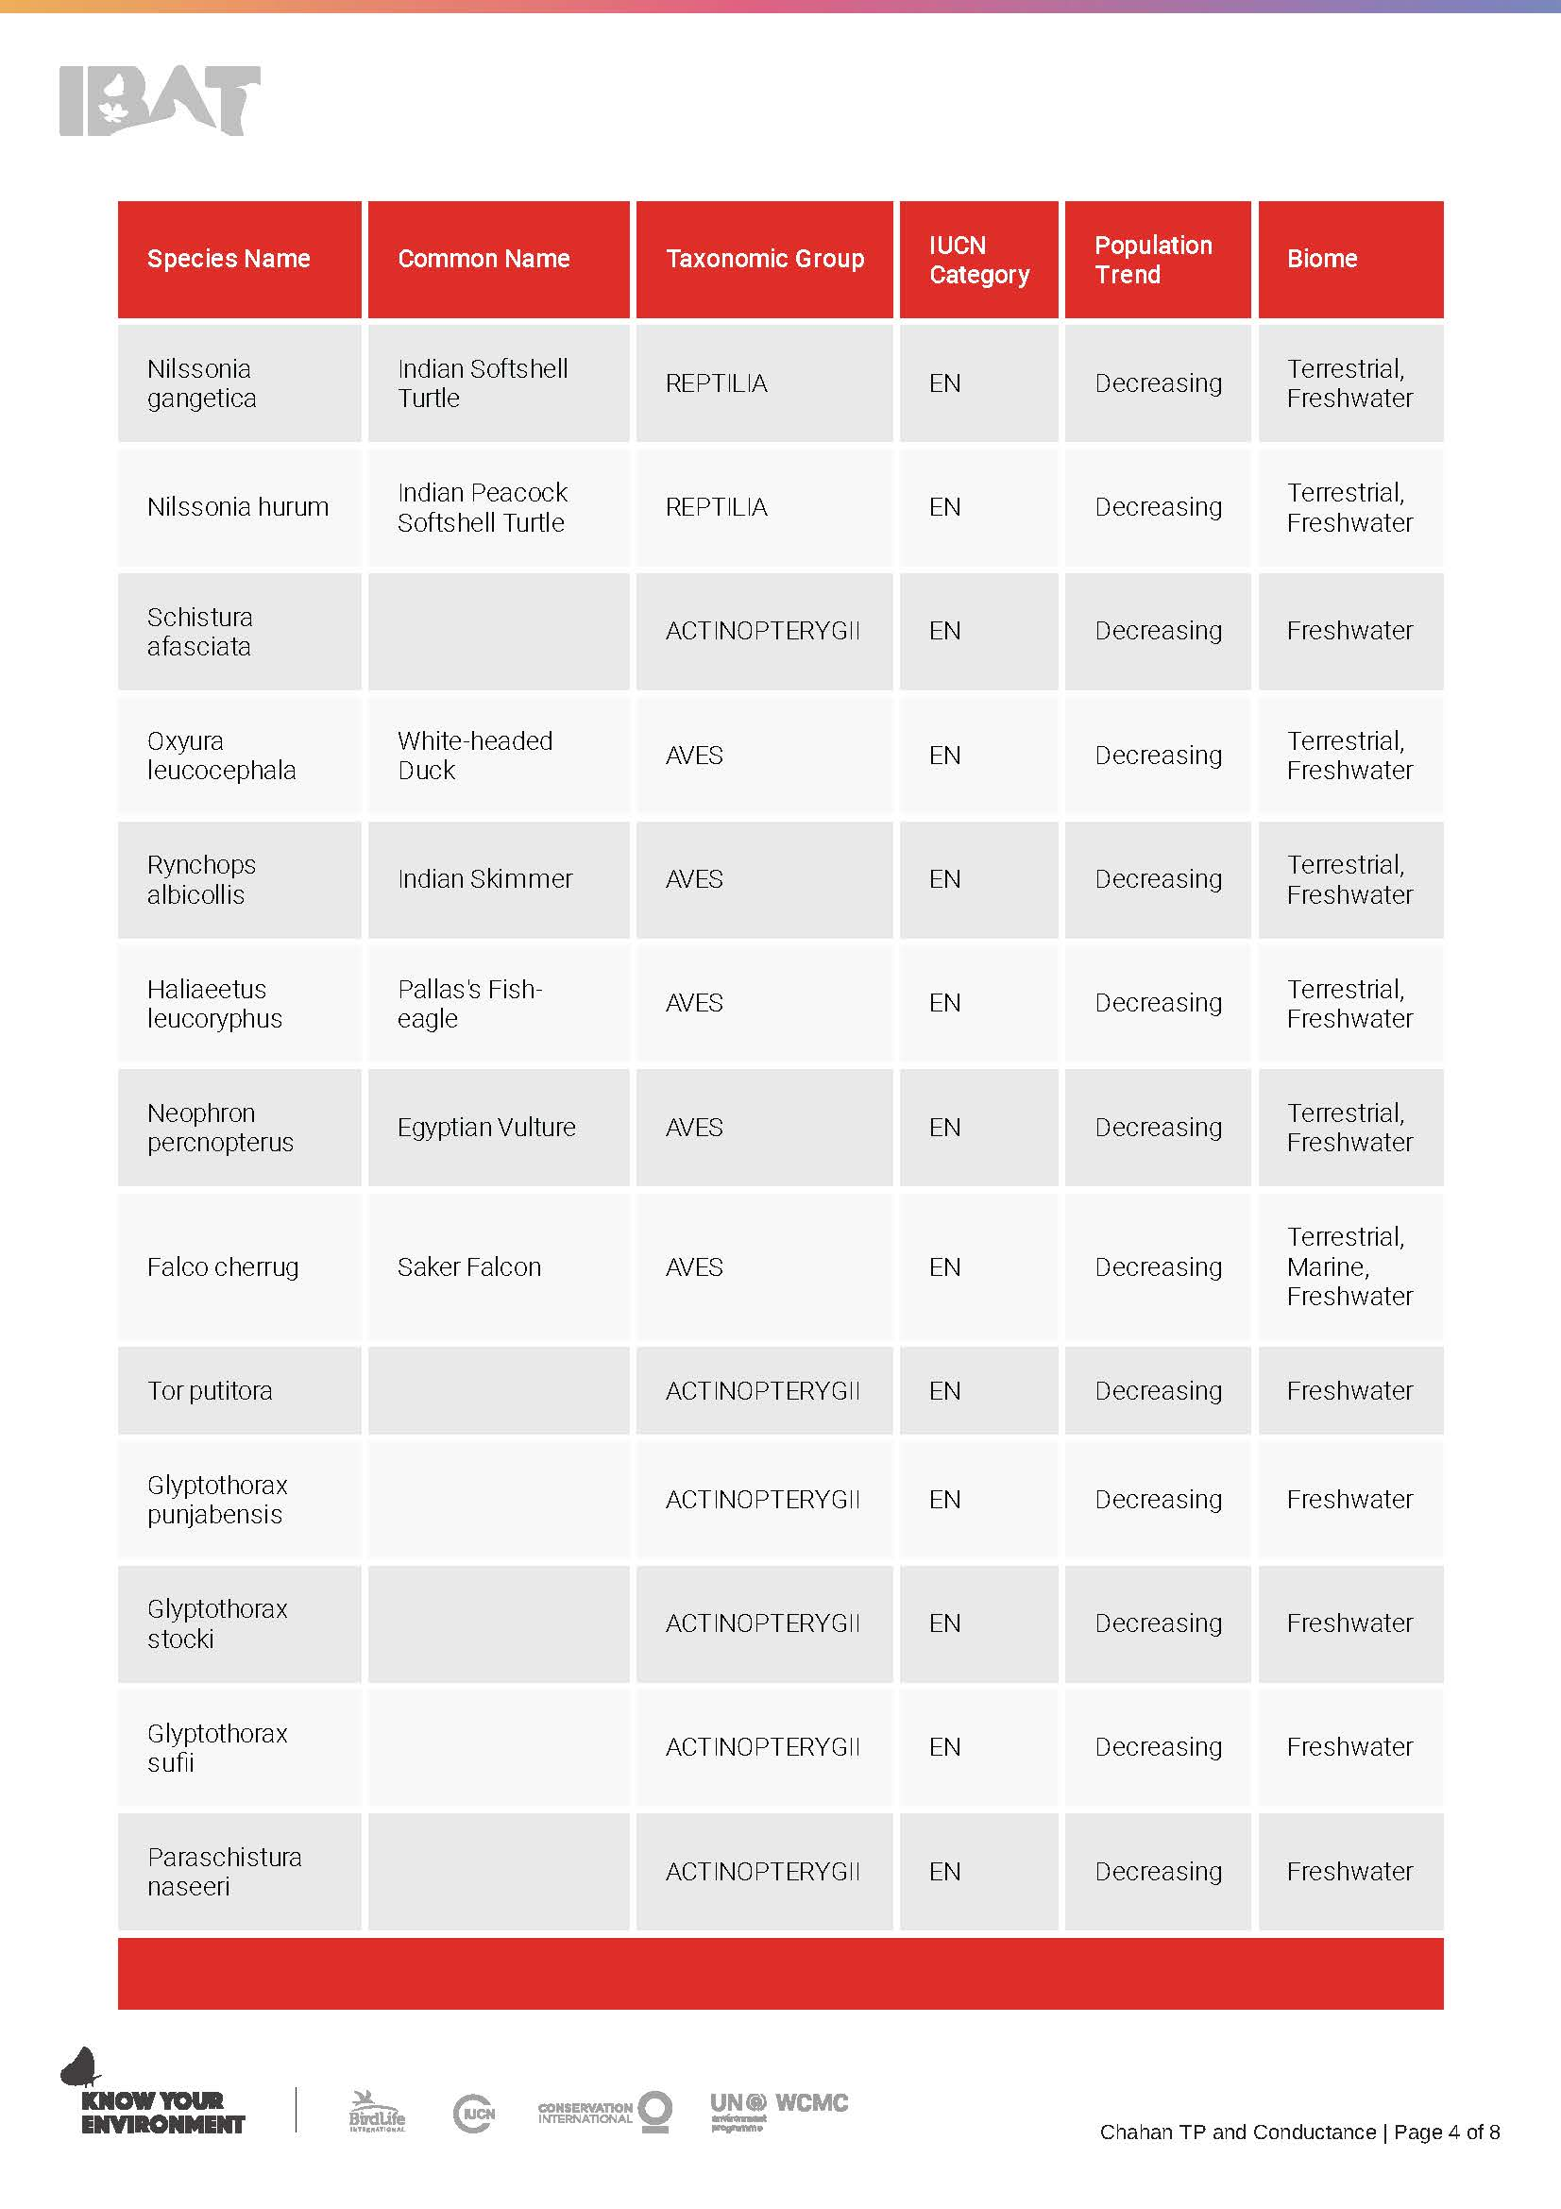
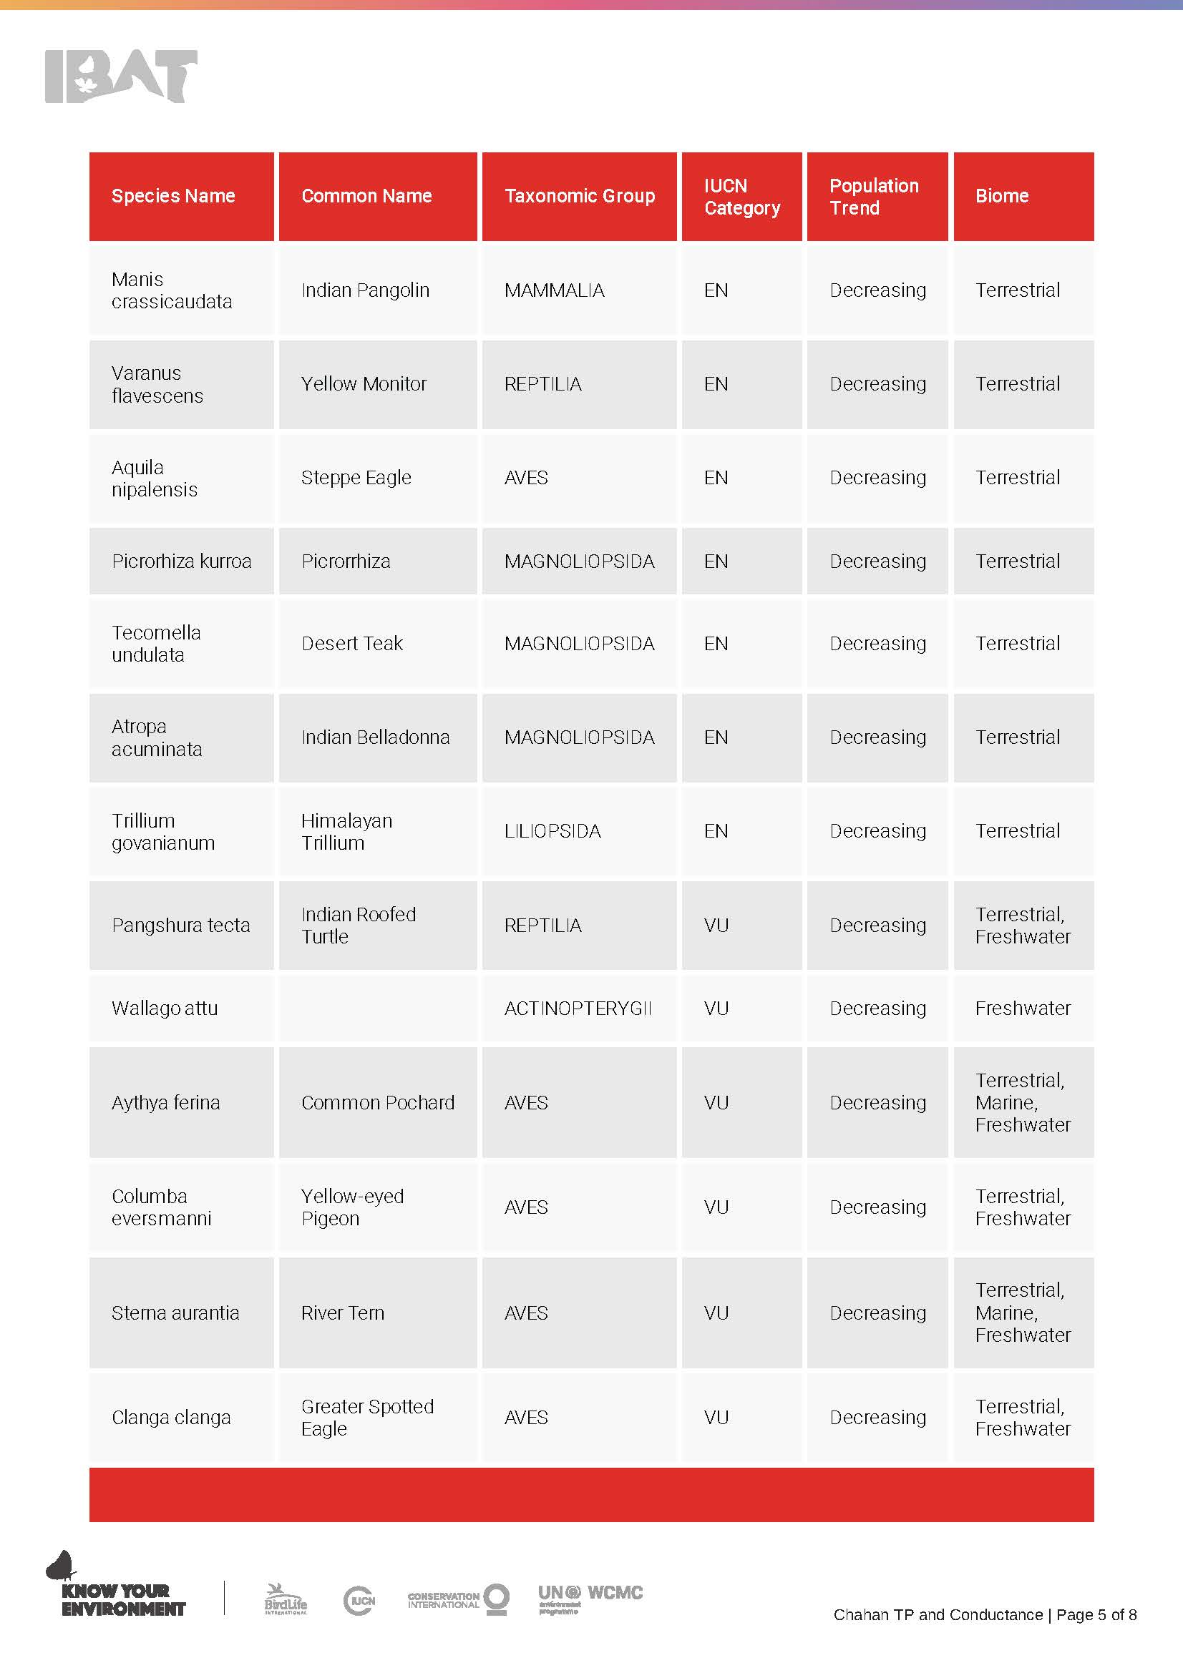
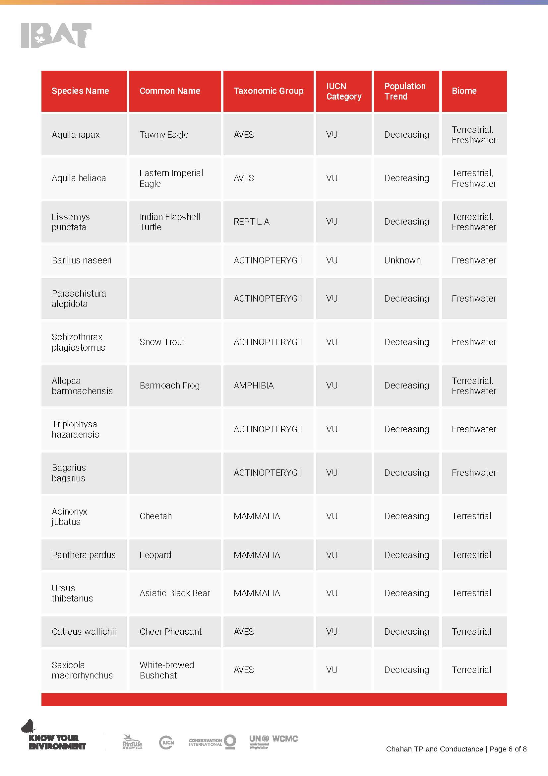
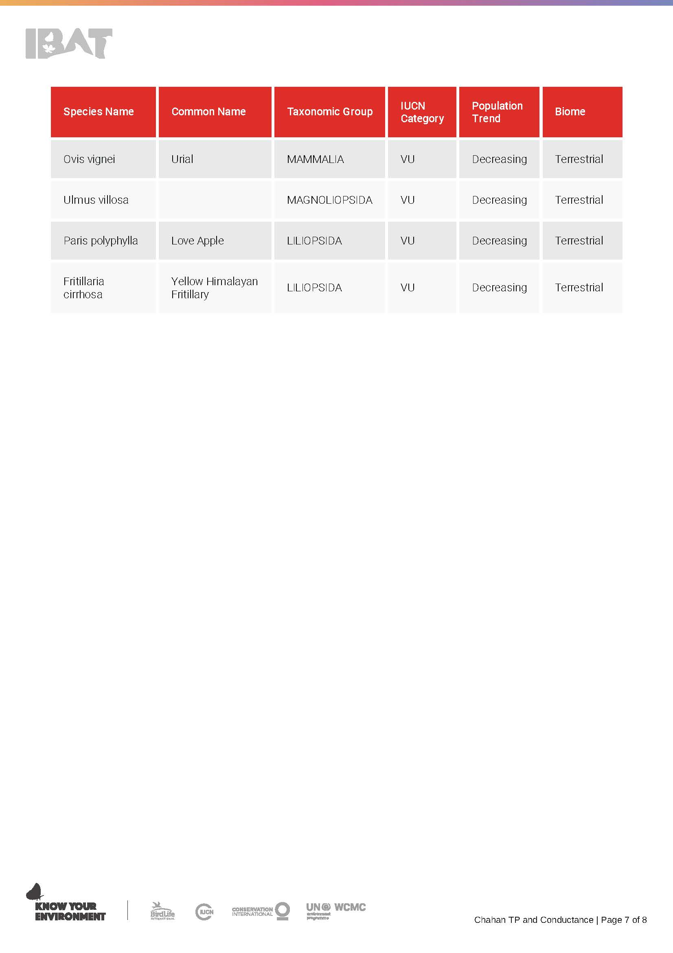
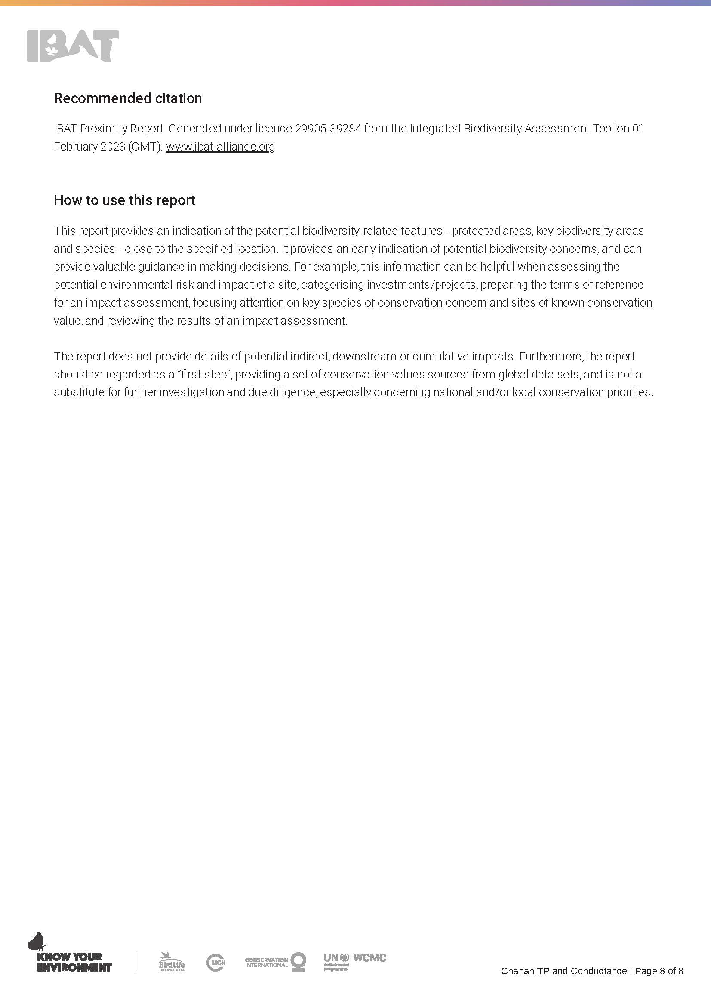

Annexure-V Chance Find Procedure

Chance Find Procedure
Project may involve deep excavation. Therefore, the possibility of chance find is not ignorable. In case of any chance find, the contractor will immediately report through Supervision Consultant to Directorate General (DG) of Archeological Department, Government of Pakistan to take further suitable action to preserve those antique or sensitive remains. Representative of the DG will visit the site and observed the significance of the antique, artifact and cultural (religious) properties and significance of the project. The report will be prepared by representative and will be given to the DG. The documentation will be completed and if required suitable action will be taken to preserve those antiques and sensitive remains.
In case any artifact, antiques and sensitive remains are discovered, chance find procedures should be adopted by contractor workers as follows:
- Stop the construction activities in the areas of chance find;
- Delineate the discovered site or area;
- Consult with the local community and provincial Archeological Department
- The suggestion of the local communities and the concerned authorities will be suitably incorporated during taking the preventive measures to conserve the antique, artifact and cultural (religious) properties;
- Secure the site to prevent any damage or loss of removable objects. In case of removable antiquities or sensitive remain, a night guard shall be arranged until the responsible local authorities take over; and
- After stopping work, the contractor must immediately report the discovery to the Supervision Engineer.
The contact Address of Archeology Department is given below:
Archeology Department
19 Ataturk Ave, Shakar Parian,
Islamabad, Islamabad Capital Territory, Pakistan

Annexure-VI Framework Dust Management Plan

Dust Management Plan
General
This plan is prepared for the project " Augmentation of Water Supply to Rawalpindi City Based upon Chahan Dam". The purpose of this plan is to describe the measures that the project shall take to ensure that the risk of emissions from dust generated by site operations during construction are minimized and that best practice measures are implemented.
Dust emissions from construction can cause ill health effects to Contractor staff along with nuisance and annoyance to members of the local community. Dust will be controlled through:
- Elimination
- Reduction/Minimization
- Control
This dust management plan shall be implemented based on the measures already provided in the Environmental Management Plan (EMP) relating to controlling dust emissions.
Methodology
The following methodology will be undertaken for each project section:
Step 1 – Identify the dust generating activities
Construction activities that are likely to produce dust will be identified. The activities that will be taken into account are:
- Haulage Routes, Vehicles and /Concrete Batching Plant
- Roads, surfaces and public highways
- Excavations for lying of new conductance and replacement of distribution pipelines
- Static and mobile combustion plant emissions
- Materials Handling, Storage, Spillage and Disposal
- Storage of material
- Stockpiles
- Spillages
- Storage of Waste
- Site Preparation and Restoration after Completion
- Earthworks, excavation and digging
- Storage of spoil and topsoil
- Demolition
- Construction and Fabrication Processes
Step 2 – Identify Sensitive Receptors
Sensitive receptors have already been identified. The nature and location of the sensitive receptors will be taken into account when implementing control measures.
Step 3 Implement Best Practice Measures to Control
Based on the nature of the activity producing the dust, the likelihood of dust being produced and the possible consequence of dust based on the sensitive receptors, the most effective control measure will be identified and implemented.
Step 4 – Monitor effectiveness of control
Construction Supervision Staff (CSC) will have the responsibility to ensure that dust control measures are being implemented and are effective.
Step 5 – Record and report result of monitoring
All inspections, audits and results of monitoring will be recorded and kept as part of the site filing system.
Method Statements and Risk Assessments
The Contractor’s Risk Assessments and Method Statements will be required to be approved by the CSC prior to commencing work and will be required to contain environmental aspects of the task, including dust control measures where required.
Where dust has been identified within the risk assessment as a significant issue, the method statement will be required to cover the following:
Methods and materials that will be used to ensure that dust generation is minimized.
The use of pre-fabricated materials where possible.
Optimum site layout:
Dust generating activities to be conducted away from sensitive receptors
Supply of water for damping down.
Good housekeeping and management
All employees will be briefed on the Risk Assessment and Method Statement before starting work.
Training
All Contractor staff will be required to attend training seminars as already mentioned in the EMP document. A site-specific induction will also be required before being allowed to work on site. These will include site-specific sensitive receptors and details regarding dust control measures to be taken.
Toolbox talks on air pollution and minimizing dust emissions will be provided on a regular basis to Contractor staff.
Identification of Dust Generating Sources and Control Methods
Haulage Routes, Vehicles and /Concrete Batching Plant
Dust Source | Dust Control Methods
Major haul roads and traffic routes | Haul roads will be dampened down via a mobile bowser, as required.
Public Roads | Road sweeper will be used to clean public roads as required.
Site traffic management | Site traffic will be restricted to constructed access roads as far as possible.  Site speed limit will be set at 10 mph as this will minimize the production of dust.
Road Cleaning | A mechanical road sweeper will be readily available and used.
Handling, Storage, Stockpiling and Spillage of Dusty materials
Material handling operations | The number of times a material will have to be handled will be kept to a minimum to prevent double handling and ensure dusty materials are not handled unnecessarily.
Transport of fine dusty materials and aggregates. | Closed tankers will be used or sheeted vehicles.
Vehicle loading/unloading materials on to vehicles and conveyors. | Dusty materials will be dampened down  Drop heights will be kept to a minimum and enclosed where possible.
Excavation for Lying new pipelines
Excavation | Excavation will be carried out by applying green sheets on the edges, especially near Environmental Sensitive Receptors, already highlighted in the IEE report.
Handling of Mucking Material | Mucking material will be stored in bonded area to avoid spillage and generation of fugitive dust
Loading of material on dumpers | Mucking material will be damped down before loading on dumpers to reduce fugitive dust emission.
Storage of Materials
Bulk cement, bentonite etc. | Bentonite will be delivered in tankers and stored in dedicated enclosed areas. Bulk cement will be transported through tractor trollies or trailers.
Fine dry materials | These will be protected from the weather and by storing in appropriate containers and indoors, where necessary.
Storage location | Material will be stored in dedicated lay-down areas.
Storage of Stockpiles
Stockpile location | Stockpiles will be placed so as to minimize double handling and facilitate the site restoration.
Building stockpiles | Stockpiles, tips and mounds will not be stored at an angle greater than an angle of repose of the material.
Small and temporary stockpiles | Where possible, stockpiles will be placed under sheeting.  Dusty material will be damped down.  Wind barriers (protective fences) of a similar height to the stockpile will be erected, if required.
Site Preparation and Restoration
Earthworks, excavation and digging | These activity areas will be kept damp where required and if possible, will be avoided during dry and windy periods.
Completed earthworks | Surfaces will be stabilized by re-vegetation as soon as possible, where applicable.
Construction and Fabrication Process
Cutting, grinding, drilling, sawing, trimming, planning, sanding | These activities will be avoided wherever possible.  Equipment and techniques that minimize dust will be implemented.  Water will be used to minimize dust.
Cutting roadways, pavements, blocks | Water sprinkling to be used.
Angle grinders and disk cutters | Best practice measures will be used such as dust extraction.

Monitoring Arrangements
Monitoring will be conducted at sensitive receptor locations in the project area as provided in the EMP. Furthermore, at locations where PM levels are exceeding applicable guidelines, additional stringent measures will be implemented at the respective location(s) in the project area to ensure dust levels are controlled as far as possible.

Annexure-VII Framework Noise and Vibration Management Plan

Objective
This management plan defines the measures to control and limit noise emissions and vibration levels, at residential properties and other sensitive receptors in the vicinity of the Project.
General Requirements
Best Practicable Means (BPM) of noise control will be applied during construction works to minimize noise (including vibration) at neighboring residential properties and other sensitive receptors arising from construction activities
The general principles of noise management are given below:
Control at source:
Equipment – noise emissions limit for equipment brought to site.
Equipment – method of directly controlling noise e.g. by retrofitting controls to plant and machinery.
Equipment - indirect method of controlling noise e.g. acoustic screens.
Equipment - indirect method of controlling noise e.g. benefits and practicality of using alternative construction methodology to achieve the objective e.g. vibratory piling techniques or hydro- demolition as opposed to more conventional but noisier techniques; selection of quieter tools/machines; application of quieter processes.
Control across site by:
- Administrative and legislative control,
- Control of working hours,
- Control of delivery areas and times,
- Careful choice of compound location,
- Physically screening site,
- Control of noise via Contract specification of limits,
- Noise Monitoring, to check compliance with noise level limits, cessation of works until alternative method is found.
- Many of the activities which generate noise can be mitigated to some degree by careful operation of machinery and use of tools. This may best be addressed by tool box talks and site inductions.
The maintenance of good community relations is vital. Experience shows that construction noise has the potential to cause disturbance but can be tolerated if prior warning and explanation has been given to residents. In particular advice regarding the nature of construction works, the duration of the works and mitigation measures to be implemented can help to reduce people’s reaction to noise.
Contractors will consult local residents/communities regarding works and to give them details of a responsible appointed person on site who will be able to deal with queries.
Construction working hours should be carefully managed. All works should take place between normal working hours 07:30 and 18:30, Monday to Friday with the exception of restricted works.
Noise and Vibration Control Measures
In addition to specific requirements of the Local Authority, the Contractor will be required to adopt the following more specific measures:
Control measures
Without prejudice to the other requirements of this section, the Contractor shall comply with the recommendations set out in BS5228:2009 and in particular with the following requirements:
- Vehicles and mechanical plant will be maintained in a good and effective working order and operated in a manner to minimise noise emissions. The contractor will ensure that all plant complies with the relevant statutory requirements;
- Site vehicles will be equipped with broadband, non-tonal reversing alarms;
- Compressor, generator and engine compartment doors will be kept closed and plant turned off when not in use;
- All pneumatic tools will be fitted with silencers/mufflers;
- Care would be taken when unloading vehicles to avoid un-necessary noise;
- Maintenance operations will be undertaken at distance from noise-sensitive receptors;
- Reduce the speed of vehicle movements;
- Ensure that operations are designed to be undertaken with any directional noise emissions pointing away from noise-sensitive receptors;
- Vehicles should be prohibited from waiting within the site with their engines running or alternatively, located in waiting areas away from sensitive receptors;
Vibration Mitigation
All vibration producing machinery will be identified by the contractor and vibration producing machinery will be operated at low frequency to reduce the vibration impacts.
- Vibration monitoring will be carried out in accordance with German Standard DIN 4150 (heritage structures) and BS 7385: Part 2 – 1993 (other structures).
- vibration monitoring will be undertaken at the nearest buildings to the construction sites during times of vibration intensive works
- Where exceedances of the criteria are recorded, corrective actions would be implemented where soils at risk of vibration induced settlement are identified.
Noise and vibration monitoring
A regular program of noise and vibration monitoring shall be implemented as a minimum in accordance with this document.
The Contractor will submit the proposed method, the frequency and the location of monitoring site to the Planning Authority for agreement prior to commencing works. Noise baseline levels will be agreed prior to commencement of construction.
Reference:
https://proaccionaau.blob.core.windows.net/media/4gbpg4vk/ctp-noise-and-vibration-management-plan.pdf.

Annexure-VIII Framework Traffic Management Plan
1. Objectives of TMP
One of the prime objectives of this TMP is to ensure the safety of all the road users along the work sites, and to address the following issues:
- Safety of pedestrians, bicyclists, and motorists travelling through the construction sites;
- Protection of workers from hazards associated with moving traffic;
- Mitigation of the adverse impact on road capacity and delays to the road users;
- Maintenance of access to adjoining properties; and
- Addressing issues and concerns that may delay the implementation of the proposed project.
2. Operating Policies for TMP
The following policies will help promote safe and efficient movement for all road users (motorists, bicyclists, and pedestrians, including persons with disabilities) through and around project sites, while reasonably protecting workers and equipment.
- Make traffic safety and temporary traffic control an integral and high-priority element of project from planning through design, construction, and maintenance;
- Inhibit traffic movement as little as possible;
- Provide clear and positive guidance to drivers, bicyclists, and pedestrians as they approach and travel through the temporary traffic routes;
- Inspect traffic control elements routinely, both day and night, and make modifications when necessary;
- Pay increased attention to roadside safety in the vicinity of temporary traffic routes;
- Train all persons that select, place, and maintain temporary traffic control devices;
- Keep the public well informed; and
- Make appropriate accommodation for abutting property owners, residents, businesses, emergency services, railroads, commercial vehicles, and transit operations.
Policy steps for the TMP are shown in Figure 1. However, operating policy for TMP for the construction of the proposed project along various types of roads is shown in Figures 2 to 7.

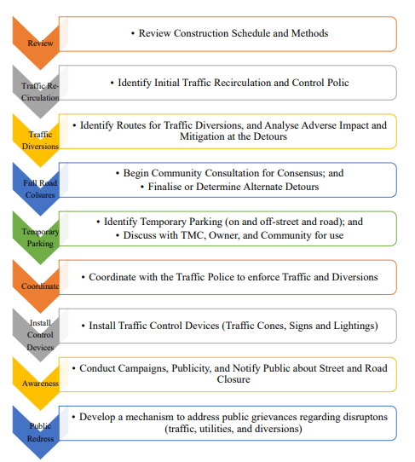
Figure 1: Policy Steps for the TMP

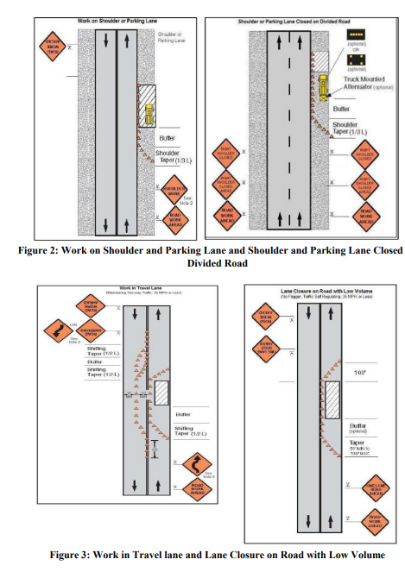

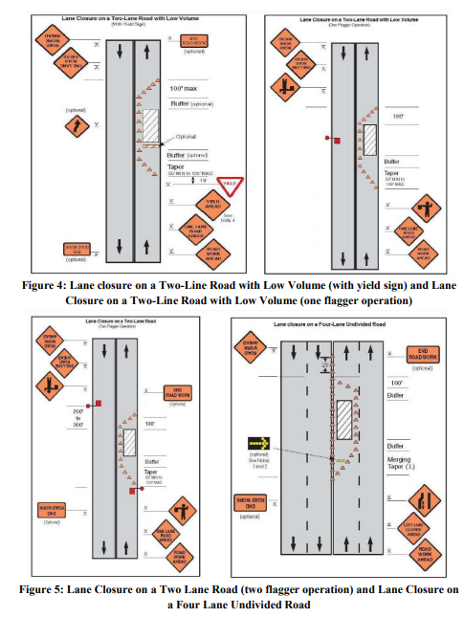

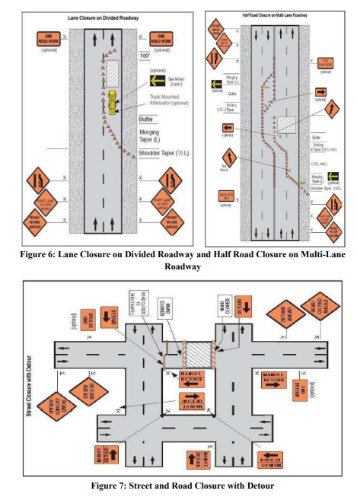
3. Analyze the Impact Due to Street and Road Closure
Apart from the capacity analysis, final decisions to temporary close a particular street and road and divert the traffic should involve the following steps:
- Approval from the Traffic Police to use the local streets and roads as detours;
- Consultation with businesses, community members, residents, road users and traffic police regarding the mitigation measures necessary at the detours where the road is diverted during the construction;
- determining of the maximum number of days allowed for road closure, and incorporation of such provisions into the contract documents;
- determining if additional traffic control or temporary improvements are needed along the detour route;
- considering how access will be provided to the worksite;
- Contacting emergency service, school officials, and transit authorities to determine if there are impacts to their operations; and
- Publish a notice through print and electronic media about road closure to avoid hindrance to public. As part of this notice, the public should be advised of alternate routes that commuters can take or will have to take as result of the traffic diversion.
If full road-closure of certain routes within the proposed project area is not feasible due to inadequate capacity of the Detour Street or public opposition, the full closure can be restricted to weekends with the construction commencing on Saturday night and ending on Monday morning prior to the morning peak period.
4. Public Awareness and Notifications
As per discussions in the previous sections, there will be travel delays during the construction, as is the case with most construction projects, although on a reduced scale if utilities and traffic management are properly coordinated. There are additional grounds for travel delays in the area, as most of the streets and roads in the proposed project sites lack sufficient capacity to accommodate additional traffic from diverted traffic, as a result of street and road closure to accommodate the construction activities.
The awareness campaign and the prior notification for the public will be a continuous activity which the project will carry out to compensate for the above delays and minimize public claims as result of these problems. These activities will take place sufficiently in advance of the time, when the roadblocks or traffic diversions take place at the particular streets and roads. The reason for this is to allow sufficient time for the public and residents to understand the changes to their travel plans. The project will notify the public about the roadblocks and traffic diversion through public notices, ward level meetings, and city level meeting with the elected representatives.
The Project Management Unit (PMU) comprising staff members of WASA, Supervision Consultant and Contractor will also conduct an awareness campaign to educate the public about the following issues:
- Traffic control devices in place at the construction sites (signs, traffic cones, and barriers);
- Defensive driving behavior along the construction sites; and
- Reduced speeds enforced at the construction sites and traffic diversions
It may be necessary to conduct the awareness programs and campaigns on road safety during construction.
The campaign will cater to all types of target groups i.e. children, adults, disabled and drivers.
Therefore, these campaigns will be conducted in schools and community centers. In addition, the project will publish a brochure for public information. These brochures will be widely circulated around the proposed project area and will also be available at the PIU, and the Contractor's site office. The text of the brochure should be concise to be effective, with a lot of graphics. It will serve the following purpose:
- Explain why the brochure was prepared, along with a brief description of the proposed project;
- Advise the public to expect the unexpected delays or roadblocks;
- Educate the public about the various traffic control devices and safety measures adopted at the construction sites;
- Educate the public about the safe road user behavior to emulate at the construction sites;
- Inform the public how to stay informed or where to inquire about road safety issues at the construction sites (name, telephone and mobile number of the contact person); and
- Indicate the office hours of authorized representatives.
5. Install Traffic Control Devices at the Construction Sites and Traffic Diversion Routes
The purpose of installing traffic control devices at the construction sites is to delineate these areas to warn, inform, and direct the road users about a hazard ahead, and to protect them as well as the workers. As proper delineation is a key to achieve the above objective, it is important to install good traffic signs at the construction sites. The following traffic control devices are used in construction sites:
- Signs;
- Pavement Markings;
- Channelizing Devices;
- Arrow Panels; and
- Warning Lights.
Procedures for installing traffic control devices at any construction sites vary, depending on road configuration, location of the work, construction activity, duration, traffic speed and volume, and pedestrian traffic. Work will take place along major roads, and the minor internal roads. As such, the traffic volume and road geometry vary. The main roads carry considerable traffic; internal the roads are narrow but carry traffic. However, regardless of where the construction takes place, all the construction sites should be cordoned off, and traffic shifted away at least with traffic cones, barricades, and temporary signs (temporary “STOP” and “GO”).
Figures 2 to 7 illustrates a typical set-up for installing traffic control devices at the construction sites of the area, depending on the location of work on the road way, and road geometrics:
- Work on shoulder or parking lane;
- Shoulder or parking lane closed on divided road;
- Work in travel lane;
- Lane closure on road with low volume;
- Lane closure on a two-line road with low volume (with yield sign);
- Lane closure on a two-line road with low volume (one flagger operation);
- Lane closure on a two lane road (two flagger operation);
- Lane closure on a four lane undivided road;
- Lane closure on divided roadway;
- Half road closure on multi-lane roadway; and
- Street closure with detour.
The construction sites should take into consideration, for the space required for a buffer zone between the workers and the traffic (lateral and longitudinal), and the transition space required for delineation, as applicable. For the construction works, a 30 centimeter clearance between the traffic and the temporary STOP and GO signs should be provided. In addition, at least 60 centimeter is necessary to install the temporary traffic signs and cones.
Traffic police should regulate traffic away from the construction sites and enforce the traffic diversion outcome from full street closure in certain areas during construction. Flaggers and personnel should be equipped with reflective jackets at all times and have traffic control batons (preferably the LED type) for regulating the traffic during night time.
In addition to the delineation devices, all the construction workers should wear fluorescent safety, vests and helmets in order to be visible to the motorists at all times. There should be provision for lighting beacons and illumination for night constructions.

Annexure-IX Framework Resource Management Plan

1. INTRODUCTION
The most of the resources in this world are finite and non-renewable in nature. We are completely dependent on these resources to fulfill all our daily requirements. Therefore, sustainable development calls for the need to conserve resources in a way that meet our needs of present generation as well as future generation, especially the non-renewable resources.
2. OBJECTIVE OF THE PLAN
The Resource Conservation Plan is intended to make an effort towards achieving sustainable development. The objective of the resource conservation plan is to:
- Minimize the use of natural resources; and
- Mitigate and prevent pollution contaminating the natural resources.
3. PLANNING
Careful estimations of quantities of material, fuel, water and energy required directly or indirectly shall be done to avoid excessive or unnecessary wastage of these materials. In addition to this, pollution prevention strategies shall also be devised to prevent contamination of resources.
The estimations include the following:
- Estimation of construction material required for the project;
- Estimation of fuel consumption for construction machinery, construction vehicles and generators;
- Estimations of the energy requirements during all the stages of the project; and
- Estimations of water consumption for construction activities and construction camp sites.
- Strategies shall be planned to reduce loads on the identified resources to be consumed;
- Best management practices shall be devised to control or reduce pollution resulting from the activities during different stages of the project; and
- An inspector shall be assigned responsibility to oversee the ongoing activities to check the compliance of the planned strategies.
4. EXECUTION OF THE PLAN
The planned strategies shall be implemented to conserve the natural resources including but not limited to the following:
Material
- Material supplied shall be in conformance with the estimated quantities and excess material shall be returned to the supplier;
- Material wastage shall be avoided by using best management practices;
- Waste produced during the project execution shall be disposed of safely to the designated disposal sites through approved contractors; and
- Reuse of the materials shall be appreciated.
Energy
- Reduce trips and optimize routes to and from the construction site for all kinds of activities;
- Regular maintenance of equipment and vehicles to avoid leaks and sustain efficient fuel consumption;
- Switch off idle equipment and vehicles to avoid wastage of fuel;
- Minimize warm up time, unnecessary acceleration and deceleration of the construction equipment and vehicles;
- Avoid unnecessary burning of fuel for cooking in construction camps;
- Avoid unnecessary use of heating and cooling systems during extreme weathers events;
- Construction shall start in early hours of the day to avoid heat in summers and utilization of day light; and
- Alternate energy sources shall be considered for electricity generations during construction and operation to conserve fossil fuel as it is non-renewable resource.
Water
- Avoid using potable water for sprinkling, curing and washing of equipment and vehicles.
- Surface water or treated effluent can be used instead;
- Wastage of water should be controlled through providing proper valves and through controlling pressure of the water;
- Unnecessary equipment washings should be avoided;
- Awareness amongst workers shall be raised to conserve water and immediately report for any leaks detected; and
- Ensure protection of canal water from contamination resulting from construction activities.
Pollution
- Emissions shall be reduced and controlled as far as possible and direct discharges to air shall be avoided by strictly adhering to the mitigation measures outlined in IEE report;
- Waste water shall not be discharged directly into the canal and must be managed as per the recommendations presented in IEE report; and
- Construction waste, and municipal solid waste shall not be dumped and burnt openly, and shall be handled according to the preventative measure given in IEE report.
5. CHECKING AND CORRECTIVE ACTIONS
The R-WASA shall bind the construction contractor through contract agreement to comply with the strategies outlined in the Resource Conservation Plan. The Environmental Committee shall also appoint an Inspector who shall monitor the daily onsite activities and shall report any issues and concerns raised in relation to Resource Conservation Plan. The inspector shall recommend adequate corrective actions to mitigate the issues raised.

Annexure-X Framework Occupational Safety and Health Management Plan

Framework for Occupational Health and Safety Management Plan
It is required that all personnel working on the project attend the Health and Safety site induction briefing prior to commencing any work on the site.
The General Site Rules shall act as the main agenda and content of the induction briefing. Additionally, any information specific to the project shall be included in the induction. The induction briefing should be, as far as possible, two-way communication with attendees invited to contribute, comment and ask questions regarding health and safety. Other rules are as follows:
- All attendees of the induction briefing will be recorded.
- High visibility jacket/vests, safety helmets and safety footwear (incorporating steel toe- caps and mid-sole) must be worn at all times.
- Safety goggles for protection during all cutting, grinding and drilling operations or where there is risk from impact, dust, chemicals or hot metal.
- Dust masks for protection from dust.
- Ear protection during all operations which produce noise above the level at which you need to raise your voice to be heard. Gloves during concreting work.
- On this site, formal permits must be in place before any of the following operations may be carried out: Permit to Excavate, Hot Work Permit & Confined Spaces Permit. (Where Applicable), thoroughly understand it and get permission from area supervisor (If required).
- Follow the messages and instructions displayed on HSE boards installed on site.
- Be aware of emergency muster (assembly) points and escape routes. In the event of an emergency do not panic, follow the site emergency response procedures.
- Report promptly all accidents to your supervisor and HSE officer at site. Immediately provide first aid for the injured and call for the medic.
- While working alone or in a confined space make sure that your nearby colleague and supervisor are well informed or use a banksman where appropriate.
- Ensure adequate lighting is in place for work on night shifts or for emergency response.
- All Scraps, waste materials and garbage must be disposed of in accordance with the construction waste management Strategy.
- Always clean your work site after completing the job or your shift.
- Maintain appropriate barricades as required.
- Never tamper with electric cables and appliances. Never insert direct cables into sockets, rather use proper plugs.
- Do not enter scaffold that is not tagged safe for access.
- Tools or materials must not be carried while climbing up or down scaffolding or ladders.
- Use pouches or ropes for this purpose.
- Do not smoke or produce naked flame in NO SMOKING area. Use of open fire is prohibited.
- Keep all gangways and aisles clear and clean at work sites.
- Vehicles must be driven at a safe speed, observing speed limits. Drivers must have a valid driving license for the class of vehicle they are operating.
- Vehicles shall only be parked in designated parking areas. Never travel in a vehicle unless in seating equipped with a seatbelt.
- Site HSE Roles and Responsibilities
1.1 Project Manager (PM)
- Develop and disseminate policies for occupational health and safety management systems and environmental management systems
- Provide resources for the management and implementation of occupational health and safety management systems and environmental management systems
- Responsible for ensuring the implementation of occupational health, safety and environmental policies
- Aware of the relevant maters of environment, health and safety.
- Allocate Budget and Provide resources for the implementation of HSE Plan in its true spirit.
- Attend meetings regarding the Health Safety and Environment.
- Report Health Safety and Environment matters to the management of the company as required.
1.2 Construction Manager (CM)
- Responsibilities include, but not limited to:
- Well conversant with international & local, Health, Safety & Environmental rules, regulations and current legislation.
- Ensure that all senior site staff is also conversant with the relevant requirements of current legislations and EPC contractor HSE plan.
- Ensure that site personnel are assigned appropriate duties and responsibilities accordingly to assist in the effective implementation of this HSE Plan.
- Ensure no job is carried on without supervision.
- Approve work methods statements; ensure safety procedures are established and undertaken.
- Funds for essential HSE facilities, equipment and personnel are made available.
- His own personal behavior supports, strengthens and confirms the site’s HSE management program.
1.3 Environmentalist/HSE Officer
- Carry out safety inspection of Work Area, Work Method, Men, Machine & Material and other tools and tackles.
- Facilitate inclusion of safety elements into Work Method Statement.
- Highlight the requirements of safety through Tool-box/other meetings.
- Conduct investigation of all incident/dangerous occurrences & recommend appropriate safety measures.
- Advice & co-ordinate for implementation of HSE plan in its true spirits.
- Convene HSE meeting & minute the proceeding for circulation & follow-up action.
- Plan procurement of PPE & Safety devices and inspect their healthiness.
- Report to Project Manager (PM) and Resident Director EPC contractor on all matters pertaining to status of safety and promotional program at site level.
- Facilitate administration of First Aid
- Facilitate screening of workmen and safety induction.
- Conduct fire and other emergency Drills and facilitate emergency preparedness
- Design campaigns, competitions & other special emphasis programs to promote safety in the workplace.
- Recommend to Site In charge, immediate discontinuance of work until rectification, of such situations warranting immediate action in view of imminent danger to life or property or environment.
- To decline acceptance of such PPE / safety equipment that do not conform to specified requirements.
- Encourage raising Near Miss Report on safety along with, improvement initiatives on safety.
- Ensuring that all injuries, accidents, incidents/near misses and hazards are positively and timely reported.
- Assisting Engineers/Area Supervisors in accident/incident investigations, where required Attending and positively contributing in the HSE Committee Meetings.
1.4 Workers
- Use the proper tools and equipment when operating. According to the requirement of operation and different hazard sources using the PPE and protective clothing provided by company, such as, helmets, safety harness, goggles, safety vest, and other personal protective equipment
- Maintain the tool and keep the tool clean after job completion.
- Report to the site supervisor or on-site project manager for the equipment damage and hidden danger.
- Develop personal safety awareness - including workers themselves and others, especially new employees and young people.
- Avoid unnecessary risk generation.
- For known sources of danger, remind new employees to stay away from these hazards.
- It will strictly be forbidden to play in the construction area or to damage the public utilities.
- Provide advice on how to eliminate hazards.
1.5 Sub-Contractor HSE Management
- Sub-contractor’s employees shall immediately correct all unsafe conditions & acts as directed by Contractor Direct supervision. Unsafe acts by any personnel may be grounds for immediate removal and permanent banning from the project site.
- Only properly trained employees shall be authorized by sub-contractor to operate equipment, machinery, vehicles & tools.
- All Sub-contractors are required to follow safe work practices, and meet the requirements clearly identified in field HSE PLAN.
- The Sub-contractor shall erect & maintain safeguards for the protection of workers, any other sub-contractors & the public and eliminate or mitigate HSE hazards created by or otherwise resulting from performance of the work.
2 Communication and HSE Meetings
2.1 HSE Targets and Goals
Pursuant to the Policy Statement, the following HSE Targets and Goals are identified in order to create a positive approach to health, safety, and protection of the environment during all activities of the project; this will be achieved by employing competent and motivated staff:
- To avoid all personal injuries during the execution of the Project,
- To ensure that all personnel employed on the Project are competent to carry out their designated tasks safely.
- To create positive health, safety and environment attitudes and perceptions at all levels of the Project organization, and to raise health safety and environmental awareness in general.
- To implement a training program that supports the achievement of personnel competency in relation to Health, Safety, and the Environment.
- To complete the Project without incurring any significant property damage to permanent equipment, or temporary facilities.
- To complete the Project with minimum avoidable impact upon the surrounding environment.
- To implement a hierarchy of communication forums that ensure that HSE concerns can be raised and addressed at all levels of the organization. To continually monitor and improve HSE performance.
2.2 HSE Score Board
Environmentalist/HSE Officer will arrange a HSE score board and display at the key location of the project site facilities. Information on the HSE Score Board will be updated on daily basis.
2.3 HSE Awareness Sign Boards
HSE awareness signboards shall be displayed at key locations around the site to create and maintain awareness and ownership of HSE issues.
2.4 Internal Site HSE Committee Meeting
Internal HSE Committee Meetings chaired by the Site Manager/Construction Manager, will be held monthly with all Area Supervisors and nominated Engineers, Supervisors and support staff. HSE committee meetings will allow communication of HSE performance and corrective actions. All-important HSE matters of the site as well as the non-compliance reported in the current month will be discussed in these meetings.
1.3 Performance Monitoring
1.3.1 Performance Review in Site HSE Committee Meetings
Performance reviews shall be held on monthly basis in the Internal Site HSE Committee Meetings. The objective of the review is to gather information from monitoring, inspection and site working activities and to assess the effectiveness of the implementation of HSE procedures on site. The key performance indicators are:
a. Compliance with Health, Safety and Environment standards
b. Identification of areas not addressed in the HSE Plan
c. Achievement of specified HSE objectives
d. HSE statistics, root cause and trend analysis of the statistics
1.3.2 HSE Inspections of Equipment and Tools
a. The Site Manager will ensure that no Civil, Electrical or Mechanical equipment will go to the working area without HSE inspection.
b. Environmentalist/HSE Officer will co-ordinate with Equipment and Plant Department for the inspection of all Civil, Electrical and Mechanical equipment or the inspection of Civil, Electrical and mechanical equipment,
c. If during inspection, any equipment is found sub-standard, Manager Site HSE is authorized to reject this equipment and inform the Site Manager.

1.4 Incident / Accident Reporting and Investigation
1.4.1 Objective
The objective of incident reporting, investigation & analysis is to identify the cause(s) of an incident to allow for preparation of recommendations, to avoid recurrence of such incident(s) in future.
1.4.2 Incident Reporting and Investigation
Any work-related incident, accident, injury, illness, exposure, or property loss must be reported to your supervisor, the SS, and within 1 hour. Motor vehicle accidents must also be reported. A report must be filed for the following circumstances:

a) Accident, injury, illness, or exposure of an employee;
b) Injury of a subcontractor;
c) Damage, loss, or theft of property; and/or
d) Any motor vehicle accident regardless of fault, which involves a company vehicle, rental vehicle, or personal vehicle while the employee is acting in the course of employment.
e) HSE Officer shall brief the Management about the lost time injury/fatal cases and serious incidents/near-misses.
f) Project Manager and Construction Manager will review the incident report and comments on the recommendations of the Site HSE Staff. They will then assign corrective actions accordingly.
g) Occupational accidents resulting in employee injury or illness will be investigated by the SS. This investigation will focus on determining the cause of the accident and modifying future work activities to eliminate the hazard.
h) All employees have the obligation and right to report unsafe work conditions, previously unrecognized safety hazards, or safety violations of others. If you wish to make such a report, it may be made orally to your supervisor or other member or management, or you may submit your concern in writing, either signed or anonymously.
i) The Site HSE Staff shall carry out a follow up of the recommendations/corrective actions from time to time where he identifies ongoing non-compliance he shall inform the Project Manager Construction Manager.
1.5 Orientation, Site HSE Induction and Other Training Activities
1.5.1 Initial HSE Orientation Program
Each and every person will undergo a HSE orientation program. On completion of orientation he will be issued an Organizational Identity card. Contractor Site HSE Staff shall perform the initial orientation based on but not limited to the following:

- Explaining Organizational HSE Policy and Standards.
- General HSE rules and regulations for working in a Construction Site, Batching plant, Excavation Area, Mechanical and Electrical work including use of Personal Protective Equipment, incident reporting, getting first aid, emergency response, (HSE inspection, housekeeping, etc.
- Hazards at construction site, works, offices, or any miscellaneous work.
- Specific hazards like height, open excavations, electrical, fire, Fumes (including spray painting) and vehicle safety etc.
- Environmental hazard.
1.5.2 Daily Tool Box Talk by Supervisors/HSE Officer
HSE tool Box talk shall be conducted by Supervisor/HSE Officer for specific work groups prior to the start of work. The tool box is a forum for two- way communication between management and the employees. Tool box talk is focused on a specific job. The agenda shall consist of the following:
- Details of the jobs being intended for immediate execution.
- The relevant hazards and risks involved in executing the job and their control and mitigating measures.
- Specific site condition to be considered while executing the job like high temperature, humidity, unfavorable weather etc.
- Recent non-compliances observed.
- Appreciation of good work done by any person.
- Feedback from employees
- Any doubt clearing session at the end.
- Record of Tool box talk shall be maintained as per format attached.
- Incidents, which may occur in the site/works, shall also be discussed in “tool box talks”.
- Daily tool box talk record format is attached as Annex. “A”.
1.5.3 HSE Training During Project Execution
HSE training shall be arranged by contractor as per the need of the project execution and recommendation of HSE committee of site.
1.5.3.1 Site-Specific Training
Prior to working at this site, an initial site-specific training session or briefing shall be conducted prior to commencement of work activities. During this initial training session, employees shall be instructed on the following topics:
- Personnel responsibilities;
- Content and implementation of the HASP;
- Description of assigned tasks/scope of work;
- Site hazards and controls;
- Site-specific hazardous procedures (e.g., lining activities, etc.);
- Coordination of Site activities;
- Training requirements;
- PPE requirements;
- Emergency information, including local emergency response team phone numbers,
- route to nearest hospital, accident reporting procedures, evacuation routes and procedures, location of assembly points, and emergency response procedures;
- Instruction in the completion of required inspections and forms; and
- Location of safety equipment (e.g., portable eyewash, first aid kit, fire extinguishers, etc.).
- The various components of the project HASP will be presented followed by an opportunity to ask questions to ensure that each attendee understands the HASP. Personnel will not be permitted to enter or work in potentially contaminated areas of the Site until they have completed the Site-specific training session.
1.5.3.2 Safety Meeting/Health and Safety Plan Review
"Tailgate" safety meetings will take place each day prior to beginning the day's work. All Site personnel will attend these safety meetings, which may be contracted personnel, subcontractor personnel, or personnel from contractors. The safety meetings will cover specific health and safety issues, Site activities, changes in Site conditions, and a review of topics covered in the Site-specific pre-entry briefing.
1.5.3.3 Management Employees Training Program
- The management employees training program will be conducted during the project to ensure that all management employees are trained.
- An HSE specialist from contractor head office shall conduct the meetings, during his visit to site.
- The duration of this course would be half day.

Annexure Sub-A
HSE TOOL BOX TALK RECORD |  |  | Quality Records Forms
 |  |  |  |  | Doc. Version 1
Project Title: Augmentation of Water Supply to Rawalpindi City Based upon Chahan Dam
Project Section:

Topic: Date
SR.  NO. | NAME OF WORKER  / STAFF | CRAFT | AREA | CONTRACTOR |  | REMARKS
Delivered By SITE HSE OFFICER

Annexure-XI Framework Emergency Response Management Plan

Emergency Response Plan
Contractors are committed and obliged to protecting the community, workers, public and concerned company’s property and the surrounding environment; in the emergency situations. These situations shall be handled through the implementation of an Emergency Preparedness and Response Plan (EPRP). The construction contractors shall meet with the local emergency service institutions and law enforcement agencies i.e. Fire and rescue 1122, Police, to review and discuss the construction process, including unique construction equipment(s), the overall construction process, and schedule/phasing. This plan will be communicated to all the concerned and personnel who will be responsible for managing the emergency situations, and those who will be effected by the emergencies.
1. Purpose
The purpose of the emergency response plan is to identify the actual and potential hazards and their risks, organize responsibilities, identify the resources and plan to utilize them in order to control and minimize impacts of risks in an efficient way. This plan is applicable to all construction processes and sites, machinery/ equipment and materials. It includes preparation to respond in the event of fires, incidents/ accidents involving personnel injuries, property damages etc., hazardous materials emissions, explosions, and natural disasters i.e. flood, earthquake etc. This plan also includes preparation to respond in the event of riots, arsons, terrorist attacks etc.
1.2 Objectives
The objectives of this plan are;
- To develop, maintain, implement, check and improve procedures and practices which will ensure efficient utilization of available resources; in order to protect workers and staff from impacts of hazard’s risks.
- To minimize impacts of emergencies and unplanned happenings.
- The plan includes preparedness and response mechanisms.
1.3 Scope
The emergency management program is applied to all Project elements and intended for use throughout the Project life cycle. The following are some emergencies that may require coordinated response.
- Construction Accident
- Road & Traffic Accident
- Hazardous material spills
- Structure collapse or failure
- Trauma or serious illness
- Sabotage
- Fire
- Environmental Pollution
- Loss of person
- Community Accident
1.4 Types of Emergencies
Following is a list of the hazards and emergency situations, which need planning and proper handling to minimize their risks.
- Fire
- Road Traffic Accidents,
- Materials/ effluents spills i.e. asphalt, POL, etc.
- Natural disasters i.e. torrential rains, floods, earthquakes
- Occupational accidents i.e. fall, electrocutions, cave-ins
- Arsons, vandals
- Terrorist attacks, etc.
1.5 Responsibilities
1.5.1 Alerting
The following procedures will be prescribed for internal reporting of emergencies:
- The Emergency Response Coordinator (ERC) will awaken on-site personnel, including visitors, of the nature of the emergency.
- The ERC will activate and deploy the concerned ERTs, and notify and inform the project person in-charge, emergency medical assistance/ Rescue 1122, fire department, Police etc., whoever and whenever needed.
- Concerned Project Manager (PM) or whosoever is in-charge of the project shall only be authorized to speak on contractors’ behalf to outside agencies (police, fire department, medical services, Media etc.) during an emergency situation.
- The ERC will identify any need for security measures at the Project Area during any emergency and will notify the concerned project or security person in-charge.
- When any person identifies an emergency situation, or the potential for an emergency situation, and reports it to the ERC, the ERC will then activate the Emergency Response Team.
- The supervision consultant shall be notified in writing within 24 hours of any emergency situation.
1.5.1 On Site Person In-charge
The Contractor’s on-site in-charge shall be responsible for handling emergency situations for concerned site. He will act as Emergency Response Coordinator (ERC) and shall be responsible for ensuring that all subcontractors, staff, on-site visitors and others adhere to the appropriate emergency response procedures as stated in this Plan.
1.5.2 Emergency Response Team (ERT)
Emergency Response Team shall be for matted at all camps, each team comprised of 3 or 5 members including and lead by the ER Coordinator or the concerned person in- charge. All the members of the ER Team shall be trained in basic First Aid, search & rescue and firefighting; that will further provide search& rescue, first aid and arrange transportation in case of accidents and emergencies, and extinguish fires, guide workers and staff to assembly points and other safe places. The ERT shall assist the ER Coordinator in accidents investigation. The contact details of the ERTs shall be posted at prominent places so that all workers are aware of them.
Project Manager | Person Incharge (ERT)
Environmentalist/HSE Manager | HSE Coordinator (ERT)
Admin / Labour Team Lead | ERT Team Member

1.5.3 Safety Training
On-site induction, Tool Box Talks (TBT), trainings shall be organized by the Emergency Response Coordinator/ HSE Officer/ Engineer regarding the health & Safety measures from potential and existing hazards, environmental protection, etc. New workers and staff shall be orientated regarding their work and the potential hazards, and safety from them. All trainings shall be recorded and communicated to the Supervision Consultant.
1.5.4 Site Inspections
The concerned HSE Officer/Engineer shall visit and inspect all the worksites, plants, machines, workshops, laboratories, working platforms, safety equipment etc., on regular basis, record and notify findings to the concerned Project Manager/ person in- charge. In- case of any observations i.e. unsafe equipment, un-safe acts, violations, absence of safety equipment, etc. required control and mitigation measures must be communicated to the concerned person Incharge and workers/staff must implement those measures immediately.
1.5.5 First Aid Post / Box
First aid post shall be established at all camps & plants or first aid box provided as per the requirement. The concerned ERTs shall be trained in basic first aid. The first aid post/ or the facilities where first aid box are kept shall be indicated prominently.
1.6 Emergency Response Procedures
1.6.1 Fire
Fire is a major cause of deaths, disabilities and deaths at house hold and work-places. Most of ten fires are caused by in appropriate and unsafe use of materials and equipment. All personnel at camp sand plants shall be trained in fire safety and use of fire Extinguishers. Fire extinguishers, no Smoking sings etc. shall be installed at all camps, offices, plants, stores, fueling stations, workshops etc. In case of fire, areas with potential to be affected shall be evacuated immediately and gathered at the assembly point, or any other safe zone. The ERTs shall be activated. The fire if at initial stages shall be extinguished with keeping in view personnel safety of employees/ workers at priority. The emergency services i.e. fire brigade, rescue 1122 shall be called immediately. All the fire safety equipment and signs shall be regularly inspected and maintained. The reasons for accidents shall be recorded; mitigation or control measures designed and communicated to all employees. The situation must be recorded and reported to the Supervision Consultant within 24 hours of the incident.
1.6.2 Road Traffic Accidents (RTA)
All the drivers at site shall be made aware regarding safe driving practices at the active construction site, borrow areas, camps to avoid accidents. All the drivers shall be trained, motivated and enforced in use of seat belt, obeying speed limit and traffic signs i.e. diversion, speed limits, U-turns, etc. which shall be installed at all required locations. In case of any RTA the concerned ERTs shall be activated; first aid shall be provided to injured person (God Forbid) if any on the spot, transported to the nearest emergency medical facility or the first aid post at the nearest concerned camp. The concerned ER Coordinator or the person in-charge shall be informed immediately. The reasons for accidents shall be investigated, recorded; mitigation or control measures designed and communicated to all employees through a series of trainings, orientations. The situation must be recorded and reported to the Assistant to Employer Representative (AER).
1.6.3 Materials / Effluents Spills
Spillage of liquids hazardous to workers’ health, wild life and property shall be avoided.
Concerned workers shall be trained in proper and safe handling of such materials. PPEs shall be provided and their unseen forced on the concerned workers. In case of liquids and effluents spills the spills must be controlled through spill control kit, collected and properly disposed which does not affect human or wild life. Spillage of significant amount shall be recorded and reported. Concerned workers shall be orientated on the findings of the reasons for spillage and control measures.
1.6.4 Natural Disasters
Since the project area in view of the past weather record is not subject and vulnerable to torrential rains, floods, earthquake; however, the camps shall be established at safe places, and in case of torrential rains, floods workers shall be alerted and mobilized to safe places prior to the impact. In case of earthquake all personnel shall evacuate settlements and gather at the assembly point or any other safe place. The ERTs shall be activated. In case of personnel injuries, first aid shall be provided on the spot and causality(s) transported to the nearest emergency medical facility/ hospital. In case of property damage, its causes shall be recorded and reported to the SC.
1.6.5 Occupational Accidents
All the workers and staff at active construction sites, camps, plants, and workshops shall be trained and orientated on occupational health and safety measures. Tool Box Talks (TBT) shall be organized by the concerned HSE Head/Manager, or site in-charge prior to any new activity or activity potentially hazardous. All such activities shall be recorded and reported accordingly. PPEs shall be provided to all workers and they shall be trained in their proper use and maintenance. All measures needed for the health and safety of workers and staff shall be put in place to a safe and healthy working environment. In case of falls from heights, electrocutions, cave-ins, etc., casualty(s); the ERTs shall be activated; they shall provide first aid and transport causality(s) to the nearest emergency medical facility or the concerned nearest camp/ first aid post. Transportation arrangements must be made immediately and the concerned ER Coordinator or person in-charge must be informed immediately. The happening must be recorded and reported to the Assistant to Employer Representative (AER). The incident must be investigated, findings recorded, control measures devised; and communicated to all concerned, in order to avoid such happenings in future. Daily Tool Box Talk Format and Incident Investigation Format are also formatted for the project.
1.6.6 Arsons / Vandals
All the social disputes among the contractor and workers, subcontractors, and community shall be settled peacefully, with mutual consensus; however, in case of unpleasant situations safety of the workers and staff shall be the priority, and the nearest police station shall be informed to protect employees. Social framework agreements may be signed to sort out the community matters if any.
1.6.7 Terrorist Attacks
Contractor’s own security system will be launched to provide the Security to staff workers and labors and visitors and also security for foreigners, who shall escort them at all construction sites, plants and camps or wherever they move. No foreigners shall be allowed to move outside work areas without Police escort. For security, the contractors have also arranged private security to protect worksites, stores and camps at day and night and prevent, unauthorized trespassing. In case of any terrorist attack (God forbid), safety of the workers and staff shall be the prime priority; however, they shall be trained to protect themselves and seek and move to safe places, moreover the nearest Police/ Elite Force station shall be notified immediately for additional security and further safety.
1.6.8 Emergency Contact Number
Emergency Response personnel/Team will be available during the whole Project and will be utilized to assist during emergency situations or provide first aid as needed.
Project Manager | Person Incharge (ERT)
Environmentalist/ HSE Manager | HSE Coordinator (ERT)
Admin / Labour Team Lead | ERT Team Member
In case of any emergency, Safety Manager or designated person will be authorized to Contact the external public safety agencies/emergency services. Following are the contacts of emergency services.
Fire | 16
Police | 15
Edhi Rescuer | 115
1.7 Fire Prevention and Fire Fighting
1.7.1 Purpose
The purpose of this procedure is to highlight the fire hazards, precautions and suppression facilities required for the Projects. The responsibilities of various staff for this purpose are stated in the table below:

Sr. No. | Staff | Responsibilities
1 | Construction Manager | Ensures that procedure is understood and being applied appropriately.
2 | Site Health, Safety and Environment Staff | Responsible for the improvement of this procedure and monitoring compliance and introducing whatever training is required for fire teams, fire wardens and personnel.
3 | HSE Supervisors | Office and Camp “FIRE ACTION” notices are displayed at strategic locations, and that sufficient “Emergency Assembly Points” are set up, and regular practice evacuation drills are performed.  A number of office/ camp staff are being assigned with the responsibility to act as fire wardens  Office/camp staff (in particular new starts) has been briefed and keeps updated on fire and emergency response procedures.  Awareness to control flammable materials being used on the premises.  Daily checks of the office to ensure that walkways are not blocked, carpet and other fittings are properly secured, fire doors kept closed and that the means of escape are available.  Kitchen areas are being monitored to ensure that electrical fittings have been turned off after use and do not present a fire hazard.  Training for the use of fire extinguishers has been to staff/workers and signs have been displayed on various locations indicating the emergency procedures.  ‘No Smoking’ policy applies in the Meetings/conference rooms.  Common social areas, mess halls and toilets, within the camp, are checked before closure of possible ignition sources following each meal time and at end of evening.
4 | E & M (Electrical and Mechanical) Manager | E & M Manager shall ensure that the following control measures are in place:  - Workshops are maintained in a neat and tidy manner and that waste oil, rags and other flammable materials are removed at the end of each shift or as necessary.  - Maintenance crews are properly trained for the use of fire extinguishers, raising the alarm and fire hazards on the work place.  - Battery recharging will be conducted in well ventilated separate areas, with no smoking signs and fire extinguishers in place  - Areas around pedestal grinders and other hot work type activities are kept free of combustibles.  - Welding and burning shall be screened and controlled to prevent fire risk and exposure to personnel  - That flammable liquid such as gasoline, diesel etc. are not used for cleaning purposes and their container is marked as per the containment.  - Provision of adequate storage areas that are located in places where exits, passage ways and stairways are not adversely affected  - Flammable liquids are stored safely, in a neat and tidy manner with adequate HSE signs provided

1.7.2 Cutting and Welding
Particular care will be taken while carrying out hot work operations on the locations where combustibles are available. This will include precautions such as; inspection of the surrounding area, removal of any combustible materials, protection by fire blankets and provision of fire extinguishers.
Compressed gas cylinders shall be closed when not in use, and shall be stored, properly secured and used in an upright position at all times. Protective end caps will be fitted when being moved or transported (unless by cylinder trolleys).
Compressed gas cylinders shall be kept clear of electrical equipment and cabling where they are part of an electrical circuit
1.8 Hazard Analysis and Risk Management
Hazard Analysis and Risk management techniques shall be adopted so that potential hazards are identified and evaluated prior to execution, thereby enabling either substitution or adoption of control techniques.
1.8.1 Purpose
To ensure that all steps are taken to control hazards identified in a job and provide a safe working environment.
1.8.2 Typical Hazards
Following are examples of typical hazards that can be encountered:
- Falling objects
- Welding
- Gas cutting
- Grinding
- Erection of steel work
- Installation of pipeline etc.
- Transportation / Lifting of heavy equipment
- Excavation Work
1.8.3 Control Hazard
The hierarchy of Risk/Hazard Control is used to determine risk reduction measure in order of their effectiveness, as follows:
- Elimination or substitution of the task / job step or substance.
- Engineering Control Including guarding and mechanical aids such as scaffolding, extraction ventilation and alike.
- Administrative Controls Including permits, training, signage, reduction in time or personnel exposure personal Protective Equipment
1.9 Personal Protective Equipment
1.9.1 Purpose
This procedure has been developed to ensure that all site personnel on the project are provided with, and wear or hold, appropriate Personal Protective Equipment (PPE) to protect them against work related hazards which may endanger their health, safety and environment.
1.9.2 Scope
This procedure applies to all contractor personnel employed including all of Sub- contractor’s deployed at the project.
1.9.3 Definitions
Personal Protective Equipment is defined as equipment designed to be worn or held by personnel to protect themselves against work related hazards which may endanger their health and safety.
1.9.4 Instructions
The risks posed in any particular work activity shall be assessed, and adequate PPE selected in accordance with the following criteria:
- Gives protection against risk(s) without itself leading to any increased risk is suitable for the personnel involved in the work including correct fitting. Is compatible with the work activity.
1.9.5 Basic Personal Protective Equipment (PPE)
Basic and minimum PPE requirements for the safe execution of proposed project are as:
- Safety helmet of plastic construction, manufactured in accordance with standard.
- Safety footwear with steel toe protection manufactured in accordance with standard.
- The construction and sole materials shall be chosen in accordance with the activity and adequate for the place of work.
- In addition to above, EPC contractor shall also supply coveralls to employees working in workshops.
1.9.5.1 Eye and Face Protection
Suitable protective goggles, face shield or screens shall be worn by personnel involved in, assisting with or adjacent to any activity where there may be a danger of projected debris, dust, sparks or other particles; corrosive fluids or mists; excessive heat, light or other harmful radiation.
1.9.5.2 Respiratory Protection
Respiratory Protective Equipment shall be available to all persons who are exposed to any situation in which there is a possibility of the atmosphere being or becoming deficient in oxygen or containing any harmful substance, whether particle, dust mist, vapors or gas.
1.9.5.3 Hearing Protection
Hearing protection shall be made available to all workers exposed to noise levels of 85 dB (A) or above. The selection of type of protection shall be in accordance with the type of noise hazard and the work being performed. In all work environments where the noise level is at or above 85 dB (A), prominent signs in English and in local language shall be displayed indicating the need for ear protection. A visual sign in the form of a line drawing of ear muffs shall also be displayed.
1.9.5.4 Hand and Arm Protection
Adequate hand and arm protection shall be available for all manual labour. The type of protection worn shall be selected according to the hazard to be protected against. These include but not limited to:
- Impacts, cuts, abrasions and infections.
- Extreme temperatures.
- Chemical, toxic, corrosive and other hazardous substances.
WORK ACTIVITIES | SUITABLE PPE
Excavators, breakers, Chippers, drillers. | Protective goggles, hand gloves, Safety helmets and Safety shoes.
Mixing cement, concrete,  Lime mortar, asphalt material, refractory material. | Safety goggles, gloves and protective foot wears.
Electricians | Insulated tools, Rubber hand gloves and electrical resistant shoes, mat.
Grinders | Protective goggles and leather hand gloves
Gas cutters, welder’s helper | Colored goggles, leather hand gloves.
Welders | Welding screen, safety shoes with rubber sole, Leather hand gloves.
Workers engaged in | Dust mask, hand gloves
High noise level area i.e.  D.G operator working, near piling work, compressor operator etc. | Ear plug / ear muff
Working in dusty | Dust mask, Safety goggles.

1.9.5.5 Harnesses
Harnesses shall be provided, worn and properly secured in all work situations, when other safeguards such as nets, planking, or scaffolding cannot be used. Such situations include, but are not limited to:
- Working on scaffolding.
- Work on any high structure, whether in construction or batching plant site.
1.9.5.6 Transportation
Only vehicles necessary to the construction operation shall be permitted on site.
- It shall be ensured that only authorized and competent personnel are allowed to drive vehicles.
- Loads shall be within the safe weight limit for the vehicle and shall not project beyond the vehicle body in such a manner as to present a hazard to other vehicles, pedestrians or adjacent structures.
- Passengers shall not be carried unless a proper seat is provided.
- Personnel shall not get on or off any vehicle whilst it is in motion.
- All vehicles shall be parked on level ground with the hand brake applied.
- Keys shall be left in the ignition unless at an authorized car park.
- Vehicles shall not block access or emergency points.
- All drivers of vehicles shall be in possession of a valid license for the class of vehicle.
- All drivers shall go through an orientation before entering the site.
- Vehicle Inspection is attached as Annex “A”.
1.9.5.7 Speed Limits
During the project laid down speed limits for the vehicles will be strictly observed.
1.9.5.8 Drivers’ Responsibilities
Drivers’ responsibilities include:
- Take responsibility for the vehicle, the load and passengers being carried.
- Checking of the vehicle prior to the start of the journey.
- Ensuring that all personnel in the vehicle are wearing seat belts.
- Shall not pick up unauthorized persons.

Sub-Annex-B

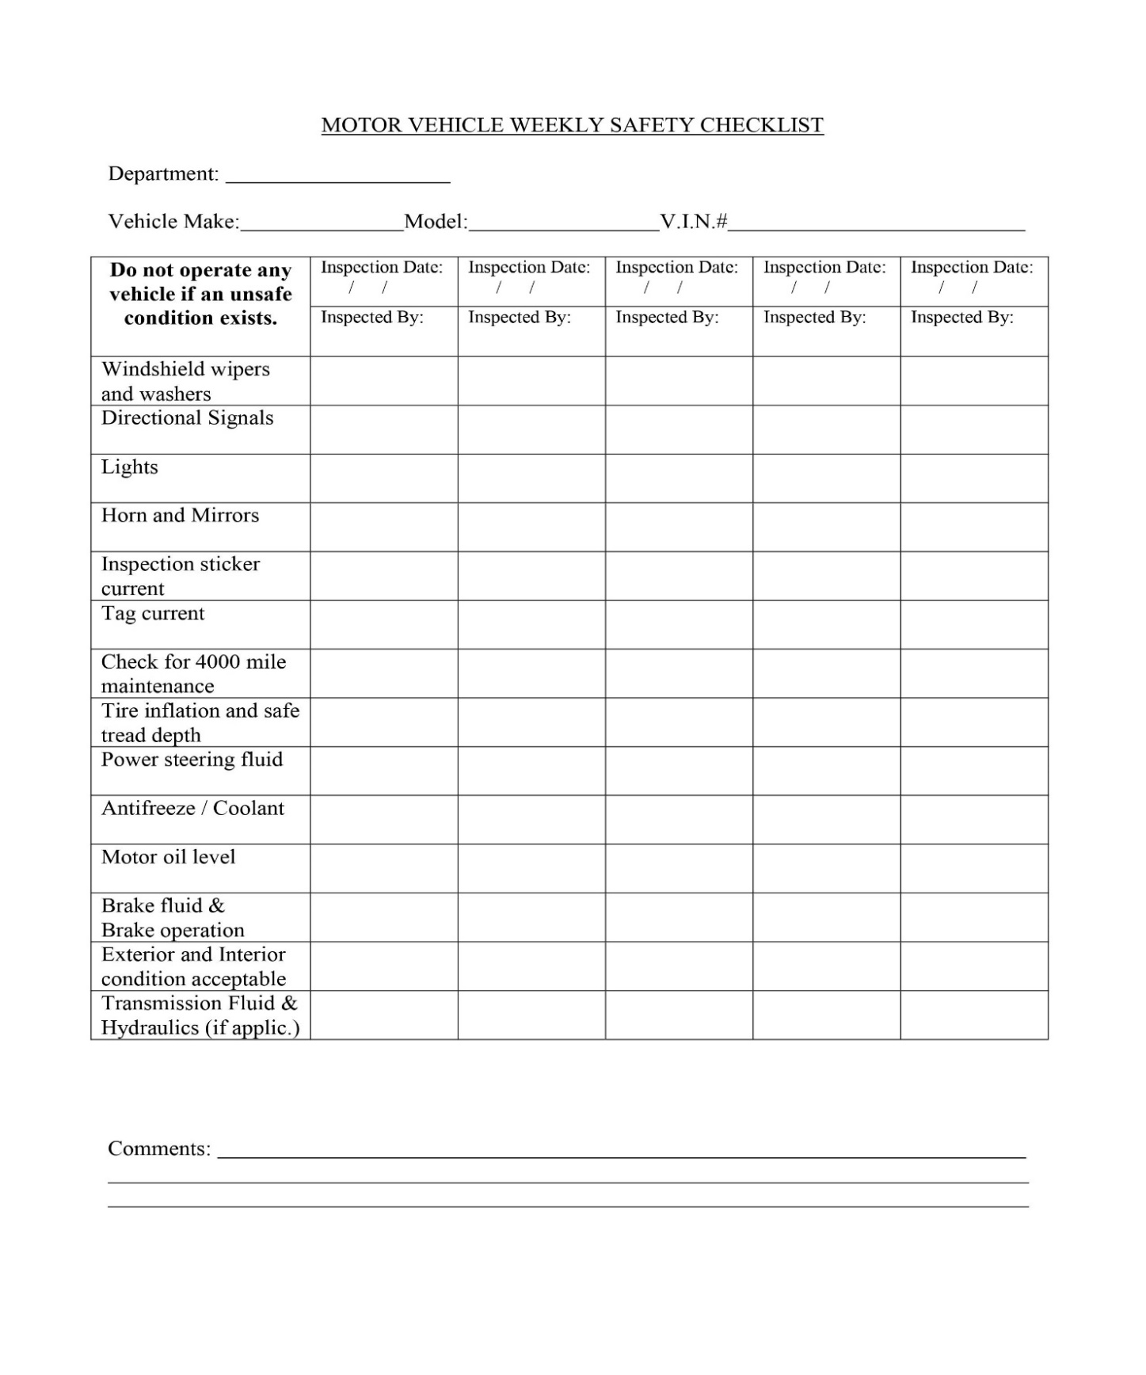

Sub-Annex-C Template for Accident Reporting Form
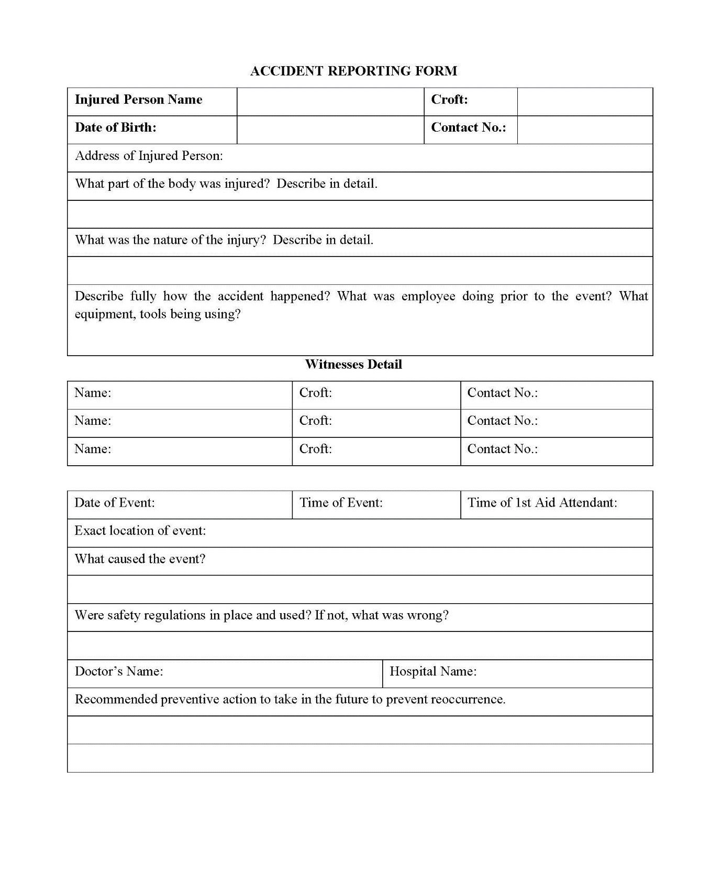

Annexure-XII Template for Site Specific EMP

GUIDE FOR DEVELOPMENT OF SSEMP
- Step 1: Define Boundaries
- Step 2: Identify Sensitive Receptors
- Step 3: Specify construction activities
- Step 4: Conduct Risk Assessment
- Step 5: Assign Environment Management measures
- Step 6: Prepare Site Plans
- Step 7: Prepare Environment Work Plans (if required)
- Step 8: Monitoring
Step 1: The project area needs to be clearly defined.
Step 2: The mapping of sensitive receptors has already been conducted and needs to be presented clearly in a map.
Step 3: The tentative construction activities to be conducted are as follows:
- Site Surveying and Vegetation (Trees and plants) Clearance
- Establishment of Work Camp and access roads
- Dismantling of existing structures including Utilities
- Preparation of ground for Landscaping
Step 4: The Risk Assessment matrix template is provided in the table below.
Risk is assessed as the likelihood that the activity will have an effect on the environment as well as the consequence of the effect occurring. It is often described like this:

Risk = Likelihood × Consequence
Likelihood Scale
Likelihood | Definition | Scale
Certain | Will certainly occur during the activity at a frequency greater than every week if preventative measures are not applied | 5
Likely | Will occur more than once or twice during the activity but less than weekly if preventative measures are not applied | 3
Unlikely | May occur once or twice during the activity if preventative measures are not applied | 2
Rare | Unlikely to occur during the project | 1

Consequence Scale
Consequence | Definition | Score
Catastrophic | The action will cause unprecedented damage or impacts on the environment or surrounding community e.g. extreme loss of soil and water resources and quality from storm water runoff extreme pollution of soil and water resources including major contamination from hazardous materials widespread effects on ecosystems with deaths of fauna/flora widespread community impacts resulting in illness, injury or inconvenience loss or destruction of archaeological or historical sites Occurrence will almost certainly result in the work being halted and a significant fine. | 5
Major | The action will cause major adverse damage on the environment or surrounding communities’ e.g. major loss of soil and water resources and quality from storm water runoff major pollution of soil and water resources including contamination from hazardous materials significant effects on ecosystems with isolated deaths of non-vulnerable flora and fauna significant annoyance or nuisance to communities major damage to or movement required to archaeological or historical sites occurrence may result in work being halted and a fine | 3
Moderate | No or minimal adverse environmental or social impacts e.g. No measurable or noticeable changes in storm water quality. Water quality remains within tolerable limits little noticeable effect on ecosystems no or isolated community complaints no or unlikely damage to archaeological or historical sites no likelihood of being fined | 2
Minor | No or minimal adverse environmental or social impacts e.g.  No measurable or noticeable changes in storm water quality. Water quality remains within tolerable limits  little noticeable effect on ecosystems  no or isolated community complaints  no or unlikely damage to archaeological or historical sites  no likelihood of being fined | 1

Risk Score Table
Likelihood | Consequence
 |  | Catastrophic | Major | Moderate | Minor
 | Certain | 25 | 15 | 10 | 5
 | Likely | 15 | 9 | 6 | 3
 | Unlikely | 10 | 6 | 4 | 2
 | Rare | 5 | 3 | 2 | 1

Risk: Significant: 15-25
Medium: 6-10
Low 1-5
Any Medium to Significant risk requires an environmental management measure to manage the potential environmental risk. Judgment will be required concerning the application of an environmental management measure to mitigate low risk situations.
The higher the risk the more intensive the required mitigation measure will need to be; e.g. where site sedimentation is deemed to be low risk, then silt fences may be needed but as the risk increases, then sediment traps may be required. The selection of the appropriate mitigation measure will require judgment based on the level of risk and the specific site parameters.
Step 5: The Environmental Management measures are to be extracted from the IEE study for the project and should be added in the last column of the table below.
No. | Construction Activity | Hazards to Consider | Likelihood that the site or sensitive receptors will be affected? | Consequence of the site or sensitive receptors being affected? | Risk Score  (consequence x likelihood) | Environmental Management Measures
i | Site Surveying & vegetation clearance | Damage to vegetation beyond project footprint |  |  |  | These can be taken from the EMP provided in the IEE report  (If Risk Score is 6 or more)
 |  | Erosion of exposed areas and sediment
 |  | Loss of topsoil
 |  | Dust generation
 |  | Noise
ii | Establishment of Work Camp, Batching plant etc. | Soil deposited onto roads from tires
 |  | Stockpile erosion
 |  | Noise & Vibration
 |  | Traffic congestion
 |  | Fuel spills
iii | Dismantling of and existing structures including Utilities | Noise and vibration
 |  | Dust generation
 |  | Community safety
 |  | Worker safety
 |  | Traffic Congestion
iv | Preparation of Sub-Base | Noise and vibration
 |  | Dust generation
 |  | Traffic Congestion
v | Camping | Noise and vibration
 |  | Dust generation
 |  | Traffic Congestion
 |  | Community safety
 |  | Labor safety (PPEs)
vi | Landscaping | Dust generation
 |  | Sediment runoff
 |  | Failure of vegetation to take root

Step 6: The Site plans are a critical part of the SSEMP and will need to be prepared, otherwise the UMDS will consider the document as incomplete.
The site plan will need to provide the following:
- Indication of North and scale
- Existing and planned supporting infrastructure (e.g. access roads, water supplies and electricity supplies)
- Location of planned work
- Contours
- Drainage systems
- Locations of sensitive receptors
Step 7 (if required): The completed SSEMP provides details of all the environmental management requirements for all stages of the construction process. For individual work teams who are responsible for only a small part of the overall construction works it can be confusing as to what is required for their particular work component. For example, the work team responsible for stripping soil for the construction areas are not going to be interested in the requirements for pouring concrete for footings and foundations. However, it is essential that the soil stripping team knows exactly what to clear and what to leave and where to put stockpiles of soil for later use.
In situations where different work activities are required at different times or at different locations, environmental work plans can be prepared. These are similar to the work method statements that are often produced for major construction projects.
Step 8: A detailed monitoring plan will be provided along with frequency and responsibilities to ensure all key environmental parameters are monitored to ensure compliance with both national and ADB requirements.
Template for SSEMP
- Introduction
- Project Overview
- Scope of SSEMP
- Objectives of SSEMP
- Map of Sensitive Receptors
- Construction Activities
- Activities
- Risk Assessment
- Risk Assessment Matrix & Mitigation Measures
- Site Plan(s)
- Environmental Monitoring Plan
- Instrumental Monitoring of Environmental Parameters by Contractor as per EMP
- In-house monitoring
- Third Party environmental monitoring
- Visual monitoring of Environmental Parameters by Contractor as per EMP
- Responsibilities
- Organizational Responsibilities and Communication
- Responsibility of EA
- Responsibility of Construction Supervision Consultant (CSC)
- Responsibility of Contractor
- Responsibility of EPA (Punjab and Federal)

Annexure-XIII Tool for Socio-economic Survey

SOCIO-ECONOMIC BASELINE SURVEY OF THE PROJECT AREA

Name of Project _ _________________

Name of Interviewer: _____________ Date: _______________

a) Settlement: ___________________ (b) Union Council: _______________________
c) Tehsil: _______________________ (d) District: _____________________________
_____________________________________________________________________________

1. Name of Respondent ________________________

2. What is your father’s name ________________________

3. What is your age

Age years 15 – 25 ________
25 – 35 ________
35 – 45 ________
Above 45 ________
4. Marital Status.

1. Married 2. Unmarried

5. What is your caste /ethnic group _____________________

6. What is your mother tongue? _____________________

7. What is your qualification?

1. Illeterate 2. Primary 3. Middle

4. Metric 5. Intermediate 6. Above Inter

8. What is your profession ____________________________

- Which of the following facilities are available in your house
1. Electricity 2. Water Supply
3. Gas 4. Telephone
5. Sewerage
- What are the sources of water for your domestic use
1. Public Water Supply 2. Hand Pumps
3. Channel 4. Any other
- In your opinion, should this Project be implemented here
1. Yes 2. No
If yes, then reasons If no, then reasons
________________________ ________________________
________________________ ________________________
________________________ ________________________
- In your opinion, what will be possible impacts of the construction of this project area project?
During Construction __________________________________________________
__________________________________________________
__________________________________________________
After Construction __________________________________________________
__________________________________________________
__________________________________________________
- What protective measures do you suggest to safeguard your interests
_________________________________________________
_________________________________________________
________________________________________________
- Is there any health institution in this locality

1. Yes 2. No

If yes, then what is that __________________________
__________________________
- Is there any educational institution in this locality
1. Yes 2. No
If yes, then what is that __________________________
__________________________
- Is there any historical /archeological monument in this locality
1. Yes 2. No
If yes, then what is that __________________________
__________________________
- Is there any shrine /mosque /graveyard in this locality
1. Yes 2. No
If yes, then what is that?
Shrine __________________________
Mosque __________________________
Graveyard __________________________

Annexure-XIV Attendance Sheets of FGDs

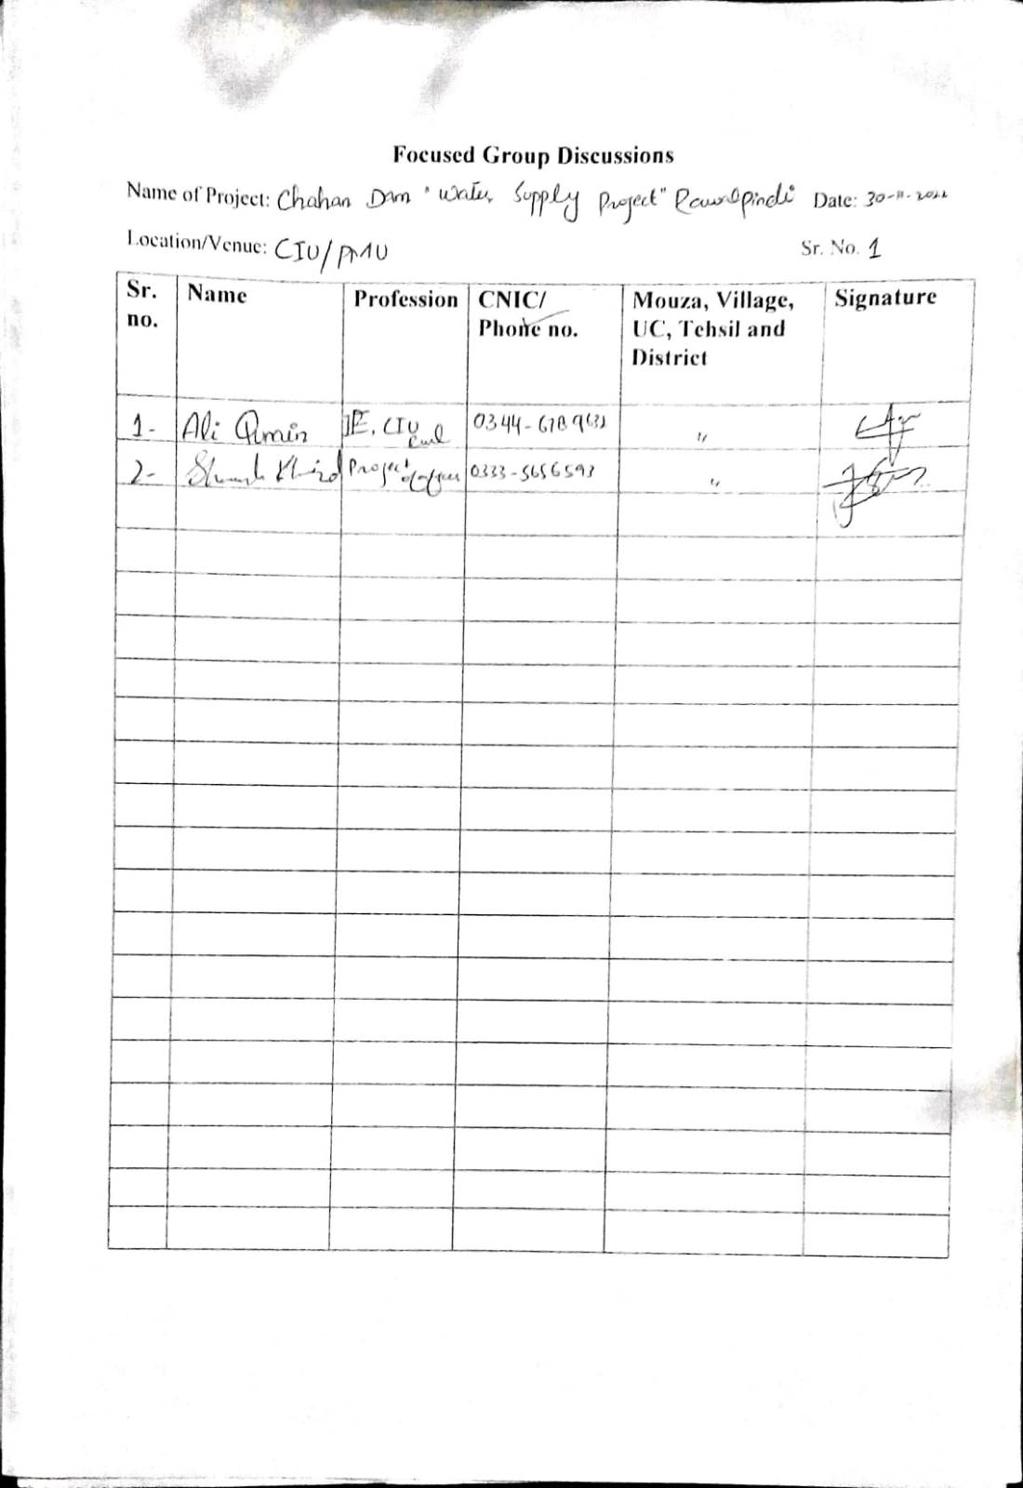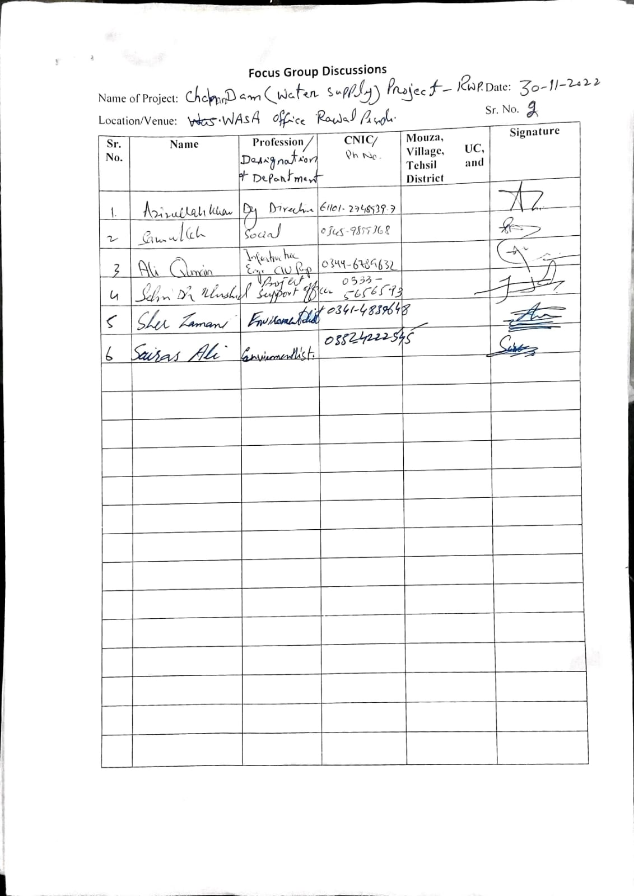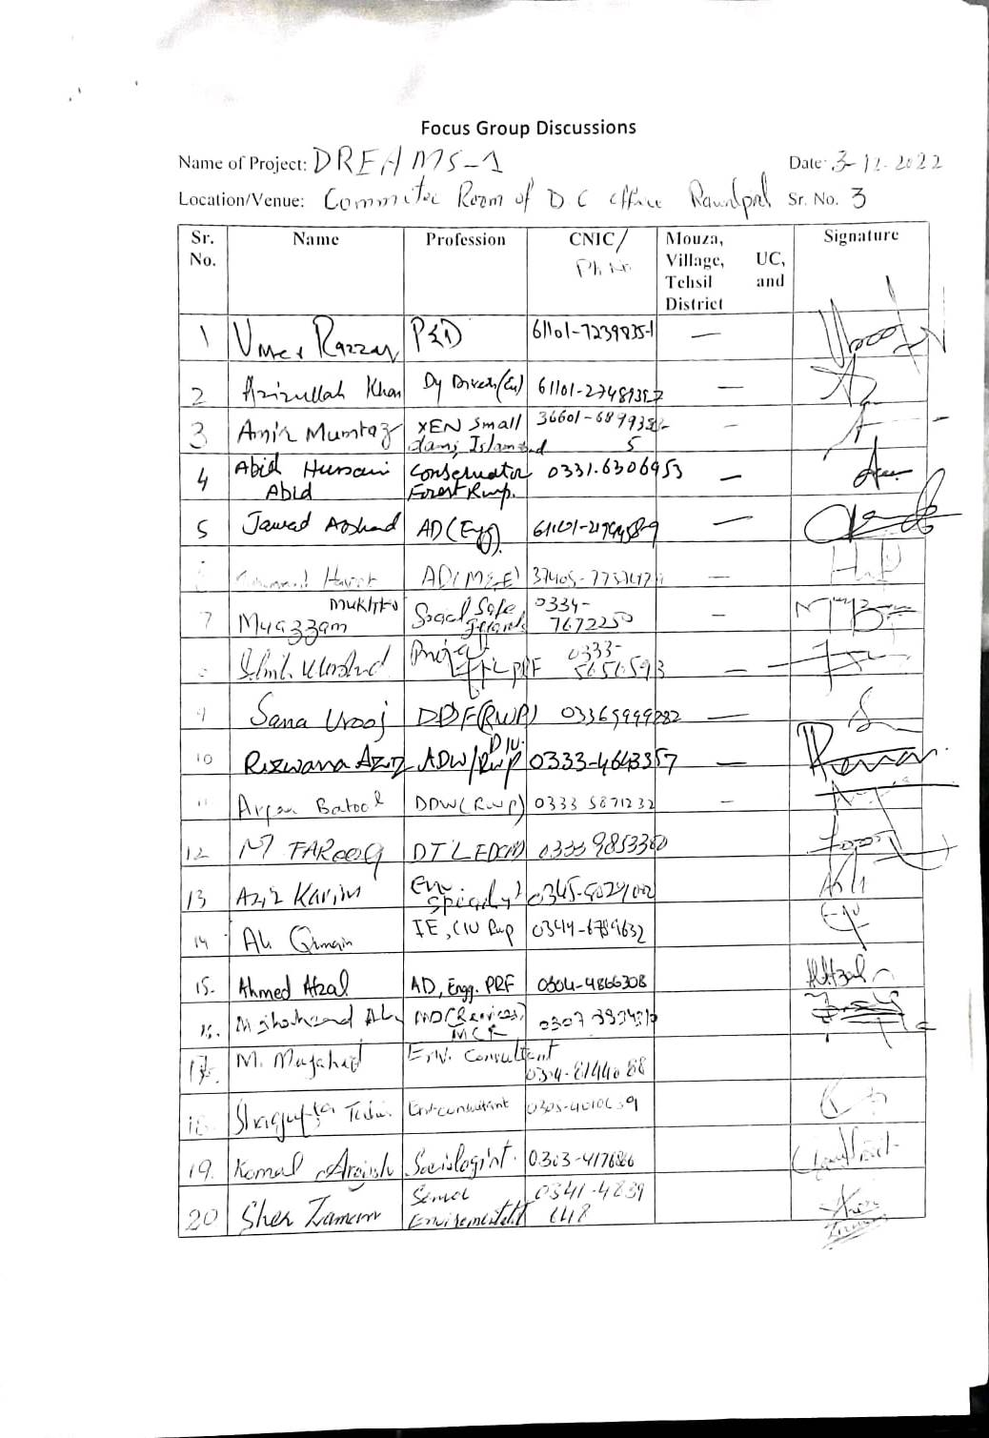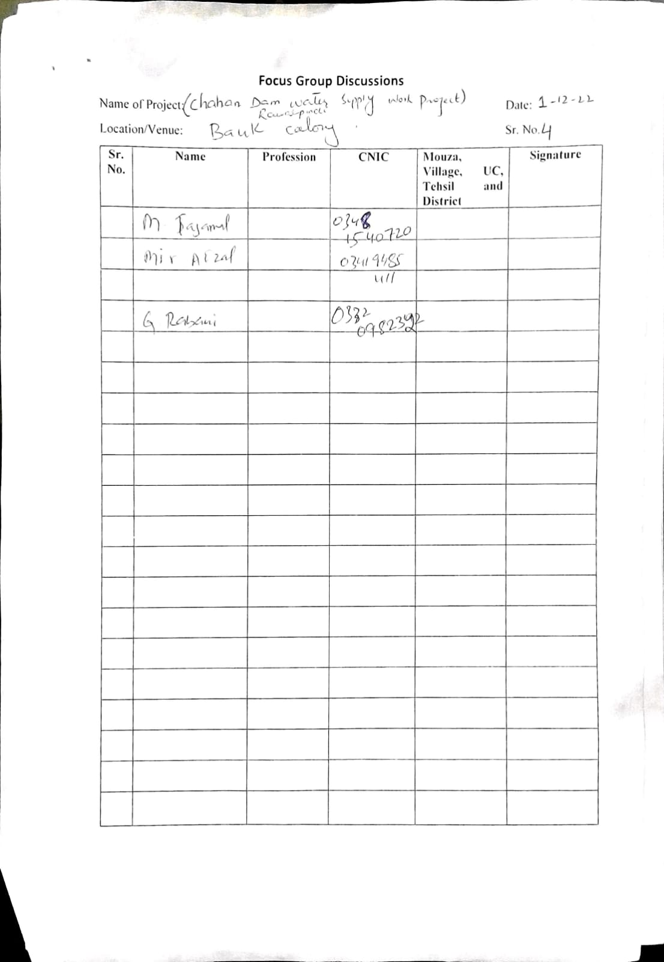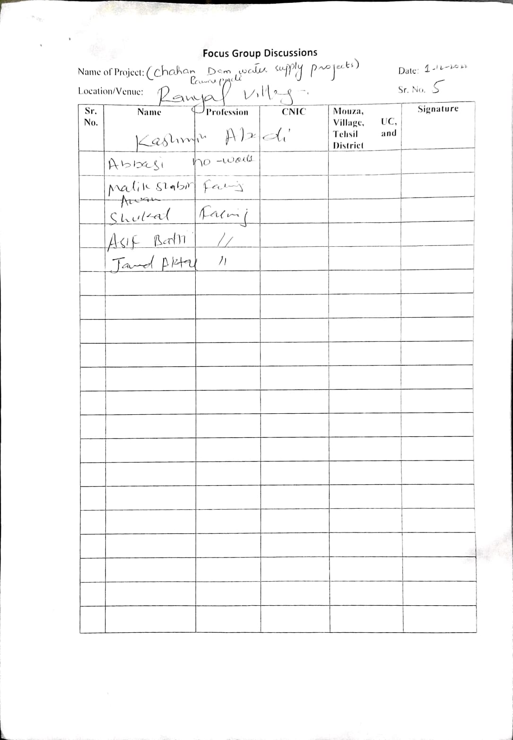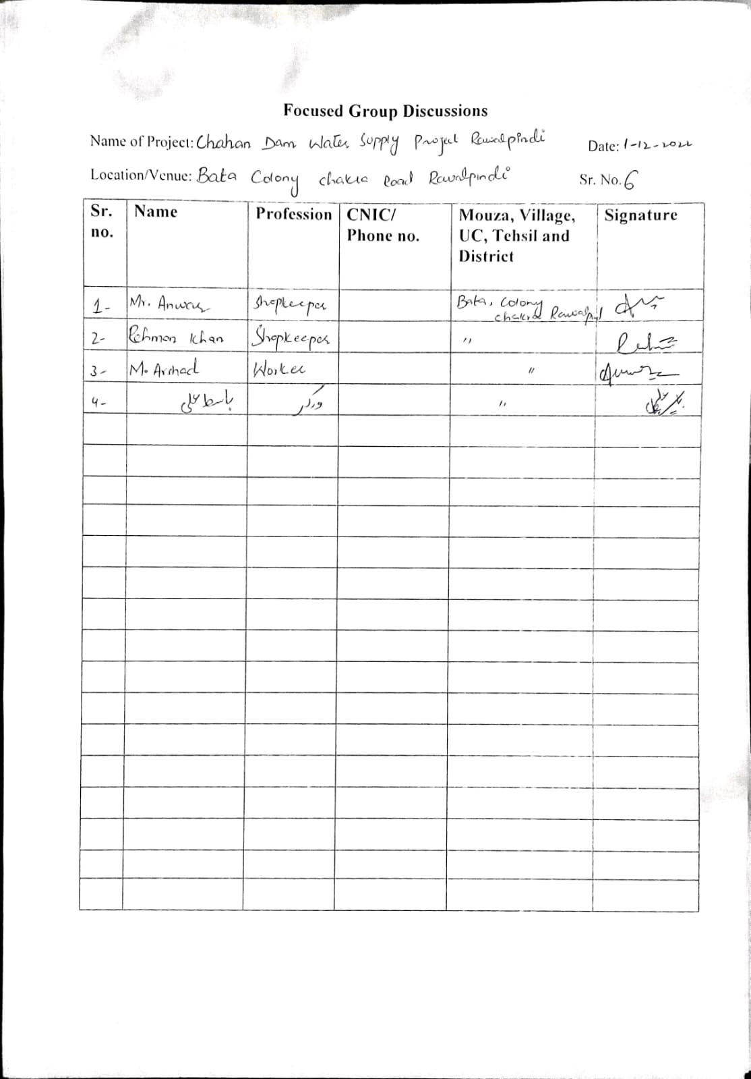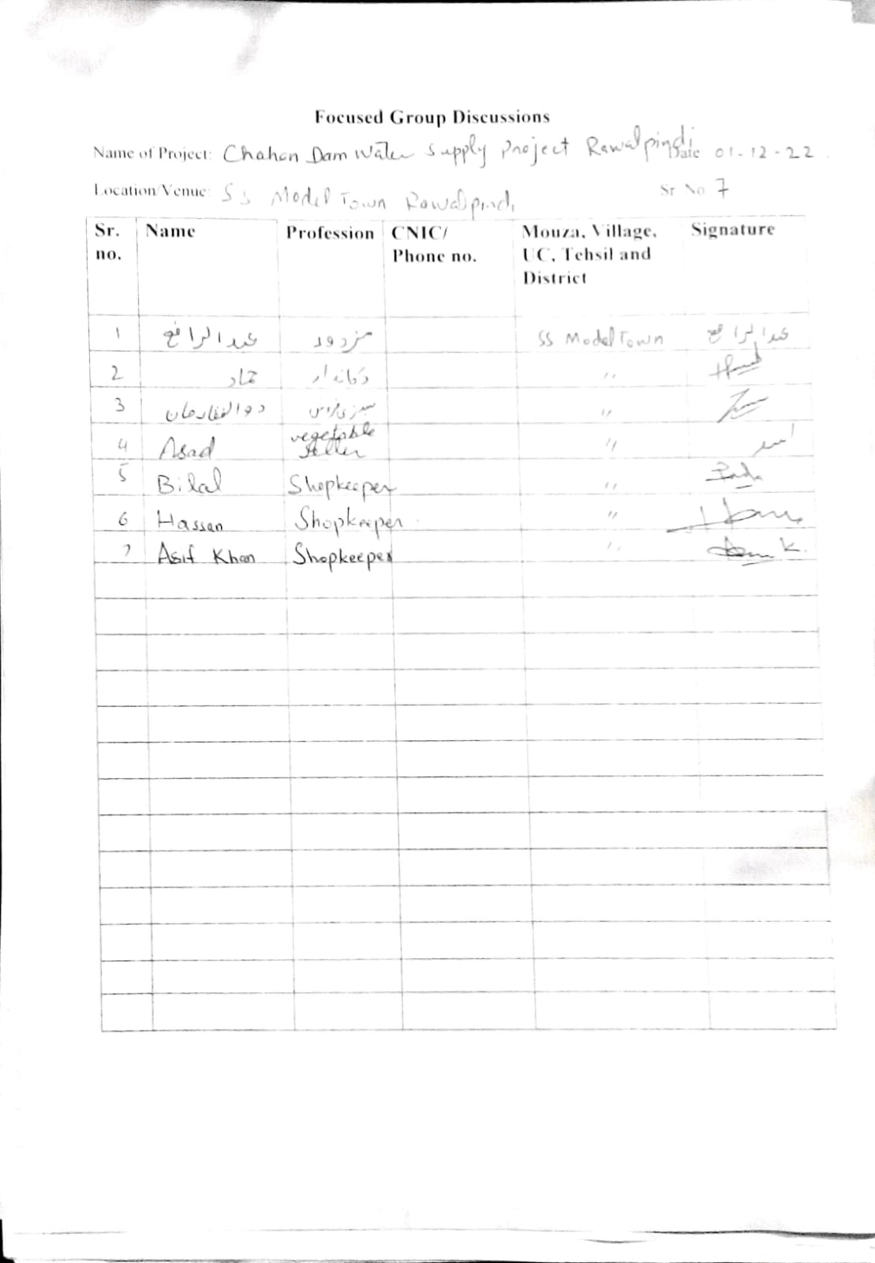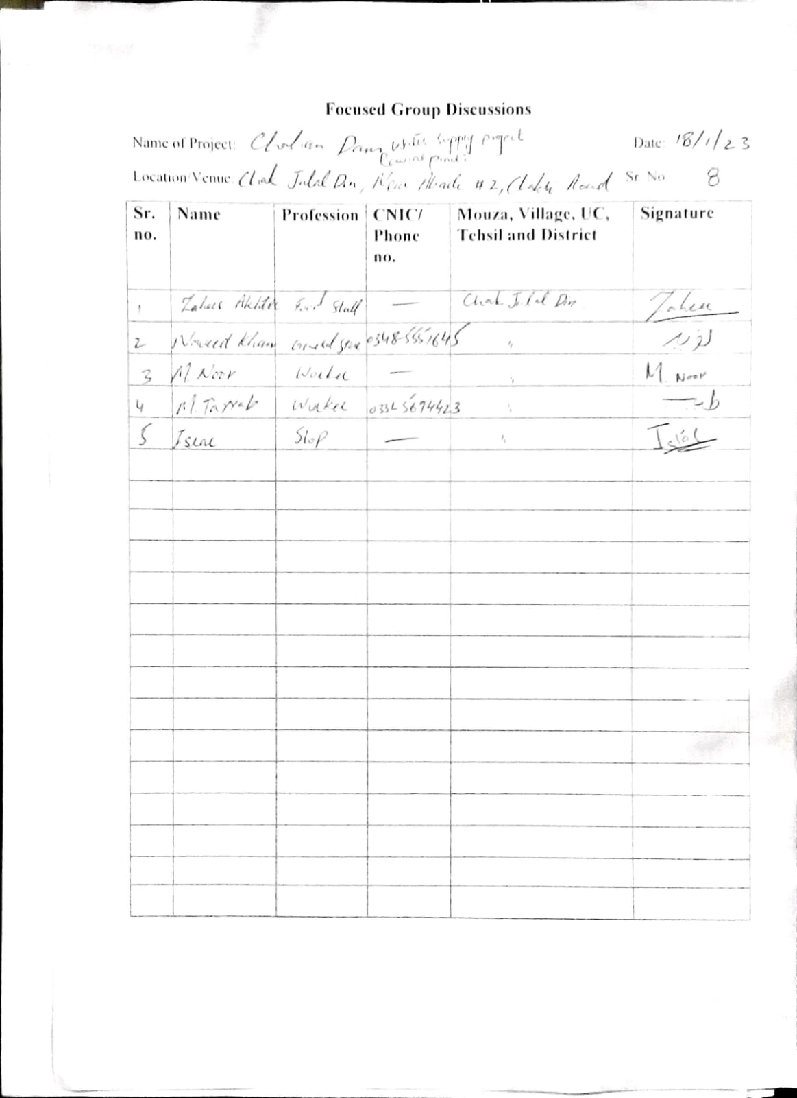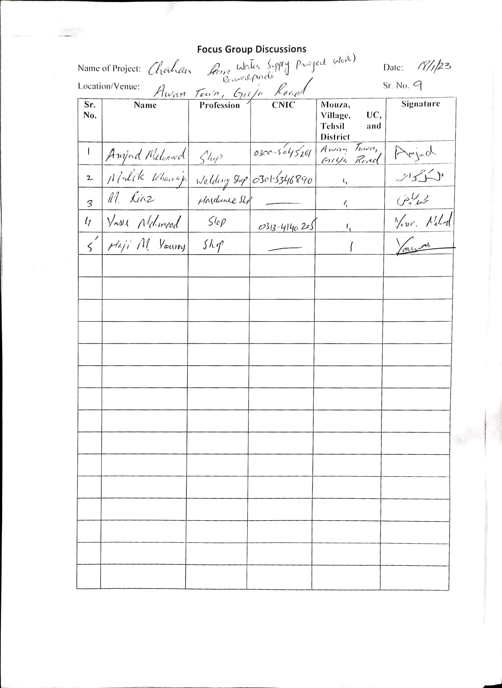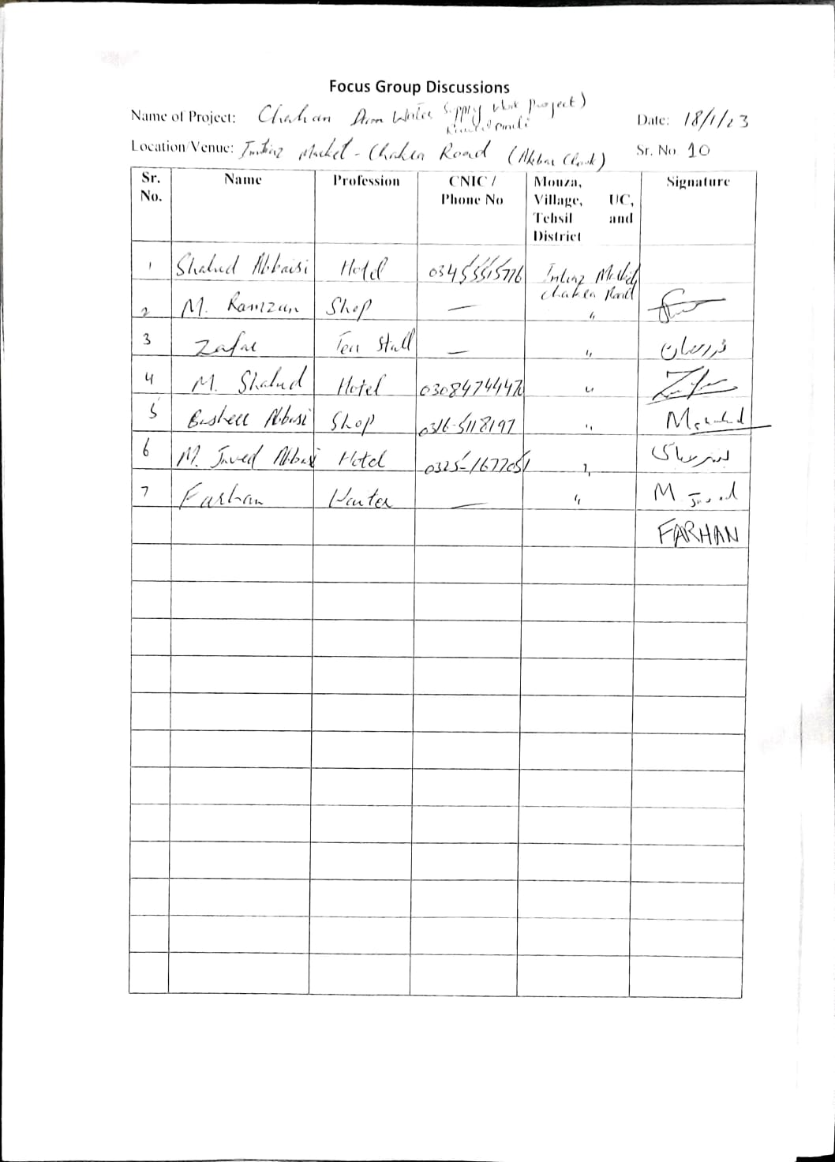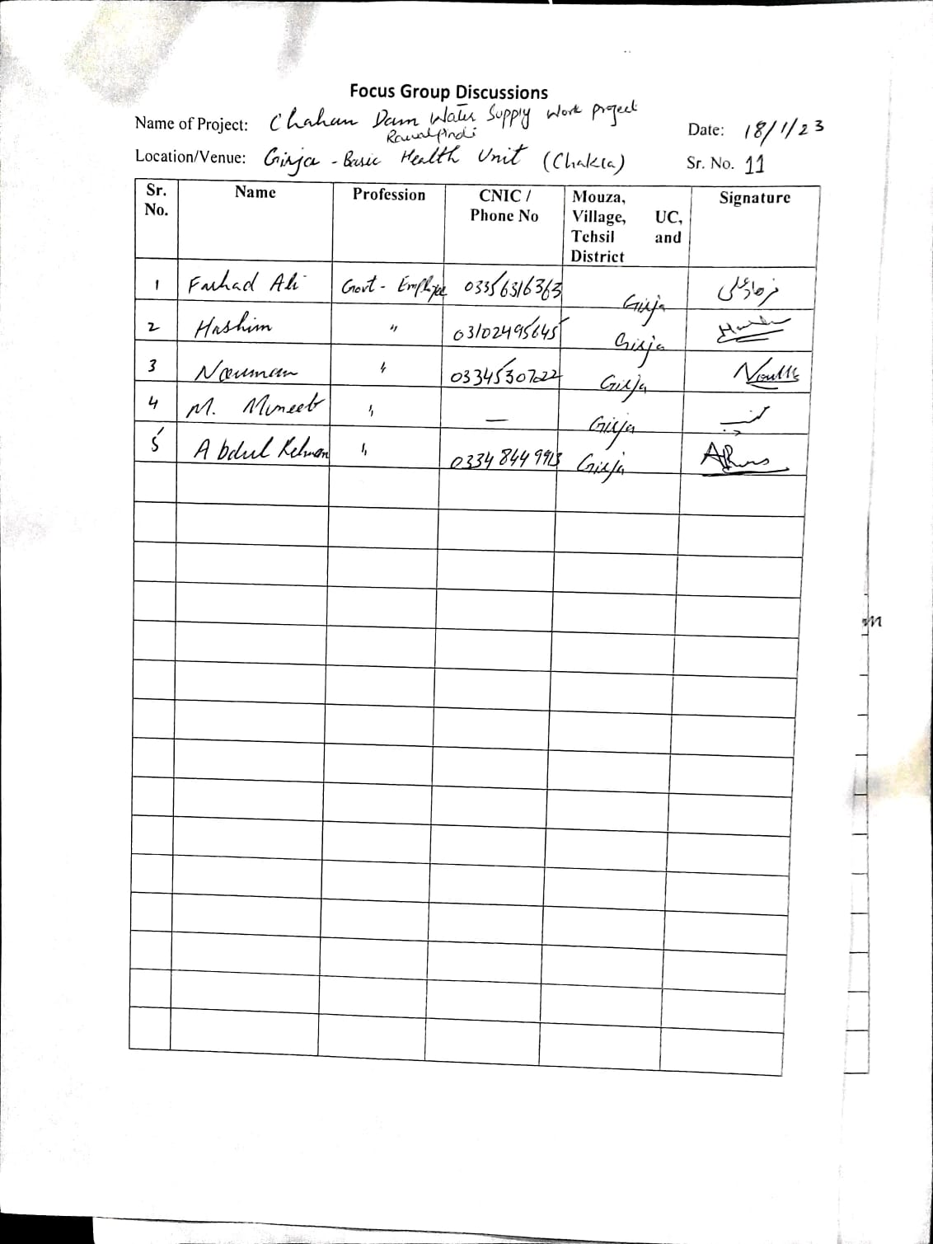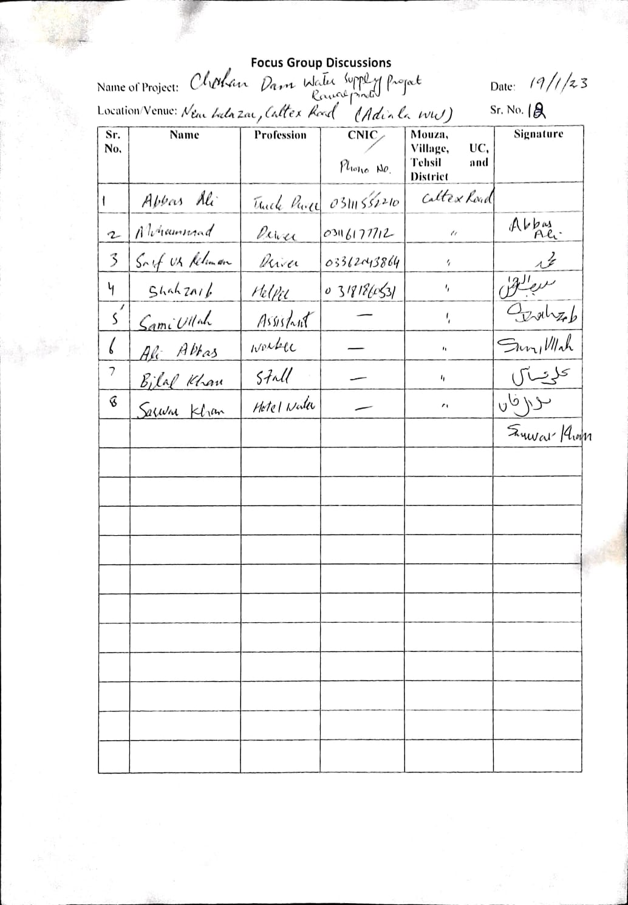

Annexure XV: Public Consultation Minutes for

Solar Installation Development

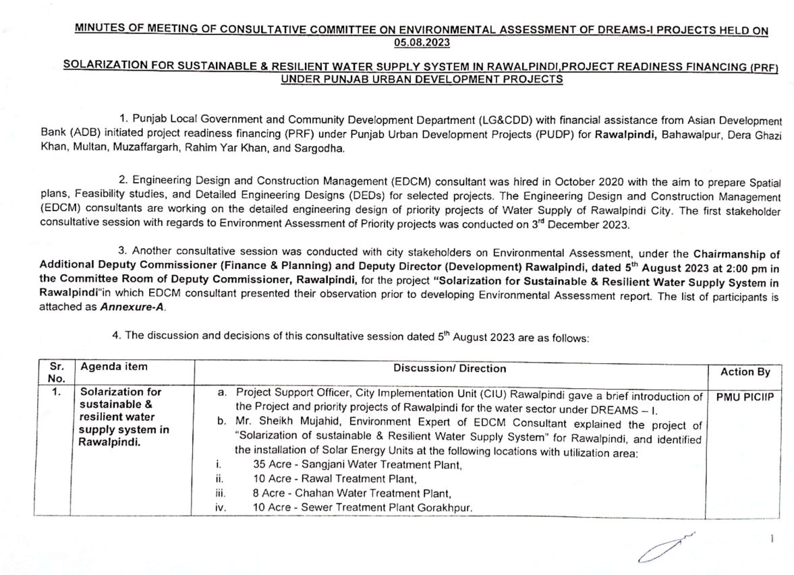
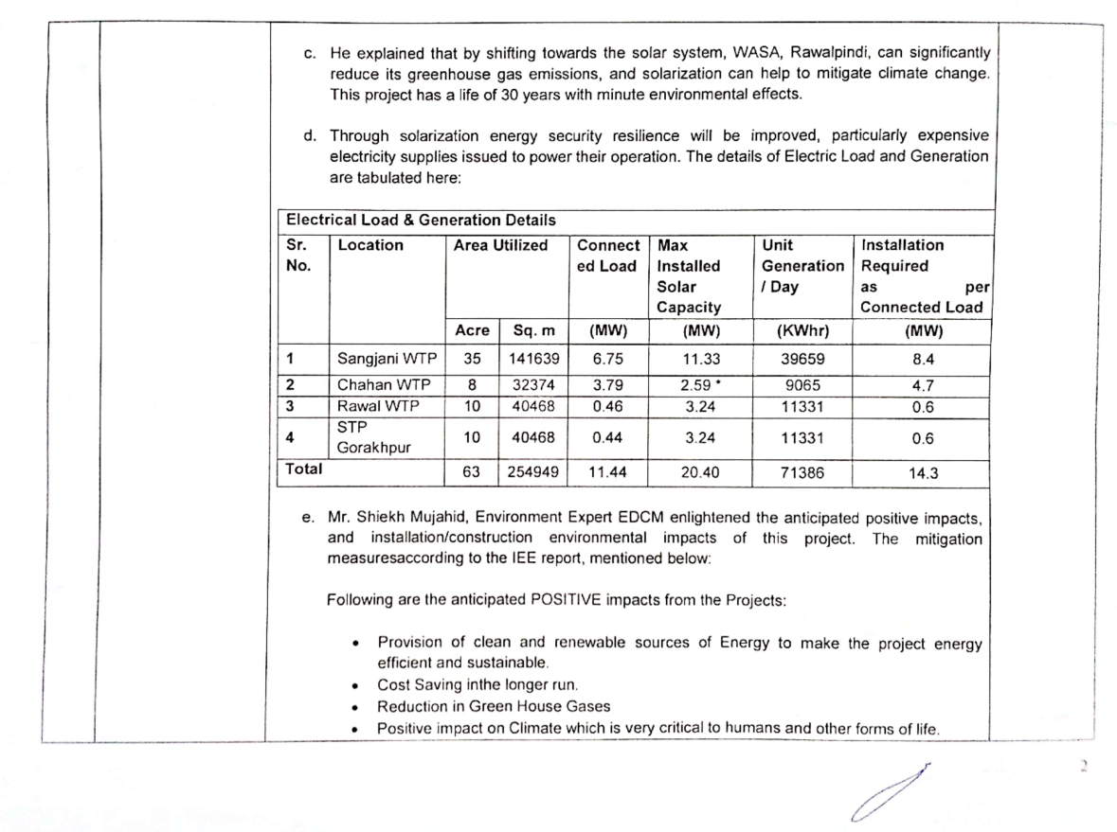
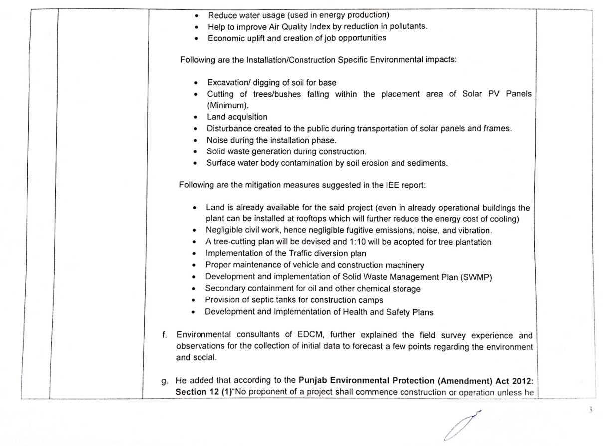
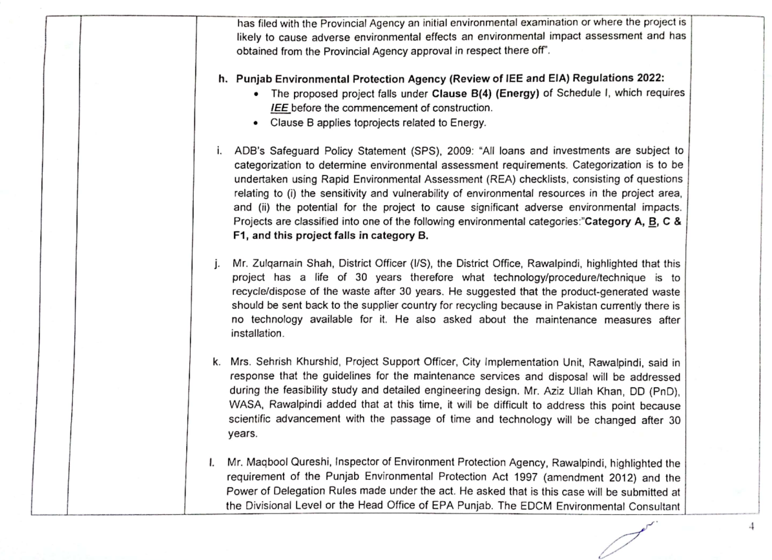
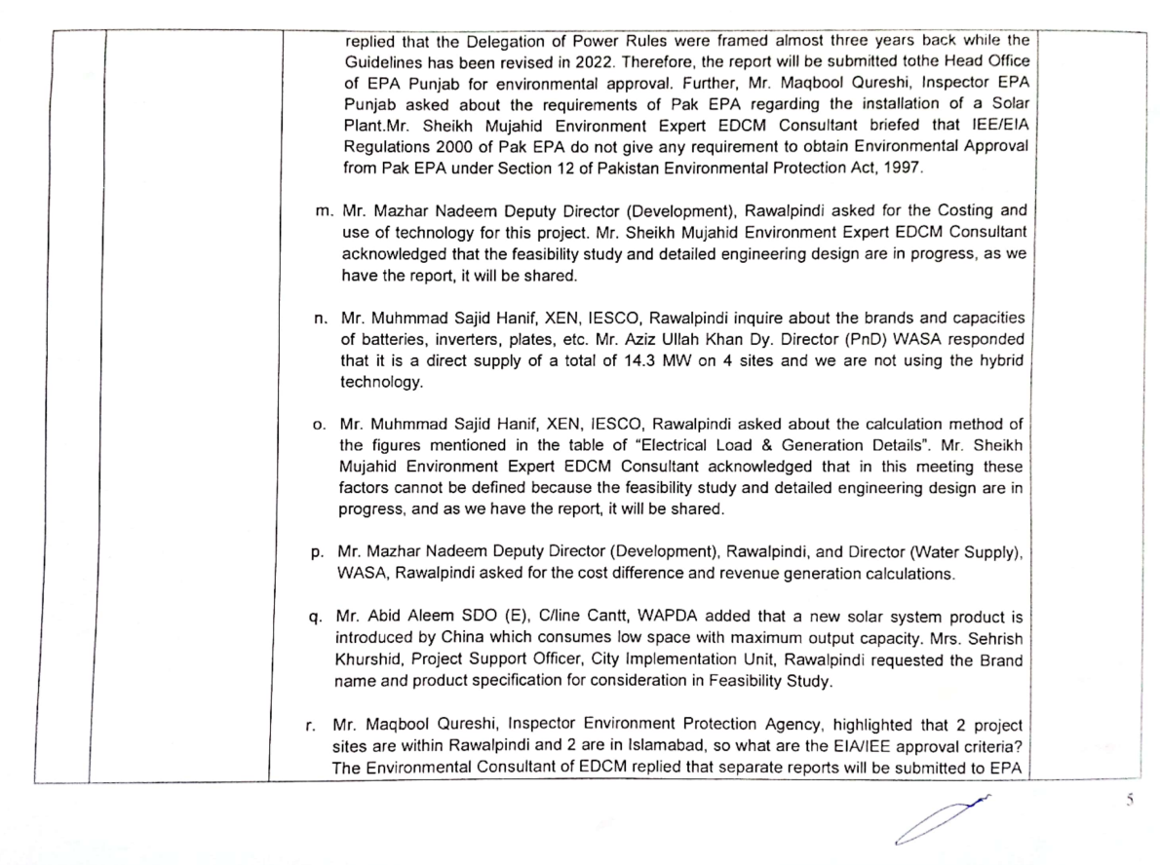
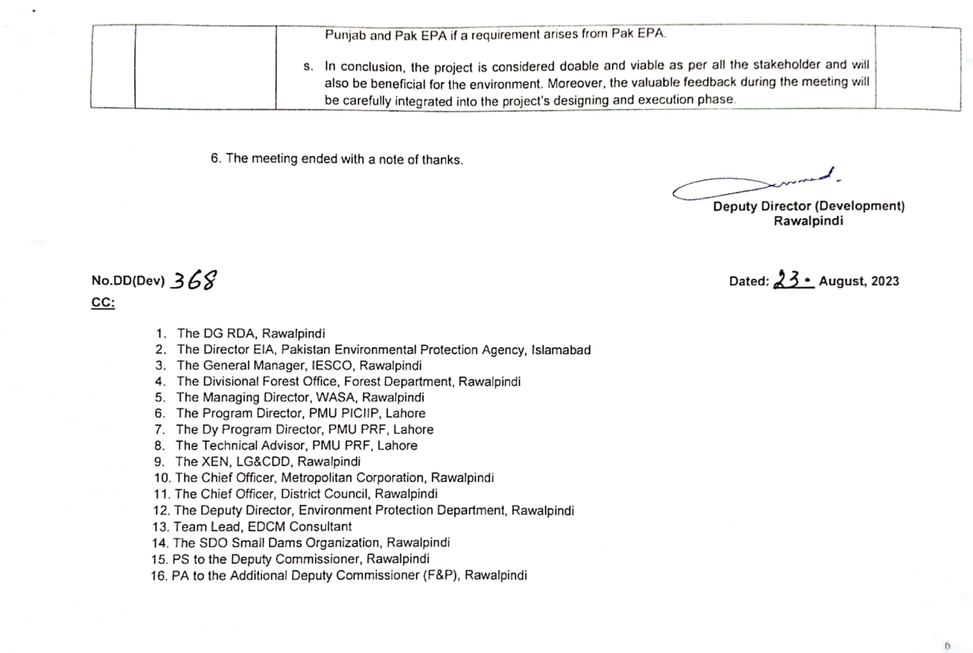

Annexure XVI: Laboratory Monitoring Results for Solar Installation Sites

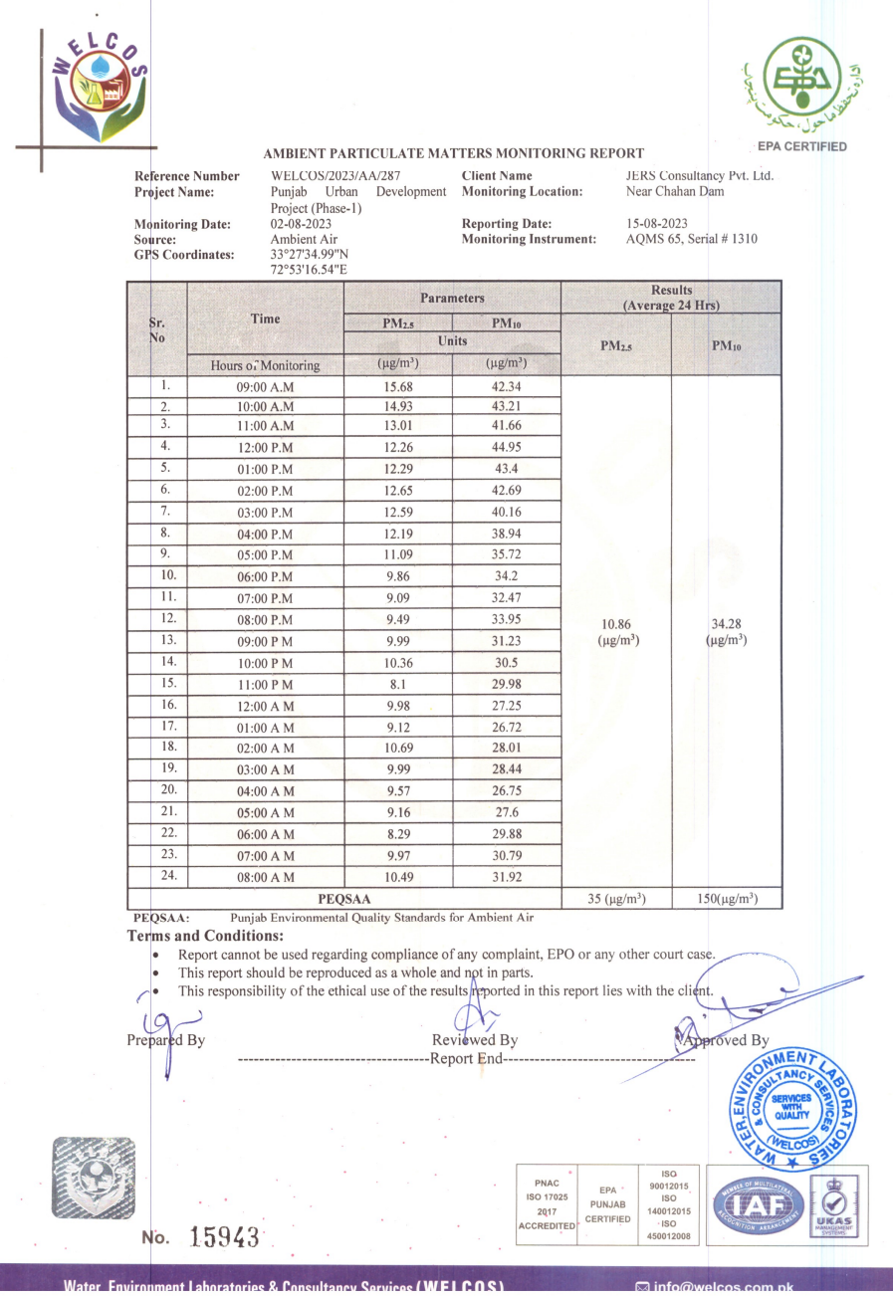
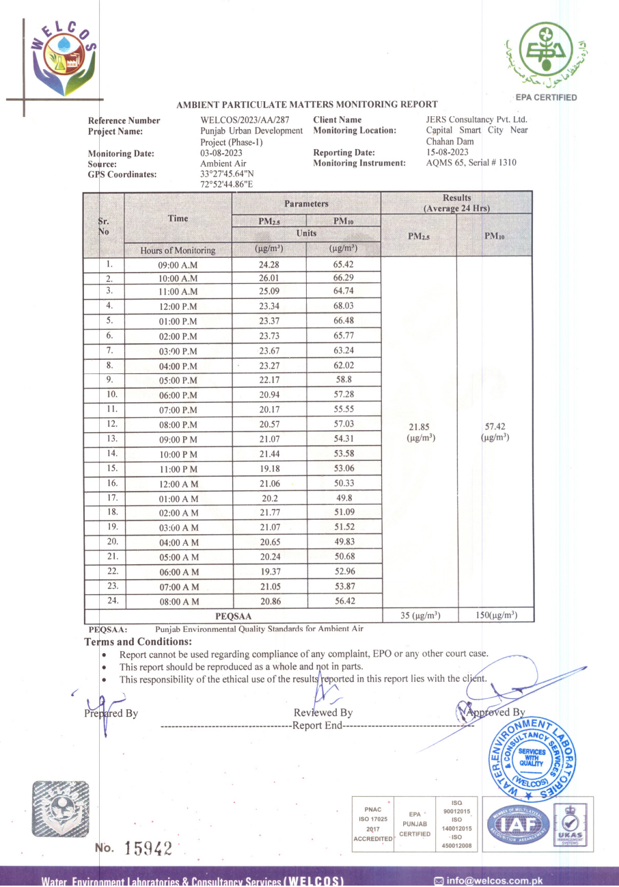

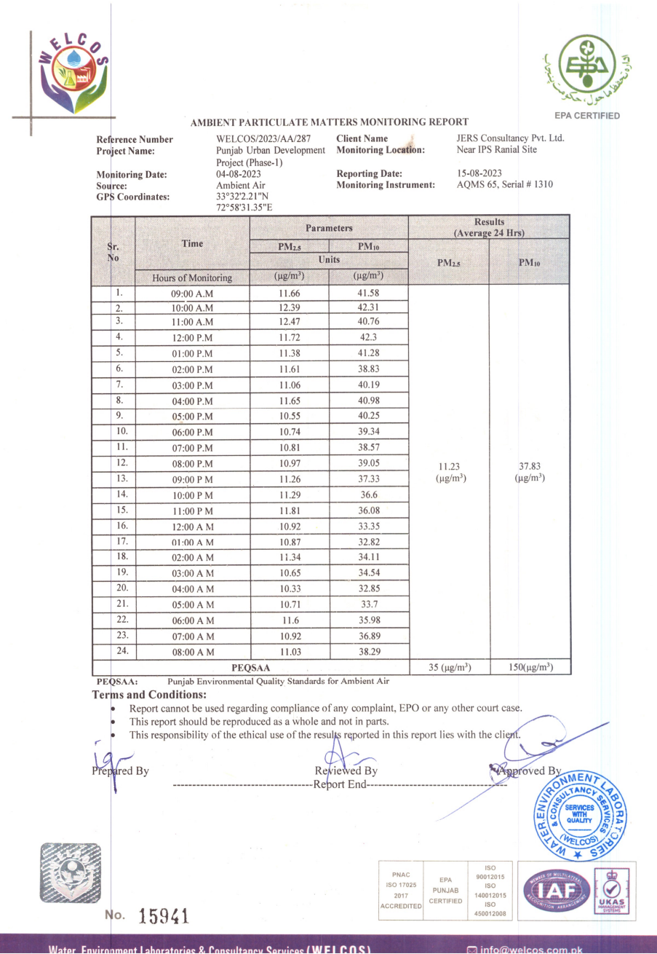

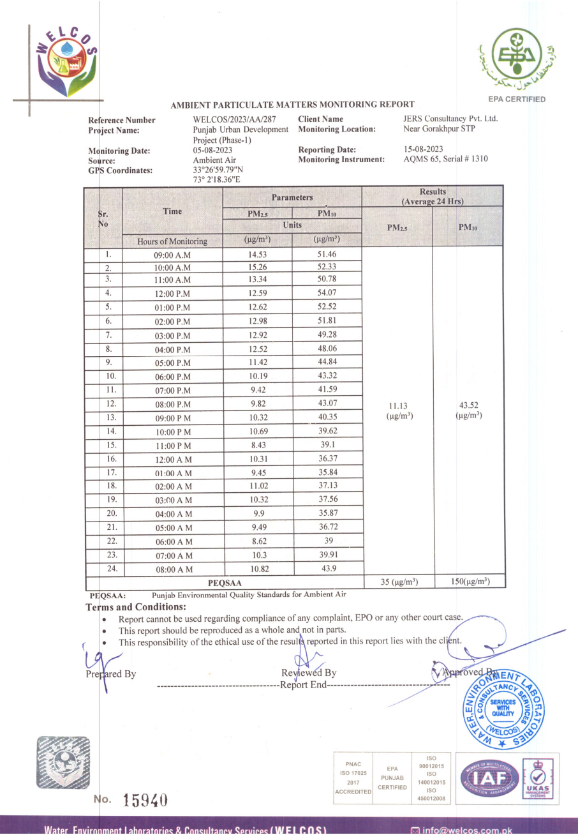

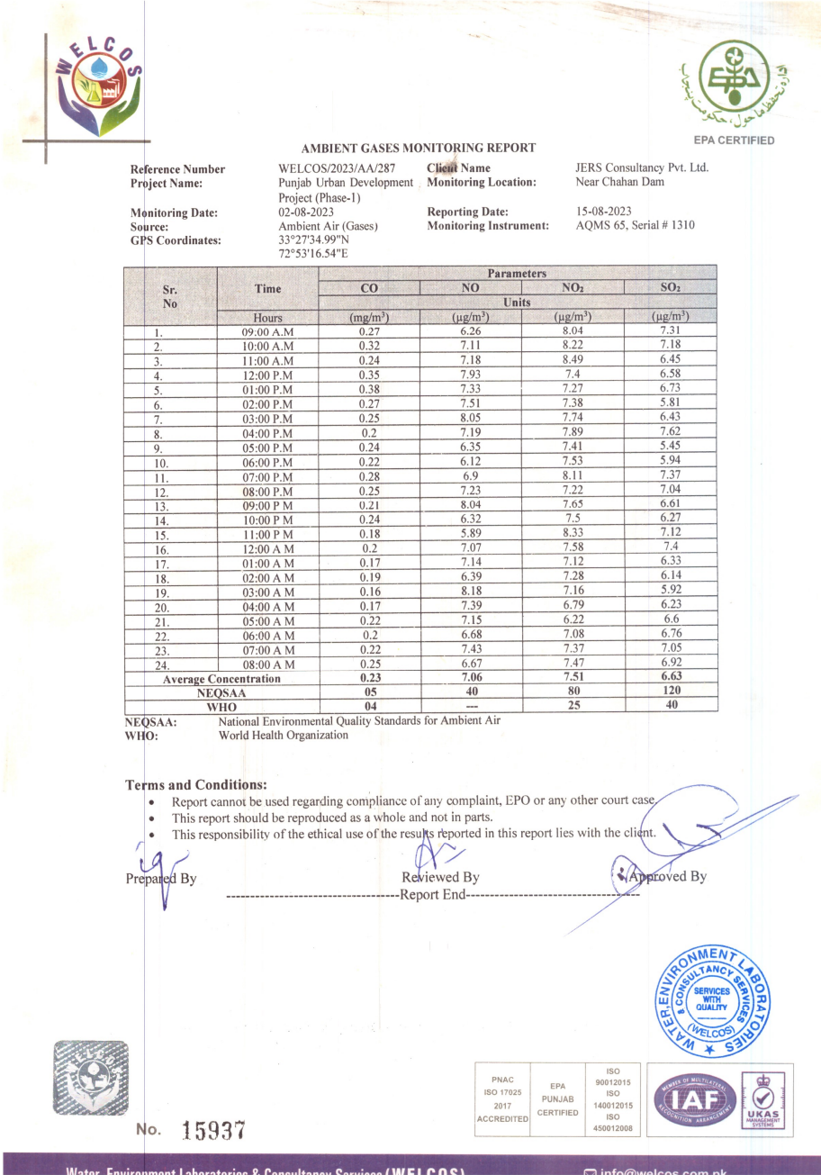

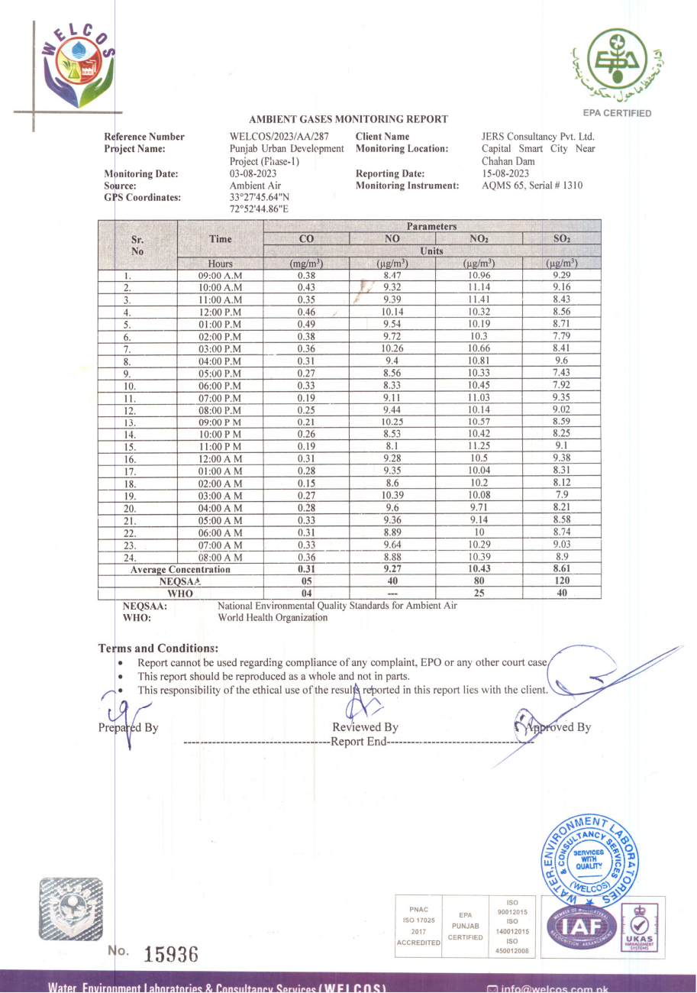

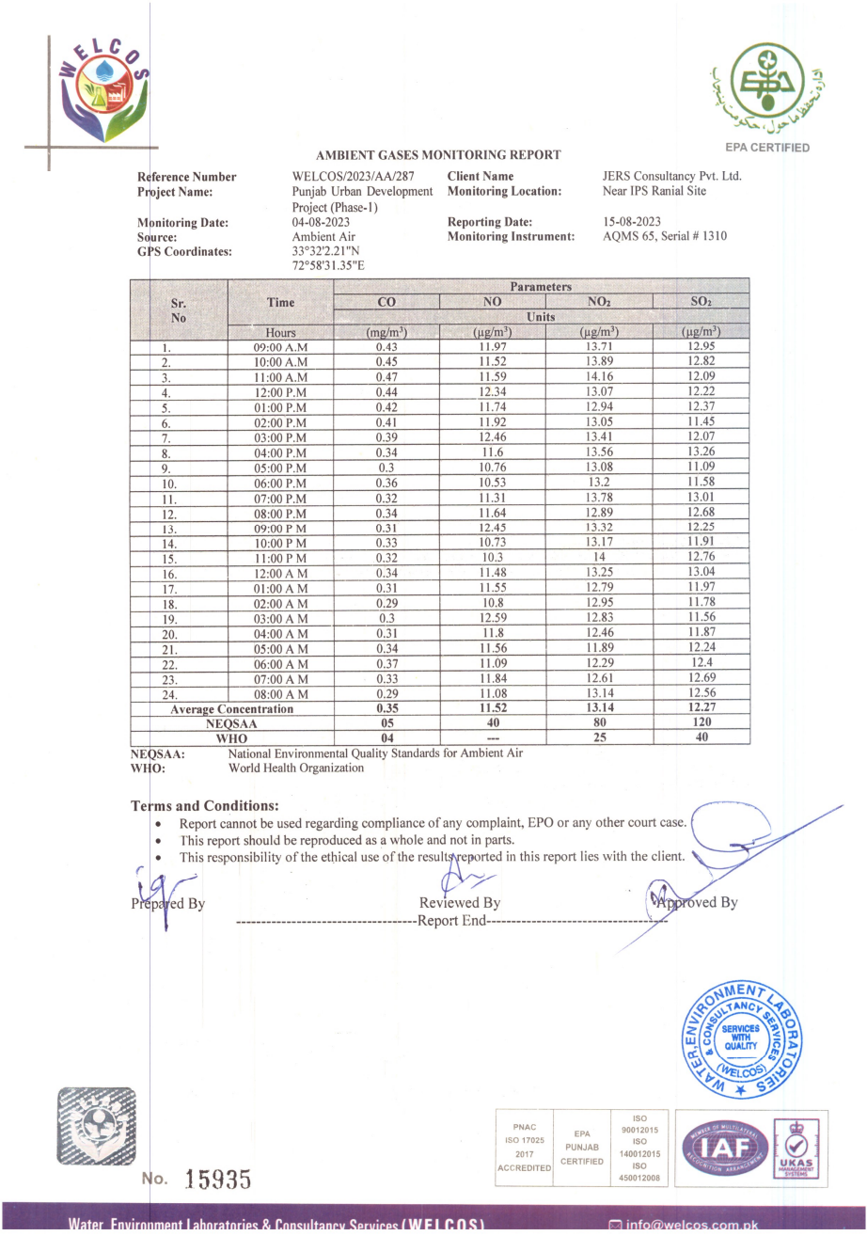

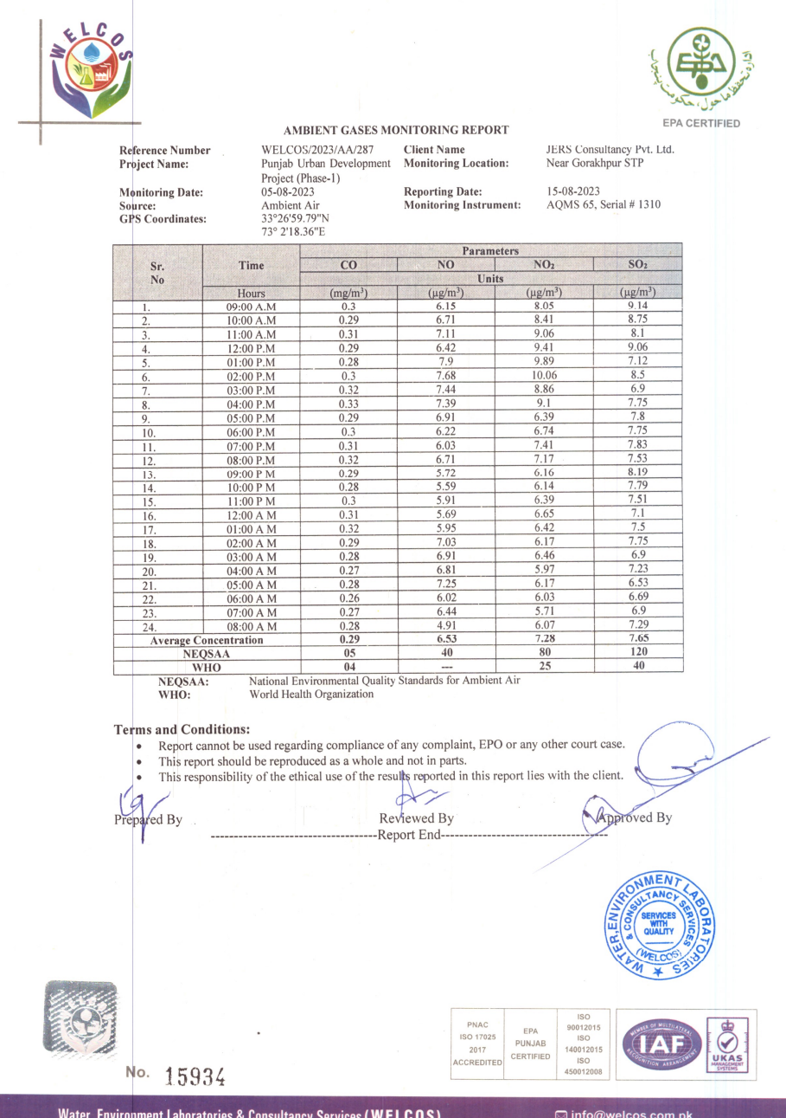

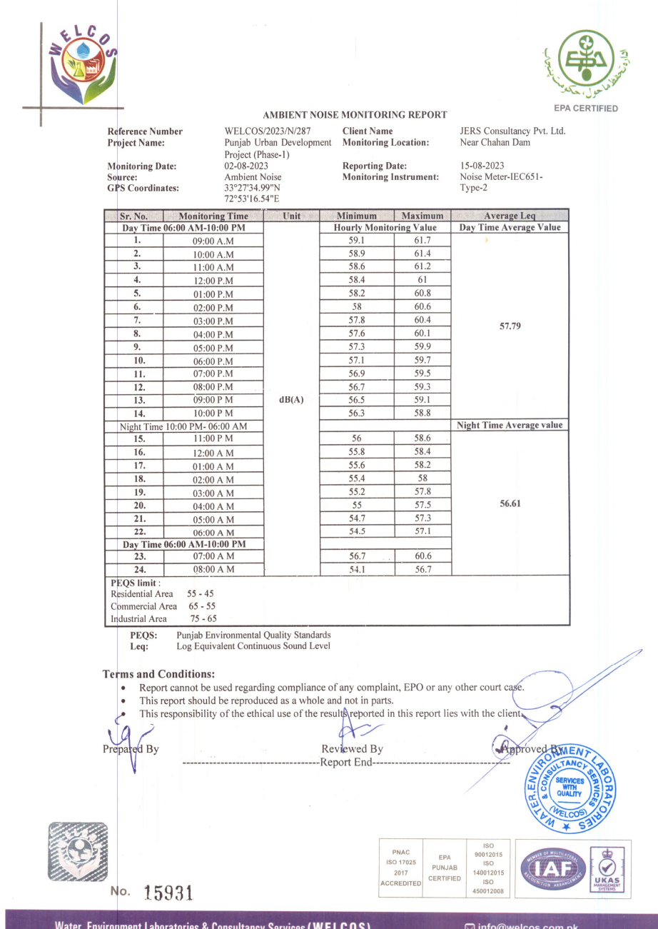
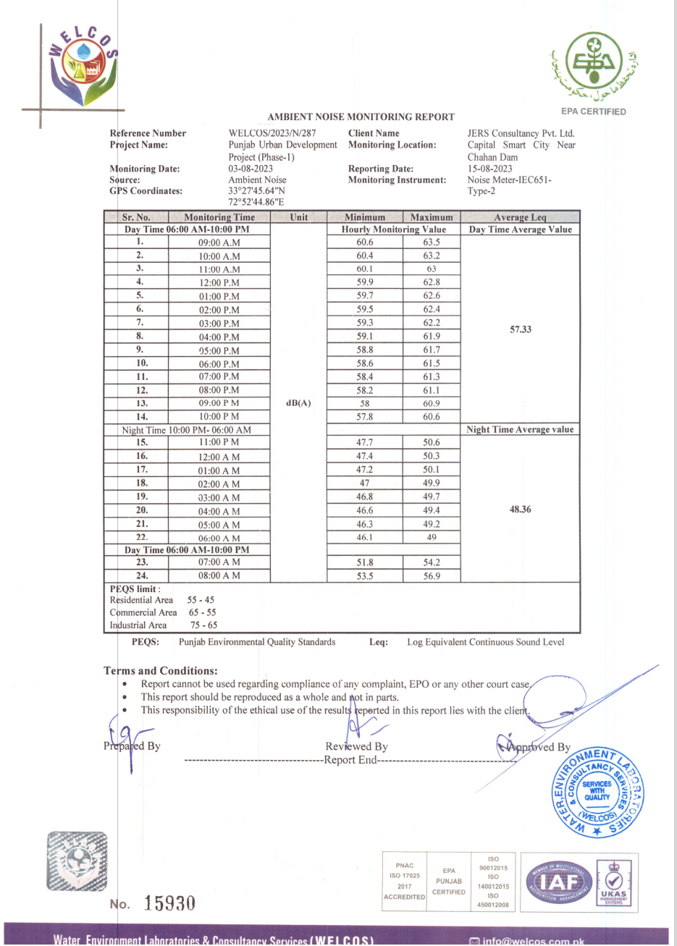

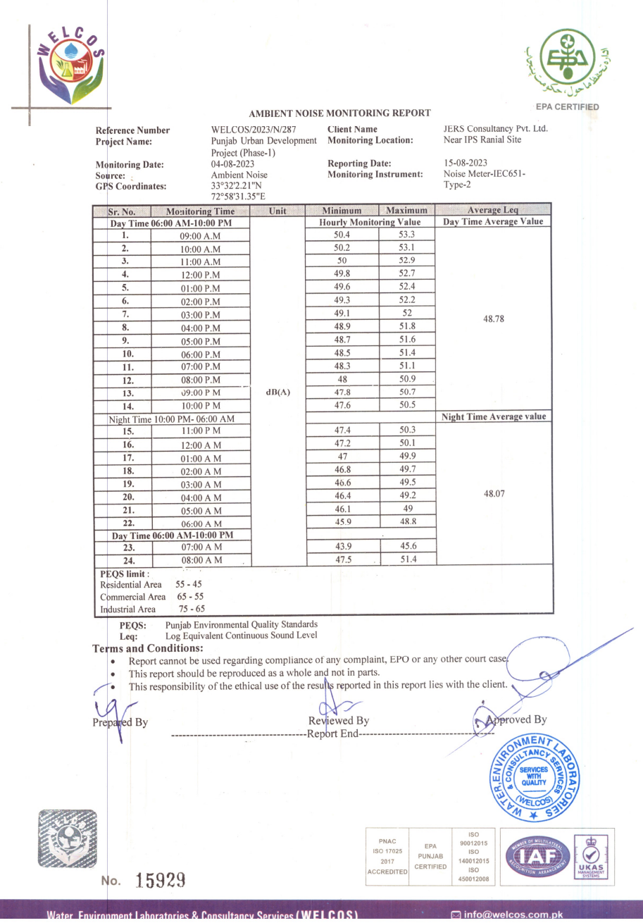
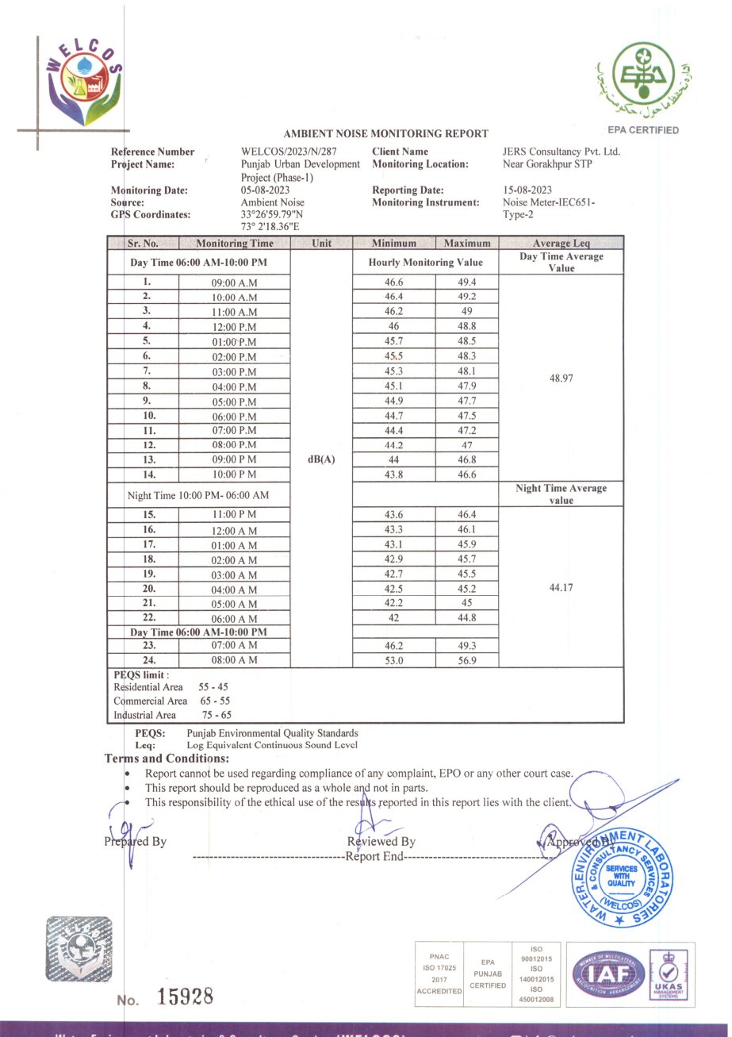

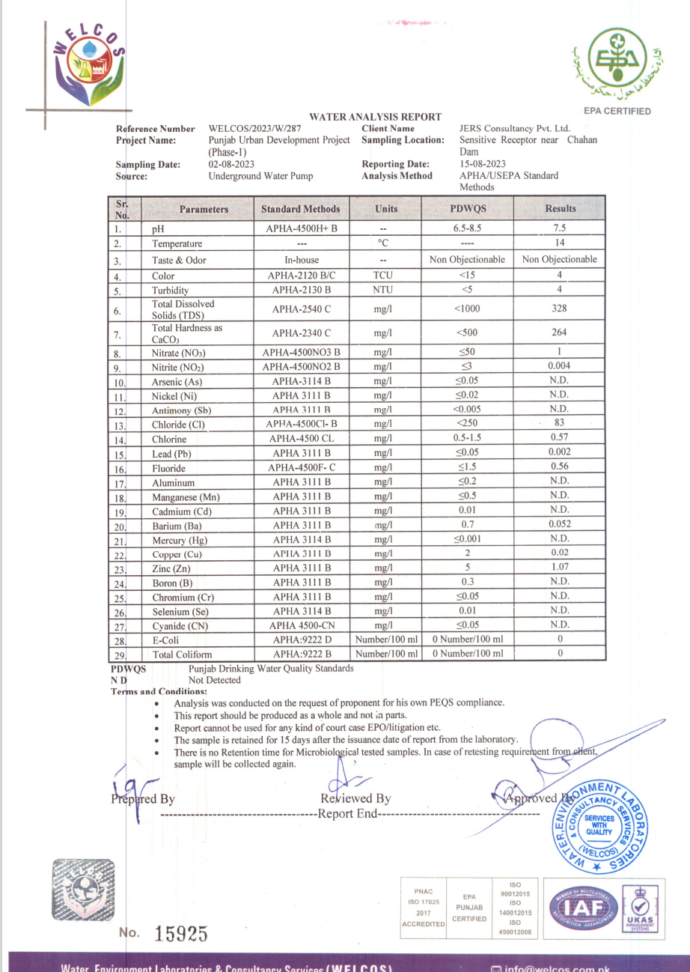
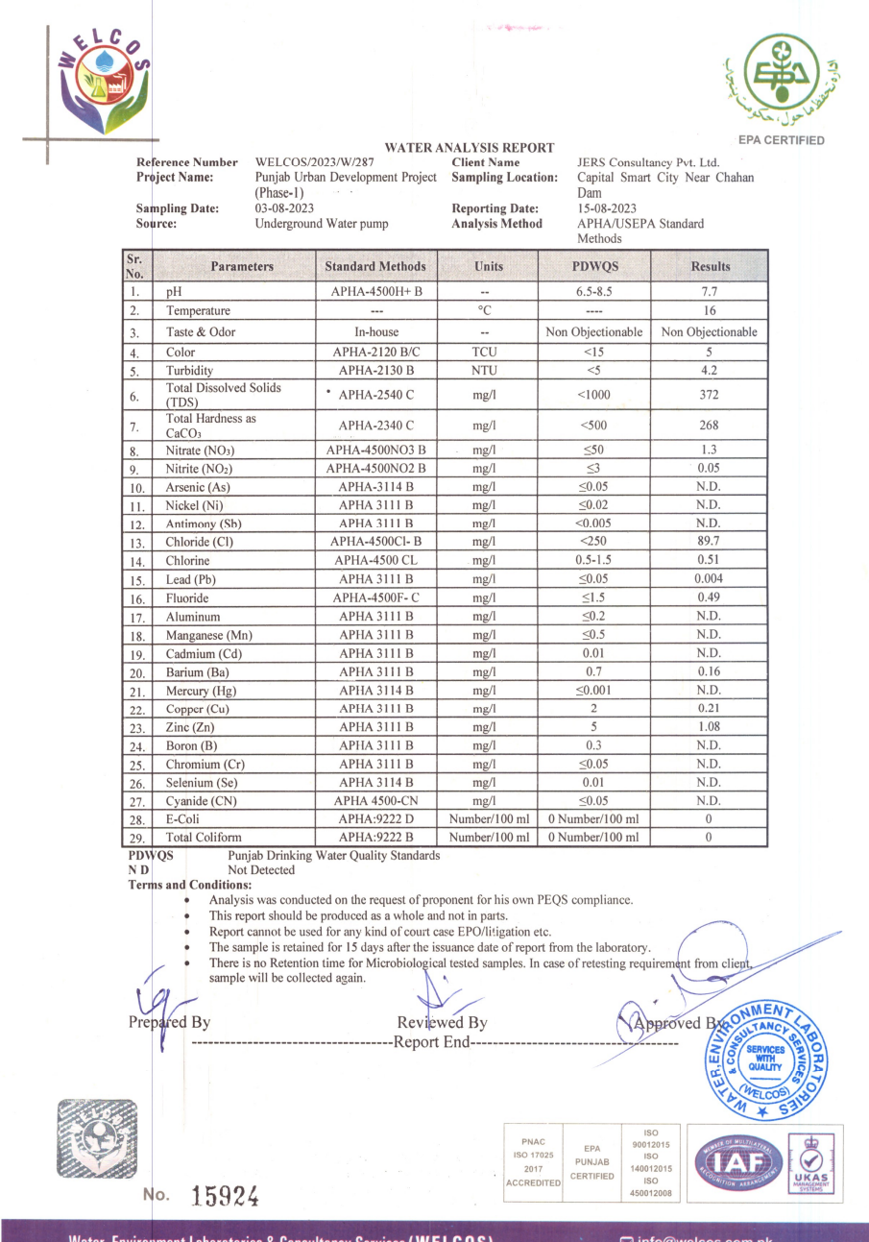
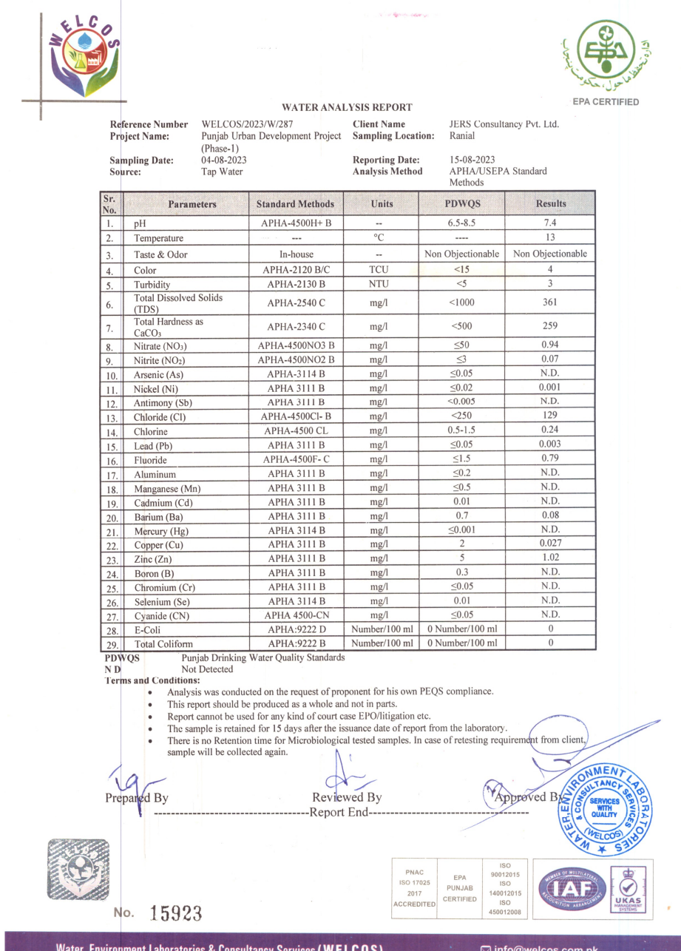

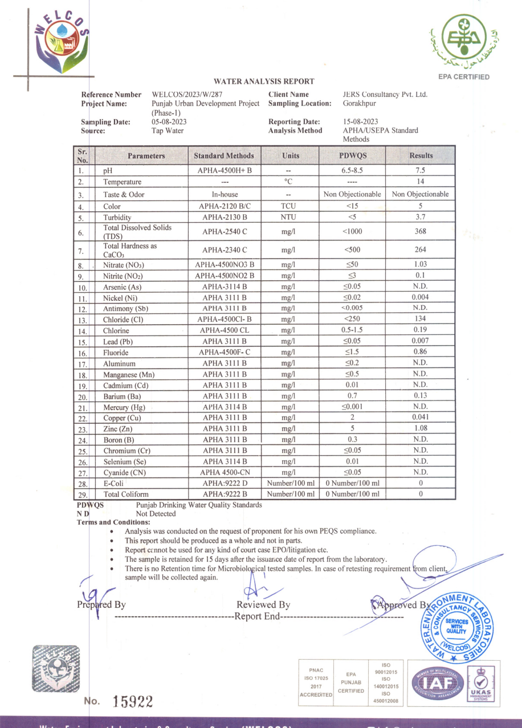

Tentative Work Force Requirements Including Client and Contractor Staff” = (100) x (100) = 10,000 liters/day = (10,000) x (80%) =8,000 liters/day
Source: The World Bank Report 2012 – What a Waste: A global review of solid waste management. Based on UNEP estimates for waste generation in the Asia Pacific. Average is 0.45 kg/capita/day
Source: Iqbal M. Sheikh et al., (Environmental Geology of the Islamabad-Rawalpindi Area, Northern Pakistan) by Geological Survey of Pakistan
Source: Iqbal M. Sheikh et al., (Environmental Geology of the Islamabad-Rawalpindi Area, Northern Pakistan) by Geological Survey of Pakistan
Building Code of Pakistan (Seismic Provisions – 2007), Ministry of Housing and Works
District Disaster Management Plan 2018 of Rawalpindi, Municipal Corporation, Local Government, Rawalpindi
*Source: WMO/GWP Associated Programme on Flood Management Pakistan: Lai Nullah basin flood problem, Islamabad – Rawalpindi cities by Ahmed kamal Federal Flood Commission, Government of Pakistan.
Source: https://www.worldbank.org/en/news/press-release/2022/10/28/pakistan-flood-damages-and-economic-losses-over-usd-30-billion-and-reconstruction-needs-over-usd-16-billion-new-assessme
https://www.citypopulation.de/en/pakistan/distr/admin/728__rawalpindi/
https://www.ifc.org/wps/wcm/connect/83217cd8-b9a5-4383-97b5-
Source: Design Criteria of Public Health Engineering for Water Supply, Sewerage and Storm Water Drain
https://www.ifc.org/wps/wcm/connect/83217cd8-b9a5-4383-97b5-
For air quality monitoring: ‘Passive samplers’ such as test tubes can be used or ‘Active samplers’ with sorbent tubes can also be used
For noise monitoring: sampling equipment with duration greater than 1 hour can be used.
ADB, Safeguards Unit for Central & West Asia Department, Environmental Management for Construction Handbook.

