Social Monitoring Report

6th Quarterly Report
July 2022

PAKISTAN: Punjab Intermediate Cities Improvement Investment Project

Prepared by the dev~consult, Pakistan for the Program Management Unit, Local Government and Community Development Department, Government of Punjab and the Asian Development Bank.

NOTES
- The fiscal year (FY) of the Government of the Islamic Republic of Pakistan and its agencies ends on 30 June.
- In this report “$” refer to US dollars.
This Social Monitoring Report is a document of the borrower. The views expressed herein do not necessarily represent those of ADB's Board of Directors, Management, or staff, and may be preliminary in nature.
In preparing any country program or strategy, financing any project, or by making any designation of or reference to a particular territory or geographic area in this document, the Asian Development Bank does not intend to make any judgments as to the legal or other status of any territory or area.

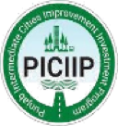
External Monitoring Report Social Safeguards
Punjab Intermediate Cities Improvement Investment Project - PICIIP

Program Management Unit (PMU)
Government of Punjab
Local Government & Community Development Department

Project Number: 46526-007
Loan Number: 3562-PAK

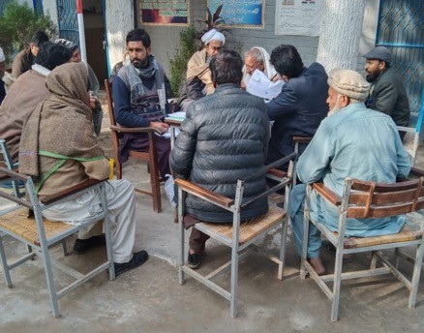
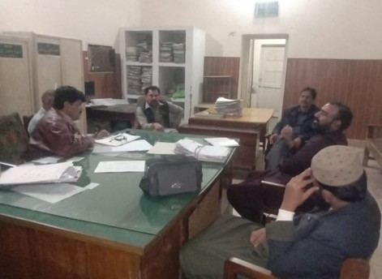
6th Quarterly External Monitoring Report of the (i) Implementation of Land Acquisition of LARP 1, Pumping Station North Zone (Lot-3) PICIIP-3-Water and Sanitation, Sahiwal; (ii) LARP 2, Pumping Station South Zone (Lot-4) LARP PICIIP 3, Water and Sanitation, Sahiwal; (iii) LARP 3 Pumping Station (Lot-3) PICIIP-11-Water and Sanitation, Sialkot; LARP 4, Waste Water Treatment Plan PICIIP-08-A, Sahiwal; and (v) LARP 5, Waste Water Treatment Plant PICIIP 12, Sialkot

Reporting Period: April to June 2022

Prepared by Hashmat Ali Khan, External Monitoring Consultant
dev~consult, Pakistan

July 2022

TABLE OF CONTENTS
1 Introduction 1
1.1 About the Report 1
1.2 Detailed Design 1
2 Monitoring Methodology 2
2.1 The monitoring methodology of LARP 1 2
2.2 The monitoring methodology of LARP 2 2
2.3 Monitoring Methodology of LARP 3 2
2.4 Monitoring Methodology LARP 4 2
2.5 Monitoring Methodology LARP 5 2
2.6 Monitoring and Evaluation 2
2.7 Need for Monitoring 3
2.8 EMA Scope of Work/TORs 3
2.9 Deliverables of EMC 4
2.10 Resettlement Monitoring Framework 4
2.11 Monitoring Indicators 4
2.12 Monitoring Methodology and Strategy Adopted by EMA 6
2.13 Review of Project Information/Data 6
2.14 Field Visit 6
2.15 Sampling Technique 6
2.16 Rapid Appraisal Methods 7
2.17 Participative Approach 7
2.18 Data Processing and Analysis 7
2.19 External Monitoring Report 7
3 LARPs Implementation/Findings 8
3.1 LARP- 1 Resettlement Budget & Financing 8
3.2 Differential Cost of LARP 1 8
3.3 LARP 2 Resettlement Budget & Financing 9
3.4 Differential Cost of LARP 2 9
3.5 Resettlement Budget and Financing Plan LARP 3 10
3.6 Differential Cost LARP-3 11
3.7 LARP 4 Resettlement Budget and Financing 11
3.8 Differential Cost LARP 4 12
3.9 LARP 5 Resettlement Budget and Financing 13
3.10 Differential cost LARP 5 14
3.11 Role and Responsibility of LARPs Implementation 14
3.12 Need of independent Valuation Study (IVS) 15
4 Institutional Arrangements 17
5 Implementation Schedule 18
6 Grievances Redress Mechanism (GRM) 22
7 Income Restoration and Rehabilitation 24
8 Consultation and Information Disclosure 25
9 Conclusions 26
10 Recommendations 27
11 Annexures 28
Annexure A – Sialkot GRC Data 28
Annexure B – Sahiwal GRC Data 32
Annexure C – Consultation Sessions with Displaced Persons 47
ABBREVIATIONS
ADB | Asian Development Bank
AH | Affected Household
CIU | City Implementation Unit
DPs | Displaced Persons
EA | Executing Agency
EMC | External Monitoring Consultant
GoP | Government of Pakistan
GRM | Grievance Redress Mechanism
IA | Implementing Agency
IMR | Internal Monitoring Report
LAA | Land Acquisition Act 1894
LAR | Land Acquisition and Resettlement
LARP | Land Acquisition and Resettlement Plan
M&E | Monitoring & Evaluation
MC | Municipal Corporation
PMU | Project Management Unit
RoW | Right of Way
SPS | Safeguard Policy Statement, 2009
SSC | Social Safeguard Consultant
ToR | Term of Reference

GLOSSARY
Displaced Household | All members of a subproject affected household residing under one roof and operating as a single economic unit, who are adversely affected by the Project or any of its components; may consist of a single nuclear family or an extended family group.
Displaced Persons | In the context of involuntary resettlement, displaced persons are those who are physically displaced (relocation, loss of residential land, or loss of shelter) and/or economically displaced (loss of land, assets, access to assets, income sources, or means of livelihoods) as a result of (i) involuntary acquisition of land, or (ii) involuntary restrictions on land use or on access to legally designated parks and protected areas.
Compensation | Payment in cash or in kind of the replacement cost of the acquired assets.
Cut-of-Date | The completion date of the census of project-displaced persons is usually considered the cut-off date. A cut-off date is normally established by the borrower government procedure that establishes the eligibility for receiving compensation and resettlement assistance by the project displaced persons. In the absence of such procedures, the borrower/client will establish a cut-off date for eligibility.
Encroachers | People who have trespassed onto private/community/public land to which they are not authorized. If such people arrived before the entitlements cut-off date, they are eligible for compensation for any structures, crops or land improvements that they will lose.
Entitlement | Range of measures comprising compensation, income restoration, transfer assistance, income substitution, and relocation, which are due to displaced persons, depending on the nature of their losses, to restore their economic and social base.
Economic Displacement | Loss of land, assets, access to assets, income sources, or means of livelihood because of (i) involuntary acquisition of land, or (ii) involuntary restrictions on land use or on access to legally designated parks and protected areas.
Involuntary Resettlement | Land and/or asset loss, which results in a reduction of livelihood level. These losses have to be compensated for so that no person is worse off than they were before the loss of land and/or assets.
Meaningful Consultation | Is a process that (i) begins early in the project preparation stage and is carried out on an ongoing basis throughout the project cycle; (ii) provides timely disclosure of relevant and adequate information that is understandable and readily accessible to affected people; (iii) is undertaken in an atmosphere free of intimidation or coercion: (iv) gender inclusive and responsive, and tailored to the needs of disadvantaged and vulnerable groups; and (v) enables the incorporation of all relevant views of affected people and other stakeholders into decision making, such as project design, mitigation measures, the sharing of development benefits and opportunities, and implementation issues.
Physical displacement | Meaning relocation, loss of residential land, or loss of shelter as a result of (i) involuntary acquisition of land, or (ii) involuntary restrictions or land use or on access to legally designated parks and protected areas.
Rehabilitation | Compensatory measures provided under the ADB Policy Framework on Involuntary Resettlement other than payment of the replacement cost of acquired assets.
Replacement Cost | The rate of compensation for acquired housing, land and other assets will be calculated at full replacement costs. The calculation of full replacement cost will be based on the following elements: (i) fair market value; (ii) transaction costs; (iii) interest accrued, (iv) transitional and restoration costs; and (v) other applicable payments, if any. In applying this method of valuation, depreciation of structures and assets should not be considered.
Squatters | Meaning those people who do not own the land but are possessing and using it for residential, commercial, agricultural or other economic purposes, and as such they usually not entitled to land compensation but sometimes provided with assistance if they are found vulnerable; they are, however, entitled to compensation for the loss of built-up structures, trees, crops and other assets.
Vulnerable Groups | Distinct group of people who may suffer disproportionately from resettlement effects. The ADB SPS 2009 defines vulnerable groups as households below the poverty line, the elderly, those without legal title to assets, landless, women, children and inhabitants.

Introduction
- The PICIIP is comprised of two phases, phase-1 includes two cities, Sialkot and Sahiwal, and phase-II extended to seven cities, namely Multan, Sargodha, Muzaffargarh, Rahimyar Khan, Bahawalpur, Rawalpindi and DG Khan. The PICIIP aims is to improve the quality of life of the residents living in the selected cities of Punjab. It will transform the intermediate cities into urban centers which are more efficient, accountable and can serve as an engine of economic growth and sustainable development as per concept note. This aim will be achieved by addressing urban development challenges at the city level including city integrated planning, improved institutional framework for urban services, and improved urban infrastructure. Additionally, two cities, Lahore and Lala Musa are also included for institutional support and capacity development.
- The Punjab Intermediate Cities Improvement Investment Program PICIIP will build on the policy reforms already undertaken by the Government of Punjab (GoPb) in the urban sector. It will support GoPb’s phased approach to urban development, focusing on broad urban reforms, followed by improvements in urban institutions and finally investments in infrastructure. It will address four core causes of low economic contribution and below optimum service delivery of urban centers, i) absence of strategic vision and integrated urban planning at the city level ii) ineffective and inefficient use of financial and natural resources iii) limited and unreliable financing of infrastructure and operation & maintenance iv) Capacity constraints.

About the Report
- This 6th external monitoring report of the social safeguards has been prepared for
- LARP 1: Pumping Station North Zone (Lot-3) PICIIP-3-Water and Sanitation, Sahiwal;
- LARP-2: Pumping Station South Zone (Lot-4 of PICIIP-3-Water and Sanitation,
- Sahiwal
- LARP 3: Pumping Station (Lot-3) - PICIIP-11-Water and Sanitation Sialkot
- LARP 4: Pumping Station Waste Water treatment plan PICIIP 08 Sahiwal; and
- LARP 5: Waste Water treatment plan PICIIP 12 Sialkot.
- The EMR covers the period from April -June 2022 and updated status of compensation against the awards, the report also offers the analysis of payments to DPs of LARP 1 to 5 by category of impacts including the allowances, differential cost which came as a result of Independent valuation study (IVS) conducted by a state Bank accredited firm (Anderson) and;
- Further, the report includes recommendations to address the issues.

Detailed Design
- Scope of PICIIP has been divided into 18 packages – of which 5 are subject to land acquisition. The design of all 5 subprojects with land and resettlement (LAR) impacts was completed in May 2020 and all 5 subprojects have already gone under bidding and the civil works where there are LAR impacts will commence after disbursement of compensations to DPs including land, non- land, replacement cost and differential cost verified by the external monitor.

Monitoring Methodology

The monitoring methodology adopted included the review of project documents, LARPs approved by ADB, quarterly internal monitoring reports, GRCs data and status of payment.

LARP 1
- LARP-1 is prepared for “Pumping Station North Zone (Lot-3 of PICIIP-3-Water and Sanitation, Sahiwal subproject)”. The Lot-3 has two components, one is access route for pumping station (passing through private land of 0.4469 acres), and second is the pumping station developed in an area of 4.652 acres.

LARP 2
- LARP-2 is prepared for Lot-4 sewerage pumping station South zone (PICIIP-3- Water and Sanitation, Sahiwal subproject). The Lot-4 has two components, one is access route for pumping station (passing through private land of 0.418 acres), and second is the sewerage pumping station to be developed in an area of 4.505 acres. Total area of affected land for sub- project is 4.923 acres.

LARP 3
- LARP-3 is prepared for Sewage pumping station of Lot-3 for contract Package-11, Water and sanitation component, Sialkot. The subproject has two components, one is access route for pumping station (passing through private land of 0.21 acre), and second is the sewage pumping station developed in an area of 2.133 acres. The project is located into two Mouzas, i) Korpur and ii) Malkha Khurd, the total land acquired is 2.343 acres.

LARP 4
- The LARP-4 is prepared for Waste Water Treatment Plant PICIIP-08 A, located in Mouza / Village Muhammad Pur and Chak No. 66 GD Tehsil & District Sahiwal. The Waste Water Treatment Plant will be established on a private agricultural land measuring 196.35 acres.

Monitoring Methodology LARP 5
- LARP-5 is prepared for Waste Water Treatment Plant (WWTP) of Package-12, located at Mouza /Village Mouza Kapoor Wali, Tonken Wali, Chak Kala and Chitti Sheikhan Tehsil & District Sialkot. The WWTP will be established on an area of private agricultural land measuring 239.30.

Monitoring and Evaluation
- The objective of external monitoring is to review and assess the implementation of LARPs and validate the i) implementation of approved LARPs, ii) payments to DPs and livelihood restoration of DPs and any change in their living standards, achievement of resettlement objectives, iii) effectiveness and adequacy of compensation entitlements of the project, iv) the remedial measures to avoid or minimize the project impacts and need for further mitigation measures (if any), v) institutional arrangements and capacity to implement the LARPs and recommend actions to address any issues to improve the implementation of both approved implementable LARPs.

Need for Monitoring
- The ADB’s Safeguard Policy Statement (2009) requires preparation and implementation of “Land Acquisition and Resettlement Plans (LARPs)” which are to be monitored internally as well as externally. Internal monitoring is being undertaken by Program Management Unit (PMU) (through Project Analyst Social Safeguards ) on a quarterly basis but external monitoring has stated on the quarterly basis by external monitoring consultant (EMC) who has been hired by PMU to provide external monitoring services to PICIIP. The report has been prepared in accordance with PMU and ADB’s requirement of the quarterly monitoring report soon after approval of the implementable LARPs 1,2,3,4, and 5 in the reporting period.

EMA Scope of Work/TORs
- Provide guidance to the LG&CDD, PMU, CIUs and MCs in improving the LAR management system of PMU and internal monitoring of LARPs;
- Review internal monitoring reports of LARPs, and assess/verify the information/progress provided in these reports by conducting independent field monitoring.
- Carry out the DPs satisfaction survey (through interview or focus group discussions) for obtaining their views about the LARPs, its preparation and implementation, the timing and adequacy of compensation and consultations with DPs.
- Assess the participation of DPs in LARP implementation through the adequacy of information disclosure and consultation activities in meeting the disclosure and meaningful consultation requirements as per ADB.
- Monitor and assess whether resettlement objectives of enhancing, or at least restoring the livelihoods of all DPs in real terms relative to pre-project levels and improving the standards of living of the displaced poor and other vulnerable groups have been met;
- Assess if the required Grievance Redress Mechanism (GRM) for the project is existing and functional. Assess the adequacy of actions taken on grievances received and recommend measures for improvements, if required;
- Identify additional involuntary resettlement impacts caused during construction activities that were not considered in the approved LARPs and prepare corrective action plans (CAPs) as and where necessary.
- Prepare independent/ external monitoring reports based on the field monitoring, consultations
- with project stakeholders and DPs, identify any gaps or deviations in implementation and recommend timed corrective or remedial actions to address the gaps; Review and verify the effective implementation of LARPs according to requirements of the loan covenants and ADB involuntary resettlement safeguards;
- Identify lessons learned and maintain a database of independent surveys.
- Suggest remedial actions with time-based outputs.
- Consultant’s deliverables include, but are not limited to, (i) Inception Report (submitted within 10 Days after NTP), (ii) 8 Quarterly Monitoring Reports (one submitted after each quarter), (iii) Mid Term Report (submitted upon completion of the 1st year), Project Completion Report, (iv) Social Audit Reports (submitted as and when required by the project based on compensation payments).

Deliverables of EMC
- As per the contract agreement, four types of the reports are required from the EMC. These reports are categorized as, i) Inception Report ii) Quarterly Monitoring Report, iii) Social Audit Reports if required and iv) Final Report. These reports will also be shared among the ADB for approval.

Resettlement Monitoring Framework
- The following Monitoring and Evaluation (M&E) Framework has been and will be applied during the LARPs monitoring & evaluation process (Table 1).
Table 1: Resettlement Monitoring Framework
Sequence | Resettlement Dimensions | Indicators | Means of verification
Inputs | Establishment | Qualified staff in place | Internal monitoring reports  Staff presence/ payroll
 |  | Equipment available | Internal monitoring reports  physical verification
 |  | Finances available deposit / Accounts | Internal monitoring reports  bank challan
Process | Information to APs | Information  Disseminated | Internal and external Monitoring reports Verification from DPs
 | Capacity building | Training of staff | Internal and external monitoring training reports
 | Consultation and  Participation | Meetings held and  committees formed | Internal and external monitoring minutes of the meetings
Outputs | Compensation | Compensation paid for assets acquired assets | Internal and external monitoring
 | Relocation | Community assets Replaced / Relocation site prepared | Internal and external monitoring reports
 | Rehabilitation | Jobs / businesses / income support provided | Internal and external monitoring reports
Impact | Results | Incomes restored | External monitoring reports
 |  | Living standards  Restored | External monitoring reports

Monitoring Indicators
- Following are the key Monitoring & Evaluation Indicators that guide the monitoring process (Table 2).
Table 2: Monitoring Indicators
Monitoring Aspects | Monitoring Indicators
Delivery of entitlements | No of DPs received entitlements according to numbers and categories of loss set out in the entitlement matrix.
 | No of DPs received payments on time.
 | No DPs Received livelihood support.
 | No of DPs received the agreed allowances according to schedule.
 | Restoration of social infrastructure and services.
Consultation and Grievance Redress System | No of consultations taken place as scheduled including meetings, groups, and community activities.
 | No of DPs participated in consultations.
 | No of DPs know their entitlements? How many know if they have been received?
 | Have any DPs used the grievance redress procedures?
 | No of complaints addressed /resolved.
 | No of meetings held of GRCs.
 | No of GRCs functional.
Participation of DPs | No. of General meetings (for both men and women).
 | % of women out of total participants.
 | No. of meetings exclusively with women.
 | No. of meetings exclusively with vulnerable groups.
 | Level of participation in meetings (of women, men & vulnerable groups).
Budget and Time Frame | Have all land acquisition and resettlement staff been appointed and mobilized for the field and office work on schedule.
 | Are implementation activities being achieved against agreed implementation plan?
 | Have resettlement offices received the scheduled funds.
 | Have funds been disbursed according to LARP schedule.
 | Has all land been acquired and occupied in time for Implementation.
Income Restoration | No. of DPs covered under income restoration program (women, men & vulnerable groups).
 | % of successful enterprise breaking even (Women, men & vulnerable groups).
 | % of DP who have restored their income. (Women, men & vulnerable groups).
 | % of DP improved their income (Women, men & vulnerable groups)
 | % of DP improved their standard of living (Women, men &vulnerable groups)
 | No. of DPs buying agricultural land (Women, men &vulnerable groups).
 | Quantity of land owned by DPs (Women, men &vulnerable groups).
 | No. of households with agricultural equipment.
 | No. of households with livestock.

Monitoring Methodology and Strategy Adopted by EMA
- The EMA used the following monitoring methodology and strategy after a thorough review of the monitoring Terms of References (TOR) and the scope of work/expected outputs assigned by PMU in the monitoring contract. The monitoring work assigned to EMC by PMU requires undertaking of external monitor of the implementation of LARPs 1 to 5 confirmation of payments made to the DPs as specified in the each approved LARP in the reporting period, any deviation observed in the field regarding implementation of LARPs and construction work, and actions taken or needed to be taken to address any gaps or deviations from the agreed LAR requirements. All 5 LARPs have been prepared and approved by ADB by the end of September 2021.

Review of Project Information/Data
- Monitoring methodology used included the use of qualitative and quantitative data collection tools consistent with monitoring of LARPs and monitoring indicators. Review of project information/data, including project documents such as LARP, project design, baseline surveys and internal monitoring report, field site visits, sample surveys also formed part of the overall monitoring methodology and strategy. Immediately after mobilization in November 2020, the EMC made efforts to collect data relevant to implementation of LARPs in the cities of Sahiwal and Sialkot. The following project documents and report were reviewed; Furthermore, the subproject sites were visited where sewer trunk line will be placed and the same was verified by EMC that there are no land and resettlement impacts and the same has been indicated in the approved social due diligence report (SDDR) of Sialkot.
- Internal Monitoring Report (IMRs)
- LARP and baseline survey/ assessment reports/ data
- Project design and drawing
- Compensation payment data
- Records to find out the absentees and meager amount payment
- Detail of Consultation Meetings
- Details of Grievance Redressed
- No of NOCs required and obtained
- Project steering Committees minutes review
- Aide Memoire and minutes of fact finding mission conducted by ADB in March 2021
- Monthly progress reports and semiannual reports
- Social Due Diligence Reports

Field Visit
- The field site visits were conducted between May-June 2022 to develop an understanding of the project and to firm-up guidelines for the external monitoring. The field visit helped to prepare key milestones and validation detailing socio-economic, number of total DPs, paid DPs, unpaid DPs, institutional arrangement, consultation and disclosure and issues related to non-compliance.

Sampling Technique
- In order to obtain feedback of DPs, it was difficult to interview all DPs as this required spending enormous resource in data collection and analyses and bearing the COVID-19 SOPs, it was not possible meeting all DPs. Therefore, within given time and resources, a stratified random sampling technique was adopted to select adequate therein the IA and EMA had conducted 6 consultations in different venues on Disposal Stations and WTTPs sub projects in Sahiwal and Sialkot in which 47 DPs participated, these sessions were conducted between May -June 2022.

Rapid Appraisal Methods
- Rapid appraisal method was also used to quickly gather the views and feedback of DPs and other relevant stakeholders. Rapid appraisal methods those were applied included:
- key informant interview
- focus group discussion
- community group interview
- direct observation of DPs.

Participative Approach
- The participatory approach adopted is as under:
- A two-ways approach was adopted and respondents were given the opportunity to express their concerns and views freely about the project;
- Community groups including marginalized sections (such as women headed households, handicapped persons, minorities and other vulnerable groups etc.) were the target of the filed monitoring;
- The participatory tool like group meeting was applied to identify and listing of the current status of payment and any issue of non-compliance;

Data Processing and Analysis
- The following steps were undertaken to ensure proper data processing and analysis:
- The collected data was processed according to separate category of the indicators for analysis purposes.
- All analyzed data was tabulated for interpretation and deriving conclusions and recommendations.

External Monitoring Report
- The monitoring report of the social safeguards has been prepared for the i) LARP 1 Pumping Station North Zone (Lot-3) PICIIP-3-Water and Sanitation, Sahiwal ii) LARP-2, Pumping Station South Zone (Lot-4 of PICIIP-3-Water and Sanitation, Sahiwal and iii) LARP- 3, Pumping Station (Lot-3) PICIIP-11 Water and Sanitation, Sialkot iv) Waste Water treatment Plant PICIIP 08 Sahiwal and v) Waste Water treatment plan PICIIP 12 Sialkot. The report offers review and analysis of the implementation both approved of LARPs, payments to DPs by category of impacts including the allowances and makes recommendations to address the issues.

LARPs Implementation/Findings

LARP- 1 Pumping Station North Zone (Lot-3) PICIIP-3-Water and Sanitation, Sahiwal; Resettlement Budget & Financing
- Resettlement Budget and Financing Plan: Total resettlement budget has been calculated to Rs.25.25 million (US$ 0.157 million). The compensation payments for land acquisition is Rs. 15.14 million, crop compensation is Rs.0.61 million, Tree compensation is Rs. 0.06 million, building structure is Rs. 0.70 million, and cost of tube well is Rs.0.86 million. Livelihood restoration measures amounting to Rs.0.65 million. Other cost categories include administrative costs (Rs. 1.80 million, monitoring and evaluation Rs 3.60 million and contingencies Rs.1.80 million).
Table 3: Types of LAR Impacts LARP 1
S/No | Description | Qty/No’s | No of DPs | Remarks
1 | Agriculture Land in Acres | 5.0989 | 8 | In the total area, 4.652 acres falls in the pumping station while the remaining  0.44 acres required for access route.
 |  |  |  | These 8 are the actual DPs of the sub- project.
2 | Crop Area in acre | 5.0989 | 8
3 | Wood Trees | 45 | 1
4 | Fruit Trees | 3 | 2
5 | Tube well | 1 | 1 | The subproject has the impact on one irrigation pump driven by electric motor
6 | Building Structure | 2 | 2 | These are pump house rooms; i) is for the existing pump and ii) is for abandoned pump. No more pumping station/machinery including bore hole exists, but the later pump house is still there and is being used as a store.
 | Total | - | 8

Differential Cost of LARP 1
- The Independent Valuation Study (IVS) worked out the differential of 40.31% from the cost determined by DPAC based on the average market rate Rs.2, 116,717/acre. The IVS cost is as per the replacement cost, i.e., Rs.2, 970,400/acre, which is Rs.853, 283/acre (40.31%) higher than the DPAC determined land rate. Similarly, the differential cost of crops is Rs.35, 691 (6.25%), tree Rs.24, 586 (48.77%), Pump house rooms Rs.314, 600 (80%), and Tube well Rs.16, 500 (1.94%). Now, the total differential in the form of land and non-land assets of this subproject is Rs.3, 115,283/- worked out as per replacement cost of the IVS. This includes all transaction costs, interests, labor, restoration costs and all applicable payments. The differential cost in the valuation of the BOR assessed compensation rates and those determined by the third party will be bridged by PMU from the project loan proceeds.

LARP 2, Pumping Station South Zone (Lot-4) LARP PICIIP 3, Water and Sanitation, Sahiwal Resettlement Budget & Financing
- The total resettlement budget has been calculated to Rs. 23.14 million (US$ 0.14 million). The compensation payment for land acquisition is Rs. 12.94 million, crop compensation is Rs.0.17 million, tree compensation is Rs. 0.026 million, building structure is Rs.0.136 million, and cost of tube well is Rs.0.87 million. Livelihood restoration measures amounting to Rs.0.52 million. Other cost categories include administrative costs Rs. 1.6 million, monitoring and evaluation Rs 3.3 million and contingencies Rs. 1.6 million. The LAR impacts of the South zone pumping station is summarized as in the below in Table 4. The disbursement of BOR and balance cost reported in independent valuation study has started in the reporting period. The modality for payment for differential and replacement were under the agenda of the last Project steering Committee held. Minutes of the meeting were annexed in the previous approved quarterly external monitoring reports.
Table 4: Type of LAR impacts LARP-2
Sr. No. | Description | Qty./Nos | DPs | Remarks
1 | Uncultivated agriculture Land (Acres) | 3.923 | 37 | Total area to be acquired for pumping station 4.923 acres in which 3.923 uncultivated agriculture and 01 acres is cultivated agriculture. Out of the total land  4.505 falls in the pumping station while the remaining  0.418 acres are required for access route. There are actual 41 DPs (40 are land owners and 01 DPs is operating a Barber shop in this sub-project area)
2 | Cultivated Agriculture Land (Acres) | 1.00 | 03 | Multiple counts, DPs being affected due to impact on land, crops and trees.
3 | Wood Trees | 30 | 08 | Multiple counts, DPs being affected due to impact on land and trees.
4 | Tube well | 01 | 01 | The subproject has impact on one irrigation pump driven by electric motor
5 | Structure | 01 | 02 | One DP is owner of the structure constructed for storing agricultural inputs and material.  This structure often remains empty and is alternately used by a second person as makeshift barber shop. The owner has provided this structure free of cost to the barber.
6 | Impact Severity | - | 09 | These DPs are losing their 10% or more productive assets

Differential Cost of LARP 2
- The Independent Valuation Study (IVS) worked out the differential of 11.36% for the land affected by the access passage comprising of 0.418 Acre and 35.93 % for the land affected by the construction of sewerage pumping station comprising of 4.505 Acres as compared to the cost determined by DPAC based on the average market rate, i.e., Rs. 7,273,650/acre for the access passage and Rs. 1,561,260/acre for the sewerage pumping station. The IVS cost is as per the replacement cost, i.e., Rs. 8,100,000/acre for the access passage and Rs. 2,122,200/acre for the land of sewerage pumping station. Similarly, the differential cost of crops is Rs. 143,892 (15.56%), trees Rs. 40,367/ (64%), Shop/ room is Rs. 398 (0.49%), and Tube well Rs. 537,500 (61.40%). The total differential in the form of land and non-land assets of this subproject is Rs. 2,056,573 /- worked out as per replacement cost of the IVS. These include all transaction costs, interests, labor, restoration costs and all applicable payments. The differential cost in the valuation of the BOR assessed compensation rates and those determined by the third party will be bridged by PMU from the project loan proceeds.

Resettlement Budget and Financing Plan LARP 3 Pumping Station (Lot-3) PICIIP-11-Water and Sanitation, Sialkot
- Total resettlement budget has been calculated to Rs. 102.33 million (US$ 0.65 million). The compensation payments for land acquisition are Rs. 66. 93 million, Tree compensation is Rs. 0.05 million, and building structure (shops, foundation work & boundary wall) is Rs.0.136 million. Livelihood restoration measures amounting to Rs.2.94 million, other cost categories include administrative costs (Rs. 7.3 million, monitoring and evaluation Rs 14.6 million and contingencies Rs.7.3 million).
Table 5: Type of LAR impacts LARP 3
S/No | Description | Qty/Nos. | No of DPs | Remarks
1 | Land in Acres | 2.343 | 28 | Total area to be acquired for pumping station is 2.343 acres in which 2.133 acres falls in the pumping station while the remaining 0.21 acres are required for access route.  There are actual 42 DPs (28 are land owners, 2 DPs are the shop renters & 12 employees of business activities).
2 | Wood Trees | 6 | 3 | Multiple counts, DPs being affected due to impact on land and trees.
3 | Fruit Trees | 12 | 5 | Multiple counts, DPs being affected due to impact on land and fruit trees.
4 | Boundary walls | 6 | 5 | Multiple counts, DPs being affected due to impact on land and boundary walls
5 | Shops | 3 | 3 | Multiple counts, 1 DPs being affected due to impact on land of the shop, while 2 DPs are the shop renters.
6 | Business (Construction n materials) | 1 | 1 | Multiple counts, DP being affected due to impact on land and business of construction materials
7 | Business of tannery work | 1 | 1 | Multiple counts, DP being affected due to impact on land and business of tannery work
8 | Loss of employment | - | 12 | The employees will lose their job owing to the i) acquiring of shops (4 DPs), ii) place used for loading and unloading the construction material (5 DPs) and iii) placed used for tannery purpose (3 DPs).
9 | Impact Severity | - | 4 | These DPs are severely impacted as they will lose their complete (100%) income sources.
10 | Vulnerability | - | 6 | These DPs have been recognized more vulnerable due to their low income than the government fixed minimum wage rate, i.e., Rs.17,500.
 | Total DPs | - | 42 | There are actual 42 DPs (28 are land owners, 2 DPs are the shop renters & 12 employees of business activities).

Differential Cost LARP-3
- The Independent Valuation Study (IVS) worked out the differential of 16.34% for the land affected by the construction of sewerage pumping station comprising of 2.33 Acres as compared to the cost determined by DPAC which is based on the average market rate i.e., Rs. 25,040,000/acre. The IVS cost for land is as per the replacement cost, i.e., Rs. 30,776,895/acre. Similarly, the differential cost of trees is Rs.6, 900/ (18.35%), Shop/ boundary wall is Rs. -3,518,939 (-52.48%). The total differential in the form of land and non- land assets of this subproject is Rs 5,993,719/-(9.34%) worked out as per replacement cost of the IVS. This includes all transaction costs, interests, labor, restoration costs and all applicable payments. The differential cost in the valuation of the BOR assessed compensation rates and those determined by the third party will be bridged by PMU from the project loan proceeds.

LARP 4 Waste Water Treatment Plant (WWTP) Sahiwal Resettlement Budget and Financing
- Total resettlement budget has been calculated to Rs. 820.68 million (US$ 5.35 million). The compensation payment for land acquisition is Rs. 565.935 million, crop compensation is Rs. 26.11 million, tree compensation is Rs. 0.43 million, building structure is Rs.12.22 million, and cost of tube well is Rs 5.53 million. Livelihood restoration measures amounting to Rs. 1.15 million, other cost categories include administrative costs Rs. 62.17 million, monitoring and evaluation Rs 124.35 million and contingencies Rs. 62.17 million.
Table 6: Types of LAR Impacts LARP 4
Sr.  No. | Description | Qty/No s. | DPs | Remarks
1 | Cultivated agriculture Land (Acres) | 196.35 | 113 | Total area to be acquired for Waste Water Treatment Plant is 196.35 acres in which 132.35 acres falls in Muhammad Pur and 64 acres agricultural land falls in Chak No.66 GD.  There is actual 142 DPs for Waste Water Treatment Plant. From the total, 113 are the land owners and 29 are the servant to land owners (working on the agriculture farms and taking care of livestock)
2 | Wood trees | 252 | 29 | Multiple counts, DPs being affected due to impact on land and trees.
3 | Fruit Trees | 33 | 9 | Multiple counts, DPs being affected due to impact on land and fruit trees.
3 | Tube well | 10 | 12 | The subproject has an impact on 10 irrigation pumps. (Six Tube wells are from Muhammad and 4 irrigation pumps fall in village 66 GD. Multicount, DPs being affected due to impact on land and irrigation pumps.
4 | Building Structure | 21 | 21 | There is total 21 building structures, 12 are the residential and 9 are pump house.  Multicount, DPs are being affected due to impact on land, residential structure and pump house.
5 | Impact Severity | - | 85 | 85 DPs are severely impacted owing to losing 10% and more of their productive assets.
6 | Vulnerability | - | 25 | From the total 25 DPs, 17 DPs recognized as the vulnerable on account of having income lower than the national minimum wage rate fixed by the government for the year 2020- 21 i.e., Rs. 17500 per month. While 8 DPs are the women those were heading the households.
7 | Employees | - | 29
 | Total | - | 321 | The actual DPs are 142 for this subproject. From the total, 113 are the land owners and 29 are the servant to land owners (working on the agriculture farms and taking care of livestock).

Differential Cost LARP 4
- The Independent Valuation Study (IVS) worked out the differential of 22.03 % for the land affected in M.Pur comprising of 132.35 Acre and 63.69 % for the land affected in Chak No.66GD comprising of 64 Acres as compared to the cost determined by DPAC based on the average market rate i.e. Rs. 2,434,255 /acre for the M.Pur and Rs. 1,649,462/acre for the Chak No.66GD. The IVS cost is as per the replacement cost, i.e., Rs. 2,970,400/acre for the M. Pur and Rs.2, 700,000/acre for the land of Chak No.66GD. Similarly, the differential cost of crops is Rs. -37,848,871 (-59.17%), trees Rs. -415,241 (-49.05%), Building structures is Rs. 3,689,450 (43%), and Tube well Rs. 188,000 (3.52%). The total differential in the form of land and non-land assets of this subproject is Rs 103,811,164/- (20.50%) worked out as per replacement cost of the IVS. This includes all transaction costs, interests, labor, restoration costs and all applicable payments. The differential cost in the valuation of the BOR assessed compensation rates and those determined by the third party will be bridged by PMU from the project loan proceeds.

LARP 5 Waste Water Treatment Plant (WWTP) Sialkot Resettlement Budget and Financing
- Total resettlement budget has been calculated to Rs. 1144.01 million (US$ 6.97 million). The compensation payment for land acquisition is Rs. 709.8 million, crop compensation is Rs. 31.71 million, tree compensation is Rs. 0.65 million, building structure is Rs.3.58 million, and cost of tube well & hand pumps is Rs 3.59 million. Livelihood restoration measures amounting to Rs. 67.84 million. Other cost categories include administrative costs Rs. 81.71 million, monitoring and evaluation Rs 163.43 million and contingencies Rs. 81.71 million.
Table 7: Types of Losses of DPs LARP
Sr. No. | Description | Qty/No s. | DHs | DPs | Remarks
1 | Cultivated agriculture Land (Acres) | 239.30 | 1,024 | 5,406 | Total area to be acquired for Waste Water Treatment Plant is 239.30 acres owned by 1,020 DHs (5,406 DPs) and 4 DHs (21 DPs) are the tenants. Hence actual DHs and DPs of this subproject are 1,024 and 5,427 respectively.
2 | Wood trees | 153 | 22 | 117 | Multiple counts, DHs/ DPs being affected due to impact on land and trees.
3 | Fruit Trees | 53 | 13 | 69 | Multiple counts, DHs/ DPs being affected due to impact on land and fruit trees.
4 | Tube well | 59 | 55 | 313 | Multi count, DHs /DPs being affected due to impact on land and irrigation pumps.
5 | Pump house | 23 | 23 | 122 | There is total 23 DHs (122 DPs) of pump house. Multi count, DHs/ DPs are being affected due to impact on land, tube- wells and pump house
6 | Boundary wall | 1 | 1 | 5 | Multi count: 1 DHs (5 DPs) are being impacted due to land and boundary wall.
7 | Hooz | 5 | 5 | 27 | 5 DHs (27 DPs) are impacted owing to losing their Hooz of the tube-wells. Multi count: DHs/DPs are being affected due to impact on land, tube-wells and Hooz
8 | Hand pumps | 2 | 2 | 11 | 2 DHs (11 DPs) are impacted owing to losing their hand pumps Multicount: These DHs/DPs are affected due to impact on land and hand pumps.
9 | Bore point | 1 | 1 | 5 | Multi count: 1 DHs (5 DPs) are being impacted due to land and bore point.
10 | Impact Severity | - | 936 | 4,961 | 936 DHs (4,961 DPs) are severely impacted owing to losing 10% and more of their productive assets.
11 | Vulnerability | - | 31 | 164 | All 31 DHs (164 DPs) are cognized as the vulnerable on account of having income lower than the national minimum wage rate fixed by the government for the year 2021-22, i.e., Rs. 20,000 per month.
12 | Tenants | - | 4 | 21 | These are the tenants
 | Total | - | 1,024 | 5,427 | The actual DHs are 1,024 and DPs 5427 for this subproject. From the total, 1,020 DHs (5,406 DPs) are the land owners and 4 DHs (21 DPs) are the tenants to land owners (cultivating the land).

Differential cost LARP 5
- The Independent Valuation Study (IVS) worked out the differential of 9% for the land affected in Tokanawali (Residential Main Road) comprising of 0.031 Acre, similarly differential of 7% for the land affected in Tokanawali (Residential Off Road) comprising of 0.256 Acre, Whereas differential of -9% is worked out for the land affected in Tokanawali (Agricultural Off road) comprising of 1.218 Acre which will be considered 0% on the basis of highest value prevailing between DPAC and IVS. Furthermore, there is a differential of 17% for the land affected in Chitti Shiekhan and Chak Kala (Phase 1) comprising of 32.743 Acres and 120.093 Acres respectively. Land Acquired in phase 2 the Independent Valuation Study (IVS) worked out the differential of 37% for the land affected in Chak Kala (Agricultural Off Road) comprising of 64.94 Acres, similarly differential of 29% for the land affected in Chitti Shiekhan (Residential Off Road) comprising of 10.85 Acres, Whereas differential of 25% is worked out for the land affected in Kapoor Wali (Agricultural Off road) comprising of 9.15 Acres. The crop compensation was not included in the award however, however, IVS assessed crop compensation on the basis of two seasonal crops (summer and winter) i.e. Rs.31, 707,647. Whereas differential cost of trees is Rs. 215,195 (41.61%), Building structures is Rs. 1,824,817 (99.74%), and Tube well/Hand pump/bore Rs. 420,500 (3.52%). The total differential in the form of land and non-land assets of this subproject is Rs 163,892,701/- (27.97%) worked out on the basis of highest rate prevailing between DPAC and IVS. This includes all transaction costs, interests, labor, restoration costs and all applicable payments.

Role and Responsibility of LARPs Implementation
- The role and responsibilities for all 5 LARPs implementation are mentioned in Table 8.
Table 8: Role and Responsibilities in LARP 1 - 5 Implementation
Sr. No. | Institution | Roles and Responsibilities
1 | PMU | PMU is the owner of the project therefore it is responsible to manage and ensure safeguard due—diligence and disclosure requirements including LARP and monitoring in accordance with ADB’s Safeguard Policy Statement (2009) and government requirements especially LA 1894.
2 | Contractor | Contractor is responsible for the construction works under the social and environment conditions.
3 | CSS | CSC is responsible for the overall supervision of the projects and ensure that LARP is implemented in a smooth and timely manner in accordance with the provisions of the LARP.
4 | District Administration | Role of district administration is to provide full support and coordination to all stakeholders and keep law and order related to security measures.
5 | Community | Local Community is the affectees as well as beneficiary of the sub- project. Community is responsible to resolve social conflicts and to safeguard their rights
6 | Independent Valuation Agency | Determine how the value of land and other assets can be assessed to meet ADB’s policy requirement for replacement cost and also satisfy the legal requirements of Pakistan
7 | ADB | ADB is the donor of the north zone pumping station and has supervisory role
8 | Revenue Department | District Collector/Deputy Commissioner is responsible for the evaluation of the lost assets and disbursement of the compensations to DPs for their lost assets.

Need of independent Valuation Study (IVS)
- LARF Para 78: The detailed measurement survey (DMS) and valuation of lost assets (VLA) provide an exact quantification and valuation of the assets lost due to the LAR impacts of a project. They will be carried out in collaboration with qualified appraisers of the BOR, SBP accredited valuators, certified companies, individuals and non-governmental organizations (NGOs) certified in valuation. A third-party with expertise in valuation will be engaged as an independent third party to observe and verify or undertake the DMS and VLA process. The census of DPs, ILA and LAR impact maps guide the preparation of the DMS and VLA.
- LARF Para 79: The DMS determines the exact size, type, and quality of each asset identified in the ILA Existing records in land and property registries are referred to, but field measurements will be carried out by the project to verify exact quantities. The DMS covers all types of land and structures and identifies their property status. It is carried out in the presence of the DPs owning and/or using the assets concerned, who confirm the results of the DMS with their signature. In case of a dispute, the project’s LAR specialist and the agency tasked with the DMS seek to resolve disagreements in situ or the issue is referred to the Grievance Redress Mechanism. The DMS will also identify income losses of displaced businesses and their employees, based on official records, including contracts, tax records, and accounts. Income losses from agricultural activity will assess lost harvests, measuring the quantities of all applicable types of lost crops and trees.
- LARF Para 80: The VLA will assess (for e.g. assessment by District Assessment Committee in Punjab) the value of all lost assets according to the principle of replacement cost and other provisions in the chapter on eligibility and entitlements of this LARF. Thus, the lost assets of DPs will be replaced either in cash or in kind. This requires that the exact quantity, type and quality of lost land, structures, businesses, jobs or crops are identified by the DMS and an accurate value constituting full replacement cost be assessed. LARF indicates the agreed definition of replacement cost as involving fair market value, transactions costs, interest accrued, transitional and restoration costs and other applicable payments, if any, without depreciation. Each LARP will specify the procedures and explain the assessment methodologies used in the VLA for a project under this project/facility.

Institutional Arrangements
- The LG&CDD is the Project Executing Agency (EA). The Program Management Unit (PMU) is responsible for the day-to-day management of the subproject (through respective CIUs). The social safeguard staff of the PMU is responsible to manage the LAR-tasks and activities including handling/resolving of any complaints or grievances of those displaced by the subproject (DPs) and fulfilling safeguard requirements. An External Monitoring Consultant (EMC) has been on board since 9th of November, 2020 for the validation of LARPs implementation process. Figure A indicates the organogram of institutional set-up for the Implementation of Land Acquisition and Resettlement Plan.
Figure A: Implementation of Land Acquisition and Resettlement Plan
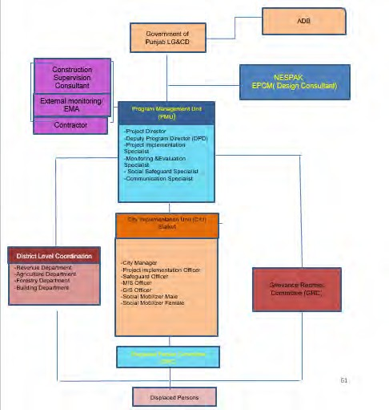

Implementation Schedule
- The months of September-October 2022 are the tentative date of the 100% implementation of LARPs 3. 4 & 5, stated by the Project Management Unit (PMU). Land Acquisition and Resettlement Plan is implemented in a participatory manner with the representations of all key stakeholders namely, the government and the displaced persons. As reported in the previous monitoring report that all approved LARPs differential have been approved by Government and disbursed among the available DPs – parallel to resettlement assistance. . This external monitoring report reflects and commencements of civil works can be proceeding after disbursement of 100% payments to available DPs whereas the PMU continue additional efforts for reaching out unavailable DPs in both cities of Sahiwal and Sialkot. out
- LARP Implementation Status: All 5 LARPs have been approved by ADB and disclosed on ADB and EAs websites. The LARPs were prepared as per the provision of project LARF, according to which independent valuation studies were carried out to meet ADB’s SPS 2009 requirement of “Replacement Cost”. The differential cost amount was calculated for each LARP (as compared to the BOR assessments), accordingly PC-I of Land Acquisition was revised to include this amount and was approved by the competent authority in September 2021.
- Exhaustive Efforts done by IA/EA in LARP implementation: In order to expedite LARP implementation process, Project Management Unit (PMU) has disseminated LARP related information to all DPs of LARP 4 & 5 which includes but not limited brochure, installation of banners at public offices such as DC office, Tehsildar’s offices, and other public places like Masjid’s and notable’s place in the project area. During the exhaustive efforts, the PMU produced information related to LARP implementation through print media i.e. local newspapers. Various posters and flip charts have been displayed showing salient features of PICIIP Project. Moreover, PMU has made announcements through loud speakers on regular basis for the information of DPs regarding their compensations and that again on their door steps. PMU along with the revenue department staff is frequently visiting all of the mouza’s in both the cities for the purpose of disbursements. To facilitate the DPs and revenue staff, PMU intimate/ provide serial number of DPs in the respective acquaintance roll in advance to help expeditious disbursement. PMU has mobilized various teams to accompany the revenue staff during preparation of required documents and disbursement process to achieve the targeted goal. However, after thorough consultation and documentation of unpaid DPs especially of LARP-3 some of the DPs agree to be compensated but the revenue department cannot intervene to process the compensation before the Court come up with a decision .. . Annexures of the supporting documents and good faith efforts were provided in the last 5th EMR approved for reaching out DPs and convincing them to receive compensation.
- Compensation Status: Payments of the BOR assessed compensation has started in June 2021. In LARP 1, BOR, Differential and Resettlement assistance 100% paid by IA/EA.
Whereas in LARP 2, by the end of quarter herein 92.5% (37) DPs have received BOR and Differential compensation out of total 41. Further, 92.5% Paid
(37 DPs out of 40 DPs have received Resettlement Allowance out of total 41 entitled. Remaining 04 are waiting for legal requirement of succession certification.
In LARP 3, 17% (5 out of 28) DPs have received compensation payment while the rest are waiting for court decision. 36% Paid (15DPs out of 42 DPs), whereas 5 out of 28 DPs have received differential compensation payment.

In LARP 4, 84% Paid (95 DPs out of 113 DPs) similarly same 84% DPs received differential compensation whereas 65% DPs received resettlement assistance
- In LARP 5, 74% (756) have received BOR and Differential compensation, whereas 41% (421) have received Resettlement Allowance. Data of the disbursement compensation of all LARPs is mentioned in Table 9.

Table 9: Status of LARPs Implementation
S. No. | Subproject | Land  (in Acres) | No. of DPs | Status of compensation of BOR | Status of differential compensation | Status of resettlement assistance | Remarks
LARP 1 | PICIIP 03: WATSAN  Sahiwal  Lot 3: North Zone pumping station | 5.01 | 8 | 100 % Paid (8 DPs) | 100 % Paid (8 DPs) | 100 % Paid (2 DPs) | All 3 types of payment 100% paid.
LARP 2 | WATSAN  Sahiwal  Lot 4: South Zone pumping station | 4.09 | 41 | 92.5% Paid  (37 DPs out of 40 DPs)  September 2022 is expected complete implementation date | 92.5% Paid  (37 DPs out of 40 DPs)  September 2022 is the expected full implementation date | 90.24 % Paid  (37 out of 41 DPs)  September 2022 is the expected full implementation date | Only 10 DPs are unpaid due to succession certification which is a legal requirement and in process.  June 15th 2022 is the 100% LARP implementation date.
LARP 3 | PICIIP 11  WATSAN Sialkot. Lot 3  Pumping Station | 2.34 | 42 | 17% (5 out of 28) DPs have received compensation payment whereas delay in compensation is because 11 out of 28 land owners filed reference in the court under section 18 of Land Acquisition Act 1894 against the low compensation assessment. Whereas 08 DPs are residing abroad/out of city. 2 DPs are not willing to receive compensation owing to the low land compensation rate. 02 DPs are deceased and inheritance mutation is required for compensation payment. | 5 out of 28 DPs have received differential compensation payment. | 36% Paid  (15DPs out of 42 DPs).  September 2022 is the expected full implementation date | The remaining unpaid DPs are waiting for Court decision and next court hearing in on April 26th 2022.  30th June 2022 is the expected 100% LARP implementation date
LARP 4 | PICIIP-8-WWTP  Sahiwal | 196 | 142 | 84% Paid  (95 DPs out of 113 DPs)  September 2022 is the expected disbursement completion date | 84 % Paid  (95 DPs out of 113 DPs)  September 2022 is the expected disbursement completion date | 65 % Paid  (92 out of 142 DPs)  September 2022 is the expected disbursement completion date | June 15th 2022 is the full implementation date of LARP 4
LARP 5 | PICIIP-12-  WWTP Sialkot | 239 | 1020 | 74% Paid  (756 out of 1020 DPs)  September 2022 is the expected disbursement completion date | 74% Paid  (756 out of 1020 DPs)  September 2022 is the expected disbursement completion date | 41% Paid  (421 DPs out of 1024 DPs) September 2022 is the expected disbursement completion date | June 30th 2022 is the expected full implementation date. The IA has made all the good efforts of guidance note. Only legal impediments cases are in process

Grievances Redress Mechanism (GRM)
- An integrated GRM for environment and social was established at the subproject level to facilitate amicable and timely resolution of complaints and grievances of the DPs, including local communities regarding the social, environmental, and resettlement aspects of the subproject.
- A grievance redress mechanism is already in place since 4th of May 2020. It is three tiers structures, i) Grievance Redress Committee at Field Level, ii) Grievance Redress Committee at Commissioner Office Level and iii) Grievance Redress Committee at PMU, Local Government & Community Development Level. The GRM is a gender responsive, culturally appropriate, and readily accessible to the stakeholders at no cost and without retribution. The stepwise process of the proposed GRM is summarized below.
- Stage 1: The affected person(s) may submit an oral or written complaint to the GRC at Field Level. The GRC will log the complaint along with relevant details in the community complaint register. The displaced person(s) can directly approach GRC. For each complaint, the GRC must investigate the complaint, assess its appropriateness/eligibility, and identify an appropriate solution. It will provide a clear response within seven working days to the complainant, PMU/CIU and Contractor (where relevant). The GRC will, as appropriate, instruct the responsible entity to take corrective actions. The GRC will review the responsible entity’s response and undertake additional monitoring as needed. During the complaint investigation, the GRC will work in close consultations with the Contractors, the CSC Consultants, PMU/CIU and other relevant agencies. The responsible entity should implement the redress solution and convey the outcome to GRC within seven working days.
- Stage 2: If no solution can be identified by the GRC or if the complainant is not satisfied with the suggested solution under Stage 1, the complainant can approach to stage 2 at City Level (Commissioner Office). The committee will review the case and give the solution within seven days of its submission.
- Stage 3: In case of dissatisfaction of the complainant at stage 2, he/she can approach to stage 3 at PMU level. Here, the GRC is headed by the Additional Secretary Development. The GRC at PMU level will resolve the complaint/grievance and the agreed action thus determined should be implemented within twenty-one days (if additional time is needed to implement the corrective action, it should be discussed and decided during the meeting).
- Implementing the GRC’s decision will be a contractual binding on the contractor.
- By the end of reporting period 11 complaints have been received in Sialkot city regarding LARP 3 & 5, out of which, seven complaints are on LARP 3 Disposal station and 4 complaints on LARP 5 WWTP. Out of total 11 complaints received 4 resolved and 7 are open relevant to LARP 3 where 11 DPs went civil court and 2 High Court for land rate enhancement. Five complaints received on LARP 5 WWTP stands resolved by meaningful consultation conducted by IA with the concern DPs under 1st Tier of GRC further the complainants were informed that the location for WWTP cannot be changed and as per design of city requirement. Moreover, DPs were informed that land rate has already been enhanced through third party validation approved by Government of Punjab, hence all the complaints reported on WWTP Sialkot stands resolved. GRC data is provided as Annexure A.
- By the end of the reporting period 25 grievances were reported in Sahiwal city which are fully resolved. Data of GRC is Annexed B.
- The IA is in continuous coordination with all those DPs with unsettled grievances and updates the status of GRM regularly and reports the updates in internal and external monitoring reports.

Income Restoration and Rehabilitation
- “Income restoration and rehabilitation of all approved LARPs of PICIIP. Training Opportunities: “PMU has to launch a skill development and livelihood restoration program for the DPs keeping in view the need of market and willingness of the DPs. The PMU with the coordination of an Agriculture department and vocational training institute will provide training to the DPs. The training will include the agriculture extension services for the efficient use of irrigation water, enhancing the agriculture productivity, human skill development on electronic work, embroidery, stitching cloth, and cooking. The training will be organized in coordination with the DPCs in the local district council that is easily accessible for the DPs. Transportation costs will be reimbursed, Lunch and tea breaks will be provided and the course will be given at no charge to the participants. An attendance certificate will be provided following the successful completion of the course. PMU will implement the training during the subproject execution.
- The training/skills development program budget is allocated in each approved LARP table 8.1 summary of entitlement matrix. It is important to note that all approved LARPs full implementation includes training and skills development and timely execution validated by the external monitor. Further all these approved LARPs were disclosed to DPs and they are well aware of these skills’ development programs, EMA confirms that the allocated budget of trainings has been transferred in the respective district treasury. In this regard, Training Need Assessment (TNA) survey is in process to identify training needs of DPs for commencement of Skill/capacity Building Trainings and training will be implemented in September, 2022. Details of budget mentioned in each LARP are given in Table 10.
Table 10. Budget for Training of DPs
LARP | DPs to be Trained | Budget (PKR)
LARP 1 | 08 | 0.2 Million
LARP 2 | 41 | 1 Million
LARP 3 | 31 | 1 Million
LARP 4 | 113 | 2 Million
LARP 5 | 1,024 | 9 Million
Total DPs to be trained | 1,217 | 13.2 Million

Consultation and Information Disclosure
- PMU/CIU and EMA is in a continuous process of conducting consultations with DPs since the LARPs planning and implementation. The consultations focused on the compensation assessment, eligibility criterion and entitlements, and compensation disbursement process. These meetings are organized at the village level and mostly the disconnection of water supply, lack of access to routes and environment related issues are discussed. The consultations focused on the compensation assessment, eligibility criterion and entitlements, and compensation disbursement process.
- The information disclosure has been well achieved by PMU through in LARPs 1 to 5 and project information brochures have been disclosed to all DPs and in fact translated in Urdu language for better understanding. The DPs seem quite aware about their entitled compensation and livelihood restoration allowances and procedures of payments. The Broachers in English and Urdu language were annexed with the previous approved external monitoring reports.
- In the reporting period 6 consultation were held on LAR impacts sub projects in which 47 men and women (DPs) participated. In general, all paid DPs are quite satisfied with the compensation they received

Conclusions
- By the end of reporting quarter, overall, 72% (901) DPs have received BOR compensation out of total 1253 DPs. Similarly, 72% (901) DPs have received Differential compensation, whereas 48% (573) have received resettlement allowance out of total 1185 DPs.
- The institutional arrangements and consultation and grievance redress mechanisms as mentioned in the approved LARPs are fully in place and generally functioning well. However, there is a need of improvement in the functioning of GRM, by involving women as GRC members so the committee has to gender inclusive and women should be able reporting their grievances without any hassle.
- All reported grievances in Sahiwal city have been resolved where is Sialkot city DPs those went to Civil court their grievances are open. Legally when the matter is in court other Government Departments cannot intervene unless the court come up with a decision.

Recommendations
- It is recommended that IA/EA needs to carry with internal quarterly monitoring reports timely.
- For both WWTPs sub projects of Sahiwal and Sialkot, ADB SPS compliance has been achieved in terms of making the payments to all payable DPs. However, the remaining compensation is stuck due to legal and administrative impediments of unpaid DPs in both cities WWTPs sub projects. The unpaid compensation is already deposited is Districts treasury under Escrow accounts (Mad-e-Amanat) to ensure that unpaid DPs can receive compensation as and when they show up after resolving their legal issues and the same will have to be reported by the external monitor.
- The technical training for restoration of the livelihood is mentioned in each LARP along with a respective budget, it is recommended that the implementation of all LARPs have been started therein IA need to start the training which will go parallel with implementation.

Annexures

Annexure A – Sialkot GRC Data
Sialkot
S# | Nature of Complaints | Reported Complaints  (No) | Number of complaints resolved | Remarks
1 | Shifting of Disposal Station | 2 | 0 | Writ Petition was filed in Lahore High Court on 28-Jan-21. On 15-04-21, PICIIP provided EA report to the court. Next hearing is awaited. Consultation meetings are being regularly conducted with complainants under GRC.
2 | Land issues at construction of OHR and Tube well under WATSAN | 1 | 1 | Writ Petition was filed in Senior Civil Court on 27.02.21. PICIIP provided all documents of property to court and court dismissed the case on 29.04.21.
3 | Reference to Court for Fair Compensation, Disposal Station | 5 | 0 | Waiting for 1st hearing date 15.02.22
4 | Shifting of WWTP | 1 | 1 | Meaningful consultations were conducted under 1st Tier of GRC and it was informed that the location for WWTP cannot be changed and as per design of city requirement. All complaints are resolved till date.
5 | Fair Compensation- WWTP | 3 | 3 | Meaningful consultations were conducted under 1st Tier of GRC and it was informed in LARP disclosure that Independent Valuation Study (IVS) has been conducted and Government has increased cost of their land. All complaints are resolved till date.
Total |  | 12 | 5

S. # | LARP | Package Complaint | Name of Complainant | Date of Complaint | Area of Complaint | Complaint Category | Remarks | Status
1 | LARP 3 | WATSAN LOT 3  (Disposal Station) | M. Akbar S/o Charagh Din | 8-Mar-21 | Korpur | Shifting of Disposal Station due to health hazards | Writ Petition was filed in Lahore High Court on 05-Nov-20. On 25-11-  20, PICIIP provided EA report to the court and Court forwarded the case to DC, Sialkot for hearing. Case is also registered in GRC register. A meeting was scheduled to provide all details of the project and DP was requested for meeting but due to his illness he refused to meet. | Open
2 | LARP 3 | WATSAN LOT 3  (Disposal Station) | Hafeez Ullah and 2 others | 5-Apr-21 | Korpur | Shifting of Disposal Station due to health hazards | Writ Petition was filed in Lahore High Court on 28-Jan-21. On 15-04-  21, PICIIP provided EA report to the court. Next hearing is awaited. | Open
3 | LARP 3 | WATSAN LOT 3  (Disposal Station) | Suria Begum Wd/o M. Yousaf | 6-Apr-21 | Korpur | Reference u/s 18 of LAA 1984 | Waiting for next hearing of Court on 07-09-22 | Open
4 | LARP 3 | WATSAN LOT 3  (Disposal Station) | Shahbaz Ali S/o M. Sadiq | 7-Apr-21 | Korpur | Reference u/s 18 of LAA 1985 | Waiting for next hearing of Court on 07-09-22 | Open
5 | LARP 3 | WATSAN LOT 3  (Disposal Station) | Hafeez Ullah | 5-Apr-21 | Korpur | Reference u/s 18 of LAA 1986 | Waiting for next hearing of Court on 07-09-22 | Open
6 | LARP 3 | WATSAN LOT 3  (Disposal Station) | Sikandar Faiz | 30-Mar-21 | Malka Khurd | Reference u/s 18 of LAA 1987 | Waiting for next hearing of Court on 07-09-22 | Open
7 | LARP 3 | WATSAN LOT 3  (Disposal Station) | M. Akbar S/o Charagh Din | 17-Mar-21 | Korpur | Reference u/s 18 of LAA 1988 | Waiting for 1st hearing of Court | Open
8 | LARP 5 | WWTP | Zulfiqar Ahmad and 31 others | 15-Jun-20 | Chak Kala | Shifting of WWTP, Alternate Land, Compensation 5 Million per Acre | A complete LARP will be prepared and they will be compensated to the full extent as per existing laws of Pakistan and ADB. | Closed
9 | LARP 5 | WWTP | M. Arshad and 11 others | 7-Jul-21 | Chitti Shiekhan | request for Fair compensation | They were called under 1st tier of GRC and they were informed that Independent Land Valuation Study has been conducted as per the market rates. It was conveyed in LARP disclosure that Differential cost will also be paid to all DPs They are satisfied with the IVS rates and are waiting for that payment. | Closed
10 | LARP 5 | WWTP | M. Munir and 13 others | 15-Jul-21 | Chak Kala | request for Fair compensation |  | Closed
11 | LARP 5 | WWTP | Hassan Ali and 11 others | 15-Jul-21 | Chak Kala | request for Fair compensation |  | Closed
12 | WATSAN | WATSAN LOT 3 (Disposal Station) | M. Younis | 3-Mar-21 | Prem Nagar Park | Claiming government land as his property | Writ Petition was filed in Senior Civil Court on 27.02.21. PICIIP provided all documents of property to court and court dismissed the case on 29.04.21. | Closed

Annexure B – Sahiwal GRC Data
S. # |  | Project Name | Name of Complainant | Address | Date of Complaint Received | Complaint Category | Key Concerns | Status | Response
1 | LARP 4 | STP,  (North Zone), Sahiwal | M. Ali Sardar, Sardar M. Amanat Ali, Abdul Ghaffar, Khair Din, Naseer Ahmed, Shabbir Ahmed, Din M., Ahmed Yar, Noor ul Mustufa, M. Aslam, Ijaz Ahmed | Chak#66 GD | 23-Feb-20 | Request for Shifting of Plant | Shifting of plant from their land as it is their sole source of earning | Closed | They were informed that the location of land has been finalized through making analysis of all other possible options and as per design and city requirement, the proposed location was finalized and now it cannot be shifted.
2 | LARP 4 | STP,  (North Zone), Sahiwal | M. Anwar | Chak#66 GD | 29-Feb-20 | Request for Shifting of Plant | Shifting of plant from their land as it is their sole source of earning | Closed | They were informed that the location of land has been finalized through making analysis of all other possible options and as per design and city requirement, the proposed location was finalized and now it cannot be shifted.
3 | LARP 4 | STP,  (North Zone), Sahiwal | Anonymous | DPs of M. PUR | 04-Mar-20 | Possession | Confirmation that whether Govt, is going to take possession of their land or not | Closed | Concerned documents were reviewed and a written reply was given to the concerned department that Govt is going to take possession of their land under Land Acquisition Act 1894.
4 | LARP 4 | STP,  (North Zone), Sahiwal | Nasir Ahmed,  M. Nawaz, Bashir Ahmed | Chak#66 GD | 05-Mar-20 | Request for Shifting of Plant | Shifting of plant from their land as it is their sole source of earning | Closed | They were informed that the location of land has been finalized through making analysis of all other possible options and as per design and city requirement, the proposed location was finalized and now it cannot be shifted.
5 | LARP 4 | STP,  (North Zone), Sahiwal | Mehar Bashir | Chak#66 GD | 18-Mar-20 | Request for Shifting of Plant | Shifting of plant from their land as it is their sole source of earning | Closed | They were informed that the location of land has been finalized through making analysis of all other possible options and as per design and city requirement, the proposed location was finalized and now it cannot be shifted.
6 | LARP 4 | STP,  (North Zone), Sahiwal | Ahmed Yar | Chak#66 GD | 06-Apr-20 | Request for Shifting of Plant | Shifting of plant from their land as it is their sole source of earning | Closed | They were informed that the location of land has been finalized through making analysis of all other possible options and as per design and city requirement, the proposed location was finalized and now it cannot be shifted.
7 | LARP 4 | STP,  (North Zone), Sahiwal | M. Afzal | M.Pur | 07-04-2020,  18-Jun-20 | Request for Fair compensation | In favor of Plant but need reasonable rates of their land | Closed | The Complainant was called under 1st tier of GRC and they were informed about the findings of IVS. They were informed that the revised rates are as per market rates. They will get the revised rates along with the resettlement allowances. They are ready to get their compensation.
8 | LARP 4 | STP,  (North Zone), Sahiwal | M. Ali Khan | M.Pur | 02-May-20 | ADB's  policy | Request to confirm that whether ADB will play any kind of role in land acquisition. If indigenous people have any objections or concerns than how can they approach ADB's relevant representatives. | closed | Concerned Documents were reviewed. The complainant was replied through email that project is funded by ADB and land acquisition is funded by Govt. of Punjab as per LA act 1894. He was also informed about the GRM of project and information in form brochure was also shared to him.
9 | LARP  4 & LARP 1 | STP and Disposal Station, (North Zone), Sahiwal | Waqar Ahmed Khan | M.Pur | 30-May-20 | Request for Shifting of Plant | Request to provide counseling regarding the timeline of the project so that they can manage their next agricultural year according to the provided guidelines. | closed | Concerned Documents were reviewed. The complainant was contacted and multiple meetings were conducted to provide him counseling and guidelines were also given to him in order to remove their ambiguities and confusions.
10 | LARP 4 | STP,  (North Zone), Sahiwal | Ch. Sardar M., Naseer Ahmed, Ch Naeem Ashraf, Bashir Ahmed, M, Anwar, M. Noor ul Mustufa, M. Aslam | Chak#66 GD | 06-Jun-20 | Request for Shifting of Plant | Shifting of plant from their land as it is their sole source of earning. If shifting of plant is not possible then an alternate piece of agricultural land having same quality of land should be given to DPs. | Closed | They were informed that the location of land has been finalized through making analysis of all other possible options and as per design and city requirement , the proposed location was finalized and now it cannot be shifted.
11 | LARP 4 | STP,  (North Zone), Sahiwal | Noor ul Mustufa | Chak#66 GD and M.Pur | 06-Jun-20 | Induction of his remaining land into plant or deduction of his whole parcel of land | Due to project his remaining land is getting defected. Out of his total land, 2 kanals is not coming in plant. He said the remaining land is useless to him. Other that 14 marlas he bought to make path to his land and which becomes useless to him. Thus he requested to take all his land or pay him for his remain land as well or return him his whole piece of land. | Closed | He was informed that he will write an application to the Tehsildar for Taqseem Dawa and his matter will be sorted out by the Revenue Authority.
12 | LARP 4 & LARP 1 | STP and Disposal Station, (North Zone), Sahiwal | M. Ali Khan, M. Sajjad Khan, Waqar Ahmed Khan, Ali Murad Khan, | M.Pur | 13-Jun-20 | Request for Shifting of Plant | shifting of plant from their land as it is their sole source of earning. If shifting of plant is not possible then an alternate piece of agricultural land having same quality of land should be given to DPs. If alternate piece of land cannot be given then 60 lakh rupees per acre should be provided to DPs. DPs should be given the Facility of water to cultivate the remaining piece of their land and a proper path to get access to their remaining piece of land. Govt. is acquiring a strip of land of 20 feet width from our land and this strip of land is contacted to the metal road thus it should be paid as per the commercial rates of the area not for the agricultural land rates. DPs should be provided with the facility of early relocation and Tube wells and other structures on their land should be relocated with the help of Govt. No one is ready to take their land on lease since they are listening about the construction of plant on their land thus if Govt cannot pay the DPs by the end of June 2020 then the price of lease per annum should be given to each DP by the start of financial/lease year. The prices for the unpaved path, Canals path and no cultivated area should be given to DPs as this is also owned by their family. No one is taking their remaining land on lease because their system of water supply and path to the remaining land will get blocked by the plant, thus they should be paid for the remain land as well in terms of lease rates per annum. As we have taken loan over land from agricultural banks and since we are unable to earn anything from our land since the announcement of plant in our area.  The markup on that land is increasing day by day. It is requested to Govt. to pay our markup over agricultural loans. Our Community should be briefed about the environmental effects of this plant and the mitigation measures to cope the bad impacts on our environment. | Closed | They were informed that the location of land cannot be shifted due to some geometrical, technical and financial reasons. They will be compensated to the full extent related to their land and non-land assets. The findings of IVS have also been shared with them.  They are satisfied with the IVS rates and are waiting for that payment.
13 | LARP 4 | STP,  (North Zone), Sahiwal | Ali Murad Khan | M.Pur | 21-Aug-20 | Payment of loan markup by the project | They want that Govt. should pay their loan and markup which they have taken on the land where Govt. is going to construct WWTP. As it was the sole source of earning and they are unable to pay the loan and markup as well. | Closed | He was informed that the matter has discussed with the EA and it came to know that no funds are available for this purpose.
14 | LARP 4 | STP,  (North Zone), Sahiwal | Naeem Ashraf | M.Pur | 25-Sep-20 | Payment Schedule | He wants to know the time of payment  . | Closed | The person was updated about the time period of the Payment. He was informed that the payments will be made after award under section 11 of land acquisition act 1894.
15 | LARP 2 | Disposal Station(South Zone), Sahiwal | Ijaz Ahmed, Amanat Ali, Akbar Ali | Chak#11 1/9L | 06-Oct-20 | Request for fair compensation | They were of the view that the rates proposed in DPAC are below market rates and they should be compensated as per market rates. | Closed | The Complainant was called under 1st tier of GRC and they were informed about the findings of IVS. They were informed that the revised rates are as per market rates. They will get the revised rates along with the resettlement allowances. They are ready to get their compensation.
16 | LARP 4 | STP,  (North Zone), Sahiwal | Noor ul Mustufa, Mian Saeed Ahmed, Bashir Ahmed, Naseer Ahmed, M. Shareef, Sardar M. Abdul Ghaffar, Haji Amanat Ali, M. Aslam, Naeem Ashraf | Chak#66 GD | 04-Nov-20 | Request for fair compensation | The complainants were of the view that the compensation assessed by the DPAC are not according to market value. Rates should be equal to M.Pur. | Closed | The Complainant was called under 1st tier of GRC and they were informed about the findings of IVS. They were informed that the revised rates are as per market rates. They will get the revised rates along with the resettlement allowances. They are ready to get their compensation.
17 | LARP  4 & LARP 1 | STP, and Disposal Station (North Zone), Sahiwal | M. Sajjid Khan, Waqar Ahmed Khan, M. Ali Khan, Ali Murad Khan, | M.Pur | 04-Nov-20 | Request for fair compensation | The complainants were of the view that the compensation assessed by the DPAC are not according to market value. | Closed | The Complainant was called under 1st tier of GRC and they were informed about the findings of IVS. They were informed that the revised rates are as per market rates. They will get the revised rates along with the resettlement allowances. They are ready to get their compensation.
18 | LARP 4 | STP,  (North Zone), Sahiwal | M. Ali Khan, Ahmed Yar Khan | M.Pur | 16-Dec-20 | Request for fair compensation | The complainants were of the view that the compensation assessed by the DPAC are not according to market value. | Closed | The Complainant was called under 1st tier of GRC and they were informed about the findings of IVS. They were informed that the revised rates are as per market rates. They will get the revised rates along with the resettlement allowances. They are ready to get their compensation.
19 | LARP 4 | STP,  (North Zone), Sahiwal | Sardar M. | 66 GD | 20-Dec-20 | Request for fair compensation | The complainants were of the view that the compensation assessed by the DPAC are not according to market value. Rates should be equal to M.Pur. | Closed | The Complainant was called under 1st tier of GRC and they were informed about the findings of IVS. They were informed that the revised rates are as per market rates. They will get the revised rates along with the resettlement allowances. This refer to unpaid DPs who are not willing to be compensated their compensation has been deposited in Escrow account
20 | LARP 4 | STP,  (North Zone), Sahiwal | Ali Khan | M.Pur | 29-Dec-20 | Request for fair compensation | The complainants were of the view that the compensation assessed by the DPAC are not according to market value. | Closed | The Complainant was called under 1st tier of GRC and they were informed about the findings of IVS. They were informed that the revised rates are as per market rates. They will get the revised rates along with the resettlement allowances. They are ready to get their compensation.
21 | SDDR of WATSAN | Through Prime minister Portal (WATSAN , Lot 1) | Rana Nazeer Ahmed | Mohalla Noor Park, St#01, Graveyard near railway Station, Sahiwal | 02-03-21 | Unfair construction of Filtration Plant | The complainants were of the view that the construction of Filtration Plant should be stopped at the site of Graveyard. | Closed | The application was moved to the 1st tier of GRC. A meeting was held on 17.03.2021 The matter was briefed to the committee and chair asked Infrastructure Engineer to brief the current situation.IE clarified the chair work on site has been started after getting NOCs. During construction no complaints has been received. So work is being executed smoothly and there is no complaint at site.
22 | SDDR  of WATSA N | Through MC,  Sahiwal (WATSA N , Lot 1) | Habitants of Madina Masjid Colony | Madina Masjid Colony | 02-03-21 | Unfair Construction of OHR | The complainant were of the view that the construction of OHR should be stopped at the ground of their colony. | Closed | The application was moved to the 1st tier of GRC. A meeting was held on 17.03.2021 The matter was briefed to the committee and chair asked Infrastructure Engineer to brief the current situation.IE clarified the chair work on site has been started after getting NOCs. During construction no complaints has been received. So work is being executed smoothly and there is no complaint at site.
23 | SDDR  of WATSA N | Through MC,  Sahiwal (WATSA N , LoT#1) | Habitant of Tariq bin Zayad Colony, Sahiwal | Tariq Bin Zayad Colony, Sahiwal | 02-04-21 | Unplanned laying of Water Supply Lines | The complainants were of the view that the laying of water supply lines should be laid in a way that maximum public can get benefits from it. | Closed | The application was moved to the 1st tier of GRC. A meeting was held on 17.03.2021 The matter was briefed to the committee and chair asked Infrastructure Engineer to brief the current situation.IE clarified the chair work on site has been started after getting NOCs. During construction no complaints has been received. So work is being executed smoothly and there is no complaint at site.
24 | LARP 4 | Through Courier at PMU | Ijaz Ur Rehman S/O Fazal Muhammad,  M. Aslam S/O  M. Ali, Sardar M., Amanat Ali, Abdul Ghaffar, pisran Khair Din | Chak 66GD | 26-04-  2021,20-05-  2021 | Request for Shifting of Plant | Shifting of plant from their land as it is their sole source of earning | Closed | The application was moved to the 1st tier of GRC. A meeting was held on 17.03.2021 The matter was briefed to the committee and chair asked Infrastructure Engineer to brief the current situation.IE clarified the chair work on site has been started after getting NOCs. During construction no complaints has been received. So work is being executed smoothly and there is no complaint at site.
25 | LARP 4 | Through Email | Imran Sardar | Chak 66GD | 12-10-21 | Request for Fair compensation | Update on the revised rates and compensation details | Closed | The Complainant was called under 1st tier of GRC and they were informed about the findings of IVS. They were informed that the revised rates are as per market rates. They will get the revised rates along with the resettlement allowances. Compensation payment of remaining 12 DPs has been deposited in Escrow account of LAC for later disbursement. The evidence of the payment deposited in Escrow account has been reported in the social audit report.

Annexure C – Consultation Sessions with Displaced Persons
SAHIWAL
Meeting with DPs of Chak No. 66 GD to redress their Grievances under PICIIP in Sahiwal
Dated: 10.05.2022 | Venue: Committee Room of City Implementation Unit, Sahiwal

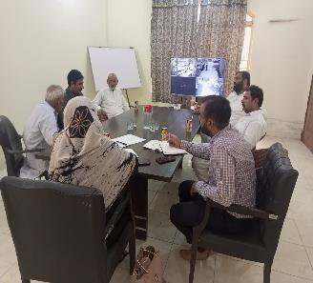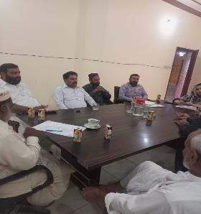
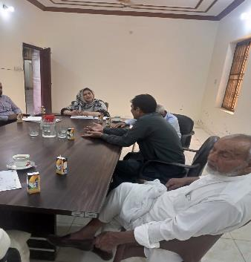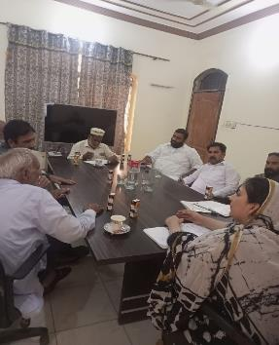

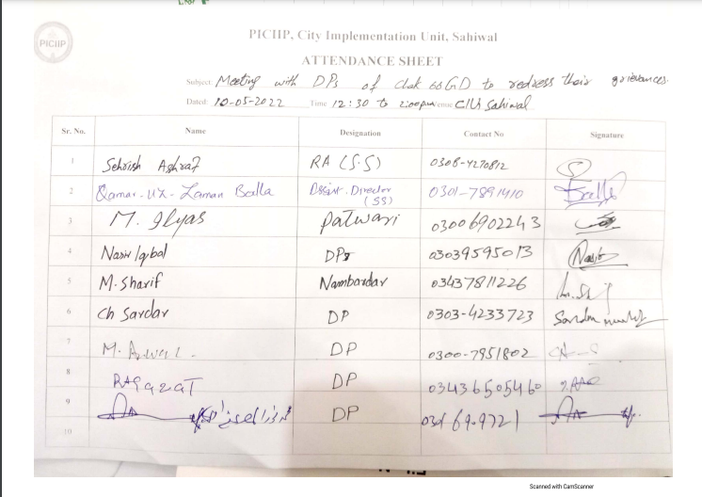

Meeting with DPs of Chak No. 66 GD to redress their Grievances under PICIIP in Sahiwal
Dated: 16.05.2022 | Venue: Committee Room of City Implementation Unit, Sahiwal

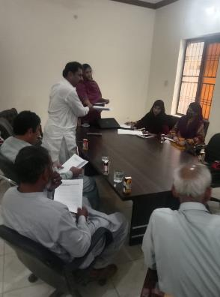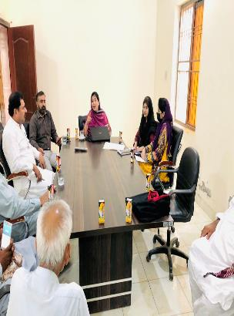
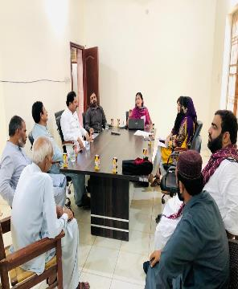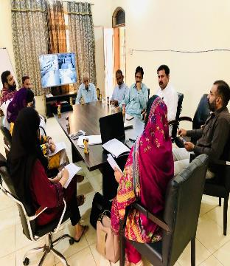

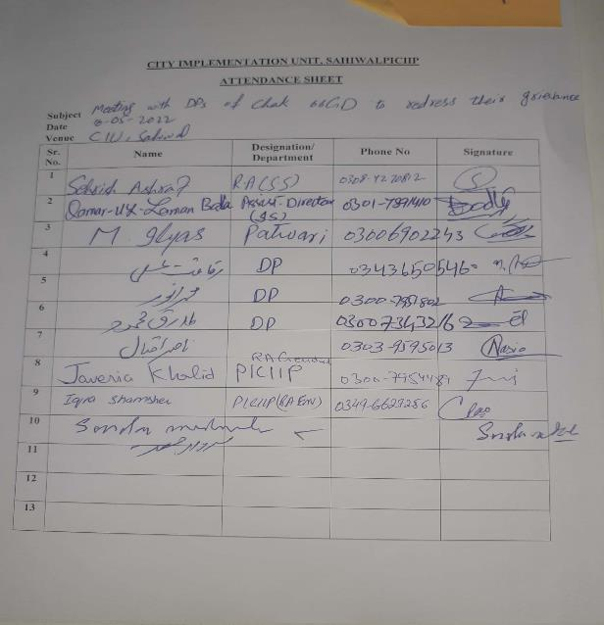

SIALKOT
Meeting with DPs of WTTP LARP 5, Sialkot
Dated: 25.05.2022 | Venue: Chak Kala Kapoorwali, Sialkot

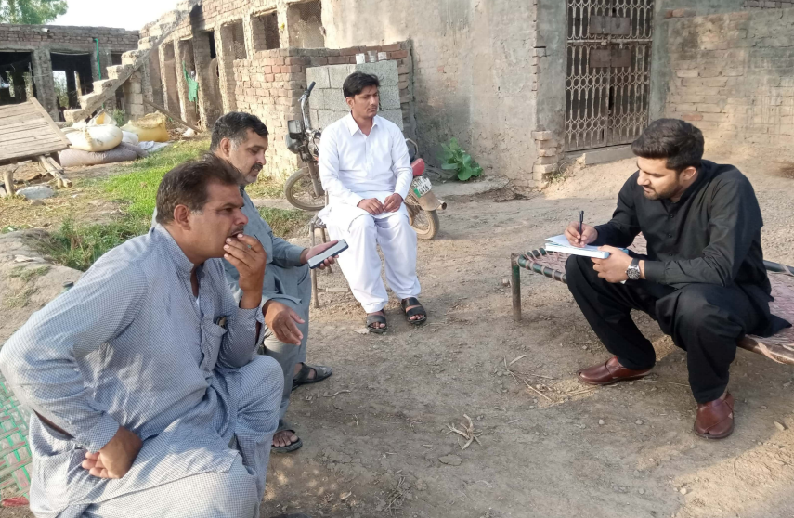

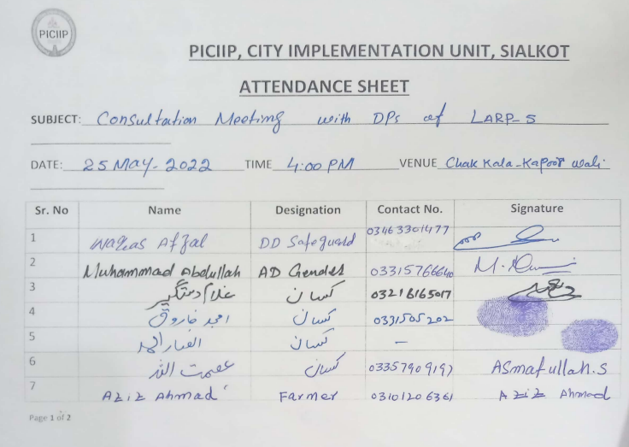

Meeting with DPs of WTTP LARP 5, Sialkot
Dated: 27.05.2022 | Venue: Chak Kala, Sialkot

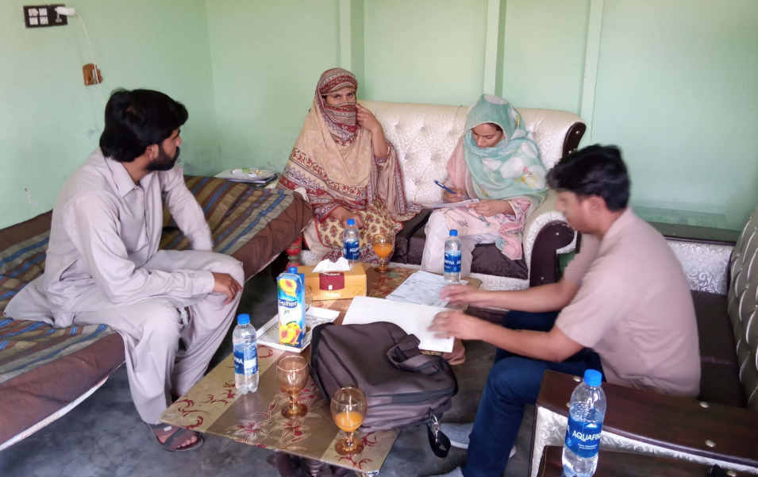

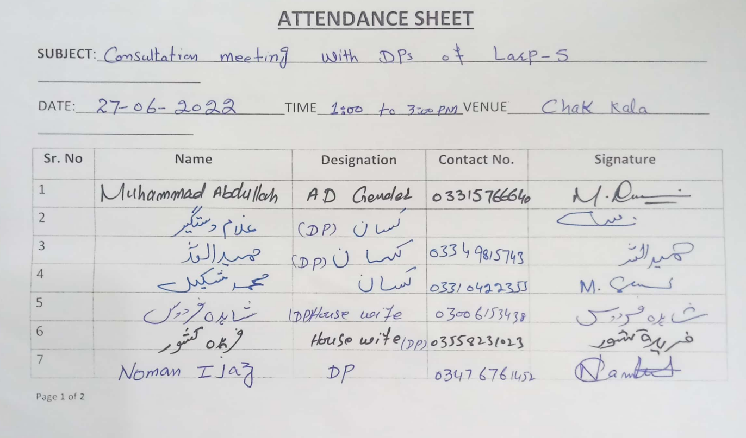

Meeting with DPs of Chitii Sheikhan of LARP 5, Sialkot
Dated: 24.05.2022 | Venue: Chiti Sheikhan, Sialkot

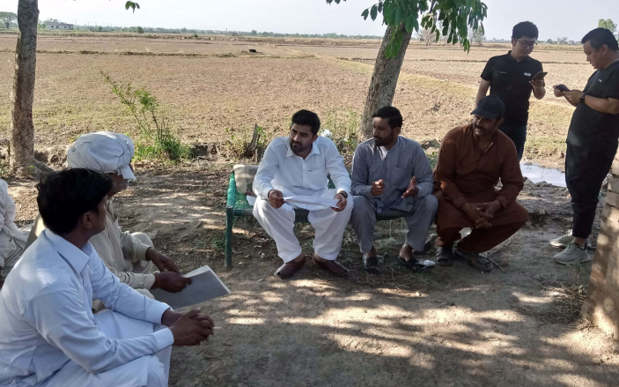

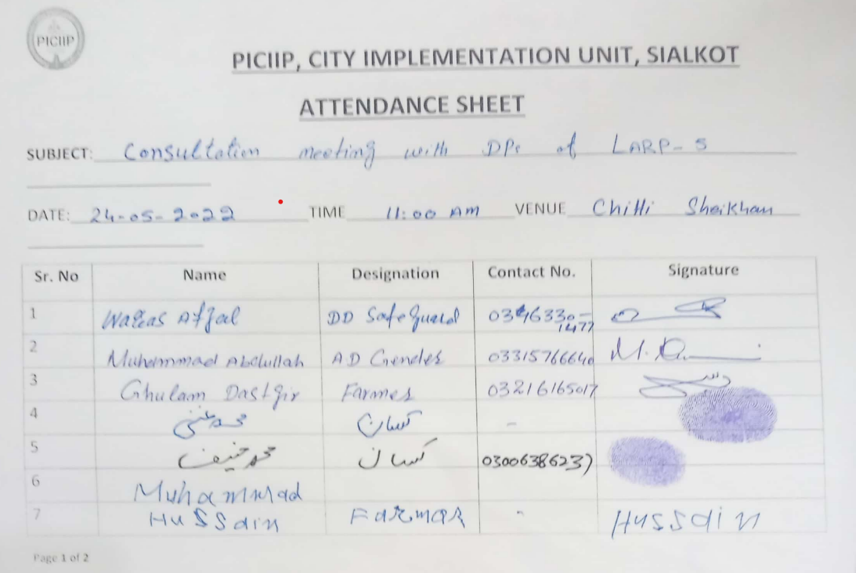

Meeting with DPs of Disposal Station LARP 3, Sialkot
Dated: 23.05.2022 | Venue: Assistant Commissioner Office, Sialkot

